Invitation to Bid- Fairview Restroom Improvements
Solicitation # 444-0613-33

Vendor | Bid
Drakes Creek Builders  1050 Glenbrook Way , Ste 480-12  Hendersonville TN 37075 | $79,100.00
Thomas Constructors  4711 Trousdale Dr, Ste 202  Nashville TN 37220 | $113,021.00

This is a tabulation of all bids received.
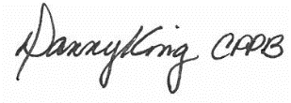
Assistant Finance Director

