Georgetown County, South Carolina

129 Screven Street, Suite 239

Post Office Drawer 421270

Georgetown, SC 29442-4200
(843) 545-3083 • Fax (843) 545-3500
E-Mail • purch@gtcounty.org
Website • http://www.gtcounty.org
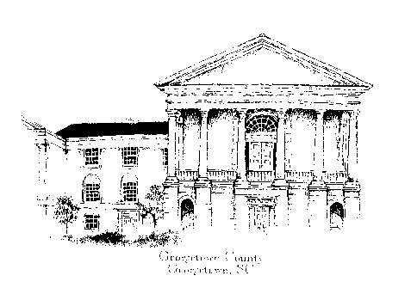

ADDENDUM #1 TO BID #19-034
BID NUMBER: 19-034 ISSUE DATE: Friday, July 5, 2019

OPENING DATE: Original Date: Wednesday, July 24, 2019 OPENING TIME: 3:00 PM (ET)

NEW OPENING DATE: WEDNESDAY, AUGUST 14, 2019

Bid Opening Location: Georgetown County Courthouse, Suite #239, (Purchasing Conference Room)

PROCUREMENT FOR: Non Engineered Road Repair, Resurfacing, Sealing and Marking, IDIQ

This addendum will amend Bid #19-034, Non Engineered Road Repair, Resurfacing, Sealing and Marking, IDIQ originally issued on Friday, July 5, 2019. This clarification is being provided to all known and registered correspondents in response to questions received. All addenda and original bid documents are also available online at: www.gtcounty.org, select Quick Links, “Bid Opportunities” and “Current Bids.”

This Addendum #1 is to postpone the Opening Date of Bid # 19-034 until Wednesday, August 14, 2019 @ 3:00 PM (ET)

[THE REMAINDER OF THIS PAGE IS INTENTIONALLY LEFT BLANK]

ADDENDUM ACKNOWLEDGEMENT

Bid #19-034
Non Engineered Road Repair, Resurfacing, Sealing and Marking, IDIQ
Mandatory Submittal Form

To be returned with the final proposal submission to Georgetown County.

COMPANY NAME:

◙ Addendum #1 Received Date: Initialed By:
□ Addendum #2 Received Date: Initialed By:
□ Addendum #3 Received Date: Initialed By:
□ Addendum #4 Received Date: Initialed By:
□ Addendum #5 Received Date: Initialed By:
□ Addendum #6 Received Date: Initialed By:

If your Bid submission has already been mailed, acknowledgment may be provided by faxing this form to (843)545-3500, or attaching a digital scan and sending by e-mail.

[THE REMAINDER OF THIS PAGE IS INTENTIONALLY LEFT BLANK]

