County of Sierra
State of New Mexico
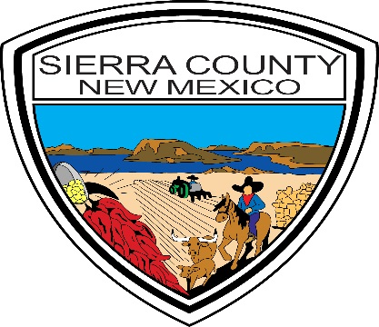
Shelly Trujillo
County Clerk
575-894-2840
Ronald D. Brown
County Sheriff
575-894-9150
Frances L. Luna
Commissioner
District 3
575-894-6215

Glenn Hamilton
Sheriff
575-894-9150
Travis Day, Commission Vice-Chair
District 2
575-894-6215
James E. Paxon, Commission Chair
District 1
575-894-6215
Thomas Pestak
Probate Judge
575-740-4900
Michael Huston
County Assessor
575-894-2589

Terri Copsin
County Treasurer
575-894-3524
Bruce Swingle
County Manager
575-894-6215
855 Van Patten
Truth or Consequences, New Mexico 87901

MANDATORY PRE-PROPOSAL CONFERENCE

February 19, 2020

For all in attendance:

RE: RFP #2020-07-011 NEW ADMINISTRATION BUILDING- AMINS

As part of this RFP process, today’s Mandatory Pre-Con, is to allow all potential offerors the opportunity to review the building and discuss with the County what it is we are seeking for the future placement off Sierra County Office’s. They consist of ‘Programming ‘for the agencies that are going into the building. (How many people, what size office or cubicle do they need, how many conference rooms (how many people), break rooms, file rooms—do they receive the public – receptionist, etc.) which agencies should be near the main front door? Which, if any, can be “back of house”? All these specifications will be addressed in today’s meeting.
The awarded Design Build Team will need to insure they provide the basic specification like conduit for wiring, not flex; metal studs, not wood; commercial toilets and sinks, etc. reports on the condition of the building. Does it need a new roof? New HVAC? New fire alarms or sprinklers? New Electrical panels? New ADA doors and bathrooms? Along, with basic floor plans as part of the renovation. Furnishings would be itemized as well.
The final agreement will be handled accordingly during the final phase of negotiations. Please, refer any questions in writing, following this meeting directly to me. Questions, may be sent via email. Thank you for your time today and we are looking forward to what you may have to offer.
Regards,

Jocelyn Holguin
Chief Procurement Officer
County of Sierra
jholguin@sierraco.org
575-894-6215

