Request for Written Quotes

Appliance Parts

Solicitation Number | Q1811
Due Date | October 11, 2017
Due Time | 2:00 p.m. EST
Deliver Responses to: |   Knoxville’s Community Development Corporation  Procurement Division  901 N. Broadway  Knoxville, TN 37917  Note: Procurement is in a separate building behind the main office building
Electronic Copies: | Electronic copies are available on KCDC’s webpage or by email at purchasinginfo@kcdc.org.
May responses be emailed to KCDC | ☒ Yes ☐ No  Paper copies must also be provided, if the solicitation so indicates.
Solicitation Meeting | ☐ Yes ☒ No
Solicitation Meeting is Mandatory | ☐ Yes ☒ No
Solicitation Meeting Date | Not applicable
Solicitation Meeting Time | Not applicable
Solicitation Meeting Location | Not applicable
Questions About This Solicitation | Submit questions to purchasinginfo@kcdc.org.

Check KCDC’s webpage for addenda and changes before submitting your response

General Information

1. BACKGROUND AND INTENT

a. Knoxville's Community Development Corporation (KCDC) is the public housing and redevelopment agency for the City of Knoxville and for the County of Knox in Tennessee. KCDC’s public housing property portfolio includes 20 sites with approximately 3,525 dwelling units. KCDC also administers approximately 3958 Section 8 Vouchers, 82 Moderate Rehabilitation units and 20 Redevelopment areas.

b. KCDC has thousands of refrigerators, stoves, water heaters and some washers, dryers and dishwashers in its units. KCDC performs many maintenance services on its appliances and from time to time needs to purchase repair and/or replacement appliance parts.

c. KCDC intends these specifications to result in the selection of a capable supplier(s) to provide replacement parts and supplies as needed. KCDC will either pick up needed parts (most common method) or require prompt delivery of ordered parts (rare). Accordingly, it is important that the supplier be conveniently located to the majority of KCDC’s locations.

d. KCDC requests a “discount off percentage” for non-specified items since KCDC may need other items from time to time. The discount can be “0” if necessary. The supplier must indicate to what pricing standard the discount applies. For instance, the discount percentage could apply to shelf price, catalog price, jobber’s price, et cetera.

e. KCDC has identified a number of specific commonly purchased items for the supplier to provide a firm fixed price. These items are in the pricing section of this document.

f. KCDC utilizes the “catalog” function of its financial software. This enables KCDC employees to quickly and easily place one item orders for items that are on contract. Please note:

1. KCDC issues individual purchase orders for specific orders.
2. KCDC transmits purchase orders via email.

2. DELIVERY

a. Delivery will be to specified locations within Knox County, Tennessee.

b. Deliveries are accepted (approximately-may depend upon the site) between 7:30 a.m. and 3:30 p.m. each business day.

c. Deliveries will not incur additional cost to KCDC.

d. KCDC may or may not ask for delivery. Typically, KCDC picks up items in the store.

3. CHANGES AFTER AWARD
It is possible that after award KCDC will need to revise the service needs or requirements specified in this document. KCDC reserves the right to make such changes after consultation with the supplier. Should additional costs arise, the supplier must document increased costs. KCDC reserves the right to accept and negotiate these charges.

4. EVALUATION
KCDC will arrive at the “lowest and best” solution for the final award. This may not entail simply awarding to the supplier quoting the lowest cost. All responses are subject to a determination of “responsive” and “responsible” prior to award. KCDC is the sole judge as to supplier “responsiveness” and “responsibility.” KCDC reserves the right to request additional information to assist in the evaluation process. This includes references and business capacity information.
Supplier’s location relative to KCDC locations will be a factor in the evaluation.

5. GENERAL INSTRUCTIONS
KCDC does not insert “General Instructions to Suppliers” in solicitation documents. These instructions are at www.kcdc.org. Click on “Procurement” and the link to the instructions. The supplier’s submittal means acceptance of the terms and conditions set forth in KCDC’s “General Instructions to Suppliers.”

6. INVOICING/ORDERING

a. Until a purchase order is in place, work is not to be performed nor are goods to be delivered. KCDC does not have a legal obligation to pay for the work performed prior to the issuance of a purchase order.

b. Suppliers must submit invoices within 90 days of the delivery of goods or services. KCDC may deny invoices submitted after the 90-day threshold. KCDC prefers invoices arrive within 10 days following the end of the month in which goods or services were supplied.

c. KCDC’s purchases of goods are exempt from Tennessee sales and use tax pursuant to Tennessee Code Annotated 67-6-329(a) (4) and KCDC is generally exempt from the Federal Excise tax. Contractors are subject to Tennessee sales and use tax on all materials and supplies used in the performance of a contract, whether such materials and supplies are purchased by the contractor, produced by the contractor, or provided to the contractor by KCDC, pursuant to Tennessee Code Annotated 67-6-209. The contractor will pay all taxes incurred in the performance of an awarded contract. Upon the placement of a purchase order or the award of a contract, KCDC will provide a State of Tennessee Sales Tax Exemption form to the supplier. KCDC will not pay taxes on invoices.

d. KCDC pays by electronic transfer (ACH) only.

7. LENGTH OF AWARD
The length of the contract will initially be 12 months along with four optional yearly renewals that KCDC may exercise at its discretion.

8. MULTIPLE AWARDS
KCDC reserves the right to award to more than one supplier if that best meets its needs.
9. PRICE STRUCTURE

- At the end of each twelve-month period, the awarded supplier may request a change to the
percentage and/or specific item charged to KCDC. The supplier must provide proof of the necessity of the increase to the Procurement Division. Suppliers may lower prices at any time with or without notice. KCDC will decide whether to accept the price increase. If the price increase is accepted, the bid file will be so noted. If the price increase is not accepted, the supplier may:

1. Continue with the existing pricing.
2. Suggest an alternative price increase.
3. End the award.

b. KCDC does not pay fuel surcharges.

10. REPORTING
At the end of each quarter, the supplier will provide KCDC with a summary recap of purchases during that quarter. The supplier will email the report to purchasinginfo@kcdc.org. Details will include:

- Item
- Cost
- Discount
- KCDC site purchasing the item

11. QUESTIONS
Direct questions pertaining to this document to purchasinginfo@KCDC.org with “Appliance Parts” in the subject line, at least five days prior to the due date.

12. USE OF SOLICITATION FORMS
Suppliers are to complete the solicitation forms contained in the solicitation package. Failure to complete these forms may result in rejection of your response. Do not alter the solicitation forms without KCDC’s approval. Suppliers are asked to use the MS Word version of the pricing pages to eliminate difficulties in reading handwritten text.

THIS AND THE PREVIOUS PAGES DO NOT NEED TO BE RETURNED

Appliance Parts Q1811

Solicitation Document A General Response Section

General Information about the Supplier
Sign Your Name to the Right of the Arrow
Your signature indicates that you have read and agree to “KCDC’s General Instructions to Suppliers” on www.kcdc.org.
Printed Name and Title
Company Name
Street Address
City/State/Zip
Contact Person (Please Print Clearly)
Telephone Number
Cell Number
Supplier’s e-mail address (Please Print Clearly)
Addenda
Addenda are at www.kcdc.org. Click on “Procurement” and then on “Open Solicitations” to find addenda. Please check for addenda prior to submitting a bid.
Acknowledge addenda have been issued by checking below as appropriate:
None ☐ | Addendum 1 ☐ |  |  | Addendum 2 ☐ |  |  | Addendum 3 ☐ |  |  | Addendum 4 ☐ |  |  | Addendum 5 ☐
Statistical Information
This business is owned & operated by persons at least 51% of the following ethnic background:
Asian/Pacific ☐ |  | Black ☐ | Hasidic Jew ☐ |  |  | Hispanic ☐ |  |  | Native ☐ Americans |  |  | White ☐
As defined on KCDC’s webpage (see the “General Instructions to Suppliers”), this business qualifies as:
Section 3 ☐ |  |  |  |  | Small Business ☐ |  |  |  |  |  | Woman Owned ☐
Prompt Payment Discount
A prompt payment discount of ________% is offered for payment within ____ days of submission of an
accurate and proper invoice.
Mastercard Acceptance
Mastercard is accepted for payment without additional fees. Yes ☐ No ☐
Mastercard is accepted for payment with a fee of _______. Yes ☐ No ☐

Appliance Parts Q1811

Solicitation Document B Affidavits

Suppliers: _____________________________________________________________________________

Conflict of Interest:

1. No commissioner or officer of KCDC or other person whose duty it is to vote for, let out, overlook or in any manner superintend any of the work for KCDC has a direct interest in the award or the supplier providing goods or services.

2. No employee, officer or agent of the grantee or sub-grantee will participate in selection, or in the award or administration of an award supported by Federal funds if a conflict of interest, real or apparent, would be involved. Such a conflict would arise when the employee, officer or agent, any member of his immediate family, his or her partner, or an organization, which employs, or is about to employ, any of the above, has a financial or other interest in the supplier selected for award.

3. The grantee's or sub-grantee's officers, employees or agents will neither solicit nor accept gratuities, favors or anything of monetary value from suppliers, potential supplier s, or parties to sub-agreements.

4. By submission of this form, the supplier is certifying that no conflicts of interest exist.

Drug Free Workplace Requirements:

5. Private employers with five or more employees desiring to contract for construction services attest that they have a drug free workplace program in effect in accordance with TCA 50-9-112.

Eligibility:

6. The supplier is eligible for employment on public contracts because no convictions or guilty pleas or pleas of nolo contender to violations of the Sherman Anti-Trust Act, mail fraud or state criminal violations with an award from the State of Tennessee or any political subdivision thereof have occurred.

General:

7. Supplier fully understands the preparation and contents of the attached offer and of all pertinent circumstances respecting such offer.

8. Such offer is genuine and is not a sham offer.

Appliance Parts Q1811

Solicitation Document B Affidavits - continued

Iran Divestment Act:

9. Concerning the Iran Divestment Act (TCA 12-12-101 et seq.), by submission of this bid/quote/proposal, each supplier and each person signing on behalf of any supplier certifies, and in the case of a joint bid/quote/proposal, each party thereto certifies as to its own organization, under penalty of perjury, that to the best of its knowledge and belief that each supplier is not on the list created pursuant to § 12-12-106.

Non-Collusion:

10. Neither the said supplier nor any of its officers, partners, owners, agents, representatives, employees or parties interest, including this affiant, has in any way colluded conspired, connived or agreed, directly or indirectly, with any other responder, supplier, or person to submit a collusive or sham offer in connection with the award or agreement for which the attached offer has been submitted or to refrain from making an offer in connection with such award or agreement, or collusion or communication or conference with any other supplier, or, to fix any overhead, profit, or cost element of the offer price or the offer price of any other supplier, or to secure through any collusion, conspiracy, connivance, or unlawful agreement any advantage against KCDC or any person interested in the proposed award or agreement.

11. The price or prices quoted in the attached offer are fair, proper and not tainted by any collusion, conspiracy, connivance, or unlawful agreement on the part of the supplier or any of its agents, representatives, owners, employees, or parties in interest, including this affiant.

The undersigned hereby acknowledges receipt of these affidavits and certifies that the submittal in response to this solicitation is in full compliance with the listed requirements.

Signed by
Printed Name
Title
Subscribed and sworn to before me this date
By (Notary Public)
My Commission Expires on
Notary Stamp

Appliance Parts Q1811
Solicitation Document C HUD Form 5369A

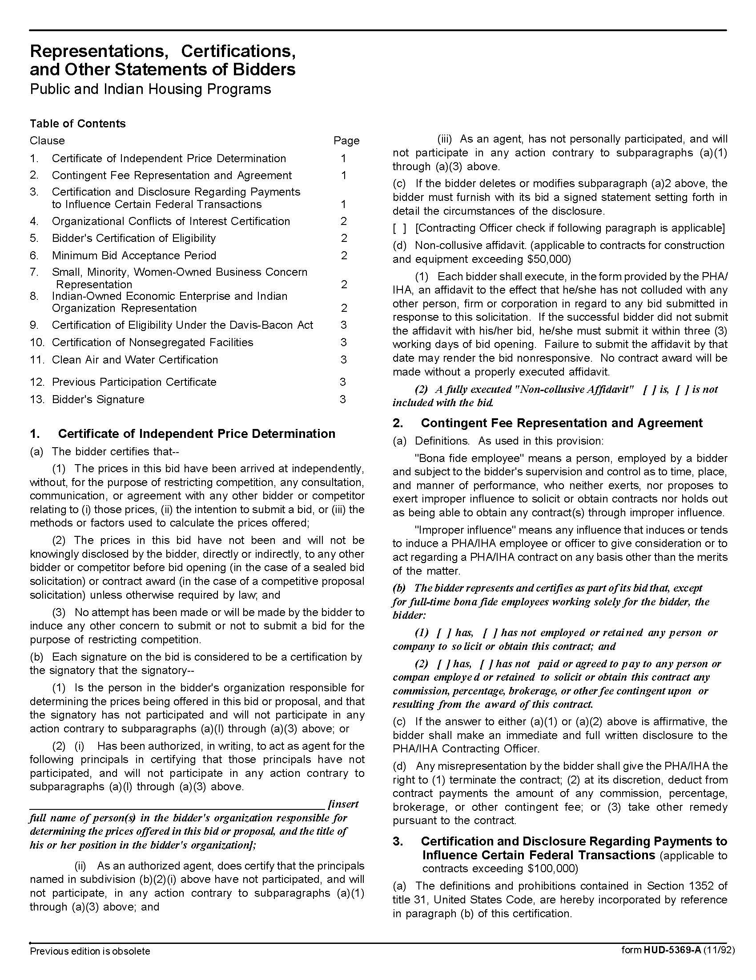

Appliance Parts Q1811
Solicitation Document C HUD Form 5369A - Continued
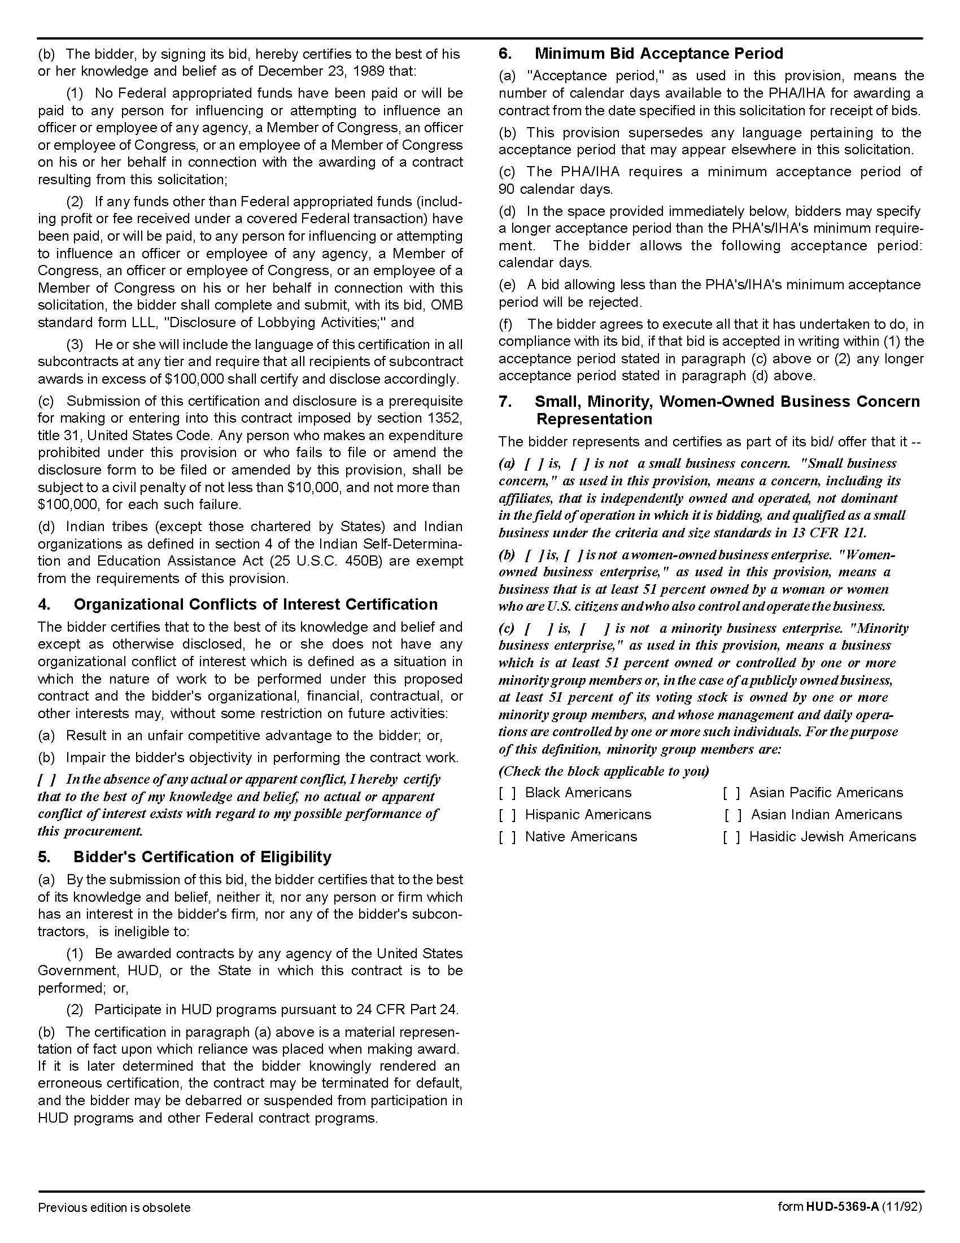

Appliance Parts Q1811
Solicitation Document C HUD Form 5369A - Continued

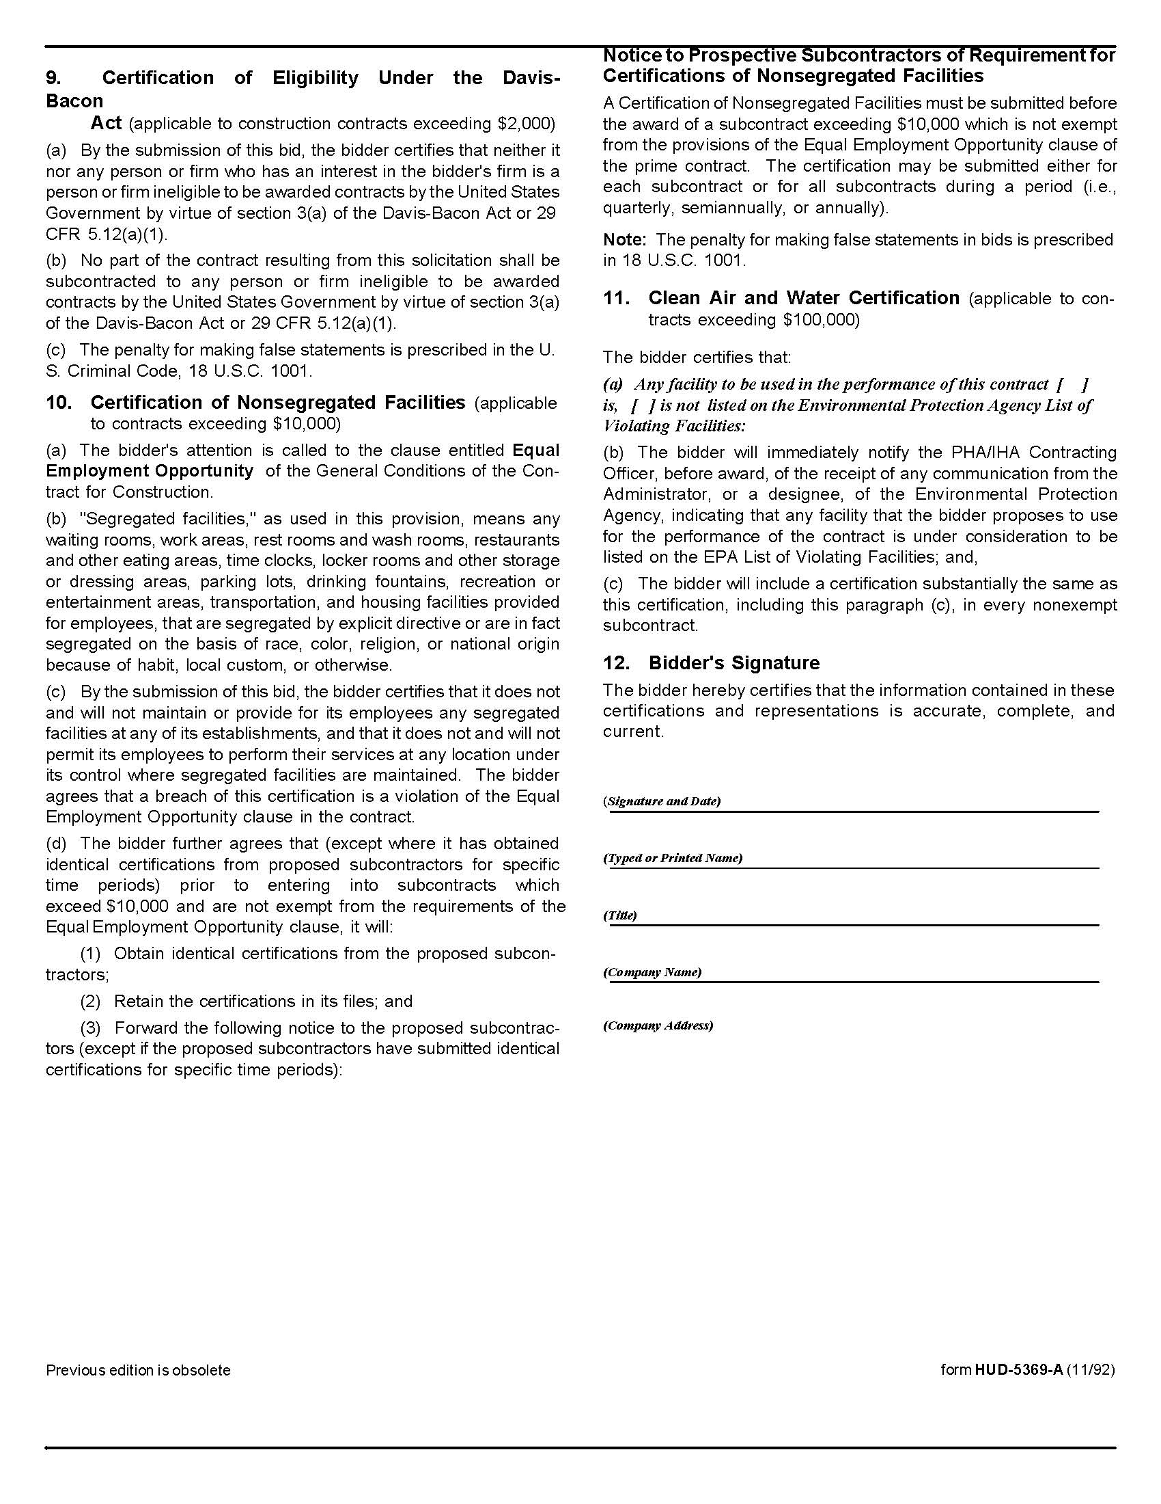

Appliance Parts Q1811
Solicitation Document D Pricing Form

Part I Discount Percentage:
The following percentage discount(s) will be applied to all KCDC purchases other than those itemized in Part II below.

Manufacturer | % Discount | Discount Base
Brown Stove Works | %
General Electric | %
Hotpoint | %
Kenmore | %
LG | %
Maytag
Whirlpool | %
Discount on additional products/services  Description: | %
Discount on additional products/services  Description: | %
Discount on additional products/services  Description: | %

Appliance Parts Q1811
Solicitation Document D Pricing Form - Continued

Part II Specific Items:
These prices will be applied to all KCDC purchases for these items during the first twelve months of the award. After that time period, the supplier may request an increase as detailed earlier.

*Indicates probably usage but is not a guarantee that KCDC will purchase this quantity.

Item | Brand/Model | Number Bought in Previous Year* | Unit of Measure | Cost
Bowl Ring Drip Pan  6 inch | Whirlpool FSPW10196406RW | 520 | Each | $
Bowl Ring Drip Pan  8 inch | Whirlpool FSPW10196405RW | 260 | Each | $
Door Gasket RANGES | Universal | 50 | Each | $
Element | CL SP12MA | Small 75 | Each | $
Element | CL SP21MA | Large 125 | Each | $

