Request for Proposals

Coin Operated Laundry Services

Due Date: By 11:00 a.m. (Eastern Standard Time) on October 2, 2015

Check KCDC’s webpage for addenda and changes before submitting your proposal.

Proposal Number: Q1611

Deliver Proposals to: Knoxville's Community Development Corporation
Purchasing Division (building behind the main office building)
901 Broadway N.E.
Knoxville, Tennessee 37917

Faxed/Emailed Responses are acceptable: Yes ☒ No ☐

Pre-Proposal Conference: None-submit questions via email.

Award Results: KCDC posts the award decision to its webpage at:
http://www.kcdc.org/en/DoingBusiness/SolicitationResults.aspx

Electronic Copies: Vendors are encouraged to use the MS Word version of this
document. If you need an electronic copy, send an email
requesting it to purchasing@kcdc.org.

General Information for Vendors

1. BACKGROUND AND INTENT

a. Knoxville's Community Development Corporation (KCDC) is the public housing and redevelopment agency for the City of Knoxville and for the County of Knox in Tennessee. KCDC’s public housing property portfolio includes seventeen housing properties with approximately 3,551 dwelling units. KCDC also administers approximately 3,700 vouchers through our Section 8 department and has three tax credit properties. KCDC employs approximately 150 persons to carry out these functions.

KCDC was created under Tennessee State enabling statutes in 1936. The primary source of funding for the operation of the various programs comes from the U.S. Department of Housing and Urban Development through an Annual Contributions Contract. Additional funding comes from grants, both local and federal, and in the collection of rent and related charges.

b. The intent of this Request for Proposal (RFP) is to obtain fixed price proposals from vendors to provide Coin Operated Laundry Equipment for five of KCDC’s locations on an as-needed basis. KCDC reserves the right to add additional sites or to delete specified sites as KCDC’s need change.

c. KCDC’s award to MacGray has nearly reached the end of its five-year maximum and thus the services must be resolicited.

2. ACCEPTANCE
A submission in response to this RFP will constitute acceptance of the terms and conditions of the RFP.

3. AUTHORIZED KCDC CONTACTS

a. KCDC authorizes the following persons to request new placements/services from the selected vendor(s).

Procurement Director Terry McKee 403-1133 tmckee@kcdc.org

b. KCDC authorizes the site managers to request maintenance and repair services from the selected vendor(s). However typically residents will call the vendor’s number (posted on or around the laundry equipment) to report issues.

4. CHANGES AFTER AWARD
It is possible that after award KCDC may need to revise the service needs or requirements specified in this document. KCDC reserves the right to make such changes after consultation with the vendor. Should additional costs arise, KCDC reserves the right to accept these charges provided the vendor can document the increased costs.

5. CONTACT PERSONNEL
A good working relationship must develop between KCDC and the successful vendor. The vendor will provide a contact(s) to handle billing inquiries and service related issues. In the event the usual contact is unavailable, the vendor will notify Human Resources of the change.

6. CONTACT POLICY
The vendor may not contact anyone other than the KCDC’s Purchasing Division from the issuance of this solicitation until award regarding this solicitation. Information obtained from an unauthorized officer, agent, or employee of KCDC will not affect the risks or obligations assumed by the vendor or relieve the vendor from fulfilling any of the conditions of the resulting award for the purpose of this project. Additionally, such contact can disqualify the vendor from participation in the solicitation process.

7. CONTRACT

a. KCDC will not sign vendor contracts but will supply its own contract -in accordance with HUD guidelines.

b. The length of the resulting award/contract will be for sixty months. However, KCDC can opt out of the award for cause with 60-day notice provided that KCDC has informed the vendor of the issues and that the problems are not alleviated.

8. EVALUATION:
KCDC will determine the responsiveness and responsibility of each proposal. Once responsiveness and responsibility are determined, KCDC will evaluate the remaining responses on these criteria:

Factors | Maximum Points
Revenue to KCDC  Funds offered to KCDC | 45
Equipment  The suitability and ease of use of the proposed equipment  Energy efficiency of the proposed equipment | 25
Qualifications  Evidence of the proposer’s abilities to provide the service | 25
References  Similar references | 5
Total Points Possible | 100

a. If oral presentations are required, the Procurement Director will arrange structured oral presentations by each vendor on the shortlist.

b. After completion of interviews and negotiations, the evaluation team will recommend an award to the Procurement Director.

c. KCDC will consider as “non-responsive” any proposal from which required information is lacking or any proposal that represents a material deviation from this RFP.

d. KCDC reserves the right to request additional information from any vendor after the submission deadline. KCDC also reserves the right to reject any and all, or part(s) of any and all proposals, to select one or more vendors, or to award no award and re-advertise this RFP; postpone or cancel the RFP process at any time, and to waive any irregularities in this RFP or in proposals received as a result of this RFP.

e. All materials submitted pursuant to this RFP become KCDC’s property. KCDC does not release information about proposals until the process is complete and a recommendation is ready for the KCDC Board. Members of the evaluation team will not release information to anyone except the Procurement Director.

f. KCDC reserves the right to use all pertinent information whether disclosed in the RFP process or learned from sources that affect KCDC’s judgment as to the appropriateness of an award to the best-evaluated vendor.

9. GENERAL INSTRUCTIONS
KCDC no longer inserts “General Instructions to Vendors” in the solicitation document. Instead, these instructions are at www.kcdc.org. Click on “Doing Business With KCDC” where you will find a link to the instructions. By submitting a response to this solicitation, the vendor accepts the responsibility for downloading, reading and abiding by the terms and conditions set forth in KCDC’s “General Instructions to Vendors.” Vendors may wish to review certain applicable HUD instructions on KCDC’s webpage.

10. INSURANCE
Upon award, Certificates of Insurance must be provided to KCDC indicating that the vendor carries at least the following minimum levels of insurance. Vendor will at its sole expense obtain and maintain in full force and effect for the duration of the resulting award and any extension hereof at least the following types and amounts of insurance for claims which may arise from or in connection with this resulting award. All insurance must be underwritten by insurers with an A.M. Best rating of A-: VI or better.

The contractor will maintain, at contractor’s sole expense, on a primary and non-contributory basis, at all times during the life of the award insurance coverages, limits, and endorsements described herein. All insurance must be underwritten by insurers with an A.M. Best rating of A-: VI or better. Upon award, the contractor will provide Certificate(s) of Insurance to KCDC evidencing said insurance coverages.

The contractor agrees the insurance requirements herein as well as KCDC’s review or acknowledgement, is not intended to and will not in any manner limit or qualify the liabilities and obligations assumed by the contractor under this award

a. Commercial General Liability Insurance: occurrence version commercial general liability insurance with a limit of not less than $1,000,000 each occurrence for bodily injury, personal injury, property damage, and products and completed operations. If such insurance contains a general aggregate limit, it will apply separately to the work/location in this award or be no less than $2,000,000.

Such insurance will contain or be endorsed to contain a provision that includes KCDC, its officials, officers, employees, and volunteers as additional insureds with respect to liability arising out of work or operations performed by or on behalf of the contractor including materials, parts, or equipment furnished in connection with such work or operations. The coverage will contain no special limitations on the scope of its protection afforded to the above-listed insureds.

The Additional Insured will read “Knoxville’s Community Development Corporation (KCDC)”.

If necessary, umbrella/excess liability insurance can be used in conjunction with the general liability insurance to meet these requirements. Unless the umbrella/excess liability insurance provides coverage on a pure/true follow-form basis, or KCDC is automatically defined as an additional insured, the contractor will add by endorsement, KCDC, its officials, officers, employees, and volunteers as an additional insured.

b. Automobile Liability Insurance: including vehicles owned, hired, and non-owned, with a combined single limit of not less than $1,000,000 each occurrence. Such insurance will include coverage for loading and unloading hazards.

c. Workers’ Compensation Insurance and Employers Liability Insurance: with statutory limits as required by the State of Tennessee or other applicable laws.

d. Other Insurance Requirements: Contractor will:
- Upon award, furnish KCDC with original Certificates of Insurance and amendatory endorsements effecting coverage required by this section. Certificates of Insurance will provide a minimum 30-day endeavor to notify KCDC of cancellation when available by contractor’s insurance. If the contractor receives a non-renewal or cancellation notice from an insurance carrier affording the required coverage, or receives notice that coverage no longer complies with the insurance requirements herein, contractor will notify KCDC by email or fax within five (5) business days and provide a copy of the non-renewal for cancellation notice or written specifics as to which coverage is no longer in compliance. The certificate holder address will read:

Knoxville’s Community Development Corporation
Attn: Contracting Officer
901 Broadway, NE
Knoxville, TN 37917

2. Provide certified copies of endorsements and policies if requested by KCDC in lieu of or in addition to Certificates of Insurance.

3. Replace certificates, policies, and endorsements for any such insurance expiring prior to completion of services.

4. Maintain such insurance from the time services commence until services are completed. Failure to maintain or renew coverage or to provide evidence of renewal may be treated by KCDC as a material breach of award.

5. Require all subcontractors to maintain during the term of the resulting award commercial general liability insurance, automobile liability insurance, and workers’ compensation/employers liability insurance (unless subcontractor’s employees are covered by contractor’s insurance) in the same manor and limits as specified for the contractor. Contractor will furnish subcontractor(s)’ Certificates of Insurance to KCDC without expense prior to subcontractor(s) commencing work.

6. Any deductibles and/or self-insured retentions greater than $50,000 must be disclosed to and approved by KCDC prior to the commencement of services. Use of large deductibles and/or self-insured retentions will require proof of financial ability as determined by KCDC.

7. Provide a waiver of subrogation for each required policy herein. When required by the insurer, or should a policy condition not permit contractor to enter into a pre-loss agreement to waive subrogation without an endorsement, the policy should be endorsed with a Waiver of Transfer of Rights of Recovery Against Others, or its equivalent. This waiver of subrogation requirement will not apply to any policy which includes a condition specifically prohibiting such an endorsement, or voids coverage should contractor enter into such an agreement on a pre-loss basis.

8. All policies must be written on an occurrence basis.

11. PRICE STRUCTURE
Vendors are to quote a specific price as described herein.

a. At the end of each award period, the successful vendor may request a price increase. Proof of increased cost to the successful vendor must accompany price increase requests. KCDC may, at its option:

1. Accept the proposed price increase; or
2. Reject the proposed price increase; or
3. Suggest an alternative price increase.

b. If KCDC rejects a proposed price the successful vendor may:

1. Continue with the existing pricing.
2. Suggest an alternative price increase.
3. End the award.

c. The vendor may decrease prices at any time with or without notice.
12. QUESTIONS
Direct questions pertaining to this document to purchasinginfo@KCDC.org with “Questions about Coin Operated Laundry Services” in the subject line, at least five days prior to the due date to.

Scope of Work

1. INTRODUCTION AND OBJECTIVES
KCDC's main interest is to provide quality machines and service to KCDC tenants. The machines must be easy to use, reliable and energy efficient. The successful proposer will be responsible for obtaining, installing, maintaining and repairing the machines. The machines may be coin and/or debit/credit operated.

2. CHARGES
KCDC wants the proposer to recommend a cost per load for both washing machines and dryers.

a. KCDC does not anticipate increasing cost to users during the period of the contract but reserves that right upon a written request from the successful proposer. The vendor shall not increase prices for washing and drying from initial set prices without KCDC's approval.

b. The vendor will collect all monies from machines on a regular basis. This is important for security and so that the machine will continue to operate.

c. The vendor is responsible for the settlement of any claims and reimbursements to users for non-performance of equipment.

3. COMMUNICATION
For its convenience, KCDC often communicates via email. Accordingly, the successful proposer will routinely use email. Additionally many KCDC staff members using “Texting” to communicate and the vendor needs to be proficient in this communication tool. Finally some KCDC staff members use the telephone frequently and the vendor must be able to effectively communicate that way also.

4. EQUIPMENT

a. Used equipment is not acceptable.

b. There will be a maximum of 48 hours to convert equipment at each building. Installations may be scheduled back to back at the various sites. KCDC will require a two-week notice prior to the installation. Mutual agreement between KCDC and the vendor(s) will be made prior to the exchange of machines.
c. All cost for installation (includes any water hoses or dryer ventilation required in addition to what KCDC currently has to make their equipment operable) will be borne by the proposer.

d. The successful proposer will maintain equipment in a good working order and keep the equipment clean.
e. The successful proposer will have any machine repaired or a replacement machine installed of equal quality (model, year, capabilities) within two business days from the time a machine is reported out of order by KCDC.

f. Any damage to machines by users or by vandalism shall not constitute reason for claim from KCDC. KCDC is to be held harmless from any and all claims that may arise from the vendor’s equipment being located on KCDC property.

g. Operating instructions for equipment shall be maintained at each site.

h. While KCDC is very interested in equipment with high-energy efficiency, there is also a concern about front loading washing machines. These issues include doors getting stuck, water leaks and water not draining properly. Accordingly, in the vendor’s response, address the high-energy efficient issues while balancing practical issues too. Some sites may want one top loading washing machine while using front loading machines for the balance of their machines.

5. KCDC RESPONSIBILITIES

a. KCDC will provide space for laundry equipment and maintain the common floor area, chairs and tables used by KCDC tenants.

b. KCDC will provide space for the vendor’s equipment for the purpose of serving KCDC tenants. KCDC will not seek non-KCDC tenants for customers and will try to prohibit non-tenants from using vendors’ equipment by providing KCDC tenants keys to both entrance to the building and the laundry room.

c. KCDC will provide and pay for all utilities used by vendor’s equipment.

6. LOCATIONS
Currently KCDC has need for coin operated laundry services at:

Site | Address | Apartments | Washers | Dryers
Autumn Landing Apartments | 6331 Pleasant Ridge Road | 95 | 4 | 5
Cagle Terrace Building A | 515 Renford Drive | 272 | 4 | 4
Cagle Terrace Building B | 515 Renford Drive | 272 | 4 | 4
Isabella Towers | 1515 Isabella Circle | 231 | 5 | 5
Love Towers Building A | 1161 & 1171 Armstrong Avenue | 248 | 4 | 5
Love Towers Building B | 1161 & 1171 Armstrong Avenue | 248 | 5 | 5
Nature’s Cove Apartments | 2639 Bakertown Road | 102 | 6 | 5
Northgate Terrace | 4301 Whittle Springs Road | 276 | 6 | 6
Valley Oaks | 3504 Oak Branch Circle | 48
 |  | 1,272 | 38 | 39

7. REVENUE

a. KCDC reports the following earnings shown below from the laundry machines.

b. While the amounts shown below are indicative of earnings, KCDC makes no guarantee as to future earnings.

c. Revenue report:

 | Autumn Landing | Cagle  Terrace | Isabella Tower | Love Towers | Natures Cove | Northgate Terrace | Valley Oaks
Total 2011 | $3,406 | $20,766 | $10,573 | $24,037 | $5,142 | $19,927 | $7,097
Total 2012 | $6,662 | $22,716 | $12,221 | $23,702 | $8,759 | $20,294 | $5,460
Total 2013 | $5,065 | $19,907 | $12,118 | $20,569 | $8,929 | $18,478 | $4,175
Total 2014 | $4,601 | $21,985 | $10,362 | $17,319 | $10,384 | $15,601 | $3,954
Total 2015 YTD | $4,161 | $10,494 | $6,501 | $13,943 | $7,266 | $9,786 | $2,919

8. SITE VISITS
Proposers are urged to visit all of the sites to view the current configurations of the machines. The failure of the proposer to do so will not relieve the proposer of such responsibility. Coordinate the site visits with the persons shown below.

Site | Contact | Phone | Email
Autumn Landing | James Pruitt | 403-1422 | jpruitt@kcdc.org
Cagle Terrace | Darlene Thomson | 403-1310 | dthomson@kcdc.org
Isabella Towers | Rhonda Harris | 403-1340 | rharris@kcdc.org
Love Towers | Steve Ellis | 403-1360 | sellis@kcdc.org
Natures Cove | James Pruitt | 403-1422 | jpruitt@kcdc.org
Northgate Terrace | Terri Evans | 403-1400 | tevans@kcdc.org
Valley Oaks | Darrell Lindsey | 403-1320 | dlindsey@kcdc.org

Proposal Structure Information

Follow these steps and guidelines when preparing your proposal.

1. Submit your proposal in the order/format shown on the following pages. Solicitation Document A is to be the first page of your proposal, followed by Solicitation Document B and so on.

2. Place your company’s name on each page.

3. Number all pages consecutively. Indicate on all pages the section that you are responding to as shown on the following pages.

4. Be thorough yet succinct in responding to this document. The use of tables in presenting information, where appropriate, will facilitate the evaluation team’s review.

5. Submit one original (with all pages marked “original”) or one electronic copy (email or CD) of your submittal.

6. Fancy brochures and advertisements are not necessary.

7. Do not use phrases such as “See the attached” or “Will be provided upon award.”

8. If you have attachments, mark them (on the cover) with the vendor’s name.

9. Bind written proposals simply since KCDC ultimately scans documents into electronic format. Acceptable binding methods include paper clips, staples and three ring binders.

10. This document is available in MS WORD format and vendors are encouraged to use the Word version for their responses. KCDC’s Adobe copy of the document will remain the “official” version of the document. Only the Adobe version has all of the required forms.

This and the previous pages do not need to be returned

Coin Operated Laundry Services Q1611

Solicitation Document A General Response Section

General Information about the Vendor
Sign Your Name to the Right of the Arrow
Your signature indicates that you have read and agree to “KCDC’s General Instructions to Vendors” on www.kcdc.org.
Printed Name and Title
Company Name
Street Address
City/State/Zip
Contact Person (Please Print Clearly)
Telephone Number
Fax Number
Cell Number
Vendor’s e-mail address (Please Print Clearly)
Addenda
Addenda are at www.kcdc.org. Click on “Doing Business With KCDC” and then on “Open Solicitations” to find addenda. Please check for addenda prior to submitting a proposal.
Acknowledge addenda have been issued by checking below as appropriate:
None ☐ | Addendum 1 ☐ |  |  | Addendum 2 ☐ |  |  | Addendum 3 ☐ |  |  | Addendum 4 ☐ |  |  |  | Addendum 5 ☐
Statistical Information
This business is owned & operated by persons at least 51% of the following ethnic background:
Asian/Pacific ☐ |  | Black ☐ | Hasidic Jew ☐ |  |  | Hispanic ☐ |  |  | Native ☐ Americans |  |  |  | White ☐
As defined on KCDC’s webpage (see the “General Instructions to Vendors”), this business qualifies
as being:
Section 3 ☐ |  |  |  |  | Small Business ☐ |  |  |  |  |  | Woman Owned ☐
Cooperative Purchasing by Other Governmental Entities
Will you extend your pricing and terms to other governments (plus any additional charges for shipping) if they desire to use the award? |  |  |  |  |  |  |  |  |  |  |  | Yes ☐ No ☐

Coin Operated Laundry Services Q1611

Solicitation Document B Affidavits

1. Vendor fully understands the preparation and contents of the attached offer and of all pertinent circumstances respecting such offer;
2. Such offer is genuine and is not a collusive or sham offer;
3. Neither the said vendor nor any of its officers, partners, owners, agents, representatives, employees
or parties interest, including this affiant, has in any way colluded conspired, connived or agreed, directly or indirectly, with any other responder, firm, or person to submit a collusive or sham offer in connection with the award or agreement for which the attached offer has been submitted or to refrain from making an offer in connection with such award or agreement, or collusion or communication or conference with any other firm, or, to fix any overhead, profit, or cost element of the offer price or the offer price of any other firm, or to secure through any collusion, conspiracy, connivance, or unlawful agreement any advantage against KCDC or any person interested in the proposed award or agreement; and
4. The price or prices quoted in the attached offer are fair, proper and not tainted by any collusion, conspiracy, connivance, or unlawful agreement on the part of the firm or any of its agents, representatives, owners, employees, or parties in interest, including this affiant.
5. The vendor is not ineligible for employment on public contracts because of a conviction or guilty plea or a plea of nolo contender to violations of the Sherman Anti-Trust Act, mail fraud or state criminal violations with an award let by the State of Tennessee or any political subdivision thereof.
6. No commissioner or officer of KCDC or other person whose duty it is to vote for, let out, overlook or in any manner superintend any of the work for KCDC has a direct interest in the responder.
7. No employee, officer or agent of the grantee or subgrantee will participate in selection, or in the award or administration of an award supported by Federal funds if a conflict of interest, real or apparent, would be involved. Such a conflict would arise when the employee, officer or agent, any member of his immediate family, his or her partner, or an organization, which employs, or is about to employ, any of the above, has a financial or other interest in the firm selected for award.
8. The grantee's or sub-grantee's officers, employees or agents will neither solicit nor accept gratuities, favors or anything of monetary value from vendors, potential vendors, or parties to sub-agreements.
9. By submission of this form, the vendor is certifying that no conflicts of interest exist.

The undersigned hereby acknowledges receipt of the above applicable laws and verifies that the proposal submitted in response to this solicitation is in full compliance with the listed requirements.

Signed by
Printed Name
Title
Subscribed and sworn to before me this date

By (Notary Public)
My Commission Expires on

Coin Operated Laundry Services Q1611

Solicitation Document C HUD Form 5369C

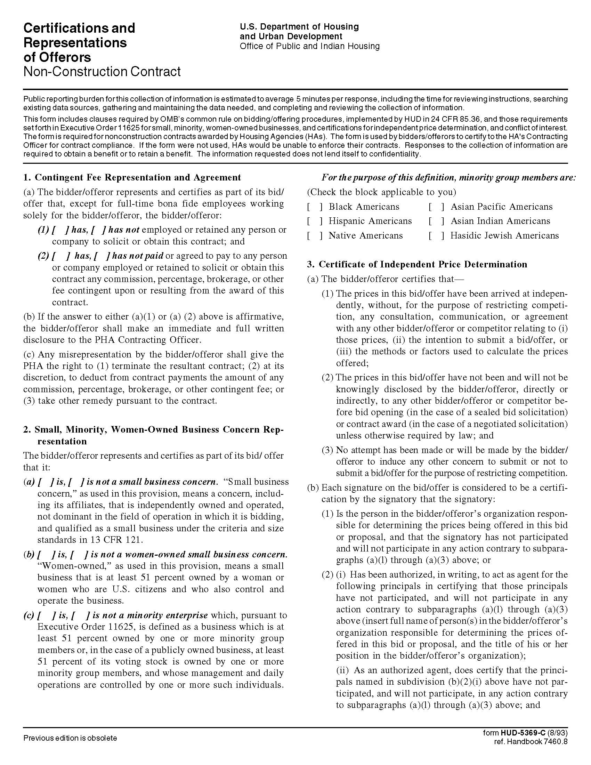

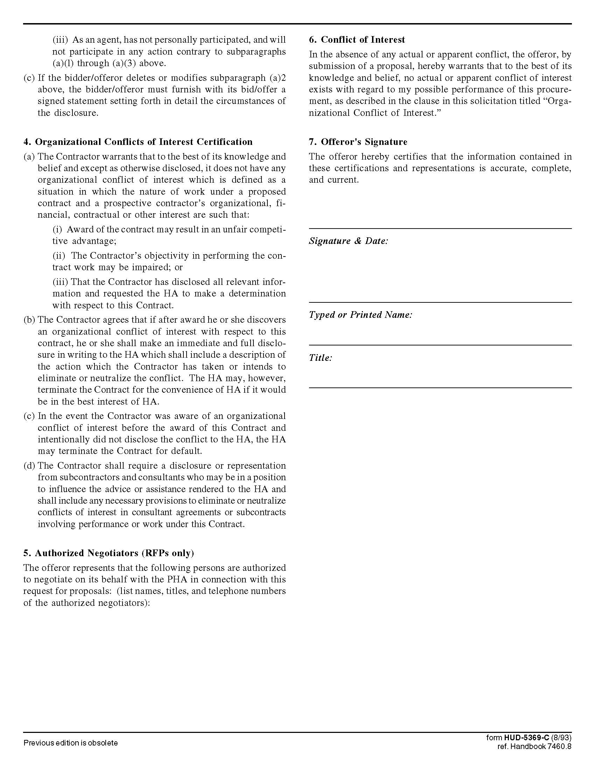

Coin Operated Laundry Services Q1611

Solicitation Document D Equipment Proposed

Vendor: _____________________________________________________________________________

Detail the proposed equipment (washers and dryers).

a. Brand

b. Model

c. Features

d. Physical Size

e. Load size

f. Energy consumption

g. Energy Star Status

h. Handicap access

i. Specify that new equipment will be installed

j. Number of units recommended for each site

k. Concerning repairs:

1. Specify who KCDC and/or residents contact for repairs (include their contact points)
2. Specify a guaranteed response timeline for repairs

l. Technical and/or marketing sheets for the equipment

m. Address high-energy efficiency issues and reported customer issues with front loading washing machines.

n. Address equipment replacement policies and plans.

(Please use additional sheets as necessary)

Coin Operated Laundry Services Q1611

Solicitation Document E Vendor Qualifications

Vendor: _____________________________________________________________________________

a. Provide a brief narrative history of the organization submitting the proposal.

b. Organization Size

c. Organizational structure

d. Financial stability (provide your latest audited annual financial report)

e. Mergers and/or acquisitions within the last five years

f. Legal status (corporation or partnership, et cetera)

g. Number of machines now in service in the Knoxville area

h. Number of accounts in the Knoxville area and under your organization as a whole

i. The number of times you check on and services machine in a given period of time (One of KCDC's objectives is minimize the laundry room being a target to theft)

j. Identify the individual(s) in your firm who will be KCDC’s contact persons

Give a brief (one paragraph maximum) chronology of their career and experience

k. Describe any unique approaches or techniques developed and used by the firm that would give it an advantage in this specific type of project

Coin Operated Laundry Services Q1611

Solicitation Document F References

1. Provide client references as similar as possible to this work. KCDC prefers references from “affordable housing” companies but will accept other references at its discretion.

2. A vendor may only list a company once even if you have done multiple jobs for them.

3. KCDC reserves the right to contact and interview the listed references via phone calls and/or other electronic survey means.

4. Provide three references in the following format.

Name of the business that was serviced
Name of the apartment complex serviced
Number of apartments
Number of washers and dryers installed
Contact person
Contact person title
Contact person’s telephone number
Contact person’s email address
Award began
Award ended

Coin Operated Laundry Services Q1611

Solicitation Document G Revenue

Detail the revenue sharing plan by indicating:

a. Percentage going to KCDC.

b. Any deductions from “revenue.”

c. Any and all costs to KCDC.

d. Any “bonus” money going to KCDC for signing with your company.

e. Cost per load for washers and cost per load for dryers.

f. The run time for a drying cycle.

