BOARD OF COMMISSIONERS
Meetings Second Tuesday

MARTIN H. MOSELEY, JR.
Chairman

ROY LEWIS
Vice-Chairman SHANITA D. BRYANT BETTY C. HILL WADE YODER
MICHAELA JONES
County Administrator

APRIL H. HODGES
Assistant County Administrator/ County Clerk
Peach County
213 Persons Street
Fort Valley, Georgia 31030 Phone 478-825-2535
Fax 478-825-2678

COUNTY OFFICIALS
KIM WILSON
Probate Judge

JOE WILDER
Clerk of Superior Court

TERRY DEESE
Sheriff

W. L. BROWN
Tax Commissioner

KERRY ROOKS
Coroner

LAURENS C. LEE
Magistrate

REQUEST FOR BIDS

RFB No. 22-006
Restore and Resurface Tennis Courts and Basketball Courts

The Peach County Board of Commissioners will be accepting Sealed Bids pertaining to restoring and resurfacing four (4) Outdoor Tennis Courts, in South Peach Park, Fort Valley, GA and five (5) Tennis Courts in North Peach Park in Byron, GA, to include One (1) Outdoor Tennis Court at each park to be converted into a Pickle Ball Court. Also, to include restoring and resurfacing eight (8) Outdoor Basketball Courts at South Peach Park in Fort Valley, GA and 4 (four) Outdoor Basketball Courts at North Peach Park in Byron, GA. Bidder’s may bid on All the Tennis Courts, All the Basketball Courts or the entire project.
Sealed Bids must Specify (A) TENNIS COURTS ONLY
(B) BASKETBALL COURTS ONLY
(C) TENNIS AND BASKETBALL COURTS

Closing date for Sealed Bids responding to Request for Bid (RFB) No. 22-006 shall be June 30, 2022 @ 2:00 p.m. Bids will be opened in public without discussion on June 30, 2022 @ 2:00 p.m. at the Peach County Board of Commissioner’s Office, 213 Persons Street, Fort Valley, GA 31030. Bid amounts will not be released until the Board of Commissioners has awarded the project to the winning contractor.

A Pre-bid meeting will be held June 15th@ 10:00 am at the Peach County Board of Commissioner’s Office, 213 Persons Street, Fort Valley, GA 31030. Attendance at the pre-bid meeting is not required to submit a bid, but is highly recommended.

The complete RFB package will be available by contacting, Stacy Sanders at (478) 825-2535,
stacy-sanders@peachcounty.net, or by visiting www.peachcounty.net.

Peach County reserves the right to reject all bids, to waive informalities, to re-advertise and/or to award any bid that is in the best interest of Peach County.

Mail or deliver Sealed Bids to:
Stacy Sanders
Peach County Board of Commissioners ATTN: RFB # 22-006
213 Persons Street Fort Valley, GA 31030

SECTION 00 01 02 PROJECT DIRECTORY

PROJECT:
Restore and Resurface Tennis Courts and Basketball Courts

South Peach Park, 200 Murray Rd. Extension,

Fort Valley, GA 31030
North Peach Park, 461 West White Rd., Byron, GA 31030

COUNTY:
Peach County Georgia 213 Persons Street Fort Valley, GA 31030

RFB No. 22-006

END OF SECTION

SECTION 00 01 03 TABLE OF CONTENTS

- 00 00 BID AND CONTRACTING REQUIREMENTS
SECTION 00 01 01 PROJECT ADVERTISEMENT
SECTION 00 01 02 PROJECT DIRECTORY
SECTION 00 01 03 TABLE OF CONTENTS
SECTION 00 02 01 INSTRUCTIONS TO BIDDERS
SECTION 00 02 03 PRE-BID MEETING
SECTION 00 03 01 BID FORMS
SECTION 00 04 01 REQUIRED VENDOR DOCUMENTATION AND CERTIFICATIONS
(Forms A through P)

- 00 00 GENERAL REQUIREMENTS
SECTION 01 01 00 GENERAL CONDITIONS
SECTION 01 02 00 SUPPLEMENTARY CONDITIONS
SECTION 01 03 00 SUMMARY OF WORK
SECTION 01 04 00 UNIT PRICES

- 00 00 GENERAL REQUIREMENTS
SECTION 02 01 00 TECHNICAL SPECIFICATIONS

PROJECT EXHIBITS

EXHIBIT 1
DRAFT CONTRACT AGREEMENT

EXHIBIT 2
DRAFT CONTRACT GENERAL CONDITIONS

EXHIBIT 3
SOUTH PEACH PARK LOCATION MAP

EXHIBIT 4
SOUTH PEACH PARK COURT MAP

EXHIBIT 5
NORTH PEACH PARK LOCATION MAP

EXHIBIT 5
NORTH PEACH PARK COURT MAP

END OF SECTION

SECTION 00 02 01 INSTRUCTIONS TO BIDDERS

Failure to submit all required data items identified within this section or submitting inaccurate information in your response may be cause for rejection as a Non-Responsive Bid. A Responsive Bid is a bid or proposal that conforms in all material respects to the requirements set forth in the invitation for bids.

INTENT
Peach County has an immediate need to hire a professional Contractor that can Restore and Resurface nine tennis courts and/or six basketball courts. One (1) of the Five (5) Tennis Court at North Peach Park will be modified into a Pickleball Court and one (1) of the Four (4) Tennis Court at South Peach Park will be modified in a Pickleball Court with new separation fence. It is the intent of this solicitation to engage qualified and experienced Contractor(s) that can provide tennis court and basketball court restoration and resurfacing at South Peach Park and North Peach Park in Peach County, Georgia. The Peach County Board of Commissioners intends to award a contract to one or more qualified companies that have extensive experience in this field. Peach County strongly encourages creative approaches.

SCOPE OF WORK
    - South Peach Park
      - Tennis Courts 4 Courts (4): Demolition, Extend Existing Net Post Sleeves, Clean and Prepare Surface, Fill Cracks, Install Tack Coat/Primer, Install Reinforcement Mat, Install New Hot Mix Asphalt Paving, Apply New Acrylic Surface, Eliminate Court Depressions, Apply New Acrylic Color Playing Surface, Paint New lines, Adjust Chain Link Fence and Gates and Reinstall, Paint Existing Net Posts and Reinstall. New Lining for Tennis Courts shall be to USTA court specifications and Pickleball Court modified to fit 3 (three) courts with post and nets installed. Bidder to supply new posts and nets and separation fence for the Pickleball Court. Bidder to supply and install new 6’ separation fence/barrier between courts #3 & #4.
      - Basketball Courts: Demolition, Extend Post Sleeves, Clean and Prepare Surface, Fill Cracks, Install Tack Coat/Primer, Install Reinforcement Mat, Install New Hot Mix Asphalt Paving, Paint Lines matching existing layouts, Paint Existing Basket Posts and Reinstall.

North Peach Park
      - Tennis Courts: Clean and Prepare Surface, Fill Cracks, Repair Cracks, Eliminate Court Depressions, Apply New Acrylic Surface, Apply New Acrylic Color Playing Surface, Paint New lines. New Lining for Tennis Courts shall be to USTA court specifications and Pickleball Court modified to fit 3 (three) courts with post and nets installed. Bidder to supply new posts and nets for the Pickleball Court and Paint Existing Net Posts and Reinstall.
      - Basketball Courts: Demolition, Extend Post Sleeves, Prepare Surface, Fill Cracks, Install Tack Coat/Primer, Install Reinforcement Mat, Install New Hot Mix Asphalt Paving, Paint Lines matching existing layouts, Paint Existing Basket Posts and Reinstall.

GENERAL INSTRUCTIONS
    - Defined Terms: Terms used in these Instructions to Bidders are defined as follows:
- Addenda – Written or graphic instruments issued prior to the opening of Bids which clarify, correct, respond to questions, or change the bidding requirements in the proposed contract documents
- Bid – The offer or proposal of a bidder submitted to the prescribed form setting forth the prices for the Work to be performed.
- Bidder - one who submits a bid directly to County, as distinct from a sub-bidder, who submits a bid to a Bidder.
- Successful Bidder - the lowest, qualified, responsible and responsive Bidder to whom County (on the basis of County’s evaluation as hereinafter provided) makes an award.
- Bidding Documents – Includes advertisement for bids, bidding requirements, instruction to bidders, proposed contract documents and all addenda.
- Responsible Bidder – A person or entity that has the capability in all respects to perform fully and reliably the contract requirements. This will be determined by the County as a bid proposal that has an aggregate score of 72 or greater as outlined in the evaluation criteria in the instructions to bidders.
- Responsive Bidder – A person or entity that has submitted a bid or proposal that conforms in all material respects (all requested information, documents, and certifications) to the requirements set forth in the invitation for bids.

    - Schedule: The Contractor, as a part of the bid, shall prepare and submit an Estimated Progress Schedule for the work. The progress schedule shall be related to the entire project to the extent required by the bid forms, and shall provide for expeditious and practical execution of the work.
    - Contact Information: Bids shall clearly indicate the legal name, address, e-mail address, and business telephone number of the Contractor (company, firm, partnership, or individual).
    - Please provide the name, title, address, telephone number. E-mail address, and fax number of the individual(s) responsible for responding to this bid.
    - Expenses: All expenses for making this bid to Peach County are to be borne by the Contractor.
    - Examination of Contract Documents and Site: It is the responsibility of each Bidder before submitting a bid, to:
- Examine the Contract Documents thoroughly
- Visit the site to become familiar with local conditions that may affect cost, progress, performance or furnishing of the work
- Consider federal, state and local Laws and Regulations that may affect cost, progress, performance or furnishing of the work.
- Study and carefully correlate Bidder’s observations with the Contract documents and Notify County of all conflicts, errors or discrepancies in the Contract Documents.
    - Project Survey: Before submitting a bid, each Bidder will, at Bidder’s own expense, make or obtain any additional examinations, investigations, explorations, tests and studies and obtain any additional information and data which pertain to the physical conditions (surface, subsurface and Underground Facilities) at or contiguous to the site or otherwise which may affect cost, progress, performance or furnishing of the work and which Bidder deems necessary to determine its bid for performing and furnishing the work in accordance with the time, price and other terms and conditions of the Contract Documents.
    - Temporary Storage: The land upon which the work is to be performed, and other lands designated for use by Contractor in performing the work are identified in the Contract Documents. All additional lands and access thereto required for temporary storage of materials and equipment are to be provided by Contractor.
    - Indemnification: The Contractor must agree to indemnify and to hold the County, its employees, and agents harmless from any and all claims for damages to persons and/or property arising out of or in any way connected with the performance by Contractor of any work, services, or functions contracted for.
    - The submission of a bid will constitute an incontrovertible representation by Bidder that without exception, the bid is premised upon performing and furnishing the work required by the Contract Documents and such means, methods, techniques, sequences or procedures of construction as may be indicated in or required by the Contract Documents, and that the Contract Documents are sufficient in scope and detail to indicate and convey understanding of all terms and conditions for performance and furnishing of the work.
    - Lobbying: All firms and their agents who intend to, or have submitted responses to this solicitation are hereby placed on formal notice that lobbying of Peach County Government employees or members of the Evaluation Committee with the intent to manipulate the Procurement process may result in the immediate disqualification of such firm by the County from further consideration for this project.
    - Qualifications of Bidders: Peach County may make such investigations deemed necessary to determine the ability of the contractor to perform the work and ensure there is no conflict of interest as it relates to the project. The contractor shall furnish to the County any additional information and financial data for this purpose as the County may request. The data may include a detailed and up- to-date list of plant equipment and materials which contractor proposes to use, indicating which portions they already possess and a detailed description of the method and program or work to be done.
    - Bidder Qualification Documentation: If, based on the documentation submitted with the bid, the Bidder does not demonstrate adequate qualifications; the County may disqualify the Bidder. The Bidder shall possess the financial capacity to pay for the expenses associated with this project prior to the initial payment and between subsequent payments, as well as the ability to provide the necessary insurance. The Bidder shall have an experienced management team, an established network of resources to provide the necessary equipment and personnel, to complete the Restoration and Resurfacing of nine tennis courts and six basketball courts. To demonstrate qualifications to perform the work, each Bidder must submit with the bid the following information.
- Financial and Corporate:
  - Documentation of Bankruptcy within last 7 years. If none state so.
  - Verification that the name of firm has not changed in the last five years. If the name of firm has changed in the last five years, provide an explanation. If no name change, please state so.
  - List of construction equipment available for use on the project
  - List of personnel (by position not name) that will be assigned to this project.
  - Certificate(s) of insurance showing that the company has adequate Liability, Auto Liability, and Workers Compensation insurance to meet the requirements of this RFB.
- Safety: Occupational Safety and Health Administration (OSHA) 300 Log for the past 24 months.
- References: Provide a list of at least three (3) current professional references for whom comparable work has been performed. This list shall include company name, person to contact, address, and telephone number
- Experience:
  - Project information from at least three comparable (cost, scope of work) projects over the last five years. Provide scope of work, Contract completion date, Contract amount and County’s name and contact information.
  - Litigation history for the last 7 years. If none, so state.
  - County’s name and contact information
  - Detailed description and plan of operation that indicates the planned operations and proposed timetable to complete all project requirements.
  - Qualifications of project manager, superintendent, and subcontractors who will be involved with the project.
  - List of Subcontractors. If none, so state.
    - Suspension or Debarment: The Bidder nor its principals must not be presently debarred, suspended, proposed for disbarment, declared ineligible, or voluntarily excluded from participation in this transaction by any Federal or state of Georgia department or agency. Prime Contractors or Subcontractors that have been debarred or suspended will be disqualified.
    - Rejection of Response: The Peach County BOC in its absolute discretion, may reject any response of a bidder that has failed, in the opinion of the Board, to complete or perform a Peach County contracted project in a timely fashion or has failed in any other way, in the opinion of the Board, to perform a prior contract in a satisfactory manner, and has directed the Peach County Purchasing Manager to emphasize this condition to potential bidders.
    - Subcontractors and Suppliers Qualifications: County may consider the qualifications and experience of subcontractors, suppliers, and other persons and organizations proposed for those
portions of the work as to which the identity of subcontractors, suppliers, and other persons and organizations must be submitted as provided in the invitation for bids. County also may consider the operating costs, maintenance requirements, performance data and guarantees of major items of materials and equipment proposed for incorporation in the work when such data is required to be submitted prior to the Notice of Award. County may conduct such investigations as it deems necessary to assist in the evaluation of any bid and to establish the responsibility, qualifications and financial ability of Bidders, proposed Subcontractors, Suppliers and other persons and organizations to perform and furnish the work in accordance with the Contract Documents to County’s satisfaction.
    - Proprietary Information: Careful consideration should be given before submitting confidential information to Peach County. The Georgia Open Records Act permits public scrutiny of most materials collected as part of this process. Please clearly mark any information that is considered a trade secret, as defined by the Georgia Trade Secrets Act of 1990, O.C.G.A. §10-1-760 et seq., as trade secrets are exempt from disclosure under the Open Records Act. Peach County does not guarantee the confidentiality of any information not clearly marked as a trade secret.
    - Liability: The successful Bidder shall act as an independent Contractor and not as an employee of Peach County. The successful Bidder will be required to indemnify, defend, and hold and save harmless Peach County, its officers, agents, and employees, from damages arising from the performance of, or the failure to perform, any Work or duty required to be performed by the successful proposer.
    - Rights of County: Peach County reserves the right to retain all bids submitted and to use any ideas in a bid, regardless of whether that bid is selected. The County reserves the right to accept or reject all or any part of any bid. The County reserves the right to add or delete from the contract after the contract has been awarded.
    - Addendum and Supplement to Request: If it becomes necessary to revise any part of the RFB, or if additional data are necessary to enable an exact interpretation of provisions of the RFB, an addendum will be issued. It is the responsibility of the party submitting the Bid to ensure that they have received all addenda prior to submitting a bid. All addenda must be acknowledged and noted on the bid form. Failure to include addenda may be ample cause for rejection of the bid as non-responsive. Addenda will be published on the Peach County web site www.peachcounty.net.
    - Questions and Inquiries:
- The county will recognize only communications that are in writing and signed. The County shall not be responsible for oral interpretations given by any County employee, representative, or others. The issuance of an addendum is the only official method whereby interpretation, clarification, or additional information can be given.
- Should a Bidder find any discrepancies in the Drawings and Specifications, or should he be in doubt as to their meaning, he/she shall notify the Owner's Representative at once, who will send a written Addendum to all Bidders concerned. Oral instructions or decisions, unless confirmed by Addenda, will not be considered valid, legal or binding.
- Written questions and inquiries will be accepted from any and all contractors or firms planning on submitting a bid. Inquires pertaining to the RFB must give firm or contractor name, RFB number, title, and acceptance date. Material questions will be answered in writing and communicated in an addendum, provided that all questions are received at least five (5) days in advance of the bid acceptance date. All written questions shall be directed to:

Stacy Sanders, Purchasing Manager
213 Persons Street
Fort Valley, GA 31030
stacy-sanders@peachcounty.net

BIDS
    - Bid Forms: All blanks in the Bid Forms must be completed, typed or printed in blue ink. Bids by corporations must be executed in the corporate name by the president or a vice-president (or other corporate officer accompanied by evidence of authority to sign) and the corporate seal must be affixed and attested by the secretary or an assistant secretary. The corporate address and state of incorporation must be shown below the signature. Bids by partnerships must be executed in the partnership name and signed by a partner, whose title must appear under the signature and the official address of the partnership must be shown below the signature. All names must be typed or printed below the signature. The bid shall contain an acknowledgement of receipt of all Addenda (the numbers of which must be filled in on the Bid Form).
    - Submission of Bids: Sealed bids must be received BEFORE be June 30, 2022 @ 2:00 p.m. Bids may be mailed, or hand delivered to Peach County Procurement Department, Attn. Stacy Sanders, 213 Persons Street, Fort Valley, Georgia 31030. Bids shall be submitted and shall be enclosed in
one opaque sealed package or envelope, marked with “RFB No 22-006, Restore and Resurface Tennis Courts and Basketball Courts” and name and address of the Bidder and accompanied by the bid security and other required documents. If the bid is sent through the mail or other delivery system, the sealed package shall be enclosed in a separate package or envelope with the notation “BID ENCLOSED” on the face of it.
    - Bid Copies: One (1) original bid, three (3) copies of your bid, and one (1) complete electronic copy of your bid in Adobe .pdf format on a flash drive must be provided.
    - Binding of Bids: All original and copies of bids shall be permanently bound. Bids submitted using spring loaded clips are not considered permanently bound. Bids not bound in a permanent method or in any way that individual sheets are not connected to adjacent sheets shall be considered non-Responsive and will not be considered for evaluation.
    - Late Bids: Bids received after the closing date and/or time will be returned to party submitting the bid unopened if the RFB number, acceptance date, and Contractor’s return address is shown on the package of envelope.
    - Opening of Bids: Following the opening of the sealed bids, the County will choose the successful bid in accordance with the following procedure: The County will first eliminate from consideration all bids that are not “responsive.” The County will then eliminate any bid to which the County does not assign an aggregate score of at least 72 under the criteria set forth in Paragraph
1.03.8 of the Instructions to Bidders. The County will deem all remaining bids to be responsive and responsible.
    - Bid Active Term: Bids to Remain Subject to Acceptance: All responsive and responsible bids will remain subject to acceptance for sixty (60) days after the day of the bid opening, but County may, in its sole discretion, and in accordance with Instruction to Bidders, release any bid and return the bid security prior to that date.
    - Bid Evaluation Criteria: The evaluation criteria to be used by the County to determine responsible Bidders (and the maximum points that the County may assign to each) in reviewing the sealed bids is as follows:
Factor | Evaluation Weight (Points)
Service Delivery Schedule | 15
Company/Contractor Integrity | 20
Record of Past Performance | 20
Experience with Similar Work | 17
Warranty | 15
Financial Resources | 10
Peach County Business Location | 3
Following the opening of bids, the following procedure will be used to determine the successful bidder:
- The County will first eliminate from consideration all bids that are not “responsive” as such term is defined as “a bid or proposal that conforms in all material respects to the

requirements set forth in the invitation for bids,” and will further eliminate any bid as “not responsible” to which the County does not assign an aggregate score of at least 72 under weighted evaluation factors set forth above.
- The County will deem all remaining bids to be responsive and responsible.
    - Bid Rejection: County reserves the right to reject any and all bids, to waive any and all informalities not involving price, time or changes in the work and to negotiate Contract terms with the Successful Bidder, and the right to disregard all nonconforming, non-responsive, unbalanced or conditional bids. Also, County reserves the right to reject the bid of any Bidder if County believes that it would not be in the best interest of the County, to make an award to that Bidder, whether the bid is not responsive, or the Bidder is unqualified or of doubtful financial ability or fails to meet any other pertinent standard or criteria established by County.
    - County reserves the right to negotiate with the apparent low Bidder including changes in the scope of work if the apparent low bid is greater than the project budget.
    - Mathematical Errors: Discrepancies in the multiplication of units of work and unit prices will be resolved in favor of the correct sum.
    - Dimensions and Elevations: Dimensions and elevations indicated on the drawings in reference to existing structures or utilities are the best available data obtainable but are not guaranteed by the County and the County will not be responsible for their accuracy.
    - Field Verification: Before proposing on any work dependent upon the data involved, the Contractor shall field check and verify all dimensions, grades, lines, levels or other conditions of limitations at the site to avoid construction errors.
    - The County reserves the right to waive any informalities or reject any and all bids, in whole or part, to utilize any applicable state contracts in lieu of or in addition to this bid and to accept the bid that in its judgment will best serve the interest of the County.
    - The Board specifically reserves the right to reject any conditional bid and will normally reject those that made it impossible to determine the true cost of the bid.
    - Bid Protests: Any Bidder or respondent, who is not the awarded Contractor, but is aggrieved in connection with the award of a Contract, may file a Notice of Protest, in writing, with the Board of Commissioners’ Office, within seventy-two (72) hours after Board of Commission approval. Bid protests must be in accordance with the Peach County Procurement Manual. The decision of the County Commission is final.
    - Modification and Withdraw of Bids
- Bids may be modified or withdrawn by an appropriate document duly executed (in the manner that a bid must be executed) and delivered to the place where bids are to be submitted at any time prior to the opening of bids.
- If, within twenty-four hours after bids are opened, any Bidder files a duly signed, written notice with County and promptly thereafter demonstrates to the reasonable satisfaction of County that there was a material and substantial mistake in the preparation of its bid, that Bidder may withdraw its bid and the bid security will be returned. Thereafter, that Bidder will be disqualified from further bidding on the work to be provided under the Contract Documents.

AWARD OF CONTRACTS
    - If the Contract is to be awarded, it will be awarded on the basis of the base bid to the lowest Bidder whose evaluation by County indicates to County that the award will be in the best interest of the County.
    - Notice of Award: If the Contract is to be awarded, County will give the Successful Bidder a written Notice of Award within sixty (60) days after the days of the bid opening.
    - The County reserves the right to award the Contract conditional upon funds being made available for such project.
    - County Obligation to Award: There is no obligation on the part of the County to award the project to the lowest bid price, and the County reserves the right to award the project to a Bidder submitting a bid response with a resulting negotiated agreement which is most advantageous and in

the best interest of Peach County, and to reject any and all bids or to waive any irregularity or technicality in bids received. Peach County shall be the sole judge of the bid and the resulting negotiated agreement that is in its best interest and its decision shall be final.
    - The County reserves the right to utilize any, all, or none of the Contractors that are awarded pursuant to the County’s solicitation for the services contained in this Agreement.
    - Signing the Agreement: When County gives a Notice of Award to the Successful Bidder, it will be accompanied by the required number of unsigned counterparts of the Agreement with all other written Contract Documents attached. Within ten (10) days thereafter Contractor shall sign and deliver the required number of counterparts of the Agreement and attached documents to County with the required Bonds. Within ten (10) days thereafter, County shall deliver one fully signed counterpart to Contractor.
    - Subcontractor Approval: If the General or Supplementary Conditions require the identity of certain Subcontractors, Suppliers, and other persons and organizations (including those who are to furnish the principal items of material and equipment) to be submitted to County in advance of the specified date prior to the Effective Date of the Agreement, the apparent Successful Bidder, and any other Bidder so requested, shall within seven days after the bid opening, submit to County, a list of all such Subcontractors, Suppliers and other persons and organizations proposed for those portions of the work for which such identification is required. Such list shall be accompanied by an experience statement with pertinent information regarding similar projects and other evidence of qualification for each such Subcontractor, Supplier, person or organization if requested by County. If County after due investigation, has reasonable objection to any proposed Subcontractor, Supplier, other person or organization, either may before the Notice of Award is given request the apparent Successful Bidder to submit an acceptable substitute without an increase in bid price. If apparent Successful Bidder declines to make any such substitution, County may award the Contract to the next lowest Bidder that proposes to use acceptable Subcontractors, Suppliers and other persons and organizations. The declining to make requested substitutions will not constitute grounds for sacrificing the bid security of any Bidder. Any Subcontractor, Supplier, other person or organization listed and to whom County does not make written objection prior to the giving of the Notice of Award shall be deemed acceptable to County subject to revocation of such acceptance after the Effective Date of the Agreement. No Contractor shall be required to employ any Subcontractor, Supplier, other person or organization against whom Contractor has reasonable objection.

CERTIFICATIONS AND DOCUMENTATION
    - Non-Segregated Facilities: Bidders must certify that they do not and will not, maintain or provide for their employees any facilities that are segregated on a basis of race, color, creed or national origin. Execution of the “Certification of Non-Segregated Facilities” contained within these documents must be accomplished and submitted with the bid.
    - Equal Opportunity: The County recognizes fair and open competition as a basic tenet of public procurement and encourages participation by minority and women owned business enterprises. All proposers are asked to make an affirmative statement as to its support of all applicable equal opportunity and affirmative action requirements.
    - Certificate of Insurance: Bidder must submit with the Bid response one of more certificate(s) of insurance showing proof that the bidder has the following minimum insurance coverage:
- Minimum General Liability Insurance: $2,000,000 aggregate, $1,000,000 per occurrence
- Minimum Automobile Liability Insurance: $2,000,000 aggregate, $1,000,000 per occurrence
- Minimum Workers Compensation Insurance: $500,000
Bids not containing Certificate(s) of Insurance proving minimum insurance coverage will be considered “non-responsive” and may be rejected from consideration.

    - Required Submittal Documentation: Submit the following completed (Signed, Dated, and Notarized) documents with the bid. Bids not containing the following completed documents will be considered “non-responsive” and may be rejected from consideration.
Form A: Peach County Vendor Information Sheet Form B: W-9 (Taxpayer Identification Number)
Form C: Contractor E-Verify Affidavit under O.C.G.A. 13-10-91(b) (1)
Form D: S.A.V.E. Affidavit Verifying Status for County Public Benefit Application Contracts
Form E: Subcontractor E-Verify Affidavit under O.C.G.A. 13-10-91(b) (1) (Required for ALL Subcontractors working for the Contractor)
Form F: Sole Proprietor Exemption Affidavit Pursuant to O.C.G.A. 36-60-6(d), if applicable (Only if contractor has zero employees)
Form G: Certification by Contractor, Non-Segregated
Form H: Certification by Contractor, Drug-Free Workplace Act Form I: Non-Collusion Affidavit or Prime Contractor
Form J: Conflict of Interest Certification Form K: Indemnity Agreement
Form L: Title VI Civil Rights Act of 1964 Contractor Agreement Form M: Debarred Bidders/Integrity Certification
Form O: Dispute Disclosure Form P: List of Subcontractors

BID SECURITY
    - Each bid must be accompanied by bid security made payable to County in an amount of five percent (5%) of the Bidder’s maximum bid price and in the form of a certified or bank check or a Bid Bond issued by a surety meeting the requirements of Paragraph 5.0 of the Bonds Section of this RFB.
    - The bid security of the Successful Bidder will be retained until such Bidder has executed the Agreement and furnished the required Contract security, whereupon the bid security will be returned. If the Successful Bidder fails to execute and deliver the Agreement and furnish the required Contract security within ten (10) days after the Notice of Award, County may nullify the Notice of Award and the bid security of that Bidder will be forfeited. The bid security of other Bidders whom County believes to have a reasonable chance of receiving the award may be retained by County until the earlier of the seventh (7) day after the Effective Date of the Agreement or the sixtieth (60) day after the bid opening, whereupon bid security furnished by such Bidders will be returned. Bid security with bids which are not competitive will be returned within seven days after the bid opening.

END OF SECTION

PRE-BID MEETING

Pre-Bid Meeting: A pre-bid meeting will be conducted on June 15, 2022 @ 10:00 a.m. at the Peach County Board of Commissioner’s Office, 213 Persons Street, Fort Valley, GA 31030. Attendance at the pre-bid meeting is not required to submit a bid, but is highly recommended.

Anyone wishing to view project sites please contact:

David Parish
Peach County Parks & Recreation Director
(478) 825-3334

END OF SECTION

SECTION 00 03 01 BID FORMS

Bid of (hereinafter called "Contractor"), a company organized and existing under the laws of the State of Georgia, *an individual, a corporation, a partnership doing business as:
Contractor or Firm Name

TO: Peach County (Hereinafter called "County") RFB Number: 22-006
Bids must meet the requirements of the County provide in this RFB for this project, in addition to the requirements of the Technical Specifications, and Project Diagrams.

Project Name: Restore and Resurface Tennis Courts and Basketball Courts

Vendor Name: (Hereinafter called "Contractor) The Contractor, in compliance with your Notice to Contractors and all Bid Documents, elects to submit a bid on the entirety of the following Work:

Base Bid: Having carefully examined the Request for Bid 22-006 entitled “Restore and Resurface Tennis Courts and Basketball Courts” and the Bid Documents, and Addendum (a), as well as the Site and conditions affecting the Work, bidder hereby offers to furnish all services, tools, labor, materials, and equipment called for by them for the entire Work, in accordance with the aforesaid documents, for the sum of:

Dollars
Alphanumeric Price Quote (i.e., Nine Thousand Two Hundred Fifty Dollars)

($ )
Numeric Price Quote (i.e., $9,250.00)

The sum listed on this page is hereinafter called the Base Bid. The Base Bid shall be the amount of the Contract Sum executed between the Owner and the Contractor.

SOUTH PEACH PARK TENNIS COURTS 1-4 SCHEDULE OF UNIT ITEM PRICES

Line No. | Description | Qty | Unit | Unit Price | Bid Total  (Quantity x Unit Price)
1 | Mobilization / Demolition | 1 | LS
2 | Adjust Ex. Post Sleeves, and Paint Ex. Posts | 1 | LS
3 | Surface Preparation | 1,528 | SY
4 | Crack Filling | 2,450 | LF
5 | Tack Coat/Primer | 260 | GL
6 | Reinforcement Mat | 1,528 | SY
7 | Hot Mix Asphalt Paving | 1,528 | SY
8 | Install and Adjust Ex. Chain Link Fence and Gates and install new fencing between #3 & 4 | 546 | LF
9 | Install Acrylic Resurface and Color Playing Surface | 1,528 | SY
10 | Line Painting | 1 | LS

SPP Tennis Courts Price Total = $

SOUTH PEACH PARK BASKETBALL COURTS A-D SCHEDULE OF UNIT ITEM PRICES

Line No. | Description | Qty | Unit | Unit Price | Bid Total  (Quantity x Unit Price)
1 | Mobilization / Demolition | 1 | LS
2 | Adjust Ex. Post Sleeves, and Paint Ex. Posts | 1 | LS
3 | Surface Preparation | 2,960 | SY
4 | Tack Coat/Primer | 505 | GL
5 | Reinforcement Mat | 2,960 | SY
6 | Hot Mix Asphalt Paving | 2,960 | SY
7 | Line Painting | 1 | LS

SPP Basketball Courts Price Total = $

NORTH PEACH PARK TENNIS COURTS 1-5 SCHEDULE OF UNIT ITEM PRICES

Line No. | Description | Qty | Unit | Unit Price | Bid Total  (Quantity x Unit Price)
1 | Mobilization / Demolition | 1 | LS
2 | Adjust Ex. Post Sleeves, and Paint Ex. Posts | 1 | LS
3 | Surface Preparation | 3,775 | SY
4 | Crack Filling | 300 | LF
5 | Crack Repair | 300 | LF
6 | Install and Adjust Ex. Chain Link Fence and Gates | 466 | LF
7 | Install Acrylic Resufacer and Color Playing Surface | 1,528 | SY
8 | Supply and install 3 pickleball court nets and posts (6). | 3/6
8 | Line Painting | 1 | LS

SPP Tennis Courts Price Total = $

NORTH PEACH PARK BASKETBALL COURTS A-B SCHEDULE OF UNIT ITEM PRICES

Line No. | Description | Qty | Unit | Unit Price | Bid Total  (Quantity x Unit Price)
1 | Mobilization / Demolition | 1 | LS
2 | Adjust Ex. Post Sleeves, and Paint Ex. Posts | 1 | LS
3 | Surface Preparation | 1,520 | SY
4 | Tack Coat/Primer | 260 | GL
5 | Reinforcement Mat | 1,520 | SY
6 | Hot Mix Asphalt Paving | 1,520 | SY
7 | Line Painting | 1 | LS

NPP Basketball Courts Price Total = $

Base Bid Price Total = $
(Total of all Basketball and Tennis Courts)

Bidder Certification:
Certification under oath. Under oath, I certify that I am a principal or other representative of the Bidder, and that I am authorized by it to execute the foregoing bid on its behalf; and further, that I am a principal person of the Bidder with management responsibility for the service of the Bidder, and as such, I am personally knowledgeable of all its pertinent matters. I further certify that this bid is made without prior understanding, agreement, or connection with any corporation, firm, or person submitting a bid for the same services, materials, labor, supplies, or equipment and is in all respects fair and without collusion or fraud. Bidder and its principals understand that collusive proposing is a violation of state and federal law and can result in fines, prison sentences, and civil damage awards. Bidder agrees to abide by all conditions of this bid.

Contractor (Print)

(Signature)

Name of Signer (Print)

Title of Signer (Print)

Date

(Affix Corporate Seal)

Sworn to and subscribed before me this Day of, 20 .

Notary Public
My commission expires: (SEAL)

NOTE: THE NOTARY SEAL MUST BE APPLIED UNDER GEORGIA LAW, WHETHER OR NOT THE LAW OF THE STATE WERE EXECUTED PERMITS OTHERWISE.

By signing this Bid Form, the Bidder hereby acknowledges receipt of all Addenda issued.

Addendum No. Date Received Name of Recipient

END OF SECTION

COMPLETE AND SUBMIT

SECTION 00 03 01 BID FORMS

FORM A



COMPLETE AND SUBMIT FORM B
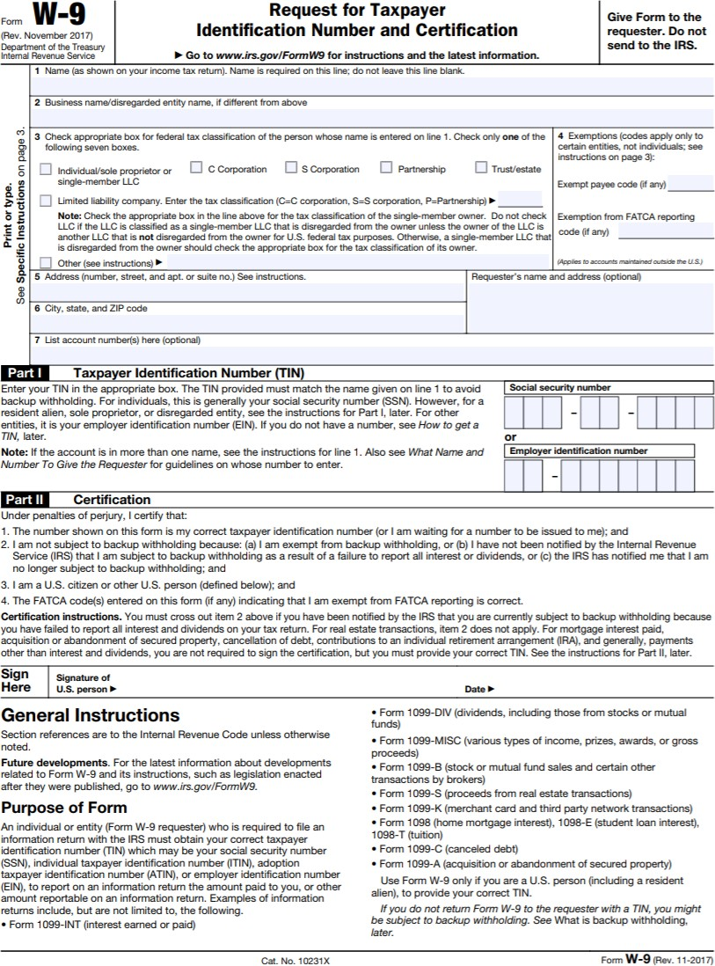

COMPLETE AND SUBMIT
FORM C

Contractor Affidavit under O.C.G.A. § 13-10-91(b)(1) Contractor E-Verify Affidavit

By executing this affidavit, the undersigned contractor verifies its compliance with
O.C.G.A. § 13-10-91, stating affirmatively that the individual, firm or corporation which is engaged in the physical performance of services on behalf of (name of public employer) has registered with, is authorized to use and uses the federal work authorization program commonly known as E-Verify, or any subsequent replacement program, in accordance with the applicable provisions and deadlines established in O.C.G.A. § 13-10-91. Furthermore, the undersigned contractor will continue to use the federal work authorization program throughout the contract period and the undersigned contractor will contract for the physical performance of services in satisfaction of such contract only with subcontractors who present an affidavit to the contractor with the information required by O.C.G.A. § 13-10-91(b). Contractor hereby attests that its federal work authorization user identification number and date of authorization are as follows:

Federal Work Authorization User Identification Number

Date of Authorization

Name of Contractor

Name of Project

Name of Public Employer
I hereby declare under penalty of perjury that the foregoing is true and correct. Executed on , , 201 in (city), (state).

Signature of Authorized Officer or Agent

Printed Name and Title of Authorized Officer or Agent

SUBSCRIBED AND SWORN BEFORE ME
ON THIS THE DAY OF ,20__.

NOTARY PUBLIC

My Commission Expires:

COMPLETE AND SUBMIT
FORM D

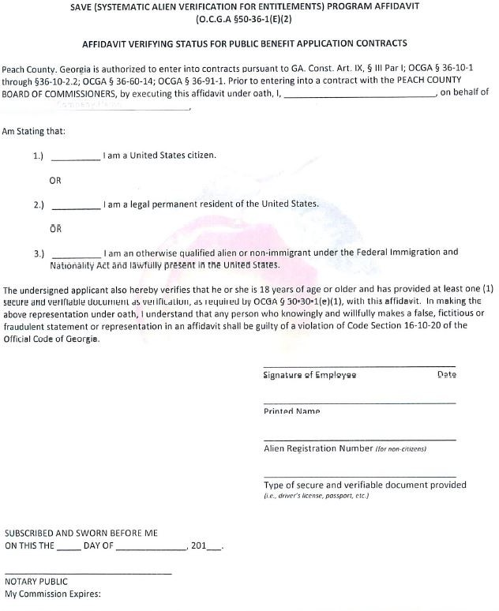

COMPLETE AND SUBMIT FORM E

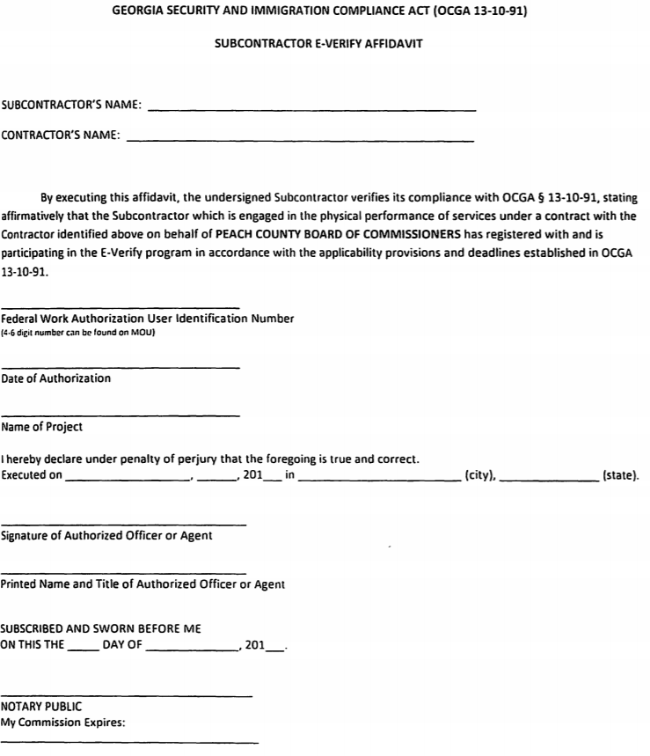

COMPLETE AND SUBMIT IF APPLICABLE FORM F

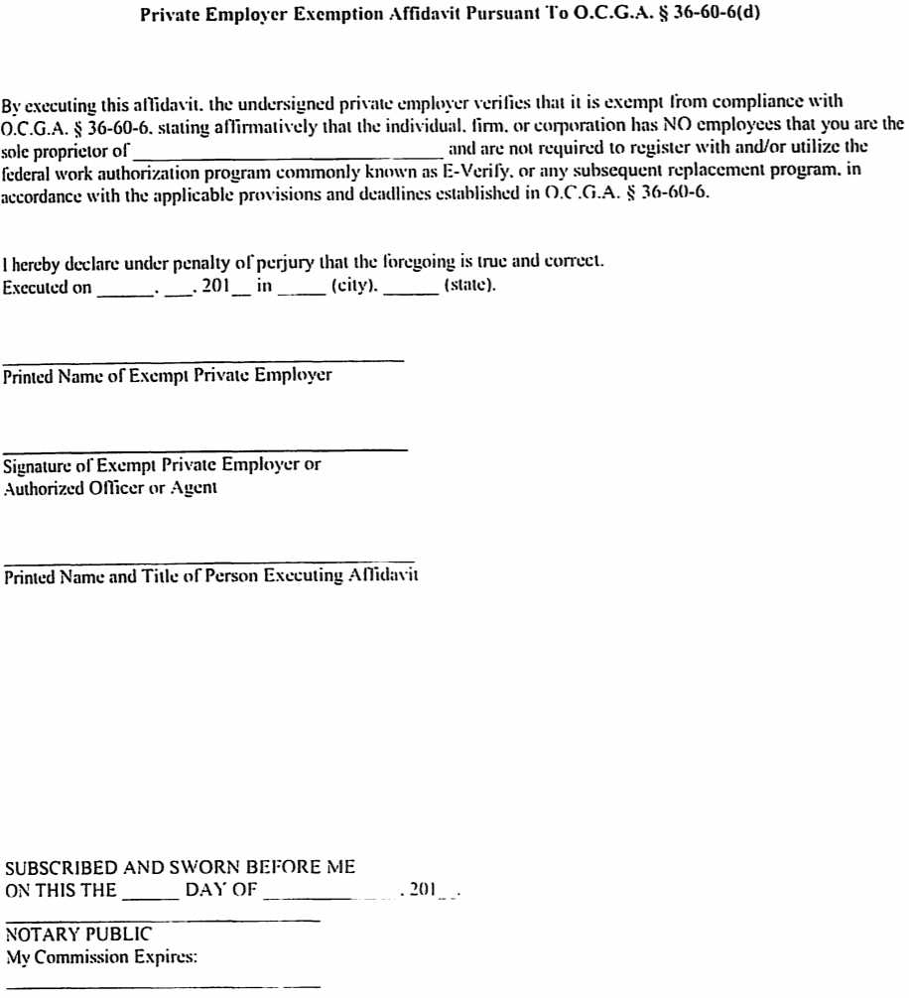

COMPLETE AND SUBMIT FORM G

CERTIFICATION BY CONTRACTOR Regarding: NON-SEGREGATED FACILITIES
The Contractor certifies that he does not, and will not, provide and maintain segregated facilities for his employees at his establishments and, further that he does not, and will not, permit his employees to perform their services at those locations, under his control, where segregated facilities are provided and maintained. Segregated facilities include, but are not necessarily limited to, drinking fountains, transportation, parking, entertainment, recreation, and housing facilities; waiting, rest, wash, dressing, and locker rooms, and time clock, Work, storage, restaurant, and other eating areas which are set apart in fact, or by explicit directive, habit, local custom, or otherwise, on the basis of color, creed, national origin, and race. The Contractor agrees that, except where he has obtained identical certifications from proposed subcontractor for specific time periods, he will obtain identical certifications from proposed subcontractor prior to the award of subcontracts exceeding $10,000.00 which are not exempt from the provisions of the Equal Opportunity clause, and that he will retain such certifications in his files.

The Contractor agrees that a breach of this certification is a violation of the Equal Opportunity clause in this Contract. The penalty for making false statements is prescribed in 18 U.S.C. 1001.

Contractor (Print)

(Signature)

Name of Signer (Print)

Title of Signer

Date

COMPLETE AND SUBMIT CERTIFICATION BY CONTRACTOR
Regarding: Drug-Free Workplace Act

FORM H

The Contractor certifies that provisions of Sections 50-24-1 through 50-24-6 of the Official Code of Georgia annotated, relating to the “Drug-Free Workplace Act” have been, and will be, complied with in full, including compliance by subcontractors performing work under this Agreement.

Contractor (Print)

(Signature)

Name of Signer (Print)

Title of Signer

Date

COMPLETE AND SUBMIT

NON-COLLUSION AFFIDAVIT OF PRIME CONTRACTOR

State of , County of

FORM I

, being first duly sworn, deposes and says that:
- He/She is (County, Partner, Officer,
Representative, or Agent) of the Contractor that has submitted the attached bid;
- He/She is fully informed respecting the preparation and contents of the attached bid and of all pertinent circumstances respecting such bid;
- Such bid is genuine and is not a collusive or sham bid;
- Neither the said Contractor nor any of its officers, partners, agents, representatives, employees, or parties in interest, including this affiant, has in any way colluded, conspired, connived, or agreed, directly or indirectly, with any other Contractor, firm or person to submit a collusive or sham bid in connection with the Contract for which the attached bid has been submitted to or refrain from Proposing in connection with such Contract, or has in any collusion or communication or conference with any other Contractor, firm or person to fix the price or prices in the attached bid or of any other Contractor, or to fix any overhead, profit or cost element of the bid price or the bid price of any other Contractor, or to secure through any collusion, conspiracy, connivance or unlawful agreement any advantage against Peach County or any person interested in the proposed Contract; and,
- The price or prices bid in the attached bid are fair and proper and are not tainted by any collusion, conspiracy, connivance, or unlawful agreement on the part of the Contractor or any of its agents, representatives, County’s employees, or parties in interest, including this affiant.

Signature

Name (Print)

Title (Print)

Subscribed and sworn to before me

This day of 20

(SEAL)

Title

COMPLETE AND SUBMIT

CONFLICT OF INTEREST CERTIFICATION

FORM J

By signing and submitting this Bid I hereby certify that employees of this company or employees of any company supplying material or subcontracting to do Work on this Contract will not engage in business ventures with employees of Peach County or Peach County Consultants nor shall they provide gifts, gratuities, favors, entertainment, loans, or other items of value to employees of Peach County.

Also, by signing and submitting this Contract, I hereby certify that I will notify Peach County through its Director of Public Works of any business ventures entered into between employees of this company or employees of any company supplying material or subcontracting to do Work on this Contract with a family member of Peach County employees.

Contractor

(Signature)

Name of Signer

Title of Signer

Date

COMPLETE AND SUBMIT
FORM K

INDEMNITY AGREEMENT

This indemnity agreement made and entered into in favor of PEACH COUNTY (“COUNTY”), a
municipal corporation, by .

WHEREAS,
.
has submitted a bid to COUNTY so as to provide

NOW, THEREFORE, as an additional consideration in COUNTY awarding the bid to
.
agrees to indemnify and hold harmless COUNTY, its agents, principals, officers, and employees, their successors and assigns, individually and collectively, with respect to all claims, demands or liability for any injuries to any person (including death) or damage to any property arising out of any alleged negligence of COUNTY, its officers, agents, or employees in connection with said bid /award; provided this indemnity shall not extend to any damage, injury or loss due to COUNTY’s sole negligence or willful misconduct of COUNTY. shall defend against all such claims and pay expenses of such defense, including reasonable attorney fees, and all judgments based thereon.

WITNESS THE HAND AND SEAL of the
authority day of , 2019.

[CORPORATE NAME]
pursuant to proper corporate

By:
Title

Attest: Title

[Affix Corporate Seal]

COMPLETE AND SUBMIT

FORM L

TITLE VI CIVIL RIGHTS ACT OF 1964 CONTRACTOR AGREEMENT

During the performance of this Contract, the Contractor, for itself, its assignees and successors in Interest (hereinafter referred to as the “Contractor”), agrees as follows:

- Compliance with Regulations: The Contractor shall comply with the Regulations relative to nondiscrimination in federally assisted programs of the Department of Transportation
(Hereinafter, “DOT”) Title 49, Code of Federal Regulation, Part 21, as they may be amended from time to time (hereinafter referred to as the Regulations), which are herein incorporated by reference and made part of this Contract.

- Nondiscrimination: The Contractor, with regard to the work performed by it during the Contract, shall not discriminate on the grounds of race, religion, color, sex, age, national origin, or disability in the selection and retention of subcontractors, including procurements of materials and leases of equipment. The Contractor shall not participate either directly or indirectly in the discrimination prohibited by Section 21.5 or the Regulations, including employment practices when the Contract covers a program set forth in Appendix B of the Regulations.

- Solicitations for Subcontracts, including procurements of materials and equipment: In all solicitations either by competitive bidding or negotiation made by the Contractor for work to be performed under a subcontract, including procurements of materials or leases of equipment, each potential subcontractor or supplier shall be notified by the Contractor of the Contractors obligations under this Contract and the Regulations relative to nondiscrimination on the grounds of race, religion, color, sex, age, national origin, or disability.

- Information and Reports: The Contractor shall provide all information and reports required by Regulations or directives issued pursuant thereto, and shall permit access to its books, records, accounts, other sources of information, and its facilities as may be determined by the recipient or the FTA to pertinent to ascertain compliance with such Regulations, orders and instructions. Where any information is required or a Contractor is in the exclusive possession of another who fails or refuses to furnish this information, the Contractor shall so certify to the recipient, or the FTA, as appropriate, and shall set forth what efforts it has made to obtain the information.

- Sanctions for Noncompliance: In the event of the Contractors noncompliance with the nondiscrimination provisions of this Contract, the recipient shall impose such Contract sanctions as it or the FTA may determine to be appropriate, including but not limited to:

  - Withholding of payments to the Contractor under the Contract until the Contractor complies, and/or
  - Cancellation, termination or suspension of the Contract, in whole or in part.

COMPLETE AND SUBMIT

FORM M
TITLE VI CIVIL RIGHTS ACT OF 1964 CONTRACTOR AGREEMENT (CONTINUED)

- Incorporation of Provisions: The Contractor shall include the provisions of paragraph (1) through (5) of this section in every subcontract, including procurements of materials and leases of equipment, unless exempt by the Regulations, or directives issued pursuant thereto. The Contractor shall take such action with respect to any subcontract or procurement as the recipient or the FTA may direct as a means of enforcing such provisions including sanctions for noncompliance: Provided, however, that, in the event a Contractor becomes involved in, or is threatened with, litigation with a subcontractor or supplier as a result of such direction, the Contractor may request the services of the Attorney General in such litigation to protect the interests of the United Sates.

DATE:

COMPANY NAME:

AUTHORIZED REPRESENTATIVE NAME:

TITLE:

SIGNATURE:

COMPLETE AND SUBMIT

FORM N

DEBARRED BIDDERS/INTEGRITY CERTIFICATION

Certification Regarding Debarment, Suspension, Ineligibility, and Voluntary Exclusion (49 CFR, Part 29):

The Contractor must certify that neither it nor its principals are presently debarred, suspended, proposed for disbarment, declared ineligible, or voluntarily excluded from participation in this transaction by any Federal department or agency. Further, the Contractor certifies that he or she shall obtain an identical certification from all its subcontractors. The Contractor also agrees that when a subcontractor is unable to certify to any of the statements in this certification, the prospective participant shall submit an explanation to the Contractor.

DATE:

COMPANY NAME:

AUTHORIZED REPRESENTATIVE NAME:

TITLE:

SIGNATURE:

COMPLETE AND SUBMIT

FORM O

DISPUTES DISCLOSURE
Answer the following questions by placing an “X” after “YES” or “NO”. If you answer “YES”, state the nature of each request for equitable adjustment, Contract claim or litigation, and include a brief description of the case, the outcome or status or suit and the monetary amount of extended Contract time involved via attachment.

Has your firm or any of its officers, received a reprimand of any nature or been suspended by the Department of Professional Regulation or any other regulatory agency or professional association within the last five- (5) years? YES [ ] NO [ ]
If yes, please explain:

Has your firm, or any member of your firm, been declared in default, terminated or removed from a Contract or job related to the services your firm provided in the regular course of business within the last five (5) years?
YES [ ] NO [ ]
If yes, please explain:

Has your firm had filed against it or filed any request for equitable adjustment, Contract claims or litigation in the past five (5) years that is related to the services your firm provides in the regular course of business?
YES [ ] NO [ ]
If yes, please explain:

I hereby certify that all statements made are true and agree and understand that any misstatement, misrepresentation, or falsification of facts shall be cause for forfeiture of rights for further consideration on this project.

(Firm) (Date)

AUTHORIZED SIGNATURE OFFICER/TITLE

PRINTED OR TYPED NAME

STATE OF: COUNTY OF:

The foregoing instrument was acknowledged before me this day of , 20 .
By , of _ (Corporation), a
Corporation, on behalf of the corporation. He/She is personally known to me or has produced as identification.

/Notary Public My commission expires:

COMPLETE AND SUBMIT

LIST OF SUBCONTRACTORS

FORM P

The bidder shall list below the name and business address of each subcontractor who will perform work under this Contract in excess of five percent of the Contractor's total bid price, and shall also list the portion of the work which will be done by such subcontractor. The listing of more than one subcontractor for each item of work to be performed with the words "and/or" will not be permitted. All information must be provided for each subcontractor. Failure to comply with this requirement shall render the proposal (bid) non-responsive and shall cause its rejection. (Attach additional sheets if required.). All subcontractors listed must complete and submit Form E, Subcontractor E-verify Affidavit with this bid.

Work to be preformed | Subcontractor License Number (If Required) | Percent of Total Contract | Subcontractor’s Legal Name, Address, and Phone #

END OF SECTION

SECTION 01 01 00 GENERAL CONDITIONS

  - RELATED DOCUMENTS
    - General provisions of the Contract including the Owner's RFB, Specification Sections, drawings, diagrams and other included documents apply to this Section.

INTENT AND INTERPRETATION OF THE CONTRACT DOCUMENTS
    - The intent of these specifications is to describe the materials and methods of construction required for the performance of the work.
    - Where discrepancies exist in the contract documents, the more stringent requirement shall apply.

DEFINED TERMS
    - Contractor - The party or parties contracting directly with the County to perform Work pursuant to this Agreement.
    - Owner – Peach County
    - Contract Documents - Refers to the RFB, written Construction Agreement, bid response, Contract, General Conditions, any required bonds, specific and supplemental conditions of the contract, project specifications, project drawings, contract change orders, supplemental agreements, Owner accepted unit prices, and Owner accepted alternates
    - Defective Work - refers to materials or products that do not meet the specific requirements of the Contract Documents including their installation and performance
    - Engineer – The Peach County Director of Engineering Services
    - Project - The entire body of work identified by the Contract Documents
    - Specifications – Identifies the portion of the Contract Documents that identify, in writing, the standards of quality and performance for the products, materials, systems, and workmanship required to meet the Contract requirements for the work on this project, which form a part of the Agreement.
    - Work – The entire construction or the various separately identifiable part thereof required to be provided under the Contract Documents. Work includes and is the result of any and all obligations, duties and responsibilities, including furnishing equipment, materials, workmanship, labor and any other services or things necessary to the successful completion of the Project, assigned to or undertaken by the Contractor under this Agreement.

RESPONSIBILITY FOR MEASUREMENTS AND QUANTITIES
    - The bidding Contractor shall be solely responsible for all accuracy of all measurements and for estimating the material quantities required to satisfy these specifications.
    - If any work is performed by the Contractor or any of his/her sub-contractors prior to adequate verification or applicable data, any resulting extra cost for adjustment of work as required to conform to existing limitations, shall be assumed by the Contractor without reimbursement or compensation by the Owner.

PROTECTION
    - The Contractor shall use every available precaution to provide for the safety of the County, visitors to the site, and all connected with the work under the specification.

    - Existing facilities shall remain operating during the period of construction. All access roadways, alleys, driveways or other means of ingress/egress must remain open to traffic unless otherwise permitted by Owner.
    - In those building areas where materials will be raised to work areas above finish grade, a protective covering shall be placed from the base of the wall extending up and over the top edge of the roof, or above the work area. This coverage shall be adequate to ensure that exterior walls and adjacent surfaces do not become stained or soiled during Work operations. Protect surfaces at finished grade in similar manner.
    - Barricades shall be erected to fence off all construction areas from operations personnel and the public.
    - Contractor shall set up all roadway work zones and perform all traffic control in accordance with the Federal Highway Administration Manual on Uniform Traffic Control Devices for Streets and Highways (MUTCD) 2009 addition. All personal working in Peach County Rights-of-Ways must wear ANSI Type 2 or 3 reflective clothing.
    - The Contractor will protect building structures, roadway structures, Peach County facilities and private property from damage in the process of the job. In the event that damage does occur to any property or equipment, notification must be made within two (2) working days of the incidents to the Owner.
    - Should the Contractor, his agents or his workers, or any of his subcontractors or material/men cause damage to County property, or to the work or materials of other contractors or persons, the damage and the repair or replacement of same shall be the sole responsibility of the Contractor. The repairs and replacing of damaged work shall be under the direction of the County, and the cost of same shall be the responsibility of the Contractor.

HOUSEKEEPING
    - Keep materials neat and orderly
    - Remove scrap, waste, and debris from project area daily

SITE CONDITION
    - The bidders shall visit the site before submitting their bids and determine the field conditions affecting their work. In considering the bids, the Owner will assume that the bidders are aware of all items, pertinent to their work and have made allowance for same in their bids.

INSPECTION
    - Where the drawings or specifications require the inspection and approval of any work in progress by the Owner or Owner's Representative, the Contractor shall give that ample notice to allow for scheduling the inspection, which shall be made promptly to avoid delay of work. If work has progressed without the required inspections or approval by the Owner or Owner's Representative, it shall be uncovered for inspection at the Contractor's expense.
    - Uncovering of work not originally inspected, or uncovering questioned work may be ordered by the Owner or Owner's Representative and it shall be done by the Contractor. If examination proves such work to be incorrectly done or not done in accordance with the plans and specifications, the Contractor shall bear all cost of the reexamination. If the work is proven correctly installed, all such expense shall be borne by the Owner.
    - The Contractor shall notify Owner, in writing of any defects in the existing facility that would prevent the work from being completed in accordance with contract documents or prevent a warranty from being placed in effect, and work shall not proceed until defects have been corrected or approved by Owner
    - Do not install new materials until all unsatisfactory conditions are corrected. Beginning work constitutes acceptance of conditions.

    - Noncompliance with the terms of this specification and ensuing contract can result in either the cancellation of the contract, or complete replacement of the defective areas at the Contractor's expense. In the event of cancellation, the Owner will not be obligated to compensate the Contractor for any work undertaken in a defective manner.
    - Damages caused by water infiltration resulting from the failure of the Contractor to secure each day's work in a weather tight manner, will be corrected at the Contractor's expense. Included as damages will be all labor costs incurred by the Owner as a result of such water infiltration.
    - The presence and activities of an Owner's Representative shall in no way relieve the Contractor of his/her contractual responsibilities.

SAFETY REQUIREMENTS
    - All Owners’ safety rules shall be adhered to in the execution of this work.
    - All application, material handling, and associated equipment shall conform to and be operated in conformance with OSHA safety requirements.
    - Contractor shall comply with federal, state, local and Owner fire and safety requirements.
    - Advise Owner whenever work is expected to be hazardous to the general public or Owner employees and/or operations.
    - Maintain proper fire extinguisher within easy access whenever power tools or equipment are being used.
    - The Contractor shall be responsible for guarding against fires, and shall provide suitable fire extinguishers conveniently located at the site.
    - Competent operators shall be in attendance at all times equipment is in use.
    - Materials shall be stored neatly and dispersed and handled so as to present a minimum danger to the public or Owners employees.
    - Material loads placed on the roofs, walls, bridges, culverts, or other facilities or infrastructure at any point shall not exceed the safe load for which the load bearing assembly is designed.
    - Contractor shall conform to requirements as designated by the United States Federal Government (O.S.H.A.). Contractor shall abide by all regulations as outlined in the O.S.H.A. handbook and shall have a handbook on location at all times.
    - The Contractor shall properly notify the Owner of conditions relating to Work areas with unsafe condition(s) which will be worked on. After such notification, the Contractor must take all necessary precautions to ensure the safety of his/her employees County personnel, and the general public. This includes, but is not limited to
    - The Owner requires the Contractor to take all steps necessary to ensure the safety of people on the project property in areas adjacent to the Contractor’s work areas. The safety of all people in or around the project site is expected to be the Contractors highest priority at all times. Preventing access to the work area, and Limiting access to areas adjacent to the work area. Use of safety mechanism such as warning signs, safety cones, safety fences, safety flags, etc. shall be utilized.

PRODUCT DELIVERY, STORAGE, AND HANDLING
    - Proper storage on or off the site shall be the responsibility of the Contractor.

WORK SEQUENCE
    - Once Work is started on a section, it shall continue without undue delay until that section is completed before starting another.
    - Coordinate sequence of Work with Owner prior to start of Work.

MISCELLANEOUS UTILITIES
    - For building and facility work electrical power will be furnished by the Owner for small tools only. All connections to the electrical system will be furnished by the Contractor. For road and infrastructure work, all electrical power needed will be provided by the Contractor.
    - For building and facility work the Owner will furnish potable water. Any connections to the water system shall be the responsibility of the Contractor. For road and infrastructure work, potable and non-potable water will be provided by the Contractor.
    - At the completion of the work, or when the above connections are no longer required, the Contractor shall remove all connections and leave the facilities in a condition at least as satisfactory as prior to the commencement of the work.
    - The Contractor will provide toilet facilities. The Contractor will be responsible for supplying a portable toilet on the job-site. The Contractor's personnel are not permitted to enter the building without proper authorization from the Owner or Owner's Representative.

CHANGES OR EXTRA WORK
    - The Owner may, without invalidating the original contract, order such changes or additions as may from time to time be deemed desirable. In so doing, the contract price shall be adjusted, as stated below, with all work being done under the conditions of the original contract except for such adjustments in extension of time as may be acceptable to the Owner. The value of such extra work shall be determined in one of the following ways: by firm price adjustment, by cost plus with a guaranteed maximum, by cost with a fixed fee, or by Unit Cost.
    - If agreement is reached that the extra cost is required the Contractor shall keep and compile correct records of the cost together with such vouchers, etc., as may be necessary to substantiate same for presentation to the Owner.
    - No change or addition impacting cost or extension of time shall be made except upon receipt by the Contractor of a signed supplemental agreement or change order from the Owner authorizing such a change. No claims for an extra to the contract price or time extension shall be valid unless so authorized.

CORRECTION OF WORK PRIOR TO FINAL PAYMENT
    - The Contractor shall promptly remove any work that does not meet the requirements of the plans and specifications or is incorrectly installed or otherwise disapproved by the Owner or the Owner's Representative as failing to meet the intent of the plans and specifications. The Contractor shall promptly replace any such work without expense to the Owner and shall bear the cost of making good all work of other contractors, or the Owner, destroyed or damaged by such removal or replacement.

DEDUCTION FOR UNCORRECTED WORK
    - If the Owner deems it unacceptable to have the Contractor correct work that has been incorrectly done, a deduction from the contract price shall be agreed upon therefore. Such a deduction from the contract price shall in no way affect the Contractor's responsibility for defects that may occur nor his/her ability for correcting them, and damage caused by them.

CORRECTION OF WORK AFTER FINAL PAYMENT
    - The Contractor shall provide the specified warranties for this project in order to address deficiencies in the work of this project after the Owner makes final payment to the Contractor.

ACCEPTABILITY OF COMPLETED WORK
    - The acceptability of completed Work will be based on its conformance to the Contract requirement.

    - The Owner is not obligated to accept non-conforming work, and such non-conforming work may be rejected. The rejected work shall be promptly replaced or corrected in a manner and by methods approved by the Owner or Owner Representative at the Contractor's expense.

LIENS
    - The Contractor shall furnish the Owner the Final Affidavit attached to the contract agreement verifying all suppliers of materials, equipment and service, subcontractors, mechanics, and laborers have been paid and there are no outstanding obligations or claims of any kind for the payment of which Peach County on the above-named projects might be liable for which liens arising out of this contract for which a lien could be filed. In lieu of the above, the Contractor may at his/her option furnish a bond to indemnify the Owner against all hazards of liens. Neither part nor final payment shall in any way release the Contractor from the above obligation and in the event that part or full payment has been made and any lien remains un- discharged, the Contractor shall refund to the Owner the necessary funds to discharge such a lien including all cost and attorney's fees.

JOB CONDITIONS
    - There is NO SMOKING allowed in Peach County Buildings or on the project property, and the Contractor shall be responsible for enforcement of this job rule at all times with his/her personnel.
    - Equipment: Any equipment used on this project must be in good condition. All equipment must be O.S.H.A. approved.
    - No drugs or alcoholic beverages are permitted on Peach County property or Rights-of-Ways.
    - During the progress of the job, if waste material and rubbish are found or damage resulting from the Contractor's operations is found, or the Contractor does not comply with the requirement by keeping the premises free of accumulations and correct the damage, it shall be the Owner's prerogative to hire personnel to do so; and the cost of this work will be deducted from the balance due the Contractor.
    - The Contractor is responsible for protecting all materials from the elements. If any material becomes
    - Damaged during storage, it cannot be installed and must be replaced at the Contractor's expense.
    - Anyone guilty of willful destruction or unlawful removal of Owner’s property will be dismissed from the job and is subject to prosecution by law.
    - The Contractor must verify that all materials can be installed to accommodate the design, governing codes and regulations, and the manufacturer's current recommendations. In the event of a conflict the more stringent shall govern.
    - Contractor will ensure that no firearms or other weapons are brought onto any part of the Owner's property where this project is located for any reason.

WORK HOURS AND DAYS
    - When the Contract is awarded, the Contractor will contact the Owner or Owner's Representative to arrange the work schedule and the hours of the day that the workers may be on the project site.

COMPLIANCE WITH LAWS
    - The Contractor shall give notices, pay all fees, permits and comply with all laws, ordinances, rules and regulations bearing on the conduct of work.

OWNER'S RULES
    - The Contractor and all his/her personnel/agent(s) shall abide by all rules created by the Owner.
    - The Contractor must contact the Owner's Representative for specific information regarding the rules governing all operations of the project.

ANTI-DISCRIMINATION IN EMPLOYMENT
    - Contractors and subcontractors shall not discriminate against any employees or applicant for employment, to be employed in performance of his/her contract, with respect to his/her hire, tenure, terms, conditions or privileges of employment because of his/her race, color, gender, sexual preference, religion, national origin, or ancestry.

FINAL INSPECTION
    - Upon completion of the work, unless noted otherwise, an inspection shall be made by the Owner, Owner’s Representative, or a representative of the material manufacturer to ascertain that the work has been installed according to the published specifications and details.

ADJUSTMENT AND REPAIR
    - Any work damaged or incorrectly installed shall be repaired or replaced as designated by the. Repairs or replacement will be made by the contractor at no expense to the Owner.

TERMINATION BY THE OWNER FOR CAUSE
    - The Owner may terminate the Contract and finish the work by whatever reasonable method he/she deems necessary if the Contractor Persistently or repeatedly refuses to supply specified materials or to provide enough skilled workers to ensure the project will be completed within the time period in the Contract Agreement or ss guilty of substantial breach of any provision of the project documents.

TAXES
    - Contractor must comply with all state, federal and local taxes. The Contractor shall accept sole and exclusive responsibility for any and all state and federal taxes with respect to Social Security, unemployment benefits, withholding taxes and sales taxes.

PERMITS
    - The acquisition of the applicable permits and associated costs to obtain said permits will be the responsibility of the Contractor.

CLEAN-UP
    - Accumulated debris shall be removed periodically to assure maximum safety and sanitation at all times. At completion of work, the Contractor shall remove all excess material and debris from the site and leave all surfaces free from accumulations of dirt, debris and other extraneous materials.

SUPERINTENDENT
    - The Contractor shall keep a competent, English language speaking superintendent, satisfactory to the Owner and Owner's Representative, on the job at all times when work is in progress. The superintendent shall not be changed without notifying the Owner and the Owner's Representative.
    - The superintendent shall attend all meetings beginning with the pre-construction meeting.
    - The superintendent shall represent the Contractor in his/her absence and all directions and instructions given to the superintendent shall be as binding as if given directly to the Contractor.

    - The superintendent shall be responsible for the conduct of all the Contractor's employees on the premises and shall promptly take necessary measures to correct any abuses called to his/her attention by the Owner.

END OF SECTION

SECTION 01 02 00 SUPPLEMENTARY CONDITIONS

  - WORK HOUR DAYS
    - The Owner offers the successful bidder site and building access Monday through Saturday between the hours of 6:00 a.m. through 6:00 p.m.
    - Actual construction times and/or work hours must be in accordance with applicable local ordinances.

PROJECT DELAYS
    - If delay is foreseen, the Contractor shall give immediate written notice to the Peach County Director of Engineering Services or a representative assigned by the Director. The Contractor must keep the County advised at all times of status of the project work.

DELIVERY FAILURE:
    - Time is of the essence. Should the Contractor fail to supply the proper materials or work at the time and place as specified, or within a reasonable period of time thereafter, or should the Contractor fail to make a timely replacement of rejected items when so requested, the County may, at its sole discretion, cancel the contract and secure another Contractor.

PAYMENT
    - A Purchase Order will be issued with the Notice to Proceed (NTP). No materials shall be delivered nor any work commence until the contractor is in receipt of the NTP and the P.O.
    - Contractor may submit partial pay requests (Invoices) on a weekly, bi-weekly, or 30-day basis. Pay requests must be submitted regularly and for no greater than 30-day periods. Partial pay estimates may include stored materials. Contractor must submit invoices and all materials must be located at the site of the work. Such payments shall be viewed by both parties as progress payments and shall not in any way relieve the Contractor of performance obligations under this contract, nor shall such payments be viewed as approval or acceptance of work performed under this contract.
    - Each invoice shall be accompanied by a detailed estimate of the amounts and values of labor expended and materials purchased up to the last day of the preceding month.
    - Contractor must submit invoices and all materials must be located at the site of the work. Invoices shall be submitted to:

Peach County Purchasing Department
Attn. Stacy Sanders, Purchasing Manager
213 Persons Street Fort Valley, GA 31030.

    - Retainage shall be an amount equal to 10% of the Contractor’s partial pay estimate until 50% completion. Further payments shall be made in full to the Contractor and no additional amounts may be retained unless the Director certifies that the job is not proceeding satisfactorily, but amounts previously retained shall not be paid to the Contractor. At 50% completion or any time thereafter when the progress of the work is not satisfactory, additional amounts may be retained, but in no event shall the total retainage be more than 20% of the value of the work completed. Upon substantial completion of the work, any amount retained may be paid to the Contractor. When the work has been substantially completed except for work which cannot be completed because of weather conditions, lack of materials, or other reasons which in the judgement of the County are valid reasons for non-completion, the

County may make additional payments, retaining at all times an amount sufficient to cover the estimated cost of the work still to be completed.
    - Final payment for the project will be made to the Contractor no later than thirty (30) days after job approval, providing the final inspection has been made and all work has been approved and accepted by the Owner, and the Contractor submits the Final Affidavit and a final invoice.
    - When the job in progress is interrupted for two (2) weeks or longer by causes beyond the Contractor's control such as a strike, weather, acts of God, etc., the Owner agrees to pay, upon request of the Contractor, a price equivalent to the percentage of work completed at that time. Regular progress payments shall be made for labor and/or materials installed and stored on- site.

SECURITY BONDS
    - Payment and performance bod(s) in the amount of 100% of the contract amount will be required prior to the County issuing a Notice to Proceed.
    - Bonds shall be in accordance with the Contract General Conditions.

ADDITIONAL REQUIREMENTS
    - A preconstruction meeting with the owner is mandatory prior to any work being started. Owner will set date and time of meeting.
    - Contractor shall post signage at courts 48 hours prior to start re: construction at courts and approximate start and finish dates.
    - Interaction with Park Patrons: Peach County gives priority of use to its park patrons. The Contractor’s vehicles and personnel shall be marked as to be easily identifiable by the park patrons. The work force of the Contractor shall be courteous to park patrons at all times. The work of the Contractor shall not interfere with scheduled events in a park and shall not, within reason, interfere with patrons’ enjoyment of a park area. Any conflict or potential conflict between the work force and park patron(s) shall be immediately brought to the attention of the project Engineer.

END OF SECTION

SECTION 01 03 00 SUMMARY OF WORK

  - RELATED DOCUMENTS
    - Project diagrams, key plans, and general provisions of the Contract including General and Supplementary Conditions and other Division 01-48 Specification Sections, apply to this Section.

SUMMARY
    - This section includes Work covered by the Contract Documents and Miscellaneous Provisions

BASE BID WORK SUMMARIES
    - Refer to project Plans and Diagrams, as well as Specifications for additional requirements. Coordinate Base Bid work with project Alternates and Unit Prices as directed.
    - All work shall be done in a neat and orderly manner using adequate number of skilled workers who are thoroughly trained and experienced in the necessary crafts and who are completely familiar with the specified requirements and the methods needed for proper performance of the work.
    - South Peach Park Tennis Courts 1-4 - Provide all labor, material and equipment to resurface the four (4) existing public tennis courts as specified herein, including converting court #4 (see Exhibit 4) into 3 (three) Pickleball Court, including but not limited to:
      - Removal of existing fencing, hardware and/or equipment to allow for resurfacing;
      - Preparation of existing surface to receive resurfacing products;
      - Tack Coat installation
      - Reinforcement Mat installation
      - HMA installation
      - Flooding of surface to determine if any ponding exists and correct per industry standards;
      - Acrylic surfacing including color application approved by County
      - Application of playing lines
      - Re-installation of any equipment or hardware removed
      - Installation of 3 Pickleball post and nets.
      - Installation of new 6’ commercial grade fencing or barrier (approved by County)
between courts approved #3 & #4 to be provided by Bidder
      - Clean-up

    - South Peach Park Basketball Courts A-D – Provide all labor, material and equipment to resurface the four (4) existing public basketball courts as specified herein, including but not limited to:
      - Removal of existing hardware and/or equipment to allow for resurfacing;
      - Preparation of existing surface to receive resurfacing products
      - Tack Coat installation
      - Reinforcement Mat installation
      - HMA installation
      - Application of playing lines
      - Re-installation of any equipment or hardware removed
      - Clean-up

    - North Peach Park Tennis Courts 1-5 – Provide all labor, material and equipment to resurface the five (5) existing public tennis courts as specified herein, including converting court #5 (see Exhibit 5) into 3 (three) Pickle Ball Courts. Including but not limited to:
      - Removal of existing fencing, hardware and/or equipment to allow for resurfacing;
      - Preparation of existing surface to receive resurfacing products;
      - Repair to existing surface including cracks, birdbaths, swales, and any irregularities;
      - Flooding of surface to determine if any ponding exists and correct per industry
standards; Full removal and disposal of materials as generated from project;
      - Resurfacing including color application approved by County
      - Re-apply playing lines.
      - Re-installation of any equipment or hardware removed
      - Installation of 3 Pickleball post and nets.
      - Clean-up

    - North peach Park Basketball Courts A-B – Provide all labor, material and equipment to resurface two (2) existing public basketball courts as specified herein, including but not limited to:
      - Removal of existing fencing, hardware and/or equipment to allow for resurfacing;
      - Preparation of existing surface to receive resurfacing products;
      - Tack coat installation
      - HMA installation
      - Application of playing lines.
      - Re-installation of any equipment or hardware removed
      - Clean-up

END OF SECTION

SECTION 01 04 00 UNIT PRICES
  - RELATED DOCUMENTS
    - Project diagrams, key plans, and general provisions of the Contract, including General and Supplementary Conditions and other Division 01-48 Specification Sections, apply to this Section.

SUMMARY
    - Section includes administrative and procedural requirements for unit prices.

DEFINITIONS
    - Schedule of Unit Item Prices - A schedule, prepared and maintained by the Contractor, allocating portions of the Contract Price to various portions of the Work and used as the basis for reviewing Contractor’s application for payment changes and/or changes in the contract price (change orders).
    - Additional Unit Price - An amount documented by Bidder on the Bid Form as a price per unit of measurement for additional materials or services that may be added to or deducted from the Contract Sum by Change Order.

PROCEDURES
    - Unit prices include all necessary material, plus cost for delivery, installation, insurance, applicable taxes, overhead, and profit.
    - See individual Specification Sections for work that requires establishment of unit prices.
    - Owner reserves the right to reject Contractor's measurement of work-in-place that involves use of established unit prices and to have this work measured, at Owner's expense, by an independent surveyor acceptable to Contractor.

ADDITIONAL UNIT PRICES
    - Unit Price No. 1:
      - Description:
      - Unit of Measurement:
      - Work for this unit price shall be performed in accordance with the specifications and requirements of this RFB and other contract documents.
      - Contractor to determine need for additional work in conjunction with this unit price and include in the unit price.

END OF SECTION

SECTION 02 01 00 TECHNICAL SPECIFICATIONS

NORTH PEACH PARK – 4 TENNIS COURTS/1 PICKLEBALL COURT

PART ONE- GENERAL
  - SUMMARY
    - This work includes surface preparation including the Armor Crack Repair System or approved equivalent, and the acrylic color system applications for existing tennis courts.

QUALITY ASSURANCE
    - Installing firm: Installer must regularly engage in construction and color acrylic surfacing. Documented experience in acrylic color system applications must be provided. Minimum of 10 projects similar in complexity in the last 3 years.
    - Surfacing shall conform to the guidelines of the ASBA, (American Sports Builders Association), and the USTA (U.S. Tennis Association)
    - Certified installer of Armor Crack Repair System

SUBMITTALS
    - Provide manufacturer specifications for all products, and installation instructions.
    - Provide color chart or samples for court colors. County shall choose the court colors upon submission.

MATERIAL HANDLING AND STORAGE
    - Store materials in accordance with manufactures specifications and MSDS.
    - All surfacing material shall be non-flammable.
    - NO MATERIAL STORED ON SITE during the duration of the project unless fully secured in a locked container, locked trailer, or with fencing.

WARRANTY
    - Provide guarantee against defects in the materials and workmanship for a minimum period of one year from the date of substantial completion unless otherwise stated.

PART 2 – PRODUCTS

  - MANUFACTURERS
    - U.S. Tennis Court Construction Company Lockport, IL 60441/ Elite Sport Coating System.
    - A.S.T., LLC Farmingdale, NJ 07727/ ARMOR CRACK REPAIR SYSTEM
    - Approved equal products.

MATERIAL
    - Patching Mix (Elite Patch Binder)-for use in patching cracks, holes, depressions, “birdbaths” and other surface imperfections.
    - Acrylic Patch Crack Filler (Elite Acrylic Patch Crack Filler)-for use in filling cracks
    - Acrylic Resurfacer (Elite Acrylic Resurfacer)- Mixed with approved silica sand and applied as a filler coat on new or existing asphalt surfaces and for pre-coating rough areas.
    - Acrylic Color Playing Surface (Elite Color Concentrate) mix with approved silica sand and applied over acrylic resurfacer or textured acrylic color.
    - Textured Line Paint (Elite Textured Line Paint)-for use as line or graphic marking on play surface.
    - ARMOR Adhesive (Follow Armor Crack Repair Guidelines) Adhesive used in bonding ARMOR CRACK REPAIR SYSTEM layers.
    - ARMOR CRACK REPAIR SYSTEM- Expandable tapes fabrics applied over prepared cracks.

PART THREE- EXECUTION

  - WEATHER LIMITATIONS
    - Do not install when rain is imminent or extremely high humidity prevents drying.
    - Do not install if surface is wet or damp.
    - Do not apply unless surface and air temperatures are 50°F and rising. *Above 60°F during crack repair installation.
    - Do not apply if surface temperature is more than 140°F.

DEMOLITION
    - All chain link fence and gates shall be removed and stored on-site.
    - Remove vertical fence and net posts as needed and store on-site.
    - Any fence post footings strap anchor foundations, or tennis post foundations heaved over the proposed finish grade shall be chiseled down to existing surface grade or below.

PREPARATION FOR ACRYLIC COLOR SYSTEM
    - Surface shall be thoroughly cleaned of all dirt, debris, and vegetation using floor scrapers, wire brooms, and mechanical blowers.
    - Surface areas with embedded dirt, or algae growth shall be pressure washed. Entire surface washing may be required. Surfaces shall be power washed using a deck power washing unit or Hydo-Jet-Blaster, wand washing will not be accepted. Surface, fencing, and athletic equipment shall be thoroughly rinsed following surface washing.
    - Cracks with vegetation shall be treated with herbicide. Cracks shall be routed with a mechanical crack router. All loose material and old or foreign crack filler shall be completely removed.
    - Cracks with vegetation shall be treated with herbicide capable of killing all existing vegetation and preventing any vegetation growth for one year.
    - Cracks shall be routed with a mechanical crack router. All loose material and old or foreign crack filler shall be completely removed.

CRACK FILLING
    - Cracks shall be filled from bottom to top with acrylic patch crack filler. Special care shall be taken to assure all void space is filled. Multiple applications will be required to level crack filler with adjacent surface.
    - All crack repairs must be extended in length by 10% over the existing crack length.
    - Sand and pre-coat as needed to assure repairs are not visible following acrylic surface applications.
    - Strictly follow manufactures mixture guidelines and moisture limitations.

ARMOR CRACK REPAIR SYSTEM
    - Install ARMOR CRACK REPAIR SYSTEM over fully prepared cracks.
    - Strictly follow manufactures installation guidelines.

COURT DEPRESSIONS “BIRDBATHS”
    - Testing: Surface shall be flooded with water by rain or manually with clean water. Surface shall be allowed to drain for 45-60 minutes in sunlight at 70°F. Remaining depressions holding enough water to cover a United States 5-cent coin laid flat (0.077 in or 1.95 mm) shall be marked.
    - Apply acrylic patch binder mix to depressions and strike off with a straight edge. Before the product begins to dry, feather edges using a trowel, putty knife, or similar method.
    - Repeat testing and acrylic patch binder applications as needed to eliminate or reduce depressions to within tolerance.
    - Sand and pre-coat as needed to assure repairs are not visible following acrylic surface applications.
    - Strictly follow manufactures mixture guidelines and weather limitations.

ACRYLIC FILLER COAT(S) (RESURFACER)
    - Two (2) coats of properly textured acrylic resurfacer shall be applied to entire surface. Special care shall be taken to keep a wet edge and remain consistent.
    - When surface is completely dry, surface shall be inspected for, ridges, bumps, and debris. Any inconsistencies shall be corrected prior to color coat applications.
    - Strictly follow manufactures mixture guidelines and weather limitations.

ACRYLIC COLOR PLAYING SURFACE
    - Complete a thorough inspection, remove any bumps or ridges in resurfacer coats, and clean surface of all loose dirt, leaves, or other debris.
    - If the surface is to receive multiple colors, apply chalk lines to distinguish the court area from the perimeter area. Follow USTA & USAPA guidelines for court dimensions.
    - Colors and their placement shall be determined by the County. Colors and the placement of the colors shall be verified by the County prior color applications.
    - Textured acrylic color surface shall be applied in two (2) applications with a 50-durometer rubber squeegee. No application should be made until the previous application is thoroughly dry.
    - Strictly follow manufactures guidelines and weather limitations.

FENCING
    - Chain link fencing and gates shall be reinstalled including all posts, wires, ties, and hardware to properly reconstruct securely.

LINE PAINTING
    - Lines shall be carefully laid out in accordance with the USTA & USAPA guidelines.
    - Masking tape shall be applied and rolled to result in a two inch (2”) wide width unless otherwise stated.
    - Masked lines shall be primed with acrylic line primer to seal the void between the textured surface and masking tape edge.
    - One (1) coat of textured white line paint shall be applied by brush or roller. NO SPRAY APPLICATIONS PERMITTED.

PROTECTION
    - Adequate barriers shall be erected to protect the public during construction.
    - Erect temporary barriers to protect coatings during drying and curing.
    - Lock gates to prevent use until acceptance by the owner.

CLEAN UP
    - Site shall be cleared of all construction debris, all waste shall be disposed of offsite in accordance with local, state and federal regulations.
    - Remove all barriers and locks.

SOUTH PEACH PARK - 4 TENNIS COURTS
One Tennis Court to be changed to PICKLEBALL COURT

PART ONE- GENERAL

  - SUMMARY
    - This work includes surface preparation, crack filling, reinforcement mat, Hot Mix Asphalt (HMA) paving, and the acrylic color system applications for existing tennis courts.

QUALITY ASSURANCE
    - Installing firm: Installer must regularly engage in construction and color acrylic surfacing. Documented experience in acrylic color system applications must be provided. Minimum of 5 projects similar in complexity in the last 3 years.

    - Surfacing shall conform to the guidelines of the ASBA, (American Sports Builders Association), and USTA (U.S. Tennis Association).

SUBMITTALS
    - Provide manufacturers’ specifications for all products, and installation instructions
    - Provide color chart or samples for court colors. County shall choose the court colors upon submission.
    - Provide asphalt mix design

MATERIAL HANDLING AND STORAGE
    - Store materials in accordance with manufactures specifications and MSDS.
    - All surfacing material shall be non-flammable.
    - NO MATERIAL STORED ON SITE during the duration of the project unless fully secured in a locked container. Locked trailer, or with fencing.

WARRANTY
    - Provide guarantee against defects in the materials and workmanship for a minimum period of one year from the date of substantial completion unless otherwise stated.

PART 2 – PRODUCTS

  - MANUFACTURERS
    - Tensar International Corp. Alpharetta, GA 30009/ GlasPave 25 Weatherproof Paving Mat or approved equal.
    - GDOT approved asphalt plant with qualified mix/ HMA & Tack Coat
    - U.S. Tennis Court Construction Company Lockport, IL 60441/ Elite Sport Coating System or approved equal.

MATERIAL/PRODUCTS
    - Reinforcement Mat (GlasPave 25 Weatherproof Paving Mat)-for use above tack coat and below compacted HMA.
    - Tack Coat/Primer (GDOT Specification Section 413)
    - HMA Surface Course 9.5 mm Superpave, free of reclaimed asphalt shingles and reclaimed asphalt pavement, applied over reinforcement mat. materials, submittals and testing will conform to the Georgia Department of Transportation (GDOT) specifications listed in table 1.

TABLE 1

Material | GDOT Specification Section
Asphalt Cement | 820.2
Coarse Aggregates for Asphaltic Concrete | 802.2.02
Fine Aggregates for Asphaltic Concrete | 802.2.01
Mineral Filler | 883.1
Heat Stable Anti-Striping Additive | 831.2.03
Hydrated Lime | 882.2.03
Silicone Fluid | 831.2.05
Bituminous Tack Coat: PG 58-22, PG 64-22, PG 67-22 | 820.02
Hot Mix Asphaltic Concrete Mixtures | 828
Fiber Stabilizing Additives | 819

    - Patching Mix (Elite Patch Binder)-for use in patching cracks, holes, depressions, “birdbaths” and other surface imperfections.

    - Acrylic Patch Crack Filler (Elite Acrylic Patch Crack Filler)-for use in filling cracks
    - Acrylic Resurfacer (Elite Acrylic Resurfacer)- Mixed with approved silica sand and applied as a filler coat on new or existing asphalt surfaces and for pre-coating rough areas.
    - Acrylic Color Playing Surface (Elite Color Concentrate) mix with approved silica sand and applied over acrylic resurfacer or textured acrylic color.
    - Textured Line Paint (Elite Textured Line Paint)-for use as line or graphic marking on play surface.

PART THREE- EXECUTION

WEATHER LIMITATIONS
    - Do not install acrylic material when raining or rain is imminent, if surface is wet or damp, if surface temperature is more than 140°F, or surface and air temperatures are 50°F and rising.
    - Reinforcement mat shall be installed when ambient temperatures are at least 50°F and rising.
    - Do not install asphalt materials if the weather conditions fall outside the conditions in GDOT specifications.

DEMOLITION
    - All chain link fencing and gates shall be removed and stored on site.
    - Remove vertical line posts as needed for paving equipment access.
    - Any fence posts footings strap anchor foundations, or tennis post foundations heaved over the proposed finish grade shall be chiseled down to existing surface grade or below.

TENNIS POST’S SLEEVES, POSTS, AND NETS
    - Extend existing net post sleeves plum and level with new surface.
    - All existing net posts shall be sanded and one coat of primer and three coats of paint that is classified for use on metal surface applied.
    - Reinstall net posts in adjusted sleeves.
    - Nets will be installed by County.

SURFACE PREPARATION
    - Surface shall be thoroughly cleaned of all dirt, debris, and vegetation using floor scrapers, wire brooms, and mechanical blowers.
    - All loose coatings shall be removed and disposed of legally off site.
    - Cracks with vegetation shall be treated with herbicide. Cracks shall be routed with a mechanical crack router. All loose material and old or foreign crack filler shall be completely removed. All crack repairs must be extended in length by 10% over the existing crack length.
    - Any oil or grease spots shall be scraped and treated to prevent bleeding through the tack coat.

CRACK FILLING
    - Cracks shall be filled from bottom to top with acrylic patch crack filler. Special care shall be taken to assure all void space is filled. Multiple applications will be required to level crack filler with adjacent surface.
    - All crack repairs must be extended in length by 10% over the existing crack length.
    - Strictly follow manufactures mixture guidelines and moisture limitations.

TACK COAT/PRIMER
    - Apply tack coat at a rate of 0.17 gallons per square yard (0.17 gal/sy)
    - Apply tack coat over asphalt or remaining properly bonded coatings in accordance with GDOT specifications. Excessive asphalt applications, or pooling, shall be swept with a broom to ensure proper bonding of the reinforcement mat and HMA.
    - After applying the tack coat material, allow it to break until it is tacky enough to receive the surface course. Do not allow traffic on the tack.

    - Install reinforcement mat after the tack coat material has been allowed to break until it is tacky.
    - Strictly follow GDOT mixture guidelines and moisture limitations

REINFORCEMENT MAT
    - Mechanically place mat to cured tack coat surface using interlayer laydown equipment or a distributor truck with a fabric applicator attached to the back. Hand placement is not allowed.
    - Mat to be applied over entire tack coat surface.
    - Overlap mat widths a minimum of four inches (4”) horizontally and two inches (2”) longitudinally.
    - Mat must be installed under sufficient tension to reduce or eliminate folds and ripples.
    - Follow all Manufacturer’s installation specifications, instructions, and guidelines.

ASPHALT PAVING
    - Install HMA surface course to a compacted at a rate of 195 lb./sy over reinforcement mat.
    - HMA shall be free of marks, segregation and be placed to required uniform elevation with a smooth texture not showing tearing, shoving, or gouging.
    - Paving equipment shall be equipped with auger extensions, and be self-propelled.
    - Hand work shall be minimized to ensure the best possible finished surface.
    - Compaction will be completed in accordance with GDOT specifications
    - Surface course longitudinal joints shall be smooth and true; no deviation from level and true.
    - Smoothness shall meet the requirements of no greater than one eighth inch (1/8”) in ten feet (10’).
    - Surface course asphalt must be placed in one day, special care shall be taken to avoid cold seams.
    - Asphalt shall be closed and protected and allowed to cure for 30-days prior to any additional surface being installed.

FENCING
    - Approximately two inches (1.75”) shall be removed from the overall height of the chain link fabric to allow for the added elevation of the surface. Exposed cut ends shall be knuckled uniformly. Gates shall be raised to match bottom of fence.
    - Chain link shall be reinstalled including all wire, ties, and hardware to properly fasten to fence structure.
    - Chain link shall be situated to allow three quarters of an inch to one- and one-half inch (3/4”- 1.5”) clearance at the bottom.
    - Chain link shall be installed following the asphalt paving and prior to the color surface applications.

COURT DEPRESSIONS “BIRDBATHS”
    - Testing: Surface shall be flooded with water by rain or manually with clean water. Surface shall be allowed to drain for 45-60 minutes in sunlight at 70°F. Remaining depressions holding enough water to cover a United States 5-cent coin laid flat (0.077 in or 1.95 mm) shall be marked.
    - Surface shall be cleaned of all debris and allowed to dry prior to installing any acrylic material.
    - Apply acrylic patch binder mix to depressions and strike off with a straight edge. Before the product begins to dry, feather edges using a trowel, putty knife, or similar method.
    - Repeat testing and acrylic patch binder applications as needed to eliminate or reduce depressions to within tolerance.
    - Sand and pre-coat as needed to assure repairs are not visible following acrylic surface applications.
    - Strictly follow manufactures mixture guidelines and weather limitations.

ACRYLIC FILLER COAT(S) (RESURFACER)
    - Two (2) coats of properly textured acrylic resurfacer shall be applied to entire surface. Special care shall be taken to keep a wet edge and remain consistent.
    - When surface is completely dry, surface shall be inspected for, ridges, bumps, and debris. Any inconsistencies shall be corrected prior to color coat applications.
    - Strictly follow manufactures mixture guidelines and weather limitations.

ACRYLIC COLOR PLAYING SURFACE
    - Complete a thorough inspection, remove any bumps or ridges in resurfacer coats, and clean surface of all loose dirt, leaves, or other debris.
    - If the surface is to receive multiple colors, apply chalk lines to distinguish the court area from the perimeter area. Follow USTA guidelines for court dimensions.
    - Colors and their placement shall be determined by the County. Colors and the placement of the colors shall be verified by the County prior color applications.
    - Textured acrylic color surface shall be applied in two (2) applications with a 50-durometer rubber squeegee. No application should be made until the previous application is thoroughly dry.
    - Strictly follow manufactures guidelines and weather limitations.

LINE PAINTING
    - Lines shall be carefully laid out in accordance with the USTA and USAPA guidelines.
Lines for Pickleball Court may need to be modified to fit between courts #3 & #4.
    - Masking tape shall be applied and rolled to result in a two inch (2”) wide width unless otherwise stated.
    - Masked lines shall be primed with acrylic line primer to seal the void between the textured surface and masking tape edge.
    - One (1) coat of textured white line paint shall be applied by brush or roller. NO SPRAY APPLICATIONS PERMITTED.

PROTECTION
    - Adequate barriers shall be erected to protect the public during construction.
    - Erect temporary barriers to protect coatings during drying and curing.
    - Lock gates to prevent use until acceptance by the owner.

CLEAN UP
    - Site shall be cleared of all construction debris, all waste shall be disposed of offsite in accordance with local, state and federal regulations.
    - Remove all barriers and locks.

NORTH PEACH PARK AND SOUTH PEACH PARK – 12 BASKETBALL COURTS

PART 1 – GENERAL

  - SUMMARY This work includes surface preparation, crack filling, reinforcement mat, Hot Mix Asphalt (HMA) paving, and the line panting for existing basketball courts.

QUALITY ASSURANCE
    - Installing firm: Installer must regularly engage in construction and Hot Mix Asphalt (HMA) surfacing. Documented experience in HMA applications must be provided. Minimum of 5 projects similar in complexity in the last 3 years.
    - Surfacing shall conform to the guidelines of the ASBA, (American Sports Builders Association).

SUBMITTALS
    - Provide manufacturers’ specifications for all products, and installation instructions
    - Provide asphalt mix design

MATERIAL HANDLING AND STORAGE
    - Store materials in accordance with manufactures specifications and MSDS.
    - All surfacing material shall be non-flammable.
    - NO MATERIAL STORED ON SITE during the duration of the project unless fully secured in a locked container. Locked trailer, or with fencing.

WARRANTY
    - Provide guarantee against defects in the materials and workmanship for a minimum period of one year from the date of substantial completion unless otherwise stated.

PART 2 – PRODUCTS

  - MANUFACTURERS
    - Tensar International Corp. Alpharetta, GA 30009/ GlasPave 25 Waterproof Paving Mat or approved equal.
    - GDOT approved asphalt plant with qualified mix/ HMA & Tack

MATERIAL/PRODUCTS
    - Reinforcement Mat (GlasPave 25 Waterproof Paving Mat)-for use above tack coat and below compacted HMA, or approved equal.
    - Hot Tack Coat/Primer (GDOT Specification Section 413)
    - HMA Surface Course 9.5 mm Superpave, free of reclaimed asphalt shingles and reclaimed asphalt pavement, applied over reinforcement mat. materials, submittals and testing will conform to the Georgia Department of Transportation (GDOT) specifications listed in table 1.

TABLE 1

Material | GDOT Specification Section
Asphalt Cement | 820.2
Coarse Aggregates for Asphaltic Concrete | 802.2.02
Fine Aggregates for Asphaltic Concrete | 802.2.01
Mineral Filler | 883.1
Heat Stable Anti-Striping Additive | 831.2.03
Hydrated Lime | 882.2.03
Silicone Fluid | 831.2.05
Bituminous Tack Coat: PG 58-22, PG 64-22, PG 67-22 | 820.02
Hot Mix Asphaltic Concrete Mixtures | 828
Fiber Stabilizing Additives | 819

    - Textured Line Paint (Elite Textured Line Paint or approved equal)-for use as line or graphic marking on play surface.

PART THREE- EXECUTION
  - WEATHER LIMITATIONS
    - Do not install acrylic material when raining or rain is imminent, if surface is wet or damp, if surface temperature is more than 140°F, or surface and air temperatures are at least 50°F and rising.
    - Reinforcement mat shall be installed when ambient temperatures are at least 50°F and rising.

    - Do not install asphalt materials if the weather conditions fall outside the conditions in GDOT specifications.

DEMOLITION
    - Remove basket posts as needed for paving equipment access.
    - Do not remove light post.

BASKET POSTS, AND SLEEVES
    - Extend existing basket post sleeves plum and level with new surface.
    - All existing basket posts shall be sanded and one coat of primer and three coats of paint that is classified for use on metal surface applied.
    - Reinstall basket posts in adjusted sleeves.

SURFACE PREPARATION
    - Surface shall be thoroughly cleaned of all dirt, debris, and vegetation using floor scrapers, wire brooms, and mechanical blowers.
    - All loose coatings shall be removed and disposed of legally off site.
    - Any oil or grease spots shall be scraped and treated to prevent bleeding through the tack coat.

CRACK FILLING
    - Cracks ¼ inch and wider shall be filled by others.

TACK COAT/PRIMER
    - Apply tack coat at a rate of 0.17 gallons per square yard (0.17 gal/sy)
    - Apply tack coat over asphalt or remaining properly bonded coatings in accordance with GDOT specifications. Excessive asphalt applications, or pooling, shall be swept with a broom to ensure proper bonding of the reinforcement mat and HMA.
    - After applying the tack coat material, allow it to break until it is tacky enough to receive the surface course. Do not allow traffic on the tack.
    - Install reinforcement mat after the tack coat material has been allowed to break until it is tacky.
    - Strictly follow GDOT mixture guidelines and moisture limitations

REINFORCEMENT MAT
    - Mechanically place mat to cured tack coat surface using interlayer laydown equipment or a distributor truck with a fabric applicator attached to the back. Hand placement is not allowed.
    - Mat to be applied over entire tack coat surface.
    - Overlap mat widths a minimum of four inches (4”) horizontally and two inches (2”) longitudinally.
    - Mat must be installed under sufficient tension to reduce or eliminate folds and ripples.
    - Follow all Manufacturer’s installation specifications, instructions, and guidelines.

ASPHALT PAVING
    - Install HMA surface course to a compacted at a rate of 195 lb./sy over reinforcement mat.
    - HMA shall be free of marks, segregation and be placed to required uniform elevation with a smooth texture not showing tearing, shoving, or gouging.
    - Paving equipment shall be equipped with auger extensions, and be self-propelled.
    - Hand work shall be minimized to ensure the best possible finished surface.
    - Compaction will be completed in accordance with GDOT specifications
    - Surface course longitudinal joints shall be smooth and true; no deviation from level and true.
    - Smoothness shall meet the requirements of no greater than one eighth inch (1/8”) in ten feet (10’).
    - Surface course asphalt must be placed in one day, special care shall be taken to avoid cold seams.
    - Asphalt shall be installed so depressions or birdbaths are not present. depressions shall be no more than 0.077 in or 1.95 m.

LINE PAINTING

    - Asphalt shall be allowed to cure for 30-days prior to line painting.
    - Surface shall be cleaned of debris and dirt that would not allow adhesion of the line paint to the asphalt.
    - Lines shall be carefully laid to current basketball goal.
    - White lines shall be cut in with respective paint to assure even, crisp edges of all lines.
    - Two (2) coats of textured white line paint shall be applied by brush or roller. NO SPRAY APPLICATIONS PERMITTED.

PROTECTION
    - Erect temporary barriers to protect public during construction.

CLEAN UP
    - Site shall be cleared of all construction debris, all waste shall be disposed of offsite in accordance with local, state and federal regulations.
    - Remove all barriers and locks.

END OF SECTION

EXHIBIT 1


PEACH COUNTY

CONTRACT AGREEMENT
Restore and Resurface Tennis Courts and Basketball Courts
South Peach Park Murray Rd. Fort Valley, GA
North Peach Park White Rd. Byron, GA
CONTRACT # C – 22-006
Peach County, Georgia
CONSTRUCTION CONTRACT

THIS AGREEMENT made by and between PEACH COUNTY, GEORGIA, a political subdivision of the State of Georgia hereinafter called "County", and <Contractor Legal Name>, Inc a contractor doing business as a corporation, authorized to do business in Georgia hereinafter called "Contractor".

WITNESSETH: that for and in consideration of the payments and agreements hereinafter mentioned, to be made and performed by the County, the Contractor hereby agrees to commence and complete the construction described as follows:

General Scope of Work:

Furnish all labor, materials, and equipment for: Tennis court and basketball court restoration and resurfacing at South Peach Park and North Peach Park in Peach County, Georgia more fully described in RFB 22-006.

W I T N E S S E T H T H A T:

WHEREAS, the COUNTY desires to engage a qualified and experienced CONTRACTOR to perform certain services relative to the CONSTRUCTION of: Tennis court and basketball court restoration and resurfacing at South Peach Park and North Peach Park in Peach County, Georgia

And; WHEREAS, the CONTRACTOR has represented to the COUNTY that it is experienced and qualified to perform the services contemplated and acknowledges that the COUNTY has relied upon such representation.

NOW, THEREFORE, the COUNTY and the CONTRACTOR in consideration of the promises and mutual obligations contained herein and under the conditions hereinafter set forth, do agree as follows:

The Restoration and Resurfacing of Tennis Courts and Basketball Courts PROJECT hereinafter called the "Project", shall be constructed by the CONTRACTOR for the sum of <Written Contract Amount>
<($Numeric Amount)> and all extra work in connection therewith, and at Contractor's own cost and expense necessary to furnish all materials, supplies, machinery, Equipment, tools, superintendence, labor, insurance, and other accessories and services to complete the said project in accordance with the conditions and prices stated in the response to 19-015, the General Scope of Work, the Contract General Conditions, and the approved plans and specifications, which include all explanatory matter thereof, as prepared by the County, hereinafter called the "Work", all of which are made a part hereof and collectively constitute the Construction Contract.

The Contractor shall promptly commence the Work with adequate force and equipment within Ten (10) calendar days from receipt of Notice to Proceed, or as may be specified by Special Provision, and to complete the Work within Ninety (90) days of the time of award, by no later than November 1, 2022 or as may be specified by Special Provision.

The County agrees to pay the Contractor in current funds for the performance of the Contract subject to additions and deductions as provided in the General Conditions of the Contract.

IN WITNESS WHEREOF, the parties to those presents have executed this Contract in two (2) counterparts, each of which shall be deemed an original.

Executed this day of , 2022.

PEACH COUNTY, GEORGIA
ATTEST: By: (Seal)
Martin H. Moseley Jr.
Chairman, Board of Commissioners
CONTRACTOR
ATTEST: By: (Seal)
Authorized Signer Name and Title (print)
Authorized Signer signature

FINAL AFFIDAVIT

TO: PEACH COUNTY, GEORGIA

I, (Contractor authorized person), hereby certify that all suppliers of materials, equipment and service, subcontractors, mechanics, and laborers employed by (Contractor) or any of his subcontractors in connection with the written agreement dated, 2022, entered into a Contract with County for Construction of [project] in PEACH COUNTY have been paid and satisfied in full as of , this day of , 2022 and that there are no outstanding obligations or claims of any kind for the payment of which Peach County on the above named projects might be liable, or subject to, in any lawful proceeding at law or in equity.

Signature

Title

(Contractor authorized person) Personally appeared before me this this day of, 2022, who under oath deposes and says that he is of the firm of (Contractor) that he has read the above statement and that to the best of his knowledge and belief same is an exact true statement.

Notary Public

My Commission Expires

Contractor’s Initials

TABLE OF CONTENTS
ARTICLE PAGE

1.0 | Definitions | GC 3
2.0 | Contract Documents | GC 5
3.0 | Covenant Against Contingent Fees | GC 7
4.0 | Insurance | GC 7
5.0 | Prohibited Interests | GC 8
6.0 | Indemnification | GC 9
7.0 | Independent Contractor | GC 9
8.0 | Subcontracting | GC 9
9.0 | Assignability | GC 9
10.0 | Equal Employment Opportunity | GC 9
11.0 | Anti-Kickback Clause | GC 10
12.0 | Claims and Disputes Pertaining to Salary Rates | GC 10
13.0 | Personnel and Equipment | GC 10
14.0 | Changes and Extra Work | GC 11
15.0 | Audits and Inspectors | GC 11
16.0 | Contractor Coordination | GC 12
17.0 | Verbal Agreement or Conversation | GC 12
18.0 | Notices | GC 12
19.0 | Liaison | GC 13
20.0 | Delivery of Documents | GC 13
21.0 | Progress Reports | GC 13
22.0 | Conferences and Field Inspections | GC 13
23.0 | Right to Entry | GC 14
24.0 | Utilities | GC 14
25.0 | Tests and Inspections | GC 14
26.0 | Review of Work | GC 14
27.0 | Notice of Defects | GC 15
28.0 | Correction or Removal of Defective Work | GC 15
29.0 | County may Correct Defective Work | GC 15

CONTRACT GENERAL CONDITIONS

30.0 | County May Stop Work | GC 15
31.0 | Supervision and Control | GC 16
32.0 | Environmental Impact | GC 16
33.0 | Maintenance During Construction | GC 17
34.0 | Barricades, Danger, Warning & Detour Signs | GC 17
35.0 | Termination of Agreement for Cause | GC 18
36.0 | Termination for Convenience of the County | GC 18
37.0 | Contractor’s Payment and Retainage of Payment | GC 19
38.0 | Sanitary Conveniences | GC 19
39.0 | Bonds | GC 19
40.0 | Damaged Infrastructure | GC 19
:

1.0 DEFINITIONS: Wherever used in the bidding requirements or contract documents, the terms listed below will have the meanings indicated which are applicable to both the singular and plural thereof.

Addenda – Written or graphic instruments issued prior to the opening of Bids which clarify, correct, respond to questions, or change the bidding requirements in the proposed contract documents

Agreement – The written instrument which is evidence of the agreement between Owner and Contractor covering the Work.

Agreement Execution - means the date on which the Owner executes and enters into an Agreement with the Contractor to perform the Work.

Application for Payment – The form acceptable to the Engineer which is to be used by Contractor during the course of the Work in requesting progress or final payments and which is to be accompanied by such supporting documentation as is required by the Contract Documents

Bid – The offer or proposal of a bidder submitted to the prescribed form setting forth the prices for the Work to be performed

Bidding Documents – The Bidding Requirements and the proposed Contract Documents including all Addenda

Change Order – A document recommended by the engineer which is signed by the Contractor and Owner and authorizes an addition, deletion, or revision in the Work or an adjustment in the contract price or Contract Times, issued on or after the Effective Date of the Agreement.

Contract – The entire and integrated written agreement between the Owner and Contractor concerning the Work. The Contract supersedes prior negotiations, representations, or agreements whether written or oral. The Agreement Documents specifically identified and incorporated herein by reference in Section 2.0, CONTRACT DOCUMENTS represent the entirety of the Contract.

Contract Price – The moneys payable by Owner to Contractor for completion of the Work in accordance with the Contract Documents as stated in the agreement

Contractor - means the party or parties contracting directly with the COUNTY to perform Work pursuant to this Agreement.

Contract - means the Agreement Documents specifically identified and incorporated herein by reference in Section 2.0, CONTRACT DOCUMENTS.

Contract Time - means the period of time stated in this Agreement for the completion of the Work.

County - means Peach County, Georgia, a political subdivision of the State of Georgia.

Change Order – A written order to the Contractor signed by Owner and accepted by the Contractor, effecting an addition, deletion or revision in the Work, or an adjustment in the Agreement Price or the Contract Time, issued after execution of this Agreement. Synonymous with the term “Supplemental Agreement.”

Day – A calendar day of 24 hours measured from midnight to the next midnight

Defective Work – Work that is faulty, deficient, does not conform to Contract Documents, does not meet the requirements of any applicable inspection, reference standard, test or approval referred to in the Contract Documents, has been damaged prior to Engineer’s recommendation of final payment (unless responsibility for the protection thereof has been assumed by the Owner at Substantial Completion)

Director - Director of Peach County Engineering Services Department

Drawings - means collectively, all the drawings, issued by the COUNTY’S Director of Engineering Services Department or sealed by a Georgia Professional Engineer, Architect, Landscape Architect, Surveyor or other approved design professionals, approved for construction by the COUNTY, listed in this Agreement, and also such supplementary drawings as the COUNTY’S Director of Engineering Services Department or COUNTY’S consultant(s) may issue from time to time in order to clarify or explain such drawings or to show details which are not shown thereon.

Effective Date of Agreement – The date indicated in the Agreement on which it becomes effective, but if no such date is indicated, it means the date on which the Agreement is signed and delivered by the last of the two parties to sign and deliver

Engineer - Director of Peach County Engineering Services Department or duly appointed representative

Field Order – A written order issued by the Engineer or duly appointed representative which requires minor changes in the work but which does not involve a change in the Contract Price or Contract Times.

MUTCD – Manual on Uniform Traffic Control Devices for Streets and Highways

Notice of Award – The written notice by the Owner to the successful bidder stating that upon timely compliance by the successful bidder with the condition’s precedent listed therein, Owner will sign and deliver the Agreement and Bonds if required.

Notice to Proceed – A written notice given by the Owner to the contractor fixing the date on which the contract times will commence to run and on which the contractor shall start to perform the work under the contract documents.

Owner – The County

Responsible Bidder – Means a person or entity that has the capability in all respects to perform fully and reliably the contract requirements. This will be determined by the County as a bid proposal that has an aggregate score of 72 or greater as outlined in the evaluation criteria in the instructions to bidders.

Responsive Bidder – Means a person or entity that has submitted a bid or proposal that conforms in all material respects to the requirements set forth in the invitation for bids.

Schedule of Unit Item Prices – A schedule, prepared and maintained by the Contractor, allocating portions of the Contract Price to various portions of the Work and used as the basis for reviewing Contractor’s application for payment changes and/or changes in the contract price (change orders).

Specifications – Identifies the portion of the Contract Documents that identify, in writing, the standards of quality and performance for the products, materials, systems, and workmanship required to meet the Contract requirements for the work on this project, which form a part of the Agreement.

Subcontractor - means any person, firm, partnership, joint venture, company, corporation, or entity having a contractual agreement with Contractor or with any of its subcontractors at any tier to provide a part of the Work called for by this Agreement.

Substantial Completion – The time at which the Work (or specified part thereof) has progressed to the point where, in the opinion of the Engineer, the Work (or specified part thereof) can be utilized for the purpose(s) for which it is intended.

Supplemental Agreement - A written order to the Contractor signed by Owner and accepted by the Contractor, effecting an addition, deletion or revision in the Work, or an adjustment in the Agreement Price or the Contract Time, issued after execution of this Agreement. Synonymous with the term “Change Order.”

Unit Price Work – Work to be paid for on the basis of unit prices

Work – The entire construction or the various separately identifiable part thereof required to be provided under the Contract Documents. Work includes and is the result of any and all obligations, duties and responsibilities, including furnishing equipment, materials, workmanship, labor and any other services or things necessary to the successful completion of the Project, assigned to or undertaken by the Contractor under this Agreement.

CONTRACT DOCUMENTS

  - List of Documents
The Agreement, any required bonds, the General Conditions, the Detailed Scope of Work, the Exhibits, The Request for Bid, The Bid Form, and all Supplemental Agreements shall constitute the Agreement Documents.

  - Conflict, Precedence, and Jurisdiction

    - The Agreement Documents are complementary, and what is called for by one is as binding as if called for by all. In the event there are any conflicting provisions or requirements in the component parts of this Agreement, the several Agreement Documents shall take precedence in the following order:

      - Supplemental Agreements
      - Agreement
      - General Conditions
      - Detailed Scope of Work
      - Proposal/Bid/Quote
      - Specifications
      - Drawings

    - Conflict Resolution: In the event a Conflict or disagreement should arise between the parties as to the performance of, or the interpretation of this agreement, or alleged breach of any provision of this agreement, the complaining party shall send a written notice to the opposite party within five (5) business days of obtaining knowledge of the conflict, disagreement, or alleged breach specifically identifying the nature of the conflict, disagreement, or alleged breach. The notified (responding) party shall have five (5) business days from the receipt of said written notice to cure said conflict, disagreement, or alleged breach. If the notified (responding) party shall cure such conflict, disagreement, or alleged breach to the satisfaction of the complaining party within five (5) business days of receipt of the written notice, this agreement shall continue unabated and the notified (responding) party shall not be liable for any loss, damage, or expense arising out such conflict, disagreement, or alleged breach. If the notified (responding) party shall not cure any such conflict, disagreement, or alleged breach within five business days from the receipt of written notice of such, then the complaining party may at its option, terminate this agreement in its entirety and seek damages or enforcement of this agreement in a court of law as hereinafter set forth; terminate this agreement in part and bring an action for damages or enforcement of any part of this agreement alleged to have been violated in a court of law as herein after provided, or proceed with the further execution and performance of this agreement without waiving any right to enforce any past or future claims for damages in a court of law as hereinafter provided.

    - Choice of Courts, Jurisdiction and Venue: The Parties hereto do hereby agree that any suit, action, or legal proceeding that may be brought by either party arising out of or from, in connection with, or as a result of this agreement or the subject matter hereof, shall be brought exclusively in the Superior Court of Peach County, Georgia and that proper jurisdiction and venue of any matter arising here from shall be vested in the Superior Court of Peach County, Georgia, and each party does hereby waive any right to object to the jurisdiction and venue of said court.

3.0 COVENANTS AGAINST CONTINGENT FEES

The CONTRACTOR shall comply with the relevant requirements of all Federal, State, County or local laws. The CONTRACTOR warrants that no person or selling agency has been employed or retained to solicit or secure this Agreement upon an agreement or understanding for a commission, percentage, brokerage, or contingent fee, excepting bona fide employees or bona fide established commercial or selling agencies maintained by the CONTRACTOR for the purpose of securing business and that the CONTRACTOR has not received any non-COUNTY fee related to this Agreement without the prior written consent of the COUNTY. For breach or violation of this warranty, the COUNTY shall have the right to annul this Agreement without liability or at its discretion to deduct from the Agreement Price or consideration, or otherwise recover, the full amount of such fee, commission, percentage, brokerage fee, gift or contingent fee.

INSURANCE

The CONTRACTOR shall, at all times that this Agreement is in effect, cause to be maintained in force and effect an insurance policy(s) that will insure and indemnify both COUNTY and CONTRACTOR against liability or financial loss resulting from injuries occurring to persons or property or occurring as a result of any negligent acts or activity of the CONTRACTOR during the term of this Agreement. The certificate holder shall be shown as Peach County Board of Commissioners, 235 Person Street, Fort Valley, Georgia 31030. The liability under such insurance policy(s) shall be not less than: $2,000,000.

    - WORKERS COMPENSATION - Coverage to apply for all employees for Statutory limits in compliance with the applicable state and federal laws. The policy must include Employer's Liability with a minimum limit of $ 500,000 each accident/ $ 500,000 disease policy limit/ $ 500,000 disease - each employee.

    - COMPREHENSIVE GENERAL LIABILITY - Shall have minimum limits of $ 1,000,000 Per Occurrence, $2,000,000 policy limit, Combined Single Limit for Bodily Injury Liability and Property Damage Liability. This shall include Premises/Operations, Independent Contractors, Products/Completed Operations, Broad Form Property Damage, XCU Coverage, Blanket Contractual Liability, and Personal Injury Coverage.

    - BUSINESS AUTO LIABILITY - Shall have minimum limits of $ 1,000,000 Per Occurrence, $2,000,000 policy limit, Combined Single Limit for Bodily Injury Liability and Property Damage Liability. This shall include, Owned Vehicles, Hired and Non- Owned Vehicles.

SPECIAL REQUIREMENTS:

- The Peach County Board of Commissioners is to be included as an ADDITIONAL INSURED on both the Comprehensive General Liability and Business Auto Liability Policies and Umbrella if necessary.

HOLD HARMLESS CLAUSE
See Article 6.0, INDEMNIFICATION

- Current valid, insurance policies meeting the requirements herein identified shall be maintained during the duration of the named project. Renewal certificates shall be sent to the COUNTY 30 days prior to any expiration date. There shall also be a 30-day notification to the COUNTY in the event of cancellation or modification of any stipulated insurance coverage.

- It shall be the responsibility of the CONTRACTOR to ensure that all subcontracts comply with the same insurance requirements that the COUNTY requires the CONTRACTOR to maintain.

- Certificates of insurance, policies, bonds, and any other contract requirements meeting the required Risk Management and Insurance provisions shall be forwarded to the COUNTY'S Purchasing Office with the executed Contract. A renewal certificate should be forwarded to the Purchasing Office 30 days prior to the expiration date of the policy. There should also be a 30-day notification to the COUNTY in the event of cancellation or modification of any stipulated insurance coverage. It will be the responsibility of the Public Works Department to monitor contract requirements.

- All Insurance Policies of the CONTRACTOR will be required to be written on an Occurrence Basis. If a particular CONTRACTOR has insurance which is written on a Claims-Made Basis, these policies should be referred for approval by the County Administrator or action by the Board of Commissioners. When requesting evidence of insurance (certificates/policies) from CONTRACTOR, it should be clearly stated on the Certificate of Insurance or Insurance Policy whether the policy is written on an Occurrence Basis or Claims-Made Basis. A Claims-Made Policy may be acceptable but does require special review and tailoring for certain items. The Finance Section will assist with this process. When a Claims-Made Policy is acceptable, actual copies of the policies will be required to be forwarded to the COUNTY'S Finance Section.

- Any certificates of insurance naming an insurance company that does not have at least a "B" rating by A. M. Best & Company shall be referred to the Finance Section for approval by the County Administrator or action by the Board of Commissioners.

- All insurance documentation and approvals must be in place before the commencement of any work.

THE COUNTY SHALL HAVE NO DUTY TO PAY OR PERFORM UNDER THIS CONTRACT OR AGREEMENT UNTIL SUCH CERTIFICATES MEETING THE ABOVE REQUIREMENTS SHALL HAVE BEEN DELIVERED TO AND APPROVED BY THE COUNTY.

  - PROHIBITED INTERESTS

    - Conflict of Interest: The CONTRACTOR agrees that it presently has no interest and shall acquire no interest, direct or indirect, that would conflict in any manner or degree with the performance of its services hereunder. The CONTRACTOR further agrees that,

in the performance of the Agreement, no person having any such interest shall be employed directly or indirectly by the CONTRACTOR.

    - Interests of Public Officials: No member, officer, or employee of the COUNTY during his tenure or for one year thereafter, shall have any interest, direct or indirect, in this Agreement or the proceeds thereof.

6.0 INDEMNIFICATION

The CONTRACTOR agrees, to the fullest extent permitted by law, to indemnify and hold harmless the COUNTY, its officers, directors, agents and employees from and against all claims, damages, liabilities or costs, including reasonable attorneys' fees and defense costs, to the extent caused by the Contractor’s negligent performance of construction services or sub-standard materials under this Agreement and that of its sub-contractors or anyone to whom the CONTRACTOR is legally liable.

7.0 INDEPENDENT CONTRACTOR

The CONTRACTOR shall perform the services under this Agreement as an independent contractor and nothing contained herein shall be construed to be inconsistent with this relationship or status. Nothing in this Agreement shall be interpreted or construed to constitute the CONTRACTOR or any of its agents or employees to be the agent, employee, or representative of the COUNTY nor shall imply any rights under any tax exemption the COUNTY might enjoy.

8.0 SUBCONTRACTING

The CONTRACTOR shall not subcontract in excess of 10% of the work covered by this Agreement or permit subcontracted work to be further subcontracted without the COUNTY’S prior written approval of the subcontractor(s). All sub-contractors must be approved by the DIRECTOR. The COUNTY will not approve any subcontractor for work covered by this Agreement that has not been recommended for approval by the DIRECTOR.

All subcontracts in the amount of $5,000 or more shall include the provisions set forth in this Agreement.

9.0 ASSIGNABILITY

The CONTRACTOR shall not assign or transfer whether by an assignment or notation, any of its rights, obligations, benefits, liabilities or other interest under this Agreement without the written consent of the COUNTY.

EQUAL EMPLOYMENT OPPORTUNITY

During the performance of this Agreement, the CONTRACTOR agrees as follows:

    - The CONTRACTOR will not discriminate against any employee or applicant for employment because of race, creed, color, sex, national origin, religion, age, disability, marital or veteran status or any other legally protected status.

    - The CONTRACTOR will, in all solicitations or advertisements for employees placed by qualified applicants, receive consideration for employment without regard to race, creed, color, sex, national origin, religion, age, disability, marital or veteran status or any other legally protected status.

    - The CONTRACTOR will cause the foregoing provisions to be inserted in all subcontracts for any work covered by the Agreement so that such provision will be binding upon each subcontractor, provided that the foregoing provisions shall not apply to contracts or subcontracts for standard commercial supplies of raw materials.

    - The CONTRACTOR shall only utilize personnel authorized to work in the United States in accordance with applicable federal and state laws. If the CONTRACTOR is found to be in violation of applicable federal, state and /or local laws and/or regulations, and if the Peach County has reasonable cause to believe that the CONTRACTOR has knowingly employed individuals who are not eligible to work in the United States, the County shall have the right to cancel the contract immediately without penalty or recourse and suspend or debar the CONTRACTOR from doing business with the County.

11.0 ANTI-KICKBACK CLAUSE

Salaries of employees, equipment operators, superintendents, technicians, or professionals performing work under this Agreement shall be paid unconditionally and not less often than once a month without deduction or rebate on any account except only such payroll deductions as are mandatory by law. The CONTRACTOR hereby promises to comply with all applicable "Anti-Kickback" laws, and shall insert appropriate provisions in all subcontracts covering work under this Agreement.

12.0 CLAIMS AND DISPUTES PERTAINING TO SALARY RATES

Claims and disputes pertaining to salary rates or to classifications of employees, equipment operators, superintendents, technicians, or professionals of subcontractors performing work under this Agreement shall be promptly reported in writing by the CONTRACTOR to the COUNTY for the latter's decision which shall be final with respect thereto. Nothing herein, however, shall be construed as relieving the CONTRACTOR from its responsibilities as primary contracting party with such subcontractors.

13.0 PERSONNEL AND EQUIPMENT

The CONTRACTOR represents that it has secured or will secure, at its own expense, all personnel necessary to complete this Agreement; none of whom shall be employees of, or have any contractual relationship with the COUNTY. Primary liaison with the COUNTY will be through a representative specifically designated by the CONTRACTOR. All of the services required hereunder will be performed by the CONTRACTOR under the

representative’s supervision, or by the sub-contractor stipulated in the proposal and all personnel engaged in the work shall be fully qualified and shall be authorized or permitted under law, if applicable, to perform such services.

The CONTRACTOR shall employ only qualified registered surveyors in responsible charge of any survey work.

The CONTRACTOR shall employ only qualified professional engineers in responsible charge of any engineering work.

The CONTRACTOR shall employ a standard of care, skill and diligence in the performance of the services in this contract as is ordinarily possessed and exercised by members of the same profession, currently practicing, under similar circumstances, sufficient to construct structures that meet accepted industry standards in terms of quality and accuracy for their intended purpose.

The CONTRACTOR acknowledges all applicable rules and regulations of the U.S. Government, the U.S. Occupational Safety and Health Administration (OSHA) and the State of Georgia with regard to worker health and safety.

14.0 CHANGES AND EXTRA WORK

The COUNTY may, at any time, request changes in the work to be performed hereunder. All such changes, including any increase or decrease in the amount of the CONTRACTOR'S compensation, which are mutually agreed upon by and between the COUNTY and the CONTRACTOR, shall be incorporated in written Supplemental Agreements to this Agreement.

Changes that involve an increase in the budgeted contract amount shall require the approval of the County Administrator or the Board of Commissioners. Changes to the scope of work that do not involve increasing the project budget may be approved by the DIRECTOR or authorized designee of the COUNTY.

15.0 AUDITS AND INSPECTORS

The CONTRACTOR shall maintain all books, documents, papers, time sheets, accounting records and other evidence pertaining to costs incurred on the Project and used in support of its proposal and shall make such material available at all reasonable times during the period of the Agreement and for seven years from the date of final payment under the Agreement, for inspection by the COUNTY or any reviewing agencies, and copies thereof shall be furnished upon request. The CONTRACTOR agrees that the provisions of this Article shall be included in any Agreements it may make with any subcontractor, assignee, or transferee.

16.0 CONTRACTOR COORDINATION

The CONTRACTOR shall cooperate fully with the DIRECTOR, or their duly authorized representative (s), Georgia Department of Transportation, Federal government officials, municipalities and local government officials, utility companies, railroads, and others, as may be directed by the COUNTY.

If the COUNTY undertakes or awards other contracts for additional related work, the CONTRACTOR shall fully cooperate with such other Contractor/Consultant and COUNTY employees or appointed committee(s), and shall carefully fit its own work to such additional work as may be directed by the COUNTY. The CONTRACTOR shall not commit or permit any act which will interfere with the performance of work by any other CONTRACTOR or by COUNTY employees.

17.0 VERBAL AGREEMENT OR CONVERSATION

No verbal agreement or conversation with any officer, agent, or employee of the COUNTY, either before, during, or after the execution of this Agreement, shall affect or modify any of the terms or obligations herein contained, nor shall such verbal agreement or conversation entitle the CONTRACTOR to any additional payment whatsoever under the terms of this Agreement. All changes to this Agreement shall be in writing and appended hereto as prescribed in Article 14.0 above.

18.0 NOTICES

All notices shall be in writing and delivered in person or transmitted by certified mail, postage prepaid.

Notices to the COUNTY shall be addressed to the DIRECTOR or authorized representative as follows:

Stacy Sanders
Peach County Purchasing Manager 213 Persons Street
Fort Valley, GA 31030 (478) 827-3150

Notices to CONTRACTOR shall be addressed as follows:

<Name of Contractor Representative>
<Name of Organization>
<Street Address>
<City, Zip Code>
<Representative Phone Number>

19.0 LIAISON

The DIRECTOR or his duly appointed representative shall act as the Liaison between the CONTRACTOR and the COUNTY and all utilities, authorities or governments whose properties will be affected. The CONTRACTOR shall arrange for conferences and exchanges of data and information and for necessary approvals.

All correspondences, data, information, invoices and reports shall be directed to the Liaison to provide for proper distribution to the parties concerned.

The Liaison will expedite any necessary decisions affecting the performance of the CONTRACTOR’S Agreement, but the CONTRACTOR shall not make use of the Liaison’s services on trivial or minor matters normally to be decided by the CONTRACTOR.

20.0 DELIVERY OF DOCUMENTS

Except as otherwise provided herein, the CONTRACTOR shall submit all progress documents, reports, sketches, planning notes, and other papers and supporting data required under this Agreement to the COUNTY in triplicate. The CONTRACTOR shall deliver the required progress reports in a timely manner so that the work can be reviewed.

PROGRESS REPORTS

The CONTRACTOR shall report to the COUNTY on suitable forms approved by the COUNTY the status of work on the last day of each month during the life of the Agreement. The report shall include, but is not limited to:

    - Construction activities completed during this period
    - Problems and/or unforeseen conditions
    - Required inspections conducted during the period
    - Complete schedule; items impacting the schedule; projected completion date
6. Quality assurance activities

22.0 CONFERENCES AND FIELD INSPECTIONS

The CONTRACTOR shall familiarize himself with existing infrastructure facilities and visit key locations throughout the PROJECT area, acquainting themselves with all local conditions involved in the prosecution of this Agreement. The CONTRACTOR may request that a representative of the COUNTY accompany him on specific site visits if field conditions are such that they warrant special attention. As work progresses either party may request a conference or additional field inspection to discuss elements of the work. In this event, the parties shall agree on a time and place for the conference or inspection and each party shall attend. All conferences and meetings shall be held at a location that will not be a direct cost to the PROJECT. In the event the parties cannot agree on a time and place for the conference, the COUNTY will have final decision. The CONTRACTOR shall attend as many meetings or conferences as necessary to finalize the work.

23.0 RIGHT TO ENTRY

The CONTRACTOR will notify all property owners or occupants of the intent to enter properties for the purpose of accomplishing surveys or other field investigations in accordance with the practices of the COUNTY. The CONTRACTOR shall discuss with and receive approval from the COUNTY prior to sending said notices of intent to enter private property. Upon request by the CONTRACTOR, the COUNTY will provide the necessary documents identifying the CONTRACTOR as being in the employ of the COUNTY for the purposes described in the Agreement. If the property owners or occupant denies the CONTRACTOR permission to enter, such incident will be reported to the COUNTY and the COUNTY will initiate such action as is dictated by current policy and procedure.

24.0 UTILITIES

Utilities such as sewer, water, data, and electric lines encountered in the work shall be protected from injury and maintained in service until moved or replaced as required under this Contract or by others as the case may be, or abandoned as may be necessary for the proper construction and use of the new work.

The CONTRACTOR shall identify all major elements of privately, publicly or cooperatively owned utilities that may be impacted by proposed elements of the PROJECT. The CONTRACTOR shall stop work, and immediately notify the COUNTY of any unforeseen utility conflicts encountered or discovered.

The CONTRACTOR shall make no commitments to the utility companies that are binding upon the COUNTY. The COUNTY will conduct any necessary negotiations with the utilities and authorities. However, the CONTRACTOR may be required to participate in such negotiations at the request of the COUNTY during the prosecution of the PROJECT if such work is undertaken by the County.

25.0 TESTS AND INSPECTIONS

CONTRACTOR shall be responsible for arranging and obtaining and shall pay all costs in connection with any inspections, tests, or approvals required for COUNTY’S and DIRECTOR’S acceptance of materials or equipment to be incorporated in the Work; or acceptance of materials, mix designs, or equipment submitted for approval prior to CONTRACTOR’S purchase thereof for incorporation in the Work. Such inspections test or approvals shall be performed by organizations acceptable to DIRECTOR and COUNTY.

26.0 REVIEW OF WORK

The COUNTY and DIRECTOR their consultants and other representatives and personnel of the COUNTY, independent testing laboratories, and governmental agencies with jurisdictional interests will have access to the Site and the Work at reasonable times for their observation, inspection, and testing. CONTRACTOR shall provide them proper and

safe conditions for such access and advise them of Contractor’s safety procedures and programs so that they may comply therewith as applicable. The Project activities and data collected under this Agreement and amendments hereto. All reports, drawings, studies, specifications, estimates, maps and computations, prepared by or for the CONTRACTOR, shall be available to authorized representatives of the COUNTY for inspection and review at all reasonable times in the main offices of the COUNTY.

Refusal by the CONTRACTOR to submit progress reports and/or required submittals shall be cause to withhold payment to the CONTRACTOR until the CONTRACTOR complies with the COUNTY’S request in this regard.

27.0 NOTICE OF DEFECTS

Prompt notice of all defective Work of which the COUNTY or DIRECTOR has actual knowledge will be given to Contractor. Defective Work may be rejected, corrected, or accepted

28.0 CORRECTION OR REMOVAL OF DEFECTIVE WORK

Promptly after receipt of written notice, CONTRACTOR shall correct all defective Work, whether or not fabricated, installed, or completed, or, if the Work has been rejected by the DIRECTOR, remove it from the Project and replace it with Work that is not defective. CONTRACTOR shall pay all claims, costs, losses, and damages (including but not limited to all fees and charges of engineers, architects, attorneys, and other professionals and all court or other dispute resolution costs) arising out of or relating to such correction or removal (including but not limited to all costs of repair or replacement of work of others).

29.0 COUNTY MAY CORRECT DEFECTIVE WORK

If CONTRACTOR fails within a reasonable time after written notice from DIRECTOR to correct defective Work, or to remove and replace rejected Work as required by DIRECTOR in accordance with Paragraph 28.0, or if CONTRACTOR fails to perform the Work in accordance with the Contract Documents, or if CONTRACTOR fails to comply with any other provision of the Contract Documents, COUNTY may, after seven days written notice to CONTRACTOR, correct, or remedy any such deficiency.

CONTRACTOR shall not be allowed an extension of the Contract Times because of any delay in the performance of the Work attributable to the exercise by COUNTY of COUNTY’S rights and remedies under this paragraph 29.0.

30.0 COUNTY MAY STOP WORK

If the Work is defective, or CONTRACTOR fails to supply sufficient skilled workers or suitable materials or equipment, or fails to perform the Work in such a way that the completed Work will conform to the Contract Documents, COUNTY may order CONTRACTOR to stop the Work, or any portion thereof, until the cause for such order has been eliminated; however, this right of COUNTY to stop the work shall not give rise to any duty on the part of the COUNTY to exercise this right for the benefit of

CONTRACTOR, any Subcontractor, any Supplier, any other individual or entity, or any surety for, or employee or agent of any of them.

31.0 SUPERVISION AND CONTROL

The CONTRACTOR shall perform the services required to accomplish the Work plan as stated herein under such control and supervision by the COUNTY as the COUNTY may deem appropriate. The CONTRACTOR shall employ sufficient qualified personnel to perform the work within the time stipulated in the agreement.

32.0 ENVIRONMENTAL IMPACT

The CONTRACTOR shall conduct all operations so as to minimize, to the greatest extent possible, adverse environmental impact.

  - Noise: All equipment and machinery shall be provided with exhaust mufflers maintained in good working order so as to reduce operating noise to minimum levels.

  - Dust/Smoke: All equipment movements shall be accompanied by a minimum of dust. Traveled surfaces and earthwork shall be maintained in a moist condition to avoid the generation of dust or the airborne movement of particulate matter under all prevailing atmospheric conditions.

Burning operations will be conducted only with written permission of the COUNTY and/or appropriate regulatory agency. The CONTRACTOR shall be responsible for obtaining all permits and comply with all codes, ordinances and regulations pertaining to the burning.

  - Traffic: Trucks shall be routed over roads which will result in the least effect on traffic and nuisance to the public. All material shall be loaded in a manner which will preclude the loss of any portion of the load in transit, including covering, if necessary.

  - Erosion Sedimentation & Pollution Control: All points runoff from rainfall shall be visually monitored to determine that no eroded material from the construction site is being deposited offsite. Measures shall be taken to promptly eliminate such a deposition if occurring, including the installation of detention basins. All Erosion Sedimentation & Pollution Control permitting shall be the responsibility of the CONTRACTOR. It shall be the CONTRACTOR’S responsibility to submit the Notice of Intent (NOI) for discharging storm water from the construction project if applicable, and the contractor shall be responsible for compliance with the requirements set forth in the Erosion Sedimentation & Pollution Control Plan and federal, state and local regulations.

  - Fuel & Lubrication Spills: All spills shall be removed from the site immediately by the CONTRACTOR.

  - Fuel Storage & transfer: All spills shall be allowed only in areas approved by the COUNTY or DIRECTOR.

33.0 MAINTENANCE DURING CONSTRUCTION

The CONTRACTOR shall maintain the Work from the beginning of construction operations until final acceptance. This maintenance shall constitute continuous and effective Work prosecuted day by day with adequate equipment and forces to the end that the site and structures thereon are kept in safe, satisfactory condition at all times, including satisfactory signing or marking as appropriate and control of traffic where required by use of traffic control devices as required in accordance with the latest MUCD standards and/or the county.

The CONTRACTOR shall provide and maintain a safe working environment at all times. This includes, but is not limited to Roads, shoulders, staging areas, and all other areas that the contractor uses to complete the work. The CONTRACTOR or CONTRACTOR’S employees shall not violate any Federal, State, or local laws within Peach County while this contract is in force.

Upon completion of the Work, the CONTRACTOR shall remove all construction signs and barriers before final acceptance.

While undergoing improvements, public roads and buildings shall be kept open to all traffic by the CONTRACTOR unless allowed in the agreement. The CONTRACTOR shall keep the portion of the project area being used by the public, whether it is through or local traffic, in such condition that traffic will be adequately accommodated. The CONTRACTOR shall bear all costs of signs and markings, barricades as required and other maintenance WORK during construction and before the WORK is accepted and of constructing and maintaining such approaches, crossings, intersections, sidewalks, hallways, ingress/egress points and others features as may be necessary without direct compensation.

34.0 BARRICADES, DANGER, WARNING & DETOUR SIGNS

The CONTRACTOR shall provide, erect, and maintain all necessary barricades, suitable and sufficient lights, danger signals, signs and other traffic control devices, and shall take all necessary precautions for the protection of the Work and safety of the public.
Highways, streets, sidewalks, buildings, hallways, and ingress/egress points closed to traffic or building users shall be protected by effective barricades, and obstructions shall be lighted during hours of darkness. Suitable warning signs shall be provided to properly control and direct traffic.

The CONTRACTOR shall furnish, install, and maintain all necessary barricades, warning signs, and other protection devices in accordance with the most recent version of Manual on the Federal Highway Administration’s Uniform Traffic Control Devices (MUTCD) standards and/or County requirements in the area which the project is located. Temporary Signs may be reused, provided they are in good condition and legible. All protective devices shall be kept in a good, legible condition while in use.

As soon as construction advances to the extent that temporary barricades, and signs are no longer needed to inform the traveling public, such signs shall be promptly removed.

The cost of furnishing, erecting, maintaining, and removing protective devices will not be paid for as a separate Bid item. Where the CONTRACTOR is required to perform any of these functions, the cost thereof shall be included in the overall Bid submitted.
Ownership of the temporary warning devices shall remain with the CONTRACTOR.

35.0 TERMINATION OF AGREEMENT FOR CAUSE

If through any cause, the CONTRACTOR shall fail to fulfill in a timely and proper manner its obligations under this Agreement, or if the CONTRACTOR shall violate any of the covenants, agreements or stipulations of this Agreement, the COUNTY shall thereupon have the right to terminate this Agreement by giving written notice to the CONTRACTOR of such termination, and specifying the effective date thereof, at least five (5) normal business days before the effective date of such termination. Failure to maintain the scheduled level of effort or providing the deliverable product for each identified project milestone as proposed and prescribed, or deviation from the project schedule without prior approval of the COUNTY, shall constitute cause for termination. In such event, all finished or unfinished work by the CONTRACTOR under this Agreement shall become the property of the COUNTY, and the CONTRACTOR shall be entitled to receive just and equitable compensation for any satisfactory work completed, as determined by the COUNTY.

If this termination of agreement for cause is invoked against the CONTRACTOR, then the CONTRACTOR shall be liable and responsible for payment to the COUNTY for any costs above the Agreement Price as defined in the Contract that are incurred by the County in order to satisfactorily complete the PROJECT to the satisfaction of the COUNTY. Payment to the COUNTY will be due within 30 calendar days upon written notification from the COUNTY.

36.0 TERMINATION FOR CONVENIENCE OF THE COUNTY

The COUNTY may terminate this Agreement for its convenience at any time by a notice in writing to the CONTRACTOR. If the Agreement is terminated by the COUNTY as provided in this Article, the CONTRACTOR will be paid compensation for those services actually performed. Partially completed tasks will be compensated for based on a signed statement of completion to be submitted by the CONTRACTOR which shall itemize each task element and briefly state what work has been completed and what work remains to be done.

All such expenses shall be properly documented and submitted to the DIRECTOR or his designee for processing. The Peach County Board of Commissioners shall be the final authority in the event of any disputes over authorized costs between the DIRECTOR and the CONTRACTOR.

37.0 CONTRACTOR’S PAYMENT AND RETAINAGE OF PAYMENT

Contractor may submit partial pay requests (Invoices) on a weekly, bi-weekly, or 30-day basis. Pay requests must be submitted regularly and for no greater than 30-day periods.

Partial pay estimates may include stored materials. CONTRACTOR must submit invoices and all materials must be located at the site of the work. Retainage will not be held on stored materials.

The retainage shall be an amount equal to 10% of the CONTRACTOR’S partial pay estimate until 50% completion. Further payments shall be made in full to the CONTRACTOR and no additional amounts may be retained unless the DIRECTOR certifies that the job is not proceeding satisfactorily, but amounts previously retained shall not be paid to the CONTRACTOR. At 50% completion or any time thereafter when the progress of the work is not satisfactory, additional amounts may be retained, but in no event shall the total retainage be more than 20% of the value of the work completed. Upon substantial completion of the work, any amount retained may be paid to the CONTRACTOR. When the work has been substantially completed except for work which cannot be completed because of weather conditions, lack of materials, or other reasons which in the judgement of the COUNTY are valid reasons for non-completion, the COUNTY may make additional payments, retaining at all times an amount sufficient to cover the estimated cost of the work still to be completed.

38.0 SANITARY CONVENIENCES

39.0 BONDS

If required in the Request for Bid or Proposal the CONTRACTOR shall furnish Payment and Performance Bonds equal to 100% of the estimated contract total listed on the Bid Sheet of the CONTRACTOR’S response.

40.0 DAMAGED INFRASTRUCTURE

The CONTRACTOR shall be responsible for any damages to existing Infrastructure including, but not limited to: utilities, concrete, asphalt, buildings, or grounds, etc., and shall repair or replace any damage to its pre-existing condition at their own expense

End of Section

Contractor’s Initials

SOUTH PEACH PARK, FORT VALLEY, GA
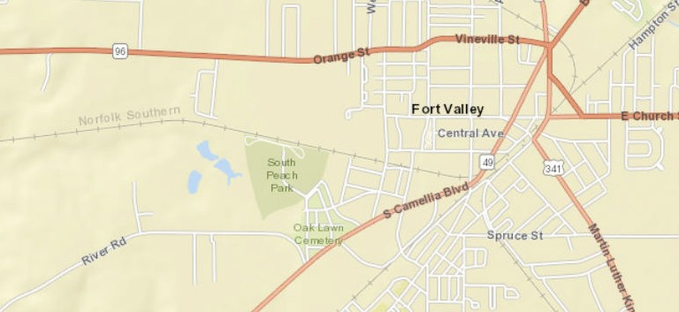
Ü

Sources: Esri, HERE, Garmin, USGS, Intermap, INCREMENT P, NRCan, Esri Japan, METI, Esri China (Hong Kong), Esri Korea, Esri (Thailand), NGCC, (c) OpenStreetMap
contributors, and the GIS User Community

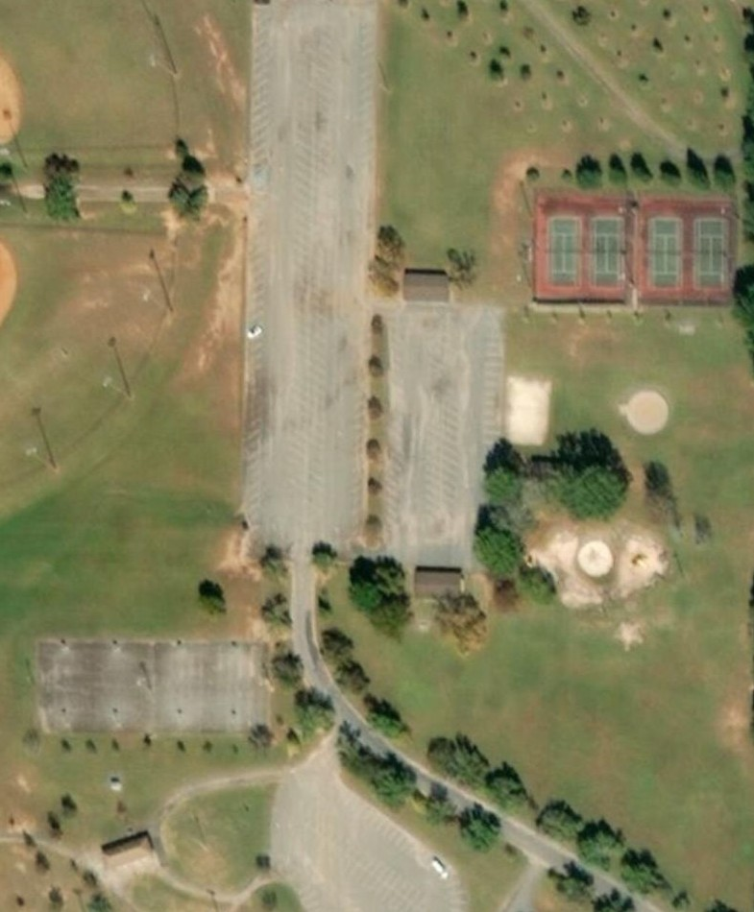
SOUTH PEACH PARK COURTS
®

1 2 3 4
TENNIS COURTS

A B C D

BASKETBALL COURTS

Source: Esri, DigitalGlobe, GeoEye, Earthstar Geographics, CNES/Airbus DS, USDA, USGS, AeroGRID, IGN, and the GIS User Community

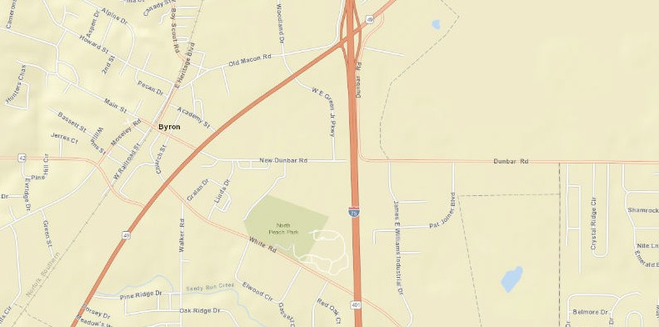
NORTH PEACH PARK, BYRON, GA
Ü
Sources: Esri, HERE, Garmin, USGS, Intermap, INCREMENT P, NRCan, Esri Japan, METI, Esri China (Hong Kong), Esri Korea, Esri (Thailand), NGCC, (c) OpenStreetMap
contributors, and the GIS User Community

E X H I B I T 6

NORTH PEACH PARK COURTS
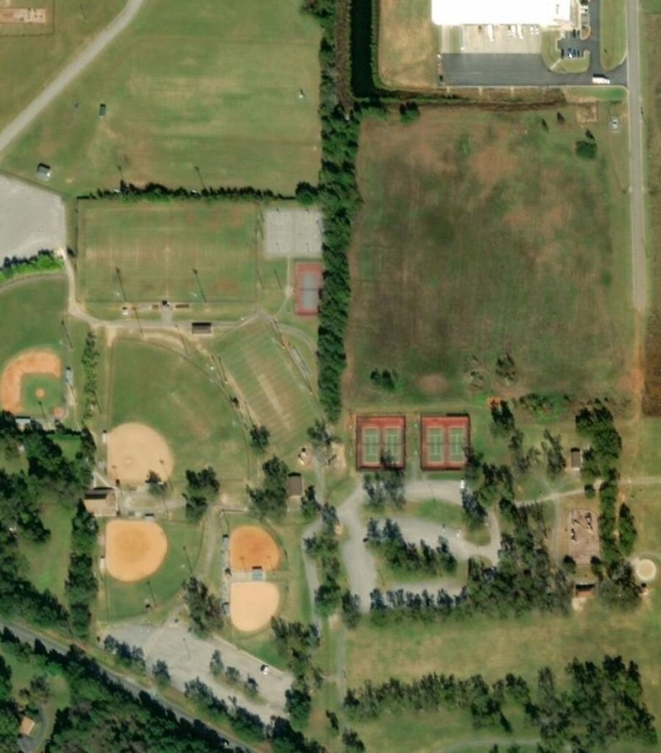
®

BASKETBALL COURTS
A B

5

TENNIS COURTS

1 2 3 4

Source: Esri, DigitalGlobe, GeoEye, Earthstar Geographics, CNES/Airbus DS, USDA, USGS, AeroGRID, IGN, and the GIS User Community

