

City of Adams, Tennessee

Paving Streets
Bid # 2022-009 Packet

Tuesday May 3rd 2022

The City of Adams, TN is requesting bids for their 2022 Paving. The City of Adams desires to obtain pricing for these paving tasks. All offerings made under this invitation shall meet or exceed the detailed requirements as set forth in the attached minimum specifications, drawings and plans, if any.

INSTRUCTION TO BIDDERS
Bid Submittal:
The bidder must submit their proposal on the “Bid Forms” provided by the City of Adams. The bid pricing must be typed or written in blue or black ink. The bids will be received by the City of Adams until the day, date and time as set forth in the “Advertisement for Bids”. The bid due date and time will be strictly observed. It is the responsibility of the bidder to ensure that their bid is delivered via mail, carrier, by hand or other method prior to the scheduled bid opening day, date and time.
Before submitting a bid or proposal each bidder shall carefully examine the project site and the specifications, drawings and plans and inform themselves fully concerning the existing conditions, and shall make their bid or proposal to provide the items covered at the lowest cost while offering the best service and quality.
Bids shall be identified on the exterior of the sealed envelope with all the information required by law, including the name of the project and the bidder's name, address and license number, expiration date and classification.

Bid Opening:
Sealed bids for the 2022 paving of three streets will be received by Adams, TN at the office of City Hall 7617 Hwy 41 N Suite 101, Adams, TN 37010 until 4:00 p.m. local time Thursday June 9th, 2022.
A bid opening will occur at the time and on the date as scheduled at 7:00 p.m. during the City Meeting on June 9th, 2022.The City of Adams reserves the right to reject any or all bids submitted.
Alternate bids and specifications are not acceptable unless specifically asked for and/or authorized in the “Advertisement for Bids”.

Bids submitted may be immediately rejected when:
• The bidder fails to use the provided bid form,
• Bid form is not signed by an authorized representative of the bidding company,
• Conditions are placed upon the bid by the bidder,
• Unauthorized additions to the bid by the bidder,
• Lack of appropriate documents as required or requested in the bid packet,

Bid Inspection:
A record shall be kept, listing each bidder by name and address and indicating their bid amounts. These records are to be open to public inspection after review and after the award to the successful bidder.
Evaluation Period:
1.The review period is following the bid opening, during which time the bids are closed to public inspection and lasts until the Adams Board of Commissioners award the project to an “Successful Bidder”.
2. During the period when evaluation is being made, all bid analysis is confidential, thereby maintaining the integrity of the bidding system.
3. None of the City of Adams personnel in any office should discuss information pertinent to any bid during this period, other than at scheduled meetings of the City of Adams personnel specifically intended for review with regard to the bid and/or project.
4. Violation of the confidentiality of bids pending award seriously compromises the City of Adams’ position in establishing contractual agreements.

During the bid review period, certain issues may be discussed with the potential “Successful” Bidder. Any failure to come to an agreement on the discussed issues may result in the rejection of that bidder’s bid and force the City of Adams to move to the next bidder in line, when deemed by the City of Adams as being in the best interest of the City of Adams.

Award of Business:
A bid shall be considered an offer subject to acceptance by the City of Adams. The City of Adams may reject any and all bids or delay or cancel the project for any reason.

Indemnity and Insurance Requirements:
The Contractor agrees to protect, defend and save harmless the City, its elected and appointed officials, agents, employees and volunteers, while working in the scope of their duties as such, from and against all claims, demands, and causes of action of any kind or character, including the cost of their defense arising from the Contractor's employees or third parties on account of bodily or personal injuries, death or damage to property arising out of services performed or omissions of service or in any way resulting from the acts or omissions of the Contractor and/or its agents, employees, subcontractors, representative or the City under this agreement.

The Contractor shall procure and maintain for the duration of the contract, at his/her own cost and expense, insurance against claims for injuries to persons or damages to property including contractual liability that may arise in connection with the performance of the work by the Contractor, his agents, representative, employees, or subcontractors under this agreement. The insurance carrier(s) must be licensed to conduct business in the State of Tennessee. The insurance will be evidenced by certificates of insurance. The certificate shall include wording that the City will be notified thirty (30) days prior to cancellation of the coverage or a major change in the coverage provided. The Contractor will either verify the listed coverage(s) for all subcontractors hired by the contractor to assist with the project, or the Contractor will assume total financial responsibility for uninsured claims of the subcontractor. The City shall be held harmless for any injuries, claims or judgments against the subcontractor. Certificates for liability coverage shall name the City as an additional insured. The following coverage will be required:
- Worker’s Compensation Insurance: A certificate shall be provided that indicates the contractor provides workman’s compensation coverage in compliance with the State Laws of Tennessee and including Employer’s Liability (Coverage B).
- General Liability Insurance with a minimum limit of $1,000,000 per occurrence. This insurance shall indicate on the certificate of insurance the following coverage:
- Broad Form Contractual
- Independent Contractor and Subcontractors
- Premises Operations
- Automobile Liability Insurance (when required) with minimum limits of $300,000 per occurrence. This insurance shall include bodily injury and property damage for the following coverage:
• Owned Automobiles
• Hired Automobiles
• Non-Owned Automobiles

Project Description:
The work consists of leveling, cleaning, tacking, milling and placing an asphalt concrete surface overlay on six streets in the City of Adams. The work described in these specifications consists of furnishing all labor, materials, tools, equipment, appurtenances, incidentals, services and performing all work required. A general description of the work to be performed includes, but is not limited to, the following items.
(1) General
(2) Degrassing
(3) Leveling Course on New Pavement Surface
(4) Clean and Grade New Pavement Edges and Shoulders

The quantities of work identified above are estimated and may vary with actual field applications. The quantities are not guaranteed to be the final scope of work. The unit prices will not be adjusted should the quantities be reduced or increased.
In the event that the bids exceed the City’s available funds, the successful bidder and the City may negotiate reducing the scope of work based on the unit prices provided. The City also has the alternative to re-bid the project.

Street List:
The streets that the city will consider for inclusion in the Bid #2022-009 Paving Streets include the following roads.

1) Murphy Street – Approximately 373 feet long and 12 feet wide
2) Pond Street (East) – Approximately 340 feet long and 12 feet wide
3) Walnut Street – Approximately 860 feet long and 16 feet wide

Requirement of Work:
Grading and Cleaning of Sides
Scratch in when needed
Material used will be E-Mix
Spray Oil before first layer.
Scratch – ¾ (inches)
Finish Coat – 1 ½ (inches)

Additional Requirements for Contractor when submitting bids:
Bidder must be licensed contractors to perform the type of construction herein described and as required by Tennessee Code Annotated.
Bidder must supply their contractor’s number with the State of Tennessee.
Bidder must also have a business license and provide a copy of their license.
Bidder must have liability and workers comp insurance and provide a copy of their certificate for each policy.
Bidder must fill out a W-9 and provide it to the City of Adams.
Bidder agrees by the submission of his bid to complete all work and provide invoicing prior to September 30th, 2022. After inspection by the City of Adams any and all work to be repaired must be completed by October 31st, 2022.
By the submission of bid, the bidder agrees to complete all work with the requirements listed on the bid packet.

Clean-up:
The Contractor shall maintain a clean and orderly project site during the course of the project. All materials shall be properly stored. All materials collected during clean-up shall be promptly removed and properly disposed of.
The Contractor shall be responsible for sweeping and cleaning of the roads both prior to, during and after repair and improvement operations. Prior to treatment, the road will be cleaned of all standing water, dirt, leaves, foreign materials, weeds, grass, etc. This work shall be accomplished by hand brooming, mechanical means, power blowing or other approved methods.

Degrassing:
Degrassing is to include the removal of intrusive grass, vegetation, accumulated debris from within the existing pavement surface and the application of a commercial herbicide such as Roundup. Degrassing shall include vegetation that has intruded perpendicularly into the pavement and also vegetation intrusion running longitudinally along the edge of the existing pavement. The removal area shall be cleaned of vegetation, mud, soil, foreign matter, and loosened particles. After removal of the vegetation the commercial herbicide shall be applied to the removal areas. In order to prevent immediate encroachment of vegetation into the pavement and also to eliminate a build-up problem, apply the commercial herbicide a minimum of 6-inches off the pavement edge. After degrassing, the surfaces shall then be thoroughly cleaned by mechanically sweepers, vacuums or hand tools.

Bid #2022-009 Paving Streets -- REFERENCE IMAGES
The exact location of the paving limits shall be coordinated at the individual roads.
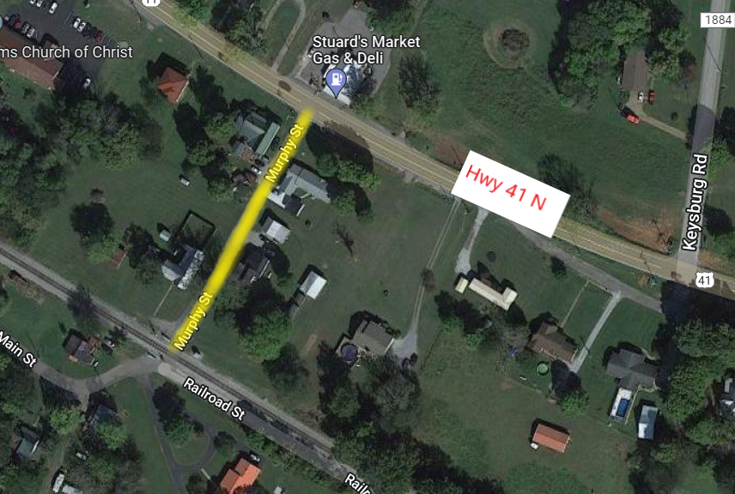

Yellow Highlighted Area: Adams TN 37010
1.) Murphy Street – Approximately 373 feet long and 12 feet wide
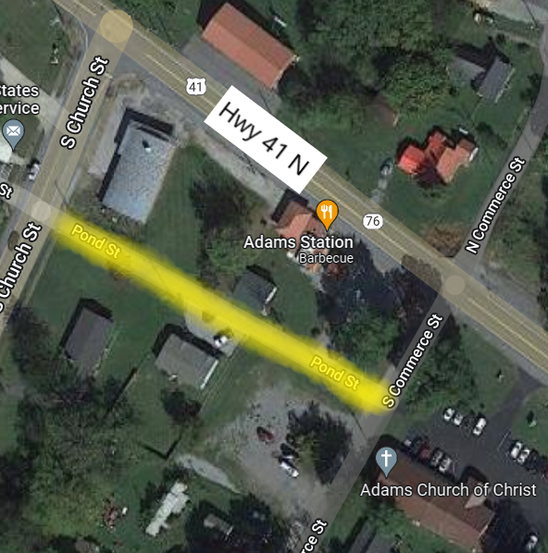

Yellow Highlighted Area: Adams TN 37010
2.) Pond Street (East) – Approximately 340 feet long and 12 feet wide

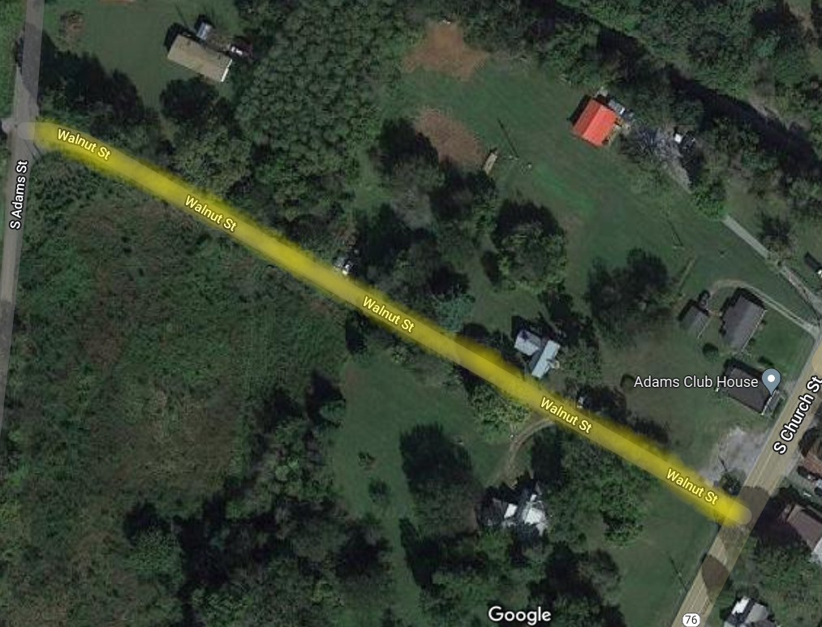

Yellow Highlighted Area: Adams TN 37010
3.) Walnut Street – Approximately 860 feet long and 16 feet wide

BID FORM: Bid #2022-009 Paving Streets
Company/Bidder: _________________________________________________________

Contact Name: ___________________________________________________________

E-mail Address: __________________________________________________________

Address: _______________________________________________________________
_______________________________________________________________
Phone: __________________________ Fax: ________________________
Federal Tax Identification # (Please send a W-9 with Bid Form): ______________________
Contractor License #__________________Contractor Classification(s): _______________
Item - Street | Footage | Bid Amount
1 – Murphy Street | 373 feet long and 12 feet wide | $
2 – Pond Street | 340 feet long and 12 feet wide | $
3 – Walnut Street | 860 feet long and 16 feet wide | $
Total of all Items (1-3) |  | $
Bid Prices

The above quantities are listed for calculation and comparison purposes only. Quantities may vary based on the City of Adams priorities and budgetary considerations.

It is further understood and agreed by the undersigned in submitting this proposal that the City of Adams reserves the following rights and privileges:
1. To accept or reject any or all bids.
CHECKLIST FOR BIDDERS FOR ALL FORMS SUBMITTED WITH BID FORM
_____Bidders shall not add any conditions or qualifying statements to this bid or the bid may be declared irregular and not being responsive to the Advertisement for Bids.
_____Bidder must be licensed contractors to perform the type of construction herein described and as required by Tennessee Code Annotated.
_____Bidder must supply their contractor’s number with the State of Tennessee.
_____Bidder must also have a business license and provide a copy of their license.
_____Bidder must have liability, workers comp, automobile insurance and provide a copy of their certificate for each policy.
_____Bidder must fill out a W-9 and provide it to the City of Adams. (Blank Form Attached)

Bidder agrees by the submission of his bid to complete all work and provide invoicing prior to September 30th, 2022. After inspection by the City of Adams any and all work to be repaired must be completed by October 31st, 2022.
By the submission of bid, the bidder agrees to complete all work with the requirements listed on the bid packet.

The undersigned BIDDER proposes and agrees, if this bid is accepted and successful, to enter into an agreement with the City of Adams, Tennessee to perform and/or furnish the goods and/or services at the prices indicated below in accordance with the terms, conditions, time frame, specifications and contract stipulations.

Bid Submitted by: ______________________________________

______________________________ _______________________________
Authorized Signature Name (Printed)

_____________________________ _______________________________
Title Date

