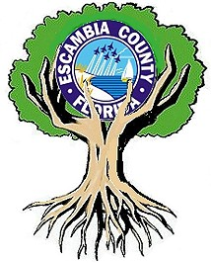
Request for Bids
Large Tree Purchase and Installation
County Park - Santa Maria Plaza
199 Madrid Rd, Cantonment, FL 32533

Original February 4, 2022
Revised February 11, 2022
Due to increased number and type of species
Escambia County, Natural Resources Management
Bid Closes February 16, 2022

The following is a request for proposals to plant twenty-nine (29) 32” to 36” root ball B&B trees. Bid is to purchase, install and water-in trees according to ANSI 300 and ISA national standards. Trees are to be rated and meet the most recent Florida No. 1 or better standard by the Florida Department of Agriculture and Consumer Services, Florida Grades and Standards for Nursery Plants. Rating standards include but not limited to no circling roots, tree height and caliper appropriate for root ball size. Trees not meeting this standard will not be accepted. Trees shall be planted per the American National Standard practices for transplanting (ANSI A300 part 6). Including:
- Watering in trees to ensure proper soil settling around root ball with “no air pockets” using up to 20 gallons of water per tree. (Depending on container size and site conditions)
- Placing tree at proper planting depth
- Cutting and folding down top 2 tiers of B&B wire basket into the planting hole
- Removing all twine, rope, wire and burlap from the top half of root ball.
- Using weed free pine straw mulch.
- Staking only if necessary
- Minimizing site disturbance

Bid should show break down pricing per species. Specify approved equal if appropriate.
“Tree planting/ installation” will be warrantied for survival for 6 months. (County will be responsible for irrigation). Trees are to have a tree well outside of the root ball area as indicated in the Tree w/ berm diagram.
Contractor may be requested to add Soil moist or like product to planting area depending on conditions Product and specifications will be supplied by the County.

Florida Grade #1 tree species:
- Six (6) Red Nuttall Oak, Quercus nuttalli 2” to 2.5” caliper
- Eight (8) Red Maples, Acer rubrum 2.0” to 2.5” caliper
- Seven (7) Willow Oak, Quercus phellos 2”to 2.5” caliper
- Four (4) Live Oak, Quercus virgininia 2”to 2.5” caliper
- Two (2) Dahoon Holly, Ilex cassine 2” caliper
- Two (2) River Birch, Betula nigra, 2.5” caliper (single trunk)

Contractor should be a member of at least one professional organization. (International Arboriculture Society, Tree Care Industry Association or Florida Nurseryman’s Association or similar). Contractor should be prepared to install trees within 2 weeks of bid acceptance. Please return bids via website or below email prior to February 16, 2022.

Santa Maria Plaza/Farm Hill Park
199 Madrid Rd, Cantonment, FL 32533

Trees are to be placed in an arrangement flagged/marked by County Staff. Trees will be planted no closer than 8 feet from walking track or permanent infrastructure. Site photos below.

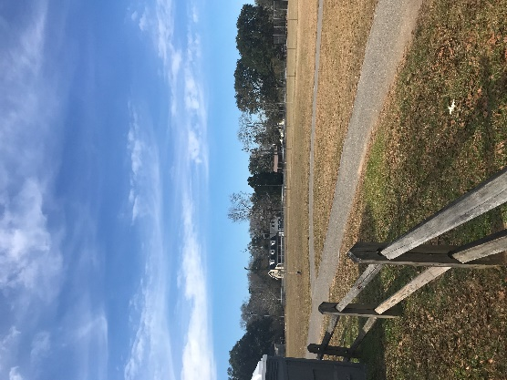
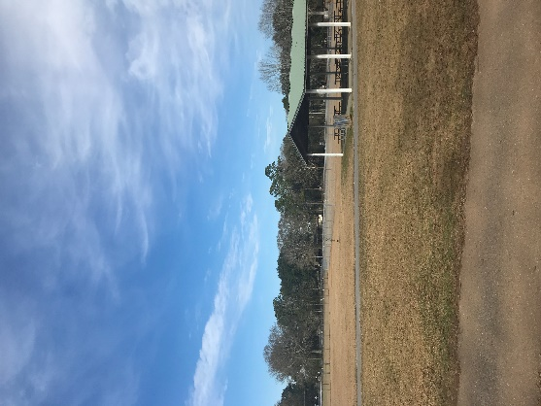
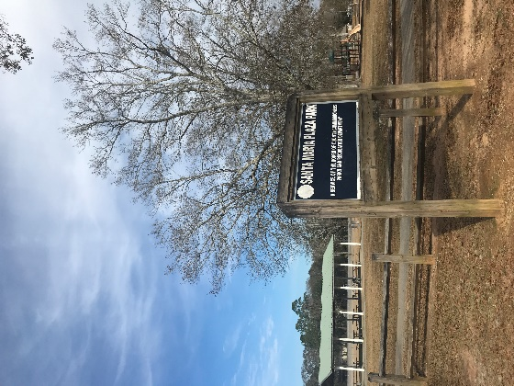

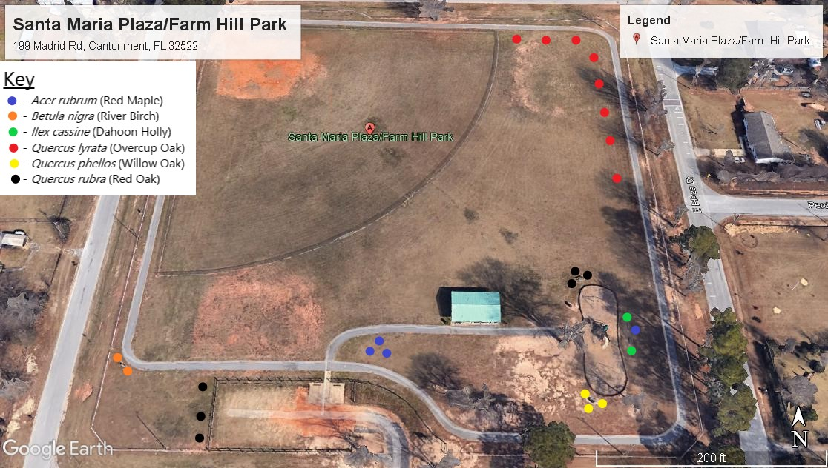

Alternating Red Maple and Willow Oak

4 Live Oak outside of
Dog Park

Additional information, please contact:
Jimmie Jarratt, ISA Arborist# FL-5447A
850-554-3071 or jnjarrat@myescambia.com
Escambia County, Natural Resources Management

