 | Legal Notice  Request for Proposal | City of Spartanburg  P.O. Box 5107  145 W. Broad Street  Spartanburg, SC. 29304  Email: cwright@cityofspartanburg.org

RFP# 1617-01-31-01
Traffic signal and interconnects
At the intersection of the St. John Street and Liberty Street.

NOTICE IS HEREBY GIVEN City of Spartanburg is requesting proposals from qualified SCDOT vendors for the installation of a NEW traffic signal and interconnects at the intersection of the St. John Street and Liberty Street.
The City of Spartanburg, hereby, notifies all proposers that it will affirmatively ensure that all disadvantaged and women’s business enterprises will be afforded full opportunity to submit proposals in response to this invitation and will not be discriminated against on the grounds of gender, race, color, or national origin in consideration for an award. Each proposer shall attest that they engaged in good faith efforts in an endeavor to achieve the City’s M/WBE goal of 10%.
The City of Spartanburg reserves the right to reject any and all Bids or to waive any informality in the bidding. Bids may be held by the City of Spartanburg for a period not to exceed sixty (60) days from the date of the opening of Bids for the purpose of reviewing the Bids and investigating the qualifications of Bidder(s), prior to awarding of the Contract.
A certified check or bank draft, payable to the City of Spartanburg, negotiable U. S. Bonds (at par value) or a satisfactory Bid Bond executed by the Bidder and an acceptable surety in an amount equal to five percent (5%) of the total bid shall be submitted with each bid.
The certified check will be returned to the successful bidder after the contract has been executed and the necessary “Bond for Construction” on the form prescribed attached to the specifications and contract has been furnished. The checks of the unsuccessful bidders will be returned after the contract has been awarded.
Each bid must be accompanied by a Bid Bond or Bank Cashier’s Check payable to the Owner for five (5) percent of the total amount of the Bid. Please seal your bid bond or Cashier’s Check in a separate envelope titled BID BOND to be opened first.
A pre-bid conference will be held January 17, 2017 at 10:00 AM at City Hall, 145 West Broad Street Spartanburg SC.
Sealed Proposals must be delivered to the Office of Procurement, Office address below, or mailed to the mailing address below. Facsimile and other electronic forms of proposal will not be accepted. All sealed proposals must be received by: 300 PM, EST, January 31, 2017 and then will be publicly opened. Sealed Proposals are subject to the conditions and all provisions set forth herein and attached.
Complete proposal package also available at http://www.cityofspartanburg.org/bid-opportunities
Proposals can be hand delivered or mailed to the following address:
City of Spartanburg
P.O. Box 5107
145 W. Broad Street
Spartanburg, SC. 29304
RFP# 1617-01-31-01
At the intersection of the St. John St. & Liberty St.
Firm’s name and address should appear on the envelope.

Deadline Enforced
Proposals or withdrawal requests, received by the Procurement Division after the time and date set for receipt of Proposals, are late and WILL NOT be accepted. Late Proposals are void and will be returned unopened to the Proposer, regardless of when they were mailed or delivered. It is the Proposer’s responsibility to ensure timely receipt by the Purchasing Department of a Proposal.

Proposal Submittal Documents Checklist:
Items must be provided, in the order listed, as a Proposal package, or Proposal may be disqualified. Proposal shall not exceed, with requested options, 50 pages. Provide one original and three copies of ALL submittal documents, all unbound, no tabs.

All Eight (12) Proposal submittal documents must be included with the Proposal, or Proposal may be disqualified.

- Page 1 Cover Sheet give bidder license information (Exhibit A)
- Page 2 Bidder’s Price page (Exhibit G)
- Page 3 Bonding Information * showing the surety sear imprint.
- Page 4 Authority to execute an contract (Exhibit C)
- Page 5 Conflict of Interest Disclosure (Exhibit E)
- Page 6 Drug Free Workplace Act Statement – (Exhibit F)
- Page 7 Existence of Subcontractors Form – (Exhibit H)
Page 8 Experience/ References – (Exhibit J)
- Page 9 AFFIDAVIT OF NON-COLLUSION
Page 10 Disadvantage Business Enterprise Good Faith Efforts.
- Page 11 Debarment statement
- Page 12 CERTIFICATION OF NON-SEGREGATED FACILITIES

The Winner must:

- Provide a certificate of insurance – (Exhibit, contains an example)
- Provide worker’s compensation documents
- Sign the City of Spartanburg Standard Contract – (Exhibit)
- Provide a City of Spartanburg business license link- http://www.cityofspartanburg.org/cms_assets/business_licensing/BL%20App%202016.pdf

Cover Bid Page
Page 1
(Exhibit A)
Request for Proposal for
Traffic Signal and Interconnects
At the intersection of the St. John Street and Liberty Street.

Job Number 0000000 | Bid Number
FROM:
Bidder Name |  | Date
Bidder’s License No | Contractor’s License No
The undersigned, as bidder, hereby declares that the only person, interested in this bid as principals(s) is, or are, named herein, and that no other person has any interest in the bid or the contract to be entered into; that his bid is made without connection with any person, company or parties making a bid; and that it is an all respects fair and in good faith without collusion or fraud.

The bidder further declares that he has examined the site of work and informed himself/herself fully in regards to all conditions pertaining to the place where the work is to be done; that he was/she examined the contract documents relative thereto; and that he /she satisfied himself/herself a to the work to the performed.

The bidder further agrees to commence work on the date stipulated in the notice to proceed and to fully complete the project within the number of consecutive calendar days thereafter as listed below. The bidder also agrees to pay as liquated damages, the sum as listed below for each consecutive calendar day thereafter the project remain impleaded.

Completion Time: 45 Days Liquidated Damages: 300.00 per day

The undersigned bidder agrees that if this proposal shall be accepted, the undersigned will, within then (10) days after notifications of such acceptance, enter into the contract for their performance of all work proposed under this improvement within the number of calendar days as stated herein, and, as a guaranty of the faithful performance therefor, to furnish at the time of executing the contact a performance bond in an amount not less than one hundred percent (100%) of the total amount bid, and with sureties subject to the approval of the owner.

The work consists of the approximate quantities shown herein which will be used as a basis for comparison of bids and not for final estimate. The owner does not, by expression or by implication, agree that the actual amount of work will correspond with the estimated quantities.

In case of error in extension, the unit price shall govern rather that the amount For lump sum items, the individual amounts shall govern the total of the bid in case of discrepancy.

Owners may delete from the contract any or all of the alternates listed in the bid form

The prices and amounts listed below include all labor, material, tool equipment, transportation, removal, overhead, profit, insurances, taxes, etc., to cover the finished work in place

Term of Proposal: Any Proposal submitted as a result of this Request for Proposal (RFP) shall be binding on the Proposer for sixty (60) calendar days following the specified opening date. Any Proposal for which the Proposer specifies a shorter acceptance period will be rejected. At the end of the sixty (60) calendar day period, Proposals may be withdrawn by submitting a written request to the Procurement Manager. The written request to withdraw the proposal must be received, regardless of when it was mailed, by the Procurement Manager within five (5) calendar days after expiration of the sixty (60) calendar day period, or the proposal shall remain in effect until an award is made or the RFP is cancelled.

Every effort has been made to ensure that all information needed is included in this document. If the proposer finds that they cannot complete its response without additional information, it may submit written questions or requests for clarification to the City of Spartanburg Procurement Division by email to cwright@cityofspartanburg.org. Written questions shall be submitted at least five (5) calendar days prior to proposal’s submission date. Questions submitted after this date will be rejected as not timely. Where the proposer fails to seek clarification, the City’s interpretation shall control. The proposer agrees it will not make any claim for, or have right to withdraw its proposal because of any misunderstanding or lack of information. Proposals are not to have any exclusions. Exclusions will come from City in the form of an addendum. Any proposals received with exclusions will not be accepted.

Questions regarding bid procedures or Technical questions should be directed to Carl Wright, Procurement and Property Manager at cwright@cityofspartanburg.org.
A Proposal received by City is considered a public document under provisions of the South Carolina Freedom of Information Act (FOIA) unless it contains information that may clearly be considered accepted and excluded from disclosure according to State statute. Offeror(s) shall visibly mark as “Confidential” each part of their proposals which they consider proprietary information that could be exempt from disclosure under Section 30-4-40, Code of Laws of South Carolina – the Freedom of Information Act (FOIA). The “Confidential” mark should be in bold font of at least 12-point type, in the upper right hand corner of each page. If any part is designated as “Confidential,” there must be attached to that part an explanation of how the information fits within one or more categories listed in Section 30-4-40. The City of Spartanburg reserves the right to determine whether this may be brought against the City of Spartanburg or its agent for its determination in this regard. MARKING YOUR ENTIRE PROPOSAL CONFIDENTIAL/PROPRIETARY IS NOT IN CONFORMANCE WITH THE SOUTH CAROLINA FREEDOM OF INFORMATION ACT ABSENT EXPLANATION PROVIDING AN EXEMPTION UNDER SECTION 30-4-40.

Procurement policy: This solicitation is subject to the provisions of the City of Spartanburg Procurement policy and any revisions thereto. A copy of the Purchasing Policy may be obtained from the City’s webpage (www.cityofspartanburgCity of Spartanburg .org) or from the Procurement Division (864) 596-2790. City of Spartanburg reserves the right to negotiate and contract with any individual firm deemed suitable to provide the services required.

Applicable Laws and Compliance: This RFP and any proposal submitted in response thereto shall be governed in all respects by the laws of the State of South Carolina. The Proposer shall comply with applicable Federal, State, and local laws and regulations. By submitting this Proposal, the Proposer certifies it is currently and will remain in compliance with:
- The Federal Civil Rights Act of 1964, as amended;
- The Federal Immigration Reform and Control Act of 1986;
- The Americans with Disabilities Act

Proposer is responsible for securing all required business licenses and permits. If requested, Proposer will furnish a copy to the City.

Link to form
http://www.cityofspartanburg.org/cms_assets/business_licensing/BL%20App%202016.pdf

Public Record: Upon award, or Protest, copies of the Proposals will be made available for public inspection, under the supervision of City of Spartanburg Procurement staff, from 9:00 a.m. until 4:00 p.m., Monday through Friday, at 145 West Broad Street Spartanburg, South Carolina

Debarment Status: By submitting a Proposal, Proposers assert that they are not currently debarred from proposing on contracts by any agency of the State of South Carolina, the federal government nor are they an agency of any person or entity currently debarred from submitting Proposals on contracts by an agency of the State of South Carolina or any federal agencies.

Proposer Responsibility: The Proposer must assume that any purchase, responsibility, insurance, and action or activity which is necessary for the satisfactory operation of the services requested in this RFP, but which is not specifically designated as a Spartanburg City of Spartanburg responsibility, is a responsibility of the Proposer’s operation, and the Proposer must include these in the response to this RFP.

Davis Bacon Wage Determination: Contractor is required to submit Certified Payroll with each monthly Payment Application. Davis-Bacon requires that the wage paid to employees must be equal to or higher than the U.S. Department of Labor’s (DOL) determination of the prevailing wage rates for the project type and locality in which the work is being done. Please visit: http://www.dol.gov/whd/contracts/dbra.htm for details and applicable wage rates.

Disclosure of Conflicts of Interest or Unfair Competitive Advantage: Proposer warrants and represent that Proposal identifies and explains any unfair competitive advantage Proposer may have in competing for the proposed contract and any actual or potential conflicts of interest that may arise from participation in this competition or receipt of an award. The two underlying principles are (a) preventing the existence of conflicting roles that might bias a contractor’s judgment, and (b) preventing an unfair competitive advantage. If Proposer has an unfair competitive advantage or a conflict of interest, the City of Spartanburg may withhold award. Before withholding award on these grounds, a Proposer will be notified of the concerns and provided a reasonable opportunity to respond. Efforts to avoid or mitigate such concerns, including restrictions on future activities, may be considered.

Proposer Qualification: The Spartanburg City of Spartanburg Government may make such reasonable investigations as deemed proper and necessary to determine the ability of the Proposer to perform stipulated contract work and the Proposer shall furnish the City of Spartanburg Government all such information and data for this purpose as may be requested. Only contractors on the SCDOT approved traffic signal contractor list may quote this work. The necessary SCDOT documentation reflecting State Contract status/eligibility.
Project Schedule: Based on the days to complete listed on the Proposal, provide a detailed schedule for completion to include the critical path, when applicable.

Insurance: By submitting a proposal, Proposer agrees to maintain and keep in force during the life of any Contract awarded pursuant to this RFP, with a company or companies authorized to do business in South Carolina, the following insurance policies:

Commercial General Liability:
$1,000,000 per occurrence – (Coverage shall include bodily injury or accidental death and property damage)*

Comprehensive Automobile Liability:
$1,000,000 per occurrence - combined single limit (Coverage shall include bodily injury and property damage and cover all vehicles including owned, non-owned and hired)*

Statutory Worker's Compensation:
Coverage – (Shall apply to all applicable State of SC laws)

Employers Liability:
$500,000 Each Accident*
$500,000 Disease, Per Employee*
$500,000 Disease, Policy Limit*
Professional Liability Insurance:
$1,000,000 per occurrence (if applicable)
Umbrella Policy:
N/A
* A combination of Umbrella/ Excess and primary limit may be used to provide coverage for the amount shown.

Proposer will provide City of Spartanburg a minimum of thirty (30) days advance notice in the event the insurance policies (or an insurance policy) are changed or canceled.

Proposer certifies to the City of Spartanburg that all subcontractors approved to perform work on this project comply with all of the requirements in this Section.

Certificate of Insurance: A copy of current Certificate of Insurance must be included with the Proposal. Certificates of Insurance for all such policies shall be provided by the Proposer’s insurance agent or broker within ten (10) working days from the date of Notice of Award and shall meet the following requirements:
- City of Spartanburg SHALL BE NAMED AS “ADDITIONAL INSURED” FOR ITS INTEREST on Commercial General Liability and any Umbrella policies, regarding ongoing operations, products and completed operations, and this shall be noted on the face of the Certificate of Insurance.

(ii) WAIVER OF SUBROGATION. As a part of the Certificate of Insurance requirement the Proposer shall also include acknowledgement and acceptance of the waiver of subrogation provision granted to the City of Spartanburg of Spartanburg, its departments, agencies, boards, employees, and commissions for losses from work performed by or on behalf of the Proposer. This acknowledgement and acceptance should be included in the same section of the Certificate of Insurance that evidences the “Additional Insured” provision.
(iii) All Certificates of Insurance submitted shall provide on the face of the certificate reference to the RFP Number

Subcontractors: Proposer shall not subcontract work hereunder without the prior written consent of the City, and any such subcontract without consent of the City shall be null and void. If Proposer proposes to subcontract any of the work hereunder, it shall submit to the City the name of each proposed Subcontractor, with the proposed scope of work which its Subcontractor is to undertake. Alternatively, the Proposer shall provide a statement that there are no subcontractors.

Service Providers: When applicable, list up to three independent firms, within 300 miles of the City of Spartanburg that can provide service work to the Proposer’s system. Provide names and direct telephone numbers.

References: The City of Spartanburg requires Proposers to list at least three (3) references, names, addresses and telephone numbers of contact persons for other companies in South Carolina or neighboring states with whom the proposer has performed or provided similar work, service or product (ie. currently operate the same model number of equipment being proposed) within the last five years. References should be listed on Exhibit I.

Experience: List five jobs, similar in size, completed by Proposer, within 100 miles of Spartanburg City of Spartanburg, for Governmental entities. List dollar amount, brief description reference name and phone number for each job.

Contractor Qualifications: When applicable a Contractor Qualification Form will be required requesting the following information:
- SIC/ NAICS Code
- OSHA Recordable Incident Rate
- EMR Rate – Provide letters from insurance companies listing proposer and subcontractor EMR ratings. EMR rating letters must be on insurance company letterhead.
- Worker’s Compensation Loss Run

Factors (a) through (d) may be used in conjunction with other required submittal documents as part of the determination process. The City of Spartanburg reserves the right to evaluate in its absolute discretion the information submitted.

City License: Proposer is required to submit a copy of its current City of Spartanburg Business license for services being procured.

Bid Bond: If applicable, Proposer shall submit with their proposal a bid bond in the amount of five percent (5%) of the proposal price. This bond may be in the form of Certified Check, Cashier’s Check or Bank Money Order of any national or state bank and shall be made payable to Spartanburg City of Spartanburg . Proposals submitted without being accompanied by any of the foregoing, as required, shall be considered non-responsive and will be rejected. Any proposal accompanied by a bid bond not properly executed in the opinion of the Procurement Director, may be rejected. The bond will be forfeited to the City of Spartanburg by the successful Proposer as liquidated damages in case a bid award is made to that Proposer and the contract and bond are not properly executed within 15 days, unless extended by the City of Spartanburg.

A check or money order will be returned to the unsuccessful bidders after award and will be returned to the successful offeror after acceptance of the final contract and surety by the offeror.

Performance and Payment Bond: If applicable, the successful proposer, within three (3) working days after acceptance of the proposer’s offer by the City of Spartanburg, shall furnish a satisfactory performance and payment bond in the amount of the total proposal price. The performance and payment bond must be received by the City of Spartanburg prior to the issuance of the executed contract and Notice to Proceed. The three (3) working days may be extended upon written approval by the Procurement Director. A copy of the written approval shall be transmitted to the successful proposer stating the terms of any extension. In the event that the proposer fails to deliver to the Purchasing Department the performance and payment bond in said period of three (3) working days after acceptance of the proposer’s offer by the City of Spartanburg, then the bid bond of the proposer shall be retained by the City of Spartanburg in its entirety and the award will be withdrawn from the proposer. The Bond must be in a format approved by the City of Spartanburg before it is made effective. The successful proposer shall have a surety a corporate surety authorized to act as surety in South Carolina. The Performance and Payment Bond will insure that the successful proposer will promptly make payments to all persons supplying labor or materials to the proposer; and shall guarantee to indemnify and save the City of Spartanburg , its officers, divisions and employees harmless from all costs, damages and expenses growing out of or by reason of the successful proposer’s failure to comply and perform the work and complete the contract in accordance with the specifications in the matter of making, furnishing and/or delivering said work or supplies.

A letter from a South Carolina Banking Institution stating the Proposer has the ability to obtain an Irrevocable Letter of Credit in amount of Proposal is an acceptable substitute. The South Carolina Banking Institution who issues the letter stating the Proposer has the ability to obtain an Irrevocable Letter of Credit must be a financial institution insured by the FDIC or FSLIC.

An Irrevocable Letter of Credit, made out to City of Spartanburg, in the full amount of Proposal, will be an acceptable substitute. The Letter of Credit will be subject to the same terms and conditions set forth above for Bonds. The Irrevocable Letter of Credit shall be issued by a financial institution insured by the FDIC or FSLIC.

At the end of the job, all of the Proposer’s subcontractors shall send a letter, on company letterhead, that they have been paid in full and City of Spartanburg can release the performance/payment bond.

Ability to Obtain Performance Bond: If applicable, Proposer shall provide a letter from a bonding company authorized to transact business in the State of South Carolina as a surety stating the Proposer has the ability to obtain a performance/payment bond in amount of Proposal.

Independent Contractor: The selected Proposer shall be legally considered an independent contractor and neither the Proposer nor its employees shall, under any circumstances, be considered employees of the City of Spartanburg; and the City shall at no time be legally responsible for any negligence or other wrong doing by the Proposer or its employees. The City shall not withhold from the contract payment to the Proposer any federal or state unemployment taxes, federal or state income taxes, Social Security tax, or any other amounts for benefits to Proposer. Further, the City shall not provide to the Proposer any insurance coverage or other benefits, including Worker’s Compensation.

The City shall have the right to reject any Subcontractor which it considers unable or unsuitable to satisfactorily perform its duties. Proposer shall not enter into any cost reimbursable agreements with any proposed Subcontractor without City’s prior written authorization. Notwithstanding any consent by the City to a proposed subcontract, Proposer shall remain responsible for all subcontracted work and services. Proposer agrees it shall be as fully responsible to the City for the acts and omission of its Subcontractors, their agents, representatives, and persons either directly or indirectly employed by them as it is for the acts and omissions of persons directly employed by Proposer. Neither this provision, the agreement, the City’s authorization of Proposer’s agreement with Subcontractor, City’s inspection of a subcontractor’s facilities or work, or any other action taken by the City in relation to a Subcontractor shall create any contractual relationship between any Subcontractor and the City. Proposer shall include in each of its subcontracts a provision embodying the substance of this provision and provide a copy, upon request, to the City before commencement of any work by a Subcontractor. Proposer’s refusal to comply with this provision shall be grounds for the City’s termination of this agreement for default, without notice or opportunity to cure.

In addition, Proposer indemnifies and holds the City harmless from and against any claims (threatened, alleged or actual) made by any Subcontractor of Proposer (of any tier) for compensation, damages or otherwise, including any cost incurred by the City of Spartanburg to investigate, defend or settle any such claim.

Award:
Evaluations:
City of Spartanburg will conduct evaluations of the proposals.

Award Criteria:
Spartanburg City of Spartanburg shall evaluate each of the Proposals using the criteria set forth in Exhibit D attached hereto. The City reserves the right to request Proposers to appear for an additional presentation followed by a question and answer period, in order to further evaluate qualifications. The additional presentations, if any, will also be scored and combined with prior scoring to determine the successful Proposer. The City of Spartanburg is not obligated to accept the lowest cost proposal. The award of the contract, if awarded, will be made to the Proposer providing the most responsive, responsible proposal that provides the best overall value and service. The award, if awarded, will take into consideration several factors, including the soundness and flexibility of the proposal, functional capability, quality of performance, quality of service, ability to provide support, overall cost, the Proposer’s experience and the Proposer’s references. At the City’s discretion, one or more firms may be engaged for this work.

CITY OF SPARTANBURG RESERVES THE RIGHT TO ACCEPT OR REJECT ANY OR ALL PROPOSALS OR PARTS THEREOF, TO GIVE THE PROPOSER THE OPPORTUNITY TO CURE ANY DEFICIENCY RESULTING FROM A MINOR INFORMALITY OR IRREGULARITY IN A PROPOSAL OR WAIVE ANY DEFICIENCY, AS SET FORTH IN THE CITY OF SPARTANBURG PROCUREMENT POLICY.

Notice of Intent to Award:
If awarded, the Notice of Intent to Award shall be e-mailed to all Proposers once a decision to award is made. This Notice of Intent to Award shall begin the time to protest the decision to award in accordance with City of Spartanburg protest provision.

Notice of Award:
If awarded, the Notice of Award shall be e-mailed and or posted to all proposers once a decision to award is made.
Exhibit A
SCOPE OF WORK / SERVICES TO BE PROVIDED

City of Spartanburg Traffic Services Department, located in City of Spartanburg, South Carolina, has secured funding for the installation of a traffic signal and interconnects at the intersection of the St. John Street and Liberty Street.
The Proposer who is awarded the contract shall perform and carry out, those services necessary to complete a traffic signal and interconnects at the intersection of the St. John Street and Liberty Street.

SCDOT TRAFFIC SIGNAL SUPPLEMENTAL TECHNICAL SPECIFICATIONS REVISED 5/16/2016 Traffic Signal Supplemental Technical Specifications Table of Contents links are found below:

http://www.scdot.org/doing/technicalpdfs/publicationsmanuals/trafficengineering/traffic_signal_supp_specs.pdf
http://www.scdot.org/doing/technicalpdfs/publicationsmanuals/trafficengineering/trafficsignal_materialspecs.pdf

The intersection pavement markings and are shown on the traffic signal plan sheet. These markings MUST be included in the bid.
An estimated list of equipment and materials will be provided for the convenience of the Proposer, but it is the Proposer’s responsibility to verify this list. The signal installation, the interconnect work at the adjacent signals, and the pavement markings will be bid as one lump sum.
This equipment will be supplied by City of Spartanburg Traffic Services:
- 336 Cabinet Assembly
- 2070 L Controller

It is the responsibility of the bidder to furnish and install a complete and operational signal and interconnect installation. The project will be considered complete upon acceptance by the SCDOT.
Encroachment permit application has been submitted. For copies of the signal plans and list of equipment, call Mike Ridgeway (803) 252-1799 or e-mail at mridgeway@srengr.com. Mike Ridgeway also the contact for questions about the plans.
- Contractor shall also supply unit price for interconnect.
Exhibit B
INSTRUCTIONS TO PROPOSERS

- Enter Proposer’s name on any specifications or descriptive papers submitted with this Proposal.
- Show trade name or brand of any article included in the specifications.
- When required, furnish samples, free of expense, prior to the Proposal opening. Label each sample with Proposer’s name and the item number. Should you wish samples returned, at your expense, when not destroyed in tests, please indicate such in writing at the time of submission of the sample.

- Proposals must be submitted on this form. Proposals made otherwise will be subject to rejection.
- Lump sum proposal price must include the amount of ALL FEES charged by Proposer. Proposals that do not include all fees will be rejected.

- Lump sum proposal price must include the amount of ALL TAXES, including any South Carolina state sales tax. Proposals which do not include all taxes may be rejected.

- Lump sum proposal price must include ALL COSTS OF TRANSPORTATION AND DELIVERY to the required destination. Proposals which do not include all costs of transportation and delivery will be rejected.

- This Proposal is subject to the City of Spartanburg Procurement policy and the attached City contract.

- If someone other than an officer of the corporation/company will be signing the contract, a corporate/company resolution MUST be attached to the proposal authorizing the individual to sign. Proposals that do not include a corporate/company resolution, when required, will be subject to rejection.

- This RFP provides basic information regarding the City of Spartanburg requirements. Items that are not specifically requested in this RFP, but are necessary to provide the goods/services requested, must be included in the Lump Sum Proposal Price.

Exhibit G
Page 2
Exhibit G
 | Price Page  Request for Proposal  Traffic signal and interconnects | City of Spartanburg  P.O. Box 5107  145 W. Broad Street  Spartanburg, SC. 29304  Email: cwright@cityofspartanburg.org
CITY OF SPARTANBURG
Traffic signal and interconnects
At the intersection of the St. John Street and Liberty Street.

Proposer has examined this Request for Proposal, the Advertisement for this Request for Proposal, and the following Addenda (receipt of which is hereby acknowledged):
Company Name: ______________________________________________
By: ______________________________________________ (Signature)
______________________________________________ (Printed Name)
Title: ______________________________________________
Date: ______________________________________________

Address: ________________________________________ Email: ________________________________________________
City: ___________________________________________ State: ______________________ Zip: ______________________
Telephone: ___________________________________________ Fax: _________________________________________________
□ Check box if corporate/company resolution attached (See Instruction 9 above).

Addenda Number: _________ Date: ______________________
Addenda Number: _________ Date: ______________________
l

BASE PRICE for $ _______________________

Proposer would be able to complete the installation by _______________________
Cost for _____________ as an option: $ _______________________
Cost for _____________ as an option: $ _______________________
Cost for _____________ as an option: $ _______________________
Please complete the provided proposal sheet which outlines the cost.

By: ______________________________________________ Title: __ _

Signature: ______________________ ______________ Date: ___________________________

Address: _____________________ ___

Telephone / ___________ ______ Email:_______________________________________
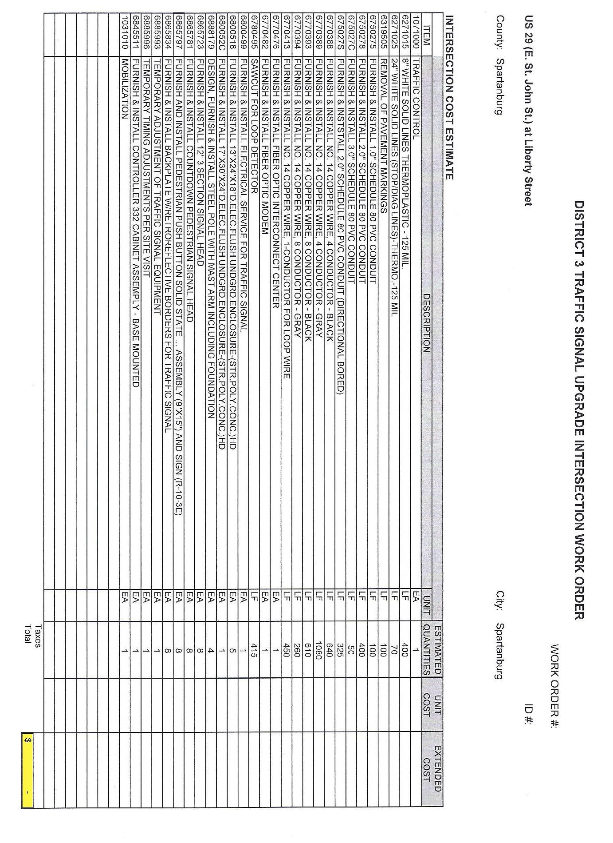
Page 2b

The Security Company’s Seal MUST be affixed to both documents
Page 3

BID BOND BOND #_____________

KNOW ALL MEN BY THESE PRESENTS, that we,_________________________________________

as Principal, hereinafter called the Principal, a corporation partnership individual duly authorized by law to do business as a construction contractor in the state of South Carolina and

(Surety Company name)

a corporation duly authorized to do a surety business under the Laws of the state of South Carolina as Surety, hereinafter called the Surety, are held and firmly bounds unto the Board of Regents, South Carolina as Obligee, hereinafter called the Obligee, in the penal sum of

 | Dollars | $

OR

5 | % of the bid

for the payment of which sum well and truly to be made, the said Principal and the said Surety, bind ourselves, our heirs, executors, administrators, successors and assigns, jointly and severally, firmly by these presents.

WHEREAS, the principal has submitted a bid for the project named:

NOW, THEREFORE, if the Obligee shall accept the bid of the Principal and the Principal shall enter into a Contract with the Obligee in accordance with the terms of such bid, and give such bonds as may be specified in the bidding or Contract Documents with good and sufficient surety for the faithful performance of such Contract and for the prompt payment of labor and material furnished in the prosecution thereof, or in the event of the failure of the Principal to enter such Contract and give such bond or bonds, if Principal shall pay to the Obligee the difference not to exceed the penalty hereof between the amount specified in said bid and such larger amount for which the Obligee may in good faith contract with another party to perform the Work covered by said bid, then this obligation shall be null and void, otherwise to remain in full force and effect.

Signed and sealed this |  | day of |  |  | 20
 |  |  |  | Principal
 |  |  |  | Signature
 |  |  |  | Print or type name signed above
 |  |  |  | Title
 |  |  |  | Surety Seal
 |  |  |  | Signature
 |  |  |  | Print or type name signed above

The Security Company’s Seal MUST be affixed to both documents
Exhibit C
Page 4
Exhibit C
Sample of Corporate / Company Resolution

A RESOLUTION

FOR THE PURPOSE OF AUTHORIZING _______________ TO EXECUTE AN CONTRACT WITH SPARTANBURG CITY

WHEREAS, ____________________ will or has submitted a bid/proposal to Spartanburg City of Spartanburg for the purpose of providing goods or services; and

WHEREAS, ____________________ may be or has been awarded a contract to provide good or services to Spartanburg City of Spartanburg ; and

WHEREAS, ____________________Type of Organization is :
Check the applicable box):
□ Sole Proprietorship
□ Partnership
□ Corporate entity (not tax-exempt)
□ Corporate entity (tax-exempt)
□ Government entity (Federal, State or Local)
□ Other _____________________________

NOW THEREFORE BE IT RESOLVED that the Board of Directors (or other appropriate governing body) of __________________ does hereby approve and authorize _________________ (Name of Individual) to execute a contract with Spartanburg City of Spartanburg in an amount not to exceed $______________.__.

ADOPTED AND APPROVED this ____ day of ________, 20__.

NAME OF ORGANIZATION [ ]
ATTESTED
________________________ By: _________________________________ (signature)

_________________________________ (printed name)

Title: _________________________________

Exhibit D
EVALUATION / AWARD CRITERIA
Note: The proposals will be publicly opened. Only the names of the proposers and prices will be disclosed at the opening. Contents of the proposal shall not be disclosed during the evaluation or negotiation phases. Proposals shall be available for public inspection after award of the agreement. Proposals must be clearly marked "CONFIDENTIAL" for each part of the proposal that is considered to be proprietary information that could be exempt from disclosure under Section 30-4-40, Code of Laws of South Carolina, 1976, as amended ("South Carolina Freedom of Information Act"). If any part is designated as "CONFIDENTIAL", there must be attached to that part an explanation of how this information fits within one or more categories listed in Section 30-4-40. The City of Spartanburg reserves the right to determine whether this information should be exempt from disclosure.

City of Spartanburg shall evaluate each written proposal, determine whether oral discussions are necessary, then based on the content of the written proposal and any oral discussion, select the proposer best qualified for the project and which is most advantageous to City of Spartanburg, based on the following factors listed below.
The evaluation criteria will be:

- Specifications Compliance — 30%
- Cost Requirements — 30%
- Service and Warranty Requirements - 20%
- Capabilities of Firm, Training and References — 20%

Award Criteria:
City of Spartanburg shall evaluate each of the Proposals using the criteria set forth in Exhibit D attached hereto. The City reserves the right to request Proposers to appear for an additional presentation followed by a question and answer period, in order to further evaluate qualifications. The additional presentations, if any, will also be scored and combined with prior scoring to determine the successful Proposer. The City of Spartanburg is not obligated to accept the lowest cost proposal. The award of the contract, if awarded, will be made to the Proposer providing the most responsive, responsible proposal that provides the best overall value and service. The award, if awarded, will take into consideration several factors, including the soundness and flexibility of the proposal, functional capability, quality of performance, quality of service, ability to provide support, overall cost, the Proposer’s experience and the Proposer’s references. At the City’s discretion, one or more firms may be engaged for this work.

Representatives of City of Spartanburg will evaluate individual proposals. Any proposer determined to be technically unqualified, or whose proposal is deemed unresponsive, will not be considered further. Any proposer that has demonstrated poor performance during either a current or previous agreement with City of Spartanburg may be considered as an unqualified source and their proposal may be rejected. City of Spartanburg reserves the right to exercise this option as is deemed proper or necessary.

Exhibit E
Page 5
Exhibit E
CITY OF SPARTANBURG, SC
Bidder Conflict of Interest Disclosure Form

RELATED PARTY RELATIONSHIP & TRANSACTIONS
QUESTIONNAIRE

The information called for in this questionnaire is for use by the City of Spartanburg in connection with its risk assessment procedures and related activities

Does your organization have any officers, managers, employees, or officials that are related to
any employees, officials, board members, committee members or City Council Members of the
City of Spartanburg, SC?

____ No (Please sign the certification below and promptly return this page with the W‐9)

____ Yes (Please sign and provide the name(s) of the individual(s)

CERTIFICATION
I certify that the information herein supplied in response to this questionnaire is complete and
correct to the best of my knowledge and belief and understand that the information
submitted is subject to audit and verification by the City of Spartanburg.
___________________________ ______________________ ________________
Name of Authorized Official Title of Authorized Official Date

____________________________________________ ________________________________ __________________________________
Signature Phone Email Address

__
______

Exhibit F
Page 6
Exhibit F
DRUG FREE WORKPLACE ACT STATEMENT
The undersigned hereby certifies on behalf of the company listed below that it is in full compliance with the requirements set forth in Title 44, Code of Laws of South Carolina, 1976, Chapter 107, Paragraph 47 and the Drug-Free Workplace Act of 1988 (Public Law 100-690, title V, Sec. 5153, as amended by Public Law 105-85, Div. A, Title VIII, Sec. 809, as codified at 41 U.S.C. § 702) and Department of Commerce implementing regulations published at 15 CFR Part 29, “Government-wide Requirements for Drug-Free Workplace (Financial Assistance)” (published in the Federal Register on November 23, 2003, 68 FR 66534).

___________________________________
(Name of Corporation or Entity)

By: _______________________________ (Signature)
___________________________________ (Print name)
Title: ___________________________________
Date: ___________________________________

Page 7
Exhibit H

Exhibit H
EXISTENCE OF SUBCONTRACTORS FORM

Will you subcontract any part of this Work? Yes ____ No ____ If so, please list the names, addresses and licenses of the subcontractors to be used for the portions of the work listed below.
- SUBCONTRACTOR NAME ___________________________________
SUBCONTRACTOR DUTY ___________________________________
TYPE OF LICENSE: ________________________________________________
(Attach copy of subcontractor license)

- SUBCONTRACTOR NAME ___________________________________
SUBCONTRACTOR DUTY ___________________________________
TYPE OF LICENSE: ________________________________________________
(Attach copy of subcontractor license)

- SUBCONTRACTOR NAME ___________________________________
SUBCONTRACTOR DUTY ___________________________________
TYPE OF LICENSE: ________________________________________________
(Attach copy of subcontractor license)

- SUBCONTRACTOR NAME ___________________________________
SUBCONTRACTOR DUTY ___________________________________
TYPE OF LICENSE: ________________________________________________
(Attach copy of subcontractor license)

- SUBCONTRACTOR NAME ___________________________________
SUBCONTRACTOR DUTY ___________________________________
TYPE OF LICENSE: ________________________________________________
(Attach copy of subcontractor license)

Exhibit I
Page 8
Exhibit F
EXPERIENCE/ REFERENCES
List five jobs, similar in size, completed by Proposer. List dollar amount, brief description reference name and phone number for each job.
- Name of Project: _____________________________________________ Owner/Engineer: _____________________________________________ Telephone No.: _____________________________________________ Address: _____________________________________________ Date Started: ______________ Date Completed: ________________ Value of Contract: ___________________________________________ Project Description: __________________________________________

- b: Name of Project: _____________________________________________ Owner/Engineer: _____________________________________________ Telephone No.: _____________________________________________ Address: _____________________________________________ Date Started: ______________ Date Completed: ________________ Value of Contract: ___________________________________________ Project Description: __________________________________________

- Name of Project: _____________________________________________ Owner/Engineer: _____________________________________________ Telephone No.: _____________________________________________ Address: _____________________________________________ Date Started: ______________ Date Completed: ________________ Value of Contract: ___________________________________________ Project Description: __________________________________________

- Name of Project: _____________________________________________ Owner/Engineer: _____________________________________________ Telephone No.: _____________________________________________ Address: _____________________________________________ Date Started: ______________ Date Completed: ________________ Value of Contract: ___________________________________________ Project Description: __________________________________________

- Name of Project: _____________________________________________ Owner/Engineer: _____________________________________________ Telephone No.: _____________________________________________ Address: _____________________________________________ Date Started: ______________ Date Completed: ________________ Value of Contract: ___________________________________________ Project Description: __________________________________________

Exhibits J
Page 9
Exhibit J
AFFIDAVIT OF NON-COLLUSION

I state that I am _____________________________ (title) of __________________________________ (name of firm) and that I am authorized to make this affidavit on behalf of my firm, and its owners, directors, and officers. I am the person responsible in my firm for the price(s) and the amount of this Offer.
I state that:
(1) The price(s) and amount of this Offer have been arrived at independently and without consultation, communication or agreement with any other Proposer or potential Proposer.
(2) That neither the price(s) nor the amount of this Offer, and neither the approximate price(s) nor approximate amount of this Offer, have been disclosed to any other firm or person who is a Proposer or potential Proposer, and they will not be disclosed before Solicitation opening.
(3) No attempt has been made or will be made to induce any firm or person to refrain from bidding on this contract, or to submit an Offer higher than this Offer, or to submit any intentionally high or noncompetitive Offer or other form of complementary Offer.
(4) The Offer of my firm is made in good faith and not pursuant to any agreement or discussion with, or inducement from, any firm or person to submit a complementary or other noncompetitive Offer.
(5) ________________________________________ (name of firm), its affiliates, subsidiaries, officers, directors and employees are not currently under investigation by any governmental agency and have not in the last four years been convicted of or found liable for any act prohibited by State or Federal law in any jurisdiction, involving conspiracy or collusion with respect to bidding on any public contract, except as described in the attached appendix.
I state that________________________________________ (name of firm) understands and acknowledges that the above representations are material and important, and will be relied on by the City of Spartanburg in awarding the contract(s) for which this Offer is submitted. I understand and my firm understands that any misstatement in this affidavit is and shall be treated as fraudulent concealment from the City of Spartanburg of the true facts relating to the submission of Offers for this contract.
_________________________________________________
(Authorized Signature)
_________________________________________________
(Name of Company/Position)

Sworn to and subscribed before me this _______ day of __________________, 20___.

_________________________________________________
Notary

My Commission Expires: __________________________

Exhibit K
GOOD FAITH DOCCUMENTATION MUST ACCOMPANY THE BID DOCUMENT

City of Spartanburg, hereby, notifies all proposers that it will affirmatively ensure that all disadvantaged and women’s business enterprises will be afforded full opportunity to submit bids in response to this invitation and will not be discriminated against on the grounds of gender, race, color, or national origin in consideration for an award. Each proposer shall attest that they engaged in good faith efforts in an endeavor to achieve the City’s M/WBE goal of 10%.

Any questions or any assistance please contact Mrs. Natasha Pitts.
Contact Information
Phone 864-596-3449
Email npitts@cityofspartanburg.org

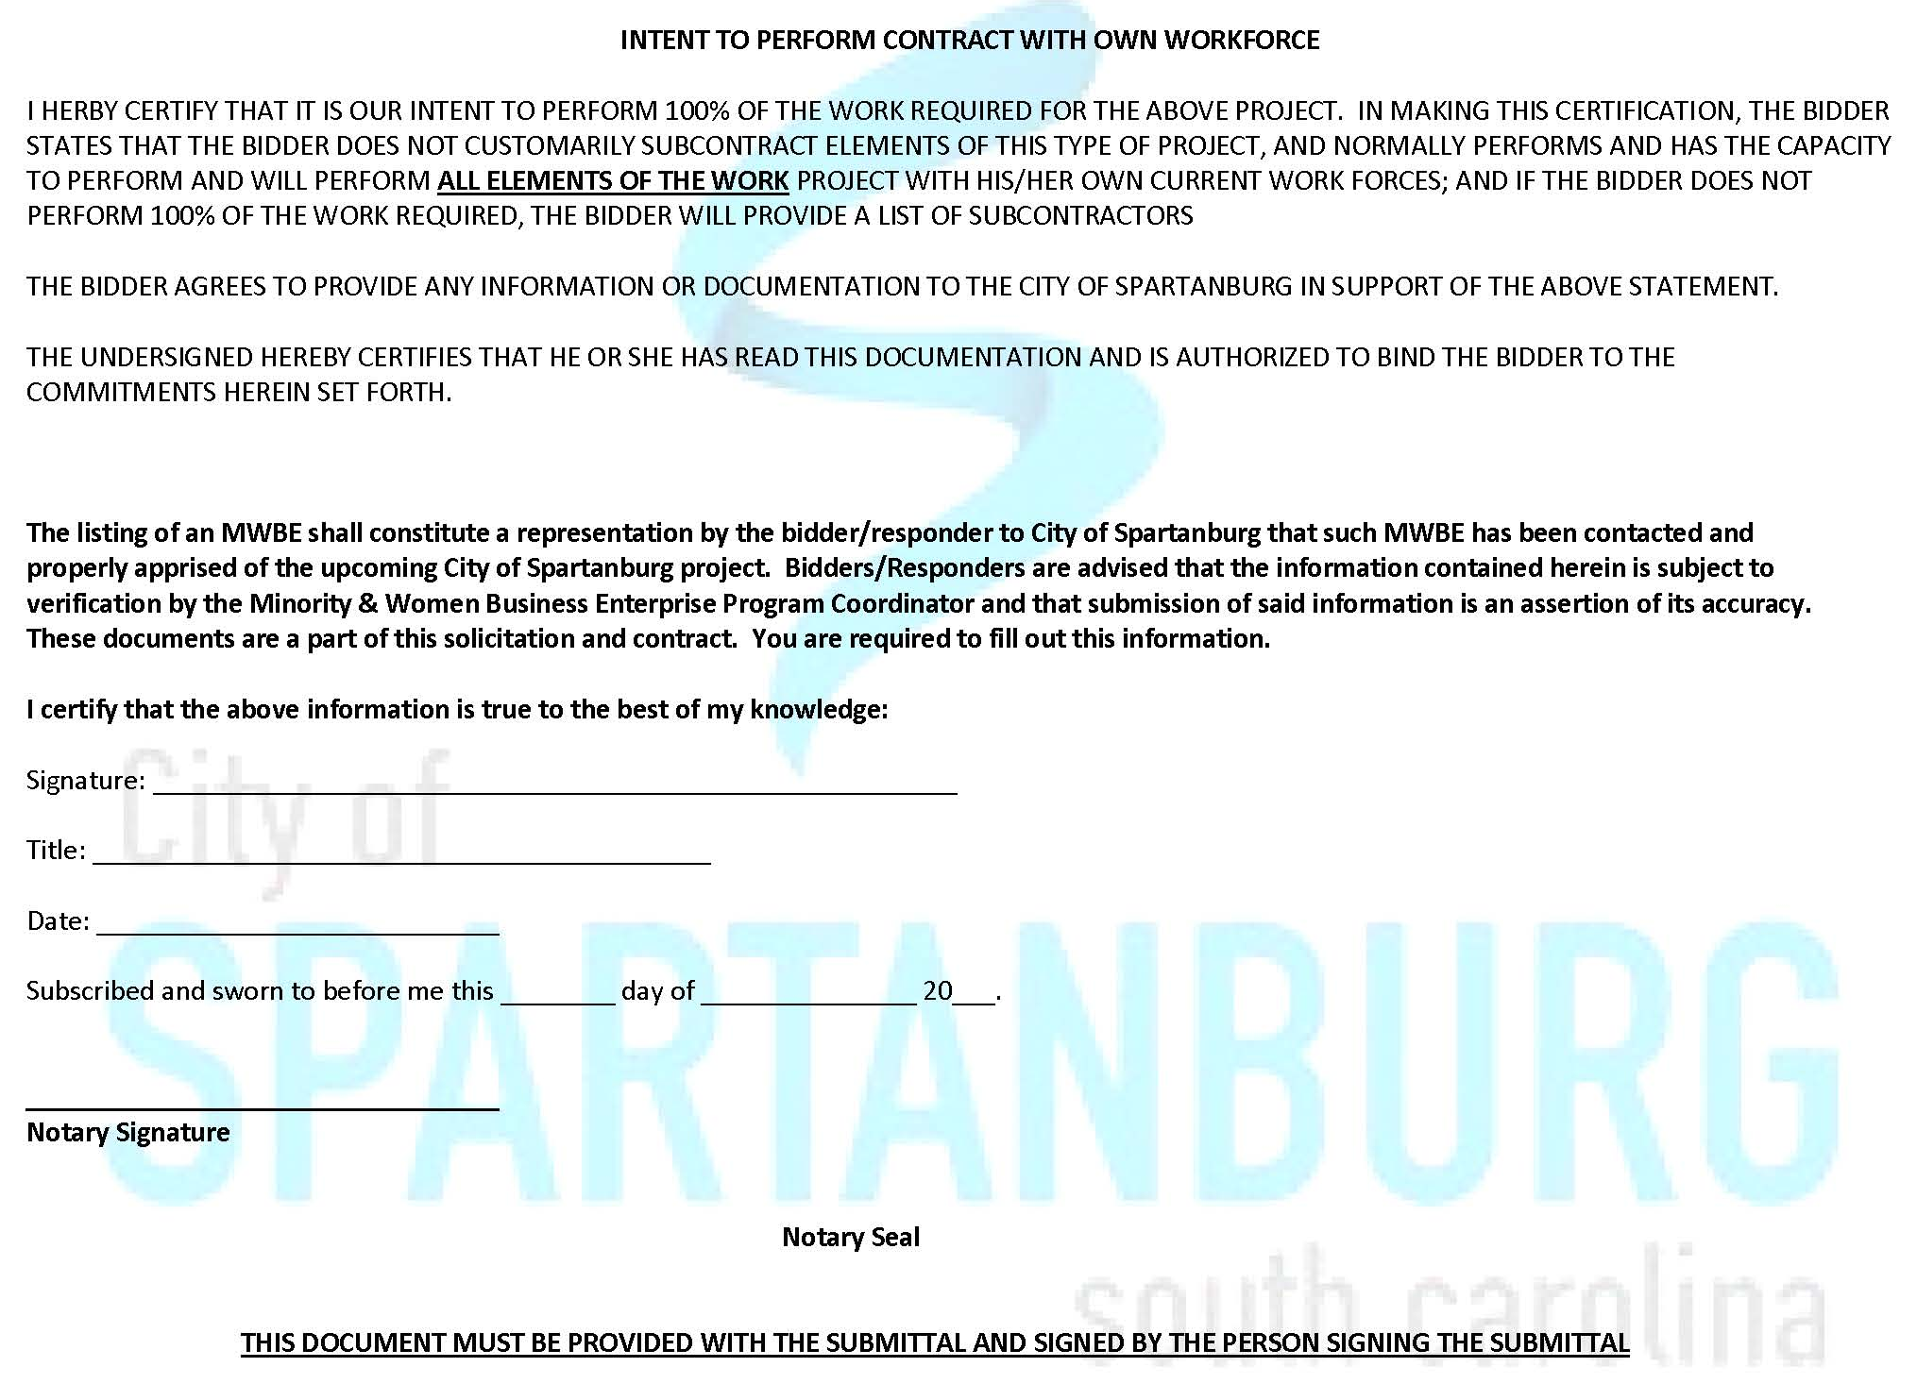
Page 10
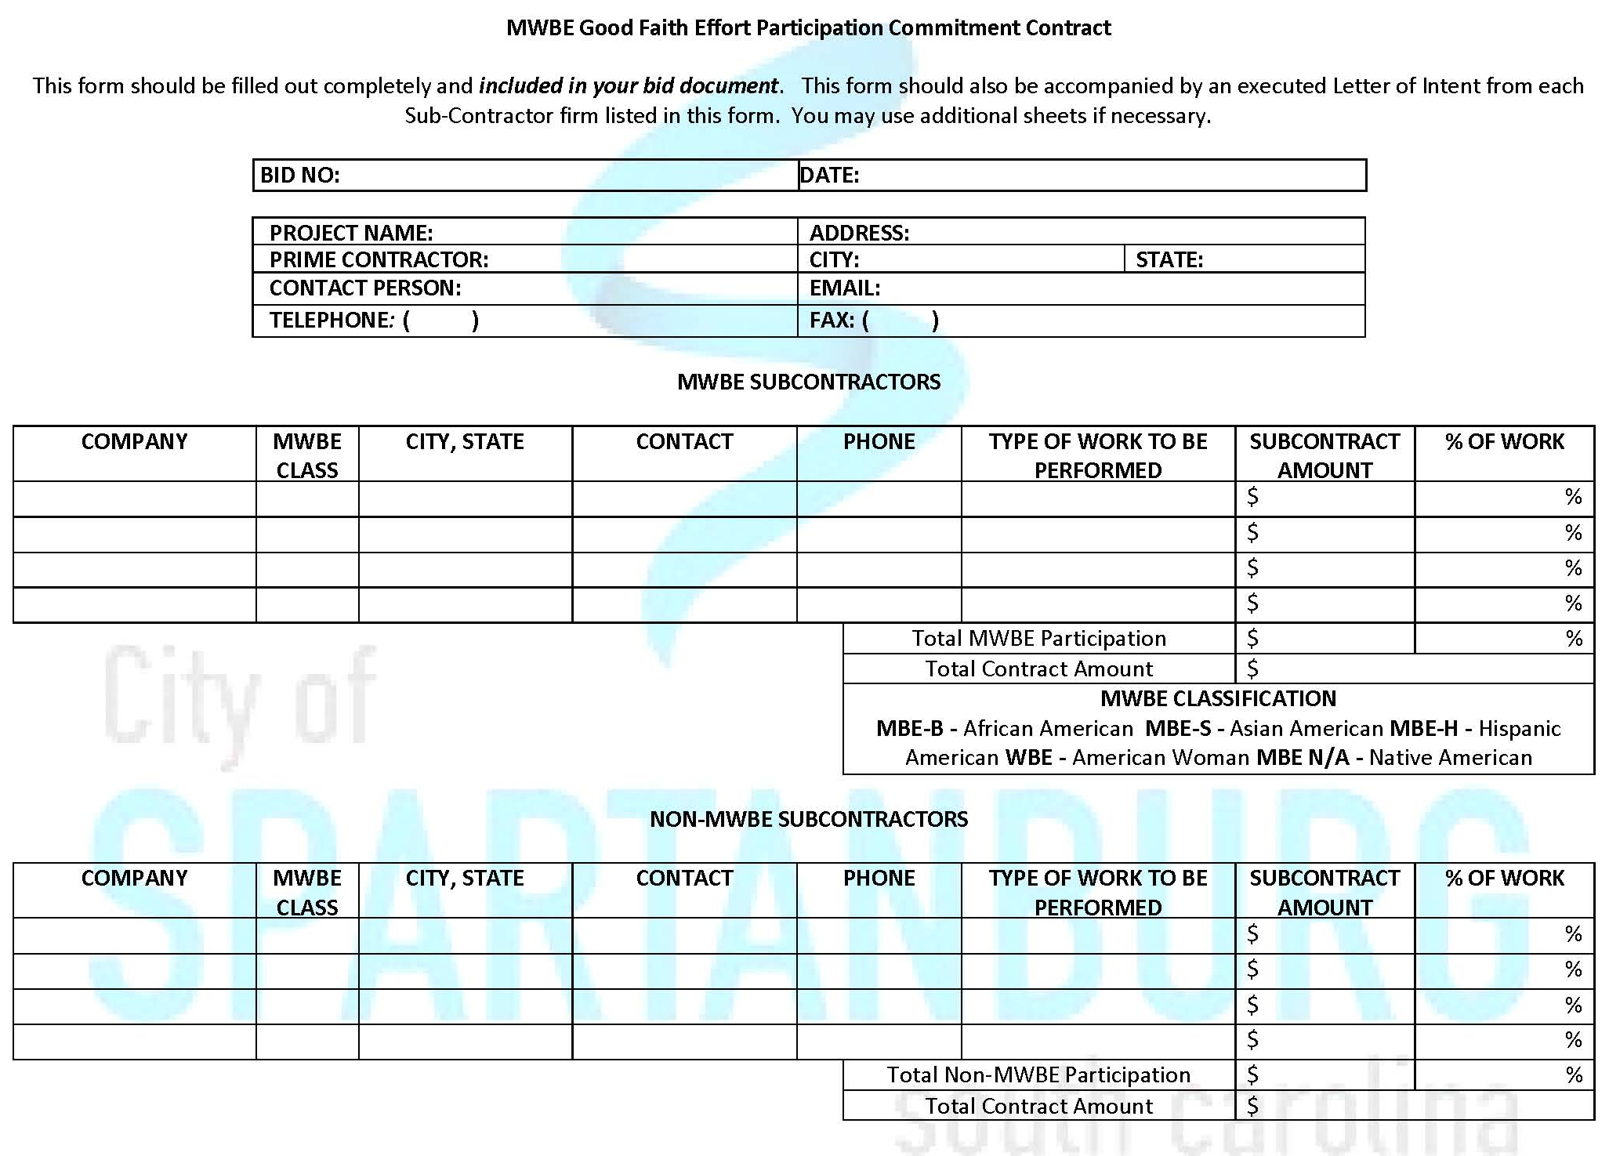
Page 10B

Debarment Statement
Page 11
CERTIFICATION REGARDING DEBARMENT, SUSPENSION, AND OTHER RESPONSIBILITY MATTERS Contractor certifies to the best of its knowledge and belief, that it and its principals:
- [ ] Are [ ] are not presently debarred, suspended, proposed for debarment, declared ineligible, or voluntarily excluded from covered transactions by any State or Federal department or agency;
- [ ] Have [ ] have not within a three-year period preceding award of this consulting agreement been convicted of or had a civil judgment rendered against them for commission of fraud or a criminal offense in connection with obtaining, attempting to obtain, or performing a public (Federal, State or Local) transaction or contract under a public transaction; violation of Federal or State antitrust statutes or commission of embezzlement, theft, forgery, bribery, falsification or destruction of records, making false statements, or receiving stolen property;
- [ ] Are [ ] are not presently indicted for or otherwise criminally charged by a governmental entity (Federal, State or Local) with commission of any of the offenses enumerated in Paragraph (b) above; and
- [ ] Have [ ] have not within a three-year period preceding award of this contract agreement had one or more public transactions (Federal, State or Local) terminated for cause or default.

________________________________ ________________________________
Consultant Signature Date

________________________________
Typed or Printed Name

Page 12
CERTIFICATION OF NON-SEGREGATED FACILITIES – YEAR 2017
We, (print company name:)_____________________________________, certify to City of Spartanburg, South Carolina we do not and will not maintain or provide for our employees any segregated facilities at any of our establishments, and that we do not and will not permit our employees to perform their services at any locations, under our control, where segregated facilities are maintained. We understand and agree that a breach of this certification is a violation of the Equal Opportunity clause.
As used in this certification, the term “segregated facilities” means any waiting rooms, work areas, rest rooms, restaurants and other eating areas, time clocks, locker rooms and other storage or dressing areas, parking lots, drinking fountains, recreation or entertainment areas, transportation and housing facilities provided for employees which are segregated by explicit directive or are in fact segregated on the basis of race, religion, color or national origin because of habit, local custom or otherwise.

We further agree that --- except where we have obtained identical certifications from proposed Subcontractors for specific time periods --- we will obtain identical certifications from proposed Subcontractors prior to the award of Subcontracts exceeding which are not exempt from the provisions of the Equal Opportunity clause; that we will retain such certifications in our files; and that we will forward the following notice to such proposed Subcontractors (except where the proposed Subcontractors have submitted identical certifications for specific time periods). NOTE: Whoever knowingly and willfully makes any false, fictitious or fraudulent representation may be liable to criminal prosecution under 18 U.S.C. 1001.
PLEASE COMPLETE BELOW AND INCLUDE THIS IN THE BID PACKAGE
Name of Company Representative: ___________________________________
Title: ___________________________________
Signature: ___________________________________ Date: ___________________

Attachment # 2

Davis Bacon Wage Determination

Contractor is require to submit Certified Payroll with each monthly Payment Application

There are several web sites for determining Davis Bacon Wage Requirements

This is one site that can give guidance in this area.

http://www.cagc.org/legal_labor_hr/files/davis_bacon_review11.cfm
Attachment
Drawings