Request for Proposals
Solicitation name and number | Revenue Collection Services Q2301
Upload responses by | 11:00 a.m. on August 17, 2022 (as KCDC’s clocks show)
Upload your responses (as one document) to | https://vrapp.vendorregistry.com/Account/LogOn  (Can also be accessed via KCDC’s webpage)
Questions about this solicitation | KCDC will not accept questions via telephone.  Submit questions to procurementinfo@kcdc.org by 6:00 p.m. on August 10, 2022.
Proposal opening | Since this is a proposal and not a bid, there will not be a public opening. Once an awarded decision is made, all information becomes public.
Award results | KCDC posts the award decision to its web page at: http://www.kcdc.org/procurement/.
Open Records/Public Access to Documents | All documents provided to KCDC are subject to the Tennessee Open Meetings Act (TCA 8-44-101) and open records requirements.
Check KCDC’s webpage for addenda and changes before submitting your response

General Information

1. Background and Intent
a. Knoxville's Community Development Corporation (KCDC) is the public housing and redevelopment agency for the City of Knoxville and for Knox County in Tennessee. KCDC’s affordable housing property portfolio includes twenty sites with approximately 3,525 dwelling units.

b. Definition/Clarification: KCDC uses “suppliers” as inclusive of various words describing interested parties often called “bidders,” “suppliers,” “contractors,” “proposers” and “vendors.”

c. KCDC’s Accounts Receivable Division is responsible for the collection of past due accounts. KCDC’s past due accounts are all from its renters. Currently Accounts Receivable makes efforts to collect on past due accounts (normally for up to ninety days). Accounts Receivable will turn over delinquent accounts to KCDC’s collections service informing them of any activity previously undertaken by Accounts Receivable. The supplier may proceed with their process for collection once KCDC gives the supplier account information.

d. KCDC limits contract length to a maximum of five years and the existing contract has nearly reached its maximum length.

e. KCDC expects this award to begin on or around September 1, 2022.

f. KCDC provides this information to give the supplier an indication of accounts that go to collections information:

 | 1st Quarter Dollars | 1st Quarter Accounts | 2nd Quarter Dollars | 2nd Quarter Accounts | 3rd Quarter Dollars | 3rd Quarter Accounts | 4th Quarter Dollars | 4th Quarter Accounts
2020 | 84,585 | 75 | 90,064 | 77 | 83,707 | 60 | 16,585 | 27
2021 | 73,048 | 46 | 30,021 | 27 | 55,955 | 25 | 68,370 | 32

g. KCDC currently uses Emphasys Elite software for its financial purposes but is transitioning to Yardi Voyager before the end of 2022.

h. KCDC does not subscribe to any offset programs.

i. Statistics and Information

Item | Information
What collection attempts occur or will occur internally prior to placement? | Letters to the last known addresses
What is the total dollar value of accounts available for placement now, including any backlog? | It averaged $56,848 quarterly
What is the total number of accounts available for placement now by category, including any backlog? | It averaged 33 quarterly
What is the average balance of accounts? | $2,136 last quarter
What is the average age of accounts at placement (at time of award and/or on a going-forward basis)? | Usually 120 days
How much did KCDC pay (estimated or actual) last year, last month, or last quarter to any incumbent(s)? | It averaged $1,000 to $3,000 quarterly. However, it depends on collections.
What is the monthly or quarterly number of accounts placed with the supplier(s) by category? | It averages 30 - 60 quarterly (all categories taken into consideration).
What is the monthly or quarterly dollar value of accounts expected to be placed with the supplier(s) by category? | It averages $50,000 - $70,000 quarterly (all categories taken into consideration).
What has been the historical rate of return or liquidation rate provided by any incumbent(s)? | No information available at this time
Will accounts held by the incumbent or any backlog be moved to any new supplier as a one-time placement at contract start up? | No

j. Following the signing of the contract, direct all day-to-day communications concerning the work to Linda Thomas, 901 Broadway N, Knoxville, Tennessee 37917. Email contact is preferred at lthomas@kcdc.org.

k. KCDC requires the proposer to maintain records showing efforts made to make collection. These records shall show methods used and dates of efforts. These need to be available to KCDC online. KCDC expects the proposer to make efforts at least every sixty days on accounts deemed active. Once the proposer deems an account inactive, the account returns to KCDC. KCDC’s desire is that the proposer makes efforts to collect for at least one year although it knows that some accounts will be deemed inactive prior to being active a full year. The proposer will return inactive accounts to KCDC at least quarterly. KCDC will only be obligated to pay the collection fees (as outlined in this solicitation) on active accounts.

l. KCDC will provide the successful supplier with and/or be responsible for the following:

- KCDC will turn over delinquent accounts to the supplier. KCDC represents that any account turned over to the supplier is legally due and owed. KCDC shall provide source documentation for all accounts due and verification of any balance due.

- KCDC agrees to pay a fee as outlined in this proposal. KCDC will not pay fees unless collections occur. KCDC will only pay this fee on active accounts. Active accounts require some method of collection every ninety days (minimum).

- KCDC reserves the right to stop any further collection efforts on any account where KCDC feels continued collection efforts would injure its reputation or practice.

- KCDC reserves the right to conduct audits of the supplier’s books and records to verify accounts.

m. KCDC requires the successful proposer to provide a listing of “In Active” accounts at least quarterly. Email such reports to your KCDC contact person.

n. Proposers have these responsibilities:
- Proper licensure
- Acceptable bonding
- Capable trained staff as collectors
- Perform all activities in compliance with all laws and regulations
- Indemnify and hold KCDC harmless from any claims related to unlawful collection activity.
- Use only legal means to obtain collection of KCDC’s accounts once the supplier has them.
- Compliance with The Fair Debt Collection Practices Act of 1977, the Tennessee Financial Privacy Act and all other applicable laws in its collection practices and procedures and will fully observe and comply with all other federal and state laws, rules, and regulations concerning collection practice.
- Payment of court costs, attorney fees and other cost associated with collecting the account if legal action is required.
- Fees earn at the time of collections only
- Provide an accurate monthly report of the status of all collection’s accounts.
- Provide quarterly reports on the status of all accounts. Separate reports by the KCDC program (KCDC has approximately ten programs). Include “efforts made” and/or “status” each quarter.
- Submit all gross monies collected to KCDC by the 10th day of the month.

2. Changes after Award
It is possible that after award KCDC will need to revise the requirements specified herein. KCDC reserves the right to make such changes after consultation with the supplier. Should additional costs arise, the supplier must document increased costs. KCDC reserves the right to accept or reject and negotiate these charges. Generally, such changes will not be of a “cardinal” nature.

3. Codes and Ordinances
All work covered is to be performed in full accord with national, state and local codes, ordinances and orders that are in effect at the time the work is performed.

4. Contact Policy
Only contact KCDC’s Procurement Division about this solicitation from the issuance of this solicitation until award. Information obtained from an unauthorized officer, agent, or employee will not affect the risks or obligations assumed by the supplier or relieve the supplier from fulfilling any of the conditions of the resulting award for the purpose of this project. Such contact can disqualify the supplier from the solicitation process.

5. Evaluation
a. KCDC will evaluate this proposal as detailed below. KCDC alone determines (using the National Institute of Governmental Procurement’s definition and other relevant sources as appropriate) the supplier’s “responsive” and “responsible” status prior to award. Responsible means a business with the financial and technical ability to perform the requirements of the solicitation and subsequent contract.

b. A responsive proposal is one that fully conforms in all material respects to the solicitation document and its requirements, including all form and substance.

c. KCDC reserves the right to request additional information to assist in the evaluation process; this includes references and business ability information.

d. Evaluation Factors

Factor | Maximum Points
Cost to KCDC | 20
Proposed Collection Process | 40
Capabilities and References | 40
Total | 100

6. General Instructions to Suppliers
KCDC’s General Instructions to Suppliers are at www.kcdc.org. Click on “Procurement” and the link to the instructions. The supplier’s submittal means acceptance of the terms and conditions found in KCDC’s “General Instructions to Suppliers.” The following paragraphs in the General Instructions to Suppliers do not apply: 4, 15, 43, 44a, 44b, 44d, 57, 69.

7. Insurance
The proposer agrees to maintain at its sole expense during the term of this agreement insurance coverages and limits in accordance with the proposer’s standard business practices and acceptable to KCDC. Coverage must include Errors and Omissions Liability (E & O) or Professional Liability with a minimum policy limit of $1,000,000. The limits afforded by this policy shall apply only to KCDC and KCDC’s officials, officers, agents and employees, and only to claims arising out of or in connection with the work under this Agreement. Upon request, the proposer shall provide KCDC with Certificates of Insurance evidencing such insurance.

8. Invoicing/Ordering
a. Until a purchase order is in place, work is not to be performed nor are goods to be delivered. KCDC does not have a legal obligation to pay for the work performed prior to the issuance of a purchase order.

b. Suppliers must submit invoices within 90 days of the delivery of goods or services. KCDC may deny invoices submitted after the 90-day threshold. KCDC prefers invoices arrive within 10 days following the end of the month in which goods or services were supplied.

c. Most KCDC purchases of goods are exempt from Tennessee sales and use tax pursuant to Tennessee Code Annotated 67-6-329(a) (4) and KCDC is exempt from the Federal Excise tax. However, suppliers are subject to Tennessee sales and use tax on all materials and supplies used in the performance of a contract, whether such materials and supplies are purchased by the supplier, produced by the supplier, or provided to the supplier by KCDC, pursuant to Tennessee Code Annotated 67-6-209.

d. Certain KCDC properties are not exempt from taxation and their invoices should include applicable taxes. These are: Eastport LP, First Creek (Bell Street) LP, First Creek (Bell Street) 2 LP, First Creek (Bell Street) 3 LP, Five Points 1, LP; Five Points 2, LP; Five Points 3, LP; Five Points 4, LP; Lonsdale Homes, LP; Northridge Crossing, LP and The Vista at Summit Hill, LP.

e. KCDC pays by electronic transfer (ACH) only. Supplier’s accounts receivable staff must use KCDC’s portal to find payments made and to which invoices they apply. Supplier’s may set up KCDC’s portal so that they receive an email with each payment detailing the amount and invoice paid.

f. Invoices must:
- Be numbered
- List a date on them that is after the work is complete or goods delivered
- List the purchase order number
- Breakdown pricing according to the award structure
- Reference the proposal number

g. Email invoices to invoices@kcdc.org . Do not send invoices through the United States Postal Service.

9. Length of Award
The length of the contract will be twelve months with four optional annual renewals that KCDC may exercise at its discretion.

10. Price Structure
a. At the end of each twelve-month period, the awarded supplier may request a change to the percentage and/or specific item charged to KCDC.

The supplier must provide proof of the necessity of the increase to the Procurement Division.
Such proof will be CPI, PPI or other similar documentation acceptable to KCDC. KCDC will decide whether to accept a price increase. If KCDC accepts the price increase, the file will note. If KCDC rejects the price increase, the supplier may:

1. Continue with the existing pricing.
2. Suggest an alternative price increase.
3. End the award.

b. KCDC does not pay fuel surcharges.

c. Suppliers may decrease prices at any time with or without notice.

This and the previous pages do not need to be returned.

Solicitation Document A |  |  |  | General Information about the Supplier
Note: Complete all cells even if the answer is “Does not apply”
Sign Your Name to the Right of the Arrow
If completing this document in Adobe, an electronic signature is acceptable to KCDC.
Your signature indicates you read and agree to “KCDC’s General Instructions to Suppliers” (www.kcdc.org) and that you are authorized to bind the supplier or are submitting the response on behalf of and at the direction of the suppliers’ representative authorized to contractually bind the supplier. I represent that the supplier or its applicable representative(s) has reviewed the information contained in this Solicitation Package and that the information submitted is accurate.
Printed Name and Title
Legal Corporate Name
Street Address
City/State/Zip
Contact Person (Please Print Clearly)
Telephone Number
Cell Number
Supplier’s E-Mail Address (Please Print Clearly)
Addenda
Check for addenda prior to uploading your submittal. KCDC posts addenda are at www.kcdc.org. Click on “Procurement” and then on “Open Solicitations” to find addenda
Acknowledge addenda have been issued by checking below as appropriate:
None ☐ | Addendum 1 ☐ |  |  |  | Addendum 2 ☐ |  | Addendum 3 ☐ |  | Addendum 4 ☐ |  | Addendum 5 ☐
Statistical Information (Check a box in each of the next four lines)
1. This business is at least 51% owned and operated by a woman |  |  |  |  |  |  |  |  |  |  | Yes ☐ No ☐
2. This business qualifies as a small business by the State of Tennessee  Total gross receipts of not more than $10,000,000 average over a three-year period  OR employs no more than 99 persons on a full-time basis |  |  |  |  |  |  |  |  |  |  | Yes ☐ No ☐
3. This business is at least 51% owned and operated by a veteran |  |  |  |  |  |  |  |  |  |  | Yes ☐ No ☐
4. This business is owned & operated by persons at least 51% of the following ethnic background:
Asian/Pacific  ☐ |  | Black  ☐ | Hasidic Jew  ☐ |  |  | Hispanic  ☐ |  | Native American ☐ |  | White  ☐ | Publicly Owned ☐
Prompt Payment Discount Statement
A ____% prompt payment discount applies when KCDC makes payment in ____ days of accurate invoicing.

Solicitation Document B | Affidavits

Conflict of Interest
1. No commissioner or officer of KCDC or other person whose duty it is to vote for, let out, overlook or
in any manner superintend any of the work for KCDC has a direct interest in the award or the supplier providing goods or services.

2. No employee, officer or agent of the grantee or sub-grantee will participate in selection, or in the award or administration of an award supported by federal funds if a conflict of interest, real or apparent, would be involved. Such a conflict would arise when the employee, officer or agent, any member of his immediate family, his or her partner, or an organization, which employs, or is about to employ, any of the above, has a financial or other interest in the supplier selected for award.

3. The grantee's or subgrantee's officers, employees or agents will neither solicit nor accept gratuities, favors or anything of monetary value from suppliers, potential suppliers, or parties to sub-agreements.

4. By submission of this form, the supplier is certifying that no conflicts of interest exist.

Drug Free Workplace Requirements
5. Private employers with five or more employees desiring to contract for construction services attest that they have a drug free workplace program in effect in accordance with TCA 50-9-112.

Eligibility
6. The supplier is eligible for employment on public contracts because no convictions or guilty pleas or pleas of nolo contender to violations of the Sherman Anti-Trust Act, mail fraud or state criminal violations with an award from the State of Tennessee or any political subdivision thereof have occurred.

General
7. Supplier fully understands the preparation and contents of the attached offer and of all pertinent circumstances respecting such offer.

8. Such offer is genuine and is not a sham offer.

Iran Divestment Act
9. Concerning the Iran Divestment Act (TCA 12-12-101 et seq.), by submission of this bid/quote/proposal, each supplier and each person signing on behalf of any supplier certifies, and in the case of a joint bid/quote/proposal, each party thereto certifies as to its own organization, under penalty of perjury, that to the best of its knowledge and belief that each supplier is not on the list created pursuant to § 12-12-106.

Accuracy of Electronic Copies
10. If the supplier provides electronic copies of the bid/proposal/quote to KCDC, the supplier certifies that the information provided on paper and in the electronic format is identical unless specifically noted otherwise.

General
11. Neither the said supplier nor any of its officers, partners, owners, agents, representatives, employees or parties interest, including this affiant, has in any way colluded conspired, connived or agreed, directly or indirectly, with any other responder, supplier, or person to submit a collusive or sham offer in connection with the award or agreement for which the attached offer has been submitted or to refrain from making an offer in connection with such award or agreement, or collusion or communication or conference with any other supplier, or, to fix any overhead, profit, or cost element of the offer price or the offer price of any other supplier, or to secure through any collusion, conspiracy, connivance, or unlawful agreement any advantage against KCDC or any person interested in the proposed award or agreement.

12. The price or prices quoted in the attached offer are fair, proper and not tainted by any collusion, conspiracy, connivance, or unlawful agreement on the part of the supplier or any of its agents, representatives, owners, employees, or parties in interest, including this affiant.

No Contact/No Advocacy Affidavit
13. After this solicitation is issued, any contact initiated by any supplier with any KCDC representative concerning this solicitation is strictly prohibited-except for communication with the Procurement Division. My signature signifies that no unauthorized contact occurred.

14. To ensure the integrity of the review and evaluation process, respondents to this solicitation nor any firm representing them, may not lobby or advocate to KCDC staff or Board members. My signature signifies that no unauthorized advocacy occurred.

Non-Boycott of Israel Affidavit
15. Concerning the Non-Boycott of Israel Act (TCA 12-4-1 et seq.), by submission of this bid/quote/proposal, each supplier and each person signing on behalf of any supplier certifies, and in the case of a joint bid/quote/proposal, each party thereto certifies as to its own organization, under penalty of perjury, that to the best of its knowledge and belief that each supplier is not boycotting Israel pursuant to § 12-4-1 and will not during the term of any award. Note: Applicable only to contracts of $250,000 or more and to suppliers with 10 or more employees.

The undersigned hereby acknowledges receipt of these affidavits and certifies that the submittal in response to this solicitation is in full compliance with the listed requirements. Failure to properly acknowledge issues concerning the above is grounds for bid rejection and may subject the signer to penalties as directed by the appropriate laws.

Signed by
Printed Name
Title

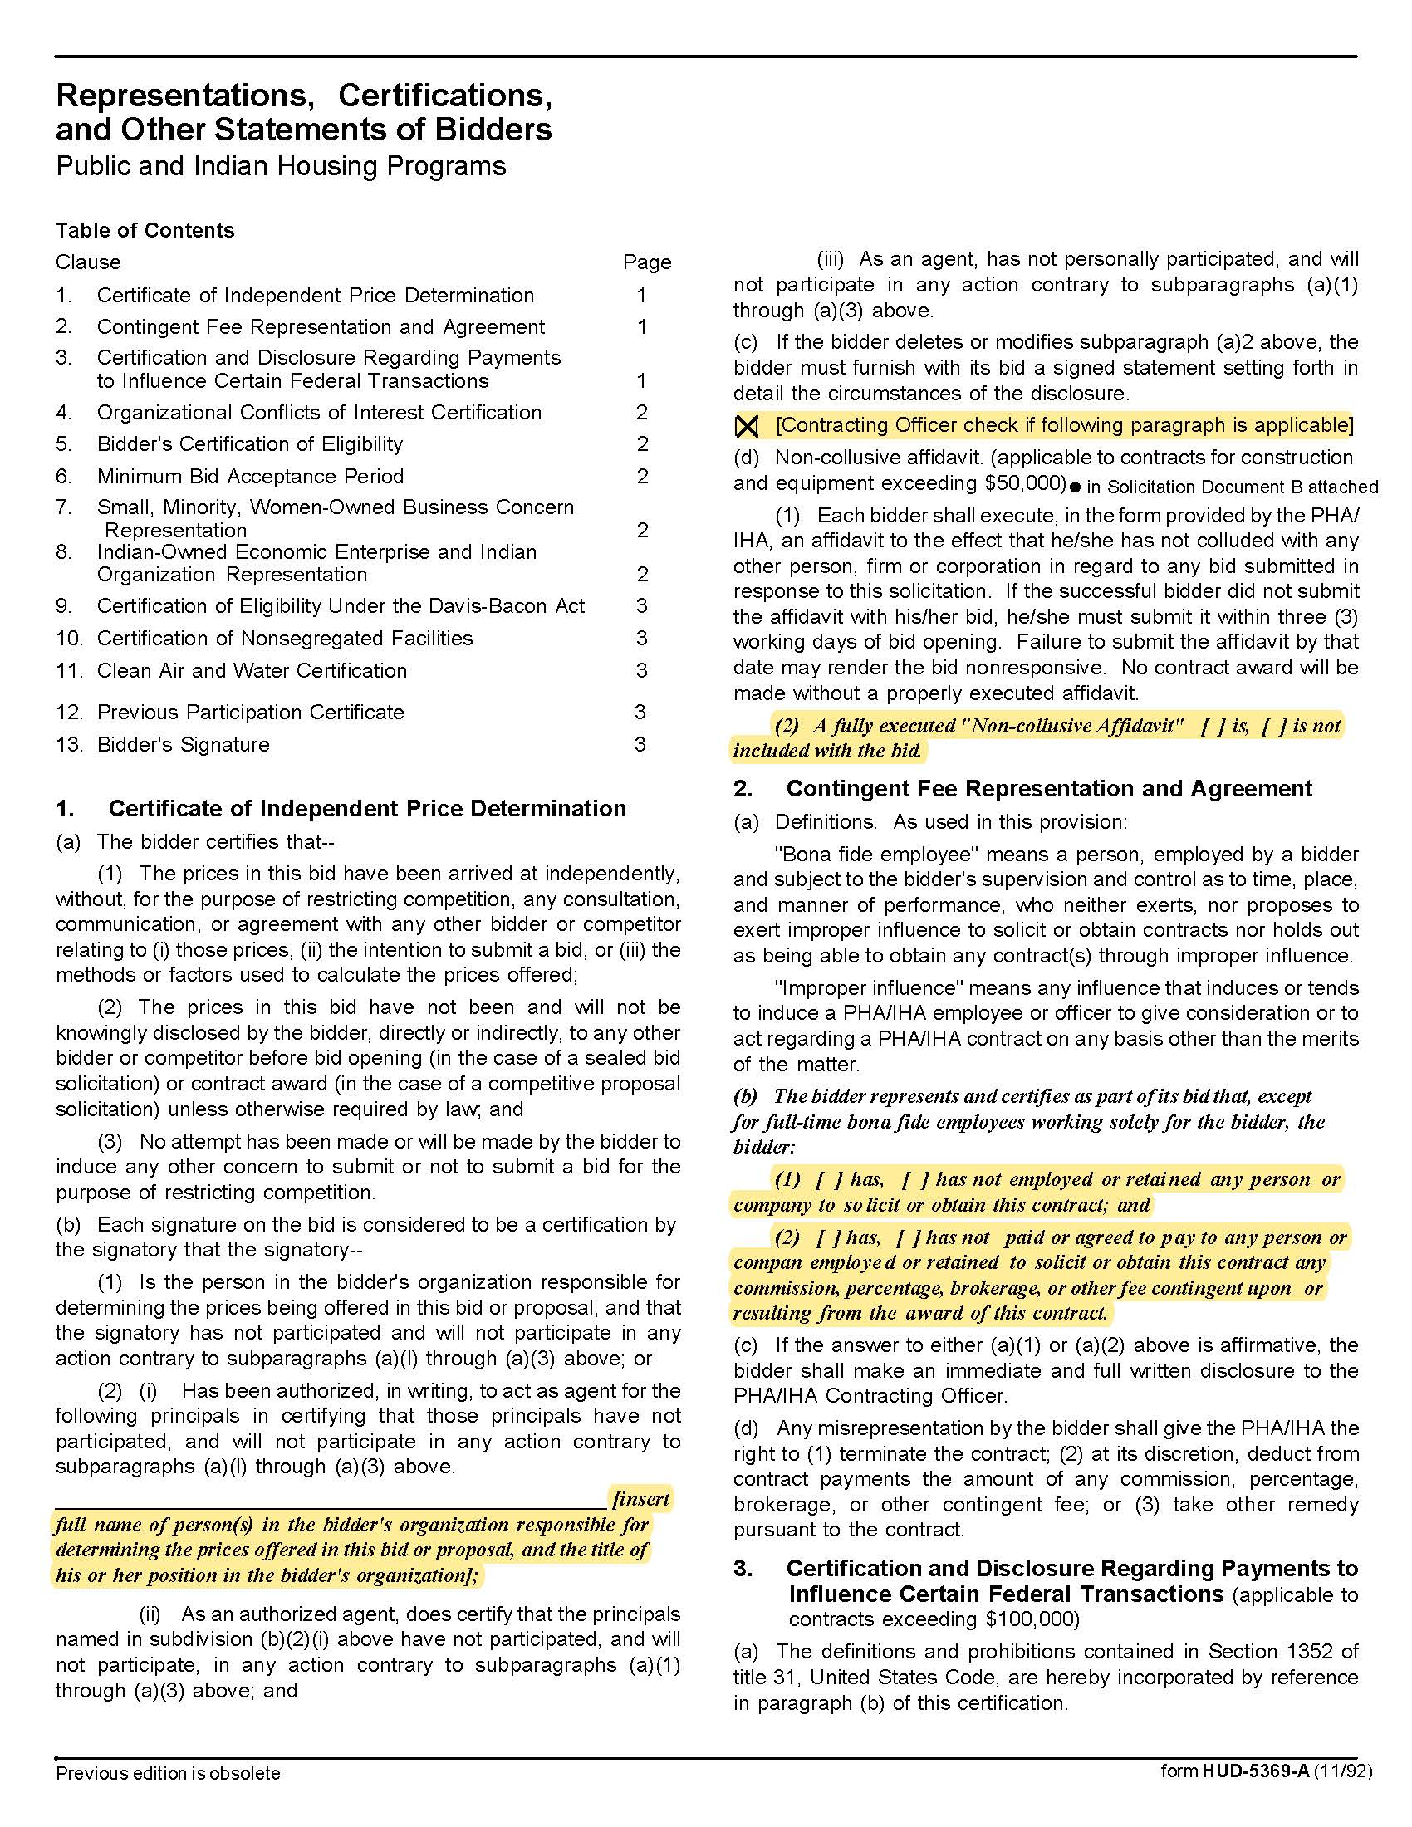
Solicitation Document C | HUD Form 5369A

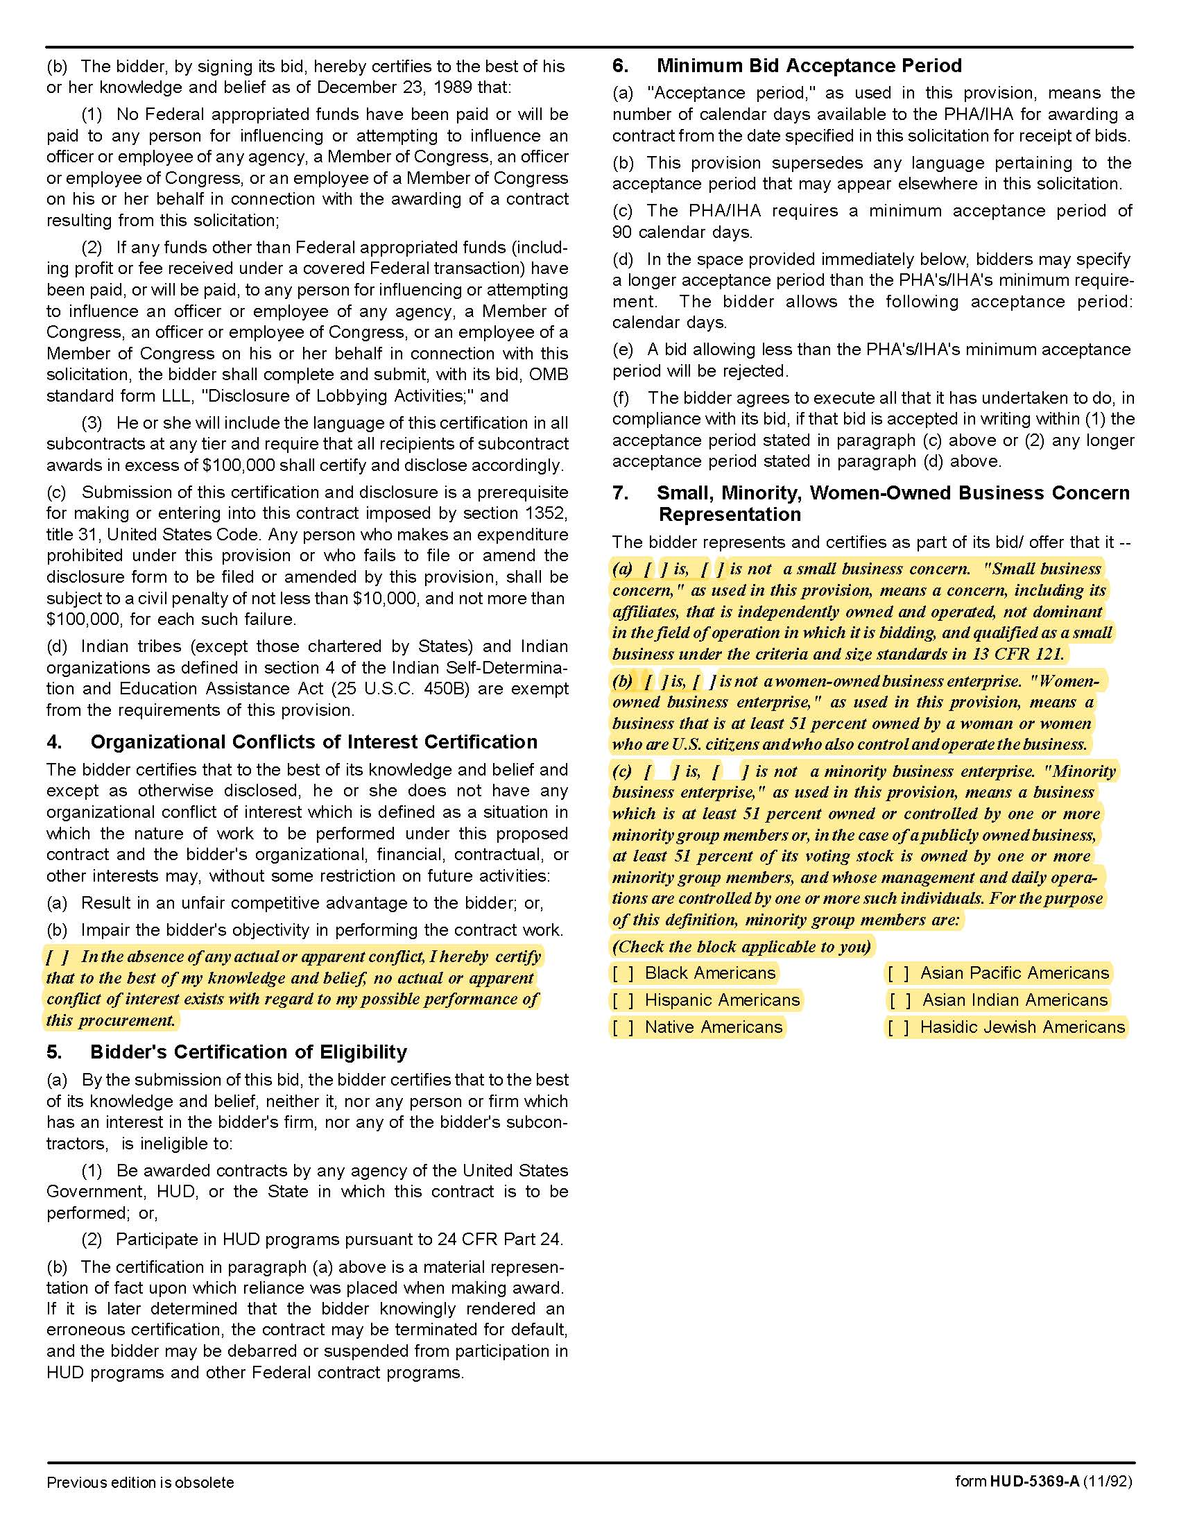

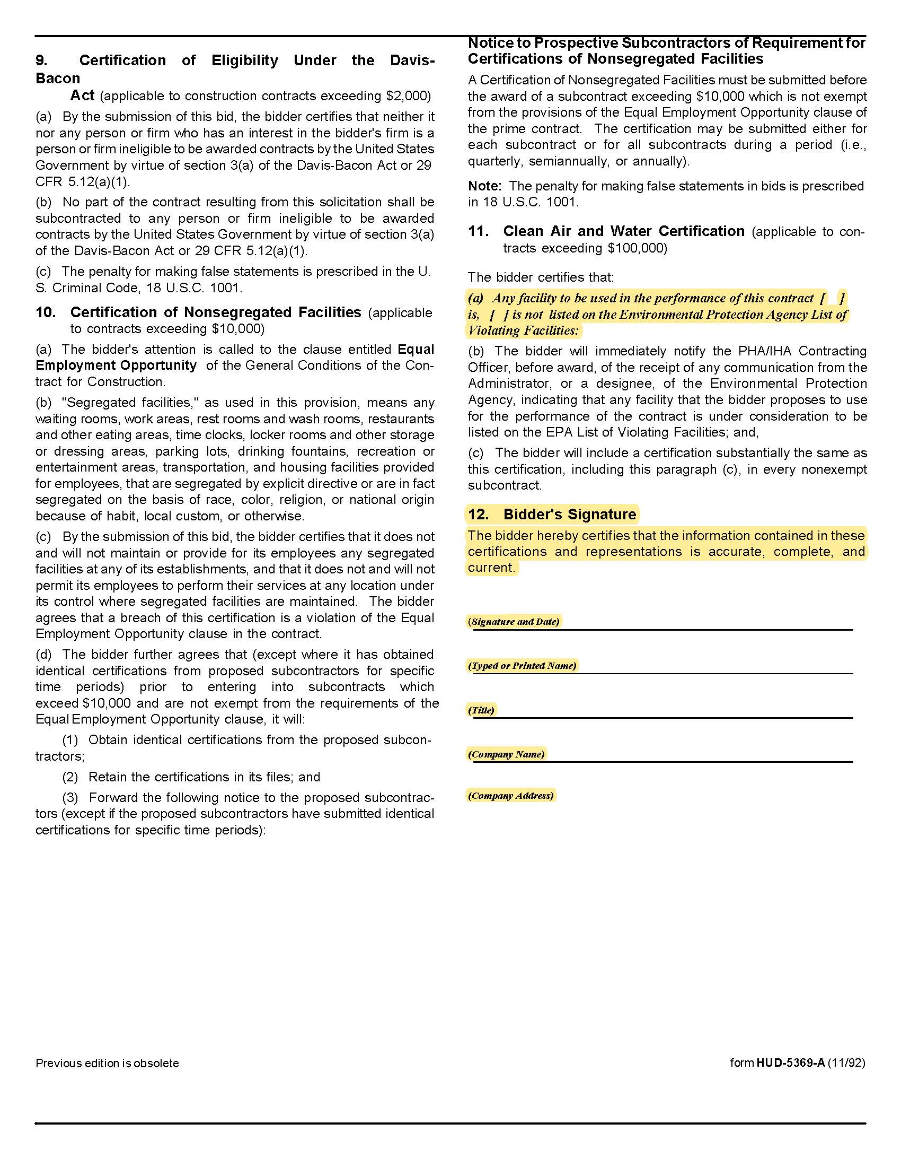

Respond to the following questions and use additional sheets of paper if necessary.

1. Number of years in this business

2. Under what other names has your company operated?

3. How many years did the company operate under this/these name(s)?

4. Has any officer or partner of your organization ever been an officer or partner of another organization that failed to complete a contract within the last five years?

5. Is your business presently involved in any litigation? If “yes,” explain.

6. Detail the charges that KCDC would pay to you.

7. Describe in detail how you would proceed with the collection of accounts. Please show the period in which steps would occur.

8. Describe your collections methods and outreach techniques.

9. KCDC is interested in your success rate when collecting debt from tenants in low and moderate-income housing. Indicate any history showing your success in collections for low to moderate income housing here.

10. Provide three references of accounts that are similar to this one. Include this information:

- Company Name
- Contact Person’s Name
- Phone/Email for Contact Person
- Date of Service Provision (start/stop)
- Description of the Service(s) provided
- Value of the Contract over its Lifetime

Solicitation Document D | Proposer’s Responses to Questions

