 | CITY OF BATTLE CREEK  NOTICE OF INVITATION FOR BIDS  IFB#: 2018-083B  TITLE: Janitorial Services  ISSUE DATE: June 4, 2018

BID DUE DATE: June 21, 2018, at 2:00 PM Local Time (office hours 8-12 and 1-5)
LOCATION: Purchasing Department
10 N. Division Street, Suite 214
Battle Creek, MI 49014

NOTE! City Hall now has Security on the 1st floor. Please allow extra time to get through Security when dropping off your bid.

Pre-Bid Conference: June 12, 2018, 9am to 12 noon, and 3pm to 3:45pm
Location: Starts at City Hall, 10 N. Division Street
(See Attachment D (last page) for the complete site visit schedule)

Purchasing Contact: Nils Vos

Phone: (269) 966-3381
E-mail: npvos@battlecreekmi.gov

DESCRIPTION: The City is soliciting bids for the purpose of contracting for the City's annual requirements for janitorial services for citywide buildings. The resulting contract is anticipated for a term of up to five (5) years.

Download this solicitation from our website at: battlecreekmi.gov Copies of the complete Invitation for Bids document may also be obtained from the Purchasing Department, Room 214, 10 N. Division Street, Battle Creek, Michigan 49014, (269) 966-3390.

PRE-BID CONFERENCE: The date, time and location of this conference are indicated above. The purpose of this conference will be to clarify the contents of this invitation for bid (IFB) in order to prevent any misunderstanding of the City's position. Any doubt as to the requirements of this IFB or any apparent omission or discrepancy should be presented to the City at this conference. The City will then determine the appropriate action necessary, if any, and issue a written amendment to the IFB. Oral statements or instructions shall not constitute an amendment to this IFB.

Bids must be in the actual possession of the Purchasing Department at the location indicated, on or prior to the exact time and date indicated above. Bids received by the correct time and date shall be opened and the amount bid shall be publicly read. Late bids shall not be considered.

BIDDERS ARE STRONGLY ENCOURAGED TO CAREFULLY READ THE ENTIRE INVITATION FOR BID.

THIS BID IS OFFERED BY: ______________________________________________
(Company Name)
1.0 INSTRUCTIONS TO BIDDERS
1. BID SUBMISSION:
A. Bids must be submitted in complete original form by mail or messenger to the following address:
Office of the Purchasing Agent, Room 214, City Hall, 10 N. Division Street, Battle Creek, MI 49014
B. Bids will be accepted at the above address until the time and date specified herein, and immediately after will be publicly opened and read aloud. The prevailing clock shall be www.time.gov.
C. All bids shall be tightly sealed in an opaque envelope and plainly marked with the Invitation for Bid number, due date and the bidder's name and address clearly indicated on the envelope.
D. Late bids will not be accepted and will be returned to the bidder.
E. All bids submitted in response to this invitation shall become the property of the City and be a matter of public record available for review.

2. PREPARATION OF BIDS:
A. The bid shall be legibly prepared with ink or typed.
B. If a unit price or extension already entered is to be altered, it shall be crossed out and initialed by the bidder with ink.
C. The bid shall be legally signed on the OFFER TO CONTRACT page and the complete address of the bidder given thereon.
D. The City is exempt from Federal Excise and State Sales Taxes, and such taxes shall not be included in bid prices

3. SIGNATURES: All bids, notifications, claims and statements must be signed by an individual authorized to bind the bidder.
(a.) CORPORATIONS: Signature of official shall be accompanied by a certified copy of the resolution of the Board of Directors authorizing the individual signing to bind the corporation.
(b.) PARTNERSHIPS: Signature of one partner shall be accompanied by a certified copy of the power of attorney authorizing the individual signing to bind all partners. If all partners sign bid no authorization is needed.

4. REJECTION OR WITHDRAWAL: Submission of additional terms, conditions or agreements with the bid document is grounds for deeming a bid nonresponsive and may result in bid rejection. The City reserves the right to reject any bids and to waive any informalities and minor irregularities defects in bids. Bids may be withdrawn in person by a bidder, or authorized representative, provided their identity is made known and a receipt is signed for the bid, but only if the withdrawal is made prior to the time set for receipt of bids. Bids are an irrevocable offer and may not be withdrawn within 90 days after opening date.

5. AWARD: The bid will be awarded to that responsible, responsive bidder whose bid, conforming to this solicitation, will be most advantageous to the City, price and other factors considered. Unless otherwise specified in this IFB, the City reserves the right to accept a bid in whole or in part, and to award by item or by group, whichever is deemed to be in the best interest of the City. Any bidder who is in default to the City at the time of submittal of the bid shall have his bid rejected. The City reserves the right to clarify any contractual terms with the concurrence of the Contractor; however, any substantial non-conformity in the offer, as determined by the City, shall be deemed non-responsive and the offer rejected.

In evaluating bids, Owner shall consider the qualifications of the Bidders, and where applicable, operating costs, delivery time, maintenance requirements, performance data, and guarantees of materials and equipment. In addition, the City may conduct such investigations as Owner deems necessary to assist in the evaluation of a Bid and to establish the responsibility, qualifications and financial ability of the Bidders to fulfill the contract.

6. CONTRACT: A response to an IFB is an offer to contract with the City based upon the terms, conditions, and specifications contained in the City's IFB. Bids do not become contracts unless and until they are executed by the City, eliminating a formal signing of a separate contract. For that reason, all of the terms and conditions of the contract are contained in the IFB, unless any of the terms and conditions are modified by an Addendum or a Contract Amendment.

7. BID RESULTS: A bid tabulation will be posted on the City’s website and will also be on file and available for review after contract award in the Purchasing Department.

8. CHANGES AND ADDENDA TO BID DOCUMENTS: Each change or addendum issued in relation to this bid document will be on file in the Office of the Purchasing Agent. In addition, to the extent possible, copies will be mailed to each person registered as having received a set of bid documents. It shall be the bidder's responsibility to make inquiry as to changes or addenda issued. All such changes or addenda shall become part of the contract and all bidders shall be bound by such addenda. Information on all changes or addenda issued will be available at the office of the City Purchasing Agent.

9. SPECIFICATIONS: Unless otherwise stated by the bidder, the bid will be considered as being in accordance with the City's applicable standard specifications, and any special specifications outlined in the Bid document. References to a particular trade name, manufacturer's catalogue, or model number are made for descriptive purposes to guide the bidder in interpreting the

requirements of the City, and should not be construed as excluding bids. However, the City does reserve the right to specify a sole brand, with no brand substitutions allowed. The bidder, if awarded a contract, will be required to furnish the particular item referred to in the specifications or description unless departure or substitution is clearly noted and described in the bid and allowed by the IFB. The City reserves the right to determine if equipment/product being bid is an acceptable alternate. All goods shall be new unless otherwise so stated in the bid. Any unsolicited alternate bid, or any changes, insertions, or omissions to the terms and conditions, specifications, or any other requirements of this bid, may be considered non-responsive. The City reserves the right to disregard any conflicting terms and conditions submitted by the contractor and hold the contractor to the submitted bid price. Contractors are strongly encouraged to not submit anything with their bid that is not specifically requested in this solicitation.

10. DELIVERY: Bids shall include all charges for delivery, packing, crating, containers, etc. Prices bid will be considered as being based on F.O.B. Delivered, freight included.

11. INTERPRETATION OF BID AND/OR CONTRACT DOCUMENTS: All inquiries shall be made within a reasonable time prior to the date and time fixed for the bid opening in order that a written response in the form of an addendum, if required, can be processed before the bids are opened. (Inquiries received that are not made in a timely fashion may or may not be considered).

12. CURRENCY: Prices calculated by the bidder shall be stated in U.S. dollars.

13. PRICING: Prices shall be stated in units of quantity specified in the Bid Document. In case of discrepancy in computing the amount of the bid, the unit price bid will govern.

14. NOTICE TO PROCEED/PURCHASE ORDER: The successful bidder may not commence work under this contract until authorized to do so by the Purchasing Agent.

15. CERTIFICATION: By signature in the offer section of the Offer and Acceptance page, bidder certifies:
A. The submission of the offer did not involve collusion or other anti-competitive practices.
B. The bidder has not given, offered to give, nor intends to give at any time hereafter, any economic opportunity, future employment, gift, loan, gratuity, special discount, trip, favor, or service to a public servant in connection with the submitted offer.
C. The bidder hereby certifies that the individual signing the bid is an authorized agent for the bidder and has the authority to bind the bidder to the contract.
D. The bidder hereby certifies that the firm will abide by the COPELAND ANTI-KICKBACK ACT, Title 18, U.S.C. June 25, 1948, Section 874, Kickbacks from Public Employees.

16. DEFINITIONS:
"CITY" - The City of Battle Creek.
"CITY UNIT" - The department of the City that intends to use the resulting contract.
"CONTRACTOR" - The bidder whose proposal is accepted by the City.

17. Michigan Constitutional Requirement: Notwithstanding any provision in this Contract to the contrary, and in accordance with Article I, Section 26 of the Michigan Constitution as adopted by the electorate November 7, 2006, The City or its general contractors shall not discriminate against, or grant preferential treatment to, any individual or group on the basis of race, sex, color, ethnicity, or national origin in the operation of this Contract. This section shall not prohibit any action that must be taken to establish or maintain eligibility for any federal program if ineligibility would result in a loss of federal funds in connection with this Contract, nor shall this section be interpreted as prohibiting bona fide qualifications based on sex that are reasonable necessary to the execution of this Contract. In the event of conflict between any term of this Contract and this section, the language of this section shall control.
2.0 GENERAL TERMS AND CONDITIONS
2.1 MATERIALS AND WORKMANSHIP: Unless otherwise specified, all materials and workmanship shall be new and of the best grade of their respective kinds for the purpose.

2.2 NON-DISCRIMINATION CLAUSE: The bidder agrees not to discriminate against any employee or applicant for employment, to be employed in the performance of such contract with respect to hire tenure, terms, conditions or privileges, of employment, or any matter directly or indirectly related to employment because of his or her actual or perceived race, color, religion, national origin, sex, age, height, weight, marital status, physical or mental disability, family status, sexual orientation, or gender identity. Breach of this covenant may be regarded as a material breach of the contract as provided for in Act 220 and Act 453 of the Public Acts of 1976, as amended, entitled "Michigan Handicapper's Civil Rights Act" and/or the "Michigan Elliott Larson Civil Rights Act" and/or City of Battle Creek Chapter 214 "Discrimination Prohibited" Ordinance. The bidder further agrees to require similar provisions from any subcontractors, or suppliers. The bidder agrees to comply with the Executive Order 11246 of September 24, 1965, entitled "Equal Employment Opportunity," as amended by Executive Order 11375 of October 13, 1967, as supplemented in Department of Labor regulations (41 CFR, Chapter 60).

2.3 ASSIGNMENT OF CONTRACT: The contractor shall assign no right or interest in this contract in whole or in part and no delegation of any duty of Contractor shall be made without prior written permission of the City.

2.4 INDEMNIFICATION: The contractor shall protect, defend, and save the City, its officials, employees, departments and agents harmless from and against any claims, demands, suits, actions, or proceedings of any kind or nature, in any way resulting from negligent acts or omissions of the contractor or any of its agents, employees, boards, commissions, divisions, departments, or authorities in performing obligations under this agreement. Each party to this agreement agrees that any bond or insurance protection required by this agreement shall limit the terms of this indemnification provision. In case of any action brought against the City by reason of any such claim, suit, action or demand, upon prompt notice from the City, contractor covenants to defend such action or proceeding by counsel that is reasonably satisfactory to the City.

2.5 CONTRACT: The contract shall contain the entire agreement between the City and the Contractor relating to this requirement and shall prevail over any previous contracts, proposals, negotiations, or master agreements in any form. By signing the Offer to Contract, it is agreed that the RFP in its entirety and all enclosed forms are fully incorporated herein as a material part of the contract. In case of conflicts, the most recent document will prevail.

2.6 PROVISIONS REQUIRED BY LAW: Each provision required by law to be in the contract shall be enforced as though it were included herein, and if any such provision is not inserted, the contract shall be amended to make such insertion or correction.

2.7 RELATIONSHIP OF PARTIES: It is clearly understood that each party shall act in its individual capacity and not as an agent, employee, partner, joint venture, or associate of the other. An employee or agent of one party shall not be deemed or construed to be the employee or agent of the other party for any purpose. Taxes or social security payments shall not be withheld from a City payment issued hereunder; Contractor should make arrangements to directly pay such expenses, if any.

2.8 RIGHTS AND REMEDIES: No provision in this contract shall be construed as a waiver by either party of any existing or future right or remedy available by law in the event of any claim, default, or breach of contract. The failure of either party to insist upon the strict performance of any term or condition of the contract or to exercise or delay the exercise of any right or remedy provided in the contract, or by law, or the acceptance of materials or services, obligations imposed by this contract or by law, shall not be deemed a waiver of any right of either party to insist upon the strict performance of the contract.

2.9 ADVERTISING: Contractor shall not advertise, issue a press release or otherwise publish information concerning this RFP or contract without prior written consent of the City. The City shall not unreasonably withhold permission.

2.10 APPLICABLE REGULATIONS/POLICIES: The Revised Code of the State of Michigan, the Charter of the City of Battle Creek, all City Ordinances, Rules and Regulations and Policies shall apply. It shall be the responsibility of the Proposer to be familiar and comply with said regulations/policies.

2.11 ROYALTIES, PATENTS, COPYRIGHTS, NOTICES AND FEES: Contractor shall give all notices and pay all royalties and fees. Contractor shall defend all suits or claims for infringement of any patent rights and shall save the City harmless from loss on account thereof. Contractor shall comply with all laws, ordinances and codes applicable to any portion of the work. All services, information, computer program elements, reports, and other deliverables that are created under this Agreement shall be the property of the City. The Contractor shall place no restrictions on the City with regard to the distribution of any of these materials; the City shall have full, unrestricted rights to make and distribute unlimited copies of any services, information, computer programs/elements, reports, or any other deliverable. Patents for any item created under this contract shall be assigned to the City.

2.12 SUBCONTRACTORS: No subcontract shall be made by the contractor with any other party for furnishing any of the services herein contracted for without the advance written approval of the City. All subcontractors shall comply with Federal and State laws and regulations that are applicable to the services covered by the subcontractor and shall include all the terms and conditions set forth herein, which shall apply with equal force to the subcontract, as if the subcontractor were the Contractor referred to herein. Contractor is responsible for contract performance whether or not subcontractors are used.

2.13 OTHER FEDERAL COMPLIANCE: Where applicable (such as, but not limited to, Construction Managers) contractor shall comply with: Copeland Anti-kickback Act (18 U.S.C. 874); Sections 103 and 107 of the Contract Work Hours and Safety Standards Act (40 U.S.C. 327A 330); Section 306 of the Clean Air Act (42 U.S.C. 1857 (h)); Section 508 of the Clean Water Act (33 U.S.C. 1368); Executive Order 11738, and EPA regulations (40 CFR, Part 15); and the Energy Policy and Conservation Act (Pub. L. 94A 163, 89 Stat. 871).

SPECIAL TERMS AND CONDITIONS
- PAYMENT: Payment shall be made monthly, or at the end of each project, within 30 days of the submittal of a correct invoice for goods received or work performed. If applicable, expenses shall be billed at cost without markup, and must be supported by actual receipts. Mileage and per diem rates, if applicable, shall not exceed the federal rates.

- TERM AND RENEWAL: The term of the contract shall commence on the first of the month following award, unless otherwise identified herein or a different date is required. The contract will most likely remain in effect for a period of one (1) year, unless terminated, canceled or extended as otherwise provided herein. They City reserves the right to award the contract with smaller terms of 1-6 months at a time. The contractor agrees that the City shall have the right, upon mutual consent, to renew the contract for up to four (4) additional one-year periods. In the event that the City exercises such right, all terms, conditions and provisions of the original contract shall remain the same and apply during the renewal period. The first three years of the contract/ renewals shall be at the pricing stated in the bid.

- PRICE ADJUSTMENT: The Purchasing Department may review a fully documented request for a price adjustment only after the contract has been in effect for three (3) years. A price adjustment shall only be considered at the time of a contract renewal and shall be a factor in the renewal review process. The City shall determine whether the requested price adjustment or an alternate option is in the best interest of the City

- LIQUIDATED DAMAGES: Failure of the Contractor to complete the work satisfactorily will result in damages being sustained by the City. Such damages are, and will continue to be, impracticable and extremely difficult to determine.
The Contractor will pay to the City for the liquidated damages, and not as penalty, fifty dollars ($50.00) for each call-back for work not completed to contract specifications. Liquidated damages are in lieu of the actual damages arising from such breaches of this contract; which said sums the City shall have the right to deduct the accrued amount from invoices submitted by the Contractor, or to sue for and recover compensation or damages for non performance of this Contract.

- QUANTITIES: Because this is an annual requirements contract, the City reserves the right to increase or decrease the estimated quantity as best fits its needs, and the City does not guarantee maximums or minimums. The City also reserves the right to spot-bid unusually large one-time quantities or to buy outside of this contract if extenuating circumstances exist.

- CONTRACTOR'S INSURANCE:
- The Contractor shall at the time of execution of this contract, file with the City the Certificate of Insurance, which shall cover all of his insurance as required herein, including evidence of payment of premiums thereon, and the policy or policies or insurance covering said City and their officers, agents and employees. Each such policy and certificate shall be satisfactory to the City. Nothing contained in these insurance requirements is to be construed as limiting the extent of the Contractor's responsibility for payment of damages resulting from his operations under this Contract.

- The contractor shall maintain insurances in force at all times during the term of this agreement at the minimum amounts and types as indicated. Sole proprietors are not required to carry Workers’ Compensation insurance.

Coverage Afforded Limits of Liability
Workers' Compensation $ 100,000 or statutory limit
Commercial General Liability: Bodily Injury $1,000,000 each occurrence
(including XCU if appropriate) Property Damage $1,000,000 each occurrence
or Combined Single Limit $1,000,000
Automobile Liability: Bodily Injury $ 300,000 each person
Liability $ 500,000 each occurrence
Property Damage $ 500,000
or Combined Single Limit $ 500,000
The City of Battle Creek shall be listed as an additional insured on general liability coverage, and shall be provided with a Certificate of Insurance that reflects this additional insured status. A 30-day notice of cancellation or material change shall be provided to the City and so noted on the Certificate of Insurance. All certificates and notices shall be sent to City of Battle Creek, P.O. Box 1717, Battle Creek, Michigan 49016.

- VENDOR EVALUATION: Experience with the City shall be taken into consideration when evaluating responsibility of the vendor.

- CANCELLATION: The City reserves the right to cancel the whole or any part of this contract due to failure by the contractor to carry out any material obligation, term, or condition of the contract. The City shall issue written notice to the contractor for any of the following circumstances:
A. The contractor fails to adequately perform the services set forth in the specifications of the contract:
B. The contractor fails to make progress in the performance of the contract or gives the City reason to believe that the contractor will not or cannot perform to the requirements of the contract.

Upon receipt of the written notice of concern, the contractor shall have ten calendar days to provide a satisfactory response to the City. Failure on the part of the contractor to adequately address all issues of concern may result in the City resorting to any single or combination of the following remedies.

A. Cancel any contract:
B. Reserve all rights or claims to damage for breach of any covenant of the Contract:
C. In case of default, the City reserves the right to complete the required work. The City may recover reasonable excess cost from the contractor by any remedies as provided by law.

The City intends to maintain a budget to cover all expenses related to this contract; however, the City may cancel this contract if funds are no longer available. In such case, the City shall provide the Contractor with a 60-day written notice of cancellation. The City will pay for all authorized completed work or received goods.

- VENUE: Any party bringing a legal action or proceeding against any other party arising out of or relating to this Agreement or the transactions it contemplates shall bring the legal action or proceeding:

(i) in the United States District Court for the Western District of Michigan; or

(ii) in any court of the State of Michigan sitting in Calhoun County, if there is no federal subject matter jurisdiction.

- GOVERNING LAW: This agreement shall be enforced under the laws of the State of Michigan. Contractor must comply with all applicable federal, state, county, and City laws, ordinances, and regulations. Contractor shall ensure payment of all taxes, licenses, permits, and other expenses of any nature associated with the provision of services herein. Contractor shall maintain in current status all Federal, State and Local licenses and permits required for the operation of the business conducted by the Contractor.

SPECIFICATIONS

- INTRODUCTION: The City of Battle Creek is seeking qualified, established, professional, cleaning firm(s) to provide janitorial services for the W.K. Kellogg Airport and the FAA-FIFO building owned by the City of Battle Creek, and maintained by the W.K. Kellogg Airport. The City is also seeking qualified cleaning firm(s) to provide janitorial services for the Battle Creek City Hall, Police Department and the Department of Public Works (main building only). It is the City’s goal to have the appearance of these facilities kept in a neat, clean fashion with minor distractions from the day Contractor staffing.

- QUALITY ASSURANCE:
The Contractor will complete a daily checklist that details tasks to be performed at the facility. The checklist will be turned in weekly to designated City staff by the weekly inspection supervisor. The City will develop the checklist and the Contractor will provide copies for their staff’s use. The City shall receive proof that audits have been performed at the various buildings. A supervisor must also conduct cleaning audits on regular basis and maybe requested to audit as needed.

- EMPLOYEE HEALTH AND SAFETY: The contractor shall comply with OSHA Standards for Blood Borne pathogens as it pertains to the training, safety and equipment needed for all employees engaged in custodial service. The contractor shall also comply with all OSHA, and any other applicable rules and regulations. All contractors and subcontractors shall be held responsible for the safety of their employees and any unsafe acts of conditions that may cause injury or damage to any persons or property within and around the work site areas under this contract.

- SCHEDULES: The Contractor shall provide, for each building they are providing janitorial services for, a schedule of when monthly, quarterly, semi-annually, and annually cleaning duties will be completed. The Contractor must coordinate with City Staff and receive approval prior to starting any semi-annual or annual work like floor scrubbing, and waxing.

- MATERIALS: All materials used be environmentally friendly and non-toxic in the facilities and must have a current MSDS sheet submitted to be kept on file at each facility. No materials harmful to restroom sinks or basins should be used as a cleaner. For the new Police Building all flooring cleaning materials must be approved by the City prior to use to ensure flooring manufacturers care instructions are followed properly and warranty terms are met.

- BUILDING SECURITY: The contractor shall keep all exterior doors locked during the performance of work or as otherwise directed, and shall ensure that all interior and exterior doors are locked at the end of the shift unless otherwise noted.

- EQUIPMENT USAGE: There shall be no usage of City or FAA-FIFO equipment, or facilities by the contractor’s staff except for a telephone designated for business use by the staff or as otherwise allowed by City staff coordinating this contract. The City or FAA-FIFO may ask the contractor to remove staff from the site if they are found to be in violation of this policy.

- REMEDY FOR FAILURE TO PERFORM REQUIRED SERVICE: The contractor may be called back to correct deficiencies in adherence to the general specifications at no additional charge to the City. Response time should be as soon as possible, but no more than twenty four (24) hours from the receipt of the call during the normal business day. The successful contractor shall be capable of receiving deficiencies and concerns through telephone and email. If the Contractor failure persists without remedy a charge back maybe applied. See special terms and conditions Line D, Liquidated Damages.

- BACKGROUND CHECKS: Federal Aviation Administration Flight Inspection Field Office contains highly confidential and sensitive information due to the nature of their business. Personnel shall be required to pass a background check performed by the FAA to obtain clearance by the FAA to work at this facility. Contractor shall be responsible for any cost related to background checks including fingerprinting. The Battle Creek City Hall, W.K. Kellogg Airport, DPW, and Police Department buildings contain highly confidential and sensitive information due to the nature of their business. Personnel will also be required to pass a background check performed by the Battle Creek Police Department to obtain clearance by the City for work at these facilities. The City or the FAA reserves the right to restrict individuals from work at these sites based on information contained in their background checks.

- BACKGROUND CHECKS COST: Contractor shall be responsible for any cost related to background checks including fingerprinting. No charge for Police Dept. personnel background checks.

- QUALIFICATIONS: Bidders must meet the minimum qualification standards as indicated on page # 22.

WK KELLOGG AIRPORT FACILITIES

Group A. FAA-FIFO Bldg & HANGAR, WK KELLOGG AIRPORT MAINT & ADMIN BLDG, FAA CONTROL TOWER
PROJECT DESCRIPTIONS

FAA-FIFO BUILDING & HANGAR: The total gross size of the main building is 20,480 square feet. There are two floors (main and upper level) serviced by two (2) stairwells. Attached to the building, and part of the FAA Building, is the FAA Hangar that is 15,368 square feet. Predominate cleaning will take place on both floors of the main building. The first floor consists mainly of general office space with hallways connecting the areas, a main corridor, a break room, an exercise room, and two (2) bathrooms with an adjoining locker/shower room. The upper level consists primarily of general office space designed in cubicles, several enclosed offices, a break area and two (2) bathrooms. The two floors are connected by two (2) stairwells and one (1) elevator. There are approximately 12,000 square feet of carpeting including hallway runners to be vacuumed. There are some vinyl tile floors with protective finish. The attached hangar will require weekly cleaning three (3) feet around the interior perimeter only.

WK Kellogg Airport Maint & Admin Bldg: The total gross size of the building is 7,500 square feet. There is one floor. The building consists of five (5) offices, the reception area, three (3) hallways, two (2) conference rooms, two (2) kitchenette areas, break room, five (5) bathrooms, and a large stainless steel sink.

FAA Control Tower: There are six (6) floors and an estimated twelve (12) trash receptacles (six (6) large and six (6) small) plus two (2) cigarette disposal units. There are three (3) regular bathrooms and one (1) janitorial bathroom. The floors are carpeted with vinyl mat on the stairs.

GENERAL SCHEDULE:

Location Days per Week Hours

FAA-FIFO Mon/Wed/Fri between the hours of 8:00am and 3:00pm.
Heavy monthly cleaning to be scheduled in
advance.
WK Kellogg Maint
& Admin Bldg Tue/Fri between the hours of 8:00am and 4:00pm

FAA Tower Mon/Wed/Friday between 12:00pm and 10:00 pm.

Firm hours will be set upon mutual agreement between both parties. The City reserves the right to maintain flexibility in the schedule for both buildings should the anticipated shift or hours becomes unworkable due to unforeseen circumstances.

Holidays: The FAA-FIFO closed for ten (10) holidays and the Airport Manager’s Office is closed for approximately twelve (12) holidays; no service is required for those days. For exact holiday schedule please refer to the City of Battle Creek web site. www.battlecreekmi.gov.

GENERAL SPECIFICATIONS FOR WORK INCLUDED:

- FAA-FIFO:

SUPPLIES: The successful firm shall be required to provide all labor, materials, supplies, and equipment to perform janitorial services for the FAA-FIFO building. Additional supplies to be supplied by the contractor are toilet paper, paper towels, antibacterial liquid soap, and liquid enzyme for drains.

STAFFING: The determination of the total staff hours required for the performance of all services herein specified is solely the responsibility of the firm with the exception of a weekly visit by a supervisor once a week. The contractor will be responsible for providing staff due to vacations, illness, etc. so that there is no loss in service to the City. Fill-in staff must also meet any required clearance procedure required by the FAA. Contractor work schedule is to fall in line with FAA schedule. No contractor should be in the FAA building without the presence of FAA employees unless given written approval

DAILY: (Main Building only)

- Empty recycle containers into proper containers, plus all wastebaskets into plastic bags. Contractor shall furnish bags, and dispose of them in a proper receptacle.
- Dust exposed filing cabinets, bookcases and shelves, desks, chairs and tables on a schedule with Friday as detail day.
- Dust horizontal surfaces to hand height, including windowsills and ledges and shelves, picture frames and heating outlets on a schedule and Friday as detail day.
- Clean drinking fountains.
- Vacuum/dust/mop both office area entryways.
- Sweep and dust mop all tile and cement floors, including stairways and landing areas, damp mop heavy traffic areas.
- Vacuum carpeted areas, including under desks and around cubicles to keep free of debris, including elevator and carpet runners.
- Clean all restroom mirrors, wash bowls, toilets and urinals inside and out. Washbowl fixtures are to have hard water deposits removed.
- Formica tops are to be cleaned with nonabrasive anti-bacterial liquid cleanser in restrooms.
- Remove spots, stains and splashes from wall and partition areas in restrooms.
- Mop restrooms with anti-bacterial disinfectant.
- Clean/shine elevator stainless surfaces.
- Fill all restrooms with paper products, and hand soap.
- Clean all interior windows.
- Clean Formica tops and scour sink in break room.

WEEKLY: (Main Building only)

- Spot clean walls (remove fingerprints and kick marks, etc.).
- Pour water or drain enzyme cleaner in bathroom drains.
- Clean all stairway handrails with anti-bacterial cleanser.
- Spot clean doorjambs, doors, and/or other fingerprinted areas.
- Clean mirror in exercise room.

MONTHLY: (Main Building Only)

- Dust baseboards, door trim, coat racks, and remove all cobwebs.
- Clean elevator walls, removing black marks, etc.
- Thoroughly clean bathroom floors (around partitions, baseboards, etc).
- Dust baseboards, the trim around the top of all partitions, window sills, radiators (on top & underneath), restroom stall sidewalls and tops, all shelves, all chrome surfaces, and remove all cobwebs.
- Clean janitorial closet

QUARTERLY: Main Building Only

- Dust Venetian blinds.
- Clean appliances in employee break room.
- Strip and wax tile floor in Avionic shop using special anti-static wax for this area.
- Inspect and spot clean carpet traffic areas.

SEMIANNUALLY: (Main Building Only)

- Wash and sanitize bathroom walls and partitions.
- Clean, scrub,strip, wax and polish tile floors.
- Clean, scrub, strip, wax and polishtile floor in Avionic shop using special anti-static wax for this area.
- Shampoo and wet vacuum carpeted areas in accordance with accepted standard industrial carpet cleaning practices. If cleaning service does not have industrial carpet cleaner, they are responsible for hiring and paying a sub-contractor to clean the carpets.

ONCE PER YEAR: (Main Building Only)

a. Wash all Venetian blinds.

AS NEEDED:

- Replace lights (except in hangar ceiling) to include stairwells and emergency exit lights. The lessor will furnish bulbs and tubes; however, it is the responsibility of the cleaning service to notify the designated FAA person when the light stock is low and needs replenishing.
- Spot clean carpets.
- Spot clean elevator walls.
- Spot clean walls.

- FAA Hangar:

SUPPLIES: The successful firm shall be required to provide all labor, materials, supplies, and equipment to perform janitorial services for the FAA Hangar building. Additional supplies to be supplied by the contractor are toilet paper, paper towels, antibacterial liquid soap, and liquid enzyme for drains.

WEEKLY:

a. Sweep and damp mop floor three (3) feet around the interior perimeter.
b. Dust windowsills and wash interior of hangar windows.

MISCELLANEOUS:

- Notify the FAA-FIFO representative of any observed irregularities, such as defective plumbing, etc.
- There may be related duties, within reason, which the Contractor shall be asked to perform from time to time.
- The FAA-FIFO shall provide the contractor a secured room for storage if necessary.

- WK Kellogg Maintenance and Administration Building:

SUPPLIES: The successful firm shall be required to provide all labor, materials, supplies, and equipment to perform janitorial services for the Airport Manager’s office. However, the City will supply toilet paper, hand towels, liquid soaps and plastic bags for this office.

STAFFING: One person. The contractor will be responsible for providing staff due to vacations, illness, etc. so that there is no loss in service to the City. Fill-in staff must also meet any required clearance procedure required by the City.

DAILY:

- Sweep and mop tile floors in kitchenette and bathroom
- Clean waterless urinals with cleaner
- Clean toilets
- Clean mirror and sink in bathroom
- Spot clean high traffic carpet areas
- Clean showers
- Empty all wastebaskets into plastic bags including bags in outside cigarette disposal units and dispose of it in outside dumpsters.

WEEKLY:

- Dust filing cabinets
- Spot clean walls
- Spot clean doors, door jambs, door handles
- Clean water fountains

- Clean and disinfect air hand dryer
- Clean microwaves in kitchen
- Vacuum all offices in AOMF building
- Clean glass doors

MONTHLY:

- Clean janitorial closet
- Perform flush-out cleaning procedures for waterless urinals and apply approved sealing liquid (Follow manufacturer guidelines).

QUARTERLY:

- Dust baseboards, window sills, and all chrome surfaces and remove all cobwebs

ANNUALLY:

- Strip and wax tile floors
- Shampoo and wet vacuum carpeted areas

AS- NEEDED:

- Spot clean carpet stains
- Clean ceiling light fixtures

- FAA Control Tower:

SUPPLIES:

- The successful firm shall be required to provide all labor, materials, supplies, and equipment to perform janitorial services. Note this facility has built in vacuums on every floor. Additional supplies to be supplied by the contractor are toilet paper, paper towels, antibacterial liquid soap, and liquid enzyme for drains.

- The facility has built in vacuums on every floor.

- Vacuum floors, dust/clean counters and window sills, and empty wastebaskets. DO NOT CLEAN computers, keyboards, touch screens, or any other electrical equipment in this area. FAA Staff will clean.

DAILY:

- Vacuum hallways and cab.
- Clean glass doors.
- Clean mirrors, toilets and sinks in restrooms.
- Mop restroom and kitchen area with anti-bacterial disinfectant.
- Fill restroom with paper products, hand soap and disinfectant spray.
- Remove spots, stains and splashes from walls in restroom.
- Clean and vacuum the elevator (carpeted), including the steel faced control panel, steel doors, and three sides simulated wood finish. Surfaces need to be free of smears and smudges.
- Empty all wastebaskets and replace new bags into receptacles.
- Clean stairway hand rails on 5th floor

WEEKLY:

- Vacuum carpeted areas including offices and locker room.
- Clean desktops with approved cleaner.
- Clean/dust smears and smudges off of desktops, mirrors, cabinets
- Sweep/Vacuum Stairway.

- Clean inside and outside of refrigerator and microwave in break room.
- Clean sink and microwave in cab.
- Clean office glass interior windows

MONTHLY:

- Clean floor mats under desks
- Clean ceiling light fixtures
- Mop stairs on 5th floor to cab
- Clean janitorial closet

SEMIANNUALLY:

- Clean, scrub, strip, wax and polish tile floors

ANNUALLY:

- Clean all file cabinet exteriors
- Shampoo and wet vacuum tower cab carpeted areas in accordance with accepted standard industrial carpet cleaning practices. If cleaning service does not have industrial carpet cleaner, they are responsible for hiring and paying a sub contractor to clean the carpets.

AS NEEDED:

- Spot clean carpets
- Spot clean walls

GROUP B: CITY HALL, GROUP C: POLICE DEPARTMENT GROUP D: POLICE BUILDING, GROUP E: DEPARTMENT OF PUBLIC WORKS, GROUP F: CAREHERE SPECIFICATIONS

CITY HALL, POLICE DEPARTMENT AND DEPARTMENT OF PUBLIC WORKS PROJECT DESCRIPTION

GROUP B: City Hall: The total gross size of the building is approximately 88,000 square feet. There are four floors serviced by one elevator and three (3) stairwells. Predominate cleaning will take place on floors 1-3 which consist of general office space and a main corridor on each floor. The fourth floor houses a print shop and mailroom. The basement is predominately used for storage. There is approximately 50,000 square feet of carpeting including hallway runners to be vacuumed. The hallways are terrazzo covered with a protective finish. There are twelve (12) bathrooms.

Total of 1st, 2nd, and 3rd floors
43,700 square feet of carpeted office space
5,940 square feet of hallway
4th Floor/Print Shop
2,420 square feet of floor
Elevator and 3 stairwells
3,400 approx. square feet
Carpeted runners
2,600 approx. square feet

GROUP C: Police Department: Newly constructed in 2018. The total flooring area that is requested to be cleaned is 32,768 square feet. There are two floors (first and second) serviced by three (3) stairwells is (1) elevator. Predominate cleaning will take place on both floors. The first floor consists a lobby, training rooms, patrol unit, records department. The second floor consists primarily of general office space, locker room, breakroom, and exercise room. There is 23,369 square feet of carpeting not including hallway runners to be vacuumed. There is unique flooring that requires specialty care like luxury vinyl flooring, rubber flooring, and resilient floor. Manufacturers care instructions will be provided to the Contractor to ensure proper care and warranty is ensured. There are thirteen (13) bathrooms plus four (4) shower rooms.

23,369 square feet of carpet tile
276 square feet of epoxy
1,568 square feet of luxury vinyl floor
1,977 square feet of polished concrete
461 square feet of paver tile
1,853 square feet of rubber floor
933 square feet of sealed concrete
162 square feet of vinyl composite floor tile
2,169 square feet of ceramic tile

GROUP D: Police Building on Elm: The total gross size of the building is 1,555 square feet. There is one floor. The floor consists of office spaces, locker rooms, kitchen, and hall way. The flooring is a mix use of carpeting, ceramic tiles, and vinyl flooring. There is one (1) bathroom, one (1) shower, and one (1) locker room.

210 square feet of carpet
520 square feet of ceramic tile
825 square feet of vinyl

GROUP E: Department of Public Works (DPW): The building is 20,269 square feet. There is one floor. The floor consists mainly of general office space and hallways. The front entrance and lobby are terrazzo covered with a protective finish. There is 11,448 square feet of carpeting including runners to be vacuumed. There are six (7) bathrooms and two (2) locker rooms.

1,375 square feet of vinyl laminate
11,448 square feet of carpeting
6,097 square feet of vinyl tile
1,831 square feet of ceramic tile
860 square feet of terrazzo tile

GROUP F: Carehere (DPW): This medical office suite located in the DPW building is 1,375 square feet in size. The suite has eight rooms with vinyl laminate flooring. In addition are four (4) hand wash stations, a bath, and water fountain and one (1) restroom. Also this office will be open on Saturdays, requiring an extra day of service.

GENERAL SCHEDULE:

Location Days per Week Hours

City Hall: 5 days per week, Mon, Tues, Wed, Thurs, Fri after 5:00 p.m.*

*Commission meetings are held in the commission chambers on the third floor of City Hall starting at 7pm on the first and third Tuesdays of the month. Priority is requested for this area and adjacent floor bathrooms behind commission chambers. Then following the commission meeting another cleaning of the chambers and bathrooms is requested. If commission meetings run late (after 9pm) it is acceptable to then clean the following day.

Battle Creek Monday – Friday, Standard / Heavy Cleaning after 5:00 p.m.
Police Department: Monday – Friday, Light Cleaning / Recheck before 6:00 a.m.
Saturday – Sunday, Light Cleaning / Recheck morning/early afternoon

Police Bldg. Elm: 1 day per week, Friday between 8am to 8pm

DPW: 5 days per week, Monday through Friday after 4:30pm

Carehere: Monday through Thursday after 7:00pm
Friday after 4:00pm
Saturday after 1:00pm

- Contractor hours will be set upon mutual agreement between both parties. The City reserves the right to maintain flexibility in the schedule for all buildings should the anticipated shift or hours becomes unworkable due to unforeseen circumstances.

- Holidays: City Hall and DPW are closed approximately twelve (12) holidays; no service is required for those days. For exact holiday schedule please refer to the City of Battle Creek web site. www.battlecreekmi.gov. Carehere Holidays do not coincide with all City Holidays. The Police Department requires continued service during observed holidays due to their 7-day per week public service schedule.

- Weekly, monthly, quarterly, semi-annually, and annually duties can be completed during the week or on the weekends but it must be scheduled beforehand with a designated City representative.

GENERAL SPECIFICATIONS FOR WORK INCLUDED: The successful Contractor shall be required to provide all labor, materials and supplies (as described) to perform janitorial services for Battle Creek City Hall, the Battle Creek Police Department, Police building on Elm street, DPW (main building only) and Carehere.

GROUP B: CITY HALL
STAFFING: All personnel shall be dedicated to City Hall, with no pulling of the workforce to cover for other City buildings. The contractor will be responsible for providing staff due to vacations, illness, etc. so that there is no loss in service to the City. Fill-in staff must also be cleared through background checks prior to beginning work. The determination of the total staff hours required for the performance of all services herein specified is solely the responsibility of the Contractor.

DAILY:

- Clean drinking fountains.
- Empty recycle containers into proper containers, plus all wastebaskets into plastic bags. Contractor shall furnish bags, and dispose of them in a proper receptacle.
- Keep all tile and terrazzo floors free of dirt and debris, including stairways, landing areas and elevator.
- Vacuum public carpeted areas daily to keep free of debris, and carpet runners. Vacuum office carpet Monday, Wednesday and Friday.
- Clean all restroom mirrors, wash bowls, toilets and urinals inside and out. Washbowl fixtures are to have hard water deposits removed using proper chemicals and scrubbing.
- Counter tops are to be cleaned with non-abrasive, non-corrosive, anti-bacterial liquid cleanser in restrooms.
- Mop restrooms with anti-bacterial disinfectant, make sure entire floor is clean, including corners.
- Clean/shine elevator stainless surfaces.
- Fill all restrooms with paper products, hand soap, and disinfectant spray.
- Keep basement and 4th floor area free of boxes, papers, and waste material.
- Clean Formica tops and scour sink in break room.Sweep and dust mop all rooms with vinyl tile.
- Sweep and dust mop all rooms with vinyl tile.
- Clean entrance glass doors.

WEEKLY:

- Damp mop all tile and terrazzo floors, including stairs and landings.
- Empty large recycle carts when requested by City staff.
- Spot clean all walls (remove fingerprints and kick marks, etc.)
- Clean all ledges on walls and doors, both hallway and inside suite doors.
- Clean table tops with cleaner in all offices and conference rooms
- Remove spots, stains and splashes from wall and partition areas in restrooms.
- Dust exposed filing cabinets, bookcases and shelves, desks, chairs and tables.
- Dust horizontal surfaces to hand height including windowsills and ledges and shelves, and heating outlets.
- Vacuum all carpeted areas on the 4th floor to keep free of debris
- Clean interior windows (e.g., Treasurer’s Office, inside entrances, doors).

MONTHLY:

- Dust baseboards, door trim coat racks, and remove all cobwebs.
- Detail all tiled and terrazzo floors, including bathrooms.
- Clean elevator walls, removing black marks, etc.
- Clean floor mats under desks.
- Flush urinals with 1 gallon of water and urinal oil.

QUARTERLY:

- Clean brass guardrails in east and west stairwells.
- Clean appliances in employee break room.
- Wash and sanitize bathroom walls and partitions.
- Clean marble ledges in hallways.

SEMIANNUALLY:

- Re-seal tile, linoleum and terrazzo tile floors on the ground/ first floor. Contractor must inform and coordinate the scheduling and approval of this task with City Staff prior starting.
- Clean all file cabinet exteriors.

ANNUALLY:

- Re-seal all remaining tile, linoleum an terrazzo tile floors on the second, third and fourth floors. Contractor must inform and coordinate the scheduling and approval of this task with City Staff prior starting.

AS NEEDED:

a. Spot clean carpets.
b. Spot clean elevator walls.
c. Spot clean walls.
d. Clean glass on pictures in hallways.

SUPPLIES:

- The contractor shall furnish all labor, supplies and equipment required for performance of the above mentioned work EXCEPT toilet paper, paper towels, liquid soap, feminine products, toilet seat covers, urinal oil, urinal cleaner, and waste basket liners.

MISCELLANEOUS:

- Notify the City’s representative of ordering requirements for supplies. Leave notice of any observed irregularities, such as defective plumbing, unlocked doors, lights left on, windows open, alarms, etc.
- There may be related duties, within reason, which the Contractor shall be asked to perform from time to time.
- The City shall provide the contractor a secured room for storage.

GROUP C: POLICE STATION: 34 N. Division Street

STAFFING: All personnel shall be dedicated to the Police Department, with no pulling of the workforce to cover for other city buildings. A list of cleared, approved staff with a City ID contractor badge must be maintained to fill in when needed. The contractor will be responsible for using approved staff for vacations, illness, etc. in an effort to avoid gaps in service to the City of Battle Creek Police Department. The determination of the total staff hours required for the performance of all services herein specified is solely the responsibility of the Contractor. Monday – Friday services should be rendered after 5:00 PM, while Saturday and Sunday service times are left to the discretion of the vendor; noting that there may be special request made within no less than 24 hours of needed service adjustments due to planned weekend events.

SUPPLIES: The contractor shall furnish all supplies and equipment required for performance of the above mentioned work EXCEPT toilet paper, paper towels, liquid soap, feminine products, toilet seat covers, urinal oil, urinal cleaner, and waste basket liners. The contractor must provide and utilize a log book designed to communicate non-urgent issues and needs regarding the facility. Urgent issues should be reported immediately to the facility manager and/or the supervisor onsite.

DAILY: Monday through Friday Service Requirements
- Clean all offices, stairwells, hallway, lobby and approved areas:
- Empty wastebaskets and recycle (dump in designated areas for city waste)
- Vacuum, sweep and mop all flooring, which includes inspecting spots, stains and remove if possible.
- Sanitize handrails
- Clean, sanitize and stock all restroom and locker room areas:
- Sanitize all toilets and urinals, inside and out and around flooring
- Wash all sink areas including polishing the basin fixtures, removing all spots, stains and splashes on the wall around such areas.
- Wash and clean all interior glass and mirrors
- Scrub and sanitize all shower stalls
- Sweep and sanitize all bathroom flooring
- Dispose and replace garage and waste containers
- Replenish toilet tissue, paper towels, room deodorizers, and soap. Also, communicate to building manager when supplies are running low and maintenance is needed (i.e. leaks, bulbs, etc.)
- Clean and polish all drinking fountains
- Clean interior and exterior door areas of the facility
- Clean all interior walls, glass partitions including bullet proof glass (excluding interior/exterior windows)
- Wipe down and dust lobby furniture
- Sweep, mop, and sanitize elevators floors, walls and exterior doors

WEEKENDS: Saturday and Sunday Service Requirements
- Clean, sanitize and stock all restroom and locker room areas:
  - Sanitize all toilets and urinals internally
  - Wipe sinks out

  - Spot clean all glass and mirrors
  - Spot clean all shower stalls
  - Spot clean floors
  - Dispose and replace garage and waste containers
  - Replenish toilet tissue, paper towels, room deodorizers, and soap. Also, communicate to building manager when supplies are running low and maintenance is needed (ie. leaks, bulbs, etc.)
- Spot clean, sweep and mop all 24 hour operational areas, including but not limited to hallways and stairwells. (Note: See 24 hour operational list)
- Clean and polish all drinking fountains
WEEKLY: At least 1 day during the week
- Dusting all office furniture and equipment such as but not limited to filing cabinets, bookcases, shelves, desk, chairs and tables.
- Dusting all horizontal surfaces to hand height, including windowsills, ledges, shelves, picture frames and heating outlets.
- Sweep and clear all exterior entrances in to the facility (no further than 25ft. to facility), including exterior doors.
MONTHLY:
- Dust & clean lockers, all doors in the facility, mop boards/baseboards
QUARTERLY:
- Sanitize and wash bathroom partitions
- Clean & dust all vents and grates
SEMI-ANNUALLY:
- Properly maintain floors as recommended by the manufacturer (Types: Vinyl Composition Floor tiles, Luxury Vinyl tiles, Rubber Flooring). Includes but not limited to scrubbing, waxing, protecting, polishing, vacuum, sealing, extraction.
The contractor shall inform the building manager of any needed bathroom supplies, such as toilet paper, paper towels, liquid soap, urinal blocks, and urinal screens.

AS_NEEDED:
- Dust, sweep and mop furniture storage, A/V Storage, Janitor/ custodial closets
- Sweep Sally port area
- Dust mailbox area

MISCELLANEOUS

- Notify the on-duty Commander of any observed irregularities, such as defective plumbing, unlocked doors, etc. as well as the building manager through the communication log book and/or e-mail.
- There may be other related duties, within reason, that the Contractor shall be expected to incorporate or perform occasionally.
- The contractor shall furnish a LOG BOOK to show when all weekly, monthly, semiannual and quarterly items listed are completed.

GROUP D: Police Building on Elm Street:

WEEK DAY: Friday Service Requirements

- Areas to be cleaned: Office space, GSU locker room, and bathrooms.
- Clean all offices, hallway, kitchen areas, which includes:
- Empty wastebaskets and recycle
- Vacuum, sweep and mop all flooring, which includes inspecting spots, stains and remove if possible.
c. Clean, sanitize and stock all restroom and “accessible” locker room areas:
- Sanitize all toilets and urinals, inside and out and around flooring
- Wash all sink areas including polishing the basin fixtures, removing all spots, stains and splashes on the wall around such areas.
- Wash and clean all glass and mirrors
- Scrub and sanitize all shower stalls
- Sweep and sanitize all bathroom flooring
- Dispose and replace garage and waste containers
- Replenish toilet tissue, paper towels, room deodorizers, and soap. Also, communicate to building manager when supplies are running low and maintenance is needed (i.e. leaks, bulbs, etc.)
d. Clean interior and exterior door areas of the facility
e. Clean all interior walls, glass and windows

SEMI-ANNUALLY:

- Move furniture, clean, scrub, seal and polish vinyl flooring.
- Move furniture, clean scrub, seal and polish tile flooring

SUPPLIES: The contractor shall furnish all supplies and equipment required for performance of the above mentioned work EXCEPT toilet paper, paper towels, liquid soap, feminine products, toilet seat covers, urinal oil, urinal cleaner, and waste basket liners. The contractor must provide and utilize a log book designed to communicate non-urgent issues and needs regarding the facility. Urgent issues should be reported immediately to the facility manager and/or the supervisor onsite.

MISCELLANEOUS:

- Log Book- The contractor shall furnish a log book to show all tasks have been completed, and to log incidents, questions, and requests to the City and or Contractor.

GROUP E: DPW (main building):
DAILY:
- Dust exposed filing cabinets, bookcases and shelves, desks, chairs and windowsills, ledges, picture frames and other horizontal surfaces reachable to hand height.
- Clean drinking fountains.
- Empty recycle containers into containers, plus all wastebaskets into plastic bags, and dispose of them in a proper receptacle. Contractor shall furnish bags.
- Sweep and damp mop all hallways and the main entrance areas.
- Sweep and damp mop all rooms with vinyl tile and/or vinyl laminate.
- Vacuum carpeted areas to keep them free of debris, including the carpet runners.

- Clean all restroom mirrors, washbasins, sinks, toilets, and urinals inside and out. Restroom counters are to be cleaned with nonabrasive anti-bacterial liquid cleanser.
- Remove spots, stains and splashes from wall and partition areas in restrooms.
- Sweep and damp mop the floors of all restrooms and both men’s and women’s locker rooms with anti-bacterial disinfectant.
- Fill all restrooms with City of Battle Creek supplied paper products and hand soap as needed.
- Clean interior windows. These are windows not on outside walls.
- Clean entrance glass doors.
- All white dry-erase boards are to be cleaned daily.
- Clean shower stalls in both men’s and women’s locker rooms.
- Empty trash and clean sink in water meter repair room.

WEEKLY:
- Spot clean walls, (remove fingerprints, and kick marks, etc).
- Clean desk tops and behind computer monitors with desk cleaner.
- Pour drain enzyme cleaner in bathroom drains.
- Buff all terrazzo and vinyl tile floor surfaces.
- Clean benches in both locker rooms.
- Clean all hallway doors going to garage area.
- Dust all marble window ledges.

MONTHLY:
- Dust baseboards, door trim, and remove all cobwebs.
- Look for and spot clean fabric covered panels/partitions.
- Dust and scrub all ceiling air vents.
- Thoroughly clean and sanitize restroom floors, partitions, baseboards, etc).

QUARTERLY:
- Strip and wax all tiled areas, to include the vinyl and terrazzo tile (or as needed).

SUPPLIES:

  - The contractor shall furnish all supplies and equipment required for performance of the above mentioned work EXCEPT toilet paper, paper towels, liquid soap, feminine products, toilet seat covers, liquid enzyme and waste basket liners.

MISCELLANEOUS:

- Sign shop/storage area is to be swept twice weekly, mopped weekly.
- Records room to be swept and mopped weekly.
- File room to be swept weekly and mopped monthly.
- Meter test room is to be swept and mopped weekly.

GROUP F: Carehere (DPW)

DAILY:
- Dust exposed filing cabinets, bookcases and shelves, desks, chairs and windowsills, ledges, picture frames and other horizontal surfaces reachable to hand height.
- Clean drinking fountains.
- Empty recycle containers into containers, plus all wastebaskets into plastic bags, and dispose of them in a proper receptacle. Contractor shall furnish bags.
- Sweep and damp mop all vinyl laminate.
- Vacuum carpeted areas to keep them free of debris, including the carpet runners.
- Clean all restroom mirrors, washbasins, sinks, toilets, and urinals inside and out. Counters are to be cleaned with nonabrasive anti-bacterial liquid cleanser.
- Remove spots, stains and splashes from wall and partition areas in exam rooms.

- Fill all exam and restrooms with City of Battle Creek supplied paper products and hand soap as needed.
- Clean entrance glass doors.
- Dust horizontal surfaces to hand height, including windowsills and ledges and shelves, picture frames and heating outlets on a schedule and Friday as detail day.

WEEKLY:
- Dust horizontal surfaces to hand height, including windowsills and ledges and shelves, picture frames and heating outlets on a schedule and Saturday as detail day.
- Look for and spot clean fabric covered chairs and panels/partitions.

MONTHLY:
- Dust and scrub all ceiling air vents.
- Thoroughly clean and sanitize exam and restroom floors, partitions, baseboards, etc.
- Dust window blinds.

SUPPLIES:

- The contractor shall furnish all supplies and equipment required for performance of the above mentioned work EXCEPT toilet paper, paper towels, liquid soap, feminine products, toilet seat covers, liquid enzyme and waste basket liners.

QUALIFICATIONS

Bidders must meet the following minimum qualifications.

- Must be an established business for a minimum amount of two (2) years in the business of commercial janitorial services.

- Bidders must have experience in similar size and scope of work and provide those reference

- Must have commercial grade cleaning equipment.

- Bidder must have sufficient staffing to service the locations bid on.

QUESTIONNAIRE

Bidders must present evidence that they are fully competent and have the necessary facilities, experience and financial resources to fulfill the conditions and terms of the janitorial contract. To provide information on this point, bidders must submit as a part of this bid the information stipulated in this Questionnaire Form.

Failure to submit this Questionnaire Form with all applicable questions completely answered may be grounds for disqualification of the bidder.

The applicant submitting this bid warrants the following:

- Has been in existence in the above-mentioned business for years.

- Number of Employees:

- How many hours and employees needed to perform duties, Please complete the following:

Building | Hours | Employees
FAA-FIFO & Hanger
Airport Maintenance and Administration
FAA Control Tower
City Hall
Police Department
Police Bldg. Elm Street
DPW Building
Carehere

- Bank References:

Bank Name Address

- Experience References:

Company Name Company Address Contact Name Contact Phone #

- Commercial grade equipment must be used for this Contract. Please provide a list of equipment (for example floor scrubber, vacuums)

Equipment description Manufacturers Name Model No.________________

PRICE SHEET

Provide total costs below, including all required labor, supplies and equipment to provide janitorial services per specifications:

1ST YEAR 2ND YEAR 3RD YEAR 3 YEAR
GROUP BUILDING ANNUAL PRICE ANNUAL PRICE ANNUAL PRICE GRAND TOTAL

A. 1) FAA-FIFO & $________ + $________ + $ = $
Hangar
16085 S Airport Rd

2) Airport
Maint & Admin $ + $ + $ = $
15551 S Airport Rd

3) FAA
Control Tower $ + $ + $ = $
16061 S Airport Rd

B. City Hall $ + $ + $ = $
10 N Division St

C. Police Department $ + $ + $ = $
34 N Division St

D. Police Bldg. $ + $ + $ = $
301 Elm Street

E. DPW $ + $ + $ = $
150 S. Kendall St

F. Care Here $ + $ + $ = $
150 S. Kendall St

***It is not required to bid on all locations.

Not used to determine low bid:
Cost for one (1) additional personnel
for work outside of the contract: $_________________per hour (include overhead)
The City intends to award by group, but the City reserves the right to accept a bid in whole, whichever is deemed to be in the best interest of the City.

Prices shall be all-inclusive to include, but not limited to, the following: shipping, travel, time, materials, overhead, etc.

Bidders must submit bids with no conflicting terms and conditions and no modifications to the price page.

If bidders believe the price page needs modification (such as the unit of measure, for example), immediately call the buyer listed on the front page of this IFB. Changes may only be made before bidding and via authorized addendum issued by the City.
OFFER TO CONTRACT:

TO THE CITY OF BATTLE CREEK:
We hereby offer and agree to furnish the materials, transportation or service in compliance with all terms, conditions, specifications, and amendments in the Invitation for Bid and any written exceptions in the offer. We understand that the items in this Invitation to Bid, including, but not limited to, all required certificates are fully incorporated herein as a material and necessary part of the contract.

The undersigned hereby states, under penalty of perjury, that all information provided is true, accurate, and complete and states that he/she has authority to submit this bid, which will result in a binding contract if accepted by the City of Battle Creek.

We acknowledge receipt of the following addendum(s): _____, _____, _____, _____.

I certify, under penalty of perjury, that I have the legal authorization to bind the firm hereunder, and that our firm is not debarred from doing business under the Federal Excluded Parties List System (epls.gov).

I, the Contractor or Contractor’s legally authorized signer, further certify compliance with the City of Battle Creek Ordinance Chapter 214, Discrimination Prohibited. I further acknowledge and agree that the Contractor's violation of Chapter 214 shall be a material breach of this contract. In addition, Contractor acknowledges and agrees that it shall be liable for any costs or expenses incurred by the City in obtaining from other sources, the work and services to be rendered or performed or the goods or properties to be furnished or delivered to the City under the contract as a result of a material breach in the Contract for violations of Chapter 214.

For clarification of this offer, contact:
Company Name

Name:
Address

Phone:
City State Zip

Fax:
Signature of Person Authorized to Sign

Email:
Printed Name

Title

ACCEPTANCE OF OFFER:

The Offer is hereby accepted for the following items: . Contract Term: ___________________

The Contractor is now bound to sell the materials or services listed by the attached contract and based upon the Invitation for Bid, including all terms, conditions, specification, amendments, etc. and the Contractor's Offer as accepted by the City.

This contract shall henceforth be referred to as Contract No. 2018-083B . The Contractor has been cautioned not to commence any billable work or to provide any material or service under this contract until Contractor receives purchase order and/or a notice to proceed from the City of Battle Creek Purchasing Agent.

COUNTERSIGNED:  City Manager Date  Witness Signature | APPROVED AS TO FORM BY:  City Attorney  __________________  Date

ATTACHMENT A - DISADVANTAGED BUSINESS (DBE) FORM
I. YOUR FIRM’S BACKGROUND:

Is your firm an MBE (at least 51% minority ownership)? _____YES _____NO

Is your firm a WBE (at least 51% woman ownership)? _____YES _____NO

Are you subcontracting any part of this project? _____YES _____NO

II. SUBCONTRACTING INFORMATION: If subcontracting any part of the project, the bidder/contractor expressly agrees that:

(1) If awarded a contract as a result of this bid, the major subcontractors used in the prosecution of the work will be those listed below, and
(2) The following list includes all subcontractors who will perform work representing approximately five percent (5%) or more of the Total Base Bid.
- The Bidder represents that the subcontractors listed below are financially responsible and are qualified to do the work required.

SUBCONTRACTOR NAME | City/State | Trade or Commodity | MBE | WBE | Approximate dollar value
________________________________________ |  | ______________ | Y / N | Y / N | $____________________
________________________________________ |  | ______________ | Y / N | Y / N | $____________________
________________________________________ |  | ______________ | Y / N | Y / N | $____________________
________________________________________ |  | ______________ | Y / N | Y / N | $____________________
________________________________________ |  | ______________ | Y / N | Y / N | $____________________
________________________________________ |  | ______________ | Y / N | Y / N | $____________________
________________________________________ |  | ______________ | Y / N | Y / N | $____________________
________________________________________ |  | ______________ | Y / N | Y / N | $____________________

III. DBE RECRUITMENT ACTIVITY LOG: List the MBE’s and WBE’s that were approached about being a subcontractor for this job, but who are NOT listed above as a subcontractor.

NAME OF FIRM APPROACHED, BUT NOT USED ON THIS PROJECT | City/State | Trade or Commodity | MBE | WBE | Reason not used on this project
________________________________________ |  | ______________ | Y / N | Y / N | _______________________
________________________________________ |  | ______________ | Y / N | Y / N | _______________________
________________________________________ |  | ______________ | Y / N | Y / N | _______________________

ATTACHMENT B – BUILDING DRAWINGS
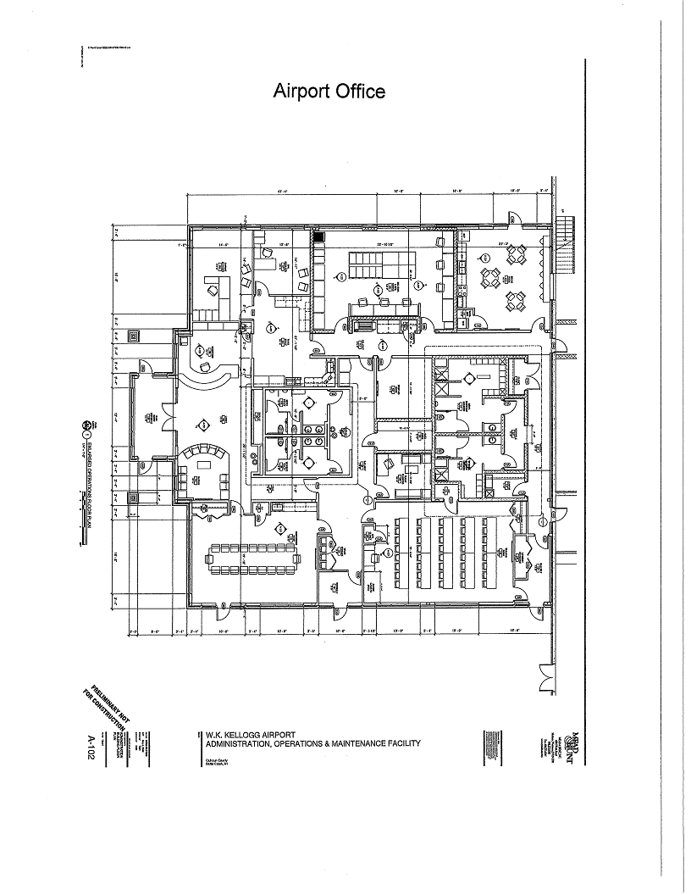

AOMF
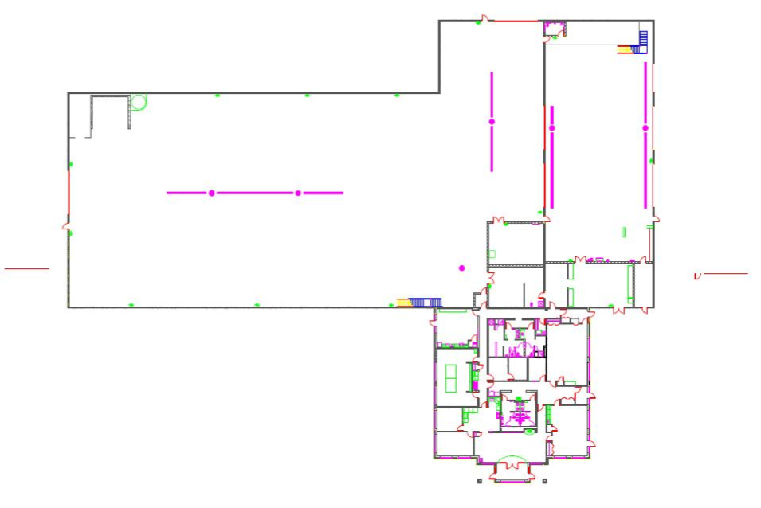

ATCT
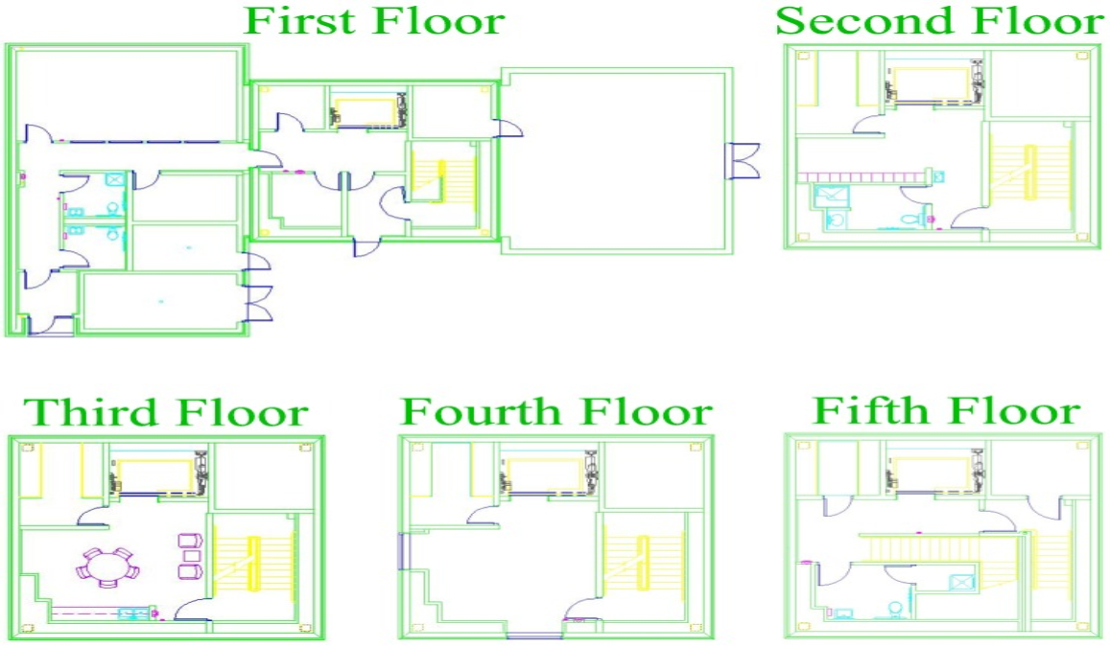

FAA Office/Hangar – First Floor
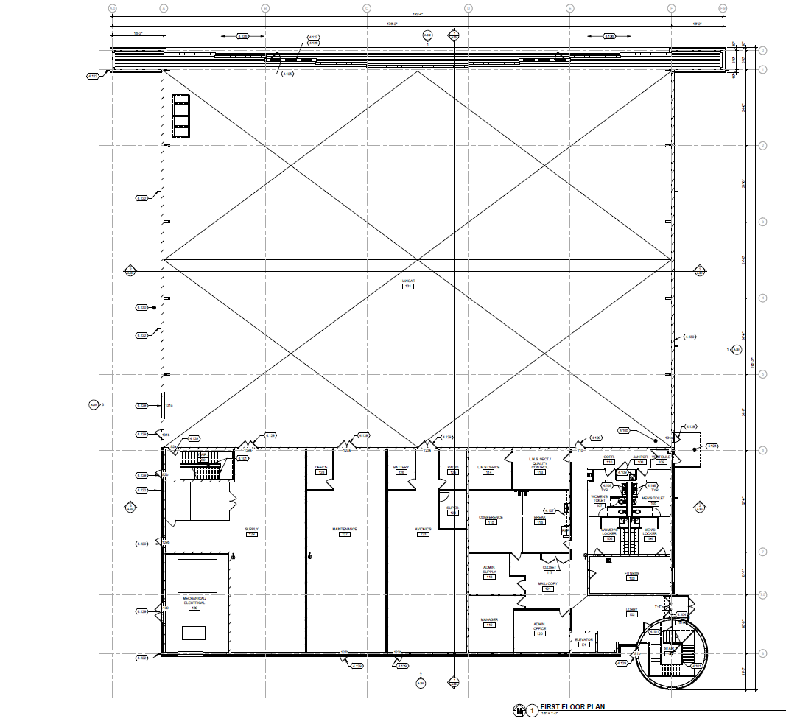

FAA Office/Hangar – Second Floor
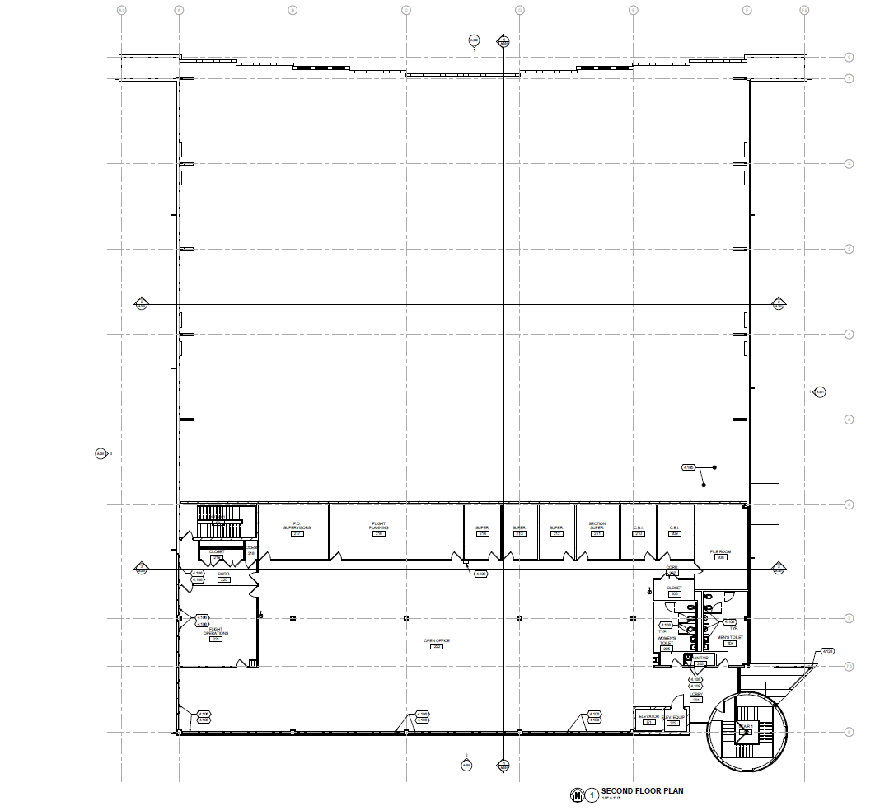

City Hall
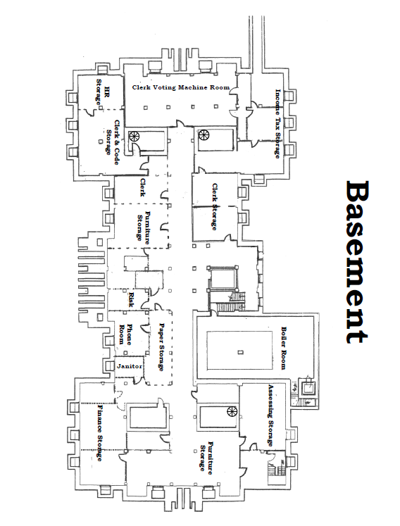

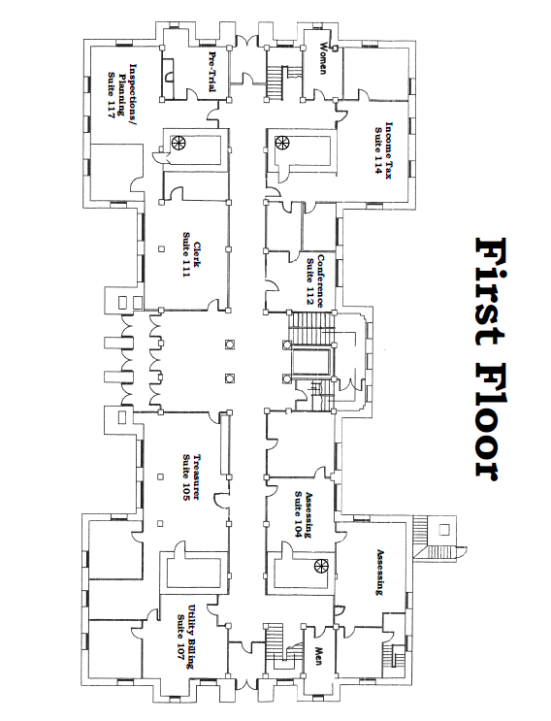

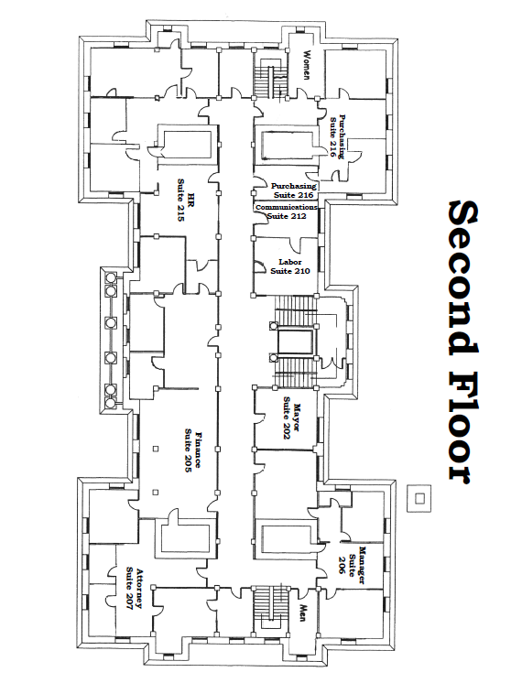

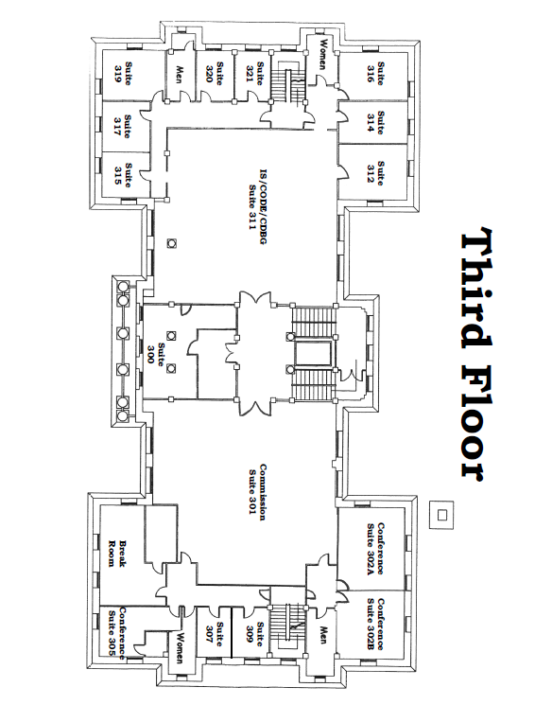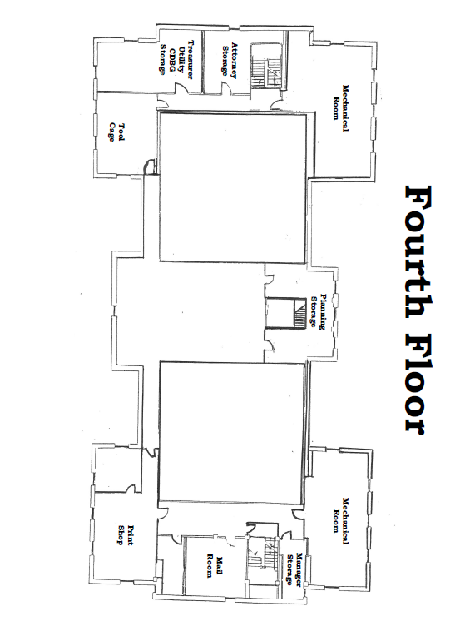

NEW POLICE BUILDING

FIRST FLOOR
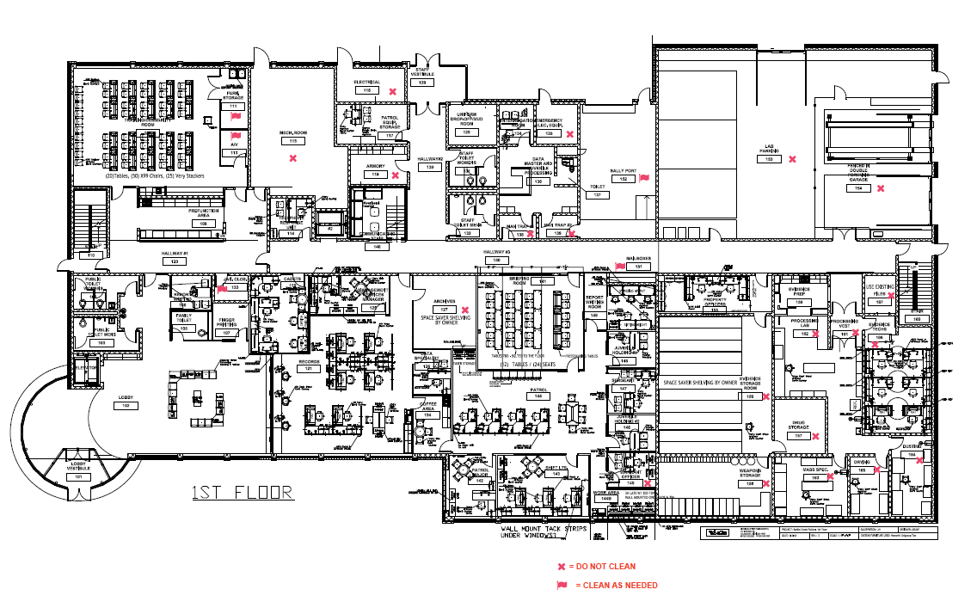

A detailed drawing is available to download on the web site:
http://battlecreekmi.gov/230/Bid-Proposal-Solicitations

NEW POLICE BUILDING

SECOND FLOOR

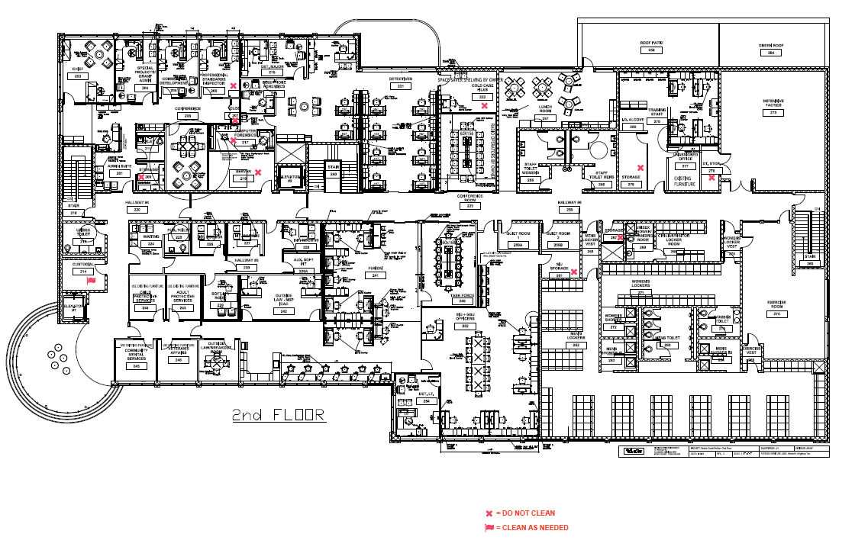
A detailed drawing is available to download on the web site:
http://battlecreekmi.gov/230/Bid-Proposal-Solicitations

POLICE BUILDING 34 N. DIVISION
REGULAR CLEANING
Room | Sq. Footage | Floor Type
Lobby (101, 102) | 1741 | CPT/VCT
Men's Restroom (103) | 127 | CT
Women's Restroom (104) | 124 | CT
Report Writing (106) | 80 | CPT
Family Restroom (105) | 65 | CT
Finger Printing (107) | 148 | CPT
Pre-function Area (108) | 224 | LVT
Community Room (109) | 1150 | CPT
TRU (114) | 106 | CPT
PATROL EQUIP. Storage (117) | 168 | CPT-7
Hallway (120) | 650 | CPT-7
CORRIDOR (130) | 335 | PC
Staff Restroom (131) | 123 | CT
Staff Restroom (132) | 140 | CT
Community Services/Cadets (119) | 285 | CPT
Employee vestibule (128) | 135 | CPT
Uniform Drop Off (129) | 66 | CT
Management Services Manager (125) | 200 | CPT
Records (121, 122, 123, 124) | 1164 | CPT
Data Specialist (126) | 106 | CPT
Briefing Room (141) | 643 | CPT
Patrol Sgt (144) | 630 | CPT
Patrol Major (142) | 192 | CPT
Patrol LT (143) | 351 | CPT
Work Area (144B) | 92 | LVT
Juvenile Holding #1 (148) | 108 | CPT
Admin Sgt (147) | 132 | CPT
Juvenile Holding #2 (146) | 108 | CPT
Report Writing Room (149) | 140 | CPT
CORRIDOR (150) | 1147 | PC
Interrogation Room (134) | 87 | CPT
Data Master Room (136) | 276 | Epoxy
Property Officers (155) | 280 | LVT
Evidence Prep (159) | 125 | PC
Evidence Techs (office 166) | 492 | CPT
Sub-Total 1st Floor Sq. Footage | 11,940
 | Second Floor
Room | Square Feet | Floor Type
Admin Conference Room (208) | 225 | CPT
Work Area (202) | 97 | LVT
Chief (203) | 272 | CPT
Special Projects (204) | 214 | CPT
Community Development (205) | 188 | CPT
Admin Suite (201) | 481 | CPT
Stairs (110, 210) | 185 | PC
Staff Restroom (211) | 56 | CT
Family Restroom (213) | 107 | CT
Detective Major (215) | 209 | CPT
Detective Sgt (216) | 150 | CPT
Cell Phone Forensics (218) | 94 | CPT
CORRIDOR (220) | 1083 | CPT-20
Detectives (221) | 1168 | CPT
Detectives Conference Room (223) | 352 | CPT
Waiting Room (224) | 138 | CPT
Interview Room #1 (226) | 90 | CPT
Interview Room #2 (227) | 91 | CPT
Soft Interview Room (228) | 95 | CPT
Aux. Soft Interview Room (228A) | 50 | CPT
Interview Room #3 (229) | 121 | CPT
Hallway (230) | 128 | CPT-22
Work Area (248) | 143 | LVT
Restroom (225) | 60 | CT
Women's Restroom (255) | 190 | CT
Stairs (240, 140) | 196 | CT
Fusion (241) | 1577 | CPT
MSP/ICAT (242) | 294 | CPT
Breakout Room (247) | 137 | CPT
APS (243) | 126 | CPT
Veteran's Affairs (246) | 137 | CPT
CMH (245) | 137 | CPT
CPS (244) | 127 | CPT
Task Force Room (249) | 368 | CPT
CORRIDOR (250) | 1240 | CPT-20
GSU/SIU Officers Area (252) | 1278 | CPT
GSU Sgt (253) | 139 | CPT
Detective Lt (254) | 226 | CPT
Men's Restroom (256) | 195 | CT
Lunch Room (257) | 652 | LVT
Roof Patio (258) | 461 | PT
Quiet Room A (259) | 88 | CPT
Quiet Room B (259) | 88 | CPT
Stairs (260, 160) | 185 | PC
Men's Vestibule (261) | 80 | LVT
Men's Locker Room (262) | 1996 | CPT/LVT
Men's Shower Area (263 & 264) | 196 | CT
Men's Restroom (265) | 250 | CT
Exercise Vestibule (266) | 37 | R
Open Locker Room (268) | 210 | CPT
Shower/Changing room (269) | 88 | CT
Women's Vestibule (270) | 40 | R
Women's Locker Room (271) | 482 | CPT/LVT
Women's Shower (272) | 83 | CT
Women's Restroom (273) | 103 | CT
Exercise Room (274) | 780 | R
Defensive Tactics (275) | 996 | R
Unassigned Office (277) | 116 | CPT
Training Staff (278) | 588 | CPT
I.D. ALCOVE (280) | 50 | CPT-8
Sub-Total 2nd Floor Sq. Footage | 19,733
AS NEEDED CLEANING
Furniture storage (111) | 100 | VCT
A/V storage (112, 113) | 62 | VCT
JAN. CLOS. (133) | 55 | SC
MAILBOXES (151) | 20 | N/A
SALLY PORT (152) | 664 | SC
CUSTODIAL (214) | 214 | SC
Sub-Total Sq. Footage | 1115
DO NOT CLEAN
Mechanical Rm (115)
Electrical (116)
ARMORY (118)
Archives (127)
EMERGENCY ELEC. Equip (135)
SEC. VEST. 1 (138)
SEC. VEST. 2 (139)
LAB PARKING (153)
FENCED IN DOUBLE Forensic Garage (154)
EVIDENCE STORAGE Room (156)
DRUG STORAGE (157)
WEAPONS STORAGE (158)
PROCESSING VEST (161)
PROCESSING LAB (162)
MASS SPEC. (163)
DUSTING (164)
DRYING (165)
EVIDENCE TECHS (166)
FILES (167)
CLOS. (207)
STORAGE (209)
STORAGE (212)
COMPUTER Forensics (217)
SERVER (219)
COLD CASE FILES (222)
SIU STORAGE (251)
STORAGE (267)
DT. STOR. (276)
STORAGE (279)
Professional Standards (206)
WARRANT OFFICER (145)
Rm (113) - Does not exist/ Old Plan
Rm (231, 232, 233, 234, 234, 235, 236, 237, 238, 239) Does not exist/ Old Plan
Total Flooring Sq. Footage | 32,768
Legend
CPT | Carpet Tiles
VCT | Vinyl Composition Floor Tiles
LVT | Luxury Vinyl Tiles
R | Rubber Flooring
PT | Paint
CT | Ceramic Tile
SC | Sealed Concrete
PC | Polished Concrete

POLICE BUILDING 301 ELM STREET

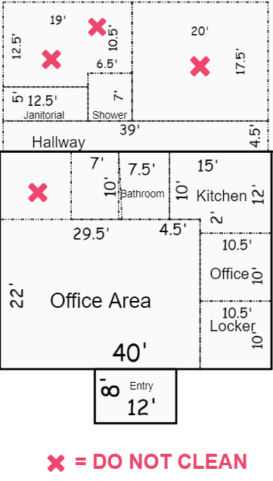

DPW Administration Building and Carehere Suite

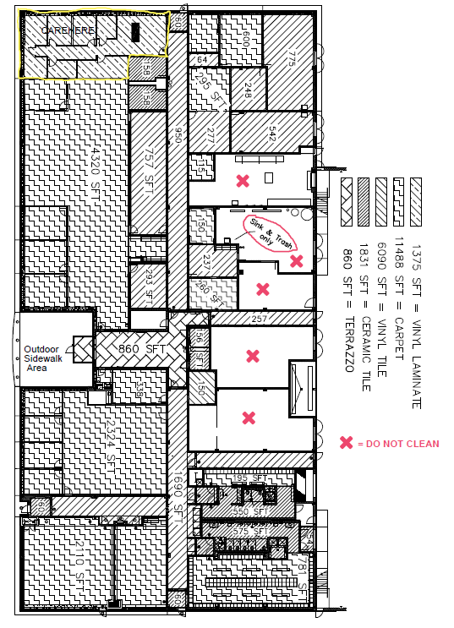

ATTACHMENT C – SAMPLE CHECK SHEET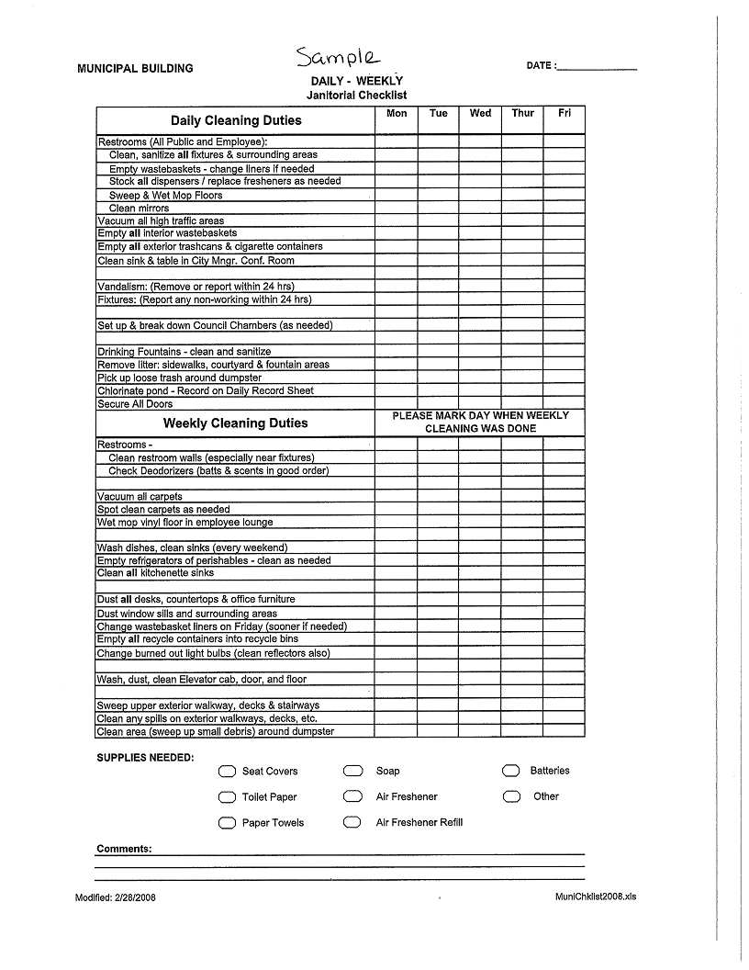

ATTACHMENT D - SITE VISIT

SCHEDULE OF LOCATIONS AND ADDRESSES

DATE | TIME | BUILDING | LOCATION
June 12, 2018 | 9:00 am – 9:30 am | City Hall | 10 N. Division St.
 | 9:35am to 9:45 am | Police Records Bldg. | 301 Elm St.
 | 10:00 am to 10:45 am | DPW Admin. Bldg. & Carehere | 150 S. Kendall St.
 | 11:00 am to 12:00 am | Airport Facilities | 15551 S Airport Rd.
 | BREAK
 | 3:00 pm – 3:45 pm | Police Building | 34 N. Division St.

The purpose of this conference and site visit will be to clarify the contents of this bid in order to prevent any misunderstanding of the City's position. Any doubt as to the requirements of this bid or any apparent omission or discrepancy should be presented to the City at this conference. The City will then determine the appropriate action necessary, if any, and issue a written amendment to the bid. Oral statements or instructions shall not constitute an amendment to this bid.

NOTE-
- Personal protection equipment is required to tour the new Police building due to final construction status. Please bring with you a hard hat, safety glasses, and a safety vest.
- A ride service is available and recommended for those participating in the pre-bid site visit. The ride service will start and finish at City Hall, 10 N. Division Street East end parking lot.

