Request for Proposals

Solicitation Name and Number | Equity and Debt Services for the Development of Phase 1b at Austin Homes Q2112
KCDC’s Procurement Division must receive your response no later than | 11:00 a.m. on January 19, 2021 (as KCDC’s clocks indicate)
Email Responses to | procurementinfo@kcdc.org
Electronic Copies | Use the MS Word version posted on KCDC’s website (or other electronic means) to provide a typed response. The final proposal is to be submitted in Adobe format.
Questions About This Solicitation | Submit questions to procurementinfo@kcdc.org by 4:00 p.m. on January 15, 2021.  KCDC will not accept questions via telephone.
Solicitation Meeting | ☒ Yes ☐ No
Solicitation Meeting Connection | KCDC will host an on-line meeting. Email procurementinfo@kcdc.org for the web link.
Solicitation Meeting is Mandatory | ☐ Yes ☒ No ☐ Not Applicable
Solicitation Meeting Date and Time | January 12, 2021 at 2:00 p.m.
Award Results | KCDC posts the award decision to its web page at: http://www.kcdc.org/procurement/
Open Records/Public Access to Documents | All document provided to KCDC are subject to the Tennessee Open Meetings Act (TCA 8-44-101) and open records requirements.
Check KCDC’s webpage (https://www.kcdc.org/procurement/) for addenda and changes before submitting your response

General Information

1. Background and Intent
a. Knoxville's Community Development Corporation (KCDC) is the public housing and redevelopment agency for the City of Knoxville and for Knox County in Tennessee. KCDC’s affordable housing property portfolio includes 20 sites with approximately 3,525 dwelling units. KCDC has extensive experience with the development, construction and renovation of affordable housing properties utilizing the Low-Income Housing Tax Credit (LIHTC) program as well as Multifamily Tax-Exempt Bond Authority (MTBA). In the last four years, KCDC has completed the following projects utilizing LIHTCs and MTBA in the Knoxville area:

- 2017 completed construction on a 90-unit senior complex (9% LIHTC)
- 2018 completed construction on an 84-unit family complex (9% LIHTC)
- 2018 completed rehab on a 260-unit family complex rehab (4% LIHTC + MTBA)
- 2018 completed rehab on a 175-unit family complex rehab (4% LIHTC + MTBA)
- 2019 completed rehab on a 270-unit family complex rehab (4% LIHTC + MTBA)
- 2019 completed construction on an 80-unit family complex (9% LIHTC)
- 2019 completed construction on an 82-unit family complex (9% LIHTC)
- 2020 closed on the financing for a 105-unit mixed income family complex (9% LIHTC) (phase 1a
of Austin Homes-currently under construction)

b. In 1936, the State of Tennessee chartered KCDC as the public housing authority for the City of Knoxville. In 2012, KCDC assumed the duties of the former Knox County Housing Authority, and charter was expanded to all of Knox County. KCDC operates as a municipality under Tennessee law.

c. KCDC’s mission is to improve neighborhoods and communities by
- Providing quality affordable housing
- Advancing development initiatives
- Fostering self-sufficiency

d. In 2019, KCDC completed a nine-month master planning process for the redevelopment of the Austin Homes site, a 23-acre former public housing site owned by KCDC and located just east of Downtown Knoxville. It is approximately one block from the site of a new proposed minor league baseball stadium. Information can be found HERE.

The master plan called for the redevelopment of the site’s infrastructure (including new roads and sidewalks, new underground utilities, improvements of the site’s topography) and the development of approximately 425 new residential units to be developed over three to four different phases. Construction of the site’s infrastructure began in the spring of 2020 and will be complete by August 2021 (funded through local external sources). The first phase of residential construction, Phase 1a, broke ground in August 2020 and is a 105-unit mixed income development that was funded in part with an award of 9% LITHCs. Phase 1a will begin lease-up in the summer of 2021 and will be complete by late 2021. Renderings are available in Appendix B.

e. Austin Homes Phase 1b is the second phase of residential development at Austin Homes. Phase 1b will consist of 180-units of new residential construction and will be 100% tax credit. KCDC intends to utilize Income Averaging. KCDC has been preliminarily awarded 45 project-based-vouchers that will be secured to the site through a 20-year HAP contract.

f. KCDC intends to apply to Tennessee Housing Development Agency (THDA) in early 2021 for an allocation of Multifamily Tax-Exempt Bond Authority (MTBA) as well as 4% non-competitive LIHTC to facilitate the development of Phase 1b at Austin Homes. KCDC is seeking a LIHTC investor to purchase the LIHTCs and a lender to provide construction and permanent financing. KCDC intends to close on the transaction within 120 days of receiving a firm commitment from THDA.

g. THDA also offers the Community Investment Tax Credit (CITC) loan program. KCDC may utilize the CITC program in cooperation with a qualified CITC lender. More information on the CITC program can be found HERE.

h. The entire Austin Homes site is in an Opportunity Zone as well as a Qualified Census Tract (QCT).

i. A summary of KCDC’s financial performance and recent audits can be found HERE.

j. KCDC will serve as the Issuer of the MTBA. The estimated amount of bonds to be issued will be $24,000,000. In the event a bond underwriter and advisor are required, Raymond James will likely serve as the bond underwriter and initial purchaser of the bonds.

k. Bell Street 3 LP is a single purpose entity and will serve as the ownership and loan borrower entity of
Phase 1b. Bell Street 3 Corporation will serve as the General Partner of Bell Street 3 LP, as well as the developer. Bell Street 3 Corporation is 100% owned by KCDC.

l. KCDC also intends to use this RFP process to establish a pool of qualified firms from which KCDC may quickly solicit proposals in the future for additional needs without issuing another formal RFP. However, KCDC may issue additional RFPs in the future, if so desired. If the panel of qualified firms is established, the panel may extend for a maximum of five years.

2. Changes after Award
It is possible that after award KCDC will need to revise the service needs or requirements specified in this document. KCDC reserves the right to make such changes after consultation with the equity provider. Should additional costs arise, the equity provider must document increased costs. KCDC reserves the right to accept and negotiate these charges.

3. Contact Policy
Only KCDC’s Procurement Division may be contacted about this solicitation from the issuance of this RFP until award. Information obtained from an unauthorized officer, agent, or employee will not affect the risks or obligations assumed by the proposer or relieve the proposer from fulfilling any of the conditions of the resulting award for the purpose of this project. Such contact can disqualify the proposer from the solicitation process.

4. Evaluation

KCDC alone determines the proposer’s “responsive” and “responsible” status prior to preliminary award. Responsible means a business with the financial and technical capacity to perform the requirements of the solicitation and subsequent contract. A responsive proposal is one that fully conforms in all material respects to the solicitation document and its requirements, including all form and substance.

a. KCDC will review all proposals and reserves the right to request necessary modifications, waive minor technicalities, reject all proposals, reject any proposal that does not meet mandatory requirement(s) or cancel this RFP, according to KCDC’s best interests. KCDC further reserves the right to adjust its evaluation scenario if this is in KCDC’s best interest and consistent with good business practices.

b. KCDC’s Evaluation Team may elect to interview one or more respondents prior to making an award. Interviews may include an in-person discussion of the proposal. KCDC will not reimburse respondents for any costs associated with the interview process.

c. KCDC’s Evaluation Team may elect to first rank proposals with a simple numeric score and then score the remaining top tier of proposals in greater detail.

d. Proposers shall submit a formal letter of intent to serve as the basis for the evaluation of this proposal.

e. KCDC may award both the LIHTC equity investment and loan opportunity to the same proposer or separately.

- The following information is requested for all LIHTC equity proposals:
  - Total amount of equity provided and purchase price per dollar of tax credit
- Provide an equity pay-in schedule
- Description of downward and upward adjusters; KCDC is assuming that the 4% LIHTC rate is fixed
at no less than 4%
- Amount of due diligence, legal, or other closing fees as well any fees during construction, if
applicable; please note any caps on costs/fees
- Any ongoing fees charged to the project after placed in service
- Waterfall terms for operating cash flow and sale proceeds
- Estimated annual credit delivery based on lease-up schedule provided in underwriting
- Reserve Requirements (Operating, Capital, et cetera)
- Developer Fee pay-out schedule
- Ability for KCDC to rely on proposal and provide approval process and timeline to execute
partnership agreement and close transaction
- Summary of investor’s purchase option and ROFR terms
- Any guaranties required and limits to guaranties
- Detailed description of the terms of recapture
- Any other terms for consideration as necessary

g. The following information is requested for all debt proposals:

- Indicate which of the following loan structures you prefer and tailor the remainder of your
loan proposal based on the structure selected:

  - A) Provide a CITC construction loan (include the maximum amount of a construction loan in
the proposal) and purchase the full amount (estimated to be $24,000,000) of the bonds directly from the Issuer (via a private offering). Bonds will be cash collateralized. When a draw is needed to pay project costs, CITC loan proceeds will be disbursed to an account that secures the bonds and a like amount of bond proceeds will be disbursed to pay the project costs. Bonds will have a mandatory tender date of approximately 24 months from issuance. After all bond proceeds are disbursed, the remaining CITC loan proceeds would be disbursed directly to pay project costs.

  - B) Provide a CITC construction loan only (include maximum amount of construction loan in
proposal) and do not commit to purchasing the amount of the bonds. This structure will require a public bond offering which would likely be underwritten and initially purchased by Raymond James. Lender may purchase a portion of the bonds from the underwriter via the public offering. Bonds will be cash collateralized. When a draw is needed to pay project costs, CITC loan proceeds will be disbursed to an account (established with the bond trustee) that secures the bonds and the bond trustee would disburse a like amount of bond proceeds to pay the project costs. After all bond proceeds are disbursed, the remaining CITC loan proceeds would be disbursed directly to pay project costs.

  - C) Provide a (non-CITC) construction loan (include the maximum amount of the construction
loan in the proposal) which would be structured as a privately placed conduit bond issue with a Series A bond and a Series B Bond. The Series A bond would be in a principal amount of up to $25,000,000 and would be tax-exempt for federal income tax purposes. The remaining amount would be the Series B bond amount and would be taxable for federal income tax purposes. The project would serve as collateral for the bonds.

- In addition to the above construction options, indicate if the construction loan will convert to a
permanent loan (permanent term to be no less than 15 years). Note, KCDC strongly prefers a construction to permanent loan execution.

- For proposals with qualified CITC construction loans and an ability to convert to a perm loan, indicate if the perm loan will also qualify for the CITC program for the term of the perm loan.

- Provide the following loan terms for each of the scenarios above:

  - Construction loan and permanent loan interest rate; note any rate floors or caps; for option
A, also indicate bond interest rate

  - Construction loan proceeds (in the event option A or C above are selected, indicate amount
of any secondary construction loan proceeds available in addition to the $24,000,000 of bond proceeds) and permanent loan proceeds

  - Loan term (in months or years) for construction and permanent loans
  - Amortization and any periods of interest only

  - Any loan/due diligence, commitment or origination fees

  - Minimum DSCR covenants

  - Any prepayment penalties

  - Mortgage constant calculation for loan sizing and covenants (amortization, interest rate and
coverage ratio)

  - KCDC guaranties (Non-recourse is preferred)

  - Reserve requirements

  - Ability for KCDC to rely on proposal and provide approval process and timeline to execute
partnership agreement and close transaction

5. General Instructions
KCDC does not insert “General Instructions to Suppliers” in solicitation documents. These instructions are at www.kcdc.org. Click on “Procurement” and the link to the instructions. The supplier’s submittal means acceptance of the terms and conditions set forth in KCDC’s “General Instructions to Suppliers.”

Paragraphs in the “General Instructions” document that do not apply to this solicitation: 4, 11, 15, 16, 18, 23, 32, 41, 42, 43, 47, 48, 50, 51, 54, 55, 56, 61, 62, 63, 64, 65, 67, 68.

6. Insurance
The proposer agrees to maintain at its sole expense during the term of this agreement insurance coverages and limits in accordance with the proposer’s standard business practices and acceptable to KCDC. Upon request, the proposer shall provide KCDC with Certificates of Insurance evidencing such insurance.

7. Licenses
The proposers shall maintain all licenses necessary to conduct business in the State of Tennessee.

8. Reservation of Rights
a. KCDC reserves the right to terminate a contract awarded pursuant to this RFP, at any time for its convenience, upon 10 days’ written notice to the successful proposer.

b. KCDC reserves the right to retain all proposals submitted and not permit withdrawal for a period of 60 days after the deadline for receiving proposals without the written consent of KCDC’s Procurement Director.

c. KCDC reserves the right to negotiate the fees proposed by the proposer if it so desires.

d. KCDC has no obligation to compensate proposers for costs incurred in responding to this RFP.
9. Submittals
All proposals, responses, inquiries, or correspondence relating to or about this RFP, and all reports, charts, displays, schedules, exhibits, and other documents provided by companies will become KCDC’s property when received.

Project Description/Scope of Work

10. Project Description
a. The property owner will be Bell Street 3 LP, a Tennessee Limited Partnership, with Bell Street 3 Corporation, a Tennessee Corporation (100% KCDC owned instrumentality) as the General Partner.

b. KCDC has begun the process of redeveloping Austin Homes – a twenty-three-acre Public Housing site – into a dynamic mixed-income, urban neighborhood. The site is a quarter of a mile east of the “Old City” district and of Downtown Knoxville; adjacent to a newly proposed minor league baseball stadium; and a quarter mile north of a proposed $100 million children’s science museum. Increased connectivity via new street connections, greenways, and sidewalks, make this a site capable of supporting all types of residential and neighborhood retail uses.

c. Phase 1b will be built on approximately six acres owned by KCDC, with a 75-year ground lease to the partnership with a nominal annual lease payment. The Phase 1b development will consist of 180 units in five buildings. There will be 86 one-bedroom units, 76 two-bedroom units and 18 three-bedroom units. Income averaging will be utilized – 45 units will be restricted to incomes of 30% of AMI or less, 95 units will be restricted to incomes of 60% of AMI or less and 40 units will be restricted to incomes of 80% of AMI or less.

d. The project has been preliminarily awarded 45 Project Based Vouchers (PBV) that will be governed by a Housing Assistance Payment (HAP) contract with an initial 20-year term and an automatic 20-year renewal term. The project will also benefit from a PILOT agreement with the City of Knoxville to be set at $0.00 per year.

11. Construction Information
a. Hardaway Construction will serve as the Construction Manager and will be engaged by the partnership through an executed AIA 133 contract. To-date, Hardaway has provided a construction cost estimate of $27,500,000 based on schematic design. Hardaway will provide updated construction cost estimates based on design development documents by late January 2021. A GMP will be entered into simultaneous with closing of the partnership. Samples of Hardaway Construction’s experience in multifamily construction is HERE.

b. Construction on Phase 1b is estimated to begin in June 2021 with lease up starting in August of 2022 and completed by the end of April 2023. For additional assumptions on the lease-up schedule see the underwriting package by clicking HERE.

12. Development Team
a. General Partner:
KCDC created Bell Street 3 Corporation, a 100% owned instrumentality to be the General Partner. KCDC has a great deal of experience with LIHTC over the years and KCDC controlled General Partners currently have over 1,100 units either currently operating or under rehab/construction within the LIHTC program.

b. Developer:
The Bell Street 3 Corporation will also serve as the developer.

c. Property Manager:
As on previous deals, KCDC will be the management entity for this property.

d. Construction Consultant/Owner’s Representative:
Partner’s Development is KCDC’s Construction Consultant/Owner’s Representative. Partners Development has been the Owner’s Representative for KCDC on our five most recent LIHTC developments (2015-20), as well as numerous other non-LIHTC development projects. Their role includes oversight of all A/E, construction and budgetary monitoring.

e. Architect:
Johnson Architecture and Southeast Venture are KCDC’s architects on the project.

f. Attorneys:
Jordana Nelson, Jay Moneyhun and Mark Mamantov of Bass, Berry, & Sims are KCDC’s attorneys on the project.

13. Underwriting Package
An underwriting package including a development budget, operating proforma and a unit matrix with a lease-up schedule has posted to the procurement section of the KCDC website in connection with this RFP.

14. Market Study
A copy of the Phase 1b market study has posted to the procurement section of the KCDC website in connection with this RFP.

15. Architectural Plans
Design Development stage architectural drawings have posted to the procurement section of the KCDC website in connection with this RFP.

16. Submittal Structure Instructions
Order your proposal in this sequence:
- Response to the evaluation criteria listed above
- Solicitation Document A General Information
- Solicitation Document B Affidavits

This and the previous pages do not need to be returned
Solicitation Document A: General Information
Sign Your Name to the Right of the Arrow
If completing this document in Adobe, an electronic signature is acceptable to KCDC.
Your signature indicates you read and agree to “KCDC’s General Instructions to Firms” (www.kcdc.org) and that you are authorized to bind the firm or are submitting the response on behalf of and at the direction of the firms’ representative authorized to contractually bind the firm. I represent that the firm or its applicable representative(s) has reviewed the information contained in this Solicitation Package and that the information submitted is accurate.
Printed Name and Title
Company Name
Street Address
City/State/Zip
Contact Person (Please Print Clearly)
Telephone Number
Cell Number
E-Mail Address (Please Print Clearly)
Addenda
Addenda are at www.kcdc.org. Click on “Procurement” and then on “Open Solicitations” to find addenda. Please check for addenda prior to submitting a proposal.
Acknowledge addenda have been issued by checking below as appropriate:
None ☐ | Addendum 1 ☐ | Addendum 2 ☐ | Addendum 3 ☐ |  | Addendum 4 ☐ | Addendum 5 ☐

Solicitation Document B Affidavits

Conflict of Interest
1. No commissioner or officer of KCDC or other person whose duty it is to vote for, let out, overlook or in any manner superintend any of the work for KCDC has a direct interest in the resulting award or the proposer’s business.

2. No KCDC employee, officer or agent will participate in selection, or in the award or administration of an award if a conflict of interest, real or apparent, would be involved. Such a conflict would arise when the employee, officer or agent, any member of his immediate family, his or her partner, or an organization, which employs, or is about to employ, any of the above, has a financial or other interest in the proposer selected for award.

3. KCDC’s officers, employees or agents will neither solicit nor accept gratuities, favors or anything of monetary value from proposers, potential proposers, or parties to sub-agreements.

4. By submission of this form, the proposer is certifying that no conflicts of interest exist.

Eligibility
5. The firm is eligible for employment on public contracts because no convictions or guilty pleas or pleas of nolo contender to violations of the Sherman Anti-Trust Act, mail fraud or state criminal violations with an award from the State of Tennessee or any political subdivision thereof have occurred.

General
6. Proposer fully understands the attached offer, all pertinent circumstances respecting such offer and the proposer attests that the offer is genuine and is not a sham offer.

Accuracy of Electronic Copies
7. If the proposer provides electronic copies of the proposal to KCDC, the proposer certifies that the information provided on paper and in the electronic format is identical unless specifically noted otherwise.
Non-Collusion
8. Neither the said firm nor any of its officers, partners, owners, agents, representatives, employees or parties interest, including this affiant, has in any way colluded conspired, connived or agreed, directly or indirectly, with any other responder, firm, or person to submit a collusive or sham offer in connection with the award or agreement for which the attached offer has been submitted or to refrain from making an offer in connection with such award or agreement, or collusion or communication or conference with any other firm, or, to fix any overhead, profit, or cost element of the offer price or the offer price of any other firm, or to secure through any collusion, conspiracy, connivance, or unlawful agreement any advantage against KCDC or any person interested in the proposed award or agreement.

9. The price or prices quoted in the attached offer are fair, proper and not tainted by any collusion, conspiracy, connivance, or unlawful agreement on the part of the firm or any of its agents, representatives, owners, employees, or parties in interest, including this affiant.
No Contact/No Advocacy Affidavit
10. After this solicitation is issued, any contact initiated by any proposer or proposer with any owner’s representative concerning this proposal is strictly prohibited-except for communication with the Procurement Division. My signature signifies that no unauthorized contact occurred.

11. To ensure the integrity of the review and evaluation process, proposers or any firm representing them, may not lobby or advocate to owner’s staff or Board members. My signature signifies that no unauthorized advocacy occurred.

Non-Discrimination
12. KCDC does not discriminate on the grounds of race, color, creed, religion, sex, natural origin, age, sexual orientation or disability. Proposers concur with KCDC’s non-discrimination standard and extend it to any resulting award. Proposers will provide equal access to subcontractors (if needed) and award to them without respect to race, color, creed, religion, sex, natural origin, age, sexual orientation, or disability.

Iran Divestment Act
13. Concerning the Iran Divestment Act (TCA 12-12-101 et seq.), by submission of this bid/quote/proposal, each firm and each person signing on behalf of any firm certifies, and in the case of a joint bid/quote/proposal, each party thereto certifies as to its own organization, under penalty of perjury, that to the best of its knowledge and belief that each firm is not on the list created pursuant to § 12-12-106.

The undersigned hereby acknowledges receipt of these affidavits and certifies that the submittal in response to this solicitation is in full compliance with the listed requirements.

Signed by
Printed Name
Title
Subscribed and sworn to before me this date
By (Notary Public)
My Commission Expires on
Notary Stamp

Appendix A Proposed Site Map Plan Attachment

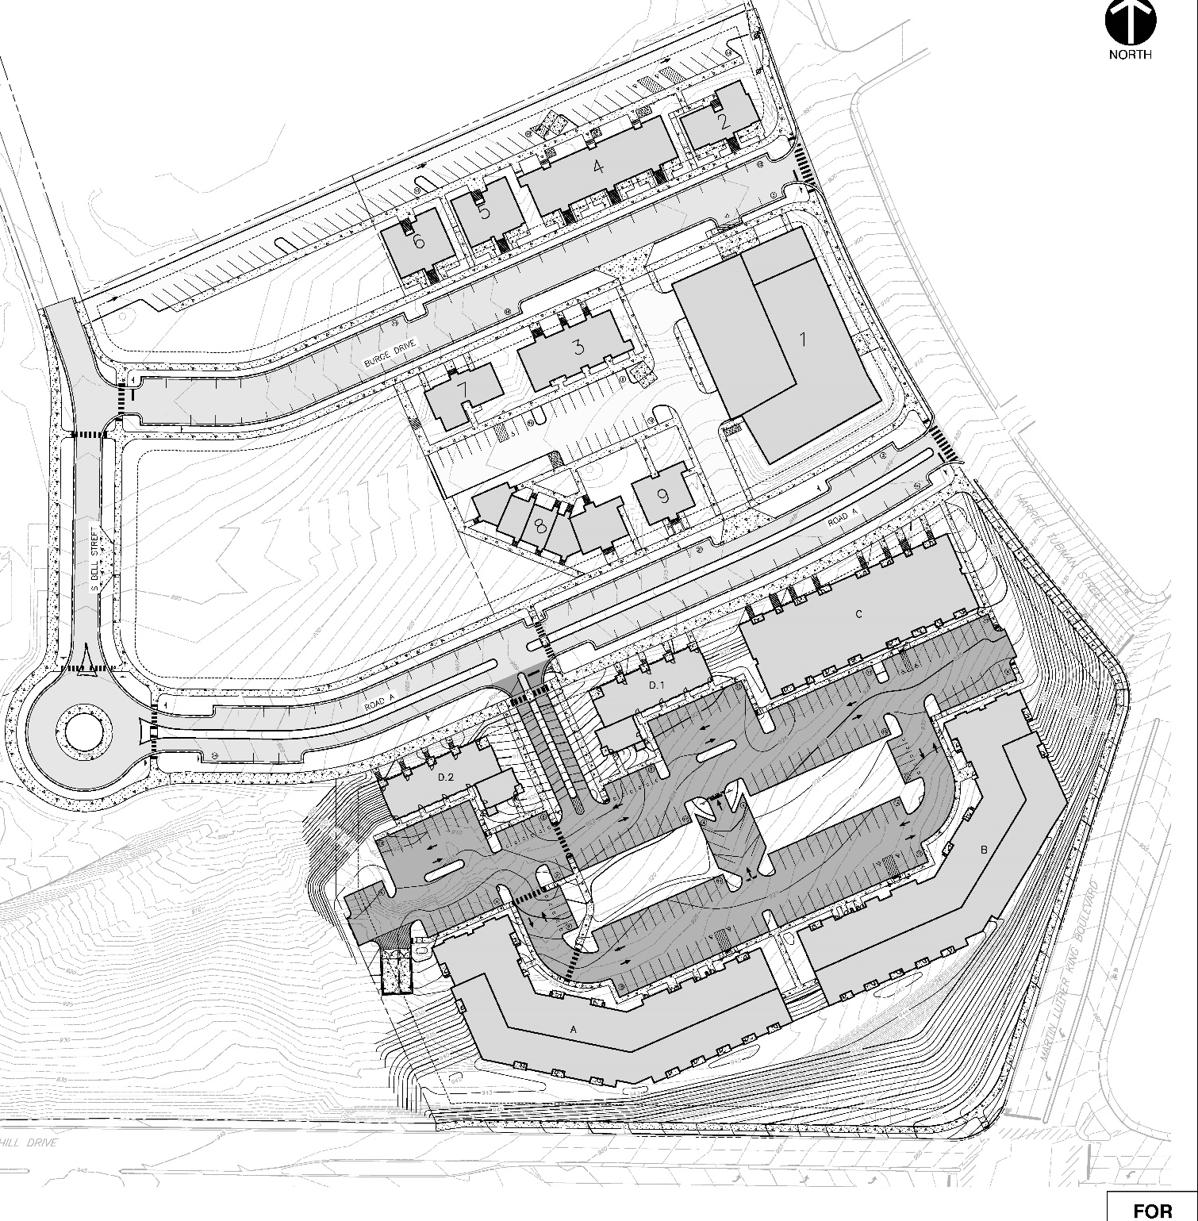
Phase 1A – 105 units
Phase 1B – 180 Units

Appendix B Renderings
