Addendum #5
Griffin Spalding Wayfinding Signage
Questions and Answers

1. Below is a snip it from the detail drawings for the posts. There is a call out for a 1 ¾” x 3” aluminum tube. This size of material does not exist to order from the mill. This would have to be fabricated to be that size otherwise the same can be accomplished with increasing the size to 2” x 3” aluminum tube which is readily available. The purpose of my message is to make sure if we can deviate from the dimensions below?
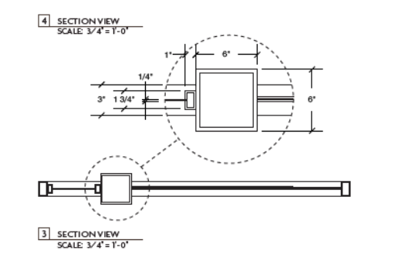

Answer. I would allow for an addendum to anyone’s bid that would suggest a less expensive way to achieve the same relative results. You should still quote the project as presented, but add the addendum to your submitted bid as an option to save on costs.

