Addendum #7
Griffin Spalding Wayfinding Signage
Questions and Answers

- Is there still an aluminum tube frame that goes around each sign?
Yes.

- I don’t see signs #25, #29, #34, #35 listed under any of the S/M/L/XL signage lists. Did I miss it somewhere?

25, 34 and 35 are listed under small size
Correction in bid sheet from RFP: “We need two of sign number 28 called Sign 28 and Sign 28.1.”; the bid sheet should say 28.1 instead of 29

- Could the city verify submission address?
  - This address has received an undeliverable notice:
Attention: Sherri Huggins, Procurement Coordinator
100 S Hill Street, 3rd Floor
Griffin, GA 30223

It should be: City of Griffin
Attention: Sherri Huggins, Procurement Coordinator
100 S Hill Street, 3rd Floor
Griffin, GA 30224

- Will the city accept a hand-delivered sealed bid by company personnel? If so to whom and where would this person be found for delivery?

The 3rd floor at the above address and hand deliver to Sherri Huggins.

- Upon review of the layout drawings and scaling them based on provided dimensions the frame width drawn is 1” wide. Please confirm 1” x 3” tube is the desired frame size.
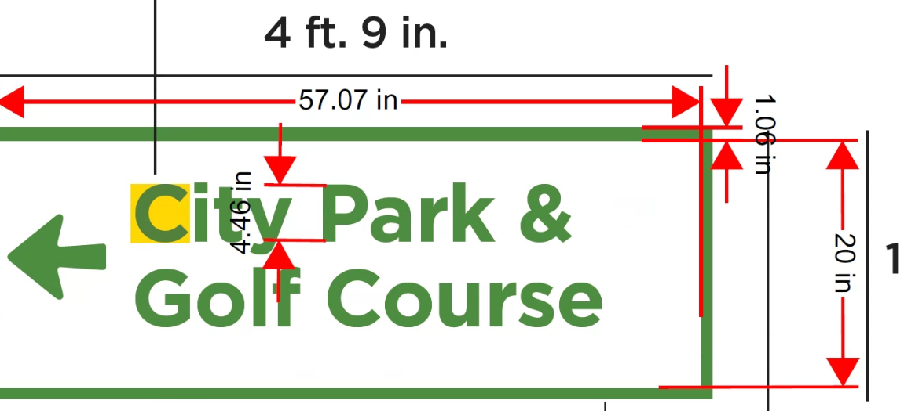
That is correct!

- Please verify no permits cost are required for this bid since the city is installing all signs.
That is correct, no permits

- We are also a little confused on the type of bases we are bidding. I see that in one spot the bid form calls out using an alignment plate and placement bolts. Then I see it also calls out for anchor cages? Can you please clarify what we need to ship in advance of the signs? Also, does the breakaway apply only to the signs labeled as DOT?
Disregard the section in the RFP which states: “Company must provide a jig for the placement of bolts in the concrete at least eight weeks prior to delivery so that the concrete footings can be poured before delivery and that the bolts set in the footings will match up to the sign post for installation.”
Instead, the company will only need to provide the anchor cages up front.

