

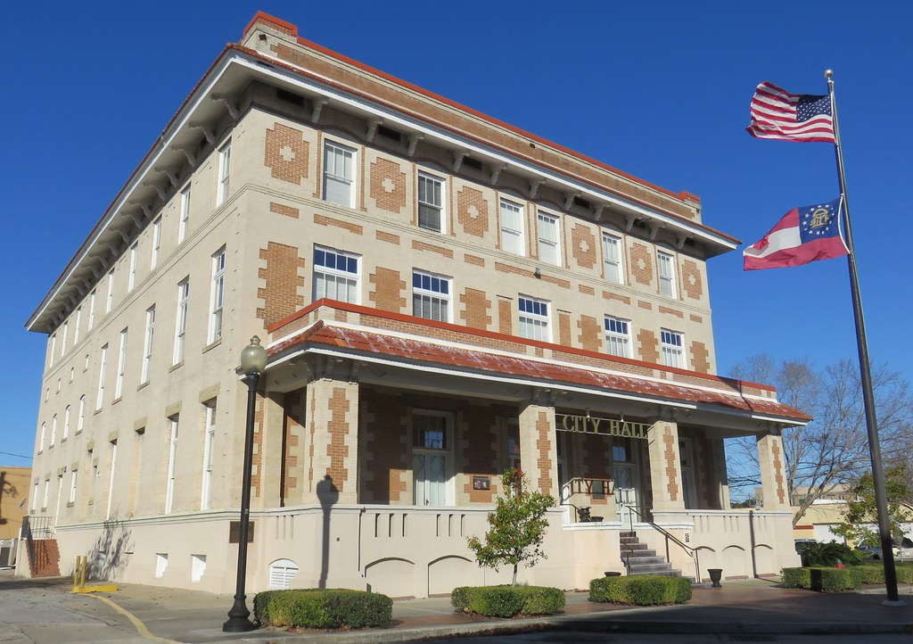

Request for Proposal
For
Scanning and Digital Imaging Services
Bid Number FY26-01
BIDS DUE NO LATER THAN 10:00 AM ON WEDNESDAY, AUGUST 20, 2025
City of Waycross
Purchasing Department
Attn: Mamie Jackson, Purchasing Manager
417 Pendleton Street
Waycross, GA 31501
Introduction
The City of Waycross (“the City”) is seeking proposals from qualified vendors to provide digital scanning and imaging services to convert physical records into digital formats. The goal is to improve accessibility, reduce physical storage needs, and enhance the management and security of public records.
Scope of Services
The selected vendor will be expected to:
- Pick up and securely transport physical documents from designated City locations.
- Prepare documents for scanning (e.g., remove staples, repair tears, etc.).
- Digitally scan documents in black & white and/or color at a minimum of 300 DPI resolution (600 DPI where required).
- Index scanned documents based on predefined metadata fields (e.g., name, date, file number).
- Deliver digital files in a format specified by the City (e.g., PDF/A, TIFF).
- Provide searchable PDFs using Optical Character Recognition (OCR) where applicable.
- Ensure quality assurance and quality control processes.
- Provide secure and compliant handling of confidential and sensitive information.
- Return original documents (based on City's instructions).
- Provide regular status reports and final delivery on a secure medium or via a secure transfer.
Document types include building plans, engineering drawings, easements, permits, and other critical property information maintained by the City's departments. The typical dimensions of records are 8½” x 11”, 11” x 17”, and 24” x 32”.
The vendor facility mut have a fire suppression system. This system must pass a site inspection of the facility by City officials.
All scanned documents must be digitized in Laserfiche’s native TIFF format. Large-format documents such as 24” x 32” drawings must be scanned with equipment capable of preserving resolution and scale accurately. Vendors must ensure compatibility with Laserfiche ECM software for indexing, importing, and metadata tagging.
Optional services (if applicable):
- Microfilm/microfiche conversion
- Large-format document scanning (e.g., maps, blueprints)
- Integration with City's existing records management systems

Preparation Requirements
For documents to be scanned, the vendor shall perform “Document Preparation” as
It is necessary to scan all files. This includes removing all staples and paperclips, repairing all
torn documents with non-reflective tape, straightening all folded plans, mounting any
irregular size memorandum on standard 8 ½ x 11 or 8 ½ x 14 paper and otherwise making
the documents ready for processing.

Ensure all Post-its or Sticky Notes on documents are captured in the scanning process.

Proposal Requirements
Proposals must include the following:
- Company Overview
- Experience and Qualifications
- Project Approach and Methodology
- Staffing Plan
- Timeline
- Technology and Equipment
- Security and Compliance
- Cost Proposal
- References
Submission Instructions
Bids will be accepted until 10:00 a.m., Wednesday, August 20, 2025. Envelopes must be sealed and marked Bid #FY26-01 Scanning and Digital Imaging Services.

Mail to:
City of Waycross,
Purchasing Department
P.O. Drawer 99
Waycross GA 31502

or hand deliver to:
Purchasing Department, 2nd Floor
City Hall
417 Pendleton Street
Waycross, GA 31501

Any bids received after the scheduled closing time for receipt of proposals shall be
returned to the Bidder unopened.

Pre-Proposal Conference
A pre-proposal conference will be held on Monday, August 11, 2025, at 10:00 a.m. at Waycross City Hall, 417 Pendelton Street, Waycross, GA 31501. Though not mandatory, potential vendors are strongly encouraged to attend the RFP Informational Meeting where a City representative will describe the project and address questions regarding this RFP and the project’s scope. Individual meetings with vendors after the informational meeting will not be allowed. A site visit to view documents will be available during the pre-proposal meeting.

Questions
All questions must be submitted in writing to Mamie Jackson, Purchasing Manager at mjackson@waycrossga.gov by Wednesday, August 13, 2025, at 5:00 p.m.

Terms and Conditions
- The City reserves the right to reject any or all proposals.
- All costs associated with proposal preparation are the responsibility of the vendor.
- This RFP does not constitute a contract or offer of employment.
- The successful vendor must enter into a formal agreement with the City.
** Please list any other costs associated with fulfilling this project not listed above in your proposal.**

Please provide an estimate of how long you will possess the records to complete processing. Days ___
Please answer "yes" or "no" to the following requirements about the facility being used to perform scanning and indexing conversion services.
Yes or No
Air-conditioned facility
Security alarm system
Fire sprinkler system
Facility fitted with Fire Suppression System
Will City records be above the floor in the facility
Will your company transport the documents in air-conditioned vehicles?

What method does your company use to straighten out the documents before scanning? ________________________________________________________________________
________________________________________________________________________
Vendor Information

Submitted by:

Name of Company: ____________________________________________________

Address: _____________________________________________________________

Contact Person: _______________________________________________________

Phone: ____________________________ Fax:______________________________

Email: _______________________________________________________________

Signature: ___________________________________________________________

Title: _______________________________________________________________

Date: _______________________________________________________________

