

Invitation for Sealed Bids
Solicitation name and number | Water Heaters (as needed) Q2304
Upload responses by | 11:00 a.m. on August XX, 2022 (as KCDC’s clocks show)
Upload your responses (as one document) to | https://vrapp.vendorregistry.com/Account/LogOn  (Can also be accessed via KCDC’s webpage)
Questions about this solicitation | KCDC will not accept questions via telephone.  Submit questions to procurementinfo@kcdc.org by 6:00 p.m. on August XX, 2022.
Bid opening | This bid will be “opened” electronically and interested parties may attend via Zoom only. To obtain the Zoom link, email procurementinfo@kcdc.org.  The bid tabulation is normally posted to KCDC’s webpage within four hours of the bid opening time.
Award results | KCDC posts the award decision to its web page at: http://www.kcdc.org/procurement/.
Open Records/Public Access to Documents | All document provided to KCDC are subject to the Tennessee Open Meetings Act (TCA 8-44-101) and open records requirements.
Check KCDC’s webpage for addenda and changes before submitting your response

General Information

1. Background and Intent
a. Knoxville's Community Development Corporation (KCDC) is the public housing and redevelopment agency for the City of Knoxville and for Knox County in Tennessee. KCDC’s affordable housing property portfolio includes twenty sites with approximately 3,525 dwelling units.

b. KCDC issued this solicitation on behalf of the Tennessee Association Housing & Redevelopment Authorities (TAHRA). Hereafter the terms “KCDC” and “TAHRA” are used interchangeably. The various Public Housing Authorities (PHAs) in the State of Tennessee often purchase common items while furnishing their units, like water heaters. To obtain volume discounts, TAHRA agreed to coordinate one solicitation that any or all housing agencies (in addition to other governmental entities) may use. However, no PHA is mandated to use this agreement.

c. Definition/Clarification: KCDC uses “suppliers” as inclusive of various words describing interested parties often called “bidders,” “suppliers,” “contractors,” “proposers” and “vendors.”

d. Once awarded, the successful supplier will honor orders, at the specified prices, from any TAHRA member agency, city, county or state agency or any other municipality or political subdivision choosing to participate.

e. However, no agency or governmental entity is required to participate and may conduct separate procurements for items contained in this solicitation. Additionally, TAHRA does not guarantee any orders will be placed and assures no responsibility, financial or otherwise, for purchases made under this contract.

f. This solicitation is to provide modern, efficient and Energy Star rated (as applicable) water heaters for use by Public Housing Authorities and other government entities across the State of Tennessee.

g. Upon award, the successful suppliers will need to market the program to the TAHRA membership. For such purposes, TAHRA will collaborate with the suppliers to communicate award notice and materials.

h. The successful suppliers are strongly encouraged to consider active participation in TAHRA, including attendance at its spring and fall meetings. Additionally, the supplier may want to consider becoming an affiliate member of TAHRA. Details are on TAHRA’s webpage at http://tahranet.org/.

2. Changes after Award
It is possible that after award KCDC will need to revise the requirements specified herein. KCDC reserves the right to make such changes after consultation with the supplier. Should additional costs arise, the supplier must document increased costs. KCDC reserves the right to accept or reject and negotiate these charges. Generally, such changes will not be of a “cardinal” nature.

3. Contact Policy
Only contact KCDC’s Procurement Division about this solicitation from the issuance of this solicitation until award.

Information obtained from an unauthorized officer, agent, or employee will not affect the risks or obligations assumed by the supplier or relieve the supplier from fulfilling any of the conditions of the resulting award for the purpose of this project. Such contact can disqualify the supplier from the solicitation process.

4. COVID-19/Pandemic Special Requirements
If COVID requirements are in effect, all workers assigned to work on this project must follow the same health and safety standards that KCDC employees do and must follow any applicable federal, state and local guidance.

5. Evaluation
a. TAHRA alone determines (using NIGP’s definition and other relevant sources as appropriate) the supplier’s “responsive” and “responsible” status prior to award. Responsible means a business with the financial and technical capacity to perform the requirements of the solicitation and subsequent contract. A responsive bid is one fully conforming in all material respects to the solicitation document and all its requirements, including all forms and substance.

b. TAHRA reserves the right to request additional information to assist in the evaluation process. This includes references and business capacity information.

c. TAHRA will review all bids and reserves the right to request necessary modifications, waive minor technicalities, reject all bids, reject any bid that does not meet mandatory requirement(s) or cancel this solicitation, according to TAHRA’s best interests. TAHRA further reserves the right to adjust its evaluation scenario if it is in TAHRA’s best interest and consistent with good business practices.

6. General Instructions to Suppliers
KCDC’s General Instructions to Suppliers are at www.kcdc.org . Click on “Procurement” and the link to the instructions. The supplier’s submittal means acceptance of the terms and conditions found in KCDC’s “General Instructions to Suppliers.” The following paragraphs in the General Instructions to Suppliers do not apply: 4, 15, 30, 43, 44a, 44c, 44d, 57, 69.

7. Invoicing/Ordering for KCDC (not other PHAs)
a. Until a purchase order is in place, work is not to be performed nor are goods to be delivered. KCDC does not have a legal obligation to pay for the work performed prior to the issuance of a purchase order.

b. Suppliers must submit invoices within 90 days of the delivery of goods or services. KCDC may deny invoices submitted after the 90-day threshold. KCDC prefers invoices arrive within 10 days following the end of the month in which goods or services were supplied.

c. KCDC’s purchases of goods are exempt from Tennessee sales and use tax pursuant to Tennessee Code Annotated 67-6-329(a) (4) and KCDC is generally exempt from the Federal Excise tax. However, suppliers are subject to Tennessee sales and use tax on all materials and supplies used in the performance of a contract, whether such materials and supplies are purchased by the supplier, produced by the supplier, or provided to the supplier by KCDC, pursuant to Tennessee Code Annotated 67-6-209.

d. The supplier pays all taxes incurred in the performance of an awarded contract. Upon the placement of a purchase order or the award of a contract, KCDC will provide a State of Tennessee Sales Tax Exemption form to the supplier. KCDC will not pay taxes on invoices.

e. KCDC pays by electronic transfer (ACH) only. Supplier’s accounts receivable staff must use KCDC’s portal to find payments made and to which invoices they apply. Supplier’s may set up KCDC’s portal so that they receive an email with each payment detailing the amount and invoice paid.

f. Invoices must:
- Be numbered
- List a date on them that is after the work is complete or goods delivered
- List the purchase order number
- Breakdown pricing according to the award structure
- Reference the bid number

g. Email invoices to apadmin@kcdc.org. Do not send invoices through the United States Postal Service.

8. Length of Award
The length of the contract will be twelve months with four optional annual renewals that KCDC may exercise at its discretion.

9. Price Structure
a. At the end of each twelve-month period, the awarded supplier may request a change to the percentage and/or specific item charged to KCDC. The supplier must provide proof of the necessity of the increase to the Procurement Division. Such proof will be CPI, PPI or other similar documentation acceptable to KCDC. KCDC will decide whether to accept a price increase. If KCDC accepts the price increase, the bid file will note. If KCDC rejects the price increase, the supplier may:

1. Continue with the existing pricing.
2. Suggest an alternative price increase.
3. End the award.

b. Suppliers may decrease prices at any time with or without notice.

c. If one supplier elects to not renew or KCDC/TAHRA elects to not renew with a supplier, the remaining suppliers may continue with the entire award or the solicitation may be re-issued.

d. If Energy Star requirements change during this award or contract, KCDC/TAHRA reserve the right to renegotiate the award or contract with the successful supplier(s) to meet the new standards without going out for new bids, if so desired.

10. Representations
By submitting a response, the supplier certifies:

a. That the supplier is financially solvent and that it is experienced in and competent to perform the type of work, and/or to furnish the personnel, plans, materials, supplies, or equipment to be performed or furnished by it; and

b. That the supplier is familiar with all federal, state, municipal and county laws, ordinances and regulations, which may in any way affect the work of those employed therein, including but not limited to any special acts relating to the work or to the project of which it is a part; and

Description of Desired Products

11. Introduction
The supplier shall provide modern, efficient and Energy Star rated (as applicable) water heaters for use by Public Housing Authorities and other government entities across the State of Tennessee.

12. Energy Star
KCDC/TAHRA is extremely interested in energy efficiency. Energy Star certified water heaters are required unless there are no such models currently so certified.

13. Delivery
a. Delivery shall be F.O.B. Destination, freight paid by the supplier, to the ordering entity. Delivery charges are included in the per unit cost. The driver will, at the minimum, assist PHA staff with unloading appliances to the tailgate of the delivery truck.

b. Agencies shall have the right to mix sizes and types of products to obtain quantity pricing. Prices given are for delivery F.O.B. to any point within Tennessee for purchases made by any participating entity. Should a governmental entity outside of Tennessee desire to use this award/contract, the supplier and the entity will negotiate shipping charges.

c. KCDC’s delivery needs have changed and now deliveries are directly to KCDC sites. While some sites can easily accommodate large trucks, many cannot accept trucks longer than fourteen (14) feet. Most KCDC sites do not have docks and the supplier will have to arrange lift gate delivery.

14. Model and Price Change Notification
After award, if models change and/or prices increase (see above concerning price increases), the supplier(s) must notify KCDC. Upon approval, notification will be sent to other TAHRA members.

15. Packing and Marking
Packaging, packing and marking shall be in accordance with standard commercial practices and be specified in the contract or order. KCDC encourages environmentally friendly packaging and the general reduction of packaging materials.

This and the previous pages do not need to be returned.

Solicitation Document A |  |  |  | General Information about the Supplier
Note: Complete all cells even if the answer if “Does not apply”
Sign Your Name to the Right of the Arrow
If completing this document in Adobe, an electronic signature is acceptable to KCDC.
Your signature indicates you read and agree to “KCDC’s General Instructions to Suppliers” (www.kcdc.org) and that you are authorized to bind the supplier or are submitting the response on behalf of and at the direction of the suppliers’ representative authorized to contractually bind the supplier. I represent that the supplier or its applicable representative(s) has reviewed the information contained in this Solicitation Package and that the information submitted is accurate.
Printed Name and Title
Legal Corporate Name
Street Address
City/State/Zip
Contact Person (Please Print Clearly)
Telephone Number
Cell Number
Supplier’s E-Mail Address (Please Print Clearly)
Addenda
Addenda are at www.kcdc.org. Click on “Procurement” and then on “Open Solicitations” to find addenda. Please check for addenda prior to submitting a proposal.
Acknowledge addenda have been issued by checking below as appropriate:
None ☐ | Addendum 1 ☐ |  |  |  | Addendum 2 ☐ |  | Addendum 3 ☐ |  | Addendum 4 ☐ |  | Addendum 5 ☐
Statistical Information (Check a box in each of the next four lines)
1. This business is at least 51% owned and operated by a woman |  |  |  |  |  |  |  |  |  |  | Yes ☐ No ☐
2. This business qualifies as a small business by the State of Tennessee  Total gross receipts of not more than $10,000,000 average over a three-year period  OR employs no more than 99 persons on a full-time basis |  |  |  |  |  |  |  |  |  |  | Yes ☐ No ☐
3. This business is at least 51% owned and operated by a veteran |  |  |  |  |  |  |  |  |  |  | Yes ☐ No ☐
4. This business is owned and operated by persons at least 51% of the following ethnic background:
Asian/Pacific  ☐ |  | Black  ☐ | Hasidic Jew  ☐ |  |  | Hispanic  ☐ |  | Native American ☐ |  | White  ☐ | Publicly Owned ☐
Prompt Payment Discount Statement
A ____% prompt payment discount applies when KCDC makes payment in ____ days of accurate invoicing.
Cooperative Procurement
Subject to additional location/delivery charges, the supplier agrees to extend the offered costs to other governments if the government so desires. Yes ☐ No ☐

Solicitation Document B | Affidavits

Conflict of Interest
1. No commissioner or officer of KCDC or other person whose duty it is to vote for, let out, overlook or
in any manner superintend any of the work for KCDC has a direct interest in the award or the supplier providing goods or services.

2. No employee, officer or agent of the grantee or sub-grantee will participate in selection, or in the award or administration of an award supported by federal funds if a conflict of interest, real or apparent, would be involved. Such a conflict would arise when the employee, officer or agent, any member of his immediate family, his or her partner, or an organization, which employs, or is about to employ, any of the above, has a financial or other interest in the supplier selected for award.

3. The grantee's or sub-grantee's officers, employees or agents will neither solicit nor accept gratuities, favors or anything of monetary value from suppliers, potential suppliers, or parties to sub-agreements.

4. By submission of this form, the supplier is certifying that no conflicts of interest exist.

Drug Free Workplace Requirements
5. Private employers with five or more employees desiring to contract for construction services attest that they have a drug free workplace program in effect in accordance with TCA 50-9-112.

Eligibility
6. The supplier is eligible for employment on public contracts because no convictions or guilty pleas or pleas of nolo contender to violations of the Sherman Anti-Trust Act, mail fraud or state criminal violations with an award from the State of Tennessee or any political subdivision thereof have occurred.
General
7. Supplier fully understands the preparation and contents of the attached offer and of all pertinent circumstances respecting such offer.

8. Such offer is genuine and is not a sham offer.

Iran Divestment Act
9. Concerning the Iran Divestment Act (TCA 12-12-101 et seq.), by submission of this bid/quote/proposal, each supplier and each person signing on behalf of any supplier certifies, and in the case of a joint bid/quote/proposal, each party thereto certifies as to its own organization, under penalty of perjury, that to the best of its knowledge and belief that each supplier is not on the list created pursuant to § 12-12-106.

Accuracy of Electronic Copies
10. If the supplier provides electronic copies of the bid/proposal/quote to KCDC, the supplier certifies that the information provided on paper and in the electronic format is identical unless specifically noted otherwise.

General
11. Neither the said supplier nor any of its officers, partners, owners, agents, representatives, employees or parties interest, including this affiant, has in any way colluded conspired, connived or agreed, directly or indirectly, with any other responder, supplier, or person to submit a collusive or sham offer in connection with the award or agreement for which the attached offer has been submitted or to refrain from making an offer in connection with such award or agreement, or collusion or communication or conference with any other supplier, or, to fix any overhead, profit, or cost element of the offer price or the offer price of any other supplier, or to secure through any collusion, conspiracy, connivance, or unlawful agreement any advantage against KCDC or any person interested in the proposed award or agreement.

12. The price or prices quoted in the attached offer are fair, proper and not tainted by any collusion, conspiracy, connivance, or unlawful agreement on the part of the supplier or any of its agents, representatives, owners, employees, or parties in interest, including this affiant.

No Contact/No Advocacy Affidavit
13. After this solicitation is issued, any contact initiated by any supplier with any KCDC representative concerning this solicitation is strictly prohibited-except for communication with the Procurement Division. My signature signifies that no unauthorized contact occurred.

14. To ensure the integrity of the review and evaluation process, respondents to this solicitation nor any firm representing them, may not lobby or advocate to KCDC staff or Board members. My signature signifies that no unauthorized advocacy occurred.

Non-Boycott of Israel Affidavit
15. Concerning the Non-Boycott of Israel Act (TCA 12-4-1 et seq.), by submission of this bid/quote/proposal, each supplier and each person signing on behalf of any supplier certifies, and in the case of a joint bid/quote/proposal, each party thereto certifies as to its own organization, under penalty of perjury, that to the best of its knowledge and belief that each supplier is not boycotting Israel pursuant to § 12-4-1 and will not during the term of any award. Note: Applicable only to contracts of $250,000 or more and to suppliers with 10 or more employees.

The undersigned hereby acknowledges receipt of these affidavits and certifies that the submittal in response to this solicitation is in full compliance with the listed requirements. Failure to properly acknowledge issues concerning the above is grounds for bid rejection and may subject the signer to penalties as directed by the appropriate laws.

Signed by
Printed Name
Title

Solicitation Document C | HUD Form 5369A
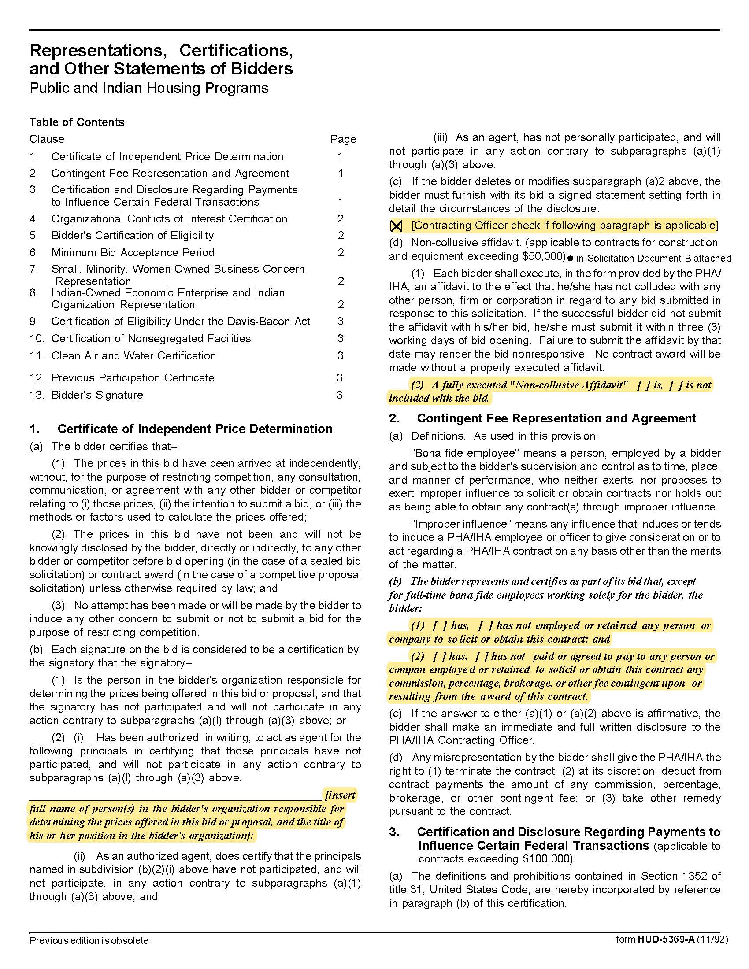

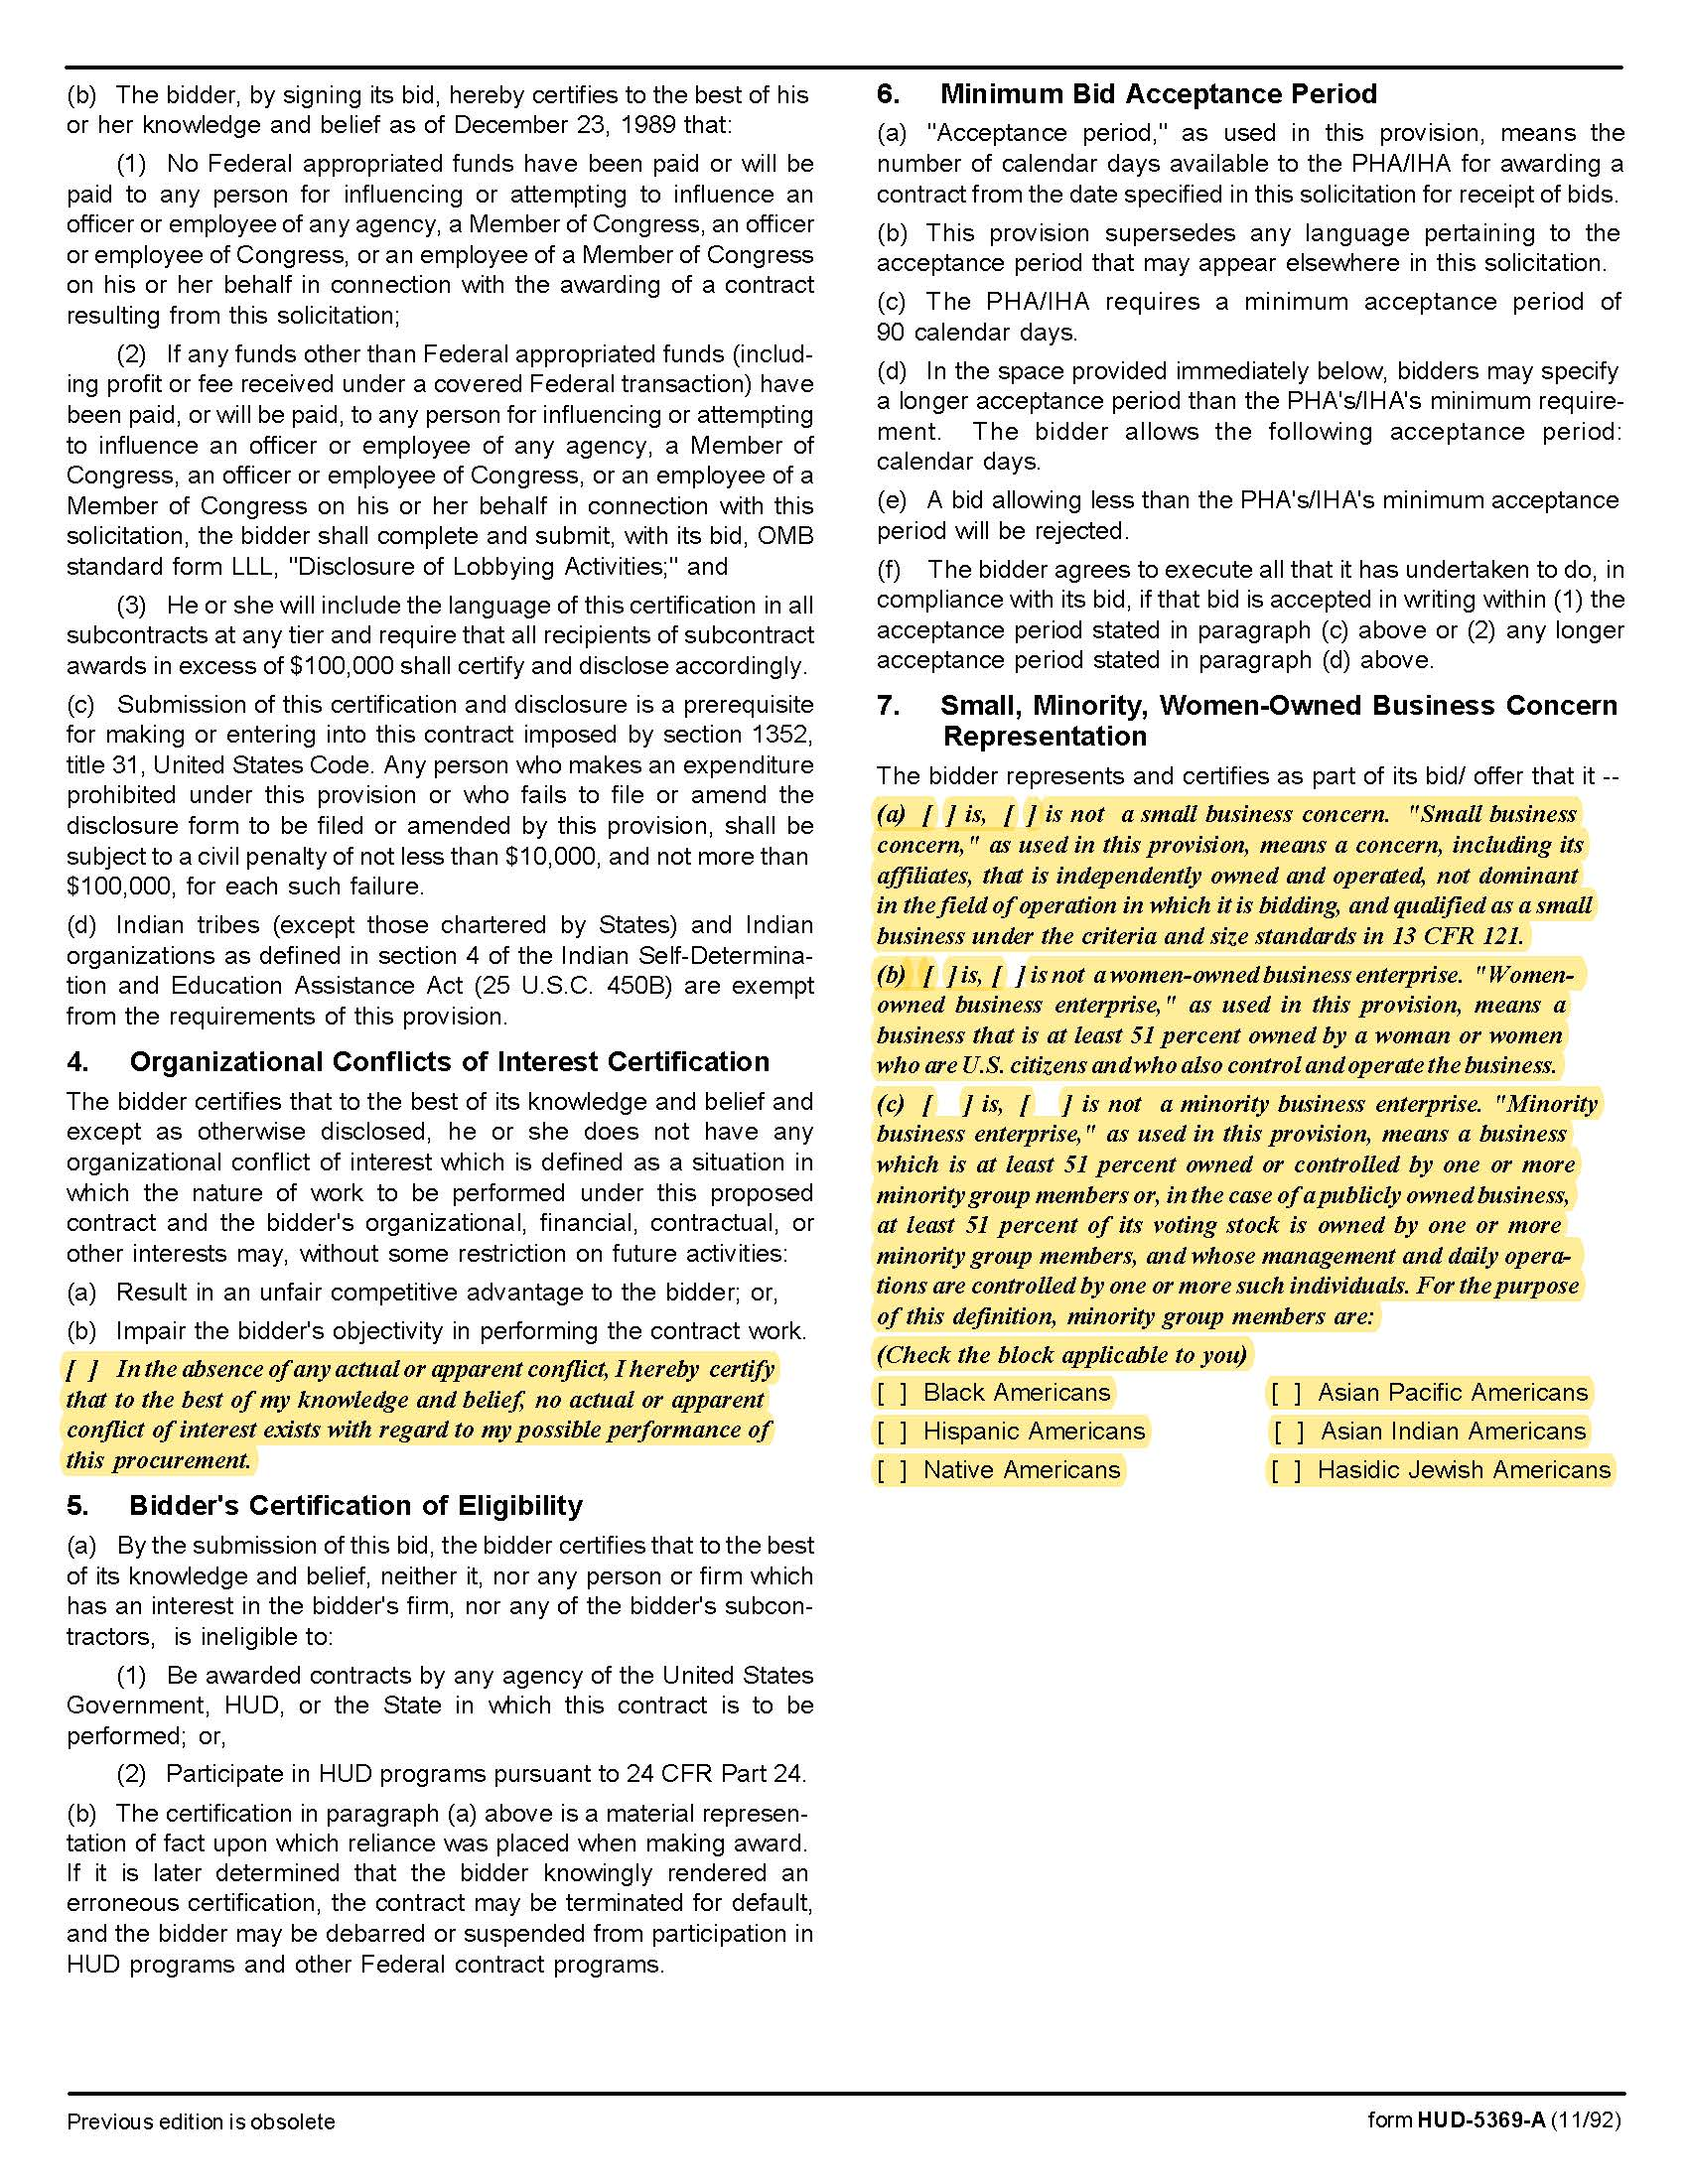

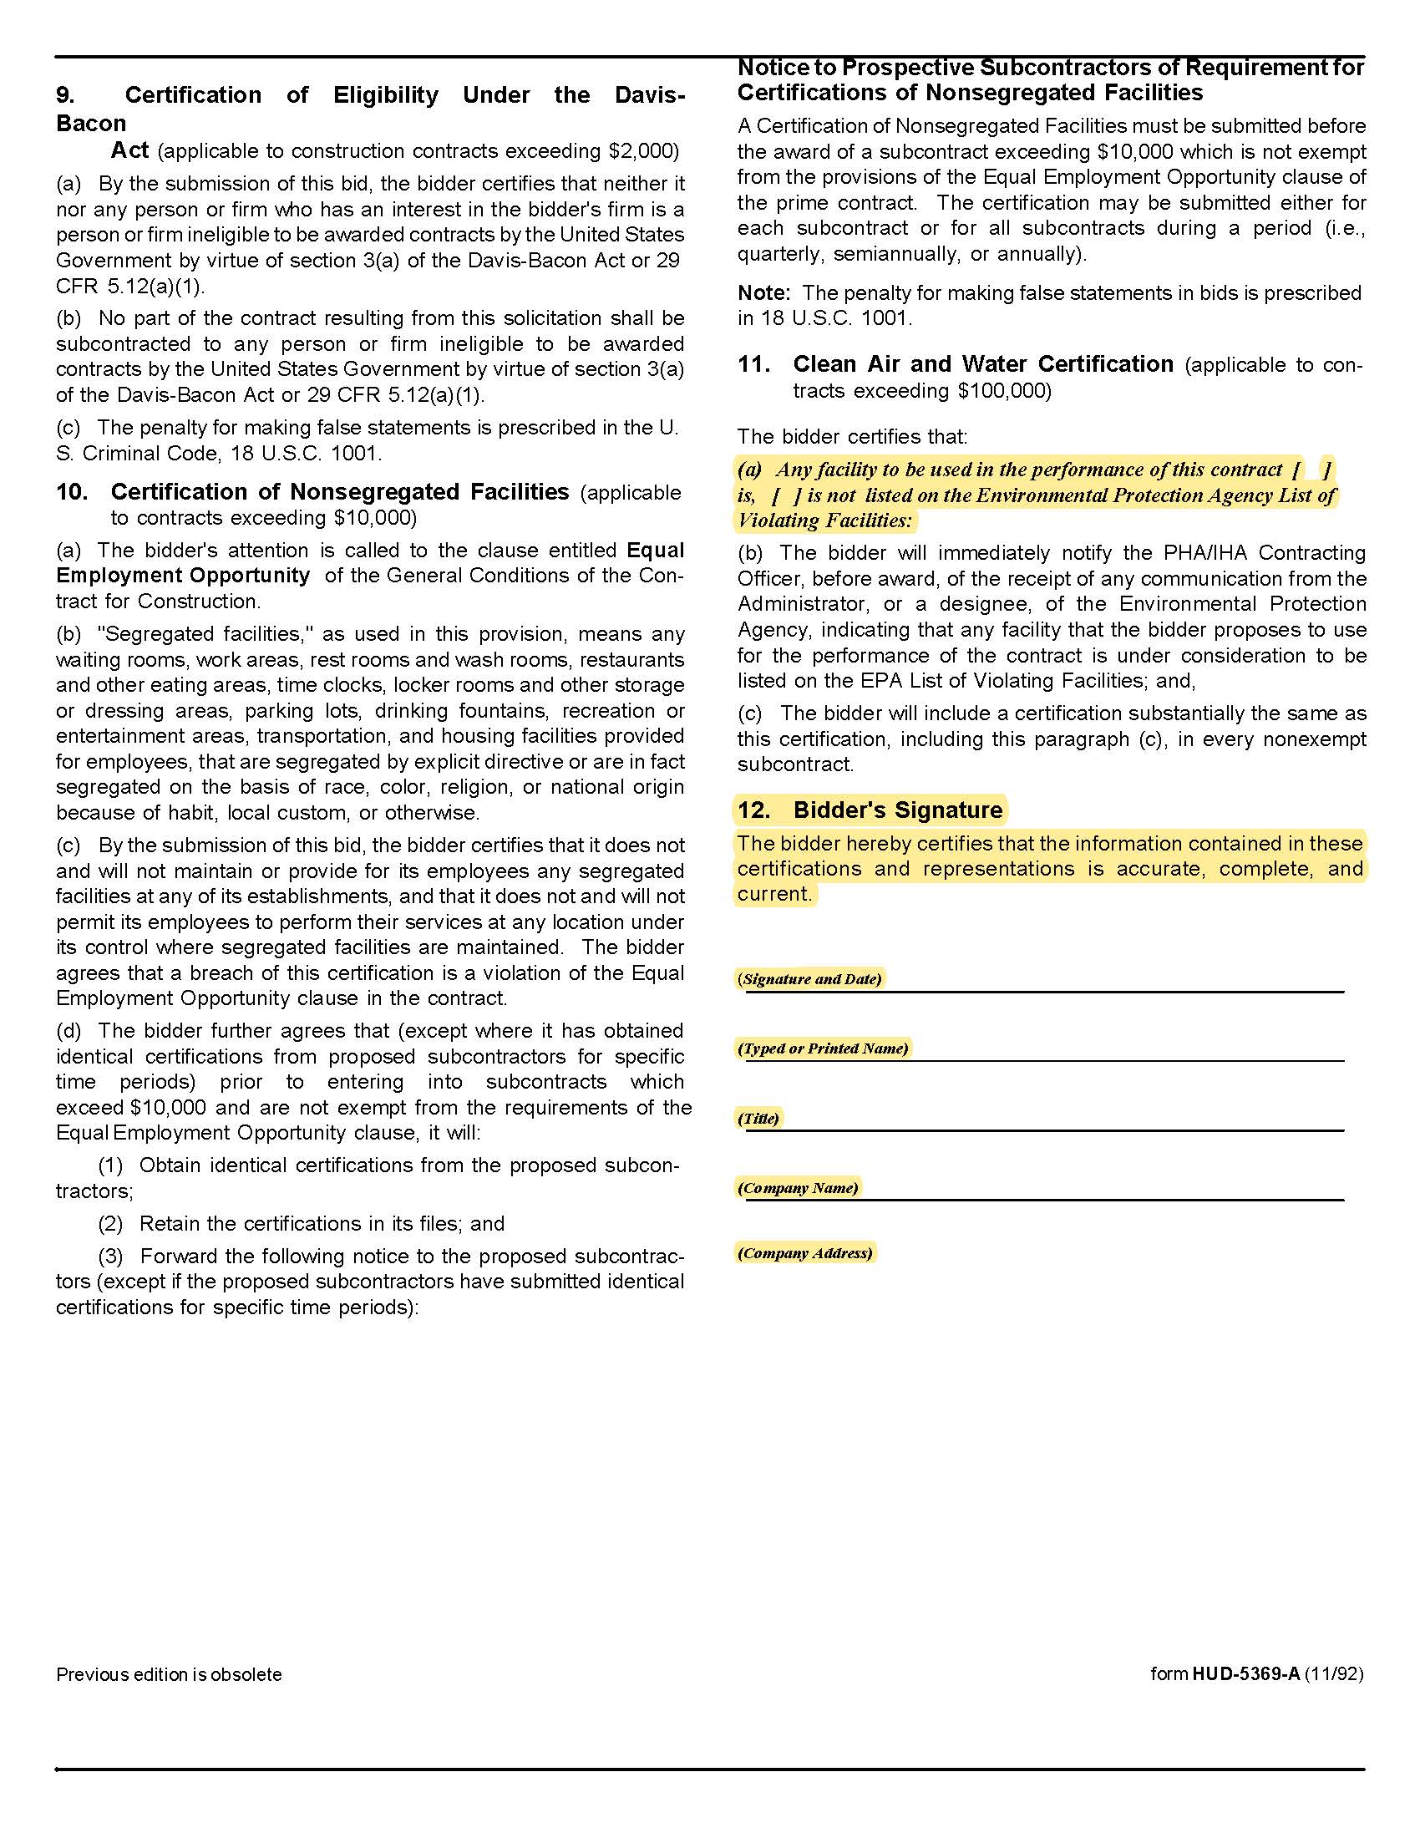

.

Solicitation Document D | Cost
 | Description of Bid Items  ‘Bid Same as or Equal To”’ | Item Bid | Energy Star Compliant | Price (each)
1. | Electric Water Heater  30 gallon – SHORT  ENS 30 – 22Wx39 ¾H |  | Yes No NA | $
2. | Electric Water Heater  30 gallon – Side Valve - SHORT  ENJB 30 – 22Wx30H |  | Yes No NA | $
3. | Electric Water Heater  30 gallon – LOWBOY  ENLB 30 – 20W x 30H |  | Yes No NA | $
4. | Electric Water Heater  30 gallon – LOWBOY  PROE30 S2 RU95 B 19 ¾ W x 32H |  | Yes No NA | $
5. | Electric Water Heater  30 gallon – TALL  ENT 30 – 19W x 46 ½H |  | Yes No NA | $
6. | Electric Water Heater  38 gallon – LOWBOY  ENLB 40 – 23W x 32H |  | Yes No NA | $
7. | Electric Water Heater  40 gallon – MEDIUM  ENS 40 – 20W x 49 ¾H |  | Yes No NA | $
8. | Electric Water Heater  40 gallon – TALL  ENT 40 – 18W x 61¼ H |  | Yes No NA | $
9. | Electric Water Heater  50 gallon – SHORT  ENS 50 – 23W x 49¼ H |  | Yes No NA | $
10. | Electric Water Heater  50 gallon – LOWBOY  ENL 50 – 26½ W x 36H |  | Yes No NA | $
11. | Electric Water Heater  50 gallon – TALL  PROE50 T2 RU95 20¼ W x 61 5/8 H |  | Yes No NA | $
12. | Gas Water Heater  30 gallon GCR 30 – 18W x 61½H |  | Yes No NA | $
13. | Gas Water Heater  40 gallon – TALL GCR 40 – 20W x 61¾H |  | Yes No NA | $
14. | Gas Water Heater  40 gallon  DIRECT VENT MODEL GDV 40 – 22W x 64H |  | Yes No NA | $

