Request for Sealed Bids

Vacant Apartment Repair Services (as needed)

Solicitation Number | Q1729
Due Date | May 11, 2017
Due Time | 11:00 a.m. eastern standard time
Deliver Responses to: | Knoxville’s Community Development Corporation    Procurement Division  901 N. Broadway  Knoxville, TN 37917  Note: Procurement is in a separate building behind the main office building
Electronic Copies: | Suppliers are encouraged to use the Adobe fillable or MS Word version to provide a typed.  Electronic copies are available on KCDC’s webpage or by email at purchasinginfo@kcdc.org.
May responses be emailed to KCDC | ☒ Yes ☐ No  Paper copies must also be provided, if the solicitation so indicates.
Solicitation Meeting | ☒ Yes ☐ No
Solicitation Meeting is Mandatory | ☐ Yes ☒ No
Solicitation Meeting Date | 05-01-17
Solicitation Meeting Time | 8:00 a.m.
Solicitation Meeting Location | KCDC’s Board Room at 901 N. Broadway
Questions About This Solicitation | Submit questions to purchasinginfo@kcdc.org

Check KCDC’s webpage for addenda and changes before submitting your response

General Information

1. BACKGROUND AND INTENT

a. Knoxville's Community Development Corporation (KCDC) is the public housing and redevelopment agency for the City of Knoxville and for the County of Knox in Tennessee. KCDC’s public housing property portfolio includes 20 sites with approximately 3,551 dwelling units. KCDC also administers approximately 4,030 vouchers through our Section 8 department.

b. KCDC wants a supplier to make vacant units ready for leasing to new occupants at its Western Heights complex, with its office located at 1621 Jourolman Avenue in Knoxville, Tennessee 37921, has 66 units awaiting “make ready” status for leasing to new occupants. KCDC’s maintenance crews are currently working in these apartments and will continue to do so. Thus, the work may be completed in some apartments before the awarded supplier gets to them. Additionally, the cost of repairs to each apartment will affect the total number of apartments serviced so it is not likely the vendor will service all 66 apartments. KCDC will guarantee at least 18 apartments to the successful supplier.

c. Generally, the selected supplier will inspect apartments and perform the agreed to services to quickly make the units ready for leasing. See the work performance details later in this document.

2. BONDS
Bid, payment and performance bonds are required if the bid exceeds $100,000 in value. Bonding requirements include:

a. A bid guarantee from each supplier equivalent to five percent (5%) of the bid price. Such bid bond must accompany the bid. Bid bonds will not be returned until a contract is signed.

b. One of the following is required (upon award):

1. A performance and payment bond for 100% of the contract price; or

2. 25% cash escrow; or

3. 25% irrevocable letter of credit.

c. All bonding companies must be listed in the Federal Register, Department of the Treasury Fiscal Service, Companies Holding Certificates of Authority as Acceptable Sureties on Federal Bonds and as Acceptable Reinsuring Companies; Notice. Companies licensed to do business in the State of Tennessee must issue all required bonds.

3. CHANGES AFTER AWARD
It is possible that after award KCDC will need to revise the service needs or requirements specified in this document. KCDC reserves the right to make such changes after consultation with the supplier. Should additional costs arise, the supplier must document increased costs. KCDC reserves the right to accept and negotiate these charges.

4. CODES AND ORDINANCES
All work covered is to be done in full accord with national, state and local codes, ordinances and orders that are in effect at the time the work is performed.

5. CONTACT POLICY
The supplier may not contact office, officer, agent, or employee of KCDC other than the KCDC’s Procurement Division from the issuance of this solicitation until award about matters pertaining to this solicitation. Information obtained from an unauthorized officer, agent, or employee of KCDC will not affect the risks or obligations assumed by the supplier or relieve the supplier from fulfilling any of the conditions of the resulting award for the purpose of this project. Additionally, such contact can disqualify the supplier from participation in the solicitation process.

6. DAMAGE
The supplier is responsible for all damage to buildings, equipment, grounds, premises and all other types of potential damage resulting from the provision of the services requested herein.

7. EMPLOYEES
Supplier will:

a. Allow only personnel thoroughly trained and skilled to work on the job.

b. Have sufficient personnel to complete the work in a timely manner.

c. Enforce strict discipline and good order among his/her employees.

d. Provide at least one employee on every job assignment with the ability to speak, read, write and understand English so KCDC’s staff can communicate effectively with them.

e. Employ the quantity and quality of supervision necessary for both effective and efficient management at all times.

f. Ensure that employees have proper identification displayed while on the job site. Employees must wear a company uniform or have photo identification badges at all times.

g. Employees parking vehicles (whether corporately or privately owned) must ensure that company identification is on the vehicles. This may be by placards on the vehicle’s side, laminated paper with the company name placed on the dashboard or other means.

8. ENTRANCE TO SITES
Supplier employees are not to be on KCDC premises unless they are working on a KCDC project. Acquaintances, family members, assistants, or any person not working on KCDC’s behalf will not accompany employees on KCDC sites.

9. EQUIPMENT
Supplier shall provide all necessary equipment, materials, supplies, et cetera needed for the work. Include the cost for such equipment, materials and supplies in the price quoted.

10. ENTRANCE TO KCDC SITES
Supplier’s employees may not be on KCDC premises unless they are working on a KCDC project. Acquaintances, family members, assistants, or any person will not accompany employees on KCDC sites unless said person is an authorized employee of the supplier.

11. EVALUATION
KCDC will arrive at the “lowest and best” solution for the final award. This may not entail simply awarding to the supplier quoting the lowest cost. All responses are subject to a determination of “responsive” and “responsible” prior to award. KCDC is the sole judge as to supplier “responsiveness” and “responsibility.” KCDC reserves the right to request additional information to assist in the evaluation process. This includes references and business capacity information.

12. GENERAL INSTRUCTIONS
KCDC does not insert “General Instructions to Vendors” in solicitation documents. These instructions can be found at www.kcdc.org. Click on “Procurement” and follow the link to the instructions. The supplier’s submittal means acceptance of the terms and conditions set forth in KCDC’s “General Instructions to Vendors.”

13. INSURANCE
Upon award, Certificates of Insurance must be provided to KCDC indicating that the supplier carries at least the following minimum levels of insurance: supplier will, at its sole expense, obtain and maintain in full force and effect for the duration of the resulting award and any extension hereof at least the following types and amounts of insurance for claims which may arise from or be in connection with this resulting award. Insurers, with an A.M. Best rating of A-: VI or better must underwrite all insurance.

The supplier will maintain, at supplier’s sole expense, on a primary and non-contributory basis, at all times during the life of the award insurance coverages, limits and endorsements described herein. Insurers with an A.M. Best rating of A-: VI or better must underwrite all insurance. Upon award, the supplier will provide Certificate(s) of Insurance to KCDC evidencing said insurance coverages.

The supplier agrees the insurance requirements herein, as well as KCDC’s review or acknowledgement, is not intended to and will not in any manner limit or qualify the liabilities and obligations assumed by the supplier under this award

a. Commercial General Liability Insurance: occurrence version commercial general liability insurance with a limit of not less than $1,000,000 each occurrence for bodily injury, personal injury, property damage and products and completed operations. If such insurance contains a general aggregate limit, it will apply separately to the work/location in this award or be no less than $2,000,000.

Such insurance will contain or be endorsed to contain a provision that includes KCDC, its officials, officers, employees and volunteers as additional insureds with respect to liability arising out of work or operations performed by or on behalf of the supplier including materials, parts, or equipment furnished in connection with such work or operations. The coverage will contain no special limitations on the scope of its protection afforded to the above-listed insureds.

The Additional Insured will read “Knoxville’s Community Development Corporation (KCDC)”.

If necessary, umbrella/excess liability insurance can be used in conjunction with the general liability insurance to meet these requirements. Unless the umbrella/excess liability insurance provides coverage on a pure/true follow-form basis, or KCDC is automatically defined as an additional insured, the supplier will add by endorsement, KCDC, its officials, officers, employees and volunteers as an additional insured.

b. Automobile Liability Insurance: including vehicles owned, hired and non-owned, with a combined single limit of not less than $1,000,000 each occurrence. Such insurance will include coverage for loading and unloading hazards.

c. Workers’ Compensation Insurance and Employers Liability Insurance: with statutory limits as required by the State of Tennessee or other applicable laws.

d. Other Insurance Requirements: Supplier will:

- Upon award, furnish KCDC with original Certificates of Insurance and amendatory endorsements effecting coverage required by this section. Certificates of Insurance will provide a minimum 30-day endeavor to notify KCDC of cancellation when available by supplier’s insurance. If the supplier receives a non-renewal or cancellation notice from an insurance carrier affording the required coverage, or receives notice that coverage no longer complies with the insurance requirements herein, supplier will notify KCDC by email or fax within five (5) business days and provide a copy of the non-renewal for cancellation notice or written specifics as to which coverage is no longer in compliance.
The certificate holder address will read:

Knoxville’s Community Development Corporation
ATTN: Contracting Officer
901 N. Broadway
Knoxville, TN 37917

2. Provide certified copies of endorsements and policies if requested by KCDC in lieu of or in addition to Certificates of Insurance.
3. Replace certificates, policies and endorsements for any such insurance expiring prior to completion of services.

4. Maintain such insurance from the time services commence until services are completed. Failure to maintain or renew coverage or to provide evidence of renewal may be treated by KCDC as a material breach of award.

5. Require all subcontractors to maintain during the term of the resulting award commercial general liability insurance, automobile liability insurance and workers’ compensation/employer’s liability insurance (unless subcontractor’s employees are covered by supplier’s insurance) in the same manor and limits as specified for the supplier. Supplier will furnish subcontractor(s)’ Certificates of Insurance to KCDC without expense prior to subcontractor(s) commencing work.

6. Any deductibles and/or self-insured retentions greater than $50,000 must be disclosed to and approved by KCDC prior to the commencement of services. Use of large deductibles and/or self-insured retentions will require proof of financial ability as determined by KCDC.

7. Provide a waiver of subrogation for each required policy herein. When required by the insurer, or should a policy condition not permit supplier to enter into a pre-loss agreement to waive subrogation without an endorsement, the policy should be endorsed with a Waiver of Transfer of Rights of Recovery Against Others, or its equivalent. This waiver of subrogation requirement will not apply to any policy which includes a condition specifically prohibiting such an endorsement, or voids coverage should supplier enter into such an agreement on a pre-loss basis.

8. All policies must be written on an occurrence basis.

9. Upon award, the supplier must provide Certificates of Insurance, as detailed above and acceptable to KCDC, within five business days.

e. Once KCDC sends the successful supplier the notification of intent to award, the supplier is required to provide a Certificate(s) of Insurance evidencing coverage as required above within the timeline detailed noted below. Failure to comply within the set timeframe may constitute unresponsiveness and KCDC reserves the right, at its sole discretion, to reconsider the award.

KCDC has determined the following timeline applies to this solicitation:

General Services: 7 calendar days ☒ Yes ☐ No
Construction Services 15 calendar days ☐ Yes ☐ No

14. INVOICING/ORDERING

a. Until a purchase order is in place, work is not to be performed nor are goods to be delivered. KCDC does not have a legal obligation to pay for goods delivered or work performed without a purchase order in place prior to the commencement of delivery of the goods or services.

b. Suppliers must submit invoices within 90 days of the delivery of goods or services. KCDC may deny invoices submitted after the 90-day threshold. KCDC prefers invoices arrive within 10 days following the end of the month in which the supplier provided the goods or services.

c. KCDC’s purchases of goods are exempt from Tennessee sales and use tax pursuant to Tennessee Code Annotated 67-6-329(a) (4) and KCDC is generally exempt from the Federal Excise tax. Suppliers are subject to Tennessee sales and use tax on all materials and supplies used in the performance of a contract, whether such materials and supplies are purchase by the supplier, produced by the supplier, or provided to the supplier by KCDC, pursuant to Tennessee Code Annotated 67-6-209. The supplier will pay all taxes incurred while performing work for KCDC.

Upon the placement of a purchase order or the award of a contract, KCDC will provide a State of Tennessee Sales Tax Exemption form to the supplier. KCDC will not pay taxes on invoices.

d. KCDC pays by electronic transfer (ACH) only.

15. LICENSURE

a. Suppliers must possess and maintain proper licensure from the State of Tennessee and all other authorities having jurisdiction throughout the term of this award.

b. In addition to any City or County licenses that may be required, all suppliers must be licensed suppliers as required by the “Contractor’s Licensing Act of 1994” as mandated by the State of Tennessee. The suppliers must have the necessary licensing classifications as required by the Rules of the Tennessee Board for Licensing General Contractors. For your convenience, a bid envelope coversheet is at the end of this document. Use it to supply the required information.

c. The State of Tennessee Contractor Licensing Board states that one of the following licenses is required for this work because the cost will exceed $25,000. Any subsequent rulings by the State Licensing Board automatically revise these specifications-irrespective of the timing of the notice from the State and irrespective of the status of this solicitation.

Work in less than five units at a time:
- BC-A (residential)
- BC
- BC-B
- BC-b(sm)

Work in more than five units at a time:
- BC-B
Other Comments:
- Obtain permits for each unit separately (as appropriate)
- Obtain inspections as work progresses for any work hidden behind drywall
- Obtain a final certificate of occupancy for the unit as a whole when the work is completed

16. LIQUIDATED DAMAGES
Liquidated damages shall apply at $100.00 per calendar day per apartment for each day beyond the scheduled completion date and such provision shall be included in the award. However, KCDC will consider explanatory information if it provides a valid reason for delays in schedule.

17. MATERIALS AND WORKMANSHIP
All materials and equipment furnished shall be new and of high quality. Work shall be accurate, skilled and subject to approval of KCDC. All materials and equipment provided shall conform to regulations of enforcement bodies having jurisdiction.

18. MEASUREMENTS AND DRAWINGS
Complete responsibility for the final determination of dimensions lies with the supplier. The supplier shall verify all dimensions with the actual on site conditions. Where the supplier’s work is to join another trade, the supplier’s shop drawings shall show actual dimensions and the method of joining the work of those trades.

19. PERMITS
The supplier shall obtain and pay for or cause its subcontractors to obtain and pay for all permits required to complete required work. In addition, supplier shall arrange, schedule, and pay for or cause its subcontractors to arrange, schedule and pay for all required final inspections by state, local, or independent certified inspecting authorities necessary for issuance of all required KCDC utilization permits for the work.

20. QUESTIONS
Direct questions pertaining to this document to purchasinginfo@KCDC.org with “Vacant Apartment Repair Service” in the subject line, at least five days prior to the due date.

21. RENOVATION, REPAIR AND PAINTING RULE
Suppliers performing renovation, repair and painting projects that disturb lead-based paint in homes, childcare facilities and schools built before 1978 must be certified and must follow specific work practices to prevent lead contamination. When work is occurring at a site, the supplier must submit proof of the applicable certification before commencing work. The supplier will keep such certification current throughout the life of the award.

To the best of KCDC’s knowledge RRP applies to this work: Yes ☒ No ☐

There is Lead Base Paint at Western Heights especially on the exterior railings and the porch posts in the older section. Consult the posted “Lead Based Paint Inspection Reports” (KCDC’s website) for details.

Additional information is available at:

1. HUD’s website:
http://portal.hud.gov/hudportal/HUD?src=/program_offices/healthy_homes/training/rrp/rrp

2. State of Tennessee’s website:
http://www.state.tn.us/environment/swm/leadpaint/

22. REPRESENTATIONS
By submitting a response, the supplier represents and warrants:

a. That the supplier is financially solvent and that it is experienced in and competent to perform the type of work, and/or to furnish the personnel, plans, materials, supplies, or equipment to be performed or furnished by it; and

b. That the supplier is familiar with all federal, state, municipal and county laws, ordinances and regulations, which may in any way affect the work of those employed therein, including but not limited to any special acts relating to the work or to the project of which it is a part; and

c. That the supplier has carefully examined the plans, the specifications and the worksites and that from its own investigations, has satisfied itself as to the nature and location of the work, the character, quality, quantity of surface and subsurface materials likely to be encountered, and character of equipment and other facilities needed for the performance of the work, the general and local conditions and all other materials which may in any way affect the work or its performance.

23. RESPONSIBILITIES
At no expense to KCDC, the supplier will:

a. Provide quality control for all services provided.

b. Provide competent supervision.

c. Provide competent workers.

d. Take precautions necessary to protect persons or property against injury and/or damage and be responsible for any such damage or injury that occurs because of their fault or negligence.

e. Perform work without unnecessary interference with the activities of KCDC, residents, or suppliers.

24. SAFETY

a. The supplier shall comply with all Occupational Safety and Health Administration (OSHA), city and state Occupational Health Standards and any other applicable rules and regulations.
b. The supplier is responsible for the safety of its employees and any unsafe acts or conditions that may cause injury or damage to any persons or property within and/or around the work site area under the resulting contract.

c. The supplier is responsible for the security of all materials, tools and equipment used in the conduct of the work while on KCDC properties.

d. The supplier shall observe all safety precautions as not to endanger tenants, the public in general and/or damage KCDC property.

25. Safety Data Sheets (SDS)

Supplier will leave Safety Data Sheets (SDS) when installing covered items. Suppliers must be certain the manufacturer properly labels (including the appropriate hazardous material symbols) all products.

26. SECTION 3 OF THE HUD ACT OF 1968
Section 3 is a provision of the Housing and Urban Development Act of 1968, which requires that programs of direct financial assistance administered by the U.S. Department of Housing and Urban Development (HUD) provide, to the greatest extent feasible, opportunities for job training and employment to lower income residents in connection with projects in their neighborhoods.

a. Recipients and suppliers must make a good faith effort to utilize Section 3 area residents as trainees and employees in connection with the project. Targeted recruitment and the selection of Section 3 area residents for available positions are two examples of good faith efforts to meet this requirement.

b. Recipients and suppliers must make good faith efforts to award subcontracts to Section 3 business concerns. An example of a good faith effort to meet this requirement is the implementation of an affirmative action plan, which includes targets for the number and dollar value for awarding contracts to Section 3 business concerns.

c. One way suppliers can find Section 3 residents is by recruiting in the neighborhood and public housing developments to tell about available training and job opportunities. Distributing flyers, posting signs, placing ads and contacting resident organizations and local community development and employment agencies to find potential workers are a few effective ways of getting jobs and people together.

e. All contracts awarded are subject to Section 3 requirements. Suppliers will seek to fill any and all positions that are needed and unfilled with residents of KCDC communities. For additional information, please go to http://www.hud.gov/offices/fheo/section3/Section3.pdf. The successful supplier will provide KCDC with job announcements for any position that must be filled as a result of the award of KCDC work. Additionally the successful supplier will supply the same job announcement to the Knoxville-Knox County Committee Action Committee’s Workforce Connections group. These can be faxed to 544-5269.

f. A Section 3 resident is one who lives within a public housing authority’s apartment. It is also people who live in an area with a HUD assisted program and whose income is below HUD’s low income requirements.

g. A Section 3 business is one that:

1. Is at least 51% owned by a Section 3 resident; or

2. Employs Section 3 residents for at least 30% of its employee base; or

3. Makes a commitment to sub award at least 25% of the project’s dollars to a Section 3 business.

27. SECURITY
The successful supplier is responsible for providing (if necessary) any and all security to equipment, materials, personnel, tools and the site that are required for this job. KCDC is not responsible for damage or losses to equipment, materials, personnel, tools or the site.

28. SITE EXAMINATION

a. Suppliers are required to visit the site and become fully acquainted and familiar with conditions, as they exist and the required operations. The supplier shall make such investigations as necessary so that they may fully understand the scope of the work and related facilities and possible complexities when executing the work.

b. The failure or omission of the supplier to receive or examine the solicitation document or any
part of the specifications, or to visit the site(s) and acquaint themselves as to the nature and location of the work, the general and local conditions and all matters which may in any way affect performance shall not relieve the supplier of any obligation to perform as specified herein. Supplier understands the intent and purpose hereof and its obligations hereunder and that it shall not make any claim for, or have any right to damages resulting from any misunderstanding or misinterpretation of the resulting agreement, or because of any lack of information.

c. By submitting a response to this solicitation, each supplier is certifying that they have inspected the site and have read the solicitation and all appendices and addenda. The failure or omission of any supplier to receive or examine any form, instrument, or document shall in no way relieve the supplier from any obligation in respect to its bid.

29. STORAGE
Most KCDC sites have limited storage space for suppliers to access. Suppliers are responsible for the storage of materials and their security. If possible, KCDC will allow suppliers to use space but the safety and security of the items stored is solely the responsibility of the supplier.

30. STORM WATER AND STREET ORDINANCES
The City of Knoxville’s Storm Water and Street Ordinances apply to this solicitation. The successful supplier will comply with all aspects of the City’s ordinances. Compliance includes but is not limited to:

a. Retaining all sediments on the project site using structural drainage controls. Drainage control costs are incidental to the work.

b. No construction or demolition related materials, wastes, spills, or residues shall be discharged from the project site to streets, drainage facilities, or adjacent properties by wind or runoff.

c. Non-storm water runoff from equipment and vehicle washing and any other activity shall be contained at the project site.

d. Additional information about NPDES, BMPs, and the Land Development Manual is at the City of Knoxville’s Storm water Engineering Division webpage:
(http://www.cityofknoxville.org/engineering/stormwater/npdes.asp).

e. The successful supplier is responsible for all work, remediation, repair and monetary penalties or fines arising out of a Notice of Violation of the City of Knoxville’s Storm water and Street Ordinances. The supplier will be charged costs KCDC incurs to install structural drainage controls or remedy a Notice of Violation. KCDC shall also charge a $50 fee per violation for related administrative costs.

31. SUBCONTRACTORS
KCDC must approve subcontractors before they commence work and subcontractors must carry the insurance coverages outlined herein.

32. TIMELINE
The successful supplier has seven calendar days to complete the work for each apartment.

33. UTILITIES
KCDC allows suppliers to use the utilities in unoccupied apartments.

34. WAGE COMPLIANCE (DAVIS BACON REQUIREMENTS)
This work is federally funded and “prevailing wage” requirements apply. The successful supplier will submit certified payroll forms each month to document wages paid. These forms must be provided monthly and be approved before payment will be authorized.

a. The minimum wage rates vary by the type of work being performed, not job titles assigned to your employees. If your employee predominately performs this work on the KCDC job, he or she must be paid at the rate below (or higher). If an additional classification is needed, contact the KCDC Procurement Division. The minimum wage rates are:

Title | Hourly Rate | Fringe Rate | Total Wage or Total Wage & Benefits
Carpenter/Glazier | $11.72 | $3.28 | $15.00
Electrician | $11.72 | $3.28 | $15.00
Laborer | $7.62 | $2.13 | $9.75
Painter | $10.76 | $3.01 | $13.77
Plasterer | $11.72 | $3.28 | $15.00
Plumber | $11.72 | $3.28 | $15.00
Skilled Worker | $9.34 | $2.62 | $11.96
Unskilled Worker | $7.72 | $2.16 | $9.88

b. These requirements apply to all subcontractors that are used by the successful supplier.

35. WORK HOURS
Acceptable work hours are Monday through Friday from 7:30 a.m. until 4:00 p.m. Work on Saturdays, Sundays or holidays will require advance approval by KCDC.

Description of Work/Expectations

36. GENERAL

a. KCDC plans to have the supplier inspect each vacant apartment with a checklist which has the agreed to prices for services. KCDC will then authorize work for each apartment or amend the suggested services as necessary.

b. KCDC wants the supplier to work from KCDC’s list of vacant apartments (longest on the list to shortest time on the list) until the funds run out.

Unit | Address | # BR's | Vacancy Date | Comments
249 | 1418 W. Oldham | 2 | 03/29/16
356 | 1467 McSpadden | 2 | 03/29/16
389 | 1701 Reed | 1 | 04/29/16
19 | 1722 Virginia | 1 down | 05/16/16
74 | 1336 Alliance | 1 | 06/01/16
266 | 1344 W. Oldham | 1 | 06/27/16
20 | 1720 Virginia | 1 | 06/28/16
278 | 1320 W. Oldham | 2 | 07/11/16
180 | 1236 Better Tomorrow | 2 | 07/25/16
7 | 1910 Virginia | 2 | 08/17/16
44 | 1809 Jourolmon | 2 | 08/17/16
39 | 1819 Jourolmon | 1 down | 08/07/16 | Police Unit
296 | 1612 Reed | 1 down | 08/17/16
170 | 1256 Better Tomorrow | 1 | 08/22/16
212 | 1449 W. Oldham | 3 flat | 08/26/16
399 | 1721 Reed | 2 | 08/26/16
182 | 1230 Better Tomorrow | 1 down | 08/31/16
86 | 1312 Alliance | 2 | 09/14/16
115 | 1431 Fort Promise | 2 | 09/27/16
174 | 1248 Better Tomorrow | 2 | 09/27/16
447 | 1205 Bonnyman | 3 | 10/19/16
40 | 1817 Jourolmon | 1 | 11/01/16
48 | 1801 Jourolmon | 1 | 11/15/16
54 | 1721 Jourolmon | 2 | 11/15/16
198 | 1245 Better Tomorrow | 2 | 11/15/16
326 | 1117 W. Scott | 2 | 11/16/16
140 | 1414 Fort Promise | 2 | 12/07/16
104 | 1411 Alliance | 1 down | 12/09/16
151 | 1422 Fort Promise | 3 | 12/09/16
270 | 1336 W. Oldham | 3 | 12/09/16
67 | 1350 Alliance | 2 | 12/13/16
71 | 1342 Alliance | 1 | 12/18/16
172 | 1252 Better Tomorrow | 1 down | 01/06/17
2 | 1905 Jourolmon | 3 flat | 01/11/17
292 | 1620 Reed | 3 | 01/20/17
372 | 1202 W. Oldham | 2 | 01/24/17
382 | 1319 W. Oldham | 3 | 01/24/17
32 | 1901 Jourolmon | 2 | 01/25/17
35 | 1827 Jourolmon | 2 | 01/25/17
114 | 1419 Fort Promise | 3 flat | 01/25/17
149 | 1426 Fort Promise | 3 | 01/25/17
307 | 1155 W. Scott | 2 | 01/25/17
390 | 1703 Reed | 1 down | 01/25/17
299 | 1606 Reed | 3 | 01/26/17
49 | 1731 Jourolmon | 1 | 01/27/17
70 | 1344 Alliance | 2 | 01/30/17
129 | 1506 Fort Promise | 2 | 02/01/17
30 | 1700 Virginia | 1 | 02/02/17
224 | 1425 W. Oldham | 2 | 02/08/17
353 | 1461 McSpadden | 2 flat | 02/08/17
146 | 1432 Fort Promise | 2 | 02/10/17
304 | 1161 W. Scott | 2 | 03/02/17
394 | 1711 Reed | 2 | 03/03/17
319 | 1131 W. Scott | 2 | 03/09/17
464 | 1241 Bonnyman | 2 | 03/09/17
94 | 1351 Alliance | 3 flat | 04/03/17
145 | 1434 Fort Promise | 2 | 04/04/17
301 | 1602 Reed | 1 | No date yet
4 | 1916 Virginia | 2 |  | Set out on/after 4/13
103 | 1309 Alliance | 1 |  | Set out on/after 4/13
118 | 1441 Fort Promise | 2 |  | Set out on/after 4/13
237 | 1208 Better Tomorrow | 2 |  | Set out on/after 4/13
176 | 1244 Better Tomorrow | 2 |  | Set out on/after 4/13
256 | 1404 W. Oldham | 2 |  | Set out on/after 4/13
392 | 1707 Reed | 3 |  | Set out on/after 4/13
311 | 1147 W. Scott | 3

c. Generally, the supplier will inspect and determine if the items below are in acceptable/working condition. If not, restore the items to proper working/functional condition. KCDC staff members have already inspected some if the items and the list of work tasks is in Attachment A.

Appliances:
- Make sure that the oven rack is present
- Make sure that the refrigerator and stove gaskets are good
- Install new hood range vent if needed
- Clean the appliances (KCDC will replace appliances where necessary)

Carpentry:
- Inspect the cove base throughout the unit
- Replace/install cove base as needed throughout unit
- Inspect closet shelves
- Replace closet shelves as needed
- Inspect walls and ceilings for holes, cracks, and other defects
- Repair holes, cracks and defects in walls and ceilings as necessary
- Skim room walls where needed for re-painting
- Plaster wall/ceiling repairs as needed - tape, skim
- Inspect window screens
- Repair or replace damaged window screens
- Inspect doors (including ensuring doors properly close and latch/lock)
- Repair damaged doors
- Replace damaged doors that are not repairable
- Inspect the screen doors (do they latch and are they bolted)
- Repair damaged screen doors
- Replace damaged screen doors that are not repairable
- Remove the screen doors on some vacant units “to be determined” and then repair/repaint where the hardware was previously
- Inspect door closers
- Replace faulty door closers
- Inspect the painting around screen doors
- Paint any raw wood around the doors
- Inspect the weather stripping on doors
- Replace damaged weather stripping as needed
- Change the door lock
- Make sure all keys work
- Inspect for door stops behind every door
- If door stops are not installed or if they are damaged, install new
- Remove existing and install approved closet door knobs
- Inspect the “Addresso” light cover on the front porch
- Repair the “Addresso” light cover on the front porch as needed
- Replace the “Addresso” light cover on the front porch as needed
- Inspect the kitchen cabinets
- Repair kitchen cabinets as needed
- Replace kitchen cabinets as needed
- Inspect kitchen countertops
- Repair kitchen countertop as needed
- Replace kitchen countertop as needed
- Remove curtain and shade brackets throughout the unit and then repair any damage
- Remove soap and toothbrush holders and repair walls
- Re-caulk the bathtub and surround with white silicone
- Inspect light fixtures
- Remount light fixtures if needed
- Replace light fixtures if needed
- Inspect flooring
- Remove and replace gapped or damaged floor tile
- Inspect all windows (including locks) )
- Determine that a valid fire extinguisher is present
- Paint all walls with double coat of KCDC beige paint (specs to be given)
- Paint unit and entry doors, stairs and handrails
- Use KILZ as appropriate

HVAC:
- Clean AC unit(s) and filters

Janitorial:
- Clean the entire unit
- Clean out all cabinets
- Strip and wax the floors (two coats)

Electrical:
- Inspect light bulbs and fixtures for proper working condition
- Replace light bulbs and fixtures as needed
- Inspect and test smoke alarms
- Replace smoke alarm batteries or smoke alarms as necessary
- When replacing smoke alarms or 9 volt batteries due to being inoperative install this type smoke alarm Kidde 120 Volt hardwired Smoke Alarm Ten Year Life Battery Backup Model i12010S (P/N 21010407-A) “or equal”
- Inspect all outlets/switch plates to determine that they are without cracks/breaks
- Replace damaged outlet/switch plates as needed
- Test all GFIs
- Replace GFI’s that are not functional
- Check the breaker box for gaps
- Remediate breaker box gaps if needed
- Inspect the bath heaters and switches
- If the switches remain, remove bathroom heater/switch and install block-off plates to both
- Remove breakable plug/switch covers and install non-breakable ones

Plumbing:
- Clean the toilet(s)/tubs
- Ensure that the toilet flushes properly and does not leak
- Repair/replace damaged or non-functional toilets
- Ensure the tub(s) and sink(s) drain
- If not, restore proper drainage
- Determine if the tub needs re-glazed and if so notify maintenance (KCDC’s contracted vendor for such repairs will be contacted)
- Determine if the water heater has a cover
- If not, install one
- Install new kitchen faucets if needed

37. LIGHTING
- Whenever fixtures are “bad,” the supplier will install new LED fixtures
- Install all bathroom light fixtures with sealed LED fixtures
- Convert all other light fixtures with a LED bulb/tube
- Supplier will provide and install LED Light fixtures from the make and model on KCDC’s standard:

SE Lighting
Bradley Aiken
730-6650
809-6820
brad@seretro.com

38. PAINTING
- Ceilings: Color: White Sheen: Flat
- All Walls and Doors: Color: KCDC Bone White Sheen: Eggshell
- Baseboards: Color: White Sheen: Semi-gloss
- Acceptable Paint: Sherwin Williams or PPG

39. WARRANTY
The supplier will provide one-year warranty on the labor and parts from date of the installation.

This and the previous pages do not need to be returned

Vacant Apartment Repair Service Q1729 042017
Solicitation Document A General Response Section
Sign Your Name to the Right of the Arrow
Your signature indicates that you have read and agree to “KCDC’s General Instructions to Suppliers” on www.kcdc.org.
Printed Name and Title
Company Name
Street Address
City/State/Zip
Contact Person (Please Print Clearly)
Telephone Number
Cell Number
Supplier’s E-mail Address (Please Print Clearly)
Addenda
Addenda are at www.kcdc.org. Click on “Procurement” and then on “Open Solicitations” to find addenda. Please check for addenda prior to submitting a bid.
Acknowledge addenda have been issued by checking below as appropriate:
None ☐ | Addendum 1 ☐ |  |  | Addendum 2 ☐ |  |  | Addendum 3 ☐ |  |  | Addendum 4 ☐ |  |  | Addendum 5 ☐
Statistical Information
This business is owned & operated by persons at least 51% of the following ethnic background:
Asian/Pacific ☐ |  | Black ☐ | Hasidic Jew ☐ |  |  | Hispanic ☐ |  |  | Native ☐ Americans |  |  | White ☐
As defined on KCDC’s webpage (see the “General Instructions to Vendors”), this business qualifies as:
Section 3 ☐ |  |  |  |  | Small Business ☐ |  |  |  |  |  | Woman Owned ☐
Prompt Payment Discount
A discount of _____% is offered if payment is made within 30 days
Insurance Requirements
I have reviewed the insurance requirements in this solicitation and will provide KCDC with a Certificate of Insurance adhering to these requirements within the stated number of days. Yes ☐ No ☐

Vacant Apartment Repair Service Q1729 042017
Solicitation Document B Costs Offered

Supplier: _______________________________________________________________________

General Cost Offered
Appliances
Make sure that the oven rack is present | $
Make sure that the refrigerator and stove gaskets are good | $
Install new hood range vent if needed | $
Clean the appliances (KCDC will replace appliances where necessary) | $
Carpentry
Inspect the cove base throughout the unit | $
Replace/install cove base as needed throughout unit | $
Inspection closet shelves | $
Replace closet shelves as needed | $
Inspect walls and ceilings for holes, cracks and other defects | $
Repair holes, cracks and defects in walls and ceilings as necessary | $
Skim room walls where needed for re-painting | $
Plaster wall/ceiling repairs as needed - tape, skim | $
Inspect window screens | $
Repair or replace damaged window screens | $
Inspect doors (including ensuring doors properly close and latch/lock) | $
Repair damaged doors | $
Replace damaged doors that are not repairable | $
Inspect the screen doors (do they latch and are they bolted) | $
Repair damaged screen doors | $
Replace damaged screen doors that are not repairable | $
Remove the screen doors on some vacant units (to be determined) and repair/re-paint where the hardware was | $
Inspect door closers | $
Replace faulty door closers | $
Inspect the painting around screen doors | $
Paint any raw wood around the doors | $
Inspect the weather stripping on doors | $
Replace damaged weather stripping as needed | $
Change the door lock out | $
Make sure all keys work | $
Inspect for door stops behind every door | $
If door stops are not installed or if they are damaged, install new | $
Remove existing and install approved closet door knobs | $
Inspect the “Addresso” light cover on the front porch | $
Repair the “Addresso” light cover on the front porch | $
Replace the “Addresso” light cover on the front porch | $

Vacant Apartment Repair Service Q1729 042017
Solicitation Document B Costs Offered-continued

Supplier: _______________________________________________________________________

Inspect the kitchen cabinets | $
Repair kitchen cabinets as needed | $
Replace kitchen cabinets as needed | $
Inspect kitchen countertops | $
Repair/replace kitchen countertop as needed | $
Repair kitchen countertop as needed | $
Replace kitchen countertop as needed | $
Remove curtain and shade brackets throughout the unit/repair damages | $
Remove the soap and toothbrush holders and repair walls | $
Re-caulk tub and surround with white silicone | $
Inspect light fixtures | $
Remount light fixtures if needed | $
Replace light fixtures if needed | $
Inspect flooring | $
Remove and replace gapped or damaged floor tile | $
Inspect all windows (locks) | $
Change the mailbox lock | $
Determine that a valid fire extinguisher is present | $
Paint all walls with double coat of KCDC beige paint (specs to be given) | $
Paint unit and entry doors, stairs and handrails | $
Use KILZ as appropriate | $
Electrical
Inspect light bulbs and fixtures for proper working condition | $
Replace light bulbs and fixtures as needed | $
Inspect and test smoke alarms | $
Replace smoke alarm batteries or smoke alarms as necessary | $
Inspect all outlet/switch plates to determine there are no cracks/breaks | $
Replace damaged outlet/switch plates as needed | $
Test all GFIs | $
Replace GFI’s that are not functional | $
Check the breaker box for gaps | $
Remediate breaker box gaps if needed | $
Inspect the bath heaters and switches | $
Bathroom the heater/switch and install block-off plates to both | $
Remove breakable plug/switch covers and install non-breakable ones | $
HVAC
Clean AC unit(s) and filters | $

Vacant Apartment Repair Service Q1729 042017
Solicitation Document B Costs Offered

Supplier: _______________________________________________________________________

Janitorial
Clean the entire unit | $
Clean out all cabinets | $
Strip and wax the floors | $
Plumbing
Clean the toilet(s)/tubs | $
Ensure that the toilet flushes properly and does not leak | $
Repair/replace damaged or non-functional toilets | $
Ensure the tub(s) and sink(s) drain | $
If not, restore proper drainage | $
Determine if the water heater has a cover | $
If not, install one | $
Install new kitchen faucets if needed | $
Apartment Specific Pricing
Apartment 19 | $
Apartment 38
Apartment 39
Apartment 89
Apartment 90
Apartment 212
Apartment 234
Apartment 249
Apartment 284
Apartment 288
Apartment 342
Apartment 352
Apartment 356
Apartment 411

Vacant Apartment Repair Service Q1729 042017

Solicitation Document C Affidavits

Suppliers: _____________________________________________________________________________

Conflict of Interest:

1. No commissioner or officer of KCDC or other person whose duty it is to vote for, let out, overlook or in any manner superintend any of the work for KCDC has a direct interest in the award or the supplier providing goods or services.

2. No employee, officer, or agent of the grantee or sub-grantee will participate in selection, or in the award or administration of an award supported by Federal funds if a conflict of interest, real or apparent, would be involved. Such a conflict would arise when the employee, officer or agent, any member of his immediate family, his or her partner, or an organization, which employs, or is about to employ, any of the above, has a financial or other interest in the supplier selected for award.

3. The grantee's or sub-grantee's officers, employees or agents will neither solicit nor accept gratuities, favors or anything of monetary value from suppliers, potential supplier s, or parties to sub-agreements.

4. By submission of this form, the supplier is certifying that no conflicts of interest exist.

Drug Free Workplace Requirements:

5. Private employers with five or more employees desiring to contract for construction services attest that they have a drug free workplace program in effect in accordance with TCA 50-9-112.

Eligibility:

6. The supplier is eligible for employment on public contracts because no convictions or guilty pleas or pleas of nolo contender to violations of the Sherman Anti-Trust Act, mail fraud or state criminal violations with an award from the State of Tennessee or any political subdivision thereof have occurred.

General:

7. Supplier fully understands the preparation and contents of the attached offer and of all pertinent circumstances respecting such offer.

8. Such offer is genuine and is not a sham offer.

Vacant Apartment Repair Service Q1729 042017

Solicitation Document C Affidavits-continued

9. Iran Divestment Act:
Concerning the Iran Divestment Act (TCA 12-12-101 et seq.), by submission of this bid/quote/proposal, each supplier and each person signing on behalf of any supplier certifies, and in the case of a joint bid/quote/proposal, each party thereto certifies as to its own organization, under penalty of perjury, that to the best of its knowledge and belief that each supplier is not on the list created pursuant to § 12-12-106.

Non-Collusion:

10. Neither the said supplier nor any of its officers, partners, owners, agents, representatives, employees or parties interest, including this affiant, has in any way colluded conspired, connived or agreed, directly or indirectly, with any other responder, supplier, or person to submit a collusive or sham offer in connection with the award or agreement for which the attached offer has been submitted or to refrain from making an offer in connection with such award or agreement, or collusion or communication or conference with any other supplier, or, to fix any overhead, profit, or cost element of the offer price or the offer price of any other supplier, or to secure through any collusion, conspiracy, connivance, or unlawful agreement any advantage against KCDC or any person interested in the proposed award or agreement.

11. The price or prices quoted in the attached offer are fair, proper and not tainted by any collusion, conspiracy, connivance, or unlawful agreement on the part of the supplier or any of its agents, representatives, owners, employees, or parties in interest, including this affiant.

The undersigned hereby acknowledges receipt of these affidavits and certifies that the submittal in response to this solicitation is in full compliance with the listed requirements.

Signed by
Printed Name
Title
Subscribed and sworn to before me this date
By (Notary Public)
My Commission Expires on
Notary Stamp

Vacant Apartment Repair Service Q1729 042017

Solicitation Document D HUD Form 5369A

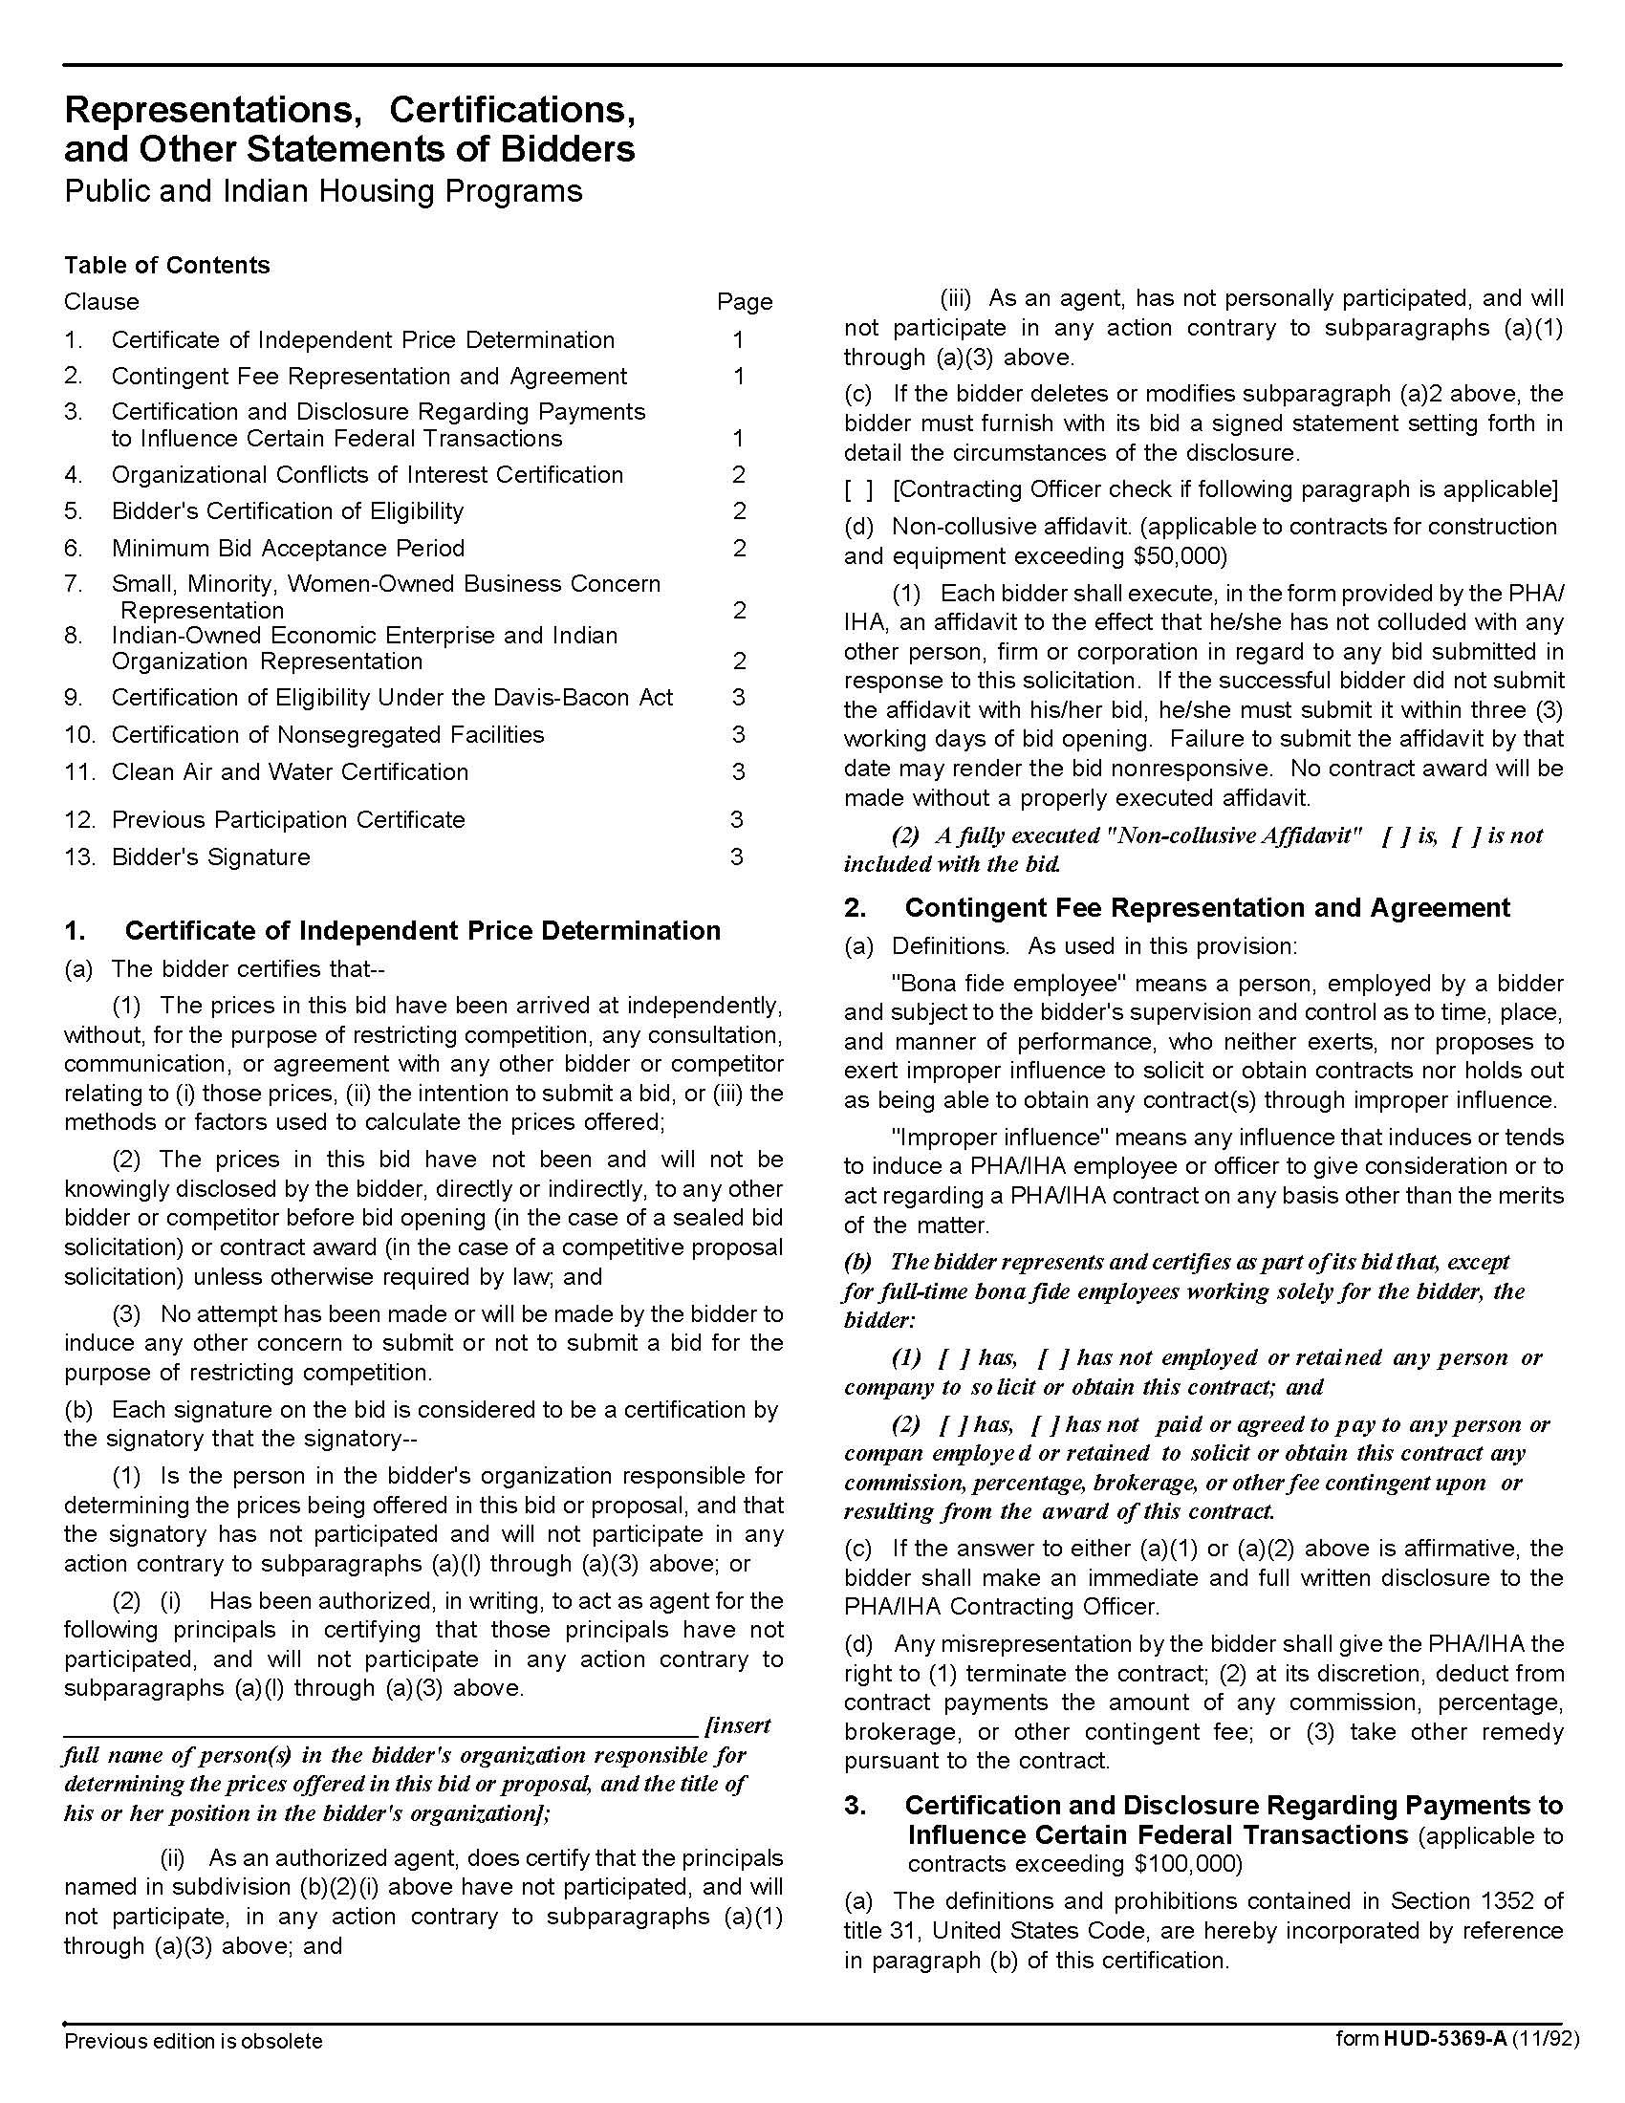

Vacant Apartment Repair Service Q1729 042017

Solicitation Document D HUD Form 5369A-continued

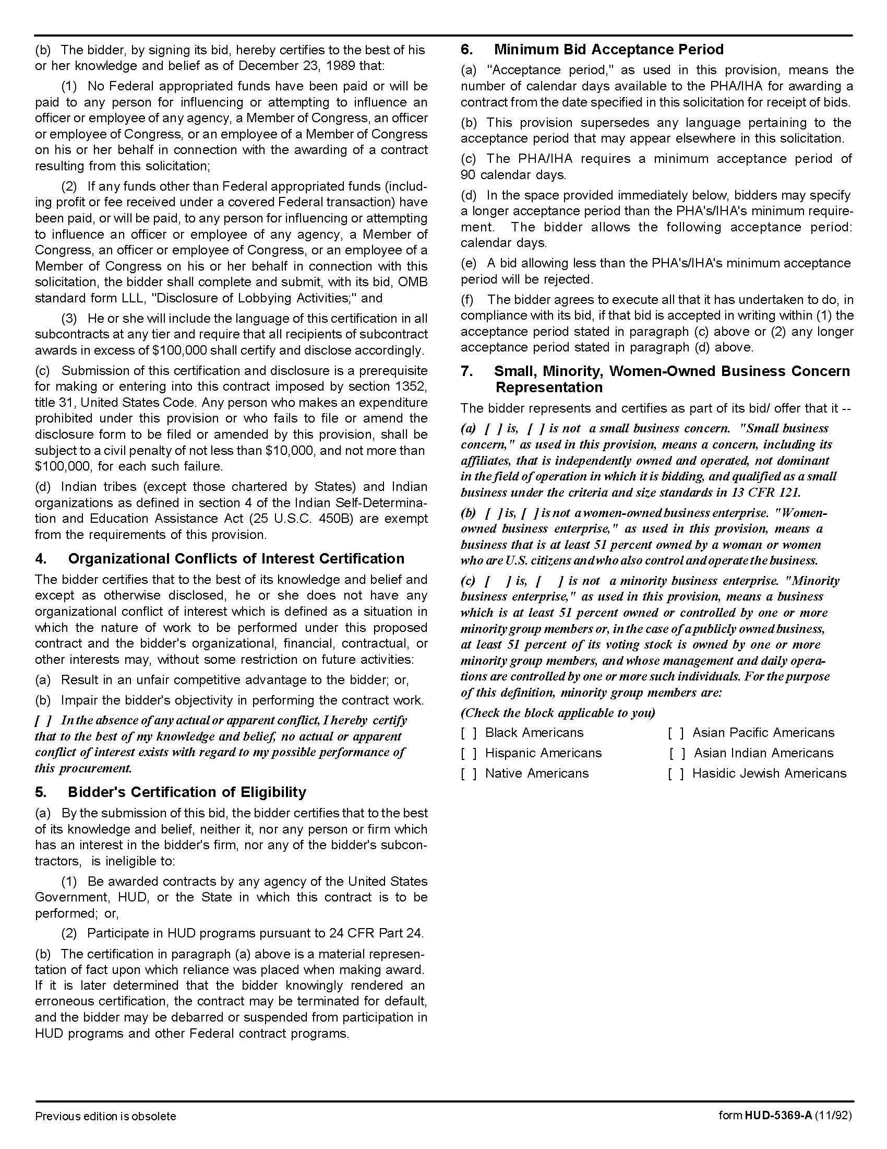

Vacant Apartment Repair Service Q1729 042017

Solicitation Document D HUD Form 5369A-continued

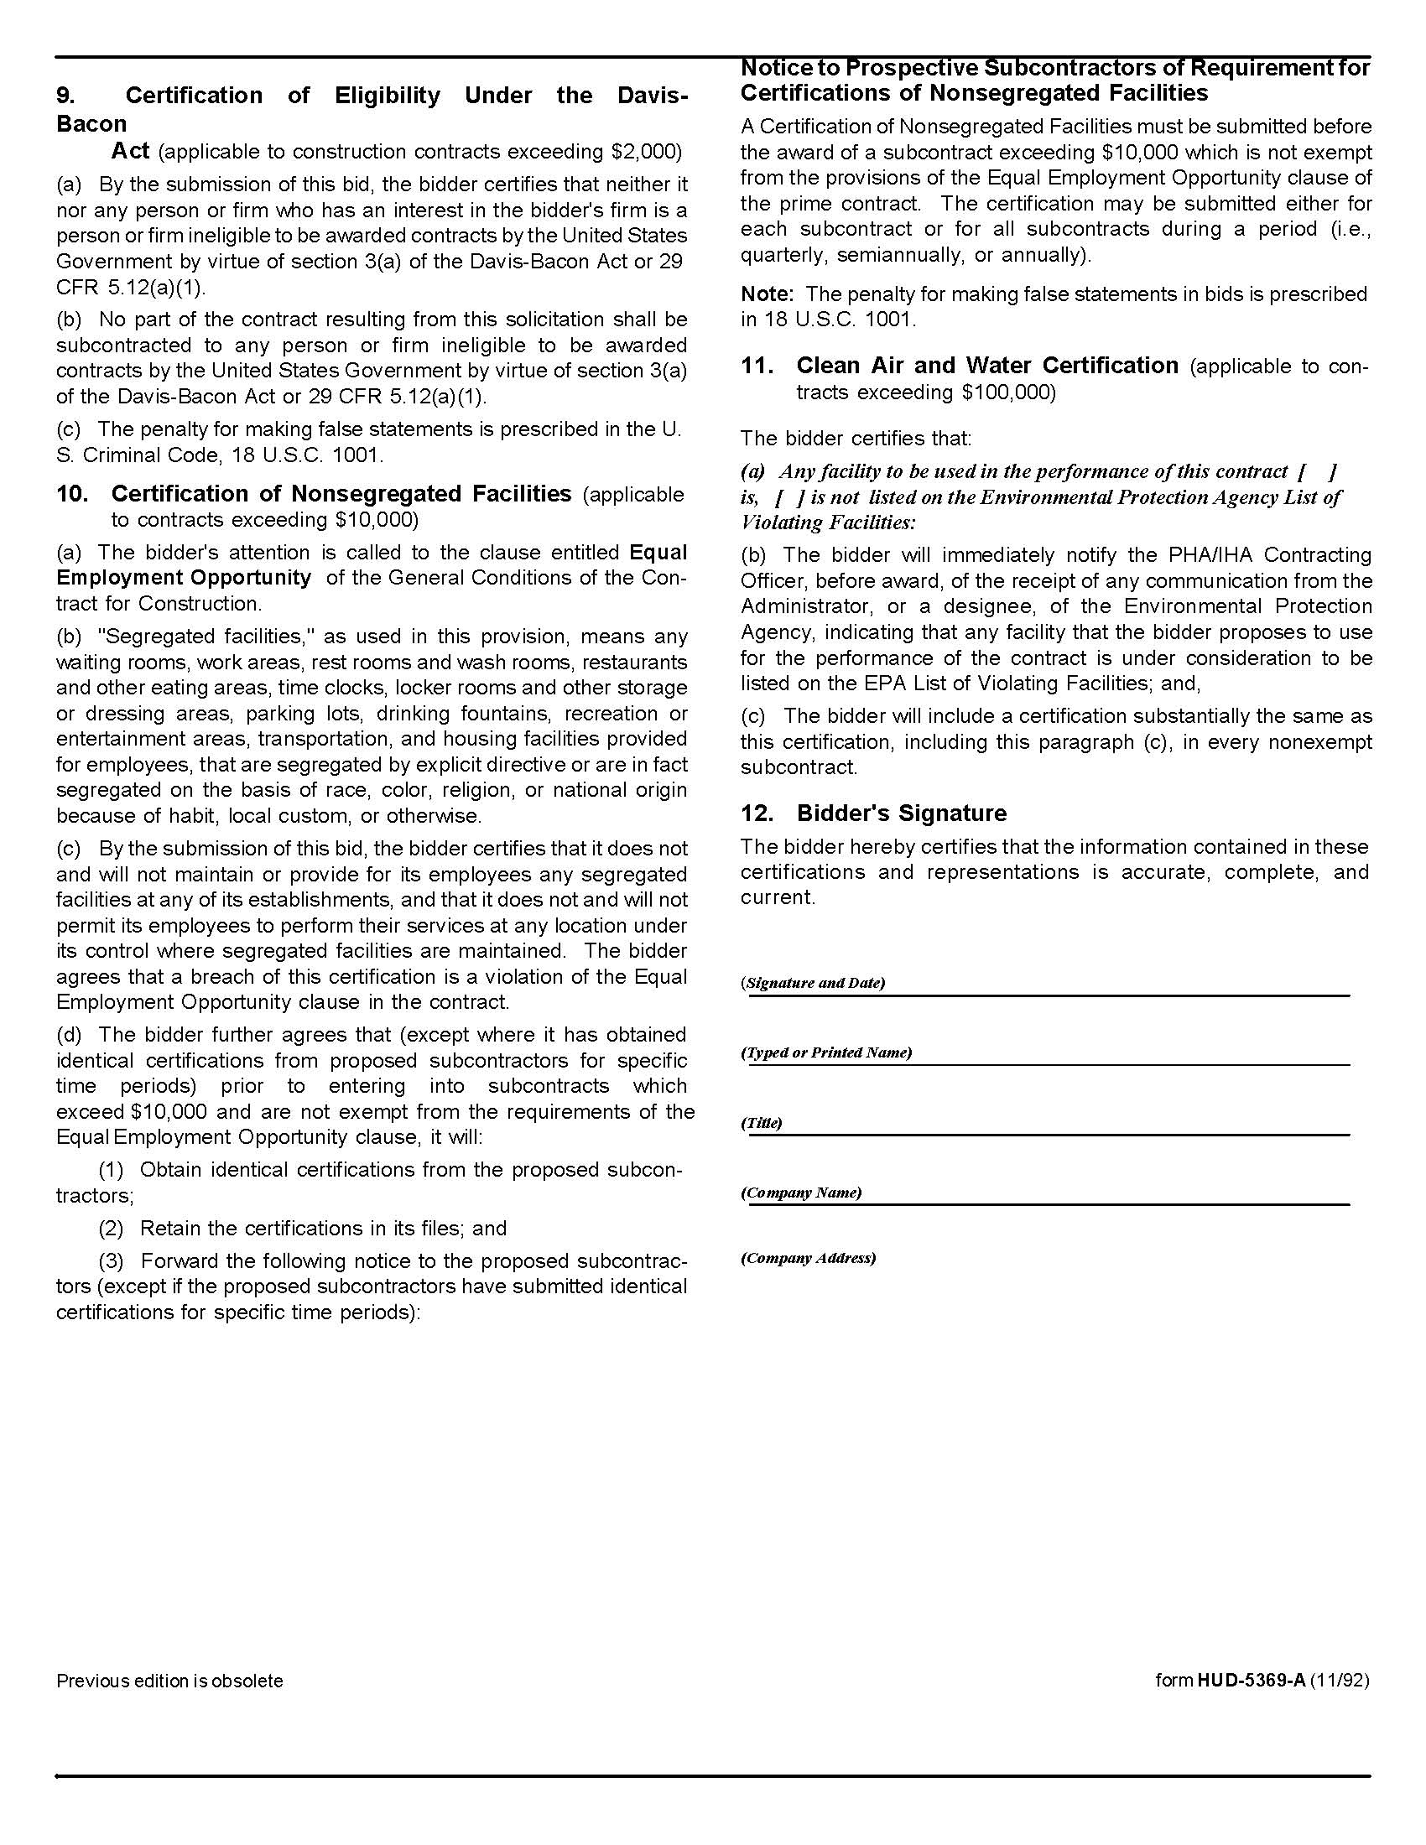

Vacant Apartment Repair Service Q1729 042017

Solicitation Document E Envelope Coversheet

Bid Due Date/Time |  | 05-11-17 at 11:00 a.m.

Bidder/Firm Name

State of Tennessee Contractor’s License Holder Name

State of Tennessee Contractor’s License Number

Pertinent State of Tennessee Contractor’s License Classification
State of Tennessee Contractor’s License Expiration Date
Subcontractors to be used on this project (If subcontract work is not required, write “none required”)
Electrical Subcontractor Name on the State of Tennessee’s Contractor’s License |  | State of Tennessee Contractor License Number
State of Tennessee Contractor License Classification(s) |  | Expiration Date of State Contractor’s License
HVAC Subcontractor Name on the State of Tennessee’s Contractor’s License |  | State of Tennessee Contractor License Number
State of Tennessee Contractor License Classification(s) |  | Expiration Date of State Contractor’s License
Masonry Subcontractor Name on the State of Tennessee’s Contractor’s License | None Required | State of Tennessee Contractor License Number | None Required
State of Tennessee Contractor License Classification(s) | None Required | Expiration Date of State Contractor’s License | None Required
Plumbing Subcontractor Name on the State of Tennessee’s Contractor’s License |  | State of Tennessee Contractor License Number
State of Tennessee Contractor License Classification(s) |  | Expiration Date of State Contractor’s License
Geothermal Subcontractor  Name on the License issued by the Department of Environment & Conservation | None Required | Department of Environment & Conservation Contractor License Number | None Required
Department of Environment & Conservation License Classification | None Required | Expiration Date Environment & Conservation License | None Required
Advisement: KCDC will not consider notes changing the bid written on the bid envelope. Such notes must be inside the envelope.

Vacant Apartment Repair Service Q1729 042017

Appendix A Specific Apartment Information

#19
Repair the plaster in the kitchen and hallway closet
Replace the kitchen countertop and install kitchen bulbs in the lights and appliances
Use KILZ on the rust in and on the living room molding
Treat the bathroom with bleach for mold
Remove the bathroom heater and switch, then install blank plates to boxes
Install tile in the bedroom where existing tile is gapped at the wall
Install door closers and latches on the screen doors
Install new smoke detectors

#38
Repair plaster and cracks throughout the unit (living room and the second bedroom)
Install new kitchen countertops
Install new smoke detectors
Install a new screen in front screen door
Install new weather stripping on the front entry door

#39
Repair the bathroom ceiling and walls, then paint the same
Pull the bathroom heater and switches then cover with blank plates
Pull soap and toothbrush holders and repair walls
Install new smoke alarms
Replace the water heater and repair the feedline
Install front and back door closers

#89
Install a new screen in the screen door
Repair the plaster and tape/skim cracks
Install approximately 3 boxes of tile throughout the unit
Remove the bath heater/switch cover and replace with blank plates
Install a towel bar
Install the small chair rail missing in bathroom
Install new smoke detectors
Install a dryer pipe

Vacant Apartment Repair Service Q1729 042017

Appendix A Specific Apartment Information-continued

#90
Touch up the walls
Remove/replace the loose tile in the living room and hallway (most tile in these areas)
Remove the bathroom heater/switch cover and replace with blank plates
Install the bedroom door and passage knobs
Install a new door closer
Repair the front door so it closes tightly

#106
Tighten the grab bar in the tub surround
Install a new light globe in the hallway and living room
Replace 1 smoke detector and put batteries in the other one
Replace broken floor tile at the entry door
Install floor tile in the living room to the wall
Replace 2 broken pieces of floor tile in the kitchen at the wall
Replace the bedroom door
Replace the kitchen countertop
Repair the metal at the front door on the porch header

#212
Repair plaster throughout the unit by scraping to remove loose tape. Then skim coat it.
Repair cracks in the ceiling throughout
Remove the bathroom heater/switch and cover with blank plates
Remove and replace the floor tile to the wall where gaps are, throughout the unit
Remove accordion doors and tracks from the bedroom closet openings and patch all holes/paint
Treat the bathroom and living room closets for mold
Stain block the rust on the molding in the bedrooms
Replace the countertop in the kitchen
Replace the kitchen faucet

#234
Install new latches on the screen door
Adjust the entry door to close tighter
Treat the mold in kitchen
Repair the floor tile throughout - missing and broken pieces
Replace the hallway door at the top of the stairs
Remove the bathroom heater/switch and cover the hole with blank plates
Remove the accordion doors and tracks from the bedroom closet and patch/paint all holes/gaps

Vacant Apartment Repair Service Q1729 042017

Appendix A Specific Apartment Information-continued

#249
Repair the kitchen ceiling
Skim the living room walls
Treat for mold in the living room and kitchen
Remove the broken floor tile in the kitchen and the living room
Install new floor tile pieces in the living room, kitchen, bedrooms and the top of the stairwell where the heaters were removed
Remount the living room light
Adjust the front door to close tightly
Install screen door latches
Install a new screen in the living room window (the existing has a hole)
Install new kitchen cabinets and a new countertop
Install new smoke detectors
Repair the bathroom door
Remove the bathroom heater/switch and cover with blank plates
Replace the door in bedroom #1
Remove the switch in bedroom #2 and install a regular switch
Remove the existing door knob and install a regular knob
Install pigtails to both the upstairs and downstairs ETAC units
Install bulbs in the kitchen lights
Install a cover on the water heater

#284
Replace 4 doors - 1st bedroom/2nd bedrooms/half bath/full bath
Remove the bathroom heater/switch and cover with blank plates
Treat the mold in the full bath
Install new kitchen cabinets and countertop
Remove the door/hinges to the hallway from the living room and fill all holes
Repair the rat hole in the living room
Install new weather stripping

Vacant Apartment Repair Service Q1729 042017

Appendix A Specific Apartment Information-continued

#288
Repair the walls in the unit
Replace/install the cove base as needed throughout the unit
Install new kitchen cabinets and countertop
Remove/replace the floor tile where gapped at the wall in the living room and all bedrooms
Repair/replace the Addresso light cover
Replace the door in the water heater closet
Install the missing tub surround tile
Remove the bathroom heater/switch and cover with blank plates
Install a flush valve (Fluidmaster) in the toilet
Install an elongated toilet seat
Put KILZ on the rust on the bathroom light fixture and molding
Install weather stripping on the front door
Repair the closet shelf in the first bedroom
Replace the bedroom light switches with regular switches/covers
Replace the front screen door closer and latch
Install compact fluorescent bulbs in living room, 2nd bedroom and 3rd bedroom
Install metal door knobs on the hallway doors and 2nd bedroom closet door

#342
Repair the front and back screen door closers and latches
Adjust the front and back doors to close tightly
Install weather stripping on the back door
Repair the walls as needed throughout the unit
Install bulbs and globes throughout the unit
Install new kitchen cabinets and a countertop
Replace the loose floor tile in laundry area
Treat the laundry area for mold
Replace all the smoke detectors
Repair/replace the 3-way switch in the kitchen
Install a door in the living room closet
Install a shelf in the living room closet
Remove the bathroom heater/switch and cover with blank plates

Vacant Apartment Repair Service Q1729 042017

Appendix A Specific Apartment Information-continued

#352
Install new kitchen cabinets and a countertop
Install new kitchen faucets
Repair the wall in the laundry area
Repair the ceiling in the bathroom
Replace the floor tile in the living room where it is gapped at the wall
Install 2 foot fluorescent bulbs in the kitchen
Remove the bathroom heater/switch and cover with blank plates
Remove the existing and install the new approved closet door knobs
Install new closers and latches on the screen doors
Install new passage knobs on the front and back doors
Install new weather stripping on the front and back doors

#356
Repair the bathroom ceiling and walls
Remove the bathroom heater/switch and cover with blank plates
Remove the door knobs on the closets
Remove and replace the floor tile in the living room where it is gapped at wall and back door
Install new closers and latches on the screen doors
Install new passage knobs on the entry door
Remount the Addresso light at the back door

#411
Replace the center window screen
Remove and replace the floor tile where it is gapped at the wall in the living room and bedroom
Remove the hallway heater and bathroom heater/switches and cover with blank plates to boxes
Install a new hood range vent

