Pest Control Services Q2014

Solicitation Document A General Response Section

General Information about the Supplier
Sign Your Name to the Right of the Arrow
Your signature indicates you read and agree to “KCDC’s General Instructions to Suppliers” (www.kcdc.org) and that you are authorized to bind the supplier or are submitting the response on behalf of and at the direction of the suppliers’ representative authorized to contractually bind the supplier. I represent that the supplier or its applicable representative(s) has reviewed the information contained in this Solicitation Package and that the information submitted is accurate.
Printed Name and Title
Company Name
Street Address
City/State/Zip
Contact Person (Please Print Clearly)
Telephone Number
Cell Number
Supplier’s E-Mail Address (Please Print Clearly)
Addenda
Addenda are at www.kcdc.org. Click on “Procurement” and then on “Open Solicitations” to find addenda. Please check for addenda prior to submitting a proposal.
Acknowledge addenda have been issued by checking below as appropriate:
None ☐ | Addendum 1 ☐ |  |  | Addendum 2 ☐ |  | Addendum 3 ☐ |  |  | Addendum 4 ☐ | Addendum 5 ☐
Statistical Information (Check all the apply)
This business is at least 51% owned and operated by a woman |  |  |  |  |  |  |  |  |  |  | Yes ☐ No ☐
This business qualifies as a small business by the State of Tennessee  Total gross receipts of not more than $10,000,000 average over a three-year period OR employs no more than 99 persons on a full-time basis |  |  |  |  |  |  |  |  |  |  | Yes ☐ No ☐
This business qualifies as Section 3 business (as defined by HUD):  It is at least 51% owned by a Public Housing resident or it employs Section 3 residents for at least 30% of its employee base; or it commits to subcontract at least 25% of the project’s dollars to a Section 3 business. |  |  |  |  |  |  |  |  |  |  | Yes ☐ No ☐
This business is owned & operated by persons at least 51% of the following ethnic background:
Asian/Pacific ☐ |  | Black ☐ | Hasidic Jew ☐ |  | Hispanic ☐ |  |  | Native Americans ☐ |  |  | White ☐
Cooperative Procurement
Subject to additional location/delivery charges, the supplier agrees to extend the offered costs to other governments if the government so desires. Yes ☐ No ☐
Prompt Payment Discount
A prompt payment discount of ________% is offered for payment within ____ days of submission of an accurate and proper invoice.
MasterCard Acceptance
Mastercard is accepted for payment without additional fees. ☐ Yes ☐ No ☐ For a fee of _________

Pest Control Services Q2014

Solicitation Document B Affidavits

Supplier: _____________________________________________________________________________

Conflict of Interest
1. No commissioner or officer of KCDC or other person whose duty it is to vote for, let out, overlook or in any manner superintend any of the work for KCDC has a direct interest in the award or the supplier providing goods or services.

2. No employee, officer or agent of the grantee or sub-grantee will participate in selection, or in the award or administration of an award supported by Federal funds if a conflict of interest, real or apparent, would be involved. Such a conflict would arise when the employee, officer or agent, any member of his immediate family, his or her partner, or an organization, which employs, or is about to employ, any of the above, has a financial or other interest in the supplier selected for award.

3. The grantee's or sub-grantee's officers, employees or agents will neither solicit nor accept gratuities, favors or anything of monetary value from suppliers, potential suppliers or parties to sub-agreements.

4. By submission of this form, the supplier is certifying that no conflicts of interest exist.

Drug Free Workplace Requirements
5. Private employers with five or more employees desiring to contract for construction services attest that they have a drug free workplace program in effect in accordance with TCA 50-9-112.

Eligibility
6. The supplier is eligible for employment on public contracts because no convictions or guilty pleas or pleas of nolo contender to violations of the Sherman Anti-Trust Act, mail fraud or state criminal violations with an award from the State of Tennessee or any political subdivision thereof have occurred.

General
7. Supplier fully understands the preparation and contents of the attached offer and of all pertinent circumstances respecting such offer.

8. Such offer is genuine and is not a sham offer.

Iran Divestment Act
9. Concerning the Iran Divestment Act (TCA 12-12-101 et seq.), by submission of this bid/quote/proposal, each supplier and each person signing on behalf of any supplier certifies, and in the case of a joint bid/quote/proposal, each party thereto certifies as to its own organization, under penalty of perjury, that to the best of its knowledge and belief that each supplier is not on the list created pursuant to § 12-12-106.

Pest Control Services Q2014

Solicitation Document B Affidavits - continued

Non-Collusion
10. Neither the said supplier nor any of its officers, partners, owners, agents, representatives, employees or parties interest, including this affiant, has in any way colluded conspired, connived or agreed, directly or indirectly, with any other responder, supplier, or person to submit a collusive or sham offer in connection with the award or agreement for which the attached offer has been submitted or to refrain from making an offer in connection with such award or agreement, or collusion or communication or conference with any other supplier, or, to fix any overhead, profit, or cost element of the offer price or the offer price of any other supplier, or to secure through any collusion, conspiracy, connivance, or unlawful agreement any advantage against KCDC or any person interested in the proposed award or agreement.

11. The price or prices quoted in the attached offer are fair, proper and not tainted by any collusion, conspiracy, connivance, or unlawful agreement on the part of the supplier or any of its agents, representatives, owners, employees, or parties in interest, including this affiant.

Accuracy of Electronic Copies
12. If the supplier provides electronic copies of the bid/proposal/quote to KCDC, the supplier certifies that the information provided on paper and in the electronic format is identical unless specifically noted otherwise.
No Contact/No Advocacy Affidavit
13. After this solicitation is issued, any contact initiated by any proposer with any KCDC representative concerning this proposal is strictly prohibited-except for communication with the Procurement Division. My signature signifies that no unauthorized contact occurred.

14. To ensure the integrity of the review and evaluation process, respondents to this solicitation nor any firm representing them, may not lobby or advocate to KCDC staff or Board members. My signature signifies that no unauthorized advocacy occurred.

The undersigned hereby acknowledges receipt of these affidavits and certifies that the submittal in response to this solicitation is in full compliance with the listed requirements.

Signed by
Printed Name
Title
Subscribed and sworn to before me this date
By (Notary Public)
My Commission Expires on
Notary Stamp

Pest Control Services Q2014
Solicitation Document C HUD Form 5369A
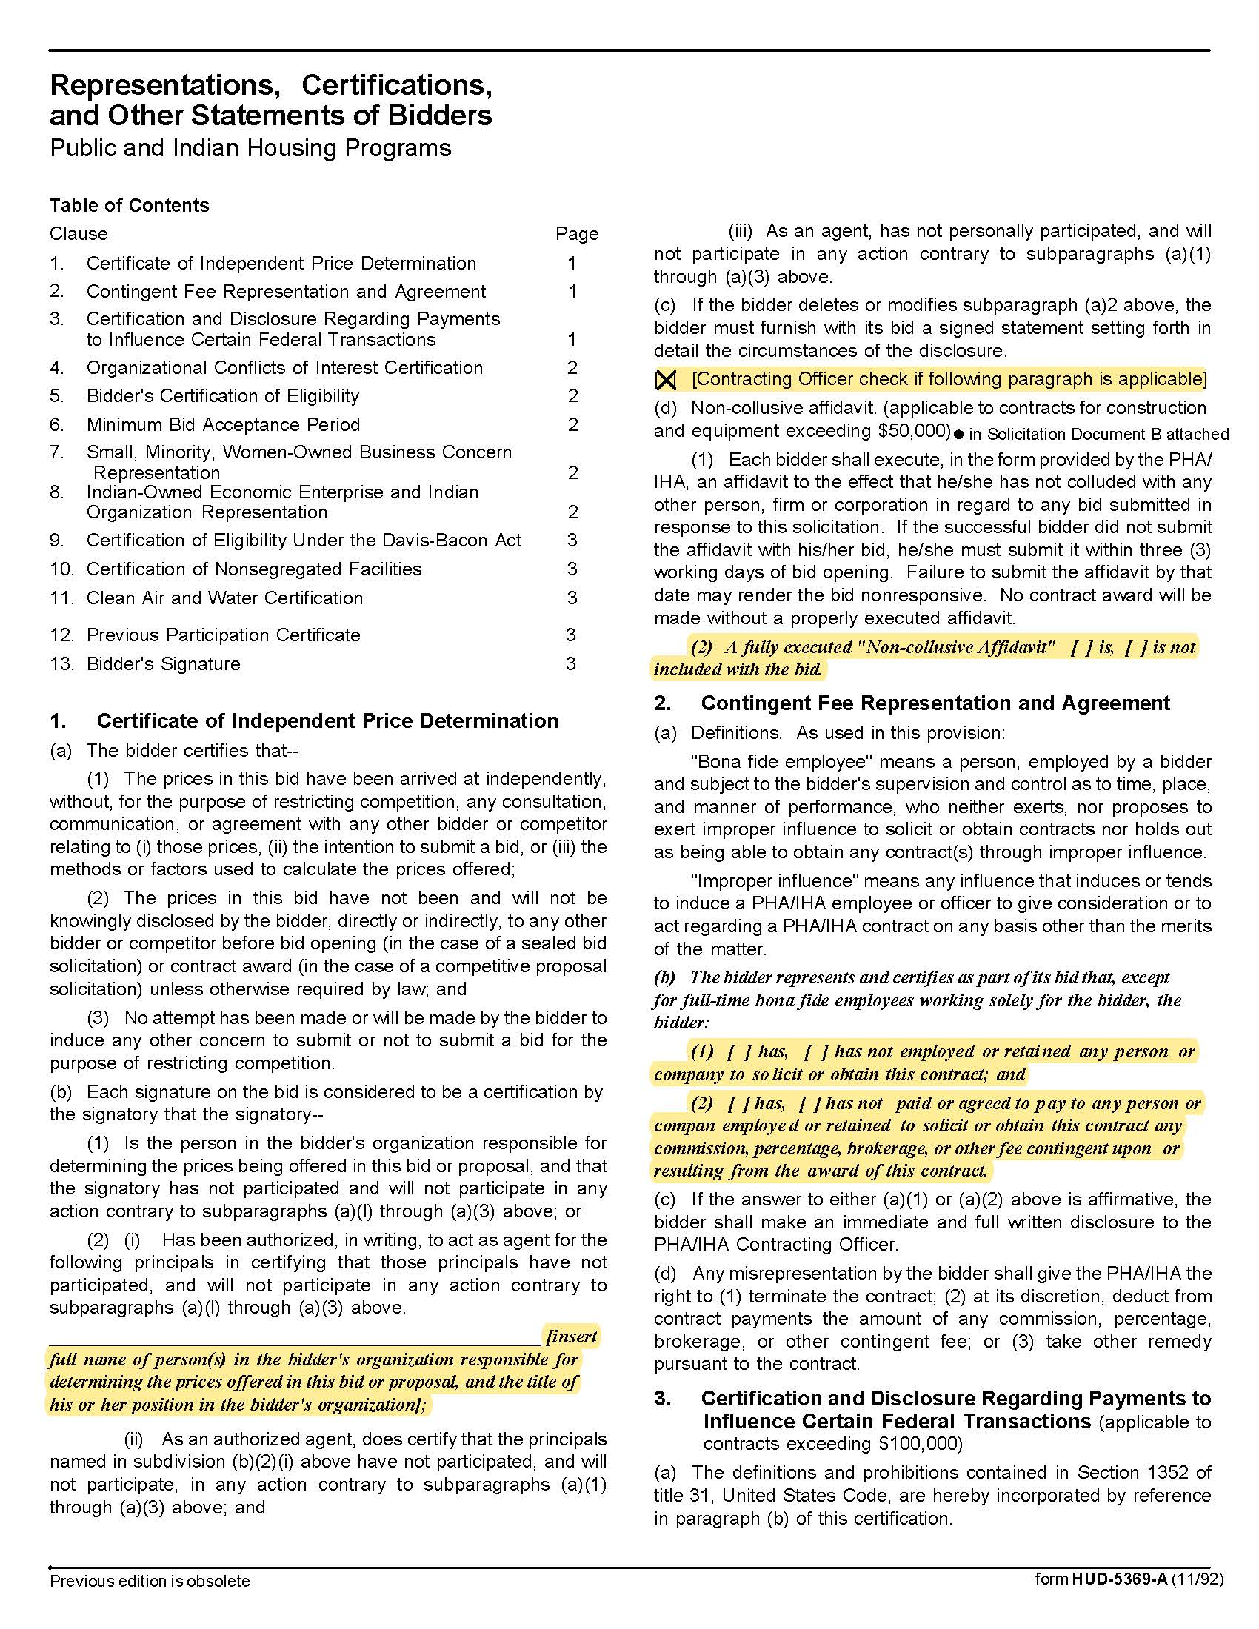

Pest Control Services Q2014
Solicitation Document C HUD Form 5369A - Continued
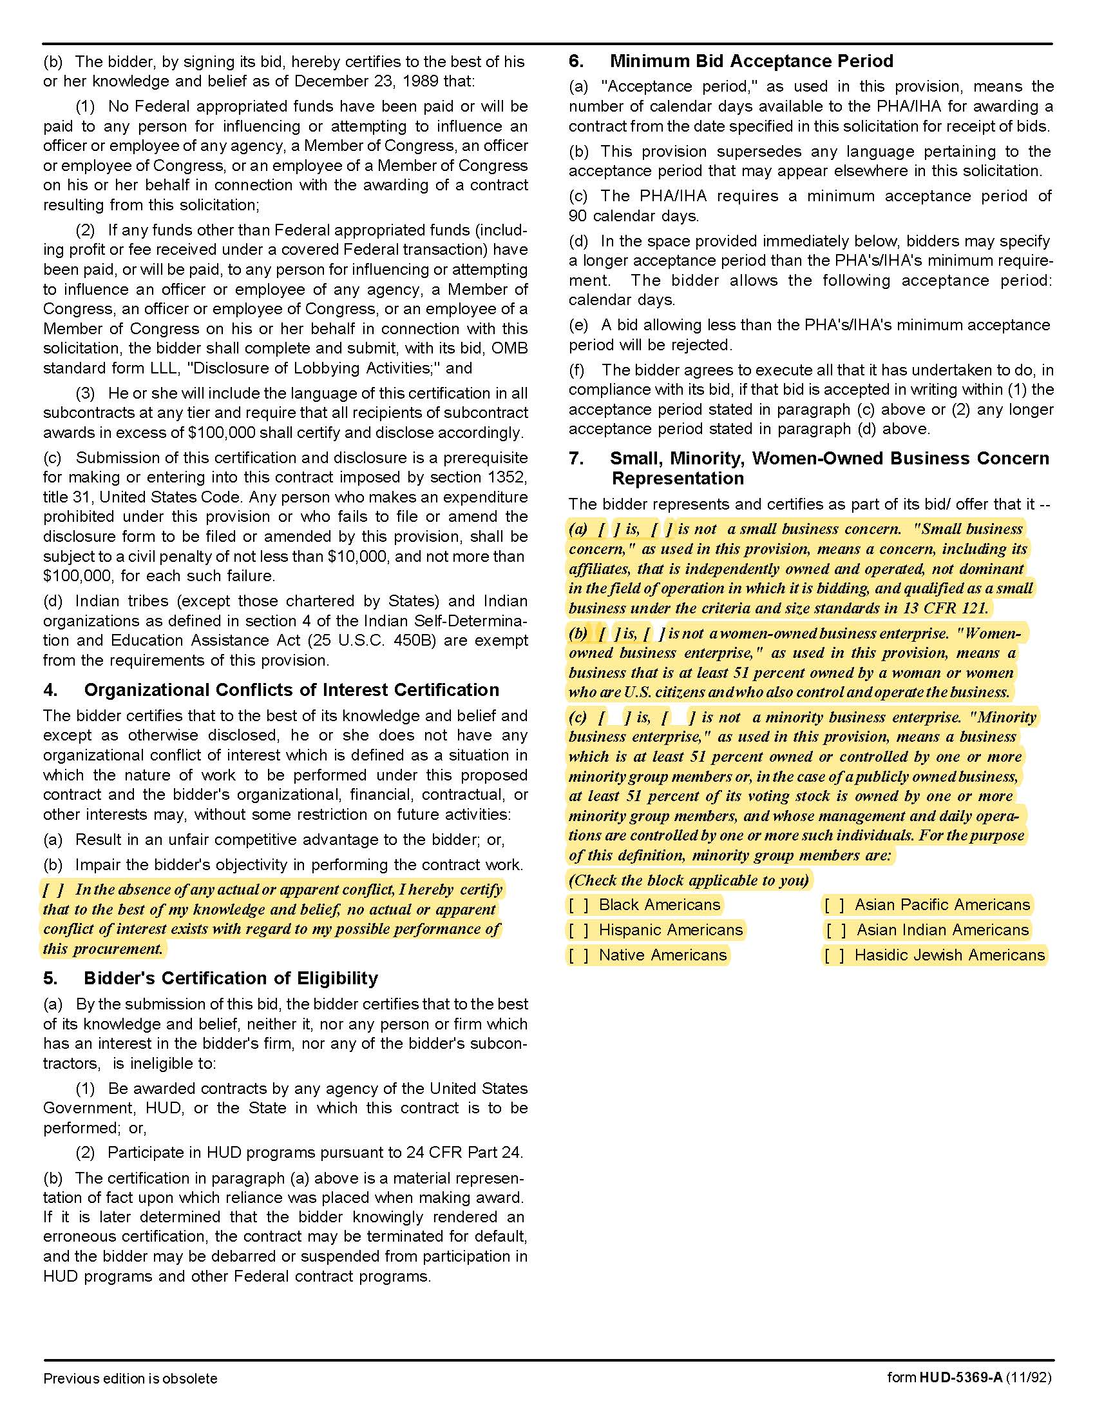

Pest Control Services Q2014
Solicitation Document C HUD Form 5369A - Continued
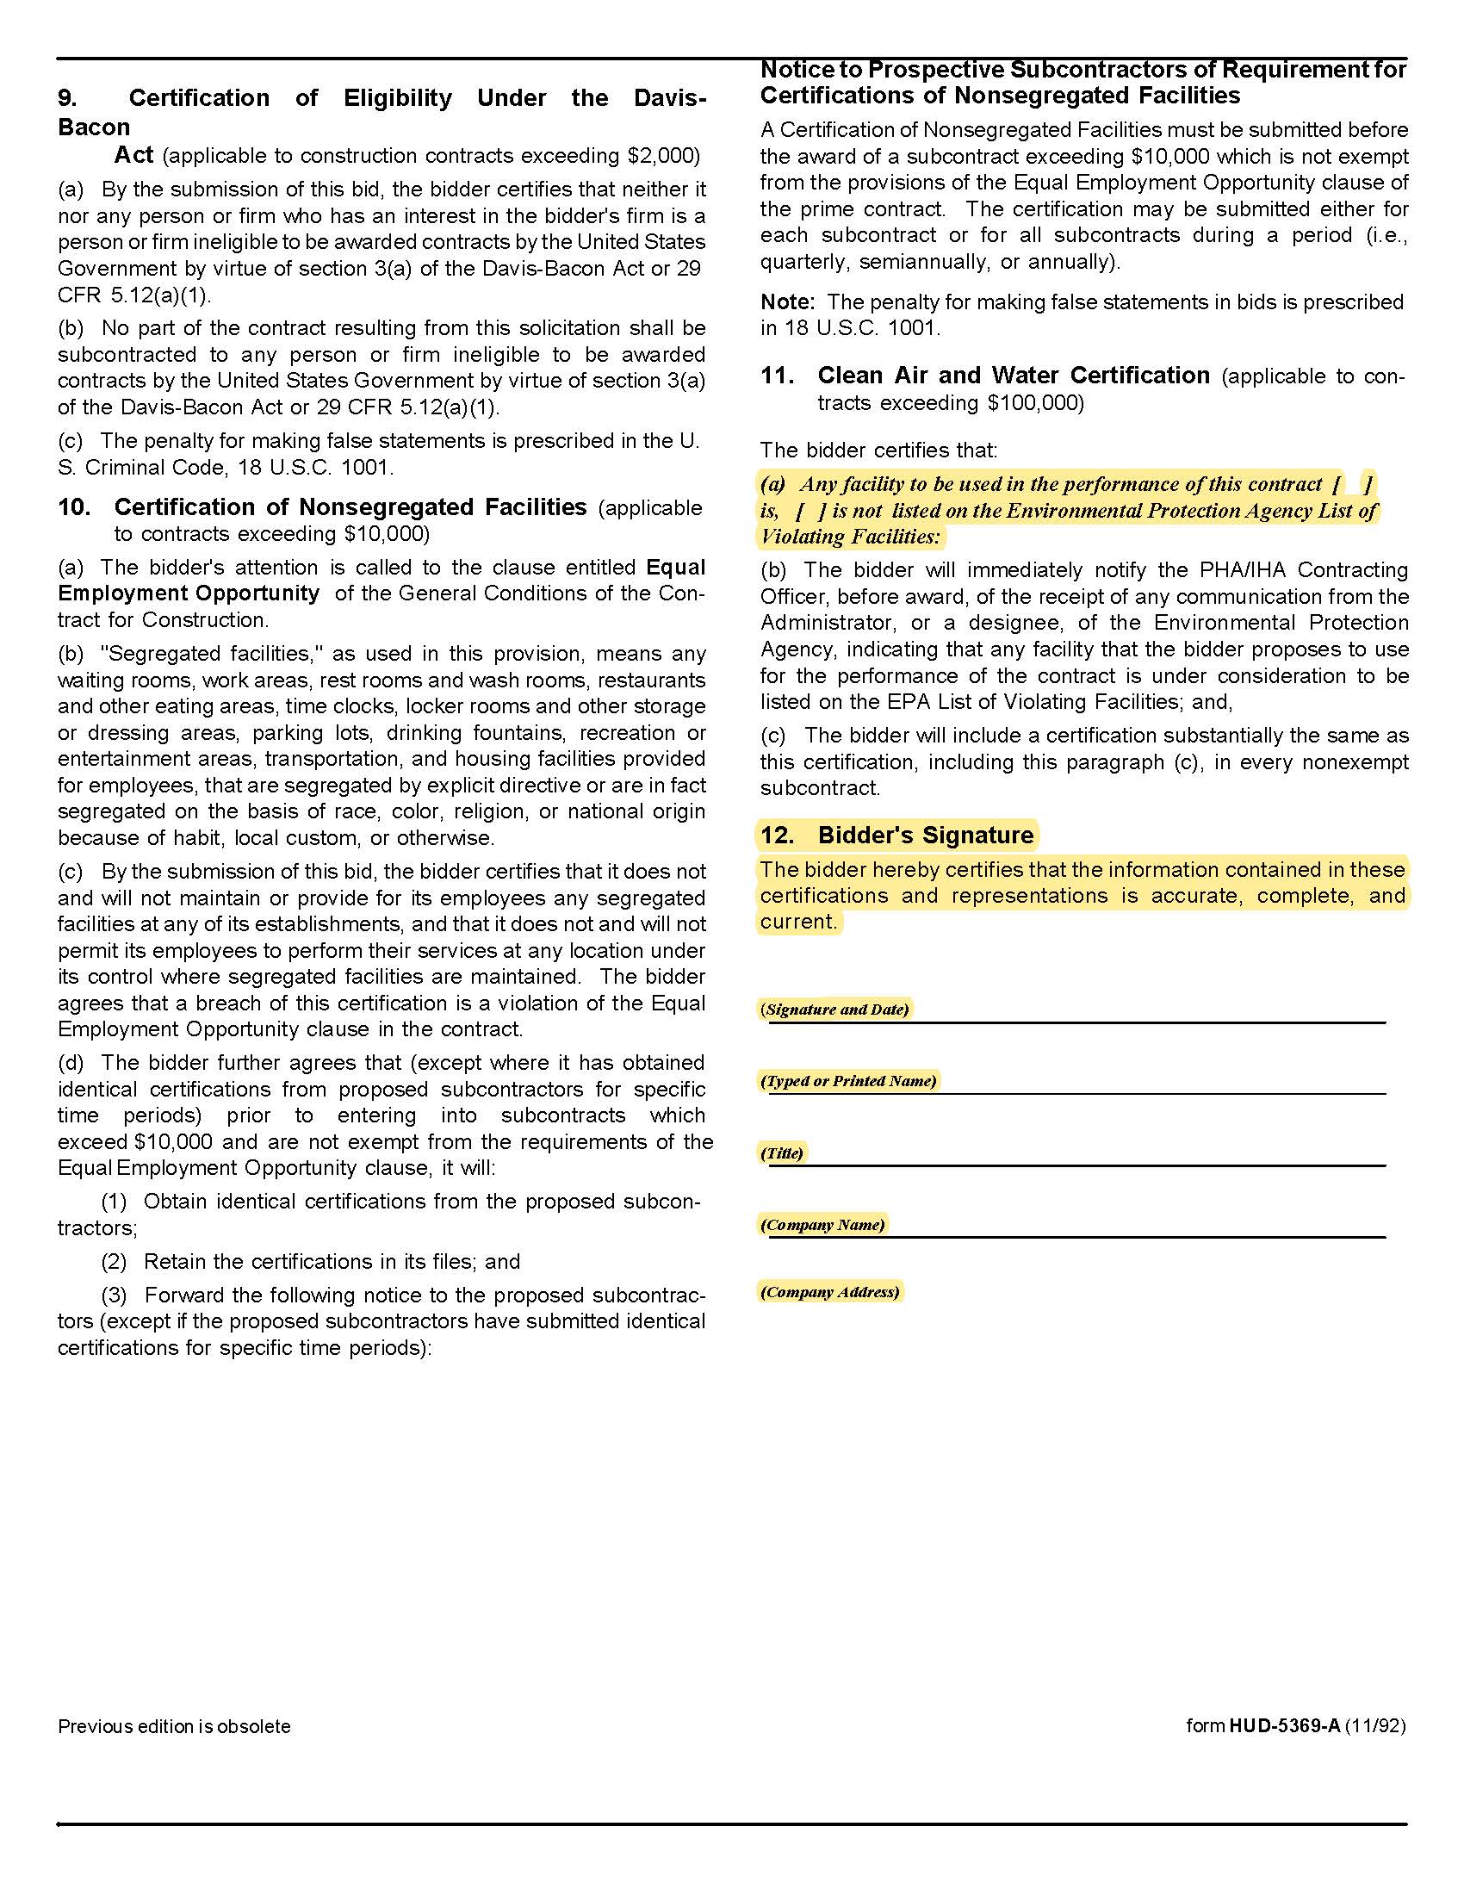

Pest Control Services Q2014
Solicitation Document D Business Capabilities

Use this section of your response to detail your company’s qualifications. Include:

1. An introduction of not more than four paragraphs that includes an explanation of why KCDC should partner with your firm.

2. An overview of your company’s history.

3. A description of your company’s capabilities.

4. What differentiates you from your competition.

5. An organizational chart that helps KCDC understand the staff that will assist with this work.

6. The names of key personnel who will be involved in this project and indicate titles and roles.

7. Half page (or less) resumes of key personnel (including technicians) showing their years of experience, certifications, et cetera.

8. If your firm will hire employees, include a copy of a job description showing the job requirements and experience.

9. Certification and licensing ID numbers.

10. Tennessee Charter Number.

11 A list of subcontractors-if applicable.

12. Guaranteed response times.

13. The plan you have in place to ensure consist quality among your technicians.

14. Other information as desired (maximum of 5 pages).

Pest Control Services Q2014
Solicitation Document E Service Plan

Use this section to detail how you plan to provide services to KCDC. Be specific and be detailed since KCDC does not have to ask additional questions during the evaluation process. Use as many pages as necessary to help KCDC fully understand how you plan to service our needs.

Proposers are to address these areas:

1. A narrative to show:
- The proposed approach to the work
- Proposed work hours
- Proposed service levels at the various KCDC sites
- The resources to be used
- The administrative plan
- Other

2. Regular Pest Control treatment proposed (attach service protocols).
- Low infestation (Procedures here and cost in Solicitation Document G)
- Medium infestation (Procedures here and cost in Solicitation Document G)
- High infestation (Procedures here and cost in Solicitation Document G)
- Products to be used (trade name, generic name, signal word)
- KCDC staff efforts required
- Resident efforts required
- Days and hours of service for each KCDC apartment (projected)
- Number of employees to be assigned to this work
- Include discussion of baiting, dusting outlets, cracks, crevices, removing switch plates, monitors, use of HEPA vacuums to remove pests, exclusion techniques. et cetera
- Discuss clutter removal issues and options
- Detail whether or not your service plan includes treating the entire building during each visit (as is KCDC’s plan). If not, discuss how your service plan accomplishes the same goals.
- Option (primarily for the high rises) for an interior rodent control program
- Other

3. Bed bug treatment(s) proposed (attach service protocols).
- Low infestation (1-10 per unit. Procedures here and cost in Solicitation Document G)
- Medium infestation (11-50 per unit. Procedures here and cost in Solicitation Document G)
- High infestation (51 or more per unit. Procedures here and cost in Solicitation Document G)
- Products to be used (trade name, generic name, signal word)
- KCDC staff efforts required
- Resident efforts required
- Number of employees to be assigned to this work
- Discussion of building wide bed bug inspections
- Use of monitors to detect and determine elimination of bed bugs
- The method used to determine bed bug elimination
- Unit contract completed by documented elimination of bed bugs
- Dusting outlets, cracks, crevices and removing switch plates
- Exclusion techniques
- Use of vacuums to remove bed bugs
- Other non-chemical options
- Discuss clutter removal issues and options
- Other

4. Termite treatment proposed (attach service protocols).
- Products to be used (trade name, generic name, signal word)
- KCDC staff efforts required
- Other

5. Fire Ant treatment proposed (attach service protocols).
- Products to be used (trade name, generic name, signal word)
- KCDC staff efforts required
- Other

6. Staff and resident education plan
- Frequency
- Method
- Results assessment

7. The administrative plan.
- The supplier’s administrative contact process and persons
- Billing/Payment plan
- A sample invoice for KCDC’s review
- How day to day operations will work
- Quality control inspection details
- Call back policies
- Sample forms
- Copies of licenses
- Copies/drafts of literature for residents (housekeeping thoughts, service preparation instructions, et cetera)
- Furniture moving
- Furniture removal (from the premises)
- Other

8. Other services provided: heat, canine scent detection teams, et cetera

9. Other information that the supplier wishes to supply to assist KCDC in the evaluation

Pest Control Services Q2014
Solicitation Document F References

Part A: The proposal must include at least five specific references of similar accounts (PHAs of a similar size and complexity are preferred). Present information in this format:

1. Entity Name

2. Contact name, Phone number and Email address

3. Number of apartments

4. Description of the contract

5. Date service began

6. Date service ended (if applicable)

Part B: Notes to References

1. While you may have performed numerous services and/or may have had numerous contracts with an entity, each entity can only be one references. Thus if you serviced 18 different Knox County departments, it is one reference.

2. Advise the listed references that KCDC may contact them via email or SurveyMonkey.

Pest Control Services Q2014
Solicitation Document G Cost Proposal

1. Provide a specific price for each KCDC site for routine pest control services as specified herein (does not include bed bugs, fire ants or termites) on this chart. Also indicate the grand total.

Site | Per Month Cost | Per Year Cost
Autumn Landing Apartments
Cagle Terrace
Cottages at Clifton Road
Eastport Residences I
Eastport Residences II
Five Points Family Multiplexes
Five Point Duplexes
Five Points Leasing Office/
Isabella Towers
Lonsdale Homes
Love Towers (both buildings)
Main Office
Mechanicsville Homes
Montgomery Village
Nature’s Cove Apartments
North Ridge Crossing
Northgate Terrace
Passport Property
Procurement Office Building
Residences at Five Points Phase 1
Residences at Eastport
Supportive Maintenance
Valley Oaks
Verandas
Vista
Western Heights
Grand Total

2. Indicate any yearly pre-payment discount for routine services.

3. Indicate any service options and the associated costs.

4. Indicate a cost (if any) for prepping units (if KCDC desires).

5. Use the following chart to indicate costs for other services.

Service |  | Cost
Bed Bugs Low Level Infestation: |  | $ efficiency apartment
Bed Bugs Low Level Infestation: |  | $ 1 bedroom apartment
Bed Bugs Low Level Infestation: |  | $ 2 bedroom apartment
Bed Bugs Low Level Infestation: |  | $ 3 bedroom apartment
Bed Bugs Low Level Infestation: |  | $ 4 bedroom apartment
Bed Bugs Low Level Infestation: |  | $ 5 bedroom apartment
Bed Bugs Medium Level Infestation: |  | $ efficiency apartment
Bed Bugs Medium Level Infestation: |  | $ 1 bedroom apartment
Bed Bugs Medium Level Infestation: |  | $ 2 bedroom apartment
Bed Bugs Medium Level Infestation: |  | $ 3 bedroom apartment
Bed Bugs Medium Level Infestation: |  | $ 4 bedroom apartment
Bed Bugs Medium Level Infestation: |  | $ 5 bedroom apartment
Bed Bugs High Level Infestation: |  | $ efficiency apartment
Bed Bugs High Level Infestation: |  | $ 1 bedroom apartment
Bed Bugs High Level Infestation: |  | $ 2 bedroom apartment
Bed Bugs High Level Infestation: |  | $ 3 bedroom apartment
Bed Bugs High Level Infestation: |  | $ 4 bedroom apartment
Bed Bugs High Level Infestation: |  | $ 5 bedroom apartment
Bed Bug Mattress Cover |  | $ each
Rodent: Mice Treatment |  | $ square foot
Rodent: Rat Treatment |  | $ square foot
Fire Ants |  | $ per
Fleas |  | $ per
Termite Services |  | $ per linear foot
Termite Services |  | $ per bait station
HEPA Vacuuming |  | $ per
Sealants |  | $ per
Furniture Removal Services |  | $
Pest Control Services Q2014
Solicitation Document H Copies of Contracts for KCDC’s Review

Use this section to provide copies of all service contracts that KCDC will be asked to sign. KCDC will review these and indicate any language which needs to be edited so that once approved, site managers can sign the contracts without the involvement of other staff.

