City of Waycross
Purchasing Department
Addendum #1
Bid # FY22-29
Police Leather Goods
April 6, 2022

- On item #21 you are asking for Hat Badges; would you please let me know the model number of the badge or a picture.

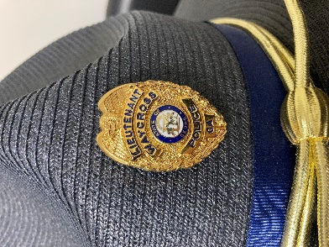
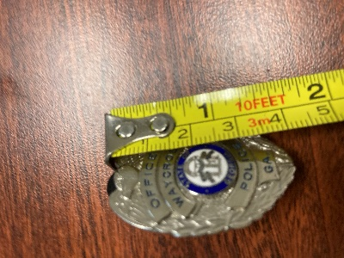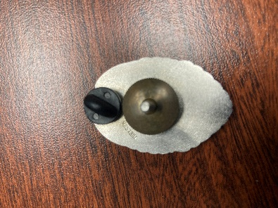

- On item #14 please let me know what size of OC this case is for. MK3

- On item #12 what type of holster are you looking for: duty, concealment, paddle, with or without a light, etc.? DUTY, Level III retention, without a light, for Glock 22-same specs for #25 just without a light.

- On item #13 what size of ASP baton is this holder for, open or closed style? Open style 21 inch-high gloss, Gould & Goodrich model H560-21 or acceptable alternate.

- On item #16 what size of tape recorder is this holder to be for? Safariland 767 Cassette Tape Recorder Pouch 767-1-2V or acceptable alternate.

- There is no manufacturer/brand or part numbers listed for Items 1, 2, 5, 7, 12, 13, 14, 15, 16, 24, 26, and 27, are Safariland products desired? If not, can you advise which brands and item numbers are preferred for each item?
Item 1 - DUTY Man 1031 with silver or gold buckle option or acceptable alternate.
Item 2- Duty Man 1331 or acceptable alternate.
Item 5-Gould & Goodrich Model H70 high gloss with gold or silver button option or acceptable alternate.
Item 7- Safariland model 730 high gloss with gold or silver option or acceptable alternate.
Item 12 - Safariland Model 6360, Level III, high gloss for Glock 22.
Item 13 - Open style 21 inch-high gloss, Gould & Goodrich model H560-21 or acceptable alternate.
Item 14 - Safariland model 38 high gloss, gold, or silver snap option or acceptable alternate.
Item 15 - Gould and Goodrich glove pouch high gloss model H555CL or acceptable alternate.
Item 16 - Safariland 767 Cassette Tape Recorder Pouch 767-1-2V or acceptable alternate.
Item 24 - DUTYMAN 8531 clarino with gold or silver option or acceptable alternate.
Item 26 - Safariland Model 6378 or acceptable alternate.

Item 27-Zero9 Holster V300 (SKU: Z9-2018-BLK-MLK)

- When “Clarino Leather” is used in the item description, is the agency requesting “Synthetic Leather”? The verbiage varies depending on the manufacturer’s specs. For example, Safariland does not use the term Clarino Leather, they use “Plain”, “Synthetic Leather”, “Hi-Gloss” etc. This question would apply to Items 1, 2, 5, 7, 12, 13, 14, 15, 16, 24, 26, and 27. High Gloss

- The bid states “If an approved equal – must submit sample”, there does not appear to be a specific manufacturer and part/item number listed for some items. Is there a specific manufacturer the agency prefers? Safariland

- Item 1: Is there a certain size desired? Larger sizes have a higher cost than smaller sizes. Submit your bid with sizes and amounts.

- Item 3: Safariland requires additional specs for this product: Color and Finish. Color- black, plain finish

- Item 4: Is there a specific manufacturer desired? Safariland

- Item 4: What color, draw hand, finish and material is desired for this holster? Black, plain finish, need quote for left hand and right hand.

- Item 4: What type of light is being utilized in this holster? Streamlight tlr-1

- Item 18: Is there a specific item number for this Galco Holster? If not, we would locate one with the gun make and model. Glock 27

- In General Information, it states the vendor is responsible for measurement and fitting…. Can you advise the items on the list where the agency is requesting the measurement and fitting? Disregard this statement. It is for police uniforms only, not leather goods.

