

Invitation for Sealed Bids

Solicitation Name | Renovations at Montgomery Village-Fillable Pages Only
Solicitation Number | C19011
Notes:
1. Bidders may use these pages to type their responses in stead of handwriting responses.
2. Bidders may not adjust any verbiage, text or format.
3. KCDC’s posted Adobe copy is the official and complete document.

Due Date | December 20, 2018
Due Time | 2:00 p.m. EST
Deliver Responses to |   Knoxville’s Community Development Corporation  Procurement Division  901 N. Broadway  Knoxville, TN 37917  The Procurement Building is behind the main office building.

Renovations at Montgomery Village C19011

Solicitation Document A General Information and Cost

General Information about the Supplier
Sign Your Name to the Right of the Arrow
By signing, you indicate you read and agree to “KCDC’s General Instructions to Suppliers” on www.kcdc.org.
Printed Name and Title
Company Name
Street Address
City/State/Zip
Contact Person (Please Print Clearly)
Telephone Number
Cell Number
Supplier’s E-Mail Address (Please Print Clearly)
Addenda
Addenda are at www.kcdc.org. Click on “Procurement” and then on “Open Solicitations” to find addenda. Please check for addenda prior to submitting a proposal.
Acknowledge addenda have been issued by checking below as appropriate:
None ☐ | Addendum 1 ☐ |  |  | Addendum 2 ☐ |  | Addendum 3 ☐ |  |  | Addendum 4 ☐ | Addendum 5 ☐
Statistical Information (Check all the apply)
This business is at least 51% owned and operated by a woman |  |  |  |  |  |  |  |  |  |  | Yes ☐ No ☐
This business qualifies as a small business by the State of Tennessee  (Gross receipts of $10,000,000 or less and employing less than 100 full time persons) |  |  |  |  |  |  |  |  |  |  | Yes ☐ No ☐
This business qualifies as a Section 3 business by defined herein |  |  |  |  |  |  |  |  |  |  | Yes ☐ No ☐
This business is owned & operated by persons at least 51% of the following ethnic background:
Asian/Pacific ☐ |  | Black ☐ | Hasidic Jew ☐ |  | Hispanic ☐ |  |  | Native Americans ☐ |  |  | White ☐
Prompt Payment Discount
A prompt payment discount of ________% is offered for payment within ____ days of submission of an accurate and proper invoice.
MasterCard Acceptance
Mastercard is accepted for payment without additional fees. Yes ☐ No ☐
Mastercard is accepted for payment with a fee of _______. Yes ☐ No ☐

Renovations at Montgomery Village C19011

Solicitation Document A General Information and Cost

Cost Offered
Total Project Cost in Numerals | $
Total Project Cost in Words:

Note: If the information entered above does not match, the cost written in numerals will be the official bid.
Alternate Deducts
Alternate 1 - Delete Re-roofing of the Maintenance Garage | -$
Alternate 2 - Delete Installation of new Floor Finishes in Ministry Building | -$
Alternate 3 - Delete Installation of new Floor Finishes in the Community Building | -$
Alternate 4 - Delete Installation of new Ceiling Finishes in the Community Building | -$
Alternate 5 - Delete replacement of new light fixtures at stairwells of dwelling  units in “B, C, and D” type buildings | -$
Allowances

Allowance 1- Provide an allowance for milling and surface restoration of 10,180 square feet parking lot and driveway as indicated in the plans. | $
Allowance 2- Provide an allowance for the sealing of 203,400 square feet of existing asphalt as indicated in the plans. | $
Allowance 3- Provide an allowance for 170 linear feet of pavement repair as indicated in the plans. | $
Allowance 4- Provide an allowance for 1,675 linear feet of Portland Cement concrete pad and sidewalk removal as indicated in the plans. | $
Allowance 5- Provide an allowance for the location, removal and replacement of waterline appurtenances as indicated in the plans. | $
Allowance 6- Provide an allowance to locate, pothole and record the depth of waterline in 36 locations as indicated in the plans. | $
Allowance 7- Provide an allowance for 5,000 lineal feet of excavation and lowering of waterline to meet a minimum depth of 36-inches of cover from the crown of the pipe. | $
Allowance 8- Provide an allowance for implementation of erosion prevention measures as detailed in the construction plans. | $
Allowance 9- Provide an allowance to remove and clean 140 HVAC registers/grilles in a mold and mildewcide solution and to reinstall the cleaned grilles | $
Allowance 10- Provide an allowance to remove and replace the silicone sealant used in 100 tub and shower surround assemblies. | $
Allowance 11- Provide an allowance to remove and replace the silicone sealant used in 100 tub and shower surround assemblies include the removal and replacement the FRP bathtub/shower surrounds. | $
Allowance 12- Provide an allowance to provide and install 5 new oak veneer, hollow-core interior doors with a new primed and painted finish. | $
Allowance 13- Provide an allowance to remove, and properly dispose of 6,000 square feet of mold contaminated gypsum wall board. | $
Allowance 14-Provide an allowance to remove 1,100 linear feet of wood base trim and replace it with new wood trim to match adjacent existing wood trim. | $
Allowance 15- Provide an allowance to remove and properly dispose of one lower kitchen sink base cabinet. | $
Allowance 16- Provide an allowance to remove and properly dispose of two upper cabinets. | $
Allowance 17- Provide an allowance to properly remove and dispose of the soffits of two exterior entry canopies. | $
Allowance 18- Provide an allowance to properly remove, replace and relocate existing high lighting in the interior stairwells of each of the units located in “B, C, or D” buildings. | $
Allowance 19- Provide an allowance to replace damaged or molded drywall from the first finished floor level to 4’-0” above the first finished floor level at the location of the water main replacement work for fifty percent (50%) of each unit type. | $
Allowance #20: Provide an allowance to properly and completely clean the interior surfaces of the existing ductwork of 135 dwelling units with a mold and mildewcide solution. | $
Unit Prices
Unit Price #1: Provide a unit price per square foot for milling and surface restoration of parking lot and driveways | $
Unit Price #2: Provide a unit price per square foot for the sealing of existing asphalt pavement. | $
Unit Price #3: Provide unit price per linear foot of pavement repair. | $
Unit Price #4: Provide a unit price per linear foot for the removal and replacement of Portland Cement concrete pad and sidewalk. | $
Unit Price #5: Provide a unit price per each for the location, removal and replacement of waterline appurtenances. Provide unit pricing for removal and replacement of each of the following appurtenances | $
6a – Remove and Replace Tee, 4-inch | $
6b – Remove and Replace Tee, 2-inch and smaller | $
6c – Remove and Replace Reducer, 4x2-inch | $
6d – Remove and Replace Reducer, 2 x 1-inch | $
6e – Remove and Replace Bend (all angles), 4-inch | $
6f – Remove and Replace Bend (all angles), 2-inch and smaller | $
6g – Remove and Replace Valve Coupling, 4-inch | $
6h – Remove and Replace Valve Coupling, 2-inch and smaller | $
Unit Price #6: Provide a unit price per each to locate, pothole and record depth of waterline as directed by the Owner. | $
Unit Price #7: Provide a unit price per linear foot for excavating and lowering of waterline to meet minimum depth requirements of 36-inches of cover from the crown of pipe. | $
Unit Price #8: Provide a unit price per linear foot the replacement of HDPE water lines. | $
8a –Replace Water Line, 4-inch | $
8b – Replace Water Line, 2-inch | $
8c – Replace Water Line, 1-inch | $
Unit Price #9: Remove one existing pre-finished metal wall mounted HVAC grille (approximately 14” x 6” in size) and thoroughly clean the register in a mold and mildewcide solution. | $
Unit Price #10: Remove existing sealant at one bathtub and FRP surround assembly, clean surrounding surfaces with mold and mildewcide solution and install new mildew resistant sealant. | $
Unit Price #11: Remove existing sealant and FRP surround at one bathtub and clean surrounding surfaces with mold and mildewcide solution and install new FRP surround and seal all joints with new mildew resistant sealant. | $
Unit Price #12: Remove and properly dispose of existing interior door and replace with new oak veneer hollow core flush wood door. | $
Unit Price #13: Provide a cost per square foot unit price for the replacement of damaged gypsum board, in thickness to match existing. | $
Unit Price #14: Provide a per linear foot unit price to install new wood base where existing base has been removed as part of the mold abatement. | $
Unit Price #15: Provide a per piece unit price to provide and install one (1) kitchen Residential Casework sink base cabinet. | $
Unit Price #16: Provide a per piece unit price to provide and install one Residential Casework wall mounted upper cabinet | $
Unit Price #17: Provide a per piece unit to properly remove and dispose of the soffits of three exterior entry canopies. Each soffit to be replaced is approximately 160 square feet in size. | $
Unit Price #18: Provide a per unit price to properly remove and relocate the high lighting fixture located above the interior stairs of the dwelling units in all of the B, C, and D buildings. | $
Unit Prices #19: Provide unit prices to replace damaged or molded drywall from the first finished floor level to 4’-0” above the first finished floor level at the location of the water main replacement work for unit type. These unit prices will be used as a deduct or addition concerning Allowance 19. | $
Unit Type 1 | $ per unit
Unit Type 2 | $ per unit
Unit Type 3 | $ per unit
Unit Type 4 | $ per unit
Unit Type 5 | $ per unit
Unit Type 6 | $ per unit
Unit Prices #20: Provide a unit-price to properly and completely clean the interior surfaces of ductwork on a per-dwelling unit basis. | $ per unit

Renovations at Montgomery Village C19011

Solicitation Document B Affidavits

Supplier: _____________________________________________________________________________

Conflict of Interest:
1. No commissioner or officer of KCDC or other person whose duty it is to vote for, let out, overlook or in any manner superintend any of the work for KCDC has a direct interest in the award or the supplier providing goods or services.

2. No employee, officer or agent of the grantee or sub-grantee will participate in selection, or in the award or administration of an award supported by Federal funds if a conflict of interest, real or apparent, would be involved. Such a conflict would arise when the employee, officer or agent, any member of his immediate family, his or her partner, or an organization, which employs, or is about to employ, any of the above, has a financial or other interest in the supplier selected for award.

3. The grantee's or sub-grantee's officers, employees or agents will neither solicit nor accept gratuities, favors or anything of monetary value from suppliers, potential supplier s, or parties to sub-agreements.

4. By submission of this form, the supplier is certifying that no conflicts of interest exist.

Drug Free Workplace Requirements:
5. Private employers with five or more employees desiring to contract for construction services attest that they have a drug free workplace program in effect in accordance with TCA 50-9-112.

Eligibility:
6. The supplier is eligible for employment on public contracts because no convictions or guilty pleas or pleas of nolo contender to violations of the Sherman Anti-Trust Act, mail fraud or state criminal violations with an award from the State of Tennessee or any political subdivision thereof have occurred.
General:
7. Supplier fully understands the preparation and contents of the attached offer and of all pertinent circumstances respecting such offer.

8. Such offer is genuine and is not a sham offer.

Iran Divestment Act:
9. Concerning the Iran Divestment Act (TCA 12-12-101 et seq.), by submission of this bid/quote/quotes, each supplier and each person signing on behalf of any supplier certifies, and in the case of a joint bid/quote/quotes, each party thereto certifies as to its own organization, under penalty of perjury, that to the best of its knowledge and belief that each supplier is not on the list created pursuant to § 12-12-106.

Non-Collusion:
10. Neither the said supplier nor any of its officers, partners, owners, agents, representatives, employees or parties interest, including this affiant, has in any way colluded conspired, connived or agreed, directly or indirectly, with any other responder, supplier, or person to submit a collusive or sham offer in connection with the award or agreement for which the attached offer has been submitted or to refrain from making an offer in connection with such award or agreement, or collusion or communication or conference with any other supplier, or, to fix any overhead, profit, or cost element of the offer price or the offer price of any other supplier, or to secure through any collusion, conspiracy, connivance, or unlawful agreement any advantage against KCDC or any person interested in the proposed award or agreement.

11. The price or prices quoted in the attached offer are fair, proper and not tainted by any collusion, conspiracy, connivance, or unlawful agreement on the part of the supplier or any of its agents, representatives, owners, employees, or parties in interest, including this affiant.

Accuracy of Electronic Copies:
12. If the supplier provides electronic copies of the bid/proposal/quote to KCDC, the supplier certifies that the information provided on paper and in the electronic format is identical unless specifically noted otherwise.

No Contact/No Advocacy Affidavit
13. After this solicitation is issued, any contact initiated by any proposer with any KCDC representative concerning this proposal is strictly prohibited-except for communication with the Procurement Division. My signature signifies that no unauthorized contact occurred.

14. To ensure the integrity of the review and evaluation process, respondents to this solicitation nor any firm representing them, may not lobby or advocate to KCDC staff or Board members. My signature signifies that no unauthorized advocacy occurred.

The undersigned hereby acknowledges receipt of these affidavits and certifies that the submittal in response to this solicitation is in full compliance with the listed requirements.

Signed by
Printed Name
Title
Subscribed and sworn to before me this date
By (Notary Public)
My Commission Expires on
Notary Stamp

Renovations at Montgomery Village C19011

Solicitation Document C HUD Form 5369A

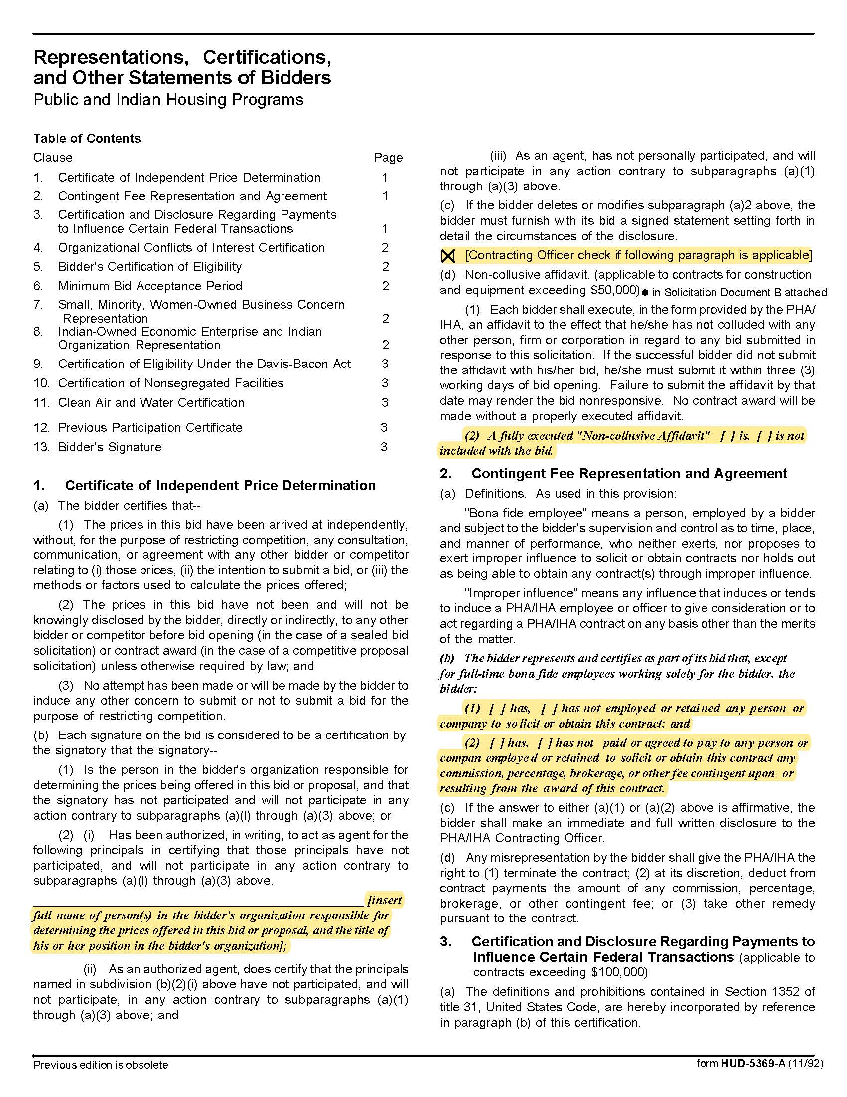

Renovations at Montgomery Village C19011

Solicitation Document C HUD Form 5369A-continued

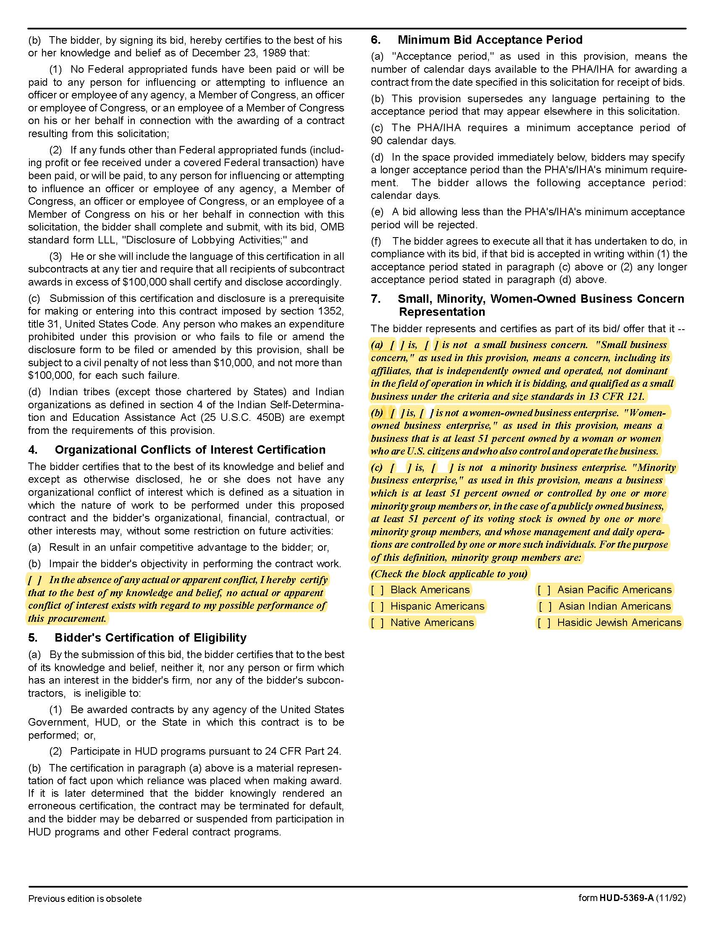

Renovations at Montgomery Village C19011

Solicitation Document C HUD Form 5369A-continued

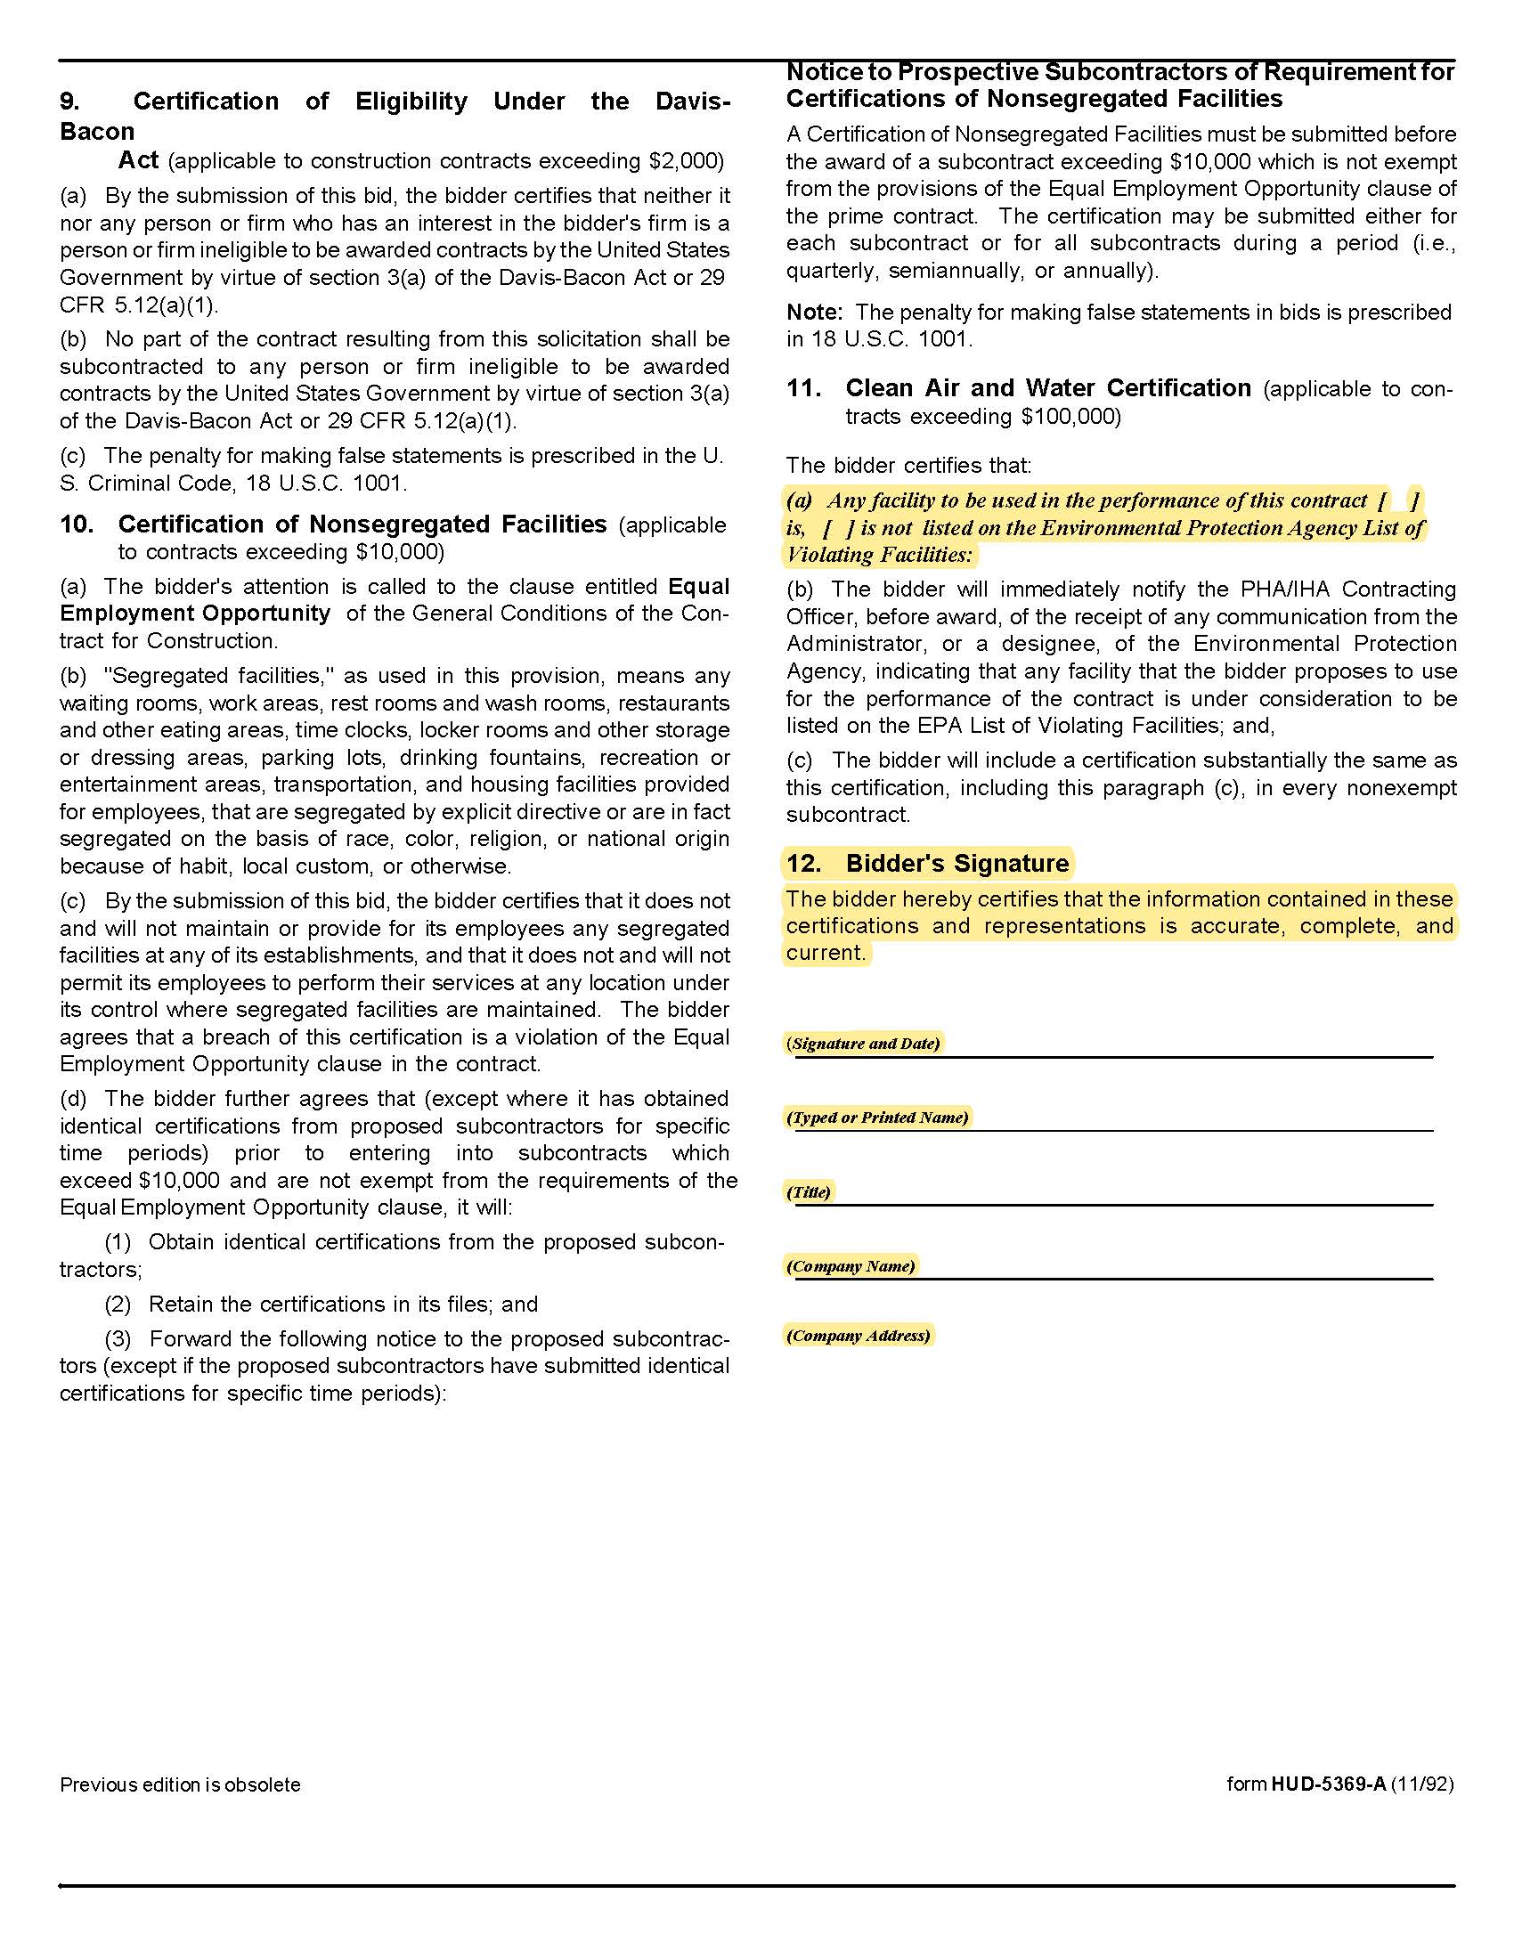

Renovations at Montgomery Village C19011

Solicitation Document D Good Faith Compliance Affidavit

The supplier must demonstrate a good faith effort to utilize Minority Owned Businesses (MOB) and Woman Owned Businesses (WOB). To assist in this effort, KCDC posts the web links of organizations, which can provide suppliers with a list of minority and women owned businesses on its web site. These lists can be useful to the supplier in preparing a response to this solicitation. Send this form with your bid.

Place a checkmark in either Section One or Section Two of this form. Provide the information in Section One if you check that box.

Section One ☐ The following companies were asked for pricing for the attached bid. Provided the listed companies meet bid document requirements and their pricing is competitive, it is our intent to use the companies listed. Attached hereto or to be provided to KCDC within five calendar days of solicitation opening is our Form of Commitment/Statement of Effort (failure to submit the Form of Commitment/Statement of Effort may be cause to reject the bid.)

Company Name | Person | Product/Service | MOB | WOB

Section Two ☐ MOB/WOB's were not contacted because sub-contractors will not be needed to complete the contract and all work will be completed by the supplier. Other MOB/WOB's not shown above, will be considered during the duration of the contract in the event the supplier decides additional subcontractors or supplier will be used (to complete all or part of the contract).

Signed by
Print Name and Title
Subscribed and Sworn to before me on this date
By
Notary Public (stamp/signature)
My Commission Expires on

Renovations at Montgomery Village C19011

Solicitation Document E Form of Commitment: Minority Owned Business/Woman Owned Business

This form may be supplied with the bid (preferred) or within 5 days after the due date.
Place a checkmark in either Section One or Section Two of this form.
Section One Does not apply - MOB/WOB subcontractors will not be used. ☐ (Stop Here)
Section Two MOB/WOB Subcontractors will be used. ☐ (Complete this page)

I, __________________________________________________ do certify the supplier has or will enter into a formal agreement with the MOB/WOB enterprise for work listed in this schedule.
Supplier Name | M  OB | W  O  B | Contact Person | Type of  Supplies to be Provided | Type of Work to be Performed | Dollar Value of Supplies or Service

COMPLETE THE FOLLOWING BOXES IF BOX ABOVE WAS NOT COMPLETED
The following companies were listed on the Good Faith Compliance Affidavit submitted with my bid.
Company Name | Person | Product/Service | MOB | WOB

Explain why each of the above companies could not be used to provide the needed products or services.
Company Name | Reason

Above information submitted by __________________________________________________________

Printed/Typed Name and Title: ___________________________________________________________

Solicitation Document F Envelope Coversheet

State Law requires certain supplier license information be on the front of your envelope. You are responsible for providing the correct information on the front of your envelope but KCDC provides this form as a guide to help you. Failure to supply such required information as invalidates your bid. Attach this completed page to the front of your bid envelope. Do not put it inside the envelope.

Bid Due Date/Time |  | 12- 20-18 at 2:00 p.m.

Supplier’s Name

State of Tennessee Supplier’s License Holder Name

State of Tennessee Supplier’s License Number

Pertinent State of Tennessee Supplier’s License Classification
State of Tennessee Supplier’s License Expiration Date
Subcontractors to be used on this project (If subcontract work is not required, write “none required”)
Electrical Subcontractor Name on the State of Tennessee’s Supplier’s License |  | State of Tennessee Supplier License Number
State of Tennessee Supplier License Classification(s) |  | Expiration Date of State Supplier’s License
HVAC Subcontractor Name on the State of Tennessee’s Supplier’s License |  | State of Tennessee Supplier License Number
State of Tennessee Supplier License Classification(s) |  | Expiration Date of State Supplier’s License
Masonry Subcontractor Name on the State of Tennessee’s Supplier’s License |  | State of Tennessee Supplier License Number
State of Tennessee Supplier License Classification(s) |  | Expiration Date of State Supplier’s License
Plumbing Subcontractor Name on the State of Tennessee’s Supplier’s License |  | State of Tennessee Supplier License Number
State of Tennessee Supplier License Classification(s) |  | Expiration Date of State Supplier’s License

Advisements:

1. KCDC will not consider notes changing the bid written on the bid envelope. Such notes must be
inside the envelope.

2. For the listed subcontractor types above, you may only list one firm.

