Request for Proposals

Solicitation Name and Number | Banking Services including Treasury Management and Portfolio Investment Services Q2015
Responses Must Arrive No Later Than (As KCDC’s clocks indicate) | 2:00 p.m. on April 3, 2020
Deliver Responses to: | Knoxville’s Community Development Corporation    Procurement Division  901 N. Broadway  Knoxville, TN 37917  Procurement is behind the main office building.
Electronic Copies | Electronic copies are available on KCDC’s webpage or by email at purchasinginfo@kcdc.org.
Responses must be Emailed to KCDC | ☒ Yes ☐ No
Printed Responses Required | ☒ Yes ☐ No
Number of Printed Copies Required | Six copies (unbound and three hole punched)
Solicitation Meeting | ☐ Yes ☒ No
Solicitation Meeting is Mandatory | ☐ Yes ☐ No ☒ Not Applicable
Solicitation Meeting Date and Time | Not Applicable
Solicitation Meeting Location | Not Applicable
Solicitation Meeting Connection | Not Applicable
Questions About This Solicitation | Submit questions to purchasinginfo@kcdc.org by 03-27-20  KCDC will not accept questions via telephone.
Award Results | KCDC posts the award decision to its web page at: http://www.kcdc.org/procurement/
Open Records/Public Access to Documents | All document provided to KCDC are subject to the Tennessee Open Meetings Act (TCA 8-44-101) and open records requirements.
Check KCDC’s webpage (https://www.kcdc.org/procurement/) for addenda and changes before submitting your response

General Information

1. Background and Intent

a. Knoxville's Community Development Corporation (KCDC) is the public housing and redevelopment agency for the City of Knoxville and for Knox County in Tennessee. KCDC’s affordable housing property portfolio includes 26 properties with approximately 3,489 dwelling units. KCDC also provides Section 8 rental assistance to approximately 4,064 households. Eight of the properties have transformed to the Project Based Rental Assistance program (PBRA) and are now owned by external limited partnerships. KCDC is the management company for those sites. The properties for which KCDC is the management company are Five Points 1, LP; Five Points 2, LP; Five Points 3 LP; Five Points 4 LP; Eastport Development LP; Lonsdale Homes, LP; Northridge Crossing, LP and The Vista at Summit Hill, LP. KCDC’s portfolio is subject to transitions, additions and deletions

b. KCDC is seeking proposals from qualified banks to provide banking services including treasury management services and portfolio investment services (optional) for the best value. The best value includes the cost and quality of service as detailed within this RFP. Banks must be qualified Federal Reserve member banks or State of Tennessee charter banks providing local over-the-counter service in Knoxville Tennessee.

c. KCDC reserves the right to issue multiple awards if deemed to be in its best interest.

2. Breach of Contract
If the supplier fails to fulfill its obligations under this contract in a timely and proper manner, or if it shall violate any of the terms of the resulting contract, KCDC has the right to immediately terminate the contract and withhold payments in excess of fair compensation for work completed. The term “breach of agreement” specifically includes, but is not limited to, failure to comply with any applicable federal, state, or local laws or regulations. Notwithstanding the above, the bank shall not be relieved of liability to KCDC for damages sustained by virtue of any breach by the bank.

3. Changes after Award
It is possible that after award KCDC will need to revise the service needs or requirements specified in this document. KCDC reserves the right to make such changes after consultation with the supplier. Should additional costs arise, the supplier must document increased costs. KCDC reserves the right to accept or reject and negotiate these charges.

4. Computers
KCDC currently operates with Intel i5 or above CPUs running Windows 10 8GB RAM, 500GB SSD, integrated 1000Mbps Ethernet.

5. Contact Policy
Only contact KCDC’s Procurement Division about this solicitation from the issuance of this RFP until its award. Information obtained any other person will not affect the risks or obligations assumed by the supplier or relieve the supplier from fulfilling any of the conditions of the resulting award. Such contact can disqualify the supplier from the solicitation process.

6. Contract Length
KCDC intends to for a three-year period beginning on or about July 1, 2020, with two optional one-year extensions for a total of five years.

7. Evaluation
a. KCDC alone determines (using NIGP’s definition and other relevant sources as appropriate) the supplier’s “responsive” and “responsible” status prior to award. Responsible means a business with the financial and technical capacity to perform the requirements of the solicitation and subsequent contract. A responsive bid/proposal is one that fully conforms in all material respects to the solicitation document and all of its requirements, including all form and substance.

b. KCDC will review all proposals and reserves the right to request necessary modifications, waive minor technicalities, reject all proposals, reject any proposal that does not meet mandatory requirement(s) or cancel this RFP, according to KCDC’s best interests.

c. KCDC’s Evaluation Team may elect to interview one or more suppliers before making an award.
Interviews may include an in-person examination of the proposed product. KCDC shall not reimburse the supplier for the costs associated with the interview process nor for the cost of preparing a proposal.

d. KCDC’s Evaluation Team may elect to first rank proposals with a simple numeric score and then detail score only the top tier of proposals.

e. KCDC evaluates responses on a weighted evaluation system. The categories and points assigned for each category are below. Details of each factor are provided later in this document.

Banking and Treasury Management Factors | Maximum Points
Capabilities to provide comprehensive services & understand KCDC’s needs | 40
Cost of Services | 30
Customer Service/Responsiveness | 30
Total | 100

Portfolio Investment Services Factors | Maximum Points
Capabilities to provide comprehensive services & understand KCDC’s needs | 50
Cost of Services | 25
Customer Service/Responsiveness | 25
Total Points Possible | 100

f. KCDC reserves the right to request additional information from any bank after the submission deadline. KCDC also reserves the right to reject any and all, or part(s) of any and all proposals, to select one or more banks, or to award no contract and re-advertise this RFP; postpone or cancel the RFP process at any time, and to waive any irregularities in this RFP or in proposals received as a result of this RFP.

g. All materials submitted pursuant to this RFP become KCDC’s property. Information about proposals which are submitted will not be released to anyone until the process is complete and a recommendation is ready for the KCDC Board. Members of the evaluation team will share information only with authorized individuals within the Agency.

h. KCDC reserves the right to use all pertinent information (also learned from sources other than disclosed in the RFP process) that affect KCDC’s judgment as to the appropriateness of an award to the best-evaluated supplier.

8. General Instructions
KCDC does not insert “General Instructions to Suppliers” in solicitation documents. These instructions are at www.kcdc.org. Click on “Procurement” and the link to the instructions. The supplier’s submittal means acceptance of the terms and conditions set forth in KCDC’s “General Instructions to Suppliers.”

These paragraphs in the “General Instructions” document do not apply to this solicitation: None

9. Insurance
The bank agrees to maintain at its sole expense during the term of this resulting contract insurance coverages and limits in accordance with the bank’s standard business practices and acceptable to KCDC. Coverage must include Banker’s Professional Liability insurance or equivalent and Banker’s Blanket Bond insurance. Upon request, the bank shall provide KCDC with Certificates of Insurance evidencing such insurance.

10. KCDC’s Audited Financial Statements
Suppliers should familiarize themselves with relevant information contained in KCDC’s Audited Financial Statements. These statements are available on KCDC’s website at www.kcdc.org.

11. Licensure
The supplier is responsible for complying with all licensing requirements and associated business regulations whether local, state or federal. It is the responsibility of the proposing bank to determine the applicability of any rule(s), regulation(s) or other requirement(s).

12. Ownership
All data prepared or obtained under the resulting contract shall be made available, upon request, to KCDC without restriction or limitation on their use. All files, images, records, et cetera shall be KCDC’s exclusive property.

13. Personnel
The supplier represents that it has or will secure at its own expense, all personnel required to perform the services under the resulting contract. Such personnel shall not be employees of or have any contractual relationship with KCDC.

14. Price Structure
The costs for services methodology are to remain fixed for the contract period unless a tiered approach to pricing is suggested by the supplier and KCDC accepts such pricing structure. Comparable services as a result of systems upgrades or bank mergers shall not cause an increase in pricing.

15. Professional Standards
The bank shall maintain books, records, documents and other evidence directly pertinent to performance of work under the resulting contract in accordance with accepted professional practice and appropriate accounting procedures and practices. Audits conducted pursuant to this provision shall be in accordance with generally accepted auditing standards and formally established audit regulations, procedures and guidelines of the reviewing or audit agency.

16. Proximity
The bank must have a branch capable of servicing KCDC within ten miles of KCDC’s Main Office at 901 N. Broadway in Knoxville, Tennessee, 37917.

17. Requirements/Qualifications Of Suppliers
Before a proposal is considered for award, the supplier must meet and provide evidence of qualification under all of the selected financial criteria outlined below. The supplier must:

a. Be insured by the Federal Deposit Insurance Corporation (FDIC) or National Credit Union Share Insurance Fund (NCUSIF).

b. Warrant that it is in compliance with the Community Reinvestment Act of 1977 and any amendments.

c. Be a banking corporation (or syndicate of banking corporations) incorporated under the laws of the State of Tennessee or of the United States of America.

18. Schedule
KCDC anticipates the following schedule for procuring the services outlined in this RFP:

March 27, 2020 | Last day to pose questions regarding the RFP
April 3, 2020 | Proposal due by 2:00 p.m.
April 30, 2020 | KCDC’s Board of Commissioners approves the contract
May 15, 2020 | Transition begins
July 1, 2020 | New service begins

19. Service Charges and Fees
In accordance with customary banking collection procedures, KCDC will allow drafts of service charges and fees from respective bank accounts. KCDC also desires a consolidated monthly summary of all charges to all accounts available within five business days of month-end.

20. Waiver
Waiver of any provision of the resulting contract shall not affect KCDC’s right of KCDC thereafter to enforce such provision or to exercise any right or remedy available to it in the event of any other default.

Scope of Work and KCDC Information

21. Cash Accounts
KCDC maintains approximately 65 cash accounts which are included in the scope of this RFP. These accounts fall under several different entities, all owned or managed by KCDC. Nineteen of these accounts are zero-balance accounts which participate in a master revolving fund account described below. Exhibit 1 provides details of these accounts. For proposal purposes, respondents must use the data provided in these attachments as the basis for responses and quotes. Subsequent data will not be provided.

b. Master Revolving Fund
The Revolving Fund account receives over-the-counter deposits (cash, checks and money orders), wire transfers, ACH transactions and intra-bank transfers and disburses payments (checks, wire transfers, and ACH transactions). The Revolving Fund account is the parent account for nine zero-balance accounts (ZBA) which are part of the Agency’s 65 accounts referred to above. A summary of the Revolving Fund account analysis for November 2019 is provided as part of Attachment 2. Currently the revolving fund account automatically funds the other ZBA Accounts, and all ZBA bank analysis fees are directly charged to the revolving fund. The average revolving fund balance in FY 2019 was $20,600,000. Note: Balances are given as a reference point only. KCDC does not guarantee future balances.

KCDC is a public entity with both a responsibility to the public and a requirement from federal grantors to maintain maximum yields from its cash and investments. Currently the master revolving fund settles account analysis charges by an offset to interest earned on deposits. KCDC no longer favors this rationale, and requests that costs of account maintenance and professional services be assessed independently of all interest earnings.

In that same regard, KCDC is seeking cash management services to ensure that the average balance in the master revolving fund is either:

- Maintained at a minimal level, or
- Yields an acceptable formula-driven rate of return on the average balance each month.

c. As business needs and best practices evolve, KCDC will open additional accounts and close accounts
during the contract period. Pricing for additional accounts and products must remain consistent throughout the proposed contract period.

22. Portfolio Investment Account
a. KCDC also seeks portfolio investment services which include a designated account manager who will provide investing strategies (through a financial institution) that meet HUD’s guidelines as prescribed in Exhibit IV (HUD’s Financial Management Handbook 7475.1 REV Part 4-5 through 4-8) Please see https://www.fdic.gov/deposit/deposits/brochures/deposit-insurance-at-a-glance-english.html and refer to it where applicable in conjunction with the HUD Handbook in this document. The KCDC investment portfolio was valued at approximately $15,800,000 on December 31, 2019.

b. The average value for the 12 months ended December 31, 2019 was $20,600,000. Month-end investment balances in CY 2019 ranged from $15,800,000 to $24,000,000. Additional investment portfolio information can be found in KCDC’s annual audited financial statements at KCDC.org. Note that these balances are provided as a reference point only. KCDC does not guarantee these amounts for the future.

c. There is also potential for a separate future investment of non-HUD funds which are not required to meet HUD’s financial management handbook guidance but to meet Tennessee Public Funds guidance at Tennessee Code Annotated Title 9 Chapter 4.

23. Collateralization
a. KCDC requires their contracted banking and investment services providers to continuously and fully (100%) secure ALL cash and investment assets of the Agency in accordance with Agency policy, which mirrors HUD’s General Depository Agreement.

b. The General Depository Agreement (Form HUD-51999) and Amendment must be executed between KCDC and the Depository. A copy of the executed Agreement and Amendment will be sent to HUD. Please refer to Exhibit 4 for the General Depository Agreement and Amendment form. This requirement applies to HUD federal funds only. KCDC will guide the selected firm as to which funds this applies.

c. The General Depository Agreement provides an exception for those institutions which are members of the state collateral pool. The supplier shall indicate in the proposal if the institution participates in the state pool and must remain an active member during the entire contract period in order to be eligible for the exception.

24. Maximization of Earnings on Cash and Investments
KCDC is obligated by public trust and federal regulation to maximize its earnings on all financial assets to the greatest extent practicable within the confines of the General Depository Agreement. HUD’s Financial Management Handbook (applicable only to federal funds provided through HUD), 7475.1 REV requires KCDC to invest idle funds in HUD-approved investments. KCDC is required to choose from the list of approved financial instruments. HUD determines investment types by considering such factors as safety, yield, liquidity, maturity, amount and administrative cost. Attached in Exhibit V is part 4-3 thru 4-8 of the HUD Financial Management handbook 7475.1 REV.

a. Investment Objectives included in HUD’s Financial Management Handbook applicable to the investment of HUD federal funds include:

1. Understanding the suitability of the investment to KCDC’s financial requirements and/or those of KCDC’s Board.

2. Preservation and safety of principal—Safety is achieved through adherence to the list of permitted investments which are backed by the full faith and credit of, or a guarantee of principal and interest by, the U.S. Government, a government agency or issued by a government-sponsored agency, coupled with an appropriate maturity date.

3. Liquidity—All investments must be capable of being liquidated on one day’s notice. Therefore, no investments may be made which impose a longer notice period for redemption or which are not readily marketable.

4. Marketability of the investment if the investment needs to be liquidated before maturity—Sale of securities prior to maturity should be avoided due to the inherent risk. (If the market interest rate increases above the yield on the investment, the market value of the securities will decline.)

KCDC may invest in securities up to three years for the investment of operating reserves.

5. Diversification of the investment portfolio.

6. Yield--The highest yield consistent with the other factors of the investment policy. Tax-exempt securities are not appropriate for investment by KCDC because it would not benefit from a tax advantage.

b. GAAP requires KCDC to book amortized cost of investments. At a minimum, KCDC requires the receipt of monthly investment portfolio statements which include the adjusted cost basis of each investment and the FMV of each investment at that point in time in order to meet this requirement.

25. Additional Services
Although not required, a bank may provide information on any other services that might be beneficial and cost-effective to KCDC in improving operational cash management or investment management efficiencies (i.e. purchasing cards, controlled disbursement, safekeeping, account reconciliation and electronic payments (a listing of fees is required for any additional service). Throughout the contract period KCDC may elect to add such services and products. Costs of such services and products shall be negotiated when selected.

26. Checks
KCDC minimizes the use of physical checks to the greatest extent practicable. Most of KCDC’s disbursements are by direct deposit or other ACH forms. Currently KCDC uses three-part checks for payables (two stubs and an actual check) that comply with the necessary layout required for our software system (Elite by Emphasys). KCDC’s disbursement software is subject to change at any time throughout the contract term. In fact, KCDC anticipates issuing a RFP for new software in March 2020.

27. Costs of Products, Services and Equipment
All banking costs must be charged by the bank with full transparency. For cost proposal purposes, the netting of interest revenue against fees for services (account maintenance fees, transaction fees, relationship/customer services fees, advisement services fees, etc.) is not acceptable.

28. Customer Service
KCDC requires a high level of customer service from the successful bank. Among other standard customer service items, KCDC is seeking a bank that will:

a. Designate specific managers who will be sources of immediate contact for both problem resolution and decision-making.
b. Furnish research items within 24 hours.

c. Conduct a quarterly review of services provided and make suggestions for other cost-effective services that may be of benefit to KCDC.

d. Respond to any inquiries by KCDC no later than the next business day.

e. Work with KCDC staff to identify and implement efficiencies and best practices.

29. Deposits
Currently funds are deposited into KCDC accounts in four ways:

a. Physical deposits of checks, money orders and cash (cash is minimal).

b. Funds are wired through the Automated Clearing House or by electronic funds transfer by the federal or state governments or by other banks.

c. Automatic draft.

d. Credit and debit card payments processed by a 3rd party

KCDC management is currently exploring options for increased economies and efficiencies in the collections process including alternatives such as lockbox collections and remote depositing from property management offices. Respondents should propose from the current physical deposits standpoint and from an assumed standpoint that KCDC will migrate to remote depositing in the near future.

30. Disaster Recovery
The bank must have a disaster recovery plan in place which addresses an Emergency Response Notification Process and an Operation Plan.

31. Future Service Needs
The supplier may also provide information on other available features and services which may enhance KCDC’s operational efficiency. Such information may include lockbox processing, rent collections through EBT, debit and credit cards, disbursement processing systems, etc.

32. Imaging and Data Storage/Retention
Data, including images of deposit items, should be maintained for immediate retrieval for 18 months. Data should be retrievable for up to ten years upon request to the designated customer service representative.

33. KCDC Contacts and Authorized Personnel
The following persons/or their designees shall be the authorizing contacts for KCDC. Only these individuals may request services from the selected supplier (or the supplier’s designees).
- Executive Director/CEO Ben Bentley
- Chief Financial Officer Tracee Pross
- Deputy Director of Finance & Administration Jim Barker
34. Notice of Changes
The bank must provide at least thirty days written notice of changes in its procedures.

35. On-Line Services

a. Electronic transmission to/from a KCDC personal computer, by electronic mail, Internet access, or notification of download availability of the following items is required (all transactions shall be “same day”):
1. Daily reports on balances in each account.
2. Daily debit/credit transactions for each account.
3. Inquiry of status of checks.
4. Stop payment processing.
5. Transfer of funds between agency accounts.
6. Transfer of funds to other institutions.
7. ACH transactions (Originator/receiver of ACH credits/debits)—Acknowledgment by e-mail of all transfers on the date received. The remitter must supply an advice narrative no later than the next business day.
8. Wire Transfers—repetitive and non-repetitive with confirmation.
9. Ability to import Payroll and Section 8 information into supplier’s banking system.
10. Ability to make ACH vendor payments.
11. Bank Statements, investment statements, account analysis statements and any other routine
statement shall be received electronically. Any hard-copy statements will be requested by KCDC as the need arises.
12. Same Day, Prior Day, Multiple Day, historical data files, etc. must be available for easy retrieval
on-line, covering at least the previous 18 months.

Note: All data should be downloadable to Excel in a worksheet format. A pdf file converted to Excel is
often insufficient as an Excel worksheet.

36. Revolving Fund Balance Earnings Methodology
As discussed in item 24 above, KCDC must maximize its return on funds on deposit. Respondents may propose based upon one of the following scenarios:

a. All of the zero-balance accounts shall be tied to the Unlimited Revolving Fund Account, which may be tied to the most advantageous Public Fund account, with a prescribed interest calculation formula, 100% collateralized with HUD-approved instruments.

b. An overnight sweep may be proposed. The bank will automatically invest any excess cash balances remaining in the concentration account.

The bank will automatically handle this overnight and weekend short-term investment activity through the use of repurchase agreements as defined in Exhibit V (HUD’s Financial Management Handbook 7475.1 Rev. 4-8, Section K).

Please note required certifications for the use of repurchase agreements. Any withholding requirements, how the amount to be invested is determined (include compensating balance calculation) and interest rate must be provided.

c. An alternate scenario of the respondent’s choosing, which is deemed more advantageous to KCDC than scenarios a or b. Full cost transparency is required. KCDC will not consider scenarios which net banking fees against interest earnings.

37. Purchasing (P-Cards)
a. KCDC uses P-Cards for approximately twelve members of its staff for various purchases. In the fiscal year ended June 30, 2019, KCDC expended $1,017,693 through 1,492 P-Card transactions. In the 7-month period ended January, KCDC expended $516,085 through 746 P-Card transactions.

b. Supplier’s P-Card system should include user management and administration capabilities including documentation attachments, GL code assignments, split code assignments, bulk download of documentation, approval workflows and online access to multiple types and ranges of data downloadable into Excel. Data retention of up to seven years is desired.

c. Suppliers are encouraged to supply information about their P-Card offerings for KCDC’s review and consideration. KCDC may or may not elect to pursue such offerings.

38. Returned Items
The bank shall automatically debit or credit the applicable account for all items returned. Each check or substitute check shall have a debit advice attached and shall be returned via e-mail notification with originals being mailed to KCDC within ten days. All notice of changes and return ACH transactions shall be reported on a daily basis via e-mail notification. Deposited checks or ACH transactions are returned for insufficient funds about twenty times per month (5 for returned checks/money orders and 15 for ACH returns).

39. Statements
a. Bank statements shall be delivered via email for automatic download within three business days after the end of each month. Earnings interest credit information should be clearly defined and included on the statement.

b. The monthly account analysis statements shall be delivered via email or be available for download no later than the 10th day of the month. The statements should include activity and charges for all accounts listing items charged, unit cost, and extended price. The statements should be clearly defined and easy to understand. Float information for all deposits in the cash concentration account should be included.

40. Transition
It is important that the bank properly handle the transition process, if applicable. The key contact person and staff for each service shall meet with KCDC officials immediately after the contract has been executed for a project kickoff meeting at which time the transition planning shall begin. In addition, the bank’s key contacts and staff shall be available for other meetings as required by KCDC.

a. The successor bank shall provide a list of any documents, files or information it shall need from the current bank in order to have a fluid transition.

b. The successor bank shall be responsible for bearing all transition costs that may occur as a result of, including but not limited to, the conversion of existing documents, loading of files, et cetera.

c. At the termination of any contract resulting from this RFP, the bank shall work with KCDC and the new banking services provider. The bank shall provide any requested files, reports or documents within one week.

d. In the section KCDC’s Mandatory Response Structure for Suppliers proposers will provide details of accounts transition to include, but not be limited to, anticipated length of the transition, other expectations with regard to required timing from financial institution, any issues foreseen with the proposed timing and whether or not KCDC’s timeline is overly aggressive.

41. Business Relationship
KCDC is seeking a banking relationship which will augment KCDC’s mission which includes efficient and cost-effective operations. KCDC expects to continue growing and evolving in the affordable housing industry, and does not expect that its business model at the end of this contract period will be the same as it is today. Respondents to this RFP must understand that, and be committed to working with KCDC for continual improvement in areas of efficiency and cost effectiveness and support of the public trust.

42. Security Systems and Protocols
KCDC requires that its data is safeguarded in accordance with industry best practices. At the same time, KCDC expects minimal impact on information retrieval process times and transaction processing times as a result of safeguard measures. Each respondent should provide details of its security systems, authentication process and product, and its impact on KCDC’s banking system utilization. In addition, details regarding passwords, PINs, random number fobs, etc. should be provided. It is expected that no KCDC employee would be required to use multiple logins, passwords, PINs or fobs.

43. Support of Affordable Housing Initiatives in Metro Knoxville
Suppliers should comment on their ability to support Knoxville’s “affordable housing initiatives.” Narratives should include any debt and equity funding options for affordable housing developments. Community Investment Tax Credit (CITC) debt option is desirable and should be included in the narrative if applicable. Please provide information regarding services and opportunities targeting low-income and affordable housing populations and support given to local non-profit agencies serving specific needs of these populations.

44. Support for Low-Income Residents in Metro Knoxville
Suppliers should provide details of free account options, financial counseling services, first time homebuyer, down payment assistance, and any other programs or services that may be provided to KCDC’s resident population.

45. Contract Retainage Escrow Accounts
KCDC’s construction-type activities require retainage escrow accounts to be established and maintained in accordance with Tennessee statute.
This type of account would require the bank to perform fiduciary monitoring of the accounts as well as the release of funds from the accounts. As of January 31, 2020, KCDC had 8 such accounts with balances ranging $13,000 to $265,000

Submittal Instructions

Submit your information in the order indicated below. General submittal notes:

a. Proposals must be submitted in MS Word format and not handwritten. An Excel computation worksheet is also required.

b. Place your company’s name on each page and number all pages consecutively.

c. Do not use phrases such as “See the attached” or “Will be provided upon award.”

d. Submit one original (with all pages marked “original”), six printed copies and one electronic copy (email or flash drive ) of your submittal.

KCDC’s Mandatory Response Structure for Suppliers to Follow:

SECTION 1 – KCDC FORMS

A. KCDC’s General Response Section form
B. KCDC’s Affidavit form
C. KCDC’s HUD Form 5369A

SECTION 2 - GENERAL INFORMATION

D. Transmittal Letter (1 page)
E. Section I: General Information
1. Supplier Data (1 page)
a. Supplier
  - Bank Name
  - Address
  - Web site
b. Primary contact
- Phone number
- E-mail address
c. Secondary contact
- Phone number
- E-mail address
2. Supplier Bank Profile (3 pages maximum)
a. Headquarters
b. History & ownership
c. Safe and Sound Rating (BestRate)
d. Service to Metro Knoxville
e. Service to East Tennessee governments
f. Service to East Tennessee PHAs and affordable housing entities
g. Knoxville/Knox County community involvement/give-back
h. Local participation in expansion and rehabilitation of affordable housing stock
3. Transition Plan
a. Provide details of the accounts transition to include but not be limited to:
- Anticipated length of the transition
- Other expectations with regard to required timing milestones
- Any typical issues foreseen with transitions and their timing
- Whether or not KCDC’s timeline is overly aggressive

SECTION 3 - BANKING AND TREASURY MANAGEMENT SERVICES

F. Capabilities to Provide Comprehensive Services to KCDC (10 pages maximum)
1. Insurance coverage (see paragraph 9)
2. Security
a. Cyber-security
b. Authentication process
c. Protection from data loss
d. Encryption requirements
e. Disaster Recovery
3. Data access
4. Data availability online
5. Data retention periods
6. Access to archived data
7. Desktop/handheld device use
8. Electronic banking
a. ACH transactions, Wires, Transfers, Approvals to include same-day, repetitive, return and reversal capabilities
b. Desktop remote depositing
c. Data access, download, format, flexibility, Real-time
d. P-Card program overview
e. Handheld device transactions and approvals
f. Daily transaction cutoff times to include deposits, ACH, and wires
g. Online training
h. Check returns, adjustments, and stop payment access and capabilities
i. Existing report capabilities
j. Brief summary of major upgrades within the last 3 years and any 2020 plans
k Down time average
9. Interest computation methodology on funds on deposit including any withholding requirement
and any minimum interest rate threshold and suggested account type
10. Collateralization assurances
11. Master revolving fund, zero balance accounts
12. End-of-month cutoff date, statement and account analysis availability
13. Affordable Housing Debt and Equity Options (include brief details of 3 comparable agency deal
examples within the last year if applicable).
14. Resident population program and service options to include any free accounts and financial
counseling services.

G. Cost of Services Estimate Summary for one-year period (1 page)
Estimates must be supported by the Excel worksheet (see KCDC’s Webpage). Per unit costs shall be fixed for the term of the contract period. Volume is variable. Interest earnings may not offset costs of service.

1. Revolving Fund and related ZBA accounts $_______________
2. Other accounts (in total) $_______________
3. Start-up costs $_______________
4. Treasury management and other services not included above $_______________
5. Total Estimated Annual Cost $_______________

H. Customer Service/Responsiveness (5 pages maximum)

1. Service Team Tentatively Assigned to KCDC – List Three Reps
a. Name
b. Title
c. Office base
d. Area of expertise
e. Experience
f. Role
g. Availability

2. Customer service commitment statement
3. Factors which make your bank a good fit for KCDC
4. Turn-around time on calls and requests
5. Brief implementation timeline, if applicable
6. Customer service awards & recognition (not required)
7. Recommendations (not required)

I. SECTION IV - PORTFOLIO INVESTMENT SERVICES -- OPTIONAL (10 pages maximum)

1. Bank capacity to provide comprehensive investment services
a. Investment Service Profile
b. Investment strategies
c. Compliance with KCDC investment policy
d. Collateralization of investment funds
e. Online system capabilities to include data access, reporting options and data retention
f. Capability to provide required market value and adjusted cost basis of each security
instrument.

2. Fees and rate structure (USE KCDC’s EXCEL SHEET POSTED TO ITS WEBPAGE)

3. Customer Service/Responsiveness
a. Representatives tentatively assigned to KCDC
1. Name
2. Title
3. Office base
4. Experience
5. Responsiveness

j. SECTION V - SUPPLEMENTAL INFORMATION (10 pages maximum)
1. Cost estimate detail worksheet
2. Other supplemental materials

Note: All evaluation criteria must be contained in the mandatory sections of the proposal.

This and the Previous Pages Do Not Need to be Returned

Treasury Management and Investment Services Q2015

Solicitation Document A General Response Section

General Information about the Supplier
Sign Your Name to the Right of the Arrow
Your signature indicates you read and agree to “KCDC’s General Instructions to Suppliers” (www.kcdc.org) and that you are authorized to bind the supplier or are submitting the response on behalf of and at the direction of the suppliers’ representative authorized to contractually bind the supplier. I represent that the supplier or its applicable representative(s) has reviewed the information contained in this Solicitation Package and that the information submitted is accurate.
Printed Name and Title
Company Name
Street Address
City/State/Zip
Contact Person (Please Print Clearly)
Telephone Number
Cell Number
Supplier’s E-Mail Address (Please Print Clearly)
Addenda
Addenda are at www.kcdc.org. Click on “Procurement” and then on “Open Solicitations” to find addenda. Please check for addenda prior to submitting a proposal.
Acknowledge addenda have been issued by checking below as appropriate:
None ☐ | Addendum 1 ☐ |  |  | Addendum 2 ☐ |  | Addendum 3 ☐ |  |  | Addendum 4 ☐ | Addendum 5 ☐
Statistical Information (Check all the apply)
This business is at least 51% owned and operated by a woman |  |  |  |  |  |  |  |  |  |  | Yes ☐ No ☐
This business qualifies as a small business by the State of Tennessee  Total gross receipts of not more than $10,000,000 average over a three-year period OR employs no more than 99 persons on a full-time basis |  |  |  |  |  |  |  |  |  |  | Yes ☐ No ☐
This business qualifies as Section 3 business (as defined by HUD):  It is at least 51% owned by a Section 3 resident (lives in Public Housing) or it employs Section 3 residents for at least 30% of its employee base; or it commits to subcontract at least 25% of the project’s dollars to a Section 3 business. |  |  |  |  |  |  |  |  |  |  | Yes ☐ No ☐
This business is owned & operated by persons at least 51% of the following ethnic background:
Asian/Pacific ☐ |  | Black ☐ | Hasidic Jew ☐ |  | Hispanic ☐ |  |  | Native Americans ☐ |  |  | White ☐
Cooperative Procurement
Subject to additional location/delivery charges, the supplier agrees to extend the offered costs to other governments if the government so desires. Yes ☐ No ☐
Prompt Payment Discount
A prompt payment discount of ________% is offered for payment within ____ days of submission of an accurate and proper invoice.

Treasury Management and Investment Services Q2015

Solicitation Document B Affidavits

Supplier: _____________________________________________________________________________

Conflict of Interest:
1. No commissioner or officer of KCDC or other person whose duty it is to vote for, let out, overlook or in any manner superintend any of the work for KCDC has a direct interest in the award or the supplier providing goods or services.

2. No employee, officer or agent of the grantee or sub-grantee will participate in selection, or in the award or administration of an award supported by Federal funds if a conflict of interest, real or apparent, would be involved. Such a conflict would arise when the employee, officer or agent, any member of his immediate family, his or her partner, or an organization, which employs, or is about to employ, any of the above, has a financial or other interest in the supplier selected for award.

3. The grantee's or sub-grantee's officers, employees or agents will neither solicit nor accept gratuities, favors or anything of monetary value from suppliers, potential suppliers or parties to sub-agreements.

4. By submission of this form, the supplier is certifying that no conflicts of interest exist.

Drug Free Workplace Requirements:
5. Private employers with five or more employees desiring to contract for construction services attest that they have a drug free workplace program in effect in accordance with TCA 50-9-112.

Eligibility:
6. The supplier is eligible for employment on public contracts because no convictions or guilty pleas or pleas of nolo contender to violations of the Sherman Anti-Trust Act, mail fraud or state criminal violations with an award from the State of Tennessee or any political subdivision thereof have occurred.

General:
7. Supplier fully understands the preparation and contents of the attached offer and of all pertinent circumstances respecting such offer.

8. Such offer is genuine and is not a sham offer.

Iran Divestment Act:
9. Concerning the Iran Divestment Act (TCA 12-12-101 et seq.), by submission of this bid/quote/proposal, each supplier and each person signing on behalf of any supplier certifies, and in the case of a joint bid/quote/proposal, each party thereto certifies as to its own organization, under penalty of perjury, that to the best of its knowledge and belief that each supplier is not on the list created pursuant to § 12-12-106.

Treasury Management and Investment Services Q2015

Solicitation Document B Affidavits - continued

Non-Collusion:
10. Neither the said supplier nor any of its officers, partners, owners, agents, representatives, employees or parties interest, including this affiant, has in any way colluded conspired, connived or agreed, directly or indirectly, with any other responder, supplier, or person to submit a collusive or sham offer in connection with the award or agreement for which the attached offer has been submitted or to refrain from making an offer in connection with such award or agreement, or collusion or communication or conference with any other supplier, or, to fix any overhead, profit, or cost element of the offer price or the offer price of any other supplier, or to secure through any collusion, conspiracy, connivance, or unlawful agreement any advantage against KCDC or any person interested in the proposed award or agreement.

11. The price or prices quoted in the attached offer are fair, proper and not tainted by any collusion, conspiracy, connivance, or unlawful agreement on the part of the supplier or any of its agents, representatives, owners, employees, or parties in interest, including this affiant.

Accuracy of Electronic Copies:
12. If the supplier provides electronic copies of the bid/proposal/quote to KCDC, the supplier certifies that the information provided on paper and in the electronic format is identical unless specifically noted otherwise.
No Contact/No Advocacy Affidavit
13. After this solicitation is issued, any contact initiated by any supplier with any KCDC representative concerning this proposal is strictly prohibited-except for communication with the Procurement Division. My signature signifies that no unauthorized contact occurred.

14. To ensure the integrity of the review and evaluation process, respondents to this solicitation nor any firm representing them, may not lobby or advocate to KCDC staff or Board members. My signature signifies that no unauthorized advocacy occurred.

The undersigned hereby acknowledges receipt of these affidavits and certifies that the submittal in response to this solicitation is in full compliance with the listed requirements.

Signed by
Printed Name
Title
Subscribed and sworn to before me this date
By (Notary Public)
My Commission Expires on
Notary Stamp

Treasury Management and Investment Services Q2015
Solicitation Document C HUD Form 5369A
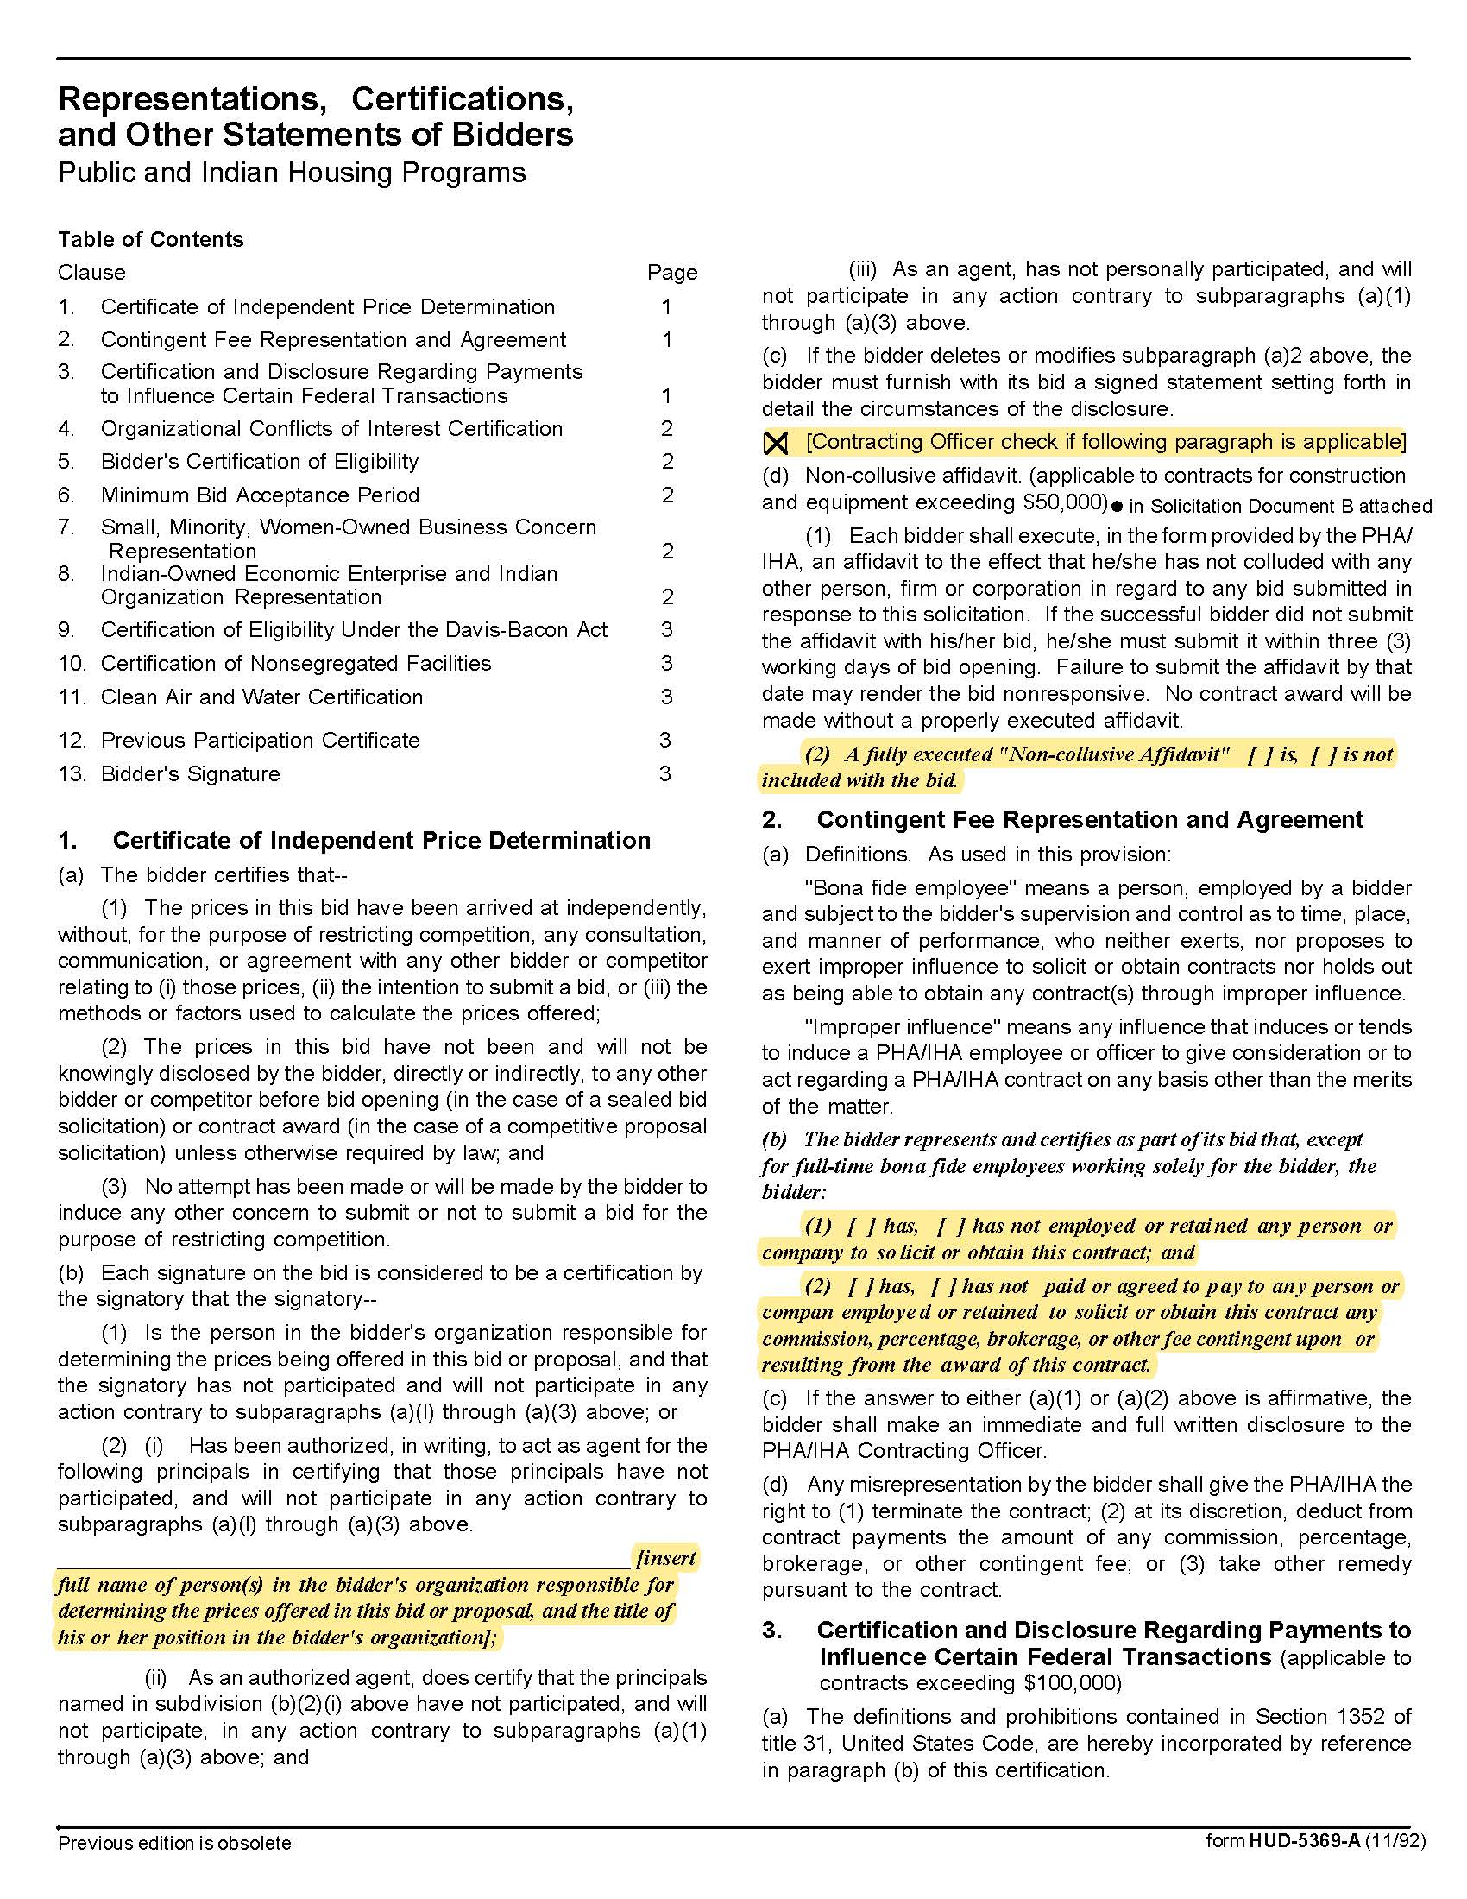

Treasury Management and Investment Services Q2015
Solicitation Document C HUD Form 5369A - Continued
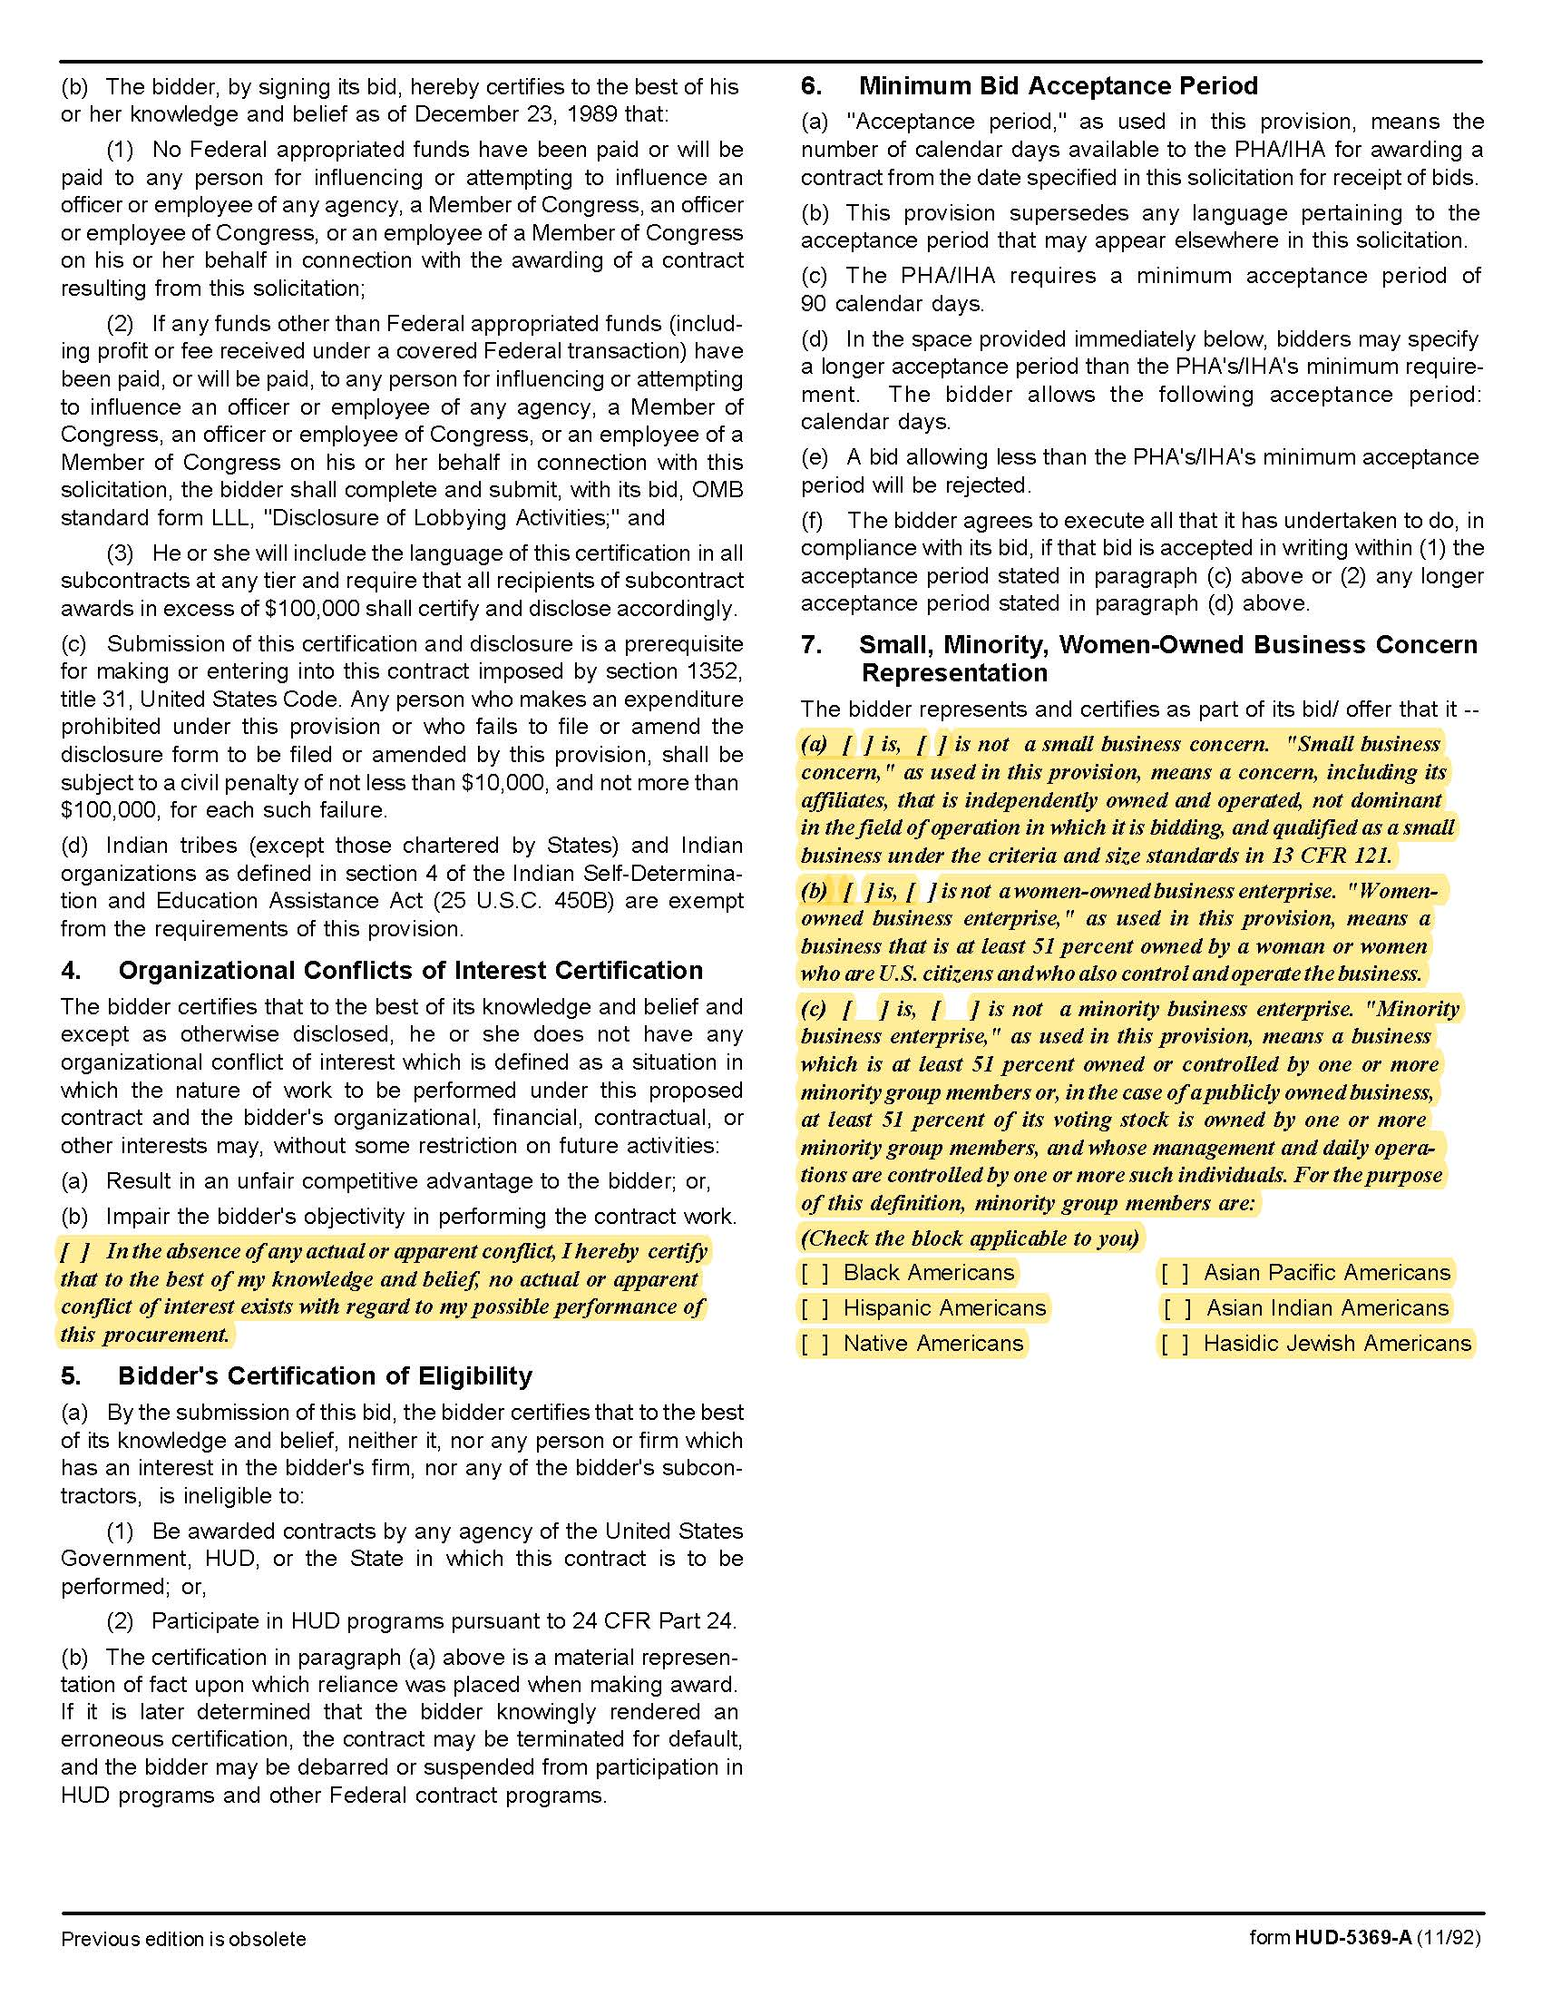

Treasury Management and Investment Services Q2015
Solicitation Document C HUD Form 5369A - Continued
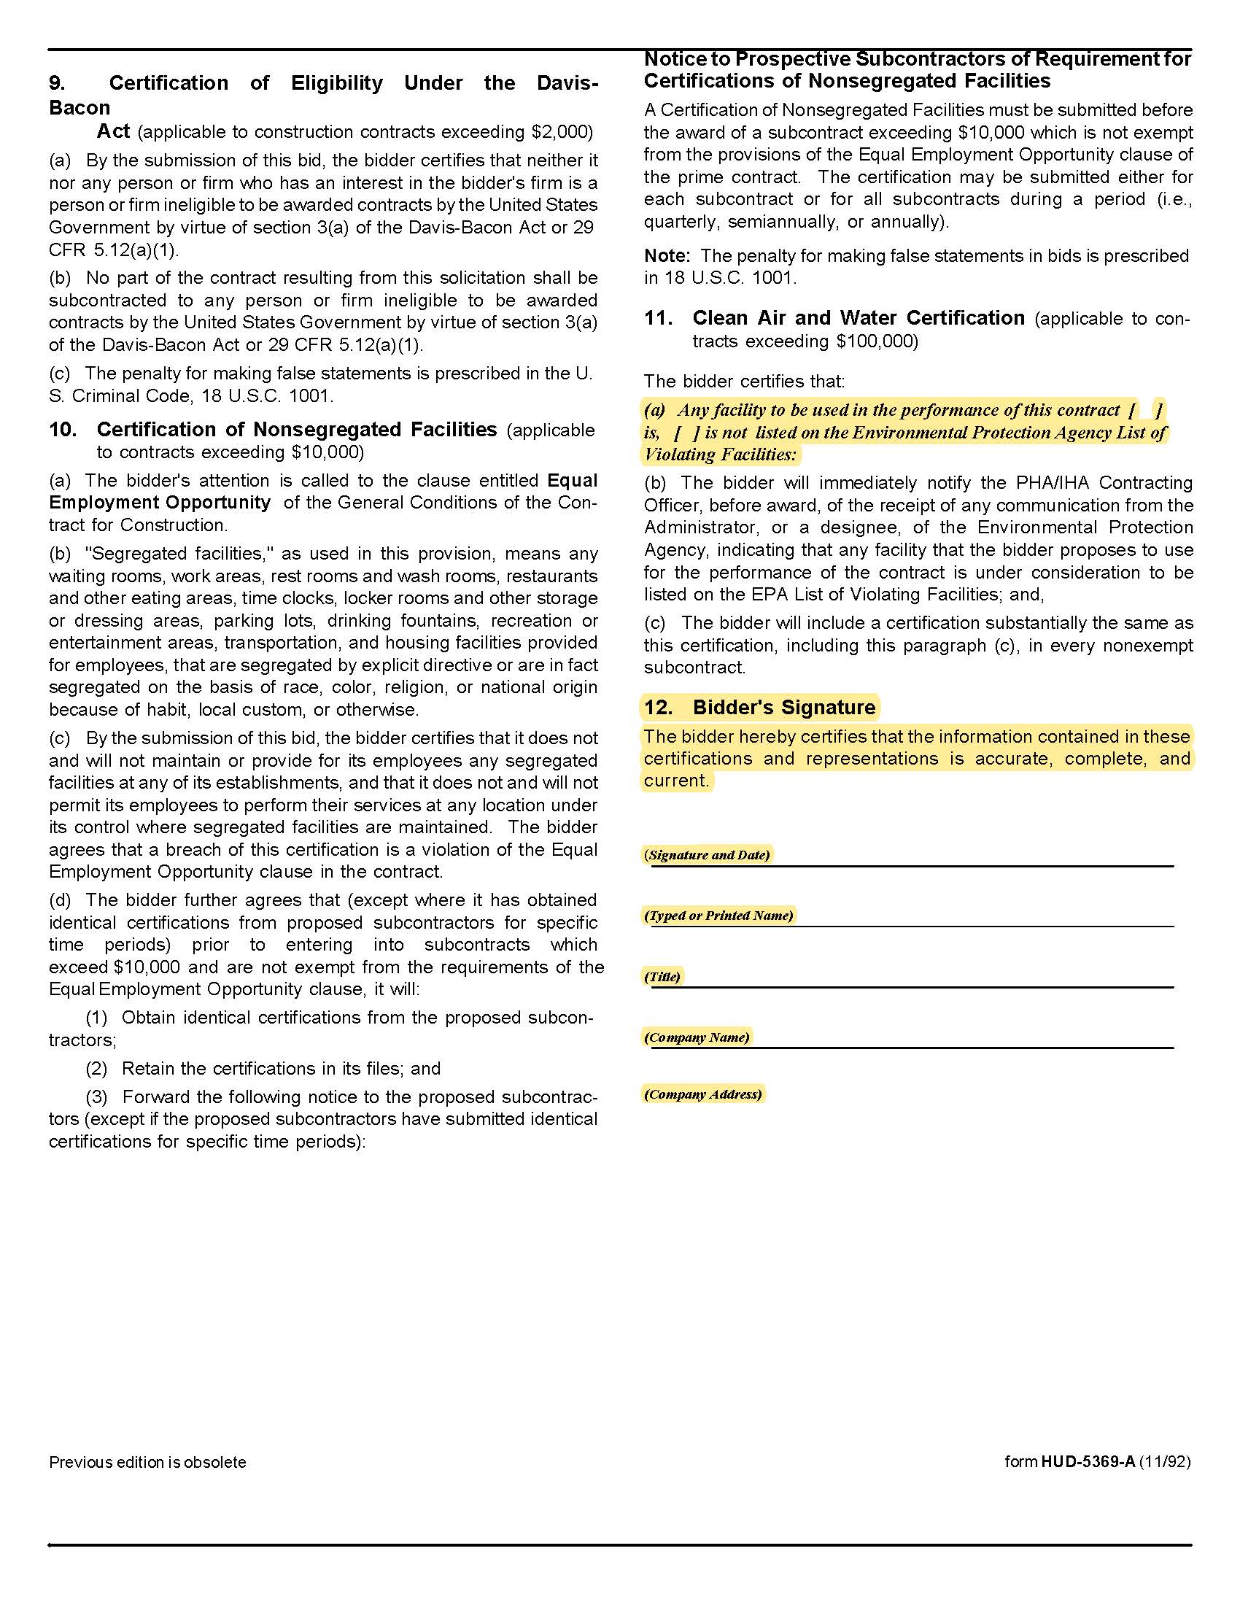

Treasury Management and Investment Services Q2015
Exhibit 1 KCDC Bank Account Listing and Details for the Month of November 2019

Treasury Management and Investment Services Q2015
Exhibit 2 Revolving Fund Balance Calendar Year 19

9498106 CY19 Monthly Ending Balances
Month | Ending balance | Notes
1/31/2019 | $ 16,667,963.94
2/28/2019 | $ 17,013,109.41
3/31/2019 | $ 18,766,384.16
4/30/2019 | $ 18,041,299.02
5/31/2019 | $ 15,101,075.75
6/30/2019 | $ 13,209,756.76
7/31/2019 | $ 12,663,224.17
8/30/2019 | $ 12,294,549.55 | Lowest Ending Balance
9/30/2019 | $ 12,933,512.77
10/31/2019 | $ 14,780,290.13
11/30/2019 | $ 19,921,427.24
12/31/2019 | $ 22,254,956.48 | Highest Ending Balance
 | $ 16,137,295.78 | Average Ending Balance

Treasury Management and Investment Services Q2015
Exhibit 3 Investment Balances Calendar Year 19

Suntrust Investment account
KCDC - Corporation
Acct#: TN2-006327
CY19 Month-end Portfolio Value
Month | Ending Value | Notes
1/31/2019 | $ 19,583,438.50
2/28/2019 | $ 18,586,628.90
3/31/2019 | $ 18,792,930.29
4/30/2019 | $ 20,050,580.52
5/31/2019 | $ 21,990,695.80
6/30/2019 | $ 23,590,394.71
7/31/2019 | $ 24,079,224.16 | Highest Portfolio Value
8/30/2019 | $ 23,394,637.49
9/30/2019 | $ 22,632,397.56
10/31/2019 | $ 20,393,447.12
11/30/2019 | $ 18,069,669.82
12/31/2019 | $ 15,799,447.49 | Lowest Portfolio Value
 | $ 20,580,291.03 | Average Month-End Value

Treasury Management and Investment Services Q2015
Exhibit 4 General Depository Agreement

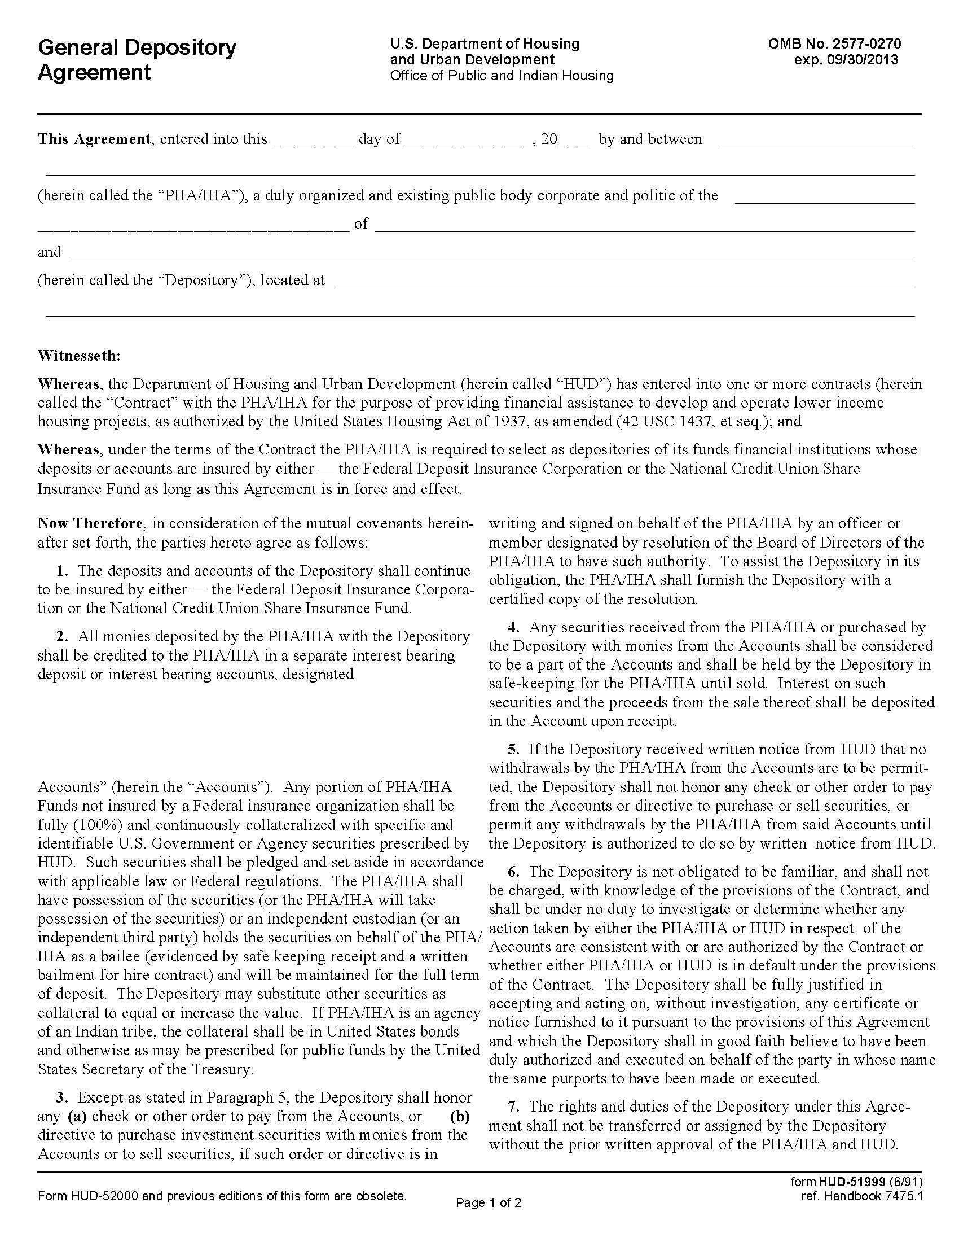
Treasury Management and Investment Services Q2015
Exhibit 4 General Depository Agreement

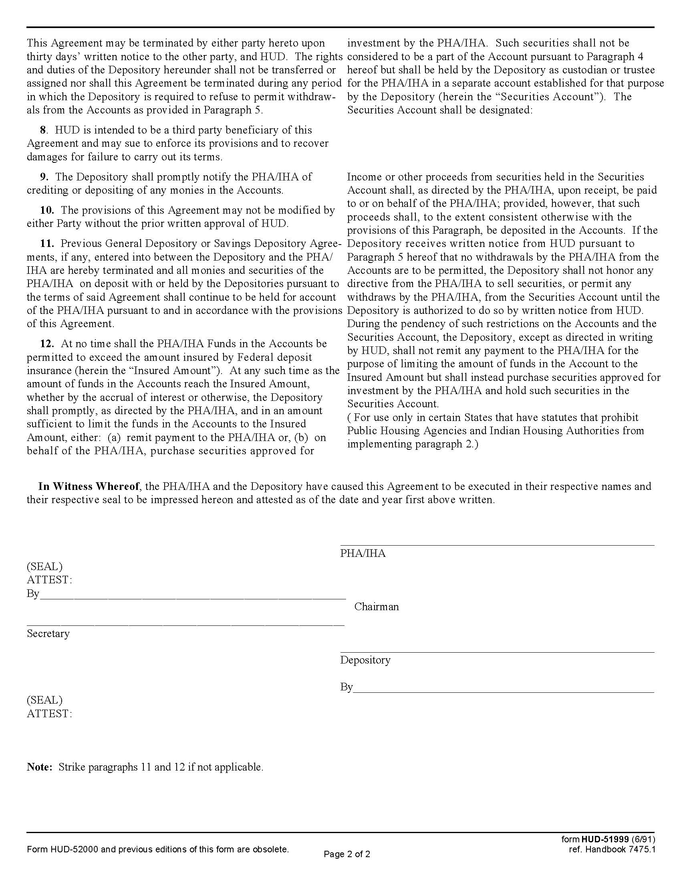

FIRST AMENDMENT TO GENERAL DEPOSITORY AGREEMENT

THIS FIRST AMENDMENT TO GENERAL DEPOSITORY AGREEMENT dated as of XXX, 2014 (this "Amendment"), by and between KNOXVILLE'S COMMUNITY DEVELOPMENT CORPORATION, a housing and redevelopment authority of the City of Knoxville, Tennessee organized under the Tennessee Housing Authorities Law, Tenn. Code Ann. §§ 13-20-101 et seq. (the "PHA/IHA"), SUNTRUST BANK, a national banking association with offices in Knoxville, Tennessee (the "Depository").

RECITALS

A. The PHA/IHA and the Depository entered into a General Depository Agreement dated July 1, 2009 (the
"Depository Agreement") pursuant to which the PHA/IHA selected the Depository as the depository of its
funds upon the terms and conditions contained in the Depository Agreement.

B. The PHA/IHA and the Depository desire to modify certain of the terms and conditions of the Depository
Agreement related to collateralization.

C. The PHA/IHA and the Depository also desire to obtain the approval of the amendment of the Depository Agreement from the United States Department of Housing and Urban Development ("HUD").

NOW THEREFORE, in consideration of the mutual agreements contained herein and other good and valuable consideration, receipt of which is hereby acknowledged, the parties agree as follows:

Definitions. Capitalized terms used but not defined in this Amendment shall have the meaning given to them in the Depository Agreement.

1. Collateralization. Paragraph 2 of the Depository Agreement is hereby deleted and the following is
substituted in lieu therefor:

2. All monies deposited by the PHA/IHA with the Depository shall be credited to the PHA/IHA in a separate interest bearing deposit or interest bearing accounts designated "Unlimited Revolving Fund Accounts" (herein, the "Accounts"). Any portion of the PHA/IHA funds not insured by a Federal insurance organization shall be fully (100%) collateralized by the collateral pool established pursuant to Tenn. Code Ann. §§ 9-4-501 et seq. (the "Collateral Pool for Public Deposits Act of 1990"). At all times during the term of this Agreement, the Depository shall qualify as a "qualified public depository" as such term is defined in the Collateral Pool for Public Deposits Act of 1990.

3. Effect of Amendment. Except as provided in this Amendment, all of the terms and conditions of the Depository Agreement shall remain in full force and effect.

4. Counterparts. This Amendment may be executed in counterparts, each of which when so executed shall be deemed an original, but all such counterparts together shall constitute but one and the same instrument.

IN WITNESS WHEREOF, the parties have caused this Amendment to be duly executed as of the day and year first above written.

PHA/IHA:

KNOXVILLE'S COMMUNITY DEVELOPMENT CORPORATION

By:_________________________________
, Chairman

Attest:

_________________________________
Secretary

DEPOSITORY:

BANK

By:_________________________________

ACKNOWLEDGED AND CONSENTED TO BY:

UNITED STATES OF AMERICA
Secretary of Housing and Urban Development

By: _____________________________
Marcia Lewis, Director
Knoxville, TN Program Center
Office of Public Housing

Treasury Management and Investment Services Q2015
Exhibit 5 HUD’s Financial Management Handbook (selected pages)

Note 1: This section is applicable to HUD funds and not necessarily to any non-federal funds which may be invested separately.

Note 2: Please refer to https://www.fdic.gov/deposit/deposits/brochures/deposit-insurance-at-a-glance-english.html as applicable.

Financial Management Handbook
7475.1 REV.
Part 4-3 thru 4-8

4-3. COLLATERALIZATION OF DEPOSITS.
PHAs shall require their depositories to continuously and fully (100%) secure all deposits whether regular, savings, or time that are in excess of the $100,000 insured amount. This may be accomplished by the pledging or setting aside collateral of identifiable U.S. Government securities as prescribed by HUD (see sub-paragraph b, c, and d of paragraph 4-8 of this Chapter). The PHA has possession of the securities (or the PHA will take possession of the securities) or an independent custodian (or an independent third party) holds the securities on behalf of the PHA as a bailee (evidenced by safe keeping receipt and a written bailment for wire contract) and will be maintained for the full term of the deposit. Such securities shall be owned by the depository and the manner of collateralization shall provide the PHA with a continuing perfected security interest for the full term of the deposit in the collateral in accordance with applicable laws and Federal regulations. Such collateral shall, at all times, have a market value at least equal to the amount of the deposits so secured.

4-4. CASH BUDGET. Not Printed Here

4-5. INVESTMENT OF FUNDS.

a. Funds Available for Investment.
Funds on deposit in the General Fund are comprised of four components: (1) funds for current transaction purposes, (2) development and/or modernization funds, (3) funds exceeding those necessary for the daily operation of the PHA which are considered available for investment and (4) any operating reserved funds. As a general rule, the average amount on deposit in the General Fund cash accounts (the targeted maximum cash balance) should be the amount needed on hand for transaction purposes or as a safeguard against cash shortages.

b. Requirement in Annual Contributions Contract.
Section 401(E) of the Annual Contributions Contract (ACC) requires that excess funds on deposit in the General Fund shall be invested in investment securities selected by the PHA and approved by HUD. This section defines excess monies as funds in excess of prudently estimated needs for the next 90 days. The requirement does not take into account modern cash management techniques which will allow a reduction in non-earning assets and the requirements of Target Investment procedures of the Performance Funding System (PFS) which require a fuller investment of assets in calculating operating subsidies.
In the interest of good cash management, non- interest/bearing deposits should be reduced to the amount necessary to maintain a good banking relationship.

c. Assigning Responsibility for the Cash Management and Investment Program.
A major factor contributing to the success of the investment program is the delegation of responsibility and authority for developing and executing it. The PHA should compare the cost of establishing a cash management program in-house if qualified professional staff are available to contracting out. If PHAs contract for cash management and investment services, then the organization should have qualified personnel to achieve cost-effectiveness. Commercial banks and savings and loans association now offer such services.

4-6. CASH MANAGEMENT INCENTIVES.

a. Introduction.
Good cash management, which is an objective of management, creates responsibilities for the use of funds. Such responsibilities are placed on both the PHA and HUD for a successful program to benefit both. The primary goals of cash management are to assure the availability of cash for transaction needs, preserve the value of cash resources and earn the maximum return on funds until disbursed.

b. Temporary Funds Available for Investment.

(1) Each PHA with an average cash balance of $10,000 or more shall invest such funds in HUD-Approved Investment Securities (see Paragraph 4-8 of this Chapter) in order to at least meet the PFS Target Investment requirements (24 CFR Section 990.109 (e)).

(2) See Handbook 7475.13, Performance Funding System (PFS), regarding reporting requirements for projecting investment income for the purpose of calculating PFS operating subsidy eligibility. These requirements mandate a minimum investment income (Target Investment Income) for calculating operating subsidies and allow PHAs to retain investment income in excess of the required amount. PHAs should review these requirements carefully in developing their cash management programs.

c. Monitoring.
The Office of Finance and Management, PIH, will oversee the overall cash management policy and programs for Public Housing. Actual monitoring of each PHA's cash management will continue to be the responsibility of the respective Field Office.

4-7. INVESTMENT STRATEGY.

a. HUD-Approved Investments.
A list of investments approved by HUD for the investment of PHA funds is contained in Paragraph 4-8 of this Chapter. PHAs are required to choose from these financial instruments. Within the HUD approved instruments, PHAs are permitted to modify their investment policy without prior HUD approvals. The choice of investments from the approved list should be made using the criteria developed in the remainder of this paragraph.

b. Determination of Investment Type.
The determination of the best types and mixtures of investments is dependent on several factors. The primary objective is safety. Once that objective is attained, the optimum return on the investment should be consistent with the goals of the cash management program of the PHA. The factors that should be taken into account include the following:

(1) Safety.
Safety is achieved through adherence to the list of permitted investments which are backed by the full faith and credit of, or a guarantee of principal and interest by, the U.S. Government, a Government agency or issued by a Government-sponsored agency, coupled with an appropriate maturity date.

(2) Yield.
The PHA should strive to achieve the highest yield consistent with the other factors of the investment policy. Tax-exempt securities are not appropriate for investment by a PHA because it would not benefit from the tax advantage.

(3) Liquidity.
All investments must be capable of being liquidated on one day's notice. Therefore, no investments may be made which impose a longer notice period for redemption or which are not readily marketable.

(4) Maturity.
Investments should be scheduled to mature when the funds are needed. Sale of securities prior to maturity should be avoided due to the inherent risk. (If the market interest rate increases above the yield on the investment, the market value of the securities will decline.) Investments shall be limited to securities maturing in periods of up to one year, or such lesser period that coincides with expected disbursements by the PHA, but not beyond the current financing cycle. PHAs may invest in securities up to three years for the investment of operating reserves.

(5) Amount.
The best type of investment depends, to some degree, on the amount available for investment because certain investments require a large initial amount.

(6) Administrative Cost.
In choosing an investment, a PHA must consider the administrative work involved, particularly with regard to investments of short duration. Substantial amounts can be invested for periods as short as one or two days. However, the administrative costs with small amounts may be greater than the return on the investment, thus would not be justified. Administrative costs will be higher with a more frequent turnover of investments and must be taken into account together with the yield and term in determining the optimum investment strategy.

c. Cash Management by the PHA.
The PHA should compare the return from an in-house cash management program with a program managed by an agent. If the PHA finds that administrative costs of an in-house program are such that the net yield on investments is less than that obtainable through an alternative, the general rule is that the PHA should use that alternative.
d. Cash Management by an Agent.
As an alternative to an in-house cash management program, a PHA may enter into a contract with an approved governmental unit such as a State agency established for this purpose (see Paragraph 4-8(g) Municipal Depository Fund of this Chapter) or another PHA, or a bank(excluding investment bankers and brokerage houses) to administer its cash management program. Such a program may include any of the functions of cash management, i.e., receipts, disbursements and investments. Such a contractual arrangement will give a small PHA the expertise and administrative skills which it would not otherwise be expected to have and often can make a cash management program cost-effective.

e. Low-Income Public Housing Development and Modernization Funds.
A PHA engaged in Low-Income Public Housing Development or Modernization programs shall not request funds from HUD in excess of their needs for two 30-day periods. Therefore, a PHA shall not consider investing such funds in securities maturing before 30 days unless it has been determined that such securities can be redeemed at par prior to the maturity date and that the yield will be at least equal to that of shorter term securities than available for investment.

4-8. APPROVED INVESTMENT SECURITIES.

a. Introduction.
In most cases, purchases of securities shall be a date which coincides with expected disbursements by the PHA. For the purpose of investing operating reserves, issues shall be limited to maturities three years or less. Although some of the following securities have maturities longer than three years, they can be traded in the secondary market.

b. Direct Obligations of the Federal Government Backed by the Full Faith and Credit of the United States.

(1) U.S. Treasury Bills.
These securities are short-term obligations which a PHA or its agent may purchase directly. Treasury Bills with 3-month and 6-month maturities are issued weekly and those with 9-month and 12-month maturities are issued monthly. The minimum denomination is $10,000. They are issued on a discount basis and are redeemed at par upon maturity.

U.S. Treasury Bills are available for purchase at any time after issuance from investment departments of banks and from dealers in investment securities. Purchases may be made conveniently using the PHA's depository bank. Treasury Bills may be acquired by subscription on the issue date from a Federal Reserve Bank or branch in amounts not in excess of $200,000. Detailed information is contained in the weekly or monthly announcements which may be received regularly upon application to a Federal Reserve Bank or branch.

(2) U.S. Treasury Notes and Bonds.
These securities are issued periodically by the Treasury Department through Federal Reserve Banks and branches. They are medium to long-term obligations which a PHA or its agent can only purchase in the secondary market to assure that they will mature at a date which coincides with scheduled disbursements by the PHA. Outstanding issues may be purchased from banks or dealers in investment securities at the market price which on any given day may be more or less than the face amount.
(a) U.S. Treasury Notes.
These notes mature in not less than one and not more than 10 years from the issue date and bear interest at fixed rates payable semi-annually.

(b) U.S. Treasury Bonds.
These bonds mature after ten years from the issue date and bear interest at fixed rates payable semiannually. Many issues of bonds are redeemable on call by the Treasury Department before maturity. The yield of such issues usually is computed to the first call date which may be as much as 5 years prior to maturity.

c. Obligations of Federal Government Agencies.

(1) Federal Financing Bank (FFB).
The Federal Financing Bank is authorized to purchase obligations held by Federal agencies and to issue obligations to the public.

(2) Government National Mortgage Association (GNMA) Mortgage-Backed Securities (GNMA I and GNMA II). The securities guaranteed by GNMA are issued by an issuer (a GNMA-approved mortgage lender). The securities are backed by a pool of government-insured or guaranteed mortgages. The holders of the securities receive monthly payments of principal and interest. The minimum denomination issued is $25,000. The difference in GNMA I and GNMA II is that the GNMA II payment date is on the 20th of the month and the GNMA I payment date is on the 15th; GNMA II uses a central paying agency whereas GNMA I has individual issuers sending checks to investors; and GNMA II has interest rates that vary within a one percent range. The maximum maturity for GNMA I and GNMA II is 30 years, except that GNMA I project loans mature in 40 years.

(3) Government National Mortgage Association (GNMA) Mortgage-Backed Securities Program Mortgage-Backed Bonds (MBS). These obligations, guaranteed by GNMA, have been issued by the Federal National Mortgage Association (FNMA) and the Federal Home Loan Mortgage Corporation (FHLMC). They have been issued in maturities varying from one to 25 years, but have not been sold since 1973. They were in denominations of $25,000, $100,000, $500,000, and $1,000,000.

(4) GNMA Participation Certificates. These securities, guaranteed by GNMA, were sold by GNMA as the trustee with various other Federal agencies as trustors. They represent beneficial interest in future payments of principal and interest on mortgage pools. Their maturities range between one and 20 years and the minimum denomination is $5,000.

(5) Maritime Administration Merchant Marine Bonds, Notes, and Obligations. These securities are issued by shipping companies and are backed by the full faith and credit of the U.S. Government. Each issue is further secured by a first preferred ship or fleet mortgage. Maturities and denominations vary.

(6) Small Business Administration (SBA) Small Business Investment Corporation (SBIC) Debentures. When authorized by appropriation acts, the SBA may guarantee principal and interest payments on debentures of SBIC. The SBA may also pool these debentures and sell SBA-guaranteed debentures. These issues have maturities of 10 years and are issued in $10,000 denominations.
(7) Tennessee Valley Authority (TVA) Power Bonds and Notes. These securities are secured by a first charge on net power proceeds. Payment of interest and principal on them is ranked ahead of annual payments to the U.S. Treasury. They have been issued in multiples of $1,000.

d. Securities of Government-Sponsored Agencies.

(1) Farm Credit Consolidated System-Wide Discount Notes. These notes are the secured joint and several obligations of the Farm Credit System which consists of the Federal Land Banks, the Federal Intermediate Credit Banks, and the Banks for Cooperatives. They are issued in denominations of $5,000 and maturities are authorized from 5 to 365 days.

(2) Federal Farm Credit Banks Consolidated System-wide Bonds. These bonds are the secured joint and several obligations of the Farm Credit Banks. Their issuance supersedes individual bond issues by the Federal Land Banks, the Federal Intermediate Credit Banks, and the Banks for Cooperatives. They are issued in multiples of $1,000 for maturities in excess of 13 months and in multiples of $5,000 for shorter maturities.

(3) Federal Land Banks Consolidated Bonds. These bonds are the secured joint and several obligations of the Federal Land Banks. They are issued in multiples of $1,000 and with maturities ranging from 1 to 15 years. The last issuances mature in 1997.

(4) Federal Home Loan Banks Consolidated Obligations. These securities are the secured joint and several obligations of the Federal Home Loan Banks comprised of:

(a) Bonds which have maturities of one year or more. They are issued in multiples of $10,000, $25,000, $100,000 and $1,000,000.

(b) Notes which have maturities of less than one year. They are issued in multiples of $10,000, $25,000, $100,000 and $1,000,000.

(c) Discount Notes which have maturities ranging from 30 to 170 days. They are issued in denominations of $100,000 and $1,000,000.

(5) FHLMC Mortgage Participation Certificates (PC) (Guaranteed). These certificates represent undivided interest in specific fixed rate, first lien conventional and residential mortgages. FHLMC provides monthly interest and principal payments. The final payment is the first of the month and year in which the last monthly payment on the last maturing mortgage is scheduled to be paid.
(6) Federal National Mortgage Association (FNMA) Debentures. These debentures are issued in denominations ranging from $10,000 and with maturities ranging from 20 to 25 years.

(7) FNMA Notes. The minimum investment in these notes is $50,000 with maturities ranging from 1 to 20 years.

(8) FNMA Short-Term Discount Notes. These notes are similar to commercial paper and are tailored to the individual needs of investors. They are sold at published rates with maturities of 30 to 270 days and in denominations ranging from $5,000.

(9) FNMA Capital Debentures. These debentures are subordinated to the noncapital debentures, notes, and short-term discount notes. They were last issued in 1975 in a $10,000 minimum denomination and with maturities of 5 and 25 years.

(10) FNMA Convertible Capital Debentures. These debentures are subordinated to all senior obligations,
including non-convertible capital debentures. There was one 25-year issue in September 1971 maturing in 1996.

(11) Student Loan Marketing Associations (SLMA) Obligations. SLMA issues obligations comprises of
guaranteed student loans as follows:

(a) Floating Rate and Master Notes. These notes bear interest at rates that vary with the 91-day Treasury Bill rate. Short-term borrowings have an original or remaining term maturity of one year or less.

(b) The Series E and F Floating Rate Notes. These notes bear interest at rates which vary with the 91-
day Treasury Bill, except that each issue has fixed minimum and maximum rates known as interest rate "collars" for any quarterly interest period.

(c) Zero Coupon Notes. These notes are shown at net proceeds adjusted for accretion of discount.

e. Demand and Savings Deposits. Demand and savings deposits at commercial banks, mutual savings banks, savings and loan associations and credit unions are permitted for PHA funds provided that the entire deposit is insured by the Federal Deposit Insurance Corporation (FDIC), the National Credit Union Share Insurance Fund (NCUSIF) or by the Federal Savings and Loan Insurance Corporation (FSLIC). A deposit in excess of the insurance coverage may be made at a depository institution provided that it is 100 percent collateralized by any of the securities listed under subparagraphs b, c, and d of this paragraph. Care should be taken that withdrawals may be made on demand without loss of interest and without penalty.

f. Money-Market Deposit Accounts. Money-Market Deposit Accounts at depository institutions that may not be insured fully by the FDIC, NCUSIF, or FSLIC are permitted provided that the certificates are fully backed by 100 percent collateral consisting of securities listed under subparagraphs b, c, or d of this paragraph.

When accounts exceed the $100,000 insurance limitation, their safety also may depend on the PHA's control of the underlying collateral which must consist of clearly identified (not pooled) U.S. Government securities. Possession of the collateral securities and a continuous perfected security interest may be the only sure protection against loss in case of bank failure.

g. Municipal Depository Fund. A Municipal Depository Fund (Fund) or Local Government Investment Pool which is established by States, municipalities, units of local government or other political subdivisions to serve as an investment fund for PHAs is permitted. The securities purchased by a Fund shall be on the HUD-approved list of investment securities.

PHAs shall have either an undivided or divided interest in securities comprising the Fund. The Fund shall be under the control of the Investment Company Act of 1940, and its objective shall be clearly stated.

The investment objective of the Fund shall be to obtain as much income as possible consistent with the preservation and conservation of capital. The Fund shall disclose clearly the basis of earnings and how they are distributed.

PHAs shall obtain a statement of potential default and risk and a clear demonstration that withdrawals from the Funds will not be so restricted as to impair a PHA's day-to-day cash management needs. The management fee shall be fixed at a reasonable amount and management shall be passive. PHAs shall limit the amount of funds invested in the Fund to no more than 30 percent of a PHA's available investment funds. The Fund shall disclose the relationships of the investment advisor, manager, trustees, custodian and transfer agent. Each financial advisory relationship shall be evidenced by a written document executed prior to, upon, or promptly after the inception of the financial advisory relationship, or promptly after the creation or selection of the issuer. If the issuer does exist or has not been determined at the time the relationship commences, that written document shall set forth the basis of compensation for the financial advisory services to be rendered.

h. Super NOW Accounts. Super NOW accounts have been available and approved for public funds since January 1983. They offer a relatively high market rate and are fully transactional (have no limitations on the number of checks or transfers).

Insurance and collateral requirements are as above for subparagraph e Demand and Savings Deposits.

i. Certificates of Deposit.

(1) Certificates of Deposit are permitted at depository institutions that are insured by an agency of the Federal Government. Caution must be exercised for certificates exceeding the $100,000 insurance limit or when the term is longer than 30-90 days. Although the certificates rate of return may be attractive for larger amounts and longer terms, U.S. Treasury securities offer superior safety and liquidity for the same amounts and terms.

(2) Certificate amounts above $100,000 are permitted provided that the excess is 100 percent collateralized by clearly identified (not pooled) U.S. Government securities. Possession of the collateral securities and a continuous perfected security interest may be the only sure protection against loss in case of bank failure.
(3) Brokered deposits should be avoided because it is no longer possible to get $100,000 of
insurance on a number of deposits placed by brokers.

J. Repurchase Agreements. Repurchase (repos) agreements for a term not to exceed 30 days may be entered into with Federally insured depository institutions to purchase and sale of securities identified under subparagraphs b, c, and d. A repurchase agreement is an agreement negotiated with a bank usually for a short period (1 to 7 days) wherein securities approved for investment are purchased from that bank at a stated price with the bank agreeing to repurchase them on a specified date for a specified amount.
The minimum may vary, although it is usually $100,000. There are three main types: (1) fixed term, where both parties are bound to the negotiated time period, (2) demand, where the agreement stays in effect until terminated by either party, and (3) day-to-day, where daily renewal is by mutual consent and 24-hour notice is required for termination. The PHA should review existing and future repos for compliance with the following certifications. Prior approval by HUD is not necessary, however, the repos seller depository or its agency must provide a written certification to HUD, Assistant Secretary for Public and Indian Housing (Office of Finance and Management), the Field Office, and to the PHA (OMB Approval Number 2577-0099).

(1) That the depository's repo program complies with applicable Federal and State statutes and regulations and that the program does not involve sales or loans of Federal securities by securities dealers that are not regulated or that report to the Federal Reserve Board;

(2) That the depository owns the underlying Federal securities (approved for repurchase under Paragraph
4-8 of this Chapter) when the repo interest is sold and that the value of the securities is equal to or greater than the amount the PHA pays for the repo;

(3) That the PHA has possession of the securities (or the PHA will take possession of the securities) or an
independent custodian (or an independent third party) holds the securities on behalf of the PHA as a bailee (evidenced by a safe keeping receipt and a written bailment for hire contract), from the time the repo interest is sold to the PHA and will be (or is expected to be) maintained for the full term of the repo;

(4) That the repo agreement and any related documents identify specific Federal securities related to the
specific repo purchased by the PHA;

(5) That the repo interest does not represent any interest in a pool or fund of Federal securities for which
registration under the Investment Company Act of 1940 may be required;

(6) That the PHA will have a continuous perfected security interest in the underlying Federal securities
Under State or Federal law for the full term of the repo (disclosing the method by which perfection has or will be accomplished, i.e., by possession, filing, registration of book-entry securities and/or Federal preemption of State law by Federal regulation);

(7) That the depository or a reporting dealer selling the repo has not received any adverse financial report from a credit reporting agency, State or Federal regulatory agency; and

(8) That the depository will not substitute other securities as collateral, except to increase the Value of the
repo security to match the repos' purchase price.

k. Sweep Accounts. Sweep Accounts is a contractual agreement between a bank and a PHA which provides that the bank will regularly "sweep" or transfer any available collected balances from the PHA's account into repurchase agreements. The Sweep Accounts agreement shall include all the certification provided in the Repurchase Agreement and adherence to paragraph 4-3, Collateralization of Deposits.

l. Separate Trading of Registered Interest and Principal of Securities. Separate Trading of Registered Interest and Principal of Securities (STRIPS) are Treasury-based zero-coupon securities which consist of interest or principal on U.S. Treasury securities. STRIPS were issued in minimum increments of $1,000. STRIPS pays no interest until maturity and the rate of return is "locked in" at the time of purchase. The delivery of STRIPS is accomplished by wire transfer through the Federal Reserve book-entry system. STRIPS shall be in the name of the PHA.

