Request for Qualifications

Solicitation Name and Number | Development Partner for Choice Neighborhood Redevelopment of Western Heights C21009
KCDC’s Procurement Division must receive your response no later than | 11:00 am EST on March 19, 2021 (as KCDC’s clocks indicate)
Deliver Responses to | procurementinfo@kcdc.org
Electronic Copies | Use the MS Word version posted on KCDC’s website (or other electronic means) to provide a typed response. The final proposal is to be submitted in Adobe format.
Questions About This Solicitation | Submit questions to procurementinfo@kcdc.org by 3:00 p.m. on March 11, 2021.  KCDC will not accept questions via telephone.
Open Records/Public Access to Documents | All documents provided to KCDC are subject to the Tennessee Open Meetings Act (TCA 8-44-101) and open records requirements.
Solicitation Meeting | ☒ Yes ☐ No
Solicitation Meeting Connection | KCDC will host an on-line meeting. Email procurementinfo@kcdc.org for the web link.
Solicitation Meeting is Mandatory | ☐ Yes ☒ No ☐ Not Applicable
Solicitation Meeting Date and Time | March 9, 2021 at 2:00 p.m.
Award Results | KCDC posts the award decision to its web page at: http://www.kcdc.org/procurement/
Check KCDC’s webpage (https://www.kcdc.org/procurement/) for addenda and changes before submitting your response

General Information

1. Agency Background
a. Knoxville’s Community Development Corporation (KCDC) is a high-performing public housing authority serving Knoxville and Knox County, Tennessee. It manages more than 3,700 units across 20 properties and 4,000 Section 8 vouchers. Additionally, it serves as the redevelopment agency for the City of Knoxville, managing redevelopment areas, TIFs, and PILOTs. Since 1997, KCDC has pursued an aggressive redevelopment agenda, beginning with a highly successful HOPE VI redevelopment at College Homes (Mechanicsville Community) and, more recently, a robust rehab and new construction program as shown below. At both Austin Homes and Five Points redevelopments, KCDC took on a Choice Neighborhood Initiative (CNI)-like approach, whereby KCDC led a community-driven planning and redevelopment process focused on achieving core goals related to Housing, People, and Neighborhood. The Five Point initiative is complete, and Austin Homes is under construction. KCDC is nearing the end of its RAD conversions. By the time the CNI implementation grant is submitted, it is expected that units in Western Heights will be the last remaining public housing in KCDC’s portfolio.

2. General Information
a. KCDC is requesting Statements of Qualifications submissions from comprehensive development teams with extensive Choice Neighborhood housing development and implementation experience. The successful respondent will prove through its submittal that it possesses the qualifications necessary to implement a comprehensive and complex revitalization strategy for the Western Heights public housing site and surrounding Choice Neighborhood, including mixes of incomes, uses, and financing sources. KCDC anticipates entering into a long-term Master Developer Agreement (MDA) with the successful respondent.
A successful development partner is expected to have been awarded a CNI implementation grant in the past or has implemented mixed-income housing with measurable proven success and has a project lead who has been a significant contributor to an awarded CNI project.

b. KCDC is in the early stages of developing a CNI Transformation Plan to guide redevelopment efforts in the Western Heights Neighborhood. KCDC has enlisted an impressive group of key stakeholders and critical community partners and has engaged a highly experienced team to assist in this process.
Western Heights is a working-class community of small homes and lots bounded by Western Avenue, Tennessee Ave, I-275 and Beaumont Avenue. The neighborhood is just 2.4 miles from downtown Knoxville and the University of Tennessee; its incredible mountain views and proximity to the highly desirable Beaumont Academy enrolls not only kids from the neighborhood, but is the gifted and talented elementary school for Knoxville, drawing families to the neighborhood from across the region. The neighborhood was once a thriving inner suburb; however, years of disinvestment and depopulation have led the community’s decline.

c. The neighborhood is home to two adjacent public housing communities. (1) Knoxville’s original public housing community totaling 244 units. These units received a $7 million rehab through a grant that has just been completed. (2) The other 196 units, which are the focus of the implementation grant, are technically about 10 years newer, but in far greater distress. D3G already completed a study that concludes they are obsolete. And, in 2011, KCDC received section 18 approval to demolish other units on the property, providing ample vacant area for an initial stage of redevelopment.

d. KCDC intends to have a finalized Transformation Plan by late summer 2021 and to apply for a Choice Neighborhood Implementation Grant a few months later. While KCDC is a high-performing agency and has significant redevelopment experience, it is seeking a true partnership with a Development Partner who is experienced with comprehensive neighborhood transformation and mixed-income housing to enhance the capacity of its team and ensure the initiative’s overall success. In the event KCDC is not successful in the 2021 round we anticipate reapplying in 2022.

3. Changes After Award
It is possible that after award KCDC will need to revise the service needs or requirements specified in this document. KCDC reserves the right to make such changes after consultation with the selected firm.

4. Contact Policy
Contact only KCDC’s Procurement Division about this solicitation from the issuance of this RFQ until its award. Information obtained from any other person will not affect the risks or obligations assumed by the firm or relieve the firm from fulfilling any of the conditions of the resulting award. Such contact can disqualify the firm from the solicitation process.

5. Evaluation
a. KCDC is utilizing a Qualifications-Based Selection (QBS) method of procurement through this Request for Qualifications (RFQ) solicitation. Under this method, Developer compensation will not be used as an evaluation factor. Responses will be evaluated by an KCDC evaluation committee utilizing the evaluation criteria outlined in this RFQ.
Based on the committee’s evaluations, KCDC’s Contracting Officer will determine which of the responsive firms may be capable of providing the services described in this RFQ and have a reasonable chance of award (the competitive range). KCDC may, at its sole discretion, enter negotiations with the highest-ranked firm in the competitive range or request additional information and/or presentations/interviews with the firm or firms considered to be in the competitive range. The evaluation committee may then re-evaluate the competitive range firms based on their original proposals and the additional information provided.

b. KCDC will negotiate compensation and other key business terms with the top-ranked firm with the intention of reaching an agreement on fair and reasonable terms and entering an MDA. If an agreement cannot be reached, KCDC will terminate negotiations with this firm and proceed to the next-highest rated firm until an agreement is reached on compensation and other business terms determined to be fair and reasonable.

c. If an award is made through this solicitation, all team members identified in the response to this RFQ will also be considered approved. The selected Development Partner will be required to comply with all applicable HUD regulations pertaining to procurement of contractor and technical services and identity of interests. The Development Partner will be required to follow a competitive solicitation process that is approved by KCDC for all other contractors in accordance with the terms and conditions of the MDA.

d. KCDC will review all proposals and reserves the right to request necessary modifications, waive minor technicalities, reject all proposals, reject any proposal that does not meet mandatory requirement(s) or cancel this RFQ, according to KCDC’s best interests. KCDC further reserves the right to adjust its evaluation scenario if this is in KCDC’s best interest and consistent with good business practices.

e. Qualifications received in response to this solicitation may be evaluated using a two-stage evaluation process. During Stage I of the evaluation process, firms will be evaluated and scored by an Evaluation Committee based on the Evaluation Criteria as described at the end of this section. KCDC may decide to enter negotiations with the highest-ranked firm at this point or, at KCDC’s sole discretion, they may initiate a Stage II process.

f. If utilized, during Stage II of the evaluation process KCDC will allow firms that KCDC has determined have a reasonable chance of being selected, to provide a presentation of their firm’s experience and capabilities and to clarify any questions the Evaluation Committee may have about their firm.
After completion of Stage II interviews, the Evaluation Committee will re-evaluate each of the Stage II firms. KCDC will then enter negotiations with the highest-ranked firm from the Stage II evaluation.

g. If a contract cannot be negotiated with this firm, negotiations will be terminated. KCDC will then initiate negotiations with the next highest-ranked firm. This procedure will continue until a mutually satisfactory contract has been negotiated.

h. KCDC reserves the right to make no award or decline to enter negotiations should it believe that no respondent to this RFQ will be capable of delivering the necessary level of services with acceptable terms and/or time period. KCDC further reserves the right to forego Stage II of the evaluation process and enter negotiations with the highest ranked firm from Stage I of the evaluation process.

i. Contract award may be subject to approval by KCDC Board and the United States Department of Housing and Urban Development (HUD), as applicable.

j. KCDC plans to award to the best overall proposal on the following evaluation scale:

Factors | Maximum Points
Respondent and Team Experience  The degree to which the respondent and its team demonstrates:  - Successful experience in the planning, redevelopment, financing, construction and  management of Choice Neighborhood and/or similar mixed-income transformation  development projects of comparable scope and complexity.  - Cohesion of the team, as demonstrated by previous experience working together.  - Degree to which developer would meet all applicable CNI threshold requirements  established by the last published Choice Neighborhood Implementation Grant Notice of  Funding Availability (NOFA)  - Degree to which developer shows a commitment to complete the due diligence and other steps necessary to submit a Choice Neighborhood Implementation Grant Application in 2021 and manage other commitments.  - Degree to which respondent demonstrates that the key staff proposed for the  developer and proposed team members have significant successful experience in their  respective disciplines as required for the planning, development, and operation of  developments of comparable size, scope, and complexity.  - Respondent must have participated in a minimum of one Choice Neighborhood comprehensive neighborhood transformation with measurable outcomes (or a comparable mixed-income project with measurable outcomes) to be scored. | 35
Methodology  - Degree to which respondent demonstrates a willingness to share roles and responsibilities of the development process.  - Degree to which the respondent demonstrates knowledge of the steps, processes, and  issues involved in implementing a Choice Neighborhood transformation and redevelopment project.  - Degree to which the respondent’s proposed roles and key business terms provide the best value  for KCDC, competitiveness for the Choice Neighborhood grant application, and the success of  the implementation. | 35
Financial Resources and Financial Capacity  - Ability to obtain, structure, and implement financing for such projects.  The financial capacity as evidenced by financial statements, the firm's most recent  audit and bank references, and the Development Partner's discussion of how it  intends to honor all guarantees should the need arise. | 15
DBE/MBE/WBE Experience and Participation Plans  Plan for meeting or fostering MBE/WBE/ SBE/DBE objectives as addressed in Section 4, item 6. | 10
Section 3 Plan/Requirements  Plan for meeting or fostering Section 3 objectives as addressed in Section 4, item 7. | 5
Total | 100

General Conditions

6. Advertising
In submitting a Statement of Qualifications, the firm and their consultants agree not to use the results as a part of any commercial advertising.

7. Assignment of Transfer
The successful firm shall not assign or transfer any interest in the contract, in whole or part, without written approval of KCDC. Claims for sums of money due, or to become due from KCDC pursuant to the contract, may be assigned to a bank, trust company or other financial institution. KCDC is hereby expressly relieved and absolved of all liability in the event a purported assignment or subcontracting is attempted in the absence of the firm obtaining KCDC’s prior written consent the contract.

8. Availability of Records
The Comptroller General of the United States, the Department of Housing and Urban Development (HUD), KCDC, and any duly authorized representative of each, shall have full and free access to, and the right to audit and to make excerpts and transcripts from, all pertinent books, records, documents, invoices, papers and the like, of the firm, or in the possession of the firm, which shall relate to, or concern the performance of the contract.

9. Cancellation
Irrespective of any default, hereunder KCDC may also at any time at its sole discretion cancel the contract in whole or in part.

In the event of cancellation, the firm shall be entitled to receive equitable compensation for all work completed and accepted prior to such termination or cancellation as shall be indicated in the contract.

10. Conflict of Interest
a. The respondent warrants that to the best of its knowledge, belief and, except as otherwise disclosed, it does not have any organizational conflict of interest. Conflict of interest is defined as a situation in which the nature of work under this solicitation and the firm's organizational, financial, contractual or other interests are such that:
- Respondent may have an unfair competitive advantage; or
- The respondent's objectivity in performing the work solicited may be impaired. In the event the respondent has an organizational conflict of interest as defined herein, the respondent shall disclose such conflict of interest fully in the Statement of Qualifications submission.

b. The respondent agrees that if, after award, he, she or it, discovers an organizational conflict of interest with respect to this solicitation, he, she or it, shall make an immediate and full disclosure in writing to the KCDC Contracting Officer. This shall include a description of the action, which the respondent has taken or intends to take to eliminate or neutralize the conflict. KCDC may, however, disqualify the respondent or if a contract has been entered into with the respondent, terminate said contract, in its sole discretion.

c. In the event the respondent was aware of an organizational conflict of interest before the award of a contract and intentionally did not disclose the conflict to the KCDC Contracting Officer, KCDC may disqualify the respondent.

d. The provisions of this Section shall be included in all subcontracts and consulting agreements wherein the work to be performed is similar to the service provided by the respondent. The respondent shall include in such subcontracts and consulting agreements any necessary provisions to eliminate or neutralize conflicts of interest.

e. No member of or delegate to the U.S. Congress or Resident Commissioner shall be allowed to share any part of the contract awarded under this solicitation or to any benefit that may arise there from. This provision shall be construed to extend to any contract made with the successful respondent.

f. No member, officer, or employee of KCDC, no member of the governing body of the locality in which the project is situated, no member of the governing body in which KCDC was activated, and no other public official of such locality or localities who exercises in respect to the project, shall during his or her tenure, or for one year thereafter, have any interest, direct or indirect, in any contract or the proceeds thereof resulting from this solicitation.

g. No member, officer or employee of the respondent selected to perform the services described above shall, during the term of their contract, or for one year thereafter, have any interest direct or indirect, in any contract that they are responsible for procuring, managing or overseeing.

h. KCDC reserves total discretion to determine the proper treatment of any conflict of interest disclosed under this Section.

11. Contract Award
The Contract for the selected Developer/Development Team shall be subject to the approval of KCDC’s Board of Commissioners and may be subject to approval by the U.S. Department of Housing and Urban Development.

12. Contract Documents
Written contract documents will be prepared by KCDC and the selected Developer Partner. Modifications may be adopted based on final negotiations and specific requirements of the contract under this RFQ.

13. Cost of Preparing the Statement of Qualifications
All costs incurred, directly or indirectly, in response to the Request for Qualifications shall be the sole responsibility of and shall be borne by the respondents.

14. Disputes
a. Issues Causing Protest: Any respondent which disputes the reasonableness, necessity, or
competitiveness, of the terms and conditions of this solicitation or who has been adversely affected by a decision concerning a notice of intended or actual award, may file a written notice of protest with the contact person listed in the solicitation.

b. Filing the Protest: The respondent must first advise the contact person listed in the solicitation in writing within 48 hours after receipt of the bid solicitation or intended or actual notice of award of their intent to file a formal written notice with the contact person listed in the solicitation.

c. Content of Formal Written Notice: The formal written notice should be printed, typewritten, or otherwise duplicated in legible form. The formal written notice of protest should contain the information that follows:

- The name and address of the respondent filing the protest and an explanation of how his/her/its substantial interests have been affected by the bid solicitation or by KCDC's notice of intended or actual award.
- A statement of how and when the respondent filing the protest received notice of the bid solicitation or notice of intended or actual award.
- A statement of all issues of disputed material fact. If there are none, the protest must so indicate.
- A concise statement of the ultimate facts alleged, as well as KCDC's policies, which entitle the respondent filing the protest to relief.
- A demand for relief the respondent deems themselves entitled.
- Any other information which the respondent contends is material.

d. Response to Protest: Upon receipt of a timely filed Notice of Protest and meeting the above requirements, the solicitation process, or award process will be stopped until the protest is resolved.
The Contracting Officer may set forth in writing particular facts and circumstances which require continuance of the solicitation process without the above-mentioned delay to avoid material increased costs or immediate or serious danger to health, safety or welfare. This written documentation will specifically detail the facts underlying the Contracting Officer’s decision and will constitute final agency action.

e. Resolution: The Contracting Officer may request such information pertaining to the matter, as he/she deems appropriate. Within seven (7) days of the date that the formal written protest is referred to him/her, the Executive Director will notify the Respondent making the protest his/her decision.
15. Federal, State, and Local Reporting Compliance
The firm shall provide such financial and programmatic information as required by KCDC to comply with all Federal, State and local law reporting requirements.

16. Form of Contract
The acceptance of the proposed firm's offer for the services specified herein will be made by issuance of a duly authorized MDA. Respondents are cautioned to make no assumptions or accept any representations by a representative of KCDC concerning the award until an MDA is negotiated and executed.

17. Government Restrictions
In the event any governmental restrictions may be imposed which would necessitate alteration of the material, quality, workmanship or performance of the goods or services offered, it shall be the responsibility of the successful firm to immediately notify KCDC in writing specifying the regulation which requires alteration. KCDC reserves the right to accept any such alternation, including any reasonable price adjustments occasioned thereby, or to cancel the contract at no expense to KCDC.

18. Insurance
a. The selected firm shall maintain at its expense during the term of the Contract the following insurance.

- Worker's Compensation Employer's Liability of at least in accordance with government limits.

- Automobile Liability Insurance in an amount not less than $5,000,000 per occurrence and $5,000,000 aggregate.

- Professional Liability Insurance in the amount of $1 million.

- General Liability Insurance in the amount of $5,000,000 per occurrence and $5,000,000 aggregate.

- KCDC and project instrumentalities shall be named as additional insured on all policies.

- The selected firm shall not hold KCDC and its instrumentalities liable for any personal injury incurred by their respective employees, agents or consultants, contractors or subcontractors while working on this Project.

- The firm agrees to hold KCDC and its instrumentalities harmless from any such claim by its employees, agents, consultants, contractors or subcontractors, unless a Court having jurisdiction finds there is gross negligence of an employee of KCDC while acting within the scope of their employment.

b. The insurance company covering the firm must be licensed to do business in the State of Tennessee and have a Best's Guide rating of "A+" or higher.

c. Proof of Liability Insurance
The successful firm shall furnish to KCDC a certified copy of the policy or policies covering the work as required in the specifications as evidence that the insurance required will be maintained in force for the entire duration of the contract with KCDC. KCDC and its instrumentalities must be listed as an additional insured.

19. Laws
The contract shall be governed by the laws of the State of Tennessee and applicable federal law.

20. Non-Conformance to Conditions/Specifications/Scope of Services
Services will be inspected for compliance with specifications. Services not conforming to specifications may not be accepted at the firm's expense. Services not provided in accordance with the Scope of Services may result in the firm being found in default. In the event of default, all procurement cost may be charged against the firm. Any violations of these stipulations may result in the firm's name being removed from KCDC's Statement of Qualifications mailing list.

21. Notices
All written notices required to be given by either party under the terms of the contract resulting from the contract award shall be addressed to the firm at their legal business residence as given in the contract. Written notices to KCDC shall be addressed as provided in the contract.

22. Patents, Licenses, and Royalties
The successful firm shall indemnify and save harmless KCDC, its instrumentalities, and employees from liability of any kind, including cost and expenses for or on account of any copyrighted, patented, or not patented invention, process or article manufactured or used in the performance of the contract, including its use by KCDC. If the firm uses a design, device or material covered by letters, patent or copyright and understood that the proposal prices shall include all royalties or costs arising from the use of such design, device or materials involved in the work. Further, all residual rights to Patents, Licenses and Royalties (e.g. software and license to sue same purchased) shall revert to KCDC at the end of the Agreement.

23. Payment
a. To the extent required and pursuant to the schedule of deliverables in accordance with the final Development Agreement negotiated by the parties KCDC may make periodic payments for services provided as required under its agreement with the selected Developer/Development Team.

b. Payment made by KCDC to the selected Developer/Development Team will be in a form approved by KCDC's Board of Commissioners. The invoice is to be emailed to APadmin@kcdc.org. Upon review and acceptance of the invoice, payment shall be due and payable within 30 days.

24. Performance Evaluation Meeting
The selected firm shall be readily available to meet with representatives of KCDC weekly the first month of the contract and as often as necessary to resolve all performance problems identified at these meetings.

25. Permits and Licenses
The successful firm shall obtain all permits and licenses that are required for performing its work. The firm shall pay all related fees and costs in connection with required permits and licenses. Proof of ownership shall be made on all software used in the execution of the contract. The firm will hold KCDC harmless for any violation of software licensing resulting from breaches by employees, owners and agents of the firm.

26. Project Personnel
Except as formally approved by KCDC, the key Statement of Qualifications shall be for the individuals who will actually complete the work, at the proposed levels of effort. Changes in staffing must be proposed in writing to KCDC and approved by KCDC in writing.

27. Removal of Employees
a. KCDC may request the successful firm to immediately remove from assignment to KCDC and/or dismiss any employee found unfit to perform duties due to one or more of the following reasons:
- Neglect of Duty.

- Disorderly conduct, use of abusive or offensive language, quarreling, intimidation by words or actions or fighting.

- Theft, vandalism, immoral conduct or any other criminal action.

- Selling, consuming, possessing, or being under the influence of intoxicants, including alcohol or illegal substances while on assignment at KCDC.

28. Section 3 Clauses
Every applicant, recipient, contracting party, contractor, and subcontractor shall incorporate or cause to be incorporated a "Section 3 Clause" in all contracts for work in connection with a Section 3 covered development. All Statement of Qualifications must also include a Compliance Plan for Section 3 requirements. (See Attachment III)

29. Standards of Conduct
The successful firm shall be responsible for maintaining satisfactory standards of its employee's competence, conduct, courtesy, appearance, honesty, and integrity. It shall be responsible for taking such disciplinary action with respect to any of its employees as may be necessary.

30. Supervision
The successful firm shall always provide adequate competent supervision during the performance of the contract. To that effect, a qualified consultant and one or more alternates shall be designated in writing to KCDC prior to contract start. The firm or his designated representative shall be readily available to meet with KCDC personnel. The successful firm shall provide the telephone numbers where its representatives) can be reached.

31. Taxes
The successful firm is responsible for all state and federal payroll and/or social security taxes. The firm shall hold KCDC harmless in every respect against tax liability.

32. Travel
All travel and miscellaneous expenses will be borne by the firm selected.

Responsibilities

33. Introduction
a. The selected Development Partner will be expected to serve the role of Housing Lead for the CNI application. However, as stated earlier, KCDC has a great deal of experience with housing development, tax credits, various forms of debt, management, etc. Therefore, it is KCDC’s expectation, that the agency will also play a significant role in the implementation of the Western Heights housing strategy. KCDC’s lack of direct experience in mixed-income development is the primary reason for bringing on a development partner, so KCDC views the arrangement as a true partnership and a capacity-building exercise. For this reason, the roles and responsibilities are anticipated to grow for KCDC throughout the project. What KCDC has set out below in 1-3 is a starting point, but KCDC is interested in your thoughts of how we can best collaborate in your response to the RFQ. If your vision is a little different than what we have laid out, please describe it in your response.

- Rehab Phase (within the CNI neighborhood but outside of CNI grant-funded scope). KCDC understands that it is essential for the 244-unit adjacent development (minimally rehabbed in 2019) to look and feel “Choice Neighborhood Ready.” To this end, KCDC expects to carefully plan (as part of the comprehensive neighborhood transformation planning) a more substantial rehab of these units over the next several months and would like the development partner’s assistance in planning and executing the rehab (including selection of the design partners, contractor, and construction supervision, but would not expect the developer to participate in the funding of the project (except to the extent deferred development fees are necessary), ownership, or management of the asset. Depending on developer’s level of participation, KCDC would expect the developer to provide a guaranty of completion, but not any LP guarantees related to the performance of the asset.

- Phases 1 and 2 of Choice Neighborhoods Implementation. In phases 1 and 2of Choice Neighborhoods Implementation, KCDC would expect to be a participant in all aspects of the development process but would also expect the Development Partner to be highly involved in the day-to-day development process. KCDC would expect to share with the developer: all predevelopment costs; owner’s equity requirements (including deferred developer fees if necessary); ownership (during the tax credit period); developer guaranty of completion; and developer tax credit LP guarantees to the extent the developer is involved in management.

- Remaining Phases of Choice Neighborhoods Implementation. KCDC would expect that it would have gained capacity in the first two phases of the Choice Neighborhoods Implementation.
Thereafter, KCDC would expect more responsibility for predevelopment and post development management. KCDC would expect developer expertise throughout the predevelopment and construction processes, and that the Development Partner would provide a guaranty of completion. KCDC would expect that any Developer ownership interests would be minority interests. KCDC would expect the developer to provide a guaranty of completion, but not any LP guarantees related to the performance of the asset.

In any LIHTC structures where Development Partner is a co-owner, KCDC would intend for a KCDC instrumentality to be the general partner and the Development Partner to be a special limited partner. While somewhat unique nationally, this structure allows for better use of available debt resources in Tennessee, and this is the structure KCDC has used even when the minority partner in other recent LIHTC partnership transactions.

b. During Choice Neighborhood application preparation, the Development Partner will be expected to work with KCDC to manage the assembled a team of consultants (along with any additional consultants) necessary to prepare the application. The Development Partner will also be expected to fully participate in the preparation and submission of the Choice Neighborhood Implementation Grant Application in 2021 and in the Spring-Summer 2021 Transformation Planning Process. For purposes of the Choice Implementation Application KCDC has already assembled a team consisting of Urban Design Associates, a local architect and civil design firm, CVR Associates for Choice Neighborhoods grant writing and consulting, a “People Partner,” and the City of Knoxville to serve as the “Neighborhood Partner.” Resident meetings have already begun.

c. Throughout the redevelopment effort, the Development Partner will work closely with KCDC and be responsive to the needs of the Choice Neighborhood team and all stakeholders, including but not limited to KCDC’s residents and the surrounding community. The Development Partner will be responsible, along with KCDC, for ensuring that the redevelopment plan is approved, financed and implemented in a timely fashion.

34. While the eventual MDA will control all phases of development, the following is an expected scope of work for the first and second phases of development under the Choice Implementation Project.

- Oversee and Implement Redevelopment Efforts: Provide the necessary staffing, expertise, supervision and guarantees to implement all aspects of the redevelopment fully and expeditiously as required by the MDA.

- Hire and Manage Consultants and Contractors Necessary for Planning and Implementation: With input from KCDC, the Development Partner will procure other consultants and/or contractors and coordinate all tasks necessary for implementation of the redevelopment plan.

- Maintain Communication Regarding Project Progress with KCDC, HUD, all key stakeholders, and the larger public: KCDC will establish a regular schedule of team meetings, in which the Development Partner will participate.

Moreover, the Development Partner will be responsible for submitting monthly progress reports to KCDC, in such formats and media as KCDC might direct, detailing project progress and milestones achieved; updated critical path schedule; budget status and projections; Section 3 and M/WBE participation and other information deemed relevant by KCDC.

- Develop and Maintain Quality Control Measures: The Development Partner is responsible for
ensuring the Project is implemented and managed with the highest quality standards. The Development Partner will be required to implement quality assurance and control measures to ensure effective performance by all parties in all aspects of the program.

- Develop and Maintain a Detailed Development Schedule and Critical Path Schedule: Develop and
maintain a detailed schedule of events, predicated on financing deadlines that include pre-development activities, construction start, project stabilization and permanent loan close. Develop a Critical Path Schedule for all phases of construction, and lease-up and stabilization.

- Foster Resident Involvement in Project Implementation: Facilitate and foster the involvement of
public housing and other neighborhood residents in the design and implementation of the redevelopment plans. In cooperation with KCDC, keep residents informed of the status of the revitalization, assist in providing job opportunities for residents during and after implementation, and assist/encourage resident businesses.

- Be Responsive to Local Community, Neighborhood, and Governmental Interests: While KCDC will be the lead in any communications with the city of Knoxville or state agencies, promote and maintain good relations with community and neighborhood groups, and federal, state, and local governments.

- Compliance with Laws, Rules and Regulations: The Development Partner will comply with all
applicable federal, state, and local laws, rules and regulations. The Development Partner will also establish systems and manage all Development Team Members proposed, as well as all contractors, consultants and others providing service during the redevelopment effort to ensure their compliance with applicable federal, state and local laws, rules and regulations.

- MDE/WBE/DBE/Section 3 Opportunities: The Development Partner will take affirmative steps necessary to assure that minority, women-owned, and disadvantaged business enterprises are used to the greatest extent feasible, and that it develops and implements a comprehensive Section 3 Program.

- Plans and Specifications: The Development Partner will be responsible for the preparation of all
construction Plans and Specifications necessary to implement the construction of the Housing phases of the project. Plans and Specifications must comply with the requirements of all local, State and Federal permitting and regulatory entities; including, but not limited to, Section 504 and Uniform Federal Accessibility Standards (UFAS) and meet HUD requirements for broadband infrastructure. In addition, Plans and Specifications must be prepared with the intent for the project to meet the highest possible cost-effective standards for energy efficiency.
Plans and Specifications must also be comprehensive and must meet or exceed industry standards of quality and sustainability. Plans and Specifications must also be of the highest quality so that construction change orders and disputes are minimized. All Plans and Specifications will be subject to review and approval by HUD and KCDC.

35. Financing
- Produce an Overall Financing Plan: Produce an attainable financing plan for the overall
redevelopment effort. The Financing Plan will reflect the goals of the master plan. The financing plan must demonstrate a sensitivity and approach to using public funds from any source in the most efficient manner, maximizing leveraging of such funds to the greatest extent possible.

- Financing Application(s): In accordance with the MDA, the Development Partner will work with KCDC to obtain all financing necessary to implement the redevelopment plans in a timely fashion, which may include, but not be limited to: tax credits; tax-exempt bonds; federal, state and local funds; and private debt.

- Maximize the Leveraging of Public and Private Resources: The Development Partner will be expected to maximize the leveraging of public and private resources by pursuing all reasonable sources of financing and utilizing a variety of partners and partnerships. Additionally, the Development Partner will take full responsibility for securing all financing sources in a timely fashion; coordinating discussion and negotiations with financial institutions and private partners, inclusive of KCDC; and ensuring KCDC is involved in all aspects of the selection of financial partners to assure that proposed terms are both competitive and reasonable. In this regard KCDC expects to fully participate in the review/approval of solicitation documents, proposals, business terms and related contractual documents.

- Obtain Equity Investment: The Development Partner will obtain equity financing commitments with the best terms currently available as required by the MDA and subject to KCDC’s approval.

- HUD Development Proposal(s): The Development Partner will work with KCDC to prepare the
necessary HUD CNI, RAD, or mixed-finance development proposals and related submissions for each phase required to obtain HUD approval.

- Guarantees: In accordance with the MDA and the long-term management structure of the project during the term of the tax credit partnership, the Development Partner will provide such guarantees required for the successful financing of the redevelopment effort.

- Operating Feasibility: As required in the MDA, structure such reserves and other resources as will
reasonably guarantee the long-term operating feasibility of the Project, including KCDC subsidized units, utilizing no more subsidy than committed by KCDC (as applicable).

- Accounting/Financing: The Development Partner shall maintain accounting records and ensure
Project financing is available at the appropriate times and utilized in the appropriate manner, in compliance with the MDA.
36. Construction
- Hire Qualified General Contractors and Oversee Construction Activities: The Development Partner
will create and implement a competitive process for selecting the most qualified General Contractor. All such entities must have all necessary licenses, financial capacity and capabilities to perform the work. During construction, the Development Partner shall provide oversight and management of construction activities by coordinating with all development team members and attending job-site meetings to ensure the expeditious implementation of construction activities. As regular onsite construction monitoring is critical to the success of the project; the Development Partner must have a full-time onsite presence during the term of construction.

- Facilitate Necessary Site Improvements: Pursuant to the MDA, the Development Partner shall initiate and complete site work and infrastructure construction in collaboration with KCDC, local and regional public utility agencies and other private utilities.

KCDC’s Role

37. KCDC’s level of participation throughout the development process will be determined by the terms and conditions codified in the MDA. Given KCDC’s capacity and experience, KCDC fully expects to play a significant role in the implementation of the housing strategy. As described above, KCDC expects to develop capacity during the initial two phases and handle more responsibility as the project progresses.

- KCDC will lead the process, along with (UDA, CVR, and the Developer) in preparation of the Choice Implementation Grant Materials.

- KCDC will lead the preparation for the HUD site visits related to the Choice Implementation Grant.

- KCDC will be involved in all the design processes to finalize the site plan, the building designs and floor plans and must approve each stage (schematic, design development and construction document) before the design team is authorized to begin the following stage.

- Subject to the Choice Neighborhood Grant, KCDC will contribute its vacant land in Western Heights and its land currently containing the units to the Choice Neighborhood project (except for land where a new Head Start Building is being constructed).

- KCDC will provide property access to developer and consultants to conduct testing.

- KCDC will provide general information relating to tenant incomes, rent, operating budgets, historical cost data, family composition, handicap accommodation, PILOTs, utilities, etc.

- KCDC will lead any necessary approvals for demolition and disposition.

- KCDC will participate in the development of the solicitation documents for investors and lenders. KCDC will also participate in negotiations with the selected investors and lenders and will approve the final terms and conditions of the equity or loan agreements.

- KCDC will work with construction schedules to prepare tenant relocation plans to minimize displacement and cost.

- KCDC will lead any RAD submissions.

- During construction, KCDC reserves the right for itself, its authorized agents, and HUD, to enter the property at any time to inspect the Project and any work in progress for the purpose of protecting or furthering its and/or HUD’s interest.

- KCDC will direct the Development Partner on all necessary communications with external stakeholders, including the City, elected officials, the current public housing residents and community residents.

- KCDC expects to secure significant funding from the City of Knoxville, from the Tennessee Housing Development Agency, as well as Choice Neighborhood funding; therefore, KCDC expects whatever funds it expends on the developments to be limited and only contributed after all other reasonable sources of funding (including deferred developer fees) are exhausted.

- KCDC will have the right to review/approve all payments made regardless of the funding source in accordance with the terms and conditions of the MDA.

- KCDC will have the right to review all project-related contracts, contract amendments and deliverables as outlined in the terms and conditions of the MDA.

Submission Requirements

All responses to this RFQ must contain the information listed below in a format, which correlates with each of the items listed.

- Cover Letter
Provide a 1–2-page cover letter that includes the following:

- Summary of key information about the firm and its qualifications; in particular, a brief introduction of at least (i) one recent Choice Neighborhood project, and (ii) at least one other multiphase mixed income project (could be Choice or a project similar in scope to Choice).

- Describe how the Developer meets all applicable CNI threshold requirements detailed in the 2020 Choice Neighborhood Implementation Grant NOFA.

- Developer’s commitment to submit a Choice Neighborhoods Implementation grant with KCDC in 2021.

- Contact information for the primary contact person, including email/phone number.

- Relevant Project Experience-In a succinct fashion, please provide a more detailed overview of the
two projects listed in the cover letter.

- Include a chart describing (by phase) the income mixing, number of units, development sources, equity investor, total development cost, closing date and completion dates.

- Include a description of any non-housing buildings developed in the transformation, along with sources (if applicable).

- Include photographs of completed work.

- Please explain how each of the projects engaged residents and the community and how the project achieved measurable outcomes.

- Please list a project reference for high level employee still working for the client.

- Please include a list (name, number of units, city) of all other mixed income developments completed in the last five years as well as a list of any projects currently in the pipeline and whether they are Choice Neighborhoods projects or not.

- Key Staff Experience

- Provide profiles of key staff of the Respondent and other proposed team members (if applicable) that would be providing services. Include a list of similar projects they have worked on and their roles.

- Please list the proposed working project manager (the key contact of developer KCDC would expect to be working with throughout the project), and provide a list of his/her current projects making clear how this person will manage this project with other work they are currently assigned.

- Proposed Roles and Key Business Terms

a. Provide an explanation of Development Partner’s definition of a development partnership with KCDC, and demonstrate how they intend to approach a sharing of responsibilities. If the developer envisions a different structure than that proposed by KCDC, please describe in this section.

b. Provide initial proposed business terms as a starting point for negotiations, understanding KCDC’s intent to play a significant role in implementation:

- Please provide an affirmative statement that any work by developer specifically attributed to applying for the Choice Neighborhoods Grant will not be charged to KCDC.

- KCDC’s budget for master planning and submission of Choice Neighborhoods Implementation Grant is approximately $725,000. KCDC already secured $450,000 from the City of Knoxville for master planning. Would developer be willing to share a portion of the remaining cost? If so how much?

c. NON-CHOICE REHAB-

- Please describe a proposed sharing of total Predevelopment Costs (%).

- Please describe Developer’s willingness to assist KCDC in this phase and describe a proposed developer fee split (%).

- Developer commitment to including project and construction management expenses within their Developer fee above.

- Developer guaranty of completion.

d. PHASES 1 and 2-

- Please describe a proposed sharing of (%) of total Predevelopment Costs.

- Proposed developer fee split (%).

- Developer commitment to including project and construction management expenses within their Developer Fee.

- Proposed ownership in the ownership entity (%).

- Developer’s requirements relating to property management, and if developer intends to be the manager of Phases 1 and 2, an explanation of its experience in managing similar projects.

- Developer commitment to include KCDC in all financing solicitations and approvals.

- Developer’s role in providing guarantees.

- Please generally describe the back-end buyout of the developer from the ownership structure at the end of the tax credit partnership.

e. REMAINING CHOICE PHASES-As mentioned earlier in the RFQ, KCDC intends to develop capacity in the first two phases, and it is anticipated that KCDC would perform many of development roles in the remaining phases; however, it is also anticipated that the Developer Partner will continue to have a role in providing assistance with transformative design, project management, and construction management. For the remaining phase(s):

- Please describe a proposed sharing of total Predevelopment Costs (%).

- Developer commitment to including project and construction management expenses within their Developer fee.

- Proposed ownership in the ownership entity (%) (if applicable).

- Developer’s requirements relating to management (if applicable).

- Proposed developer fee split (%).

- Developer’s role in providing guarantees beyond completion (if applicable).

- Financial Capacity
Please describe the financial capacity of the entity to be the developer of this Choice Neighborhoods project, along with all the other work in its pipeline. Please be specific. The top ranked developer will be expected to confirm its narrative with audited financial statements.

- DBE/MBE/WBE Experience and Participation Plans
- Describe Respondent’s experience with DBE/MBE/WBE contracting on prior projects.

- Describe Respondent’s plans for maximizing DBE/MBE/WBE contracting for KCDC projects.

- Section 3 Plan
Section 3’s intent is to ensure that employment and other economic opportunities generated by HUD assistance or HUD-assisted projects covered by Section 3, shall to the greatest extent feasible, be directed to low-and very-low-income persons, particularly persons who are recipients of HUD assistance for housing.

- Describe Respondent’s past experience with Section 3 contracting on prior projects.

- Describe Respondent’s plans for maximizing Section 3 contracting for KCDC projects.

- Required Certifications
Complete the certification forms provided in Attachments B & C.

Please Do not Return This and the Previous Pages
Solicitation Document A: General Information about the Firm
Sign Your Name to the Right of the Arrow
If completing this document in Adobe, an electronic signature is acceptable to KCDC.
Your signature indicates you read and agree to “KCDC’s General Instructions to Suppliers” (www.kcdc.org) and that you are authorized to bind the firm or are submitting the response on behalf of and at the direction of the firms’ representative authorized to contractually bind the firm. I represent that the firm or its applicable representative(s) has reviewed the information contained in this Solicitation Package and that the information submitted is accurate.
Printed Name and Title
Company Name
Street Address
City/State/Zip
Contact Person (Please Print Clearly)
Telephone Number
Cell Number
Firm’s E-Mail Address (Please Print Clearly)
Addenda
Addenda are at www.kcdc.org. Click on “Procurement” and then on “Open Solicitations” to find addenda. Please check for addenda prior to submitting a proposal.
Acknowledge addenda have been issued by checking below as appropriate:
None ☐ | Addendum 1 ☐ |  |  | Addendum 2 ☐ |  | Addendum 3 ☐ |  |  | Addendum 4 ☐ | Addendum 5 ☐
Statistical Information (Check all the apply)
This firm is at least 51% owned and operated by a woman |  |  |  |  |  |  |  |  |  |  | Yes ☐ No ☐
This firm qualifies as a small business by the State of Tennessee  Total gross receipts of not more than $10,000,000 average over a three-year period OR employs no more than 99 persons on a full-time basis |  |  |  |  |  |  |  |  |  |  | Yes ☐ No ☐
This firm qualifies as Section 3 business (as defined by HUD):  It is at least 51% owned by a Public Housing resident or it employs Section 3 residents for at least 30% of its employee base; or it commits to subcontract at least 25% of the project’s dollars to a Section 3 business. |  |  |  |  |  |  |  |  |  |  | Yes ☐ No ☐
This business is owned & operated by persons at least 51% of the following ethnic background:
Asian/Pacific ☐ |  | Black ☐ | Hasidic Jew ☐ |  | Hispanic ☐ |  |  | Native Americans ☐ |  |  | White ☐

Solicitation Document B: Affidavits

Conflict of Interest
1. No commissioner or officer of KCDC or other person whose duty it is to vote for, let out, overlook or in any manner superintend any of the work for KCDC has a direct interest in the award or the firm providing goods or services.

2. No employee, officer or agent of the grantee or sub-grantee will participate in selection, or in the award or administration of an award supported by federal funds if a conflict of interest, real or apparent, would be involved. Such a conflict would arise when the employee, officer or agent, any member of his immediate family, his or her partner, or an organization, which employs, or is about to employ, any of the above, has a financial or other interest in the firm selected for award.

3. The grantee's or sub-grantee's officers, employees or agents will neither solicit nor accept gratuities, favors or anything of monetary value from suppliers, potential suppliers or parties to sub-agreements.

4. By submission of this form, the firm is certifying that no conflicts of interest exist.

Drug Free Workplace Requirements
5. Private employers with five or more employees desiring to contract for construction services attest that they have a drug free workplace program in effect in accordance with TCA 50-9-112.

Eligibility
6. The firm is eligible for employment on public contracts because no convictions or guilty pleas or pleas of nolo contender to violations of the Sherman Anti-Trust Act, mail fraud or state criminal violations with an award from the State of Tennessee or any political subdivision thereof have occurred.

General
7. The firm fully understands the preparation and contents of the attached offer and of all pertinent circumstances respecting such offer.

8. Such offer is genuine and is not a sham offer.

Iran Divestment Act
9. Concerning the Iran Divestment Act (TCA 12-12-101 et seq.), by submission of this proposal, each firm and each person signing on behalf of any firm certifies, and in the case of a joint proposal, each party thereto certifies as to its own organization, under penalty of perjury, that to the best of its knowledge and belief that each firm is not on the list created pursuant to § 12-12-106.

Accuracy of Electronic Copies
10. If the firm provides electronic copies of the proposal to KCDC, the firm certifies that the information provided on paper and in the electronic format is identical unless specifically noted otherwise.

Non-Collusion
11. Neither the said firm nor any of its officers, partners, owners, agents, representatives, employees or parties interest, including this affiant, has in any way colluded conspired, connived or agreed, directly or indirectly, with any other responder, firm, or person to submit a collusive or sham offer in connection with the award or agreement for which the attached offer has been submitted or to refrain from making an offer in connection with such award or agreement, or collusion or communication or conference with any other firm, or, to fix any overhead, profit, or cost element of the offer price or the offer price of any other firm, or to secure through any collusion, conspiracy, connivance, or unlawful agreement any advantage against KCDC or any person interested in the proposed award or agreement.

12. The price or prices quoted in the attached offer are fair, proper and not tainted by any collusion, conspiracy, connivance, or unlawful agreement on the part of the firm or any of its agents, representatives, owners, employees, or parties in interest, including this affiant.

No Contact/No Advocacy Affidavit
13. After this solicitation is issued, any contact initiated by any firm with any KCDC representative concerning this proposal is strictly prohibited-except for communication with the Procurement Division. My signature signifies that no unauthorized contact occurred.

14. To ensure the integrity of the review and evaluation process, respondents to this solicitation nor any firm representing them, may not lobby or advocate to KCDC staff or Board members. My signature signifies that no unauthorized advocacy occurred.

The undersigned hereby acknowledges receipt of these affidavits and certifies that the submittal in response to this solicitation is in full compliance with the listed requirements.

Signed by
Printed Name
Title
Subscribed and sworn to before me this date
By (Notary Public)
My Commission Expires on
Notary Stamp

Attachment C: Identity of Interest Disclosure Certificate

IDENTITY OF INTEREST (IOI) DISCLOSURE CERTIFICATE

SECTION I: TO BE COMPLETED BY ALL RESPONDENTS

Respondent Name: _____________________________________________________________________

CHECK SECTION II OR III, AS APPLICABLE

SECTION II. TO BE COMPLETE ONLY WHEN NO IDENTITY OF INTEREST EXISTS
______ Certification of No Identity of Interest

I, ____________________________________ hereby certify that I have read Section IV of this Disclosure Certificate and understand what the DOH has determined constitutes an Identity of Interest and that NO identity of interest relationships exist between me and ANY individual or organization doing business with my organization or with the projects. (Complete Section VI)

SECTION III. TO BE COMPLETED WHEN AN IDENTITY OF INTEREST DOES EXIST

________ Certification of Identity of Interest

I, ____________________________________ hereby certify that I have read and understand what the Agency has determined constitutes an identity of interest, as outlined in Section IV, and hereby disclose in Section V those entities with which I have an identity of interest relationship. (Complete Section V)

SECTION IV. IDENTITY OF INTEREST STATEMENT
- When there is a family relationship through blood, marriage or adoption with any officer, director, board member, or authorized agent of any other development team member.
- When there is any financial interest between the proponent and any other development team member’s firm or corporation and/or a supplying entity.
- When one or more of the officers, directors, stockholders or partners of the proponent is also an officer, director, stockholder, or partner of any other development team member and/or the supplying entity.
- When any officer, director, board member, or authorized agent of any development team member advances any funds or items of value to the proponent.
- When any development team member and/or supplying entity provides and pays on behalf of the proponent the cost of any materials and/or services in connection with obligations under the agreement.
- When the supplying entity takes stock or any interest in the proponent as part of the consideration to be paid them.
- When there exist of come into being and side deals, agreements, contracts or understandings entered thereby altering, amending, or canceling any agreement document, except as approved by the agency.
SECTION V. TO BE COMPLETED FOR EACH IDENTITY OR INTEREST ENTITY.
(ADD ADDITIONAL SHEETS IF NECESSARY)
Type of Entity: Contractor Subcontractor Property Management Agent

Other _____________________________

Supplier of: Goods Labor Material Both

Services

Entity Name: ______________________________________________________________________

Address: __________________________________________________________________________

Phone Number: ____________________________________________________________________

Trade/Business: ____________________________________________________________________

Describe relationship to IOI entity: _____________________________________________________

__________________________________________________________________________________

Type of Entity: Contractor Subcontractor Property Management Agent

Other _____________________________

Supplier of: Goods Labor Material Both

Services

Entity Name: _______________________________________________________________________

Address: ___________________________________________________________________________

Phone Number: _____________________________________________________________________

Trade/Business: _____________________________________________________________________

Describe relationship to IOI entity: ______________________________________________________
__________________________________________________________________________________

SECTION VI. TO BE COMPLETED BY ALL RESPONDENTS
I further understand and agree that, if a contract is awarded to my organization, if any of my business change during the life of the contract to include Identity of Interest relationship referred to above, I will file an amended disclosure Certificate.

I also agree to provide a new disclosure Certificate at any time requested by the Agency.

I hereby certify that this information may be verified, that the information submitted is true and accurate and that no other identity of interest relationship exist between me and any individual or organization, except as described above. I further understand that failure to disclose an Identity of Interest to the Agency will also subject me to all administrative remedies available to the Agency. Such remedies may include suspension and debarment from participating in any Agency or Federal Program.

____________________________________ ___________________
Signature Date

____________________________________ ___________________
Signature Date

HUD Form 5369A
Attachment D: HUD Form 5369-B

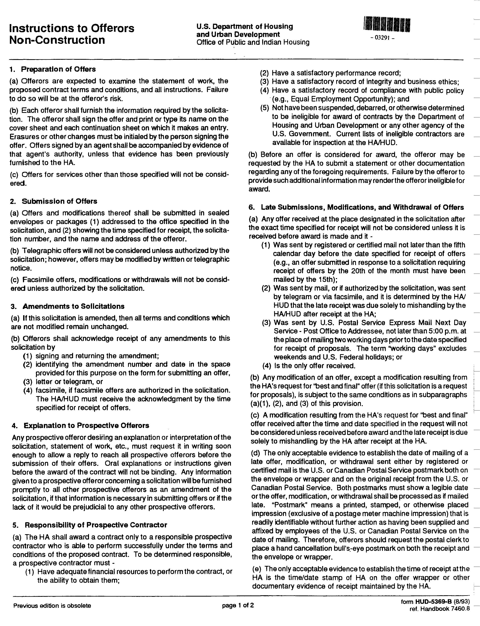

Attachment A: HUD Form 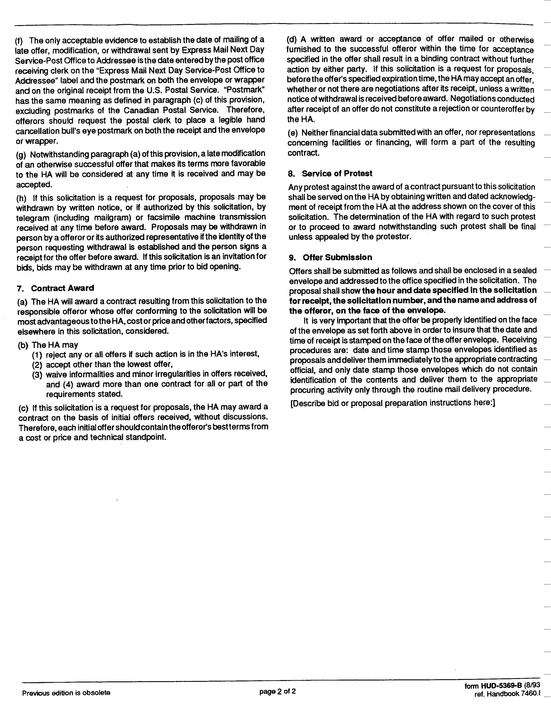5369B

Attachment E: HUD Form 5370-C

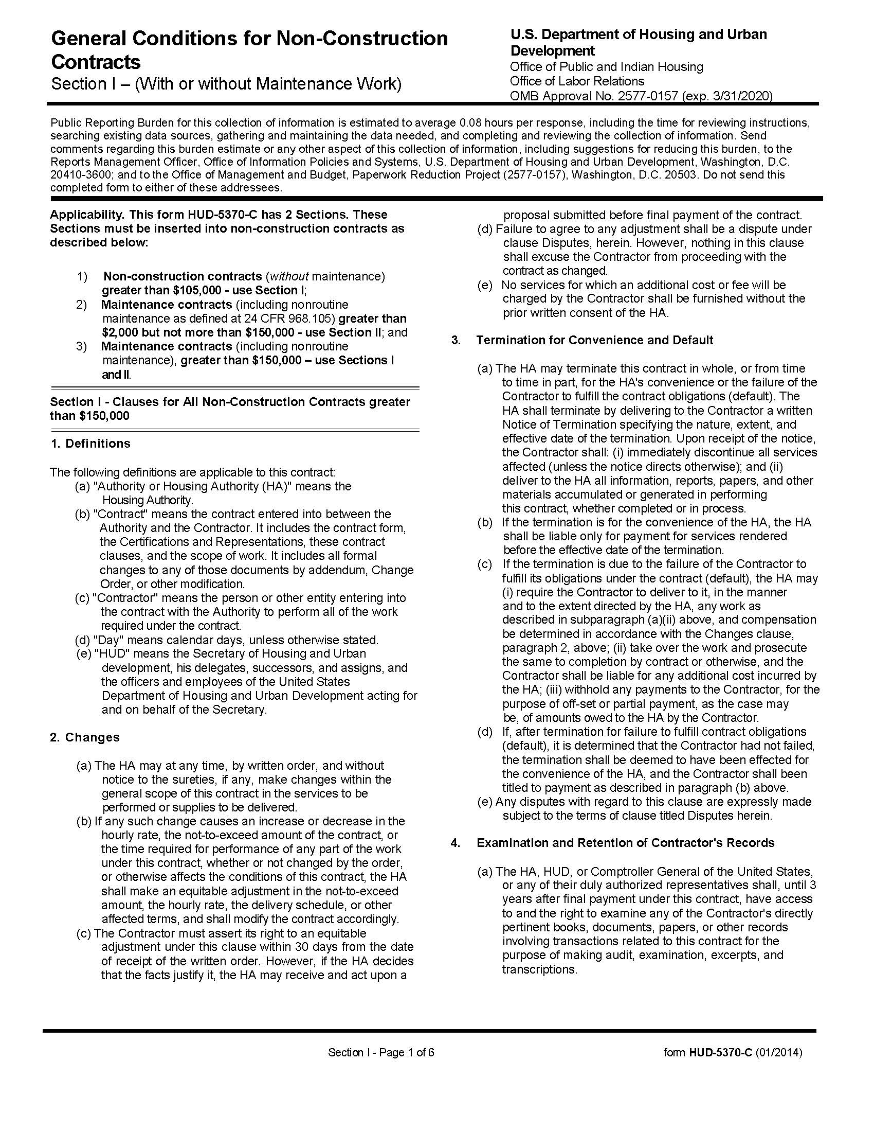
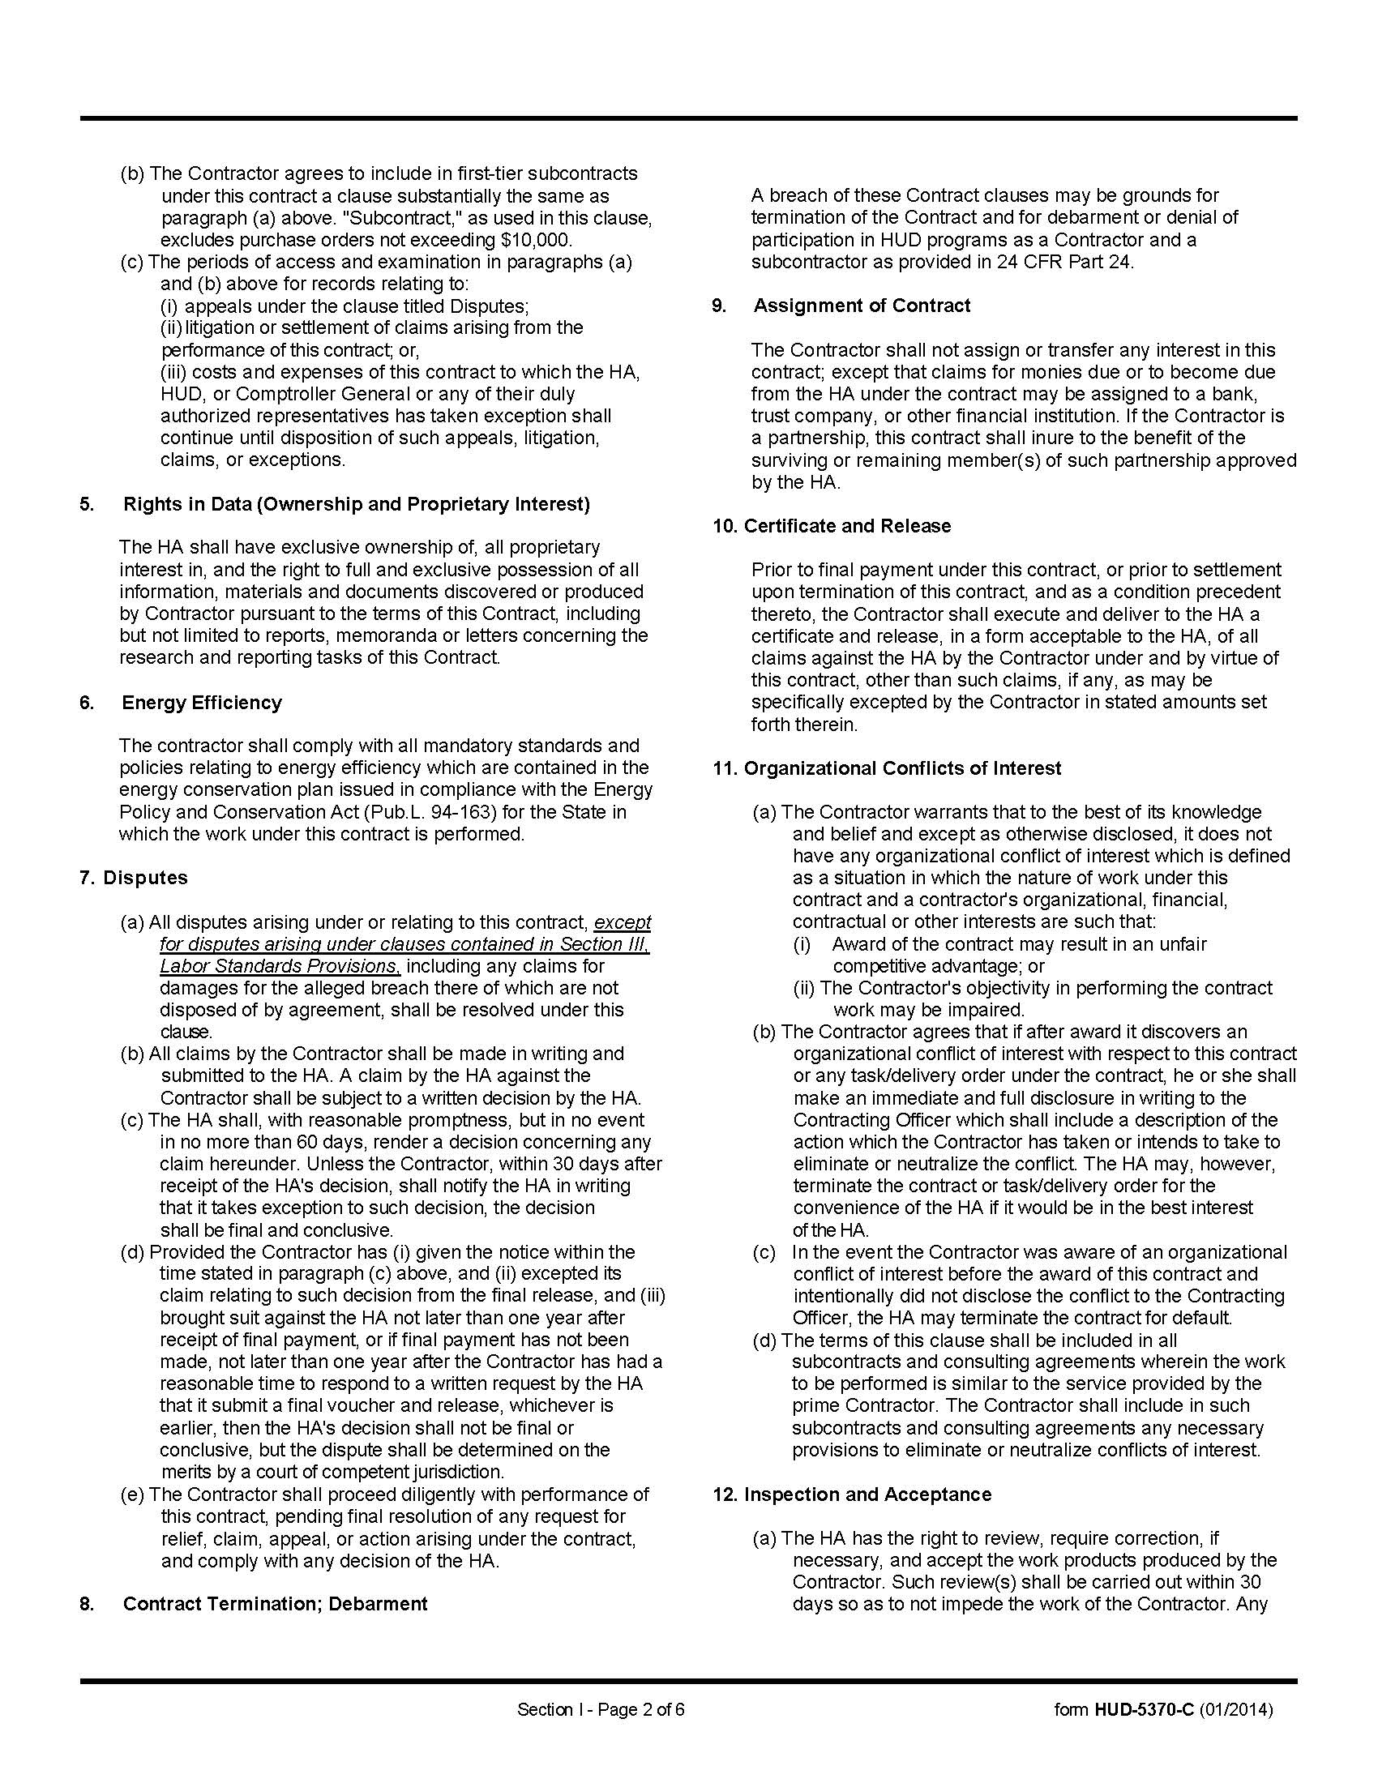
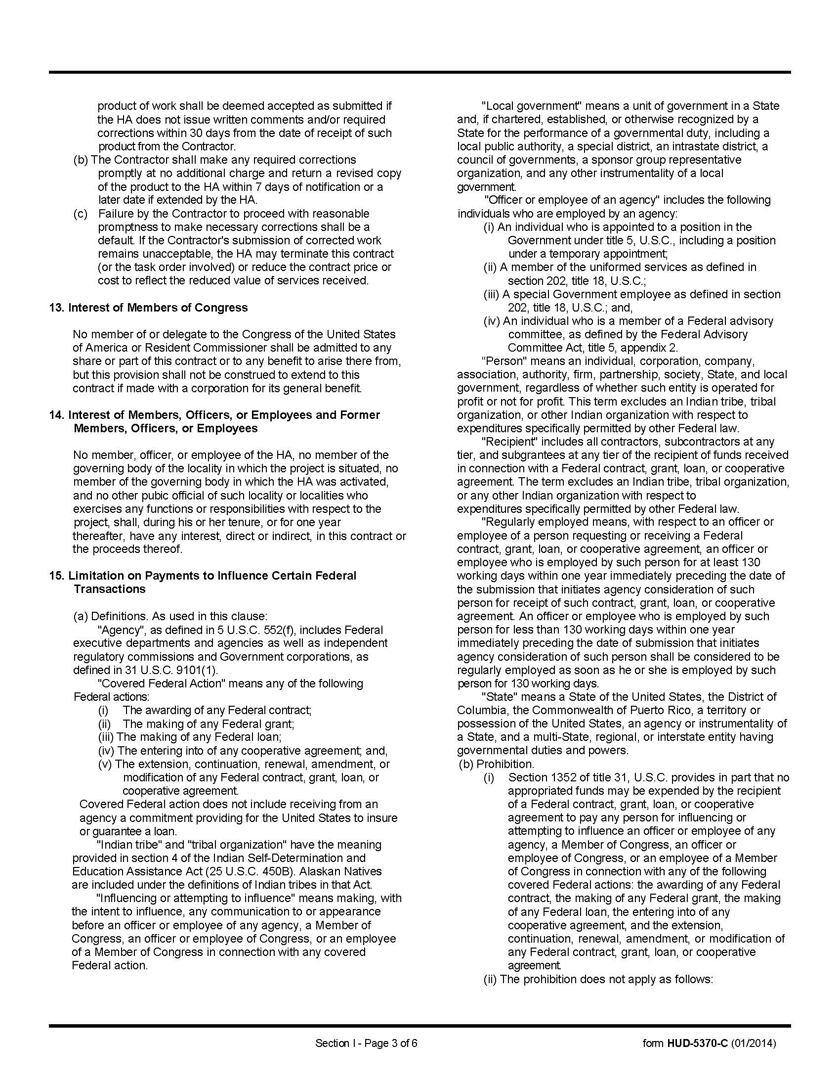
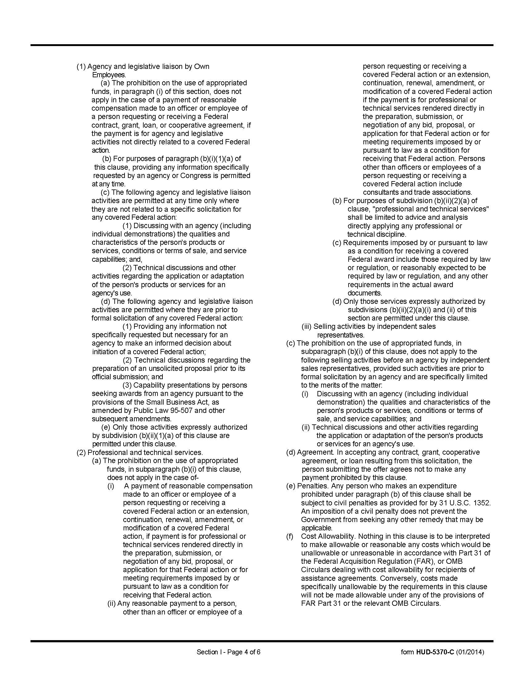
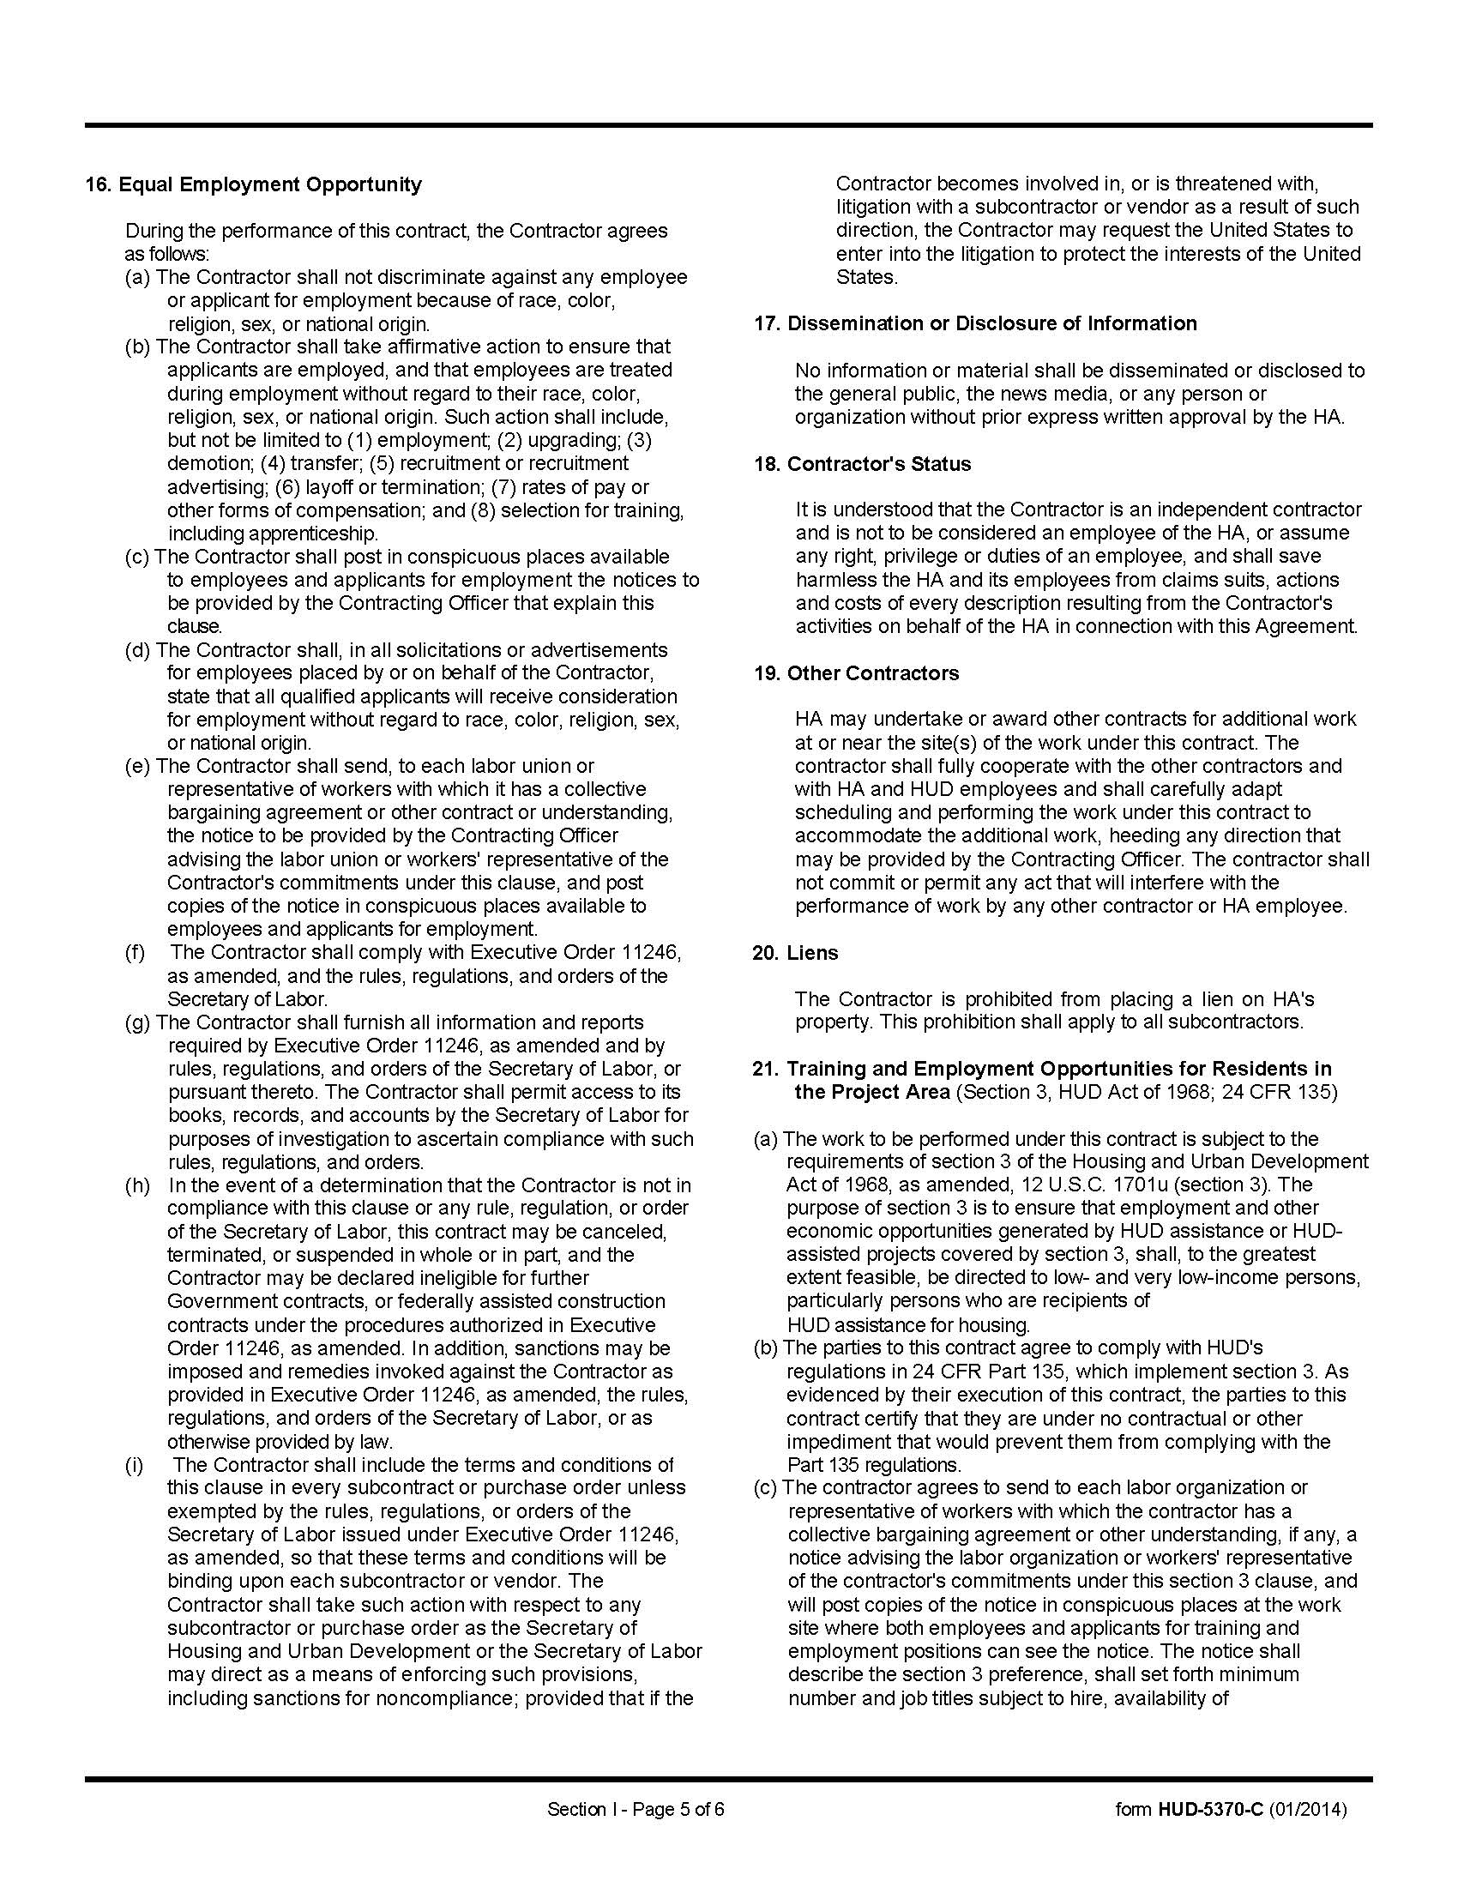
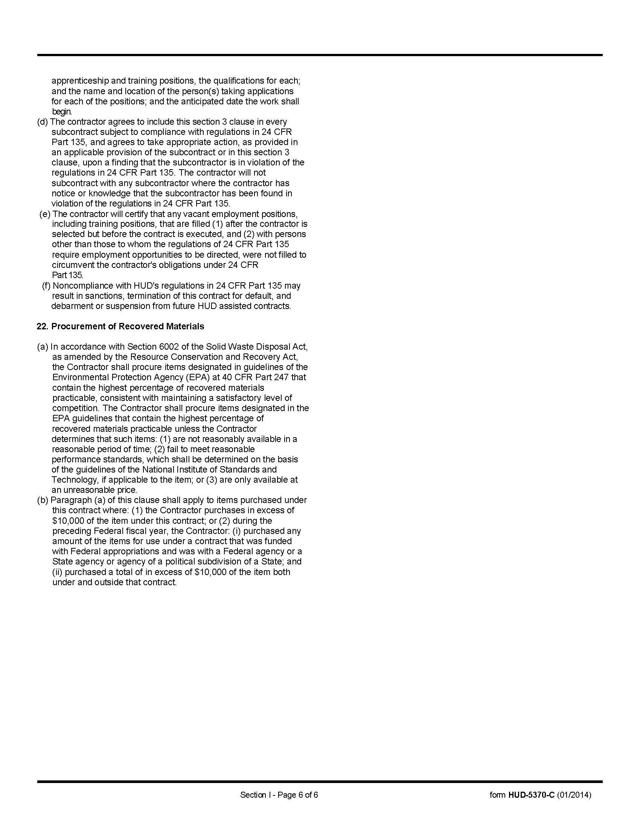
Attachment F: Section 3 Information
Attachment A: HUD Form 5369B
Section 3 is a provision of the Housing and Urban Development Act of 1968 which requires that programs of direct financial assistance administered by the U.S. Department of Housing and Urban Development (HUD) provide, to the greatest extent feasible, opportunities for job training and employment to lower income residents in connection with projects in their neighborhoods. Section 3 is a tool for fostering local economic development, neighborhood economic improvement and individual self-sufficiency.

a. Recipients and sub-recipients must make a good faith effort to utilize Section 3 area residents as trainees and employees in connection with the project. Targeted recruitment and the selection of Section 3 area residents for available positions are two examples of good faith efforts to meet this requirement.

b. Recipients and sub-recipients must make a good faith effort to award contracts to Section 3 business concerns for work in connection with the project. An example of a good faith effort to meet this requirement is the implementation of an affirmative action plan, which includes targets for the number and dollar value for awarding contracts to Section 3 business concerns.

c. Recipients and sub-recipients must keep records and submit reports to HUD documenting the good faith efforts taken and the results of these actions. Examples of such documentation include letters to community organizations, employment development and business development centers, copies of solicitations for bids or proposals, and copies of affirmative action plans.

d. Contractors must track hours worked by Section 3 workers and report them yearly.

e. How can businesses find Section 3 residents to work for them? This can be accomplished by recruiting in the neighborhood and public housing developments to tell residents about available training and job opportunities. Distributing flyers, posting signs, placing ads, and contacting resident organizations and local community development and employment agencies to find potential workers are a few effective ways of getting jobs and people together.

f. The successful firmwill give KCDC job announcements for any position that must be filled as a result of the award of KCDC work. Additionally the successful firm will supply the same job announcement to the Knoxville-Knox County Committee Action Committee’s Workforce Connections group. These can be emailed to windie.wilson@knoxcac.org or faxed to 544-5269.

g. A Section 3 worker is, when hired:
- A worker whose annual income for the previous or projected calendar year is below HUD income limits or
- Is employed by a Section 3 business concern or
- A YouthBuuld participant

h. A Targeted Section 3 worker is:
- Is employed by a Section 3 business concern or
- A Public Housing resident or HCV participant or
- Resident of other housing assisted by the Public Housing Authority or
- A YouthBuuld participant

i. A Section 3 business is one that:
- Is at least 51% owned and controlled by low or very low income persons; or
- Is at least 51% or more owned and controlled by Public Housing residents or HCV participants; or
3. Has over 75% of labor hours performed on construction projects done by low or very low income persons. This is measured during the last 3-months of work performed by the business during the reporting period.

Additional information is available from HUD at https://www.hud.gov/press/press_releases_media_advisories/HUD_No_20_159

