
Addendum #1
Date: January 26, 2023
Rockwood School District – RFP No. RFP1123HRPBM
Pharmacy Benefit Management Services
The Request for Proposals (RFP) for the above-named project is amended as noted in this Addendum. This Addendum consists of questions and Rockwood School District’s responses.
- Is the client still utilizing Smartben for eligibility? Yes
- How many onsite meetings would the client like to have during open enrollment? Unknown at this time.
- How many onsite meetings would the client like annually? Quarterly at minimum
- What entity currently produces the SPD for the client? Carrier
- How does the client engage and communicate with members currently? Email communication
- Does the client currently have an EGWP?- They do have a group Medicare supplemental plan.
- Are there any other commissions that need to be considered? No
- In regards to page 18, number 14 of the RFP, please define who is providing consulting services? USI
- In regards to page 23, in categories Data Sharing and Consulting Payment, what is the compensation for MMA consulting and what services does MMA provide? MMA does not provide services. All consulting is provided by USI.
- Are there any commissions for USI that need to be considered? No
- In the Financial section on page 17 for number 2, please confirm if an attachment will be provided to complete? Included on page 19 and 20.
- Rx Claims data Included
- Current Rx Contract Not providing
- Can you tell us for the 90-day network if Rockwood uses retail locations? If so, is the hub CVS or Walgreens? Both Smart90 Walgreens and CVS are included.
- Can you confirm we need to provide 2 printed (paper) RFP responses as well as one electronic response for all three RFPs – dental medical and pharmacy? Yes
- Can we get a pharmacy claims file for 2021 and 2022 plan years? Included
- Can we get a provider disruption file for pharmacy? Included
- What are the value adds/programs that Rockwood uses today with ESI? (For example, SaveOn SP)? SaveOn Sp, Livongo
- What formulary is Rockwood on today? National Preferred Formulary
- We are requesting an RX repricing file. Included
- What sort of formulary do they have in place (Open with Exclusions / Open with no exclusions/ Closed?) They are currently on the national Preferred. Please provide your standard as well as options.
- Do they have any sort of Retail 90 program in place currently (i.e. Broad retail 90 network or limited retail 90 network) Smart90 with CVS and Walgreens
- What type of Specialty Network do they employ currently (Closed /Exclusive or Broad /Open)? National Network, please provide your standard as well as any options you may propose.
- Do they currently have a Specialty Manufacturer Copay Solution in place?- Yes, Saveon SP
- What is the best method to provide any redlines to the Conditions RFP’s provided terms and conditions? A separate “exceptions” tab in your proposal will be sufficient.
- Please confirm if Rockwood School District has an on-site pharmacy filling claims. No If yes, please confirm the NABP numbers so we can pull those out appropriately. N/A
- For the RFP question “ Please provide current unit pricing (and other specified information) for the top 100 retail drugs by amount and by volume”, please confirm if you are requesting the Top 100 in RSD’s claims data. Top 100 in RWSDs claims data. Claims for disruption and pricing analysis have been provided.
- Please confirm the highlighted columns below should read 11/01/2023, 11/01/2024, 11/01/2025. Confirmed
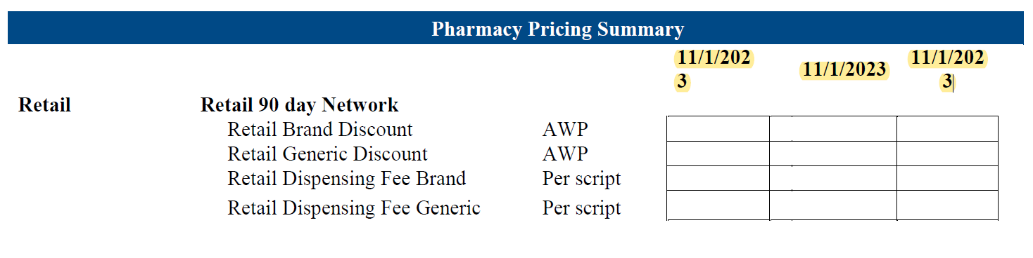
27. Please elaborate on what you would like populated in this section of the pricing table. Any pertinent enrollment information.
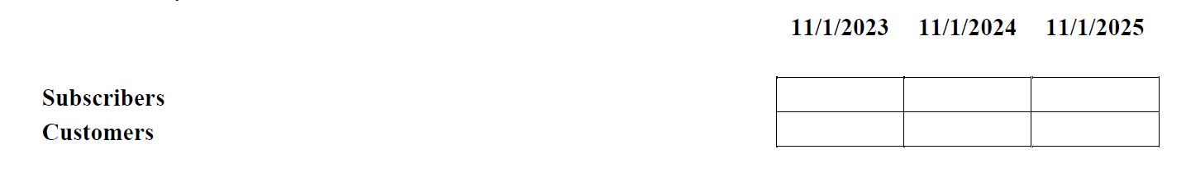
28. When will answers to the submitted questions be sent to vendor? January 23, 2023.
29. What is the best method to provide any redlines to the RFP provided terms and conditions? A separate “exceptions” tab in your proposal will be sufficient.
30. Do we have to return Exhibit B with a signature? Yes
31. Performance Guarantees – Please provide detailed instructions for information to be provided in the “Actual Results 2019” column. Please include your PGs.
32. Please provide the total life count for the district. See Census information.
33. Should we submit a redacted version of our proposal? If so, should it be sent as a separate attachment and/or document with final hard and electronic versions? Include together.
34. Please provide the district’s current formulary? National Preferred Formulary with ESI
35. Please provide current benefit design and detailed information on available clinical programs. Included.
36.Please provide monthly volume of calls handled by the center. Unknown
37. Please provide the average number of prior appeals, and grievances per month or annually. Unknown
38. Please provide the average number of DMRs per month or annually. Unknown
39. Does the client have a self-insured or fully-insured EGWP? Unknown
40. In regards to signatures on your proposal documents, will you accept an electronic signature from the appropriate executive at our company? Electronic signatures are acceptable.
41. Can form Exhibit A, affidavit of work authorization (if this section is applicable) be returned electronically signed without being notarized? Notarization is required on the affidavit of work authorization. Forms that are not notarized will be rejected.
42. In an effort to be environmentally friendly, would it be acceptable to submit an electronic proposal (via email)? Electronic copy via email is acceptable.
43. Please confirm if the electronic copy should be on USB, CD, or sent via email. Electronic copy via email is acceptable.
44. Will you accept requested attachments and/or sample documents on a CD instead of printed hard-copy? Printed copies are required. If you require printed copies, please confirm you will accept double-sided printing. Double-sided copies are acceptable.
End of Addendum #1

