

Invitation for Quotes

Solicitation Name | Industrial Supplies
Solicitation Number | Q1922
Due Date | May 21, 2019
Due Time | 11:00 a.m. EST
Deliver Responses to: |   Knoxville’s Community Development Corporation  Procurement Division  901 N. Broadway  Knoxville, TN 37917  The Procurement Building is behind the Main Office building.
Electronic Copies | Electronic copies are available on KCDC’s webpage or by email at purchasinginfo@kcdc.org.
Responses may be Emailed to KCDC | ☒ Yes ☐ No
Printed Responses Required | ☐ Yes ☒ No
Solicitation Meeting | ☐ Yes ☒ No
Solicitation Meeting is Mandatory | ☐ Yes ☐ No ☒ Not Applicable
Solicitation Meeting Date | Not applicable
Solicitation Meeting Time | Not applicable
Solicitation Meeting Location | Not applicable
Questions About This Solicitation | KCDC will not accept questions via telephone. Submit questions to purchasinginfo@kcdc.org by 4:00 p.m. on May 16, 2019.
Award Results | KCDC posts a summary of the quotes received and the award decision to its web page to http://www.kcdc.org/procurement/
Open Records/Public Access to Documents | All document provided to KCDC are subject to the Tennessee Open Meetings Act (TCA 8-44-101) and open records requirements.

Check KCDC’s webpage for addenda and changes before submitting your response

General Information

1. Background and Intent

a. Knoxville's Community Development Corporation (KCDC) is the public housing and redevelopment agency for the City of Knoxville and for Knox County in Tennessee. KCDC’s affordable housing property portfolio includes 20 sites with approximately 3,525 dwelling units. Several of the properties include Low Income Housing Tax Credits units and KCDC is both the General Partner and the management company for those sites. Those properties include Eastport LP, Five Points 1, LP; Lonsdale Homes, LP; Northridge Crossing, LP and The Vista at Summit Hill, LP. KCDC also oversees approximately 3,958 Section 8 Vouchers, 82 Moderate Rehabilitation units and 20 Redevelopment areas.

b. KCDC performs many maintenance functions at its properties. KCDC intends to use the award resulting from this solicitation to purchase miscellaneous industrial supplies on an as needed basis. As such needs arise, the site manager will contact the successful supplier to request supplies.

c. Any agreement resulting from this solicitation will be an “open-end” type of agreement. There is no guarantee that any specified or minimum level of services will be required by KCDC or provided by the supplier.

d. It is understood that KCDC intends to use the successful supplier for these products or services; however, KCDC reserves the right to purchase these products or services elsewhere if it is in KCDC’s best interest.

e. To develop a good working relationship with the successful supplier, it is imperative that KCDC’s account be handled efficiently and professionally. KCDC should be assigned no more than two contacts to handle billing inquiries and service related issues. In the event one or both contacts leave the KCDC account, the successful supplier shall formally introduce the new contacts to KCDC personnel. These contacts must be knowledgeable of KCDC so as to avoid any interruption of service.

2. Changes after Award
It is possible that after award KCDC will need to revise the service needs or requirements specified in this document. KCDC reserves the right to make such changes after consultation with the supplier. Should additional costs arise, the supplier must document increased costs. KCDC reserves the right to accept and negotiate these charges.

3. Contact Personnel
The supplier will assign no more than two contacts to handle billing inquiries and service related issues. In the event one or both contacts leave the KCDC account, the supplier will introduce the new contacts to KCDC personnel. These contacts must be knowledgeable of KCDC’s account to avoid any interruption of service.

4. Contact Policy
The supplier may not contact an officer, agent or employee of KCDC other than the KCDC’s Procurement Division about matters pertaining to this solicitation, from the issuance of this solicitation until its award. Information obtained from an unauthorized officer, agent or employee of KCDC will not affect the risks or obligations assumed by the supplier or relieve the supplier from fulfilling any of the conditions of the project. Such contact can disqualify the supplier from participation in the solicitation process.

5. Delivery

a. Delivery will be to specified locations within Knox County, Tennessee. Please see Solicitation Document E - KCDC Site Addresses.

b. Deliveries are accepted (approximately - may depend upon the site) between 7:30 a.m. and 3:30 p.m. each business day.

c. Deliveries will not incur additional cost to KCDC.

d. KCDC may or may not ask for delivery.

6. Evaluation
KCDC will evaluate this solicitation and award to the “lowest and best.” KCDC alone determines (using NIGP’s definition and other relevant sources as appropriate) the supplier’s “responsive” and “responsible” status prior to award.

Responsible means a business with the financial and technical capacity to perform the requirements of the solicitation and subsequent award.

A responsive bid is one that fully conforms in all material respects to the solicitation document and all its requirements, including all form and substance. KCDC reserves the right to request additional information to assist in the evaluation process; this includes references and business capacity information.

7. General Instructions
KCDC does not insert “General Instructions to Suppliers” in solicitation documents. These instructions are at www.kcdc.org. Click on “Procurement” and the link to the instructions. The supplier’s submittal means acceptance of the terms and conditions set forth in KCDC’s “General
Instructions to Suppliers.”

8. Invoicing/Ordering

a. Until a purchase order is in place, work is not to be performed nor are goods to be delivered. KCDC does not have a legal obligation to pay for the work performed prior to the issuance of a purchase order.

b. Suppliers must submit invoices within 90 days of the delivery of goods or services. KCDC may deny
invoices submitted after the 90 day threshold. KCDC prefers invoices arrive within 10 days following the end of the month in which goods or services were supplied.

c. KCDC’s purchases of goods are exempt from Tennessee sales and use tax pursuant to Tennessee Code Annotated 67-6-329(a) (4) and KCDC is generally exempt from the Federal Excise tax. Suppliers are subject to Tennessee sales and use tax on all materials and supplies used in the performance of a contract, whether such materials and supplies are purchased by the supplier, produced by the supplier, or provided to the supplier by KCDC, pursuant to Tennessee Code Annotated 67-6-209.
The supplier will pay all taxes incurred in the performance of an awarded contract. Upon the placement of a purchase order or the award of a contract, KCDC will provide a State of Tennessee Sales Tax Exemption form to the supplier. KCDC will not pay taxes on invoices.

d. KCDC pays by electronic transfer (ACH) only. Supplier’s accounts receivable staff must use KCDC’s
portal to ascertain payments made and to which invoices they apply. Supplier’s may set up KCDC’s portal so that they receive an email with each payment detailing the amount and invoice paid.

e. Since KCDC is the managing partner for four separate corporations under the KCDC umbrella, those separate corporations must receive separate invoices. Thus the supplier will generally:

- Bill each specific site for work performed or goods delivered
- With KCDC’s permission, generate one monthly master invoice showing all locations and their
individual costs (except for those listed below)
- Create separate invoices for Five Points I, Lonsdale Homes, North Ridge Crossing and The Vista.

f. Invoices must:

1. Be numbered
2. List a date on them that is after the work is completed or goods delivered
3. List the purchase order number
4. Breakdown pricing according to the award structure

g. KCDC requires that invoices be submitted via email.

9. Length of Award
The length of the award will be twelve months with four optional annual renewals that KCDC may exercise at its discretion.

10. Price Structure

a. At the end of each twelve month period, the awarded supplier may request a change to the percentage and/or specific item charged to KCDC. The supplier must provide proof of the necessity of the increase to the Procurement Division. KCDC will decide whether to accept a price increase. If the price increase is accepted, the award file will be so noted. If the price increase is not accepted, the supplier may:
1. Continue with the existing pricing.
2. Suggest an alternative price increase.
3. End the award.

b. KCDC does not pay fuel surcharges.

c. Suppliers may decrease prices at any time with or without notice.

11. Questions
Send direct questions pertaining to this document to purchasinginfo@KCDC.org with “Industrial Supplies” in the subject line, at least five business days prior to the due date. KCDC does not accept questions via telephone.

12. Use of Solicitation Forms
Suppliers are to complete the solicitation forms contained in the solicitation package. Failure to complete these forms may result in rejection of your response. Do not alter the solicitation forms without KCDC’s approval. Suppliers are to use the MS Word version of the pricing pages to eliminate difficulties in reading handwritten text.

13. Smoking Policy
KCDC has a Smoke Free policy that applies to you, your employees and all subcontractors. This policy mandates:

• No smoking on KCDC’s property
• No e-vape or similar usage on KCDC’s property
• The Smoke Free policy applies in personal or corporate vehicles on KCDC’s property

HUD definitions include:

- “Smoking” means inhaling, exhaling, burning or carrying any lighted or heated cigar, cigarette or pipe, or any other lighted or heated tobacco or plant product intended for inhalation, including hookahs and marijuana, whether natural or synthetic, in any manner or in any form.

- “Smoking” also includes the use of an electronic smoking device which creates an aerosol or vapor, in any manner or in any form.

- “Electronic Smoking Device” means any product containing or delivering nicotine or any other substance intended for human consumption that can be used by a person in any manner for the purpose of inhaling vapor or aerosol from the product.

The term includes any such device, whether manufactured, distributed, marketed or sold as an e-cigarette, e-cigar, e-pipe, e-hookah or vape pen or under any other product name or descriptor.

- Property means all KCDC owned buildings, parking lots, streets, structures and land.
Should supplier staff be observed violating these requirements, KCDC’s Procurement Division will notify the corporate level contact about the problem. Should there be recurrences; KCDC may ask the supplier to not send the employee to owner’s property. Repeated offenses may result in forfeiture of your award.

This and the Previous Pages Do Not Need to be Returned

Industrial Supplies Q1922

Solicitation Document A General Response Section

General Information about the Supplier
Sign Your Name to the Right of the Arrow
By signing, you indicate you read and agree to “KCDC’s General Instructions to Suppliers” on www.kcdc.org.
Printed Name and Title
Company Name
Street Address
City/State/Zip
Contact Person (Please Print Clearly)
Telephone Number
Cell Number
Supplier’s E-Mail Address (Please Print Clearly)
Addenda
Addenda are at www.kcdc.org. Click on “Procurement” and then on “Open Solicitations” to find addenda. Please check for addenda prior to submitting a response.
Acknowledge addenda have been issued by checking below as appropriate:
None ☐ | Addendum 1 ☐ |  |  | Addendum 2 ☐ |  | Addendum 3 ☐ |  |  | Addendum 4 ☐ | Addendum 5 ☐
Statistical Information (Check all the apply)
This business is at least 51% owned and operated by a woman |  |  |  |  |  |  |  |  |  |  | Yes ☐ No ☐
This business qualifies as a small business by the State of Tennessee  (Gross receipts of $10,000,000 or less and employing less than 100 full time persons ) |  |  |  |  |  |  |  |  |  |  | Yes ☐ No ☐
This business qualifies as Section 3 business (as defined by HUD):  It is at least 51% owned by a Section 3 resident (lives in Public Housing) or it employs Section 3 residents for at least 30% of its employee base; or it commits to sub contract at least 25% of the project’s dollars to a Section 3 business. |  |  |  |  |  |  |  |  |  |  | Yes ☐ No ☐
This business is owned & operated by persons at least 51% of the following ethnic background:
Asian/Pacific ☐ |  | Black ☐ | Hasidic Jew ☐ |  | Hispanic ☐ |  |  | Native Americans ☐ |  |  | White ☐
Cooperative Procurement
Subject to additional location/delivery charges, the supplier agrees to extend the offered costs to other governments if the government so desires. Yes ☐ No ☐
Prompt Payment Discount
A prompt payment discount of ________% is offered for payment within ____ days of submission of an accurate and proper invoice.
MasterCard Acceptance
Mastercard is accepted for payment without additional fees. Yes ☐ No ☐
Mastercard is accepted for payment with a fee of _______. Yes ☐ No ☐

Industrial Supplies Q1922

Solicitation Document B Cost

Part I Specific Items and Cost
The brand name items below are offered to assist in the description of the product only. Products offered must be equal to the products listed. KCDC is the sole judge as to product equivalency.

Momar Brand Name | Description | Brand/Model Offered | Cost | Unit of Measurement
ASAP | Solvent Cleaner |  | $
Burgess Thermo Fogger | Water or Oil Based Sprayer/Fogger |  | $
Coil & Filter | Coil and Filter Cleaner |  | $
Crack Sealer | Crack Sealant |  | $
Edger | Turf and Water Weed Killer |  | $
Great Grape | Floating Degreaser and Solvent |  | $
Gym Floor Clean | Wood Floor Cleaner |  | $
Hammer | Floor Cleaner, Buffing Agent |  | $
Hit | Tile and Grout Cleaner, Mildew Remover |  | $
Insta-Patch | Concrete Patch |  | $
Lucent RTU | Glass Cleaner |  | $
Magnet RTU | Dusting Cleaner |  | $
Muriatic Acid | Concrete, Cement, Remover, Rust |  | $
Neutra-Dis | Disinfectant, Cleaner, Deodorizer |  | $
No Mow II Gallons | Non Selective Weed Killer |  | $
Odo-Way | Deodorizing Granules |  | $
One Step Gallons | Weed Killer |  | $
Plug Buster | Heavy Duty Drain Opener |  | $
Purge | Insecticide for Smart Spray Dispenser |  | $
Red Fantastic | Butyl-Based Cleaner Degreaser |  | $
Safe Grit Non Skid | Rubberized Enamel Coating |  | $
SLR | Scale, Lime and Rust Remover |  | $
Smart Spray | Deodorizers |  | $
Smart Spray Dispenser | Dispenser |  | $
SS Plus | Metal Cleaner/Polisher |  | $
Stallion | Black Rubber Coating |  | $
Tough as Nails | Floor Coating |  | $
Tuffy | Foaming Stripper |  | $
Vigor | Peroxide Fortified Cleaner/Degreaser |  | $
Vandal Mark Remover | Graffiti Remover |  | $
WeatherMaster | Caulk |  | $
Zyme-Attack | Cleaner/Deodorizer |  | $

Part II Discount Pricing
This section is intended to allow for the purchase of additional, non-specified items priced at the catalog/shelf/jobber’s cost. The cost is specified by the supplier, minus the discount rate offered. While prices may fluctuate from time-to-time, the discount will remain the same as quoted below.

Discount Category | Percentage Offered  (0 is acceptable) | Discount Base  Catalog, Shelf, Jobber’s
Base Discount Offered | %
Other Discount | %
Other Discount | %
Other Discount | %
Other Discount | %

Industrial Supplies Q1922

Solicitation Document C Affidavits

Supplier: _____________________________________________________________________________

Conflict of Interest:
1. No commissioner or officer of KCDC or other person whose duty it is to vote for, let out, overlook or in any manner superintend any of the work for KCDC has a direct interest in the award or the supplier providing goods or services.

2. No employee, officer or agent of the grantee or sub-grantee will participate in selection, or in the award or administration of an award supported by Federal funds if a conflict of interest, real or apparent, would be involved. Such a conflict would arise when the employee, officer or agent, any member of his immediate family, his or her partner, or an organization, which employs, or is about to employ, any of the above, has a financial or other interest in the supplier selected for award.

3. The grantee's or sub-grantee's officers, employees or agents will neither solicit nor accept gratuities, favors or anything of monetary value from suppliers, potential supplier s, or parties to sub-agreements.

4. By submission of this form, the supplier is certifying that no conflicts of interest exist.

Drug Free Workplace Requirements:
5. Private employers with five or more employees desiring to contract for construction services attest that they have a drug free workplace program in effect in accordance with TCA 50-9-112.

Eligibility:
6. The supplier is eligible for employment on public contracts because no convictions or guilty pleas or pleas of nolo contender to violations of the Sherman Anti-Trust Act, mail fraud or state criminal violations with an award from the State of Tennessee or any political subdivision thereof have occurred.

General:
7. Supplier fully understands the preparation and contents of the attached offer and of all pertinent circumstances respecting such offer.

8. Such offer is genuine and is not a sham offer.

Iran Divestment Act:
9. Concerning the Iran Divestment Act (TCA 12-12-101 et seq.), by submission of this bid/quote/proposal, each supplier and each person signing on behalf of any supplier certifies, and in the case of a joint bid/quote/proposal, each party thereto certifies as to its own organization, under penalty of perjury, that to the best of its knowledge and belief that each supplier is not on the list created pursuant to § 12-12-106.

Industrial Supplies Q1922

Solicitation Document C Affidavits - continued

Non-Collusion:
10. Neither the said supplier nor any of its officers, partners, owners, agents, representatives, employees or parties interest, including this affiant, has in any way colluded conspired, connived or agreed, directly or indirectly, with any other responder, supplier, or person to submit a collusive or sham offer in connection with the award or agreement for which the attached offer has been submitted or to refrain from making an offer in connection with such award or agreement, or collusion or communication or conference with any other supplier, or, to fix any overhead, profit, or cost element of the offer price or the offer price of any other supplier, or to secure through any collusion, conspiracy, connivance, or unlawful agreement any advantage against KCDC or any person interested in the proposed award or agreement.

11. The price or prices quoted in the attached offer are fair, proper and not tainted by any collusion, conspiracy, connivance, or unlawful agreement on the part of the supplier or any of its agents, representatives, owners, employees, or parties in interest, including this affiant.

Accuracy of Electronic Copies:
12. If the supplier provides electronic copies of the bid/proposal/quote to KCDC, the supplier certifies that the information provided on paper and in the electronic format is identical unless specifically noted otherwise.

No Contact/No Advocacy Affidavit:
13. After this solicitation is issued, any contact initiated by any supplier with any KCDC representative concerning this solicitation is strictly prohibited-except for communication with the Procurement Division. My signature signifies that no unauthorized contact occurred.

14. To ensure the integrity of the review and evaluation process, respondents to this solicitation nor any firm representing them, may not lobby or advocate to KCDC staff or Board members. My signature signifies that no unauthorized advocacy occurred.

The undersigned hereby acknowledges receipt of these affidavits and certifies that the submittal in response to this solicitation is in full compliance with the listed requirements.

Signed by
Printed Name
Title
Subscribed and sworn to before me this date
By (Notary Public)
My Commission Expires on
Notary Stamp
Industrial Supplies Q1922
Solicitation Document D HUD Form 5369A

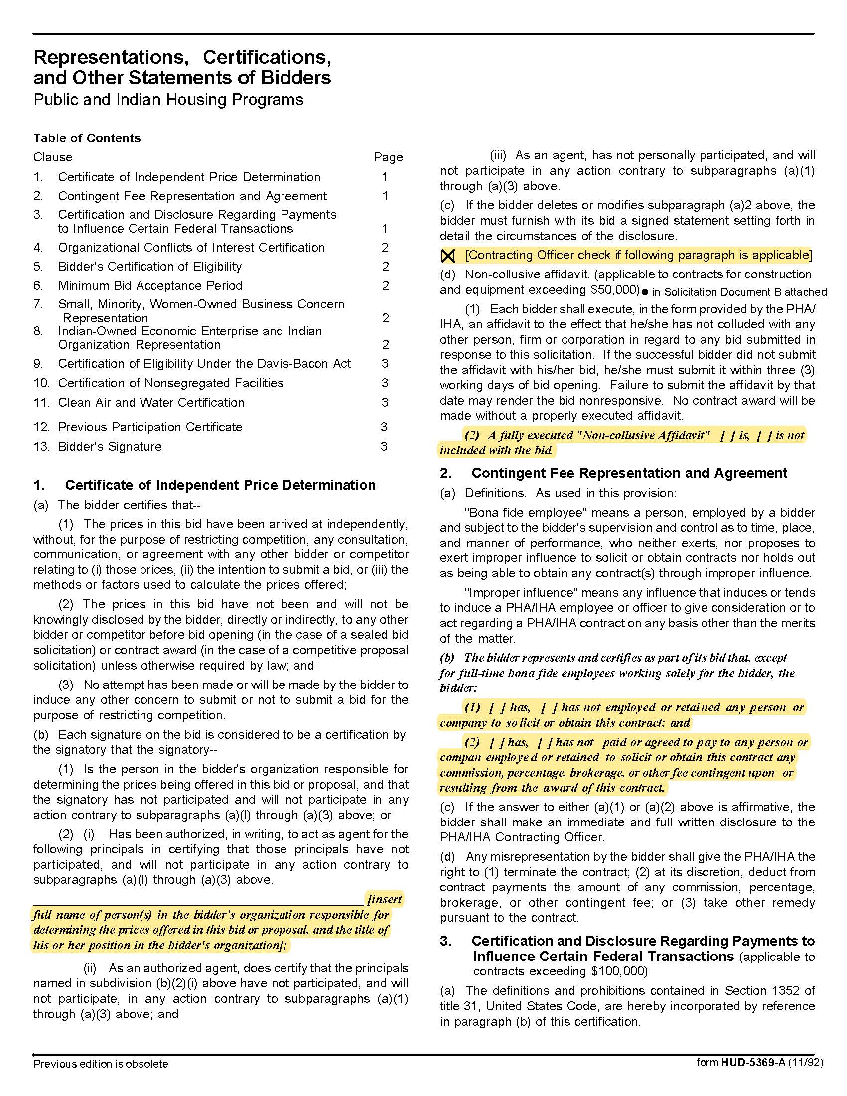

Industrial Supplies Q1922
Solicitation Document D HUD Form 5369A - Continued
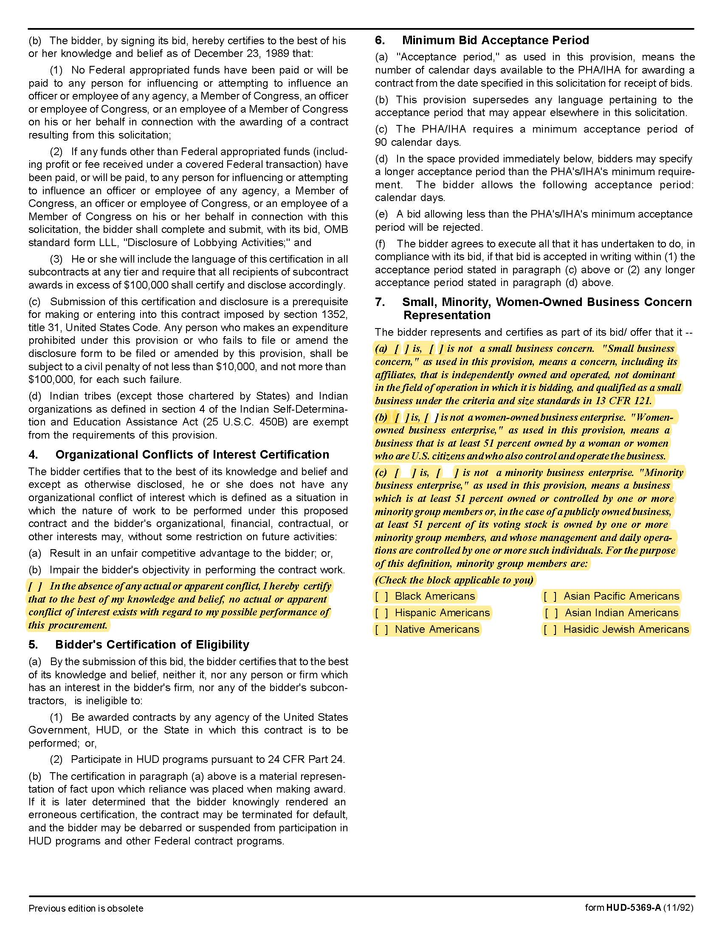

Industrial Supplies Q1922
Solicitation Document D HUD Form 5369A - Continued
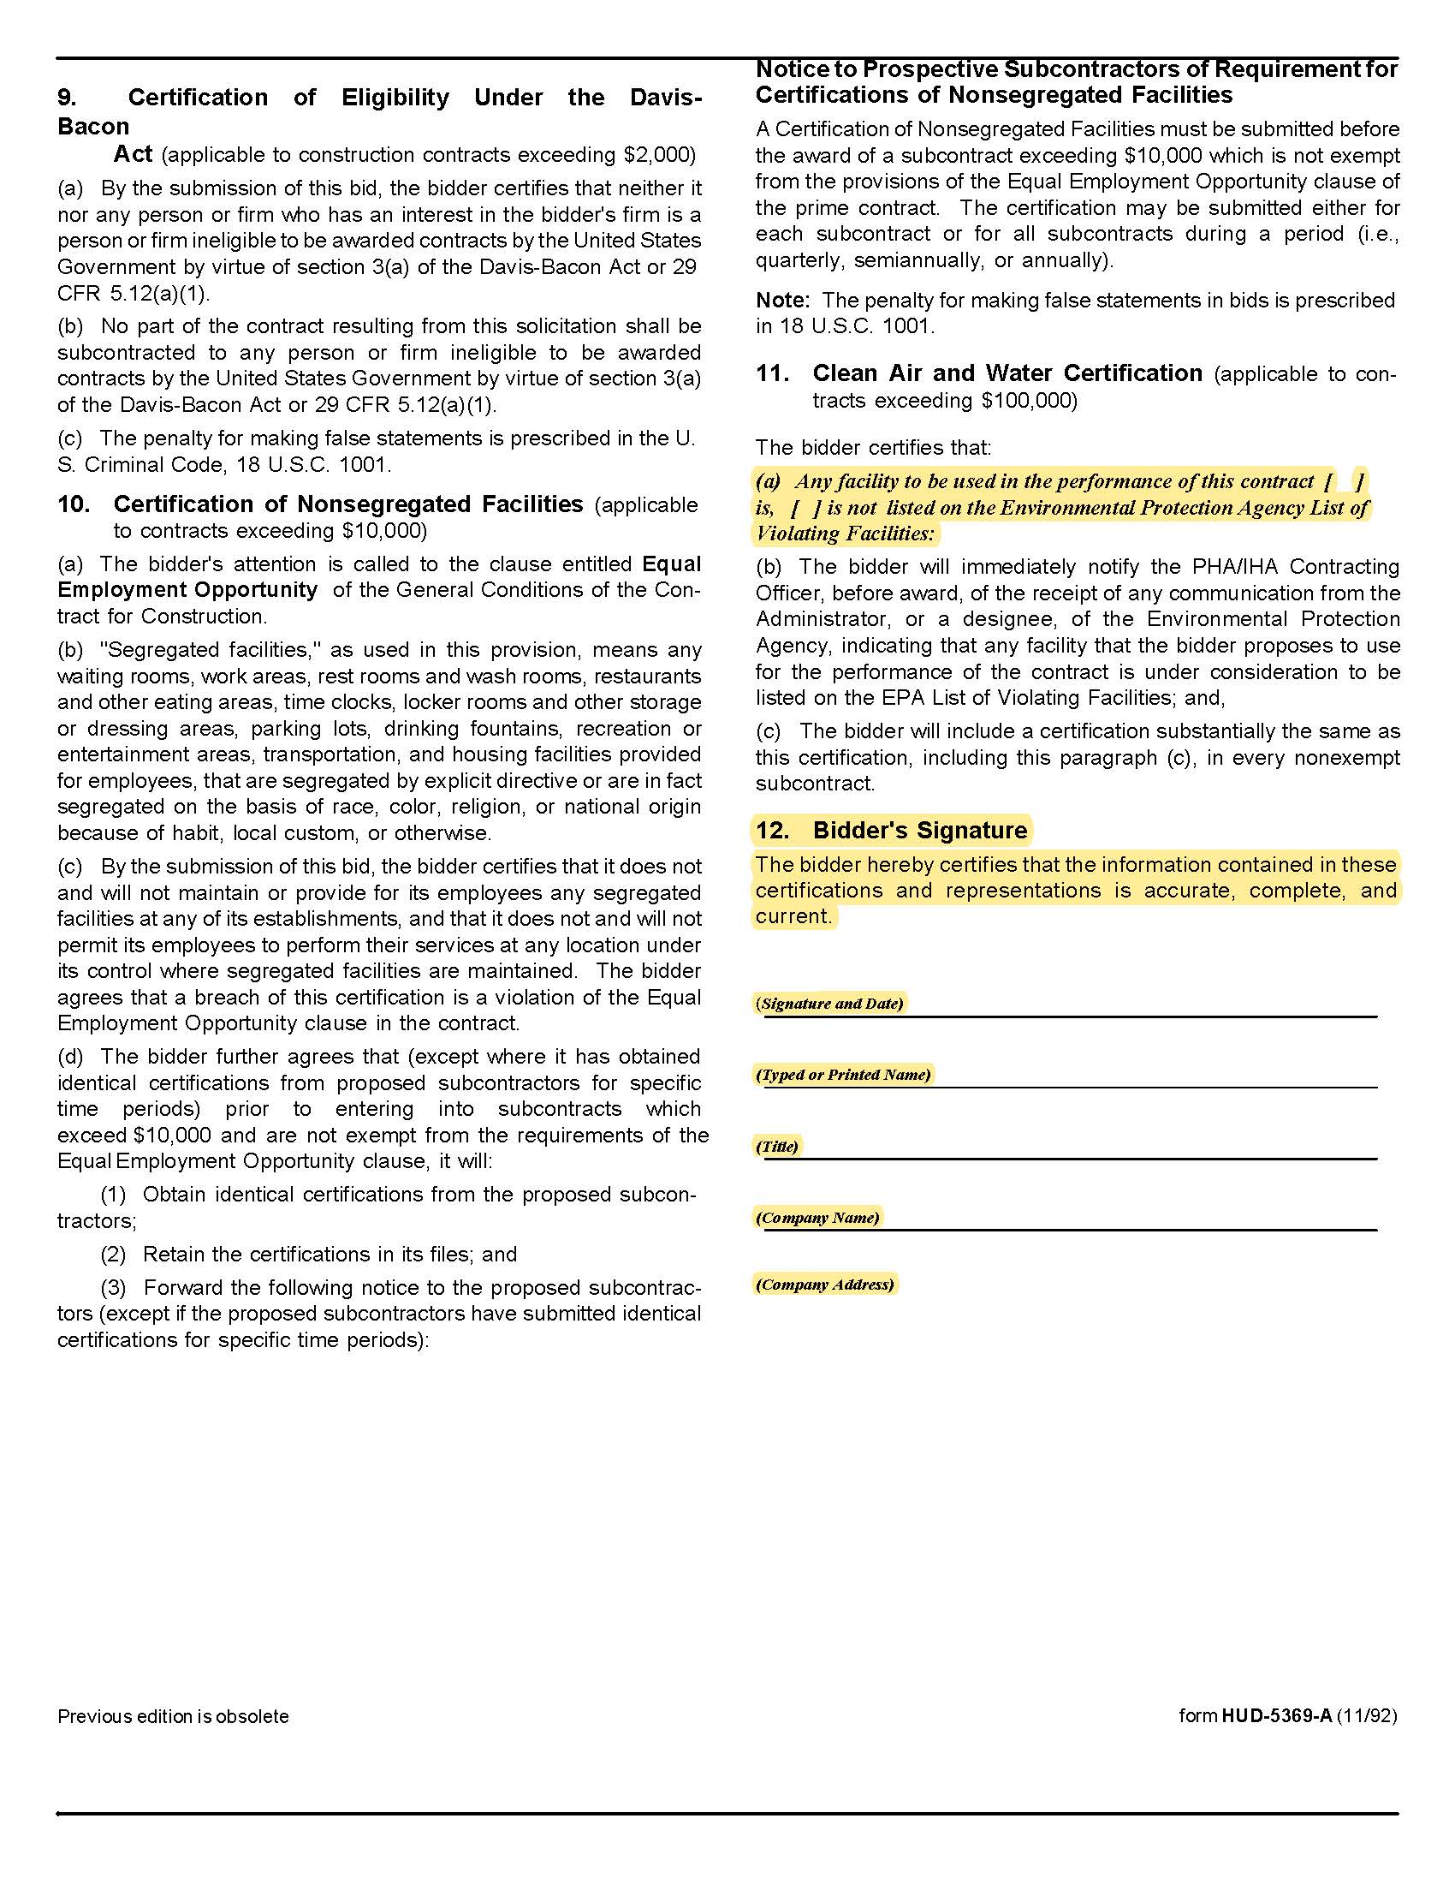

Industrial Supplies Q1922
Solicitation Document E Site Manager’s Contact Information

Property | Address | Manager | Contact Points
Austin Homes | 957 East Hill Avenue | Darrell Lindsey | dlindsey@kcdc.org 403-1300
Autumn Landing | 6331 Pleasant Ridge Road | James Pruitt | jpruitt@kcdc.org 403-1422
Cagle Terrace | 515 Renford Drive | Manager: Rhonda Harris  Maintenance: Larry Medley | rharris@kcdc.org 403-1310  lmedley@kcdc.org
Five Points Properties | Office at 381 McConnell | Kim Clark | kclark@kcdc.org 403-1390
Isabella Towers | 1515 Isabella Circle | Manager: Sam Chambers  Maintenance: Mark Meade | schambers@kcdc.org 403-1340  mmeade@kcdc.org
Lonsdale Homes | 2020 Minnesota Avenue | Darlene Farmer | dfarmer@kcdc.org 403-1350
Love Towers | 1171 Armstrong Avenue | Steve Ellis | Sellis@kcdc.org 403-1360
Mechanicsville | Office at 2020 Minnesota Avenue | Darlene Farmer | dfarmer@kcdc.org 403-1350
Montgomery Village | 4530 Joe Lewis Road | Linda Jeter | ljeter@kcdc.org 403-1380
Nature's Cove | 2639 Bakertown Road | Manager: James Pruitt  Maintenance: Johnny Booker | jpruitt@kcdc.org 403-1422  jbooker@kcdc.org
North Ridge Crossing | 712 Breda Drive | Adronicus Thomas | athomas@kcdc.org 403-1320
Northgate Terrace | 4301 Whittle Springs Road | Manager: Terri Evans  Maintenance: Rodney Yardley | tevans@kcdc.org 403-1400  ryardley@kcdc.org
Passport Properties/Residences | Office at 381 McConnell | Kim Clark | kclark@kcdc.org 403-1390
Supportive Maintenance | 1130 Cornelia Street | Jack Canada | jcanada@kcdc.org 403-1371
Valley Oaks | 3504 Oak Branch Circle | Adronicus Thomas | athomas@kcdc.org 403-1320
Verandas | 107 Flenniken Avenue | Linda Jeter | ljeter@kcdc.org 403-1380
Vista | 957 East Hill Avenue | Darrell Lindsey | dlindsey@kcdc.org 403-1300
Western Heights | 1621 Jourolmon Avenue | Manager: Kristie Toby  Maintenance: Bryan Coffee | ktoby@kcdc.org 403-1420  bcoffey@kcdc.org

