

RANDOLPH COUNTY
725 McDowell Road
Asheboro, NC 27205
Tel: (336) 318-6304
Fax: (336) 636-7568
Email: lisa.garner@randolphcountync.gov

REQUEST FOR BIDS

Bid# 16-0910

FOR

Sale and Removal of Improvements to Real Property
(6 Houses)

Issued on: Monday, October 10, 2016
Due Date: Tuesday, November 15, 2016

Administered by: Lisa T. Garner, Purchasing Officer

NOTICE TO BIDDERS

Pursuant to General Statutes of North Carolina Section 160A-268 as amended, bids will be received by the Purchasing Officer for Randolph County for the following:

REQUEST for BIDS 16-0910
Sale and Removal of Improvements to Real Property
(6 Houses)

The County plans to sell the improvements described herein and is accepting bids from interested parties.

Submission of any bid signifies the Bidder’s agreement that its bid and the contents thereof are valid for 120 days (four months) following the submission deadline. The purchase price submitted with the bid shall remain in effect for the 120-day period.

Bidders shall be screened to determine if the Bidder has any delinquent financial obligations (taxes, fees, etc.) to Randolph County Government and to determine if the Bidder is listed as debarred by state or federal government. A finding of debarment or delinquency shall disqualify the Bidder from consideration.

Randolph County reserves the right to reject any and/or all bids.

Sincerely,

Lisa T. Garner

Lisa T. Garner,
Purchasing Officer

1. Intent and General Information

Randolph County intends to sell the following structure(s) and submits this Request for Bids (RFB) from prospective buyers.

Exhibit A: The structure is a one-story, wood frame, home with vinyl siding originally built in or around the year 2000 and approximately 1,873 square feet in size located at 5515 Troy Smith Road, Liberty, North Carolina 27298. For more information, see GIS web link: http://gis.randolphcountync.gov/randolphjs/ and search on property identification number 8718900964.

Exhibit B: The structure is a one-story, wood frame, home originally built in or around the year 1974 and approximately 2,296 square feet in size located at 5353 Troy Smith Road, Liberty, North Carolina 27298. For more information, see GIS web link: http://gis.randolphcountync.gov/randolphjs/ and search on property identification number 8717895590.

Exhibit C: The structure is a one-story ranch home, brick exterior originally built in or around the year 1961 and approximately 1,420 square feet in size located at 8169 Old 421 Road, Liberty, North Carolina 27298. For more information, see GIS web link: http://gis.randolphcountync.gov/randolphjs/ and search on property identification number 8718534909.

Exhibit D: The structure is a one-story ranch home, brick exterior originally built in or around the year 1964 and approximately 1,878 square feet in size located at 8807 Old 421 Road, Liberty, North Carolina 27298. For more information, see GIS web link: http://gis.randolphcountync.gov/randolphjs/ and search on property identification number 8708937765.

Exhibit E: The structure is a 1.75 story home with vinyl siding originally built in or around the year 1986 and approximately 1,141 square feet in size located at 5226 Orange Blossom Drive, Liberty, North Carolina 27298. For more information, see GIS web link: http://gis.randolphcountync.gov/randolphjs/ and search on property identification number 8718337986.

Exhibit F: The structure is a one-story home with vinyl siding originally built in or around the year 1998 and approximately 2,190 square feet in size located at 5301 Orange Blossom Drive, Liberty, North Carolina 27298. For more information, see GIS web link: http://gis.randolphcountync.gov/randolphjs/ and search on property identification number 8718435778.

The purpose of this solicitation is for the removal of the structure(s) from the property, whether by demolition or removal. Removal of the structure(s) must take place within one hundred twenty (120) days from the date of the award of the bid.

The County will not be bound by or be responsible for any explanation, interpretation or conclusions of this RFB or any documents provided by the County other than those given in writing by the County through the issuance of addenda. The Bidder shall not rely on any oral statements by the County or its’ agents, advisors or consultants. It is the full responsibility of the Bidder to thoroughly investigate the needs/requirements of the County as described in this RFB and to bid in accordance with said needs/requirements.

1.2 Issuing Office and Inquiries

This Request for Bids (RFB) is issued by Randolph County Purchasing Office on behalf of Randolph County. Any inquiries, clarifications, or interpretations regarding this RFB should be directed in writing to:

Lisa Garner
Purchasing Officer
Randolph County Administration
725 McDowell Road
Asheboro, NC 27205

(336) 318-6304
lisa.garner@randolphcountync.gov

Responses to inquiries that affect the content of this RFB will be provided in writing to all recipients of the RFB through an addendum that will be posted on the County website, http://www.co.randolph.nc.us/purchasing/bid.htm. It is the responsibility of each Bidder to inquire about any aspect of the RFB that is not fully understood or is believed to be susceptible to more than one interpretation. The County will accept only written inquiries regarding this RFB until Wednesday, October 26, 2016 at 5:00 P.M. All times listed are understood to be Eastern Standard Time unless otherwise noted. The County’s interpretation of the RFB shall be controlling in all cases.

1.3 Important Dates

Issue Date: Monday, October 10, 2016

Open House: Call for appointment
Paxton Arthurs (336) 318-6605

Final Date for Written Questions: Wednesday, October 26, 2016 at 5:00 P.M.

Final Date for Addenda Posting: Monday, October 31, 2016 at 5:00 P.M.

Deadline for Submitting Bids & Bid Opening: Tuesday, November 15, 2016 at 10:00 A.M.

1.4 Submission of Bids

Bids must be presented on the Bid Proposal Form included in this RFB; placed in an envelope along with the required bid deposit, sealed and delivered to:

Lisa Garner
Purchasing Officer
Randolph County Administration
725 McDowell Road
Asheboro, NC 27205

(336) 318-6304
lisa.garner@randolphcountync.gov

Any bid submitted on forms other than the Randolph County Bid Form may be disqualified.

Bid must be accompanied by a bid deposit equal to 5% of the bid. The bid deposit may be provided in cash, cashier’s check, or certified check. Personal checks not accepted.

In order to be considered for selection, bids must be received by the date, time and place previously outlined. The bidding process will be considered closed at 10:00 A.M. on Tuesday, November 15, 2016. Failure to meet this deadline will disqualify the bidder. Randolph County is not responsible for nor will any allowances be made for bids received after this time and date for any reason.

1.7 Addenda

Any addendums to the conditions and/or specifications outlined in is document shall be in writing and will be posted on the County’s website at http://www.co.randolph.nc.us/purchasing/bid.htm.
All addendums will become part of this RFB and the contract. Information provided verbally outside these specifications shall not be binding. No oral statements, explanations, or commitments by anyone shall be of any effect unless incorporated into an addendum. It is the responsibility of the Bidder to periodically check the County’s website before submitting a bid to obtain any addenda that have been issued. No addendum shall be posted after 5:00 P.M. on Monday, October 31, 2016. Your signature on the Bid Proposal Form indicates your receipt of all of the addendum issued by Randolph County.

1.8 Bid Withdrawal

If the Bidder desires to withdraw his bid, he must submit in writing to the Purchasing Office before the bid opening deadline indicating his reason for withdrawal. After the bid opening deadline, bids shall only be withdrawn in accordance with N.C.G.S. Section 143-129.1.

1.9 Bids Property of Randolph County

All bids submitted in response to this RFB become the property of the County once they are received. All bids submitted and supporting material are a matter of public record.

1.10 Rejection of Bids

The County reserves the right to reject any and all bids, with or without cause, and to waive informalities when such rejection is in the best interest of Randolph County.

1.11 Award

The award of this bid will be based solely on price.
.
1.12 Notification of Award

After all the specifications have been met by the Bidder and the award for this contract is made the successful Bidder will be notified in writing. Verbal notification of the award is not considered a reliable mode of notification and, therefore, will not be recognized as official notification.

1.13 Bidder’s Guarantee

By submitting a bid on these specifications, the Bidder binds himself to all conditions in these specifications. Any variance with the specifications must be stated with the submitted bid and may, after review of all consequences of the variance, disqualify the bid.

1.14 Payment

Upon notification that he has been awarded the bid, the successful Bidder shall provide the County with a cashier’s check or certified check for the full amount of the bid. The County shall retain the bid deposit until the successful Bidder has completed the removal/demolition and clean-up required herein to the County’s satisfaction. If the Bidder fails to comply with the specifications covering removal and cleanup, then it is understood that Randolph County will remove the improvements and/or clean up the premises and the cost of same shall be deducted from the bid deposit and the balance, if any, will be returned to the Bidder and Bidder will have no claim against the County as a result of such forfeiture. If the bid deposit is insufficient to cover the costs or removal and/or clean up, then the County may pursue any and all legal remedies available to it in order to recover the funds from the Bidder. If the improvements(s) has/have not been moved within one hundred twenty (120) days of the date of the award of the bid, all monies paid to the County by Bidder as purchaser shall be forfeited to the County and the County will be released from any further claim the Bidder may make relating to the purchase of the structure(s).

  - Indemnification

The successful Bidder shall hold the County, to include all Board members and employees, harmless from all liabilities, obligations, losses, claims, damages, actions, suits, proceedings, costs, expenses, including attorneys’ fees, that arise out of, are connected with, or result directly or indirectly from the successful Bidder’s performance or Bidder’s failure to perform any of its obligations under this request for bids.

2. Purchase Specifications

The successful Bidder shall remove the houses from the properties listed on page 3, paragraph 1 (hereinafter the “Premises”).

All houses are to be entirely cleared from the Premises by demolition or removal and the Premises left clear of all debris from buildings or structures. All chimneys, steps, foundations above the ground level, sheds, porches, etc. which are attached to a building are considered a part of the building and are to be demolished and/or removed with the building. All fences, outbuildings or other obstructions on the Premises are considered to be a part of the building and are to be removed with the building unless otherwise specified herein.

The successful Bidder is to be responsible for making any necessary arrangements with utility companies for the disconnection of service and the removal of and recovery by them of any electric meters, gas meters, telephones, or any other utility facilities owned by the utility companies and shall pay all costs or fees charged by said utility companies. Any deposit or refunds due for the return to the utility company of electric, gas or water meters, telephones or other utility facilities are to be adjusted between the utility company and the former occupants of the property.

The successful Bidder is to be responsible for the disconnecting and closing of water and sewer connections to buildings or structures. Such disconnecting and closing of water and sewer connections must conform to the codes and regulations of the Board of Health pertaining to such work.

The successful Bidder will secure all permits for demolition work, also for moving on state roads of any building and pay all fees for such permits. The successful Bidder will conform to all local safety codes. The permit for moving a building or improvement along a state highway must be obtained by the Bidder prior to moving.

No material from demolished buildings is to be stock-piled or disposed of on the Premises or on adjacent property.

Septic tanks, concrete walks, driveways, foundations, basement or cellar walls, which are not above the ground level, may remain in place. However, all basements or cellars must be cleared of contents and any debris and leveled or filled with suitable material so no unsafe or unsightly condition will exist. Concrete floors can remain in place.

If contaminated and/or hazardous material is discovered or becomes known, the successful Bidder shall be solely responsible for the removal and disposal of said material at his/her expense. The successful Bidder shall be solely responsible for any damages caused by the existence of said material now and at any time in the future and will save Randolph County harmless from any legal actions or penalties arising as a result of this contamination and/or hazardous materials.

BID# 16-0815 PROPOSAL FORM

Randolph County Government Bidder:
Sale/Removal of Buildings and Improvements Date: ________

Bids are to be opened at 10:00 a.m. on Tuesday, November 15, 2016 in Meeting Room A (first floor) in the Randolph County Office Building, 725 McDowell Road, Asheboro, North Carolina.

Description of improvements to be sold: |  |  | A. 5515 Troy Smith Road, Liberty, North Carolina 27298  Parcel# 8718900964  B. 5353 Troy Smith Road, Liberty, North Carolina 27298  Parcel# 8717895590  C. 8169 Old 421 Road, Liberty, North Carolina 27298  Parcel# 8718534909  D. 8807 Old 421 Road, Liberty, North Carolina 27298  Parcel# 8708937765  E. 5226 Orange Blossom Drive, Liberty, North Carolina 27298  Parcel# 8718337986  F. 5301 Orange Blossom Drive, Liberty, North Carolina 27298  Parcel# 8718435778
The undersigned hereby agrees to pay to Randolph County the sum of $ |  |  |  |  |  |  |  |  |  |  |  | for
the improvements hereinabove described and to remove them from the premises within one hundred twenty (120) days after the award of this bid in accordance with the provisions hereinafter set forth.
As a further guarantee that I will comply with my offer to purchase the improvements, I enclose with my bid, a
bid deposit in an amount of $ |  |  |  |  | , which I understand will be refunded to me if I am not
the successful bidder. (Amount enclosed is 5% of my bid amount.)
If I am the successful bidder, I will promptly upon request, furnish to Randolph County a certified or cashier’s check in the full amount of the purchase price of the improvements. My bid deposit shall be retained by Randolph County until I have successfully completed all of my obligations regarding removal/clean-up as outlined herein.
If Randolph County feels that I have failed to comply with the Special Provisions covering removal and cleanup, then it is understood that Randolph County will remove the improvements and/or clean up the premises and the cost of same shall be deducted from my bid deposit and the balance, if any, returned to me; and I will have no claim against the County as a result of such forfeiture. If the bid deposit is insufficient to cover the costs or removal and/or clean up, then the County may pursue any and all legal remedies available to it in order to recover the funds from me. If the improvements(s) has/have not been moved by the above stated removal date, all monies paid to the County by me as purchaser shall be forfeited to the County and I release the County from any further claim I may make relating to the purchase of the above listed improvement.
I understand that if I am the successful bidder, all of the Special Provisions outlined below shall apply to me as the purchaser of the improvements.

THE FOLLOWING SPECIAL PROVISIONS SHALL GOVERN THE REMOVAL:
All houses are to be entirely cleared from the premises by demolition or removal and the premises left clear of all debris from buildings or structures. All chimneys, steps, foundations above the ground level, sheds, porches, etc., which are attached to a buildings are considered a part of the building and are to be demolished and removed with the building. All fences, outbuildings or other obstructions on a property are considered to be a part of the building and are to be removed with the building, unless otherwise specified herein.
The purchaser is to be responsible for making any necessary arrangements with utility companies for the disconnection of service and the removal of and recovery by them of any electric meters, gas meters, telephones, or any other utility facilities owned by the utility companies and purchaser shall pay all costs or fees charged by said utility companies. Any deposits or refunds due for the return of the utility company or city of electric, gas or water meters, telephones or other utility facilities are to be adjusted between the utility company and the former occupants of the property.
The purchaser is to be responsible for the disconnecting and closing of water and sewer connections to buildings or structures. Such disconnecting and closing of water and sewer connections must conform to the codes and regulations of the Board of Health pertaining to such work.
The purchaser will secure all permits for demolition work, also moving on state roads of any building and pay all fees for such permits. The purchaser will conform to all safety codes, laws and regulations. The permit for moving a building must be obtained by the purchaser prior to moving
No material from demolished buildings is to be stock-piled or disposed of on the remainder of a property or on adjacent property.
Septic tanks, concrete walks, driveways, foundations, basement or cellar walls, which are not above the ground level may remain in place. However, all basements or cellars must be cleared of contents and any debris and leveled or filled with suitable material so no unsafe or unsightly condition will exist. Concrete floors can remain in place.
If contaminated and/or hazardous material is discovered or becomes known, the Purchaser shall be solely responsible for the removal and disposal of said material at their expense. The Purchaser shall be solely responsible for any damages caused by the existence of said material now and at any time in the future, and will save the County harmless from any legal actions or penalties arising as a result of this contamination and/or hazardous materials.
Purchaser understands that the property is being sold “AS IS”. Furthermore once the Purchaser has paid for the property, the Purchaser assumes all risk of loss, including but not limited to damage or loss due to fire, flood, vandalism or any other occurrence.
ACCEPTED: Randolph County |  |  |  |  |  | SIGNATURE OF BIDDER:
BY: |  |  |  |  |  |  |  |  |  |  | (SEAL)
 |  |  |  |  |  |  | Address
 |  |  |  |  |  |  | Telephone No.

Exhibit A

Property Located at:
5515 Troy Smith Road
Liberty, North Carolina 27298

Parcel# 8718900964

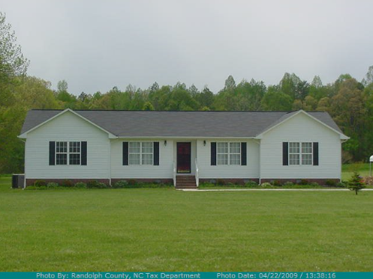

Exhibit A

Property Located at:
5515 Troy Smith Road
Liberty, North Carolina 27298

Parcel# 8718900964

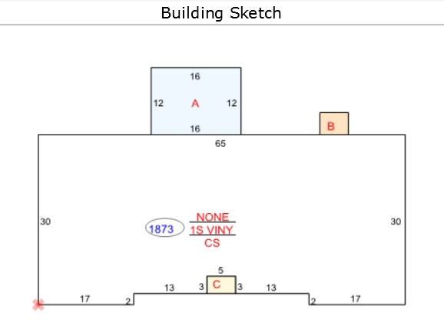

Exhibit B

Property Located at:
5353 Troy Smith Road
Liberty, North Carolina 27298

Parcel# 8717895590

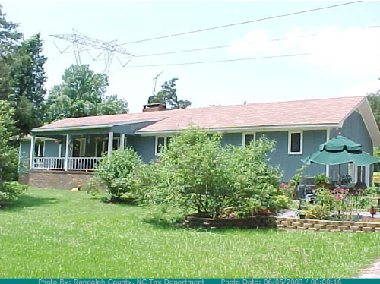

Exhibit B

Property Located at:
5353 Troy Smith Road
Liberty, North Carolina 27298

Parcel# 8717895590

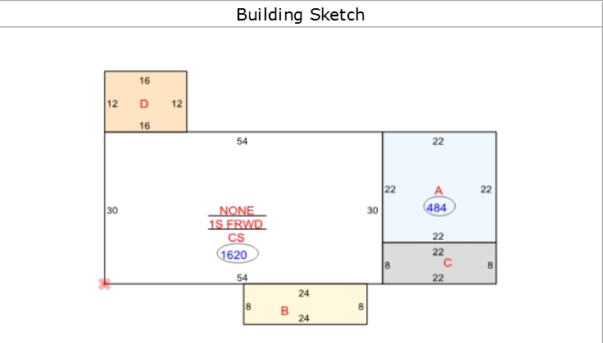

Exhibit C

Property Located at:
8169 Old 421 Road
Liberty, North Carolina 27298

Parcel# 8718534909

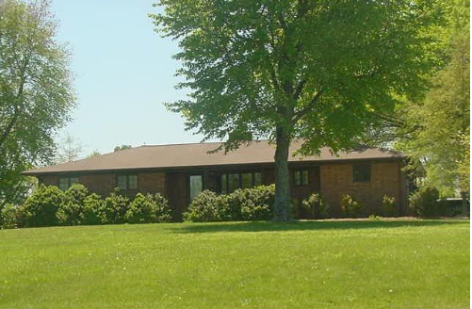

Exhibit C

Property Located at:
8169 Old 421 Road
Liberty, North Carolina 27298

Parcel# 8718534909

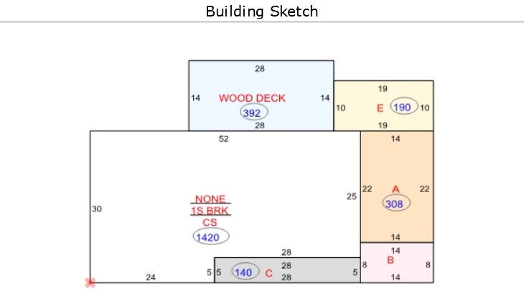

Exhibit D

Property Located at:
8807 Old 421 Road
Liberty, North Carolina 27298

Parcel# 8708937765

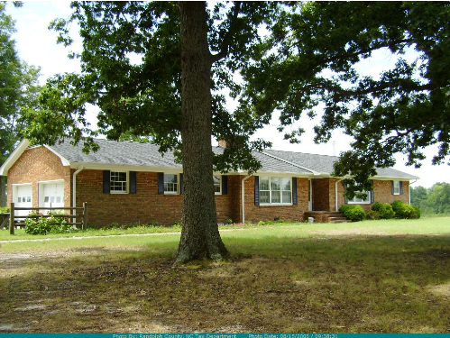

Exhibit D

Property Located at:
8807 Old 421 Road
Liberty, North Carolina 27298

Parcel# 8708937765

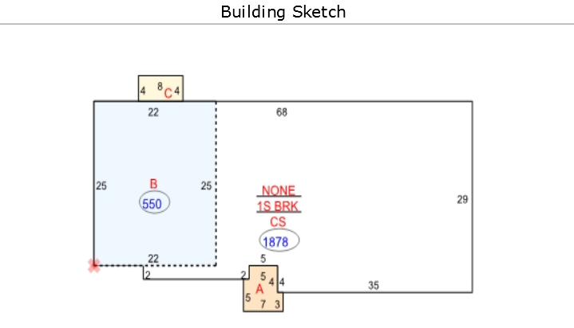

Exhibit E

Property Located at:
5226 Orange Blossom Drive
Liberty, North Carolina 27298

Parcel# 8718337986

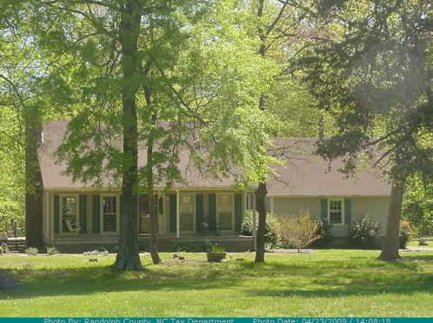

Exhibit E

Property Located at:
5226 Orange Blossom Drive
Liberty, North Carolina 27298

Parcel# 8718337986

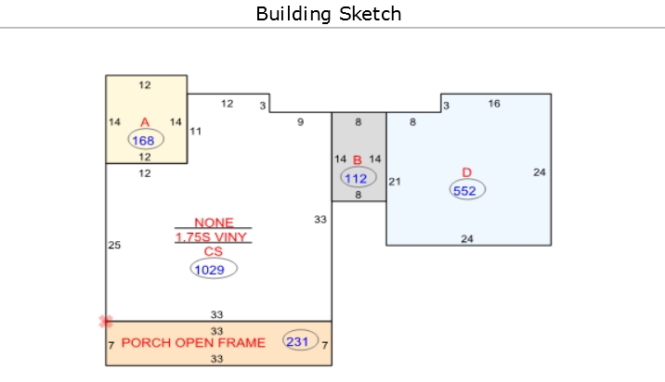

Exhibit F

Property Located at:
5301 Orange Blossom Drive
Liberty, North Carolina 27298

Parcel# 8718435778

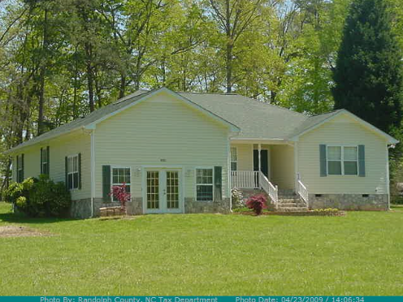

Exhibit F

Property Located at:
5301 Orange Blossom Drive
Liberty, North Carolina 27298

Parcel# 8718435778

