

THE UNIVERSITY OF ALABAMA IN HUNTSVILLE
PROCUREMENT SERVICES
301 SPARKMAN DRIVE
HUNTSVILLE, ALABAMA 35899
PHONE (256) 824-6484

ALL BIDS WILL BE PUBLICLY OPENED ON THE OPENING DATE DESIGNATED AT THE UNIVERSITY OF ALABAMA IN HUNTSVILLE, PROCUREMENT SERVICES, BUSINESS SERVICES BLDG., HUNTSVILLE, ALABAMA 35899. BIDS RECEIVED AFTER THE SPECIFIED TIME ON THE OPENING DATE WILL NOT BE CONSIDERED.
06/03/2020
3:00 PM
BID NUMBER
B002684
DATE
05/20/2020
RESPONSE DUE BY:

REQUEST FOR FORMAL BID

CONTACT EMAIL VENDOR NO.
Kelly Haas Kelly.haas@uah.edu

ALL BIDS MUST BE SIGNED AND SUBMITTED ON THE WEBSITE VENDORREGISTRY.COM. FAILURE TO COMPLY WILL RESULT IN A “NO BID” RESPONSE IN ACCORDANCE WITH ALABAMA COMPETITIVE BID LAW 41-16-24 sub-part b.

V
E
N
D
O
THE ABOVE BID NUMBER MUST APPEAR ON ALL BIDS AND RELATED CORRESPONDENCE
R

NO | QUANTITY | UNIT | DESCRIPTION | UNIT PRICE | EXTENSION
01  02  03 |  |  | The University of Alabama in Huntsville requests bids for UAH Lowe House Main Floor Draperies (B002684) as per the specifications noted within  *** All bid responses are required to be submitted electronically via vendor registry. No bid responses will be accepted via fax, email, the US Postal service, UPS, FedEX or any other mailing services and you may not submit the bid in person at the University. ***  *** All questions must be submitted electronically to receive answers from the university procurement officer. ***  Award:  No award information will be made available by telephone, fax, email, or mail. Once the bid is awarded, the award information and tabulation will be posted to Vendor Registry. HTTP://WWW.UAH.EDU/BUSINESS-SERVICES/VENDORS/BID-OPPORTUNITIES  Award: Bid Awards will be posted online on Vendor Registry (Click on closed solicitations.)  SHOULD A PURCHASE ORDER BE ISSUED, THE FOREGOING AND THE TERMS AND CONDITIONS ON THE ATTACHED SHEET SHALL BE APPLICABLE AND BINDING UPON THE VENDOR.  I ACKNOWLEDGE THAT I HAVE SIGNATURE AUTHORITY TO SIGN ON BEHALF OF THE COMPANY AND HEREBY AGREE TO ALL GENERAL CONDITIONS OF THIS BID REQUEST.  TOTAL
SIGNATURE _______________________________________________ DATE____________________________ PAGE 1
COMPANY REPRESENTATIVE An Affirmative Action/Equal Opportunity Institution
BID NUMBER: B002684

The University of Alabama in Huntsville requests bids for the UAH Lowe House Main Floor Draperies (B002684)

All requests for Bids must be submitted through Vendor Registry by 3:00pm on 06/03/2020.

In the event it becomes necessary to revise any part of this request for bid prior to the assigned return date, revisions will be posted in writing by procurement services on our UAH Vendor Registry website. Vendorregistry.com. The University will be the sole determinant of whether any revisions/addenda should be issues as a result of any questions or other matters, and will extend the bid deadline if such information significantly amends this solicitation or makes compliance with the original bid due date impractical.

In order to be considered for selection, vendors must submit a complete response to this request for bid including business license, vendor disclosure statement and certificate of insurance. The vendors shall make no other distribution of the bids.

No bid may be amended or withdrawn after the scheduled closing time of receipt for a period of sixty (60) days. The University reserves the right to waive any informality and to reject any and all bids.

Vendors must fill out the bid completely and include their certificate of insurance, vendor disclosure statement and business license when submitting to vendor registry.

All measurements are for estimated purposes only. Field measurements are required prior to production. All Fabric, hardware design, Etc. must be approved by the University of Alabama in Huntsville and their architect before production.

The target completion date and deadline is August 7, 2020

Installation must be coordinated by the University and occupants.

A performance bond or bid bond may be required from the awarded vendor.

Non-Mandatory Pre-bid Meeting will be held 10am CST, Tuesday May 26, 2020 at the Lowe House. Please meet in the driveway in front of the house. You may park along the street in the neighborhood. Please limit 2 visitors for each company. Please confirm that you will be at pre-bid meeting before 5pm on Friday May 22, 2020 email Kelly.haas@uah.edu your confirmation.

Please know that safety on our campus is a top priority of the University. While on campus, we ask that all visitors adhere to the following requirements and safety reminders:
• Visitors must abide by all CDC requirements and guidance at all times including social distancing of at least 6 feet. UAH expects strict compliance with these requirements.
• Each visitor is responsible for providing and properly wearing their own personal protective equipment (PPE) including a facemask, gloves and shoe covers.
• In the event that a visitor tests positive for the coronavirus disease within 14 days of visiting the campus, UAH must be notified immediately. Please contact the Office of Environmental Health & Safety at (256) 824-6668.

All questions pertaining to this request for bid should be addressed to Kelly Haas via Vendor Registry: Subject: UAH Lowe House Main Floor Draperies B002684.

SPECIFICATIONS

UAH LOWE HOUSE MAIN FLOOR DRAPERIES
(MEASUREMENTS ARE FOR ESTIMATING PURPOSES ONLY. FIELD MEASUREMENTS ARE REQUIRED PRIOR TO PRODUCTION)
- INSTALLATION TO BE INCLUDED IN PRICE
- TARGET COMPLETION DATE IS
- INSTALLATION MUST BE COORDINATED WITH UNIVERSITY & OCCUPANTS.
- FABRICS, HARDWARE, DESIGN, ETC. MUST BE APPROVED BY DESIGNER/CLIENT PRIOR TO PRODUCTION

SITTING ROOM – DRAPERIES AND ROMAN SHADES
MAIN FABRIC:
MANUFACTURER: THIBAUT FABRIC NAME: ROYALE TOILE FABRIC NUMBER: F972577 QUANTITY:
ONE (1) PAIR OF DRAPERIES, TWO (2) WIDTHS PER PANEL; THREE (3) ROMAN SHADES
BANDING FABRIC:
MANUFACTURER: NORBAR COLLECTION: LINEN LYNX II
FABRIC NAME AND COLOR: JOPLIN SMOKEY BLUE 57

LINING:
MANUFACTURER: UNITED SUPPLY CO.
MODEL: 7517000-0920 LUSTRE SATEEN IVORY 75/300

INTERLINING:
MANUFACTURER: UNITED SUPPLY CO.
MODEL: 755888-1405 FLANNEL COTTON 100/400 NATURAL ARCHITRAC ROD SET:
MANUFACTURER: KIRSCH MODEL: 94270H025 FINISH: WHITE
TYPE & SIZE: WALL MOUNTED, SPLIT DRAWN, 80”L, 5 ½” return

TREATMENT INSTRUCTIONS:
  - PAIR DRAPE 80”W X 132 ½”L TO TOP OF ROD
  - WIDTHS PER PANEL
2 FOLD PINCH PLEAT AT TOP LINED AND INTERLINED
5 ½” RETURN
OVERLAP 1 7/8” MADE TO CLOSE
1 ½” DECORATIVE BAND ON LEADING EDGE LENGTH INCLUDES ½” BREAK ON FLOOR
1 CUSTOM VALANCE 81”W X 24”L LINED AND INTERLINED
7 ½” RETURN
1 ½” DECORATIVE BAND ON BOTTOM EDGE SEE DRAWING
3 ROMAN SHADES 31”W X 93 ½”L INSIDE MOUNT
OPERABLE FLAT PANEL
LINED AND INTERLINED
- ½” DECORATIVE BAND ON BOTTOM EDGE ALLOW FOR ONE FIXED PLEAT AT BOTTOM EDGE

DINING ROOM- DRAPERIES
MAIN FABRIC:
MANUFACTURER: LIBAS FABRC NAME: DOUPIONI SILK
FABRIC NUMBER: 214C/003 AGRA
QUANTITY: TWO PAIR OF DRAPERIES, TWO (2) WIDTHS PER PANEL BANDING FABRIC:
MANUFACTURER: PINDLER
FABRIC NAME AND COLOR: 1888 DOUPPIONI SILK SAPPHIRE

LINING:
MANUFACTURER: UNITED SUPPLY CO.
MODEL: 7517000-0920 LUSTRE SATEEN IVORY 75/300

INTERLINING:
MANUFACTURER: UNITED SUPPLY CO.
MODEL: 755888-1405 FLANNEL COTTON 100/400 NATURAL

METAL RODS:
MANUFACTURER: ANTIQUE DRAPERY ROD COMPANY MODEL: RRWGU42_UN
FINISH: WHITE WASHED GOLD QUANTITY & SIZE:
TWO (2) EACH 1 ¾”DIA. X 80”L

BRACKETS:
MANUFACTURER: ANTIQUE DRAPERY ROD COMPANY MODEL: BRWGZP9
FINISH: WHITE WASHED GOLD QUANTITY & SIZE: SIX (6) EACH
FINIALS:
MANUFACTURER: ANTIQUE DRAPERY ROD COMPANY STYLE: BULLION
MODEL: FIWG18W
FINISH: WHITE WASHED GOLD QUANTITY: TWO (2) PAIRS

RINGS:
MANUFACTURER: ANTIQUE DRAPERY ROD COMPANY MODEL: RIWGBS3 (50 COUNT) & RIWG3T7 (7 COUNT) FINISH: WHITE WASHED GOLD
QUANTITY: SEVENTY-ONE (71)

TREATMENT INSTRUCTIONS:
- PAIR DRAPE 80”W X 134 ½”L TO TOP OF ROD
2 WIDTHS PER PANEL
2 FOLD PINCH PLEAT AT TOP LINED AND INTERLINED
NO RETURN OVERLAP 1 7/8” MADE TO CLOSE
1 ½” DECORATIVE BANDING ON LEADING EDGE, BOTTOM AND SIDE LENGTH INCLUDES ½” BREAK ON FLOOR

LIBRARY- DRAPERIES
MAIN FABRIC:
MANUFACTURER: TRAVERS FABRIC NAME: AUBREY DAMASK FABRIC NUMBER: 44067-587
QUANTITY:

ONE PAIR OF DRAPERIES, TWO (2) WIDTHS PER PANEL

LINING:
TWO PAIR OF DRAPERIES, ONE AND ONE HALF (1 ½) WIDTHS PER PANEL

MANUFACTURER: UNITED SUPPLY CO.
MODEL: 7517000-0920 LUSTRE SATEEN IVORY 75/300

INTERLINING:
MANUFACTURER: UNITED SUPPLY CO.
MODEL: 755888-1405 FLANNEL COTTON 100/400 NATURAL METAL RODS:
MANUFACTURER: ANTIQUE DRAPERY ROD COMPANY MODEL: RRAU42_UN
FINISH: ANTIQUE GOLD QUANTITY & SIZE:
ONE (1) EACH 1 ¾” DIA. X 82”L TWO (2) EACH 1 ¾” DIA. X 62”L

BRACKETS:
MANUFACTURER: ANTIQUE DRAPERY ROD COMPANY MODEL: BRAZP9
FINISH: ANTIQUE GOLD QUANTITY & SIZE: NINE (9) EACH
FINIALS:
MANUFACTURER: ANTIQUE DRAPERY ROD COMPANY STYLE: BEVELED BALL
MODEL: FIABEB FINISH: ANTIQUE GOLD
QUANTITY: THREE (3) PAIRS

RINGS:

MANUFACTURER: ANTIQUE DRAPERY ROD COMPANY MODEL: RIABS3 (50 COUNT)
FINISH: ANTIQUE GOLD QUANTITY: FIFTY (50)

TREATMENT INSTRUCTIONS:
- PAIR DRAPE 82”W X 134 ½”L TO TOP OF ROD
- WIDTHS PER PANEL
2 PAIR DRAPE 62”W X 134 ½”L TO TOP OF ROD
- ½ WIDTHS PER PANEL
- FOLD PINCH PLEAT AT TOP LINED AND INTERLINED
5 ½” RETURN
OVERLAP 1 7/8”

MADE TO CLOSE
LENGTH INCLUDES ½” BREAK ON FLOOR

LIVING ROOM DRAPERIES AND DOOR SHADE:
MAIN FABRIC:
MANUFACTURER: VILLA ROMO FABRIC NAME: VALLETA MOONBEAM FABRIC NUMBER: 1149/183 QUANTITY:
ONE PAIR OF DRAPERIES, TWO (2) WIDTHS PER PANEL
TWO PAIR OF DRAPERIES, ONE AND ONE HALF (1 ½) WIDTHS PER PANEL DECORATIVE TAPE:
MANUFACTURER: SCHUMACHER STYLE NAME: LABYRINTH TAPE STYLE NUMBER: 66140-66145
QUANTITY: ONE (1) PER PANEL; FULL HEIGHT OF PANEL DECORATIVE BAND:
MANUFACTURER: PINDLER
FABRIC NAME AND COLOR: 1888 DOUPPIONI SILK SAPPHIRE
QUANTITY: ONE (1) PER SHADE AND VALANCE – PER TREATMENT INSTRUCTIONS

LINING:
MANUFACTURER: UNITED SUPPLY CO.
MODEL: 7517000-0920 LUSTRE SATEEN IVORY 75/300

INTERLINING:
MANUFACTURER: UNITED SUPPLY CO.
MODEL: 755888-1405 FLANNEL COTTON 100/400 NATURAL METAL RODS:
MANUFACTURER: ANTIQUE DRAPERY ROD COMPANY MODEL: RRAU42_UN
FINISH: ANTIQUE GOLD QUANTITY & SIZE:
ONE (1) EACH 1 ¾” DIA. X 90”L TWO (2) EACH 1 ¾” DIA. X 50”L

BRACKETS:
MANUFACTURER: ANTIQUE DRAPERY ROD COMPANY MODEL: BRAZP9
FINISH: ANTIQUE GOLD QUANTITY & SIZE: SIX (6) EACH

CORNER BRACKETS:
MANUFACTURER: ANTIQUE DRAPERY ROD COMPANY MODEL: ACAHCW
FINISH: ANTIQUE GOLD QUANTITY: TWO (2)
FINIALS:
MANUFACTURER: ANTIQUE DRAPERY ROD COMPANY STYLE: ACANTHUS
MODEL: FIAABW FINISH: ANTIQUE GOLD QUANTITY: ONE (1) PAIR

RINGS:
MANUFACTURER: ANTIQUE DRAPERY ROD COMPANY MODEL: RIABS3 & RIA3T7
FINISH: ANTIQUE GOLD QUANTITY: FIFTY-SEVEN (57)

TREATMENT INSTRUCTIONS:
- PAIR DRAPE 90”W X 134 ½”L TO TOP OF ROD
- WIDTHS PER PANEL
2 PAIR DRAPE 50”W X 134 ½”L TO TOP OF ROD
- ½ WIDTHS PER PANEL
- FOLD PINCH PLEAT AT TOP LINED AND INTERLINED
5 ½” RETURN
OVERLAP 1 7/8” MADE TO CLOSE
DECORATIVE TAPE INSET 1 ½” ON LEADING EDGE LENGTH INCLUDES ½” BREAK ON FLOOR
1 DOOR SHADE 27”W X 74”L WITH 8” VALANCE OUTSIDE MOUNT
OPERABLE FLAT PANEL
LINED AND INTERLINED
1 ½” DECORATIVE BAND ON BOTTOM EDGE OF SHADE AND VALANCE ALLOW FOR ONE FIXED PLEAT AT BOTTOM EDGE

TOTAL OF SPECIFICATIONS INCLUDING INSTALLATION $

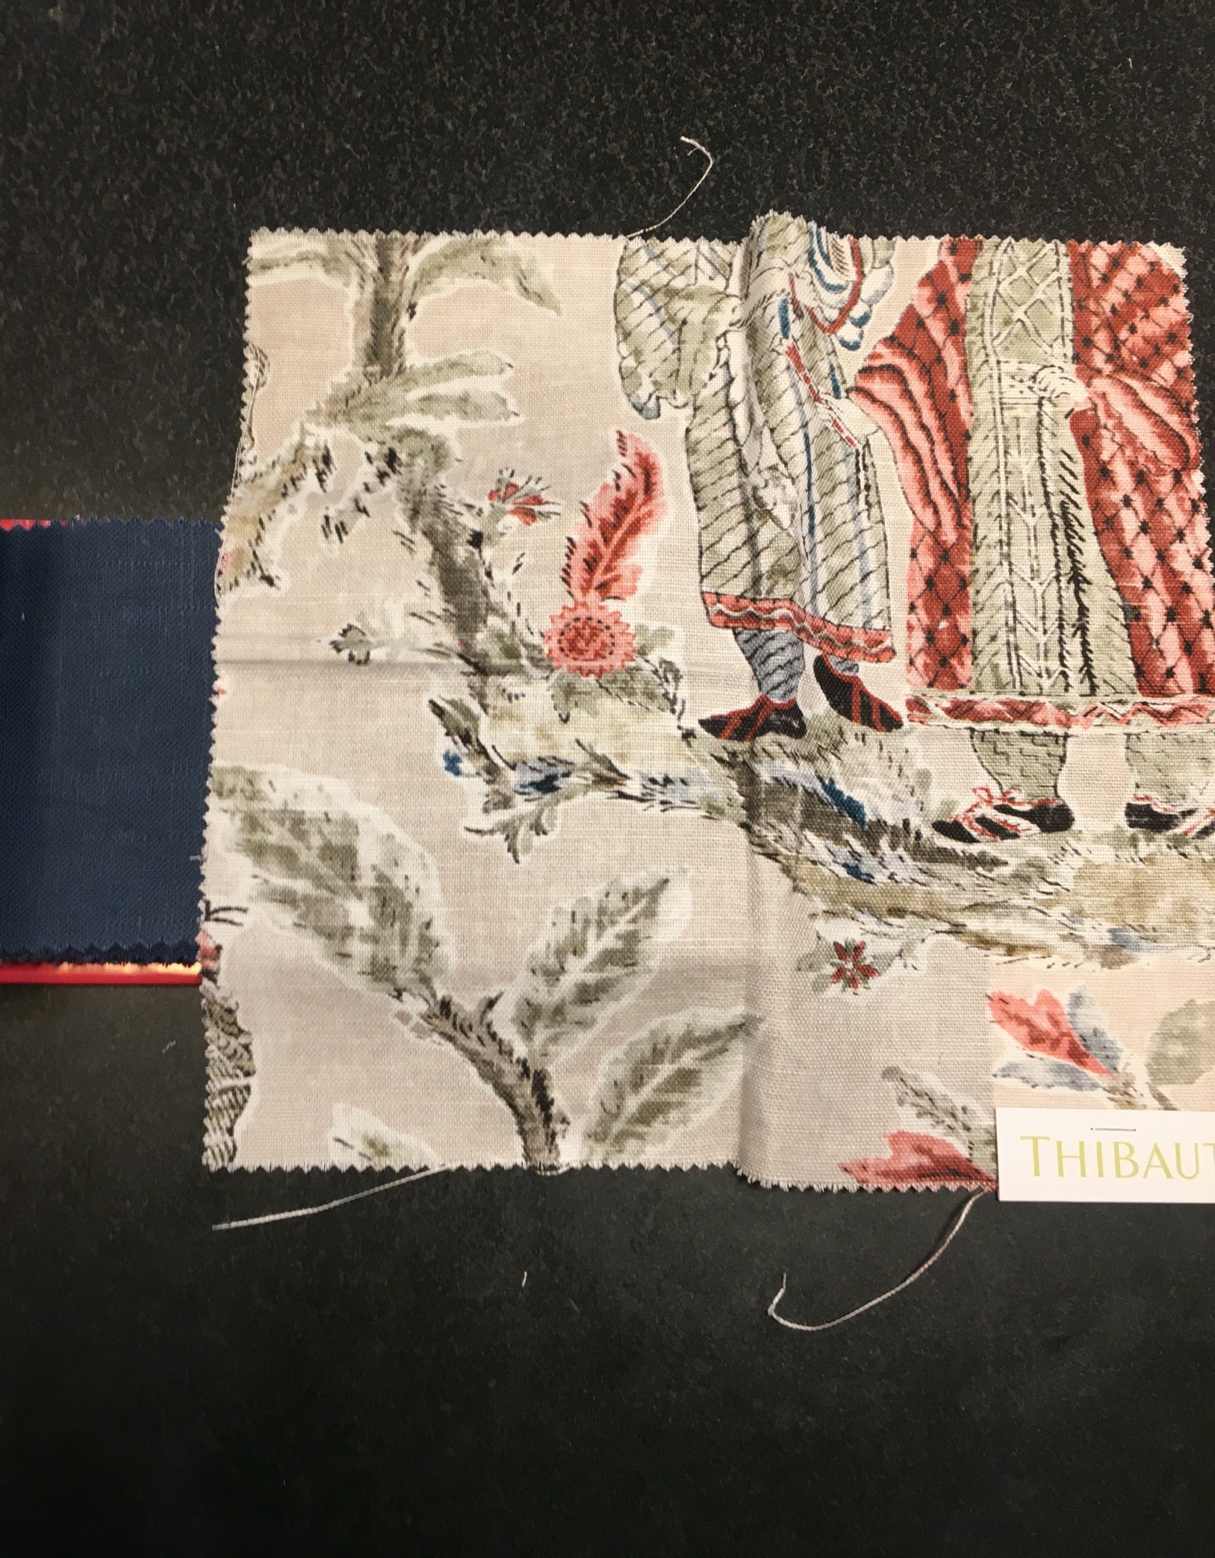
Figure 1- Sitting Room

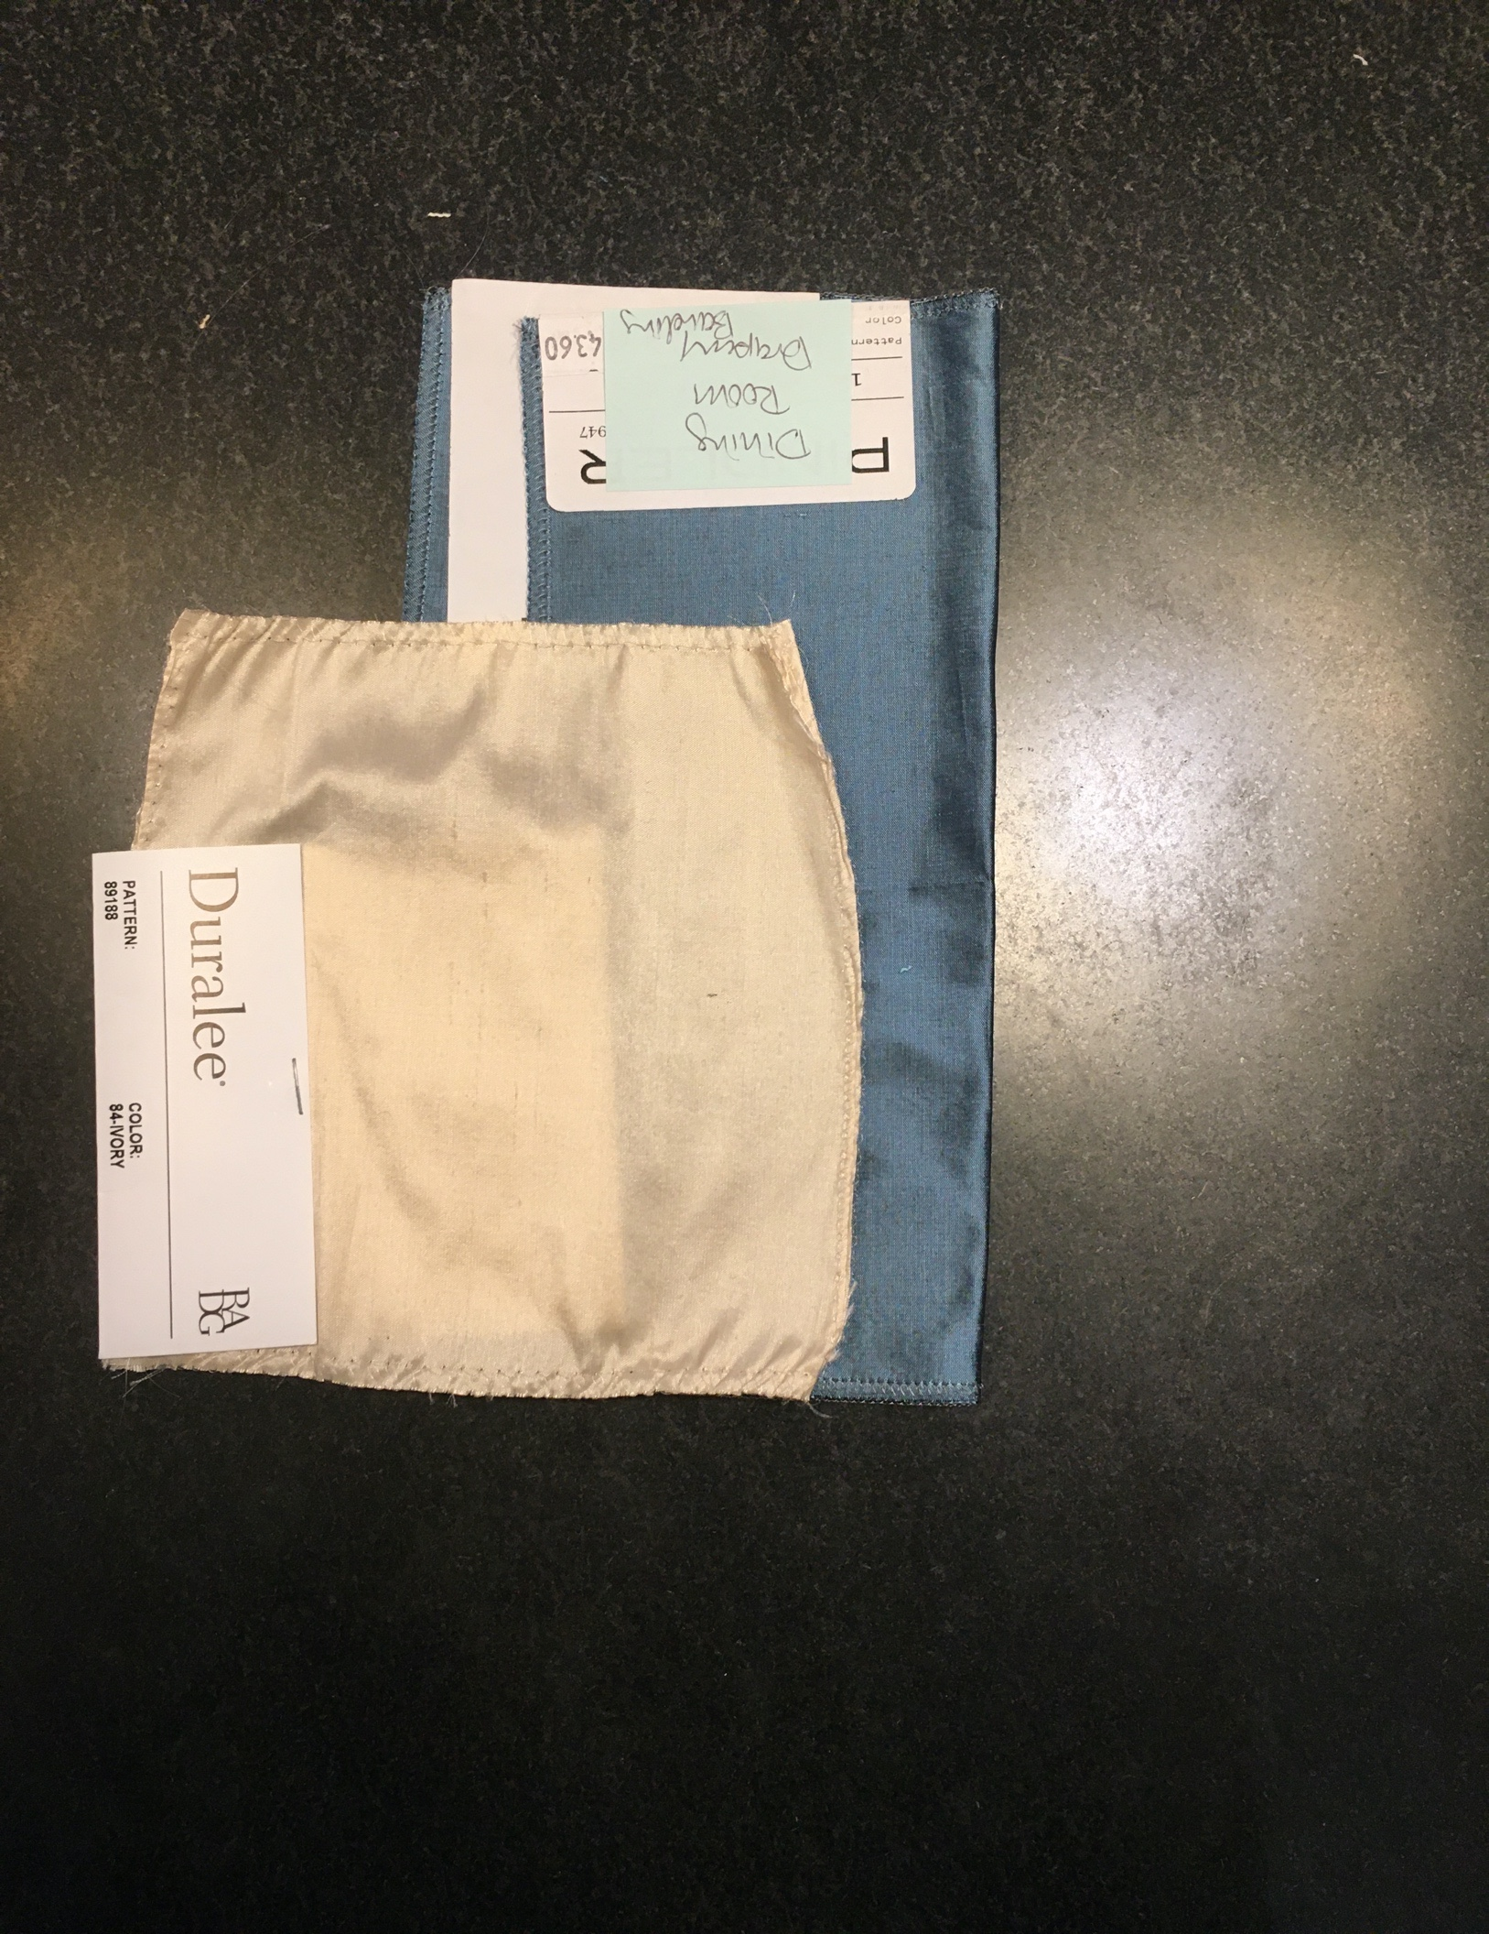
Figure 2 Dining Room

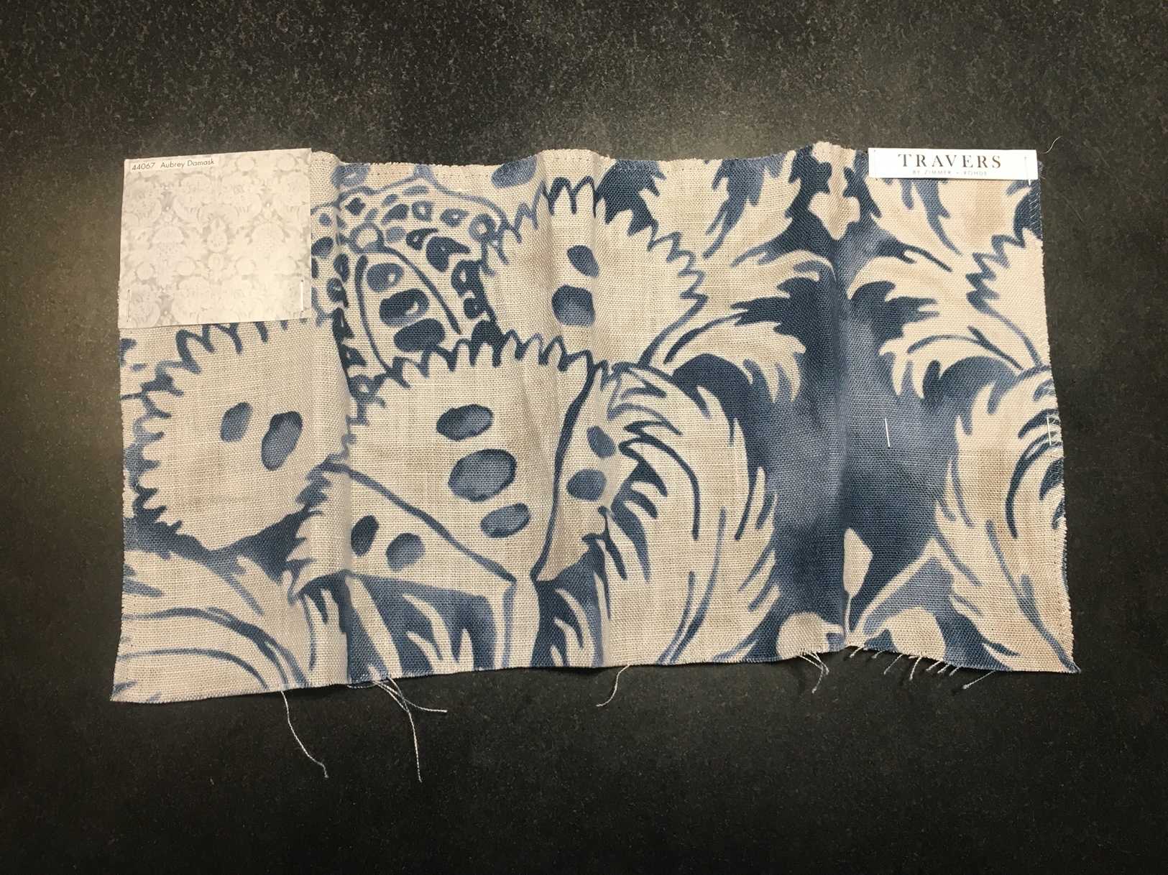
Figure 3 Library

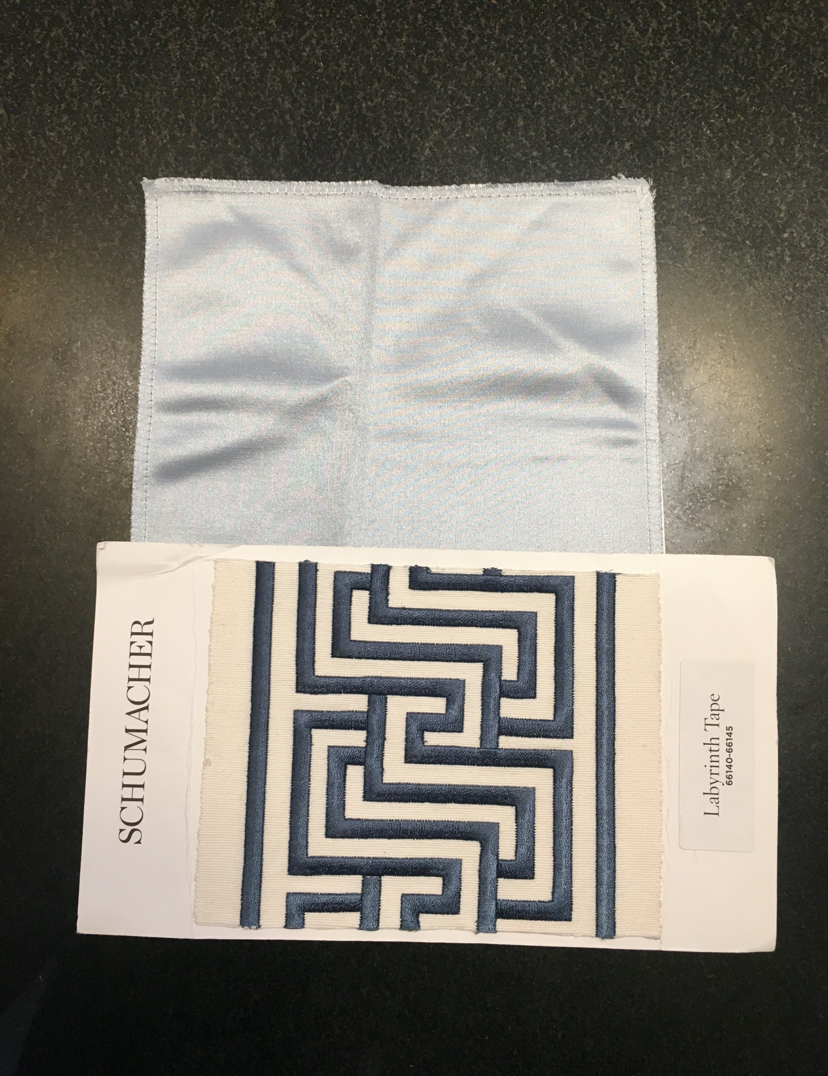
Figure 4 Living Room

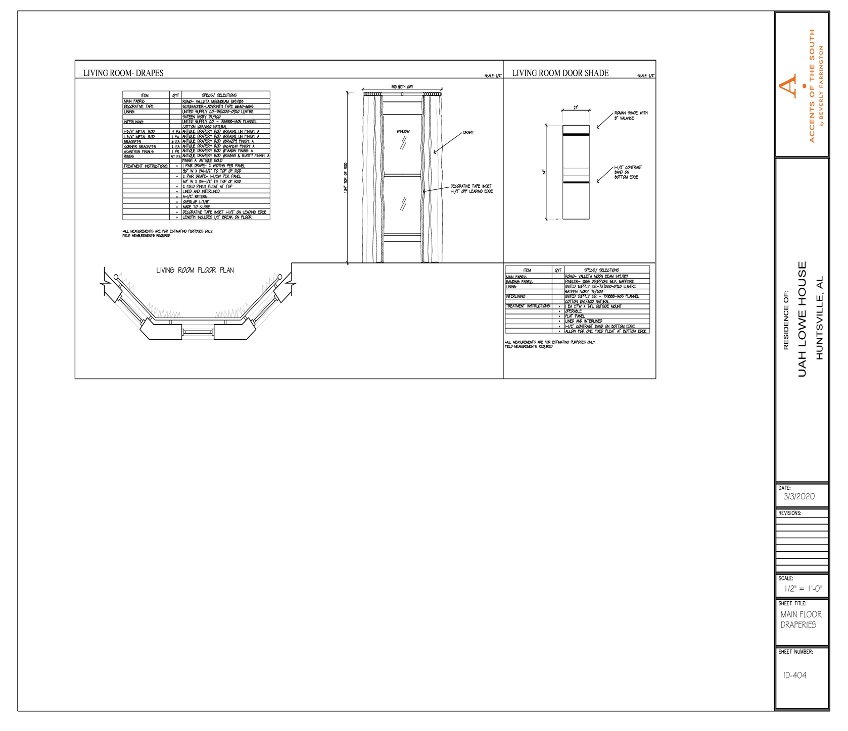

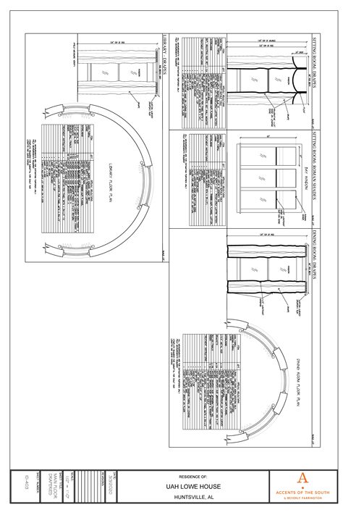

A. SUPERVISION: Contractor consults with the University of Alabama in Huntsville concerning details of scheduling of all work. Contractor has a competent person in charge of his work at all times to whom the University of Alabama in Huntsville may issue directives and who shall accept and act upon such directives. Failure for the supervisor to act on said directives shall be sufficient cause to give notice that the Contractor is in default of contract unless such directives would create potential personal injury of safety hazards.

1. All labor, supervision, equipment, materials, and supplies necessary for the execution of this work must be provided for by the contractor at no additional cost to the University of Alabama in Huntsville.

2. All debris disposal will be provided by the contractor at no additional cost to the University of Alabama in Huntsville.

B. TRAFFIC CONTROL: Is the total responsibility of Contractor and is coordinated with the proper department of the University of Alabama in Huntsville. The contractor shall be solely responsible for pedestrian and vehicular safety and control within the work site and shall provide the necessary warning devices, barricades, and personnel needed to give safety, protection, and warning to persons and vehicular traffic within the area. Blocking of public streets shall not be permitted unless prior arrangements have been made with the University of Alabama in Huntsville and is coordinated with the appropriate departments. Traffic control is the responsibility of the Contractor and shall be accomplished in conformance with State, County, and Local codes.

C. CLEAN UP: The work site is left equal to or cleaner than pre-work conditions. It shall be the responsibility of the Contractor to remove and dispose in a proper and acceptable manner all debris resulting from the maintenance operations.

D. DAMAGES: Done by the Contractor to any person or property, public or private, are the total responsibility of the Contractor and are repaired or compensated for by the Contractor to the satisfaction of both injured party and the University of Alabama in Huntsville.

E. INSURANCE: Contractor shall be fully insured as specified and shall be completely covered by State Workers' Compensation during the life of this contract. The Contractor shall have liability insurance in the amount of $2,000,000.00 for each occurrence and shall name the Board of Trustees and the University of Alabama in Huntsville as an additional insured on its policy for the work being performed at the University of Alabama in Huntsville.

F. WORKING HOURS: The Contractor will schedule work between the hours of 7:00 a.m. and 6:00 p.m. Monday through Saturday unless authorized by the University of Alabama in Huntsville to do otherwise.

G. SUBCONTRACTS: The Contractor will not be allowed to subcontract work under this contract unless written approval is granted by the University of Alabama in Huntsville. The Subcontractor, as approved, shall be bound by the conditions of the contract between the University of Alabama in Huntsville and the Contractor. The authorization of a Subcontractor is to perform in accordance with all terms of the contract and specifications. All directions given to the Subcontractor in the field shall bind the Contractors as if the notice had been given directly to the Contractor.

H. EXECUTION OF CONTRACT: The successful Bidder shall, within two (2) calendar days of the written notice of selection as the successful bidder, enter into contract with the University of Alabama in Huntsville on forms included within the bidding documents for the performance of work awarded him and shall simultaneously provide the appropriate bonds, indemnities, and insurance required hereunder. The contract, when executed, shall be deemed to include the entire agreement between the parties; the Contractor shall not base any claim for modification of the contract upon any prior representation or promises made by representatives of the University of Alabama in Huntsville, or other persons.

I. DISCONTINUANCE OF WORK: Any practice obviously hazardous as determined by the University of Alabama in Huntsville shall be immediately discontinued by the Contractor upon receipt of either written or oral notice to discontinue such practice.

J. OBSERVANCE OF LAWS, ORDINANCES, AND REGULATIONS: The Contractor, at all times during the term of this contract, shall observe and abide by all Federal, State, and Local laws which in any way affect the conduct of the work and shall comply with all decrees and orders of courts and competent jurisdiction. The Contractor shall comply fully and completely with any and all applicable State and Federal Statutes, rules, and regulations as they relate to hiring, wages, and other applicable conditions of employment.

K. SUPERVISION: This contract will be under the direct supervision of the University of Alabama in Huntsville or its authorized representatives. Any alteration or modifications of the work performed under this contract shall be made only in written agreement between the Contractor and the University of Alabama in Huntsville-authorized representative and shall be made prior to commencement of the altered or modified work. No claims for extra work or materials shall be allowed unless covered by written agreement.

L. REFERENCES: The bidder will provide two (2) clients that it has serviced in the past three years with a contact person listed.

M. AWARD: For a bid to be considered, a price must be quoted for the entire project.

N. CONTRACT TERMINATION: The University of Alabama in Huntsville shall have the right to terminate a contract or a part thereof before the work is completed in the event: i. Previous unknown circumstances arise making it desirable in the public interest to void the contract; ii. The Contractor is not adequately complying with the specifications; iii. Proper arboricultural techniques are not being followed after warning notification by the University of Alabama in Huntsville or its authorized representatives; iv. The Contractor refuses, neglects, or fails to supply properly trained or skilled supervisory personnel and/or workers or proper equipment of the specified quality and quantity; v. The Contractor in the judgment of the University of Alabama in Huntsville is unnecessarily or willfully delaying the performance and completion of the work; vi. The Contractor refuses to proceed with work when as directed by the University of Alabama in Huntsville; or vii. The Contractor abandons the work.

O. INDEMNIFICATION: I, the Contractor, agree to indemnify, hold harmless, and defend the University of Alabama in Huntsville from and against any and all loss, damage, or expense which the University of Alabama in Huntsville may suffer or for which the University of Alabama in Huntsville may be liable by reason of any injury (including death) or damage to any property arising out of negligence on the part of the Contractor in the execution of the work to be performed hereunder.

This indemnity provision shall not apply in cases where the Contractor has not been provided with timely notice, nor shall the Contractor be liable to the University of Alabama in Huntsville for any settlement of any complaint affected without the prior written consent of the Contractor.

P. BID DUE DATE: All bids are to be submitted to vendorregistry.com on or before, June 3, 2020 at 3:00pm CST.

GENERAL CONDITIONS

- Award: The University of Alabama in Huntsville reserves the right to accept or to reject any or all bids and is not necessarily bound to accept the lowest bid if that bid is contrary to the best interest of the University. In making an award, intangible factors such as bidder’s service, integrity, facilities, equipment, reputation, and past performance will be weighed along with the quality displayed in the samples submitted. Bids may be awarded either item by item, in products groups, or all or none, whichever appears to be in the best interest of the University. The University reserves the right to waive any or all formalities.

- Bid Withdrawal: No bids may be withdrawn without approval from The University of Alabama in Huntsville Procurement Services. Any requests for withdrawal must be in writing to Procurement Services within five (5) days after opening date with justification for reason of withdrawal. More than two (2) such requests could result in removal from our bid list. No bid may be withdrawn after the issuance of purchase order. If a withdrawal is made after the purchase order is issued, the vendor will be considered in default. Refer to “Default of Contractor”.

- Prices and Payment Terms: Bidders should quote applicable cash discounts. The University will not take into consideration in bid evaluation any cash discount of less than thirty (30) days duration. However, we will take advantage of all discounts for which we are eligible. Identify these discounts in your bid response. Bids containing “payment in advance” or “COD” requirements may be rejected.

- Applicable Law: It is agreed this quotation is valid to the extent that it does not violate the constitution or the laws of the State of Alabama.

Bidder represents and warrants that all article and services covered by this bid meet or exceed the safety standards established and promulgated under the Federal Occupational Safety and Health Act of 1970, No. 2006, and its regulations in effect or proposed as of the date of this bid.

The furnishing of materials, supplies, equipment or service to The University of Alabama in Huntsville under this purchase order, contract, solicitation for bids, or construction specification constitutes assurance by the vendor or contractor of his compliance with applicable provisions of and pertinent regulations promulgated under Executive Order 11246, date September 28, 1965 issued by the President of the United States of America, and Public Law 88-352, 88th Congress, the “Civil Rights Act of 1964”.

- Non-Collusion: Any agreement or collusion among bidders or prospective bidders in restraint of freedom of competition, by agreement to bid at a fixed price or to refrain from bidding, or otherwise, shall render the bids of such bidders void. Each bidder certifies that he has not been a party to such an agreement by signing this bid.

- New Products: Unless specifically called for in the bid, all products for purchase must be new, never previously used, and the current model and/or packaging. No remanufactured, demonstrator, used, or irregular product will be considered for purchase unless otherwise specified in the bid. The manufacturer’s standard warranty will apply unless otherwise specified in the bid. All requests should be supplied complete, ready to be installed, including all cabling and connectors where applicable.

- Bonds: Bid and performance security bond, when required will be indicated.

- Bid Submission: Failure to submit a bid on the official The University of Alabama in Huntsville form provided for that purpose shall be a cause for rejection of the bid. Return of the complete document is required. Modification of or additions to any portion of the solicitation may be cause for rejection of the bid; however, The University of Alabama in Huntsville reserves the right to decide, on a case by case basis, in its sole discretion, whether or not to reject such a bid as non-responsive.

All information shall be entered in ink or typewritten in the appropriate space on the form. Mistakes may be crossed out and corrections inserted before submission of your bid. Corrections shall be initialed in ink by the person signing the bid.

All bids must be signed. Failure to do so will result in rejection of bid.

- Delivery: Time of delivery shall be stated as the number of calendar days following receipt of the order by the vendor, to receipt of the goods by The University of Alabama in Huntsville.

Delivery time may be a criterion in awarding bids. Specify earliest possible delivery after receipt of order.

Failure to deliver within the time vendor specified in the bid will constitute a default and may cause cancellation of the contract. Refer to “Default of Contractor”.

All prices quoted are to be F.O.B. delivered to The University of Alabama in Huntsville, Central Receiving Building, 301 Sparkman Drive, Huntsville, Alabama, 35899 (unless another F.O.B. point is stated by the University on bid form). The successful bidder must assume all responsibility for damage in transit. When installation is required, it will be stated. If you are not quoting a delivered price, indicate your shipping point, and provide shipping cost for evaluation purposes.

- Bid Terms: Show unit prices, extensions, and total price. In the event of a discrepancy between the unit price and the extension, the unit price shall govern. Bids shall remain firm for minimum thirty (30) days from date of bid opening and any exception must be clearly stated.

- Bid Opening: Bidders may attend the bid opening, but no information or opinions concerning the ultimate award will be given at the bid opening or during the evaluation process. After the public opening of this bid, the results will not be available to bidders not attending the opening until after an award is made. Bid tabulations can be reviewed by accessing Procurement Services website at http://uah.edu/business-services. Click on “Vendors” then “Bid Awards”.

- Bids are Public Record: All bids become a matter of public record at bid award. The University accepts no responsibility for maintaining confidentiality of any information submitted with bid whether labeled confidential or not.

- Standards of Quality: When a material, article or piece of equipment is identified in these specifications by reference to manufacturer’s or vendor’s name, trade name, catalog and stock numbers, etc., it is intended merely to establish a standard; and, any material, article or equipment of other manufacturer and vendor which will perform equally the duties imposed by the general design, provided the material, article, or equipment proposed, is in the opinion of the Procurement Agent of equal substance and function. It shall not be purchased or installed by the contractor without the Procurement Agents’ written approval.

The bidder is responsible to clearly and specifically indicate the product being offered and to provide sufficient descriptive literature, catalog cuts and technical detail to enable The University of Alabama in Huntsville to determine if the product offered meets the requirements of the invitation. Normally in competitive sealed bidding only the information furnished with the bid will be considered in the evaluation. Failure to furnish adequate data for evaluation purposes may result in declaring a bid nonresponsive. Unless the bidder clearly indicates in its bid that the product offered is an “Equal” product, such bid will be considered to offer the brand name product referenced in the invitation. The University of Alabama in Huntsville will be sole judge of EQUAL items bid.

- Vendor Authorization: Vendor must be an authorized distributor/agent to sell products proposed in this bid request. When it is deemed to be in the best interest of the University, Procurement Services may request an on-site premise visit to examine the facility.

- Default of Contractor: Where the University has determined the contractor to be in default, the University reserves the right to purchase any or all products or services covered by the contract on the open market and to charge the contractor with cost in excess of the contract price. Until such assessed charges have been paid, no subsequent bid from the defaulting contractor will be considered.

- Fiscal Funding Clause: The continuation of this contract is contingent upon the appropriation of funds to fulfill the requirements of the contract by the legislature. If the legislature fails to appropriate sufficient monies to provide the continuation of a contract, the contract shall terminate on the date of the beginning of the first fiscal year for which funds are not appropriated.

- Contract Cancellation: Procurement Services has the right to cancel any contract, in accordance with Procurement Rules and Regulations, for cause, including, but not limited to, the following: (1) failure to deliver within the contract; (2) failure of the product or service to meet specifications, conform to sample quality, or to be delivered in good condition; (3) misrepresentation by the contractor; (4) fraud, collusion, conspiracy, or other unlawful means of obtaining any contract with the state; (5) conflict of contract provisions with constitutional or statutory provisions of state or federal law; and (6) any other breach of contract.

- Warranties: Should merchandise described on this bid contain a manufacturer’s warranty, bidders must state the warranty terms in the space provided on the bid. Bids offered for merchandise when no warranty applies must clearly state: “NO WARRANTY COVERAGE”. Warranty information may be criteria in making this award. Failure of bidders to furnish this data may cause rejection of the complete bid as being non-responsive.

- Disclosure Statement: The successful bidder will be required to file with Procurement Services a disclosure statement of relationship between contractors/grantees and employees/officials of the University. This form must be completed prior to issuance of the Purchase Order by The University of Alabama in Huntsville.

20. State of Alabama Immigration Law: Pursuant to the State of Alabama Immigration Law, by signing this contract,
the contracting parties affirm, for the duration of the agreement, that they will not violate federal immigration law or
knowingly employ, hire for employment, or continue to employ an unauthorized alien within the State of Alabama.
Furthermore, a contracting party found to be in violation of this provision shall be deemed in breach of the
agreement and shall be responsible for all damages resulting there from.

- Restrictions On Communications with University Staff: From the issue date of this Solicitation until a Contractor is selected and a contract award is made, Bidders are not allowed to communicate about the subject of the bid with any University administrator faculty, staff, or members of the Board of Trustees except:

- The Procurement Services representative, any University Procurement Official representing the
University administration, or others authorized in writing by the Procurement Office and
University Representatives during Bidder presentations.

If violation of this provision occurs, the University reserves the right to reject the Bidder’s response to
this Solicitation.

PRO REV. 6/12

Note: In order for an alternate bid to be considered, bidders must supply current catalogs or brochures, including pictorials and specifications.

F.O.B. Point  The University of Alabama in Huntsville DESTINATION | TERMS | WARRANTY
ESTIMATED DELIVERY | YOUR REFERENCE NO.* | QUOTATION EFFECTIVE UNTIL
BUSINESS CLASSIFICATION (see note below): | EMAIL ADDRESS:

* Your company reference number, if applicable with this bid quotation.

NOTE: Please indicate your company classification in the appropriate box above: Small Business (SB), a Small Disadvantaged Business (SD), a Black Small Disadvantaged Business (BD), a Woman-Owned Small Business (WB), a Woman-Owned Small Disadvantaged Business (WD), a Black Woman-Owned Small Disadvantaged Business (BW), a Large Business (LB), an Individual (IN), Educational (ED), Non-Profit (NP), a Labor Surplus Area Concern (LS), Disabled Veteran-Owned Small Business (DV), Veteran-Owned Small Business (VS), Historically Underutilized Business Zone (UZ), or a Governmental Agency (GV).

Certification Pursuant To Act No. 2006-557
Alabama Law (Section 41-4-116, Code of Alabama 1975) provides that every bid submitted and contract executed shall contain a certification that the vendor, contractor, and all of its affiliates that make sales for delivery into Alabama or leases for use in Alabama are registered, collecting, and remitting Alabama state and local sales, use, and/or lease tax on all taxable sales and leases into Alabama. By submitting this bid, the bidder is hereby certifying that they are in full compliance with Act No. 2006-557, they are not barred from bidding or entering into a contract pursuant to 41-4-116, and acknowledges that the awarding authority may declare the contract void if the certification is false.

____________________________________________________ ____________________________________
COMPANY NAME (TYPE OR PRINT) TELEPHONE NUMBER

____________________________________________________ ____________________________________
SIGNER’S NAME (TYPE OR PRINT) FAX NUMBER

____________________________________________________ ____________________________________
SIGNATURE DATE

The University of Alabama in Huntsville prohibits the installation of asbestos on its campus. Suppliers and contractors will not supply any equipment, material, or supplies, which contain asbestos without prior written approval.

Failure to designate Bid Number and Opening Date on the outside of your sealed envelope containing your bid and more than one bid submitted in this envelope will result in a “No Bid” response in accordance with Alabama Competitive Bid Law 41-16-24 sub-part b.

The University of Alabama in Huntsville will not accept faxed bids.

Any product that fails to meet the specifications, performance requirements or compatibility requirements will be rejected and returned to the vendor at no cost to the University.

REV. 8/12
State of Alabama Immigration Law

If the successful bidder is located in Alabama or employs an individual or individuals within the State of Alabama, the successful bidder shall provide a copy of its Employment Eligibility Verification (E-Verify) company profile. To expedite the ordering process, this document may be submitted with the bid response.

If the successful bidder is not located in the State of Alabama and does not employ an individual or individuals within the State of Alabama, the successful bidder shall complete and return the Certification of Compliance form included with this Request for Price Quotation (E-Verify company profile is not required). To expedite the ordering process, this document may be submitted with the bid response.

If you are not currently enrolled in E-Verify, follow these instructions:
- Log onto www.uscis.gov/everify
- Click “Getting Started” for information about the program, requirements, and enrollment process.
- Click “Enroll in E-Verify” and begin enrollment process.
- When enrollment process is complete, click “Edit Company Profile” and print this one-page document.
- This one-page document must be submitted prior to a contract or purchase order being issued.
- For further assistance please consult the E-Verify Quick Reference Guide.

If you have previously enrolled in E-Verify, follow these instructions:
- Log onto www.uscis.gov/everify
- Click “Edit Company Profile” and print this one-page document.
- This one-page document must be submitted prior to a contract or purchase order being issued.

REV. 6/12

CERTIFICATION OF COMPLIANCE WITH THE
STATE OF ALABAMA IMMIGRATION LAW

The undersigned officer of _________________________________ (Company)
certifies to the Board of Trustees of the University of Alabama that the Company is not located in Alabama and that the Company does not employ an individual or individuals within the State of Alabama.

_____________________________________
SIGNATURE OF COMPANY OFFICER

____________________________________
PRINT COMPANY NAME

_____________________________________
PRINT NAME OF COMPANY OFFICER

_____________________________________
PRINT TITLE OF COMPANY OFFICER

_____________________________________

DATE

REV. 6/12

- Did the amount of goods and /or services identified in response to Question 4 total $1,000,000 or more? Yes No
- a. Do You have a relationship with any UAS employee or Trustee who may directly or indirectly receive any benefit from the proposed Agreement, or whose family member or business may directly or indirectly benefit? Yes No
b. Do You have a relationship with any Public Official who may directly or indirectly receive any benefit from the proposed Agreement, or whose family member or business may directly or indirectly benefit? Yes No
If You answered “Yes” to questions 6.a. and/or b., please provide the following information for each UAS employee, Trustee, or Public Official with whom You have a Relationship.
Name of UAS employee, Trustee, or Public Official: _______________________________________
Campus/department where employed or position held:____________________________________
Nature of relationship: __________________________________________________________
Potential Benefit: _____________________________________________________________
Name of UAS employee, Trustee, or Public Official: ______________________________________ Campus/department where employed or position held: ___________________________________
Nature of relationship: _________________________________________________________
Potential Benefit: _____________________________________________________________
If you need to provide further information regarding UAS employee(s) or Trustee(s), or Public Officials with whom You have a Relationship, and who may directly or indirectly benefit from this Agreement, please attach an addendum to this Disclosure Statement.
- Have any paid consultants, lobbyists, and/or Public Official assisted in obtaining the proposed
Agreement? Yes No
If yes, please provide the following information for each consultant or lobbyist.
Name: _____________________________________________________________________
Address: ____________________________________________________________________
Name: _____________________________________________________________________
Address: ____________________________________________________________________
If you need to provide further information regarding paid consultants and/or lobbyists utilized to obtain the proposed Agreement, please attach an addendum to this Disclosure Statement.
- List any current litigation or administrative action that has been filed within the last 3 years, either state or federal, related to public or higher education construction or finance that the contractor or others associated with the firm may have against them.

By signing below, I certify under oath and penalty of perjury that all statements on or attached to this form are true and correct to the best of my knowledge. By proposing or entering into an Agreement with UAS, I certify I am authorized to complete this form on behalf of the Entity in whose name or on whose behalf goods or services are being provided, and I further certify no employee or official of UAS, nor any of their family members or any business with which they may be associated, will receive a benefit from this contract, except as has been disclosed, in writing herein. I will promptly disclose any Relationship which may arise in the future, or any existing Relationship which may become known to me, and update this statement to disclose the same.
______________________________________________________________________________________
Signature Date

