Request for Proposals

Exterior Painting Services (as needed) Q1926

Solicitation Number | Q1926
Due Date | February 5, 2019
Due Time | 11:00 a.m. EST
Deliver Responses to: | Knoxville’s Community Development Corporation    Procurement Division  901 N. Broadway  Knoxville, TN 37917  Procurement is located behind the main office building.
Electronic Copies | Electronic copies are available on KCDC’s webpage or by email at purchasinginfo@kcdc.org.
Responses may be Emailed to KCDC | ☐ Yes ☒ No
Printed Responses Required | ☒ Yes ☐ No
Solicitation Meeting | ☐ Yes ☒ No
Solicitation Meeting is Mandatory | ☐ Yes ☐ No ☒ Not Applicable
Solicitation Meeting Date | Not applicable
Solicitation Meeting Time | Not applicable
Solicitation Meeting Location | Not applicable
Questions About This Solicitation | Submit questions to purchasinginfo@kcdc.org  KCDC will not accept questions via telephone.
Award Results | KCDC posts both a summary of the quotes received and the award decision to its web page at: http://www.kcdc.org/procurement/
Open Records/Public Access to Documents | All document provided to KCDC are subject to the Tennessee Open Meetings Act (TCA 8-44-101) and open records requirements.

Check KCDC’s webpage for addenda and changes before submitting your response

General Information

1. Background and Intent

a. Knoxville's Community Development Corporation (KCDC) is the public housing and redevelopment agency for the City of Knoxville and for Knox County in Tennessee. KCDC’s affordable housing property portfolio includes 20 sites with approximately 3,525 dwelling units. Several of the properties include Low Income Housing Tax Credits units and KCDC is both the General Partner and the management company for those sites. Those properties include Eastport LP, Five Points 1, LP; Lonsdale Homes, LP; Northridge Crossing, LP and The Vista at Summit Hill, LP. KCDC also oversees approximately 3,958 Section 8 Vouchers, 82 Moderate Rehabilitation units and 20 Redevelopment areas.

b. The intent of this solicitation is to have one or more suppliers under contract to perform exterior painting services for KCDC as needs arise. As such needs arise, the site manager will contact the successful supplier to request services.

Typically KCDC will not use this solicitation for painting services if the cost exceeds $25,000. However, KCDC does reserve the right to do so if it is in KCDC’s best interest.

c. Any agreement resulting from this solicitation will be an “open-end” type of agreement. There is no guarantee that any specified or minimum level of services will be required by KCDC or provided by the supplier.

d. It is understood that KCDC intends to use the successful supplier for these products or services; however, KCDC reserves the right to purchase these products or services elsewhere if it is in KCDC’s best interest.

2. Changes after Award
It is possible that after award KCDC will need to revise the service needs or requirements specified in this document. KCDC reserves the right to make such changes after consultation with the supplier. Should additional costs arise, the supplier must document increased costs. KCDC reserves the right to accept and negotiate these charges.

3. Codes and Ordinances
All work covered is to be done in full accord with national, state and local codes and ordinances
and orders that are in effect at the time the work is performed.

4. Contact Personnel
The supplier will assign no more than two contacts to handle billing inquiries and service related issues. In the event one or both contacts leave the KCDC account, the supplier will introduce the new contacts to KCDC personnel. These contacts must be knowledgeable of KCDC’s account to avoid any interruption of service.

5. Contact Policy
The supplier may not contact an officer, agent or employee of KCDC other than the KCDC’s Procurement Division about matters pertaining to this solicitation, from the issuance of this solicitation until its award. Information obtained from an unauthorized officer, agent or employee of KCDC will not affect the risks or obligations assumed by the supplier or relieve the supplier from fulfilling any of the conditions of the project. Such contact can disqualify the supplier from participation in the solicitation process.

6. Damage
The awarded supplier is responsible for any and all damage to buildings, equipment, grounds, premises and all other types of potential damage resulting from the provision of the services requested herein.

7. Employees
Supplier will:

a. Allow only personnel thoroughly trained and skilled to work on the job.

b. Have sufficient personnel to complete the work in a timely manner.

c. Enforce strict discipline and good order among his/her employees.

d. Provide at least one employee on every job assignment with the ability to speak, read, write and understand English so KCDC’s staff can communicate effectively with them.

e. Employ the quantity and quality of supervision necessary for both effective and efficient management at all times.

f. Employees parking vehicles (whether corporately or privately owned) must ensure that company identification is on the vehicles. This may be by placards on the vehicle’s side, laminated paper with the company name placed on the dashboard or other means.

8. Entrance to Sites
Supplier’s employees are not to be on KCDC premises unless they are working on a KCDC project. Acquaintances, family members, assistants or any person not working on KCDC’s behalf will not accompany employees on KCDC sites.

9. Equipment
Supplier shall provide all necessary equipment, materials, supplies, et cetera needed for the performance of the work.

10. Evaluation
KCDC will evaluate this proposal as detailed below. KCDC alone determines (using NIGP’s definition and other relevant sources as appropriate) the supplier’s “responsive” and “responsible” status prior to award. Responsible means a business with the financial and technical capacity to perform the requirements of the solicitation and subsequent contract. A responsive proposal is one that fully conforms in all material respects to the solicitation document and all of its requirements, including all form and substance. KCDC reserves the right to request additional information to assist in the evaluation process; this includes references and business capacity information.

a. KCDC will review all proposals and reserves the right to request necessary modifications, waive minor technicalities, reject all proposals, reject any proposal that does not meet mandatory requirement(s) or cancel this RFP, according to KCDC’s best interests.

b. KCDC’s Evaluation Team may elect to interview one or more suppliers before making an award. Interviews may include an in person examination of the proposed product. KCDC shall not reimburse the supplier for the costs associated with the interview process.

Factors | Maximum Points
Cost | 40
Qualifications | 20
Response Time | 20
Supplier References | 20
Total | 100

11. General Instructions
KCDC does not insert “General Instructions to Suppliers” in solicitation documents. These instructions are at www.kcdc.org. Click on “Procurement” and the link to the instructions. The supplier’s submittal means acceptance of the terms and conditions set forth in KCDC’s “General Instructions to Suppliers.”

12. Identification
The supplier’s employees shall have proper identification displayed, at all times, while on KCDC property. All employees must wear a company uniform or have photo identification badges or other company identification at all times.

13. Insurance
Please see Appendix 1.

14. Invoicing/Ordering

a. Until a purchase order is in place, work is not to be performed nor are goods to be delivered. KCDC does not have a legal obligation to pay for the work performed prior to the issuance of a purchase order.

b. Suppliers must submit invoices within 90 days of the delivery of goods or services. KCDC may deny invoices submitted after the 90 day threshold. KCDC prefers invoices arrive within 10 days following the end of the month in which goods or services were supplied.

c. KCDC’s purchases of goods are exempt from Tennessee sales and use tax pursuant to Tennessee Code Annotated 67-6-329(a) (4) and KCDC is generally exempt from the Federal Excise tax. Suppliers are subject to Tennessee sales and use tax on all materials and supplies used in the performance of a contract, whether such materials and supplies are purchased by the supplier, produced by the supplier, or provided to the supplier by KCDC, pursuant to Tennessee Code Annotated 67-6-209. The supplier will pay all taxes incurred in the performance of an awarded contract. Upon the placement of a purchase order or the award of a contract, KCDC will provide a State of Tennessee Sales Tax Exemption form to the supplier. KCDC will not pay taxes on invoices.

d. KCDC pays by electronic transfer (ACH) only. Supplier’s accounts receivable staff must use KCDC’s portal to ascertain payments made and to which invoices they apply. Supplier’s may set up KCDC’s portal so that they receive an email with each payment detailing the amount and invoice paid.

e. Since KCDC is the managing partner for four separate corporations under the KCDC umbrella, those separate corporations must receive separate invoices. Thus the supplier will generally:

- Bill each specific site for work performed or goods delivered
- With KCDC’s permission, generate one monthly master invoice showing all locations and their individual costs (except for those listed below)
- Create separate invoices for Five Points I, Lonsdale Homes, North Ridge Crossing and The Vista.

f. Invoices must:

1. Be numbered
2. List a date on them that is after the work is completed or goods delivered
3. List the purchase order number
4. Breakdown pricing according to the award structure

g. KCDC requires that invoices be submitted via email.

15. Length of Award
The length of the contract will be twelve months with four optional annual renewals that KCDC may exercise at its discretion.

16. Licensure

a. Suppliers must be properly licensed by the State of Tennessee and all other authorities having jurisdiction. Throughout the term of this contract, the supplier shall maintain the required license.

b. In addition to any City or County licenses that may be required, all bidders must be licensed contractors as required by the “Contractor’s Licensing Act of 1994” as mandated by the State of Tennessee. The bidder must have the necessary licensing classifications as required by the Rules of the Tennessee Board for Licensing General Contractors. An envelope coversheet is provided at the end of this document for your convenience in providing this information.

c. The State of Tennessee Contractor Licensing Board has told KCDC that one of the following licenses is required for this work because the cost will exceed $25,000. However, KCDC will abide by any opinions or rulings that the State Vendor Licensing Board issues irrespective of this initial ruling. Any subsequent ruling by the State Licensing Board automatically revises these specifications-irrespective of the timing of the notice from the State and irrespective of the status of this solicitation.

- BC
- BC-11 (Painting)
- BC-A
- BC-B (Commercial)
- BC-b (sm)

17. Materials and Workmanship
All materials and equipment furnished shall be new and of high quality. Work shall be accurate, skilled and subject to approval of KCDC. All materials and equipment provided shall conform to regulations of enforcement bodies having jurisdiction.

18. Permits
The vendor shall obtain and pay for or cause its subcontractors to obtain and pay for all permits required to complete required work. In addition, vendor shall arrange, schedule, and pay for or cause its subcontractors to arrange, schedule and pay for all required final inspections by state, local, or independent certified inspecting authorities necessary for issuance of all required KCDC utilization permits for the work.

19. Price Structure

a. At the end of each twelve month period, the awarded supplier may request a change to the percentage and/or specific item charged to KCDC. The supplier must provide proof of the necessity of the increase to the Procurement Division. KCDC will decide whether to accept a price increase. If the price increase is accepted, the bid file will be so noted. If the price increase is not accepted, the supplier may:

1. Continue with the existing pricing.
2. Suggest an alternative price increase.
3. End the award.

b. KCDC does not pay fuel surcharges.

c. Suppliers may decrease prices at any time with our without notice.

20. Questions
Send direct questions pertaining to this document to purchasinginfo@KCDC.org with “Exterior Painting Services” in the subject line, at least five business days prior to the due date. KCDC does not accept questions via telephone.

21. Renovation, Repair and Painting Rule
Suppliers performing renovation, repair and painting projects that disturb lead-based paint in homes, childcare facilities and schools built before 1978 must be certified and must follow specific work practices to prevent lead contamination. When work is occurring at a site, the supplier must submit proof of the applicable certification before commencing work. The supplier will keep such certification current throughout the life of the award.

Not all of KCDC’s sites are subject to RRP rules since some of KCDC’s sites were built after 1978, some sites have been remediated and some sites are exempt. However, some of KCDC’s sites may have lead paint issues and the vendor must be prepared to deal with these sites. Accordingly, as a site requests service, the vendor must inquire with each order as to the lead based paint status of the site requesting the work.

To the best of KCDC’s knowledge RRP applies to this work: Yes ☐ No ☒

Additional information is at:

1. HUD’s website:
http://portal.hud.gov/hudportal/HUD?src=/program_offices/healthy_homes/training/rrp/rrp
2. State of Tennessee’s website:
http://www.state.tn.us/environment/swm/leadpaint/

22. Representations
By submitting a response, the supplier represents and warrants:

a. That the supplier is financially solvent and that it is experienced in and competent to perform the type of work, and/or to furnish the personnel, plans, materials, supplies or equipment to be performed or furnished by it; and

b. That the supplier is familiar with all federal, state, municipal and county laws, ordinances and regulations, which may in any way affect the work of those employed therein, including but not limited to any special acts relating to the work or to the project of which it is a part; and

c. That the supplier has carefully examined the plans, the specifications and the worksites and from its own investigations, has satisfied itself as to the nature and location of the work, the character, quality, quantity of surface and subsurface materials likely to be encountered, and character of equipment and other facilities needed for the performance of the work, the general and local conditions and all other materials which may in any way affect the work or its performance.

23. Responsibilities
At no expense to KCDC, the supplier will:

a. Provide quality control for all services provided.

b. Provide competent supervision.

c. Provide competent workers.

d. Take precautions necessary to protect persons or property against injury or damage and be responsible for any such damage, or injury that occurs because of their fault or negligence.

e. Perform work without unnecessarily interfering with the activities of KCDC, residents or other vendors.

24. Safety

a. The supplier will provide and place barricades, tarps, plastic, flag tape and other safety/traffic control equipment to protect the public, surrounding areas, equipment and vehicles.

b. The supplier shall ensure that the flow of vehicular traffic is impeded as little as possible during the project. The safety of the public is of prime concern to KCDC and all costs associated are the responsibility of the vendor.

c. The supplier shall ensure that its employees exercise all necessary caution and discretion to avoid injury to persons or damage to property.

d. The supplier will protect all buildings, appurtenances and furnishings from damage. The supplier shall, at his expenses, repair such damages (or replace the items) by approved methods to restore the damaged areas to their original condition.

e. Supplier shall use caution signs as required by OSHA Regulation 1910.144 and 1910.145 at no cost to KCDC. Caution signs shall be on-site on commencement of contract.

f. Supplier shall comply with all other OSHA and TOSHA safety standards that apply.

25. Safety Data Sheets (SDS)

Vendor will leave Safety Data Sheets (SDS) for covered items. Vendors ascertain that all products are properly labeled (including the appropriate hazardous material symbols).

26. Section 3 of the HUD Act of 1968
Section 3 is a provision of the Housing and Urban Development Act of 1968 which requires that programs of direct financial assistance administered by the U.S. Department of Housing and Urban Development (HUD) provide, to the greatest extent feasible, opportunities for job training and employment to lower income residents in connection with projects in their neighborhoods. Further, to the greatest extent feasible, contracts in connection with these projects are to be awarded to local businesses. Section 3 is a tool for fostering local economic development, neighborhood economic improvement and individual self-sufficiency.

a. Recipients and suppliers must make a good faith effort to utilize Section 3 area residents as trainees and employees in connection with the project. Targeted recruitment and the selection of Section 3 area residents for available positions are two examples of good faith efforts to meet this requirement.

b. Recipients and suppliers must make a good faith effort to award contracts to Section 3 business concerns for work in connection with the project. An example of a good faith effort to meet this requirement is the implementation of an affirmative action plan, which includes targets for the number and dollar value for awarding contracts to Section 3 business concerns.

c. Recipients and suppliers must keep records and submit reports to HUD documenting the good faith efforts taken and the results of these actions. Examples of such documentation include letters to community organizations, employment development and business development centers, copies of solicitations for bids or proposals; and copies of affirmative action plans.

d. How can businesses find Section 3 residents to work for them? This can be accomplished by recruiting in the neighborhood and public housing developments to tell about available training and job opportunities. Distributing flyers, posting signs, placing ads, and contacting resident organizations and local community development and employment agencies to find potential workers are a few effective ways of getting jobs and people together.

e. All contracts awarded are subject to Section 3 requirements. Supplier shall seek to fill any and all position that are needed and unfilled with residents of KCDC communities. For additional information, please go to http://www.hud.gov/offices/fheo/section3/Section3.pdf. The successful supplier will supply KCDC with job announcements for any position that must be filled as a result of the award of KCDC work. Additionally the successful supplier will supply the same job announcement to the Knoxville-Knox County Committee Action Committee’s Workforce Connections group. These can be faxed to 544-5269.

f. A Section 3 resident is one who lives within a public housing authority’s site. It is also people who live in an area with a HUD assisted program and whose income is below HUD’s low income requirements.

g. A Section 3 business is one that:

1. Is at least 51% owned by a Section 3 resident; or
2. Employs Section 3 residents for at least 30% of its employee base; or
3. Makes a commitment to sub contract at least 25% of the project’s dollars to a Section 3
business.

h. Upon award, the successful supplier will supply two documents to KCDC:

1. A Section 3 Business determination (forms supplied by KCDC) provided one is not already on file.
2. A Section 3 Business plan for this work.

27. Smoking Policy
KCDC has a new Smoke Free policy that applies to you and your employees. Specifically, the policy (which is HUD required) mandates:

- No smoking on KCDC property
- No e-vape or similar usage on KCDC property
- The Smoke Free policy applies in personal or corporate vehicles on KCDC’s property

HUD definitions include:

- “Smoking” means inhaling, exhaling, burning, or carrying any lighted or heated cigar, cigarette, or pipe, or any other lighted or heated tobacco or plant product intended for inhalation, including hookahs and marijuana, whether natural or synthetic, in any manner or in any form. “Smoking” also includes the use of an electronic smoking device which creates an aerosol or vapor, in any manner or in any form.

- “Electronic Smoking Device” means any product containing or delivering nicotine or any other substance intended for human consumption that can be used by a person in any manner for the purpose of inhaling vapor or aerosol from the product. The term includes any such device, whether manufactured, distributed, marketed, or sold as an e-cigarette, e-cigar, e-pipe, e-hookah, or vape pen or under any other product name or descriptor.

- Property means all buildings, parking lots, streets, structures and land owned by KCDC.

Should vendor staff be observed violating these requirements, KCDC’s Procurement Division will notify the corporate level contact about the problem. Should there be recurrences; KCDC may ask the vendor to not send the employee to KCDC property. Repeated offenses may result in forfeiture of your awarded “contract.”

28. Subcontractors
Subcontractors must:

a. Be approved by KCDC prior to beginning work.

b. Not be on HUD’s Debarment List.

c. Carry the insurance coverages as outlined herein.

d. Not be changed without KCDC’s permission.

e. Comply with the Davis Bacon requirements and submit certified payrolls

29. Submittal Instructions
Submit your information in the order indicated below:

Document Number | Title | Form Provided by
Solicitation Document A | General Response Section | KCDC
Solicitation Document B | Affidavits | KCDC
Solicitation Document C | HUD Form 5369A | KCDC
Solicitation Document D | Supplier’s Business Information | Supplier
Solicitation Document E | Supplier’s References | Supplier
Solicitation Document F | Supplier’s Cost Proposal | Supplier

a. Place your company’s name on each page and number all pages consecutively.

b. The use of tables in presenting information facilitates the evaluation team’s review.

c. Do not use phrases such as “See the attached” or “Will be provided upon award.”

d. Bind proposals simply since KCDC ultimately scans documents into electronic format. Acceptable binding methods include paper clips, staples and three ring binders.

30. Use of Solicitation Forms
Suppliers are to complete the solicitation forms contained in the solicitation package. Failure to complete these forms may result in rejection of your response. Do not alter the solicitation forms without KCDC’s approval. Suppliers are asked to use the MS Word version of the pricing pages to eliminate difficulties in reading handwritten text.

31. Wage Compliance
The successful supplier will be required to submit certified wage compliance forms once per month. Failure to do so will be sufficient cause for withholding payment and/or termination of the contract. Additionally, periodically KCDC will have to “interview” one or more of your employees while they are on site working. These are brief interviews that usually last around two minutes.

a. Two forms will be used:

1. Employee Statement of Wages & Hours Worked.
2. Supplier Certification of Wage Compliance.

These forms and completion instructions will be supplied to the successful supplier.

b. The minimum rates are:

Title | Hourly Rate | Fringe Benefit | Or a Total Wage of at Least
Equipment Operator I | $10.76 | $3.01 | $13.77
Equipment Operator II | $11.72 | $3.28 | $15.00
Housing Craftsman I | $10.76 | $3.01 | $13.77
Housing Craftsman II | $11.72 | $3.28 | $15.00
Laborer | $ 7.62 | $2.13 | $9.75
Painter | $10.76 | $3.01 | $13.77
Plasterer | $11.72 | $3.28 | $15.00
Pressure Washer | $ 8.31 | $2.33 | $10.64
Skilled Laborer | $ 8.31 | $2.33 | $10.64

c. These requirements apply to all subcontractors that may be used by the successful supplier.

32. Work Hours
Acceptable work hours are Monday through Saturday from 7:30 a.m. until 4:00 p.m. However the supplier must understand KCDC’s staff will not be on site or readily available after 4:00 p.m. during the workweek nor at all on Saturdays. Work on Sundays or holidays requires KCDC’s advance approval.

Scope of Work

33. General Requirements
The following comments are a general description of expected work outcomes. However, each assigned job will have specific requirements to meet. The supplier and KCDC staff requesting the work will discuss the scope of work (including deadlines) and incorporate the information into the detailed estimate. KCDC wants the supplier to provide an acceptable, professional grade job.

34. After Hours Work
The supplier may have to perform work during KCDC’s non-working hours, on weekends or holidays. The Project Manager must approve all repairs, including afterhours work. The supplier shall invoice at the rate of time-and-a-half based on the regular hourly labor rates cited on the pricing page herein.

35. Cleanup and Precautions
The supplier shall keep KCDC’s premises free from accumulation of waste materials or rubbish caused by their operations at all times. Upon completion of the work, the supplier shall remove all waste materials and rubbish from and around the facility. The supplier may not place trash, paint buckets or other debris in KCDC dumpsters or other trash facilities belonging to KCDC.

a. The supplier shall also remove any accidental spills and drippings of paint or finishes from all walls, windows, floors and finished surfaces that were not present before work commenced.

c. The supplier will complete all work mindful of the convenience and safety of the residents. If there are complaints from occupants about fumes, smells, et cetera, the supplier will immediately cease work, ventilate the area and correct the problem. Such remedies will not cost KCDC.

d. The supplier will protect KCDC surfaces and other areas by covering with drop cloths or other type of covering, moving, masking or employing detailed application methods.

36. Contact Personnel
It shall be essential to the success of this contract to develop a good working relationship with the successful supplier. It is imperative that the KCDC account be handled efficiently and professionally. KCDC should be assigned no more than two contacts to handle billing inquiries and service related issues. In the event one or both contacts leave the KCDC account, the successful bidder shall formally introduce the new contacts to KCDC personnel. These contacts must be knowledgeable of KCDC so as to avoid any interruption of service.

37. Estimates
The supplier will be required to visit the potential job sites and submit accurate quotations before the work is authorized. If the quotation is accepted and the work is performed, the supplier’s invoice shall not exceed the quote. Quotations must be provided within five business days of request. All quotations are to be accompanied by a list of any subcontractors to be employed for the job.

a. Quotations must include, but are not limited to include:

- Cost of labor
- Cost of materials
- Detailed description of the scope of work
- Any required subcontracted services

b. Quotations shall remain firm for thirty days from acceptance by KCDC.

c. All estimation and quotation preparation shall be provided at no cost or obligation to the KCDC.

d. All estimates will be based upon the bid prices submitted in response to this solicitation.

38. Guarantee
The successful supplier shall guarantee all workmanship and materials to be free from defects, rust and/or peeling for a period of one year from date of final acceptance. Within five working days of notification, the supplier will correct such defects and/or deficiencies at his own expense. Final acceptance does not relieve the supplier from responsibility for latent defects or deficiencies.

39. Inspection
KCDC will use this schedule but it is subject to change depending on the specific work required.

a. Once a building’s surface preparation is complete, it shall be inspected and approved by KCDC or designate.

b. After the prime coat is applied, it shall be inspected and approved before applying the finish coat.

c. All work during application is subject to inspection by KCDC staff.

d. The supplier and KCDC, when painting is completed, inspect the site to determine if specifications were met.

40. Labor Charges

a. Suppliers shall include all costs (overhead, insurance, workmen’s compensation unemployment insurance, unemployment insurance, social security, routine supplies and materials, et cetera) in the hourly rate.

b. Suppliers are required to have hours worked certified by KCDC personnel. The billable time starts when the worker checks in and ends when the worker checks out with the designated KCDC employee. A job/service ticket will be left with the KCDC designee. This document will show the arrival and departure time and date for each employee.

c. Additional charges will not be allowed for truck mileage.

d. Overtime/holiday rates will not be paid unless specifically authorized in writing by KCDC.

e. Any time consumed for meals eaten during the time on the job will be deducted. (Not relevant to job specific quotes).

41. Licensing
If applicable, suppliers must be properly licensed by the State of Tennessee and all other authorities having jurisdiction. Copies of all such licenses and/or permits are to be submitted with the informal response. Failure to submit copies of such may lead to informal response rejection.

42. Materials

a. KCDC reserves the right to specify the types of materials used.

b. The supplier shall only use materials compatible with existing materials that will ensure proper bonding and longevity of surfaces.

c. All finishes and colors shall match those existing unless directed otherwise by KCDC.

d. All tools and equipment used in the performance of the work (i.e. brushes, rollers, sanders, drop clothes, sandpaper, hand tools, et cetera) shall be provided by the supplier and included in the unit prices as overhead.

e. When caulk is required, the supplier will use a good quality, latex, exterior caulk such as DAP® DYNAFLEX 230® Premium Indoor/Outdoor Sealant or KCDC approved equal.

f. KCDC has established quality and control criteria for the paint used in its facilities. Suppliers may use other brands that are equal and approved by KCDC for each specific job assignment.

- Exterior Latex Semi-Gloss House Paint Acceptable Brand: PPG 6-500 Line or KCDC approved equal

- Exterior Flat Latex House Paint Acceptable Brand: PPG-72 Line or KCDC approved equal

- Oil Based Enamel Acceptable Brand: PPG-6-282Series or KCDC approved equal

- Exterior 'Hardy' Lap Siding and Trim: Two coats of A89W01151 - SuperPaint® Exterior Latex Satin Sherwin Williams or KCDC approved equal

- Exterior Metal Entrance Doors: Spot prime with B66W00310 - Pro Industrial Pro-Cryl® Universal Acrylic Primer. Spot prime any Rusted/Bare Metal with two coats of B54W00151 - Pro Industrial Urethane Alkyd Enamel or KCDC approved equal

- Wood Porches, Wood Rails, Wood at Basement Entrance: Spot prime with Y24W08980 - Fast Drying Interior/Exterior Oil-Based Primer. Spot prime all bare wood with two coats of A89W00151 - SuperPaint® Exterior Latex Satin by Sherwin Williams or KCDC approved equal

- Plywood Ceilings on Porch: Spot prime with B51W00620- PrepRite® ProBlock® Interior/Exterior Latex Primer/Sealer. Spot prime any bare plywood with two coats of A89W00151 - SuperPaint® Exterior Latex Satin or KCDC approved equal

- Vinyl Shutters: Apply two coats of A89W00151 - SuperPaint® Exterior Latex Satin or KCDC approved equal

- Metal Flashing Above Porches: Apply two coats of B66W00211 - DTM Acrylic Coating Semi-Gloss by PPG or KCDC approved equal

- Wood Walkways (Clear): Apply two coats of SC0031034 - SUPERDECK® Deck & Dock Elastomeric Coating (50 G/L Low V.O.C.) Red by Sherwin Williams or KCDC approved equal

- Metal railings are to be spot primed using a primer equal to PPG 6-208 Rust Inhibitor Primer and apply two coats of finish equal to DTM Acrylic Coating Semi-Gloss by PPG or KCDC approved equal

43. Paint Application

a. Supplier shall store, handle and apply all materials according to manufacturer's specifications, and in compliance with all applicable government regulations.

b. Supplier shall install materials in accordance with manufacturer’s instructions. Install material in proper relation with adjacent construction and with uniform appearance. Clean and prime area as recommended by manufacturer.

c. All coating applications or mixing or thinning of material must be in accordance with the manufacturer specifications.

d. The supplier will consult with KCDC staff for each work assignment as to whether paint may be applied by roller or sprayer.

e. Provide "Wet Paint" signs to protect newly painted surfaces.

f. KCDC cannot provide a water source for power washing as each occupant is responsible for their own water bill.

44. Preparation of Surfaces

a. Thoroughly scrape, with either scrapers or wire brushes, any rough or peeling surfaces anywhere on the exterior. Such areas shall be feather edged with sandpaper before being primed with the appropriate primer prior to the application of two coats of finish as specified.

b. Remove all pitch (roof tar) from gutters, flashing and fascia boards prior to the application of primer coat. Remove all pitch (roof tar) from all copper and aluminum gutters, gutter flashings and fascia. Copper and aluminum gutters, gutter flashings and fascia are not to be painted.

c. Caulk all painted window frames and doorframes prior to application of paint. Perform all glazing and caulking prior to the application of the primer coat around window glass. Caulking shall include between windows and brickwork, between coping and brickwork and between coats where two coats are specified.

d. Paint all doors on both sides, around top, sides and end. All doors (metal and wood), doorframes and window frames, except those having an aluminized unpainted finish, shall be painted.

e. All operable windows shall open freely upon completion of work.

45. Productive Hours
Hours charged under this award shall be only productive hours at the job site. Time spent for transportation of workers, material acquisition, handling and delivery or for movement of vendor owned or rented equipment is not chargeable directly, but is overhead, and the cost shall be included in the fixed hourly rate. The hourly rate shall also include direct labor, general and administrative overhead, taxes, insurance, profit and the cost of equipment that is normal and necessary tools of the trade.

a. KCDC must approve overtime in advance.

b. The supplier will not add truck mileage charges to the bill.

c. A trip charge is permissible if indicated so on the supplier’s quote sheet herein.

46. Standards
All work shall meet the standards of ASTM D16.

47. Touch-up Paint
The supplier will ascertain whether staff wants the touch up paint before providing it.

48. Quality
All work must meet the applicable requirements of all authorities having jurisdiction.

49. Scheduling of Work

a. Supplier shall cooperate with KCDC officials in performing the work so that interference with KCDC’s normal program is minimized.

b. The supplier must cooperate in scheduling work so work by other suppliers is not impeded.

50. Subcontractors
Subcontractors must:

a. Be approved by KCDC prior to beginning work.

b. Carry the insurance coverages as outlined herein.

c. Comply with the Davis Bacon requirements and submit certified payrolls.

d. Not be on HUD’s Debarment List.

e. Not be changed without KCDC’s permission.

51. Security
The successful supplier is responsible for providing (if necessary) any and all security to equipment, materials, personnel, tools and the site that are required for this job. KCDC is not responsible for damage or losses to equipment, materials, personnel, tools or the site.

52. Storage
KCDC sites have limited storage space for suppliers to access. Accordingly, suppliers are responsible for the storage of materials and their security. If possible, KCDC will allow suppliers to use space; however, the safety and security of the items stored is solely the responsibility of the vendor.

53. Storm Water and Street Ordinances
The City of Knoxville’s Storm Water and Street Ordinances apply to this solicitation. The successful supplier will comply with all aspects of the City’s ordinances. Compliance includes, but is not limited to:

a. Retaining all sediments on the project site using structural drainage controls. Drainage control costs are incidental to the work.

b. No construction or demolition related materials, wastes, spills or residues shall be discharged from the project site to streets, drainage facilities or adjacent properties by wind or runoff.

c. Non-storm water runoff from equipment and vehicle washing and any other activity shall be contained at the project site.

d. Additional information about NPDES, BMPs and the Land Development Manual is at the City of Knoxville’s Storm Water Engineering Division webpage: (http://www.cityofknoxville.org/engineering/stormwater/npdes.asp).

e. The successful supplier is responsible for all work, remediation, repair and monetary penalties or fines arising out of a Notice of Violation of the City of Knoxville’s Storm Water and Street Ordinances. The supplier will be charged any cost incurred by KCDC to install structural drainage controls or remedy a Notice of Violation. Such charges will be deducted from funds due for the work. KCDC shall also charge a $50 fee per violation for related administrative costs.

54. Utilities

a. When work is at or in its apartments, KCDC does not normally supply utilities for suppliers because the residents pay their own utility bills. In such cases, the supplier will arrange for any necessary utilities.

b. When work is at its office areas and other non-resident locations, KCDC will normally provide utilities for suppliers as long as they are currently available at the area.

c. The supplier must ascertain the availability of utilities for this work prior to submitting a bid.

55. Supplier Service Tickets
The supplier shall furnish service tickets for all work performed. Each project requires individual service tickets that shall detail labor, material utilized, rental equipment and subcontractors utilized. The service tickets shall be imprinted with the company's name and submitted to the Project Manager or his designated representative at the completion of each workday. If service tickets are not left at the site, KCDC has the right to withhold payment.

Service Tickets must include the following:

a. Facility name

b. Equipment name and ID number

c. Personnel name, labor classification and hours worked

d. Materials used

e. A detailed description of work performed.

THIS AND THE PREVIOUS PAGES DO NOT NEED TO BE RETURNED

Exterior Painting Services (as needed) Q1926

Solicitation Document A General Response Section

General Information about the Supplier
Sign Your Name to the Right of the Arrow
By signing, you indicate you read and agree to “KCDC’s General Instructions to Suppliers” on www.kcdc.org.
Printed Name and Title
Company Name
Street Address
City/State/Zip
Contact Person (Please Print Clearly)
Telephone Number
Cell Number
Supplier’s E-Mail Address (Please Print Clearly)
Addenda
Addenda are at www.kcdc.org. Click on “Procurement” and then on “Open Solicitations” to find addenda. Please check for addenda prior to submitting a proposal.
Acknowledge addenda have been issued by checking below as appropriate:
None ☐ | Addendum 1 ☐ |  |  | Addendum 2 ☐ |  | Addendum 3 ☐ |  |  | Addendum 4 ☐ | Addendum 5 ☐
Statistical Information (Check all the apply)
This business is at least 51% owned and operated by a woman |  |  |  |  |  |  |  |  |  |  | Yes ☐ No ☐
This business qualifies as a small business by the State of Tennessee  (Gross receipts of $10,000,000 or less and employing less than 100 full time persons ) |  |  |  |  |  |  |  |  |  |  | Yes ☐ No ☐
This business qualifies as Section 3 business (as defined by HUD):  It is at least 51% owned by a Section 3 resident (lives in Public Housing) or it employs Section 3 residents for at least 30% of its employee base; or it commits to sub contract at least 25% of the project’s dollars to a Section 3 business. |  |  |  |  |  |  |  |  |  |  | Yes ☐ No ☐
This business is owned & operated by persons at least 51% of the following ethnic background:
Asian/Pacific ☐ |  | Black ☐ | Hasidic Jew ☐ |  | Hispanic ☐ |  |  | Native Americans ☐ |  |  | White ☐
Cooperative Procurement
Subject to additional location/delivery charges, the supplier agrees to extend the offered costs to other governments if the government so desires. Yes ☐ No ☐
Prompt Payment Discount
A prompt payment discount of ________% is offered for payment within ____ days of submission of an accurate and proper invoice.
MasterCard Acceptance
Mastercard is accepted for payment without additional fees. Yes ☐ No ☐
Mastercard is accepted for payment with a fee of _______. Yes ☐ No ☐

Exterior Painting Services (as needed) Q1926

Solicitation Document B Affidavits

Supplier: _____________________________________________________________________________

Conflict of Interest:
1. No commissioner or officer of KCDC or other person whose duty it is to vote for, let out, overlook or in any manner superintend any of the work for KCDC has a direct interest in the award or the supplier providing goods or services.

2. No employee, officer or agent of the grantee or sub-grantee will participate in selection, or in the award or administration of an award supported by Federal funds if a conflict of interest, real or apparent, would be involved. Such a conflict would arise when the employee, officer or agent, any member of his immediate family, his or her partner, or an organization, which employs, or is about to employ, any of the above, has a financial or other interest in the supplier selected for award.

3. The grantee's or sub-grantee's officers, employees or agents will neither solicit nor accept gratuities, favors or anything of monetary value from suppliers, potential supplier s, or parties to sub-agreements.

4. By submission of this form, the supplier is certifying that no conflicts of interest exist.

Drug Free Workplace Requirements:
5. Private employers with five or more employees desiring to contract for construction services attest that they have a drug free workplace program in effect in accordance with TCA 50-9-112.

Eligibility:
6. The supplier is eligible for employment on public contracts because no convictions or guilty pleas or pleas of nolo contender to violations of the Sherman Anti-Trust Act, mail fraud or state criminal violations with an award from the State of Tennessee or any political subdivision thereof have occurred.

General:
7. Supplier fully understands the preparation and contents of the attached offer and of all pertinent circumstances respecting such offer.

8. Such offer is genuine and is not a sham offer.

Iran Divestment Act:
9. Concerning the Iran Divestment Act (TCA 12-12-101 et seq.), by submission of this bid/quote/proposal, each supplier and each person signing on behalf of any supplier certifies, and in the case of a joint bid/quote/proposal, each party thereto certifies as to its own organization, under penalty of perjury, that to the best of its knowledge and belief that each supplier is not on the list created pursuant to § 12-12-106.

Exterior Painting Services (as needed) Q1926

Solicitation Document B Affidavits - continued

10. Neither the said supplier nor any of its officers, partners, owners, agents, representatives, employees or parties interest, including this affiant, has in any way colluded conspired, connived or agreed, directly or indirectly, with any other responder, supplier, or person to submit a collusive or sham offer in connection with the award or agreement for which the attached offer has been submitted or to refrain from making an offer in connection with such award or agreement, or collusion or communication or conference with any other supplier, or, to fix any overhead, profit, or cost element of the offer price or the offer price of any other supplier, or to secure through any collusion, conspiracy, connivance, or unlawful agreement any advantage against KCDC or any person interested in the proposed award or agreement.

11. The price or prices quoted in the attached offer are fair, proper and not tainted by any collusion, conspiracy, connivance, or unlawful agreement on the part of the supplier or any of its agents, representatives, owners, employees, or parties in interest, including this affiant.

Accuracy of Electronic Copies:
12. If the supplier provides electronic copies of the bid/proposal/quote to KCDC, the supplier certifies that the information provided on paper and in the electronic format is identical unless specifically noted otherwise.

No Contact/No Advocacy Affidavit:
13. After this solicitation is issued, any contact initiated by any supplier with any KCDC representative
concerning this solicitation is strictly prohibited-except for communication with the Procurement Division. My signature signifies that no unauthorized contact occurred.

14. To ensure the integrity of the review and evaluation process, respondents to this solicitation nor any firm representing them, may not lobby or advocate to KCDC staff or Board members. My signature signifies that no unauthorized advocacy occurred.

The undersigned hereby acknowledges receipt of these affidavits and certifies that the submittal in response to this solicitation is in full compliance with the listed requirements.

Signed by
Printed Name
Title
Subscribed and sworn to before me this date
By (Notary Public)
My Commission Expires on
Notary Stamp
Exterior Painting Services (as needed) Q1926
Solicitation Document C HUD Form 5369A

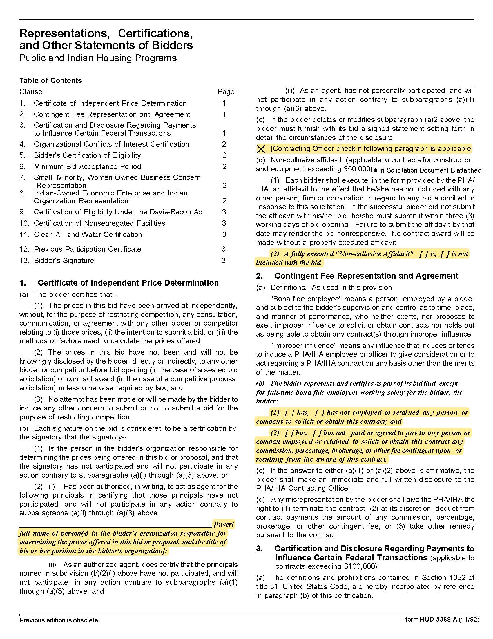

Exterior Painting Services (as needed) Q1926
Solicitation Document D HUD Form 5369A - Continued
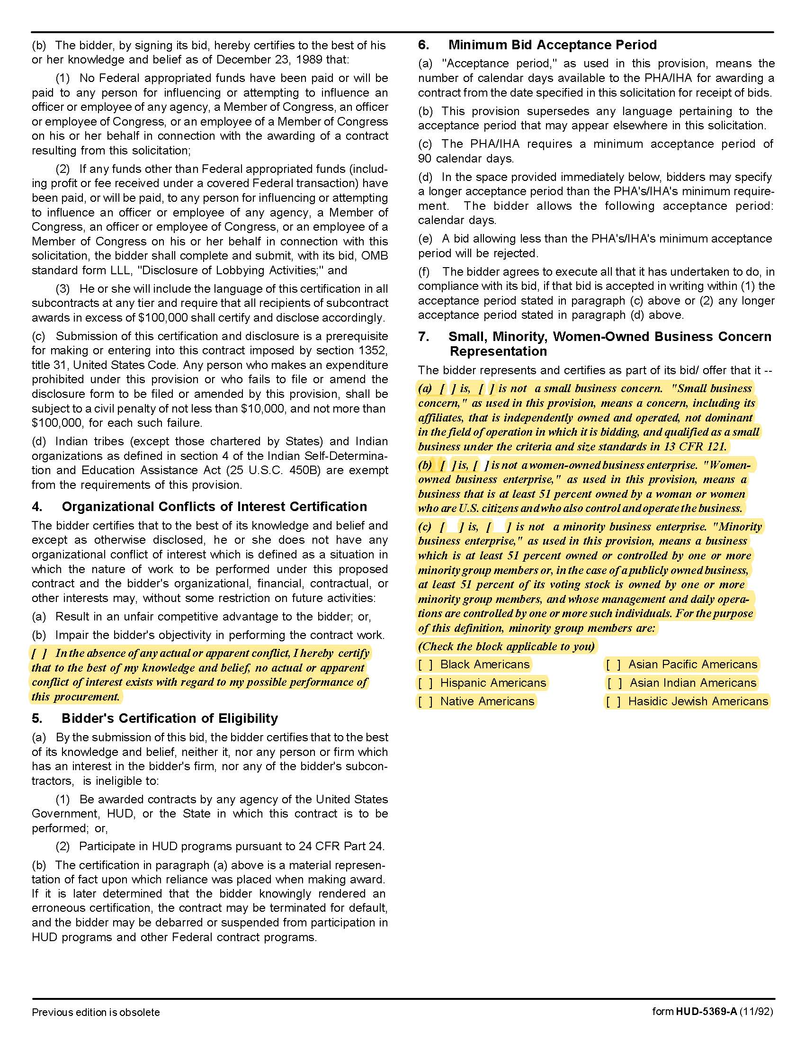

Exterior Painting Services (as needed) Q1926
Solicitation Document D HUD Form 5369A - Continued

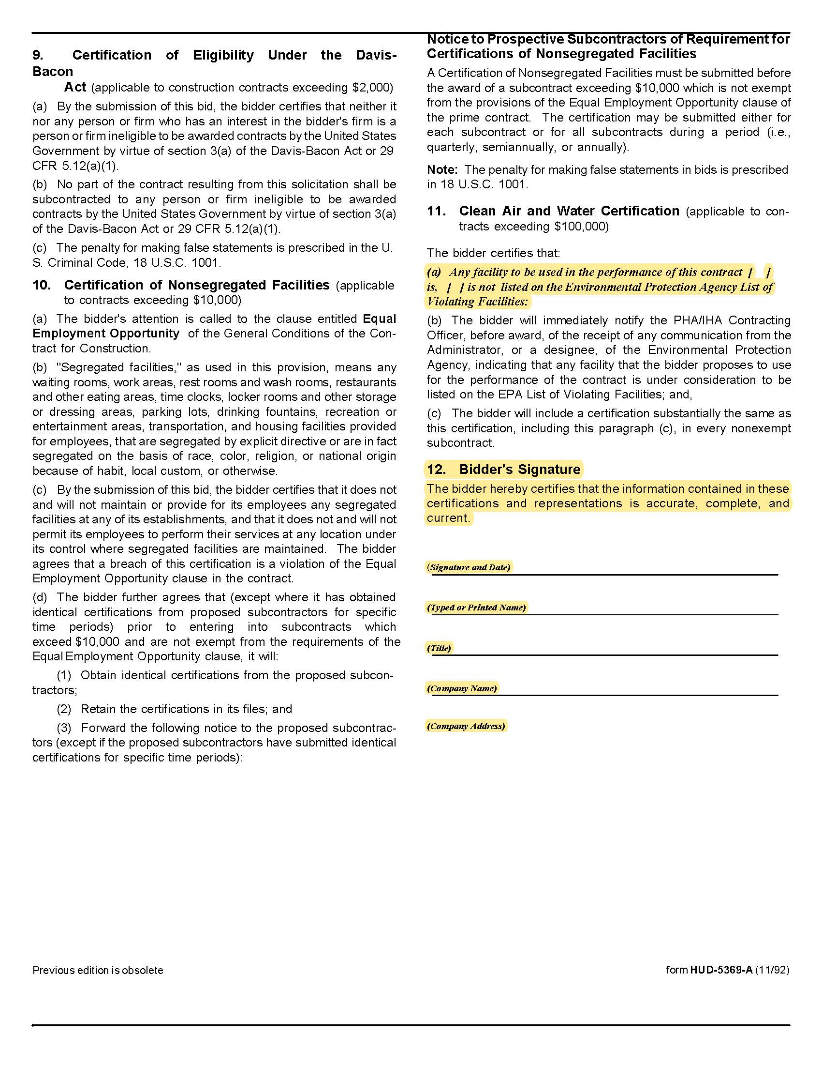

Exterior Painting Services (as needed) Q1926
Solicitation Document D Supplier Business Information
Supplier: ________________________________________________________________________________

1. Experience:
Years in business
Years in business under this name
Years performing this type of work
Value of work now under contract
Value of work in place last year
Number of clients
Will this make KCDC your largest client?
Percentage (%) of work usually self-performed
(not sub-contracted)
Has your firm:
Failed to complete a contract? | Yes No
Been involved in bankruptcy or reorganization? | Yes No
Pending judgment claims or suits against firm? | Yes No
What company do you use for pre-employment criminal background checks?

2. Safety:
Have you had any OSHA fines within the last three (3) years? | Yes No
Have you had any job related fatalities within the last five (5) years? | Yes No
If you have answered YES to either of the above questions, you MUST submit, on a separate sheet, the details describing the circumstances surrounding each incident.

3. Personnel, Equipment & Materials:
How many total employees does your company employ?
Area | Fulltime | Part Time
Clerical
Management
Technicians
Other

Exterior Painting Services (as needed) Q1926
Solicitation Document E Supplier References
Supplier: ________________________________________________________________________________

Provide three (3) references as similar in nature and scope to this project as possible. A firm may only be listed as a reference once - even if you have completed multiple projects/jobs for them.

Name of Business
Contact Person
Contact Person Title
Contact Person Telephone Number
Description of Service Provided
Date Contract Began
Date Contract Ended
Approximate Dollar Value of the Contract | $

Name of Business
Contact Person
Contact Person Title
Contact Person Telephone Number
Description of Service Provided
Date Contract Began
Date Contract Ended
Approximate Dollar Value of the Contract | $

Name of Business
Contact Person
Contact Person Title
Contact Person Telephone Number
Description of Service Provided
Date Contract Began
Date Contract Ended
Approximate Dollar Value of the Contract | $

Exterior Painting Services (as needed) Q1926

Solicitation Document F Cost
Affidavits

Item | Rate | Unit of Measure
Painting Services – Regular Time | $ | Per hour
Graffiti Removal – Regular Time | $ | Per hour
Pressure Washing | $ | Per square foot
Minimum Charge – If Applicable | $
Trip Charge – If Applicable: Once per day/per site allowed | $
Materials Markup – If applicable, specify which materials: | $
Number calendar days guaranteed to respond once purchase order is received by supplier? | Days
Other | $
Other | $
Other | $

KCDC reserves the right to have all suppliers or the top scoring suppliers apply their pricing to specific work scenarios as a part of the evaluation process.

Exterior Painting Services (as needed) Q1926
Solicitation Document G Site Manager’s Contact Information

Property | Address | Manager | Contact Points
Austin Homes | 957 East Hill Avenue | Darrell Lindsey | dlindsey@kcdc.org 865-403-1300
Autumn Landing | 6331 Pleasant Ridge Road | Manager: James Pruitt  Maintenance: Johnny Booker | jpruitt@kcdc.org 865- 403-1422 jbooker@kcdc.org
Cagle Terrace | 515 Renford Drive | Manager: Rhonda Harris  Maintenance: Larry Medley | rharris@kcdc.org 865-403-1310  lmedley@kcdc.org
Five Points Properties | 381 McConnell Street (office) | Manager: Kim Clark Manager: Beth Bacon | kclark@kcdc.org 865-403-1390 bbacon@kcdc.org
Isabella Towers | 1515 Isabella Circle | Manager: Sam Chambers  Maintenance: Mark Meade | schambers@kcdc.org 865-403-1340  mmeade@kcdc.org
Lonsdale Homes | 2020 Minnesota Avenue | Darlene Farmer | dfarmer@kcdc.org 865-403-1350
Love Towers | 1171 Armstrong Avenue | Steve Ellis | sellis@kcdc.org 865-403-1360
Mechanicsville | 2020 Minnesota Avenue (office) | Darlene Farmer | dfarmer@kcdc.org 865-403-1350
Montgomery Village | 4530 Joe Lewis Road | Linda Jeter | ljeter@kcdc.org 865-403-1380
Nature's Cove | 2639 Bakertown Road | Manager: James Pruitt  Maintenance: Gerald Littlejohn | jpruitt@kcdc.org 865-403-1422  glittlejohn@kcdc.org
North Ridge Crossing | 712 Breda Drive | Adronicus Thomas | athomas@kcdc.org 865-403-1320
Northgate Terrace | 4301 Whittle Springs Road | Manager: Terri Evans  Maintenance: Rodney Yardley | tevans@kcdc.org 865-403-1400  ryardley@kcdc.org
Passport Properties/Residences | 381 McConnell Street (office) | Beth Bacon | bbacon@kcdc.org 865-403-1390
Supportive Maintenance | 1130 Cornelia Street | Jack Canada | jcanada@kcdc.org 865-403-1371
Valley Oaks | 3504 Oak Branch Circle | Adronicus Thomas | athomas@kcdc.org 865-403-1320
The Verandas | 107 Flenniken Avenue | Linda Jeter | ljeter@kcdc.org 865-403-1380
The Vista | 957 East Hill Avenue | Darrell Lindsey | dlindsey@kcdc.org 865-403-1300
Western Heights | 1621 Jourolmon Avenue | Manager: Kristie Toby  Maintenance: Bryan Coffey | ktoby@kcdc.org 865-403-1420  bcoffey@kcdc.org

Exterior Painting Services (as needed) Q1926
Solicitation Document H Bid Envelope Coversheet


State Law requires certain supplier license information be on the front of your envelope. You are responsible for providing the correct information on the front of your envelope but KCDC provides this form as a guide to help you. Failure to supply such required information as invalidates your bid. Attach this completed page to the front of your bid envelope. Do not put it inside the envelope.

Bid Due Date/Time |  | 02-05-19 at 11:00 a.m.
Supplier’s/Firm’s Name
State of Tennessee Supplier’s License Holder Name
State of Tennessee Supplier’s License Number
Pertinent State of Tennessee Supplier’s License Classification
State of Tennessee Supplier’s License Expiration Date
Subcontractors to be used on this project (If subcontract work is not required, write “none required”)
Electrical Subcontractor Name on the State of Tennessee’s Supplier’s License |  | State of Tennessee Supplier License Number
State of Tennessee Supplier License Classification(s) |  | Expiration Date of State Supplier’s License
HVAC Subcontractor Name on the State of Tennessee’s Supplier’s License |  | State of Tennessee Supplier License Number
State of Tennessee Supplier License Classification(s) |  | Expiration Date of State Supplier’s License
Masonry Subcontractor Name on the State of Tennessee’s Supplier’s License |  | State of Tennessee Supplier License Number
State of Tennessee Supplier License Classification(s) |  | Expiration Date of State Supplier’s License
Plumbing Subcontractor Name on the State of Tennessee’s Supplier’s License |  | State of Tennessee Supplier License Number
State of Tennessee Supplier License Classification(s) |  | Expiration Date of State Supplier’s License

Advisement: KCDC will not consider notes changing the bid written on the bid envelope. Such notes must be inside the envelope.

Exterior Painting Services (as needed) Q1926
Appendix 1 Insurance Requirements

Insurance
The Supplier shall maintain, at supplier’s sole expense, on a primary and non‐contributory basis, at all times during the life of the contract insurance coverages, limits, and endorsements described herein. All insurance must be underwritten by insurers with an A.M. Best rating of A :VIII or better. Upon award, the supplier shall provide Certificate(s) of Insurance and amendatory endorsements to KCDC evidencing said insurance coverages.

The supplier agrees the insurance requirements herein as well as KCDC’s review or acknowledgement, is not intended to and shall not in any manner limit or qualify the liabilities and obligations assumed by the supplier under this contract. KCDC’s failure to require a certificate of insurance, acceptance of a non-conforming certificate or allowing the supplier to commence work shall not operate as a waiver of these minimum insurance requirements or the liabilities and obligations assumed by the supplier under this contract.

  - Commercial General Liability and Umbrella/Excess Liability Insurance: with a minimum combined single limit of $1,000,000 per occurrence with $2,000,000 in the aggregate covering bodily injury, personal injury, property damage and products and completed operations.

Such insurance shall contain or be endorsed to contain a provision that includes KCDC, its officials, officers, employees and volunteers as additional insureds providing coverage at least as broad as CG 20 10 07 04 and 20 37 07 04 endorsements. The coverage shall contain no special limitations on the scope of its protection afforded to the listed insureds.

If necessary, umbrella/excess liability insurance can be used in conjunction with the general liability insurance to meet these requirements. Unless the umbrella/excess liability insurance provides coverage on a pure/true follow-form basis, or KCDC its officials, officers, employees and volunteers are automatically defined as an additional insured, the Supplier shall add by endorsement, KCDC, its officials, officers, employees and volunteers as an additional insured for both ongoing and completed operations, providing coverage at least as broad as CG 20 10 07 04 and 20 37 07 04 endorsements.

See paragraph “d.1.” for exact naming of certificate holder and additional insured.

  - Commercial Automobile Liability Insurance: for all owned, hired and non-owned vehicles utilized by supplier in connection with the project. Coverage is to include coverage for loading and unloading hazards.

Such insurance shall contain or be endorsed to contain a provision that includes KCDC, its officials, officers, employees and volunteers as additional insureds.

See paragraph “d.1.” for exact naming of certificate holder and additional insured.

  - Workers’ Compensation Insurance and Employers Liability Insurance: Workers’ Compensation Insurance with statutory limits as required by the State of Tennessee or other applicable laws and Employers Liability coverage.

Exterior Painting Services (as needed) Q1926
Appendix 1 Insurance Requirements - Continued

  - Other Insurance Requirements:

1. Upon award, supplier shall furnish KCDC with original Certificate(s) of Insurance and amendatory
endorsements effecting coverage required by this section.

The certificate holder and additional insured shall be:

Knoxville’s Community Development Corporation (KCDC), its officials, officers, employees and volunteers
901 N Broadway
Knoxville, TN 37917

2. Provide a waiver of subrogation for each required policy herein. When required by the insurer, or should
a policy condition not permit Supplier to enter into a pre‐loss agreement to waive subrogation without an endorsement, the policy should be endorsed with a Waiver of Transfer of Rights of Recovery Against Others, or its equivalent. This waiver of subrogation requirement shall not apply to any policy which includes a condition specifically prohibiting such an endorsement, or voids coverage should Supplier enter into such an agreement on a pre‐loss basis.

3. A minimum 30‐day cancellation notice for all insurances (by endorsement if necessary) is required.

4. Provide certified copies of endorsements and policies if requested by KCDC in lieu of or in addition to Certificates of Insurance.

5. Replace certificates, policies and endorsements for any such insurance expiring prior to completion of services.

6. Maintain such insurance from the time services commence until services are completed or through such extended discovery/reporting/tail period as required. Failure to maintain or renew coverage or to provide evidence of renewal may be treated by KCDC as a material breach of contract.

7. Any deductibles and/or self‐insured retentions greater than $50,000 must be disclosed to and approved by KCDC prior to the commencement of services. Use of large deductibles and/or self‐insured retentions will require proof of financial ability as determined by KCDC.

8. All policies must be written on an occurrence basis.

9. Require all subcontractors to maintain during the term of the resulting contract commercial general liability insurance, automobile liability insurance and workers’ compensation/employers liability insurance (unless subcontractor’s employees are covered by Supplier’s insurance) in the same manor and limits as specified for the supplier.

e. Right to Revise or Reject: KCDC reserves the right, but not the obligation, to review or revise any

Exterior Painting Services (as needed) Q1926
Appendix 1 Insurance Requirements - Continued

insurance requirement, not limited to limits, coverages and endorsements based on insurance market conditions affecting the availability or affordability of coverage; or changes in the scope of work / specifications affecting the applicability of coverage.

f. No Representation of Coverage Adequacy: The coverages, limits or endorsements required herein protect the primary interests of KCDC, and the Supplier agrees in no way should these coverages, limits or endorsements required be relied upon when assessing the extent or determining appropriate types and limits of coverage to protect the Supplier against any loss exposures, whether as a result of the project or otherwise.

Term Sheet - Insurance Requirements

Certificate Holder &  Additional Insureds | Knoxville’s Community Development Corporation (KCDC), its officials, officers, employees, and volunteers
GL (Supplier & Subs) | $1M / $2M
Auto (Supplier & Subs) | Required
WC & Employers Liability (Supplier & Subs) | Statutory Limits
30-day cancellation | Required – Must indicate on COI
Primary non-contributory | Required – Must indicate on COI
Waiver of Subrogation | Required – Must indicate on COI

