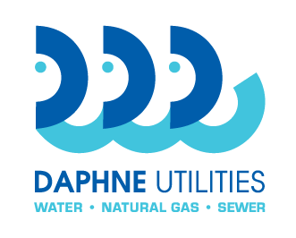
Daphne Utilities
Marinda Turner, Buyer
251-210-1647 Office
marinda@daphneutilities.com

Request for Bid no.: | RFB 20-04
Name of bid: | Storage Tank 3,000 gallon
Contact person: | Marinda Turner 251-210-1647  Larry English 251-583-5643 (technical information)

Bid Form
FRP 0.8% Sodium Hypochlorite Storage Tank

One (1) FRP 0.8% Sodium Hypochlorite storage tank $ __________
(Do not include sales tax. Tax Exemption Certificate to be provided)

Freight to 28340 County Road 13, Daphne, AL 36526 $__________

One Year Warranty $__________
Two Year Warranty $__________
Three Year Warranty $__________
(please provide warranty inclusions and exclusions and terms, if applicable. Warranty is not a requirement.)

I have read and understood the terms and conditions and the bid specifications of this bid. I have provided or will provide at the appropriate time, all documentation required. Omission of any required documentation may result in the bid being deemed unresponsive by Daphne Utilities.

Submitted by: __________________________________________________________ Company name of bidder

_________________________________________________________________________________________
By: company officer name

_________________________________________________________________________________________
Signature

__________________________________________ ________________________________ Title Date

_________________________________________________________________________________________
Company address, city, state, zip

___________________________________________ ________________________________
Phone EIN / tax id number

___________________________________________ ________________________________
Point of contact name Point of contact phone

___________________________________________
Point of contact email

