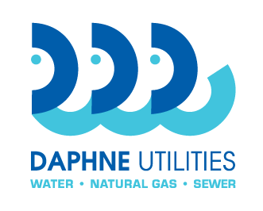
Daphne Utilities
Marinda Turner, Buyer
251-210-1647 Office
marinda@daphneutilities.com

Request for Bid no.: | RFB 20-04
Name of bid: | Storage Tank 3,000 gallon
Contact person: | Marinda Turner 251-210-1647  Larry English 251-583-5643 (technical information)

Bid Specifications
FRP 0.8% Sodium Hypochlorite Storage Tank
Tank is to be designed for storage of 0.8% Sodium Hypochlorite, at specific gravity 1.2, ambient temperature and atmospheric pressure. Withstand 105 mph winds, 3 ft uplift condition and seismic conditions in accordance with IBC 2009. Tank will be outdoors. Tank will be manufactured per ASTM D-3299 and ASTM D-4097 specifications from Hetron FR992 vinyl ester resin throughout with double C-veil liner with BPO-DMA cure.
- 3,000 gallon
- 8’ diameter x 8’ straight side height
- Vertical
- Flat bottom
- Dome top
- Single wall
- Fiberglass tank

Tank to include the following:
- 1 – 24” top manway with Viton gasket and 316 ss bolts
- 3 – 3” flanges with conical gussets
- 1 – 3” fiberglass J-vent assembly
- 1 – 2” flange with conical gusset
- 1 – 2” double flange with conical gusset
- 2 – 1” flanges with conical gussets
- 1 – 1” clear PVC sight gauge assembly with wind guards
- 1 – 2” foam insulation with 100 mil fiberglass overcoat
- 1 – fiberglass ladder
- 4 – 316 ss lifting lugs and tie down lugs
- Hydro test
- Post cure
- Stainless steel nameplate with bracket support
Freight costs for delivery to Daphne Utilities Water Quality Plant, 28340 County Road 13, Daphne, Alabama 36526 shall be included as a separate item and should be a firm cost.

