

Request for Proposals

Solicitation Name and Number | Auditing Services Q2001
Responses Must Arrive No Later Than | 11:00 a.m. on November 6, 2020 (as KCDC’s clocks indicate)
Deliver Responses to | procurementinfo@kcdc.org
Electronic Copies | Use the MS Word version posted on KCDC’s website (or other electronic means) to provide a typed response. The final proposal is to be submitted in Adobe format.
Solicitation Meeting | ☒ Yes ☐ No
Solicitation Meeting is Mandatory | ☐ Yes ☒ No ☐ Not Applicable
Solicitation Meeting Date and Time | October 22, 2020 at 2:00 p.m.
Solicitation Meeting Connection | Email KCDC at procurementinfo@kcdc.org for the web link.
Questions About This Solicitation | Submit questions to procurementinfo@kcdc.org by 4:00 p.m. on November 1, 2020.  KCDC will not accept questions via telephone.
Award Results | KCDC posts the award decision to its web page at: http://www.kcdc.org/procurement/
Open Records/Public Access to Documents | All document provided to KCDC are subject to the Tennessee Open Meetings Act (TCA 8-44-101) and open records requirements.
Check KCDC’s webpage (https://www.kcdc.org/procurement/) for addenda and changes before submitting your response

General Information

1. Background and Intent
a. Knoxville's Community Development Corporation (KCDC) is the public housing and redevelopment agency for the City of Knoxville and for Knox County in Tennessee. KCDC’s housing property portfolio includes 17 properties with approximately 3,500 dwelling units. KCDC also administers approximately 3,958 Section 8 Vouchers and 82 Moderate Rehabilitation units. Other activities of KCDC include management of 9 LIHTC properties, administration of development and redevelopment projects for local governments and several related business activities.

b. KCDC uses “supplier” as inclusive of various words describing interested parties often called “vendor,” “bidders,” “contractors” and “suppliers.”

c. KCDC is seeking proposals from qualified Certified Public Accounting firms to conduct an independent audit for the fiscal year ending June 30, 2021.

d. KCDC is contracting for a single agency audit in accordance with Office of Management and Budget (OMB) Uniform Guidance 2 CFR 200, which includes other agreed-upon procedures regarding Uniform Financial Reporting Standards (UFRS).

e. KCDC is a public body corporate and politic pursuant to the laws of the State of Tennessee which was organized to provide low rent housing for qualified individuals in accordance with the rules and regulations prescribed by the United States Department of Housing and Urban Development (HUD) and other federal agencies. The primary purpose of KCDC is to provide safe, decent, sanitary and affordable housing to low income, elderly and handicapped families in Knoxville and in Knox County, Tennessee.

f. The governing body of KCDC is its Board of Commissioners, which is composed of seven members appointed by the Mayor of the City of Knoxville. The Board appoints a Chief Executive Officer to administer the business of KCDC. KCDC is not considered a component unit of the City of Knoxville, as the Board independently oversees KCDC’s operations.

g. KCDC’s financial statements are comprised of the following funds and programs:
- Central Office Cost Center
- Low Income Public Housing under HUD ACC – Two AMPs consisting of 440 and 277 units
- Capital Fund in relation to LIPH properties
- Section 8 Programs under HUD ACC
- Housing Choice Vouchers
- Mainstream Vouchers
- Section 8 Moderate Rehabilitation – 3 projects
- Family Self-Sufficiency
- Multi-Family Housing – 11 developments averaging 110 units each
- Section 8 PBV consisting of 75units
- Wholly owned Subsidiary Corporations as follows:

- Passport Development Corporation (PDC) is a Section 115 Corporation which has served as KCDC’s general partner (GP) to limited partnerships formed in conjunction with low-income tax credits. Currently PDC is the GP for Eastport Development LP., owner of The Residences at Eastport Phase 2.
- Knoxville’s Housing Development Corporation is a Section 115 Corporation established to acquire, rehab or develop affordable housing projects in the Knoxville area for KCDC. KHDC is the owner of Passport Homes and Clifton Road Apartments.
- Family Investment Foundation, Inc. is a 501(c) (3) Corporation established for charitable, social, vocational, recreational and health purposes, and related business ventures.
- Greater Tennessee Housing Assistance Corporation -is a Section 115 Corporation established for the purpose of funding the construction of six Section 8 New Construction housing projects. All debts have been paid and all projects have been sold. The corporation is now dormant.
- Five Points 1 Corporation is a Section 115 Corporation that is an instrumentality of KCDC. The purpose of the corporation is to be the general partner in a limited partnership formed in conjunction with low-income housing tax credits for the development of the Five Points Senior Building.
- Five Points 2 Corporation is a Section 115 Corporation that is an instrumentality of KCDC. The purpose of the corporation is to be the general partner in a limited partnership formed in conjunction with low-income housing tax credits for the development of Five Points Phase 2 Apartments which will consist of 84 family and elderly units.
- Five Points 3 Corporation is a Section 115 Corporation that is an instrumentality of KCDC. The purpose of the corporation is to be the general partner in a limited partnership formed in conjunction with low-income housing tax credits for the development of the Five Points Phase 3 Apartments which consist of 80 family and elderly units.
- Five Points 4 Corporation is a Section 115 Corporation that is an instrumentality of KCDC. The purpose of the corporation is to be the general partner in a limited partnership formed in conjunction with low-income housing tax credits for the development of the Five Points Phase 4 Apartments which will consist of 82 units.
- Passport Housing Corporation is a Section 115 Corporation that is an instrumentality of KCDC. The purpose of the corporation is to be the general partner in a limited partnership formed in conjunction with low-income housing tax credits for the rehabilitation and operation of apartment units at Residences at Lonsdale, North Ridge Crossing, and The Vista at Summit Hill.
- Townview Towers Affordable Housing Corporation is a Section 115 Corporation that is an instrumentality of KCDC. The purpose of the corporation is to facilitate the renovation of Townview Towers Apartments. The corporation holds a 40% ownership interest in TVT GP, LLC, General Partner to TVT, LP established to finance transactions related to the rehabilitation of Townview Towers Apartments.
- Montgomery Village Housing Corporation is a Section 115 Corporation that is a wholly owned instrumentality of KCDC. The purpose of the corporation is to own and facilitate the renovation of Montgomery Village Apartments. These apartments, consisting of 384 units, are a part of KCDC’s multi-family portfolio, but have a federal loan guarantee, which necessitates the Corporation.

- Hollywood GP Corporation is a Section 115 Corporation wholly owned by KCDC, created for ownership and financing activities related to 817 Hollywood Road, Knoxville, Tennessee, and for similar properties and activities as determined beneficial.
- Young High GP Corporation is a Section 115 Corporation wholly owned by KCDC, created for ownership and financing activities related to Young High, Knoxville, Tennessee, and for similar properties and activities as determined beneficial.
- Moss Grove GP Corporation is a Section 115 Corporation wholly owned by KCDC, created for ownership and financing activities related to Moss Grove, Knoxville, Tennessee, and for similar properties and activities as determined beneficial.
- Bell Street Corporation (BSC) is a Section 115 Corporation wholly owned by KCDC. BSC is to be the general partner in a limited partnership formed in conjunction with low-income housing tax credits for the development of affordable housing units through RAD initiatives.
- Bell Street 2 Corporation is (BS2) is a Section 115 Corporation wholly owned by KCDC. BS2 is to be the general partner in a limited partnership formed in conjunction with low-income housing tax credits for the development of affordable housing units through RAD initiatives.
- Bell Street 3 Corporation is (BS3) is a Section 115 Corporation wholly owned by KCDC. BS3 is to be the general partner in a limited partnership formed in conjunction with low-income housing tax credits for the development of affordable housing units through RAD initiatives.
- Cagle Terrace Corporation is a Section 115 Corporation that is a wholly owned instrumentality of KCDC. The purpose of the corporation is to own and facilitate the renovation of Cagle Terrace through RAD initiatives. These apartments, consisting of 274 units, are a part of KCDC’s multi-family portfolio, but have a federal loan guarantee, which necessitates the Corporation.

These blended component units are reported in the aggregate in the Combining Schedule of Net Assets and Combining Schedule of Revenues, Expenses and Changes in Net Position.

h. Other KCDC Programs:
- Redevelopment Program administers CDBG and other projects for the City of Knoxville and Knox
County.
- The Manor is a program whereby KCDC provides meals, laundry service and has a twenty-four-
hour staff available for the special needs of the more dependent elderly tenants. This service is provided to those tenants for a fee.
- Other Business Activities: KCDC is the management agent for nine limited partnership entities.

These LPs, each with a December 31 fiscal year end, are audited by other auditors. They are presented collectively as discrete component units in KCDC’s financial statements.

I. KCDC has 10 employees on its accounting staff with various education and experience levels.

j. The accounting staff consists of the following employees:

Title | Years with KCDC | Years in the Industry
Chief Financial Officer | 30+ | 30+
Deputy Director of Finance & Administration | 3 | 30
Accounting Administrator | 5 | 10
Senior Accountant 1 | 20+ | 20+
Senior Accountant 2 | 20+ | 20+
Senior Accountant 3 | New | 5
Accountant 1 | 5 | 5
Accountant 2 | New | 1
Accounting Technicians II | 20+ | 20+
Accounting Technician II | 20+ | 20+
Accounting Technician 1 | 1 | 1

k. Other staff information
- Two of the staff are CPAs and most others possess degrees in accounting.

- Most other management personnel throughout the agency have also been with KCDC more than 15 years.

l. There has been no known fraud during the past ten years.

m. KCDC is currently in development and rehabilitation of several capital projects, and it is possible that the addition of other projects with debt service could occur between now and the end of this fiscal year. KCDC has two remaining LIPH properties which are scheduled to be converted to HUD Multi-family properties through RAD within the next two years.

n. Internal financial statements are prepared monthly. Executive Management and Directors review these statements. Property Managers review and comment on the statements within their areas of responsibility. The monthly statements are prepared on a hybrid method. Year-end statements are converted to full accrual under GAAP.

o. There are no current or pending HUD investigations/audits that would have an impact on the engagement.

p. Prior audit reports and operating budgets are available on KCDC’s website. Check our web page at www.kcdc.org for additional significant information covering several years of financial history and agency information.

2. Changes after Award
It is possible that after award KCDC will need to revise the service needs or requirements specified in this document. KCDC reserves the right to make such changes after consultation with the supplier. Should additional costs arise, the supplier must document increased costs. KCDC reserves the right to accept and negotiate these charges.

3. Contact Policy
Contact only KCDC’s Procurement Division about this solicitation from the issuance of this RFP until its award. Information obtained from any other person will not affect the risks or obligations assumed by the supplier or relieve the supplier from fulfilling any of the conditions of the resulting award. Such contact can disqualify the supplier from the solicitation process.

4. Contract Approval
The resulting contracts are subject to the approval and review of KCDC’s Board, HUD and the State of Tennessee Comptroller’s Office.

5. Contract Form
KCDC is required to use the State of Tennessee’s form of contract. The State of Tennessee has an on-line electronic filing system (CARS). KCDC initiates the contract with the State of Tennessee’s Comptroller’s Office. The form is filled out on-line and sent through their approval system. A sample contract is posted on KCDC’s webpage. However, KCDC would entertain executing an engagement letter as well.

6. Errors and Deficiencies
The successful supplier is required to revise any material prepared under an agreement resulting from this RFP without additional compensation if it is determined that the supplier is responsible for errors or deficiencies.

7. Evaluation
a. KCDC alone determines (using NIGP’s definition and other relevant sources as appropriate) the supplier’s “responsive” and “responsible” status prior to award. Responsible means a business with the financial and technical capacity to perform the requirements of the solicitation and subsequent contract. A responsive proposal is one that fully conforms in all material respects to the solicitation document and all of its requirements, including all form and substance.

b. KCDC reserves the right to request additional information to assist in the evaluation process.

c. KCDC will review all proposals and reserves the right to request necessary modifications, waive minor technicalities, reject all proposals, reject any proposal that does not meet mandatory requirement(s) or cancel this RFP, according to KCDC’s best interests. KCDC further reserves the right to adjust its evaluation scenario if this is in KCDC’s best interest and consistent with good business practices.

d. KCDC may require oral presentations as part of the evaluation process.

e. KCDC plans to award to the best overall proposal on the following evaluation scale:

Factors | Maximum Points
Professional and Technical Competence and Experience | 35
Professional Staff to be assigned | 20
Capability to Provide Timely Services | 20
Cost | 25
Total | 100
8. General Instructions
KCDC does not insert “General Instructions to Suppliers” in solicitation documents. These instructions are at www.kcdc.org. Click on “Procurement” and then follow the link to the instructions. The supplier’s submittal means acceptance of the terms and conditions set forth in KCDC’s “General Instructions to Suppliers.” Paragraphs in the “General Instructions” document that do not apply to this solicitation: None

9. Insurance
The supplier agrees to maintain at its sole expense during the term of this agreement insurance coverages and limits in accordance with the supplier’s standard business practices and acceptable to KCDC. Coverage must include Professional Liability or Errors and Omissions Liability with a minimum policy limit of $1,000,000. Supplier shall provide KCDC with Certificates of Insurance evidencing such insurance prior to contract execution and upon each policy term renewal. If you or your insurance agent have concerns or believe that some coverages are not necessary, email procurementinfo@kcdc.org detailing any requested changes before this solicitation’s due date.

10. Length of Award
The length of the contract will be twelve months with four optional annual renewals that KCDC may exercise at its discretion.

11. Licenses
a. Proper licensure by the State of Tennessee and all other authorities having jurisdiction is required. Throughout the term of this contract, the supplier shall maintain the required current licenses.

b. All suppliers must meet independence standards which include the IPA’s technical qualification requirements set forth by Government Auditing Standards (GAS) and Generally Accepted Auditing Standards (GAAS) including the qualifications of the staff assigned to the engagement.

12. Price Structure
At the end of each twelve-month period, the awarded supplier(s) may request a change to the agreed to price as detailed in proposal pricing section.

13. Section 3 of the HUD Act of 1968
Section 3 is a provision of the Housing and Urban Development Act of 1968 which requires that programs of direct financial assistance administered by the U.S. Department of Housing and Urban Development (HUD) provide, to the greatest extent feasible, opportunities for job training and employment to lower income residents in connection with projects in their neighborhoods. Further, to the greatest extent feasible, contracts in connection with these projects are to be awarded to local businesses. Section 3 is a tool for fostering local economic development, neighborhood economic improvement and individual self-sufficiency.

a. Recipients and suppliers must make a good faith effort to utilize Section 3 area residents as trainees and employees in connection with the project. Targeted recruitment and the selection of Section 3 area residents for available positions are two examples of good faith efforts to meet this requirement.

b. Recipients and supplier must make a good faith effort to award contracts to Section 3 business concerns for work in connection with the project. An example of a good faith effort to meet this requirement is the implementation of an affirmative action plan, which includes targets for the number and dollar value for awarding contracts to Section 3 business concerns.

c. Recipients and supplier must keep records and submit reports to HUD documenting the good faith efforts taken and the results of these actions. Examples of such documentation include letters to community organizations, employment development and business development centers, copies of solicitations for bids or proposals, and copies of affirmative action plans.

d. How can businesses find Section 3 residents to work for them? This can be accomplished by recruiting in the neighborhood and public housing developments to tell about available training and job opportunities. Distributing flyers, posting signs, placing ads, and contacting resident organizations and local community development and employment agencies to find potential workers are a few effective ways of getting jobs and people together.

e. All contracts awarded are subject to Section 3 requirements. Supplier shall seek to fill all positions that are unfilled with KCDC residents. For additional information, go to http://www.hud.gov/offices/fheo/section3/Section3.pdf. The successful supplier will give KCDC job announcements for any position that must be filled as a result of the award of KCDC work. Additionally the successful supplier will supply the same job announcement to the Knoxville-Knox County Committee Action Committee’s Workforce Connections group. These can be faxed to 865-544-5269.

f. A Section 3 resident is one who lives within a public housing authority’s site. It is also people who live in an area with a HUD assisted program and whose income is below HUD’s low income requirements.

g. A Section 3 business is one that:
- Is at least 51% owned by a Section 3 resident; or
- Employs Section 3 residents for at least 30% of its employee base; or
3. Makes a commitment to sub contract at least 25% of the project’s dollars to a Section 3 business.

h. Upon award, the successful supplier will supply two documents to KCDC:
- A Section 3 Business determination provided one is not already on file.
2. A Section 3 Business plan for this work.

14. Smoking Policy
KCDC’s Smoke Free policy is applicable to you, your employees and subcontractors.

a. The policy mandates:
- No smoking on owner’s property
- No e-vape or similar usage on owner’s property
- The Smoke Free policy applies in personal or corporate vehicles on owner’s property

b. Applicable definitions include:

- “Smoking” means inhaling, exhaling, burning or carrying any lighted or heated cigar, cigarette or pipe, or any other lighted or heated tobacco or plant product intended for inhalation, including hookahs and marijuana, whether natural or synthetic, in any manner or in any form. “Smoking” also includes the use of an electronic smoking device which creates an aerosol or vapor, in any manner or in any form.

- “Electronic Smoking Device” means any product containing or delivering nicotine or any other
substance intended for human consumption that can be used by a person in any manner for the purpose of inhaling vapor or aerosol from the product. The term includes any such device, whether manufactured, distributed, marketed or sold as an e-cigarette, e-cigar, e-pipe, e-hookah or vape pen or under any other product name or descriptor.

- Property means all buildings, parking lots, streets, structures and land. Should supplier staff be observed violating these requirements, KCDC’s Procurement Division will notify the supplier about the problem. Should there be recurrences, KCDC may ask the supplier to not send the employee to KCDC’s property. Repeated offenses may result in forfeiture of your awarded “contract.”

15. Submittal Instructions
Submit your information in the order indicated below:

Document Number | Title
Solicitation Document A | General Information about the Supplier
Solicitation Document B | Affidavits
Solicitation Document C | HUD Form 5369A
Solicitation Document D | Suppliers’ Professional & Technical Competence and Experience
Solicitation Document E | Staff Assigned to KCDC’s Project
Solicitation Document F | Ability to meet KCDC’s Timelines
Solicitation Document G | References
Solicitation Document H | Cost Proposal (in a separate file/envelope)
Solicitation Document I | Sample Contract for KCDC to consider

a. Place your company’s name on each page and number all pages consecutively

b. The use of tables in presenting information facilitates the evaluation team’s review.

c. Do not use phrases such as “See the attached” or “Will be provided upon award.”

Conditions and Work Description

16. Contract Liaison
KCDC and the supplier shall each designate a primary authorized representative for administering the resulting agreement. The liaison shall be named after award. Traditionally KCDC staff and the supplier meet throughout the audit period via status meetings, conference calls, Zoom, et cetera. This works well for both the auditors and KCDC.

17. Deliverables
The successful supplier is responsible for complete fulfillment of the terms of the engagement by December 31, 2021. This includes but is not limited to completion of all audit and attestation processes, submission of 30 bound copies of the audit report to KCDC, provision of electronic copies of the audit report as necessary, satisfaction of the UFRS requirements to HUD REAC and the Federal Clearing House and submission of the audit to the State of Tennessee.

The successful supplier is responsible for agreed upon procedures related to the audited submission in HUD’s Real Estate Assessment Center (REAC) online database before issuance of the audit report.

18. KCDC currently utilizes the following computer software
  - Emphasys Elite for procurement, financial accounting and housing operations.
  - Vista is utilized for payroll and human resources.
  - Excel spreadsheets are used extensively by staff.
  - Docstar Eclipse is utilized for various workflows and electronic document storage and retrieval.
  - Auditors will be granted appropriate levels of access to these systems and data.

19. Audit History
- KCDC has always received unmodified opinions on both the financial statements and compliance.
- Malcolm Johnson Company, DeBary, Florida, has served as KCDC auditors for several cycles.

20. Other Assistance
As a matter of convenience to KCDC staff, and to enhance efficiency, the successful supplier will assist in preparation of the top-level financial statements, the related note disclosures, the supplemental information and the Schedule of Expenditure of Federal Awards. KCDC staff will prepare necessary schedules. KCDC staff will review these documents, make necessary amendments to them and accept full responsibility for them before issuance.

21. Fieldwork
KCDC requires an entrance conference at the beginning of onsite fieldwork, informal updates throughout the audit process as well as a preliminary exit conference at the conclusion of fieldwork. An Exit Conference is also required prior to report issuance. The entrance and exit conferences may be conducted with the Executive Management Team and other staff members as may be prudent. Presentation of the audit to the Board of Commissioners is optional as determined by KCDC’s needs. Zoom or similar technology may be used to facilitate meetings as determined to be most beneficial to all parties.

22. Auditor/Auditee Responsibilities:
The supplier agrees to comply with relevant and applicable laws and regulations.

a. KCDC prepares financial statements in accordance with Generally Accepted Accounting Principles (GAAP).

b. KCDC is required to comply with applicable housing requirements and other federal and state requirements applicable to Public Housing and Section 8 Units and/or the Property or Project, including, without limitation, the following: (a) The Fair Housing Act, (b) Titles VI and VIII of the Civil Rights Act of 1964 (c) Age Discrimination Act of 1975 (d) Section 504 of the Rehabilitation Act of 1973 (e) Section 3 of the Housing and Urban Development Act of 1968 (f) Wage Rates under the Davis-Bacon Act (g) Section 42 and related provisions of the Internal Revenue Code of 1986, as amended and (h) any other applicable state, county, city laws and requirements.

c. The audit must be conducted in accordance with Office of Management and Budget (OMB) Uniform Guidance 2 CFR 200.

d. The audit of financial statements shall be conducted in accordance with Generally Accepted Government Auditing Standards (GAGAS) and/or Government Auditing Standards (GAS). The audit shall cover the entire operations of the auditee.

e. Financial Statements: The auditor shall determine whether the auditee’s financial statements are fairly presented in all material respects in conformity with generally accepted accounting principles (GAAP). The auditor shall also determine whether the schedule of expenditure of Federal awards is presented fairly in all material respects in relation to the auditee’s financial statements taken as a whole. The audited financial statements should reflect entity-wide operations, including component units and joint venture activities in compliance with GASB 14 and GAAP.

f. Internal Control: The auditor shall perform procedures to obtain an understanding of the auditee’s internal control systems and perform tests as appropriate for the purpose of expressing an opinion on the financial statements

g. Compliance: The auditor shall opine as to whether the auditee has complied with laws, regulations, and terms and conditions of federal awards that may have a direct and material effect on its federal programs and financial statement amounts.

h. Audit Follow-up: The auditor shall follow-up on prior audit findings; perform procedures to assess the reasonableness of the summary of schedule of prior audit findings prepared by the auditee.

i. Data Collection Form: The auditor shall complete and sign specified sections of the data collection form.

j. Audit Reporting: The auditor’s report shall include all elements which may be required by Governmental Auditing Standards, including the following:

1. An opinion (or disclaimer) as to whether financial statements are presented fairly in all material respects in conformity with the stated accounting principles and an opinion (or disclaimer) as to whether the schedule of expenditures of Federal awards is presented fairly in all material respects in relation to the financial statements taken as a whole.

2. A report on internal control over financial reporting and on compliance with laws, regulations and provisions of contracts and award agreements; noncompliance with which could have a material effect on the financial statements and other matters based upon the audit of the financial statements. The report shall describe the scope of testing of internal control and compliance and the results of the tests.

3. A report on compliance and internal control over compliance applicable to each major program. This report shall describe the scope of testing of internal control over compliance and compliance to include an opinion (or disclaimer) as to whether auditee complied with laws, regulations terms and conditions of Federal awards which could have a direct and material effect on each major program.

4. A schedule of findings and questioned costs presented and appropriately documented to
provide clear and sufficient context and perspective.

k. Audit Working Papers.

1. Retention of Working Papers: The auditor shall retain working papers after the date of final issuance for the greater of the minimum period required by governmental auditing standards and the cognizant federal agency (HUD).

2. Access to Working Papers: Audit working papers shall be made available upon request to the cognizant or oversight agency for audit or its designee at completion of audit, as part of a quality review to resolve audit findings or carry out oversight responsibilities.

3. Access to working papers includes the right of federal agencies to obtain copies of working papers, as is reasonable and necessary.

l. The auditor shall determine the Housing Authority’s (HA’s) major federal programs per a risk-based approach.

m. Prepare the Audit Engagement Letter as applicable in accordance with AICPA standards. This letter is a formal contract between the auditor and the auditee. It confirms the auditor’s acceptance of the appointment and documents the agreed-upon scope and terms of the engagement.

n. Conduct the audit in accordance with all applicable guidance, to include, but not limited to, the following:

1. HUD Handbook 2000, 04 REV-2, Consolidated Audit Guide for Audits of HUD Programs.
2. Government Auditing Standards (the “Yellow Book”) promulgated by the Comptroller General of
the United States General Accounting Office.
3. The General Accounting Office publication Assessing Compliance With Applicable Laws and Regulations.
4. The American Institute of Certified Public Accountants guidance for audits of state and local governments.
5. The HUD publication “24 CRF Part 5, et al. Uniform Financial Reporting Standards for HUD Housing Programs; Final Rule.

23. Schedule of Expenditures of Federal Awards
See Appendix A.

24. Timelines
a. All or a majority of requested work papers should be available on the first day of fieldwork and should be ready in the month of October. This is dependent upon both the fieldwork start date and the date the request is received.

b. The audit shall be completed, all workpaper matters finalized, all auditors’ requests satisfied, all reports issued (KCDC, HUD, REAC, Audit Clearing House, State of Tennessee, etc.) and any related attestations completed by December 31st.

This and the Previous Pages Do Not Need to be Returned

Solicitation Document A: General Information about the Supplier
Sign Your Name to the Right of the Arrow
If completing this document in Adobe, an electronic signature is acceptable to KCDC.
Your signature indicates you read and agree to “KCDC’s General Instructions to Suppliers” (www.kcdc.org) and that you are authorized to bind the supplier or are submitting the response on behalf of and at the direction of the suppliers’ representative authorized to contractually bind the supplier. I represent that the supplier or its applicable representative(s) has reviewed the information contained in this Solicitation Package and that the information submitted is accurate.
Printed Name and Title
Company Name
Street Address
City/State/Zip
Contact Person (Please Print Clearly)
Telephone Number
Cell Number
Supplier’s E-Mail Address (Please Print Clearly)
Addenda
Addenda are at www.kcdc.org. Click on “Procurement” and then on “Open Solicitations” to find addenda. Please check for addenda prior to submitting a proposal.
Acknowledge addenda have been issued by checking below as appropriate:
None ☐ | Addendum 1 ☐ |  |  | Addendum 2 ☐ |  | Addendum 3 ☐ |  |  | Addendum 4 ☐ | Addendum 5 ☐
Statistical Information (Check all the apply)
This business is at least 51% owned and operated by a woman |  |  |  |  |  |  |  |  |  |  |  | Yes ☐ No ☐
This business qualifies as a small business by the State of Tennessee  Total gross receipts of not more than $10,000,000 average over a three-year period OR employs no more than 99 persons on a full-time basis |  |  |  |  |  |  |  |  |  |  |  | Yes ☐ No ☐
This business qualifies as Section 3 business (as defined by HUD):  It is at least 51% owned by a Public Housing resident or it employs Section 3 residents for at least 30% of its employee base; or it commits to subcontract at least 25% of the project’s dollars to a Section 3 business. |  |  |  |  |  |  |  |  |  |  |  | Yes ☐ No ☐
This business is owned & operated by persons at least 51% of the following ethnic background:
Asian/Pacific ☐ |  | Black ☐ | Hasidic Jew ☐ |  | Hispanic ☐ |  |  | Native Americans ☐ |  |  |  | White ☐
Prompt Payment Discount
A prompt payment discount of ________% is offered for payment within ____ days of submission of an accurate and proper invoice.
MasterCard Acceptance
Mastercard is accepted for payment without additional fees. |  |  |  |  |  |  |  |  |  |  | ☐ Yes ☐ No

Solicitation Document B: Affidavits

Conflict of Interest
1. No commissioner or officer of KCDC or other person whose duty it is to vote for, let out, overlook or in any manner superintend any of the work for KCDC has a direct interest in the award or the supplier providing goods or services.

2. No employee, officer or agent of the grantee or sub-grantee will participate in selection, or in the award or administration of an award supported by Federal funds if a conflict of interest, real or apparent, would be involved. Such a conflict would arise when the employee, officer or agent, any member of his immediate family, his or her partner, or an organization, which employs, or is about to employ, any of the above, has a financial or other interest in the supplier selected for award.

3. The grantee's or sub-grantee's officers, employees or agents will neither solicit nor accept gratuities, favors or anything of monetary value from suppliers, potential suppliers or parties to sub-agreements.

4. By submission of this form, the supplier is certifying that no conflicts of interest exist.

Drug Free Workplace Requirements
5. Private employers with five or more employees desiring to contract for construction services attest that they have a drug free workplace program in effect in accordance with TCA 50-9-112.

Eligibility
6. The supplier is eligible for employment on public contracts because no convictions or guilty pleas or pleas of nolo contender to violations of the Sherman Anti-Trust Act, mail fraud or state criminal violations with an award from the State of Tennessee or any political subdivision thereof have occurred.
General
7. Supplier fully understands the preparation and contents of the attached offer and of all pertinent circumstances respecting such offer.

8. Such offer is genuine and is not a sham offer.

Iran Divestment Act
9. Concerning the Iran Divestment Act (TCA 12-12-101 et seq.), by submission of this bid/quote/proposal, each supplier and each person signing on behalf of any supplier certifies, and in the case of a joint bid/quote/proposal, each party thereto certifies as to its own organization, under penalty of perjury, that to the best of its knowledge and belief that each supplier is not on the list created pursuant to § 12-12-106.

Accuracy of Electronic Copies
10. If the supplier provides electronic copies of the bid/proposal/quote to KCDC, the supplier certifies that the information provided on paper and in the electronic format is identical unless specifically noted otherwise.

Non-Collusion
11. Neither the said supplier nor any of its officers, partners, owners, agents, representatives, employees or parties interest, including this affiant, has in any way colluded conspired, connived or agreed, directly or indirectly, with any other responder, supplier, or person to submit a collusive or sham offer in connection with the award or agreement for which the attached offer has been submitted or to refrain from making an offer in connection with such award or agreement, or collusion or communication or conference with any other supplier, or, to fix any overhead, profit, or cost element of the offer price or the offer price of any other supplier, or to secure through any collusion, conspiracy, connivance, or unlawful agreement any advantage against KCDC or any person interested in the proposed award or agreement.

12. The price or prices quoted in the attached offer are fair, proper and not tainted by any collusion, conspiracy, connivance, or unlawful agreement on the part of the supplier or any of its agents, representatives, owners, employees, or parties in interest, including this affiant.

No Contact/No Advocacy Affidavit
13. After this solicitation is issued, any contact initiated by any supplier with any KCDC representative concerning this proposal is strictly prohibited-except for communication with the Procurement Division. My signature signifies that no unauthorized contact occurred.

14. To ensure the integrity of the review and evaluation process, respondents to this solicitation nor any firm representing them, may not lobby or advocate to KCDC staff or Board members. My signature signifies that no unauthorized advocacy occurred.

The undersigned hereby acknowledges receipt of these affidavits and certifies that the submittal in response to this solicitation is in full compliance with the listed requirements.

Signed by
Printed Name
Title
Subscribed and sworn to before me this date
By (Notary Public)
My Commission Expires on
Notary Stamp

Solicitation Document C: HUD Form 5369A
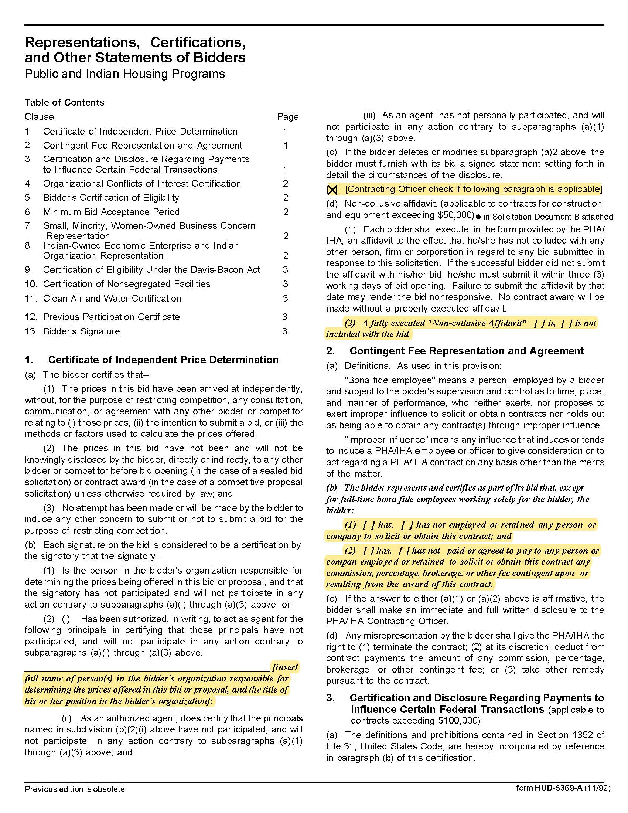

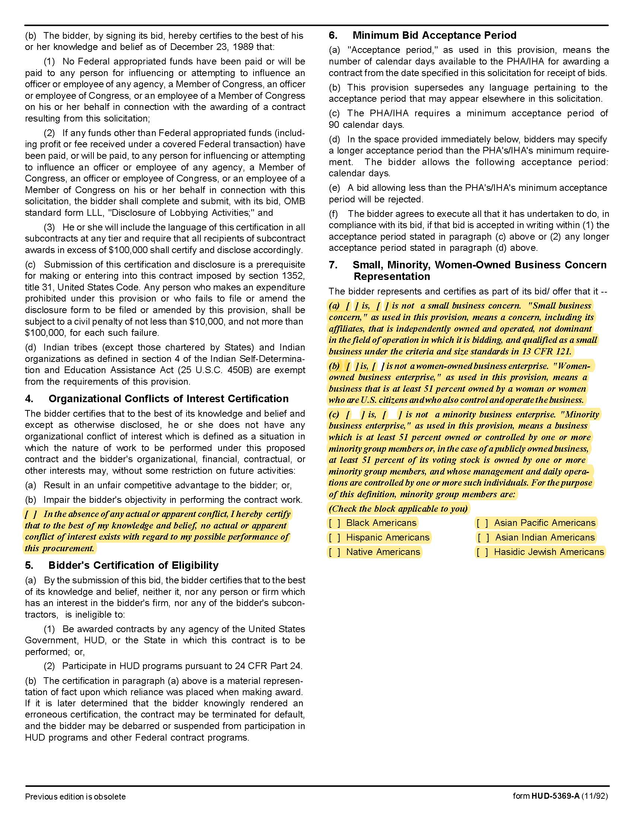

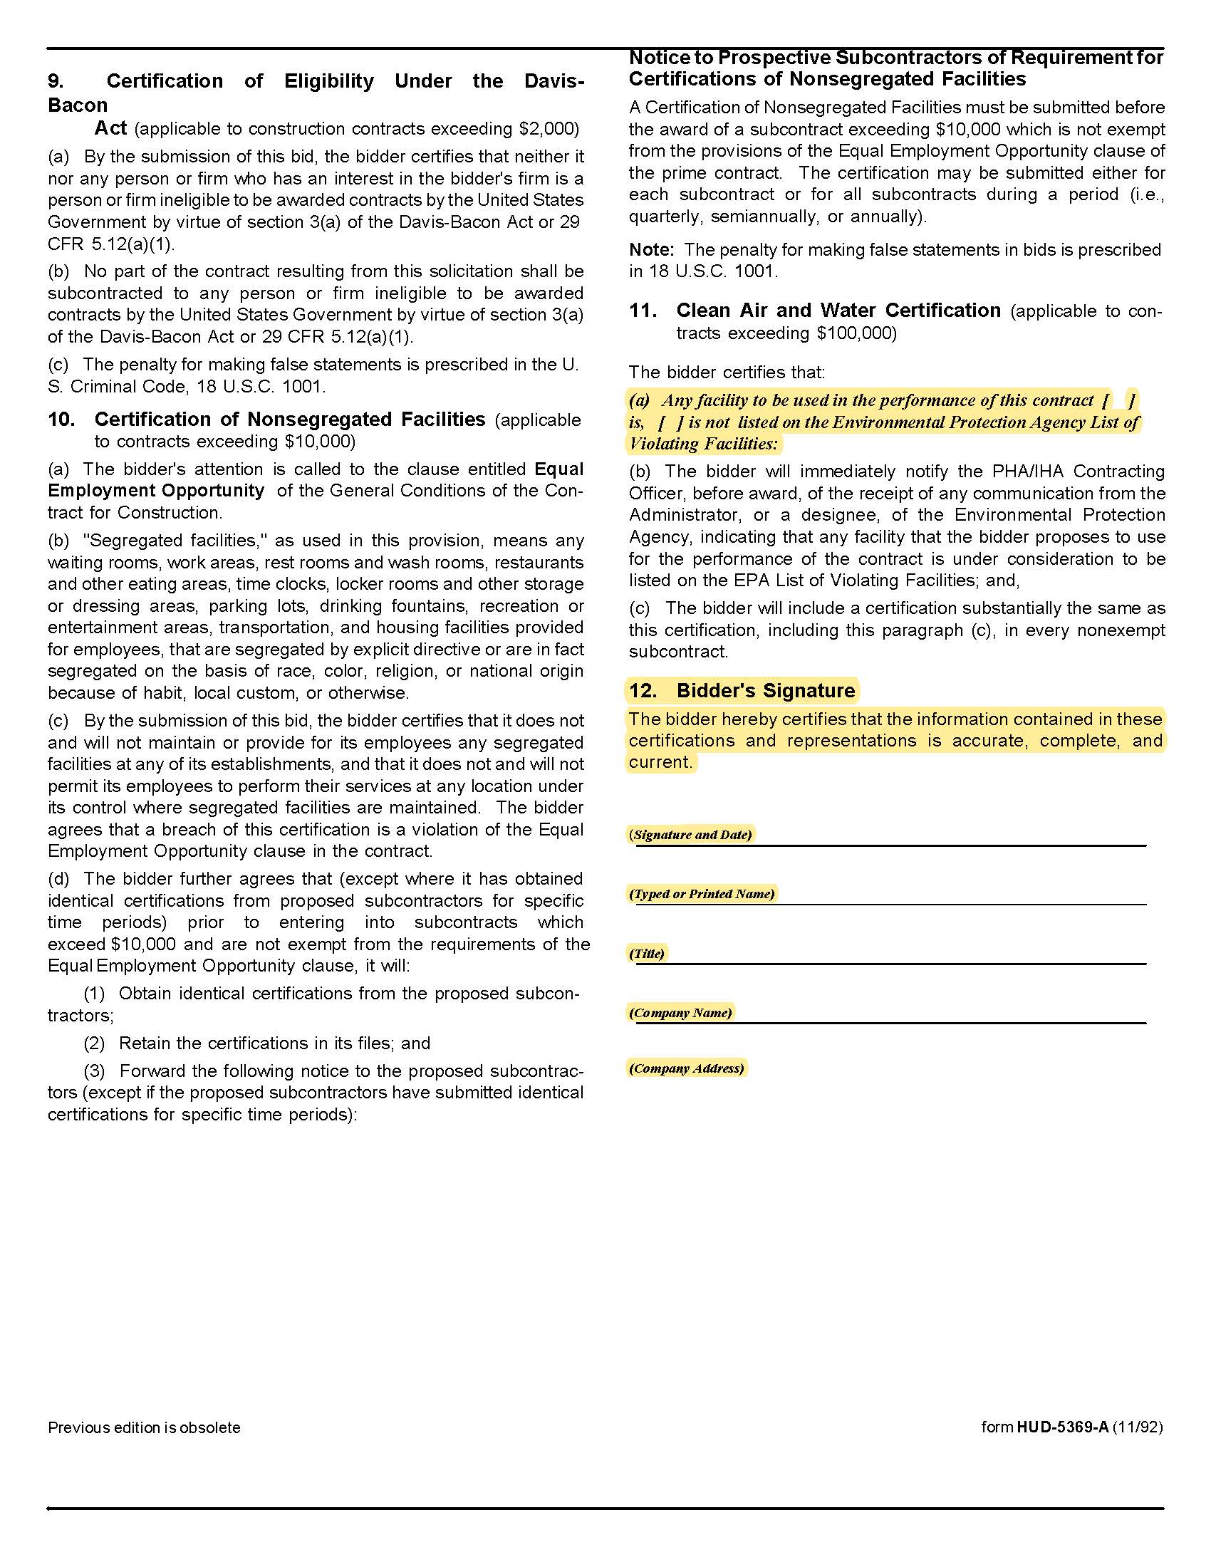

Solicitation Document D: Professional and Technical Competence and Experience

Provide the information requested below so that KCDC can determine your capacity to perform the required work. You may provide additional relevant information as desired.

1. Describe the proposed scope of the audit.
2. Provide a summary of your proposed approach to the audit.
3. Detail the level of assistance the auditor would require of KCDC's staff to conduct the audit.
4. Provide a brief narrative description of the organization submitting the proposal including:
- Organization Size
- Organizational structure
- Financial stability
- Years in business
- Mergers and/or acquisitions within the last five years
- Pending litigation detail
- Legal status (corporation or partnership, et cetera)
5. Identify the individual(s) in your firm responsible for managing and overseeing the audit engagement.
6. Describe any unique approaches or techniques developed and used by the firm that would give it an advantage in this specific type of audit.
7. Specify the total number of employees in the firm with significant experience in conducting audits of public housing authorities.
8. Specify the total number of CPA’s in the firm who are involved with audit engagements of this type.
9. Provide evidence that independence standards are met (technical qualification requirements set forth by Generally Accepted Auditing Standards (GAAS) and/or Generally Accepted Government Auditing Standards (GAGAS).
10. Provide a detailed approach or plan of action, which shows how the auditor would plan to meet the objectives of this engagement.
11. Provide data regarding PHA audit experience of your firm over the past five years. Annotate specific engagements which included RAD conversions.
12. Provide data on the PIH/REAC rejection rate of audits from your firm.
13. Has your firm had a Quality Assurance audit done by PIH/REAC QASS division? If so, provide the most recent results letter.
14. Provide information concerning the status of any disciplinary action taken against the firm.

Solicitation Document E: Staff Assigned to KCDC’s Project

1. Provide brief resumes of the personnel who will be handling this audit, listing pertinent experience and technical qualifications. The format for resumes for key personnel is as follows:

- Name
- Position title
- Total years’ experience with current firm
- Total years in this field with special emphasis on HUD and governmental auditing experiences
- Education (degree, major, institution, year)
- Summary of relevant experience and qualifications
- Satisfactory peer review (non PIH/REAC QASS review) of principals or associates

2. Complete the summary chart below

Name | Title/Skill Set | Role on this Project | Hours on  this Project  On-site/Remote

Solicitation Document F: Ability to Meet KCDC’s Timelines

1. Provide the number of business days expected to complete the necessary fieldwork.

2. Provide the number of days expected to complete the entire audit and the accompanying schedules.

3. Provide a detailed description of the work plan, approach, methodology and timeline that you propose using to meet the objectives.

4. Provide the deadline for KCDC staff to provide the necessary information to complete the audit per the deadlines in this RFP.

5. Provide details of any additional information that your firm will require KCDC staff provide.

6. Current and future projects contemplated which are anticipated to coincide with this engagement and relate the impact of such work on the schedule anticipated for this job.

7. A suggested time frame for the work (which should include the number of days expected to complete the necessary fieldwork and the number of days expected to complete the entire audit) which is limited only by the time frame established in the contract for completion of the project. Include information on how the audit will be conducted in a single year.

The auditor’s report should be completed and submitted to KCDC prior to six months following the end of the fiscal period to be audited (June 30th) in compliance with State of Tennessee’s regulations. If a state extension is required due to unforeseen circumstances, the auditor’s report should be received no later than seven to eight months following the end of the fiscal period to be audited.

As a part of the services provided, we are requesting the auditor to provide data entry services and attestation to the Real Estate Assessment Center (REAC) upon audit completion. HUD requires electronic submission of audited financial data to PIH/REAC nine months after its fiscal year end date in compliance with the requirements of 24CFR, Part 4, et al. The desirable time frame for completion of fieldwork is four months after the end of the fiscal year (October) to meet the audit report deadline of six months after the end of the fiscal period to be audited.

8. The procedures necessary to determine if additional audit work is needed and the fee basis for such work.

9. The average amount of time spent on fieldwork on each PHA audit of similar size you have completed.

Solicitation Document G: References

Provide the information requested below so that KCDC can determine your capacity to perform the required work in a timely manner. You may provide additional relevant information.

1. Provide three client references as similar as possible to this work.

2. While you may have performed numerous services and/or may have had numerous contracts with an entity, each entity can only be one references. Thus, if you serviced Knox County 10 times, it is one reference.

3. KCDC reserves the right to contact and interview the listed references via electronic survey means.

4. Advise the listed references that KCDC may contact them via email or SurveyMonkey.

Use this format for each reference

Name of the business that was serviced
Contact person
Contact person title
Contact person’s telephone number
Contact person’s email address
Description of the service provided (effort and complexity)
Identify contract issues and explain how they were addressed and resolved
Award began
Award ended
Approximate total revenue audited | $

Solicitation Document H: Cost Proposal

Complete this form and submit it separately as detailed earlier in this document.

Audit Cost
1. The supplier shall submit with the proposal a cost break out showing but not limited to the following. These are not in addition to the total project costs but are given as a reference point and should additional similar services be needed and provide a basis for pricing such services.

Key Persons | Hours | Rate | Total
Partners |  | $ | $
Managers |  | $ | $
Supervisory Staff |  | $ | $
Staff |  | $ | $
Other (specify) |  | $ | $
 |  | $ | $
Subtotal |  | $ | $

Meals and Lodging | $
Transportation | $
Consultants | $
Other (Specify) | $

Total all-inclusive price for FY20 $____________________

2. Provide a cost and/or percentage (%) increase of optional years. Supplier will allocate all audit costs to all programs. The successful supplier will work with KCDC to arrive at a final breakdown of the percentages/costs for future audits.

Year | Maximum Increase
1 | Not applicable
2 | %
3 | %
4 | %
5 | %

Solicitation Document I: Supplier Proposed Contract

Use this section to provide KCDC with your proposed contract for review.

Appendix A: Schedule of Expenditures of Federal Awards

