Request for Quotes

Solicitation Name | Temporary Employment Services
Solicitation Number | Q2001
Must Arrive by | 11:00 a.m. on September 30, 2019
Deliver Responses to: | Knoxville’s Community Development Corporation    Procurement Division  901 N. Broadway  Knoxville, TN 37917  Procurement is located behind the main office building.
Electronic Copies | Electronic copies are available on KCDC’s webpage or by email at purchasinginfo@kcdc.org.
Responses may be Emailed to KCDC | ☒ Yes ☐ No
Printed Responses Required | ☐ Yes ☒ No
Solicitation Meeting | ☐ Yes ☒ No
Solicitation Meeting is Mandatory | ☐ Yes ☐ No ☒ Not Applicable
Solicitation Meeting Date | Not applicable
Solicitation Meeting Time | Not applicable
Solicitation Meeting Location | Not applicable
Questions About This Solicitation | Submit questions to purchasinginfo@kcdc.org  KCDC will not accept questions via telephone.
Award Results | KCDC posts both a summary of the quotes received and the award decision to its web page at: http://www.kcdc.org/procurement/
Open Records/Public Access to Documents | All document provided to KCDC are subject to the Tennessee Open Meetings Act (TCA 8-44-101) and open records requirements.

Check KCDC’s webpage for addenda and changes before submitting your response

General Information

1. Background and Intent

a. Knoxville's Community Development Corporation (KCDC) is the public housing and redevelopment agency for the City of Knoxville and for Knox County in Tennessee. KCDC’s affordable housing property portfolio includes 20 sites with approximately 3,525 dwelling units. Several of the properties include Low Income Housing Tax Credits units and KCDC is both the General Partner and the management company for those sites. Those properties include Eastport LP, Five Points 1, LP; Five Points 2, LP; Five Points 3, LP; Five Points 4, LP; Lonsdale Homes, LP; Northridge Crossing, LP and The Vista at Summit Hill, LP. KCDC also oversees approximately 3,958 Section 8 Vouchers, 82 Moderate Rehabilitation units and 20 Redevelopment areas. KCDC has issued this solicitation for itself and on the behalf of the various properties that it now provides “management services” as detailed above. Any resulting awards are either for KCDC itself or are on behalf of those properties which KCDC provides “management services.”

b. KCDC intends these specifications to result in an “all or none” selection of a capable firm of providing after hours answering services relative to emergency maintenance calls. The selected supplier will forward those calls to the appropriate KCDC employee.

c. The supplier will provide daily emails that verify the calls received and their outcome. E-mails are to include the:

- Name of the person calling
- Date of the call
- Time of the call
• Address
• Unit number
• Phone number where the caller can be reached.

Additionally, the vendor will provide information on:

• Whether or not they attempted to dispatch the call
• The time of dispatch
• Who they attempted to call.

d. KCDC residents will call a telephone number designated by KCDC for after hour’s maintenance emergencies. These calls will be automatically forwarded to the answering service during non-business hours. However there may times callers get to the after-hours answering service during KCDC business hours. If that happens, the operators will tell the residents they need to call their management office, since it is during business hours.

e. The supplier will answer calls and forward them to the appropriate person. Calls will be routed to an onsite after-hours staff person when deemed an emergency situation based on written criteria that will be provided to the supplier (See Appendices B and C). All calls, whether dispatched or not, are to be logged as having been received with all of the same information as noted in Item 1(d).

f. The maximum number of rings before the service answers will be three.

g. The supplier will provide service from 4:00 p.m. to 7:30 a.m. Monday to Friday, 24 hours a day on all weekends and KCDC holidays.

h. Currently KCDC averages 500 calls per month. KCDC’s highest month had 869 calls (January - likely due to the extreme cold weather) and the lowest was 275.

i. The supplier’s primary contact when dispatching calls will be maintenance personnel who will be contacted via a mobile “On-Call” phone. Other employees that the operator may speak with when dispatching calls is the Senior Asset Manager or Asset Manager of the properties.

The supplier will be provided with the name, number and email address of the primary contact at the KCDC office. The primary contact will be available during business hours for discussing issues regarding invoicing and payments or any problems with dispatching calls for the previous night.

KCDC provides the list of appropriate staff members and their telephone number in Appendix A.

2. Changes after Award
It is possible that after award KCDC will need to revise the service needs or requirements specified in this document. KCDC reserves the right to make such changes after consultation with the supplier. Should additional costs arise, the supplier must document increased costs. KCDC reserves the right to accept and negotiate these charges.

3. Contact Policy
The supplier may not contact an officer, agent or employee of KCDC other than the KCDC’s Procurement Division about matters pertaining to this solicitation, from the issuance of this solicitation until its award. Information obtained from an unauthorized officer, agent or employee of KCDC will not affect the risks or obligations assumed by the supplier or relieve the supplier from fulfilling any of the conditions of the project. Such contact can disqualify the supplier from participation in the solicitation process.

4. Evaluation
KCDC will evaluate this as a formal sealed bid and the award is to the “lowest and best.” KCDC alone determines (using NIGP’s definition and other relevant sources as appropriate) the supplier’s “responsive” and “responsible” status prior to award.

Responsible means a business with the financial and technical capacity to perform the requirements of the solicitation and subsequent contract. A responsive bid is one that fully conforms in all material respects to the solicitation document and all of its requirements, including all form and substance. KCDC reserves the right to request additional information to assist in the evaluation process; this includes references and business capacity information.

5. General Instructions
KCDC does not insert “General Instructions to Suppliers” in solicitation documents. These instructions are at www.kcdc.org. Click on “Procurement” and the link to the instructions. The supplier’s submittal means acceptance of the terms and conditions set forth in KCDC’s “General Instructions to Suppliers.”

6. Insurance

The Supplier shall maintain, at Supplier’s sole expense, on a primary and non‐contributory basis, at all times during the life of the contract insurance coverages, limits, and endorsements described herein. All insurance must be underwritten by insurers with an A.M. Best rating of A- :VI or better. Upon award, the Supplier shall provide Certificate(s) of Insurance and amendatory endorsements to KCDC evidencing said insurance coverages. See paragraph “f” for exact naming of certificate holder and additional insureds (Owner Entities).

The Supplier agrees the insurance requirements herein as well as KCDC’s review or acknowledgement, is not intended to and shall not in any manner limit or qualify the liabilities and obligations assumed by the Supplier under this contract. KCDC’s failure to require a certificate of insurance, acceptance of a non-conforming certificate, or allowing the Supplier to commence work shall not operate as a waiver of these minimum insurance requirements or the liabilities and obligations assumed by the Supplier under this contract.

a. Errors and Omissions Liability (E & O) / Professional Liability: Supplier shall maintain a minimum
policy limit of no less than $1,000,000. Supplier shall continue such coverage for at least five (5) years after completion of the services. If the Supplier maintains broader coverage and/or higher limits than the minimum shown above, Owner Entities shall be entitled to the broader coverage and/or higher limits maintained by the Supplier.

b. Commercial General Liability and Umbrella/Excess Liability Insurance: occurrence version general
liability insurance with a minimum combined single limit of $1,000,000 per occurrence with $2,000,000 in the aggregate covering the following perils: bodily injury, personal injury, and broad form property damage including products/completed operations for one year after completion of the Project. Limits must apply separately to the work/location in this contract.

Such insurance shall contain or be endorsed to contain a provision that includes the Owner Entities as additional insureds with respect to the Supplier’s ongoing and completed operations, providing coverage at least as broad as CG 20 10 07 04 and 20 37 07 04 endorsements. The coverage shall contain no special limitations on the scope of its protection afforded to the listed insureds.

If necessary, umbrella/excess liability insurance can be used in conjunction with the general liability insurance to meet these requirements. Unless the umbrella/excess liability insurance provides coverage on a pure/true follow‐form basis, or the Owner Entities are automatically defined as additional insureds, the Supplier shall add by endorsement the Owner Entities as additional insured for ongoing and completed operations, providing coverage at least as broad as CG 20 10 07 04 and 20 37 07 04 endorsements.

c. Cyber Liability: in an amount not less than $100,000 per claim/event and sub limits not less than
$100,000 each for at least Cyber Extortion, Regulatory Action, and Event Management.

d. Commercial Automobile Liability Insurance: in an amount not less than $1,000,000 (combined
single limit) for all owned, hired, and non-owned vehicles utilized by Supplier in connection with the Project. Coverage is to include coverage for loading and unloading hazards.

Such insurance shall contain or be endorsed to contain a provision that includes the Owner Entities as additional insureds.

e. Workers’ Compensation Insurance and Employers Liability Insurance: Workers’ Compensation
Insurance with statutory limits as required by the State of Tennessee or other applicable laws.

e. Other Insurance Requirements:

- Upon award, Supplier shall furnish KCDC with original Certificate(s) of Insurance and amendatory endorsements effecting coverage required by this section.

- Provide a waiver of subrogation for each required policy herein. When required by the insurer, or should a policy condition not permit Supplier to enter into a pre‐loss agreement to waive subrogation without an endorsement, the policy should be endorsed with a Waiver of Transfer of Rights of Recovery Against Others, or its equivalent. This waiver of subrogation requirement shall not apply to any policy which includes a condition specifically prohibiting such an endorsement, or voids coverage should supplier enter into such an agreement on a pre‐loss basis.

- A minimum 30‐day cancellation notice for all insurances (by endorsement if necessary) is required.

- Replace certificates, policies, and endorsements for any such insurance expiring prior to completion of services.

- Maintain such insurance from the time services commence until services are completed or through such extended discovery/reporting/tail period as required. Failure to maintain or renew coverage or to provide evidence of renewal may be treated by KCDC as a material breach of contract.

- Any deductibles and/or self‐insured retentions greater than $50,000 must be disclosed to and approved by KCDC prior to the commencement of services. Use of large deductibles and/or self‐insured retentions will require proof of financial ability as determined by KCDC.

- All policies must be written on an occurrence basis with the exception of Errors and Omissions Liability (E & O) / Professional Liability and Cyber Liability which may be claims made coverage.

f. Certificate Holder and Owner Entities:

The Certificate Holder shall be:
KCDC
901 N Broadway
Knoxville, TN 37917

Owner Entities are defined as those entities listed below and shall be provided all insurance coverages, limits, and endorsements included herein including additional insured status. Provided Supplier’s insurer(s) permits the entities listed below can be identified collectively as “Owner Entities”:

KCDC, its officials, officers, employees, and volunteers
Knoxville’s Housing Development Corporation
Eastport Development, LP
Five Points 1 LP
Five Points 2 LP
Five Points 3 LP
Five Points 4 LP
Lonsdale, LP
North Ridge Crossing, LP
Vista at Summit Hill, LP
Montgomery Village Corporation
Cagle Terrace Corporation

(Note: Only one (1) certificate needs to be provided. Certificate must reflect KCDC as the Certificate Holder and specify all coverages and terms apply to all Owner Entities.)

g. Right to Revise or Reject: KCDC reserves the right to revise any insurance requirement, including but not limited to, limits, coverages and endorsements based on changes in scope of work/specifications, insurance market conditions affecting the availability or affordability of coverage.

h. No Representation of Coverage Adequacy: The coverages, limits or endorsements required herein protect the primary interests of KCDC, and the Supplier agrees in no way should these coverages, limits or endorsements required be relied upon when assessing the extent or determining appropriate types and limits of coverage to protect the Supplier against any loss exposures, whether as a result of the project or otherwise.

7. Invoicing/Ordering

a. Until a purchase order is in place, work is not to be performed nor are goods to be delivered. KCDC does not have a legal obligation to pay for the work performed prior to the issuance of a purchase order.

b. Suppliers must submit invoices within 90 days of the delivery of goods or services. KCDC may deny invoices submitted after the 90 day threshold. KCDC prefers invoices arrive within 10 days following the end of the month in which goods or services were supplied.

c. KCDC’s purchases of goods are exempt from Tennessee sales and use tax pursuant to Tennessee Code Annotated 67-6-329(a) (4) and KCDC is generally exempt from the Federal Excise tax. Suppliers are subject to Tennessee sales and use tax on all materials and supplies used in the performance of a contract, whether such materials and supplies are purchased by the supplier, produced by the supplier, or provided to the supplier by KCDC, pursuant to Tennessee Code Annotated 67-6-209. The supplier will pay all taxes incurred in the performance of an awarded contract. Upon the placement of a purchase order or the award of a contract, KCDC will provide a State of Tennessee Sales Tax Exemption form to the supplier. KCDC will not pay taxes on invoices.

d. KCDC pays by electronic transfer (ACH) only.

e. Since KCDC is the managing partner for four separate corporations under the KCDC umbrella, those
separate corporations must receive separate invoices. Thus the supplier will generally:

- Bill each specific site for work performed or goods delivered there
- With KCDC’s permission, generate one monthly master invoice showing all locations and their individual costs (except for those listed below)
- Create separate invoices for Five Points I, Lonsdale Homes, North Ridge Crossing and The Vista.

f. KCDC requires that invoices be submitted via email.

8. Length of Award
The length of the contract will be twelve months with four optional annual renewals that KCDC may exercise at its discretion.

9. Price Structure

a. At the end of each twelve-month period, the supplier may request a change to the percentage and/or specific item charged to KCDC. The supplier must provide proof of increased cost, in the form of Producer Price Index (PPI) increase for Knoxville to the Procurement Division. KCDC will decide whether to accept a price increase. If the price increase is accepted, the bid file will be so noted. If the price increase is not accepted, the supplier may:

1. Continue with the existing pricing.
2. Suggest an alternative price increase.
3. End the award.

b. Suppliers may decrease prices at any time with or without notice.

10. Section 3 of the HUD Act of 1968
Section 3 is a provision of the Housing and Urban Development Act of 1968 which requires that programs of direct financial assistance administered by the U.S. Department of Housing and Urban Development (HUD) provide, to the greatest extent feasible, opportunities for job training and employment to lower income residents in connection with projects in their neighborhoods. Further, to the greatest extent feasible, contracts in connection with these projects are to be awarded to local businesses. Section 3 is a tool for fostering local economic development, neighborhood economic improvement and individual self-sufficiency.

a. Recipients and suppliers must make a good faith effort to utilize Section 3 area residents as trainees and employees in connection with the project. Targeted recruitment and the selection of Section 3 area residents for available positions are two examples of good faith efforts to meet this requirement.

b. Recipients and suppliers must make a good faith effort to award contracts to Section 3 business concerns for work in connection with the project. An example of a good faith effort to meet this requirement is the implementation of an affirmative action plan, which includes targets for the number and dollar value for awarding contracts to Section 3 business concerns.

c. Recipients and suppliers must keep records and submit reports to HUD documenting the good faith efforts taken and the results of these actions. Examples of such documentation include letters to community organizations, employment development and business development centers, copies of solicitations for bids or proposals; and copies of affirmative action plans.

d. How can businesses find Section 3 residents to work for them? This can be accomplished by recruiting in the neighborhood and public housing developments to tell about available training and job opportunities. Distributing flyers, posting signs, placing ads, and contacting resident organizations and local community development and employment agencies to find potential workers are a few effective ways of getting jobs and people together.

e. All contracts awarded are subject to Section 3 requirements. Supplier shall seek to fill all positions that are unfilled with KCDC residents. For additional information, go to http://www.hud.gov/offices/fheo/section3/Section3.pdf. The successful supplier will give KCDC job announcements for any position that must be filled as a result of the award of KCDC work. Additionally the successful supplier will supply the same job announcement to the Knoxville-Knox County Committee Action Committee’s Workforce Connections group. These can be faxed to 544-5269.

f. A Section 3 resident is one who lives within a public housing authority’s site. It is also people who live in an area with a HUD assisted program and whose income is below HUD’s low income requirements.

g. A Section 3 business is one that:

- Is at least 51% owned by a Section 3 resident; or
- Employs Section 3 residents for at least 30% of its employee base; or
3. Makes a commitment to sub contract at least 25% of the project’s dollars to a Section 3 business.

h. Upon award, the successful supplier will supply two documents to KCDC:

- A Section 3 Business determination provided one is not already on file.
2. A Section 3 Business plan for this work.

11. Subcontractors
Subcontractors must:

a. Be approved by KCDC prior to beginning work.

b. Carry the insurance coverages as outlined herein.

c. Comply with the Davis Bacon requirements and submit certified payrolls.

d. Not be on HUD’s Debarment List.

e. Not be changed without KCDC’s permission.

THIS AND THE PREVIOUS NEED NOT BE RETURNED

After Hours Answering Services Q2001

Solicitation Document A General Response Section

General Information about the Supplier
Sign Your Name to the Right of the Arrow
By signing, you indicate you read and agree to “KCDC’s General Instructions to Suppliers” on www.kcdc.org.
Printed Name and Title
Company Name
Street Address
City/State/Zip
Contact Person (Please Print Clearly)
Telephone Number
Cell Number
Supplier’s E-Mail Address (Please Print Clearly)
Addenda
Addenda are at www.kcdc.org. Click on “Procurement” and then on “Open Solicitations” to find addenda. Please check for addenda prior to submitting a response.
Acknowledge addenda have been issued by checking below as appropriate:
None ☐ | Addendum 1 ☐ |  |  | Addendum 2 ☐ |  | Addendum 3 ☐ |  |  | Addendum 4 ☐ | Addendum 5 ☐
Statistical Information (Check all the apply)
This business is at least 51% owned and operated by a woman |  |  |  |  |  |  |  |  |  |  | Yes ☐ No ☐
This business qualifies as a small business by the State of Tennessee  (Gross receipts of $10,000,000 or less and employing less than 100 full time persons ) |  |  |  |  |  |  |  |  |  |  | Yes ☐ No ☐
This business qualifies as Section 3 business (as defined by HUD):  It is at least 51% owned by a Section 3 resident (lives in Public Housing) or it employs Section 3 residents for at least 30% of its employee base; or it commits to sub contract at least 25% of the project’s dollars to a Section 3 business. |  |  |  |  |  |  |  |  |  |  | Yes ☐ No ☐
This business is owned & operated by persons at least 51% of the following ethnic background:
Asian/Pacific ☐ |  | Black ☐ | Hasidic Jew ☐ |  | Hispanic ☐ |  |  | Native Americans ☐ |  |  | White ☐
Cooperative Procurement
Subject to additional location/delivery charges, the supplier agrees to extend the offered costs to other governments if the government so desires. Yes ☐ No ☐
Prompt Payment Discount
A prompt payment discount of ________% is offered for payment within ____ days of submission of an accurate and proper invoice.
MasterCard Acceptance
Mastercard is accepted for payment without additional fees. Yes ☐ No ☐
Mastercard is accepted for payment with a fee of _______. Yes ☐ No ☐

After Hours Answering Services Q2001

Solicitation Document B Affidavits

Supplier: _____________________________________________________________________________

Conflict of Interest:
1. No commissioner or officer of KCDC or other person whose duty it is to vote for, let out, overlook or in any manner superintend any of the work for KCDC has a direct interest in the award or the supplier providing goods or services.

2. No employee, officer or agent of the grantee or sub-grantee will participate in selection, or in the award or administration of an award supported by Federal funds if a conflict of interest, real or apparent, would be involved. Such a conflict would arise when the employee, officer or agent, any member of his immediate family, his or her partner, or an organization, which employs, or is about to employ, any of the above, has a financial or other interest in the supplier selected for award.

3. The grantee's or sub-grantee's officers, employees or agents will neither solicit nor accept gratuities, favors or anything of monetary value from suppliers, potential supplier s, or parties to sub-agreements.

4. By submission of this form, the supplier is certifying that no conflicts of interest exist.

Drug Free Workplace Requirements:
5. Private employers with five or more employees desiring to contract for construction services attest that they have a drug free workplace program in effect in accordance with TCA 50-9-112.

Eligibility:
6. The supplier is eligible for employment on public contracts because no convictions or guilty pleas or pleas of nolo contender to violations of the Sherman Anti-Trust Act, mail fraud or state criminal violations with an award from the State of Tennessee or any political subdivision thereof have occurred.

General:
7. Supplier fully understands the preparation and contents of the attached offer and of all pertinent circumstances respecting such offer.

8. Such offer is genuine and is not a sham offer.

Iran Divestment Act:
9. Concerning the Iran Divestment Act (TCA 12-12-101 et seq.), by submission of this bid/quote/proposal, each supplier and each person signing on behalf of any supplier certifies, and in the case of a joint bid/quote/proposal, each party thereto certifies as to its own organization, under penalty of perjury, that to the best of its knowledge and belief that each supplier is not on the list created pursuant to § 12-12-106.

After Hours Answering Services Q2001

Solicitation Document B Affidavits - Continued

Non-Collusion:
10. Neither the said supplier nor any of its officers, partners, owners, agents, representatives, employees or parties interest, including this affiant, has in any way colluded conspired, connived or agreed, directly or indirectly, with any other responder, supplier, or person to submit a collusive or sham offer in connection with the award or agreement for which the attached offer has been submitted or to refrain from making an offer in connection with such award or agreement, or collusion or communication or conference with any other supplier, or, to fix any overhead, profit, or cost element of the offer price or the offer price of any other supplier, or to secure through any collusion, conspiracy, connivance, or unlawful agreement any advantage against KCDC or any person interested in the proposed award or agreement.

11. The price or prices quoted in the attached offer are fair, proper and not tainted by any collusion, conspiracy, connivance, or unlawful agreement on the part of the supplier or any of its agents, representatives, owners, employees, or parties in interest, including this affiant.

Accuracy of Electronic Copies:
12. If the supplier provides electronic copies of the bid/proposal/quote to KCDC, the supplier certifies that the information provided on paper and in the electronic format is identical unless specifically noted otherwise.

No Contact/No Advocacy Affidavit:
13. After this solicitation is issued, any contact initiated by any supplier with any KCDC representative
concerning this solicitation is strictly prohibited-except for communication with the Procurement Division. My signature signifies that no unauthorized contact occurred.

14. To ensure the integrity of the review and evaluation process, respondents to this solicitation nor any firm representing them, may not lobby or advocate to KCDC staff or Board members. My signature signifies that no unauthorized advocacy occurred.

The undersigned hereby acknowledges receipt of these affidavits and certifies that the submittal in response to this solicitation is in full compliance with the listed requirements.

Signed by
Printed Name
Title
Subscribed and sworn to before me this date
By (Notary Public)
My Commission Expires on
Notary Stamp

After Hours Answering Services Q2001
Solicitation Document C HUD Form 5369A

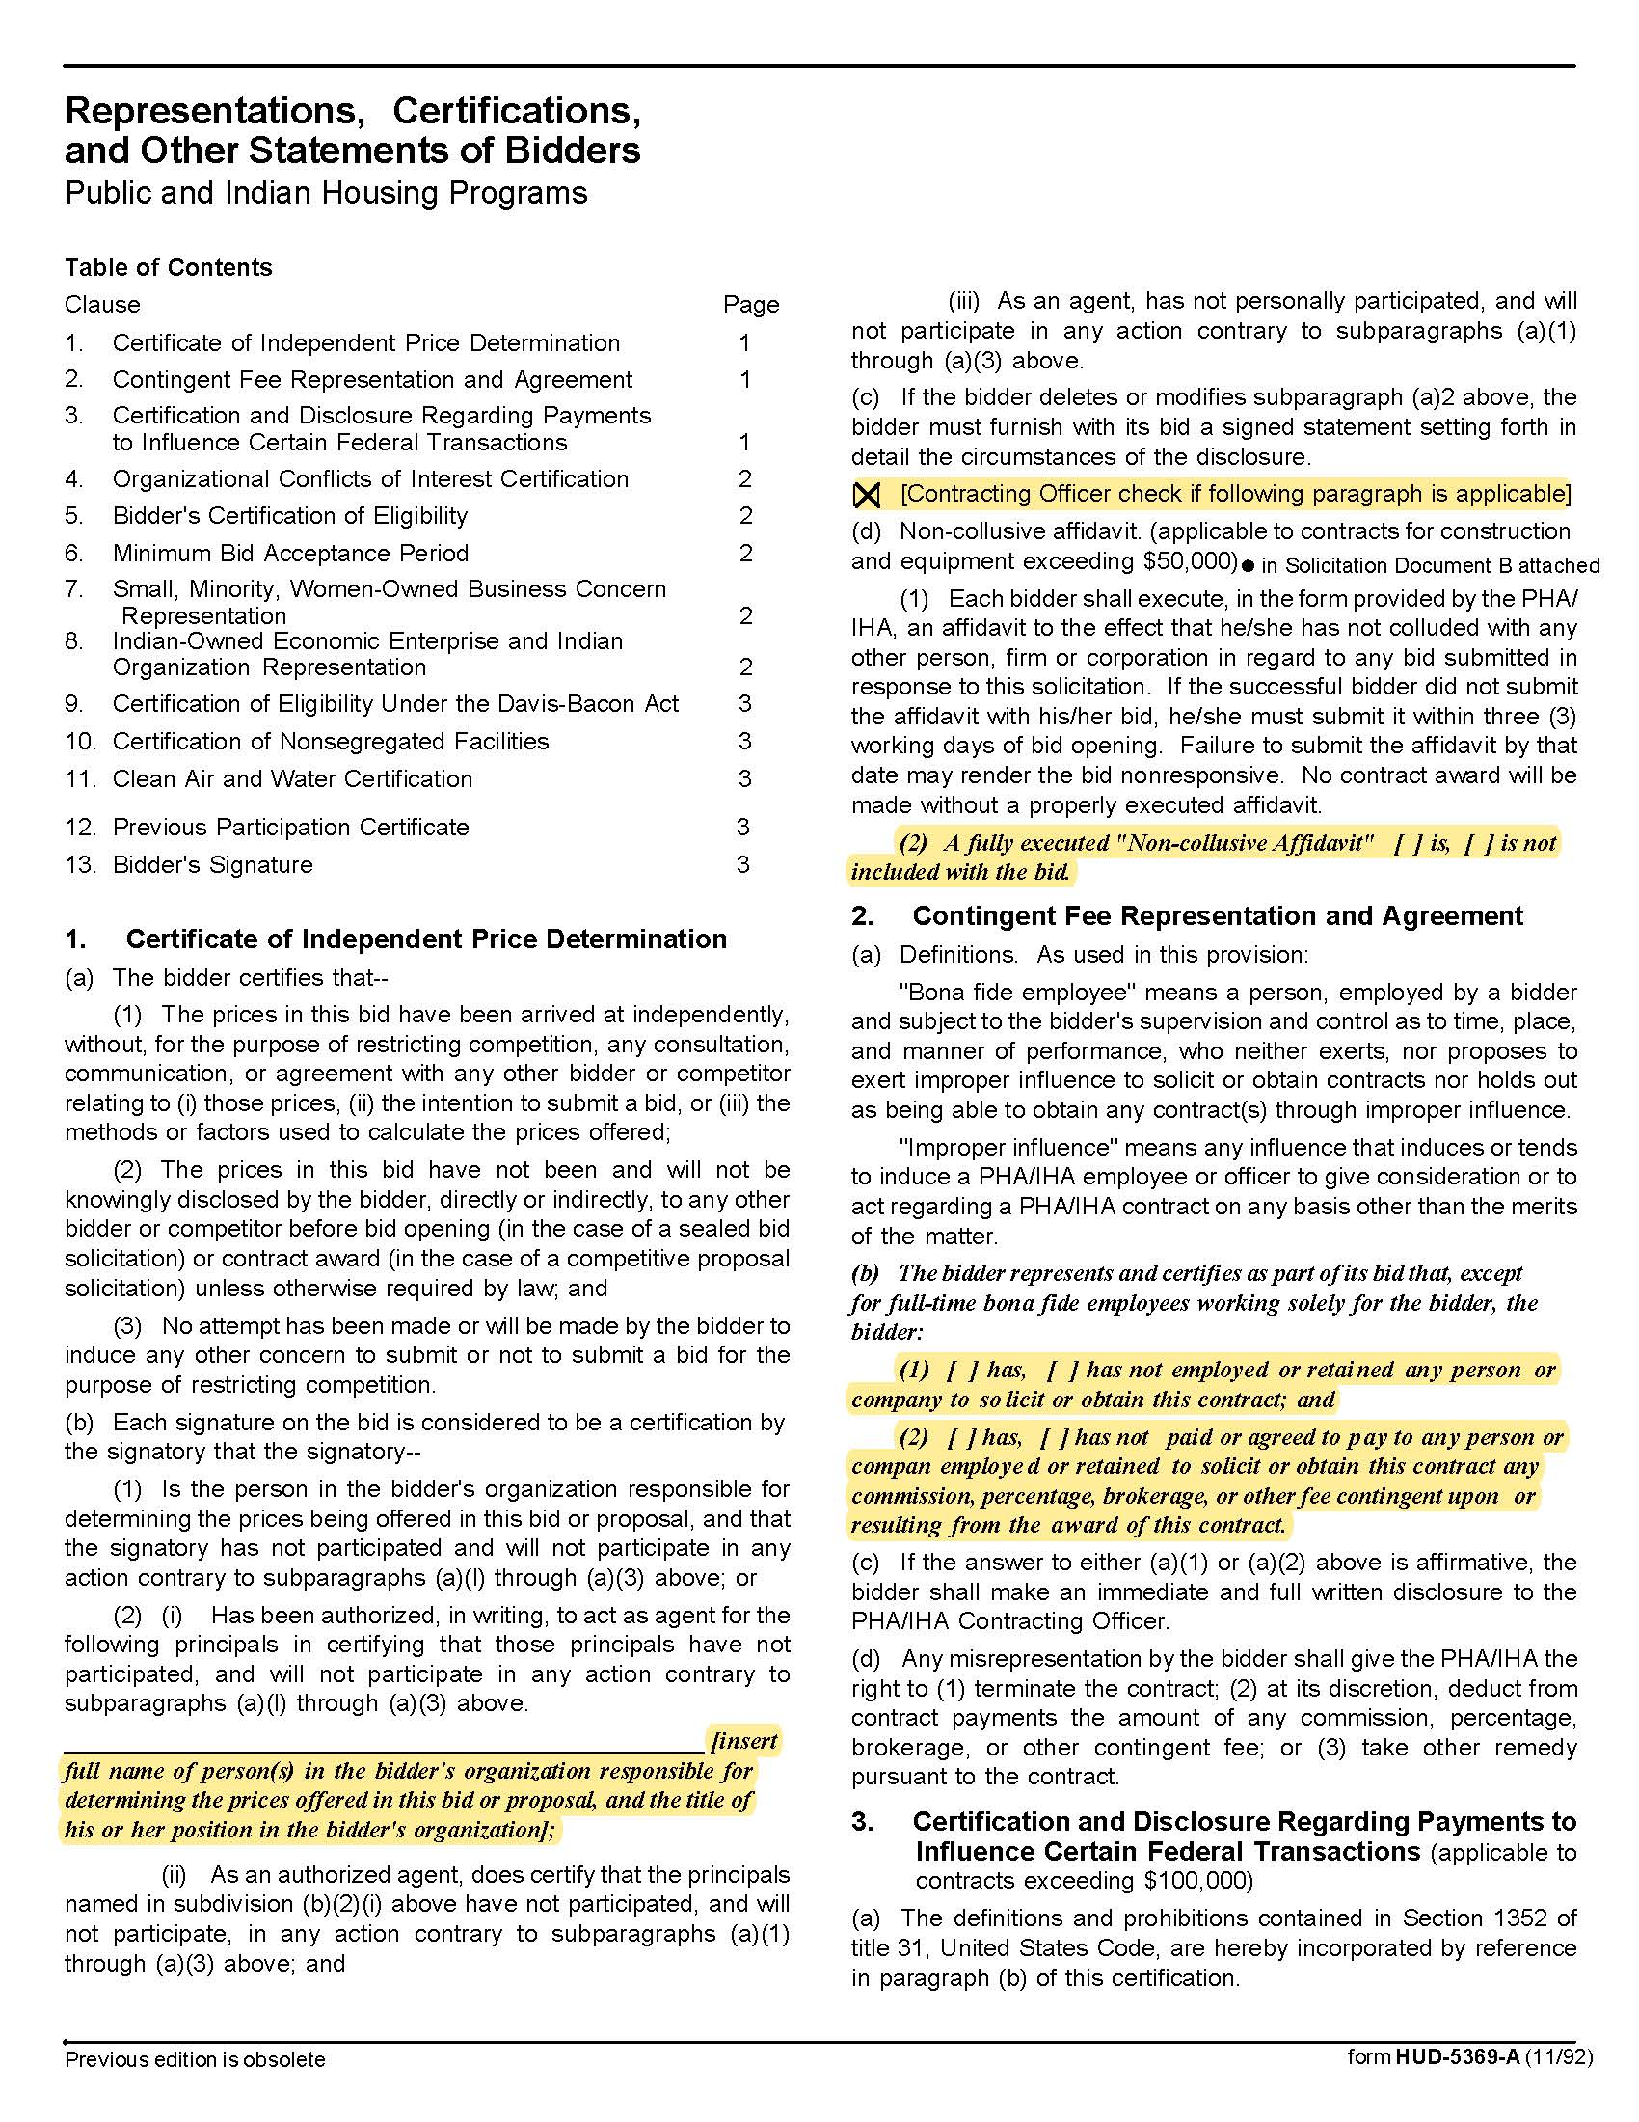

After Hours Answering Services Q2001
Solicitation Document C HUD Form 5369A - Continued
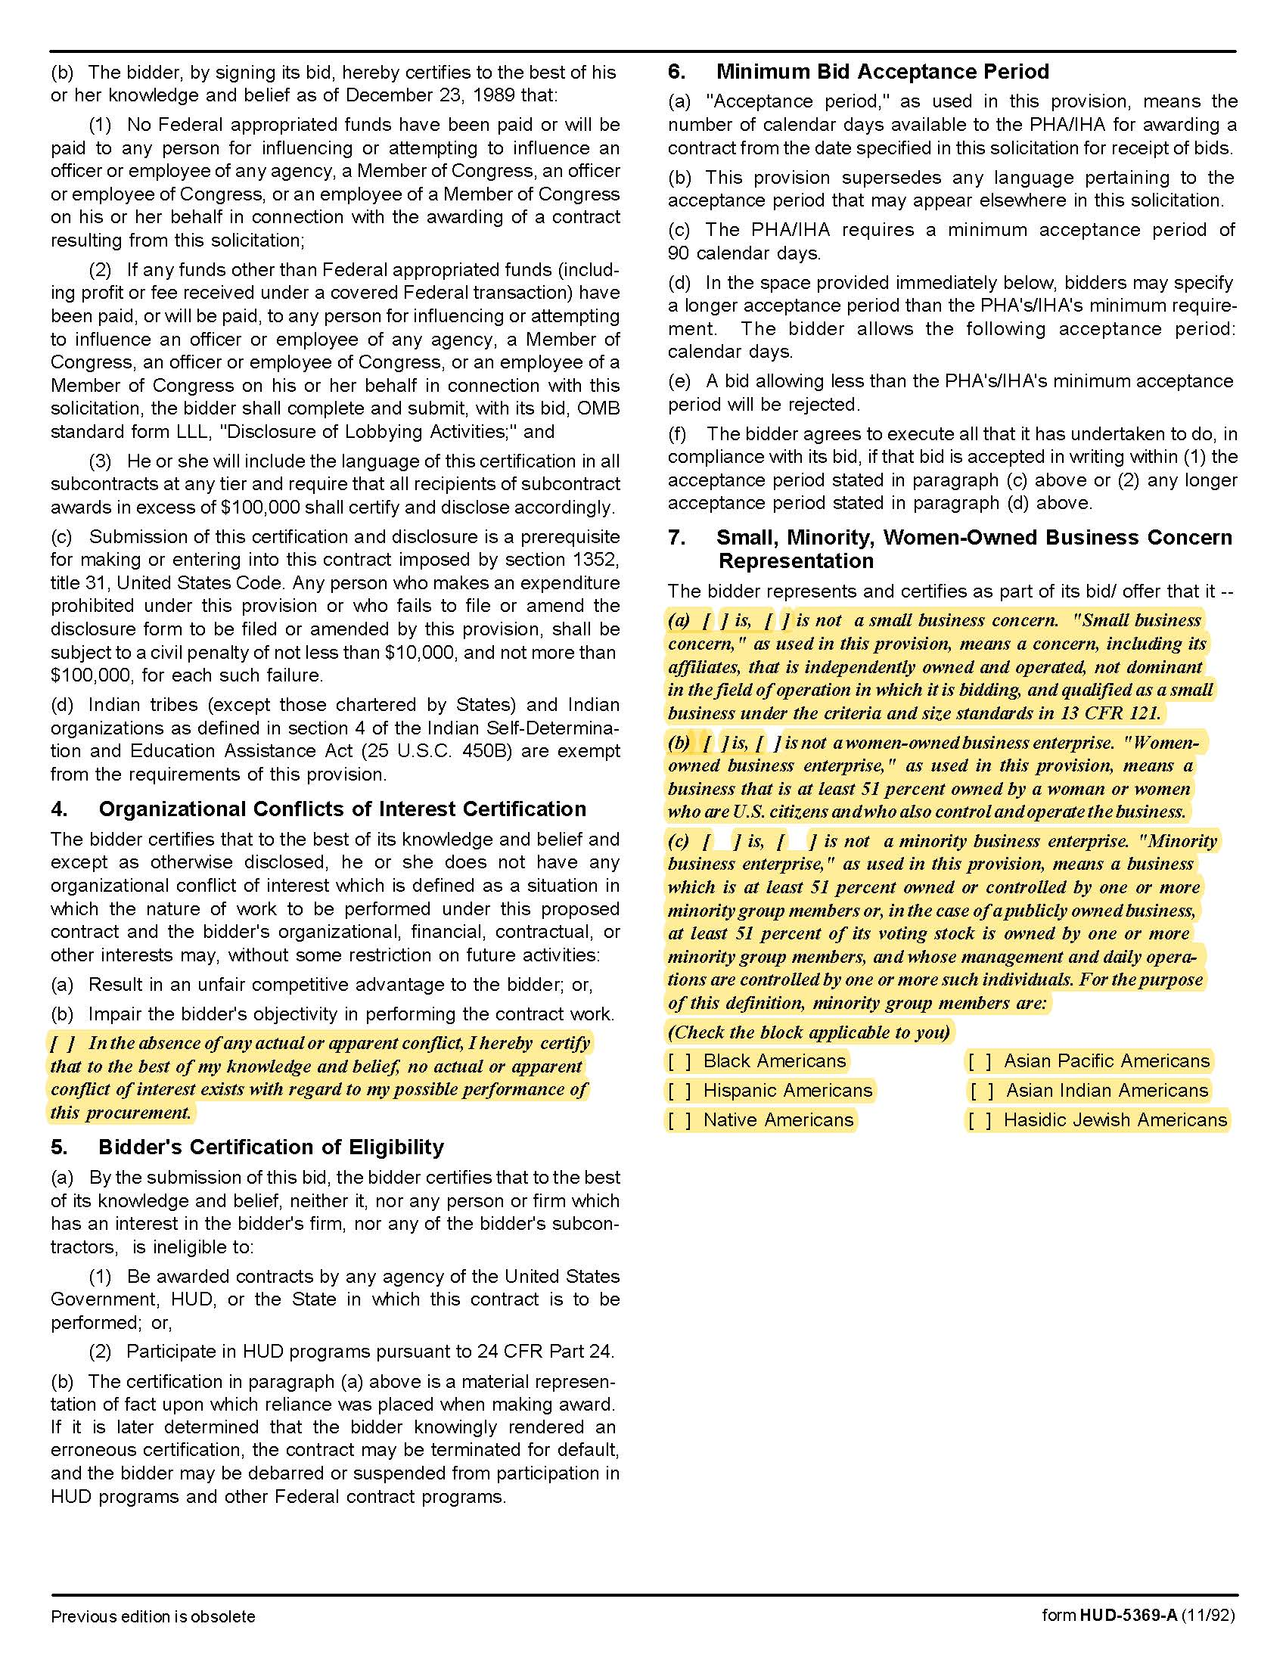

After Hours Answering Services Q2001
Solicitation Document C HUD Form 5369A - Continued
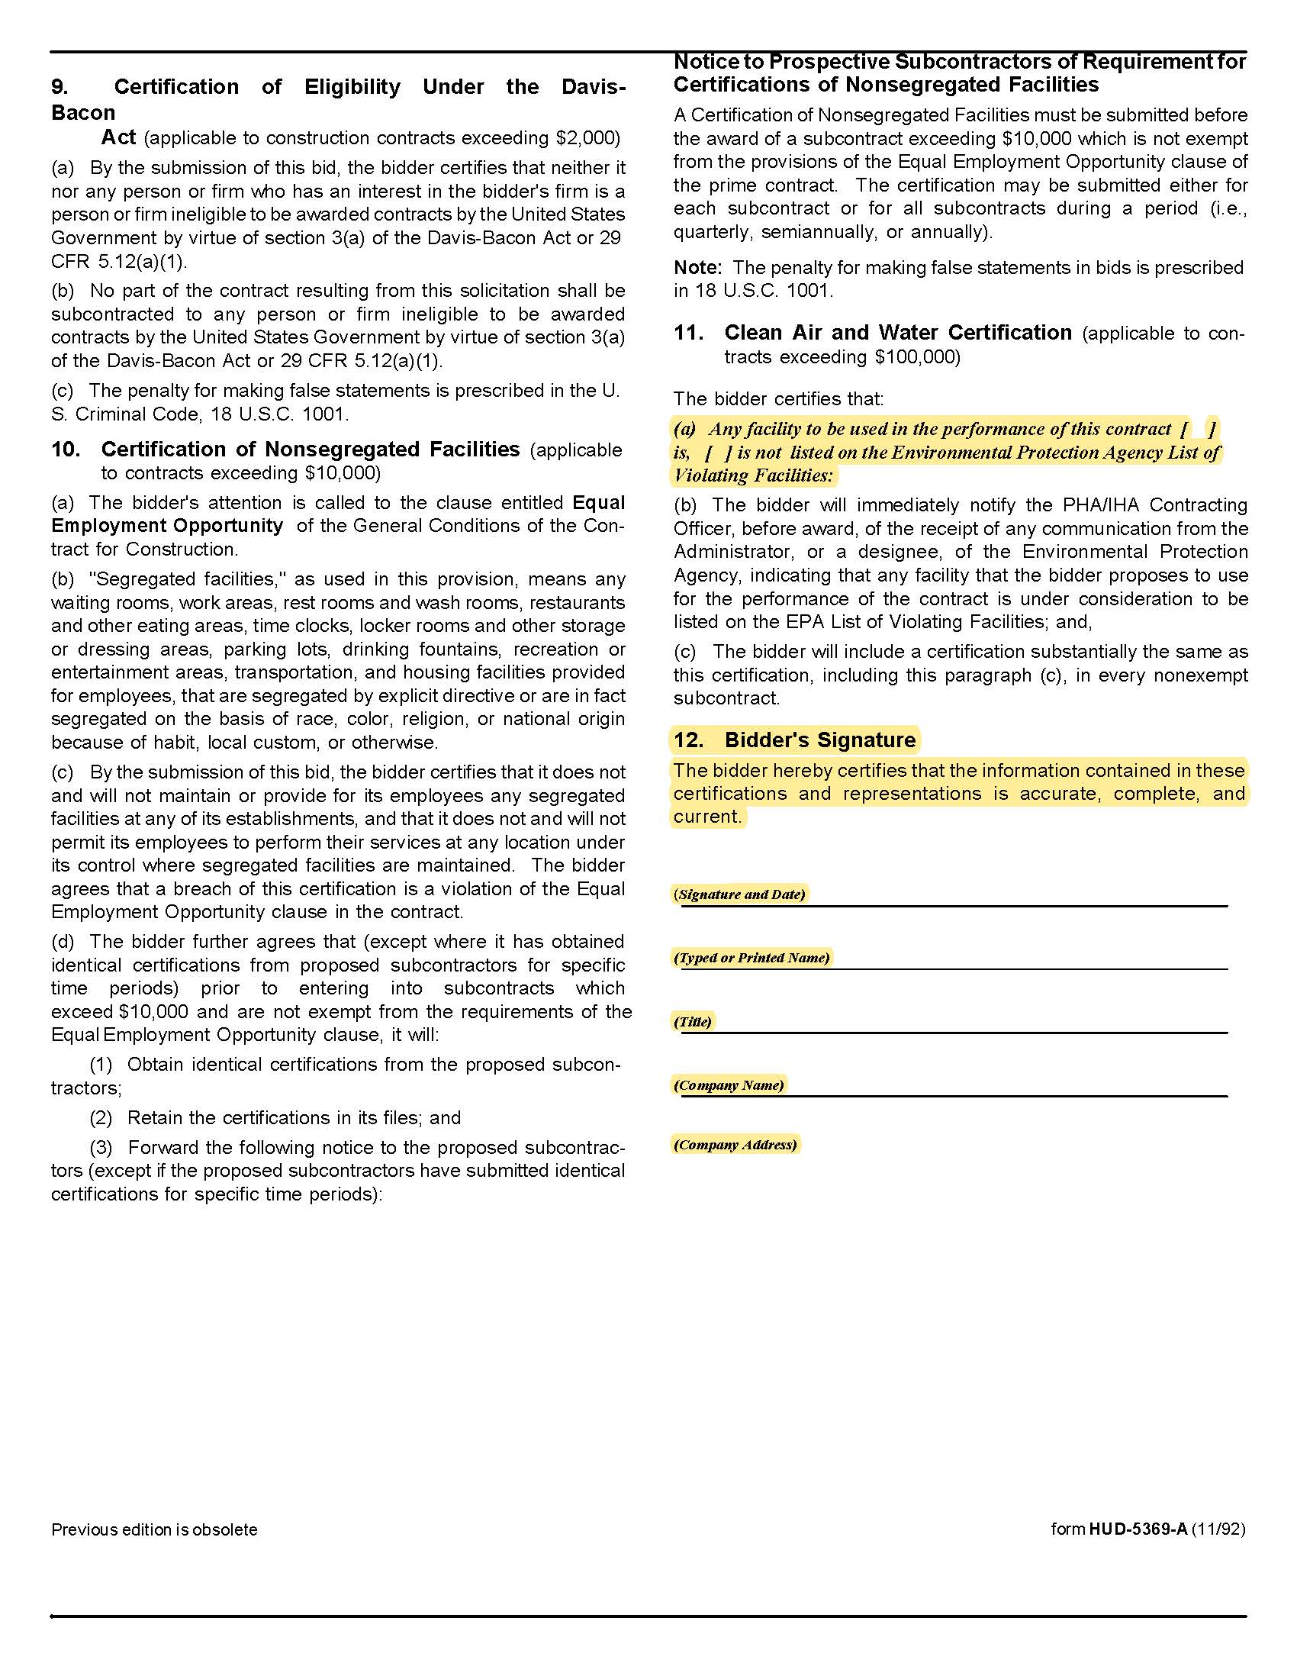

After Hours Answering Services Q2001

Solicitation Document D References

Supplier: ________________________________________________________________________________

Provide three (3) references as similar in nature and scope to this project as possible. A firm may only be listed as a reference once - even if you have completed multiple projects/jobs for them.

Name of Business
Contact Person
Contact Person Title
Contact Person Telephone Number
Description of Service Provided
Date Contract Began
Date Contract Ended
Approximate Dollar Value of the Contract | $

Name of Business
Contact Person
Contact Person Title
Contact Person Telephone Number
Description of Service Provided
Date Contract Began
Date Contract Ended
Approximate Dollar Value of the Contract | $

Name of Business
Contact Person
Contact Person Title
Contact Person Telephone Number
Description of Service Provided
Date Contract Began
Date Contract Ended
Approximate Dollar Value of the Contract | $

After Hours Answering Services Q2001

Solicitation Document E Cost

Supplier: ________________________________________________________________________________

ITEM | MINIMUM
Cost per Month for Base Service Described Herein | $
Other Costs – Include Description
Other: | $
Other: | $
Other: | $
Other: | $
Other: | $
Other: | $

After Hours Answering Services Q2001

Solicitation Document F Insurance Term Sheet

Certificate Holder | KCDC  901 N Broadway  Knoxville, TN 37917
Additional Insureds (Owner Entities)  (can be identified collectively as Owner Entities) | KCDC, its officials, officers, employees, and volunteers  Knoxville’s Housing Development Corporation (KHDC)  Eastport Development, LP  Five Points 1 LP  Five Points 2 LP  Five Points 3 LP  Five Points 4 LP  Lonsdale, LP  North Ridge Crossing, LP  Vista at Summit Hill, LP  Montgomery Village Corporation  Cagle Terrace Corporation
Professional Liability | $1M (minimum limit)
GL | $1M / $2M (minimum limit)
Cyber Liability | $100,000. Sublimit of $100,000 each for Cyber Extortion, Regulatory Action, & Event Management. (minimum limit)
Auto | $1M (owned, hired, & non-owned)
WC & Employers Liability | statutory limits
30-day cancellation | Required– must indicate on COI
Primary non-contributory | Required – must indicate on COI
Waiver of Subrogation | Required – must indicate on COI

After Hours Answering Services Q2001

Appendix 1 Call Contacts

KCDC AFTER-HOURS EMERGENCY CONTACTS
ON-CALL NUMBER BY SITE

SITE # | PROPERTY NAME | ON-CALL #
1 | Austin Homes/The Vista at Summit Hill | 661-4835
2 | Autumn Landing (formerly Virginia Walker) & Natures Cove (formerly Bakertown Apts.) | 740-3378
3 | Cagle Terrace | 661-4838
4 | Isabella Towers | 679-3993
5 | Lonsdale Homes & Mechanicsville | 661-4834
6 | Guy B. Love Towers | 661-4836
7 | Montgomery Village/The Verandas on Flenniken | 679-3992
8 | North Ridge Crossing/Valley Oaks Apartments | 679-3991
9 | Northgate Terrace/The Manor at Northgate | 755-6052
10 | The Residences at Five Points/Five Points II/Five Points II/The Residences at Eastport/Five Points/Sr. Duplexes/Five Points Family Multiplexes/Five Points Phase 2/Passport Properties/Passport Homes S8 | 661-4837
11 | Western Heights  Clifton Cottages | 661-4833
Last Updated 8/23/19

After Hours Answering Services Q2001

Appendix 1 - Continued Call Contacts

ALTERNATE NUMBERS
WHEN ON-CALL NUMBER CANNOT BE REACHED*
SITE # | IF NO RESPONSE, MAINTENANCE STAFF AND/OR MANAGERS TO CALL BY SITE NUMBER
1 | Managers: Jonathan Romeo 755-5960, Darrell Lindsey 233-7043
2 | Maint. Supervisor: Johnny Booker, Manager: James Pruitt 755-5964  Maint. Supervisor: Gerald Littlejohn, Manager: James Pruitt 755-5964
3 | Maint. Supervisor: Larry Medley 755-6026, Manager: Rhonda Harris 755-5959
4 | Maintenance Supervisor: Mark Meade 755-5956, Manager: Sam Chambers 755-5954
5 | Managers: Jack Haynes 388-0115, Darlene Farmer 755-5961. If no answer, call Darlene Farmer at 789-8463.
6 | Maint. Supervisor: David Wayne Lovelace 257-3508, Manager: Steve Ellis 755-5988
7 | Managers: Diana Caldwell 306-7405, Linda Jeter 755-5965,
8 | Managers: Adronicus Thomas 755-5990, Vickie Worrell 755-5985
9 | Maint. Supervisor: Rodney Yardley, Manager: Terri Evans 755-5994
10 | Managers: Kim Clark 755-5974, Lisa Weddle 755-5957, Beth Bacon 755-5996
11 | Maint. Supervisor: Bryan Coffey 755-6050, Managers: Kristie Toby 755-5989, Rhonda McCulley 755-3330, Tiara Webb 755-5991

*In all cases, if On-call person, maintenance staff or managers cannot be reached,
contact Sean Gilbert at 865-755-5953.

After Hours Answering Services Q2001

Appendix 2 After Hours Emergency Call Handling Procedures

KCDC HI-RISE AND ELDERLY-DESIGNATED PROPERTIES AFTER-HOURS EMERGENCY CALL HANDLING

Maintenance staff will respond to the following situations:

Commode - Overflowing or Continuing to run Commode - Stopped up (Only if one toilet in unit) Tubs and Sinks – Only if sewage is backing up into it Water Heater – Leaks in pipes or water heater unit
Water Heater - No Hot Water (Only if it will be more than 24 hours before management office is open)
Water Leaks/Flooding – Interior Only

Furnished Appliances (Stoves, Refrigerators) - Shocks resident or sparks occurring from appliance
Refrigerators – Not cooling (Only if it will be more than 24 hours before management office is open)

No Heat - Only if outside temperature is below 50 degrees for 24 hours or more continuously
A/C –Resident must be on oxygen or outside temperature must be above 90 degrees for 24 hours or more continuously, with the exception of A/C outages for Eastport which should be routed to On-call number regardless.

No Power to Unit - Only after resident has contacted KUB to verify no area outage - Answering service to provide KUB number for resident to call.

Elevators - Only if all elevators in building are not working High Rise Main

Entrance Doors not operable

Garbage Chutes stopped up (Weekends only at Northgate)

Smoke Detector Going Off – Answering service will ask resident if there is evidence of flames, smoke or the smell of something burning. If so, they will be instructed to evacuate all family members immediately and call 911. If there is no evidence of immediate danger, the On-call will be contacted to follow-up with the resident for additional information.

Major Damages from Fire - Any calls from Fire Department
Major Damages from Wind - Roof/Windows damaged causing leaks inside unit.

Lock outs- Only if before 10:00pm. Resident must be able to have in possession supporting documents assuring they are on lease for this unit. Resident must agree to a $75 fee for this service.
Key FOB Doesn’t Work – Only for Eastport

Welfare Checks - Person calling must call 911 first and KCDC will only respond after call from Emergency Services, Fire Dept. or Police Dept. is made to KCDC Emergency number.

NOTE: High-Rise locations are Northgate Terrace, Cagle Terrace, Love Towers and Isabella Towers. Elderly-designated properties include The Residences at Eastport, The Duplexes at Five Points, and The Verandas on Flenniken.

After Hours Answering Services Q2001

Appendix 2 After Hours Emergency Call Handling Procedures – Continued

KCDC FAMILY-STYLE PROPERTIES AFTER-HOURS EMERGENCY CALL HANDLING
Maintenance staff will respond to the following situations:
Commode - Overflowing or continuing to run Commode - Stopped up (Only if one toilet in unit) Tubs and Sinks – Only if sewage is backing up into it Water Heater – Leaks in pipes or water heater unit
Water Heater - No Hot Water (Only if it will be more than 24 hours before management office is open)
Water Leaks/Flooding – Interior Only
Furnished Appliances (Stoves, Refrigerators) - Shocks resident or sparks occurring from appliance
Refrigerators – Not cooling (Only if it will be more than 24 hours before management office is open)
No Heat -Only if outside temperature is below 40 degrees for 24 hours or more continuously
A/C Not Working – Only if resident is on oxygen or outside temperature is above 90 degrees for 24 hours or more continuously
No Power to unit - Only after resident has contacted KUB to verify no area outage - Answering service to provide KUB number for resident to call.
Gas Leaks - Any reported smell at locations of Austin, Taylor, Lee Williams, North Ridge, Passport Homes, Passport Residences, KHDC, and Mechanicsville. Resident must supply Street Address.
Smoke Detector Going Off – Answering service will ask resident if there is evidence of flames, smoke or the smell of something burning. If so, they will be instructed to evacuate all family members immediately and call 911. If there is no evidence of immediate danger, the On-call will be contacted to follow-up with the resident for additional information.

Major Damages from Fire - Any calls from Fire Department
Major Damages from Wind - Roof/Windows damaged causing leaks inside unit.
Lock outs - We will not respond to Lock Outs after regular business hours. Residents will need to call their Management office Monday thru Friday during business hours. Key FOB Doesn’t Work – Only for addresses on Juanita Cannon Street and Chestnut Street

Welfare Checks - Person calling must call 911 first and KCDC will respond after call from Emergency Services, Fire Dept. or Police Dept. is made to KCDC Emergency number.

Exterior Painting Services (as needed) Q1926
Appendix 3 Site Manager’s Contact Information

Property Name | Address | Manager | Contact Points
Austin Homes | 957 East Hill Avenue | Darrell Lindsey | dlindsey@kcdc.org 865-403-1300
Autumn Landing | 6331 Pleasant Ridge Road | Manager: James Pruitt  Maintenance: Johnny Booker | jpruitt@kcdc.org 865- 403-1422 jbooker@kcdc.org
Cagle Terrace | 515 Renford Drive | Manager: Rhonda Harris  Maintenance: Larry Medley | rharris@kcdc.org 865-403-1310  lmedley@kcdc.org
Five Points Properties | 381 McConnell Street (office) | Manager: Kim Clark Manager: Beth Bacon | kclark@kcdc.org 865-403-1390 bbacon@kcdc.org
Isabella Towers | 1515 Isabella Circle | Manager: Sam Chambers  Maintenance: Mark Meade | schambers@kcdc.org 865-403-1340  mmeade@kcdc.org
Lonsdale Homes | 2020 Minnesota Avenue | Darlene Farmer | dfarmer@kcdc.org 865-403-1350
Love Towers | 1171 Armstrong Avenue | Steve Ellis | sellis@kcdc.org 865-403-1360
Mechanicsville | 2020 Minnesota Avenue (office) | Darlene Farmer | dfarmer@kcdc.org 865-403-1350
Montgomery Village | 4530 Joe Lewis Road | Linda Jeter | ljeter@kcdc.org 865-403-1380
Nature's Cove | 2639 Bakertown Road | Manager: James Pruitt  Maintenance: Gerald Littlejohn | jpruitt@kcdc.org 865-403-1422  glittlejohn@kcdc.org
North Ridge Crossing | 712 Breda Drive | Adronicus Thomas | athomas@kcdc.org 865-403-1320
Northgate Terrace | 4301 Whittle Springs Road | Manager: Terri Evans  Maintenance: Rodney Yardley | tevans@kcdc.org 865-403-1400  ryardley@kcdc.org
Passport Properties/Residences | 381 McConnell Street (office) | Beth Bacon | bbacon@kcdc.org 865-403-1390
Supportive Maintenance | 1130 Cornelia Street | Jack Canada | jcanada@kcdc.org 865-403-1371
Valley Oaks | 3504 Oak Branch Circle | Adronicus Thomas | athomas@kcdc.org 865-403-1320
The Verandas | 107 Flenniken Avenue | Linda Jeter | ljeter@kcdc.org 865-403-1380
The Vista | 957 East Hill Avenue | Darrell Lindsey | dlindsey@kcdc.org 865-403-1300
Western Heights | 1621 Jourolmon Avenue | Manager: Kristie Toby  Maintenance: Bryan Coffey | ktoby@kcdc.org 865-403-1420  bcoffey@kcdc.org

