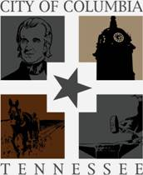

Request for Qualifications – Call for Artist

March 10, 2017
Solicitation # 999-0217-32
The City of Columbia is inviting professional artists to submit their qualifications for the creation of a mural to be permanently displayed on an outdoor sculptural wall located in downtown Columbia Tennessee. The work will be an integral part of the new Columbia Arts District and serve as a catalyst for further development of the arts, culture and tourism in the City.
Columbia
The City of Columbia is located approximately 45 miles South of Nashville in the rolling hills of Middle Tennessee. The downtown is located along the scenic Duck River which is the longest river located entirely in the State of Tennessee and the most ecologically diverse river in North America. In addition to the beauty afforded by its geographic location, Columbia is rich with history dating back to its founding in 1817. Columbia also serves as the ancestral home of President James K Polk, the eleventh president of the United States and has the only remaining home in which President Polk ever resided.
The City has a renewed interest in the promotion of the arts through funding of public art projects and creation of an Arts Council. A portion of our downtown area has recently been designated as an arts district which grants certain privileges to land owners in the district to develop, promote and market the arts in its various forms. The City is commissioning the construction of a sculptural wall to serve as an entry point to the arts district. The description of the wall is included below. In addition to the unique design and size of the wall, the City wishes to use the wall as a backdrop or canvas for a mural that will welcome citizens and visitors alike to the Columbia Arts District.
A second but no less important goal of the City and this project is the promotion of tourism. Columbia is a beautiful town, rich with history and full of stories. The proposed wall and mural should help us tell our story, help create a sense of community pride and add to the livability of Columbia through promotion of public art.
Site Description
The City is constructing a sculptural wall on a plot of ground located at 1000 South Garden Street. The wall will serve as a significant piece of public art itself and also serve as the canvas for the artist creation called for in this request. The wall itself will be a solid concrete structure. The serpentine design is reflective of the turns of the Duck River passing through downtown and the varying vertical heights represent the rolling hills of Middle Tennessee.
Approximate Wall Dimensions
Span 50’
Depth 28’
Total Length 76’
Max Height 8’
Min Height 6”
Thickness 8”
Scope of the project
The constructed serpentine wall will allow for two mural surfaces. Side A will face outward toward Carmack Boulevard while Side B will face inward toward an area to be designated as Fireman’s Park. The Sesquicentennial of the fire service in Columbia will be celebrated this year. The creation of a mural on Side B celebrating that anniversary is the primary objective of this artist call; however, the City will consider a mural for Side A that more broadly reflects the community- its culture, history, beauty or other such theme. Muralist submission will be considered for both Sides A and B of wall.
See Exhibit A for site and wall elevations, and historical information on the Columbia Fire Department
Artwork Requirements
- The artwork should help tell the story of Columbia either past present or future.
- The design should be sensitive to the public location and not portray overtly racial, religious or violent themes or sexualized images in any manner.
- As a gathering place for both local residents and tourist of all ages, the work should engage, perhaps educate and please a wide demographic of viewers.
- The materials and methods used for the creation of the mural should be of highest quality and conducive to the material to which it will be applied and have the ability to withstand the varying climatic conditions of the site.
Artist Qualifications and Submission Requirements
- A letter of interest indicating your vision and approach to the project limited to two pages.
- A professional resume/CV with qualifications limited to two pages.
- Three professional references with current contact information from current or completed projects.
- Visual supporting material of previous work (10 images or less). This may be in the form of a CD, prints, websites, etc.
- Proposed number of days for design submission after contract award date
- Number of days after approved design to commencement of work
- All submissions shall be made to :
City of Columbia
Danny King, Purchasing Agent
700 North Garden St.
Columbia, TN 38401
Timeline
- Deadline for Submission : April 7, 2017; 2:00 PM CT
- Contract award date: May 11,2017

Budget
- This project will be funded utilizing monies received as part of the hotel/ motel tax for Columbia.
- The total budget for the project to include all artist fees, travel, design, insurance, permits, fabrication labor and installation will be $10,000.00.

Selection Process

A selection committee composed of members of the Columbia Arts Council will conduct the artist selection process based on the following criteria:
- Demonstrated experience with projects of similar size and/or prominence.
- Quality of Previous work
- Durability of the artwork relative to the environment.
- Ability of the artist to meet the project deadlines
- Expression of vision as revealed in the cover letter and artist rendering

EXHIBIT A

RENDERING OF THE CONCRETE SERPENTINE WALL

FRONT ELEVATION

REAR ELEVATION
Bird’s Eye View

Top View

SITE
Wall to be located in the foreground on the site of Fire Hall 1 shown in the background. Fire Station one front Carmack Boulevard. South Garden Street is not shown but lays to left of the picture. The sculpture wall will be located on the northern boundary of the Columbia Arts District.
The 50 foot length of the sculpture wall will be view from Carmack Boulevard. The 28 foot width will be viewed from South Garden Street and to an extend by north and south bound traffic on Carmack Boulevard.
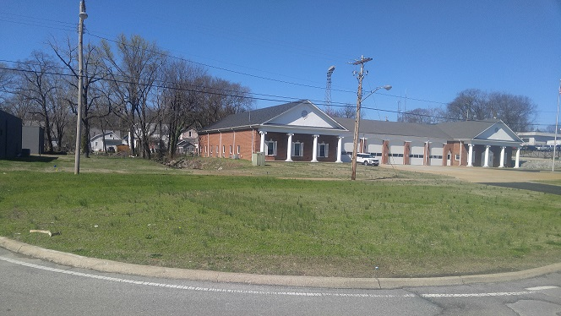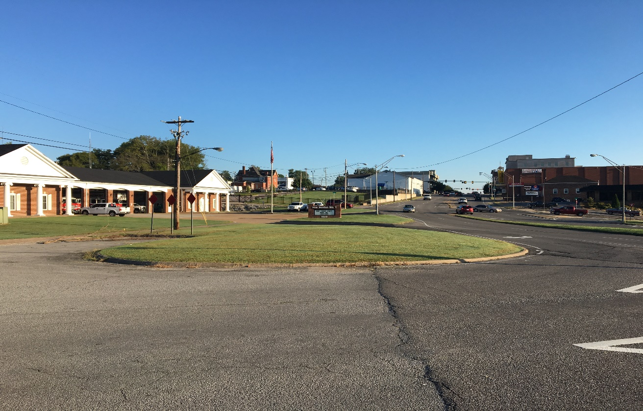
RENDERING OF WALL
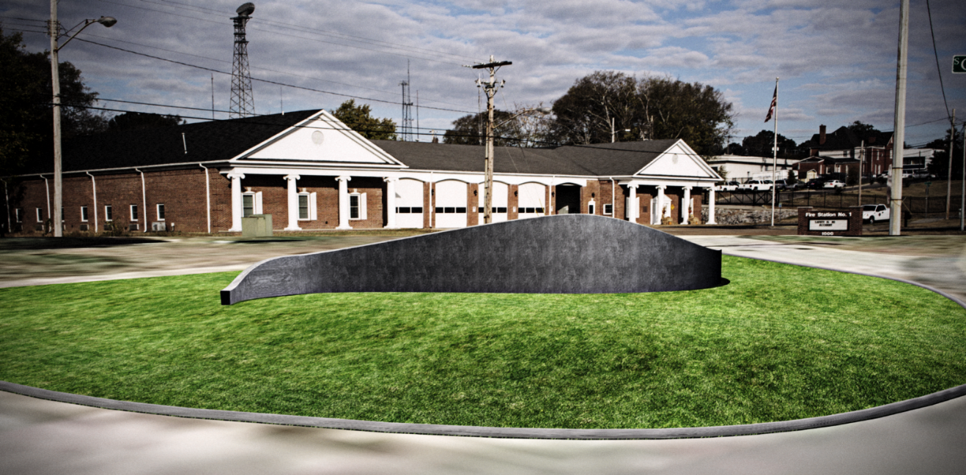

HISTORY OF FIRE SERVICE AND THE COLUMBIA FIRE DEPARTMENT

The Columbia Fire Department enjoys a distinguished and proud history of service to Columbia citizsnes and businesses…ISO 1, etc.

In addition to the mural commemorating 150 of fire services for the citizens of Columbia, the city also plans to develop Firefighter’s Park ,,,,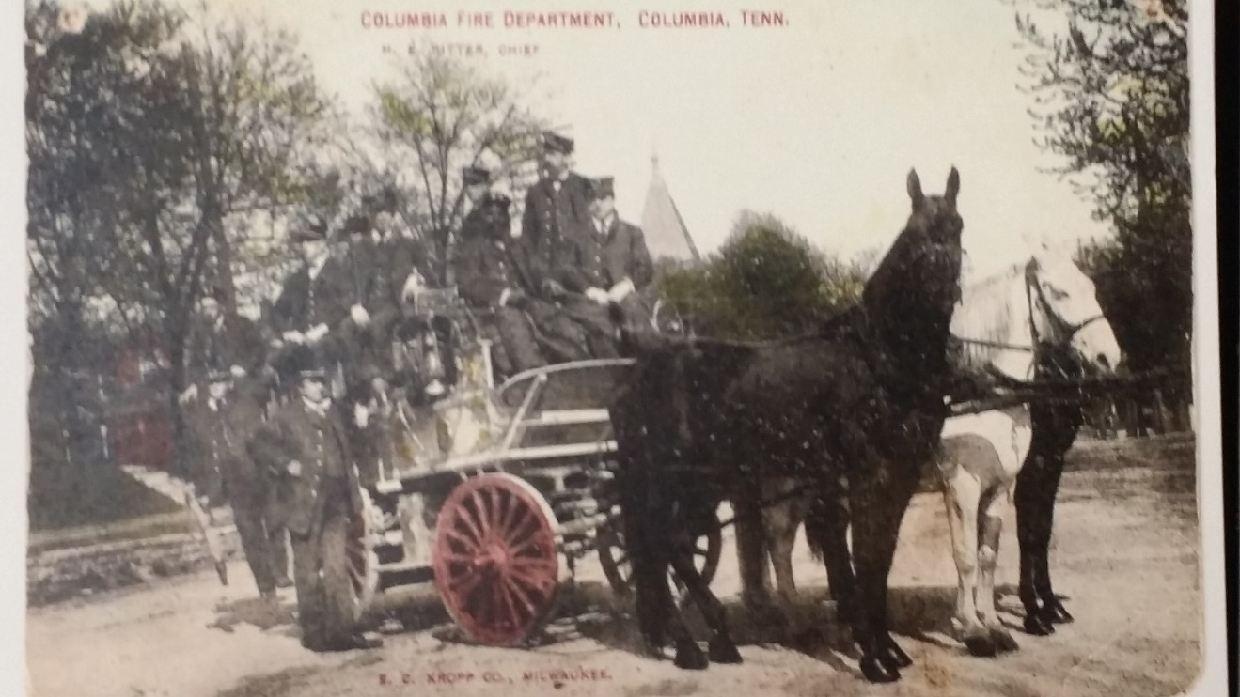
Columbia Fire Department - 19th Century fire carriage
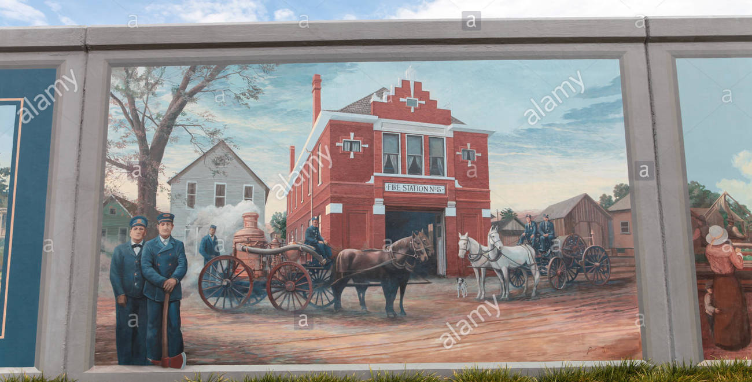
Paducah. KY Mural – Located on Flood Wall in the city’s arts district

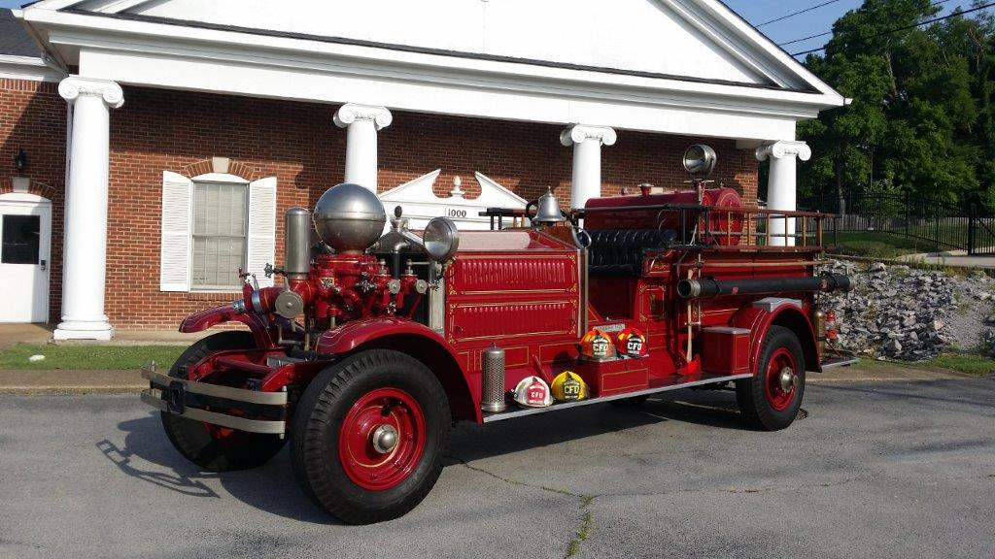
1925 Ahrens-Fox Fire Engine, City of Columbia

COLUMBIA FIRE DEPARTMENT TODAY
