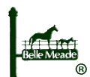

CONTRACTOR CERTIFICATION
TCA Title 12, Chapter 12 – IRAN DIVESTMENT ACT

Date: ________________________________

Contractor Name________________________
Address_______________________________
City, State_____________________________

Contract Name/description:

The City of Belle Meade has executed and hands you herewith an executed counterpart of its contract with you for the performance of the above work. In your performance on this contract, we call to your attention the provisions of Tennessee Code Annotated Title 12, Chapter 12, Iran Divestment Act, which requires that any bidder submitting a bid or proposal, or who contracts with the state or political subdivision of the state, including a contract renewal or assumption, shall certify the following statement as true under the penalties of perjury: “By submission of this bid, each bidder and each person signing on behalf of any bidder certifies, and in the case of a joint bid each party thereto certifies as to its own organization, under penalty of perjury, that to the best of its knowledge and belief that each bidder is not on the list created pursuant to TCA Section 12-12-106” (copy attached).
In your performance of this contract, we shall expect full compliance with the requirements of this statute and request your confirmation of this fact upon the line provided below.

THE CITY OF BELLE MEADE

By: Date: _ ___ __________________
Mayor

_______________________ (Contractor) certifies that it understands the requirements of the above-referenced statute and agrees that it will comply fully with the same in the performance of the above contract.

By: Date:
(Contractor’s Representative)

________________________________
Print name of Representative
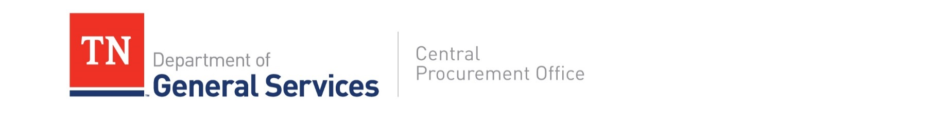

NOTICE

Tenn. Code Ann. § 12-12-106 requires the chief procurement officer to publish, using credible information freely available to the public, a list of persons it determines engage in investment activities in Iran, as described in § 12-12-105.

For these purposes, the State intends to use the attached list of “Entities Ineligible to Contract with the State of South Carolina or any Political Subdivision of the State per the Iran Divestment Act of 2014, S.C. Code Ann. §§ 11-57-10, et. seq.”

While inclusion on this list would make a person ineligible to contract with the state of Tennessee, if a person ceases its engagement in investment activities in Iran, it may be removed from the list.

If you feel as though you have been erroneously included on this list please contact the Central Procurement Office at CPO.Website@tn.gov.

List Date: April 15, 2020
Source: https://www.ogs.ny.gov/iran-divestment-act-2012

- Ak Makina, Ltd.
- Amona
- Bank Markazi Iran (Central Bank of Iran)
- Bank Mellat
- Bank Melli Iran
- Bank Saderat Iran
- Bank Sepah
- Bank Tejarat
- China Precision Machinery Import- Export Corporation (CPMIEC)
- ChinaOil (China National United Oil Corporation)
- China National Offshore Oil Corporation (CNOOC)
- China National Petroleum Corporation (CNPC)
- Indian Oil Corporation
- Kingdream PLC
- Naftiran Intertrade Co. (NICO)
- National Iranian Tanker Co. (NITC)
- Oil and Natural Gas Corporation (ONGC)
- Oil India, Ltd.
- Persia International Bank
- Petroleos de Venezuela (PDVSA Petróleo, SA)
- PetroChina Co., Ltd.
- Petronet LNG, Ltd.
- Sameh Afzar Tajak Co. (SATCO)
- Shandong FIN CNC Machine Co., Ltd.
- Sinohydro Co., Ltd.
- Sinopec Corp. (China Petroleum & Chemical Corporation)
- SKS Ventures
- SK Energy Co., Ltd.
- Som Petrol AS
- Unipec (China International United Petroleum & Chemicals Co., Ltd.)
- Zhuhai Zhenrong Co.

