
ROCKWOOD SCHOOL DISTRICT

REQUEST FOR PROPOSAL

RFP No.: RFP0921SCREP

Title: Stage Rigging System Repairs

Issue Date: September 2, 2021

This document constitutes Rockwood School District’s (hereafter called the “District” or “RSD”) Request for Proposals ("RFP") soliciting proposals from qualified individuals, firms or organizations to provide stage rigging system repair services as described in this RFP.

SEALED PROPOSALS FOR FURNISHING THE PRODUCTS AND SERVICES DESCRIBED HEREIN MUST BE RECEIVED BY 2:00 PM CST ON SEPEMBER 30, 2021. Proposals submitted after that time and date will be rejected.

PROPOSALS SHALL BE SUBMITTED TO:

Coordinator of Purchasing
Rockwood School District
111 East North Street
Eureka, Missouri 63025

All inquiries for information regarding Proposal Preparation and Submission Requirements shall be in writing and shall be directed to:

Brenda Kirchhoefer
Coordinator of Purchasing
Rockwood School District
111 East North Street
Eureka, Missouri 63025
kirchhoeferbrenda@rsdmo.org
636.733.2045

All other communications and questions regarding this RFP must be directed to the above individual. No other contact with any members of the Rockwood School Board, any administrators, staff or employees of the District is permitted before or after completion of the RFP process. Failure to follow this directive or any attempt to contact or to influence any such person may result in rejection or disqualification of a proposal.

Any and all responses to written requests for information and questions will be in writing and will be sent to all known interested parties. Any oral responses will be considered unauthorized and non-binding on the District.

Important Dates

RFP Issue Date September 2, 2021

Deadline for RFP Clarification September 16, 2021

Proposal Due Date September 30, 2021 at 2:00 PM

Award Recommendation Submitted to BOE October 6, 2021

BOE Approval Date October 21, 2021

Contract Commencement Date October 22, 2021

[REMAINDER OF PAGE INTENTIONALLY LEFT BLANK]

I. RFP INSTRUCTIONS AND CONDITIONS

- INTRODUCTION

The District is a nationally recognized, diverse community of learners. Currently the District serves nearly 21,000 students, made up of four high schools, six middle schools, and nineteen elementary schools, a talented and gifted campus, and a school for at-risk high school students. The District employs over 3,500 people, and covers 150 square miles in much of western St. Louis and northern Jefferson counties. The District has consistently earned the accreditation of Distinction in Performance by the Missouri Department of Education. Additional detailed information about the District may be found at www.rsdmo.org.

The Rockwood School District invites you to submit a bid according to requirements contained herein for stage rigging repair services at each of the District’s four high schools.

- PROPOSAL PREPARATION AND SUBMISSION REQUIREMENTS

A. In order to be considered, proposers must submit one (1) hard copy of the proposal prior to the deadline and submit an electronic copy via email after 2:00 pm on September 30, 2021. Proposals shall be signed and printed or type written, submitted sealed with the envelope plainly marked with the title and RFP No.: RFP0921SCREP. Proposals shall be delivered to:

Coordinator Purchasing
Rockwood School District
RFP0921SCREP
111 East North Street
Eureka, Missouri 63025

SEALED PROPOSALS FOR FURNISHING THE PRODUCTS AND SERVICES DESCRIBED HEREIN MUST BE RECEIVED BY 2:00 PM CST ON SEPEMBER 30, 2021. Proposals submitted after that time and date will be rejected.

B. Proposals shall be prepared simply, but completely, providing a straightforward, concise description of capabilities to satisfy the requirements of the RFP. Emphasis should be on completeness and clarity of content. At the same time, proposals should be as thorough and detailed as possible so that the District may properly evaluate the Proposer's capabilities to provide the required services.

Electronic or facsimile proposals alone will not be considered in response to this RFP, nor will modifications by electronic or facsimile notice be accepted.

C. Proposers must include at least the following information, data and responses labeled accordingly in their proposals (i.e. C1, D, E. etc.):

(1) Proposer's full name and principal office address, and descriptions of the type of business entity (e.g., publicly held corporation, private non-profit, proprietorship, partnership, etc.).

(2) If Proposer is incorporated, include the state in which it is incorporated, and list the name and occupation of those individuals servicing on the board of directors, along with the name of any entity or person owning 10% or more of the corporation.

(3) The name, title, mailing address, telephone number, fax number, and email address of the contact person for this RFP and the proposal.

(4) A summary description or work plan which describes how Proposer intends to perform the required services and include a description of any involvement and responsibilities which would be required of the District.

(5) The name(s) of the employees, persons or contractor(s) proposed to perform the services, and describe the qualifications and experience of each.

(6) Description of the manner by which Proposer proposes to be compensated for the services to be provided, including a listing or schedule of fees, commissions, costs and expenses, including reimbursable costs and Proposer’s total cost for the services to be provided.

- Indicate if proposed pricing includes the acceptance of payment with a procurement card (p-card) or credit card in lieu of a check. If Proposer agrees, no additional fees shall be charged to the District for card acceptance.

- Indicate if proposed pricing could be offered to other Missouri school districts of similar size and order volumes.

D. Proposers must provide a description or evidence of their experience and qualifications to undertake and to provide the services described in this RFP with a particular emphasis upon experience and services provided to Missouri K-12 school districts.

E. Proposers must provide evidence or information as to their financial condition and stability.

F. Proposers must provide a minimum of five (5) references with names, addresses and phone numbers, and including specifically any governmental entities and school districts for which each Proposer has provided services.

G. Proposers must state whether they have been involved in any litigation during the last five years, and if so, describe any such litigation.

- PRE-PROPOSAL MEETING

A pre-proposal meeting is not currently scheduled. Potential bidders requiring clarification of proposal requirements shall contact Rockwood School District’s Coordinator of Purchasing by 4:00 PM CST on September 16, 2021. All District responses to bidder’s questions will be posted via Rockwood School District’s RFP website link. http://gov.findrfp.com/gov/List.aspx?id=87502

- AWARD

Award(s) will be made to the responsive and responsible Proposer(s) whose proposal(s) is deemed to be most advantageous to the District, taking into account overall content of the proposal, cost, overall proposal, experience and qualifications of the firm and staff assigned and quality and content of the manner in which the services are proposed to be performed. The District reserves the right to split the award or to make multiple awards, and to make award on a part or portion of a proposal. The District may request additional information and/or an interview with some or all Proposers as part of the selection process. In no event shall the District be required to explain the evaluation process or award selection to any Proposer.

- RIGHT TO REJECT

The District reserves the right to accept any proposal, to reject any and all proposals, and to waive any irregularities or informalities in any proposals. Conditional proposals will not be accepted.

- PROPOSALS FINAL

All proposals shall be deemed final, conclusive and irrevocable, and no proposal shall be subject to correction or amendment for any error or miscalculation.

- COST OF PREPARATION

The cost of preparing and submitting a response to this RFP will be assumed solely by each Proposer, whether or not any agreement is signed as a result of this RFP.

- OWNERSHIP OF SUBMITTALS

All completed proposals submitted in response to this RFP become the property of the District upon submission. The District may use the proposal for any purpose deemed appropriate. The proposal material may become part of any contract between the successful Proposer and the District.

- RFP INTERPRETATION

Interpretation of the wording of this RFP will be the responsibility of the District and that interpretation will be final and binding.

- PRICE

Proposers are cautioned that services must be furnished at the fees, costs and/or rates submitted and proposed unless otherwise stated. No increase in costs will be permitted during the term of the contract.

- CONTRACT

The Rockwood Board of Education must formally approve the award of any contract(s) or agreement to purchase with approval anticipated to be received no later than October 21, 2021. The successful Proposer will be required to enter into a written contract with the District which will include, but not be limited to, the scope of services described herein and the contract provisions included herein.

- BILLING AND PAYMENT

Invoices shall be submitted directly to the Rockwood School District via email at accountspayable@rsdmo.org or mailed to the District’s Finance Office at 111 E. North St., Eureka, MO 63025. Each invoice should contain the District purchase order number, date of shipment, quantity, price and items(s) shipped. Invoices will not become due and payable until all times listed on the invoice are received complete.

Rockwood School District’s payment terms are Net 45.

- INSURANCE

The successful Proposer will be expected to provide the following types of insurance with the described limits:

Comprehensive General Liability $ 1,000,000 per person per occurrence
(Including Contractual Liability)

$ 1,000,000 property damage per occurrence

$ 1,000,000 aggregate all claims per occurrence

Workers' Compensation As required by applicable law

Employer's Liability $ 1,000,000 per occurrence

- TAXES

Proposers shall NOT INCLUDE FEDERAL EXCISE TAX, TRANSPORTATION TAX, or STATE RETAIL SALES TAX in their cost proposal, as these taxes do not apply to the District.

- NO PARTICIPATION

The successful Proposer shall not directly or indirectly participate as a proposer, bidder, or subcontractor to a proposer or bidder on any bids or request for proposals to be designed, or services to be provided, as part of the projects contemplated by this RFP.

- EXCEPTIONS

If a Proposer takes exception to any part of these specifications as written, or as amended by any addenda subsequently issued, or the Agreement, they must do so in writing. Said exceptions must be submitted with the proposal. Failure to do so will be construed as acceptance of all items of the specification and the Agreement.

- USE OF INFORMATION

A. Any specifications, drawings, sketches, models, samples, data, computer programs or documentation or other technical or business information (“Information”) furnished or disclosed to interested parties under this RFP, or as the result of this RFP, shall remain the property of the District and, when in tangible form, all copies of such information shall be returned to the District upon request. Unless such information was previously known to a party, free of any obligation to keep it confidential, or has been or is subsequently made public by the District or a third party, it shall be held in confidence by such party, shall be used only for the purposes of this RFP, and may not be used for other purposes except upon such terms and conditions as may be mutually agreed upon in writing.

B. No specifications, drawings, sketches, models, samples, tools, or other apparatus programs, technical information or data, written, oral or otherwise, furnished by any interested party to the District under this RFP shall be considered to be confidential or proprietary.

II. SCOPE OF SERVICES

Through this RFP, the District is seeking to obtain proposals from qualified and experienced persons, organizations, companies or firms with certification(s) for Entertainment Technician Certification Program (ETCP) Certified Rigger – Theatre, to conduct necessary repairs to the counterweight rigging system at (4) high school theaters. Recent inspections of the stage rigging systems yielded some necessary repairs and maintenance that need to be completed on the systems. Please see the details of each location below.

Proposers should include an estimated timeframe to complete each repair in their proposal.

The selected company will be responsible for providing all the equipment necessary to complete the repairs.

Marquette High School Theater
Marquette is located at 2351 Clarkson Road, Chesterfield, MO 63017. The stage rigging system is comprised of (23) single-purchase line sets with (7) loft block pickups on each set. It is managed by a J-Bar wall.

Lafayette High School Theater
Lafayette is located at 17050 Clayton Road, Wildwood, MO 63011. Lafayette’s stage rigging system is comprised of a motorized mine set system including (15) line sets and (6) light ladders.

Rockwood Summit High School Theater
Rockwood Summit is located at 1780 Hawkins Road, Fenton, MO 63026. The stage rigging system is comprised of (23) single-purchase line sets with (7) loft block pickups on each set. It is managed by a J-Bar.

Eureka High School Theater
Eureka is located at 4525 Highway 109, Eureka, MO 63025. The stage rigging system is comprised of (23) single-purchase line sets with (7) loft block pickups on each set. It is managed by a T-Bar. There is an inspection grid at Eureka.

- Please review the following information and pictures for the required repairs.
- Bidders must provide an estimated timeline of completion of the repairs and maintenance on the system.
- Bidders must work with the existing schedule of the facility to complete the maintenance and repairs.

Required Repairs @ Marquette High School

Termination Concerns:

- Nico Sleeves
  - Aluminum sleeves are being used as terminations on the (4) electrics. This is against code and is a safety concern. The electrics need to be terminated with proper termination hardware that meets code.

- Termination points on all lines need to be adjusted to align with loft block positions.
Loft & Mule Block Concerns:

- A general adjustment of the loft blocks on all lines with relationship to the fleet angles needs to be made. Many lines are climbing out of their shives because they are not running true.
- Idler rollers need to be adjusted to match the alignment of the lift lines and loft blocks related to the above concern.
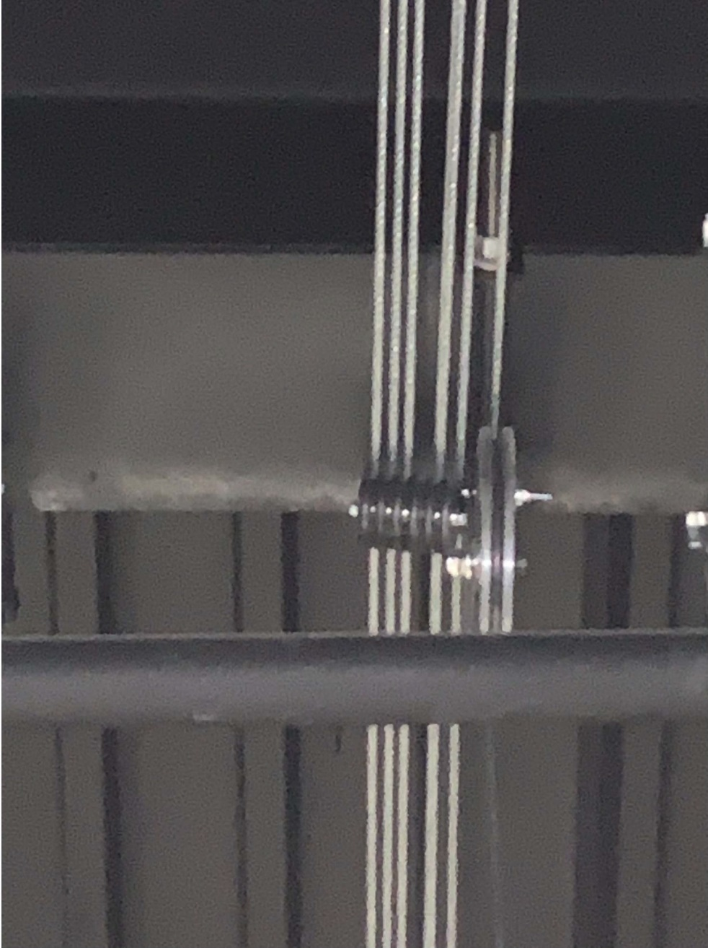
- The main curtain lift lines are cutting into loft block one. Adjustments must be made to make sure all loft blocks and lift lines are in proper alignment to repair this safety issue. Replace main curtain lift lines as necessary due to abrasions formed on lines from cutting into the loft block.

Battens & Splices:

- Level Lines - All lines need to be checked and adjusted as necessary so they are level.
- Straight & True Lines – All lines need to be checked and adjusted as necessary to make sure they are straight and true.
Required Repairs @ Lafayette High School
Control Cabinet

- The selector switches on the control cabinet are worn and have “play” in the switches. Please replace all (3) selector switches. See pictures below of current switches. One switch controls (4) electrics, one switch controls (6) light ladders, and one switch controls (11) scenery battens.

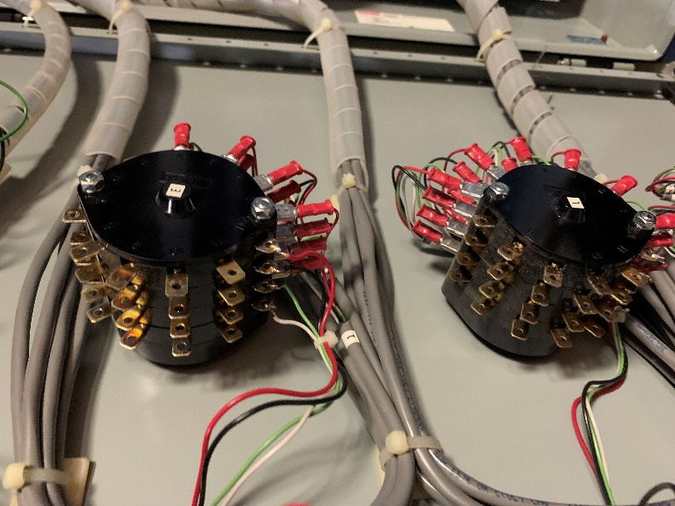
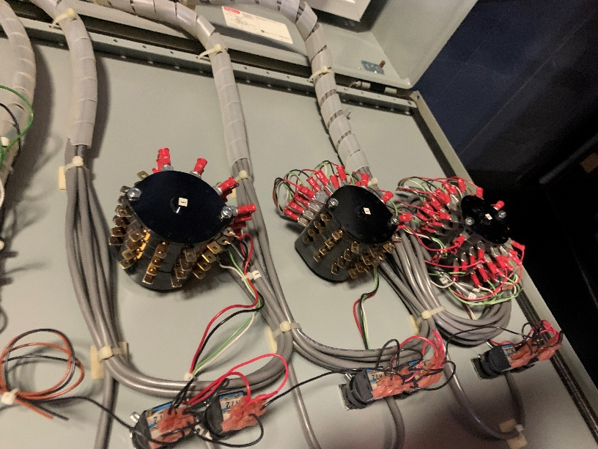
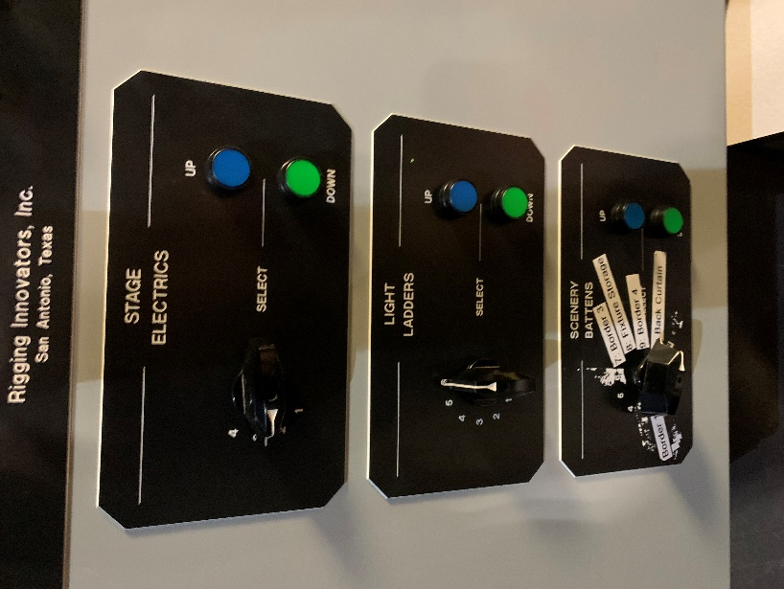

Required Repairs @ Rockwood Summit High School

Control Line

- The control/hand lines on the electrics show signs. The hand line on line set (5) appears to have a broken internal cord. Replace the hand lines on all (4) electric line sets.

Rope Locks

- The dawgs/jaws of the rope locks on all line sets need to be adjusted to the proper specifications.
Wire Rope

- All ¼” wire rope lines were painted black and need to be replaced.

Terminations

- Wire rope clips need to be replaced with drop forged clips.
- Termination points need to be adjusted on all line sets to align with loft block positions.

Head Blocks

- The bearing and shaft of the head blocks on all electric line sets are failing. Line set (5) is difficult to move and makes squealing noise like it has a bad bearing. Failing components need to be replaced to correct this issue.

Loft & Mule Blocks

- All loft and mule blocks need a good cleaning to remove debris from painted aircraft cable.

Battens & Splices

- All line sets need to be checked and adjusted so all battens are level.
- All line sets need to be checked and adjusted so all battens are straight and true.
Required Repairs @ Eureka High School

Control Line

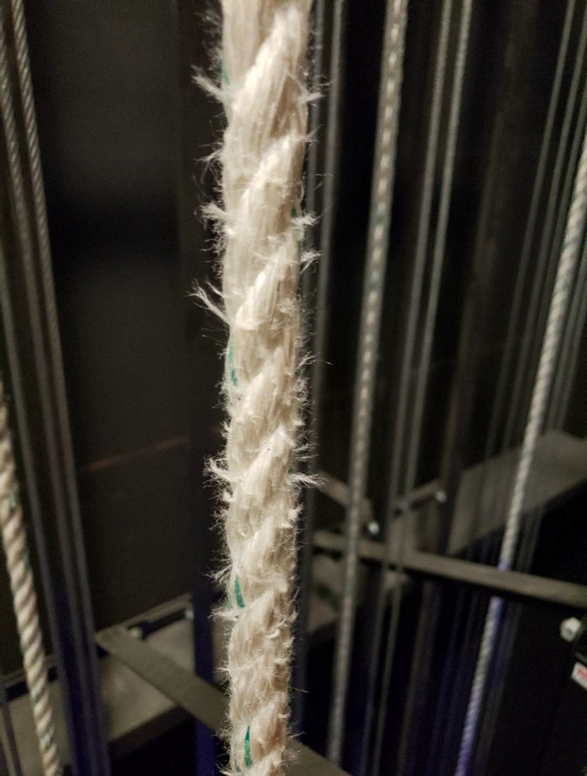
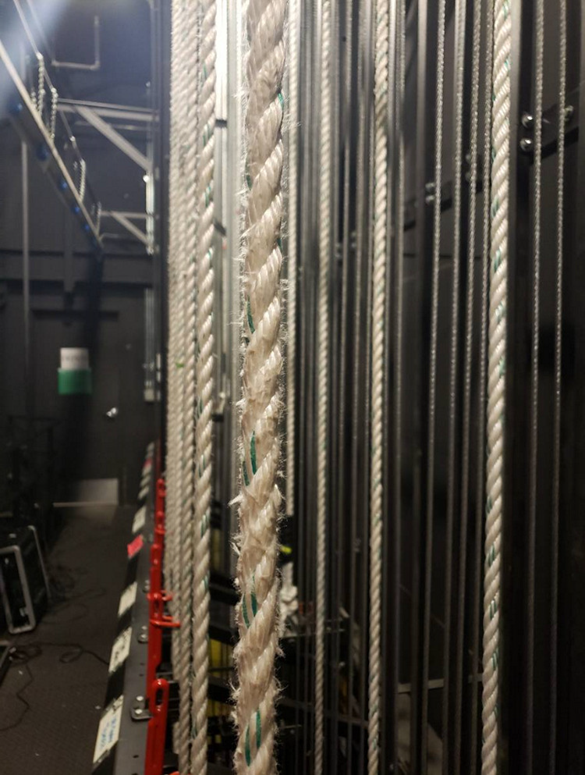
- All control line needs to be replaced. The stress control markers in the hand line are beginning to break and the inner core is being pulled to the surface of the rope.

Terminations

- Termination points need to be adjusted on all line sets to align with loft block positions.
- The (4) electrics need to be re-terminated so that they cannot be crashed into the floor. They travel too far towards the stage floor allowing fixtures to hit the floor before the arbor reached the bumper rail.

Loft & Mule Blocks

- A general adjustment of all loft blocks with relationship to fleet angles needs to be made. Many lines are not running true and are climbing out of their shives or idler pulleys.

Battens & Splices
- Line set needs to be adjusted to be level.

III. CONTRACT TERMS AND CONDITIONS

INTRODUCTION TO THIS SECTION

The successful Proposer will be expected to enter into a written contract with the District. The terms and conditions in this section are expected to be incorporated into any contract awarded as a result of this RFP. In submitting a proposal, the Proposer agrees to the terms and conditions in this section, unless a statement is made to the contrary. Acceptance of alternate language, terms and conditions is at the sole discretion of the District. While the exact term of the contract is subject to final determination, the successful Proposer would be expected to commence the services on or about October 22, 2021 and complete the services as mutually agreed. The following terms and conditions are not to be considered complete, and other terms and conditions will be included in any resulting contract.

WARRANTY FOR SERVICES

Contractor warrants and represents to the District that Contractor possesses the background, experience, expertise and qualifications to undertake and to carry out the Services. Contractor further warrants and represents that the Services will be performed in a professional, good, thorough and workmanlike manner, and consistent with accepted industry standards.

REMEDIES FOR UNSATISFACTORY SERVICES

In the event Contractor fails to provide the Services consistent with the warranties and representations set forth in Section 2 above, the District at its option, may: (a) require Contractor to reperform the unsatisfactory Services at no cost to the District; (b) refuse to pay Contractor for Services, unless and until Services are corrected and performed satisfactorily; (c) require Contractor to reimburse the District all amounts paid for such unsatisfactory Services; and/or (d) proceed with, and assert, any and all remedies available at law. The foregoing options and remedies available to the District shall be deemed to be mutual and severable, and not exclusive.

INSURANCE

A. Contractor shall maintain occurrence-based insurance including comprehensive general liability, automotive liability, and if applicable, workers’ compensation and employers' liability in the amounts described herein. Such insurance shall be provided by insurance companies authorized to do business in the State of Missouri.

B. The District shall be included as an additional insured on all required insurance policies, except Workers’ Compensation and Employers' Liability, with respect to the liability arising out of the performance of Contractor's Services under this Agreement.

C. Certificates of insurance of Contractor's insurance coverage shall be furnished to the District at the time of commencement of the Services.

D. All such insurance shall provide for notice to the District of cancellation of insurance policies thirty (30) days before such cancellation is to take effect.

TERMINATION

A. The District may terminate this Agreement with or without cause at any time by giving 15 days' prior written notice to the other party of its intention to terminate as of the date specified in the notice. Contractor shall be paid for Services satisfactorily performed up to the time notice of termination is received. Contractor shall also be paid for all Services satisfactorily performed between the time notice is received and the date of termination, as long as all such performed Services are approved by the Board in a separate writing and in advance of their performance.

B. In the event of a breach of this Agreement by either Contractor or the District, the non-breaching party shall give the breaching party written notice specifying the default, and the breaching party shall have 15 days within which to cure the default. If the default is not cured within that time, the non-breaching party shall have the right to then terminate this Agreement by providing written notice of such termination.

FORCE MAJEURE

In the event either party is unable, as a result of a Force Majeure Event, to perform Services as set forth in this Agreement, neither party shall have any liability under this Agreement with respect to one another. Neither party shall be liable to the other for any additional costs, expenses or damages arising out of the rescheduling or cancellation of the Services pursuant to this Section. "Force Majeure Event" means unforeseeable causes beyond the parties' control and without their fault or negligence, including but not limited to, governmental action or inaction, war, acts of God or of the public enemy, riots, fires, floods, earthquakes, pandemics, epidemics, coronavirus, COVID-19, or any other deadly and communicable virus or disease, quarantines, strikes, lockouts, freight embargoes, electrical outage, computer or communication failures.

INDEMNITY

Contractor agrees to indemnify and hold harmless the District and the members of the Rockwood Board of Education, and the District’s officers, employees, servants and agents from and against any and all liabilities, losses, damages, costs and expenses of any kind (including, without limitation, reasonable legal fees and expenses in connection with any investigative, administrative or judicial proceeding, whether or not designated a party thereto) which may be suffered by, incurred by or threatened against the District or any members, officers, employees, servants or agents of the District on account of or resulting from injury, or claim of injury, to person or property arising from Contractor’s actions or omissions relating to this Agreement, or arising out of Contractor’s breach or failure to perform any term, covenant, condition or agreement herein provided to be performed by Contractor.

GOVERNING LAW - JURISDICTION

This Agreement shall be governed, construed and interpreted under Missouri law, and shall be deemed to be executed and performed in the County of St. Louis, Missouri. Any legal action arising out of, or relating to this Agreement shall be governed by the laws of the State of Missouri, and the parties agree to the exclusive exercise of jurisdiction and venue over them by a court of competent jurisdiction located in the County of St. Louis, Missouri.

REPORTING

During the term of this Agreement, Contractor shall report to, and confer with, the District’s Theater Supervisor and/or their designee on a regular basis, and as may be reasonably requested, concerning the Services performed by Contractor and issues related to the Services. Contractor also agrees to meet and confer with other District administrators, officers and employees as directed, or as may be necessary or appropriate.

ASSIGNMENT

Contractor agrees, for Contractor and on behalf of Contractor’s successors, heirs, executors, administrators, and any person or persons claiming under Contractor, that this Agreement and the obligations, rights, interests, and benefits hereunder cannot be assigned, transferred, pledged, or hypothecated in any way and shall not be subject to execution, attachment, or similar process, without the express written consent of the District. Any attempt to do so, contrary to these terms, shall be null and void and shall relieve the District of any and all obligations or liability hereunder.

LICENSES AND PERMITS

Contractor shall obtain at Contractor’s expense all licenses and permits necessary to perform the Services.

CONTRACTOR REPRESENTATIONS

Contractor acknowledges and represents that (i) Contractor is legally authorized to transact business in the State of Missouri and to provide the Services required hereunder, (ii) the entering into this Agreement has been duly approved by the Contractor, (iii) the undersigned is duly authorized to execute this Agreement on behalf of Contractor and to bind Contractor to the terms hereof, and (iv) Contractor will comply with all State, federal and local statutes, regulations and ordinances, including civil rights and employment laws, and agrees not to discriminate against any employee or applicant for employment or in the provision of Services on the basis of race, color, national origin, sex, sexual orientation, age or disability. Contractor also agrees to abide by all applicable District policies and regulations.

Contractor agrees that any employee acting on behalf of the contractor and performing duties on District property will adhere to District policies related to staff conduct, including but not limited to: banning the use of tobacco on District property, drug-free workplace and activities that could be viewed as unethical or a conflict of interest. Vendors whose staff will regularly enter school buildings will perform background screening on each staff member to ensure that they are not on a sexual offender or predator list. A complete list of District policies can be found at:

www.rsdmo.org/departments/boe/policiesandregulations

INDEPENDENT CONTRACTOR

The District and Contractor agree that Contractor will act for all purposes as an independent contractor and not as an employee, in the performance of Contractor’s duties under this Agreement. Accordingly, Contractor shall be responsible for payment of all taxes, including federal, state and local taxes arising out of Contractor’s Services, including by way of illustration but not limitation, federal and state income tax, Social Security tax, Unemployment Insurance taxes, and any other taxes. In addition, Contractor and Contractor’s employees shall not be entitled to any vacation, insurance, health, welfare, or other fringe benefits provided by the District. Contractor shall have no authority to assume or incur any obligation or responsibility, nor make any warranty for or on behalf of the District or to attempt to bind the District.

NON-DISCRIMINATION

The District actively follows a policy of nondiscrimination on the basis of age, race, color, religion, sex, national origin, sexual orientation, marital status, disability, and Vietnam-Era-veteran-status. The District also complies with the following laws and implementing regulations: Title VI and Title VII of the Civil Rights Act of 1964 regarding race, color, national origin, religious and sex discrimination; Title IX of the Education Amendments Act of 1972 regarding sex discrimination; the Americans with Disabilities Act, as amended by the ADA Amendments Act; the Missouri Humans Rights Act; Section 504 of the Rehabilitation Act of 1973 regarding discrimination based on disabilities and handicaps; the Age Discrimination in Employment Act; the Missouri Anti-Discrimination Against Israel Act; and other state and federal laws and regulations. By entering into this Agreement, Contractor agrees to be bound by all aforementioned laws and regulations. Contractor shall also comply with all legal requirements of the Americans with Disabilities Act and the Missouri Human Rights Act regarding accessibility of facilities and programs, as may apply. Further, Contractor certifies that it is not currently engaged in and shall not, for the duration of this Agreement, engage in a boycott of goods or services from the State of Israel; companies authorized by, licensed by, or organized under the laws of the State of Israel; or companies, persons, or entities doing business in or with the State of Israel.

FEDERAL WORK AUTHORIZATION PROGRAM

As an independent contractor of the District, Contractor will provide documentation and a sworn affidavit that all employees of Contractor are not considered unauthorized aliens as defined by Federal law and are enrolled in and actively participate in a federal work authorization program (FWAP) used to verify citizenship information of newly hired employees under the Immigration Reform and Control Act of 1986.

Pursuant to section 285.530, RSMo, if the Contractor meets the section 285.525, RSMo, definition of a “business entity” (http://revisor.mo.gov/main/PageSelect.aspx?section=285.530) the Contractor must affirm the Contractor’s enrollment and participation in the E-Verify federal work authorization program with respect to the employees hired after enrollment in the program who are proposed to work in connection with the services requested herein. The Contractor should complete applicable portions of Exhibit A, Business Entity Certification, Enrollment Documentation, and Affidavit of Work Authorization. The applicable portions of Exhibit A must be submitted prior to an award of a contract.

- CONTRACTOR’S PERSONNEL

The Contractor shall only employ personnel authorized to work in the United States in accordance with applicable federal and state laws. This includes but is not limited to the Illegal Immigration Reform and Immigrant Responsibility Act (IIRIRA) and INA Section 274A.

If the Contractor is found to be in violation of this requirement or the applicable state, federal and local laws and regulations, and if the State of Missouri has reasonable cause to believe that the Contractor has knowingly employed individuals who are not eligible to work in the United States, the state shall have the right to cancel the contract immediately without penalty or recourse and suspend or debar the Contractor from doing business with the state. The state may also withhold up to twenty-five percent of the total amount due to the Contractor.

The Contractor shall agree to fully cooperate with any audit or investigation from federal, state or local law enforcement agencies.

If the Contractor meets the definition of a business entity as defined in section 285.525, RSMo, pertaining to section 285.530, RSMo, the Contractor shall maintain enrollment and participation in the E-Verify federal work authorization program with respect to the employees hired after enrollment in the program who are proposed to work in connection with the contracted services included herein. If the Contractor’s business status changes during the life of the contract to become a business entity as defined in section 285.525, RSMo, pertaining to section 285.530, RSMo, then the Contractor shall, prior to the performance of any services as a business entity under the contract:

- Enroll and participate in the E-Verify federal work authorization program with respect to the employees hired after enrollment in the program who are proposed to work in connection with the services required herein; AND
- Provide to the District the documentation required in the exhibit titled, Business Entity Certification, Enrollment Documentation, and Affidavit of Work Authorization affirming said company’s/individual’s enrollment and participation in the E-Verify federal work authorization program; AND
- Submit to the District a completed, notarized Affidavit of Work Authorization provided in the exhibit titled, Business Entity Certification, Enrollment Documentation, and Affidavit of Work Authorization.

In accordance with subsection 2 of section 285.530, RSMo, the Contractor should renew their Affidavit of Work Authorization annually. A valid Affidavit of Work Authorization is necessary to award any new contracts.

[REMAINDER OF PAGE INTENTIONALLY LEFT BLANK]

EXHIBIT A
BUSINESS ENTITY CERTIFICATION, ENROLLMENT DOCUMENTATION,
AND AFFIDAVIT OF WORK AUTHORIZATION

BUSINESS ENTITY CERTIFICATION:
The Proposer must certify their current business status by completing either Box A or Box B or Box C on this Exhibit.

BOX A: To be completed by a non-business entity as defined below.
BOX B: To be completed by a business entity who has not yet completed and submitted documentation pertaining to the federal work authorization program as described at www.e-verify.gov/.
BOX C: To be completed by a business entity who has current work authorization documentation on file with a Missouri state agency including Division of Purchasing and Materials Management.

Business entity, as defined in section 285.525, RSMo, pertaining to section 285.530, RSMo, is any person or group of persons performing or engaging in any activity, enterprise, profession, or occupation for gain, benefit, advantage, or livelihood. The term “business entity” shall include but not be limited to self-employed individuals, partnerships, corporations, contractors, and subcontractors. The term “business entity” shall include any business entity that possesses a business permit, license, or tax certificate issued by the state, any business entity that is exempt by law from obtaining such a business permit, and any business entity that is operating unlawfully without such a business permit. The term “business entity” shall not include a self-employed individual with no employees or entities utilizing the services of direct sellers as defined in subdivision (17) of subsection 12 of section 288.034, RSMo.

Note: Regarding governmental entities, business entity includes Missouri schools, Missouri universities (other than stated in Box C), out of state agencies, out of state schools, out of state universities, and political subdivisions. A business entity does not include Missouri state agencies and federal government entities.

BOX A – CURRENTLY NOT A BUSINESS ENTITY
I certify that _________________________ (Company/Individual Name) DOES NOT CURRENTLY MEET the definition of a business entity, as defined in section 285.525, RSMo pertaining to section 285.530, RSMo as stated above, because: (check the applicable business status that applies below)

- I am a self-employed individual with no employees; OR
- The company that I represent employs the services of direct sellers as defined in subdivision (17) of subsection 12 of section 288.034, RSMo.

I certify that I am not an alien unlawfully present in the United States and if ____________________ (Company/Individual Name) is awarded a contract for the services requested herein under ________________ (RFP/RFQ Number) and if the business status changes during the life of the contract to become a business entity as defined in section 285.525, RSMo, pertaining to section 285.530, RSMo, then, prior to the performance of any services as a business entity, ____________________ (Company/Individual Name) agrees to complete Box B, comply with the requirements stated in Box B and provide Rockwood School District with all documentation required in Box B of this document.
 | Authorized Representative’s Name  (Please Print) |  | Authorized Representative’s Signature
 | Company Name (if applicable) |  | Date

EXHIBIT A, continued

(Complete the following if you DO NOT have the E-Verify documentation and a current Affidavit of Work Authorization already on file with the State of Missouri. If completing Box B, do not complete Box C.)

BOX B – CURRENT BUSINESS ENTITY STATUS
I certify that _________________________ (Business Entity Name) MEETS the definition of a business entity as defined in section 285.525, RSMo, pertaining to section 285.530.

 | Authorized Business Entity  Representative’s Name (Please Print) |  | Authorized Business Entity  Representative’s Signature
 | Business Entity Name |  | Date
 | E-Mail Address
As a business entity, the consultant/contractor must perform/provide each of the following. The consultant/contractor should check each to verify completion/submission of all of the following:

- Enroll and participate in the E-Verify federal work authorization program (Website: www.e-verify.gov; Phone: 888-464-4218; Email: e-verify@dhs.gov) with respect to the employees hired after enrollment in the program who are proposed to work in connection with the services required herein; AND

- Provide documentation affirming said company’s/individual’s enrollment and participation in the E-Verify federal work authorization program. Documentation shall include EITHER the E-Verify Employment Eligibility Verification page listing the consultant’s/contractor’s name and company ID OR a page from the E-Verify Memorandum of Understanding (MOU) listing the consultant’s/contractor’s name and the MOU signature page completed and signed, at minimum, by the consultant/contractor and the Department of Homeland Security – Verification Division. If the signature page of the MOU lists the consultant’s/contractor’s name and company ID, then no additional pages of the MOU must be submitted; AND

- Submit a completed, notarized Affidavit of Work Authorization provided on the next page of this document.

EXHIBIT A, continued

AFFIDAVIT OF WORK AUTHORIZATION:

The consultant/contractor who meets the section 285.525, RSMo, definition of a business entity must complete and return the following Affidavit of Work Authorization.

Comes now _________________________ (Name of Business Entity Authorized Representative) as _________________________ (Position/Title) first being duly sworn on my oath, affirm ___________________________________ (Business Entity Name) is enrolled and will continue to participate in the E-Verify federal work authorization program with respect to employees hired after enrollment in the program who are proposed to work in connection with the services related to contract(s) with the State of Missouri for the duration of the contract(s), if awarded in accordance with subsection 2 of section 285.530, RSMo. I also affirm that ___________________________________ (Business Entity Name) does not and will not knowingly employ a person who is an unauthorized alien in connection with the contracted services provided under the contract(s) for the duration of the contract(s), if awarded.

In Affirmation thereof, the facts stated above are true and correct. (The undersigned understands that false statements made in this filing are subject to the penalties provided under section 575.040, RSMo.)

Authorized Representative’s Signature |  | Printed Name
Title |  | Date
E-Mail Address |  | E-Verify Company ID Number

Subscribed and sworn to before me this ____________ of ________________________. I am
^{(DAY)} ^{(MONTH, YEAR)}
commissioned as a notary public within the County of _________________________, State of
^{(NAME OF COUNTY)}
_______________________, and my commission expires on ____________________.
^{(NAME OF STATE)} ^{(DATE)}

Signature of Notary |  | Date

EXHIBIT A, continued

(Complete the following if you have the E-Verify documentation and a current Affidavit of Work Authorization already on file with the State of Missouri. If completing Box C, do not complete Box B.)

BOX C – AFFIDAVIT ON FILE - CURRENT BUSINESS ENTITY STATUS
I certify that _________________________ (Business Entity Name) MEETS the definition of a business entity as defined in section 285.525, RSMo, pertaining to section 285.530, RSMo, and have enrolled and currently participates in the E-Verify federal work authorization program with respect to the employees hired after enrollment in the program who are proposed to work in connection with the services related to contract(s) with the State of Missouri. We have previously provided documentation to a Missouri state agency or public university that affirms enrollment and participation in the E-Verify federal work authorization program. The documentation that was previously provided included the following.

- The E-Verify Employment Eligibility Verification page OR a page from the E-Verify Memorandum of Understanding (MOU) listing the consultant’s/contractor’s name and the MOU signature page completed and signed by the consultant/contractor and the Department of Homeland Security – Verification Division
- A current, notarized Affidavit of Work Authorization (must be completed, signed, and notarized within the past twelve months).

Name of Missouri State Agency or Public University* to Which Previous E-Verify Documentation Submitted: _____________________________________________________________________
(*Public University includes the following five schools under chapter 34, RSMo: Harris-Stowe State University – St. Louis; Missouri Southern State University – Joplin; Missouri Western State University – St. Joseph; Northwest Missouri State University – Maryville; Southeast Missouri State University – Cape Girardeau.)

Date of Previous E-Verify Documentation Submission: ______________________

Previous RFP/RFQ Number for Which Previous E-Verify Documentation Submitted: ___________________ (if known)

 | Authorized Business Entity  Representative’s Name (Please Print) |  | Authorized Business Entity  Representative’s Signature
 | E-Verify MOU Company ID Number |  | E-Mail Address
 | Business Entity Name |  | Date
FOR STATE USE ONLY
Documentation Verification Completed By:
 | Buyer |  | Date

ACKNOWLEDGEMENT FORM
(Complete and return as part of your proposal)

The Proposer hereby declares understanding, agreement and certification of compliance to provide the items and/or services, at the prices quoted, in accordance with all terms and conditions, requirements and specifications of the original Request for Proposal (RFP) and as modified by any addenda.

Company Name Representative's Name Title

Address City/State/Zip Telephone # Fax #

E-mail Address

Years in Operation Years under current structure and/or under previous structure

- Name of Company’s Officers:
NAME |  | TITLE

- The undersigned hereby acknowledges the receipt of the following addenda:
Addendum Number |  | Date Issued |  | Date  Acknowledged |  | Signature

- The undersigned hereby acknowledges that the Company has read and agrees to the terms and conditions set forth in the RFP, and that the terms and conditions set forth in the Proposal will remain open for at least 90 days from the deadline for submission of Proposals
Company Officer’s Name
Signature Date

