EXIBIT D -- ADA APPROVED SIGNAGE
(BLUE IN COLOR)
PHASE ONE – QTY 2
PHASE TEN – QTY 2

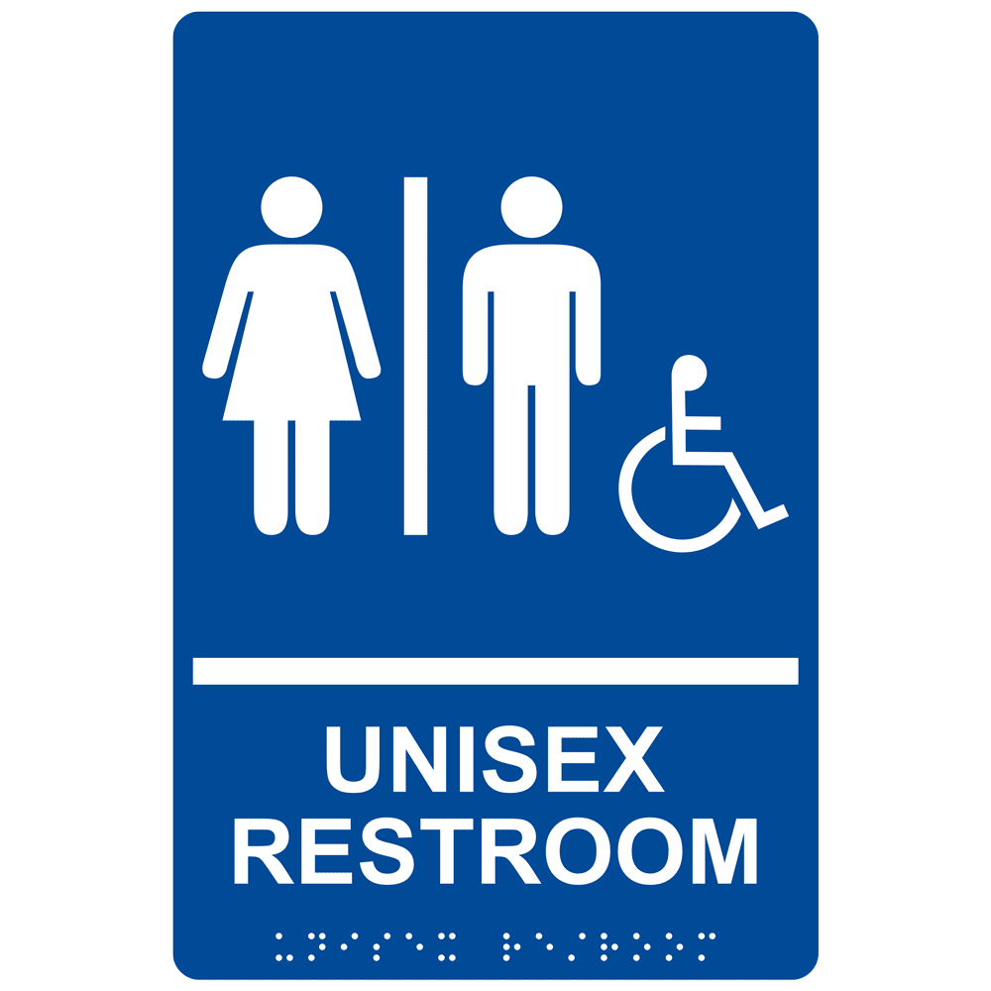

(BLUE IN COLOR)
PHASE FIVE – QTY 1
PHASE SIX – QTY 1

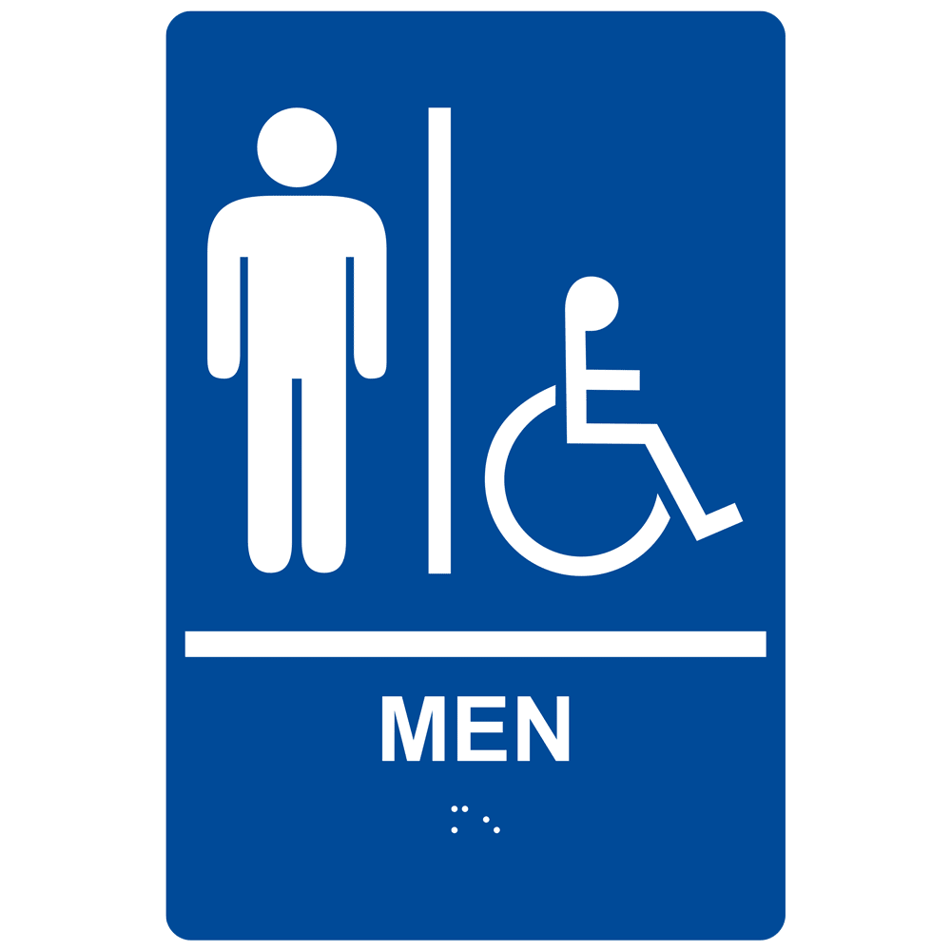

(BLUE IN COLOR)

PHASE FIVE – QTY 1
PHASE SIX – QTY 1

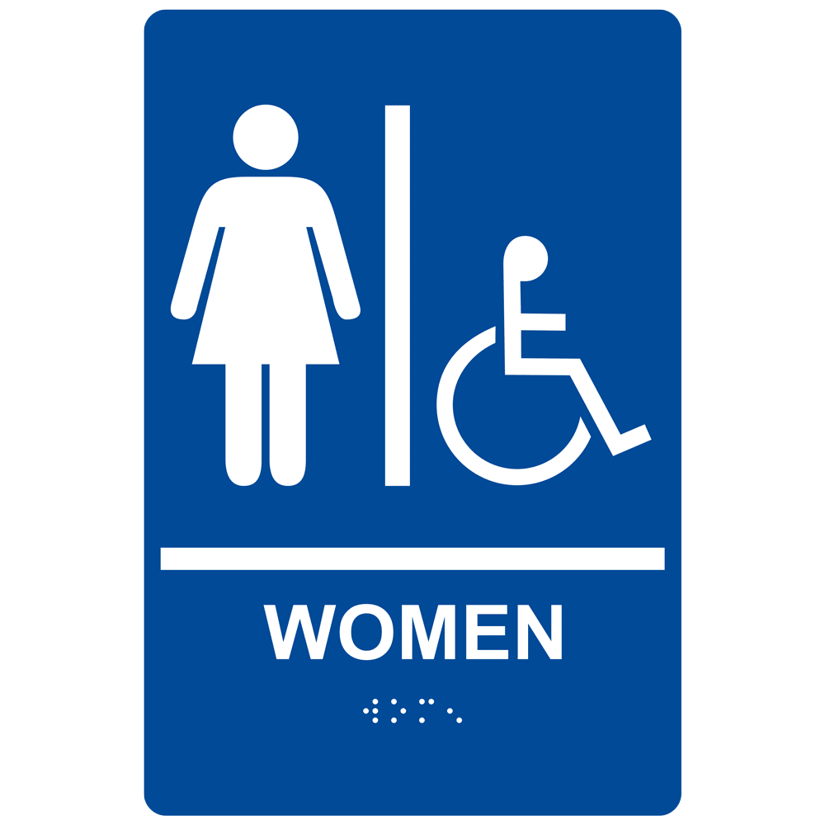

PLACEMENT AT ELEVATORS (BLACK & WHITE)
PHASE FOUR – QTY 2
PHASE TEN - QTY 2
PHASE FIVE – QTY 1
PHASE SIX – QTY 1
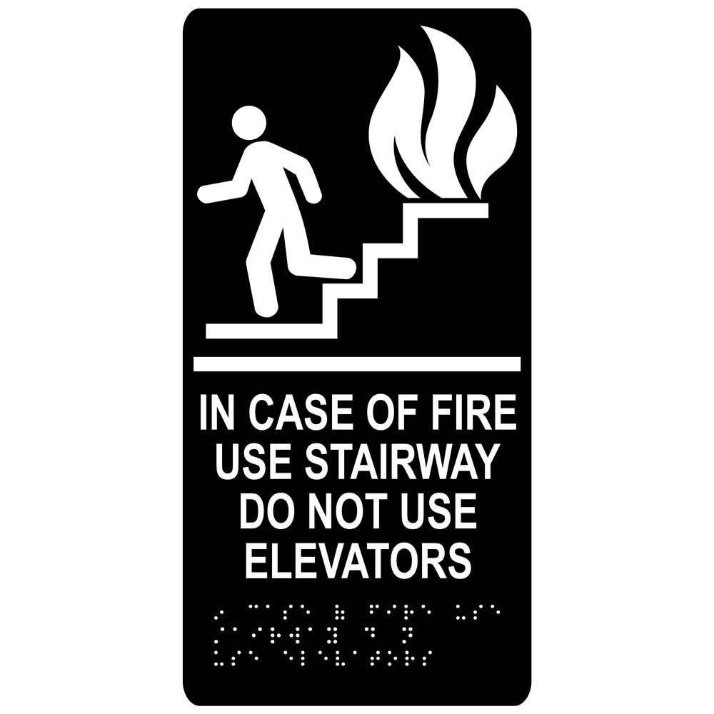

TO BE INSTALLED IN CORRIDOR AT STAIRWELL DOOR (BLACK & WHITE)

PHASE FOUR – QTY 2
PHASE TEN – QTY 3
PHASE FIVE – QTY 2
PHASE SIX – QTY 2
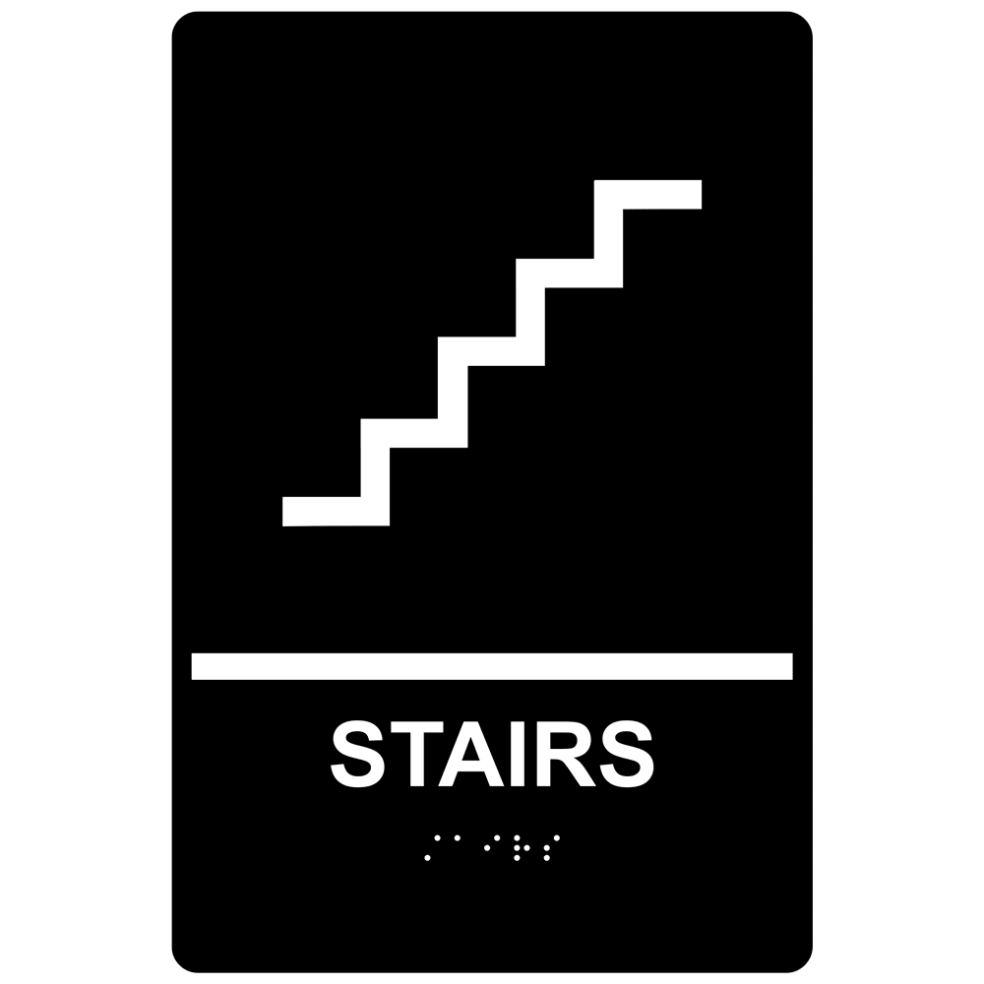
TO BE INSTALLED INSIDE OF STAIRWELL AT DOOR (BLACK & WHITE)

PHASE FOUR – QTY 2

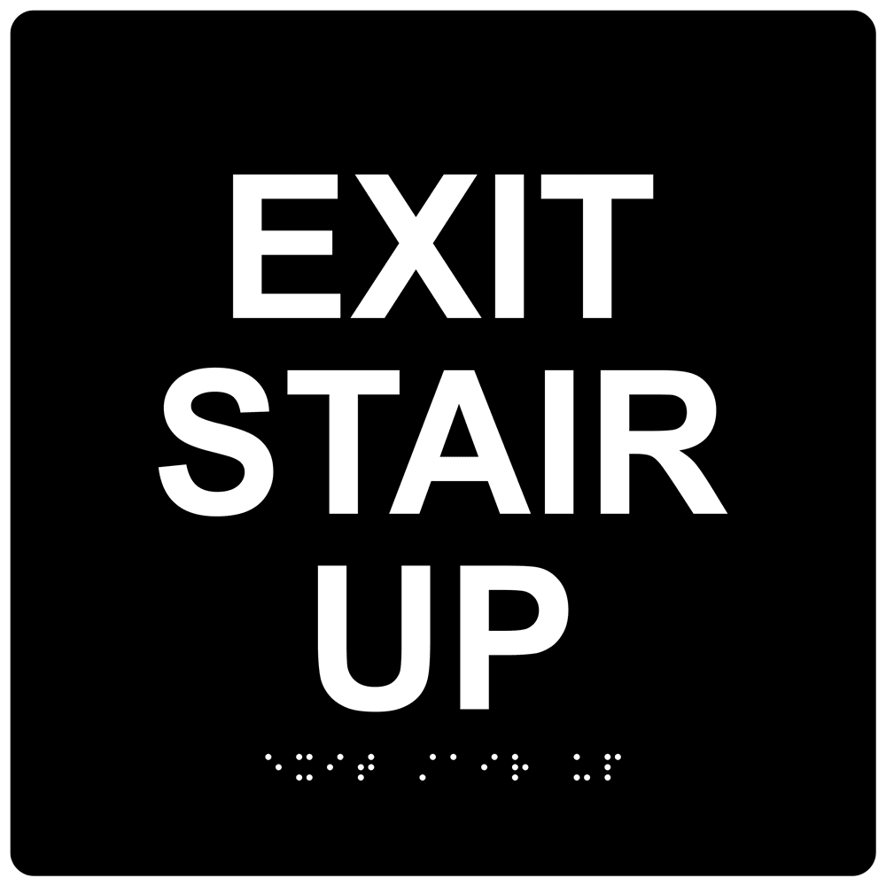

TO BE INSTALLED INSIDE STAIRWELL AT DOOR (BLACK&WHITE)

PHASE TEN – QTY 1
PHASE FIVE – QTY 1
PHASE TEN – INSIDE LEVEL 2 STAIRWELL – QTY 2

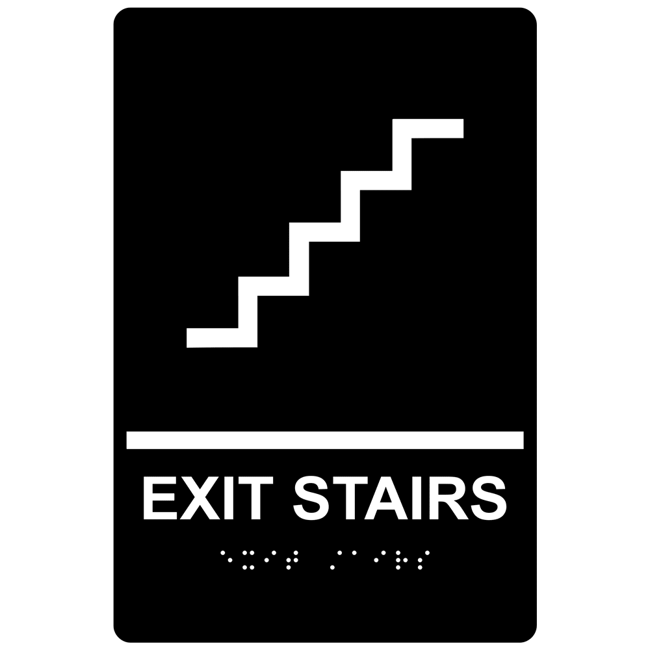

TO BE INSTALLED INSIDE STAIRWELL AT DOOR (BLACK & WHITE)

PHASE TEN – QTY 2
PHASE FIVE – QTY 2
PHASE SIX – QTY 2

