Topa Topa Building 1
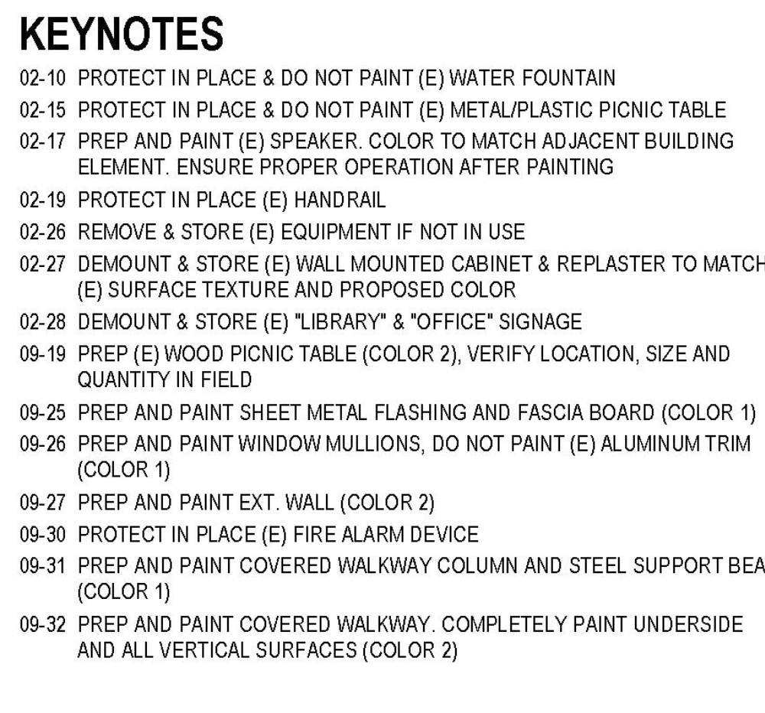
02-19 Change to paint in place, color 3
02-28, Our intent is to replace the office signage, but this item is ok and remove and store.
09-31 Metal columns and posts throughout to be color 3. Change from Color 1. Horizontal roof supports at walkway should be color 2 to match the ceiling color.
09-44 One downspout at the main entrance is tied to the post which is color 3. The downspout here should be color 3 also. The intent is to make the downspouts blend in, not to accent them in any way.
09-52 Metal post, change to color 3

Topa Topa Building 1
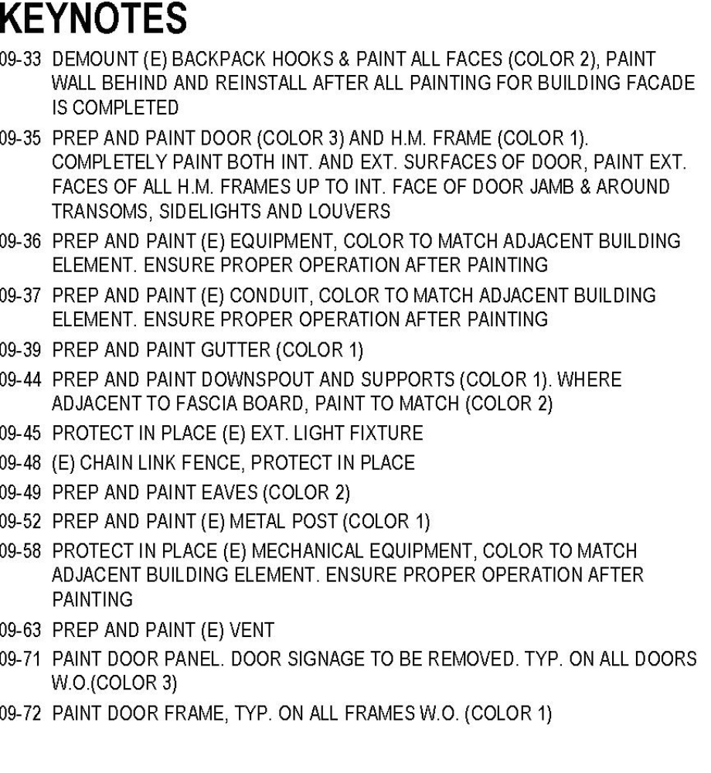

Topa Topa Building 2.
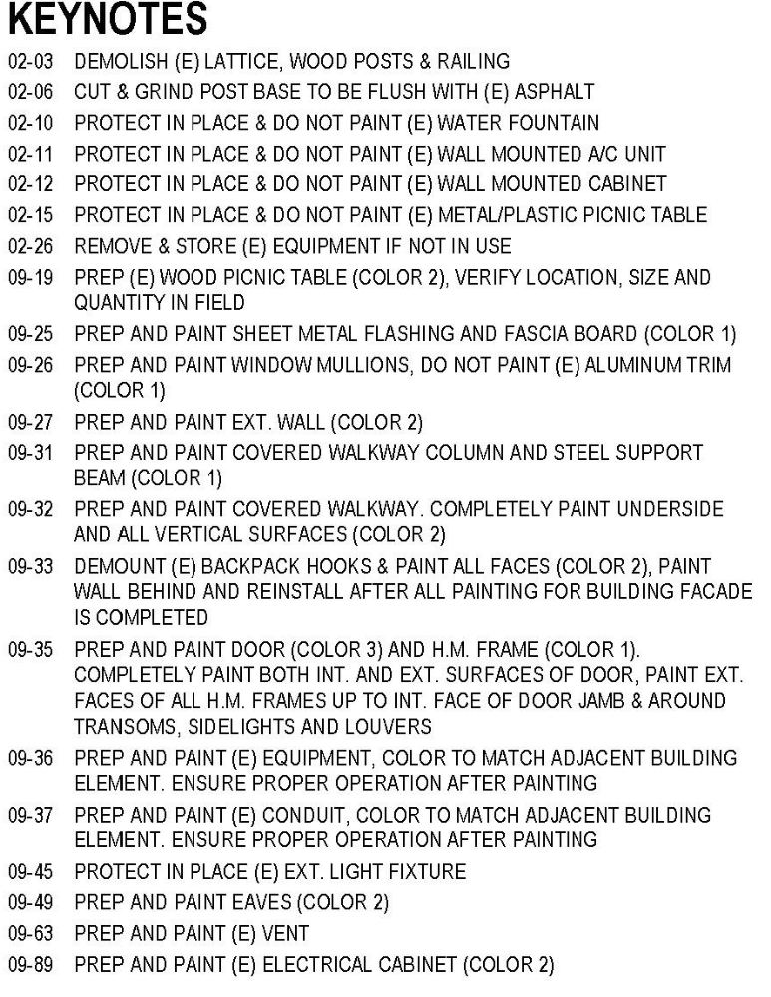
09-31 Steel support beam, horizontal portion to match ceiling, Color 2

Topa Topa Building 3
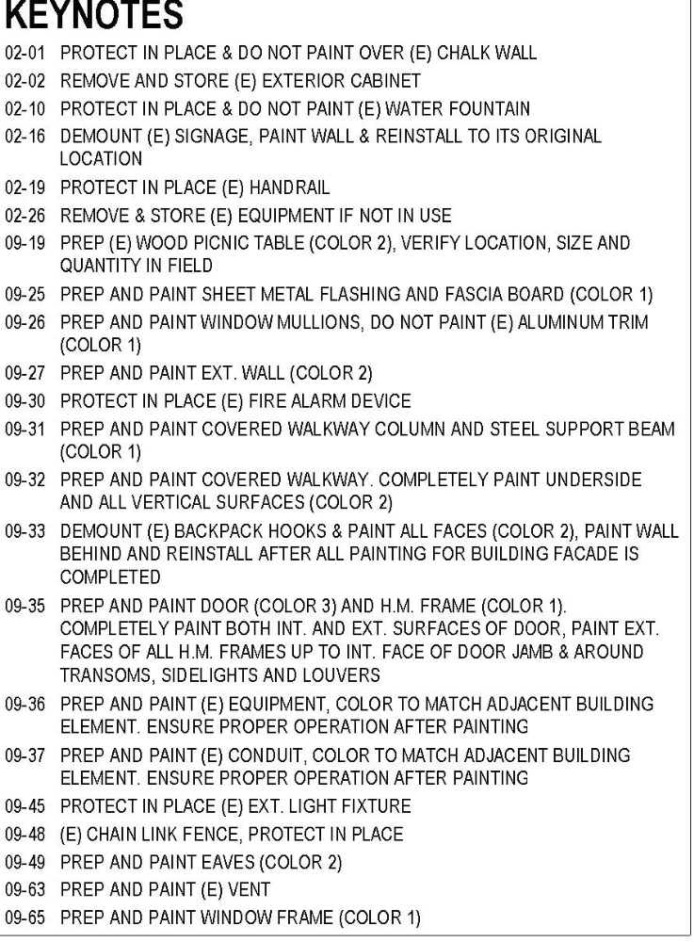
Picture “D” Rails color 3
02-01 Should the blackboard be removed and painted behind, then replaced?
02-19 Paint in place color 3
Topa Topa Building 4
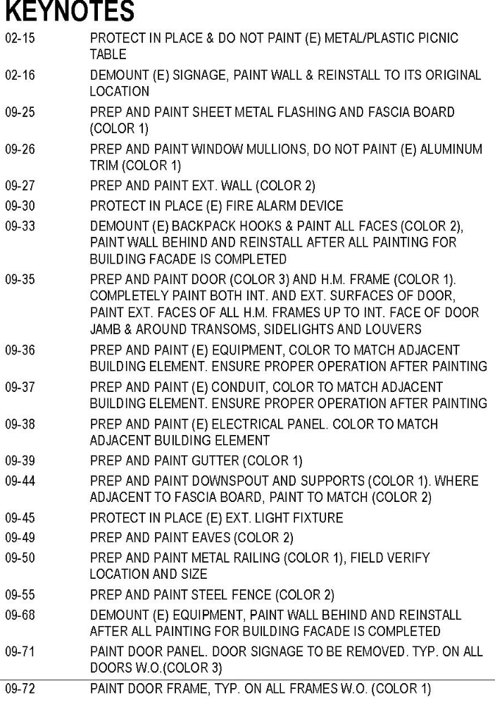
09-50 Change to color 3
09-55 Change to color 3
Rooms 20-21 are scheduled to be demo’d. We want to schedule the painting project for July 15 – Aug 1 to allow time to accomplish the demo and other roofing projects.
Topa Topa Portable Buildings Rooms 23-26
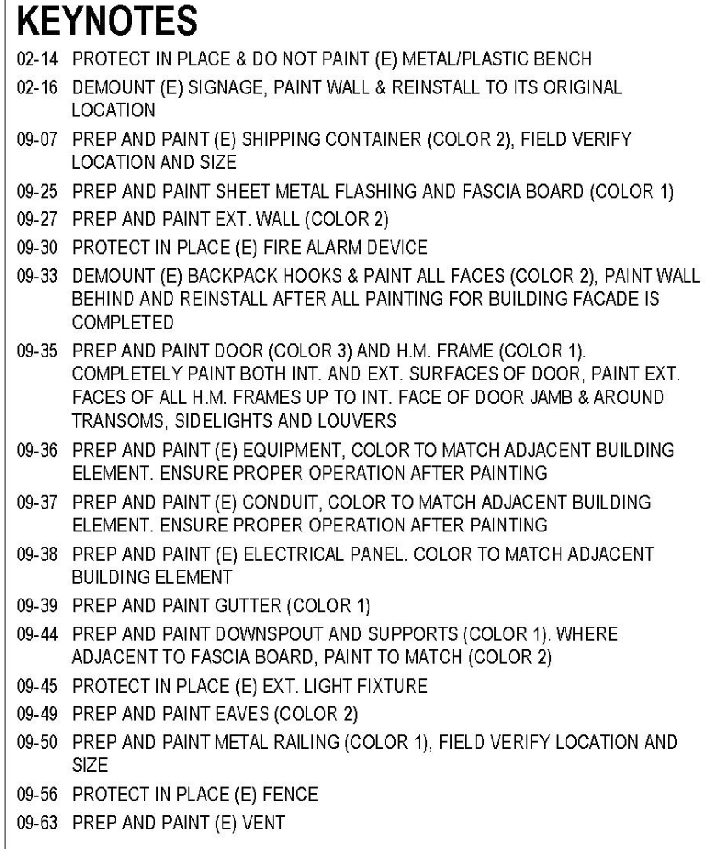
09-50 Change to color 3

Topa Topa Building 6

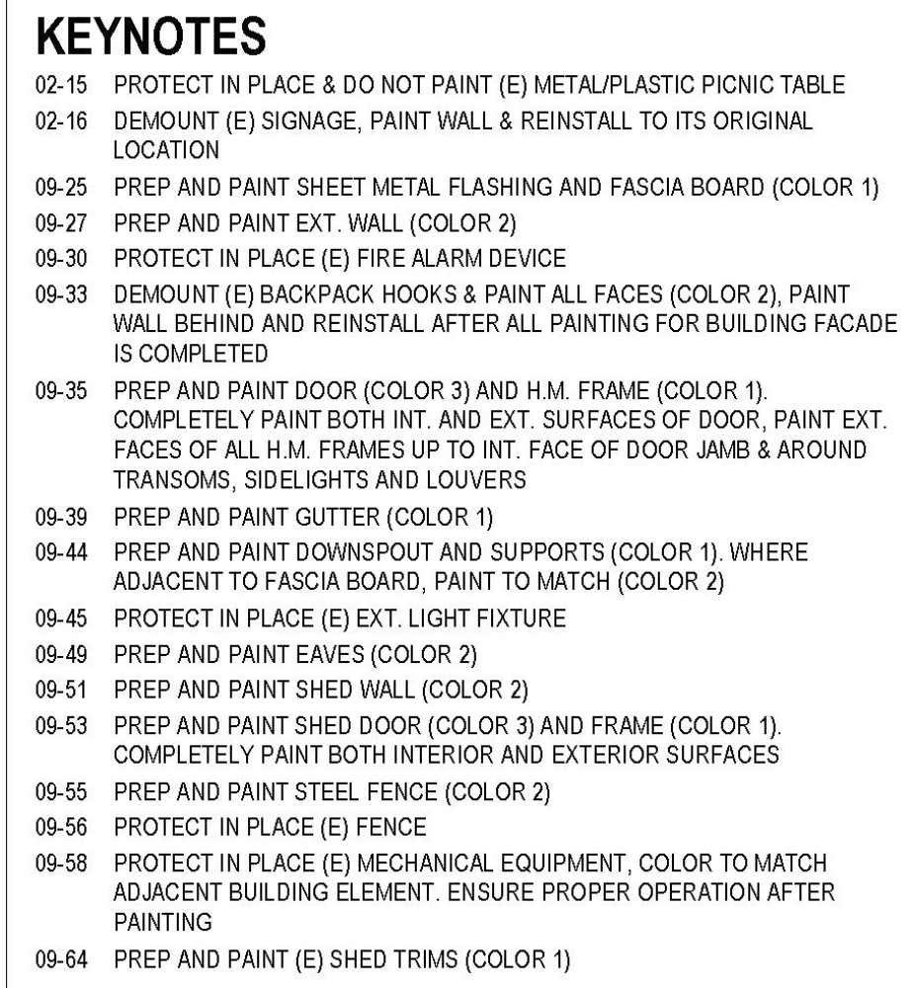
09-55 Change to color 3

Topa Topa Playground
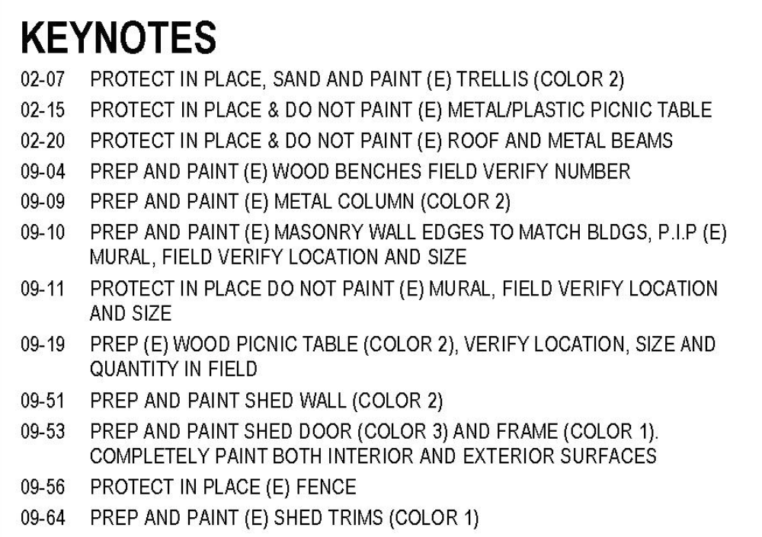
02-20 changed to paint roof panels and support posts. Excluded galvanized roof joists (not painted.) Color 3
NOTE: Some lunch tables are plastic table with wooden benches attached. The intent is to paint wood, but not plastic throughout.

