City of Myrtle Beach
Invitation for Bid
IFB 17-B0055

Employee Uniforms

Issue Date: April 26, 2017


First in Service

Issued By:
Tina Causey
Purchasing Division
3231 Mr. Joe White Avenue
Myrtle Beach, SC 29577
Phone: 843-918-2170
www.cityofmyrtlebeach.com

City of Myrtle Beach Purchasing Division
3231 Mr. Joe White Avenue
Myrtle Beach, SC 29577

INVITATION FOR BID
IFB # 17-B0055 Employee Uniforms

Buyer Contact: | Tina Causey  (843) 918-2184  tcausey@cityofmyrtlebeach.com
Mandatory Pre-Bid Conference:  Attendance is required for bid consideration. | NA
Opening Date & Time: | March 11, 2017 at 2:00PM
Bid Opening Location: | City of Myrtle Beach  3231 Mr. Joe White Avenue  Myrtle Beach, SC 29577

Please note the following required condition (if indicated by an X below):

_____ Bid for a service $20,000.00 or greater must be accompanied by a bidder’s bond in the amount of five
percent (5%) of the total dollar amount of the bid submitted, payable to the City of Myrtle Beach.

No bids will be accepted unless submitted on the forms furnished herein. All pages of the bid must be in a sealed envelope and delivered in accordance with these instructions:
- The envelope must be marked with the name of bidder, bid number/name, and time/date of bid opening.
- Bid packages shall be delivered to the address listed above. The City of Myrtle Beach is not responsible for late or misdirected mail.
If the above criteria are not met, your bid shall be rejected. Bids will be opened and read publicly at the time and date specified above.

Bidders are advised that from the date of issue of this solicitation until award of the contract, no contact with City personnel related to this solicitation is permitted. All communications/requests for clarification are to be directed to the Buyer listed above.

It is the intent and purpose of the City of Myrtle Beach that this Invitation for Bid promotes competitive bidding. It shall be the Bidder’s responsibility to advise the Purchasing Division if any language, requirements, etc., or any combination thereof, inadvertently restricts or limits the requirements stated in this Invitation to Bid to a single source. Such notification must be submitted in writing and must be received by the Purchasing Division no later than three (3) City of Myrtle Beach business days prior to the bid opening date.

Bidder to complete this section:

Name of Bidder: ________________________________________________________________________

Address: ______________________________________________________________________________

Phone Number: ________________________________________________________________________

E-mail: ______________________________________________________________________________

Please note: Signature is required on page 16.

CITY OF MYRTLE BEACH – GENERAL INSTRUCTIONS
MUST BE SIGNED AS PART OF INVITATION FOR BID PACKAGE

1.0 SUMMARY

  - DOCUMENT INCLUDES:

2.0 Authority
2.01 Equal Weight and Force
2.02 Written Explanations
2.03 Disputes with Written Explanations
2.04 Written Addenda

3.0 Requirements for Written Bid Documents
3.01 Availability of Documents
3.02 Non-Responsive Bids
3.03 Document Completion
3.04 Contents of Bid Packet
3.05 Single Package Requirement
3.06 Bid Submission
3.07 Bid Delivery/Opening
3.08 Document Ownership

4.0 Full Examination
4.01 Thorough Investigation
4.02 Pre-Bid Meetings
4.03 Evidence of Examination

5.0 Pricing
5.01 Unit Pricing
5.02 Cash Discounts
5.03 Changes in Cost

6.0 Tax Information
6.01 Sales Tax/Federal Tax
6.02 Payment of Taxes

7.0 Material Assessment
7.01 Product Documentation
7.02 MSDS
7.03 Evidence of Work/Product
7.04 Sample Submission
7.05 Sample Ownership
7.06 Furnished Items
7.07 Quality of Items
8.0 Changes in Specifications
8.01 Authority of Specifications
8.02 Equipment
8.03 Deviation from Specifications
8.04 Material Preference
8.05 Changes after Award
8.06 Equivalent Items

9.0 Modifications
9.01 Additional Work
9.02 Adjustments to Items/Work

10.0 Bond Requirements
10.01 Bid/Performance/Payment Bonds

11.0 Delivery
11.01 Warehouse Deliveries
11.02 Dates
11.03 Delivery Price
11.04 Documentation
11.05 Wrong Deliveries

12.0 Award Criteria/Timeline
12.01 Award Criteria
12.02 Contract Issuance
12.03 Contract Timeline
12.04 Notification

13.0 Bidder Responsibilities
13.01 Duration of Bid
13.02 Transfer of Responsibilities
13.03 Subcontractors
13.04 Coordination and Contact
13.05 Liquidated Damages

14.0 Indemnity Clause
14.01 Hold Harmless

15.0 Federal and State Laws
15.01 Employment Regulations

16.0 Financial Accounting
16.01 Representation
16.02 Payment

17.0 Bid Rejection/Withdrawal
17.01 Reasons for Rejection
17.02 Best Interest
17.03 Withdrawal Timeline

18.0 Protest Procedures/Timelines
18.01 Bid Specifications/Contract Terms
18.02 Intent to Award

19.0 City Reserved Rights
19.01 Reserved Right
19.02 Final Judgment
19.03 Clarification
19.04 Price Increase
19.05 Loss/Damage
19.06 Performance Failure
19.07 Negotiation

20.0 ADA Compliance
20.01 Contact Information

21.0 Signatures
21.01 Accuracy and Completeness
21.02 Compliance

  - DEFINITIONS:

- City of Myrtle Beach – herein referred to as “City.”
B. IFB – Invitation for Bid
C. Bidder – any vendor, proprietor, business, company, service provider, or
corporation who submits a bid to the City.
D. Bid – the collection of documents that includes these general instructions, the
scope of work and/or specifications, a written offer, and signature
page to be used for consideration in negotiations and/or contract
development.
E. Addendum – a written change, addition, alteration, correction, or revision to a
bid document.
F. Bond – provides financial assurance that the bid has been submitted in good
faith, that a bidder will enter into a contract at the amount bid, and
will provide the appropriate performance and payment bonds.
G. Bid Bond – an insurance agreement, accompanied by a monetary commitment,
by which a third party accepts liability and guarantees that the bidder
will not withdraw from the bid.
H. Performance Bond – guarantees execution of the terms of a contract.
I. Payment Bond – covers payment of subcontractors, laborers, and materials
suppliers associated with the project.

2.0 AUTHORITY:

2.01 Equal Weight and Force. The instructions herein contained are given for the
purpose of guidance in properly preparing an applicable bid. These directions
have equal weight and force with the specifications and strict compliance is
required with all of the provisions. Unless otherwise stated in the special
instructions of the bid, these general instructions will apply.

2.02 Written Explanations. Only written information from the procurement manager
or an authorized representative of the purchasing division is binding; therefore no
verbal instructions or verbal information from any other source will be binding on
the City. The City will not be responsible for any other explanation or interpretation
and the decision of the procurement manager or an authorized representative of the
purchasing division shall be final and binding upon each Bidder.

2.03 Disputes with Written Explanations. The written specifications are considered
clear and complete. Failure of the Bidder to call attention in writing to any disputes,
definitions, discrepancies, inconsistencies or incompleteness before the opening of
the bid in the time and manner set forth herein is a waiver of right to do so upon
opening of the bids. Clarifications requested by Bidders must be in writing not less
than three (3) City of Myrtle Beach business days before date and time set for
receipt of bids.

2.04 Written Addenda. Should the procurement manager deem it necessary to alter bid
specifications, those alterations will be made in the form of written addenda that
will be posted on the City website. The Bidder is responsible for monitoring the
website. These addenda shall then be considered as part of these specifications.

3.0 REQUIREMENTS FOR WRITTEN DOCUMENTS:

3.01 Availability of Documents. Bid documents shall be obtained through the City of
Myrtle Beach website (www.cityofmyrtlebeach.com), or in person at the City of
Myrtle Beach Purchasing Office, 3231 Mr. Joe White Avenue, Myrtle Beach, SC
29577, Monday through Friday (excluding City holidays), from 8:00 AM to 5:00
PM. Bid documents may be mailed or sent via e-mail by vendor request only.

3.02 Non-Responsive Bids. Bids that are incomplete, unsigned, improperly signed or
sealed, conditional, illegible, obscure, contain arithmetical errors, erasures without
initials, alterations or irregularities of any kind, shall be declared non-responsive.

3.03 Document Completion. Bid and signature document are provided as part of the
solicitation. This form must be used in submitting a bid and all pages of the bid
document must be completely filled out and signed by the Bidder. No bids will be
accepted unless submitted on the forms furnished herein. Erasures or corrections
made on the bid documents prior to submission must be initialed by the Bidder.

3.04 Contents of Bid Packet. The general instructions, scope of work and/or
specifications, and the bid and signature document constitute the bid packet. By
submitting a bid, the Bidder is deemed to have accepted all of the terms and
conditions set forth in the bid packet documents. All bid packet documents, after

completion by the Bidder, must be returned with the bid in the same order as
received by the Bidder.

3.05 Single Package Requirement. Unless otherwise stated in the special instructions
section of this bid request, submit one complete bid package using the attached
form(s), if applicable, for bid pricing.

3.06 Bid Submission. Each bid must be enclosed in a sealed envelope, clearly marked
on the outside with information as stated on the cover page and delivered to the
procurement buyer. If the required information is not clearly stated on the outside
of the envelope, the bid is considered non-responsive. Bids submitted after the date
and time set for receipt will be returned to the Bidder unopened and shall be
considered non-responsive.

3.07 Bid Delivery/Opening. All bids must be sealed, marked and delivered in
accordance with these instructions to Purchasing Division, City of Myrtle Beach,
3231 Mr. Joe White Avenue, Myrtle Beach, SC 29577. Bids will be opened and
read publicly at the time so specified on the front cover sheet.

3.08 Document Ownership. All documents, reports, bids, submittals, working
papers or other material submitted to the City from the Bidder shall become the
sole and exclusive property of the City, in the public domain, and are not the
property of the Bidder. The Bidder shall not copyright, or cause to be copyrighted,
any portion of any of said documents submitted to the City as a result of this
solicitation.

4.0 FULL EXAMINATION:

4.01 Thorough Investigation. Bidders shall make all investigations necessary to
thoroughly inform themselves regarding plant and facilities for delivery of material
and equipment and/or service to be performed as required by the bid conditions.
No plea of ignorance by the Bidder of conditions that exist or that may hereafter
exist as a result of failure or omission on the part of the Bidder to make the
necessary examination and investigations, or failure to fulfill in every detail the
requirements of the contract documents, will be accepted as a basis for varying the
requirements of the City or the compensation.

4.02 Pre-Bid Meetings. When Bidders are required to make site visits or attend
pre-bid meetings, all expenses shall be paid for by the Bidder, unless previous
written arrangements are made with the City. No bidder will be admitted to a pre-bid
meeting after the specified start time, otherwise the bid will be considered non-responsive.

4.03 Evidence of Examination. Submission of a bid will be considered as
conclusive evidence of the Bidder’s complete examination, understanding, and
acceptance of the specifications.

5.0 PRICING:

5.01 Unit Pricing. Unit pricing will govern over extended prices unless otherwise stated
in special instructions in this bid request. All prices quoted should be firm. In those
cases where a firm bid cannot be made, consideration will still be given to all
Bidders. Also, maximum or ceiling prices should be quoted where possible when
bid contain non-firm prices.

5.02 Cash Discounts. Cash discounts, if allowed, should be so stated on the bid form.
Prices must, however, be based upon payment thirty (30) calendar days after
delivery.

5.03 Changes in Cost. If during the term of the contract entered into as a result of this
bid, the cost of material(s) is/are increased through no act on the part of the
contractor other than to comply with any prevailing rise in the market price(s) of
material(s) used, it shall be the contractor’s responsibility to notify the City of
Myrtle Beach Purchasing Office in writing of the price increase(s) and the effective
date of the increase(s). Price(s) shall be increased only to the point of absorbing
additional cost(s) of material(s) paid for by the contractor. At any time during the
term of the contract, the City may request that the contractor provide written
documentation from the manufacturer/supplier of the material(s) to substantiate
price increase(s). If during the term of the contract, the cost of material(s) to the
contractor is reduced, then the contractor shall reduce the contract price(s) and
notify the procurement buyer in writing.

6.0 TAX INFORMATION:

6.01 Sales Tax/Federal Tax. The City of Myrtle Beach pays South Carolina State Sales
Tax. The City is exempt from Federal Excise Tax and will issue exemption
certificates if required. All applicable taxes should be shown as separate line items
unless otherwise indicated.

6.02 Payment of Taxes. The contractor agrees to pay all taxes and license fees of
whatever nature applicable to conduct business and furnish the City of Myrtle
Beach, if requested, with duplicate receipts or other satisfactory evidence showing
the prompt payment of all taxes and fees when referred to and showing that all
licenses are in effect.

7.0 MATERIAL ASSESSMENT:

7.01 Product Documentation. Bid shall include adequate brochures, latest printed
specification and advertising literature describing the product(s) offered in such a
fashion as to permit ready comparison with the specifications on an item-by-item
basis where applicable.

7.02 Materials Data Safety Sheet (MSDS). If so requested in the bid documents, a
completed MSDS for the item(s) indicated must be provided with the bid
documents. Failure to submit this form upon request shall result in rejection of
bid.

7.03 Evidence of Work/Product. All Bidders must be prepared to present suitable
evidence of similar work recently completed or goods supplied. Products are to be
brand name or equal unless otherwise specified. If submitting an equal product,
supporting documents must be provided with bid.

7.04 Sample Submission. When samples are required with a bid, they must be
submitted with the bid unless approved by the purchasing manager or purchasing
manager’s authorized representative, or the bid shall be considered non-responsive.

7.05 Sample Ownership. Samples submitted will become the property of the City of
Myrtle Beach. The entire cost of the sample(s) shall be paid for by the Bidder
unless previous written arrangements are made with the City.

7.06 Furnished Items. Bidders are required to state exactly what they intend to furnish;
otherwise, they shall be required to furnish the items as specified.

7.07 Quality of Items. Bidders will submit, with their bid, data necessary to evaluate
and determine the quality of the item(s) they are bidding.

8.0 CHANGES IN SPECIFICATIONS:

8.01 Authority of Specifications. It shall be understood that in all cases the terms and
conditions, as detailed in the specifications, shall supersede terms and conditions,
as detailed in the general instructions.

8.02 Equipment. If this bid is for the purchase of equipment, the Bidder guarantees that
the equipment offered is standard new equipment, latest model or regular stock
product, with parts regularly used for the type of equipment offered; also that no
attachment or part has been substituted or applied contrary to the manufacturer’s
recommendations and standard practices.

8.03 Deviation from Specifications. Any deviation from specifications must be noted
in detail and submitted in writing with this bid. Complete specifications should be
attached for any substitutions offered, or when amplifications are desirable or
necessary. The absence of a specification deviation statement and accompanying
specifications will hold the Bidder strictly accountable to the specifications as
written herein.

8.04 Material Preference. The specifications, as listed herein, represent our preference
in material; however, we are fully cognizant that no two pieces of comparable
material are identical and/or same in size, function, and operation; and some of the
specifications will not completely coincide with ours as listed. Please list your
exceptions and explanations separately. It is not our intent to write specifications
for any project on which only one proponent can submit a bid.

8.05 Changes after Award. Any changes in specifications, after the purchase
order/contract has been awarded, must be with the written consent of the purchasing
division; otherwise, the responsibility for such changes shall be with the Bidder.

8.06 Equivalent Items. When brand names or trade names and model numbers
followed by the words "or equivalent" or "or other approved equal" are used, it is
for the quality, style and features of those brands and models. Bids on equivalent
items of substantially the same quality, style and features are then invited.
However, to receive consideration, such equivalent bids must be accompanied by
sufficient descriptive literature and/or specifications to clearly identify the units and
provide for competitive evaluation with the brands or models.

9.0 MODIFICATIONS:

9.01 Additional Work. No extras or additional work will be allowed or paid for unless
such extras or additional work are/is ordered in writing by the purchasing division
and with the price for such established and agreed upon before such extras are
delivered or work is performed.

9.02 Adjustments to Items/Work. The City of Myrtle Beach shall have the right,
without invalidating the contract, to make additions to or deductions from the items
or work covered by the specifications. In case such deductions or additions are
made, an equitable price adjustment shall be made between the City and the
contractor. Any such adjustments in price shall be made in writing.

10.0 BOND REQUIREMENTS:

10.01 Bid/Performance/Payment Bonds. If required, Bidder shall supply a bid bond of
5% of the total bid amount. The successful Bidder at its own cost and expense shall
furnish, if required, a valid performance and payment bond (payable to the City of
Myrtle Beach) in the full amount of this agreement conditioned on the full and
faithful performance of the work under this agreement in accordance with the
specifications and contract documents. Bonds are required if the contract work is
valued at $20,000.00 or more for construction and/or any type of service related
requirement. The performance and payment bonds shall be executed by the
contractor and a bonding company authorized to do business in the State of South
Carolina and approved by the State of South Carolina to issue such performance
and payment bonds. Only the forms provided by the City for the performance and
payment bonds will be accepted.

11.0 DELIVERY:

11.01 Warehouse Deliveries. Unless otherwise stated in the special instructions section
of this bid request, deliveries will be accepted during the hours between 8:00 AM
and 4:00 PM Monday through Friday, excluding City holidays.

11.02 Dates. The delivery date as stated in the bid shall be the time required to deliver
the complete item(s) after the receipt of the order or award of the contract. Where
multiple items appear on a bid request, the Bidder shall, unless otherwise stated by
the City, show delivery date for each item separately. If only a single delivery date
is shown, it will be assumed to mean that all items included in the bid can and will
be delivered on or before the specified date. The Bidder certifies that the delivery
will be completed in the time the Bidder states, starting at the time the order is
placed, provided that the time between the bid opening and the placing of the order
does not exceed the number of days stipulated in the bid. The right is reserved to
reject any bid on which the delivery time indicated is considered sufficient to delay
the operation for which the commodity is intended. Successful Bidder will be
responsible for making any and all claims against carriers for missing or damaged
items.

11.03 Delivery Price. Bid prices are to be Delivered Price (FOB Destination). Bid
prices must include all delivery costs, including but not limited to, loading and
unloading cost(s), transportation charge(s) and fuel surcharge(s). The City of
Myrtle Beach will not be responsible for any demurrage charge(s).

11.04 Documentation. Invoice(s), certificates of origin, warranties and guarantees must
be submitted at the time of delivery of the item(s).

11.05 Wrong Deliveries. In the event that materials, supplies, etc. are delivered which
do not comply with specifications and have not been approved by the purchasing
division, the contractor, upon notification, shall immediately remove from the
premises any such materials, supplies, etc. and replace them with materials,
supplies, etc. in full accordance with the specifications.

12.0 AWARD CRITERIA/TIMELINE:

12.01 Award Criteria. The award will be made within the time specified to the
responsible Bidder meeting the specifications and having the lowest possible cost
consistent with the quality and service needed for effective use. The following
criteria will be used in making this determination:
A. Superior quality and specification adherence
B. Adequate maintenance and service
C. Delivery and/or completion time
D. Guarantees and warranties
E. Company’s reputation and financial status
F. Past experience and cost with similar or like equipment or service
G. Anticipated future cost and experience
H. Performance of proponent’s equipment by other agencies, plants, and
firms
Evaluation factors, if required, shall be stated in either a percent basis or a
numerical format.

12.02 Contract Issuance. The award of a contract is accomplished by executing a
written agreement that incorporates the entire bid, Bidder’s response, clarifications,
addenda, and additions. All such materials constitute the contract documents. The
Bidder agrees to accept the contract terms unless substantive changes are made
without the approval of the Bidder. The procurement office is the sole point of
contact for the issuance of the contract.

12.03 Contract Timeline. In the event the successful Bidder fails or refuses to execute
a formal written contract with the City of Myrtle Beach in form and content
acceptable to the City, within ten (10) City business days after notice of acceptance
of the bid, the bid shall be revoked, and all obligations of the City in connection
with the bid shall be canceled.

12.04 Notification. Bid tabulations will be available on-line at
www.cityofmyrtlebeach.com/purchasing.html. Winning Bidder will be notified
five (5) City business days after bid tabulations are posted.

13.0 BIDDER RESPONSIBILITIES:

13.01 Duration of Bid. Bid prices, terms and conditions shall be firm for a period of at
least one hundred twenty (120) calendar days from the deadline for receipt of
submittal, or until such time as established in the bid. The successful bid shall not
be subject to future price escalation or changes of terms if accepted during the one
hundred twenty (120) day period, or the specified bid time. Price decreases or
changes in terms by others after the acceptance of a bid will not be considered.

13.02 Transfer of Responsibilities. The contractor shall not assign or otherwise transfer
any of its responsibilities or obligations under the contract to any other person or
entity without prior written consent of the City.

13.03 Subcontractors. The contractor shall be wholly responsible for the performance
of all subcontractors and for their acts and omissions, and those of persons either
directly or indirectly employed by the contractor, and the fact that subcontractors
are subject to the approval of the City of Myrtle Beach shall not affect the
contractor’s responsibility in this regard. The Bidder shall bind every subcontractor
to all terms and conditions anywhere contained in the contract documents as far as
applicable to the work of such subcontractor so that the subcontractor assumes
toward the contractor and toward the work all the obligations and responsibilities
that the contract assumes toward the City as to the performance of the
subcontractor’s portion of the work.

13.04 Coordination and Contact. The selected Bidder will be required to assume
responsibility for coordination, engineering, delivery, installation, and maintenance
of all equipment, software and services offered in their bid, whether they are the
manufacturer or producer of them. Further, the City of Myrtle Beach will consider
the selected Bidder to be the sole point of contact with regard to contractual matters,
including payment of any and all charges resulting from the lease or purchase of
the entire service equipment and software configuration, when applicable. Only
service and equipment offered by Bidders who have installed similar systems of
comparable size will be considered. All service and equipment offered will be in
current standard production and of the latest design.

13.05 Liquidated Damages. If the Bidder fails to deliver the supplies or perform the
services within the time specified in the contract, the Bidder shall, in place of
actual damages, pay to the City of Myrtle Beach liquidated damages of
$__________ per calendar day of delay. If the City terminates the contract, in
whole or in part, the contractor is liable for liquidated damages accruing until the
City reasonably obtains delivery or performance of similar supplies or services
from an alternate bidder. These liquidated damages are in addition to excess
costs of repurchase due to contract termination. The Bidder will not be charged
with liquidated damages when the delay in delivery or performance is
documented to be beyond the control and without the fault or negligence of the
Bidder.

14.0 INDEMNITY CLAUSE:

14.01 Hold Harmless. The contractor agrees to indemnify and save harmless the City of
Myrtle Beach, its representatives, employees and agents, from all claims, demands,
actions, suits and liabilities arising from the contractor’s own fault or negligence or
through the negligence or fault of the manufacturer of goods supplied by the
contractor. This obligation shall extend to and include, all litigation costs and
reasonable attorney fees incurred by the City in response to such claims, demands,
actions or liabilities, provided it is ultimately determined that such claims result
from the contractor’s or manufacturer’s fault or negligence.

15.0 FEDERAL AND STATE LAWS:

15.01 Employment Regulations. Bidders shall comply with all local, state, and federal
directives, orders, and laws as applicable to this bid and subsequent contract(s)
including, but not limited to Equal Employment Opportunity (EEO), in compliance
with executive Order 11246, Minority Business Enterprise (MBE), and
Occupational Safety and Health Act (OSHA), as applicable to this contract and
Immigration Bill H4400 which states that every contractor doing business with the
City of Myrtle Beach for the physical performance of services with the total value
of the contract to be performed in a twelve month period exceeding fifteen thousand
dollars ($15,000.00) must agree to the following:
- Register and participate in the federal work authorization program to
verify the employment authorization of all new employees; and require
agreement from its sub-contractors to do the same; or
B. To employ only workers who:
1. Possess a valid South Carolina Driver’s License or ID issued by
the South Carolina Department of Motor Vehicles;
2. Are eligible to obtain a South Carolina Driver’s License or ID
card in that they meet the requirements.
3. Possess a valid Driver’s License or ID card from another state
where the requirements are at least as strict as those in South
Carolina.

16.0 FINANCIAL ACCOUNTING:

16.01 Representation. The selected Bidder shall assign a competent account
representative acceptable to the City of Myrtle Beach who will represent the
Bidder in providing contracted services to the City. If the account representative
is removed by the Bidder, the new representative must be acceptable to the City.

16.02 Payment. Payments shall be made to the contractor within thirty (30) calendar
days of receipt of invoice after inspection by and acceptance of the material, goods
and/or service by an authorized representative of the City.

17.0 BID REJECTION/WITHDRAWAL:

17.01 Reasons for Rejection. The City of Myrtle Beach shall reject a bid if:
A. The Bidder misstates or conceals any material fact in the bid; or if,
B. The bid does not strictly conform to the law or requirements of the bid;
or if,
C. The bid is conditional, except that the Bidder may qualify his/her bid for
acceptance by the City on an “all or none” basis, or a “low item”
basis. An “all or none” basis bid must include all items upon which
bids are invited.

17.02 Best Interest of City of Myrtle Beach. The City may, however, reject all bids
whenever it is deemed in the best interest of the City to do so, and may reject any
part of a bid unless the bid has been qualified as provided in statement.

17.03 Withdrawal Timeline. Bids may be withdrawn on a written request, received
from Bidders prior to the bid closing date and time. Negligence on the part of the
Bidder in preparing the bid creates no right for withdrawal of the bid after the bid
has been opened. No modifications, clarifications, or explanations of any bids will
be allowed after the date and time of closing.

18.0 PROTESTS:

18.01 Procedures/Timelines. Protest of Bid Specifications and/or Contract Terms:
- Specifications and contract terms shall be made available for inspection
and copying. Unless a different deadline is specified in the IFB,
protests of the bid specifications or contract terms shall be presented to
the City in writing within five (5) City of Myrtle Beach business days
prior to bid closing.
- Such protest or request for change shall include the reasons for protest
or request, and any proposed changes to specifications or terms.
- Envelopes containing protests of specifications shall be marked and
mailed, or hand delivered within five (5) city of Myrtle Beach business
days to the procurement buyer.
- No protest against award because of the content of bid specifications or
contract terms shall be considered after the deadline established for
submitting such protest in paragraph A above.
- Submission of a bid without the timely submission of protest of
specifications or contract terms is deemed a waiver to the right to protest
specifications or contract terms.
- A decision by the procurement buyer shall be given in writing in each
of such cases at least one (1) City of Myrtle Beach business day before
the time set for the opening of bids. A copy of the decision may be
obtained at the procurement manager’s office.
- If, in the judgment of the procurement manager, the previously
mentioned inquiry requires explanation or interpretation, any such
explanation or interpretation of said plans, specifications, or other
contract documents will be made by written addendum duly issued with
copies mailed or delivered to each person or firm receiving a set of
contract documents.

18.02 Procedures/Timelines. Intent to Award:
A. The written purchase order shall constitute a final decision of the City
of Myrtle Beach to award the contract if no written protest is filed with
the City within five (5) City of Myrtle Beach business days of the
posting of the bid tab. If a protest is timely filed, the purchase order is
a final decision of the City only upon issuance of a written decision
denying the protest and affirming the award.
B. Purchasing buyer shall notify winning Bidder five (5) City days after
bid tab is posted on the City website. It is the responsibility of the
Bidder to check the website. Any actual Bidder who is adversely
affected or aggrieved by the award of the contract to another Bidder on
the same solicitation shall have five (5) City business days after the
posting of bid tab to submit to the City a written protest of the award.
The written protest shall specify the grounds upon which the protest is
based. The city shall not entertain a protest submitted after the time
period established in this rule or such different period as may be
provided in the City’s request for bids.
C. Bidders must submit written protests of the intent to award to the
procurement manager within five (5) business days. The written protest
must include name and contact information of the protestor, solicitation
title and number, the grounds upon which the protest is based, and relief
expected.

19.0 CITY RESERVED RIGHTS:

19.01 Reserved Rights. The City of Myrtle Beach expressly reserves the following
rights:
A. To reject any and/or all irregularities in the bids submitted
B. To reject any and all bids, or parts thereof, as deemed in the best interest
of the City.
C. To base awards due with regard on quality of services, experiences,
compliance with specifications, and other such factors as may be
necessary in the circumstances.
D. To make the award to any Bidder who, in the opinion of senior
management, is in the best interest of the City.

19.02 Final Judgment. If any doubt or difference of opinion arises between the City of
Myrtle Beach and the Bidder as to the interpretation of this request for bid, the
decision of the City will be final and binding upon all parties.

19.03 Clarification. The City of Myrtle Beach reserves the right to obtain clarification
on any point in the Bidder’s bid. The failure of the Bidder to make additional
information available could result in the rejection of the response. Such
clarification might involve the delivery of demonstration equipment to the City for
evaluation purposes. Such hardware will be provided at no cost to the City. The
City is not obliged to evaluate any or all products.

19.04 Price Increase. The City of Myrtle Beach reserves the right to accept or reject any
price increase(s) and to cancel any and all item(s) under the contract for which price
increase(s) is/are considered unacceptable.
19.05 Loss/Damage. The City of Myrtle Beach will not be responsible for the loss or
damage of any items during the IFB process.

19.06 Performance Failure. In the event that the Bidder fails to perform any material
obligations, the City of Myrtle Beach reserves the right to give the Bidder written
cure notice of such failure. The Bidder will then have five (5) calendar days to
resolve the failure. If the failure is not resolved within five (5) calendar days, the
City reserves the right to withhold all money that is due and payable to the Bidder.
Such a remedy is in addition to other remedies that might be available to the City.
Moreover, the City reserves the right to terminate the contract if the Bidder exceeds
the five (5) calendar days of non-performance without the approval of the purchasing manager.

19.07 Negotiation. After determining the lowest responsive Bidder(s), but prior to the
notice of award to any bidder, the City of Myrtle Beach may elect to open
negotiations with the selected responsive and responsible Bidder(s) in an effort to
improve the bid for a period of five (5) days. In these negotiations, the City
may address scope of work, unit pricing, or any other contractual requirements
fairly contained within the bid documents. In the event that the apparent
responsive and responsible low Bidder(s) should decline to negotiate, or should
negotiations commence but fail, the City shall reject any or all bids.

20.0 ADA COMPLIANCE:

20.01 Contact Information. Questions concerning the bid requirements or
specifications should be directed in writing to the procurement buyer shown on the
front page of this bid package. If you need disability-related accommodations,
please contact (843) 918-2170.

21.0 SIGNATURES:

21.01 Accuracy and Completeness. The authorized signer of the bid shall represent and
warrant that they have been sufficiently informed in all matters relating to the
specified products; that they have checked their bid for errors and omissions; that
the prices stated in their bid are correct and as intended are a complete and correct
statement of prices.

21.02 Compliance. By Signature below the Bidder affirms that they have examined,
understands and accepts all instructions, specifications and conditions, and will
provide for appropriate insurance, deposits, and performance bonds if required, and
will comply fully with specifications as attached for the agreed contract, especially
where materials and work are involved, and that any and all registration
requirements where required for Bidders as set forth in law are met.
________________________ _____________________________________________________
Signature of Bidder Date of Signing

______________________________________________________________________________
Print Name of Bidder

If more convenient, tabulations are available for pick-up after final award. No bid tabulations will be faxed.
STATEMENT OF WORK

INTENT
It is the intent of this bid to establish a blanket purchase order for Employee Uniforms to be delivered on an “as needed” basis for the City of Myrtle Beach.

At the City’s request and direction, bidder shall provide product samples of items bid to ensure compliance with specifications. Samples, demonstrations and/or testing may be requested prior to award of the contract, upon delivery and/or at any point during the term of resulting contract. After notification, samples, demonstrations must be provided within ten days. Failure to provide samples prior to award of contract will disqualify bidder from consideration. All samples (including return thereof), demonstrations shall be at the expense of the bidder. Samples will be returned upon request; otherwise, samples will become property of the City of Myrtle, ten days after award of the contract.

GENERAL REQUIREMENTS AND SPECIFICATIONS
1. Prior to award of the contract, the City of Myrtle Beach may, at the City’s option, require that the successful bidder show to the complete satisfaction of the City that they have the necessary facilities, capabilities and financial resources to perform all of the contract requirements in a satisfactory manner and to deliver all goods within the time required as stated in these bid documents.

2. Bidders' facilities and equipment may be a determining factor in making the bid award. All bidders may be subject to inspection of their facilities and equipment.

3. All prices shall be F.O.B. Destination City of Myrtle Beach, 3231 Mr. Joe White Avenue, Myrtle Beach, SC 29577 as applicable. All charges (e.g., freight, packaging and handling) must be included in the bid response, Price Schedule. No other charges will be allowed unless specified in the bid document. Fuel charges are unacceptable and will not be permitted.

4. City will be responsible for art charges and a one (1) time set up fee for any new designs, emblems and/or logos.

5. Allowances for special freight charges will be acceptable only when expedited delivery is requested and approved by the City of Myrtle Beach.

6. Products purchased as a result of the City of Myrtle Beach are to be supplied as offered and accepted without substitutions of material or style.

7. Patches, screen printed, color printed, and/or embroidered patches shall be attached to garment in script or block lettering in upper and/or lower case or as determined by the City.

8. Bidder agrees to accept for credit any merchandise returned in good condition within thirty (30) calendar days after receipt of goods without any handling charges; however, no return shall be made of any material which has been put into operation other than for test. When products delivered fail to meet specification, the cost of return freight shall be charged to the account of Bidder, and City may deduct such charges from amounts otherwise owed to Bidder.

STATEMENT OF WORK (continued)

9. If a contract is awarded to a Bidder as a result of this solicitation, the City may request that Bidder provide pricing in an electronic, web based format.

10. Routine delivery response for standard and non-standard sized products to the City shall be within thirty (30) calendar days after receipt of order. For custom made items, such as silk screened printed T-Shirts, it will be the responsibility of the awarded Bidder to communicate with the ordering entity all delivery details. Delivery shall be made during normal working hours of the individual ordering entity. All deliveries must be labeled with the purchase order number and accompanied by a copy of the actual invoice.

11. Approval for delivery of partial or incomplete orders must be obtained in writing prior to delivery from the City that submitted the order. Partial deliveries without approval may not be accepted and any charges incurred (freight, restocking fees, etc.) shall be the responsibility of the Bidder. (Exceptions to maximum thirty (30) calendar day delivery time may be granted in writing for long lead time items, provided the successful bidder contacts the City within seven (7) calendar days after order is placed to request approval for extended delivery schedule). Failure to comply with delivery requirements may result in termination of the contract in whole or in part.

12. The City may request emergency delivery. Bidder shall use their best efforts to comply with rush or emergency requests. However, if the successful Bidder cannot fulfill the emergency delivery requirements, the participating entity may procure its needs from alternative sources without penalty.

13. Uniform categories are Public Works, Recreation and other City departments to include T-shirts, work shirts, caps, jackets, sweatshirts, and coveralls. This does not include any type of footwear or accessories. Inclusion in this list does not guarantee that the City will use all of the categories listed.

14. Any catalogs, manufacturers, brand names and numbers, features and specifications contained in this are for descriptive purposes only and are intended to reflect a level of quality and capability desired. They are not intended to limit competition and Bidders are encouraged to submit bids on comparable models that possess the same quality and capability specified. Unless otherwise noted, all product quoted must be new and unused.

15. Upon notification by City for request of sizing sample garment, Bidder shall have ten (10) working days to deliver requested sample garments.

16. The City reserves the right to order as few as six (6) garment per order. Bidder shall not impose a minimum order quantity threshold. Bids submitted with minimum order quantities may be rejected.

17. Upon request following award, additional catalogs submitted in Bidder’s bid response must be supplied to the City at no charge.

STATEMENT OF WORK (continued)

BIDDER QUALIFICATIONS
Bidders must be manufacturers, manufacturer representatives or dealers principally engaged in the uniform supply business.

Each bidder, by virtue of submitting a bid, warrants and guarantees that all items and all materials used will be first quality goods of current manufacture and no seconds or rejects are used.

DELIVERY TIME
Orders will be placed on an “as needed” basis and all items ordered must be received within thirty (30) calendar days thereafter.

If the successful vendor fails to provide all items ordered within thirty (30) calendar days after order placement, the City may consider the vendor in breach of contract and may cancel any/all pending orders and award the contract to the next responsible bidder or put out for bid the uniform contract again, whichever is in the best interest of the City.

SHIPPING/ACCEPTANCE OF GOODS
All goods are to be shipped in lots according to type, size and purchase order number.

Prior to final acceptance, all goods will be subject to rigid inspection and any/all goods delivered that are not in conformance with the specifications contained herein will be rejected.

TERM OF CONTRACT
The term of the contract shall be for a five (5) year period, effective upon notification of award.

QUANTITIES
The City does not guarantee specific quantities of any item will be purchased during the term of the contract. Items will be purchased based on the actual needs of the City.

The City maintains stock at all times on all items specified. Approximately three hundred fifty (350) employees purchase from the stocked items. Normal clothing allowance for these employees per year are five (5) shirts, five (5) pants and one (1) jacket, coverall, etc.

ONLINE CAPABILITIES
Describe online capabilities, to include order placement, pricing, order tracking, virtual catalogs, customer account information, electronic invoicing, electronic reporting and any other features that would benefit the City.

BID PRICES
Bid prices are to include all costs required for the delivery of finished goods excluding the hemming of pants (Item #’s 11 and 12 only). All costs for embroidery, screen-printing, sewing of patches and hemming of pants where specified in the bid specifications must be included in the bid prices.

No artwork, screen or embroidery files are available. The successful bidder will be required to create the required artwork, screens and embroidery files. Upon request by the successful bidder, black and white or color copies of the City Seal can be mailed in 75/300 dpi jpeg/tif format to aid in creating artwork for the City Seal only.

STATEMENT OF WORK (continued)

Bid prices shall be DELIVERED PRICES (FOB Destination) and are to include all shipping costs, including but not limited to, loading/unloading cost(s), fuel charge(s), fuel surcharge(s) energy surcharge(s) and environmental fee(s). The City will not be responsible for any demurrage charge(s).

BID AWARD
Award may be made in whole or in part. Award will be made in the best interest of the City.

PRICE INCREASES
Bid prices shall remain firm for the initial one (1) year term of the contract.

Price increase(s) will be considered only if the contract is renewed for additional term(s) and price increase(s) may be put into effect only at the beginning of a renewal term. Price increase(s) must be requested on an individual item basis only; across the board price increases will not be considered.

The City shall be solely responsible for allowing or denying price increase(s) and the City’s decision shall be final.

If at any time during the term of this contract other customers receive general price decreases, these price decreases must also be afforded to the City.

CHANGES IN SERVICE
The City shall have the right to make additions, deletions, modifications or amendments to this contract when mutually agreed upon by both parties. Such changes shall in no way affect, vitiate, or make void this agreement or any part thereof, except that which is necessarily affected by such changes.

INVOICING
Invoicing shall be submitted upon completion of each shipment. All invoices must reference the blanket purchase order number and shall be itemized to include description, size, quantity, unit price and extended price of each item purchased.

Invoices shall be submitted to: | City of Myrtle Beach  Finance Department/Accounts Payable  PO Box 2468  Myrtle Beach, SC 29578-2468

SUBSTITUTIONS / SAMPLES
Manufacturer brands and styles are specified to indicate minimum acceptable quality levels. Substitutions of equal or better quality will be considered, please provide substitutions samples.

For bid consideration, brand(s) and style(s) being offered must be annotated on the bid. Include in the bid package product specification sheets, descriptive literature or catalog descriptions when bidding manufacturer brand(s)/styles(s) other than that/those specified.

STATEMENT OF WORK (continued)

The City reserves the right to request actual sample(s) prior to final award of the contract. Samples(s) must be received by the Purchasing Office within ten (10) calendar days after notifications to submit sample(s) has been made.

Sample(s) will be returned to bidder(s), at the bidder’s expense, upon award of the contract.

Any item delivered that does not conform in every way to any sample accepted as an approved substitute will be rejected. Such rejected items shall be removed at the vendor’s expense and items meeting the requirements of the City shall be furnished at no additional cost to the City.

BID ATTACHMENTS
Examples shown in bid attachments are for informational purposes only. Examples shown are not to be considered “actual size”.

PROOFS
Prior to production, the successful bidder shall provide to the Purchasing Office for approval, actual proofs of the embroidery and screen-printing for all items.

No measurement of employees will be required.

STATEMENT OF WORK (continued)

Successful bidder will be responsible for all artwork, embroidery, screen-printing, sewing of patches and hemming of pants when specified.

Item #’s 1, 2, 3, 4:
Men’s Industrial Uniform Work Shirt, Short and Long Sleeve, Yellow and White, Red Kap Short Sleeve Style #SP24, Long Sleeve Style #SP14 or approved equal. (Indicate Tall and Big sizes available on Bid Price Schedule page.)

- 4.25 ounce TouchTexTM soft hand poplin, 65% polyester, 35% cotton
- Durable press finish treated for soil release
- Two (2) piece convertible interlined collar with permanent stays
- Two (2) piece back yoke
- Stitched down front facing
- Button front closure
- Two (2) button thru breast pockets with left pocket pencil holder
- Set in sleeves, long sleeves to have lined cuffs with button closures

The City ordered approximately thirty six (36) short sleeve yellow shirts, twelve (12) long sleeve yellow shirts and thirty two (32) short sleeve white shirts in our last budget year.

Short and long sleeve shirts are usually ordered in quantities of twelve (12) or more but a quantity of three (3) may be ordered if a need arises.

All industrial men’s uniform work shirts are to have the “Myrtle Beach” and “First In Service” logos embroidered above the left breast pocket. (See attachment 1).

Yellow and White Shirts: Both logos are to be embroidered in one (1) color in process blue.

Stitch count for the “Myrtle Beach” logo shall be a minimum of 6500 stitches.

Stitch count for the “First In Service” logo shall be a minimum of 1700 stitches.

Item #’s 5 thru 8:
All white and yellow pocket T- shirts are to have the 3 inch in diameter City Seal screen-printed above the left breast pocket in colors of white, yellow and process blue.

The back of all pocket T- shirts are to have “City of Myrtle Beach” and “First In Service” screen-printed in process blue, the one color only (Item #’s 5 – 8). Letters are to be approximately 1-1/4 to 1-3/4 inches in height. (See attachment 2).

The City ordered approximately four hundred ninety (490) white T-shirts, three hundred ten (310) yellow T-shirts and seventy-two (72) orange T-shirts in our last budget year.

STATEMENT OF WORK (continued)

5. Pocket T-Shirt, Short Sleeve, Yellow Adult Hanes Adult Tagless Short-Sleeve
Beefy-T with pocket, Style #Hanes 5190 or approved equal

- Preshrunk 100% ring-spun cotton
- 6.1 ounce
- High stitch-density fabric
- Shoulder to shoulder taping
- Double needle cover seamed neck
- Double needle sleeves and bottom hems
- 5 point left chest pocket

6. Pocket Short Sleeve, White, Adult Hanes Adult Tagless Short-Sleeve
Beefy-T with pocket, Style #Hanes 5190 or approved equa

- Preshrunk 100% ring-spun cotton
- 6.1 ounce
- High stitch-density fabric
- Shoulder to shoulder taping
- Double needle cover seamed neck
- Double needle sleeves and bottom hems
- 5 point left chest pocket

7. Pocket Long Sleeve T- Shirts, Yellow, Adult Tagless Long Sleeve, with pocket, Style Port & Company, with pocket or approved equal.

- Heavyweight 100% soft spun cotton
- 6.1 ounce
- Left chest pocket

8. Pocket Long Sleeve T- Shirts, White, Hanes Adult Tagless Long Sleeve, with pocket, Style #Hanes 5586 or approved equal

- 100% ComfortSoft cotton
- 6 ounce
- Shoulder to shoulder taping
- Double needle cover seamed neck with lay-flat collar
- Double needle bottom hem, rib knit cuff
- Tag free neck lab

9. High Visibility Pocket T- Shirt, Short Sleeve, Orange, style VEA-102 VEA Class II or approved equal

10. High Visibility Pocket T- Shirt, Long Sleeve, Orange, style VEA-102 VEA Class II or approved equal.

STATEMENT OF WORK (continued)

- ANSI 107 Class 2 Compliant – Reflective silver stripe to run horizontally around middle of torso and to run vertically on both sides of the upper body on both front and back of shirt.
- 3M Scotchlite reflective taping material to meet ANSI/ISEA 107-2004
- Level 2 retroreflective performance requirements.
- No reflective silver stripe on front pocket
- 4.1 ounce lightweight performance fabric, soft birds-eye knit
- Durable fabric, wicks moisture away from the body and minimizes odor.
- Tape shoulder to shoulder
- Left breast pocket, topstitched and double needle stitched hem
- Double needle stitched sleeve hem and bottom hem

All high visibility T- shirts are to have the 3 inch in diameter City Seal screen-printed on the left breast pocket in colors of white, yellow and process blue.
The back is to be screen-printed in one (1) color on all shirts. The color is to be black . Letters are to be approximately ½ inch to ¾ inch in height and are to be centered between the horizontal and vertical reflective stripes. (See attachment 3).

11. Uniform Pants Men’s, Navy Blue, unfinished lengths, Red Kap TouchTex™ Style #PT10NV or approved equal

- 8 ounce 65% polyester, 35% cotton
- Button closure waistband, interlined to retain shape
- Heavy duty brass zipper
- Two (2) slack style front pockets
- Two (2) set in hip pockets, left with button closure

12. Uniform Pants, Men’s, Tan, unfinished lengths, Red Kap TouchTex™ Style #PT10TN or approved equal

- 8 ounce 65% polyester, 35% cotton.
- Button closure waistband, interlined to retain shape
- Heavy duty brass zipper
- Two (2) slack style front pockets
- Two (2) set in hip pockets, left with button closure

Pants are usually ordered in quantities of eighteen (18) or more however only three (3) may be ordered if a need arises. The City ordered approximately six hundred seventy (670) pants our last budget year.

Item #’s 13 thru #19:
All items to have the 3 inch in diameter City Seal patch sewn above the left breast pocket with “First In Service” embroidered above the City Seal patch. The City will provide patches to the successful bidder. (See attachment 4). Patches on hand should be sufficient for the initial term of purchase order.

STATEMENT OF WORK (continued)

Upon depletion of the City seal patch stock, the successful bidder will be required to duplicate and embroider the City Seal over the left breast or left breast pocket (as applicable on all items.)

The City Seal shall be three (3) colors. The colors are to be white, yellow, and process blue. The diameter of the City Seal is to be approximately three (3) inches in diameter. Stitch count for the City Seal is approximately 8110 stitches.

13. Coverall, Heavyduty, Short Sleeve, Navy Blue, Standard and Tall Lengths, Rep Kap style #CP30 or approved equal

- 5.25 ounce Touchtex Soft Hand Poplin 65% polyester 35% combed cotton twill
- One (1) piece topstitched collar
- Stitched down pleated back
- Two (2) way zipper front closure with heavy duty brass zipper
- Two (2) breast pockets with pencil/pen holder
- Double entry pockets
- Two (2) back pockets
- Sleeves and legs are to be hemmed
- Soil release finish

All Coveralls are to be embroidered in White to read “First In Service” above the City Seal patch provided to the successful bidder. (See attachment 4).

14. Coverall, Heavyduty, Long Sleeve, Navy Blue, Standard and Tall Lengths, Red Kap Style #CT10 or approved equal

- 7.5 ounce 65% polyester 35% cotton twill
- One piece topstitched collar
- Stitched down pleated back
- Two (2) way zipper front closure with heavy duty brass zipper
- Gripper at top of zipper and label
- Two (2) sets in front pockets
- Two (2) sets patch hip pockets
- Two (2) side vent openings
- One (1) rule pocket on leg
- Legs are to be hemmed

All Coveralls are to be embroidered in White to read “First In Service” above the City Seal patch provided to the successful bidder. (See attached Example #4).

15. Team Jacket, Solid Navy Blue, Standard and Tall Lengths, WearGuard Style #1411 or approved equal

- 7.5 ounce 65% polyester 35% cotton twill
- Permanent liner, quilted
- Rib knit collar, cuffs and waistband
- Zip front closure with heavy duty brass zipper
- Two (2) lower inset slash pockets

STATEMENT OF WORK (continued)

All Team Jackets are to be embroidered in White to read “First In Service” above the City Seal patch provided. (See attached Example #4).

16. VEA 421 or High Visibility Safety Orange 3 Season Jacket or approved equal

- ANSI/ISEA Type R Class 3 Compliant
- 2” Retro reflective Tape with 360 degree reflective coverage
- High Visibility Orange –a.k.a. Fluorescent red-orange
- Reflective material to be 3M Scotchlite reflective material – 8910 Silver Fabric trim
- Outer material to be water resistant
- Inter material to be 105 gsm woven polyester pongee with PU Coating
- 330g polar fleece lining
- 3 Season Jacket
- Zip Closure
- Zip through collar
- 2 front zipped slash pockets
- 1 shoulder cell phone pocket

All Three Season Insulated Jacket are to have the City Seal patch sewn on left chest. Patch provided to successful bidder. First In Service” to be embroidered on left bicep in black. (See attachment #5).

Item #’s 17 & 19:
All royal blue baseball caps are to have the “Myrtle Beach” and “First In Service” logos embroidered on the front of the hat. (See attachment #6).

- The “Myrtle” and “First In Service” logo is be embroidered in white. “Beach” is be embroidered in yellow.
- Stitch count for the “Myrtle Beach” logo shall be a minimum of 6500 stitches.
- Stitch count for the “First In Service” logo shall be place under Myrtle Beach” minimum of 1700 stitches.

17. Summer Flexfit Tucker Mesh back Cap, Royal Blue, Style #6511or approved equal

- Six (6) panel
- Cotton twill front panel, mesh back
- 55% polyester poplin 43% cotton, 2% PU Spandex
- Eight (8) rows stitching on visor
- Reinforced seams
- Gray fabric under visor
- Black color sweatband
- Flexfix

STATEMENT OF WORK (continued)

18. Winter Flexfit V Flex Twill Cap Royal Blue, Style 5001 or approved equal

- Six (6) panel cap
- 98% Cotton, 2% PU Spandex
- Seamed Front panel without buckram
- Six (6) embroidered eyelets matching crown color
- Eight (8) rows stitching on visor
- Gray fabric under visor
- Black color sweatband
- Flexfit

Item #’s 19 & 20:
All High Visibility baseball caps are to have the City Seal embroidered in three (3) colors. The colors are to be white, yellow, and process blue. The diameter of the City Seal is to be approximately three (3) inches in diameter. Stitch count for the City Seal is approximately 8,110 stitches with “First In Service” embroidered under the City Seal in white. All embroidery is to be on front of the baseball caps. (See attachment #7).

19. High Visibility Summer Mesh Baseball Cap, Orange, Outdoor Cap Style #203IS or approved equal

- Polyester jersey mesh
- Six (6) panel
- Unstructured
- Air Mesh
- Pre-curved visor
- Plastic adjustable snap closure

20. High Visibility Winter Baseball Cap, Orange, Outdoor Cap Style #SAF-100 or approved equal

- Polyester
- Six (6) panel
- Reflective silver “V” crown, visor trim
- Six (6) embroidered eyelets matching crown color
- Velcro closure

21. Cuffed Toboggan, Royal Blue, Ypoong Style #1501 or approved equal

- 100% Turbo Acrylic
- Rolled Cuff

All cuffed toboggans are to have the City Seal embroidered in three (3) colors. The colors are to be white, yellow, and process blue. The diameter of the City Seal is to be approximately three (3) inches in diameter. Stitch count for the City Seal is approximately 8,110 stitches. All embroidery is to be on front of the toboggans. (See attachment #8).

STATEMENT OF WORK (continued)

22. Cuffed Toboggan, Orange, Cornerstone Style # CS5800 or approved equal

- 100% Acrylic
- ½ inch 3M Scotchlite Reflective around band in cuff
- Rolled Cuff

All cuffed toboggans are to have the City Seal embroidered in three (3) colors. The colors are to be white, yellow, and process blue. The diameter of the City Seal is to be approximately three (3) inches in diameter. Stitch count for the City Seal is approximately 8110 stitches. All embroidery is to be on front of the toboggans. (See attachment #8).

Upon depletion of the City Seal patch stock, the successful bidder will be required to duplicate and embroider the City Seal over the left breast or above the left breast pocket (as applicable) on all items.

The quantity of patches on hand should be sufficient for the initial term of purchase order.

Items #23 thru #26
All navy sweatshirts to have the City Seal embroidered in three (3) colors. The colors are to be white, yellow, and process blue. The diameter of the City Seal is to be approximately three (3) inches in diameter. Stitch count for the City Seal is approximately 8,110 stitches. All embroidery is to be on front of the sweatshirts. Embroidery to read “Myrtle Beach” “First In Service” Myrtle embroidered in White, Beach embroidered in Yellow, First In Service embroidered in White. (See attachment #8).

23. Super Sweats, Jerzees Full Zip Hooded Sweatshirt, Navy, Style #4999M
- 9.5 ounce, 50/50 cotton/poly NuBlend pill-resistant fleece
- High stitch density for a smooth printing canvas
- Double ply hood with grommets
- Aluminum zipper
- Matching tipped, knotted drawcord
- 1 x 1 rib knit cuffs and waistband with spandex
- Double needle coverseamed neck, armholes and waistband
- Concealed seam on cuffs
- Front pouch pockets

24. Super Sweats, Jerzees Pullover Hooded, Navy, Style #4997M
- 9.5 ounce, 50/50 cotton/poly NuBlend pill-resistant fleece
- High stitch density for a smooth printing canvas
- Double ply hood with grommets
- Matching tipped, knotted drawcord
- 1 x 1 rib knit cuffs and waistband with spandex
- Double needle coverseamed neck, armholes and waistband
- Concealed seam on cuffs
- Front pouch pockets

STATEMENT OF WORK (continued)

25. Super Sweats, Jerzees Crewneck Sweatshirt, Navy, Style #4662M
- 9.5 ounce, 50/50 cotton/poly NuBlend pill-resistant fleece
- High stitch density for a smooth printing canvas
- 1 x 1 rib knit with spandex in crewneck, cuffs and waistband
- Double needle coverseamed neck, armholes and waistband
- Concealed seam on cuffs

All orange sweatshirts to have the City Seal embroidered in three (3) colors. The colors are to be white, yellow, and process blue. The diameter of the City Seal is to be approximately three (3) inches in diameter. Stitch count for the City Seal is approximately 8,110 stitches. All embroidery is to be on front of the sweatshirts. Embroidery to read “Myrtle Beach” “First In Service” Myrtle embroidered in Black, Beach embroidered in Black, First In Service embroidered in Black.

26. Gildan Heavyweight (9.3 oz.) Pullover Crewneck, Safety Orange
- Heavyweight (9.3 oz.) 50/50 poly/cotton fabric
- Air jet spun yarn for no pill performance
- Pullover style
- 2-Ply hood
27. Gildan Heavyweight (9.3 oz.) Pullover Hoodie, Safety Orange
- Heavyweight (9.3 oz.) 50/50 poly/cotton fabric
- Air jet spun yarn for no pill performance
- Pullover style
- 2-Ply hood
28. Gildan Heavyweight (9.3 oz.) Full Zip Hoodie, Safety Orange
- Heavyweight (9.3 oz.) 50/50 poly/cotton fabric
- Air jet spun yarn for no pill performance
- Full zip style
- Single-ply hood

ADDITIONAL TERMS AND CONDITIONS

- Include with your bid at least three (3) references of similar products provided by your company. Telephone number and person to contact must be included for bid consideration.

1) | __________________________________________________________________
 | __________________________________________________________________
 | __________________________________________________________________
2) | __________________________________________________________________
 | __________________________________________________________________

3) | __________________________________________________________________
 | __________________________________________________________________
 | __________________________________________________________________

- List any exceptions to specifications:

_______________________________________________________________________
_______________________________________________________________________
_______________________________________________________________________
_______________________________________________________________________
_______________________________________________________________________

Price Schedule

All bid prices must include all costs for embroidery, screen-printing, sewing of patches and hemming of pants where specified in the bid specifications.

Item # | Description | Qty | Unit | Unit Bid Price/  Regular Sizes | Unit Bid Price/  Oversize | Unit Bid Price/Tall & Oversize
1. | Men’s Industrial Uniform Work Shirt, Short Sleeve, Yellow, Style RedKap #SP24  Mfg, and Style # Bid:  ________________________ | 1 | Each | $_________ | $________ | $________
2. | Men’s Industrial Uniform Work Shirt, Short Sleeve, Yellow, Style RedKap #SP24  Mfg, and Style # Bid:  ________________________ | 1 | Each | $_________ | $________ | $________
3. | Men’s Industrial Uniform Work Shirt, Short Sleeve, White, RedKap Style #SP24  Mfg. and Style # Bid:  ________________________ | 1 | Each | $_________ | $________ | $________
4. | Men’s Industrial Uniform Work Shirt, Long Sleeve, White, RedKap, Style #SP14  Mfg. and Style # Bid:  ________________________ | 1 | Each | $_________ | $________ | $________
5. | Pocket T-Shirts, Short Sleeve, Yellow, Hanes Adult Tagless Beefy-T, Style #5190  Mfg and Style # Bid:  ________________________ | 1 | Each | $_________ | $________ | $________

AUTHORIZED SIGNATURE: __________________________________________________

COMPANY NAME: __________________________________________________________

Price Schedule (continued)

Item # | Description | Qty | Unit | Unit Bid Price/  Regular Sizes | Unit Bid Price/  Oversize | Unit Bid Price/Tall & Oversize
6. | Pocket T-Shirts, Short Sleeve, White, Hanes Adult Tagless Beefy-T, Style #5190  Mfg and Style # Bid:  ________________________ | 1 | Each | $___________ | $___________ | $___________
7. | Pocket Long Sleeve, Yellow, Adult Tagless  Mfg and Style # Bid:  _______________________ | 1 | Each | $___________ | $___________ | $___________
8. | Pocket Long Sleeve, White, Adult Tagless Style Hanes 5586  Mfg and Style # Bid:  _______________________ | 1 | Each | $___________ | $___________ | $___________
9. | High Visibility Pocket Mesh T-Shirts, Short Sleeve, Orange Style VEA-102 Class II  Mfg and Style # Bid:  _______________________ | 1 | Each | $___________ | $___________ | $___________
10. | High Visibility Pocket Mesh T-Shirts, Long Sleeve, Orange VEA-102 Class II  Mfg and Style # Bid:  _______________________ | 1 | Each | $___________ | $___________ | $___________

AUTHORIZED SIGNATURE: __________________________________________________

COMPANY NAME: __________________________________________________________

Price Schedule (continued)

Item # | Description | Qty | Unit | Unit Bid Price/  Regular Sizes | Unit Bid Price/  Oversize | Unit Bid Price/Tall & Oversize
11. | Uniform Pants Men’s, Navy Blue, Style #RedKap Touch Tex, Style #PT10NV  Mfg and Style # Bid:  _______________________ | 1 | Each | $___________ | $___________ | $___________
12. | Uniform Pants Men’s, Tan, Style #RedKap Touch Tex, Style #PT10TN  Mfg and Style # Bid:  _______________________ | 1 | Each | $___________ | $___________ | $___________
13. | Coverall, Heavyduty, Short Sleeve, Navy Blue, Standard Size, RepKap  Style #CP30  Mfg and Style # Bid:  _______________________ | 1 | Each | $___________ | $___________ | $___________
14. | Coverall, Heavyduty, Long Sleeve, Navy Blue, Standard Size, RepKap  Style #CT10  Mfg and Style # Bid:  _______________________ | 1 | Each | $___________ | $___________ | $___________

AUTHORIZED SIGNATURE: __________________________________________________

COMPANY NAME: __________________________________________________________

Price Schedule (continued)
Item # | Description | Qty | Unit | Unit Bid Price/  Regular Sizes | Unit Bid Price/  Oversize | Unit Bid Price/Tall & Oversize
15. | Team Jacket, Solid Navy Blue, Standard, RedKap Style #JT36  Mfg and Style # Bid:  _______________________ | 1 | Each | $___________ | $___________ | $___________
16. | High Visibility Safety Orange 3 Season Jacket, Style VEA 421  Mfg and Style # Bid:  _______________________ | 1 | Each | $___________ | $___________ | $___________
17. | Summer Flexfit Tucker Mesh back cap, Royal Blue, Style #6511  Mfg and Style # Bid:  _______________________ | 1 | Each | $___________ | $___________ | $___________

AUTHORIZED SIGNATURE: __________________________________________________

COMPANY NAME: __________________________________________________________

Price Schedule (continued)
Item # | Description | Qty | Unit | Unit Bid Price/  Regular Sizes | Unit Bid Price/  Oversize | Unit Bid Price/Tall & Oversize
18. | Winter Flexfit V Flex Twill Cap, Royal Blue, Style 5001  Mfg and Style # Bid:  _______________________ | 1 | Each | $___________ | $___________ | $___________
19. | High Visibility Summer Mesh Baseball Cap, Orange, Outdoor Cap Style #203IS  Mfg and Style # Bid:  _______________________ | 1 | Each | $___________ | $___________ | $___________
20. | High Visibility Winter Mesh Baseball Cap, Orange, Outdoor Cap Style #SAF-100  Mfg and Style # Bid:  _______________________ | 1 | Each | $___________ | $___________ | $___________
21. | Cuffed Toboggan, Royal Blue, Ypoong style #1501  Mfg and Style # Bid:  _______________________ | 1 | Each | $___________ | $___________ | $___________
22. | Cuffed Toboggan, Orange, Cornerstone, Style CS5800  Mfg and Style # Bid:  _______________________ | 1 | Each | $___________ | $___________ | $___________

AUTHORIZED SIGNATURE: __________________________________________________

COMPANY NAME: __________________________________________________________

Price Schedule (continued)
Item # | Description | Qty | Unit | Unit Bid Price/  Regular Sizes | Unit Bid Price/  Oversize | Unit Bid Price/Tall & Oversize
23. | Super Sweats, Jerzees Full Zip Hooded Sweatshirt, Navy Style #4999M  Mfg and Style # Bid:  ___________________ | 1 | Each | $___________ | $___________ | $___________
24. | Super Sweats, Jerzees, Pullover Hoodie, Navy, Style #4997M  Mfg and Style # Bid:  ___________________ | 1 | Each | $___________ | $___________ | $___________
25. | Super Sweats, Jerzees Crewneck Sweatshirt, Navy, Style #4662M  Mfg and Style # Bid:  ___________________ | 1 | Each | $___________ | $___________ | $___________

AUTHORIZED SIGNATURE: __________________________________________________

COMPANY NAME: __________________________________________________________

BID AND SIGNATURE DOCUMENT
Bid Number: 17-B0055

The undersigned, as bidder, declare that we have examined all bid documents contained herein and will contract, thereon, with the City of Myrtle Beach (hereinafter referred to as the "City")
to do everything necessary for the fulfillment of this contract. We agree any addenda received are part of the bid documents. (If no addenda has been received, please place a zero in the space provided.)

In addition, we propose to furnish the following services in strict conformance to the bid specifications and bid invitation issued by the City of Myrtle Beach for this bid. Any exceptions are clearly noted as required.

We understand that any false statements made to meet any requirements may result in contract cancellation or initiation of action under Federal or State laws or both.

_________________________________  Bidder-Company Name |  |  | _________________________________  Addenda Numbers Received
_________________________________  City Business License Number |  |  | _________________________________  Telephone Number
_________________________________  Authorized Signature |  |  | _________________________________  Fax Number
_________________________________  Printed Name |  |  | _________________________________  Email
South Carolina Sales Tax Registration No.: ___________________________________________
If SC Sales Tax No. not supplied, please state reason: ___________________________________
Federal Tax ID No. (FEIN): _______________________________________________________
_________________________________  Mailing Address |  |  | ____________________  Date
_________________________________
City, State, Zip
_________________________________
Remittance Address (If different from mailing address)

_________________________________
City, State, Zip

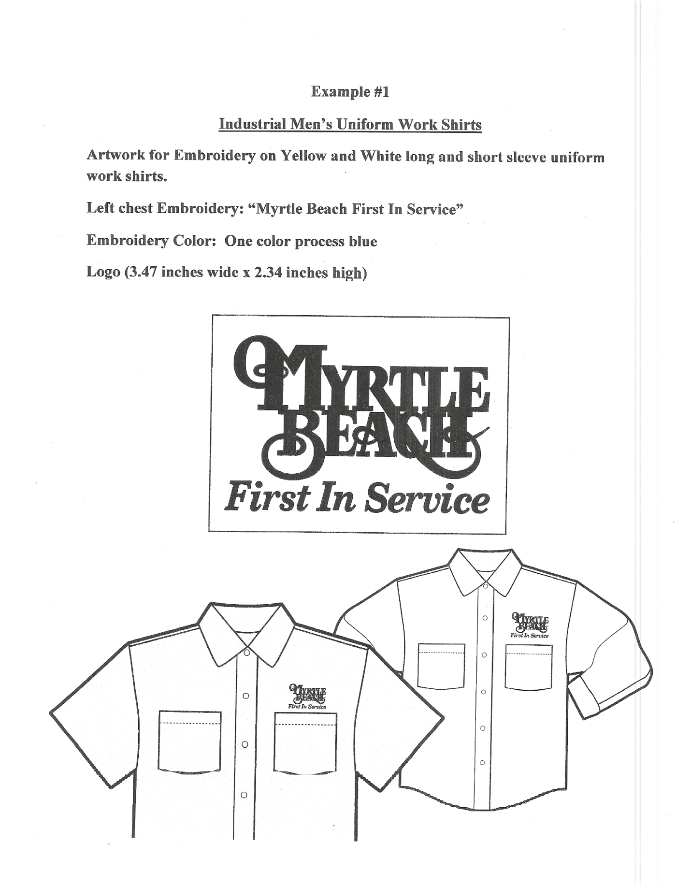

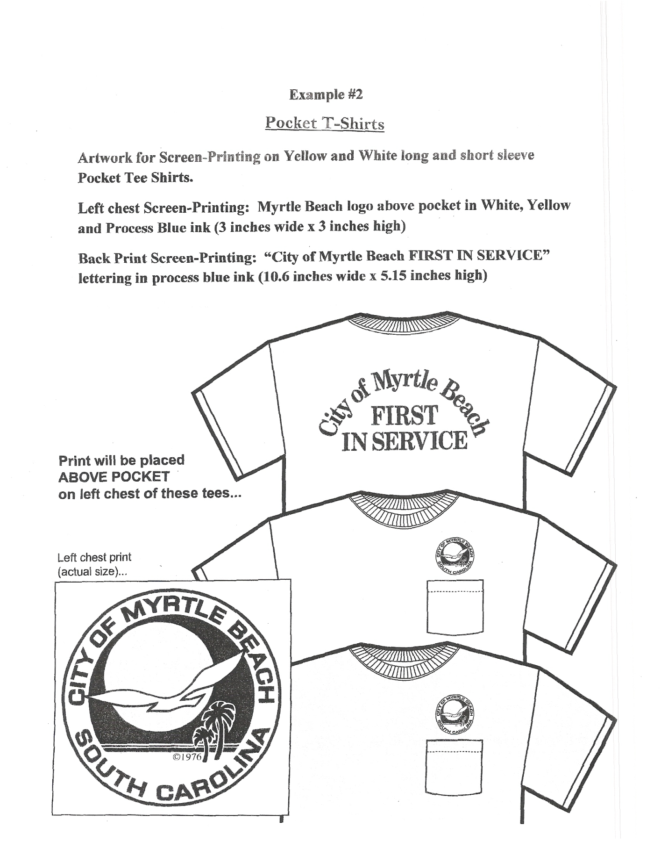

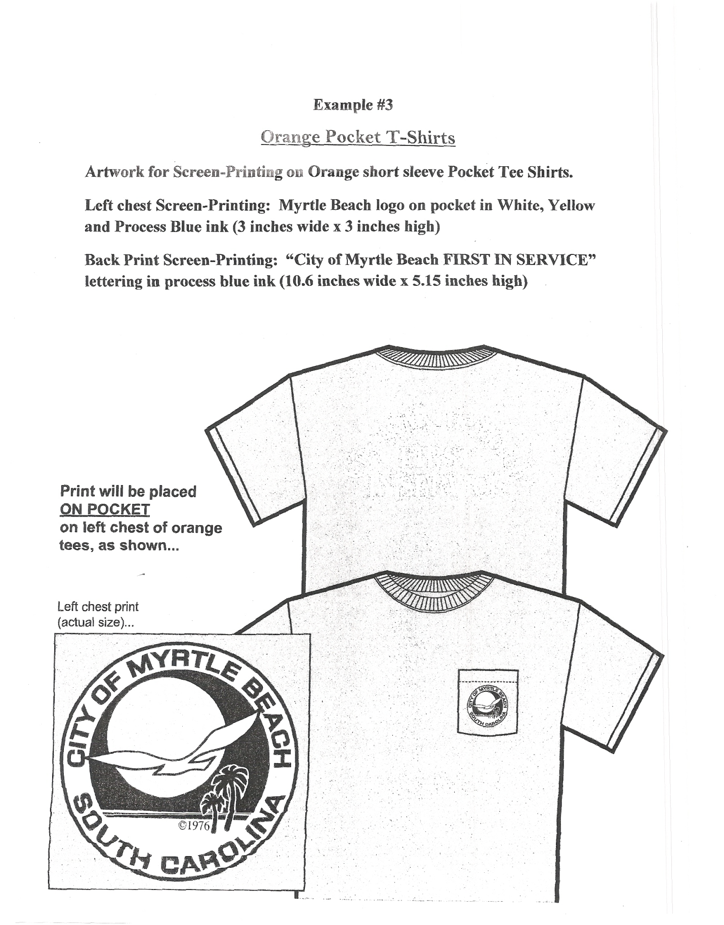

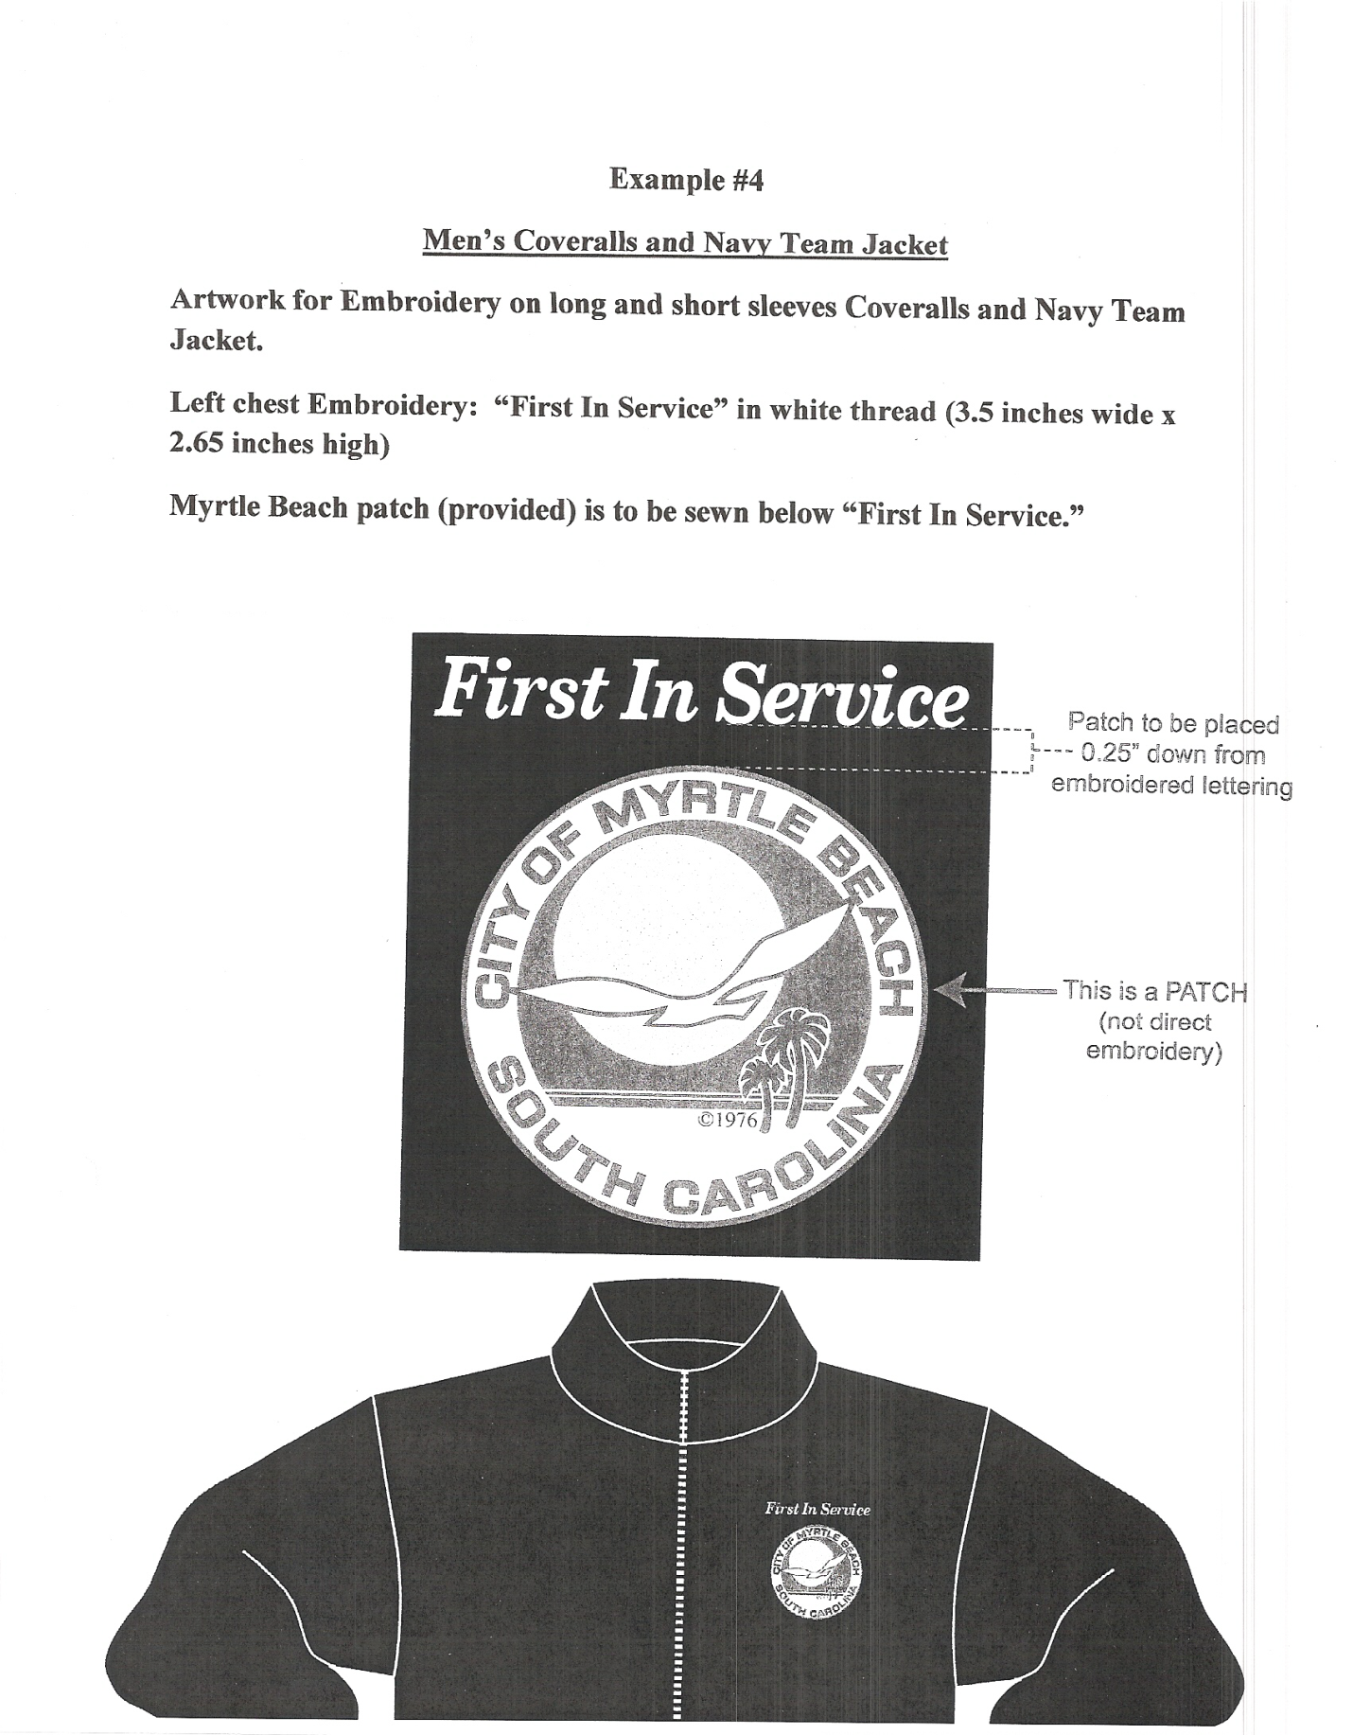

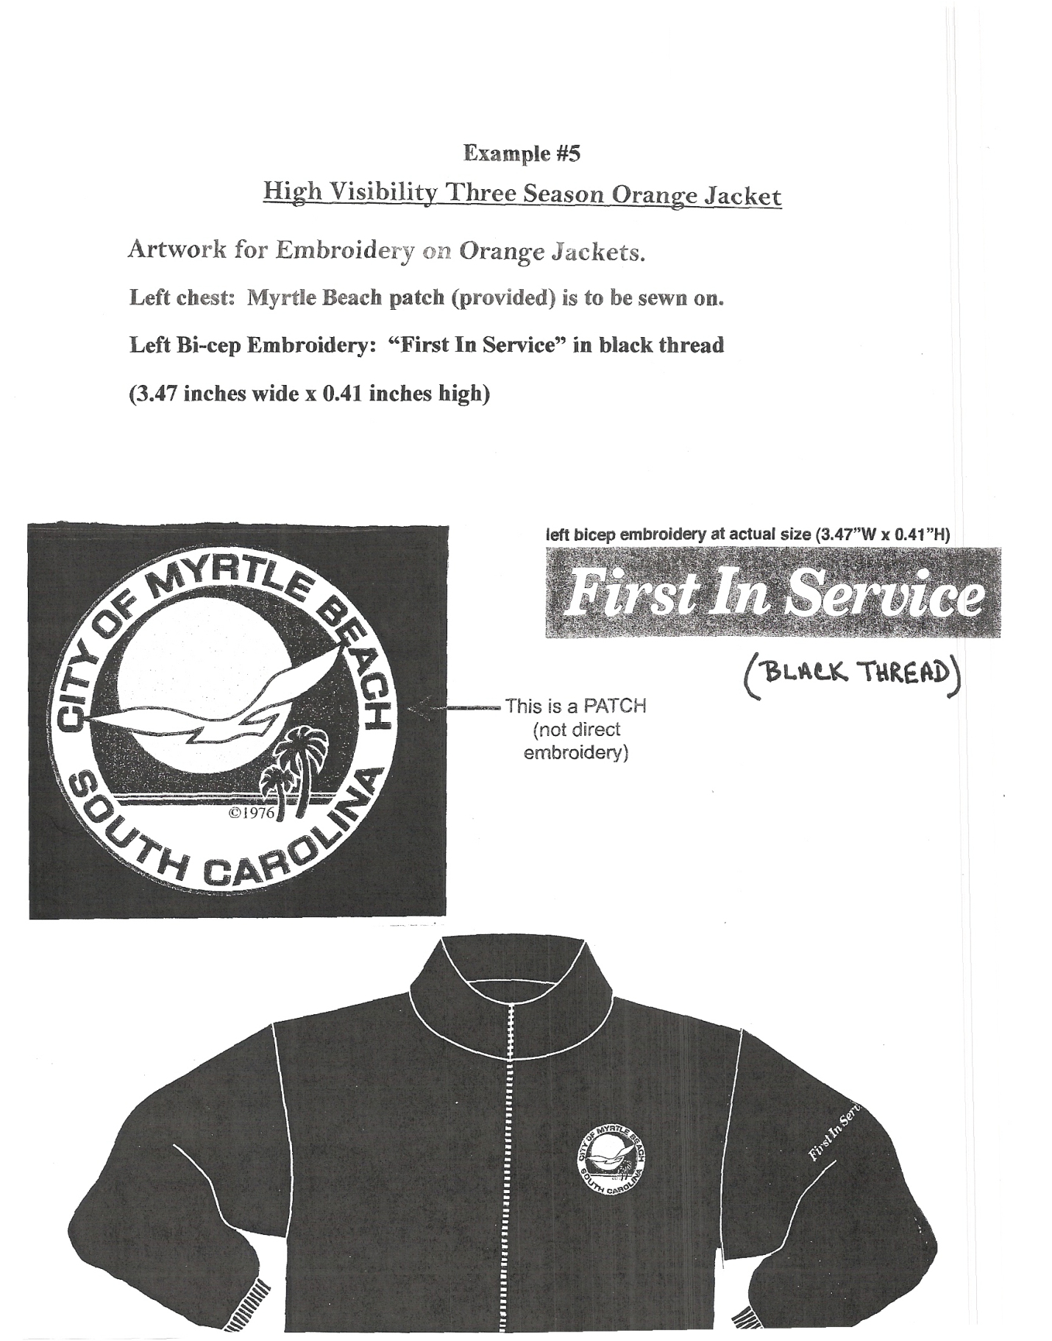

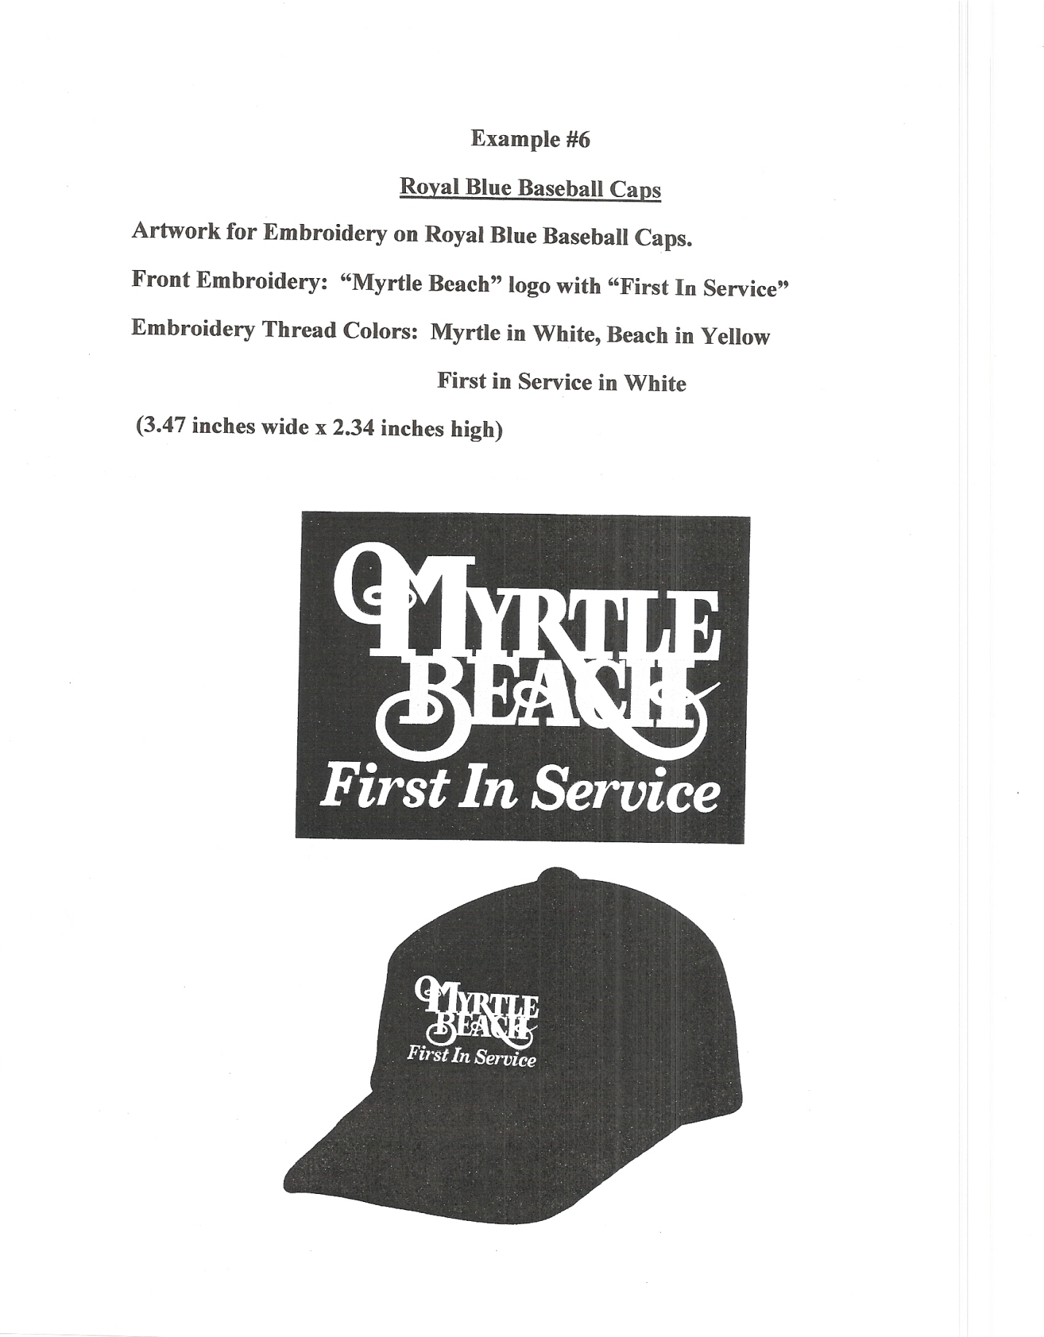

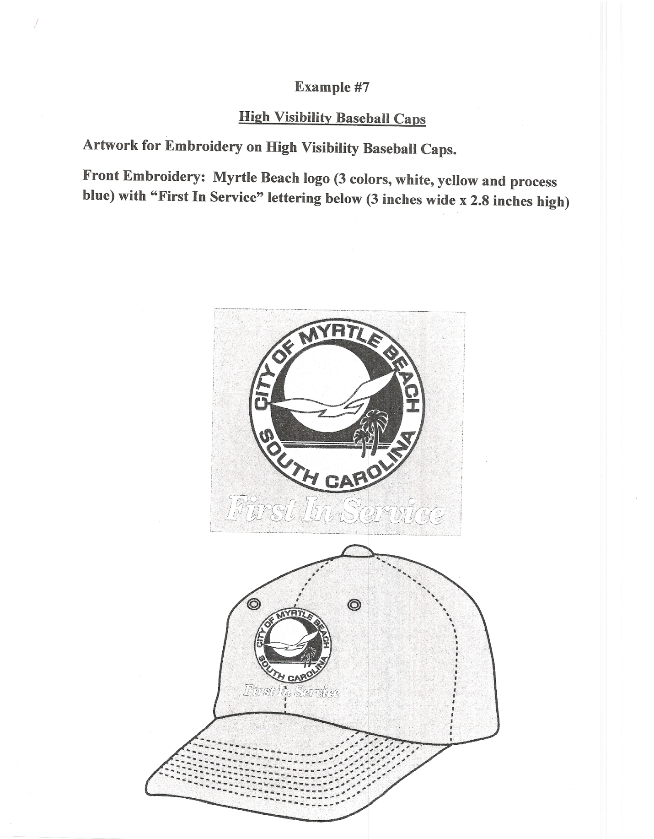

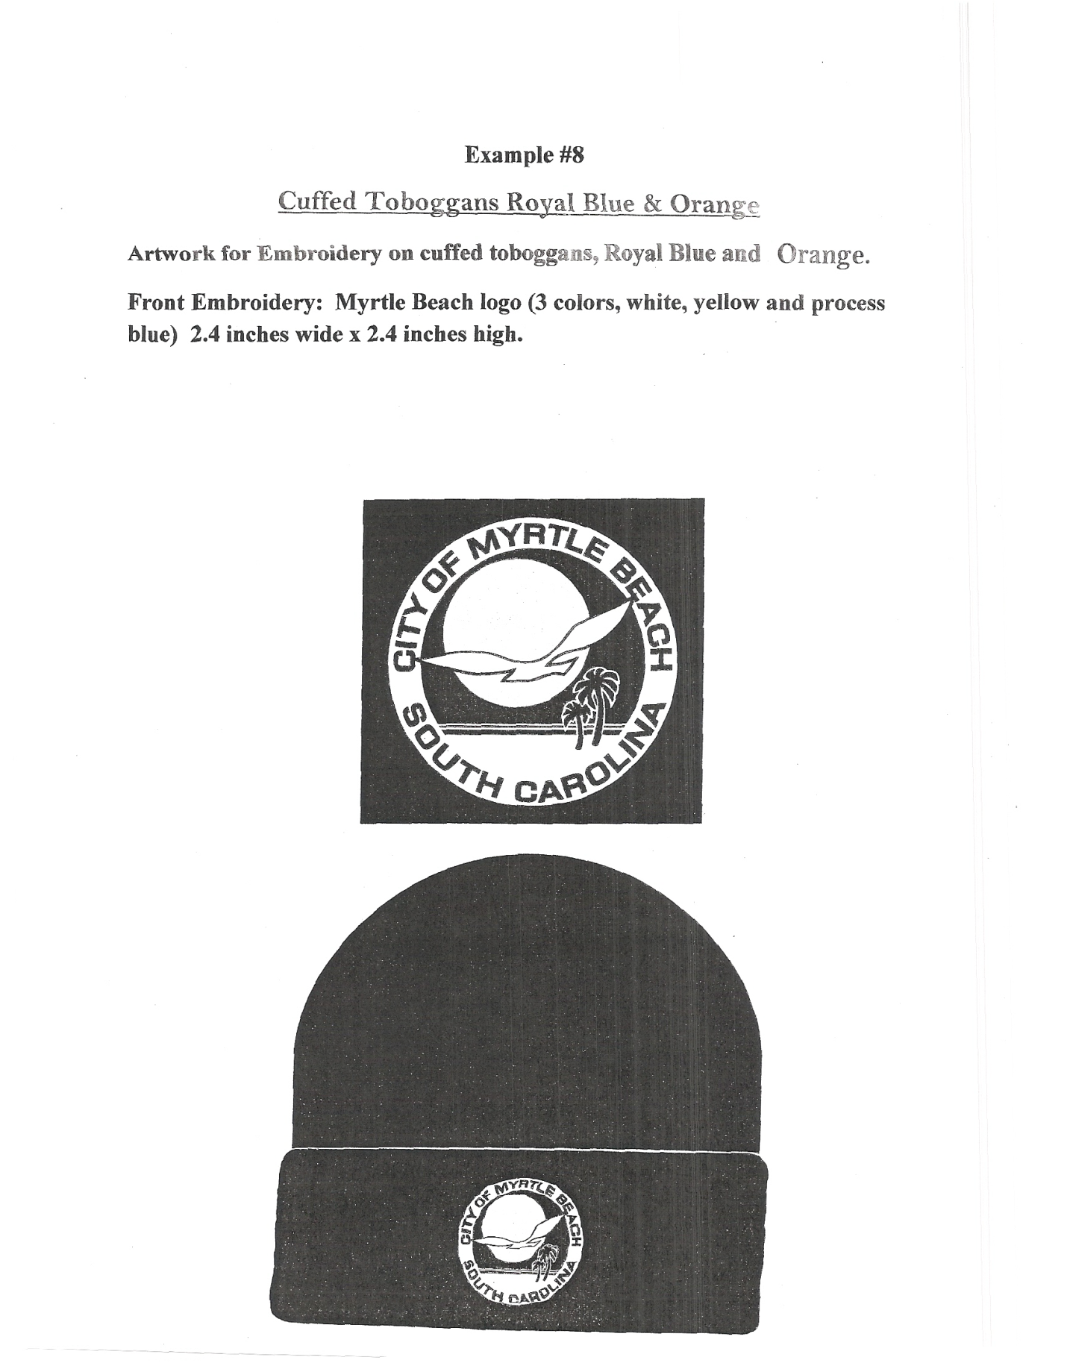

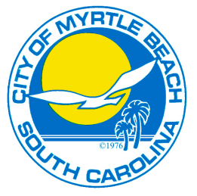 | CITY OF MYRTLE BEACH  LOCAL VENDOR PREFERENCE  TO QUALIFY FOR LOCAL PREFERENCE  FORM MUST BE SUBMITTED WITH BID
First in Service

APPLICATION OF ELIGIBILITY TO QUALIFY FOR LOCAL VENDOR PREFERENCE WITHIN THE DEFINED BOUNDARIES: MYRTLE BEACH CITY LIMITS, HORRY COUNTY, NESA AREA (NESA area is comprised of Horry, Georgetown, Williamsburg, Florence, Marion, Darlington, Dillon, Chesterfield, and Marlboro Counties).

City of Myrtle Beach Business License: (To qualify for Local Vendor Preference vendor must have had a City of Myrtle Beach Business License a minimum of ninety (90) days prior to the request for bid/ proposal being made public)
City of MB Business License Number: ______________  *NOT Horry County License Number | Date issued: ______________

Complete all areas below. Incomplete forms may be rejected.

 | 1. | LEGAL NAME OF BUSINESS: |  |  | __________________________________________
 |  | Mailing Address: |  |  |  |  | ________________________________________  ________________________________________
 |  | Physical Address:  (To qualify vendor must have maintained  a physical address and office as a principal place of business within the defined boundaries of the category sought for at least one (1) year, and during that time have had a majority of full-time employees, chief officers and managers regularly conducting work and business from this office.) |  |  |  |  | ________________________________________  ________________________________________
 | 2. | Year business was established in the City of Myrtle Beach / Horry County / NESA area:
 |  | Year: | ______________ |  |  |  |  | County: |  | ______________
 |  |  |  |  |  | (Name of County)
************************************************************************************
Under penalty of perjury, the undersigned states that the foregoing statements are true and correct.
The undersigned also acknowledges that any person, firm, corporation or entity intentionally submitting false information to the City in an attempt to qualify for local preference shall be prohibited from bidding on City of Myrtle Beach products and services for a period of one (1) year.
 | Authorized Signature: |  |  | ____________________________________ |  |  |  |  |  |  | Date: | ______________
 | Printed Name & Title: |  |  | ____________________________________ |  |  |  |  |  |  | Phone: | ______________

LOCAL VENDOR PREFERENCE continued

Bid Amount | Within City Limits | Within Horry County | Within NESA Area
Up to $5000.00 | 5% of Bid | 4% of Bid | 3% of Bid
$5001.00 to $10,000.00 | $250.00 plus 4% of amount between $5001.00 and $10,000.00 | $200.00 plus 3% of amount between $5001.00 and $10,000.00 | $150.00 plus 2% of amount between $5001.00 and $10,000.00
$10,001.00 and up | $450.00 plus 3% of amount above $10,000.00 with the maxium being $2000.00, including the $450.00 | $400.00 plus 2% of amount above $10,000.00 with the maxium being $1800.00, including the $400.00 | $300.00 plus 1% of amount above $10,000.00 with the maxium being $1600.00, including the $300.00

If company/individual performs services on City property a Certificate of Insurance must be provided prior to commencement of work meeting requirements of the City.

The vendor must submit this copy of the Local Vendor Preference Certificate with their bid.

An eligible business shall maintain such status throughout the term of any contract with the City. Failure to maintain such status or to keep current on all fees and taxes owed the City shall be grounds to terminate the contract.

