Request for Proposals

Solicitation Name and Number | Card Operated Laundry Services Q2116
KCDC’s Procurement Division must receive your response no later than | 11:00 a.m. on March 12, 2021 (as KCDC’s clocks indicate)
Deliver Responses to | procurementinfo@kcdc.org
Electronic Copies | Use the MS Word version posted on KCDC’s website (or other electronic means) to provide a typed response. The final proposal is to be submitted in Adobe format.
Questions About This Solicitation | Submit questions to procurementinfo@kcdc.org by 6:00 p.m. on March 9, 2021.  KCDC will not accept questions via telephone.
Open Records/Public Access to Documents | All document provided to KCDC are subject to the Tennessee Open Meetings Act (TCA 8-44-101) and open records requirements.
Check KCDC’s webpage (https://www.kcdc.org/procurement/) for addenda and changes before submitting your response

General Information

1. Background and Intent
a. Knoxville's Community Development Corporation (KCDC) is the public housing and redevelopment agency for the City of Knoxville and for Knox County in Tennessee. KCDC’s housing property portfolio includes 17 properties with approximately 3,500 dwelling units. KCDC also administers approximately 3,958 Section 8 Vouchers and 82 Moderate Rehabilitation units. Other activities of KCDC include management of 9 LIHTC properties, administration of development and redevelopment projects for local governments and several related business activities.

b. KCDC uses “supplier” as inclusive of various words describing interested parties often called “supplier,” “bidders,” “contractors” and “suppliers.”

c. Several of KCDC’s properties have “Coin Operated” laundry machines for their residents. KCDC’s current award to Caldwell & Gregory has nearly reached the end of its five-year maximum and thus the services must be resolicited.

d. The purpose of this solicitation is to make an award to one supplier for providing these laundry machines at KCDC’s sites.

2. Changes After Award
It is possible that after award KCDC will need to revise the service needs or requirements specified in this document. KCDC reserves the right to make such changes after consultation with the supplier. Should additional costs arise, the supplier must document increased costs. KCDC reserves the right to accept and negotiate these charges.

3. Contact Policy
Contact only KCDC’s Procurement Division about this solicitation from the issuance of this RFP until its award. Information obtained from any other person will not affect the risks or obligations assumed by the supplier or relieve the supplier from fulfilling any of the conditions of the resulting award. Such contact can disqualify the supplier from the solicitation process.

4. Contact Personnel
A good working relationship must develop between KCDC and the successful supplier. The supplier will provide a contact(s) to handle billing inquiries and service-related issues. In the event the usual contact is unavailable, the supplier will notify Human Resources of the change.

5. Contract Length
KCDC anticipates the length of the contract will not exceed 60 months.

6. Damage
The supplier is responsible for all damage to buildings, equipment, grounds, premises and all other types of potential damage resulting from the provision of the services requested herein.

7. Employees
Supplier will:

a. Allow only personnel thoroughly trained and skilled to work on the job. Employees are not to be accompanied in their work area by acquaintances, family members, assistants or any person unless said person is an authorized employee of the supplier.

b. Have sufficient personnel to complete the work in a timely manner.

c. Provide adequate supervision and adequate discipline among his/her employees.

d. Provide at least one employee on every job assignment with the ability to speak, read, write and understand English so owner’s staff can communicate effectively with them.

e. Ensure that employees have proper identification displayed while on the job site. Employees must wear a company uniform or always have photo identification badges.

f. Employees parking vehicles (whether corporately or privately owned) must ensure that company identification is on the vehicles. This may be by placards on the vehicle’s side, laminated paper with the company name placed on the dashboard or other means.

8. Evaluation
a. KCDC alone determines (using NIGP’s definition and other relevant sources as appropriate) the supplier’s “responsive” and “responsible” status prior to award. Responsible means a business with the financial and technical capacity to perform the requirements of the solicitation and subsequent contract. A responsive proposal is one that fully conforms in all material respects to the solicitation document and all its requirements, including all form and substance.

b. KCDC reserves the right to request additional information to assist in the evaluation process.

c. KCDC will review all proposals and reserves the right to request necessary modifications, waive minor technicalities, reject all proposals, reject any proposal that does not meet mandatory requirement(s) or cancel this RFP, according to KCDC’s best interests. KCDC further reserves the right to adjust its evaluation scenario if this is in KCDC’s best interest and consistent with good business practices.

d. KCDC may require oral presentations as part of the evaluation process.

e. KCDC plans to award to the best overall proposal on the following evaluation scale:

Factors | Maximum Points
Revenue to KCDC | 45
Equipment | 25
Qualifications | 25
References | 5
Total | 100

9. General Instructions
KCDC does not insert “General Instructions to Suppliers” in solicitation documents. These instructions are at www.kcdc.org. Click on “Procurement” and then follow the link to the instructions. The supplier’s submittal means acceptance of the terms and conditions set forth in KCDC’s “General Instructions to Suppliers.” Paragraphs in the “General Instructions” document that do not apply to this solicitation: 4, 33, 42 and 57.

10. Insurance
See Appendix 1. These insurances and levels are required and not optional. If you or your insurance agent have concerns or believe that some coverages are not necessary, email procurementinfo@kcdc.org detailing any requested changes before this solicitation’s due date. The supplier will include all insurance costs in the base bid.

11. Price Structure
Suppliers are to quote a specific price as described herein.

a. At the end of each award period, the successful supplier may request a price increase. Proof of increased cost to the successful supplier must accompany price increase requests. KCDC may, at its option:

1. Accept the proposed price increase; or
2. Reject the proposed price increase; or
3. Suggest an alternative price increase.

b. If KCDC rejects a proposed price the successful supplier may:
1. Continue with the existing pricing.
2. Suggest an alternative price increase.
3. End the award.

c. The supplier may decrease prices at any time with or without notice.

12. Smoking Policy
KCDC’s Smoke Free policy is applicable to you, your employees and subcontractors.

a. The policy mandates:
- No smoking on owner’s property
- No e-vape or similar usage on owner’s property
- The Smoke Free policy applies in personal or corporate vehicles on owner’s property

b. Applicable definitions include:
- “Smoking” means inhaling, exhaling, burning or carrying any lighted or heated cigar, cigarette or pipe,
or any other lighted or heated tobacco or plant product intended for inhalation, including hookahs and marijuana, whether natural or synthetic, in any manner or in any form. “Smoking” also includes the use of an electronic smoking device which creates an aerosol or vapor, in any manner or in any form.

- “Electronic Smoking Device” means any product containing or delivering nicotine or any other
substance intended for human consumption that can be used by a person in any manner for the purpose of inhaling vapor or aerosol from the product. The term includes any such device, whether manufactured, distributed, marketed or sold as an e-cigarette, e-cigar, e-pipe, e-hookah or vape pen or under any other product name or descriptor.

- Property means all buildings, parking lots, streets, structures and land. Should supplier staff be
observed violating these requirements, KCDC’s Procurement Division will notify the supplier about the problem. Should there be recurrences, KCDC may ask the supplier to not send the employee to KCDC’s property. Repeated offenses may result in forfeiture of your awarded “contract.”

13. Subcontractors
Subcontractors must:

a. Be approved by KCDC prior to beginning work. Any changes must be approved by KCDC.

b. Not be on federal or the State of Tennessee’s debarment lists.

c. Carry the insurance coverages as outlined herein.

d. KCDC requires the supplier(s) to reach out to small business, minority owned businesses and women owned businesses as possible subcontractors if subcontracting services are needed.

Scope of Work

14. Introduction and Objectives
KCDC's main interest is to provide quality machines and service to KCDC tenants. The machines must be easy to use, reliable and energy efficient. The successful supplier will be responsible for obtaining, installing, maintaining and repairing the machines. The machines will be on a laundry card system that that will use credit cards or laundry cards. A laundry card dispenser will also be needed for the laundry room with an online portal to monitor sales.

15. Charges
KCDC wants the supplier to recommend a cost per load for both washing machines and dryers. Currently however, the charge is $1.25 per load.

a. KCDC does not anticipate increasing cost to users during the period of the contract but reserves that right upon a written request from the successful supplier. The supplier shall not increase prices for washing and drying from initial set prices without KCDC's approval.

b. The supplier is responsible for the settlement of any claims and reimbursements to users for non-performance of equipment.

16. Communication
For its convenience, KCDC often communicates via email. Accordingly, the successful supplier will routinely use email. Additionally, many KCDC staff members using “Texting” to communicate and the supplier needs to be proficient in this communication tool. Finally, some KCDC staff members use the telephone frequently and the supplier must be able to effectively communicate that way also.

17. Equipment
a. Used equipment is not acceptable.

b. Front loading washing machines are required.

c. There will be a maximum of 48 hours to convert equipment at each building. Installations may be scheduled back-to-back at the various sites. KCDC will require a two-week notice prior to the installation. KCDC and the supplier must agree prior to the exchange of machines.

d. All cost for installation (includes any water hoses or dryer ventilation required in addition to what KCDC must do to make their equipment operable) will be borne by the supplier.

e. The successful supplier will maintain equipment in a good working order and keep the equipment clean.

f. The successful supplier will have any machine repaired or a replacement machine installed of equal quality (model, year, capabilities) within two business days from the time a machine is reported out of order by KCDC.

g. Any damage to machines by users or by vandalism shall not constitute reason for claim from KCDC. KCDC is to be held harmless from all claims that may arise from the supplier’s equipment being located on KCDC property.

h. Operating instructions for equipment shall be maintained at each site.

18. KCDC Responsibilities
a. KCDC will provide space for laundry equipment and maintain the common floor area, chairs and tables used by KCDC tenants.

b. KCDC will provide space for the supplier’s equipment for the purpose of serving KCDC tenants. KCDC will not seek non-KCDC tenants for customers and will try to prohibit non-tenants from using suppliers’ equipment by providing KCDC tenants keys to both entrance to the building and the laundry room.

c. KCDC will provide and pay for all utilities used by supplier’s equipment.

19. Locations
Currently KCDC has need for coin operated laundry services at:

Site | Address | Apartments | Washers | Dryers
Autumn Landing Apartments | 6331 Pleasant Ridge Road | 95 | 4 | 5
Cagle Terrace Building A | 515 Renford Drive | 272 | 4 | 4
Cagle Terrace Building B | 515 Renford Drive | 272 | 4 | 4
Isabella Towers | 1515 Isabella Circle | 231 | 5 | 5
Love Towers Building A | 1161 & 1171 Armstrong Avenue | 248 | 4 | 5
Love Towers Building B | 1161 & 1171 Armstrong Avenue | 248 | 5 | 5
Nature’s Cove Apartments | 2639 Bakertown Road | 102 | 6 | 5
Northgate Terrace | 4301 Whittle Springs Road | 276 | 6 | 6
Valley Oaks | 3504 Oak Branch Circle | 48
 |  | 1,272 | 38 | 39

KCDC’s Desired Configuration for Washers
Site | Number of Top Loaders Desired | Number of Front Loaders Desired
Autumn Landing Apartments | 4 | 0
Cagle Terrace Building A | 3 | 1
Cagle Terrace Building B | 3 | 1
Isabella Towers | 2 | 3
Love Towers Building A | 3 | 1
Love Towers Building B | 4 | 1
Nature’s Cove Apartments | 6 | 0
Northgate Terrace | 5 | 1
Valley Oaks | 0 | 4
Totals | 30 | 12

20. Revenue
a. KCDC reports the following earnings shown below from the laundry machines.

b. While the amounts shown below are indicative of earnings, KCDC makes no guarantee as to future earnings.

 | Autumn  Landing | Cagle Terrace | Isabella Towers | Love Towers | Nature’s Cove | Northgate Terrace | Valley Oaks | Totals
Total 2016 | $7,582 | $18,332 | $10,015 | $21,034 | $10,326 | $14,572 | $5,766 | $87,627
Total 2017 | $8,727 | $20,831 | $10,847 | $22,289 | $10,309 | $16,024 | $5,596 | $94,623
Total 2018 | $8,424 | $19,565 | v10,845 | $22,862 | $9,621 | $16,387 | $4,983 | $92,687
Total 2019 | $8,037 | $18,553 | $10,775 | $22,612 | $9,302 | $17,696 | $4,050 | $91,025
Total 2020 | $6,657 | $15,232 | $9,253 | $17,776 | $9,399 | $16,936 | $4,720 | $79,973
 |  |  |  |  |  |  |  | $445,935

21. Site Visits
Suppliers are urged to visit all sites to view the current configurations of the machines. The failure of the supplier to do so will not relieve the supplier of such responsibility. Coordinate the site visits with the persons shown below.

Site | Contact | Phone | Email
Autumn Landing | James Pruitt | 403-1422 | jpruitt@kcdc.org
Cagle Terrace | Rhonda Harris | 403-1310 | rharris@kcdc.org
Isabella Towers | Sam Chambers | 403-1340 | schambers@kcdc.org
Love Towers | Steve Ellis | 403-1360 | sellis@kcdc.org
Natures Cove | James Pruitt | 403-1422 | jpruitt@kcdc.org
Northgate Terrace | Terri Evans | 403-1400 | tevans@kcdc.org
Valley Oaks | Adronicus Thomas | 403-1320 | athomas@kcdc.org

Note that standard COVID protection requirements (such as, but not limited to, wearing masks, washing hands and not entering the property if feeling unwell or having a fever) apply.

22. Submittal Instructions
Submit your information in the order indicated below:

Document Number | Title
Solicitation Document A | General Information about the Supplier
Solicitation Document B | Affidavits
Solicitation Document C | HUD Form 5369A
Solicitation Document D | Equipment Proposed
Solicitation Document E | Qualifications
Solicitation Document F | References
Solicitation Document G | Revenue Proposal

- Place your company’s name on each page and number all pages consecutively

b. The use of tables in presenting information facilitates the evaluation team’s review.

c. Do not use phrases such as “See the attached” or “Will be provided upon award.”

This and the Previous Pages Do Not Need to Be Returned

Solicitation Document A: General Information about the Supplier
Sign Your Name to the Right of the Arrow
If completing this document in Adobe, an electronic signature is acceptable to KCDC.
Your signature indicates you read and agree to “KCDC’s General Instructions to Suppliers” (www.kcdc.org) and that you are authorized to bind the supplier or are submitting the response on behalf of and at the direction of the suppliers’ representative authorized to contractually bind the supplier. I represent that the supplier or its applicable representative(s) has reviewed the information contained in this Solicitation Package and that the information submitted is accurate.
Printed Name and Title
Company Name
Street Address
City/State/Zip
Contact Person (Please Print Clearly)
Telephone Number
Cell Number
Supplier’s E-Mail Address (Please Print Clearly)
Addenda
Addenda are at www.kcdc.org. Click on “Procurement” and then on “Open Solicitations” to find addenda. Please check for addenda prior to submitting a proposal.
Acknowledge addenda have been issued by checking below as appropriate:
None ☐ | Addendum 1 ☐ |  |  | Addendum 2 ☐ |  | Addendum 3 ☐ |  |  | Addendum 4 ☐ | Addendum 5 ☐
Statistical Information (Check all the apply)
This business is at least 51% owned and operated by a woman |  |  |  |  |  |  |  |  |  |  | Yes ☐ No ☐
This business qualifies as a small business by the State of Tennessee  Total gross receipts of not more than $10,000,000 average over a three-year period OR employs no more than 99 persons on a full-time basis |  |  |  |  |  |  |  |  |  |  | Yes ☐ No ☐
This business qualifies as Section 3 business (as defined by HUD):  It is at least 51% owned by a Public Housing resident or it employs Section 3 residents for at least 30% of its employee base; or it commits to subcontract at least 25% of the project’s dollars to a Section 3 business. |  |  |  |  |  |  |  |  |  |  | Yes ☐ No ☐
This business is owned & operated by persons at least 51% of the following ethnic background:
Asian/Pacific ☐ |  | Black ☐ | Hasidic Jew ☐ |  | Hispanic ☐ |  |  | Native Americans ☐ |  |  | White ☐

Solicitation Document B: Affidavits

Conflict of Interest
1. No commissioner or officer of KCDC or other person whose duty it is to vote for, let out, overlook or in any manner superintend any of the work for KCDC has a direct interest in the award or the supplier providing goods or services.

2. No employee, officer or agent of the grantee or sub-grantee will participate in selection, or in the award or administration of an award supported by Federal funds if a conflict of interest, real or apparent, would be involved. Such a conflict would arise when the employee, officer or agent, any member of his immediate family, his or her partner, or an organization, which employs, or is about to employ, any of the above, has a financial or other interest in the supplier selected for award.

3. The grantee's or sub-grantee's officers, employees or agents will neither solicit nor accept gratuities, favors or anything of monetary value from suppliers, potential suppliers or parties to sub-agreements.

4. By submission of this form, the supplier is certifying that no conflicts of interest exist.

Drug Free Workplace Requirements
5. Private employers with five or more employees desiring to contract for construction services attest that they have a drug free workplace program in effect in accordance with TCA 50-9-112.

Eligibility
6. The supplier is eligible for employment on public contracts because no convictions or guilty pleas or pleas of nolo contender to violations of the Sherman Anti-Trust Act, mail fraud or state criminal violations with an award from the State of Tennessee or any political subdivision thereof have occurred.
General
7. Supplier fully understands the preparation and contents of the attached offer and of all pertinent circumstances respecting such offer.

8. Such offer is genuine and is not a sham offer.

Iran Divestment Act
9. Concerning the Iran Divestment Act (TCA 12-12-101 et seq.), by submission of this bid/quote/proposal, each supplier and each person signing on behalf of any supplier certifies, and in the case of a joint bid/quote/proposal, each party thereto certifies as to its own organization, under penalty of perjury, that to the best of its knowledge and belief that each supplier is not on the list created pursuant to § 12-12-106.

Accuracy of Electronic Copies
10. If the supplier provides electronic copies of the bid/proposal/quote to KCDC, the supplier certifies that the information provided on paper and in the electronic format is identical unless specifically noted otherwise.

Non-Collusion
11. Neither the said supplier nor any of its officers, partners, owners, agents, representatives, employees or parties interest, including this affiant, has in any way colluded conspired, connived or agreed, directly or indirectly, with any other responder, supplier, or person to submit a collusive or sham offer in connection with the award or agreement for which the attached offer has been submitted or to refrain from making an offer in connection with such award or agreement, or collusion or communication or conference with any other supplier, or, to fix any overhead, profit, or cost element of the offer price or the offer price of any other supplier, or to secure through any collusion, conspiracy, connivance, or unlawful agreement any advantage against KCDC or any person interested in the proposed award or agreement.

12. The price or prices quoted in the attached offer are fair, proper and not tainted by any collusion, conspiracy, connivance, or unlawful agreement on the part of the supplier or any of its agents, representatives, owners, employees, or parties in interest, including this affiant.

No Contact/No Advocacy Affidavit
13. After this solicitation is issued, any contact initiated by any supplier with any KCDC representative concerning this proposal is strictly prohibited-except for communication with the Procurement Division. My signature signifies that no unauthorized contact occurred.

14. To ensure the integrity of the review and evaluation process, respondents to this solicitation nor any firm representing them, may not lobby or advocate to KCDC staff or Board members. My signature signifies that no unauthorized advocacy occurred.

The undersigned hereby acknowledges receipt of these affidavits and certifies that the submittal in response to this solicitation is in full compliance with the listed requirements.

Signed by
Printed Name
Title
Subscribed and sworn to before me this date
By (Notary Public)
My Commission Expires on
Notary Stamp

C: HUD Form 5369A
Solicitation Document C: HUD Form 5369A
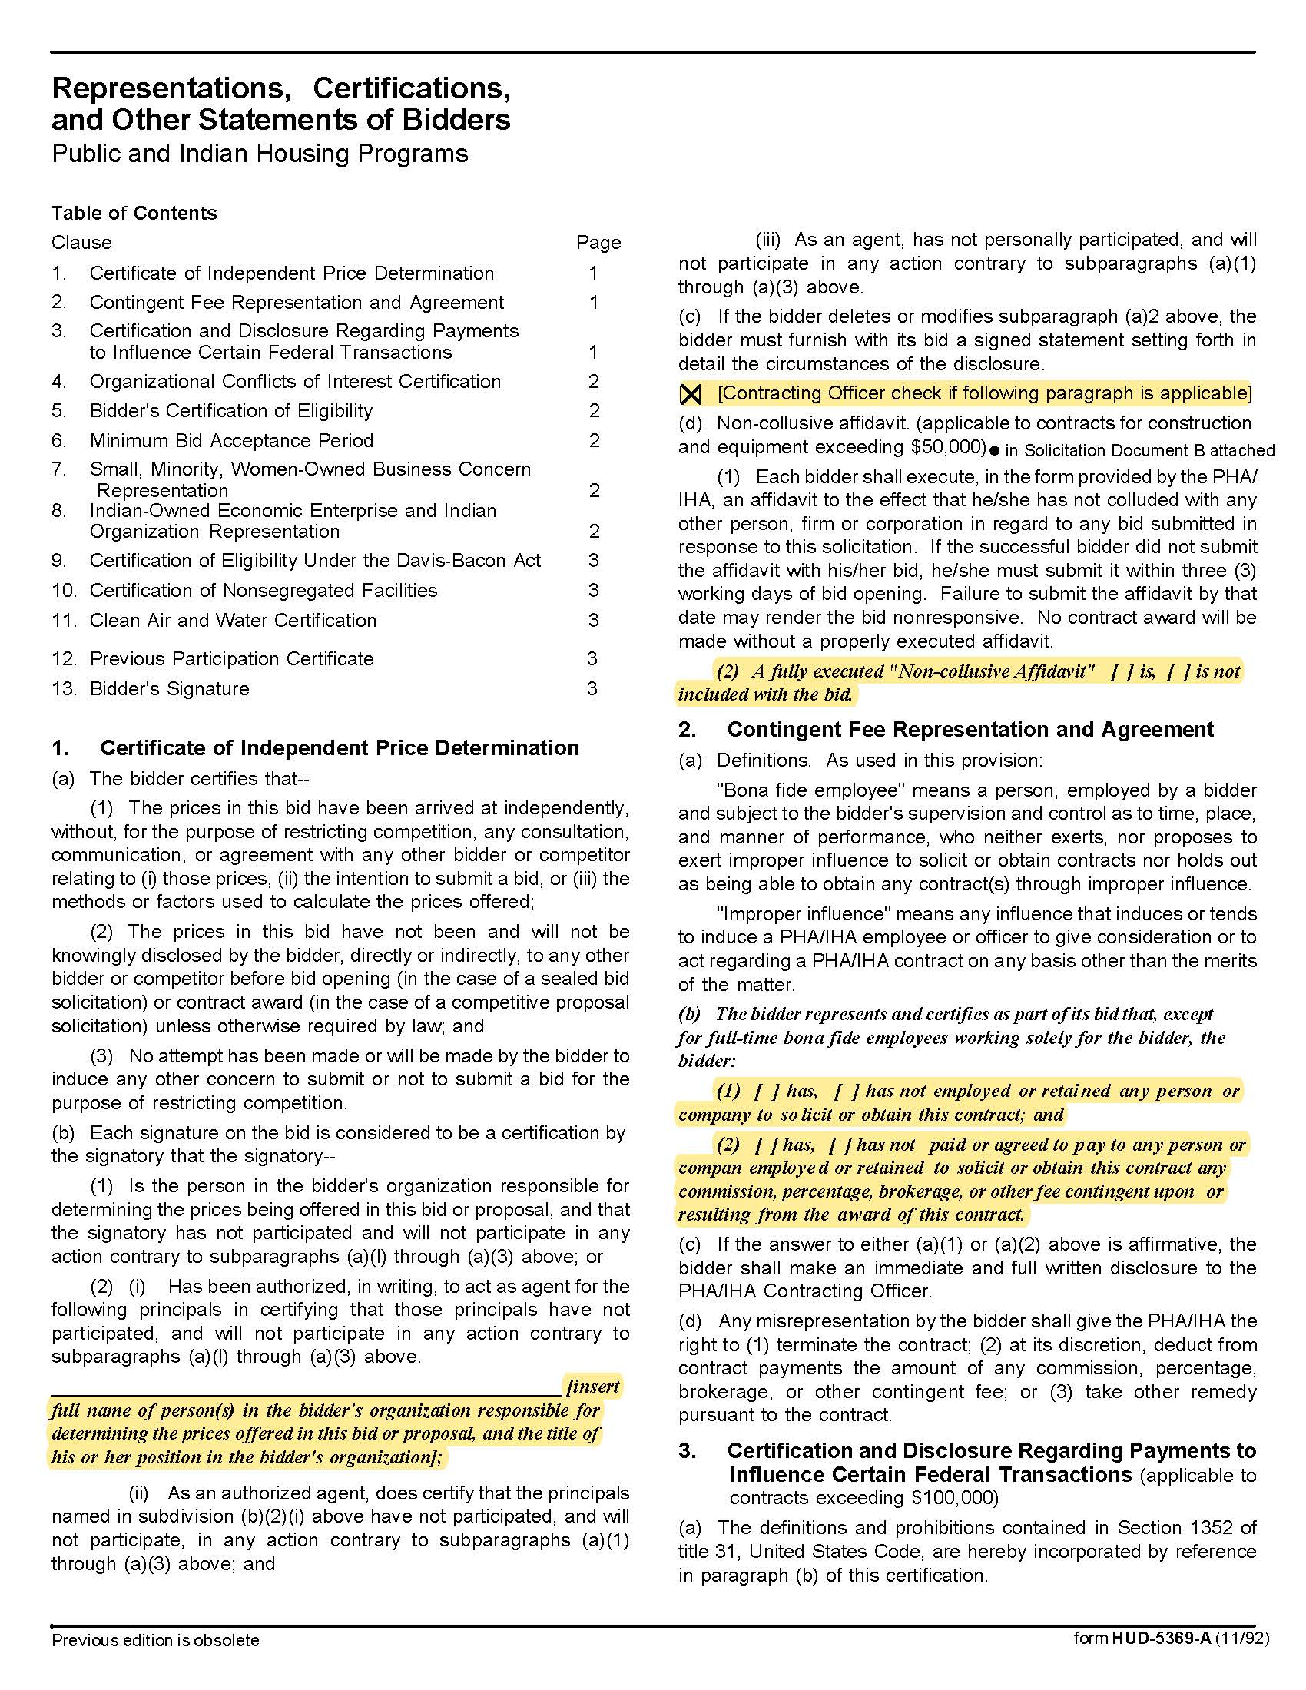

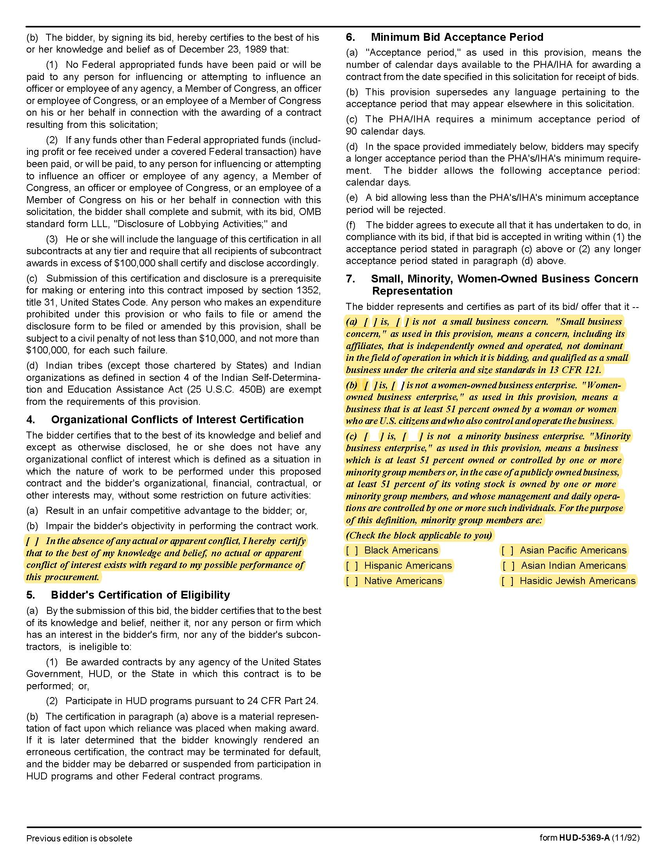

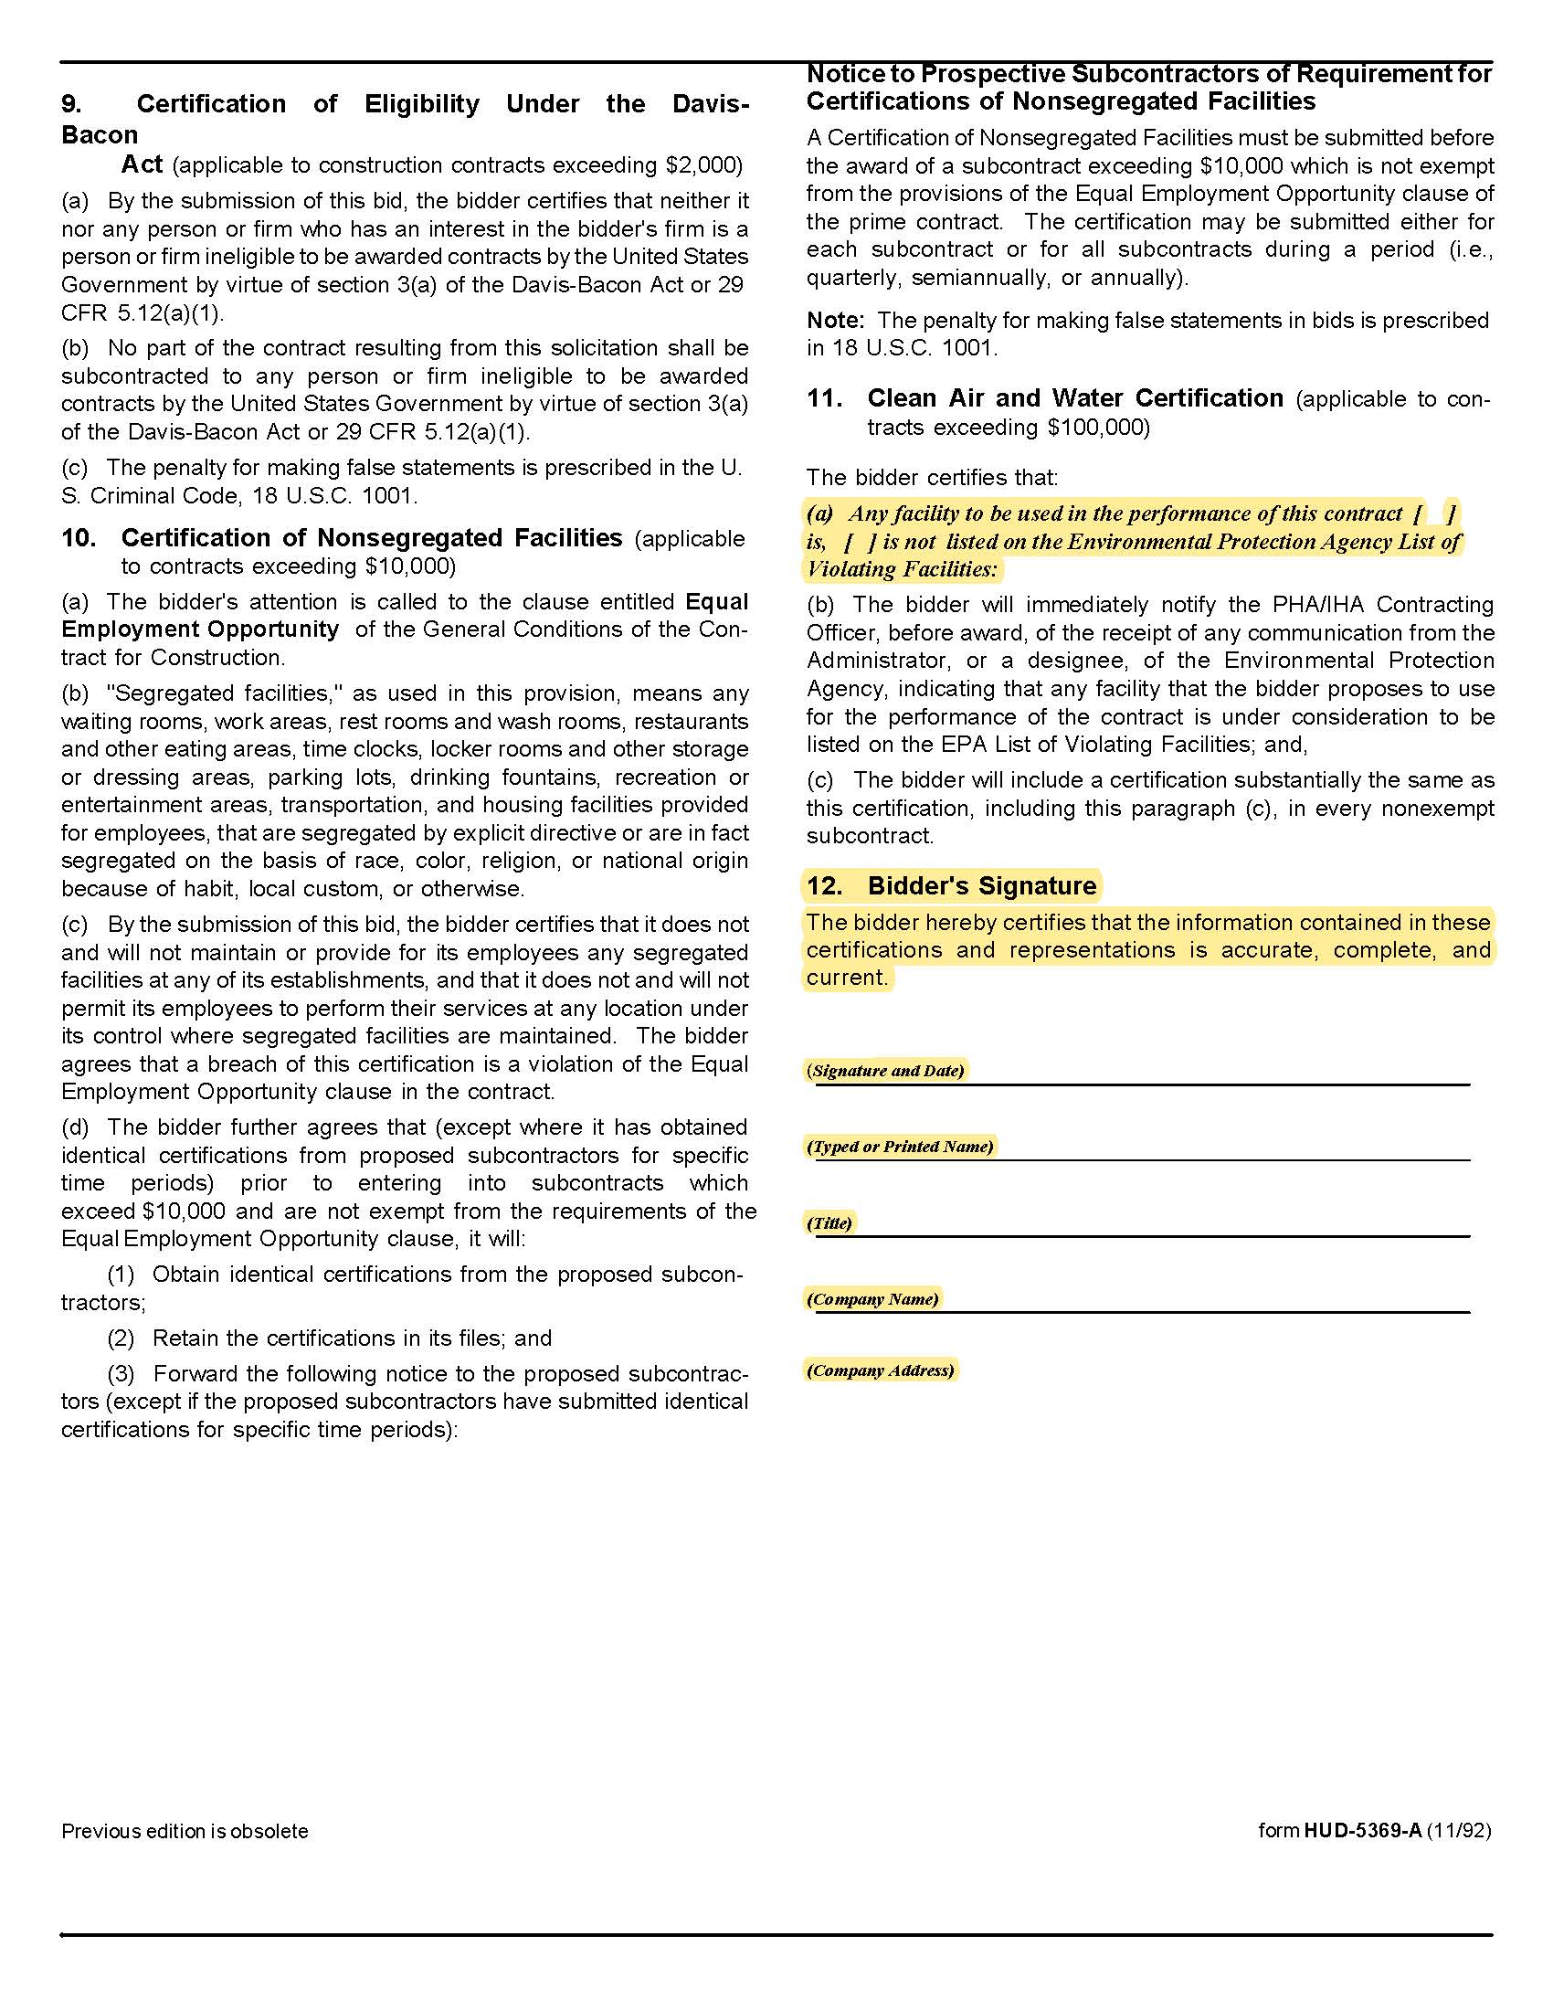

Solicitation Document D Equipment Proposed

Detail the proposed equipment (washers and dryers).

1. Brand

2. Model

3. Features

4. Physical Size

5. Load size

6. Energy consumption

7. Energy Star Status/Energy Ratings

8. Handicap access

9. Specify that new equipment will be installed

10. Number of units recommended for each site

11. Concerning repairs:

a. Specify who KCDC and/or residents contact for repairs (include their contact points)

b. Specify a guaranteed response timeline for repairs

12. Technical and/or marketing sheets for the equipment

13. Address high-energy efficiency issues and reported customer issues with front loading washing machines.

14. Address equipment replacement policies and plans.

Solicitation Document E Supplier Qualifications

1. Provide a brief narrative history of the organization submitting the proposal.

2. Organization Size

3. Organizational structure

4. Provide financial stability indicators

5. Mergers and/or acquisitions within the last five years

6. Legal status (corporation or partnership, et cetera)

7. Number of machines now in service in the Knoxville area

8. Number of accounts in the Knoxville area and under your organization as a whole

9. The frequency of times you check on and services machine (One of KCDC's objectives is minimize the laundry room being a target to theft)

10. Identify the individual(s) in your firm who will be KCDC’s contact persons

11. Give a brief (one paragraph maximum) chronology of their career and experience

12. Describe any unique approaches or techniques developed and used by the firm that would give it an advantage in this specific type of project

Solicitation Document F References

1. Provide client references as similar as possible to this work. KCDC prefers references from “affordable housing” companies but will accept other references at its discretion.

2. A supplier may only list a company once even if you have done multiple jobs for them.

3. KCDC reserves the right to contact and interview the listed references via phone calls and/or other electronic survey means.

4. Provide three references in the following format.

Name of the business that was serviced
Name of the apartment complex serviced
Number of apartments
Number of washers and dryers installed
Contact person
Contact person title
Contact person’s telephone number
Contact person’s email address
Award began
Award ended

Solicitation Document G Revenue Proposal

Detail the revenue sharing plan by indicating:

1. Percentage going to KCDC.

2. Any deductions from “revenue.”

3. All costs to KCDC.

4. Any “bonus” money going to KCDC for signing with your company.

5. Cost per load for washers and cost per load for dryers.

6. The run time for a drying cycle.

7. Detail your plan for the monthly accounting of review with a representative from KCDC’s management staff.

8. Detail your “space improvement” fee proposal. Note that KCDC expects a minimum of $1,500.

Appendix A Insurance Requirements

- INSURANCE
The Supplier shall maintain, at Supplier’s sole expense, on a primary and non‐contributory basis, at all times during the life of the contract insurance coverages, limits, and endorsements described herein. All insurance must be underwritten by insurers with an A.M. Best rating of A- :VI or better. Upon award, the Supplier shall provide Certificate(s) of Insurance and amendatory endorsements to KCDC evidencing said insurance coverages. See paragraph “e” for exact naming of certificate holder and additional insured.

The Supplier agrees the insurance requirements herein as well as KCDC’s review or acknowledgement, is not intended to and shall not in any manner limit or qualify the liabilities and obligations assumed by the Supplier under this contract. KCDC’s failure to require a certificate of insurance, acceptance of a non-conforming certificate, or allowing the Supplier to commence work shall not operate as a waiver of these minimum insurance requirements or the liabilities and obligations assumed by the Supplier under this contract.

a. Commercial General Liability Insurance: occurrence version general liability insurance with a
minimum combined single limit of $1,000,000 per occurrence with $2,000,000 in the aggregate covering the following perils: bodily injury, personal injury, and broad form property damage including products/completed operations for one year after completion of the Project(s). Limits must apply separately to the work/location in this contract.

Such insurance shall contain or be endorsed to contain a provision that includes the KCDC, its officials, officers, employees, and volunteers as additional insureds with respect to the Supplier’s ongoing and completed operations, providing coverage at least as broad as CG 20 10 07 04 and 20 37 07 04 endorsements. The coverage shall contain no special limitations on the scope of its protection afforded to the listed insureds.

b. Commercial Automobile Liability Insurance: in an amount not less than $1,000,000 (combined single limit) for all owned, hired, and non-owned vehicles utilized by Supplier in connection with the Project. Coverage is to include coverage for loading and unloading hazards.

Such insurance shall contain or be endorsed to contain a provision that includes KCDC, its officials, officers, employees, and volunteers as additional insureds.

c. Workers’ Compensation Insurance and Employers Liability Insurance: Workers’ Compensation Insurance with statutory limits as required by the State of Tennessee or other applicable laws.

d. Other Insurance Requirements:

- Upon award, Supplier shall furnish KCDC with original Certificate(s) of Insurance and amendatory
endorsements effecting coverage required by this section.

- Provide a waiver of subrogation for each required policy herein. When required by the insurer, or
should a policy condition not permit Supplier to enter into a pre‐loss agreement to waive subrogation without an endorsement, the policy should be endorsed with a Waiver of Transfer of Rights of Recovery Against Others, or its equivalent. This waiver of subrogation requirement shall not apply to any policy which includes a condition specifically prohibiting such an endorsement, or voids coverage should supplier enter into such an agreement on a pre‐loss basis.

- A minimum 30‐day cancellation notice for all insurances (by endorsement if necessary) is required.

- Replace certificates, policies, and endorsements for any such insurance expiring prior to completion
of services.

- Maintain such insurance from the time services commence until services are completed or through
such extended discovery/reporting/tail period as required. Failure to maintain or renew coverage or to provide evidence of renewal may be treated by KCDC as a material breach of contract.

- Any deductibles and/or self‐insured retentions greater than $50,000 must be disclosed to and
approved by KCDC prior to the commencement of services. Use of large deductibles and/or self‐insured retentions will require proof of financial ability as determined by KCDC.

- All policies must be written on an occurrence basis with the exception of Errors and Omissions Liability
(E & O) / Professional Liability and Pollution Liability which may be claims made coverage.

8. Require all subcontractors to maintain during the term of the resulting contract commercial general liability insurance, automobile liability insurance, and workers’ compensation/employers liability insurance (unless subcontractor’s employees are covered by contractor’s insurance) in the same manor and limits as specified for the Supplier.

e. Certificate Holder and Additional Insured:
KCDC, its officials, officers, employees, and volunteers
901 N Broadway
Knoxville, TN 37917

f. Right to Revise or Reject: KCDC reserves the right to revise any insurance requirement, including but not limited to, limits, coverages, and endorsements based on changes in scope of work/specifications, insurance market conditions affecting the availability or affordability of coverage.

g. No Representation of Coverage Adequacy: The coverages, limits or endorsements required herein protect the primary interests of KCDC, and the Supplier agrees in no way should these coverages, limits or endorsements required be relied upon when assessing the extent or determining appropriate types and limits of coverage to protect the Supplier against any loss exposures, whether a result of the project or otherwise.

