Request for Proposals

Solicitation Name | LIHTC Compliance Monitoring
Solicitation Number | Q1927
Must Arrive by | 11:00 a.m. on April 11, 2019
Deliver Responses to: | Knoxville’s Community Development Corporation    Procurement Division  901 N. Broadway  Knoxville, TN 37917  Procurement is located behind the main office building.
Electronic Copies | Electronic copies are available on KCDC’s webpage or by email at purchasinginfo@kcdc.org.
Responses may be Emailed to KCDC | ☒ Yes ☐ No
Printed Responses Required | ☐ Yes ☒ No
Solicitation Meeting | ☐ Yes ☒ No
Solicitation Meeting is Mandatory | ☐ Yes ☐ No ☒ Not Applicable
Solicitation Meeting Date | Not applicable
Solicitation Meeting Time | Not applicable
Solicitation Meeting Location | Not applicable
Questions About This Solicitation | Submit questions to purchasinginfo@kcdc.org  KCDC will not accept questions via telephone.
Award Results | KCDC posts both a summary of the quotes received and the award decision to its web page at: http://www.kcdc.org/procurement/
Open Records/Public Access to Documents | All document provided to KCDC are subject to the Tennessee Open Meetings Act (TCA 8-44-101) and open records requirements.

Check KCDC’s webpage for addenda and changes before submitting your response

General Information

1. Background and Intent

a. Knoxville's Community Development Corporation (KCDC) is the public housing and redevelopment agency for the City of Knoxville and for Knox County in Tennessee. KCDC’s affordable housing property portfolio includes 20 sites with approximately 3,525 dwelling units. Several of the properties include Low Income Housing Tax Credits units and KCDC is both the General Partner and the management company for those sites. Those properties include Eastport LP, Five Points 1, LP; Lonsdale Homes, LP; Northridge Crossing, LP and The Vista at Summit Hill, LP. KCDC also oversees approximately 3,958 Section 8 Vouchers, 82 Moderate Rehabilitation units and 20 Redevelopment areas.

b. The intent of this solicitation is to have one supplier to provide Low Income Housing Tax Credit file monitoring services for KCDC. Details of desired services are in the Scope of Work section.

2. Changes after Award
It is possible that after award KCDC will need to revise the service needs or requirements specified in this document. KCDC reserves the right to make such changes after consultation with the supplier. Should additional costs arise, the supplier must document increased costs. KCDC reserves the right to accept and negotiate these charges.

3. Contact Policy
The supplier may not contact an officer, agent or employee of KCDC other than the KCDC’s Procurement Division about matters pertaining to this solicitation, from the issuance of this solicitation until its award. Information obtained from an unauthorized officer, agent or employee of KCDC will not affect the risks or obligations assumed by the supplier or relieve the supplier from fulfilling any of the conditions of the project. Such contact can disqualify the supplier from participation in the solicitation process.

4. Evaluation
KCDC will evaluate this proposal as detailed below. KCDC alone determines (using NIGP’s definition and other relevant sources as appropriate) the supplier’s “responsive” and “responsible” status prior to award. Responsible means a business with the financial and technical capacity to perform the requirements of the solicitation and subsequent contract. A responsive proposal is one that fully conforms in all material respects to the solicitation document and all of its requirements, including all form and substance. KCDC reserves the right to request additional information to assist in the evaluation process; this includes references and business capacity information.

a. KCDC will review all proposals and reserves the right to request necessary modifications, waive minor technicalities, reject all proposals, reject any proposal that does not meet mandatory requirement(s) or cancel this RFP, according to KCDC’s best interests.

b. KCDC’s Evaluation Team may elect to interview one or more suppliers before making an award. Interviews may include an in person examination of the proposed product. KCDC shall not reimburse the supplier for the costs associated with the interview process.

Factors | Maximum Points
Qualifications | 20
Response Time | 20
Supplier References | 20
Cost | 40
Total | 100

c. The selection of a supplier is subject to the approval of any tax credit partners KCDC may have.

5. General Instructions
KCDC does not insert “General Instructions to Suppliers” in solicitation documents. These instructions are at www.kcdc.org. Click on “Procurement” and the link to the instructions. The supplier’s submittal means acceptance of the terms and conditions set forth in KCDC’s “General Instructions to Suppliers.”

6. Insurance
The proposer agrees to maintain at its sole expense during the term of this agreement insurance coverages and limits in accordance with the proposer’s standard business practices and acceptable to KCDC. Proposer shall provide KCDC with Certificates of Insurance evidencing such insurance prior to contract execution.

7. Invoicing/Ordering

a. Until a purchase order is in place, work is not to be performed nor are goods to be delivered. KCDC has no legal obligation to pay for work performed prior to the issuance of a purchase order.

b. Suppliers must submit invoices within 90 days of the delivery of goods or services. KCDC may deny invoices submitted after the 90 day threshold. KCDC prefers invoices arrive electronically within 10 days following the end of the month in which goods or services were supplied.

c. KCDC’s purchases of goods are exempt from Tennessee sales and use tax pursuant to Tennessee Code Annotated 67-6-329(a) (4) and KCDC is generally exempt from the Federal Excise tax. Upon the placement of a purchase order or the award of a contract, KCDC will provide a State of Tennessee Sales Tax Exemption form to the supplier. KCDC will not pay taxes on invoices.

d. KCDC pays by electronic transfer (ACH) only. Supplier’s accounts receivable staff must use KCDC’s Vendor Portal to ascertain payments made and to which invoices they apply. Suppliers will set up an account in KCDC’s Vendor Portal so that they receive an email with each payment detailing the amount and invoice paid.

e. Since KCDC is the managing partner for four separate corporations under the KCDC umbrella, those separate corporations must receive separate invoices. Thus the supplier will generally:

- Bill each specific site for work performed or goods delivered
- With KCDC’s permission, generate one monthly master invoice showing all locations and their individual costs (except for those listed below)
- Create separate invoices for Five Points I, Lonsdale Homes, North Ridge Crossing and The Vista

8. Length of Award
The length of the contract will be twelve months with four optional annual renewals that KCDC may exercise at its discretion.

9. Price Structure

a. At the end of each twelve month period, the awarded supplier may request a change to the percentage and/or specific item charged to KCDC. The supplier must provide proof of increased cost, in the form of Producer Price Index (PPI) increase for Knoxville to the Procurement Division. KCDC will decide whether to accept a price increase. If the price increase is accepted, the bid file will be so noted. If the price increase is not accepted, the supplier may:

1. Continue with the existing pricing
2. Suggest an alternative price increase
3. End the award

b. Suppliers may decrease prices at any time with or without notice.

10. Questions
Send direct questions pertaining to this document to purchasinginfo@KCDC.org with “LIHTC Compliance Services” in the subject line, at least five business days prior to the due date. KCDC does not accept questions via telephone.

11. Submittal Instructions
Submit your information in the order indicated below:

Document Number | Title | Form Provided by
Solicitation Document A | General Response Section | KCDC
Solicitation Document B | Affidavits | KCDC
Solicitation Document C | HUD Form 5369A | KCDC
Solicitation Document D | Supplier’s Experience & Qualifications | Supplier
Solicitation Document E | Supplier’s Response Timeline | Supplier
Solicitation Document F | Supplier’s References | Supplier
Solicitation Document G | Supplier’s Cost Proposal | Supplier

a. Do not use phrases such as “See the attached” or “Will be provided upon award.”

b. Bind proposals simply since KCDC ultimately scans documents into electronic format. Acceptable binding methods include paper clips, staples and three ring binders.

Scope of Work

12. General Requirements
The selected supplier will review LIHTC tenant files for compliance with Section 42 of the Internal Revenue Code and to ensure that the household is qualified for the LIHTC program. This includes:

• Appropriate rent and income limits
• Appropriate utility allowance as provided by the property
• Household members defined
• Appropriate set aside limits as provided by the property
• Third party verification forms identified by the application and/or questionnaire
• Tenant affidavit forms as needed
• Other supporting documents such as tax returns, bank statements, pay stubs
• Completion and computation of all income and assets
• Correct actual household income limit on TIC
• TIC effective date
• Household student status
• Appropriate lease terms
• Required signatures
• IRS and state agency LIHTC compliance protocol
• Management's overall policies; procedures, and understanding of compliance requirements
• Compliance with gross rent requirements
• Unit mix and set aside requirements
• Compliance with age requirements for designated senior housing developments.

13. Guidelines and Requirements
Supplier will use the guidelines and requirements:

- Set forth by the IRS
- Of the state agency responsible for monitoring LIHTC compliance
- Industry standards
- Best Practices

14. Procedures

a. Supplier will review the LIHTC files uploaded by KCDC for compliance with the LIHTC program and Section 42 requirements. Any findings or deficiencies identified will be recorded in a LIHTC file review report. Upon completion, the LIHTC file review report will be provided back to KCDC. Any files noted as having a deficiency will need to have the deficiencies corrected by KCDC. Corrected files that are resubmitted will be reviewed by the supplier and the results will be provided to KCDC.

b. Supplier will not hold up approval of files based on minor compliance issues (as long as they do not affect eligibility).

c. Standard reviews are completed within two weeks from receipt.

15. Optional Services
KCDC desires pricing for certain optional services that it may require. These include:

a. Applicant File Pre-Approvals
This is for new properties leasing up for the first time or for existing properties as units tum over. Under this work, pending move-in files are reviewed for LIHTC eligibility.

b. Acquisition Rehab-Expedited Review of Existing Tenants
This service is available for properties with existing tenants that are funded using acquisition/rehab
credits. In most cases, owners want to have all existing households certified within 120 days of the
acquisition.

c. Final Compliance Review (After Expedited Review)
With this scope the site will send signed lease and TIC forms to the supplier for review.

d. Investor Tenant File Annual Compliance Review
This service provides a sampling of tenant files reviewed each year to ensure strong LIHTC compliance procedures are being applied by management staff.

e. Acquisition Rehab-Standard Review of Existing Tenants
This service is for properties with existing tenants that are funded using acquisition/rehab credits.

THIS AND THE PREVIOUS NEED NOT BE RETURNED

LIHTC Compliance Monitoring Q1927

Solicitation Document A General Response Section

General Information about the Supplier
Sign Your Name to the Right of the Arrow
By signing, you indicate you read and agree to “KCDC’s General Instructions to Suppliers” on www.kcdc.org.
Printed Name and Title
Company Name
Street Address
City/State/Zip
Contact Person (Please Print Clearly)
Telephone Number
Cell Number
Supplier’s E-Mail Address (Please Print Clearly)
Addenda
Addenda are at www.kcdc.org. Click on “Procurement” and then on “Open Solicitations” to find addenda. Please check for addenda prior to submitting a proposal.
Acknowledge addenda have been issued by checking below as appropriate:
None ☐ | Addendum 1 ☐ |  |  | Addendum 2 ☐ |  | Addendum 3 ☐ |  |  | Addendum 4 ☐ | Addendum 5 ☐
Statistical Information (Check all the apply)
This business is at least 51% owned and operated by a woman |  |  |  |  |  |  |  |  |  |  | Yes ☐ No ☐
This business qualifies as a small business by the State of Tennessee  (Gross receipts of $10,000,000 or less and employing less than 100 full time persons ) |  |  |  |  |  |  |  |  |  |  | Yes ☐ No ☐
This business qualifies as Section 3 business (as defined by HUD):  It is at least 51% owned by a Section 3 resident (lives in Public Housing) or it employs Section 3 residents for at least 30% of its employee base; or it commits to sub contract at least 25% of the project’s dollars to a Section 3 business. |  |  |  |  |  |  |  |  |  |  | Yes ☐ No ☐
This business is owned & operated by persons at least 51% of the following ethnic background:
Asian/Pacific ☐ |  | Black ☐ | Hasidic Jew ☐ |  | Hispanic ☐ |  |  | Native Americans ☐ |  |  | White ☐
Cooperative Procurement
Subject to additional location/delivery charges, the supplier agrees to extend the offered costs to other governments if the government so desires. Yes ☐ No ☐
Prompt Payment Discount
A prompt payment discount of ________% is offered for payment within ____ days of submission of an accurate and proper invoice.
MasterCard Acceptance
Mastercard is accepted for payment without additional fees. Yes ☐ No ☐
Mastercard is accepted for payment with a fee of _______. Yes ☐ No ☐

LIHTC Compliance Monitoring Q1927

Solicitation Document B Affidavits

Supplier: _____________________________________________________________________________

Conflict of Interest:
1. No commissioner or officer of KCDC or other person whose duty it is to vote for, let out, overlook or in any manner superintend any of the work for KCDC has a direct interest in the award or the supplier providing goods or services.

2. No employee, officer or agent of the grantee or sub-grantee will participate in selection, or in the award or administration of an award supported by Federal funds if a conflict of interest, real or apparent, would be involved. Such a conflict would arise when the employee, officer or agent, any member of his immediate family, his or her partner, or an organization, which employs, or is about to employ, any of the above, has a financial or other interest in the supplier selected for award.

3. The grantee's or sub-grantee's officers, employees or agents will neither solicit nor accept gratuities, favors or anything of monetary value from suppliers, potential supplier s, or parties to sub-agreements.

4. By submission of this form, the supplier is certifying that no conflicts of interest exist.

Drug Free Workplace Requirements:
5. Private employers with five or more employees desiring to contract for construction services attest that they have a drug free workplace program in effect in accordance with TCA 50-9-112.

Eligibility:
6. The supplier is eligible for employment on public contracts because no convictions or guilty pleas or pleas of nolo contender to violations of the Sherman Anti-Trust Act, mail fraud or state criminal violations with an award from the State of Tennessee or any political subdivision thereof have occurred.

General:
7. Supplier fully understands the preparation and contents of the attached offer and of all pertinent circumstances respecting such offer.

8. Such offer is genuine and is not a sham offer.

Iran Divestment Act:
9. Concerning the Iran Divestment Act (TCA 12-12-101 et seq.), by submission of this bid/quote/proposal, each supplier and each person signing on behalf of any supplier certifies, and in the case of a joint bid/quote/proposal, each party thereto certifies as to its own organization, under penalty of perjury, that to the best of its knowledge and belief that each supplier is not on the list created pursuant to § 12-12-106.

LIHTC Compliance Monitoring Q1927

Solicitation Document B Affidavits - Continued

10. Neither the said supplier nor any of its officers, partners, owners, agents, representatives, employees or parties interest, including this affiant, has in any way colluded conspired, connived or agreed, directly or indirectly, with any other responder, supplier, or person to submit a collusive or sham offer in connection with the award or agreement for which the attached offer has been submitted or to refrain from making an offer in connection with such award or agreement, or collusion or communication or conference with any other supplier, or, to fix any overhead, profit, or cost element of the offer price or the offer price of any other supplier, or to secure through any collusion, conspiracy, connivance, or unlawful agreement any advantage against KCDC or any person interested in the proposed award or agreement.

11. The price or prices quoted in the attached offer are fair, proper and not tainted by any collusion, conspiracy, connivance, or unlawful agreement on the part of the supplier or any of its agents, representatives, owners, employees, or parties in interest, including this affiant.

Accuracy of Electronic Copies:
12. If the supplier provides electronic copies of the bid/proposal/quote to KCDC, the supplier certifies that the information provided on paper and in the electronic format is identical unless specifically noted otherwise.

No Contact/No Advocacy Affidavit:
13. After this solicitation is issued, any contact initiated by any supplier with any KCDC representative
concerning this solicitation is strictly prohibited-except for communication with the Procurement Division. My signature signifies that no unauthorized contact occurred.

14. To ensure the integrity of the review and evaluation process, respondents to this solicitation nor any firm representing them, may not lobby or advocate to KCDC staff or Board members. My signature signifies that no unauthorized advocacy occurred.

The undersigned hereby acknowledges receipt of these affidavits and certifies that the submittal in response to this solicitation is in full compliance with the listed requirements.

Signed by
Printed Name
Title
Subscribed and sworn to before me this date
By (Notary Public)
My Commission Expires on
Notary Stamp
LIHTC Compliance Monitoring Q1927
Solicitation Document C HUD Form 5369A

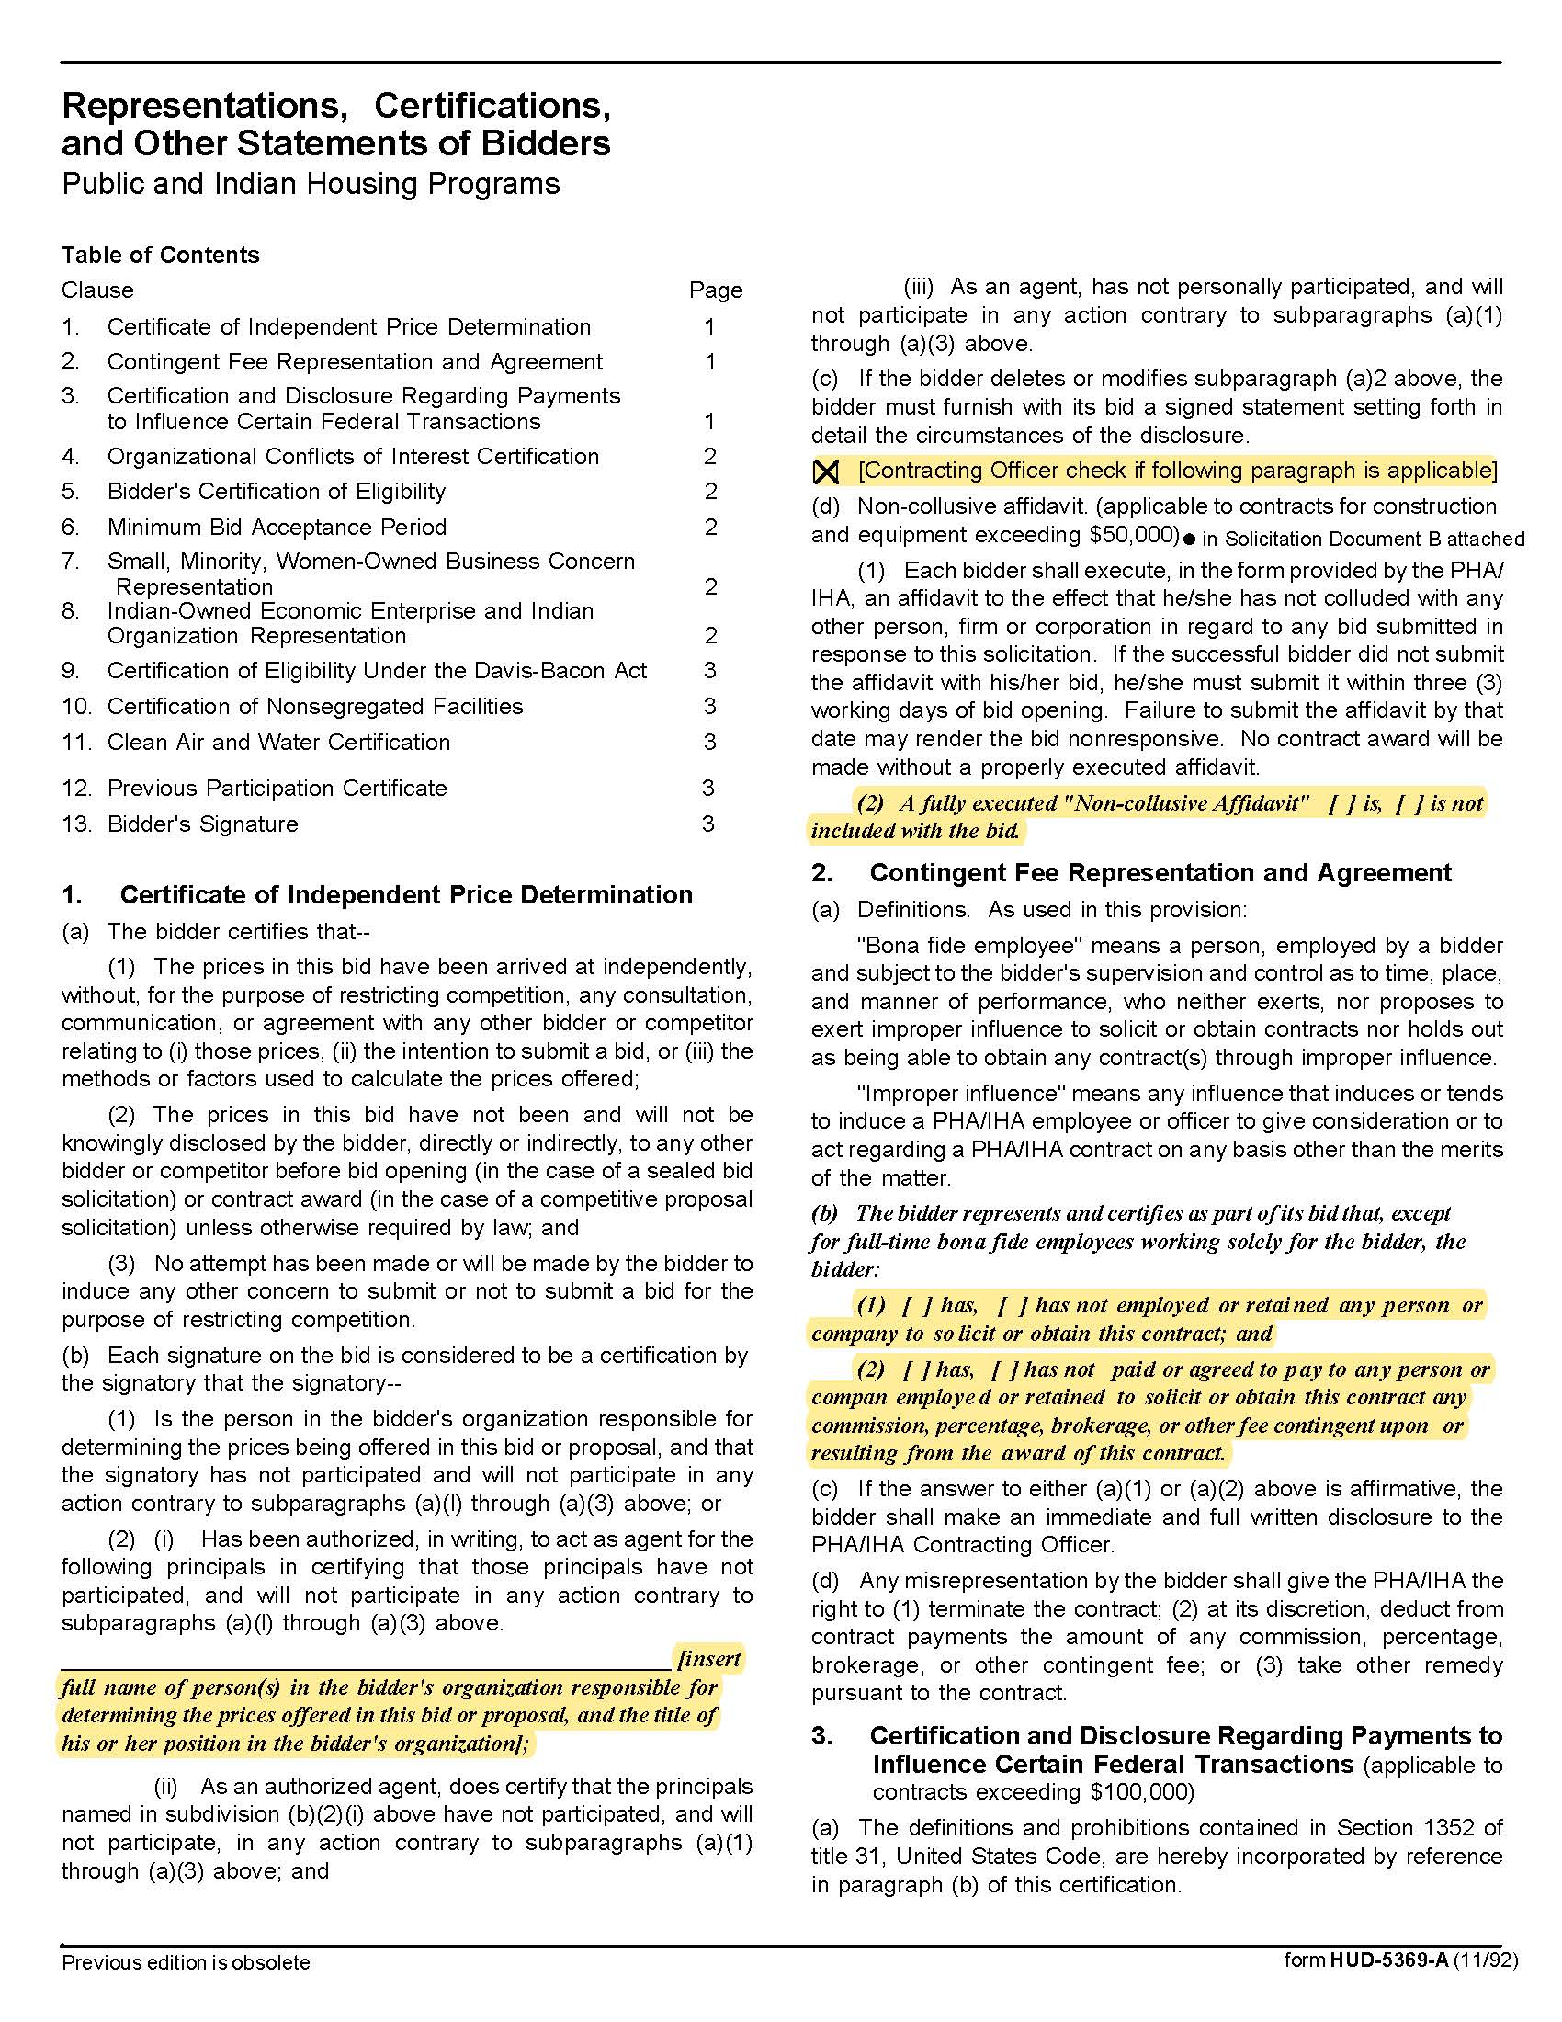

LIHTC Compliance Monitoring Q1927
Solicitation Document C HUD Form 5369A - Continued
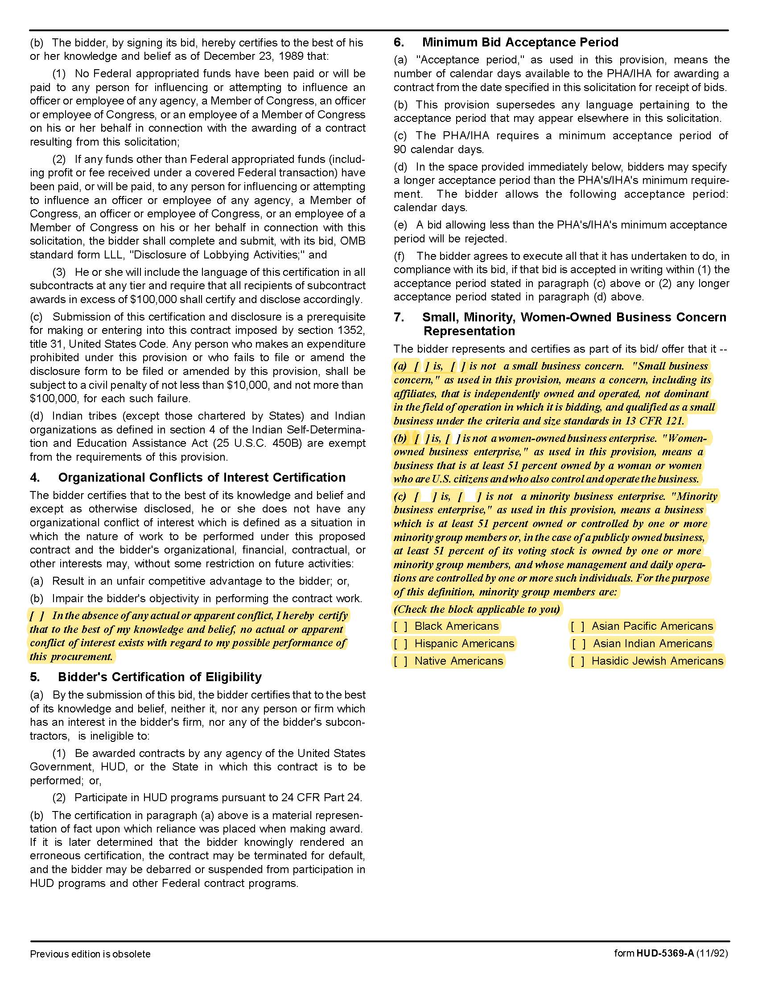

LIHTC Compliance Monitoring Q1927
Solicitation Document C HUD Form 5369A - Continued
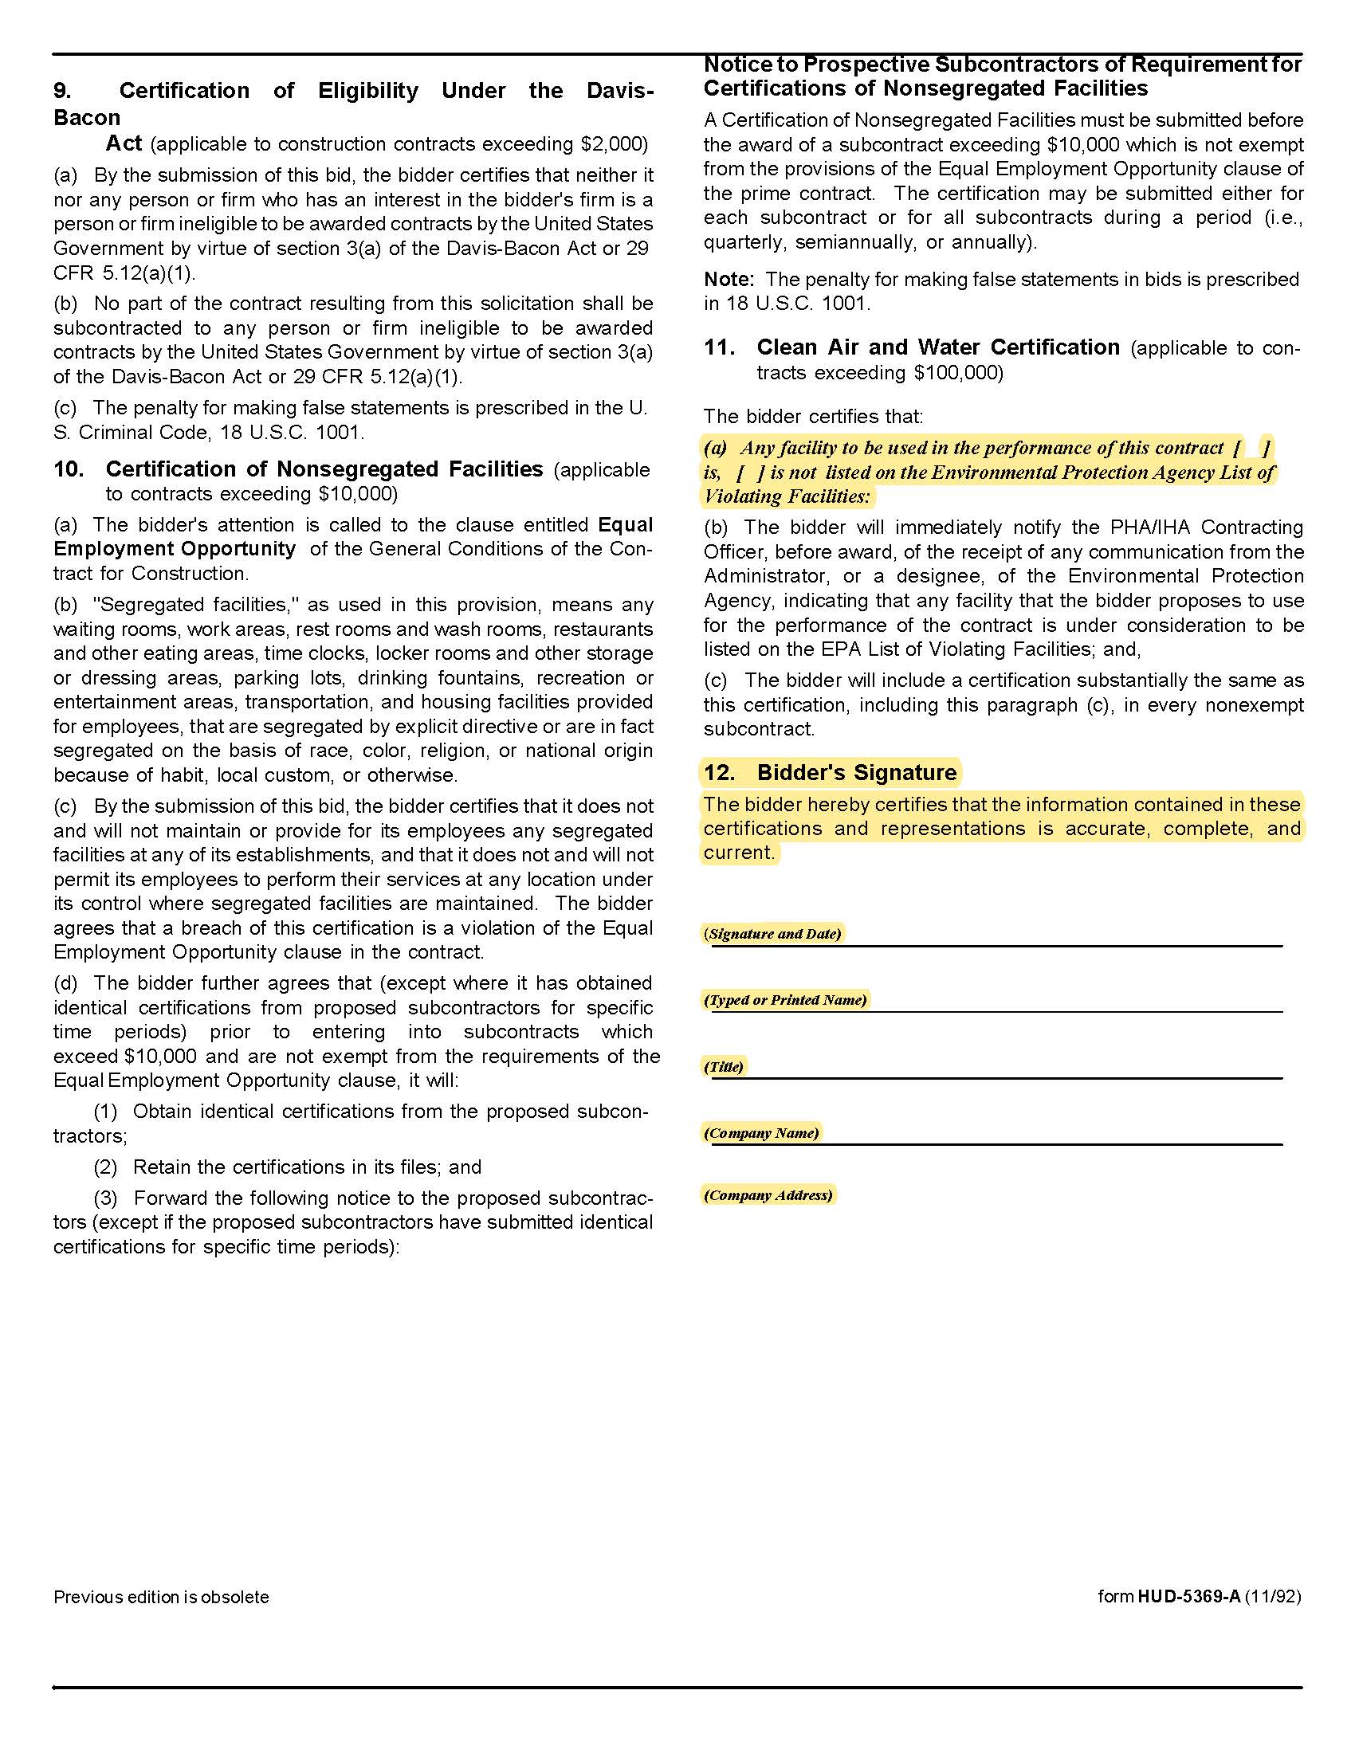

LIHTC Compliance Monitoring Q1927

Solicitation Document D Supplier’s Experience and Qualifications

1. Provide a brief narrative description of the organization submitting the proposal. Include as part of the description:

- Statement explaining your interest in the project
- Organization size
- Organizational structure
- Financial stability
- Years in business
- Legal Status (corporation or partnership, et cetera)
- Experience in the performance of similar projects in the past three years
- Experience in the performance of similar projects for governmental entities in the past three years
- Overview of the proposed project team; include key individuals, their proposed roles in the project, years
of experience and any current certifications applicable to the professional services the employee will provide
- A brief narrative of why the team is best qualified to provide the services

LIHTC Compliance Monitoring Q1927

Solicitation Document E Response Timelines

Using no more than two pieces of paper provide your guaranteed work completion timelines for the various services detailed herein.

LIHTC Compliance Monitoring Q1927

Solicitation Document F References

Supplier: ________________________________________________________________________________

The proposal must include at least three specific references of similar accounts. While you may have had numerous separate contracts with a particular company, a company can only be one reference.

Name of Business
Contact Person
Contact Person Email Address
Contact Person Telephone Number
Description of Service Provided
Date Contract Began
Date Contract Ended
Approximate Dollar Value of the Contract | $

Name of Business
Contact Person
Contact Person Email Address
Contact Person Telephone Number
Description of Service Provided
Date Contract Began
Date Contract Ended
Approximate Dollar Value of the Contract | $

Name of Business
Contact Person
Contact Person Email Address
Contact Person Telephone Number
Description of Service Provided
Date Contract Began
Date Contract Ended
Approximate Dollar Value of the Contract | $

LIHTC Compliance Monitoring Q1927

Solicitation Document G Cost
Affidavits
Provide costs for your services:

Item | Rate
Standard File Review | $ each
Applicant File Pre-Approval | $ each
Acquisition Rehab-Expedited Review of Existing Tenants | $ each
Final Compliance Review (After Expedited Review) | $ each
Investor Tenant File Annual Compliance Review | $ each
Acquisition Rehab-Standard Review of Existing Tenants | $ each
Expedited File Reviews | $ each
File Correction Review | $ each
Other: | $ each
Other: | $ each
Other: | $ each
Other: | $ each
Other: | $ each
Other: | $ each

