Request for Proposals

Solicitation Name | Temporary Employment Services – Administrative Workers
Solicitation Number | Q2004
Responses Must Arrive No Later Than (As KCDC’s clocks indicate) | 11:00 a.m. on Thursday, September 5, 2019
Deliver Responses to: | Knoxville’s Community Development Corporation    Procurement Division  901 N. Broadway  Knoxville, TN 37917  Procurement is located behind the main office building.
Electronic Copies | Electronic copies are available on KCDC’s webpage or by email at purchasinginfo@kcdc.org.
Responses may be Emailed to KCDC | ☒ Yes ☐ No
Printed Responses Required | ☐ Yes ☒ No
Solicitation Meeting | ☐ Yes ☒ No
Solicitation Meeting is Mandatory | ☐ Yes ☐ No ☒ Not Applicable
Solicitation Meeting Date | Not applicable
Solicitation Meeting Time | Not applicable
Solicitation Meeting Location | Not applicable
Questions About This Solicitation | Submit questions to purchasinginfo@kcdc.org  KCDC will not accept questions via telephone.
Award Results | KCDC posts both a summary of the quotes received and the award decision to its web page at: http://www.kcdc.org/procurement/
Open Records/Public Access to Documents | All document provided to KCDC are subject to the Tennessee Open Meetings Act (TCA 8-44-101) and open records requirements.

Check KCDC’s webpage for addenda and changes before submitting your response

General Information

1. Background and Intent

a. Knoxville's Community Development Corporation (KCDC) is the public housing and redevelopment agency for the City of Knoxville and for Knox County in Tennessee. KCDC’s affordable housing property portfolio includes 20 sites with approximately 3,525 dwelling units. Several of the properties include Low Income Housing Tax Credits units and KCDC is both the General Partner and the management company for those sites. Those properties include Eastport LP, Five Points 1, LP; Five Points 2, LP; Five Points 3, LP; Five Points 4, LP; Lonsdale Homes, LP; Northridge Crossing, LP and The Vista at Summit Hill, LP. KCDC also oversees approximately 3,958 Section 8 Vouchers, 82 Moderate Rehabilitation units and 20 Redevelopment areas. KCDC has issued this solicitation for itself and on the behalf of the various properties that it now provides “management services” as detailed above. Any resulting awards are either for KCDC itself or are on behalf of those properties which KCDC provides “management services.”

b. KCDC has a regular employee base of approximately 130 persons. From time to time, KCDC requires temporary workers to perform additional or supplemental clerical, labor and other functions.

c. The intent of this solicitation is to obtain fixed price proposals from suppliers to provide temporary employment services for various KCDC departments and divisions on an as needed basis.

2. Changes after Award
It is possible that after award KCDC will need to revise the service needs or requirements specified in this document. KCDC reserves the right to make such changes after consultation with the supplier. Should additional costs arise, the supplier must document increased costs. KCDC reserves the right to accept and negotiate these charges.

3. Contact Policy
Only contact KCDC’s Procurement Division about this solicitation from the issuance of this RFP until award. Information obtained from an unauthorized officer, agent, or employee will not affect the risks or obligations assumed by the proposer or relieve the proposer from fulfilling any of the conditions of the resulting award for the purpose of this project. Such contact can disqualify the proposer from the solicitation process.

4. Evaluation
KCDC will evaluate this proposal as detailed below. KCDC alone determines (using NIGP’s definition and other relevant sources as appropriate) the supplier’s “responsive” and “responsible” status prior to award. Responsible means a business with the financial and technical capacity to perform the requirements of the solicitation and subsequent contract. A responsive proposal is one that fully conforms in all material respects to the solicitation document and all of its requirements, including all form and substance. KCDC reserves the right to request additional information to assist in the evaluation process; this includes references and business capacity information.

a. KCDC will review all proposals and reserves the right to request necessary modifications, waive minor technicalities, reject all proposals, reject any proposal that does not meet mandatory requirement(s) or cancel this RFP, according to KCDC’s best interests.

b. KCDC’s Evaluation Team may elect to interview one or more suppliers before making an award. Interviews may include an in person examination of the proposed product. KCDC shall not reimburse the supplier for the costs associated with the interview process.

Factors | Maximum Points
Adequacy and Availability for Temporary Staff Placements | 30
Cost | 30
Credentials/Business Qualifications | 30
Related Experience | 10
Total | 100

c. If oral presentations are required, the Procurement Director will arrange structured oral presentations by each supplier on the shortlist.

d. After completion of interviews and negotiations, the evaluation team will recommend an award to the Procurement Director.

e. The selection of a supplier is subject to the approval of any tax credit partners KCDC may have.

5. General Instructions
KCDC does not insert “General Instructions to Suppliers” in solicitation documents. These instructions are at www.kcdc.org. Click on “Procurement” and the link to the instructions. The supplier’s submittal means acceptance of the terms and conditions set forth in KCDC’s “General Instructions to Suppliers.”

6. Insurance
The supplier agrees to maintain at its sole expense on a primary and non-contributory basis during the term of this agreement insurance coverages and limits in accordance with the supplier’s standard business practices and acceptable to KCDC. Winning proposer shall provide KCDC with Certificates of Insurance evidencing such insurance prior to contract execution.

7. Invoicing/Ordering

a. Until a purchase order is in place, work is not to be performed nor are goods to be delivered. KCDC has no legal obligation to pay for work performed prior to the issuance of a purchase order. Emergency situations are exempted from this statement and such situations can be approved by the Procurement Division.

b. Suppliers are asked to email invoices to the temporary worker’s location supervisor with 10 days following work completion and are required to submit invoices within 90 days following the delivery of the goods or services. KCDC may deny invoices submitted after the 90-day threshold.

c. KCDC pays by electronic transfer (ACH). Supplier’s accounts receivable staff must use KCDC’s Vendor Portal to ascertain payments made and to which invoices they apply. Suppliers will set up an account in KCDC’s Vendor Portal so that they receive an email with each payment detailing the invoice number and the amount paid. KCDC is not able to routinely offer payment history assistance and so if the supplier is unable or unwilling to use KCDC’s Supplier Portal to track payments, consider whether or not to submit a response to this solicitation.

d. The purchase of goods and services for use by KCDC owned properties are exempt from Tennessee
sales and use tax pursuant to Tennessee Code Annotated 67-6-329(a) (4) and KCDC is generally exempt from the Federal Excise tax. Upon the placement of a purchase order or the award of a contract, KCDC will provide a State of Tennessee Sales Tax Exemption form to the supplier. KCDC will not pay taxes on invoices for its tax exempt properties; however, certain properties are not exempt from taxation and their invoices should include applicable taxes. These are: Eastport LP, Five Points 1, LP; Five Points 2, LP; Five Points 3, LP; Five Points 4, LP; Lonsdale Homes, LP; Northridge Crossing, LP and The Vista at Summit Hill, LP.

e. Since KCDC is the managing partner for nine separate corporations under the KCDC umbrella, those separate corporations must receive separate invoices. Thus the supplier will generally:

- Bill each assigned worksite separately for work performed
- Email invoices to reporting Supervisor at each site

f. Invoices must:
- Be numbered
- List workweek dates being billed
- Be distributed after the workweek is complete and hours are approved by reporting supervisor
- List the purchase order number
- Breakdown pricing according to the award structure

8. Length of Award
The length of the contract will be twelve months with four optional annual renewals that KCDC may exercise at its discretion.

9. Price Structure

a. At the end of each twelve month period, the awarded supplier may request a change to the percentage and/or specific item charged to KCDC. The supplier must provide proof of increased Producer Price Index (Knoxville) to the Procurement Division. Suppliers may lower prices at any time with or without notice. KCDC will decide whether to accept a price increase. If the price increase is accepted, the solicitation file will be so noted. If the price increase is not accepted, the supplier may:

1. Continue with the existing pricing.
2. Suggest an alternative price increase.
3. End the award.

b. KCDC does not pay fuel surcharges.
10. Questions
Send direct questions pertaining to this document to purchasinginfo@kcdc.org with “Temporary Employment Services” in the subject line, at least five business days prior to the due date. KCDC does not accept questions via telephone.

11. Submittal Instructions
Submit your information in the order indicated below:

Document Number | Title | Form Provided by
Solicitation Document A | General Response Section | KCDC
Solicitation Document B | Affidavits | KCDC
Solicitation Document C | HUD Form 5369A | KCDC
Solicitation Document D | Supplier’s Experience & Qualifications | Supplier
Solicitation Document E | Supplier’s Adequacy & Availability of Temporary Staffing Placements | Supplier
Solicitation Document F | Supplier’s References | Supplier
Solicitation Document G | Supplier’s Cost Proposal | Supplier

a. Do not use phrases such as “See the attached” or “Will be provided upon award.”

b. Bind proposals simply since KCDC ultimately scans documents into electronic format. Acceptable binding methods include paper clips, staples, binder clips and three ring binders.

Scope of Work

1. General
All proposals must be made on the basis of, and either meet or exceed, the requirements contained herein.

2. Absences, Dismissals and Lack of Qualifications

a. Supplier shall provide a properly qualified temporary worker as soon as possible for any temporary worker who has reported absent at the beginning of the shift, if desired by KCDC.

b. If KCDC determines the temporary worker does not meet the qualifications of the position description placed, KCDC reserves the right to negotiate a lesser rate and/or discontinue the temporary assignment.

c. KCDC reserves the right to refuse/dismiss any temporary worker at any time with or without notice.

3. Assignments

a. The supplier shall not solicit KCDC employees to hire temporary workers or review temporary workers information unless it was first requested by KCDC HR Staff or KCDC hiring supervisor. The supplier may send limited marketing emails to KCDC’s Human Resource Department, not hiring supervisors.
b. All temporary workers shall be on site at the time requested in proper attire for the work assignment. If temporary workers do not report to work on time or in appropriate attire, as detailed in Item 8, KCDC reserves the right to request different temporary workers or to cancel the placement.

4. Background and Screening Services

a. Prior to being placed with KCDC, all temporary workers shall undergo a background screening provided by the supplier. The screening includes eligibility to work in the United States and verification of their work history and criminal background check. Temporary workers also must undergo a 10 panel urine drug test and breath alcohol testing.

b. The supplier must notify KCDC of any confirmed felony convictions (within 10 years) associated with the temporary worker prior to providing temporary leased workers.

c. The supplier shall supply KCDC’s Human Resources Department with the full name of the temporary worker and a brief work history prior to placement for internal review.

5. Communication Skills
Unless otherwise requested, all temporary workers must be able to read, write, speak and comprehend the English language in accordance with the minimum requirements of the position description.

6. Confidentiality
The supplier acknowledges and understands that its workers may have access to proprietary, business information or other confidential information belonging to KCDC. Therefore, except as required by law, the supplier agrees that its workers will not:

a. Access or attempt to access data that is unrelated to their job duties or authorizations as related to this solicitation.

b. Access or attempt to access information beyond their stated authorization.

c. Disclose to any other person or allow any other person access to any information related to KCDC or any of its facilities or any other user of this solicitation that is proprietary or confidential. Disclosure of information includes, but is not limited to, verbal discussions, fax transmissions, electronic mail messages, voice mail communication, written documentation, “loaning” computer access codes and/or another transmission or sharing of data.

d. The supplier understands that KCDC, or others may suffer irreparable harm by disclosure of proprietary or confidential information and that KCDC may seek legal remedies available to it should such disclosure occur. Further, the supplier understands that violations of this provision may result in award termination.

e. The supplier further understands that information and data obtained during the performance of this agreement shall be considered confidential, during and following the term of this solicitation, and will not be divulged without KCDC’s written consent and then only in strict accordance with prevailing laws. The supplier shall hold all information provided by the supplier as proprietary and confidential, and shall make no unauthorized reproduction or distribution of such material.

7. Courtesy and Cordiality towards All Others
Temporary workers shall be respectful of all people with whom they interact, including KCDC employees and customers. KCDC reserves the right to reject any temporary workers that do not exhibit common courtesy and cordiality towards all individuals with which they may come in contact.

8. Dress Codes
Dress for all temporary workers will be appropriate for the work assignment.

a. Business Casual Attire is appropriate for clerical workers. Business casual means clothes that are professional and comfortable, including but not limited to dress slacks, khaki pants, polo shirts with a collar, sport coats, blouses and sweaters.

b. The clothes will be neat, clean and without holes.

c. Refusal to wear KCDC provided personal protective equipment (PPE) will result in temporary workers being dismissed or refused.

9. Driver’s Licenses
Certain positions may require valid Driver’s Licenses.

10. Drug Testing
All temporary workers must have passed a recent 10 panel drug and breath alcohol screening (within one year of placement at KCDC). The supplier will pay for these tests.

11. DMV Check
If driving is a requirement of a position, KCDC will require a Department of Motor Vehicle check before the temporary worker begins work. The cost of this service shall be incurred by the supplier. A copy of the DMV report may be requested by KCDC.

12. Employed by the Supplier
The supplier shall employ all temporary workers. The supplier shall be responsible for all payroll taxes, worker’s compensation, insurance and other federal and state requirements for temporary workers. KCDC is not the employer.

13. FSLA
KCDC will not be considered a joint employer of the supplier’s temporary workers under this contract. Furthermore, KCDC will not be liable for violations of the Fair Labor Standards Act (FLSA). Specifically, the supplier shall:

a. Determine the FLSA status (exempt or non-exempt) status of their employees.
b. Keep track of the total hours its workers actually work, for all employers, in each workweek.

c. Compute and pay its worker’s wages, including overtime and benefits.

d. Maintain FLSA required records for its workers.

14. Independent Status
The parties to this solicitation are independent suppliers and none of the provisions of this solicitation and award shall be interpreted or deemed to create any relationship between such parties other than that of independent suppliers. Nothing contained in this award shall be construed to create a relationship of employer and employee, master and servant, principal and agent, or co-venture between KCDC and the supplier, between KCDC and any employee of the supplier, or between the supplier and any KCDC employee. KCDC shall have no right to control or direct the details, manner or means by which the supplier performs the services or other requirements of this contract except to require compliance with such requirements, and the supplier, similarly, shall have no control over or management authority with respect to KCDC or its operations.

15. Interviews
Depending on the length or type of assignment, resumes and interviews may be requested. KCDC reserves the right to reject any temporary workers for any reason.

16. Job Placement Assurance

a. The supplier shall provide the appropriate contact person, phone numbers and email address, which KCDC can call to make requests.

b. The supplier shall assure a suitable placement to a job order within a reasonable amount of time.

17. No Trespass List
KCDC maintains a No Trespass List. All temporary workers must be verified by KCDC’s Human Resources Department not to be on the No Trespass List prior to reporting to worksite.

18. Refusal
KCDC has the right at any time to refuse or determine unacceptable, any temporary workers assigned by the supplier. Once refused, temporary workers shall be immediately removed and prompt arrangements made for a suitable replacement.

19. Removal of Supplier’s Workers
Supplier agrees to utilize only experienced responsible and capable temporary workers in the performance of the work. KCDC may require the supplier to remove from the job covered by this solicitation, workers who endanger persons or property or whose continued employment under this contract is inconsistent with the interests of KCDC.

20. Time Cards
The supplier shall provide all temporary workers with time cards or other appropriate timekeeping methods. Hours worked will be approved, on a daily or weekly basis, by a KCDC supervisor prior to being billed. KCDC will pay only for actual hours worked at the designated KCDC location. KCDC will not pay other expenses or allowances unless so indicated in the proposal and approved by KCDC. Temporary workers shall be trained on the supplier’s process of timekeeping.

Each proposal shall include an example and/or template of timekeeping methods for KCDC’s review and approval.

21. Transportation
It is the temporary worker’s responsibility to provide transportation to and from the required locations.

22. Security
If a temporary worker is assigned any access keys, fobs, badges or other tangible items during the assignment, those must be returned or the temporary agency must reimburse KCDC for the expense of the replacement items.

22. Supplier Responsibilities
The supplier will:

a. Provide competent workers with the qualifications specified for each job assignment.

b. Provide replacement workers within a timely fashion after notification when KCDC determines a temporary worker is not acceptable. KCDC reserves the right to reject or to have replaced any temporary workers judged deficient by the ordering department/division.

c. Ensure that temporary workers assigned are in good health, proper physical condition and free from the influence of altering drugs, medicine, alcohol, et cetera.

d. Ensure that all temporary workers can fulfill the physical requirements of the job. This includes but is not limited to lifting requirements.

e. Ensure all temporary workers report to work at the specified facility at the scheduled time and in the proper attire.

f. Understand that each temporary worker shall receive one thirty minute break per six-hour shift in accordance with Tennessee state regulations. This is unpaid and the supervisor determines the timing of the break. A one-hour unpaid lunch may be requested but its granting is not guaranteed.

g. Understand that once assigned, the temporary workers shall complete the full assignment unless KCDC releases the temporary worker.

h. Understand that assigned temporary workers will work the requested daily work hours for the time periods specified.
i. Understand that the “Hourly Rate Billed to KCDC” will be straight time up to forty hours. The straight time rate shall be increased by a factor of 1.5 for each hour worked, during a single workweek, in excess of forty hours (overtime). The temporary worker must get permission from KCDC staff prior to working more than 40 hours in a single workweek.

j. Understand that KCDC will not pay for holiday hours or for hours that the company or specific work location closes due to inclement weather, companywide meetings or any other reason.

k. Understand the supplier is solely responsible for the provision of and payment for all workers compensation claims. KCDC does not and will not assume any liability for any worker's compensation claims, injuries or other claims that a temporary worker may file. Such claims shall be the sole responsibility of the supplier.

l. Acquaintances, family members, assistants or any person will not accompany workers in their work area.

23. Work Hours
Generally, KCDC employees work Monday through Friday from 7:30 a.m. until 4:00 p.m. There are occasional variances in this schedule. Workhours will be confirmed at placement, but are subject to change as business needs require during assignment. Temporary workers will be notified in advance of any changes in work hours.

THIS AND THE PREVIOUS NEED NOT BE RETURNED

Temporary Employment Services – Administrative Workers Q2004

Solicitation Document A General Response Section

General Information about the Supplier
Sign Your Name to the Right of the Arrow
By signing, you indicate you read and agree to “KCDC’s General Instructions to Suppliers” on www.kcdc.org.
Printed Name and Title
Company Name
Street Address
City/State/Zip
Contact Person (Please Print Clearly)
Telephone Number
Cell Number
Supplier’s E-Mail Address (Please Print Clearly)
Addenda
Addenda are at www.kcdc.org. Click on “Procurement” and then on “Open Solicitations” to find addenda. Please check for addenda prior to submitting a proposal.
Acknowledge addenda have been issued by checking below as appropriate:
None ☐ | Addendum 1 ☐ |  |  | Addendum 2 ☐ |  | Addendum 3 ☐ |  |  | Addendum 4 ☐ | Addendum 5 ☐
Statistical Information (Check all the apply)
This business is at least 51% owned and operated by a woman |  |  |  |  |  |  |  |  |  |  | Yes ☐ No ☐
This business qualifies as a small business by the State of Tennessee  Total gross receipts of not more than $10,000,000 average over a three-year period OR employs no more than 99 persons on a full-time basis |  |  |  |  |  |  |  |  |  |  | Yes ☐ No ☐
This business qualifies as Section 3 business (as defined by HUD):  It is at least 51% owned by a Section 3 resident (lives in Public Housing) or it employs Section 3 residents for at least 30% of its employee base; or it commits to sub contract at least 25% of the project’s dollars to a Section 3 business. |  |  |  |  |  |  |  |  |  |  | Yes ☐ No ☐
This business is owned & operated by persons at least 51% of the following ethnic background:
Asian/Pacific ☐ |  | Black ☐ | Hasidic Jew ☐ |  | Hispanic ☐ |  |  | Native Americans ☐ |  |  | White ☐
Cooperative Procurement
Subject to additional location/delivery charges, the supplier agrees to extend the offered costs to other governments if the government so desires. Yes ☐ No ☐
Prompt Payment Discount
A prompt payment discount of ________% is offered for payment within ____ days of submission of an accurate and proper invoice.
MasterCard Acceptance
MasterCard is accepted for payment without additional fees. Yes ☐ No ☐
MasterCard is accepted for payment with a fee of _______. Yes ☐ No ☐

Temporary Employment Services – Administrative Workers Q2004

Solicitation Document B Affidavits

Supplier: _____________________________________________________________________________

Conflict of Interest:
1. No commissioner or officer of KCDC or other person whose duty it is to vote for, let out, overlook or in any manner superintend any of the work for KCDC has a direct interest in the award or the supplier providing goods or services.

2. No employee, officer or agent of the grantee or sub-grantee will participate in selection, or in the award or administration of an award supported by Federal funds if a conflict of interest, real or apparent, would be involved. Such a conflict would arise when the employee, officer or agent, any member of his immediate family, his or her partner, or an organization, which employs, or is about to employ, any of the above, has a financial or other interest in the supplier selected for award.

3. The grantee's or sub-grantee's officers, employees or agents will neither solicit nor accept gratuities, favors or anything of monetary value from suppliers, potential supplier s, or parties to sub-agreements.

4. By submission of this form, the supplier is certifying that no conflicts of interest exist.

Drug Free Workplace Requirements:
5. Private employers with five or more workers desiring to contract for construction services attest that they have a drug free workplace program in effect in accordance with TCA 50-9-112.

Eligibility:
6. The supplier is eligible for employment on public contracts because no convictions or guilty pleas or pleas of nolo contender to violations of the Sherman Anti-Trust Act, mail fraud or state criminal violations with an award from the State of Tennessee or any political subdivision thereof have occurred.

General:
7. Supplier fully understands the preparation and contents of the attached offer and of all pertinent circumstances respecting such offer.

8. Such offer is genuine and is not a sham offer.

Iran Divestment Act:
9. Concerning the Iran Divestment Act (TCA 12-12-101 et seq.), by submission of this bid/quote/proposal, each supplier and each person signing on behalf of any supplier certifies, and in the case of a joint bid/quote/proposal, each party thereto certifies as to its own organization, under penalty of perjury, that to the best of its knowledge and belief that each supplier is not on the list created pursuant to § 12-12-106.

Temporary Employment Services – Administrative Workers Q2004

Solicitation Document B Affidavits - Continued

10. Neither the said supplier nor any of its officers, partners, owners, agents, representatives, employees or parties interest, including this affiant, has in any way colluded conspired, connived or agreed, directly or indirectly, with any other responder, supplier, or person to submit a collusive or sham offer in connection with the award or agreement for which the attached offer has been submitted or to refrain from making an offer in connection with such award or agreement, or collusion or communication or conference with any other supplier, or, to fix any overhead, profit, or cost element of the offer price or the offer price of any other supplier, or to secure through any collusion, conspiracy, connivance, or unlawful agreement any advantage against KCDC or any person interested in the proposed award or agreement.

11. The price or prices quoted in the attached offer are fair, proper and not tainted by any collusion, conspiracy, connivance, or unlawful agreement on the part of the supplier or any of its agents, representatives, owners, employees, or parties in interest, including this affiant.

Accuracy of Electronic Copies:
12. If the supplier provides electronic copies of the bid/proposal/quote to KCDC, the supplier certifies that the information provided on paper and in the electronic format is identical unless specifically noted otherwise.

No Contact/No Advocacy Affidavit:
13. After this solicitation is issued, any contact initiated by any supplier with any KCDC representative
concerning this solicitation is strictly prohibited-except for communication with the Procurement Division. My signature signifies that no unauthorized contact occurred.

14. To ensure the integrity of the review and evaluation process, respondents to this solicitation nor any firm representing them, may not lobby or advocate to KCDC staff or Board members. My signature signifies that no unauthorized advocacy occurred.

The undersigned hereby acknowledges receipt of these affidavits and certifies that the submittal in response to this solicitation is in full compliance with the listed requirements.

Signed by
Printed Name
Title
Subscribed and sworn to before me this date
By (Notary Public)
My Commission Expires on
Notary Stamp
Temporary Employment Services – Administrative Workers Q2004
Solicitation Document C HUD Form 5369A

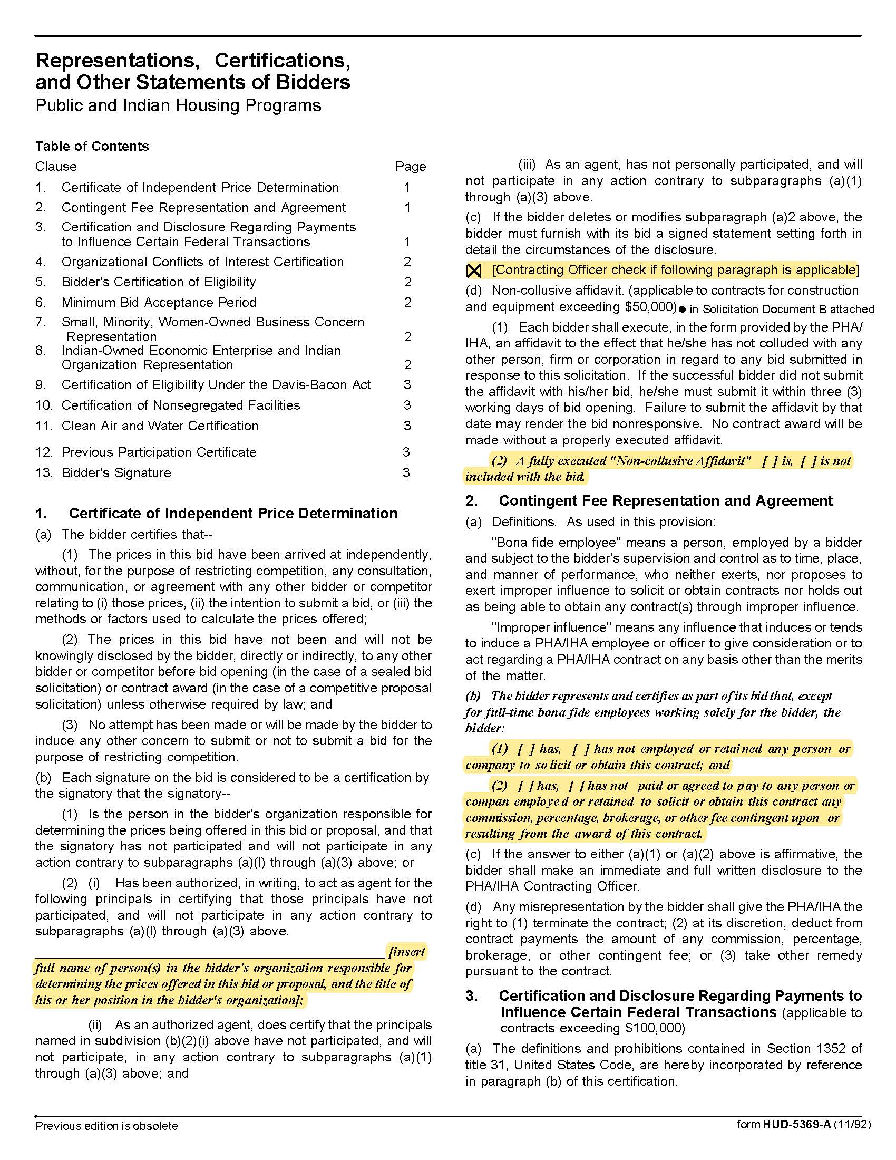

Temporary Employment Services – Administrative Workers Q2004
Solicitation Document C HUD Form 5369A - Continued
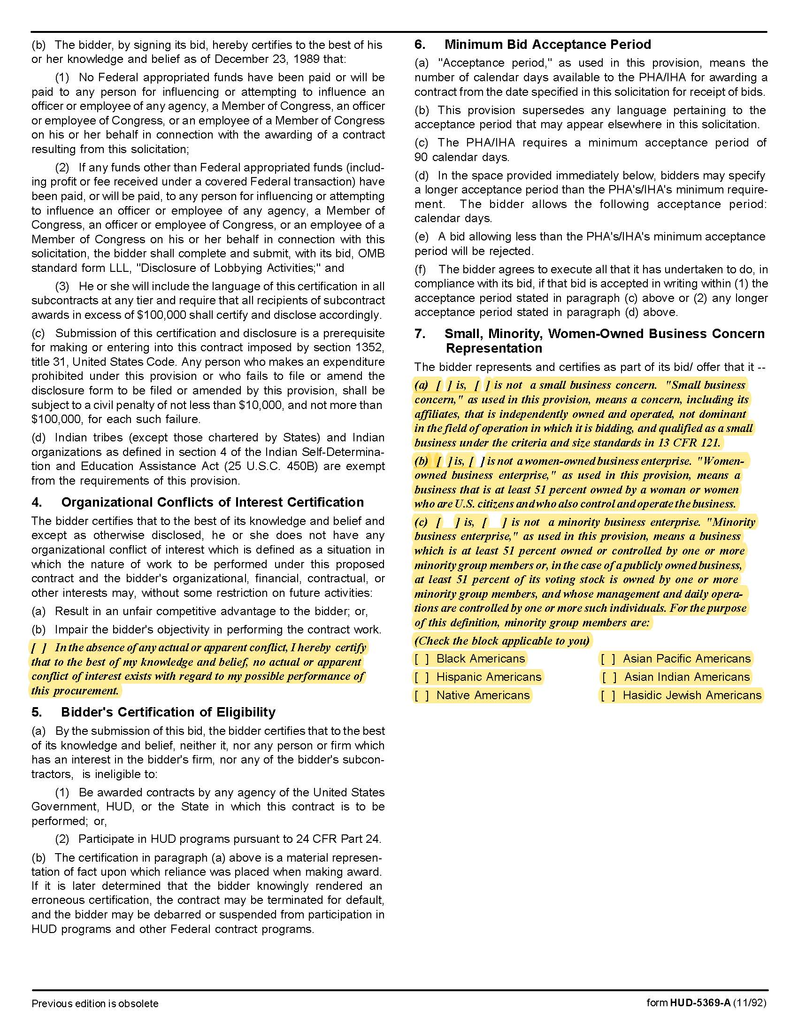

Temporary Employment Services – Administrative Workers Q2004
Solicitation Document C HUD Form 5369A - Continued
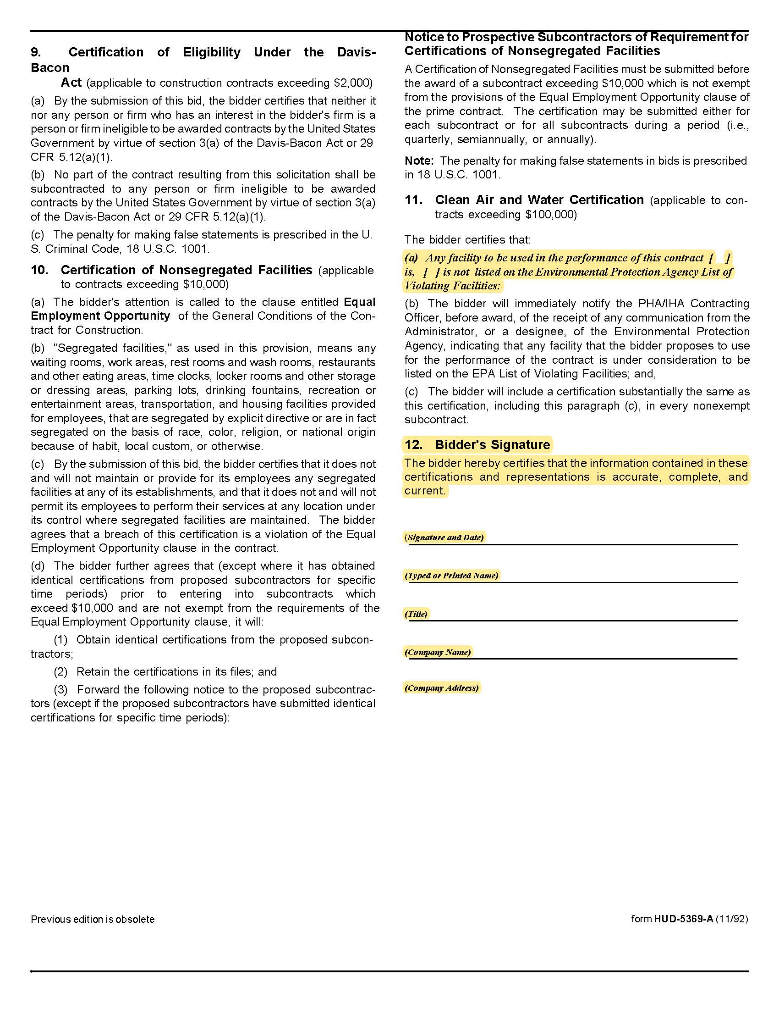

Temporary Employment Services – Administrative Workers Q2004

Solicitation Document D Supplier’s Experience and Qualifications

Provide a brief narrative description of the organization submitting the proposal. Include as part of the description:

- Brief overview of company’s operations
- Brief description of company’s ability to meet or exceed the requirements detailed herein
- Organization size
- Years in business
- Legal Status (corporation or partnership, et cetera)
- Provide a sample timesheet or access to a web portal for review
- Describe your company’s client follow-through process for finding a worker and follow through during the worker’s assignment
- Describe your company’s methods for solving particularly challenging staffing assignments/emergency requests
- Describe how you prepare your workers for their assignments
- What training opportunities do you offer to workers; note if training is required or not required. Specifically note the following:
  - Confidentiality
  - Driver Safety
  - Drug Free Workplace
  - Harassment Prevention
  - OSHA Hazard Communications Standard Training
  - Safety
- Describe any programs in place to reward and retain workers
- Describe your customer satisfaction feedback mechanisms
- Describe your processes for evaluating the performance of your workers

Temporary Employment Services – Administrative Workers Q2004

Solicitation Document E Supplier’s Adequacy & Availability of Temporary Staffing Placements

Use this section to detail your company’s adequacy and availability of temporary staffing placements. Be specific and be detailed. Use as many pages as necessary to help KCDC fully understand how you plan to service our needs.

1. Adequacy and availability of temporary worker placements:

a. Describe the process by which you select and provide temporary workers to KCDC once a request is received.

b. Does your company have a database of temporary workers from which requests are filled?

c. Describe the screening and testing process of temporary workers before assigning them to a position.

d. Describe your company’s method/process to fill requests as quickly as possible.

e. What is your company’s average placement time (list by position)?

2. Include other information that the supplier wishes to provide to assist KCDC in the evaluation.

3. Describe your company’s methods of sourcing, recruiting and assessing temporary workers by job class (i.e. clerical/administrative, technical, professional).

4. What methods do you use to establish local wage levels and how often are these levels reevaluated?

5. Describe your company’s pre-employment requirements, including driver license verification, drug screening and background checks and the frequency of each.

6. Describe the benefits you offer temporary workers.

7. Describe the cost structure associated with the temporary workers to hire process. Note by position, if different. Can structure change as part of long term contract?

Temporary Employment Services – Administrative Workers Q2004

Solicitation Document F References

Supplier: ________________________________________________________________________________

The proposal must include at least three specific references of similar accounts. While you may have had numerous separate contracts with a particular company, a company can only be one reference.

Name of Business
Contact Person
Contact Person Email Address
Contact Person Telephone Number
Description of Service Provided
Date Contract Began
Date Contract Ended
Type of positions placed for this client
Identify any contract issues and describe how they were resolved
Approximate number of placements within an average 12 month period

Name of Business
Contact Person
Contact Person Email Address
Contact Person Telephone Number
Description of Service Provided
Date Contract Began
Date Contract Ended
Type of positions placed for this client
Identify any contract issues and describe how they were resolved
Approximate number of placements within an average 12 month period

Temporary Employment Services – Administrative Workers Q2004

Solicitation Document F References – Continued

Supplier: ________________________________________________________________________________

Name of Business
Contact Person
Contact Person Email Address
Contact Person Telephone Number
Description of Service Provided
Date Contract Began
Date Contract Ended
Type of positions placed for this client
Identify any contract issues and describe how they were resolved
Approximate number of placements within an average 12 month period

Affidavits

Temporary Employment Services – Administrative Workers Q2004

Solicitation Document G Cost

Supplier: ________________________________________________________________________________

Position | Hourly Pay Rate | Markup % | Hourly Billing Rate
Accountant | $ | % | $
Accounting Technician | $ | % | $
Administrative Assistant | $ | % | $
Receptionist | $ | % | $
Other Positions – Include Description
Position | Hourly Pay Rate | Markup % | Hourly Billing Rate
Other: | $ | % | $
Other: | $ | % | $
Other: | $ | % | $

