Request for Proposals

Equity Investor

Solicitation Number | C18004
Due Date | October 27, 2017
Due Time | 11:00 a.m. eastern standard time
Deliver Responses to: |   Knoxville’s Community Development Corporation  Procurement Division  901 N. Broadway  Knoxville, TN 37917  Note: Procurement is in a separate building behind the main office building
Electronic Copies: | Proposers are encouraged to provide a typed response to this solicitation.
May responses be emailed to KCDC | ☒ Yes ☐ No
Questions About This Solicitation | Submit questions to purchasinginfo@kcdc.org

Check KCDC’s webpage for addenda before submitting your proposal

General Information

1. BACKGROUND AND INTENT

a. Knoxville's Community Development Corporation (KCDC) is the public housing and redevelopment agency for the City of Knoxville and for the County of Knox in Tennessee. In recent years, KCDC created several subsidiary corporations to own and manage low-income properties through the Low Income Housing Tax Credit (LIHTC) program. KCDC controlled General Partners currently have almost 1,000 units either currently operating or under rehab/construction within the LIHTC program. KCDC and its subsidiaries have a total property portfolio including 20 sites with over 3,700 dwelling units. KCDC also administers approximately 3,958 Section 8 vouchers and 82 moderate rehabilitation units through our Section 8 department.

b. In 1936, the State of Tennessee chartered KCDC as the public housing authority for the City of Knoxville. In 2012, KCDC assumed the duties of the former Knox County Housing Authority. KCDC operates as a municipality under Tennessee law.

c. KCDC’s mission is to create, provide and increase high quality housing opportunities for Knoxville and Knox County residents through effective and responsive management and responsible stewardship of public and private funds.

d. This RFP is to accomplish two goals. First, is to award to a qualified equity partner for the specified project. The second purpose is to establish a pool of pre-qualified potential equity partners for up to five years. As KCDC has needs, KCDC may request proposals from the qualified pool without further formal solicitations. Such opportunities will typically have a very quick turnaround requirement.

e. KCDC has been allocated 9% Low Income Housing Tax Credits (LIHTC) in an annual amount of 1.1 million for the third phase of its Five Points redevelopment project through the Tennessee Housing Development Agency (THDA). KCDC desires to find a LIHTC investor to purchase the LIHTC allocation. Because THDA also offers the Community Investment Tax Credit (CITC) loan program, KCDC intends to pair our LIHTC credits with a CITC loan.

f. KCDC’s 2017 Final Audit is available at www.kdc.org/https://www.kcdc.org/about/financials/ .

2. CONTACT POLICY
The proposer may not contact anyone about this solicitation, other than the KCDC’s Procurement Division from the issuance of this RFP until award. Additionally, such contact can disqualify the proposer from participation in the solicitation process.

3. EVALUATION
All responses are subject to a determination of “responsive” and “responsible” prior to award. KCDC is the sole judge as to proposer “responsiveness” and “responsibility.” KCDC reserves the right to request additional information to assist in the evaluation process. This includes references and business capacity information.

a. KCDC will review all proposals and reserves the right to request necessary modifications, waive minor technicalities, reject all proposals, reject any proposal that does not meet mandatory requirement; reject incomplete proposals, proposals offering alternate or non-requested services or cancel this RFP, according to KCDC’s best interests.

b. KCDC’s Evaluation Team may elect to interview one or more proposers before making an award.

c. Proposers shall submit a formal letter of intent and shall also fill out KCDC’s Equity Investor spreadsheet, both of which also serve as the basis for the evaluation of this proposal:

- Total value of the Tax Credit proposal incorporating:
  - Total amount of tax credits paid
  - Please assume the following for pay-in so all proposals can be reviewed equally:
    - 10% at closing
    - 5% at construction completion
    - 82.5% on January 1, 2020
    - 2.5% at 8609
  - Description of adjusters
  - Capped amount of due diligence, legal, or other closing fees
  - Construction management fees
  - Any ongoing fees charged to the project

- CITC Lending
  - Experience in combining CITC and tax credits or
  - Willingness to incorporate a CITC Lender
  - See https://thda.org/business-partners/community-investment-tax-credit for details.

- Pay-in schedule of Developer Fee
- Ability to rely on proposal
- Terms of the proposal
  - Anticipated purchase option language
  - Any guaranties required and limits to guaranties
  - Detailed description of the terms of recapture
  - Any other terms you would like us to consider
4. GENERAL INSTRUCTIONS
KCDC does not insert “General Instructions to Suppliers” in the solicitation document. These instructions are at www.kcdc.org. Click on “Procurement” and follow the link. By submitting a response to this solicitation, the proposer accepts the responsibility for downloading, reading and abiding by the terms and conditions set forth in KCDC’s “General Instructions to Suppliers.” Not every item listed in the General Instructions will apply to this solicitation.

5. INSURANCE
The proposer agrees to maintain at its sole expense during the term of this agreement insurance coverages and limits in accordance with the proposer’s standard business practices and acceptable to KCDC. Proposer shall provide KCDC with Certificates of Insurance evidencing such insurance prior to contract execution.

6. LICENSES
The proposers shall maintain all licenses necessary to conduct business in the State of Tennessee.

7. QUESTIONS
Direct questions pertaining to this document to purchasinginfo@KCDC.org with “Equity Investor” in the subject line, at least five days prior to the due date.

8. RESERVATION OF RIGHTS

a. KCDC reserves the right to terminate a contract awarded pursuant to this RFP, at any time for its convenience, upon 10 days’ written notice to the successful proposer.

b. KCDC reserves the right to retain all proposals submitted and not permit withdrawal for a period of 60 days subsequent to the deadline for receiving proposals without the written consent of KCDC’s Procurement Director.

c. KCDC reserves the right to negotiate the fees proposed by the firm if it so desires.

d. KCDC has no obligation to compensate proposers for costs incurred in responding to this RFP.

9. SUBMITTALS
All proposals, responses, inquiries, or correspondence relating to or in reference to this RFP, and all reports, charts, displays, schedules, exhibits, and other documents provided by companies will become KCDC’s property of when received.

All documents submitted are subject to Tennessee’s broad public records laws. Upon award, KCDC must make all documents available to Tennessee residents upon request.

Project Description/Scope of Work

10. PROJECT DESCRIPTION
The project will be built on approximately 8.35 acres owned by KCDC and ground leased to the partnership. The project is in a qualified census tract. Demolition of the current units is underway and should be completed (along with the site preparation) by January 2018. That scope of work, along with perimeter infrastructure work (utilities and drainage) and upgraded city streets is excluded from this project and is funded from other sources. The proposed LIHTC project consists of 80 units in 28 buildings, which has 46 one-bedroom units; 16 two-bedroom units; and 18 three-bedroom units.

11. SCHEDULE
KCDC would like to have the financial closing in February 2018 with construction to start soon after, with an anticipated completion of July 2019.

12. DEVELOPMENT TEAM

a. General Partner: KCDC created the Five Points 3 Corporation, a 100% owned instrumentality to be the General Partner. KCDC manages and rents more than 3,700 units across more than 20 properties. KCDC has a great deal of experience with LIHTC over the years and KCDC controlled General Partners currently have almost 1,000 units either currently operating or under rehab/construction within the LIHTC program.

b. Developer: The Five Points 3 Corporation will also serve as the developer.

c. Property Manager: KCDC
d. Construction Consultant/Owner’s Representative:
Partner’s Development. Partners Development has helped KCDC on first two phases of the Five Points redevelopment as well as a number of other projects, helping organize the project from beginning to end, working to prevent delays or cost overruns.

e. Architect: Barber McMurry along with Urban Design Associates as consultants.

f. Attorneys: Jordana Nelson and Mark Mamantov of Bass, Berry, & Sims.

g. General Contractor: In the process of bidding.
13. OWNERSHIP STRUCTURE
The Owner of the property will be the Five Points 3 LP, a Tennessee Limited Partnership. As stated above, the General Partner is the Five Points 3 Corporation, a Tennessee Corporation (100% owned KCDC instrumentality).

14. SUBMITTAL STRUCTURE INSTRUCTIONS

a. Order your proposal in this sequence:
- Introductory cover letter
- Solicitation Document A General Information
- Solicitation Document B Affidavits
- Letter of Intent/Five Points Phase 3 Equity Proposals

b. Submit one original (with all pages marked “original”), three printed copies and one electronic copy (email or flash drive) of your submittal).

Equity Investor C18004

Solicitation Document A General Response Section

General Information about the Proposer
Sign Your Name to the Right of the Arrow
Your signature indicates that you have read and agree to “KCDC’s General Instructions to Suppliers” on www.kcdc.org.
Printed Name and Title
Company Name
Street Address
City/State/Zip
Contact Person (Please Print Clearly)
Telephone Number
Cell Number
Proposer’s e-mail address (Please Print Clearly)
Addenda
Addenda are at www.kcdc.org. Click on “Procurement” and then on “Open Solicitations” to find addenda. Please check for addenda prior to submitting a proposer.
Acknowledge addenda have been issued by checking below as appropriate:
None ☐ | Addendum 1 ☐ |  |  | Addendum 2 ☐ |  |  | Addendum 3 ☐ |  |  | Addendum 4 ☐ |  |  | Addendum 5 ☐
Statistical Information
This business is owned & operated by persons at least 51% of the following ethnic background:
Asian/Pacific ☐ |  | Black ☐ | Hasidic Jew ☐ |  |  | Hispanic ☐ |  |  | Native ☐ Americans |  |  | White ☐
As defined on KCDC’s webpage (see the “General Instructions to Suppliers”), this business qualifies as:
Section 3 ☐ |  |  |  |  | Small Business ☐ |  |  |  |  |  | Woman Owned ☐

Equity Investor C18004

Solicitation Document B Affidavits

Proposer: _____________________________________________________________________________

Conflict of Interest:
1. No commissioner or officer of KCDC or other person whose duty it is to vote for, let out, overlook or in any manner superintend any of the work for KCDC has a direct interest in the award or the proposer providing goods or services.

2. No employee, officer or agent of the grantee or sub-grantee will participate in selection, or in the award or administration of an award supported by Federal funds if a conflict of interest, real or apparent, would be involved. Such a conflict would arise when the employee, officer or agent, any member of his immediate family, his or her partner, or an organization, which employs, or is about to employ, any of the above, has a financial or other interest in the proposer selected for award.

3. The grantee's or sub-grantee's officers, employees or agents will neither solicit nor accept gratuities, favors or anything of monetary value from proposers, potential proposers, or parties to sub-agreements.

4. By submission of this form, the proposer is certifying that no conflicts of interest exist.

Eligibility:
5. The proposer is eligible for employment on public contracts because no convictions or guilty pleas or pleas of nolo contender to violations of the Sherman Anti-Trust Act, mail fraud or state criminal violations with an award from the State of Tennessee or any political subdivision thereof have occurred.

General:
6. Proposer fully understands the preparation and contents of the attached offer and of all pertinent circumstances respecting such offer.

7. Such offer is genuine and is not a sham offer.

Iran Divestment Act:
8. Concerning the Iran Divestment Act (TCA 12-12-101 et seq.), by submission of this bid/quote/quote, each proposer and each person signing on behalf of any proposer certifies, and in the case of a joint bid/quote/quote, each party thereto certifies as to its own organization, under penalty of perjury, that to the best of its knowledge and belief that each proposer is not on the list created pursuant to § 12-12-106.

Equity Investor C18004

Solicitation Document B Affidavits-continued

Non-Collusion:
9. Neither the said proposer nor any of its officers, partners, owners, agents, representatives, employees or parties interest, including this affiant, has in any way colluded conspired, connived or agreed, directly or indirectly, with any other responder, proposer, or person to submit a collusive or sham offer in connection with the award or agreement for which the attached offer has been submitted or to refrain from making an offer in connection with such award or agreement, or collusion or communication or conference with any other proposer, or, to fix any overhead, profit, or cost element of the offer price or the offer price of any other proposer, or to secure through any collusion, conspiracy, connivance, or unlawful agreement any advantage against KCDC or any person interested in the proposed award or agreement.

10. The price or prices quoted in the attached offer are fair, proper and not tainted by any collusion, conspiracy, connivance, or unlawful agreement on the part of the proposer or any of its agents, representatives, owners, employees, or parties in interest, including this affiant.

The undersigned hereby acknowledges receipt of this Solicitation Document B and certifies that the submittal in response to this solicitation is in full compliance with the listed requirements.

Signed by
Printed Name
Title
Subscribed and sworn to before me this date
By (Notary Public)
My Commission Expires on
Notary Stamp

Equity Investor C18004

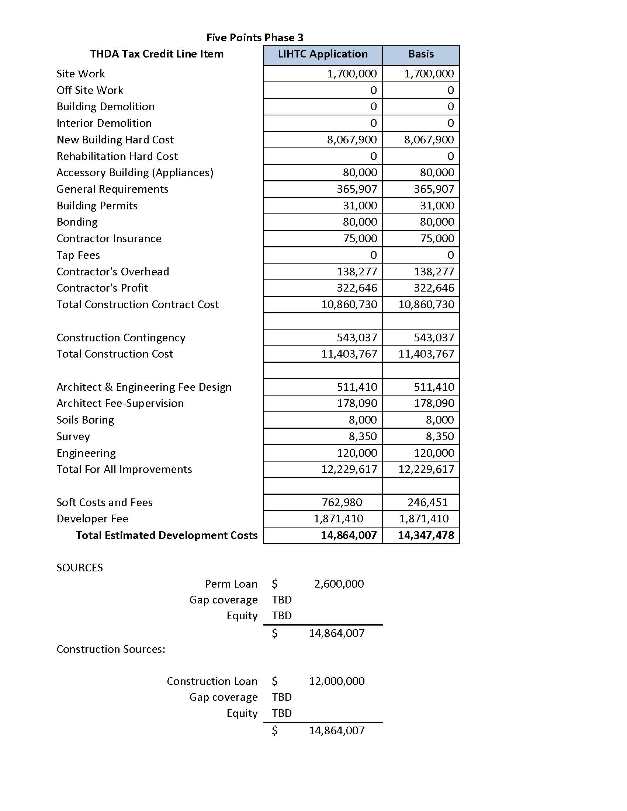
Appendix A Pro-Forma Attachment

Equity Investor C18004

Appendix B Site Map and Plan Attachment

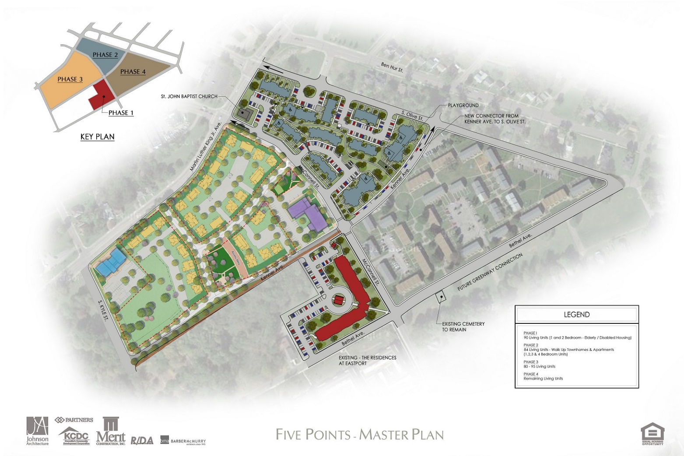

Equity Investor C18004

Appendix C Equity Pricing Attachment

Please complete the Excel sheet posted on KCDC’s webpage and submit this document electronically.

EQUITY PRICING
Projected LIHTC | $11,000,000.00
Equity to LP
Pricing Factor
Total Equity
2019 Credit Delivery
2020-2027 Credit Delivery
2028 Credit Delivery
Credit delivery upward Adj.
Credit delivery downward Adj.
Early Delivery Adj.
Late Delivery Adj.
OTHER MAJOR TERMS
Equity Due Dil./Legal Fee
Any Construction Monitoring Fees
Any ongoing fees to limited partner
Minimum Op Reserve Balance
Yearly Replacement Reserve
Replacement Reserve escalator
max spend without LP approval
ODG Period
Guarantor Liquidity requirement
Proposed ROFR/Option language
Please describe in LOI | Stabilized Operations, Any required guaranties and limits to guaranties, and a detailed description of recapture terms.

