

Request for Proposals

Plumbing Services
(as needed) Q2520



Solicitation Name / Number
Plumbing Services Q2520

Upload Responses By

July 9, 2025 at 11:00 a.m.

Click here To Upload Responses
- All proposals must be submitted through the Vendor Registry platform as ONE document.
- When uploading proposals, be sure to upload all required documents.
- Proposals delivered by email, fax, USPS or in person WILL be rejected.

Click here To Post Questions About this Solicitation
- Deadline: 8:00 p.m. on June 30, 2025
- KCDC will NOT accept questions via email or phone.

Pre-Proposal Meeting

None scheduled

Solicitation Opening

This solicitation will not be “opened” publicly since it is a proposal.

Award Results Click here
- KCDC posts the award information on its website ONCE an award decision is made. Please click the link above.

Open Records / Public Access to Documents

All documents provided to KCDC are subject to the Tennessee Open Meetings Act (TCA 8-44-101) and open records requirements ONCE an award decision is made.

General Information

1. Background and Intent

a. Knoxville's Community Development Corporation (“KCDC”) is the public housing authority for the City of Knoxville and for Knox County in Tennessee. KCDC’s affordable housing portfolio includes more than 26 properties with approximately 3,600 dwelling units. In addition to operating its public housing apartments, KCDC oversees approximately 4,097 Section 8 Vouchers and 76 Moderate Rehabilitation units. Additionally, KCDC serves as the redevelopment agency for the City of Knoxville, managing redevelopment areas, TIFs, and PILOTs.

b. Definition/Clarification: KCDC uses “suppliers” as inclusive of various words describing interested parties often called “bidders,” “contractors,” “firms,” “proposers” and “vendors.”

c. The purpose of this solicitation is the selection of one or more suppliers, at a pre- determined rate, to provide plumbing services as needs arise across KCDC’s portfolio. While KCDC has its own employees who perform plumbing work, from time to time, KCDC needs supplemental plumbing services from suppliers. Suppliers do not have to provide every type of plumbing service imaginable to participate in this solicitation. If your company wishes to offer select services only, indicate this in your proposal for KCDC’s consideration.

e. KCDC reserves the right to award up to five suppliers to meet its varied needs. If KCDC awards to multiple suppliers, when a job is expected to reach $3,000 in value, KCDC staff will contact all awarded suppliers for a specific quote for the work (based on the awarded cost terms). KCDC reserves the right to move forward with any one supplier if its best interests are served.

f. If KCDC awards to multiple suppliers and costs, supplier expertise, work quality and completion timelines are equal, KCDC staff will try to alternate work between the awarded suppliers.

Typically, KCDC will not use this solicitation for projects if the cost exceeds $25,000. However, KCDC does reserve the right to do so if it is in KCDC’s best interest.

g. Any agreement resulting from this solicitation will be an “open-end” type of agreement. There is no guarantee that KCDC will require any specified or minimum level of services or provided by the supplier.

2. Changes after Award

KCDC reserves the right to make changes after award upon consultation with the supplier. Should additional costs arise, the supplier must document increased costs. KCDC reserves the right to accept or reject and negotiate these charges. Generally, such changes will not be of a “cardinal” nature.

3. Codes and Ordinances

All work covered is to be done in full accord with national, state and local codes and ordinances and

4. Contact Policy

Only contact KCDC’s Procurement Division about this solicitation from the issuance of this solicitation until award. Information obtained from an unauthorized officer, agent, or employee will not affect the risks or obligations assumed by the supplier or relieve the supplier from fulfilling any of the conditions of the resulting award for this project. Such contact can disqualify the supplier from the solicitation process.

5. Damage

The awarded supplier is responsible for any and all damage to buildings, equipment, grounds, premises and all other types of potential damage resulting from the provision of the services requested herein.

6. Employees

Supplier will:

a. Provide at least one employee on every job assignment with the ability to speak, read, write and understand English so KCDC staff can communicate effectively with them.

b. Ensure that employees have proper identification displayed while on the job site. Employees, while on site, must wear a company uniform or have photo identification displayed.

c. Ensure employees parking vehicles (whether corporately or privately owned) must ensure that company identification is on the vehicles. This may be by placards on the vehicle’s side, laminated paper with the company name placed on the dashboard or other means.

d. Allow only personnel thoroughly trained and skilled to work on the job.

e. Provide sufficient employees to complete the work in a timely manner.

f. Not allow employees to be on KCDC premises unless they are working on a KCDC project. Acquaintances, family members, assistants or any person not working on KCDC’s behalf will not accompany employees on KCDC sites.

g. Have employees bonded (typically called “Employee Dishonest Bond”) and proof of such submitted to KCDC prior to work commencement.

h. KCDC reserves the right to require immediate removal of any employee from KCDC service it deems unfit for service for any reason.

7. Evaluation

a. KCDC alone determines (using NIGP’s definition and other relevant sources as appropriate) the supplier’s “responsive” and “responsible” status prior to award. Responsible means a business with the financial and technical capacity to fulfill the requirements of the solicitation and subsequent contract. A responsive proposal is one that fully conforms in all material respects to the solicitation document and all of its requirements, including all form and substance.

b. KCDC reserves the right to request additional information to assist in the evaluation process. This includes references and business capacity information.

c. KCDC will review all proposals and reserves the right to request necessary modifications, waive minor technicalities, reject all proposals, reject any proposal that does not meet mandatory requirement(s) or cancel this RFP, according to KCDC’s best interests.

d. KCDC’s Evaluation Team may elect to interview one or more suppliers before making an award.

e. KCDC’s Evaluation Team may elect to first rank proposals with a simple numeric score and then detail score only the top tier of proposals.

f. KCDC score and award to the best overall supplier(s) on the following evaluation scale:

Factors | Maximum Points
Supplier Information & Qualifications | 25
Assigned Staff Qualifications and Experience | 25
References | 10
Cost | 40
Total | 100

8. General Instructions

KCDC’s General Instructions to Suppliers are at www.kcdc.org. Click on “Procurement” and the link to the instructions. The supplier’s submittal means acceptance of the terms and conditions found in KCDC’s “General Instructions to Suppliers.” The following paragraphs in the General Instructions to Suppliers do not apply: 46a, 46b, 46d, 46e, 46f and 59.

9. Insurance

a. See Appendix 1. These insurances and levels are required and not optional. If you or your insurance agent have concerns or believe that some coverages are not necessary, email procurementinfo@kcdc.org detailing any requested changes before this solicitation’s due date. The supplier will include all insurance costs in the base bid.

b. KCDC’s Insurance Appendix requires your and your insurance agent’s certification that, upon award, you will provide the specified insurances without exception.

c. Upon notice of intent to award, your insurance agent(s) will email the proposed Certificate of Insurance (COI) to procurementinfo@kcdc.org for review and acceptance.

10. Invoicing and Ordering

KCDC’s Invoicing and Ordering Standards are at www.kcdc.org. Click on “Procurement” and the link to the Invoicing Standards. The supplier’s submittal of a proposal means acceptance of KCDC’s invoicing and Ordering Standards.

11. Length of Award

The length of the contract will be twelve months with four optional annual renewals that KCDC may exercise at its discretion.

12. Licensure

Suppliers must possess and maintain proper licensure from the State of Tennessee and all other authorities having jurisdiction throughout the term of this award. This includes compliance with the Contractor’s Licensing Act of 1994” as mandated by the State of Tennessee.

13. Permits

The supplier shall procure and pay for all permits and licenses, charges and fees and give all notices necessary and incidental to the due and lawful prosecution of the work. The cost of all permits, fees, et cetera, shall be included in price proposed as noted in the specifications and requirements.

14. Price Structure

a. At the end of each twelve‐month period, the awarded supplier(s) may request a change to the agreed price. The supplier(s) must provide proof of increased Producer Price Index (Knoxville) to the Procurement Division.

b. KCDC will decide whether to accept a price increase. If the price increase is accepted, the solicitation file will be noted. If the price increase is not accepted, the supplier may:

- Continue with the existing pricing
- Suggest an alternative price increase
- End the award

c. KCDC does not pay fuel surcharges.

d. Suppliers may lower prices at any time with or without notice.

15. Renovation, Repair and Painting Rule

Suppliers performing renovation, repair and painting projects that disturb lead-based paint in homes, childcare facilities, and schools built before 1978 must be certified and must follow specific work practices to prevent lead contamination. When work is occurring at a site, the supplier must submit proof of the applicable certification before commencing work. The supplier will keep such certification current throughout the life of the award.

To the best of KCDC’s knowledge RRP applies to this work (at some sites): Yes ☒ No ☐

Additional information is at:

1. HUD’s website:
http://portal.hud.gov/hudportal/HUD?src=/program_offices/healthy_homes/training/ rrp/rrp

2. State of Tennessee’s website:
http://www.state.tn.us/environment/swm/leadpaint/

16. Safety/OSHA Guidelines Compliance

a. Public safety is of prime concern to KCDC, and all costs associated are the responsibility of the supplier. The supplier shall ensure that its employees exercise all necessary caution and discretion to avoid injury to people or damage to property.

b. Supplier shall use caution signs as required by OSHA Regulation 1910.144 and 1910.145 at no cost to KCDC. Caution signs shall be on-site on commencement of contract.

c. The supplier will provide and place barricades, tarps, plastic, flag tape and other safety/traffic control equipment to protect the public, surrounding areas, equipment and vehicles as appropriate. This includes taking the necessary steps to exclude people (residents, visitors, other suppliers) from entering work areas.

d. The supplier will protect all buildings, appurtenances and furnishings from damage. The supplier shall, at his expense, repair such damages (or replace the items) by approved methods to restore the damaged areas to their original condition.

e. Supplier shall comply with all other OSHA and TOSHA safety standards that apply.

f. Safety Data Sheets (SDS) for each chemical used must be left. Suppliers must be certain the brand(s) they are offering are labeled by the manufacturer with appropriate hazardous material symbols where applicable.

17. Security

The successful supplier is responsible for providing (if necessary) any and all security to equipment, materials, personnel, tools and the site that are required for this job. KCDC is not responsible for damage or losses to equipment, materials, personnel, tools or the site.

18. Small Business Outreach

KCDC requires the successful supplier to reach out to minority, small, veteran, and woman owned businesses for goods and subcontracted services to fulfill this award. In addition to the successful supplier reporting on dollars spent with such businesses each January, KCDC expects outreach that results in actual subcontracting arrangements with such suppliers.

19. Smoke Free Policy

KCDC’s Smoke Free policy is applicable to you, your employees and subcontractors. The policy mandates:

    - No smoking on KCDC’s property
    - No e‐vape or similar usage on KCDC’s property
    - The Smoke Free policy applies in personal or corporate vehicles on KCDC’s property

20. Stormwater and Street Ordinances

Knoxville’s Storm Water and Street Ordinances apply to this solicitation. The successful supplier will comply with the City’s ordinances. Compliance includes but is not limited to:

a. Retaining all sediments on the project site using structural drainage controls. The cost of all drainage controls shall be considered incidental to the work.

b. No construction or demolition related materials, wastes, spills, or residues shall be discharged from the project site to streets, drainage facilities or adjacent properties by wind or runoff.

c. Non-storm water runoff from equipment and vehicle washing and any other activity shall be contained at the project site.

d. Eliminate erosion from slopes and channels by implementing Best Management Practices (BMPs) that may include, but are not limited to, limiting grading scheduled during the wet season, inspecting graded areas during rain events, planning and maintaining vegetation on slopes, and covering erosion susceptible slopes.

e. Additional information about NPDES, BMPs, and Land Development Manual is on the City of Knoxville’s Storm water Engineering Division webpage. To access the additional information, go to (http://www.cityofknoxville.org/engineering/stormwater/npdes.asp).

f. Supplier is responsible for all work, remediation, repair, and monetary penalties or fines arising out of a Notice of Violation of the City of Knoxville’s Storm water and Street Ordinances. The supplier shall be charged any cost incurred by KCDC to install structural drainage controls or remedy a Notice of Violation. KCDC shall also charge a $100 fee per violation for related administrative costs.

21. Subcontractors

Subcontractors must:

a. Be approved by KCDC prior to beginning work

b. Not be on HUD’s nor the State of Tennessee’s debarment lists

c. Carry the insurance coverages as outlined herein

d. Not be changed without KCDC’s permission.

22. Utilities

a. When work is at or in its occupied apartments, KCDC does not normally supply utilities because the residents pay their own utility bills. In such cases, the supplier will arrange for any necessary utilities.

b. When work is at its office areas and other non-resident locations, KCDC will normally provide utilities for suppliers as long as they are currently available at the area.

c. The supplier must ascertain the availability of utilities for this work prior to submitting a proposal.

23. Warranty

a. The supplier is responsible for notifying KCDC of any warranties or guarantees, and the terms contained therein.

b. Labor, parts and materials have at a minimum, one-year warranty from the date of issuance of Certification of Completion.

c. The supplier expressly warrants that all items are new and free from defects, warranted for their merchantability and meet the performance specifications of the original equipment.

24. Work Hours

KCDC’s normal work hours are Monday through Saturday from 7:30 a.m. until 4:00 p.m. While suppliers may work later than 4:00, KCDC’s staff will not be on site or readily available after 4:00 during the workweek nor at all on Saturdays. Work on Sundays or holidays requires KCDC’s advance approval.

Description of Services, Standards and Restrictions

25. Introduction

The supplier shall perform installation, maintenance and repairs on a Time and Material Basis:

a. The supplier shall do all work necessary for the performance and completion of this work, in the manner called for, at the appropriate prices shown herein.

b. The supplier shall provide all supervision, labor, service trucks, materials, tools, equipment, and appurtenances necessary for the completion of this work in the manner specified in this solicitation and the successful supplier’s response to it.
26. ADA Standards

All new construction, additions and alterations to existing facilities must be designed, constructed or altered in compliance with the American with Disabilities Act Accessibility Guidelines (ADAAG) for buildings and facilities.

27. After-Hours’ Work

The supplier may be required to perform work during KCDC’s non-working hours or on weekends or holidays. The requestor or designated representative must approve all repairs including after-hours work. The supplier shall invoice at the rate of time-and-a-half based on the regular hourly labor rates.

28. Call Back Service

Upon emailed or otherwise written notice from KCDC, the supplier must without additional charge, replace/repair improper work or products installed within one year of service. Such call back services shall be within two hours of notification for emergencies and within twenty-four hours for non-emergency situations.

29. Charges

a. Equipment Cost
Supplier shall charge their quoted rate per hour for actual time used only. The time that equipment sits idle is not billable. If a staff member has dual responsibilities as an equipment operator and as a plumber, his or her time will be separated appropriately as to the actual duties performed. For instance, if the plumber is the equipment operator for five hours, then the invoice will reflect his or her time as equipment operator for five hours.
If the operator then performs plumbing services for five hours, those hours will be reflected at the plumbing rate on the invoice. KCDC will not pay both the operator’s rate and the plumber’s rate for the same five hours in this example.

b. Labor

1. Supplier shall include all costs (overhead, profit, insurance, workmen's compensation, unemployment insurance, social security, et cetera), in the hourly rate figures. The only exclusions from this section are the cost of supplies and parts that are directly attributable to a specific job and the approved equipment rental.

2. Regular time will be KCDC’s normal business hours of 7:30 a.m. to 4:00 p.m., Monday through Friday, unless otherwise authorized.

3. A maximum of one hour (thirty minutes each way) per day will be allowed for travel time (workman's hourly rate) between your business address (shop) and the jobsite. However, travel time closer to thirty minutes (fifteen minutes each way) shall be billed accordingly.

4. Overtime is work done at times other than normal business hours. Holiday rates go in effect on the holidays that KCDC observes. After award, the supplier will be furnished with the latest list of KCDC holidays.

5. Suppliers may be required to have hours worked certified at the job site by KCDC staff.

6. Additional vehicle mileage charges are not allowed.

7. Normally a Journeyman Plumber will reply and handle to routine calls. Any additional personnel must be authorized by KCDC.

8. Supplier will deduct time consumed for meals eaten during the time on the job.

c. Materials
Supplier shall itemize materials or parts on the invoice (only those charges that are for equipment for that specific job) and add their markup (the figure shown on your bid submittal). KCDC reserves the right to require documentation of the cost vendors pay for materials or parts.

d. Mobilization

1. Mobilization (if required) will be paid once for assignment regardless of the scope of work.

2. Work in one area or on a one street in which the areas of activity are contiguous or close together, regardless of the scope or scopes of work, is considered one job and the supplier shall be paid for one mobilization.

3. Work, at least one mile away from the last work area that requires the supplier’s crew to break down the equipment, relocate, and reset at the new work is a new job and the supplier shall be paid for another mobilization.

4. The pricing page for this solicitation provides a space for suppliers to submit two mobilization charges. The supplier also inserts the dollar range for each price.

30. Commencement and Completion of Work

The supplier shall commence on-site work no later than seven working days after work authorization. Emergency work, if specified in the authorization, shall commence within 24 hours after authorization. Verbal authorization by the Procurement Director is sufficient for assignment of emergency work. Repeated failure to meet estimated start and/or completion dates shall result in termination of the contract.

31. Confined Space

The supplier's employees may have to enter confined spaces to perform work outlined in this contract. Entry into a confined space is allowed only through strict compliance with OSHA 29 CIR.1910.146, latest revision. The supplier is advised that all safety equipment necessary for supplier's employees to enter restricted access areas or confined spaces shall be provided by the supplier.

32. Debris Removal

The supplier shall remove all debris from the site and clean affected work areas. Supplier shall keep the premises free of debris and unusable materials resulting from their work and as work progresses, or upon request by KCDC shall remove such debris and materials from KCDC property. The supplier shall leave all affected areas as they were prior to beginning work.

33. Equipment

The supplier is responsible for having or acquiring all standard equipment necessary to perform under this agreement. KCDC shall not reimburse for any standard equipment rental nor for damages incurred in using equipment for KCDC’s needs.

34. Estimates

a. The supplier may be required to visit the potential jobsites and submit accurate quotations (based on the award rates) before the work is authorized.

b. If the quotation is accepted and the work is performed, the supplier's invoice shall not exceed the approved rates.

c. Request for quotes, will typically be emailed to the supplier(s).

d. The supplier must provide quotations within five business days of request.

e. A list of proposed subcontractors (if any) will accompany quotes.

f. Formal written quotes are not required for jobs below $3,000. Instead, the supplier will simply email the Property Manager the cost.

g. For projects above $3,000 the supplier will visit the site and provide a formal quote.

h. As referenced above, “Quotes” mean a not to exceed cost for each job. Unless KCDC authorizes additional work or approves changes for unforeseen conditions, the estimate (based on the awarded rates) will not be exceeded.

35. Inspection and Acceptance

KCDC staff will inspect all work before signing “punch lists” and before processing invoices for payment. Punch lists, once signed, officially accept the work and authorize payment.

36. Materials and Workmanship

a. All work must conform to the 2006 National Standard Plumbing Code (PHCC). Additional requirements may be directed to the vendor on an individual per job basis.

b. All materials and equipment furnished shall be new and best quality.

c. All materials and equipment provided shall conform to the regulations of the entities having authority.

d. Supplier shall furnish material samples for approval if desired by KCDC. KCDC reserves the right to specify the materials to be utilized on specific jobs. KCDC must approve substitutions.

e. Work shall be accurate, professionally finished and subject to KCDC’s approval prior to payment authorization.

f. The successful supplier(s) may be required to establish a mockup unit for larger projects. Once completed, KCDC will examine the mockup unit. Once approved, work may then begin on the other units.

37. Project Service Tickets

a. The supplier shall leave (or email) Service Tickets (KCDC will provide) for all work performed. Each project requires individual Service Tickets that shall detail labor, material utilized, rental equipment, and subcontractors utilized. The Service Tickets are submitted to the Project Manager or designee at the completion of each workday.

b. Service tickets must include the following:

- Facility name
- Equipment name and ID number
- Personnel name, labor classification, and hours worked
- Materials used
- A detailed description of work performed.

38. Property Damage

Should the supplier cause any damage to KCDC property, the supplier must notify the Property Manager immediately and make repairs to the satisfaction of KCDC, at no cost to KCDC. However, KCDC may elect to make repairs or replacement of damaged property and deduct the cost of such repairs from monies due, or to become due the supplier.

39. Response Time

Response time will be within two hours of notification for emergencies and within twenty-four hours for regular service. In the case of emergencies, all work will be pursued until completion.

40. Roof Protection

On those occasions when the supplier must do work on a flat roof, the supplier shall place protective plywood sheets of an appropriate size on the surface of the roof from the point of access to the point where the work is to be performed. Under no circumstances is the supplier to walk or work on a flat roof without first protecting it.

41. Trenching

Suppliers will follow OSHA and TOSHA guidelines for trenching. OSHA requires employers to provide ladders, steps, ramps, or other safe means of egress for workers working in trench excavations 4 feet or deeper. The means of egress must be located so as not to require workers to travel more than 25 feet (7.62 meters) laterally within the trench. OSHA’s trenching guidelines handbook are at
https://www.osha.gov/sites/default/files/publications/osha2226.pdf.

What do I turn into KCDC and in what format?
Upload your information in the order indicated below as ONE document uploaded as detailed on the cover page.

Document Number | Title
Solicitation Document A | General Response Section  Note: Make this the first page of your submittal. Complete all lines and blanks-even if the answer is “NA.”
Solicitation Document B | Affidavits  Note: Read and sign.
Solicitation Document C | HUD Form 5369A  Note: Read and respond as prompted.
Solicitation Document D | Supplier Business Information and Qualifications  Note: Provide the requested information in sufficient detail to allow KCDC’s evaluation team to properly score your company on its qualifications.
Solicitation Document E | References  Note: Provide the requested information in sufficient detail to allow KCDC’s evaluation team to properly score your company on its references.
Solicitation Document F | Cost Proposal  Note: Provide the requested information in sufficient detail to allow KCDC’s evaluation team to properly score your company on its cost offered.
Solicitation Document G | Insurance Agent’s Statement and Certification  Note: This is an important document that you and your agent(s) must take seriously. You are certifying that you and your agent(s) have reviewed KCDC’s insurance requirements and will meet those requirements without exception if awarded.

This and the preceding pages do not need to be returned to KCDC.

Solicitation Document A |  |  |  | General Information about the Supplier
Note: Complete all cells even if the answer is “Does not apply”
Sign Your Name in the field to the right
If completing this document in Adobe, an electronic signature is acceptable to KCDC.
Your signature indicates you, reviewed Solicitation Package, agree to “KCDC’s General Instructions to Suppliers” (www.kcdc.org), the information you provided is accurate and you are authorized to contractually bind the supplier.
Printed Name and Title
Legal Corporate Name
Street Address
City/State/Zip
Contact Person (Please Print Clearly)
Telephone Number
Cell Number
Supplier’s E-Mail Address (Please Print Clearly)
Addenda and Questions
Questions raised during the bidding process are posted and answered on KCDC’s portal. Suppliers must review these before uploading responses. Once these have been reviewed, certify so below:
I have read all the posted Questions and Answers: Yes ☐
Addenda are at www.kcdc.org. Click on “Procurement” and then on “Open Solicitations” to find addenda. Please check for addenda prior to submitting a bid.
Acknowledge addenda have been issued by checking below as appropriate:
None ☐ | 1 ☐ |  |  |  | 2 ☐ |  | 3 ☐ |  | 4 ☐ |  | 5 ☐
Statistical Information (Check a box in each of the next four lines)
1. This business is at least 51% owned and operated by a woman |  |  |  |  |  |  |  |  |  |  | Yes ☐ No ☐
2. This business qualifies as a small business by the State of Tennessee  Total gross receipts of not more than $10,000,000 average over a three-year  period OR employs no more than 99 persons on a full-time basis |  |  |  |  |  |  |  |  |  |  | Yes ☐ No ☐
3. This business is at least 51% owned and operated by a veteran |  |  |  |  |  |  |  |  |  |  | Yes ☐ No ☐
4. This business is owned & operated by persons at least 51% of the following ethnic background:
Asian/Pacific  ☐ |  | Black  ☐ | Hasidic Jew  ☐ |  |  | Hispanic  ☐ |  | Native American ☐ |  | White  ☐ | Corporation ☐
Prompt Payment Discount Statement
A ____% prompt payment discount applies when KCDC makes payment in ____ days of invoicing.
Cooperative Procurement
If awarded, will the supplier extend the terms to other governments in Tennessee? |  |  |  |  |  |  |  |  |  |  | Yes ☐ No ☐

Solicitation Document B | Affidavits

Conflict of Interest
1. No commissioner or officer of KCDC or other person whose duty it is to vote for, let out, overlook or in any manner superintend any of the work for KCDC has a direct interest in the award or the supplier providing goods or services.

2. No employee, officer or agent of the grantee or sub-grantee will participate in selection, or in the award or administration of an award supported by federal funds if a conflict of interest, real or apparent, is involved. Such a conflict arises when the employee, officer or agent, any member of his immediate family, his or her partner, or an organization, which employs, or is about to employ, any of the above, has a financial or other interest in the supplier selected for award.

3. The grantee's or sub-grantee's officers, employees or agents will neither solicit nor accept gratuities, favors or anything of monetary value from suppliers, potential suppliers, or parties to sub-agreements.

4. By submission of this form, the supplier is certifying that no conflicts of interest exist.

Eligibility
5. The supplier is eligible for public contracts because no convictions, guilty pleas or pleas of nolo contender to violations of the Sherman Anti-Trust Act, mail fraud or state criminal violations with the State of Tennessee or any political subdivision thereof have occurred.

General
6. Supplier fully understands the preparation and contents of the attached offer and of all pertinent circumstances respecting such offer.

7. Such offer is genuine and is not a sham offer.

Iran Divestment Act
8. Concerning the Iran Divestment Act (TCA 12-12-101 et seq.), by submission of this bid/quote/proposal, each supplier and each person signing on behalf of any supplier certifies, and in the case of a joint bid/quote/proposal, each party thereto certifies as to its own organization, under penalty of perjury, that to the best of its knowledge and belief that each supplier is not on the list created pursuant to § 12-12-106.

Accuracy of Electronic Copies
9. If the supplier provides electronic copies of the bid/proposal/quote to KCDC, the supplier certifies that the information provided on paper and in the electronic format is identical unless specifically noted otherwise.

General
10. Neither the said supplier nor any of its officers, partners, owners, agents, representatives, or employees, including this affiant, has in any way colluded conspired, connived or agreed, directly or indirectly, with any other responder, supplier, or person to submit a collusive or sham offer in connection with the award or agreement for which the attached offer has been submitted or to refrain from making an offer in connection with such award or agreement, or collusion or communication or conference with any other supplier, or, to fix any overhead, profit, or cost element of the offer price or the offer price of any other supplier, or to secure through any collusion, conspiracy, connivance, or unlawful agreement any advantage against KCDC or any person interested in the proposed award or agreement.

11. The prices quoted in the attached offer are fair, proper and not tainted by any collusion, conspiracy, or unlawful agreement on the part of the supplier or any of its agents, representatives, owners, employees, or parties in interest, including this affiant.

No Contact/No Advocacy Affidavit
12. After this solicitation is issued, contact initiated by any supplier with any KCDC representative concerning this solicitation is prohibited-except for communication with the Procurement Division. My signature signifies that no unauthorized contact occurred.

13. To ensure the integrity of the review and evaluation process, respondents to this solicitation nor any firm representing them, may not lobby or advocate to KCDC staff or Board members. My signature signifies that no unauthorized advocacy occurred.

Non-Boycott of Israel Affidavit (TCA 12-4-1 et seq.),
14. Each supplier and each person signing on behalf of any supplier certifies, and in the case of a joint bid/quote/proposal, each party thereto certifies as to its own organization, under penalty of perjury, that to the best of its knowledge and belief that each supplier is not boycotting Israel pursuant to § 12-4-1 and will not during the term of any award. Applicable only to contracts of $250,000 or more and to suppliers with 10 or more employees.

The undersigned hereby acknowledges receipt of these affidavits and certifies that the submittal in response to this solicitation is in full compliance with the listed requirements. Failure to properly acknowledge issues concerning the above is grounds for bid rejection and may subject the signer to penalties as directed by the appropriate laws.

Signed By
Printed Name
Title
Solicitation Document C | HUD Form 5369A
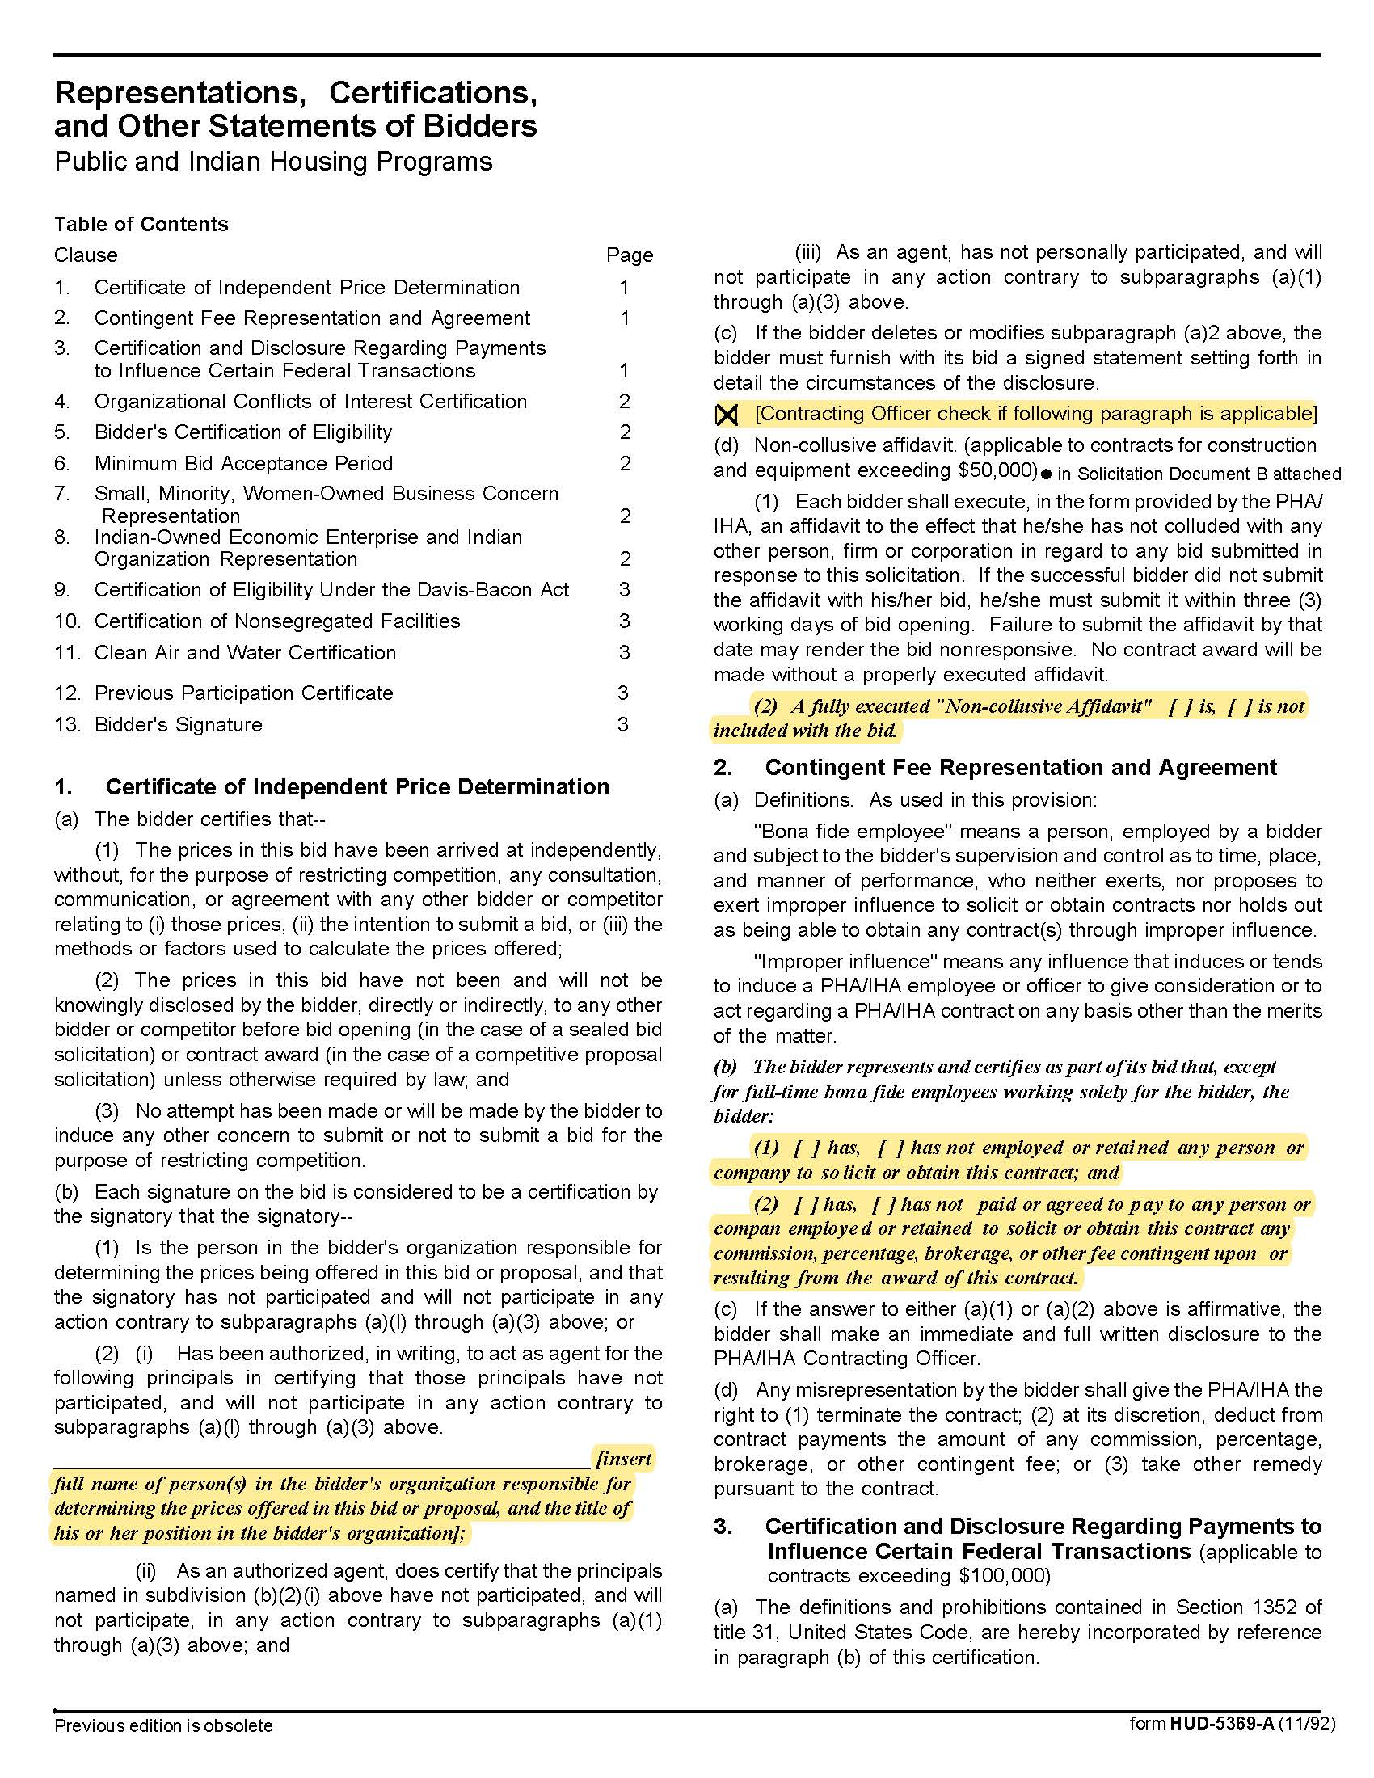

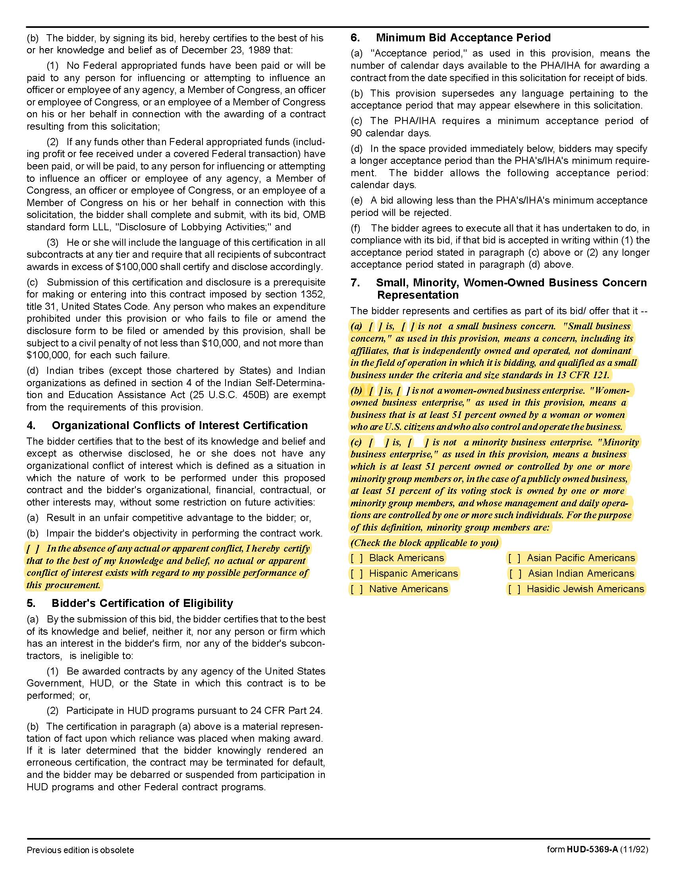

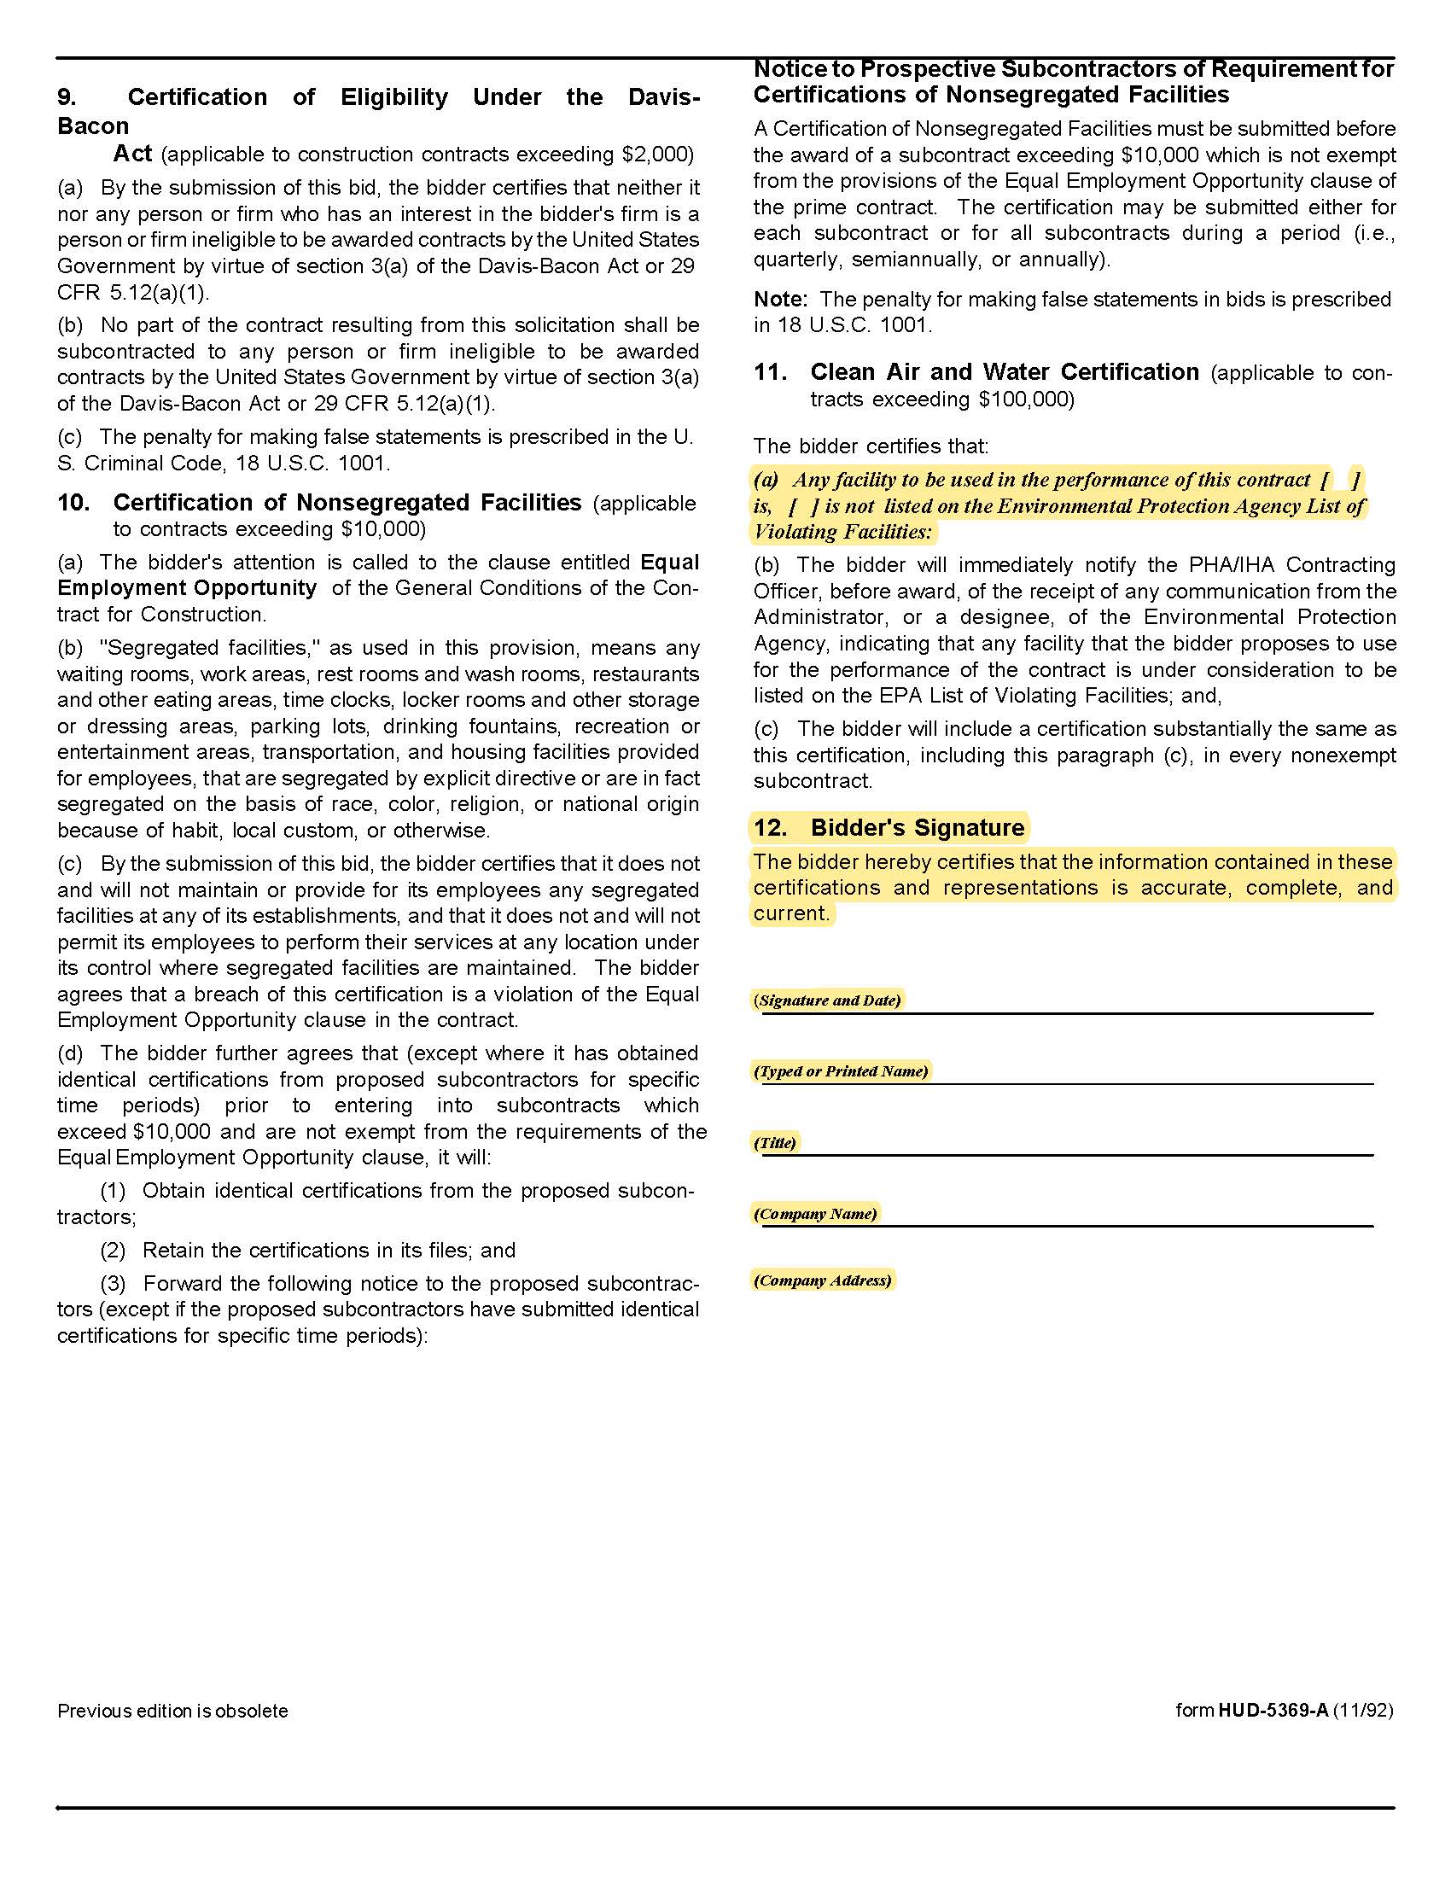

Solicitation Document D | Supplier Business Information and Qualifications

1. Overview

a. An introduction of not more than two paragraphs that includes an explanation of why
KCDC should partner with your company.

b. Explain what differentiates you from your competition.

c. List your total number of business clients.

2. Provide the information requested below (use the right column).

Years in business
Years in business under this name
Years performing this type of work
Value of work now under contract
Value of work in place last year
Number of clients
Will this make KCDC your largest client?
Percentage of work usually self-performed
(Not sub-contracted)
Has your firm:
Failed to complete a contract? | Yes No
Been involved in bankruptcy or reorganization? | Yes No
Pending judgment claims or suits against firm? | Yes No
What company do you use for pre-employment criminal background checks?

2. Safety:
Have you had any OSHA fines within the last three years? | Yes No
Have you had any job-related fatalities within the last five years? | Yes No
If you have answered YES to either of the above questions, you MUST submit, on a separate sheet, the details describing the circumstances surrounding each incident.

3. Personnel, Equipment & Materials:
How many total employees does your company employ?
Area | Fulltime | Part Time
Plumbers
Clerical
Management
Total Employees working for your company

4. Response Time
Item | Hours
For giving quotes
For starting work when a purchase order is issued

5. Major Equipment Owned
Item | Quantity | Description/Note

6. Subcontractors that may be used (if applicable). KCDC expects outreach to small, woman and minority-owned businesses.

Name | Service Provided | Small Business | Woman Owned | Minority Owned
Company 1: |  | Yes ☐ No ☐ | Yes ☐  No ☐ | Yes ☐  No ☐
Company 2: |  | Yes ☐ No ☐ | Yes ☐  No ☐ | Yes ☐  No ☐
Company 3: |  | Yes ☐ No ☐ | Yes ☐  No ☐ | Yes ☐  No ☐
Company 4: |  | Yes ☐ No ☐ | Yes ☐  No ☐ | Yes ☐  No ☐
Company 5: |  | Yes ☐ No ☐ | Yes ☐  No ☐ | Yes ☐  No ☐

7. Renovation, Repair and Painting Rule experience (i.e., Lead Based Paint certification).

a. Include a copy of the certification (if any).

8. Asbestos certifications (if any) and/or the subcontractor that you routinely use for this work

a. Include a copy of the certification (if any).

Solicitation Document E | References

Part I Provide three references as similar as possible to this work. Suppliers may only list a firm (including KCDC) as a reference once even if you have done multiple jobs for them.

- Name of the business serviced
- Contact person
- Contact person title
- Contact person’s telephone number
- Contact person’s email address
- Description of the service provided
- Contract began
- Contract ended
- Size of job

Part II Provide a list of all clients during the last three years as shown below.

Client Name/Contact Person | Still Providing Service

Solicitation Document F | Cost Information

Pricing is inclusive of all labor, miscellaneous supplies, overhead, profit, administration and all other fees.

Item | Note | Cost
Plumbing Technician | Regular time | $
Plumbing Apprentice | Regular time | $
Plumbing Helper | Regular time | $
Plumbing Journeyman | Regular time | $
Backhoe Operator | Regular time | $
Skidsteer Operator | Regular time | $
Dump Truck Driver | Regular time | $
Plumbing Technician | Overtime | $
Plumbing Apprentice | Overtime | $
Plumbing Helper | Overtime | $
Plumbing Journeyman | Overtime | $
Backhoe Operator | Overtime | $
Skidsteer Operator | Overtime | $
Dump Truck Driver | Overtime | $

Other Fees that Apply to All Work
Mark up on materials | %
Service Truck Charge (total for each day) | $
Service Charge per Job | $
Mini-Excavator Per Day | $
Dump Truck Per Day | $
Pump Vacuum Truck per Day | $
Backhoe Per Day including Transport Fees | $
Camera Sewer Lines | $ Per:

Other
Work (labor) is guaranteed for how many years?
Materials are guaranteed for how many years?

Solicitation Document G | Insurance Agent’s Statement and Certification

I certify that I have reviewed the insurance requirements Appendix with the supplier named below and have told the supplier that the required coverages will be available without exception if they are awarded this solicitation.

Insurance Agency 1 Name: ________________________________________________________

Agent’s Certifying Signature: _________________________________________________

Insurance Agency 2 Name: ________________________________________________________

Agent’s Certifying Signature: _________________________________________________

Insurance Agency 3 Name: ________________________________________________________

Agent’s Certifying Signature: _________________________________________________

Proposer’s Statement and Certification:
I certify that:
1. I have reviewed these requirements with my insurance agent(s).

2. If awarded the contract, I and my subcontractors (if any) will comply with the insurance requirements herein WITHOUT exception.

3. I and my insurance agency take no exceptions to the listed insurance requirements.

4. My subcontractors (if any) take no exceptions to the listed insurance requirements.

Supplier’s Name: ____________________________________________________

Supplier’s Certifying Signature: _________________________________________________

Falsification of information on this page can result in proposal rejection and debarment from KCDC business for three years as well as a recommendation for debarment from receiving any federally funded work for three years.
Return this and the preceding 7 pages to KCDC.
Appendix 1 | Insurance Requirements

INSURANCE

The Supplier shall maintain, at Supplier’s sole expense, on a primary and non‐contributory basis, at all times during the life of the contract insurance coverages, limits, and endorsements described herein. All insurance must be underwritten by insurers with an A.M. Best rating of A-: VI or better. Upon award, the Supplier shall provide Certificate(s) of Insurance and amendatory endorsements to KCDC evidencing said insurance coverages. See paragraph “e” for exact naming of certificate holder and additional insureds (Owner Entities).

The Supplier agrees the insurance requirements herein as well as KCDC’s review or acknowledgement, is not intended to and shall not in any manner limit or qualify the liabilities and obligations assumed by the Supplier under this contract. KCDC’s failure to require a certificate of insurance, acceptance of a non-conforming certificate, or allowing the Supplier to commence work shall not operate as a waiver of these minimum insurance requirements or the liabilities and obligations assumed by the Supplier under this contract.

a. Commercial General Liability Insurance: occurrence version general liability insurance including contractual liability with a minimum combined single limit of $1,000,000 per occurrence with $2,000,000 in the aggregate covering the following perils: bodily injury, personal injury, and broad form property damage including products/completed operations for one year after completion of the Project(s). Limits must apply separately to the work/location in this contract.

Such insurance shall contain or be endorsed to contain a provision that includes the Owner Entities (paragraph “e”) as additional insureds with respect to the Supplier’s ongoing and completed operations, providing coverage at least as broad as CG 20 10 07 04 and 20 37 07 04 endorsements. The coverage shall contain no special limitations on the scope of its protection afforded to the listed insureds.

b. Commercial Automobile Liability Insurance: in an amount not less than $1,000,000 (combined single limit) for all owned, hired, and non-owned vehicles utilized by Supplier in connection with the Project. Coverage is to include coverage for loading and unloading hazards.

Such insurance shall contain or be endorsed to contain a provision that includes the Owner Entities (paragraph “e”) as additional insureds.

c. Workers’ Compensation Insurance and Employers Liability Insurance: Workers’ Compensation Insurance with statutory limits as required by the State of Tennessee or other applicable laws.

d. Other Insurance Requirements:

- Upon award, Supplier shall furnish KCDC with original Certificate(s) of Insurance and amendatory endorsements effecting coverage required by this section.

- Provide a waiver of subrogation for each required policy herein. When required by the insurer, or should a policy condition not permit Supplier to enter into a pre‐loss agreement to waive subrogation without an endorsement, the policy should be endorsed with a Waiver of Transfer of Rights of Recovery Against Others, or its equivalent. This waiver of subrogation requirement shall not apply to any policy which includes a condition specifically prohibiting such an endorsement, or voids coverage should supplier enter into such an agreement on a pre‐loss basis.

- A minimum 30‐day cancellation notice for all insurances (by endorsement if necessary) is required.

- Replace certificates, policies, and endorsements for any such insurance expiring prior to completion of services.

- Maintain such insurance from the time services commence until services are completed or through such extended discovery/reporting/tail period as required. Failure to maintain or renew coverage or to provide evidence of renewal may be treated by KCDC as a material breach of contract.

- Any deductibles and/or self‐insured retentions greater than $50,000 must be disclosed to and approved by KCDC prior to the commencement of services. Use of large deductibles and/or self‐insured retentions will require proof of financial ability as determined by KCDC.

- All policies must be written on an occurrence basis with the exception of Errors and Omissions Liability (E & O) / Professional Liability and Pollution Liability which may be claims made coverage.

8. Require all subcontractors to maintain during the term of the resulting contract commercial general liability insurance, automobile liability insurance, and workers’ compensation/employers liability insurance (unless subcontractor’s employees are covered by contractor’s insurance) in the same manor and limits as specified for the Supplier.

e. Certificate Holder and Additional Insureds:

The Certificate Holder shall be: KCDC
901 N Broadway
Knoxville, TN 37917

Additional Insureds: Owner Entities are defined as those entities listed below and shall be provided all insurance
coverages, limits, and endorsements included herein including additional insured status. Provided Supplier’s insurer(s)
permits, the entities listed below can be identified collectively as “Owner Entities”:

KCDC, its officials, officers, employees, and volunteers
Bell Street LP
Bell Street 2 LP
Bell Street 3 LP
Cagle Terrace Corporation
Eastport Development, LP
Five Points 1 LP
Five Points 2 LP
Five Points 3 LP
Five Points 4 LP
Liberty Place Knoxville LP
Lonsdale, LP
Montgomery Village Corporation
North Ridge Crossing, LP
Vista at Summit Hill, LP
Western Heights LP

(Note: Only one (1) certificate needs to be provided. Certificate must reflect KCDC as the Certificate Holder and specify all coverages and terms apply to all Owner Entities.)

f. Right to Revise or Reject: KCDC reserves the right to revise any insurance requirement, including but not limited to, limits, coverages, and endorsements based on changes in scope of work/specifications, insurance market conditions affecting the availability or affordability of coverage.

g. No Representation of Coverage Adequacy: The coverages, limits or endorsements required herein protect the primary interests of the Owner Entities, and the Supplier agrees in no way should these coverages, limits or endorsements required be relied upon when assessing the extent or determining appropriate types and limits of coverage to protect the Supplier against any loss exposures, whether as a result of the project or otherwise.

Certificate Holder | KCDC  901 N Broadway  Knoxville, TN 37917
Additional Insureds (Owner Entities)  (can be identified collectively as Owner Entities) | KCDC, its officials, officers, employees, and volunteers  Bell Street LP  Bell Street 2 LP  Bell Street 3 LP  Cagle Terrace Corporation  Eastport Development, LP  Five Points 1 LP  Five Points 2 LP  Five Points 3 LP  Five Points 4 LP  Liberty Place Knoxville LP  Lonsdale, LP  Montgomery Village Corporation  North Ridge Crossing, LP  Vista at Summit Hill, LP  Western Heights LP
GL (Supplier & Subcontractors) | $1M / $2M (including contractual liability)
Auto (Supplier & Subcontractors) | $1M (owned, hired, & non-owned)
WC & Employers Liability (Supplier & Subcontractors) | statutory limits
30-day cancellation (Supplier & Subcontractors) | Required– must indicate on COI
Primary non-contributory (Supplier & Subcontractors) | Required – must indicate on COI
Waiver of Subrogation (Supplier & Subcontractors) | Required – must indicate on COI

(Note: Only one (1) certificate needs to be provided. Certificate must reflect KCDC as the Certificate Holder and specify all coverages and terms apply to all Owner Entities.)

This page does not need to be returned to KCDC.

