REQUEST FOR PROPOSALS FOR
LANDSCAPING SERVICES



CITY OF LAKELAND, TENNESSEE 10001 U.S. HIGHWAY 70
LAKELAND, TN 38002

January 9, 2023

REQUEST FOR PROPOSALS LANDSCAPING SERVICES
CITY OF LAKELAND, TENNESSEE

- Purpose

The City of Lakeland, Department of Public Works, requests proposals from qualified professional contractors to provide landscaping services. The selected contractor will provide landscaping services on flower beds in multiple locations throughout the city. The contract will be for two (2) years starting on April 1st, 2023.

Scope of Services

The Contractor shall be capable of providing all the following services related to landscaping services of city assets.

  - Weekly Flower Bed Inspection and Maintenance
  - Two (2) Mulch Applications Per Year (Labor Only)
  - 200 Flats of Flowers Planted Twice Per Year (Labor Only)
  - Two (2) Pre-emergent Applications Per Year

Proposal Requirements

The Proposal should demonstrate that the Contractor understands the intent and scope of the project, the character of the deliverables, the services required for their delivery and the specific tasks that must be performed while supplying these services. In addition, the Contractor should demonstrate the qualifications necessary to successfully complete this project. To assist in the evaluation process, please include the following information in the proposal:

Introduction
Proposal shall include basic relative information. Include a detailed cost for each of the services listed in the Scope of Services section above.

Qualifications and Experience
Proposal shall detail the Contractor’s experience relating specifically to landscaping projects. Include a listing of relevant work, within the past three years, which would indicate experience. This listing shall include a description of the work and the approximate date the work was completed.

Contractor Selection Procedure

An evaluation committee will review and rank each proposal based on the following criteria:

  - Responsiveness to project description
  - Overall experience of the contractor
  - Performance on similar projects
  - Specific experience of the proposed staff

Selection of the contractor may be based solely on the submittal of the proposal. If the committee wishes to conduct interviews, City staff will contact each contractor to set up a date for the interview. The interview process will allow the firms to better educate City staff about their experience and qualifications. Interviews will be limited to 30 minutes. The Contractors deemed most qualified to provide the required services will be selected and the contracts will be presented to the Board of Commissioners for their approval of the contract.

The City of Lakeland reserves the right to seek clarification of any proposal submitted and to select the proposals considered to best promote the public interest of Lakeland.

All proposals become the property of the City of Lakeland upon submission. The cost of preparing, submitting and presenting a proposal is the sole expense of the Contractor. Lakeland reserves the right to reject any and all proposals received as a result of this solicitation, to negotiate with any qualified source, to waive any formality and any technicalities or to cancel the RFP in part or in its entirety if it is in the best interest of City of Lakeland. This solicitation of proposals in no way obligates Lakeland to award a contract.

The City of Lakeland will not discriminate against any individual for any reason and will provide services to all citizens and contractors, both potential and current, in a nondiscriminatory fashion. It is the intent of the city to fully comply with the provision of Title VI and Title VII of the Civil Rights Act of 1964. The City is committed to a moral, ethical, and legal responsibility to ensure equitable employment practices and the delivery of city services regardless of an individual’s race, color, religion, national origin, age, disability, gender or political affiliation. Interested certified Disadvantaged Business Enterprise (DBE) firms as well as other minority-owned and women- owned firms are encouraged to respond to all advertisements.

Proposal Submittal

All contractors who wish to be considered for Landscaping Services shall submit a proposal by

Tuesday, February 21, 2023, at 2:00pm to:

Lakeland City Hall Public Works Dept. 10001 U.S. Highway 70
Lakeland, TN 38002
Phone: (901)-867-2717

Proposals shall be presented in a sealed envelope and clearly marked “Proposal for Landscaping Services”. Include three (3) copies of the proposal.

If any of the above requirements are not met, the proposal may not be considered. Proposals received after the deadline will not be accepted. Faxed or emailed proposals will not be accepted.

Questions regarding the RFP should be directed to:

Daniel Lovett.
Public Works Director
(901) 867-2717
Dlovett@lakelandtn.org

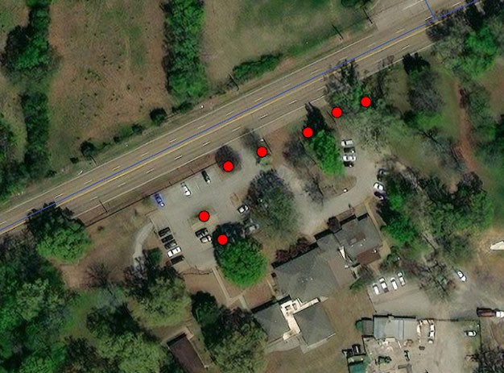
Seven individual flower beds are located at City Hall.
10001 Hwy 70
Lakeland TN

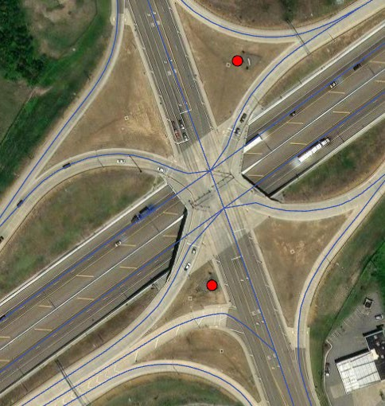
Two flower beds around the gateway signs at the I 40 and Canada Rd interchange

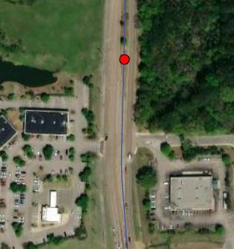
One large flower bed in front of the gateway sign located on Canada Rd 800 feet North od Hwy 64 intersection

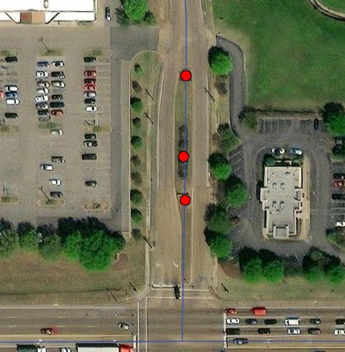
Three flower beds at the Fletchers Trace and Hwy intersection

