 | Legal Notice  Request for Qualifications  For Real Estate Sales Firm | City of Spartanburg  P.O. Box 5107  145 W. Broad Street  Spartanburg, SC. 29304  Email: cwright@cityofspartanburg.org

RFP# 1617-01-31-01
Request for Qualifications for Real Estate Sales Firm

NOTICE IS HEREBY GIVEN – The City of Spartanburg is hereby requesting Real Estate Firms to present their qualifications to the City of Spartanburg. The City will be looking for a firm to meet its specific needs and prefers a contract for a period of one year.

The City of Spartanburg, hereby, notifies all proposers that it will affirmatively ensure that all disadvantaged and women’s business enterprises will be afforded full opportunity to submit proposals in response to this invitation and will not be discriminated against on the grounds of gender, race, color, or national origin in consideration for an award. Each proposer shall attest that they engaged in good faith efforts in an endeavor to achieve the City’s M/WBE goal of 10%.
The City of Spartanburg reserves the right to reject any and all Bids or to waive any informality in the bidding. Bids may be held by the City of Spartanburg for a period not to exceed sixty (60) days from the date of the opening of Bids for the purpose of reviewing the Bids and investigating the qualifications of Bidder(s), prior to awarding of the Contract.
Sealed Proposals must be delivered to the Office of Procurement, Office address below, or mailed to the mailing address below. Facsimile and other electronic forms of proposal will not be accepted. All sealed proposals must be received by: 300 PM, EST, January 24, 2017 and then will be publicly opened. Sealed Proposals are subject to the conditions and all provisions set forth herein and attached.
Complete proposal package also available at http://www.cityofspartanburg.org/bid-opportunities
Proposals can be hand delivered or mailed to the following address:
City of Spartanburg
P.O. Box 5107
145 W. Broad Street
Spartanburg, SC. 29304
RFP# 1617-01-31-01
Request for Qualifications For Real Estate Sales Firm
Firm’s name and address should appear on the envelope.

Deadline Enforced
Proposals or withdrawal requests, received by the Procurement Division after the time and date set for receipt of Proposals, are late and WILL NOT be accepted. Late Proposals are void and will be returned unopened to the Proposer, regardless of when they were mailed or delivered. It is the Proposer’s responsibility to ensure timely receipt by the Purchasing Department of a Proposal.

Proposal Submittal Documents Checklist:
Items must be provided, in the order listed, as a Proposal package, or Proposal may be disqualified. Proposal shall not exceed, with requested options, 50 pages. Provide one original and three copies of ALL submittal documents, all unbound, no tabs.
INCOMPLETE INFORMATION OR UNSIGNED RFQ WILL BE REJECTED IMMEDIATELY WITHOUT RECOURSE.

All Eight (12) Proposal submittal documents must be included with the Proposal, or Proposal may be disqualified.
- Page 1 Cover Sheet give bidder information (Exhibit A)
- Page 2 Price page (Exhibit B)
- Page 3 Authority to execute an contract (Exhibit C)
- Page 4 Conflict of Interest Disclosure (Exhibit D)
- Page 5 Drug Free Workplace Act Statement (Exhibit E)
- Page 6 Experience/ References – (Exhibit F)
- Page 7 AFFIDAVIT OF NON-COLLUSION (Exhibit G)
- Page 8 Debarment statement (Exhibit H)
- Page 9 Good Faith Efforts. (Exhibit I)
- Page 10 CERTIFICATION OF NON-SEGREGATED FACILITIES (Exhibit J

The Winner must:

- Provide a certificate of insurance –
- Provide worker’s compensation documents
- Performance Bond is not required
- Sign the City of Spartanburg Standard Contract
- Provide a City of Spartanburg business license link- http://www.cityofspartanburg.org/cms_assets/business_licensing/BL%20App%202016.pdf

Cover Letter
Page 1
(Exhibit A)
REQUEST FOR QUALIFICATIONS
FOR REAL ESTATE SALES FIRM
RFP# 1617-01-31-01

 |  | Date
Firm’s Name Email Address
Address |  |  | Phone # cell #
Real estate License No |  | Licensed with SCLLR# or LLC
The principal(s) and staff of the firm
Principle and or Staff’s Name | Title |  |  | Year of Experience residential Sales | Attach Document stating experience

The City of Spartanburg is soliciting proposals from Real Estate Firms providing services for residential improved and unimproved properties and light commercial real estate sales and small track land sales and leasing of properties owned by the City of Spartanburg within the City of Spartanburg.
Bidding Requirements
Must be currently certified and licensed with SCLLR, if a Corporation or LLC, and Registered with SC Secretary of State Insured and a copy of each enclosed. Attach any certifications and or licenses

1. Must have at least five (5) years of experience in residential sales.
2. Must have sufficient equipment and personnel to complete work.
3. Interested companies must submit an RFQ and be able to demonstrate proficiency in completing the assignment in accordance with Real Estate Standard Rules and Ethics.
4. Fees for the Sales should be based on single-family homes; along with vacant lots
(Exhibit B)
5. Winner must be Insured per City’s requirements
6. Please review Addendum A – Projects with Federal Funding Requirements
REQUIRED INFORMATION
Your response must include the following information:
1. Cover letter with the firm's legal name, address, and telephone number Exhibit A
2. The principal(s) of the firm and their experience and qualifications, and the experience and qualifications of the staff available to be assigned to the project.
3. Five references Exhibit F
4. The proposed work plan and schedule for activities to be performed.
5. Indicate fees per sale of house, building or land and fees per lease of house or building or land. Exhibit B

APPROACH
The services to be provided will include house and vacant property sale or lease activities:
1. Provide assistance to the City in the selling and leasing of available properties.
2. Make recommendations to the City as to the sale or lease price of a specific property based upon market conditions and the buyer’s income required to qualify for the sale or lease price established.
3. Marketing, including listing the property in the Multiple Listing Service (MLS)
4. Coordinate with client, counselor and lender to help client structure the best financing. Determine if client can receive down payment and closing cost assistance.
5. Prepare purchase agreement or lease agreements, if necessary.
6. Assist in structure of appropriate financing
7. Attend closing or lease signing
8. Prepare periodic progress reports and attend meetings with City staff as needed.
Term of Proposal: Any Proposal submitted as a result of this Request for Qualifications (RFQ) shall be binding on the Proposer for sixty (60) calendar days following the specified opening date. Any Proposal for which the Proposer specifies a shorter acceptance period will be rejected. At the end of the sixty (60) calendar day period, The RFQ may be withdrawn by submitting a written request to the Procurement Manager. The written request to withdraw the proposal must be received, regardless of when it was mailed, by the Procurement Manager within five (5) calendar days after expiration of the sixty (60) calendar day period, or the proposal shall remain in effect until an award is made or the RFQ is cancelled.

Every effort has been made to ensure that all information needed is included in this document. If the submitter finds that they cannot complete its RFQ without additional information, it may submit written questions or requests for clarification to the City of Spartanburg Procurement Division by email to cwright@cityofspartanburg.org. Written questions shall be submitted at least five (5) calendar days prior to proposal’s submission date. Questions submitted after this date will be rejected as not timely. Where the proposer fails to seek clarification, the City’s interpretation shall control. The proposer agrees it will not make any claim for, or have right to withdraw its proposal because of any misunderstanding or lack of information. Proposals are not to have any exclusions. Exclusions will come from City in the form of an addendum. Any proposals received with exclusions will not be accepted.

Questions regarding bid procedures or Technical questions should be directed to Carl Wright, Procurement and Property Manager at cwright@cityofspartanburg.org.
A RFQ received by City is considered a public document under provisions of the South Carolina Freedom of Information Act (FOIA) unless it contains information that may clearly be considered accepted and excluded from disclosure according to State statute. Offeror(s) shall visibly mark as “Confidential” each part of their proposals which they consider proprietary information that could be exempt from disclosure under Section 30-4-40, Code of Laws of South Carolina – the Freedom of Information Act (FOIA). The “Confidential” mark should be in bold font of at least 12-point type, in the upper right hand corner of each page. If any part is designated as “Confidential,” there must be attached to that part an explanation of how the information fits within one or more categories listed in Section 30-4-40. The City of Spartanburg reserves the right to determine whether this may be brought against the City of Spartanburg or its agent for its determination in this regard. MARKING YOUR ENTIRE PROPOSAL CONFIDENTIAL/PROPRIETARY IS NOT IN CONFORMANCE WITH THE SOUTH CAROLINA FREEDOM OF INFORMATION ACT ABSENT EXPLANATION PROVIDING AN EXEMPTION UNDER SECTION 30-4-40.

Procurement policy: This solicitation is subject to the provisions of the City of Spartanburg Procurement policy and any revisions thereto. A copy of the Purchasing Policy may be obtained from the City’s webpage (www.cityofspartanburgCity of Spartanburg .org) or from the Procurement Division (864) 596-2790. City of Spartanburg reserves the right to negotiate and contract with any individual firm deemed suitable to provide the services required.

Applicable Laws and Compliance: This RFP and any proposal submitted in response thereto shall be governed in all respects by the laws of the State of South Carolina. The Proposer shall comply with applicable Federal, State, and local laws and regulations. By submitting this Proposal, the Proposer certifies it is currently and will remain in compliance with:
- The Federal Civil Rights Act of 1964, as amended;
- The Federal Immigration Reform and Control Act of 1986;
- The Americans with Disabilities Act

Proposer is responsible for securing all required business licenses and permits. If requested, Proposer will furnish a copy to the City.

Link to form
http://www.cityofspartanburg.org/cms_assets/business_licensing/BL%20App%202016.pdf

Public Record: Upon award, or Protest, copies of the Proposals will be made available for public inspection, under the supervision of City of Spartanburg Procurement staff, from 9:00 a.m. until 4:00 p.m., Monday through Friday, at 145 West Broad Street Spartanburg, South Carolina

Debarment Status: By submitting a Proposal, Proposers assert that they are not currently debarred from proposing on contracts by any agency of the State of South Carolina, the federal government nor are they an agency of any person or entity currently debarred from submitting Proposals on contracts by an agency of the State of South Carolina or any federal agencies.

Proposer Responsibility: The Proposer must assume that any purchase, responsibility, insurance, and action or activity which is necessary for the satisfactory operation of the services requested in this RFP, but which is not specifically designated as a Spartanburg City of Spartanburg responsibility, is a responsibility of the Proposer’s operation, and the Proposer must include these in the response to this RFP.

Disclosure of Conflicts of Interest or Unfair Competitive Advantage: Proposer warrants and represent that Proposal identifies and explains any unfair competitive advantage Proposer may have in competing for the proposed contract and any actual or potential conflicts of interest that may arise from participation in this competition or receipt of an award. The two underlying principles are (a) preventing the existence of conflicting roles that might bias a contractor’s judgment, and (b) preventing an unfair competitive advantage. If Proposer has an unfair competitive advantage or a conflict of interest, the City of Spartanburg may withhold award. Before withholding award on these grounds, a Proposer will be notified of the concerns and provided a reasonable opportunity to respond. Efforts to avoid or mitigate such concerns, including restrictions on future activities, may be considered.

Proposer Qualification: The Spartanburg City of Spartanburg Government may make such reasonable investigations as deemed proper and necessary to determine the ability of the Proposer to perform stipulated contract work and the Proposer shall furnish the City of Spartanburg Government all such information and data for this purpose as may be requested. .
Project Schedule: Based on the days to complete listed on the Proposal, provide a detailed schedule for completion to include the critical path, when applicable.
The respondent shall include in such subcontracts and other such agreements any necessary provisions to eliminate or neutralize conflicts of interest.

Page 2
Exhibit B

 | Exhibits C  Price Page  Request for Qualifications  For Real Estate Sales Firm | City of Spartanburg  P.O. Box 5107  145 W. Broad Street  Spartanburg, SC. 29304  Email: cwright@cityofspartanburg.org

Houses to be sold under this proposal
Fees for the Sales should be based on single-family homes, along with vacant lots
Address |  |  | Fees for the Sales
117 Phifer Drive
620 South Irwin Avenue
161 Home Street

Request for Qualifications (RFQ) shall be binding on the Proposer for sixty (60) calendar days following the specified opening date. Any Proposal for which the Proposer specifies a shorter acceptance period will be rejected. At the end of the sixty (60) calendar day period, The RFQ may be withdrawn by submitting a written request to the Procurement Manager. The written request to withdraw the proposal must be received, regardless of when it was mailed, by the Procurement Manager within five (5) calendar days after expiration of the sixty (60) calendar day period, or the proposal shall remain in effect until an award is made or the RFQ is cancelled.

NAME OF ORGANIZATION [ ]
ATTESTED
________________________ By: _________________________________ (signature)

_________________________________ (printed name)

Title: _________________________________

CITY OF SPARTANBURG
INSURANCE REQUIREMENTS FOR CONTRACTORS AND VENDORS
CONTRACTOR'S/VENDORS LIABILITY AND OTHER INSURANCE: The Contractor/Vendor shall purchase and maintain with a company acceptable to the City and authorized to do business in the State of South Carolina, such insurance as will protect him from claims under workers' compensation laws, disability benefit laws or other similar employee benefit laws; from claims for damages because of bodily injury, occupational sickness or disease, or death of his employees, and claims insured by usual personal injury liability coverage; from claims for damages because of bodily injury, sickness or disease, or death of any person other than his employees, including claims insured by usual bodily injury liability coverage; and from claims for injury to or destruction of tangible property, including loss of use resulting there from - any or all of which may arise out of or result from the Contractor/Vendor operation under the contract documents, whether such operations be by himself or any subcontractor or anyone directly or indirectly employed/volunteering by any of them or for whose acts any of them may be legally liable. This insurance shall be written for not less than the limits of liability specified below, or required by law.

Automobile Liability: The amounts of such insurance shall not be less than: Combined Single Limit - $1,000,000; Split Limits: Bodily injury per person - $500,000; Bodily Injury per Occurrence - $1,000,000; and Property Damage - $500,000

Commercial General Liability: The amounts of such insurance shall not be less than: Each Occurrence - $1,000,000; Damage to Rented Premises - $100,000; Med Expenses (per person) $5,000; Personal & Advertising Injury - $1,000,000; General Aggregate - $2,000,000; and Products Completed Operations Aggregate - $2,000,000. This coverage shall be on an “Occurrence” basis. Coverage shall include Premises and Operations; Products and Completed Operations; Medical Expense in reference to General Liability, and Contractual Liability. Bodily injury and property damage liability shall protect the Contractor and any subcontractor performing work under this contract from claims of bodily injury, Personal & Advertising injury, and property damage which could arise from operations of this contract whether such operations are performed by the Contractor, any subcontractor or anyone directly or indirectly employed by either.

This insurance shall include coverage for products/completed operations, personal injury liability and contractual liability assumed under the indemnity provision of this contract and broad form property damage, explosion, collapse and underground utility damage stating if policy is written on an occurrence basis. Any policy written on a claim made basis must be approved by the City of Spartanburg in advance.

Property Insurance including Builders Risks-Property coverage will name the City of Spartanburg as loss payee in instances where the City has an interest in the property unless otherwise requested.

Workers' Compensation and Employer’s Liability – This coverage shall meet the STATUTORY requirement of the State of South Carolina. Employers Liability shall be in the amount of $500,000 each accident and disease - each employee and $500,000 disease - policy limit. Sole Proprietors, Partners, Members of LLC and Corporate officers will not be excluded from coverage.

Employers Liability: Each Accident - $1,000,000; Disease each employee - $1,000,000; Disease Policy Limit - $1,000,000

- This is part of Workers' Compensation coverage

Umbrella Liability: Each Occurrence – TBD; Aggregate – TBD
This coverage should be required for high hazard operations including excavation, roofing,
water tower installation, painting, repair and removal, large construction projects.
Should also consider for certain high hazard special event activities such as fireworks
displays, inflatables, mechanical rides, etc.

Professional Liability: Per Occurrence - $1,000,000; Aggregate - $1,000,000
This coverage should be required for professional services such as accountant, attorneys,
architects, design, engineering and most consultants.

The Contractor/Vendor shall provide the City with insurance certificates certifying that the foregoing insurance is in force; and such insurance certificates shall include provisions that the insurance shall not be cancelled, allowed to expire or be materially changed without giving the City thirty (30) days advance notice by registered mail.

The City of Spartanburg, its employees, and agents shall be named as additional insured under the Contractor/Vendor's general liability policies.

The Contractor is advised that if any part of the work under the contract is sublet, he shall require the subcontractor(s) to carry insurance as required above. However, this will in no way relieve the Contractor/Vendor from providing full insurance coverage on all phases of the project/event, including any that is sublet.

When certain work is to be performed inside right-of-way owned by railroads, South Carolina Department of Transportation or other Agencies, both the Contractor and any subcontractor may be required to furnish individual insurance certificates made in favor by the controlling agency, with limits as established by that agency.

Cancellation and Re-issuance of Insurance: If any insurance required to be provided by the Contractor should be canceled or changed by the insurance company or should any such insurance expire during the period of this contract, the Contractor shall be responsible for securing other acceptable insurance to provide continuous coverage during the life of this contract.

Failure of the Contractor/Vendor to maintain continuous coverage as specified herein will result in this project/event being shut down and any payments due, or to become due, withheld until such time as adequate, acceptable insurance is restored. This would be in addition to any legal recourse open to the City under breach of contract.

All coverage’s and provisions shall be in place, and documentation of such coverage shall be provided to the City of Spartanburg, before any work can began.

**All emailed Certificates of Insurance can be forwarded to:
kbooker@cityofspartanburg.org

** All Certificate of Insurance submitted via postal mail can be sent to:

City of Spartanburg
145 W. Broad St.
Spartanburg, SC 29306
Attn: Kenneth Booker

Exhibit C
Sample of Corporate / Company Resolution
Page 3
Exhibit C

A RESOLUTION

FOR THE PURPOSE OF AUTHORIZING _______________ TO EXECUTE AN CONTRACT WITH SPARTANBURG CITY

WHEREAS, _____________________________ will or has submitted a bid/proposal to
Firm’s Name
Spartanburg City of Spartanburg for the purpose of providing goods or services; and

WHEREAS, ____________________ may be or has been awarded a contract to provide good or
Firm’s Name
services to Spartanburg City of Spartanburg ; and

WHEREAS, ____________________Type of Organization is :
Check the applicable box):
□ Sole Proprietorship
□ Partnership
□ Corporate entity (not tax-exempt)
□ Corporate entity (tax-exempt)
□ Government entity (Federal, State or Local)
□ Other _____________________________

NOW THEREFORE BE IT RESOLVED that the Board of Directors (or other appropriate governing body) of _________________________ does hereby approve and authorize
_______________________ to execute a contract with Spartanburg City of Spartanburg in
(Name of Individual)
an amount not to exceed $______________.__.

ADOPTED AND APPROVED this ____ day of ________, 20__.

NAME OF ORGANIZATION [ ]
ATTESTED
________________________ By: _________________________________ (signature)

_________________________________ (printed name)

Title: _________________________________

Exhibit D
EVALUATION / AWARD CRITERIA
Note: The proposals will be publicly opened. Only the names of the proposers and prices will be disclosed at the opening. Contents of the proposal shall not be disclosed during the evaluation or negotiation phases. Proposals shall be available for public inspection after award of the agreement. Proposals must be clearly marked "CONFIDENTIAL" for each part of the proposal that is considered to be proprietary information that could be exempt from disclosure under Section 30-4-40, Code of Laws of South Carolina, 1976, as amended ("South Carolina Freedom of Information Act"). If any part is designated as "CONFIDENTIAL", there must be attached to that part an explanation of how this information fits within one or more categories listed in Section 30-4-40. The City of Spartanburg reserves the right to determine whether this information should be exempt from disclosure.

City of Spartanburg shall evaluate each written proposal, determine whether oral discussions are necessary, then based on the content of the written proposal and any oral discussion, select the proposer best qualified for the project and which is most advantageous to City of Spartanburg, based on the following factors listed below.
The evaluation criteria will be:

- Specifications Compliance — 30%
- Cost Requirements — 30%
- Service and Warranty Requirements - 20%
- Capabilities of Firm, Training and References — 20%

Award Criteria:
City of Spartanburg shall evaluate each of the Proposals using the criteria set forth in Exhibit D attached hereto. The City reserves the right to request Proposers to appear for an additional presentation followed by a question and answer period, in order to further evaluate qualifications. The additional presentations, if any, will also be scored and combined with prior scoring to determine the successful Proposer. The City of Spartanburg is not obligated to accept the lowest cost proposal. The award of the contract, if awarded, will be made to the Proposer providing the most responsive, responsible proposal that provides the best overall value and service. The award, if awarded, will take into consideration several factors, including the soundness and flexibility of the proposal, functional capability, quality of performance, quality of service, ability to provide support, overall cost, the Proposer’s experience and the Proposer’s references. At the City’s discretion, one or more firms may be engaged for this work.

.

Representatives of City of Spartanburg will evaluate individual proposals. Any proposer determined to be technically unqualified, or whose proposal is deemed unresponsive, will not be considered further. Any proposer that has demonstrated poor performance during either a current or previous agreement with City of Spartanburg may be considered as an unqualified source and their proposal may be rejected. City of Spartanburg reserves the right to exercise this option as is deemed proper or necessary.

Exhibit D
Page 4
Exhibit D
CITY OF SPARTANBURG, SC
Bidder Conflict of Interest Disclosure Form

PROJECTS WITH FEDERAL FUNDING REQUIREMENTS
The information called for in this questionnaire is for use by the City of Spartanburg in connection with its risk assessment procedures and related activities

Does your organization have any officers, managers, employees, or officials that are related to
any employees, officials, board members, committee members or City Council Members of the
City of Spartanburg, SC?
____ No ____ Yes

Conflict of Interest
- The respondent warrants that to the best of their knowledge and belief, and except as otherwise disclosed it does not have any organizational conflict of interest. Conflict of interest is defined as a situation in which the nature of work under this solicitation and the firm’s organizational, financial, contractual or other interests are such that:
  - Respondent may have an unfair competitive advantage; or
  - The respondent’s objectivity in performing the work solicited may be impaired. In the event the respondent has an organizational conflict of interest as defined herein, the respondent shall disclose such conflict of interest fully in the proposal submission.
- The respondent agrees that if, after award he, she or it, discovers an organizational conflict of interest with respect to this solicitation, he, she or it, shall make an immediate and full disclosure in writing to the City of Spartanburg that shall include a description of the action, which the respondent has taken or intends to take to eliminate or neutralize the conflict. The City of Spartanburg may, however, disqualify the respondent or if a contract has been entered into with the respondent, terminate said contract, at its sole discretion.
- In the event the respondent was aware of an organizational conflict of interest before the award of a contract and intentionally did not disclose the conflict to the City of Spartanburg, the City of Spartanburg may disqualify the respondent.
- The respondent shall include in such subcontracts and other such agreements any necessary provisions to eliminate or neutralize conflicts of interest.
- No member of or delegate to the U.S. Congress or Resident Commissioner or Resident Advisor to the Board of Commissioners, shall be allowed to share in any part of the contract awarded under this solicitation or to any benefit that may arise therefrom. This provision shall be construed to extend to any contract made with the successful respondent.
- No member, officer, or employee of the City of Spartanburg, no member of the governing body of the locality in which the project is situated, no member of the governing body in which the City of Spartanburg was activated, and no other public official of such locality or localities who exercises any functions or responsibilities with respect to the project, shall during his or her tenure, or for one year thereafter, have any interest, direct or indirect, in any contract or the proceeds thereof resulting from this solicitation.
- No member, officer or employee of the respondent selected to perform the services described above shall, during the term of their contract, or for one year thereafter, have any interest direct or indirect, in any contract that they are responsible for procuring, managing or overseeing on in the proceeds of any such contract.
Government Restrictions
In the event any governmental restrictions may be imposed which would necessitate alteration of the material, quality, workmanship or performance of the goods or services offered, it shall be the responsibility of the successful firm to immediately notify the City of Spartanburg in writing specifying the regulation which requires alteration. The City of Spartanburg reserves the right to accept any such alteration, including any reasonable price adjustments occasioned thereby, or to cancel the contract at no expense to the City of Spartanburg.
Assignment or Transfer
The successful firm shall not assign or transfer any interest in the contract, in whole or part, without written approval of the City of Spartanburg. Claims for sums of money due, or to become due from the City of Spartanburg pursuant to the contract may be assigned to a bank, trust company or other financial institution. The City of Spartanburg is hereby expressly relieved and absolved of any and all liability in the event a purported assignment or subcontracting of the contract is attempted in the absence of the firm obtaining the Collaborative Partner’s prior written consent.

Availability of Records
The Comptroller General of the United States, the Department of Housing and Urban Development (HUD), the City of Spartanburg and any duly authorized representative of each, shall have full and free access to, and the right to audit and to make excerpts and transcripts from, any and all pertinent books, records, documents, invoices papers and the like, of the vendor, or in the possession of the firm, which shall relate to, or concern the performance of the contract.
The successful firm shall obtain all permits and licenses that are required for performing its work. The firm shall pay all related fees and costs in connection with required permits and licenses. Proof of ownership shall be made on all software used in the execution of the contract. The firm will hold the City of Spartanburg harmless for any violation of software licensing resulting from breaches by employees, owners and agents of the firm.
Taxes
The successful firm is responsible for all state and federal payroll and/or social security taxes. The firm shall hold the City of Spartanburg harmless in every respect against tax liability.

Standards of Conduct
The successful firm shall be responsible for maintaining satisfactory standards of its employees’ competence, conduct, courtesy, appearance, honesty, and integrity. It shall be responsible for taking such disciplinary action with respect to any of its employees as may be necessary.

Federal, State, and Local Reporting Compliance
The firm shall provide such financial and programmatic information as required by the City of Spartanburg to comply with all Federal, State and local law reporting requirements.

Section 3 Clause
Every applicant, recipient, contracting party, contractor, and subcontractor shall incorporate or cause to be incorporated a “Section 3 Clause” in all contracts for work in connection with a Section 3 covered development if applicable. All proposals must also include a Compliance Plan to include submittal of reports applicable to Section 3 requirements.

Davis Bacon Requirements
When applicable contractors or subcontractors performing construction work in order to accomplish the activities set forth in the Scope of Work portion of any agreement, shall comply with all Federal Labor Standards specifically those of the Davis-Bacon Act and Section 5 of Title 29 of the Code of Federal Regulations, including, but not limited to, obtaining a wage determination for all skills to be utilized, verification of wage payments, review of payroll records and on the site interviews with laborers.
Notices
All written notices required to be given by either party under the terms of the contract(s) resulting from the contract award shall be addressed to the firm at their legal business residence as given in the contract. Written notices to the City of Spartanburg shall be addressed as provided in the contract.
Cancellation
Irrespective of any default hereunder the City of Spartanburg may also at any time, at its discretion, cancel the contract in whole or in part. In the event of cancellation, the Firm shall be entitled to receive equitable compensation for all work completed and accepted prior to such termination or cancellation as shall be indicated in the contract.
Laws
The laws of the State of South Carolina and applicable federal law shall govern the contract.
Contract Documents
Written contract documents will be prepared by the City of Spartanburg. Modifications may be adopted based on final negotiations and specific requirements of the contract under this particular procurement or contract.
CERTIFICATION
I certify that the information herein supplied in response to this questionnaire is complete and
correct to the best of my knowledge and belief and understand that the information
submitted is subject to audit and verification by the City of Spartanburg.
___________________________ ______________________ ________________
Name of Authorized Official Title of Authorized Official Date

____________________________________________ ________________________________ __________________________________
Signature Phone Email Address

Exhibit E
Page 5
Exhibit E
DRUG FREE WORKPLACE ACT STATEMENT
The undersigned hereby certifies on behalf of the company listed below that it is in full compliance with the requirements set forth in Title 44, Code of Laws of South Carolina, 1976, Chapter 107, Paragraph 47 and the Drug-Free Workplace Act of 1988 (Public Law 100-690, title V, Sec. 5153, as amended by Public Law 105-85, Div. A, Title VIII, Sec. 809, as codified at 41 U.S.C. § 702) and Department of Commerce implementing regulations published at 15 CFR Part 29, “Government-wide Requirements for Drug-Free Workplace (Financial Assistance)” (published in the Federal Register on November 23, 2003, 68 FR 66534).

___________________________________
(Name of Corporation or Entity)

By: _______________________________ (Signature)
___________________________________ (Print name)
Title: ___________________________________
Date: ___________________________________

Debarment Statement Exhibit H
Page 8
Exhibit H
CERTIFICATION REGARDING DEBARMENT, SUSPENSION, AND OTHER RESPONSIBILITY MATTERS Contractor certifies to the best of its knowledge and belief, that it and its principals:
- [ ] Are [ ] are not presently debarred, suspended, proposed for debarment, declared ineligible, or voluntarily excluded from covered transactions by any State or Federal department or agency;
- [ ] Have [ ] have not within a three-year period preceding award of this consulting agreement been convicted of or had a civil judgment rendered against them for commission of fraud or a criminal offense in connection with obtaining, attempting to obtain, or performing a public (Federal, State or Local) transaction or contract under a public transaction; violation of Federal or State antitrust statutes or commission of embezzlement, theft, forgery, bribery, falsification or destruction of records, making false statements, or receiving stolen property;
- [ ] Are [ ] are not presently indicted for or otherwise criminally charged by a governmental entity (Federal, State or Local) with commission of any of the offenses enumerated in Paragraph (b) above; and
- [ ] Have [ ] have not within a three-year period preceding award of this contract agreement had one or more public transactions (Federal, State or Local) terminated for cause or default.

________________________________ ________________________________
Consultant Signature Date

________________________________
Typed or Printed Name

Exhibit F
Page 6
Exhibit F
EXPERIENCE/ REFERENCES
List five jobs, similar in size, completed by Proposer. List dollar amount, brief description reference name and phone number for each job.
- Name of Project: _____________________________________________ Owner/Engineer: _____________________________________________ Telephone No.: _____________________________________________ Address: _____________________________________________ Date Started: ______________ Date Completed: ________________ Value of Contract: ___________________________________________ Project Description: __________________________________________

- b: Name of Project: _____________________________________________ Owner/Engineer: _____________________________________________ Telephone No.: _____________________________________________ Address: _____________________________________________ Date Started: ______________ Date Completed: ________________ Value of Contract: ___________________________________________ Project Description: __________________________________________

- Name of Project: _____________________________________________ Owner/Engineer: _____________________________________________ Telephone No.: _____________________________________________ Address: _____________________________________________ Date Started: ______________ Date Completed: ________________ Value of Contract: ___________________________________________ Project Description: __________________________________________

- Name of Project: _____________________________________________ Owner/Engineer: _____________________________________________ Telephone No.: _____________________________________________ Address: _____________________________________________ Date Started: ______________ Date Completed: ________________ Value of Contract: ___________________________________________ Project Description: __________________________________________

- Name of Project: _____________________________________________ Owner/Engineer: _____________________________________________ Telephone No.: _____________________________________________ Address: _____________________________________________ Date Started: ______________ Date Completed: ________________ Value of Contract: ___________________________________________ Project Description: __________________________________________

Exhibits G
Page 7
Exhibit G
AFFIDAVIT OF NON-COLLUSION

I state that I am _____________________________ (title) of __________________________________ (name of firm) and that I am authorized to make this affidavit on behalf of my firm, and its owners, directors, and officers. I am the person responsible in my firm for the price(s) and the amount of this Offer.
I state that:
(1) The price(s) and amount of this Offer have been arrived at independently and without consultation, communication or agreement with any other Proposer or potential Proposer.
(2) That neither the price(s) nor the amount of this Offer, and neither the approximate price(s) nor approximate amount of this Offer, have been disclosed to any other firm or person who is a Proposer or potential Proposer, and they will not be disclosed before Solicitation opening.
(3) No attempt has been made or will be made to induce any firm or person to refrain from bidding on this contract, or to submit an Offer higher than this Offer, or to submit any intentionally high or noncompetitive Offer or other form of complementary Offer.
(4) The Offer of my firm is made in good faith and not pursuant to any agreement or discussion with, or inducement from, any firm or person to submit a complementary or other noncompetitive Offer.
(5) ________________________________________ (name of firm), its affiliates, subsidiaries, officers, directors and employees are not currently under investigation by any governmental agency and have not in the last four years been convicted of or found liable for any act prohibited by State or Federal law in any jurisdiction, involving conspiracy or collusion with respect to bidding on any public contract, except as described in the attached appendix.
I state that________________________________________ (name of firm) understands and acknowledges that the above representations are material and important, and will be relied on by the City of Spartanburg in awarding the contract(s) for which this Offer is submitted. I understand and my firm understands that any misstatement in this affidavit is and shall be treated as fraudulent concealment from the City of Spartanburg of the true facts relating to the submission of Offers for this contract.
_________________________________________________
(Authorized Signature)
_________________________________________________
(Name of Company/Position)

Sworn to and subscribed before me this _______ day of __________________, 20___.

_________________________________________________
Notary

My Commission Expires: __________________________

Exhibit K
GOOD FAITH DOCCUMENTATION MUST ACCOMPANY THE BID DOCUMENT

City of Spartanburg, hereby, notifies all proposers that it will affirmatively ensure that all disadvantaged and women’s business enterprises will be afforded full opportunity to submit bids in response to this invitation and will not be discriminated against on the grounds of gender, race, color, or national origin in consideration for an award. Each proposer shall attest that they engaged in good faith efforts in an endeavor to achieve the City’s M/WBE goal of 10%.

Any questions or any assistance please contact Mrs. Natasha Pitts.
Contact Information
Phone 864-596-3449
Email npitts@cityofspartanburg.org

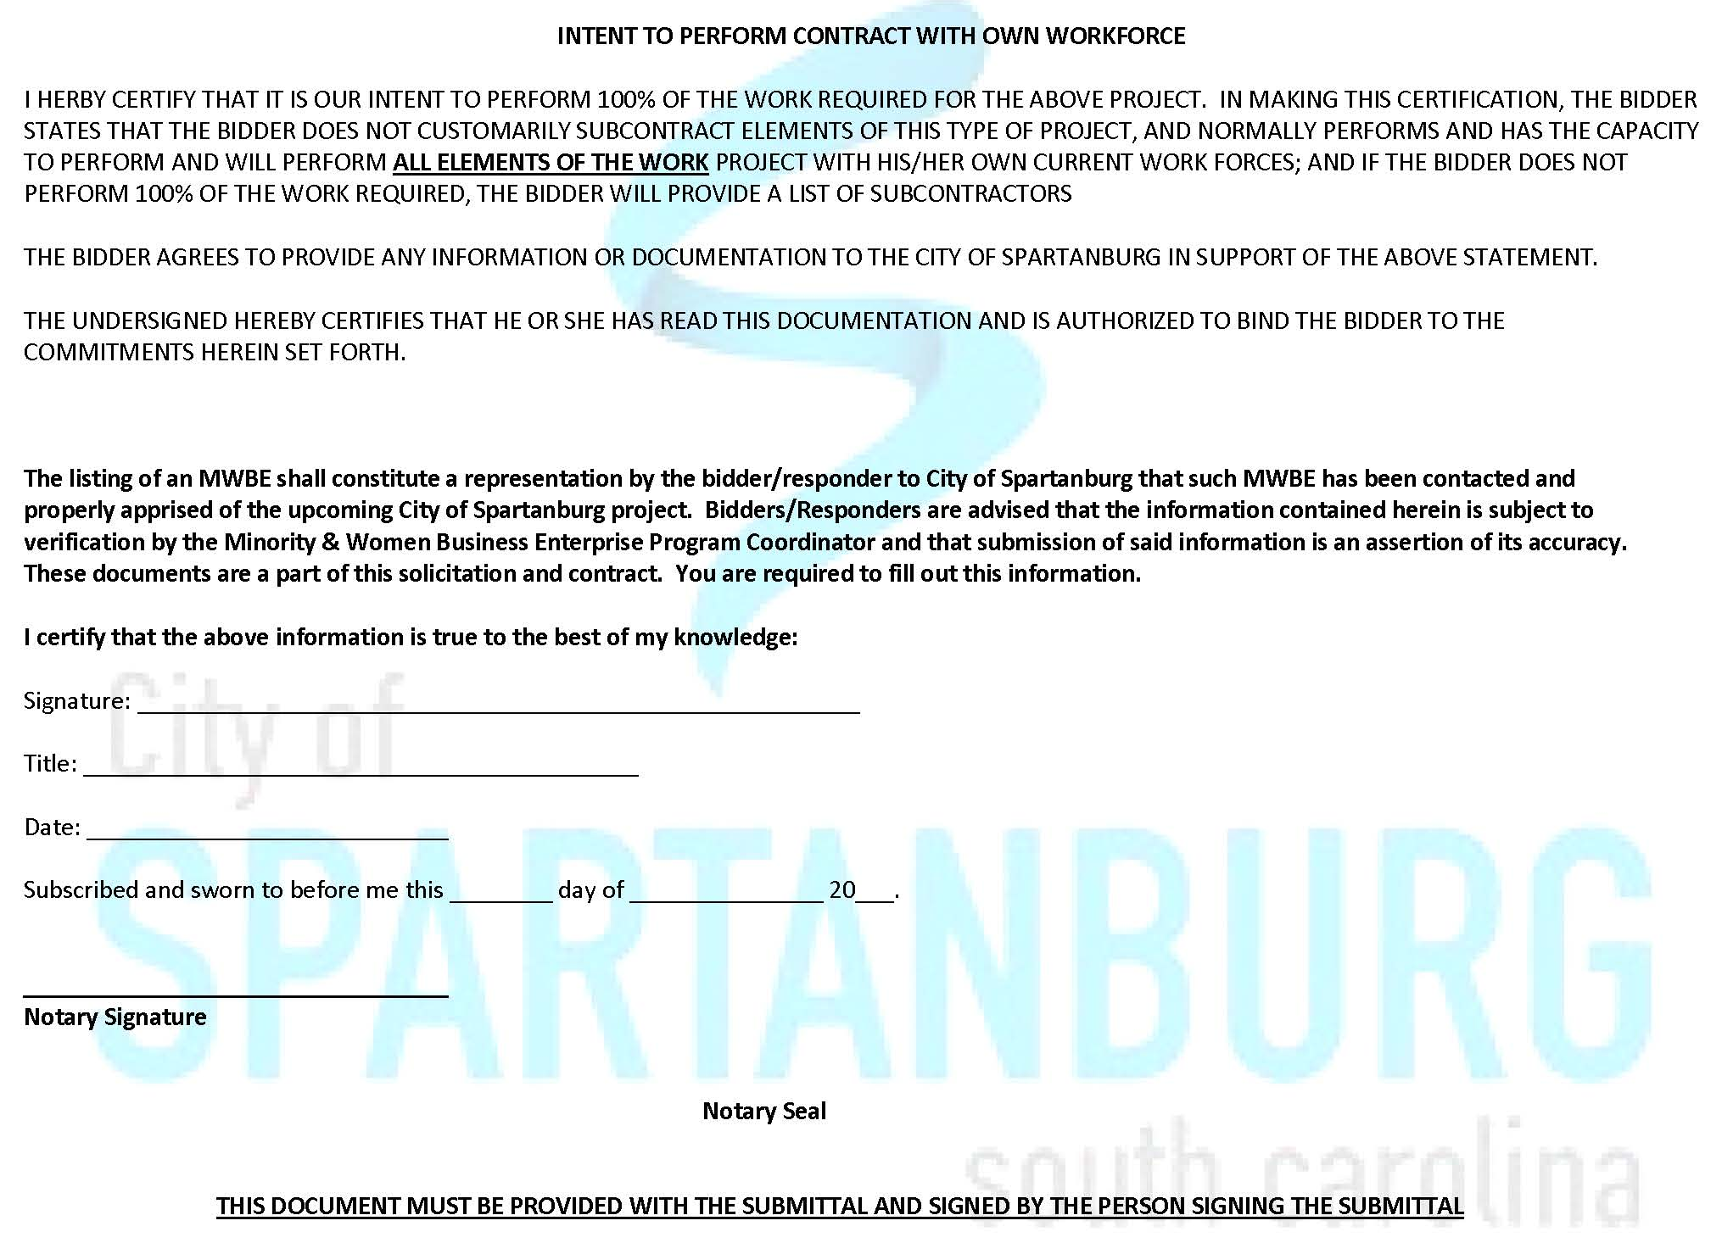
Page 9
Exhibit I
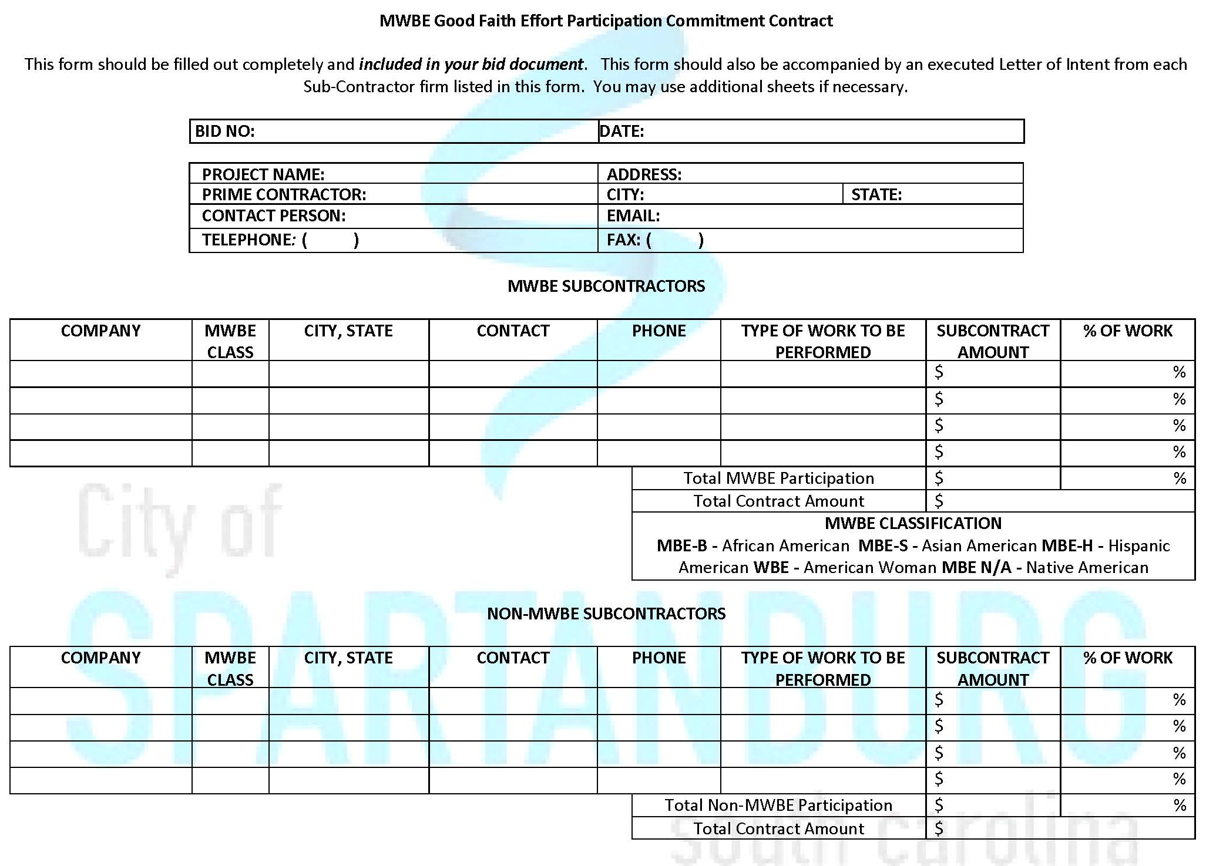
Page 10B

Debarment Statement
Page 11
CERTIFICATION REGARDING DEBARMENT, SUSPENSION, AND OTHER RESPONSIBILITY MATTERS Contractor certifies to the best of its knowledge and belief, that it and its principals:
- [ ] Are [ ] are not presently debarred, suspended, proposed for debarment, declared ineligible, or voluntarily excluded from covered transactions by any State or Federal department or agency;
- [ ] Have [ ] have not within a three-year period preceding award of this consulting agreement been convicted of or had a civil judgment rendered against them for commission of fraud or a criminal offense in connection with obtaining, attempting to obtain, or performing a public (Federal, State or Local) transaction or contract under a public transaction; violation of Federal or State antitrust statutes or commission of embezzlement, theft, forgery, bribery, falsification or destruction of records, making false statements, or receiving stolen property;
- [ ] Are [ ] are not presently indicted for or otherwise criminally charged by a governmental entity (Federal, State or Local) with commission of any of the offenses enumerated in Paragraph (b) above; and
- [ ] Have [ ] have not within a three-year period preceding award of this contract agreement had one or more public transactions (Federal, State or Local) terminated for cause or default.

________________________________ ________________________________
Consultant Signature Date

________________________________
Typed or Printed Name

Page 10
Exhibit J

CERTIFICATION OF NON-SEGREGATED FACILITIES – YEAR 2017
We, (print company name:)_____________________________________, certify to City of Spartanburg, South Carolina we do not and will not maintain or provide for our employees any segregated facilities at any of our establishments, and that we do not and will not permit our employees to perform their services at any locations, under our control, where segregated facilities are maintained. We understand and agree that a breach of this certification is a violation of the Equal Opportunity clause.
As used in this certification, the term “segregated facilities” means any waiting rooms, work areas, rest rooms, restaurants and other eating areas, time clocks, locker rooms and other storage or dressing areas, parking lots, drinking fountains, recreation or entertainment areas, transportation and housing facilities provided for employees which are segregated by explicit directive or are in fact segregated on the basis of race, religion, color or national origin because of habit, local custom or otherwise.

We further agree that --- except where we have obtained identical certifications from proposed Subcontractors for specific time periods --- we will obtain identical certifications from proposed Subcontractors prior to the award of Subcontracts exceeding which are not exempt from the provisions of the Equal Opportunity clause; that we will retain such certifications in our files; and that we will forward the following notice to such proposed Subcontractors (except where the proposed Subcontractors have submitted identical certifications for specific time periods). NOTE: Whoever knowingly and willfully makes any false, fictitious or fraudulent representation may be liable to criminal prosecution under 18 U.S.C. 1001.
PLEASE COMPLETE BELOW AND INCLUDE THIS IN THE BID PACKAGE
Name of Company Representative: ___________________________________
Title: ___________________________________
Signature: ___________________________________ Date: ____

