
City of Etowah, TN
701 Tennessee Avenue
Etowah, TN 37331
(423) 263-2202
www.cityofetowahtn.com

BID SPECIFICATIONS

PROJECT: New or Used ADA + 2 Station Portable Restroom Trailer

The City of Etowah, TN is currently soliciting bids for a used ADA + 2 Station Portable Restroom Traile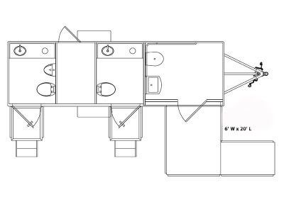
Specifications Required:
Stations: 3
Standard Toilets: 2
ADA Toilets: 1
Urinals: 1
Sinks: 3
Laundry: No
Fresh Water Tank (Gallons): 105
Waste Tank (Gallons): 360
Water Heater: No
Mechanics Room: Yes
Box Length: 20'
Box Width: 6'
A/C Unit Type (BTU): 9
A/C Unit Count: 1
Water Supply: City Water- Pressurized Water System- Garden Hose
Power Supply/Cords: (1) 240v/50 amp cord

For any further questions contact Building Inspector Anthony Munoz, amunoz @cityofetowahtn.com or City Manager Russ Blair, (423) 263-2202 or email, etowahcm@cityofetowahtn.com

