Request for Proposals

Multi-Function Copiers (as needed)

Solicitation Number | Q1725
Due Date | May 31, 2017
Due Time | 11:00 a.m. eastern standard time
Deliver Responses to: |   Knoxville’s Community Development Corporation  Procurement Division  901 N. Broadway  Knoxville, TN 37917  Note: Procurement is in a separate building behind the main office building
Electronic Copies: | Suppliers are encouraged to use the MS Word version to provide a typed response. Electronic copies are available on KCDC’s webpage or by emailing purchasinginfo@kcdc.org.
May responses be emailed to KCDC | ☒ Yes ☐ No  If the solicitation narrative calls for written submittals, the supplier must provide them as indicated.
Solicitation Meeting | Yes
Solicitation Meeting is Mandatory | ☐ Yes ☒ No
Solicitation Meeting Date | 05-15-17
Solicitation Meeting Time | 9:00 a.m.
Solicitation Meeting Location | KCDC’s Board Room at 901 N. Broadway
Questions About This Solicitation | Submit questions to purchasinginfo@kcdc.org
Award Results | KCDC posts both a summary of the quotes received and the award decision to its web page at: http://www.kcdc.org/procurement/

Check KCDC’s webpage for addenda and changes before submitting your response

General Information

1. BACKGROUND AND INTENT

a. Knoxville's Community Development Corporation (KCDC) is the public housing and redevelopment agency for the City of Knoxville and for the County of Knox in Tennessee. KCDC’s public housing property portfolio includes 20 sites with approximately 3,547 dwelling units. KCDC also administers approximately 3,958 vouchers and 82 moderate rehabilitation units through our Section 8 department.

b. KCDC is seeking proposals for a supplier who provides the best solution for its evolving copying, printing and scanning needs as described herein. Currently KCDC pays a fixed monthly fee per machine and then a “per print/per fax received” charge. KCDC does not own the machines. While KCDC assumes this will still be the preferred structure, proposers may choose to propose other arrangements as part of their “best solution.”

c. Equipment proposed must be new and KCDC may require on-site product demonstration as part of the evaluation process. If KCDC requests a demonstration, KCDC staff will use the machines for at least twenty-four hours. Their comments are part of the evaluation. KCDC will be the sole party with the authority to determine whether machines fit KCDC’s needs. There shall be no cost to KCDC for any portion of the demonstration and analysis.

d. KCDC will evaluate the options presented and award to the proposer presenting the options that best meet KCDC’s financial and functional needs. Each site or office will choose the copier that best meets its needs and budget.

e. KCDC is reasonably pleased with its existing fleet of multi-function machines-(except for the Savin 3510’s) and expects proposers to recommend equipment that exceeds the service currently provided by the 3510s. Since the bulk of KCDC’s fleet is, the 3510’s and given KCDC current needs, the proposed replacement for this device must be more robust than the 3510s and have a minimal downtime record. Proposers must recommend higher functioning equipment.

f. Technology evolves rapidly and has evolved since KCDC last solicited multi-function copiers. Therefore, KCDC is highly interested in proposals detailing technological capabilities that exist and might be of interest. For instance, while KCDC has never explored account code tracking, holding print jobs until the user enters a print code on the machine, the capability of the machine assigning office users a specific slot to find their print jobs, et cetera; staff wants to hear about all options to ascertain if they would assist in efficiency improvement.

2. CHANGES AFTER AWARD
It is possible that after award KCDC will need to revise the service needs or requirements specified in this document. KCDC reserves the right to make such changes after consultation with the proposer. Should additional costs arise, the proposer must document the increased costs. KCDC reserves the right to accept and negotiate these charges.
3. CONTRACT ADMINISTRATOR/TECHNICAL POINT OF CONTACT
The following employees are the main points of contact for the successful proposer.

a. Contractual Issues: Terry McKee, IT & Procurement Director

b. Technical Issues: Eric Bellamy (ebellamy@kcdc.org) will work directly with the proposer to
schedule and coordinate work on the installations and then to provide general direction.

c. Day to Day Needs: Site managers, office administrators and KCDC employees in charge of the
copiers at their work location.

4. CONTACT PERSONNEL
The proposer will not have more than two persons to handle billing inquiries and service related issues. In the event one or both contacts leave the KCDC account, the successful proposer will introduce the new contacts to KCDC personnel.

5. CONTACT POLICY
The proposer may not contact anyone about this solicitation, other than the KCDC’s Procurement Division from the issuance of this RFP until award. Information obtained from an unauthorized officer, agent, or employee will not affect the risks or obligations assumed by the supplier or relieve the supplier from fulfilling any of the conditions of the resulting award for the purpose of this project. Additionally, such contact can disqualify the supplier from participation in the solicitation process.

6. COPIES
The proposer will deliver three copies and one original (so marked) of your proposal by the due date and time. Additionally, the proposer will submit an electronic copy of the proposal. Suppliers can email a copy or send a copy on a flash drive.

7. EVALUATION
KCDC will arrive at the “lowest and best” solution for the final award. This may not entail simply awarding to the proposer quoting the lowest cost. All responses are subject to a determination of “responsive” and “responsible” prior to award. KCDC is the sole judge as to proposer “responsiveness” and “responsibility.” KCDC reserves the right to request additional information to assist in the evaluation process. This includes references and business capacity information.

a. KCDC will evaluate responses with a weighted evaluation system. The categories and points assigned for each category are:

Item | Maximum Points
Experience & Qualifications | 10
Cost | 50
Quality and Capacity | 40
Grand Total Points | 100

b. KCDC will review all proposals properly submitted. KCDC reserves the right to request necessary modifications, waive minor technicalities, reject all proposals, reject any proposal that does not meet mandatory requirement(s) or cancel this RFP, according to KCDC’s best interests.

c. KCDC’s Evaluation Team may elect to interview one or more proposers before making an award.

d. KCDC’s Evaluation Team may elect to first rank proposals with a simple numeric score and then detail only the top tier of proposals.

KCDC reserves the right to waive technical irregularities in submissions or to reject any or all proposals if to do so is in the best interest of KCDC.

8. GENERAL INSTRUCTIONS
KCDC does not insert “General Instructions to Proposers” in the solicitation document. These instructions are at www.kcdc.org. Click on “Procurement” and follow the link. By submitting a response to this solicitation, the supplier accepts the responsibility for downloading, reading and abiding by the terms and conditions set forth in KCDC’s “General Instructions to Proposers.” Suppliers may wish to review certain applicable HUD instructions on KCDC’s webpage.

9. INSURANCE
Upon award, Certificates of Insurance must be provided to KCDC indicating that the proposer carries at least the following minimum levels of insurance. Proposer will at its sole expense obtain and maintain in full force and effect for the duration of the resulting award and any extension hereof at least the following types and amounts of insurance for claims which may arise from or in connection with this resulting award. All insurance must be underwritten by insurers with an A.M. Best rating of A-: VI or better.

The proposer will maintain, at proposer’s sole expense, on a primary and non-contributory basis, at all times during the life of the award insurance coverages, limits, and endorsements described herein. All insurance must be underwritten by insurers with an A.M. Best rating of A-: VI or better. Upon award, the proposer will provide Certificate(s) of Insurance to KCDC evidencing said insurance coverages.

The proposer agrees the insurance requirements herein as well as KCDC’s review or acknowledgement, is not intended to and will not in any manner limit or qualify the liabilities and obligations assumed by the proposer under this award

a. Commercial General Liability Insurance: occurrence version commercial general liability insurance with a limit of not less than $1,000,000 each occurrence for bodily injury, personal injury, property damage, and products and completed operations. If such insurance contains a general aggregate limit, it will apply separately to the work/location in this award or be no less than $2,000,000.

Such insurance will contain or be endorsed to contain a provision that includes KCDC, its officials, officers, employees, and volunteers as additional insureds with respect to liability arising out of work or operations performed by or on behalf of the proposer including materials, parts, or equipment furnished in connection with such work or operations. The coverage will contain no special limitations on the scope of its protection afforded to the above-listed insureds.

The Additional Insured will read “Knoxville’s Community Development Corporation (KCDC)”.

If necessary, umbrella/excess liability insurance can be used in conjunction with the general liability insurance to meet these requirements. Unless the umbrella/excess liability insurance provides coverage on a pure/true follow-form basis, or KCDC is automatically defined as an additional insured, the proposer will add by endorsement, KCDC, its officials, officers, employees, and volunteers as an additional insured.

b. Automobile Liability Insurance: including vehicles owned, hired, and non-owned, with a combined single limit of not less than $1,000,000 each occurrence. Such insurance will include coverage for loading and unloading hazards.

c. Workers’ Compensation Insurance and Employers Liability Insurance: with statutory limits as required by the State of Tennessee or other applicable laws.

d. Other Insurance Requirements: Proposer will:
- Upon award, furnish KCDC with original Certificates of Insurance and amendatory endorsements effecting coverage required by this section. Certificates of Insurance will provide a minimum 30-day endeavor to notify KCDC of cancellation when available by proposer’s insurance. If the proposer receives a non-renewal or cancellation notice from an insurance carrier affording the required coverage, or receives notice that coverage no longer complies with the insurance requirements herein, proposer will notify KCDC by email or fax within five (5) business days and provide a copy of the non-renewal for cancellation notice or written specifics as to which coverage is no longer in compliance.

The certificate holder address will read:
Knoxville’s Community Development Corporation
Attn: Contracting Officer
901 N. Broadway
Knoxville, TN 37917

2. Provide certified copies of endorsements and policies if requested by KCDC in lieu of or in addition to Certificates of Insurance.

3. Replace certificates, policies, and endorsements for any such insurance expiring prior to completion of services.

4. Maintain such insurance from the time services commence until services are completed. Failure to maintain or renew coverage or to provide evidence of renewal may be treated by KCDC as a material breach of award.
5. Require all subcontractors to maintain during the term of the resulting award commercial general liability insurance, automobile liability insurance, and workers’ compensation/employers liability insurance (unless subcontractor’s employees are covered by proposer’s insurance) in the same manor and limits as specified for the proposer. Proposer will furnish subcontractor(s)’ Certificates of Insurance to KCDC without expense prior to subcontractor(s) commencing work.

6. Any deductibles and/or self-insured retentions greater than $50,000 must be disclosed to and approved by KCDC prior to the commencement of services. Use of large deductibles and/or self-insured retentions will require proof of financial ability as determined by KCDC.

7. Provide a waiver of subrogation for each required policy herein. When required by the insurer, or should a policy condition not permit proposer to enter into a pre-loss agreement to waive subrogation without an endorsement, the policy should be endorsed with a Waiver of Transfer of Rights of Recovery Against Others, or its equivalent. This waiver of subrogation requirement will not apply to any policy which includes a condition specifically prohibiting such an endorsement, or voids coverage should proposer enter into such an agreement on a pre-loss basis.

8. All policies must be written on an occurrence basis.

e. Once KCDC sends the successful proposer the notification of intent to award, the proposer is required to provide a Certificate(s) of Insurance evidencing coverage as required above within the timeline detailed noted below. Failure to comply within the set timeframe may constitute unresponsiveness and KCDC reserves the right, at its sole discretion, to reconsider the award.

KCDC has determined the following timeline applies to this solicitation:

General Services: 7 calendar days ☒ Yes ☐ No
Construction Services 15 calendar days ☐ Yes ☐ No

10. INVOICING/ORDERING

a. Until a purchase order is in place, work is not to be performed nor are goods to be delivered. Purchase orders authorize work and obligate payment. KCDC does not have a legal obligation to pay for work or goods delivered prior to purchase order issuance.

b. Invoices must:

1. Be numbered

2. Have a date on them that is after the work is completed or goods delivered

3. Show the purchase order number.

4. Breakdown pricing according to the bid structure. For instance, if the award is priced by the hour, then the invoice needs to show the hours and rates. This is important so that KCDC can quickly compare the rates charged with the approved rates.

5. Be suitable for scanning since KCDC does not maintain paper records.

c. Suppliers are required to submit invoices within 90 days following the delivery of the goods or services. KCDC may deny invoices submitted after the 90-day threshold.

d. KCDC’s purchases of goods are exempt from Tennessee sales and use tax pursuant to Tennessee Code Annotated 67-6-329(a) (4). KCDC is exempt from the Federal Excise tax. Contractors are subject to Tennessee sales and use tax on all materials and supplies used in the performance of a contract, whether such materials and supplies are purchase by the contractor, produced by the contractor, or provided to the contractor by KCDC, pursuant to Tennessee Code Annotated 67-6-209. The contractor will pay all taxes incurred in the performance of an awarded contract.

Upon the placement of a purchase order or the award of a contract, KCDC will provide a State of Tennessee Sales Tax Exemption form to the supplier. KCDC will not pay taxes on invoices.

e. KCDC pays by electronic transfer (ACH) only.

11. LENGTH OF AWARD
The initial award will be for 12 months. The award has four one-year optional renewals that KCDC may choose to exercise.

12. PRICE STRUCTURE

a. At the end of each award year, the successful proposer may request a price increase. Proof of increased cost to the successful proposer must accompany price increase requests. KCDC may, at its option:

1. Accept the proposed price increase.
2. Reject the proposed price increase.
3. Suggest an alternative price increase.

b. If KCDC rejects a proposed price, the successful proposer may:

1. Continue with the existing pricing.
2. Suggest an alternative price increase.
3. End the award.

13. QUESTIONS
Direct questions pertaining to this document to purchasinginfo@KCDC.org with “Copiers” in the subject line, at least five days prior to the due date.

14. SECTION 3 OF THE HUD ACT OF 1968
Section 3 is a provision of the Housing and Urban Development Act of 1968, which requires that programs of direct financial assistance administered by the U.S. Department of Housing and Urban Development (HUD) provide, to the greatest extent feasible, opportunities for job training and employment to lower income residents in connection with projects in their neighborhoods. Further, to the greatest extent feasible, contracts in connection with these projects are to be awarded to local businesses. Section 3 is a tool for fostering local economic development, neighborhood economic improvement and individual self-sufficiency.

a. Recipients and vendors must make a good faith effort to utilize Section 3 area residents as trainees and employees in connection with the project. Targeted recruitment and the selection of Section 3 area residents for available positions are two examples of good faith efforts to meet this requirement.

b. Recipients and vendors must make a good faith effort to award contracts to Section 3 business concerns for work in connection with the project. An example of a good faith effort to meet this requirement is the implementation of an affirmative action plan, which includes targets for the number and dollar value for awarding contracts to Section 3 business concerns.

c. Recipients and vendors must keep records and submit reports to HUD documenting the good faith efforts taken and the results of these actions. Examples of such documentation include letters to community organizations, employment development and business development centers, copies of solicitations for proposals or proposals; and copies of affirmative action plans.

d. How can businesses find Section 3 residents to work for them? By recruiting in the neighborhood and public housing developments to tell about available training and job opportunities. Distributing flyers, posting signs, placing ads, and contacting resident organizations and local community development and employment agencies to find potential workers are a few effective ways of getting jobs and people together.

e. All contracts awarded are subject to Section 3 requirements. Proposer will seek to fill any and all position that are needed and unfilled with residents of KCDC communities. For additional information, please go to http://www.hud.gov/offices/fheo/section3/Section3.pdf. The successful proposer will supply KCDC with job announcements for any position that must be filled as a result of the award of KCDC work. Additionally the successful proposer will supply the same job announcement to the Knoxville-Knox County Committee Action Committee’s Workforce Connections group. These can be faxed to 544-5269.

f. A Section 3 resident is one who lives within a public housing authority’s apartment. It is also people who live in an area with a HUD assisted program and whose income is below HUD’s low income requirements.

g. A Section 3 business is one that:

1. Is at least 51% owned by a Section 3 resident; or

2. Employs Section 3 residents for at least 30% of its employee base; or
3. Makes a commitment to sub award at least 25% of the project’s dollars to a Section 3 business.

15. SUBCONTRACTORS
KCDC must approve subcontractors prior to them beginning work and the subcontractors must carry the insurance coverages outlined herein.

Scope of Work/Description of Minimums

16. GENERAL COMMENTS
KCDC’s goal is to have one or more suitability sized, high functioning multi-function digital copiers in place at each site or department so that KCDC employees can make copies, fax (incoming and outgoing) and scan as needed. KCDC wants an award with maximum flexibility.

a. KCDC has 14 site offices requiring one or more multi-function copiers plus 40 copiers in various offices at its corporate headquarters at 901 N. Broadway.

b. Several of KCDC’s properties are changing to a new management structure, which affects printing and copying needs. Additionally KCDC has launched a paperless work initiative and it involves intense scanning needs. These changes plus evolving technology capabilities mean that KCDC needs state of the art multi-function copiers that can meet our current needs and that can evolve to meet our needs as they change.

c. KCDC prefers not to sign a third party lease but will consider doing so if it is in its best interest. KCDC intends to make an award and issue purchase orders to authorize the placement of copiers.

d. Appendix A shows the proposed reconfiguration of KCDC’s current copier fleet. However, this does not reflect printing volumes. KCDC wants this configuration matched as closely as possible with machines that are equal/better than the ones currently listed in the Appendix with the already noted exception of the 3510s. KCDC encourages proposers to use all the other information presented to develop the best proposal for KCDC to minimize costs while maximizing functionality.

e. KCDC’s overall objectives/needs are for a highly flexible, innovative multi-function copier arrangement, which can adapt to KCDC’s needs over time in a cost effective manner.

17. BILLING/USAGE TRACKING
KCDC is seeking an electronic and automated solution for managing copier and duplicator usage that provides site monitoring and reporting capabilities, e.g. the ability to monitor copying, printing, faxing and walk-up use, as applicable per equipment.

18. ENERGY STAR
Copiers must meet the EPA’s Energy Star specifications. Copiers must automatically enter a low-power mode of 30 watts or less after a period of approximately 15 to 30 minutes of inactivity. The copier shall automatically recover from the low-power mode upon receipt of external input (e.g., keyboard activity, entry of an ID number). Equipment configured for multifunction copier/printer/fax/scanner, shall recover from low-power mode upon receipt of external input including incoming fax transmission or print command from the computer network.

The proposer shall include a rating sheet and/or rating statistics describing the energy ratings of proposed equipment.

19. EQUIPMENT

a. KCDC prefers that all equipment be from the same manufacturer but will consider options that best meet its needs.

b. Once an award is in place, if models are discontinued, proposed substitutions require KCDC’s approval. Any proposed model offered must be of equal or greater capability than the model replaced.

c. All equipment shall have PIN code and/or mailbox secured access for users.

d. All equipment shall have programmable cost center/accounting meters with a minimum of 50 separate cost centers/meters. The proposer will indicate the number of digits accommodated per account code.

e. At the end of the award, the proposer will remove all equipment in coordination with KCDC’s needs and at no cost to KCDC. Proposer shall remove equipment within 30 days after KCDC’s notification.

20. FLEXIBILITY
Conditions and needs change over time. KCDC may acquire or close sites and thus require additional or less equipment. Technological needs may change over time. The proposer must accept KCDC’s need to add/change/delete sites and equipment as well as adapt to changing technological needs.

KCDC has the right to request additional units if needed and the right to reduce the number of units in place should KCDC’s needs change substantially. The supplier will prorate any such additional units only to the end of the maximum contract length. KCDC has the right to request new equipment to meet changed technological needs.

21. HARD DRIVE SECURITY
Data security is very important for KCDC. Units removed from KCDC’s premises must have the data stored on the hard drive must be erased or otherwise made inaccessible to others. Proposer will either provide a certified erasure measure or properly destroy the hard drive.

22. HELP DESK SUPPORT
The successful proposer will:

a. Provide a single point of contact for KCDC staff

b. Have unlimited phone support on initial service calls during normal business hours (7:30 a.m. to 4:00 p.m.) Monday through Friday except for KCDC recognized holidays.

c. Have unlimited network support during normal business hours (7:30 a.m. to 4:00 p.m.) Monday through Friday except for KCDC recognized holidays.

23. INSTALLATION
The successful proposer will ship, deliver and install the equipment (and any necessary supplies) at no additional cost to KCDC.

a. Installation includes unboxing, setting up, testing and removing all packaging materials from KCDC sites. The proposer may not use KCDC dumpsters for disposal.

b. The proposer must totally test the copier’s functionality to ensure proper working order at the installation site. If any components are defective, the installer will obtain replacement parts. A warranty call will not be required.

c. Copiers must utilize the standard 125V 20 AMP grounded electrical household service.

d. The proposer must install the hardware after award but before the agreed to contract start date.

24. MAINTENANCE AND REPAIR
The proposer will:

a. Respond to a request for repairs within one hour.

b. Complete repairs within four hours after the initial response.

c. Maintain an adequate supply of spare components to minimize equipment downtime.

d. Provide a free loaner machine of equivalent or greater capacity when existing equipment will be out of service for longer than 48 hours.

e. Replace machines if excessive breakdowns occur. The proposer will specify the parameters of excessive breakdowns as requested in Solicitation Document E.

f. Have total responsibility for the disposal of repairs parts, supplies and packaging.

g. Supply KCDC with an electronic call completion notification.

25. MANUFACTURER AUTHORIZATION

a. The proposer must be an authorized dealer for the equipment bid.

b. Manufacturer-authorized technicians shall perform all warranty or maintenance services.

c. Trained service personnel will provide installation, training, maintenance, and repairs. Service personnel shall be direct employees of the proposer.

26. NETWORK PRINTING CONFIGURATION & INSTALLATION REQUIREMENTS

a. The costs quoted herein include network printing configuration and installation.

b. Network installation must include physically connecting (including CAT 5e or CAT 6 certified patch cable, depending on site cable requirements) the copier to the Windows network, leaving the appropriate drivers on a CD or a link that would provide up to date versions of all drivers and setting up the copier.

c. The only supported and accepted copier/printer configuration is a TCP/IP. The installer is responsible for preparation of the network copier including firmware updates and a configuration tag identifying the network name of the copier, etc. The installer will configure the TCP/IP network settings of the copier for DHCP using the manufacturer's utility.

d. The proposer must perform all printing tests to verify correct network connectivity.

e. Interface Connection: Standard 10/100 Base-T (RJ-45) and Gigabyte
connections where available.

f. Supportable protocols: TCP/IP, AppleTalk (EtherTalk) and any other
industry standards.

g. Workstation Operation System compatibility: Windows Vista, Windows 7, 8.1 and 10.

h. Server Operation System compatibility: Windows Server 2012 R2.

i. PDL support: PCL 5 and PCL 6, PostScript

j. One machine must be capable of printing Postscript and PCL.

k. The proposer will supply the necessary drivers for Windows and Novell. The Windows environment includes but is not limited to Vista, Windows 7, Windows 8.1, Windows 10 and Server 2003, 2008 and 2012.

27. REPORTING
The successful proposer is required to send usage and repair reports (at least once per year) to Eric Bellamy, in an Excel type format that shows:
a. The model and number of each unit

b. The location of each unit

c. The volume produced by each unit

28. SUPPLIES
The proposer shall provide and deliver to the using site, all supplies, except paper and staples, for the operation of the copiers at no additional cost. A Safety Data Sheet (SDS) shall accompany any chemical products delivered to any location in conjunction with this contract.

29. TRAINING
The proposer shall provide training to KCDC staff as required. Specifically:

a. Initial on-site user training covering general usage, available functions, setting changes and how to deal with minor equipment malfunctions; changing toner, installing staples, clearing jams, all functional options, et cetera.

b. The proposer will provide additional on-site user training sessions if KCDC personnel changes warrant the sessions.

c. Provide an operator's manual with each copier machine.

30. TECHNOLOGY REQUIREMENTS (See attached spreadsheet)

a. All units must have enlarge/reduce capabilities.

b. All main units located at sites must have color capabilities for copying/printing.

c. Multi-function machines must have current scanning software for KCDC’s usage.

d. The machine placed in the Executive Office area must include a fax routing via email option. If this is at an additional cost, the proposer must clearly quote such cost.

e. KCDC normally scans to folders so this functionality is required.

f. KCDC needs scanned documents to be of high quality and as color images as applicable.

g. KCDC does not use proximity cards to authenticate user credentials but may want to use fobs if that is available or at the least, use codes for individual employees so print jobs are not run until the employee enters their code at the machine.

h. KCDC does not use a fax server.

i. KCDC uses the multi-function copiers to scan to email, network folders and desktop folders.

31. UP TIME
The equipment must be “up” and usable 95% of the time.

Submittal Structure Instructions

1. Submit your information in the order indicated below:

Document Number | Title | Form Provided by
Solicitation Document A | General Response Section | KCDC
Solicitation Document B | Affidavits | KCDC
Solicitation Document C | HUD Form 5369A | KCDC
Solicitation Document D | Proposer’s Qualifications and Capacity | Proposer
Solicitation Document E | Proposer’s Equipment Proposed for KCDC | Proposer
Solicitation Document F | Proposer’s Cost Schedule | Proposer
Solicitation Document G | Proposer’s Equipment Functionality Information | Proposer

2. Place your company’s name on each page and number all pages consecutively

3. The use of tables in presenting information facilitates the evaluation team’s review.

4. Submit one original (with all pages marked “original”), three printed copies and one electronic copy (email or flash drive /CD) of your submittal).

5. Fancy brochures and advertisements are not necessary.

6. Do not use phrases such as “See the attached” or “Will be provided upon award.”

7. Bind proposals simply since KCDC ultimately scans documents into electronic format. Acceptable binding methods include paper clips, staples and three ring binders.

8. KCDC strongly urges proposers to use a typed version for their responses.

This and the previous pages do not need to be returned

Multi-Function Copiers Q1725

Solicitation Document A General Response Section

General Information about the Proposer
Sign Your Name to the Right of the Arrow
Your signature indicates that you have read and agree to “KCDC’s General Instructions to Vendors” on www.kcdc.org.
Printed Name and Title
Company Name
Street Address
City/State/Zip
Contact Person (Please Print Clearly)
Telephone Number
Cell Number
Proposer’s e-mail address (Please Print Clearly)
Addenda
Addenda are at www.kcdc.org. Click on “Procurement” and then on “Open Solicitations” to find addenda. Please check for addenda prior to submitting a bid.
Acknowledge addenda have been issued by checking below as appropriate:
None ☐ |  | Addendum 1 ☐ |  |  | Addendum 2 ☐ |  |  | Addendum 3 ☐ |  |  | Addendum 4 ☐ |  |  | Addendum 5 ☐
Statistical Information
This business is owned & operated by persons at least 51% of the following ethnic background:
Asian/Pacific ☐ |  |  | Black ☐ | Hasidic Jew ☐ |  |  | Hispanic ☐ |  |  | Native ☐ Americans |  |  | White ☐
As defined on KCDC’s webpage (see the “General Instructions to Proposers”), this business qualifies as:
Section 3 ☐ |  |  |  |  |  | Small Business ☐ |  |  |  |  |  | Woman Owned ☐
Cooperative Procurement by Other Governmental Entities
Subject to additional location/delivery charges, the proposer agrees to extend the offered costs to other governments if the other government so desires. Yes ☐ No ☐
Insurance Requirements
I have reviewed the insurance requirements in this solicitation and will provide KCDC with a Certificate of Insurance adhering to these requirements within the stated number of days. Yes ☐ No ☐
 | Prompt Payment Discount
 | A discount of _____% is offered if payment is made within 30 days

Multi-Function Copiers Q1725

Solicitation Document B Affidavits

Supplier: _____________________________________________________________________________

Conflict of Interest:

1. No commissioner or officer of KCDC or other person whose duty it is to vote for, let out, overlook or in any manner superintend any of the work for KCDC has a direct interest in the award or the proposer providing goods or services.

2. No employee, officer or agent of the grantee or sub-grantee will participate in selection, or in the award or administration of an award supported by Federal funds if a conflict of interest, real or apparent, would be involved. Such a conflict would arise when the employee, officer or agent, any member of his immediate family, his or her partner, or an organization, which employs, or is about to employ, any of the above, has a financial or other interest in the proposer selected for award.

3. The grantee's or sub-grantee's officers, employees or agents will neither solicit nor accept gratuities, favors or anything of monetary value from proposers, potential proposers, or parties to sub-agreements.

4. By submission of this form, the proposer is certifying that no conflicts of interest exist.

Drug Free Workplace Requirements:

5. Private employers with five or more employees desiring to contract for construction services attest that they have a drug free workplace program in effect in accordance with TCA 50-9-112.

Eligibility:

6. The proposer is eligible for employment on public contracts because no convictions or guilty pleas or pleas of nolo contender to violations of the Sherman Anti-Trust Act, mail fraud or state criminal violations with an award from the State of Tennessee or any political subdivision thereof have occurred.

General:

7. Proposer fully understands the preparation and contents of the attached offer and of all pertinent circumstances respecting such offer.

8. Such offer is genuine and is not a sham offer.

Multi-Function Copiers Q1725

Solicitation Document B Affidavits-continued

9. Iran Divestment Act:
Concerning the Iran Divestment Act (TCA 12-12-101 et seq.), by submission of this bid/quote/quote, each proposer and each person signing on behalf of any proposer certifies, and in the case of a joint bid/quote/quote, each party thereto certifies as to its own organization, under penalty of perjury, that to the best of its knowledge and belief that each proposer is not on the list created pursuant to § 12-12-106.

Non-Collusion:

10. Neither the said proposer nor any of its officers, partners, owners, agents, representatives, employees or parties interest, including this affiant, has in any way colluded conspired, connived or agreed, directly or indirectly, with any other responder, proposer, or person to submit a collusive or sham offer in connection with the award or agreement for which the attached offer has been submitted or to refrain from making an offer in connection with such award or agreement, or collusion or communication or conference with any other proposer, or, to fix any overhead, profit, or cost element of the offer price or the offer price of any other proposer, or to secure through any collusion, conspiracy, connivance, or unlawful agreement any advantage against KCDC or any person interested in the proposed award or agreement.

11. The price or prices quoted in the attached offer are fair, proper and not tainted by any collusion, conspiracy, connivance, or unlawful agreement on the part of the proposer or any of its agents, representatives, owners, employees, or parties in interest, including this affiant.

The undersigned hereby acknowledges receipt of this Solicitation Document B and certifies that the submittal in response to this solicitation is in full compliance with the listed requirements.

Signed by
Printed Name
Title
Subscribed and sworn to before me this date
By (Notary Public)
My Commission Expires on
Notary Stamp

Multi-Function Copiers Q1725

Solicitation Document C HUD Form 5369A
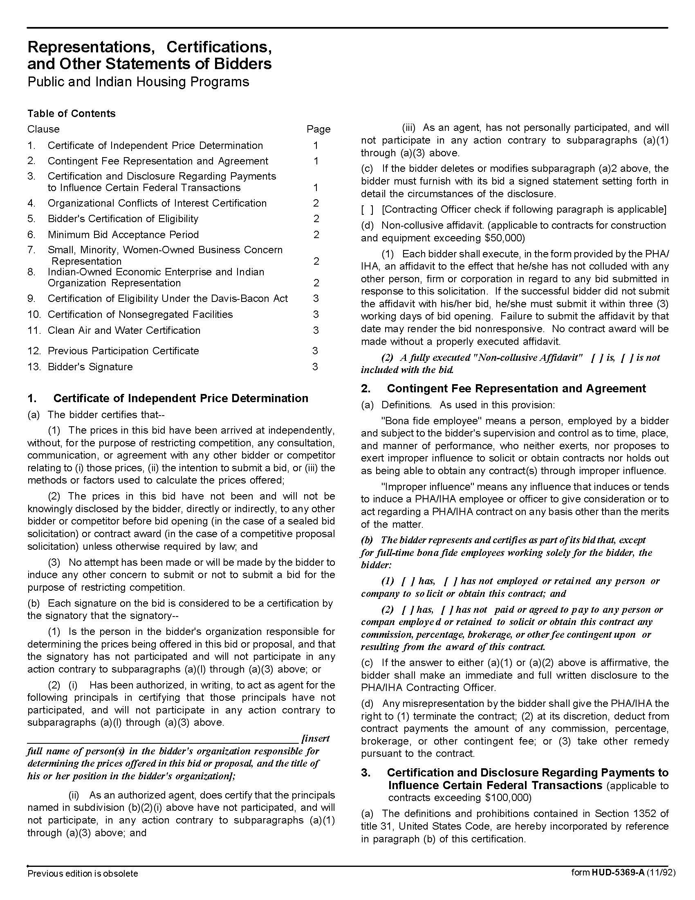

Multi-Function Copiers Q1725

Solicitation Document C HUD Form 5369A-continued
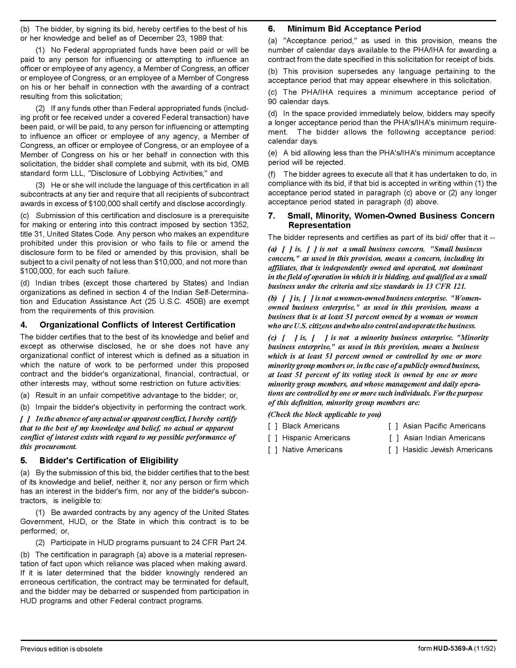

Multi-Function Copiers Q1725

Solicitation Document C HUD Form 5369A-continued
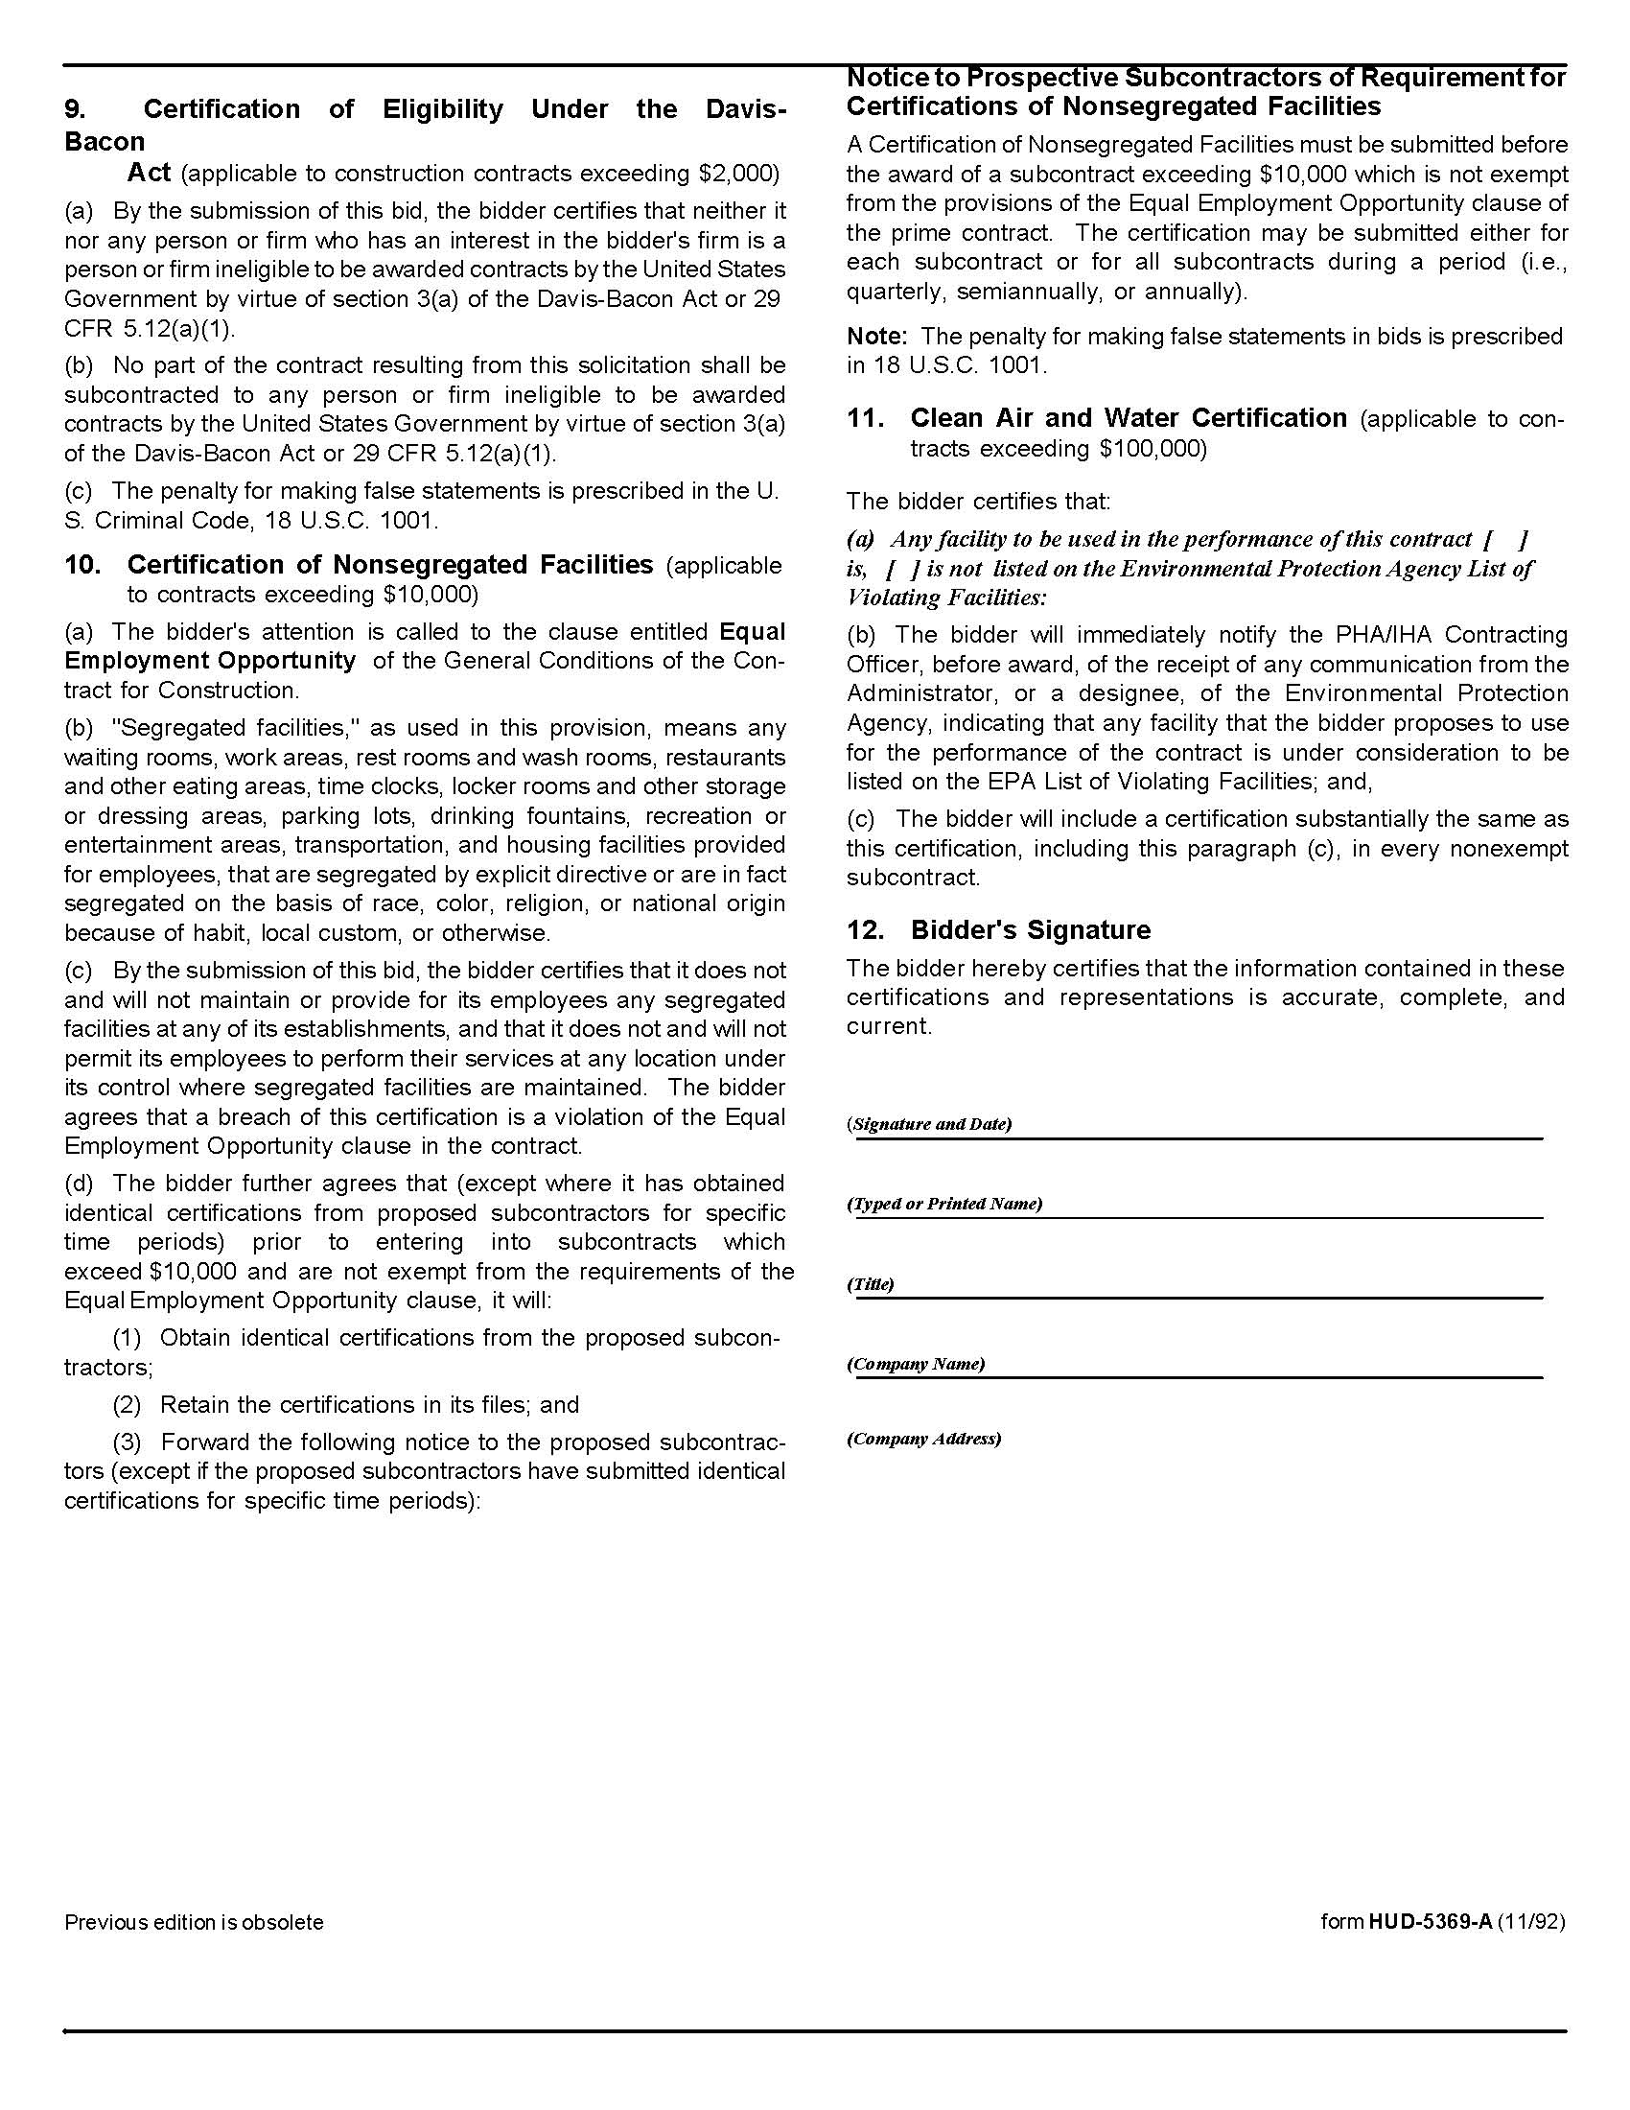

Multi-Function Copiers Q1725

Solicitation Document D Proposer’s Corporate History and Qualifications

Proposer: _____________________________________________________________________________

- Corporate Name
- Corporate Structure
- Start Date
- Number of Employees
- Employees by Classifications (sales, technician, administration, et cetera)
- Number of Clients
- Number of Copiers in place
- Include information/certificates from manufacturers showing that you are an authorized dealer for this product and that your firm is authorized to work on them
- Et cetera

Multi-Function Copiers Q1725

Solicitation Document E Proposer’s Equipment Proposed

Proposer: _____________________________________________________________________________

- Discuss your overall plan for meeting KCDC’s needs
- Discuss your plan/options for being able to evolve as KCDC’s needs evole
- Brands/Models offered
  - Specifications
  - Capabilities
  - Energy Star Ratings/Certificates
- Hard Drive Security and Plan after removal
- Parameters for replacing a defective machine
- Et Cetera

Multi-Function Copiers Q1725

Solicitation Document F Proposer’s Cost Schedule

Proposer: _____________________________________________________________________________

- Use a chart like the one below to compare KCDC’s current equipment’s features/capabilities to those of the machines you propose.
- Add line items to the chart as appropriate.
- Create one chart per type of machine offered.

Unit A: XX Copies Per Minute Black Network/Print/Scan and Color Network/Print/Scan
 | KCDC’s Current Equipment | Proposer’s Suggested Equipment Offers
Brand Bid
Model Bid
Speed Per Minute After First Page
Maximum Copies per Month Machine Rating
Cost Per Month |  | $
Cost Per Copy |  | $0.
Scans Cost |  | $0. Per page
Faxes (Incoming Cost) |  | $0. Per page
Fax Included |  | Yes No
Fax Cost |  | $
Postscript Included |  | Yes No
Postscript Cost |  | $
Duplexes 2 to 2 |  | Yes No
Stapling Possible |  | Yes No
Stapling Maximum Pages
Stapling Additional Cost |  | $
Largest Size Paper Possible
(Does not need to exceed 8.5 x 14)
Hole Punch Capability

Multi-Function Copiers Q1725

Solicitation Document G Functionality Information

Proposer: _____________________________________________________________________________

Provide the following Network Functionality information about the units proposed for KCDC.

1. Proposer shall indicate the following about networked multi-function printer/scanners:

a. The acceptable Operating system(s) of the computer that will host the Network Scanning software which directs scans from an MFP into a folder on a network server, specified by the ‘address book” entry chosen by the operator. For example, will the software run on Windows 2003 Server, on a Windows 7, 8.1 or 10 Client computer, or other operating system?

b. Can Multi-function units scan documents and interact with network scanning software across multiple subnets with in the network?

c. Must the MFP be in the same subnet as the server hosting the scanning software?

d. Can KCDC direct a scan to a computer or server in another subnet from the server hosting the scanning software?

e. Does this differ by MFP model?

f. All models need the ability for remote access via the web or GUI

2. Email communication from the MFPs to the proposer support group (KCDC has its own on-site Exchange 2007 server.)

a. Can the MFP send email notices to the proposer support group when maintenance is required?

b. Can the MFP send email notices to the proposer support group when an error condition exists?

c. Will the MFP send a page count each month to the appropriate billing office so that it will not be necessary for KCDC to manually read the accumulated impressions on each machine and then send them to the proposer for billing?

d. Will the machine simultaneously send a page count to an administrator email account within KCDC?

3. Describe the capability of each proposed machine in reference to faxing. Specifically:

a. Telephone books

b. Can existing telephone books be imported into the proposed equipment?

Multi-Function Copiers Q1725

Solicitation Document G Functionality Information-continued

Proposer: _____________________________________________________________________________

c. Coversheets

1. How many standard coversheets are included that are suitable for business?

2. Does the technology allow a user to create/modify coversheets to meet their needs? If so, describe the programming that is required.

3. Does the technology only allow for linear text on a coversheet or can text be in paragraphs?

4. Will the machines print from wireless devices such as tablets (Android and IPads) and cellphones?

Multi-Function Copiers Q1725

Appendix A KCDC’s Copier Fleet

Printer Manufacturer | Savin
Department/Site | 3510 | 5210 | C3003 | C4503 | MP5002 | C305 | C830DN | TOTAL
 | 37 | 5 | 14 | 3 | 2 | 2 | 1 | 64
Accounting | 9 | 1 |  |  |  |  |  | 10
Autumn Landing | 1 |  | 1 |  |  |  |  | 2
Cagle Terrace | 1 |  | 1 |  |  |  |  | 2
Executive Management | 7 |  |  | 1 |  | 1 |  | 9
Housing | 1 |  | 1 | 2 |  |  |  | 4
Human Resources |  |  | 1 |  |  |  |  | 1
Information Technology | 1 |  |  |  |  |  | 1 | 2
Isabella Towers | 1 |  | 1 |  |  |  |  | 2
Lonsdale Homes |  |  | 1 |  |  |  |  | 1
Love Towers | 1 |  | 1 |  |  |  |  | 2
Manor | 2 |  |  |  |  |  |  | 2
Montgomery Village | 1 |  | 1 |  |  |  |  | 2
North Ridge Crossing | 1 |  | 1 |  |  |  |  | 2
Northgate Terrace | 1 |  | 1 |  |  |  |  | 2
Purchasing |  |  | 1 |  |  |  |  | 1
Redevelopment |  |  |  |  |  |  |  | 0
Section 8 | 6 | 3 |  |  | 2 | 1 |  | 12
Supportive Maintenance |  | 1 |  |  |  |  |  | 1
Taylor Homes | 2 |  | 1 |  |  |  |  | 3
The Vista | 1 |  | 1 |  |  |  |  | 2
Western Heights | 1 |  | 1 |  |  |  |  | 2

