Request for Written Quotes

re-glazing & related services

Solicitation Number | Q1828
Due Date | May 10, 2018
Due Time | 11:00 a.m. EST
Deliver Responses to: | Knoxville’s Community Development Corporation    Procurement Division  901 N. Broadway  Knoxville, TN 37917  Note: Procurement is in a separate building behind the main office building.
Electronic Copies | Electronic copies are available on KCDC’s webpage or by email at purchasinginfo@kcdc.org.
Responses may be Emailed to KCDC | ☒ Yes ☐ No  Paper copies must also be provided, if the solicitation so indicates.
Printed Responses Required | ☐ Yes ☒ No
Solicitation Meeting | ☐ Yes ☒ No
Solicitation Meeting is Mandatory | ☐ Yes ☒ No
Solicitation Meeting Date | Not applicable
Solicitation Meeting Time | Not applicable
Solicitation Meeting Location | Not applicable
Questions About This Solicitation | Submit questions to purchasinginfo@kcdc.org  KCDC will not accept questions via telephone.
Award Results | KCDC posts both a summary of the quotes received and the award decision to its web page at: http://www.kcdc.org/procurement/

Check KCDC’s webpage for addenda and changes before submitting your response

General Information

1. Background and Intent

a. Knoxville's Community Development Corporation (KCDC) is the public housing and redevelopment agency for the City of Knoxville and for Knox County in Tennessee. KCDC’s affordable housing property portfolio includes 20 sites with approximately 3,525 dwelling units. KCDC also oversees approximately 3958 Section 8 Vouchers, 82 Moderate Rehabilitation units and 20 Redevelopment areas. Several of the properties have transformed to the Project Based Rental Assistance program (PBRA) and KCDC is the management company for those sites. The properties for which KCDC is the management company include Five Points 1, LP; Lonsdale Homes, LP; Northridge Crossing, LP and The Vista at Summit Hill, LP.

b. The intent of this solicitation is to hire a supplier to re-glaze bathtubs and perform other related services on an “as needed” basis. As needs arise, the site manager will contact the successful supplier and request such services. Any agreement resulting from this solicitation will be an “open-end” type of agreement; there is no guarantee that any specified or minimum level of services will be required by KCDC or provided by the supplier.

c. It is understood that KCDC intends to use the successful supplier for these products or services; however, KCDC reserves the right to purchase these products or services elsewhere if it is in KCDC’s best interest.

2. Changes After Award
It is possible that after award KCDC will need to revise the service needs or requirements specified in this document. KCDC reserves the right to make such changes after consultation with the supplier. Should additional costs arise, the supplier must document increased costs. KCDC reserves the right to accept and negotiate these charges.

3. Codes and Ordinances
All work covered is to be done in full accord with national, state and local codes and ordinances
and orders that are in effect at the time the work is performed.

4. Contact Policy
The supplier may not contact an officer, agent or employee of KCDC other than the KCDC’s Procurement Division about matters pertaining to this solicitation, from the issuance of this solicitation until its award. Information obtained from an unauthorized officer, agent or employee of KCDC will not affect the risks or obligations assumed by the supplier or relieve the supplier from fulfilling any of the conditions of the project. Such contact can disqualify the supplier from participation in the solicitation process.

5. Damage
The awarded supplier is responsible for any and all damage to buildings, equipment, grounds, premises and all other types of potential damage resulting from the provision of the services requested herein.
6. Employees
Supplier will:

a. Allow only personnel thoroughly trained and skilled to work on the job.

b. Have sufficient personnel to complete the work in a timely manner.

c. Enforce strict discipline and good order among his/her employees.

d. Provide at least one employee on every job assignment with the ability to speak, read, write and understand English so KCDC’s staff can communicate effectively with them.

e. Employ the quantity and quality of supervision necessary for both effective and efficient management at all times.

f. Employees parking vehicles (whether corporately or privately owned) must ensure that company identification is on the vehicles. This may be by placards on the vehicle’s side, laminated paper with the company name placed on the dashboard or other means.

7. Entrance to Sites
Supplier’s employees are not to be on KCDC premises unless they are working on a KCDC project. Acquaintances, family members, assistants or any person not working on KCDC’s behalf will not accompany employees on KCDC sites.

8. Equipment
Supplier shall provide all necessary cleaning equipment, materials, supplies, et cetera needed for the performance of the work.

9. Evaluation
KCDC will arrive at the “lowest and best” solution for the final award. This may not entail simply awarding to the supplier quoting the lowest cost. All responses are subject to a determination of “responsive” and “responsible” prior to award. KCDC is the sole judge as to supplier “responsiveness” and “responsibility.” KCDC reserves the right to request additional information to assist in the evaluation process. This includes references and business capacity information.

10. General Instructions
KCDC does not insert “General Instructions to Suppliers” in solicitation documents. These instructions are at www.kcdc.org. Click on “Procurement” and the link to the instructions. The supplier’s submittal means acceptance of the terms and conditions set forth in KCDC’s “General
Instructions to Suppliers.”

11. Identification
The supplier’s employees shall have proper identification displayed, at all times, while on KCDC property. All employees must wear a company uniform or have photo identification badges or other company identification at all times.
12. Insurance
The supplier shall maintain, at supplier’s sole expense, on a primary and non-contributory basis, at all times during the life of the contract insurance coverages, limits and endorsements described herein. All insurance must be underwritten by insurers with an A.M. Best rating of A-:VI or better. Upon award, the supplier shall provide Certificate(s) of Insurance to KCDC evidencing said insurance coverages.

The supplier agrees the insurance requirements herein as well as KCDC’s review or acknowledgement, is not intended to and shall not in any manner limit or qualify the liabilities and obligations assumed by the supplier under this contract.

a. Commercial General Liability Insurance: occurrence version commercial general liability insurance with a limit of not less than $1,000,000 each occurrence for bodily injury, personal injury, property damage and products and completed operations. If such insurance contains a general aggregate limit, it shall apply separately to the work/location in this contract or be no less than $2,000,000.

Such insurance shall contain or be endorsed to contain a provision that includes KCDC, its officials, officers, employees and volunteers as additional insureds with respect to liability arising out of work or operations performed by or on behalf of the supplier including materials, parts or equipment furnished in connection with such work or operations. The coverage shall contain no special limitations on the scope of its protection afforded to the above-listed insureds.

The Additional Insured shall read “Knoxville’s Community Development Corporation (KCDC).”
If necessary, umbrella/excess liability insurance can be used in conjunction with the general liability insurance to meet these requirements. Unless the umbrella/excess liability insurance provides coverage on a pure/true follow-form basis, or KCDC is automatically defined as an additional insured, the supplier shall add by endorsement, KCDC its officials, officers, employees and volunteers as an additional insured.

b. Automobile Liability Insurance: including vehicles owned, hired and non-owned, with a combined single limit of not less than $1,000,000 each occurrence. Such insurance shall include coverage for loading and unloading hazards.

c. Workers’ Compensation Insurance and Employers Liability Insurance: with statutory limits as required by the State of Tennessee or other applicable laws.

d. Other Insurance Requirements: Supplier shall:

1. Provide certified copies of endorsements and policies if requested by KCDC in lieu of or in addition to Certificates of Insurance.

2. Replace certificates, policies and endorsements for any such insurance expiring prior to completion of services.

3. Require all subcontractors to maintain during the term of the resulting contract commercial general liability insurance, automobile liability insurance, and workers’ compensation/employers liability insurance (unless subcontractor’s employees are covered by supplier’s insurance) in the same manor and limits as specified for the supplier. Supplier shall furnish subcontractor(s)’ Certificates of Insurance to KCDC without expense prior to subcontractor(s) commencing work.

4. Upon award, furnish KCDC with original Certificates of Insurance and amendatory endorsements effecting coverage required by this section. Certificates of Insurance shall provide a minimum 30-day endeavor to notify KCDC of cancellation when available by supplier’s insurance. If the supplier receives a non-renewal or cancellation notice from an insurance carrier affording the required coverage, or receives notice that coverage no longer complies with the insurance requirements herein, supplier shall notify KCDC by email or fax within five (5) business days and provide a copy of the non-renewal for cancellation notice or written specifics as to which coverage is no longer in compliance.

The certificate holder address shall read:

Knoxville’s Community Development Corporation
Attn: Contracting Officer
901 N. Broadway
Knoxville, TN 37917

5. Maintain such insurance from the time services commence until services are completed. Failure to maintain or renew coverage or to provide evidence of renewal may be treated by KCDC as a material breach of contract.

6. Any deductibles and/or self-insured retentions greater than $50,000 must be disclosed to and approved by KCDC prior to the commencement of services. Use of large deductibles and/or self-insured retentions will require proof of financial ability as determined by KCDC.

7. Provide a waiver of subrogation for each required policy herein. When required by the insurer, or should a policy condition not permit supplier to enter into a pre-loss agreement to waive subrogation without an endorsement, the policy should be endorsed with a Waiver of Transfer of Rights of Recovery Against Others, or its equivalent. This waiver of subrogation requirement shall not apply to any policy which includes a condition specifically prohibiting such an endorsement, or voids coverage should supplier enter into such an agreement on a pre-loss basis.

8. All policies must be written on an occurrence basis.

e. Right to Revise or Reject: KCDC reserves the right, but not the obligation, to review or revise any insurance requirement, not limited to limits, coverages and endorsements based on insurance market conditions affecting the availability or affordability of coverage; or changes in the scope of work / specifications affecting the applicability of coverage.
f. No Representation of Coverage Adequacy: The coverages, limits or endorsements required herein protect the primary interests of KCDC, and the supplier agrees in no way should these coverages, limits or endorsements required be relied upon when assessing the extent or determining appropriate types and limits of coverage to protect the supplier against any loss exposures, whether as a result of the project or otherwise.

g. Once KCDC sends the successful supplier the notification of intent to award, the supplier is required to provide a Certificate(s) of Insurance evidencing coverage as required above within the timeline detailed noted below. Failure to comply within the set timeframe may constitute unresponsiveness and KCDC reserves the right, at its sole discretion, to reconsider the award.

KCDC has determined the following timeline applies to this solicitation:

General Services: 7 calendar days ☒ Yes ☐ No
Construction Services 15 calendar days ☐ Yes ☐ No

13. Invoicing/Ordering

a. Until a purchase order is in place, work is not to be performed nor are goods to be delivered. KCDC does not have a legal obligation to pay for the work performed prior to the issuance of a purchase order.

b. Suppliers must submit invoices within 90 days of the delivery of goods or services. KCDC may deny invoices submitted after the 90-day threshold. KCDC prefers invoices arrive within 10 days following the end of the month in which goods or services were supplied.

c. KCDC’s purchases of goods are exempt from Tennessee sales and use tax pursuant to Tennessee Code Annotated 67-6-329(a) (4) and KCDC is generally exempt from the Federal Excise tax. Suppliers are subject to Tennessee sales and use tax on all materials and supplies used in the performance of a contract, whether such materials and supplies are purchased by the supplier, produced by the supplier, or provided to the supplier by KCDC, pursuant to Tennessee Code Annotated 67-6-209. The supplier will pay all taxes incurred in the performance of an awarded contract. Upon the placement of a purchase order or the award of a contract, KCDC will provide a State of Tennessee Sales Tax Exemption form to the supplier. KCDC will not pay taxes on invoices.

d. KCDC pays by electronic transfer (ACH) only.

e. Since KCDC is the managing partner for four separate corporations under the KCDC umbrella, those separate corporations must receive separate invoices. Thus the supplier will generally:

- Bill each specific site for work performed or goods delivered there
- With KCDC’s permission, generate one monthly master invoice showing all locations and their individual costs (except for those listed below)
- Create separate invoices for Five Points I, Lonsdale Homes, North Ridge Crossing and The Vista.
f. KCDC requires that invoices be submitted via email.

14. Length of Award
The length of the contract will initially be 12 months with four optional annual renewals that KCDC may exercise at its discretion.

15. Permits
The supplier shall obtain and pay for or cause its subcontractors to obtain and pay for all permits required to complete required work. In addition, supplier shall arrange, schedule and pay for or cause its subcontractors to arrange, schedule and pay for all required final inspections by state, local or independent certified inspecting authorities necessary for issuance of all required KCDC utilization permits for the work.

16. Price Structure

a. At the end of each twelve month period, the awarded supplier may request a change to the percentage and/or specific item charged to KCDC. The supplier must provide proof of the necessity of the increase to the Procurement Division. Suppliers may lower prices at any time with or without notice. KCDC will decide whether to accept a price increase. If the price increase is accepted, the bid file will be so noted. If the price increase is not accepted, the supplier may:

1. Continue with the existing pricing.
2. Suggest an alternative price increase.
3. End the award.

b. KCDC does not pay fuel surcharges.

17. Questions
Send direct questions pertaining to this document to purchasinginfo@KCDC.org with “HVAC Services” in the subject line, at least five days prior to the due date.

18. Renovation, Repair and Painting Rule
Suppliers performing renovation, repair and painting projects that disturb lead-based paint in homes, childcare facilities and schools built before 1978 must be certified and must follow specific work practices to prevent lead contamination. When work is occurring at a site, the supplier must submit proof of the applicable certification before commencing work. The supplier will keep such certification current throughout the life of the award.

To the best of KCDC’s knowledge RRP applies to this work (at some sites): Yes ☒ No ☐

Additional information is at:

1. HUD’s website:
http://portal.hud.gov/hudportal/HUD?src=/program_offices/healthy_homes/training /rrp/rrp

2. State of Tennessee’s website:
http://www.state.tn.us/environment/swm/leadpaint/

19. Representations
By submitting a response, the supplier represents and warrants:

- That the supplier is financially solvent and that it is experienced in and competent to perform the type of work, and/or to furnish the personnel, plans, materials, supplies or equipment to be performed or furnished by it; and
b. That the supplier is familiar with all federal, state, municipal and county laws, ordinances and regulations, which may in any way affect the work of those employed therein, including but not limited to any special acts relating to the work or to the project of which it is a part; and

c. That the supplier has carefully examined the plans, the specifications and the worksites and that from its own investigations, has satisfied itself as to the nature and location of the work, the character, quality, quantity of surface and subsurface materials likely to be encountered, and character of equipment and other facilities needed for the performance of the work, the general and local conditions and all other materials which may in any way affect the work or its performance.

20. Safety and OSHA Guideline Compliance

- The supplier is responsible for providing and placing barricades, tarps, plastic, flag tape and other safety/traffic control equipment to protect the public, surrounding areas, equipment and vehicles.

- The safety of staff and the public is of prime concern to KCDC and all costs associated are the responsibility of the supplier.

- The supplier shall ensure that its employees exercise all necessary caution and discretion to avoid injury to persons or damage to property.

- The supplier will protect all buildings, appurtenances and furnishings from damage. The supplier shall, at his expenses, repair such damages (or replace the items) by approved methods to restore the damaged areas to their original condition.

- Supplier shall use caution signs as required by OSHA Regulation 1910.144 and 1910.145 at no cost to KCDC. Caution signs shall be on-site at commencement of contract.

- Supplier shall comply with all other OSHA and TOSHA safety standards that apply.

21. Section 3 of the HUD Act of 1968
Section 3 is a provision of the Housing and Urban Development Act of 1968 which requires that programs of direct financial assistance administered by the U.S. Department of Housing and Urban Development (HUD) provide, to the greatest extent feasible, opportunities for job training and employment to lower income residents in connection with projects in their neighborhoods. Further, to the greatest extent feasible, contracts in connection with these projects are to be awarded to local businesses. Section 3 is a tool for fostering local economic development, neighborhood economic improvement and individual self-sufficiency.

a. Recipients and suppliers must make a good faith effort to utilize Section 3 area residents as trainees and employees in connection with the project. Targeted recruitment and the selection of Section 3 area residents for available positions are two examples of good faith efforts to meet this requirement.

b. Recipients and suppliers must make a good faith effort to award contracts to Section 3 business concerns for work in connection with the project. An example of a good faith effort to meet this requirement is the implementation of an affirmative action plan, which includes targets for the number and dollar value for awarding contracts to Section 3 business concerns.

c. Recipients and suppliers must keep records and submit reports to HUD documenting the good faith efforts taken and the results of these actions. Examples of such documentation include letters to community organizations, employment development and business development centers, copies of solicitations for bids or proposals; and copies of affirmative action plans.

d. How can businesses find Section 3 residents to work for them? This can be accomplished by recruiting in the neighborhood and public housing developments to tell about available training and job opportunities. Distributing flyers, posting signs, placing ads, and contacting resident organizations and local community development and employment agencies to find potential workers are a few effective ways of getting jobs and people together.

e. All contracts awarded are subject to Section 3 requirements. Supplier shall seek to fill any and all position that are needed and unfilled with residents of KCDC communities. For additional information, please go to http://www.hud.gov/offices/fheo/section3/Section3.pdf. The successful supplier will supply KCDC with job announcements for any position that must be filled as a result of the award of KCDC work. Additionally the successful supplier will supply the same job announcement to the Knoxville-Knox County Committee Action Committee’s Workforce Connections group. These can be faxed to 544-5269.

f. A Section 3 resident is one who lives within a public housing authority’s site. It is also people who live in an area with a HUD assisted program and whose income is below HUD’s low income requirements.

g. A Section 3 business is one that:

1. Is at least 51% owned by a Section 3 resident; or
2. Employs Section 3 residents for at least 30% of its employee base; or
3. Makes a commitment to sub contract at least 25% of the project’s dollars to a Section 3 business.

h. Upon award, the successful supplier will supply two documents to KCDC:

1. A Section 3 Business determination (forms supplied by KCDC) provided one is not already on file.
2. A Section 3 Business plan for this work.

22. Storm Water and Street Ordinances
The City of Knoxville’s Storm Water and Street Ordinances apply to this solicitation. The successful supplier will comply with all aspects of the City’s ordinances. Compliance includes but is not limited to:

a. Retaining all sediments on the project site using structural drainage controls. Drainage control costs are incidental to the work.

b. Not discharging any construction or demolition related materials, wastes, spills, or residues from the project site to streets, drainage facilities, or adjacent properties by wind or runoff.

c. Containing non-storm water runoff from equipment and vehicle washing and any other activity at the project site.

d. The successful supplier is responsible for all work, remediation, repair and monetary penalties or fines arising out of a Notice of Violation of the City of Knoxville’s Storm water and Street Ordinances. The supplier will be charged costs KCDC incurs to install structural drainage controls or remedy a Notice of Violation. KCDC shall also charge a $50 fee per violation for related administrative costs.

23. Subcontractors
Subcontractors must:

a. Be approved by KCDC prior to beginning work.

b. Carry the insurance coverages as outlined herein.

c. Comply with the Davis Bacon requirements and submit certified payrolls.

d. Not be on HUD’s Debarment List.

e. Not be changed without KCDC’s permission.

24. Use of Solicitation Forms
Suppliers are to complete the solicitation forms contained in the solicitation package. Failure to complete these forms may result in rejection of your response. Do not alter the solicitation forms without KCDC’s approval. Suppliers are asked to use the MS Word version of the pricing pages to eliminate difficulties in reading handwritten text.

25. Utilities

a. When work is at or in its apartments, KCDC does not normally supply utilities for vendors because the residents pay their own utility bills. In such cases, the vendor will arrange for any necessary utilities.

b. When work is at its office areas and other non-resident locations, KCDC will normally provide utilities for vendors as long as they are currently available at the area.

c. The vendor must ascertain the availability of utilities for this work prior to submitting a bid.

26. Wage Compliance
The successful supplier will be required to submit certified wage compliance forms once per month. Failure to do so will be sufficient cause for withholding payment and/or termination of the contract. Additionally, periodically KCDC will have to “interview” one or more of your employees while they are on site working. These are brief interviews that usually last around two minutes.

a. Two forms will be used:

1. Employee Statement of Wages & Hours Worked.
2. Supplier Certification of Wage Compliance.

These forms and completion instructions will be supplied to the successful supplier.
b. The minimum rates are:

Title | Hourly Rate | Fringe Benefit | Or a Total Wage of at Least
Carpenter | $11.72 | $3.28 | $15.00
Concrete Finisher | $10.01 | $0.00 | $10.01
Custodian | $ 6.99 | $1.96 | $8.95
Electrician | $11.72 | $3.28 | $15.00
Elevator Technician | $11.72 | $3.28 | $15.00
Equipment Operator I | $10.76 | $3.01 | $13.77
Equipment Operator II | $11.72 | $3.28 | $15.00
Grounds Maintenance Specialist | $ 7.62 | $2.13 | $9.75
Housing Craftsman I | $10.76 | $3.01 | $13.77
Housing Craftsman II | $11.72 | $3.28 | $15.00
HVAC Laborer | $ 8.31 | $2.33 | $10.64
HVAC Technician | $11.72 | $3.28 | $15.00
Laborer | $ 7.62 | $2.13 | $9.75
Mower | $ 7.62 | $2.13 | $9.75
Painter | $10.76 | $3.01 | $13.77
Pest Control Technician | $ 8.31 | $2.33 | $10.64
Plasterer | $11.72 | $3.28 | $15.00
Plumber | $11.72 | $3.28 | $15.00
Plumber’s Assistant/Helper | $ 9.87 | $2.76 | $12.63
Pressure Washer | $ 8.31 | $2.33 | $10.64
Roofer | $13.00 | $0.00 | $13.00
Skilled Laborer | $ 8.31 | $2.33 | $10.64
Welder | $11.72 | $3.28 | $15.00

c. These requirements apply to all subcontractors that may be used by the successful supplier.

27. Work Hours
Acceptable work hours are Monday through Saturday from 7:30 a.m. until 4:00 p.m. However the supplier must understand KCDC’s staff will not be on site or readily available after 4:00 p.m. during the workweek nor at all on Saturdays. Work on Sundays or holidays requires KCDC’s advance approval.

Scope of Work

28. General Requirements
KCDC primarily intends for this contract to result in an award for bathtub re-glazing services. However, from time to time the successful supplier may be asked to refinish counter tops or chemically clean tubs. The supplier shall furnish all equipment and material, and it shall be commercial quality from a regular product line to complete the work described herein.

29. Re-glazing

a. Cleaning
It is critical to get the surface clean of all soap and scum before work commences. Suppliers may need to scrub the surface with an abrasive cleaner and a scrubber pad. A razor blade may be necessary for stubborn brown soap deposits. Remove all caulking from the tub.

b. Covering Floors

1. Use three-mil plastic sheathing on the bathroom floor, covering two feet of the bathtub perimeter.

2. Attach the plastic with duct tape on the edges surrounding the tub or fixtures being serviced. If the surface above the tub is a dark glossy tile or mirror, it must be covered with masking paper also.

c. Personal Protection
Wearing a respirator is required. A full-face respirator, with splash protection, is ideal for this step. Suppliers must at least use a standard respirator, goggles and rubber gloves.

d. Room Preparation

1. Check to ensure that the various plumbing instruments are not leaking and that the tub drains correctly.

2. Remove all articles from the room (towels, pictures, toiletries et cetera). Articles in cabinets may remain.

3. Remove plumbing that is in or too close to the tub (normally over the flow cap and spout). In rare cases, if the toilet is too close to the tub it may have to be removed to have access to the front of the tub.

4. Remove whatever borders the tub around all of its edges (caulking and grout) and vacuum.

5. Blue low-tack tape is best for freshly painted walls. Hang it from the top at the ceiling to the floor. Secure it with tape on top of the floor plastic. Protect the area over the tub with masking tape and eighteen-inch masking paper. Hang plastic from the top of the wall from the ceiling, down to the eighteen-inch paper. Seal it all the way around with solid strips of tape.

e. Surface Preparation & Glazing

1. With the ventilation system running and cleaning steps completed, dry the surface with a towel.

2. With a large natural bristle paintbrush or industrial sponge, apply an etching solution containing hydrofluoric acid compounds. Use extreme caution not to splash or spill any liquid on the floor or surrounding areas since it will cause permanent damage to most surfaces.

3. Do not allow acid to flow freely down the drain. The room will have a very strong acid smell but this will be removed through the vent system. The solution must remain on the surface for at least fifteen minutes to do its job of etching and preparing the surface to accept a new coating. Then catalyze it with baking soda powder to protect the plumbing system.

4. Wash and rinse the tub with clean, warm water several times. Use a scrubbing pad to remove residue and powder build up. Proceed to eliminate all water drips and moisture sources from the tub area. Cover the showerhead, and the tub spout with plastic bags to catch any later drips. If there are any signs that repairs are needed, complete these prior to the refinish.

5. Repair to chips and damaged areas should follow the acid etching process. Mix and fill a small batch of fiberglass body filler. Apply it with a plastic spreader and cover all chips and nicks, Cover the drain with masking tape and trim around it with a razor blade. Sand and vacuum the tub clean.

6. Solvent wash the tub surface. Air dry them with the spray system hose (especially the drain area). Use a tack cloth to remove dust.

7. Mix and spray a urethane primer, according to the manufacture's recommendations and follow the manufacturer’s recommended dry times.

8. Mix and spray the polyurethane topcoats (to supplier specifications).

9. These materials should cure and be ready for use anywhere from twenty-four to forty-eight hours under normal temperatures and job conditions.

10. Clean the bathtub with an industrial cleaner, rinse and wet sand (120 grit) to remove any paint or calcium deposits. Wipe the tub dry.

11. Acid wash the tub with hydrofluoric acid. Let this sit five to ten minutes. Rinse with cold water and wet sand tub (120 grit). Wipe the tub dry.

12. Use a compressor or Shop-Vac to blow dry borders of tub, over flow hole and drain. Tape rubber gloves over the showerhead and tub spout to make sure no moisture gets on the tub after it is completely dry.

13. Use body filler and lightly fill the entire bottom and top ledges of the tub. Depending on how much acid damage there is to the tub you may have to repeat this process two or three times to adequately fill the damaged areas. Be neat. It is easier to apply body fillers than to sand them off.

14. Sand the body filler smooth. Completely vacuum the room. Tack cloth the entire tub surface. The tub is now ready to re-glaze.

15. Primer the tub (epoxy product preferred) and let it dry according to the company’s specifications.
16. Tack cloth the entire surface again and apply a top coat according to company’s specifications.
17. Let the tub sit overnight. Return the next afternoon and replace the plumbing fixtures you removed and re-grout or re-caulk the tub borders.

f. Ventilation
The room must be vented mechanically by the use of a window fan, (if a window is available) or
an exhaust blower if a window is not available.

g. Bathtub Chemical Cleaning
If KCDC elects this option, the vendor will perform the service in accordance with manufacturer’s recommendations and all safety requirements.

h. Countertop Resurfacing
If KCDC elects this option, the vendor will perform the service in accordance with manufacturer’s recommendations and all safety requirements.

30. Call Back Service
Upon written notice from KCDC, the supplier must, without charge, promptly and properly replace any and all improper work and material that may become apparent within a one year period from the date of acceptance by the KCDC. Call back service for previous repairs or maintenance will be on a twenty-four hour, seven days a week basis at no additional cost to the KCDC and response time will be within two hours of notification for emergencies and twenty-four hours for non-emergencies.

Should KCDC and a supplier disagree about whether or not a call back service is a warranty issue, the supplier will submit details of the situation in writing to KCDC and the situation will be reviewed.

31. Charges
KCDC will not pay “portal” or “travel” charges. Costs to KCDC will start when workers arrive on KCDC property. Charges to KCDC will cease when workers leave KCDC property.

32. Clean-up and Precautions

a. All rubbish accumulated from a job shall be removed from KCDC's premises by the supplier at his expense. No trash, paint buckets or other debris shall be placed in KCDC dumpsters or other trash facilities belonging to KCDC.

b. All clean-up requirements will be completed before payment is made for a job.

c. All work is to be completed at the convenience and safety of the occupants. If there are complaints from occupant s about fumes, smells, et cetera, the supplier shall be required to immediately cease work and ventilate the area until the problem is corrected. The supplier will be required to reschedule the work at a time suitable to the occupants or devise a ventilation method that eliminates the problem. Any remedy used by the supplier will be done at no additional cost to KCDC.

33. Codes
All work shall be conducted in complete accord with all requirements of all authorities having jurisdiction. KCDC will not authorize payment until compliance with codes is achieved.

34. Contact Personnel
It shall be essential to the success of this contract to develop a good working relationship with the successful supplier. It is imperative that the KCDC account be handled efficiently and professionally. KCDC should be assigned no more than two contacts to handle billing inquiries and service related issues. In the event one or both contacts leave the KCDC account, the successful bidder shall formally introduce the new contacts to KCDC personnel. These contacts must be knowledgeable of KCDC so as to avoid any interruption of service.

35. Entrance to KCDC Sites
Only authorized employees of the successful bidder are allowed on the premises of KCDC. Supplier’s employees are not to be accompanied in their work area by acquaintances, family members, assistants or any person unless said person is an authorized employee of the supplier.

36. Equipment
Supplier shall be responsible for having or acquiring all standard equipment necessary to perform under this agreement. KCDC shall not reimburse any equipment rental expense under this agreement unless it is of a special nature.

37. Estimates
The supplier may be required to visit the potential job sites and submit accurate quotations before the work is authorized. If the quotation is accepted and the work is performed, the supplier’s invoice shall not exceed the quote. Quotations must be provided within five business days of request. All quotations are to be accompanied by a list of any subcontractors to be employed for the job. Quotations must show the approved labor and material rates.

38. Labor Charges

a. Suppliers shall include all costs (overhead, insurance, workmen’s compensation unemployment insurance, unemployment insurance, social security, routine supplies and materials, et cetera in the hourly rate.

b. Suppliers are required to have hours worked certified by KCDC personnel. The billable time starts when the worker checks in and ends when the worker checks out with the designated KCDC employee. A job/service ticket will be left with the KCDC designee. This document will show the arrival and departure time and date for each employee.

c. Additional charges will not be allowed for truck mileage.

d. Overtime/holiday rates will not be paid unless specifically authorized in writing by KCDC.

e. Any time consumed for meals eaten during the time on the job will be deducted. (Not relevant to job specific quotes).

39. Licensing
If applicable, suppliers must be properly licensed by the State of Tennessee and all other authorities having jurisdiction. Copies of all such licenses and/or permits are to be submitted with the informal response. Failure to submit copies of such may lead to informal response rejection.

40. Notice to Proceed

- All work shall be authorized in writing and/or confirmed by KCDC via purchase orders.

b. Any one routine job shall not exceed $10,000 unless authorized by the Procurement Division.

c. In occupied apartments, KCDC must give 48 hours advance notice before work can commence- except in emergencies. If only a child under 18 is in the apartment, work may not take place.

41. Permits
The supplier will be responsible for obtaining all required permits. KCDC will reimburse for the cost of all required permits.

42. Personnel Requirements
Supplier's technical staff must be thoroughly trained with a minimum of four years’ experience in the commercial HVAC field and be completely familiar with the specified requirements and methods needed for proper performance of this contract.

43. Quality
All work must meet the applicable requirements of all authorities having jurisdiction.

44. Routine Work
Routine work shall be started within two business days of request and completed within 3 business days following the issuance of the purchase order.

45. Safety and Protection

a. The supplier shall be solely and completely responsible for initiating, maintaining and supervising all safety precautions and programs in connection with the work.

b. The supplier shall take all necessary precautions for the safety of, and shall provide the necessary protection to prevent injury to, all employees on the work site and other persons including but not limited to, the public who may be affected thereby.

c. The supplier shall be responsible for providing and for the placement of barricades, tarps, plastic, flag tape and other safety/traffic control equipment required to protect the public, surrounding areas, equipment and vehicles.

d. The flow of vehicular traffic shall not be impeded at any time during the project.

e. The safety of the public is of prime concern to KCDC and all costs associated are the responsibility of the supplier.

f. The supplier is responsible for training their employees in Safety and Health Regulations for the job, assuring compliance with Tennessee Occupational Safety and Health Regulations and with the requirements of any other regulatory agency.

g. The supplier shall ensure that its employees observe and exercise all necessary caution and discretion so as to avoid injury to person or damage to property of any and all kinds.

h. All buildings, appurtenances and furnishings shall be protected by the supplier from damage, which might be done or caused by work performed under this contract.

i. Such damages to the foregoing shall be repaired and/or replaced by approved methods so as to restore the damaged areas to their original condition at the expense of the supplier.

46. Supplier Service Tickets
Supplier will leave a service ticket (provided by KCDC) on site with the Senior Asset Manager or Asset Manager at the completion of each day on which services were provided to KCDC. If these are not left, KCDC has the right to withhold payment.

THIS AND THE PREVIOUS PAGES DO NOT NEED TO BE RETURNED

Re-glazing & Related Services Q1828

Solicitation Document A General Response Section

General Information about the Supplier
Sign Your Name to the Right of the Arrow
By signing, you indicate you read and agree to “KCDC’s General Instructions to Suppliers” on www.kcdc.org.
Printed Name and Title
Company Name
Street Address
City/State/Zip
Contact Person (Please Print Clearly)
Telephone Number
Cell Number
Supplier’s E-Mail Address (Please Print Clearly)
Addenda
Addenda are at www.kcdc.org. Click on “Procurement” and then on “Open Solicitations” to find addenda. Please check for addenda prior to submitting a proposal.
Acknowledge addenda have been issued by checking below as appropriate:
None ☐ | Addendum 1 ☐ |  |  | Addendum 2 ☐ |  | Addendum 3 ☐ |  |  | Addendum 4 ☐ | Addendum 5 ☐
Statistical Information (Check all the apply)
This business is at least 51% owned and operated by a woman |  |  |  |  |  |  |  |  |  |  | Yes ☐ No ☐
This business qualifies as a small business by the State of Tennessee  (Gross receipts of $10,000,000 or less and employing less than 100 full time persons ) |  |  |  |  |  |  |  |  |  |  | Yes ☐ No ☐
This business qualifies as Section 3 business (as defined by HUD):  It is at least 51% owned by a Section 3 resident (lives in Public Housing) or it employs Section 3 residents for at least 30% of its employee base; or it commits to sub contract at least 25% of the project’s dollars to a Section 3 business. |  |  |  |  |  |  |  |  |  |  | Yes ☐ No ☐
This business is owned & operated by persons at least 51% of the following ethnic background:
Asian/Pacific ☐ |  | Black ☐ | Hasidic Jew ☐ |  | Hispanic ☐ |  |  | Native Americans ☐ |  |  | White ☐
Cooperative Procurement
Subject to additional location/delivery charges, the supplier agrees to extend the offered costs to other governments if the government so desires. Yes ☐ No ☐
Prompt Payment Discount
A prompt payment discount of ________% is offered for payment within ____ days of submission of an accurate and proper invoice.
MasterCard Acceptance
Mastercard is accepted for payment without additional fees. Yes ☐ No ☐
Mastercard is accepted for payment with a fee of _______. Yes ☐ No ☐

Re-glazing & Related Services Q1828

Solicitation Document B Cost

ITEM | COST | UNIT OF MEASURE
Acid wash & polish tub not previously coated | $ | Each
Chemical clean tub | $ | Each
Patch fiberglass tub | $ | Each
Patch fiberglass tub & bottom rebuild | $ | Each
Re-glaze tub, including stripping & polishing | $ | Each
Re-glaze tub & surround | $ | Each
Rescheduling fee due to resident issues | $ | Each
Strip tub | $ | Each
Countertop refinish | $ | Per Linear Foot
Maximum repair charge for tub or countertop | $ | Each
Tub surround clear coat over the resurfacing (optional) | $ | Each
Tub surround resurfacing – using epoxy coating & caulking for joints | $ | Each
Tub surround resurfacing for multi-sectional walls – using epoxy coating, caulk removal & realign joints | $ | Each
Other Charges. Use this section to detail costs for other services that may apply.

Re-glazing & Related Services Q1828

Solicitation Document C Affidavits
Document C Affidavits
Supplier: _____________________________________________________________________________

Conflict of Interest:

1. No commissioner or officer of KCDC or other person whose duty it is to vote for, let out, overlook or in any manner superintend any of the work for KCDC has a direct interest in the award or the supplier providing goods or services.

2. No employee, officer or agent of the grantee or sub-grantee will participate in selection, or in the award or administration of an award supported by Federal funds if a conflict of interest, real or apparent, would be involved. Such a conflict would arise when the employee, officer or agent, any member of his immediate family, his or her partner, or an organization, which employs, or is about to employ, any of the above, has a financial or other interest in the supplier selected for award.

3. The grantee's or sub-grantee's officers, employees or agents will neither solicit nor accept gratuities, favors or anything of monetary value from suppliers, potential supplier s, or parties to sub-agreements.

4. By submission of this form, the supplier is certifying that no conflicts of interest exist.

Drug Free Workplace Requirements:

5. Private employers with five or more employees desiring to contract for construction services attest that they have a drug free workplace program in effect in accordance with TCA 50-9-112.

Eligibility:

6. The supplier is eligible for employment on public contracts because no convictions or guilty pleas or pleas of nolo contender to violations of the Sherman Anti-Trust Act, mail fraud or state criminal violations with an award from the State of Tennessee or any political subdivision thereof have occurred.

General:
7. Supplier fully understands the preparation and contents of the attached offer and of all pertinent circumstances respecting such offer.

8. Such offer is genuine and is not a sham offer.

Re-glazing & Related Services Q1828

Solicitation Document C Affidavits - continued

Iran Divestment Act:

9. Concerning the Iran Divestment Act (TCA 12-12-101 et seq.), by submission of this bid/quote/proposal, each supplier and each person signing on behalf of any supplier certifies, and in the case of a joint bid/quote/proposal, each party thereto certifies as to its own organization, under penalty of perjury, that to the best of its knowledge and belief that each supplier is not on the list created pursuant to § 12-12-106.

Non-Collusion:

10. Neither the said supplier nor any of its officers, partners, owners, agents, representatives, employees or parties interest, including this affiant, has in any way colluded conspired, connived or agreed, directly or indirectly, with any other responder, supplier, or person to submit a collusive or sham offer in connection with the award or agreement for which the attached offer has been submitted or to refrain from making an offer in connection with such award or agreement, or collusion or communication or conference with any other supplier, or, to fix any overhead, profit, or cost element of the offer price or the offer price of any other supplier, or to secure through any collusion, conspiracy, connivance, or unlawful agreement any advantage against KCDC or any person interested in the proposed award or agreement.

11. The price or prices quoted in the attached offer are fair, proper and not tainted by any collusion, conspiracy, connivance, or unlawful agreement on the part of the supplier or any of its agents, representatives, owners, employees, or parties in interest, including this affiant.

Accuracy of Electronic Copies:

12. If the supplier provides electronic copies of the bid/proposal/quote to KCDC, the supplier certifies that the information provided on paper and in the electronic format is identical unless specifically noted otherwise.

Re-glazing & Related Services Q1828
Solicitation Document C Affidavits - continued

The undersigned hereby acknowledges receipt of these affidavits and certifies that the submittal in response to this solicitation is in full compliance with the listed requirements.

Signed by
Printed Name
Title
Subscribed and sworn to before me this date
By (Notary Public)
My Commission Expires on
Notary Stamp

Re-glazing & Related Services Q1828
Solicitation Document D HUD Form 5369A

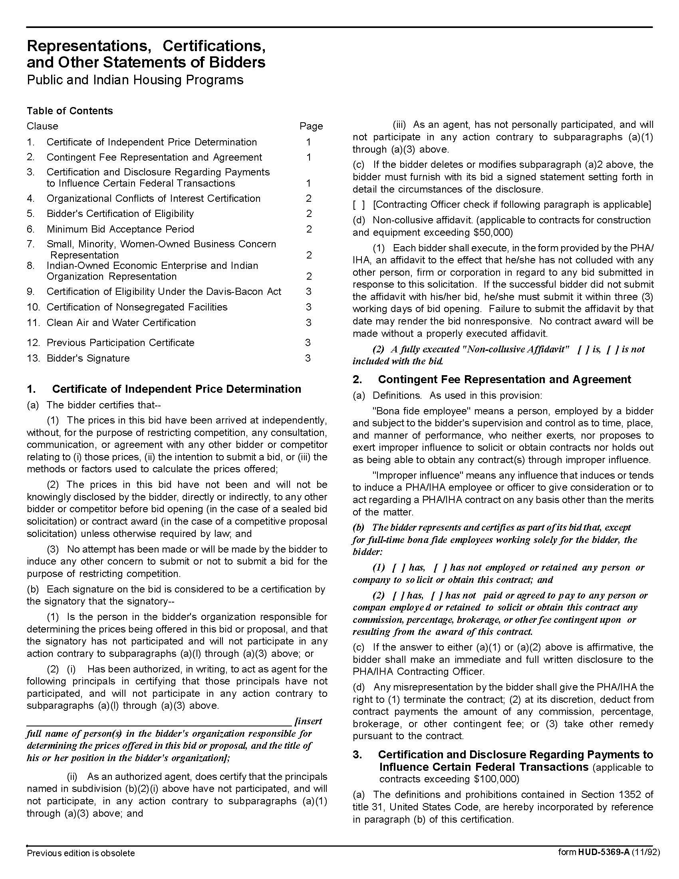

Re-glazing & Related Services Q1828
Solicitation Document D HUD Form 5369A - Continued
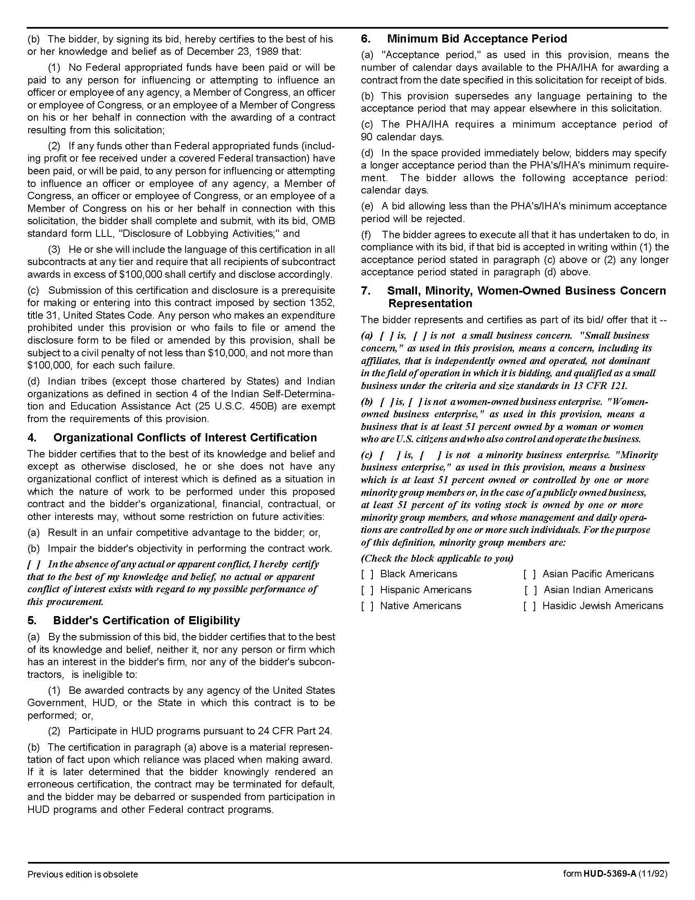

Re-glazing & Related Services Q1828
Solicitation Document D HUD Form 5369A - Continued

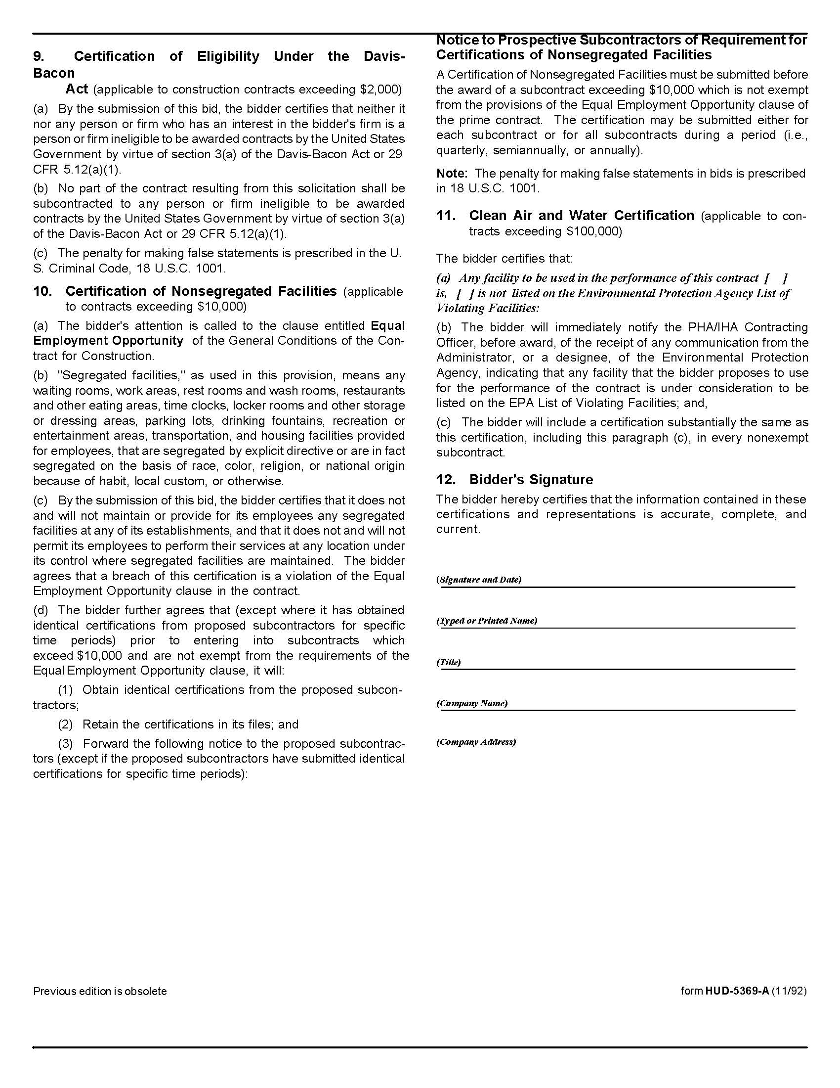

Re-glazing & Related Services Q1828
Solicitation Document E Vendor Business Information
Supplier: ________________________________________________________________________________

1. Experience:
Years in business
Years in business under this name
Years performing this type of work
Value of work now under contract
Value of work in place last year
Number of clients
Will this make KCDC your largest client?
Percentage (%) of work usually self-performed
(not sub-contracted)
Has your firm:
Failed to complete a contract? | Yes No
Been involved in bankruptcy or reorganization? | Yes No
Pending judgment claims or suits against firm? | Yes No
What company do you use for pre-employment criminal background checks?

2. Safety:
Have you had any OSHA fines within the last three (3) years? | Yes No
Have you had any job related fatalities within the last five (5) years? | Yes No
If you have answered YES to either of the above questions, you MUST submit, on a separate sheet, the details describing the circumstances surrounding each incident.

3. Personnel, Equipment & Materials:
How many total employees does your company employ
Area | Fulltime | Part Time
Clerical
Management
Technicians
Other

Re-glazing & Related Services Q1828
Solicitation Document F References
Supplier: ________________________________________________________________________________

Provide three (3) references as similar in nature and scope to this project as possible. A firm may only be listed as a reference once - even if you have completed multiple projects/jobs for them.

Name of Business
Contact Person
Contact Person Title
Contact Person Telephone Number
Description of Service Provided
Date Contract Began
Date Contract Ended
Approximate Dollar Value of the Contract | $

Name of Business
Contact Person
Contact Person Title
Contact Person Telephone Number
Description of Service Provided
Date Contract Began
Date Contract Ended
Approximate Dollar Value of the Contract | $

Name of Business
Contact Person
Contact Person Title
Contact Person Telephone Number
Description of Service Provided
Date Contract Began
Date Contract Ended
Approximate Dollar Value of the Contract | $

