

THE UNIVERSITY OF ALABAMA IN HUNTSVILLE
PROCUREMENT SERVICES
301 SPARKMAN DRIVE
HUNTSVILLE, ALABAMA 35899
PHONE (256) 824-6484

ALL BIDS WILL BE PUBLICLY OPENED ON THE OPENING DATE DESIGNATED AT THE UNIVERSITY OF ALABAMA IN HUNTSVILLE, PROCUREMENT SERVICES, BUSINESS SERVICES BLDG., HUNTSVILLE, ALABAMA 35899. BIDS RECEIVED AFTER THE SPECIFIED TIME ON THE OPENING DATE WILL NOT BE CONSIDERED.
BID NUMBER
B002725
DATE
11/18/2020
RESPONSE DUE BY:
12/01/2020
1:30 PM

WHEN USING FEDEX, UPS, OR ANY EXPRESS PACKAGING/SHIPPING, THE BID NUMBER MUST BE CLEARLY PRINTED ON THE AIR BILL.

REQUEST FOR FORMAL BID

CONTACT PHONE VENDOR NO.
KELLY HAAS 256-824-6492 «vendornum»

ALL BIDS RESPONSES ARE REQUIRED TO BE SUBMITTED ELECTRONICALLY VIA VENDOR REGISTRY. NO BID RESPONSES WILL BE ACCEPTED VIA US MAIL, FAX, OR EMAIL. FAILURE TO COMPLY WILL RESULT IN A “NO BID” RESPONSE IN ACCORDANCE WITH ALABAMA COMPETITIVE BID LAW 41-16-24 sub-part b.

V
E
N
D
O
R
THE ABOVE BID NUMBER MUST APPEAR ON ALL BIDS AND RELATED CORRESPONDENCE

OR EQUAL, REFER TO GENERAL CONDITIONS ON ATTACHED SHEET
NO | QUANTITY | UNIT | DESCRIPTION | UNIT PRICE | EXTENSION
01  02  TOTAL |  |  | THE UNIVERSITY OF ALABAMA IN HUNTSVILLE REQUESTS BIDS FOR LEAF REMOVAL SERVICES AS PER THE SPECIFICATIONS.  All bid responses are required to be submitted electronically via Vendor Registry. No bid responses will be accepted via fax or email.  AWARD:  NO AWARD INFORMATION WILL BE MADE AVAILABLE BY TELEPHONE, FAX, MAIL, OR EMAIL. ONCE THE BID IS AWARDED, THE AWARD INFORMATION AND TABULATION WILL BE POSTED TO OUR WEBSITE THRU VENDOR REGISTRY.  HTTP://WWW.UAH.EDU/BUSINESS-SERVICES/VENDORS/BID-OPPORTUNITIES  AWARD: BID AWARDS WILL BE POSTED ONLINE ON VENDOR REGISTRY (CLICK ON CLOSED SOLICITATIONS).  ALL BID RESPONSES ARE TO BE SUBMITTED THRU VENDOR REGISTRY
SHOULD A PURCHASE ORDER BE ISSUED, THE FOREGOING AND THE TERMS AND CONDITIONS ON THE ATTACHED SHEET SHALL BE APPLICABLE AND BINDING UPON THE VENDOR.
I ACKNOWLEDGE THAT I HAVE SIGNATURE AUTHORITY TO SIGN ON BEHALF OF THE COMPANY AND HEREBY AGREE TO ALL GENERAL CONDITIONS OF THIS BID REQUEST.

SIGNATURE ________________________________________________ DATE____________________________ PAGE 1
COMPANY REPRESENTATIVE An Affirmative Action/Equal Opportunity Institution

THE UNIVERSITY OF ALABAMA IN HUNTSVILLE requests bids for Leaf Removal Services as listed below per the specification below:

Bid Prices are to include all shipping charges. (FOB: Destination)

Delivery may be a factor in determining the award of this bid. Quote earliest possible delivery after receipt of purchase order:
____________________

In the event of a manufacturer price increase, proof of price change from the manufacturer must be submitted in writing to Procurement Services including the effective date of price change.

Any item found to be of inferior quality will be returned to the vendor.

The University of Alabama in Huntsville reserves the right to increase or decrease services as needed according to availability of funds for the duration of this bid.

The University is not obligated to purchase the all the services listed, but will purchase them on an as needed basis.

The successful bidder shall not substitute any required service without the prior approval of the University. Unauthorized substitutions shall not be acceptable.

The University Reserves the right to accept or reject any or all bids and is not necessarily bound to accept the lowest bid if that bid is contrary to the best interest of the University. (See GENERAL CONDITIONS 1. AWARD)
NOTE: For information regarding bid responses, it is the bidder’s responsibility to provide in detail clear proof that the products they are bidding on are equal to or better than the requirements of the invitation. The bidder is responsible to clearly and specifically indicate the product being offered and to provide sufficient descriptive literature, catalog cuts, and technical details to enable UAH to determine if the product offered meets the requirement of the invitation. Normally as in competitive sealed bidding only, the information furnished with the bid will be considered in the evaluation. Failure to furnish adequate data for evaluation purposes may result in declaring a bid nonresponsive. Unless the bidder clearly indicates in its bid that the product offered is an “EQUAL” product, such bid will be considered to offer the brand name product referenced in the invitation. The University of Alabama in Huntsville will be sole judge of “EQUAL” items submitted for bid.
"Any contract resulting from this request will be made available to other eligible entities. This may include but is not limited to; The University of Alabama System, comprised of The University of Alabama; The UAB Enterprise, consisting of The University of Alabama at Birmingham, the UAB Health System and their related foundations and affiliates , and The University of Alabama, Tuscaloosa, AL; and other state entities. Contracts resulting from the award of this request cover shipments by any entity listed above. Each entity will generate its own purchase orders, payments, etc. and delivery must be made according to the instructions on the purchase order.
The thrust of the contract is to obtain greater volume price discounts by combining the volume of purchases from participating entities within the State of Alabama.”
QUESTIONS: ALL QUESTIONS ARE TO BE DIRECTED TO KELLY HAAS VIA EMAIL KDH0017@uah.edu, UNLESS OTHERWISE STATED IN THE SPECIFICATION.

The University of Alabama in Huntsville Leaf Removal Services Bid (B002725)
November 18, 2020

- GENERAL:
  - Expectation: UAH requires all contractors to provide excellent performance, high quality, and consistent customer service to our campus, students, staff, and community.

  - UAH campus policies and procedures: Service contractors shall comply with all UAH policies and procedures. Violation of any of these policies and/or procedures can result in immediate termination of contract, without warning or notice. These policies include, but are not limited to:
    - Smoke and tobacco-free campus
    - Sexual harassment
    - Interaction with UAH students/staff/employees
    - Weapons/firearms
    - Drug free workplace
    - Motor vehicle and parking regulations

  - Liability for damage: Contractor will be liable for any and all damage incurred by their personnel and/or operation to UAH property, vehicles, and/or persons.

  - Maintenance schedule:
    - Weekly maintenance shall be performed consistently on days agreed upon between the UAH and the contractor.
    - Contractor will create and communicate a weekly maintenance schedule to UAH Grounds leadership.
    - Any change in schedule due to rain and/or holidays will be coordinated and communicated with UAH Grounds leadership prior to implementation.

- PERFORMANCE:
  - Contractor will provide all personnel, equipment, and materials necessary to fulfill the requirements within this scope of work.

  - Contractor will perform a national, seven-year felony and misdemeanor background check on each hiring applicant before they are assigned to work at UAH. This information should be obtained at the person’s consent and retained in the Contractor’s file. The Contractor will not employ anyone at UAH who has not successfully passed a felony and misdemeanor background check. All
background check costs are the Contractor’s responsibility.

  - Background checks will be provided to UAH before employees of contractors will work on campus. These background checks will be provided to UAH prior to start of service along with a list of the approved employees that will work on campus. If a new employee starts on campus the contractor will submit a background check and get approval from UAH before they are able to work on campus.

  - Contractor will only allow clearly marked company trucks, cars, and vehicles on campus. No personal vehicles will be allowed anywhere on campus.

  - Contractor will NOT store any equipment and/or materials on UAH property. All equipment and/or materials will be transported to the job site on the day of
maintenance and be removed from the property upon completion of that day’s maintenance, unless approved in advance by UAH Grounds Management.

  - Contractor will not move or remove any UAH property without prior written consent from UAH Grounds leadership.

  - Contractor will provide a sufficient number of qualified supervisors to be on site to lead, train, quality control, manage, and ensure completion of all operations.

  - Contractor’s employees will wear appropriate and identifiable company uniforms at all times while on site.

  - UAH Grounds leadership will regularly inspect the contractor’s performance to ensure scope of work is completed to terms of agreement. Contractor will only be paid for services that are satisfactorily completed based upon this scope of work and standards at the discretion of UAH Grounds leadership.

  - Contractor will communicate with UAH Grounds leadership as often as necessary, but at least weekly, to achieve optimal performance.

  - Contractor management will meet with UAH Grounds leadership monthly to perform a scheduled walk-thru of maintained properties in order to review service quality and performance.

  - Scope of work will be performed by contractor’s employees (no subcontractors) unless approved in advance writing by UAH.

- SCOPE OF WORK:
  - All leaves, debris, sticks, limbs, trash etc. shall be removed from all flower beds, shrub beds, sidewalks, parking areas, driveways and grass areas.

  - All removed materials shall be disposed of off-site. Contractor will not be allowed to dump on the UAH campus.

  - Leaf removal will be completed continuously throughout the leaf season (typically November through January), but may require additional services depending on longevity of the leaf season.

  - Total number of leaf removal services will be determined by UAH Grounds Department.

  - Contractor will remove leaves weekly to avoid allowing “build-up” of materials.

  - Operations should be done in correlation with the UAH Grounds Department to ensure accessibility is available.

  - Mechanical blowers, baggers, vacuums, sweepers, sweeper trucks etc. should be used to guarantee best results. “Mulching” IS NOT an acceptable form of leaf removal.

  - Mulch shall not be blown excessively out of beds and shall be replaced by the contractor, at the contractor’s expense, if such actions occurs.

  - Additional area is added to years 2 and 3.

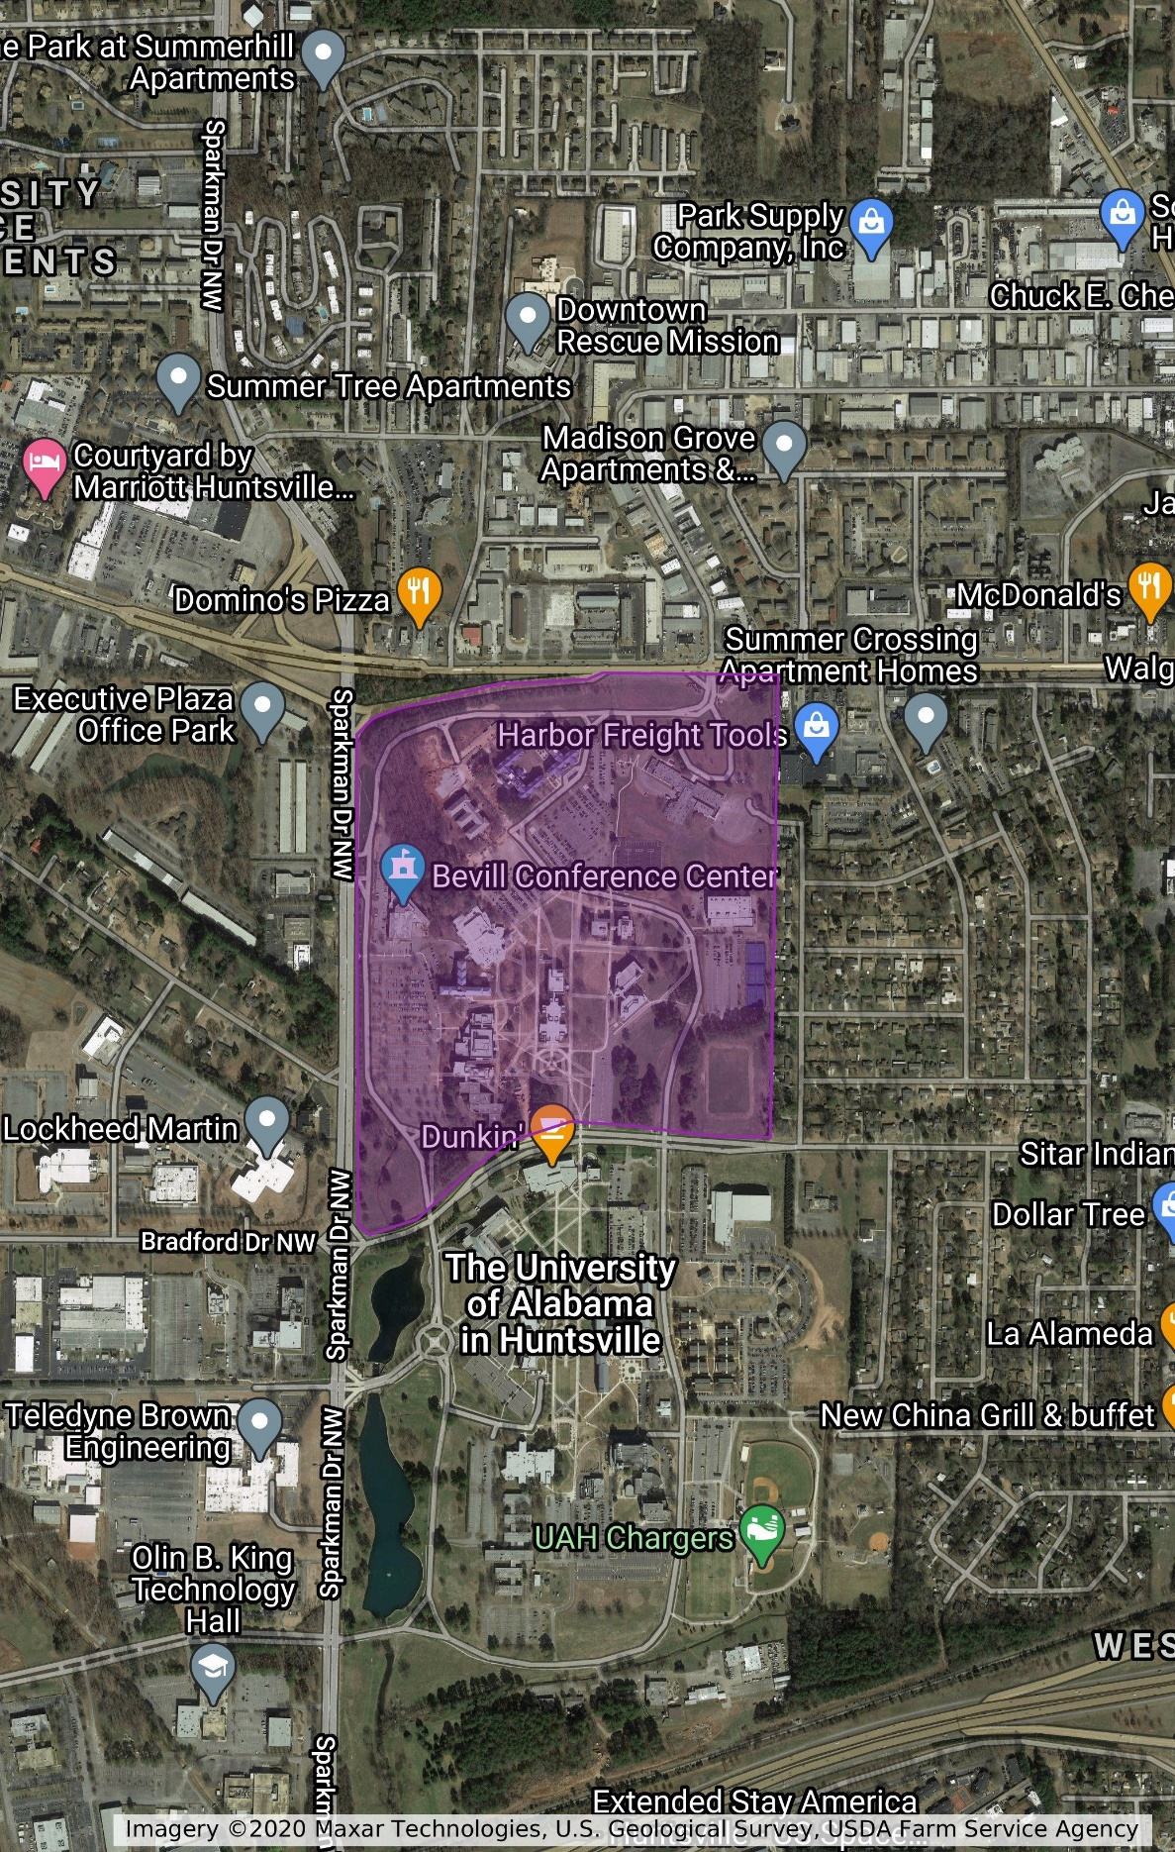
LEAF REMOVAL AREA (year 1)

Untitled layer

LEAF REMOVAL AREA (year 1)

LEAF REMOVAL AREA (years 2-3)

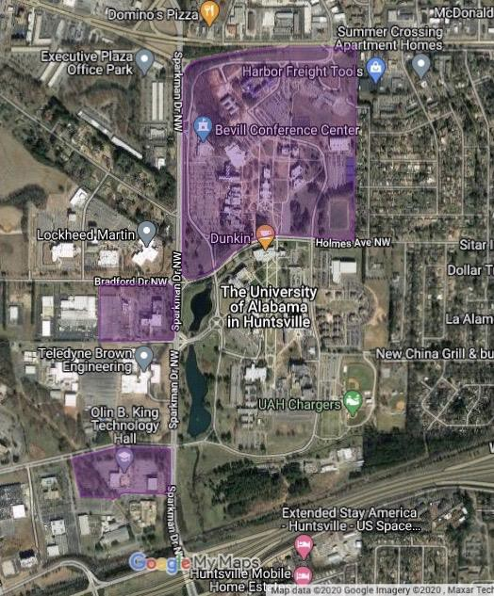

BID SHEET

YEAR 1

Highlighted Area- per service

YEAR 2 (additional area added)

Highlighted Area- per service

YEAR 3 (additional area added)

Highlighted Area- per service

GENERAL CONDITIONS

- Award: The University of Alabama in Huntsville reserves the right to accept or to reject any or all bids and is not necessarily bound to accept the lowest bid if that bid is contrary to the best interest of the University. In making an award, intangible factors such as bidder’s service, integrity, facilities, equipment, reputation, and past performance will be weighed along with the quality displayed in the samples submitted. Bids may be awarded either item by item, in products groups, or all or none, whichever appears to be in the best interest of the University. The University reserves the right to waive any or all formalities.

- Bid Withdrawal: No bids may be withdrawn without approval from The University of Alabama in Huntsville Procurement Services. Any requests for withdrawal must be in writing to Procurement Services within five (5) days after opening date with justification for reason of withdrawal. More than two (2) such requests could result in removal from our bid list. No bid may be withdrawn after the issuance of purchase order. If a withdrawal is made after the purchase order is issued, the vendor will be considered in default. Refer to “Default of Contractor”.

- Prices and Payment Terms: Bidders should quote applicable cash discounts. The University will not take into consideration in bid evaluation any cash discount of less than thirty (30) days duration. However, we will take advantage of all discounts for which we are eligible. Identify these discounts in your bid response. Bids containing “payment in advance” or “COD” requirements may be rejected.

- Applicable Law: It is agreed this quotation is valid to the extent that it does not violate the constitution or the laws of the State of Alabama.

Bidder represents and warrants that all article and services covered by this bid meet or exceed the safety standards established and promulgated under the Federal Occupational Safety and Health Act of 1970, No. 2006, and its regulations in effect or proposed as of the date of this bid.

The furnishing of materials, supplies, equipment or service to The University of Alabama in Huntsville under this purchase order, contract, solicitation for bids, or construction specification constitutes assurance by the vendor or contractor of his compliance with applicable provisions of and pertinent regulations promulgated under Executive Order 11246, date September 28, 1965 issued by the President of the United States of America, and Public Law 88-352, 88th Congress, the “Civil Rights Act of 1964”.

- Non-Collusion: Any agreement or collusion among bidders or prospective bidders in restraint of freedom of competition, by agreement to bid at a fixed price or to refrain from bidding, or otherwise, shall render the bids of such bidders void. Each bidder certifies that he has not been a party to such an agreement by signing this bid.

- New Products: Unless specifically called for in the bid, all products for purchase must be new, never previously used, and the current model and/or packaging. No remanufactured, demonstrator, used, or irregular product will be considered for purchase unless otherwise specified in the bid. The manufacturer’s standard warranty will apply unless otherwise specified in the bid. All requests should be supplied complete, ready to be installed, including all cabling and connectors where applicable.

- Bonds: Bid and performance security bond, when required will be indicated.

- Bid Submission: Failure to submit a bid on the official UAH form provided for that purpose shall be a cause for rejection of the bid. Return of the complete document is required. Modification of or additions to any portion of the solicitation may be cause for rejection of the bid; however, UAH reserves the right to decide, on a case by case basis, in its sole discretion, whether or not to reject such a bid as non-responsive.

All information shall be entered in ink or typewritten in the appropriate space on the form. Mistakes may be crossed out and corrections inserted before submission of your bid. Corrections shall be initialed in ink by the person signing the bid.

All bids must be signed. Failure to do so will result in rejection of bid.

- Delivery: Time of delivery shall be stated as the number of calendar days following receipt of the order by the vendor, to receipt of the goods by The University of Alabama in Huntsville.

Delivery time may be a criterion in awarding bids. Specify earliest possible delivery after receipt of order.

Failure to deliver within the time vendor specified in the bid will constitute a default and may cause cancellation of the contract. Refer to “Default of Contractor”.

All prices quoted are to be F.O.B. delivered to The University of Alabama in Huntsville, Central Receiving Building, 301 Sparkman Drive, Huntsville, Alabama, 35899 (unless another F.O.B. point is stated by the University on bid form). The successful bidder must assume all responsibility for damage in transit. When installation is required, it will be stated. If you are not quoting a delivered price, indicate your shipping point, and provide shipping cost for evaluation purposes.

- Bid Terms: Show unit prices, extensions, and total price. In the event of a discrepancy between the unit price and the extension, the unit price shall govern. Bids shall remain firm for minimum thirty (30) days from date of bid opening and any exception must be clearly stated.

- Bid Opening: Bidders may attend the bid opening, but no information or opinions concerning the ultimate award will be given at the bid opening or during the evaluation process. After the public opening of this bid, the results will not be available to bidders not attending the opening until after an award is made. Bid tabulations can be reviewed by accessing Procurement Services website at http://uah.edu/business-services. Click on “Vendors” then “Bid Awards”.

- Bids are Public Record: All bids become a matter of public record at bid award. The University accepts no responsibility for maintaining confidentiality of any information submitted with bid whether labeled confidential or not.

- Standards of Quality: When a material, article or piece of equipment is identified in these specifications by reference to manufacturer’s or vendor’s name, trade name, catalog and stock numbers, etc., it is intended merely to establish a standard; and, any material, article or equipment of other manufacturer and vendor which will perform equally the duties imposed by the general design, provided the material, article, or equipment proposed, is in the opinion of the Purchasing Agent of equal substance and function. It shall not be purchased or installed by the contractor without the Purchasing Agents’ written approval.

The bidder is responsible to clearly and specifically indicate the product being offered and to provide sufficient descriptive literature, catalog cuts and technical detail to enable UAH to determine if the product offered meets the requirements of the invitation. Normally in competitive sealed bidding only the information furnished with the bid will be considered in the evaluation. Failure to furnish adequate data for evaluation purposes may result in declaring a bid nonresponsive. Unless the bidder clearly indicates in its bid that the product offered is an “Equal” product, such bid will be considered to offer the brand name product referenced in the invitation. The University of Alabama in Huntsville will be sole judge of EQUAL items bid.

- Vendor Authorization: Vendor must be an authorized distributor/agent to sell products proposed in this bid request. When it is deemed to be in the best interest of the University, Procurement Services may request an on-site premise visit to examine the facility.

- Default of Contractor: Where the University has determined the contractor to be in default, the University reserves the right to purchase any or all products or services covered by the contract on the open market and to charge the contractor with cost in excess of the contract price. Until such assessed charges have been paid, no subsequent bid from the defaulting contractor will be considered.

- Fiscal Funding Clause: The continuation of this contract is contingent upon the appropriation of funds to fulfill the requirements of the contract by the legislature. If the legislature fails to appropriate sufficient monies to provide the continuation of a contract, the contract shall terminate on the date of the beginning of the first fiscal year for which funds are not appropriated.

- Contract Cancellation: Procurement Services has the right to cancel any contract, in accordance with Purchasing Rules and Regulations, for cause, including, but not limited to, the following: (1) failure to deliver within the contract; (2) failure of the product or service to meet specifications, conform to sample quality, or to be delivered in good condition; (3) misrepresentation by the contractor; (4) fraud, collusion, conspiracy, or other unlawful means of obtaining any contract with the state; (5) conflict of contract provisions with constitutional or statutory provisions of state or federal law; and (6) any other breach of contract.

- Warranties: Should merchandise described on this bid contain a manufacturer’s warranty, bidders must state the warranty terms in the space provided on the bid. Bids offered for merchandise when no warranty applies must clearly state: “NO WARRANTY COVERAGE”. Warranty information may be criteria in making this award. Failure of bidders to furnish this data may cause rejection of the complete bid as being non-responsive.

- Disclosure Statement: The successful bidder will be required to file with Procurement Services a disclosure statement of relationship between contractors/grantees and employees/officials of the University. This form must be completed prior to issuance of the Purchase Order by The University of Alabama in Huntsville.

20. State of Alabama Immigration Law: Pursuant to the State of Alabama Immigration Law, by signing this contract,
the contracting parties affirm, for the duration of the agreement, that they will not violate federal immigration law or
knowingly employ, hire for employment, or continue to employ an unauthorized alien within the State of Alabama.
Furthermore, a contracting party found to be in violation of this provision shall be deemed in breach of the
agreement and shall be responsible for all damages resulting therefrom.

- Restrictions On Communications with University Staff: From the issue date of this Solicitation until a Contractor is selected and a contract award is made, Bidders are not allowed to communicate about the subject of the bid with any University administrator faculty, staff, or members of the Board of Trustees except:

- The Procurement Services representative, any University Procurement Official representing the
University administration, or others authorized in writing by the Procurement Office and
- University Representatives during Bidder presentations.

If violation of this provision occurs, the University reserves the right to reject the Bidder’s response to
this Solicitation.

PRO REV. 6/12

Note: In order for an alternate bid to be considered, bidders must supply current catalogs or brochures, including pictorials and specifications.

F.O.B. Point  UAH DESTINATION | TERMS | WARRANTY
ESTIMATED DELIVERY | YOUR REFERENCE NO.* | QUOTATION EFFECTIVE UNTIL
BUSINESS CLASSIFICATION (see note below): | EMAIL ADDRESS:

* Your company reference number, if applicable with this bid quotation.

NOTE: Please indicate your company classification in the appropriate box above: Small Business (SB), a Small Disadvantaged Business (SD), a Black Small Disadvantaged Business (BD), a Woman-Owned Small Business (WB), a Woman-Owned Small Disadvantaged Business (WD), a Black Woman-Owned Small Disadvantaged Business (BW), a Large Business (LB), an Individual (IN), Educational (ED), Non-Profit (NP), a Labor Surplus Area Concern (LS), Disabled Veteran-Owned Small Business (DV), Veteran-Owned Small Business (VS), Historically Underutilized Business Zone (UZ), or a Governmental Agency (GV).

Certification Pursuant To Act No. 2006-557
Alabama Law (Section 41-4-116, Code of Alabama 1975) provides that every bid submitted and contract executed shall contain a certification that the vendor, contractor, and all of its affiliates that make sales for delivery into Alabama or leases for use in Alabama are registered, collecting, and remitting Alabama state and local sales, use, and/or lease tax on all taxable sales and leases into Alabama. By submitting this bid, the bidder is hereby certifying that they are in full compliance with Act No. 2006-557, they are not barred from bidding or entering into a contract pursuant to 41-4-116, and acknowledges that the awarding authority may declare the contract void if the certification is false.

____________________________________________________ ____________________________________
COMPANY NAME (TYPE OR PRINT) TELEPHONE NUMBER

____________________________________________________ ____________________________________
SIGNER’S NAME (TYPE OR PRINT) FAX NUMBER

____________________________________________________ ____________________________________
SIGNATURE DATE

The University of Alabama in Huntsville prohibits the installation of asbestos on its campus. Suppliers and contractors will not supply any equipment, material, or supplies, which contain asbestos without prior written approval.

Failure to designate Bid Number and Opening Date on the outside of your sealed envelope containing your bid and more than one bid submitted in this envelope will result in a “No Bid” response in accordance with Alabama Competitive Bid Law 41-16-24 sub-part b.

The University of Alabama in Huntsville will not accept faxed bids.

Any product that fails to meet the specifications, performance requirements or compatibility requirements will be rejected and returned to the vendor at no cost to the University.

REV. 8/12

State of Alabama Immigration Law

If the successful bidder is located in Alabama or employs an individual or individuals within the State of Alabama, the successful bidder shall provide a copy of its Employment Eligibility Verification (E-Verify) company profile. To expedite the ordering process, this document may be submitted with the bid response.

If the successful bidder is not located in the State of Alabama and does not employ an individual or individuals within the State of Alabama, the successful bidder shall complete and return the Certification of Compliance form included with this Request for Price Quotation (E-Verify company profile is not required). To expedite the ordering process, this document may be submitted with the bid response.

If you are not currently enrolled in E-Verify, follow these instructions:
- Log onto www.uscis.gov/everify
- Click “Getting Started” for information about the program, requirements, and enrollment process.
- Click “Enroll in E-Verify” and begin enrollment process.
- When enrollment process is complete, click “Edit Company Profile” and print this one-page document.
- This one-page document must be submitted prior to a contract or purchase order being issued.
- For further assistance please consult the E-Verify Quick Reference Guide.

If you have previously enrolled in E-Verify, follow these instructions:
- Log onto www.uscis.gov/everify
- Click “Edit Company Profile” and print this one-page document.
- This one-page document must be submitted prior to a contract or purchase order being issued.

REV. 6/12



CERTIFICATION OF COMPLIANCE WITH THE
STATE OF ALABAMA IMMIGRATION LAW

The undersigned officer of _________________________________ (Company)
certifies to the Board of Trustees of the University of Alabama that the Company is not located in Alabama and that the Company does not employ an individual or individuals within the State of Alabama.

_____________________________________
SIGNATURE OF COMPANY OFFICER

____________________________________
PRINT COMPANY NAME

_____________________________________
PRINT NAME OF COMPANY OFFICER

_____________________________________
PRINT TITLE OF COMPANY OFFICER

_____________________________________

DATE

REV. 6/12

