

Invitation for Sealed Bids

Solicitation Name and Number | Elevator Maintenance Services Q2107
KCDC’s Procurement Division must receive your response no later than | 11:00 a.m. on November 25, 2020 (as KCDC’s clocks indicate)
Deliver Responses to | procurementinfo@kcdc.org
Electronic Copies | Bidders are to use the MS Word version (or other software) posted on KCDC’s website to provide a typed response. The final bid is to be submitted in Adobe format.
Solicitation Meeting | ☐ Yes ☒ No
Solicitation Meeting is Mandatory | Not Applicable
Solicitation Meeting Date and Time | Not Applicable
Solicitation Meeting Connection | Not Applicable
Site Visit Schedule | Due to the current Pandemic, contact KCDC Procurement at procurementinfo@kcdc.org to obtain an appointment.
Questions About This Solicitation | KCDC will not accept questions via telephone.  Submit questions to procurementinfo@kcdc.org by 6:00 p.m. on November 20, 2020.
Solicitation Opening | The “bid opening” will be conducted via Zoom. Contact procurementinfo@kcdc.org to obtain the meeting link.
Award Results | KCDC posts the award decision to its web page at: http://www.kcdc.org/procurement/
Open Records/Public Access to Documents | All document provided to KCDC are subject to the Tennessee Open Meetings Act (TCA 8-44-101) and open records requirements.
Check KCDC’s webpage (https://www.kcdc.org/procurement/) for addenda and changes before submitting your response

General Information

1. Definitions
a. “Requirements Contact” and “Term Bid” are standing arrangements between KCDC and a supplier in which prices and terms are decided and in which during the duration, KCDC may call on the supplier to deliver goods or services (or both) under the terms and at the agreed to pricing.

b. “Senior Asset Manager” is the manager of one or more KCDC properties. He or she may delegate the administration of this work to an “Asset Manager” or “Maintenance” employee. In any case, the Senior Asset Manager or designee will request work as needs arise.

c. “Supplier” is inclusive of various words describing interested parties often called “vendor,” “bidders,” “contractors” and “proposers.”

2. Background and Intent
a. Knoxville's Community Development Corporation (KCDC) is the public housing and redevelopment agency for the City of Knoxville and for Knox County in Tennessee. KCDC’s affordable housing property portfolio includes 20 sites with approximately 3,525 dwelling units. Several of the properties include Low Income Housing Tax Credits units and KCDC is both the General Partner and the management company for those sites. Those properties include Eastport LP, Five Points 1, LP; Five Points 2, LP; Five Points 3, LP; Five Points 4, LP; Lonsdale Homes, LP; Northridge Crossing, LP and The Vista at Summit Hill, LP. KCDC also oversees approximately 3,958 Section 8 Vouchers, 82 Moderate Rehabilitation units and 20 Redevelopment areas. KCDC has issued this solicitation for itself and on the behalf of the various properties that it now provides “management services” as detailed above. Any resulting awards are either for KCDC itself or are on behalf of those properties which KCDC provides “management services.”

b. The intent of this specification is to hire a well‐qualified supplier to perform elevator maintenance on a “requirements” basis for the KCDC properties. The supplier will provide pro‐active preventive maintenance for the equipment covered by this agreement to facilitate the following:

    - Consistent safe operation of equipment
    - Maximum operational performance of equipment
    - Maximum beneficial usage of equipment
    - Maximum life cycle of equipment

c. KCDC requires the supplier(s) to reach out to small business, minority owned businesses and women owned businesses as possible subcontractors if subcontracting services are needed.

3. Changes after Award
It is possible that after award KCDC will need to revise the service needs or requirements specified in this document. KCDC reserves the right to make such changes after consultation with the supplier. Should additional costs arise, the supplier must document increased costs. KCDC reserves the right to accept or reject and negotiate these charges.

4. Codes and Ordinances
All work covered is to be done in full accord with national, state and local codes, ordinances and orders that are in effect at the time the work is performed.

5. Contact Policy
Only contact KCDC’s Procurement Division about this solicitation from the issuance of this solicitation until award. Information obtained from an unauthorized officer, agent, or employee will not affect the risks or obligations assumed by the supplier or relieve the supplier from fulfilling any of the conditions of the resulting award for the purpose of this project. Such contact can disqualify the supplier from the solicitation process.

6. Contract Length
The length of the contract will be for twelve months. The contract will have four one-year optional renewals that can be exercised upon KCDC's request.

7. COVID-19 Requirements
All workers assigned to work on this project must follow the same health and safety standards that KCDC employees do and agree to the following:

a. Workers will not enter the building if he/she answers "yes" to the existence of the any of the below symptoms or circumstances and will contact his/her supervisor immediately.

b. Worker will leave the premises immediately if any of the below symptoms appear during the workday and will contact his/her supervisor of why he/she had to leave.

c. Worker must obtain a release to work from his/her healthcare provider if he/she or anyone in his/her household experiences any of the symptoms listed below.

d. Worker will wash his/her hands after entering the building, and periodically throughout the workday.

e. Worker will maintain at least 6 feet of spacing and social distancing between him-/her-self.

f. Worker will wear a face mask if he/she is in a common/public area where others are or will be present.

g. If worker tests positive for COVID-19, he/she will be required to provide documentation from the Health Department or his/her physician indicating he/she is able to return to work.

h. If worker tests positive for COVID-19, he/she will be expected to notify his/her supervisor, who will notify the project manager or others who may need the information for their own health and wellbeing.

i. Worker shall understand that social distancing and other health mitigations that are listed as part of this contract also apply when he/she is traveling outside of his/her community; and worker will complete a COVID-19 screening test and receive a negative test result before returning to the workplace if, to the best of his/her knowledge, he/she comes into contact with anyone or have been exposed to anyone in the past 14 days who is positive for COVID-19.
j. Symptoms: Have you or anyone in your household had any of the following symptoms as new onset in the past 72 hours? (This does not include chronic conditions.)
  - Fever of 100 degrees or greater
  - New onset of cough
  - New onset of shortness of breath
  - New onset of sore throat
  - New onset of body aches
  - Diarrhea
  - New onset of headache
  - New onset of loss of taste or smell.

8. Employees
Supplier will:

a. Allow only personnel thoroughly trained and skilled to work on the job. Employees are not to be accompanied in their work area by acquaintances, family members, assistants or any person unless said person is an authorized employee of the supplier.

b. Have sufficient personnel to complete the work in a timely manner.

c. Provide adequate supervision and adequate discipline among his/her employees.

d. Provide at least one employee on every job assignment with the ability to speak, read, write and understand English so owner’s staff can communicate effectively with them.

e. Always employ the quantity and quality of supervision necessary for both effective and efficient management.

f. Ensure that employees have proper identification displayed while on the job site. Employees must always wear a company uniform or have photo identification badges.

g. Employees parking vehicles (whether corporately or privately owned) must ensure that company identification is on the vehicles. This may be by placards on the vehicle’s side, laminated paper with the company name placed on the dashboard or other means.

9. Evaluation
a. KCDC alone determines (using NIGP’s definition and other relevant sources as appropriate) the supplier’s “responsive” and “responsible” status prior to award. Responsible means a business with the financial and technical capacity to perform the requirements of the solicitation and subsequent contract. A responsive bid is one fully conforming in all material respects to the solicitation document and all of its requirements, including all forms and substance.

b. KCDC reserves the right to request additional information to assist in the evaluation process. This includes references and business capacity information.

c. KCDC will review all bids and reserves the right to request necessary modifications, waive minor technicalities, reject all bids, reject any bid that does not meet mandatory requirement(s) or cancel this solicitation, according to KCDC’s best interests. KCDC further reserves the right to adjust its evaluation scenario if they are in KCDC’s best interest and consistent with good business practices.

d. KCDC’s Evaluation Team may elect to interview one or more suppliers before making an award.

e. KCDC score and award to the best overall supplier(s) on the following evaluation scale:

Factors | Maximum Points
Cost | 100
Total | 100

10. General Instructions
KCDC does not insert “General Instructions to Suppliers” in solicitation documents. These instructions are at www.kcdc.org. Click on “Procurement” and the link to the instructions. The supplier’s submittal means acceptance of the terms and conditions set forth in KCDC’s “General Instructions to Suppliers.” These paragraphs in the “General Instructions” document do not apply to this solicitation: None.

11. Insurance
a. See Appendix 1. These insurances and levels are required and not optional. If you or your insurance agent have concerns or believe that some coverages are not necessary, email purchasinginfo@kcdc.org detailing any requested changes before this solicitation’s due date.

b. Email Certificates of Insurance to procurementinfo@kcdc.org .

12. Invoicing/Ordering
a. Until a purchase order is in place, work is not to be performed nor are goods to be delivered. KCDC has no legal obligation to pay for work performed prior to the issuance of a purchase order. Emergency situations are exempted from this statement and such situations can be approved by the Procurement Division.

b. Suppliers are asked to email invoices with 10 days following work completion and are required to submit invoices within 90 days following the delivery of the goods or services. KCDC may deny invoices submitted after the 90-day threshold.

c. KCDC pays by electronic transfer (ACH). Supplier’s accounts receivable staff must use KCDC’s Supplier Portal to ascertain payments made and to which invoices they apply. Suppliers will set up an account in KCDC’s Supplier Portal so that they receive an email with each payment detailing the invoice number and the amount paid.

KCDC is not able to routinely offer payment history assistance and so if the supplier is unable or unwilling to use KCDC’s Supplier Portal to track payments, should consider whether or not to submit a response to this solicitation.
d. Since KCDC is the managing partner for nine separate corporations under the KCDC umbrella, those
separate corporations must receive separate invoices. Thus, the supplier will generally:

- Bill each specific site for work performed or goods delivered.
- Create separate invoices for Eastport LP, Five Points 1, LP; Five Points 2, LP; Five Points 3, LP; Five
Points 4, LP; Lonsdale Homes, LP; Northridge Crossing, LP and The Vista at Summit Hill, LP showing them as the “Owner” or “Bill To” entity.

e. Invoices must:
- Be numbered
- List a date on them that is after the work is completed or goods delivered
- List the purchase order number
- Breakdown pricing according to the award structure
- Show the supplier’s name and address

13. Licenses
a. Suppliers must be properly licensed by the State of Tennessee and all other authorities having jurisdiction. Throughout the term of this award, the supplier shall maintain the required licenses.

b. In addition to any City or County licenses that may be required, all suppliers must be licensed as required by the State of Tennessee’s “Contractor Licensing Act of 1994.” The supplier must have the necessary licensing classifications as required by the Rules of the Tennessee Board for Licensing General Contractors. For your convenience, an envelope coversheet is provided at the end of this document. Use it to supply the required information.

c. The State of Tennessee Contractor Licensing Board has told KCDC that one of the following licenses is required for this work because the overall award is expected to exceed $25,000. However, KCDC will abide by any opinions or rulings that the State Contractor Licensing Board issues irrespective of this initial ruling. Any subsequent ruling by the State Licensing Board automatically revises these specifications-irrespective of the timing of the notice from the State and irrespective of the status of this solicitation.

- BC‐17 (Elevator, Escalators and Dumbwaiters)
- BC
- BC‐B (Commercial)
- BC‐b (sm)
- If there is electrical work, the supplier may subcontract it to a licensed CE supplier

14. Price Structure at Renewals
a. At the end of each twelve-month period, the awarded supplier(s) may request a change to the agreed to price. The supplier(s) must provide proof of increased Producer Price Index (Knoxville) to the Procurement Division.

b. KCDC will decide whether to accept a price increase. If the price increase is accepted, the solicitation file will be so noted. If the price increase is not accepted, the supplier may:

1. Continue with the existing pricing.
2. Suggest an alternative price increase.
3. End the award.

c. KCDC does not pay fuel surcharges.

d. KCDC will consider price increases due to tariffs and embargos upon submitted documentation. KCDC reserves the right to deny such requests. Further if a price increase is granted due to a tariff or embargo, prices must return to their previous rates once the issue is resolved.

e. Suppliers may lower prices at any time with or without notice

15. Representations
By submitting a response, the supplier represents and warrants:

a. That the supplier is financially solvent and that it is experienced in and competent to perform the type of work, and/or to furnish the personnel, plans, materials, supplies or equipment to be performed or furnished by it; and

b. That the supplier is familiar with all federal, state, municipal and county laws, ordinances and regulations, which may in any way affect the work of those employed therein, including but not limited to any special acts relating to the work or to the project of which it is a part; and

c. The failure or omission of the supplier to receive or examine the solicitation document or any part of the specifications, or to visit the sites and acquaint themselves as to the nature and location of the work, the general and local conditions and all matters which may in any way affect performance will not relieve the supplier of any obligation to perform as specified herein.

d. By submitting a response to this solicitation, each supplier is certifying that they have read the solicitation, all appendices and addenda.

16. Responsibilities
At no expense to KCDC, the supplier(s) will:

a. Provide quality control for all services provided.

b. Take precautions necessary to protect persons or property against injury or damage and be responsible for any such damage, or injury that occurs because of their fault or negligence.

c. Perform work without unnecessarily interfering with the activities of KCDC, residents or other suppliers.

17. Safety/OSHA Guideline Compliance
a. Staff and public safety are of prime concern to KCDC. All costs are the supplier’s responsibility.

b. Supplier(s) shall comply with all applicable OSHA and TOSHA rules.
c. The supplier(s) shall ensure that its employees exercise all necessary caution and discretion to avoid injury to persons or damage to property.

d. The supplier(s) is responsible for providing and placing barricades, tarps, plastic, flag tape and other safety/traffic control equipment to protect the public, surrounding areas, equipment and vehicles.

e. The supplier(s) will protect all buildings, appurtenances and furnishings from damage. The supplier(s) shall, at his expense, repair such damages (or replace the items) by approved methods to restore the damaged areas to their original condition.

f. Supplier(s) shall use caution signs as required by OSHA Regulation 1910.144 and 1910.145.

g. Safety Data Sheets (SDS) for each item must be left when the items are installed. Suppliers must be certain the brand(s) they are offering are labeled by the manufacturer with appropriate hazardous material symbols.

18. Section 3 of the HUD Act of 1968
Section 3 is a provision of the Housing and Urban Development Act of 1968 which requires that programs of direct financial assistance administered by the U.S. Department of Housing and Urban Development (HUD) provide, to the greatest extent feasible, opportunities for job training and employment to lower income residents in connection with projects in their neighborhoods.

Further, to the greatest extent feasible, contracts in connection with these projects are to be awarded to local businesses. Section 3 is a tool for fostering local economic development, neighborhood economic improvement and individual self-sufficiency.

a. Recipients and suppliers must make a good faith effort to utilize Section 3 area residents as trainees and employees in connection with the project. Targeted recruitment and the selection of Section 3 area residents for available positions are two examples of good faith efforts to meet this requirement.

b. Recipients and suppliers must make a good faith effort to award contracts to Section 3 business concerns for work in connection with the project. An example of a good faith effort to meet this requirement is the implementation of an affirmative action plan, which includes targets for the number and dollar value for awarding contracts to Section 3 business concerns.

c. Recipients and suppliers must keep records and submit reports to HUD documenting the good faith efforts taken and the results of these actions. Examples of such documentation include letters to community organizations, employment development and business development centers, copies of solicitations for bids or proposals, and copies of affirmative action plans.

d. How can businesses find Section 3 residents to work for them? This can be accomplished by recruiting in the neighborhood and public housing developments to tell about available training and job opportunities. Distributing flyers, posting signs, placing ads, and contacting resident organizations and local community development and employment agencies to find potential workers are a few effective ways of getting jobs and people together.

e. All contracts awarded are subject to Section 3 requirements. Supplier shall seek to fill all positions that are unfilled with KCDC residents. For additional information, go to http://www.hud.gov/offices/fheo/section3/Section3.pdf.

The successful supplier will give KCDC job announcements for any position that must be filled as a result of the award of KCDC work. Additionally the successful supplier will supply the same job announcement to the Knoxville-Knox County Committee Action Committee’s Workforce Connections group. These can be emailed to windie.wilson@knoxcac.org or faxed to 544-5269.

f. A Section 3 resident is one who lives within a public housing authority’s site. It is also people who live in an area with a HUD assisted program and whose income is below HUD’s low income requirements.

g. A Section 3 business is one that:
- Is at least 51% owned by a Section 3 resident; or
- Employs Section 3 residents for at least 30% of its employee base; or
3. Makes a commitment to sub contract at least 25% of the project’s dollars to a Section 3 business.

h. Upon award, the successful supplier will supply two documents to KCDC:
- A Section 3 Business determination provided one is not already on file.
2. A Section 3 Business plan for this work.

19. Security
The successful supplier is responsible for providing all security for equipment, materials, personnel and tools required for this work. KCDC is not responsible for damage or losses to equipment, materials, personnel or tools.

20. Site Examination
a. Suppliers are required to visit the site and become fully acquainted and familiar with conditions as they exist and the operations to be carried out. The supplier shall make such investigations as necessary so that they may fully understand the scope of the work and related facilities and complexities that may be encountered when executing the work.

b. The failure or omission of the supplier to receive or examine the solicitation document or any part of the specifications, or to visit the site(s) and acquaint themselves as to the nature and location of the work, the general and local conditions and all matters which may in any way affect performance shall not relieve the supplier of any obligation to perform as specified herein. Supplier understands the intent and purpose hereof and its obligations hereunder and that it shall not make any claim for, or have any right to damages resulting from any misunderstanding or misinterpretation of the resulting agreement, or because of any lack of information.

c. By submitting a response to this solicitation, each supplier is certifying that they have inspected the site and have read the solicitation and all appendices and addenda. The failure or omission of any supplier to receive or examine any form, instrument or document shall in no way relieve the supplier from any obligation in respect to its bid.

21. Smoke Free Policy
a. KCDC’s Smoke Free policy is applicable to you, your employees and subcontractors. The policy mandates:
- No smoking on KCDC’s property
- No e-vape or similar usage on owner’s property
- The Smoke Free policy applies in personal or corporate vehicles on KCDC’s property

b. Applicable definitions include:
- “Smoking” means inhaling, exhaling, burning or carrying any lighted or heated cigar, cigarette or pipe, or any other lighted or heated tobacco or plant product intended for inhalation, including hookahs and marijuana, whether natural or synthetic, in any manner or in any form. “Smoking” also includes the use of an electronic smoking device which creates an aerosol or vapor, in any manner or in any form.

- “Electronic Smoking Device” means any product containing or delivering nicotine or any other
substance intended for human consumption that can be used by a person in any manner for the purpose of inhaling vapor or aerosol from the product. The term includes any such device, whether manufactured, distributed, marketed or sold as an e-cigarette, e-cigar, e-pipe, e-hookah or vape pen or under any other product name or descriptor.

- Property means all buildings, parking lots, streets, structures and land owned by owners. Should
Your staff be observed violating these requirements, KCDC’s Procurement Division will notify you about the problem. Should there be recurrences, KCDC may ask you to not send the employee to KCDC’s property. Repeated offenses may result in forfeiture of your award.

22. Solicitation Requirements
Caution: Requirements in the solicitation are not optional. If you have concerns or issues with any of the stated requirements, raise them before the solicitation due date. Examples of past issues where suppliers made faulty assumptions include bonds, insurance requirements and payment expectations.

23. Storage
KCDC sites have very limited storage space for suppliers to access. Accordingly, suppliers are responsible for the storage of materials and their security. If possible, KCDC will allow suppliers to use space but the safety and security of the items stored is solely the responsibility of the supplier.

24. Storm Water and Street Ordinances
The City of Knoxville’s Storm Water and Street Ordinances apply to this solicitation. The successful supplier will comply with the City’s ordinances. Compliance includes but is not limited to:

a. Retaining all sediments on the project site using structural drainage controls. The cost of all drainage controls shall be considered incidental to the work.

b. No construction or demolition related materials, wastes, spills, or residues shall be discharged from the project site to streets, drainage facilities or adjacent properties by wind or runoff.

c. Non-storm water runoff from equipment and vehicle washing and any other activity shall be contained at the project site.

d. Eliminate erosion from slopes and channels by implementing Best Management Practices (BMPs) that may include, but not limited to, limiting grading scheduled during the wet season, inspecting graded areas during rain events, planning and maintaining vegetation on slopes, and covering erosion susceptible slopes.

e. Additional information about NPDES, BMPs, and Land Development Manual is on the City of Knoxville’s Storm water Engineering Division webpage. To access the additional information, go to (http://www.cityofknoxville.org/engineering/stormwater/npdes.asp).

f. Supplier shall be responsible for all work, remediation, repair, and monetary penalties or fines arising out of a Notice of Violation of the City of Knoxville’s Storm water and Street Ordinances. The supplier shall be charged any cost incurred by KCDC to install structural drainage controls or remedy a Notice of Violation. KCDC shall also charge a $100 fee per violation for related administrative costs.

25. Subcontractors
Subcontractors must:

a. Be approved by KCDC prior to beginning work.

b. Carry the insurance coverages as outlined herein.

c. Not be on the general federal government, HUD’s nor the State of Tennessee’s debarment lists.

d. Not be changed without owner’s permission.

26. Work Hours
Normal work hours are Monday through Saturday from 7:30 a.m. until 5:30 p.m. Work on Sundays or holidays will require advance approval by KCDC.

Description of Work

27. Introduction
a. The successful supplier will provide all labor, materials, and equipment necessary to perform comprehensive regular and supplemental maintenance on each of KCDC's elevators more specifically detailed below. All machinery and equipment shall be maintained in the minimum condition required by the Tennessee elevator law, rules and regulations; the terms and conditions of this document; and with good, safe maintenance practices.

b. KCDC “high‐rise buildings” were built in the late 1960's and early 1970's. When the buildings were constructed different brand of elevators were installed. The brands included Dover, Montgomery and Otis. Each company worked only on their elevators.

c. In the early 1990's KCDC renovated the elevator controllers. The intent was to renovate with a generic controller so that KCDC would not be tied to one company for maintenance service. Baxco Ultra 1000 controllers or equal were selected. KCDC currently has Baxco and MCE controllers.

d. KCDC currently has Baxco Controllers at Isabella Towers, Love Towers and Northgate Terrace. KCDC has Montgomery/MCE Controllers in the elevator at Cagle Terrace.

e. In 2002, KCDC renovated its Main Office and one elevator is there.

f. In 2005, KCDC opened “The Verandas” and one elevator is there.

g. In 2009, KCDC acquired the properties of the former Knox County Housing Authority. One property, Autumn Landing, has an elevator. It was renovated in the spring of 2009.

h. In 2009, the elevators are Cagle Terrace were modernized and brought to the 2010 code.

i. In 2010‐2011, the elevators at Isabella Towers, Love Towers and Northgate Terrace were modernized.

j. In 2015, KCDC opened “The Residences at Five Points” and one elevator is there.

28. Inspection
Inspections will be made from time to time by authorized inspectors of the Tennessee Department of Labor, Division of Elevator Safety. Citations and recommendations may be issued by the inspectors, and the successful supplier will be required to comply with these citations and recommendations within ten working days. Except for changes required by changes to the code requirements or vandalism, the supplier will be liable for the costs.

29. Materials
The term “materials” shall include all tangible property, whether designated as materials, goods, parts, or otherwise. All such materials shall be:

a. New

  - Best quality and suitable for their intended uses.

c. Obtained from or recommended by original manufacturer(s) of equipment for replacement or repair, including parts redesigned by and recommended as replacement parts by the original equipment manufacturer(s). Equivalent parts may be used if approved by KCDC in writing.

d. Parts requiring repair shall be rebuilt to “like new” condition.

e. All lubricants shall be suitable for purpose intended and shall meet or exceed minimum requirements specified by original manufacturer of equipment to which the lubricant is applied.

f. All materials delivered and stored at the property which are intended to become part of the completed services shall pass to KCDC upon installation.

g. Provide metal cabinets of suitable size for storage of materials in each machine room. Open storage of materials is not permitted. Supplier shall stock cabinets with adequate renewal parts and lubricants to maximize beneficial usage of equipment covered by this agreement.

h. Lubricants, cleaning fluids and all combustible liquids shall be stored in a metal cabinet in machine room and shall be disposed of in accordance with federal and local jurisdiction guidelines. A metal can with lid shall be provided in each machine room for temporary storage of oily rags.

i. Proration of equipment or materials is not allowed.

j. No consideration shall be given regarding obsolescence of systems, materials, or parts.

k. Consideration shall be given regarding obsolescence of systems, materials, or parts only when both the original equipment manufacturer(s) and after‐market elevator industry suppliers no longer manufacture or rebuild required parts or assemblies. Rebuilt parts and/or assemblies are acceptable when documentation is provided indicating parts and/or assembly meets all design requirements of the original part and/or assembly.

30. Monthly Maintenance Visits
The successful supplier shall inspect each elevator a minimum of one time each month not including service calls. However, the elevator in the Procurement Office building (due to its extremely limited usage) shall only be inspected once per year or as otherwise required by code. The following shall be completed at time of inspection:

  - Adjustments
All machinery and equipment shall be adjusted as required. Circuit breakers or main line switches, together with fuses for same are excluded.

  - Cleaning
All accumulated dirt, dust and rubbish shall be removed from the machine rooms, hoistways and pits. The supplier shall furnish all cleaning supplies and tools. Cleaning and refinishing of the interior of cars and exterior of hoistways, doors and frames are excluded.

c. Lubrication
All machinery and equipment shall be lubricated, as required, with materials recommended by the manufacturer of the specific machinery and equipment. The supplier shall furnish all lubricants.

d. Repairs
When necessary the supplier shall determine the nature and extent of the parts and labor that will be required to restore the machinery and equipment to its satisfactory performance condition. The supplier shall furnish labor and parts as listed below.

31. Penalties
KCDC will assess a penalty of $100 if the agreed to timeframe for responding service calls is not met more than twice per quarter.

32. Phone Monitoring
Emergency phone monitoring is to be included in the elevator maintenance cost.

33. Record Keeping
a. The successful supplier shall maintain accurate and complete records of all inspections and service calls as well as detailed documentation of all emergency requests reported to them. The supplier shall record the name of any person requesting service or emergency service.

b. Each quarter the supplier shall email a comprehensive record of all services and repairs rendered to the KCDC Supportive Maintenance Manager Jack Canada. Email the reports to jcanada@kcdc.org .

34. Removal
No parts or equipment required by services may be removed from the property without KCDC’s written approval. This does not include renewal parts stocked on site by the supplier, which shall remain supplier’s sole property until installed on the equipment. Expeditiously replenish parts/materials as utilized.

35. Repairs (Traction Type)
a. The supplier shall furnish and install or repair /replace when and as necessary:
- Annunciators Bearings
- Brake Magnet Coils Brake Shoes Brushes
- Cams
- Car Door & Hoistway Door Hangers Car Gates
- Commutators Contacts Controllers
- Door Operating Devices Gears
- Governors Hoist Cables
- Interlocks and Contacts
- Lamp Replacements in Signal Systems Machine Motors
- Motor Generator Push Buttons Rotating Elements Safety Devices
- Selectors
- Shell Lanterns & Indicators Thrusts
- All other elevator signal and accessory equipment
- Tracks and Guides Windings
- Worms

b. All parts shall be of the original manufacturer's design and specification and compatible with existing systems thereto.

c. The supplier shall not:
- Supply and replace incandescent or fluorescent lamps for car light fixtures.

- Supply and replace floor covering on elevator car platform.

- Make renewals or repairs necessitated by reason of negligence or misuse of the equipment by persons other than the supplier, his representatives and employees or by reason of any other cause beyond control of the supplier or, except normal wear and tear.

- In the event the supplier receives calls for “emergency” service, the supplier will record the name and contact points (phone/address/email) for the caller.

- Additionally, wherever possible KCDC wants suggestions, minor repair tips, et cetera from the supplier so that maintenance staff can perhaps reduce costs by handling minor issues themselves.

36. Sign In
Each site has a “Sign In Sheet” that the success supplier will sign each time that they are on‐site to service or otherwise work on the elevators.

37. Signage
Whenever an elevator is out of service for repairs or maintenance, the supplier will place “Out of Service” or “Out of Service for Repair” or similar signs on the affected elevator. Such signs will be professional looking and contain the supplier’s name and/or logo.

38. Locations
a. KCDC has the following elevator equipment included in this solicitation:

Location | Elevator Manufacturer | Model | Capacity | Last Updated
Autumn Landing  6331 Pleasant Ridge Road | Thyssenkrupp | 640092 | 2,500 pounds | 2009
Cagle Terrace  515 Renford Drive | Montgomery/MCE | Motion 4000 | 2,000 pounds | 2009
Cagle Terrace  515 Renford Drive | Montgomery/MCE | Motion 4000 | 2,250 pounds | 2009
Cagle Terrace  515 Renford Drive | Montgomery/MCE | Motion 4000 | 2,000 pounds | 2009
Cagle Terrace  515 Renford Drive | Montgomery/MCE | Motion 4000 | 2,000 pounds | 2009
Isabella Towers | Otis/GAL | 22 CT | 2,000 pounds | 2010-2011
1515 Isabella Circle | Otis/GAL | 22 CT | 2,500 pounds | 2010-2011
KCDC Main Office  901 N. Broadway | National |  | 2,500 pounds | Unknown
KCDC Procurement Office  Elevator/Lift  901 N. Broadway | Custom Industrial | Unknown | 1,000 pounds | Unknown
Love Towers  1161, 1171 Armstrong Avenue | Otis/GAL | 301639 | 2,000 pounds | 2010-2011
Love Towers  1161, 1171 Armstrong Avenue | Otis/GAL | 301640 | 2,500 pounds | 2010-2011
Love Towers  1161, 1171 Armstrong Avenue | Otis/GAL | 301641 | 2,000 pounds | 2010-2011
Love Towers  1161, 1171 Armstrong Avenue | Otis/GAL | 301642 | 2,500 pounds | 2010-2011
Northgate Terrace  4301 Whittle Springs Road | Otis/GAL | 303251 | 2,000 pounds | 2010-2011
Northgate Terrace  4301 Whittle Springs Road | Otis/GAL | 303252 | 2,000 pounds | 2010-2011
Northgate Terrace  4301 Whittle Springs Road | Otis/GAL | 303253 | 2,000 pounds | 2010-2011
Residences at Five Points  2061 Bethel Avenue | Vertical Express | 297BN | 3,500 | 2015
The Verandas  107 Flenniken Avenue | National | 34709 | 2,500 pounds | 2005

b. KCDC may add equipment (if additional elevators are added to KCDC’s portfolio) or delete elevators should elevators or property go out of KCDC portfolio. In either event, KCDC will negotiate with the supplier to reach a satisfactory cost change.

39. Work Hours
Supplier will perform all normal repairs, maintenance and inspections during regular working hours unless otherwise requested by KCDC staff or as otherwise detailed below. In the case of an emergency request by KCDC, the supplier will provide prompt emergency service at any hour or any day of the week as outlined below.

a. Passengers trapped in an elevator
The supplier will immediately dispatch service personnel to the location of the emergency. In such cases the supplier’s personnel shall arrive within 60 minutes. The dispatch of supplier's service personnel to emergency calls shall be given equal priority with emergency calls from other customers and shall receive priority over all other service calls. The cost for this service is to be included in the base maintenance fee.

b. One elevator out of service
The supplier shall respond to a service call that an elevator is out of service by sending its service personnel to the site within two hours after receiving the service call. If this occurs after KCDC’s normal work hours and another elevator is available, the service call may occur the next day. The cost for this service is to be included in the base maintenance fee.

c. Two elevators out of service or the only elevator out of service
If a site has two elevators and they both go out of service or if a site has only one elevator and it goes out of service, the supplier will respond immediately. The cost for this service is to be included in the base maintenance fee.

d. If the “north” elevator at Northgate Terrace is “out of service” it is considered an “emergency.” This is the only elevator at Northgate Terrace that will accommodate a stretcher.

e. Not later than eight hours after receiving a service call that an elevator is out of service; the supplier shall restore the elevator to service. In computing such eight‐hour period, the time that elapses between when the supplier orders a part and the receipt of the part shall not be counted. For example, if the supplier receives a service call at 8:00 a.m. on December 1, it is required to respond by sending its service personnel to the site not later than 12:00 noon on the same day. If a part is not required to be ordered to repair the elevator, the elevator must be repaired and operating by 4:00 p.m. the same day. If a part is required to repair the elevator, assuming that it is ordered at 1:00 p.m. on December 1 and is received at 10:00 a.m. on December 3rd, the supplier would be required to repair the elevator not later than 1:00 p.m. on December 3 (i.e., five hours elapsed on December 1 before the part was ordered, leaving the supplier three hours to repair the elevator after the part was received).

40. Workmanship and Materials
All materials and equipment furnished shall be new and best quality. Work shall be accurate, professionally finished and subject to KCDC’s approval. All materials and equipment provided shall conform to regulations of enforcement bodies having jurisdiction. Supplier shall furnish material samples for approval if specified and so desired by KCDC.

41. Submit your information in the order indicated below
Document Number | Title
Solicitation Document A | General Information about the Supplier
Solicitation Document B | Costs Offered
Solicitation Document C | Affidavits
Solicitation Document D | HUD Form 5369A
Solicitation Document E | Business Information and Capabilities
Solicitation Document F | Employee Training
Solicitation Document G | References

Place your company’s name on each page and number all pages consecutively

This and the Previous Pages Do Not Need to be Returned
Solicitation Document A: General Information about the Supplier
Sign Your Name to the Right of the Arrow
If completing this document in Adobe, an electronic signature is acceptable to KCDC.
Your signature indicates you read and agree to “KCDC’s General Instructions to Suppliers” (www.kcdc.org) and that you are authorized to bind the supplier or are submitting the response on behalf of and at the direction of the suppliers’ representative authorized to contractually bind the supplier. I represent that the supplier or its applicable representative(s) has reviewed the information contained in this Solicitation Package and that the information submitted is accurate.
Printed Name and Title
Company Name
Street Address
City/State/Zip
Contact Person (Please Print Clearly)
Telephone Number
Cell Number
Supplier’s E-Mail Address (Please Print Clearly)
Addenda
Addenda are at www.kcdc.org. Click on “Procurement” and then on “Open Solicitations” to find addenda. Please check for addenda prior to submitting a response.
Acknowledge addenda have been issued by checking below as appropriate:
None ☐ | Addendum 1 ☐ |  |  | Addendum 2 ☐ |  | Addendum 3 ☐ |  |  | Addendum 4 ☐ | Addendum 5 ☐
Statistical Information (Check all the apply)
This business is at least 51% owned and operated by a woman |  |  |  |  |  |  |  |  |  |  | Yes ☐ No ☐
This business qualifies as a small business by the State of Tennessee  Total gross receipts of not more than $10,000,000 average over a three-year period OR employs no more than 99 persons on a full-time basis |  |  |  |  |  |  |  |  |  |  | Yes ☐ No ☐
This business qualifies as Section 3 business (as defined by HUD):  51% or more owned by a Section 3 resident (lives in Public Housing) or it employs Section 3 residents for 30% or more of its workforce or commits to subcontract at least 25% of the project’s dollars to a Section 3 business. |  |  |  |  |  |  |  |  |  |  | Yes ☐ No ☐
This business is owned & operated by persons at least 51% of the following ethnic background:
Asian/Pacific ☐ |  | Black ☐ | Hasidic Jew ☐ |  | Hispanic ☐ |  |  | Native Americans ☐ |  |  | White ☐
Prompt Payment Discount
A prompt payment discount of ________% is offered for payment within ____ days of submission of an accurate and proper invoice.
MasterCard Acceptance
Mastercard is accepted for payment without additional fees. ☐ Yes ☐ No
Insurance
I have reviewed the insurance requirements and will comply with them without exception. Yes ☐ No ☐

Solicitation Document B: Costs Offered

Part 1 Costs for routine inspection and maintenance services

Location | Yearly Cost for this Site
Autumn Landing | $
Cagle Terrace | $
Isabella Towers | $
KCDC Main Office | $
KCDC Purchasing Office | $
Love Towers | $
Northgate Terrace | $
The Residences at Five Points | $
The Verandas | $
Grand Total | $

Part 2 Cost for Non-Routine Services

Item | Cost
Hourly rates for non‐covered work: Regular Time | $
Hourly rates for non‐covered work: Non-Regular Time | $

Part 3 Definition of “Regular Hours and Days” (all others constitute “Non-Regular Time”

Day | Regular Hours are
Monday | a.m. to p.m.
Tuesday | a.m. to p.m.
Wednesday | a.m. to p.m.
Thursday | a.m. to p.m.
Friday | a.m. to p.m.
Saturday | a.m. to p.m.
Sunday | a.m. to p.m.

Part 4 Holidays (those designated below constitute “Non-Regular Time”
Name | Is a Holiday? | Name | Is a Holiday?
New Years | Yes ☐ No ☐ | Labor Day | Yes ☐ No ☐
President’s Day | Yes ☐ No ☐ | Columbus Day | Yes ☐ No ☐
Martin Luther King Jr. Day | Yes ☐ No ☐ | Veteran’s Day | Yes ☐ No ☐
Good Friday | Yes ☐ No ☐ | Thanksgiving and Day After | Yes ☐ No ☐
Memorial Day | Yes ☐ No ☐ | Christmas Eve | Yes ☐ No ☐
July 4th | Yes ☐ No ☐ | Christmas Day | Yes ☐ No ☐
 |  | New Year’s Eve | Yes ☐ No ☐

Solicitation Document C: Affidavits

Conflict of Interest
1. No commissioner or officer of KCDC or other person whose duty it is to vote for, let out, overlook or in any manner superintend any of the work for KCDC has a direct interest in the award or the supplier providing goods or services.

2. No employee, officer or agent of the grantee or sub-grantee will participate in selection, or in the award or administration of an award supported by Federal funds if a conflict of interest, real or apparent, would be involved. Such a conflict would arise when the employee, officer or agent, any member of his immediate family, his or her partner, or an organization, which employs, or is about to employ, any of the above, has a financial or other interest in the supplier selected for award.

3. The grantee's or sub-grantee's officers, employees or agents will neither solicit nor accept gratuities, favors or anything of monetary value from suppliers, potential suppliers or parties to sub-agreements.

4. By submission of this form, the supplier is certifying that no conflicts of interest exist.

Drug Free Workplace Requirements
5. Private employers with five or more employees desiring to contract for construction services attest that they have a drug free workplace program in effect in accordance with TCA 50-9-112.

Eligibility
6. The supplier is eligible for employment on public contracts because no convictions or guilty pleas or pleas of nolo contender to violations of the Sherman Anti-Trust Act, mail fraud or state criminal violations with an award from the State of Tennessee or any political subdivision thereof have occurred.
General
7. Supplier fully understands the preparation and contents of the attached offer and of all pertinent circumstances respecting such offer.

8. Such offer is genuine and is not a sham offer.

Iran Divestment Act
9. Concerning the Iran Divestment Act (TCA 12-12-101 et seq.), by submission of this bid/quote/proposal, each supplier and each person signing on behalf of any supplier certifies, and in the case of a joint bid/quote/proposal, each party thereto certifies as to its own organization, under penalty of perjury, that to the best of its knowledge and belief that each supplier is not on the list created pursuant to § 12-12-106.

Accuracy of Electronic Copies
10. If the supplier provides electronic copies of the bid/proposal/quote to KCDC, the supplier certifies that the information provided on paper and in the electronic format is identical unless specifically noted otherwise.

Non-Collusion
11. Neither the said supplier nor any of its officers, partners, owners, agents, representatives, employees or parties interest, including this affiant, has in any way colluded conspired, connived or agreed, directly or indirectly, with any other responder, supplier, or person to submit a collusive or sham offer in connection with the award or agreement for which the attached offer has been submitted or to refrain from making an offer in connection with such award or agreement, or collusion or communication or conference with any other supplier, or, to fix any overhead, profit, or cost element of the offer price or the offer price of any other supplier, or to secure through any collusion, conspiracy, connivance, or unlawful agreement any advantage against KCDC or any person interested in the proposed award or agreement.

12. The price or prices quoted in the attached offer are fair, proper and not tainted by any collusion, conspiracy, connivance, or unlawful agreement on the part of the supplier or any of its agents, representatives, owners, employees, or parties in interest, including this affiant.

No Contact/No Advocacy Affidavit
13. After this solicitation is issued, any contact initiated by any supplier with any KCDC representative concerning this proposal is strictly prohibited-except for communication with the Procurement Division. My signature signifies that no unauthorized contact occurred.

14. To ensure the integrity of the review and evaluation process, respondents to this solicitation nor any firm representing them, may not lobby or advocate to KCDC staff or Board members. My signature signifies that no unauthorized advocacy occurred.

The undersigned hereby acknowledges receipt of these affidavits and certifies that the submittal in response to this solicitation is in full compliance with the listed requirements.

Signed by
Printed Name
Title
Subscribed and sworn to before me this date
By (Notary Public)
My Commission Expires on
Notary Stamp

Solicitation Document D: HUD Form 5369A
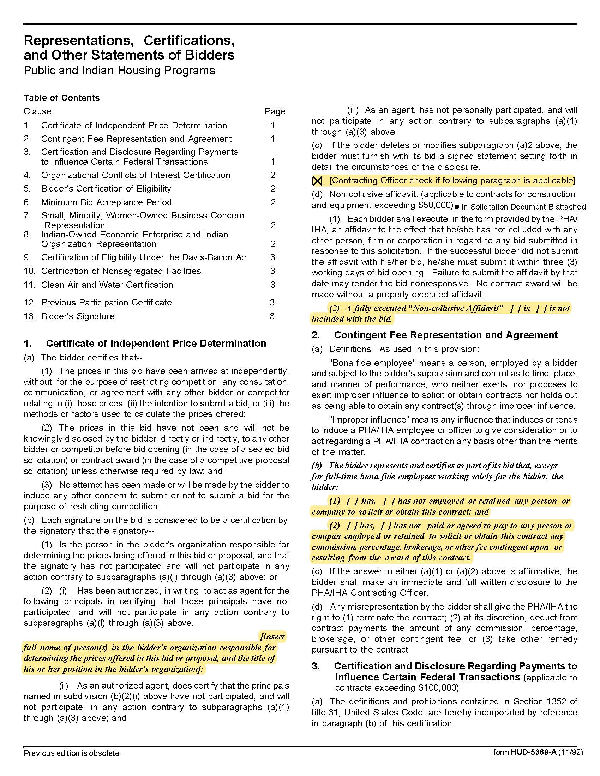

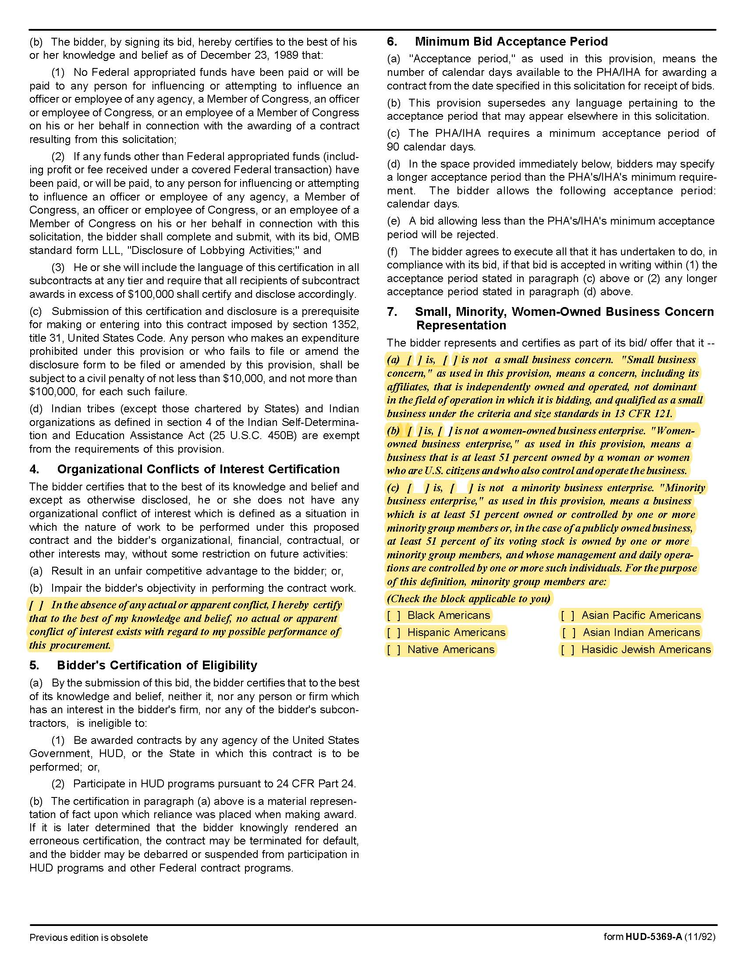

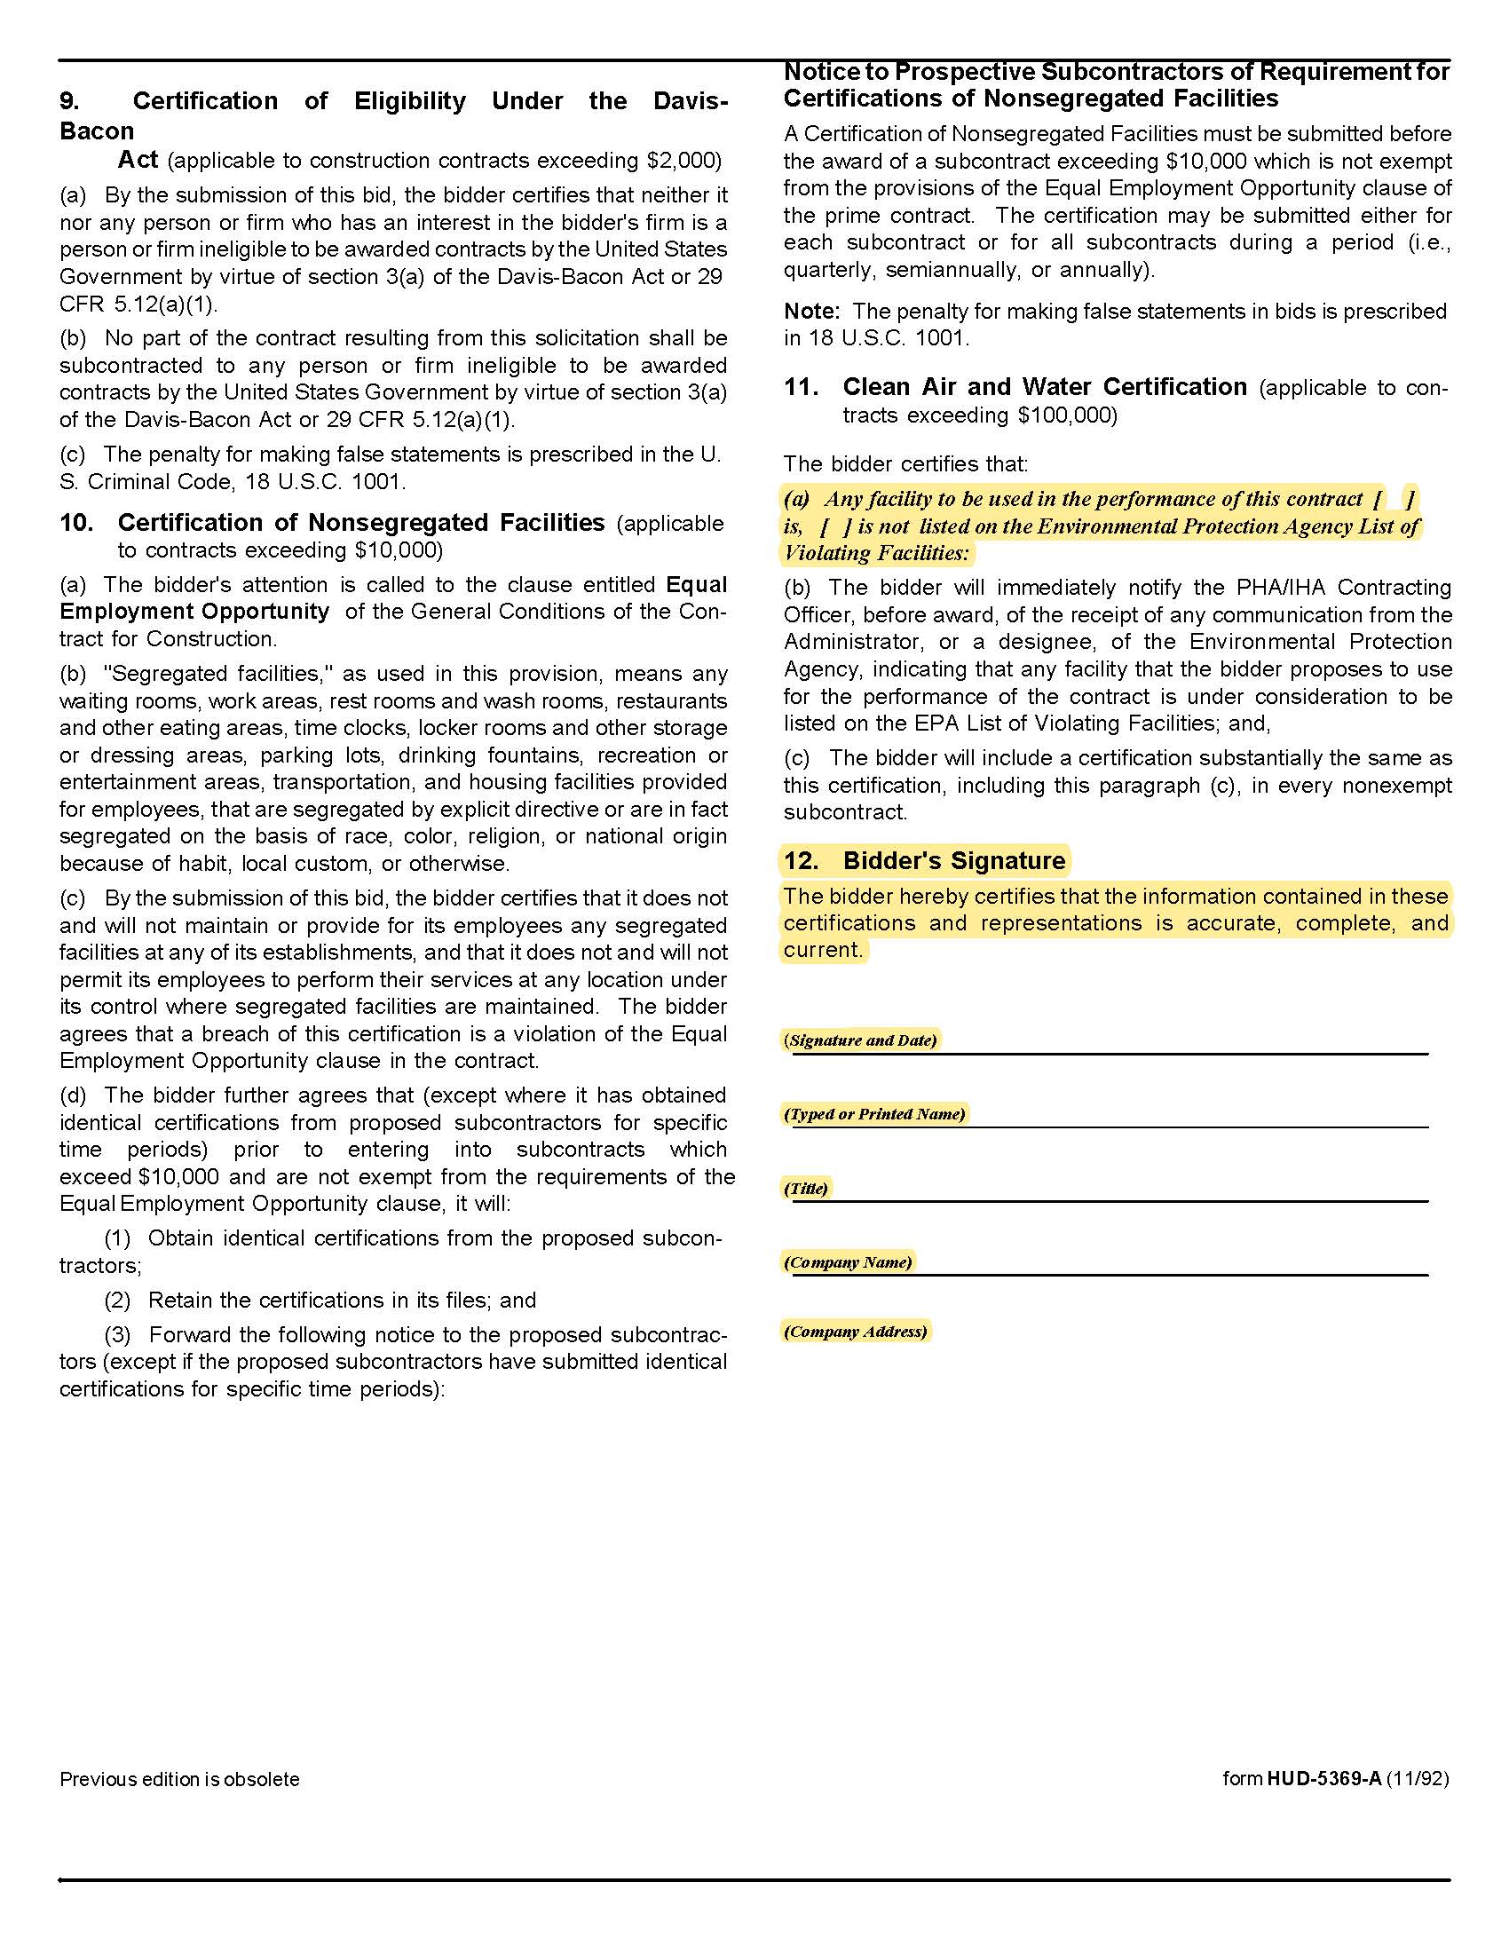

Solicitation Document E: Business Information and Capabilities

Suppliers are to provide the information requested below so that KCDC can determine their capacity to perform the required work.

1. General Business Information

Years in business
Years in business under this name
Years performing this type of work
Value of work now under award
Value of work in place last year
Number of clients
Would this award make KCDC your largest client?
Percentage (%) of work usually self-performed (not sub contracted)
What company do you use for pre-employment criminal background checks?
What percentage of your equipment do you replace each year?
Has your company:
Failed to complete an award? | Yes ☐ No ☐
Been involved in bankruptcy or reorganization? | Yes ☐ No ☐
Pending judgment claims or suits against supplier? | Yes ☐ No ☐

2. Safety

Have you had any OSHA fines within the last three (3) years? | Yes ☐ No ☐
Have you had any job-related fatalities within the last five (5) years? | Yes ☐ No ☐
If you have answered YES to either of the above questions, you MUST submit, on a separate sheet, the details describing the circumstances surrounding each incident.

3. Staff Size and Composition

Area | Fulltime | Part Time
Clerical
Management
Technicians
Total Employees working for your company

Solicitation Document F: Employee Training

1. Use this section to show resumes, training and licenses or certifications of key persons that qualifies them to work on KCDC’s elevators.

2. Discuss your firm’s continuing education program for your employees.

Solicitation Document G: References

Part 1: The bid must include five specific references of similar accounts (PHAs or apartment complexes of a similar size and complexity are preferred). Present information in this format:

Reference
Contact Person
Phone
Email
Service Date Start
Service Date End
Description of Service Provided
Number of apartments/buildings serviced

Part 2: Notes to References

1. While you may have performed numerous services and/or may have had numerous contracts with an entity, each entity can only be one references. Thus, if you serviced Knox County under 10 separate awards, it is one reference.

2. Advise the listed references that KCDC may contact them via email or SurveyMonkey.

Appendix 1 Insurance Requirements

INSURANCE
The Supplier shall maintain, at Supplier’s sole expense, on a primary and non‐contributory basis, at all times during the life of the contract insurance coverages, limits, and endorsements described herein. All insurance must be underwritten by insurers with an A.M. Best rating of A- :VI or better. Upon award, the Supplier shall provide Certificate(s) of Insurance and amendatory endorsements to KCDC evidencing said insurance coverages. See paragraph “e” for exact naming of certificate holder and additional insured.

The Supplier agrees the insurance requirements herein as well as KCDC’s review or acknowledgement, is not intended to and shall not in any manner limit or qualify the liabilities and obligations assumed by the Supplier under this contract. KCDC’s failure to require a certificate of insurance, acceptance of a non-conforming certificate, or allowing the Supplier to commence work shall not operate as a waiver of these minimum insurance requirements or the liabilities and obligations assumed by the Supplier under this contract.

a. Commercial General Liability Insurance: occurrence version general liability insurance with a minimum combined single limit of $1,000,000 per occurrence with $2,000,000 in the aggregate covering the following perils: bodily injury, personal injury, and broad form property damage including products/completed operations for one year after completion of the Project(s). Limits must apply separately to the work/location in this contract.

Such insurance shall contain or be endorsed to contain a provision that includes the KCDC, its officials, officers, employees, and volunteers as additional insureds with respect to the Supplier’s ongoing and completed operations, providing coverage at least as broad as CG 20 10 07 04 and 20 37 07 04 endorsements. The coverage shall contain no special limitations on the scope of its protection afforded to the listed insureds.

b. Commercial Automobile Liability Insurance: in an amount not less than $1,000,000 (combined single limit) for all owned, hired, and non-owned vehicles utilized by Supplier in connection with the Project. Coverage is to include coverage for loading and unloading hazards.

Such insurance shall contain or be endorsed to contain a provision that includes KCDC, its officials, officers, employees, and volunteers as additional insureds.

c. Workers’ Compensation Insurance and Employers Liability Insurance: Workers’ Compensation Insurance with statutory limits as required by the State of Tennessee or other applicable laws.

d. Other Insurance Requirements:

- Upon award, Supplier shall furnish KCDC with original Certificate(s) of Insurance and amendatory
endorsements effecting coverage required by this section.

- Provide a waiver of subrogation for each required policy herein. When required by the insurer, or
should a policy condition not permit Supplier to enter into a pre‐loss agreement to waive subrogation without an endorsement, the policy should be endorsed with a Waiver of Transfer of Rights of Recovery Against Others, or its equivalent. This waiver of subrogation requirement shall not apply to any policy which includes a condition specifically prohibiting such an endorsement, or voids coverage should supplier enter into such an agreement on a pre‐loss basis.

- A minimum 30‐day cancellation notice for all insurances (by endorsement if necessary) is required.

- Replace certificates, policies, and endorsements for any such insurance expiring prior to completion
of services.

- Maintain such insurance from the time services commence until services are completed or through
such extended discovery/reporting/tail period as required. Failure to maintain or renew coverage or to provide evidence of renewal may be treated by KCDC as a material breach of contract.

- Any deductibles and/or self‐insured retentions greater than $50,000 must be disclosed to and
approved by KCDC prior to the commencement of services. Use of large deductibles and/or self‐insured retentions will require proof of financial ability as determined by KCDC.

- All policies must be written on an occurrence basis with the exception of Errors and Omissions Liability
(E & O) / Professional Liability and Pollution Liability which may be claims made coverage.

8. Require all subcontractors to maintain during the term of the resulting contract commercial general
liability insurance, automobile liability insurance, and workers’ compensation/employers liability insurance (unless subcontractor’s employees are covered by contractor’s insurance) in the same manor and limits as specified for the Supplier.

e. Certificate Holder and Additional Insured:
KCDC, its officials, officers, employees, and volunteers
901 N Broadway
Knoxville, TN 37917

f. Right to Revise or Reject: KCDC reserves the right to revise any insurance requirement, including but not limited to, limits, coverages, and endorsements based on changes in scope of work/specifications, insurance market conditions affecting the availability or affordability of coverage.

g. No Representation of Coverage Adequacy: The coverages, limits or endorsements required herein protect the primary interests of KCDC, and the Supplier agrees in no way should these coverages, limits or endorsements required be relied upon when assessing the extent or determining appropriate types and limits of coverage to protect the Supplier against any loss exposures, whether as a result of the project or otherwise.

This page does not need to be returned

