

Request for Written Quotes

Solicitation Name and Number | Printing Services Q2008
Responses Must Arrive No Later Than  (As KCDC’s Procurement Office clocks indicate) | 11:00 a.m. on December 5, 2019
Deliver Responses to: | Knoxville’s Community Development Corporation    Procurement Division  901 N. Broadway  Knoxville, TN 37917  Note: Procurement is in a separate building behind the main office building.
Electronic Copies | Electronic copies are available on KCDC’s webpage or by email at purchasinginfo@kcdc.org.
Responses may be Emailed to KCDC | ☒ Yes ☐ No
Printed Responses Required | ☐ Yes ☒ No
Solicitation Meeting | ☐ Yes ☒ No
Solicitation Meeting is Mandatory | ☐ Yes ☐ No ☒ Not Applicable
Solicitation Meeting Date | Not applicable
Solicitation Meeting Time | Not applicable
Solicitation Meeting Location | Not applicable
Questions About This Solicitation | KCDC will not accept questions via telephone. Submit questions to purchasinginfo@kcdc.org by 4:00 p.m. on November 16, 2019.
Award Results | KCDC posts both a summary of the quotes received and the award decision to its web page at: http://www.kcdc.org/procurement/
Open Records/Public Access to Documents | All documents provided to KCDC are subject to the Tennessee Open Meetings Act (TCA 8-44-101) and open records requirements.
Check KCDC’s webpage (https://www.kcdc.org/procurement/) for addenda and changes before submitting your response

General Information

1. Background and Intent

a. Knoxville's Community Development Corporation (KCDC) is the public housing and redevelopment agency for the City of Knoxville and for Knox County in Tennessee. KCDC’s affordable housing property portfolio includes 20 sites with approximately 3,525 dwelling units. Several of the properties include Low Income Housing Tax Credits units and KCDC is both the General Partner and the management company for those sites. Those properties include Eastport LP, Five Points 1, LP; Five Points 2, LP; Five Points 3, LP; Five Points 4, LP; Lonsdale Homes, LP; Northridge Crossing, LP and The Vista at Summit Hill, LP. KCDC also oversees approximately 3,958 Section 8 Vouchers, 82 Moderate Rehabilitation units and 20 Redevelopment areas. KCDC has issued this solicitation for itself and on the behalf of the various properties that it now provides “management services” as detailed above. Any resulting awards are either for KCDC itself or are on behalf of those properties which KCDC provides “management services.”

b. The intent of this solicitation is to hire a supplier to provide ‘Print on Demand/As Needed” printing services for KCDC as detailed herein. Each of KCDC’s properties use various forms and the quantity of forms needed for each property may vary.

c. It is understood that KCDC intends to use the successful supplier for these products or services. However, KCDC reserves the right to purchase these products or services elsewhere if it is in KCDC’s best interest.

2. Changes after Award
It is possible that after award KCDC will need to revise the service needs or requirements specified in this document. KCDC reserves the right to make such changes after consultation with the supplier. Should additional costs arise, the supplier must document increased costs. KCDC reserves the right to accept and negotiate these charges.

3. Contact Personnel
It shall be essential to the success of this award to develop a good working relationship with the successful supplier. It is imperative that the KCDC account be handled efficiently and professionally. The supplier will assign no more than two contacts to handle billing inquiries and service related issues. In the event one or both contacts leave the KCDC account, the supplier will introduce the new contacts to KCDC personnel. These contacts must be knowledgeable of KCDC’s account to avoid any interruption of service.

4. Contact Policy
Only contact KCDC’s Procurement Division about this solicitation from the issuance of this solicitation until award. Information obtained from an unauthorized officer, agent or employee will not affect the risks or obligations assumed by the bidder or relieve the bidder from fulfilling any of the conditions of the resulting award for the purpose of this solicitation. Such contact can disqualify the bidder from the solicitation process.

5. Delivery

a. Printer will offer two options for delivery.

- Delivery to 901 N. Broadway, Knoxville, TN 37917 on a monthly basis with order submittal and delivery date at the printer’s discretion as noted on Solicitation Document D Cost.
- Delivery to individual sites on an as needed basis. Orders may be shipped to individual sites with a minimum order requirement for free delivery or predetermined delivery fees for those orders not meeting the minimum requirement as noted on Solicitation Document D Cost. Please see Solicitation Document E for KCDC site addresses and contact information.

b. Deliveries are accepted between 7:30 a.m. and 3:30 p.m. (may vary for individual sites) each business day.

c. A delivery/packing list shall accompany each printing job and shall show the purchase order number, form number, quantity per package and cost.

d. Orders shall be individually packaged per instructions shown on Solicitation Document D.

e. All forms are to be shrink-wrapped or boxed.

6. Entrance to Sites
Supplier’s employees are not to be on KCDC premises unless they are working on a KCDC project. Acquaintances, family members, assistants or any person not working on KCDC’s behalf will not accompany employees on KCDC sites.

7. Evaluation
KCDC alone determines (using NIGP’s definition and other relevant sources as appropriate) the supplier’s “responsive” and “responsible” status prior to award.

Responsible means a business with the financial and technical capacity to perform the requirements of the solicitation and subsequent award. A responsive bid is one that fully conforms in all material respects to the solicitation document and all of its requirements, including all form and substance. KCDC reserves the right to request additional information to assist in the evaluation process; this includes references and business capacity information.

8. General Instructions
KCDC does not insert “General Instructions to Suppliers” in solicitation documents. These instructions are at www.kcdc.org. Click on “Procurement” and the link to the instructions. The supplier’s submittal means acceptance of the terms and conditions set forth in KCDC’s “General
Instructions to Suppliers.”

These paragraphs in the “General Instructions” document do not apply to this solicitation:

11, 15, 23, 42, 50, 65, 67

9. Identification
The supplier’s employees shall have proper identification displayed, at all times, while on KCDC property. All employees must wear a company uniform or have photo identification badges or other company identification at all times.

10. Invoicing/Ordering

a. Until a purchase order is in place, work is not to be performed nor are goods to be delivered. KCDC has no legal obligation to pay for work performed prior to the issuance of a purchase order.

b. Suppliers are asked to email invoices with 10 days following work completion and are required to submit invoices within 90 days following the delivery of the goods or services. KCDC may deny invoices submitted after the 90 day threshold.

c. KCDC pays by electronic transfer (ACH). Supplier’s accounts receivable staff must use KCDC’s Vendor Portal to ascertain payments made and to which invoices they apply. Suppliers will set up an account in KCDC’s Vendor Portal so that they receive an email with each payment detailing the invoice number and the amount paid. KCDC is not able to routinely offer payment history assistance and so if the supplier is unable or unwilling to use KCDC’s Supplier Portal to track payments, consider whether or not to submit a response to this solicitation.

d. The purchase of goods and services for use by KCDC owned properties are exempt from Tennessee sales and use tax pursuant to Tennessee Code Annotated 67-6-329(a) (4) and KCDC is generally exempt from the Federal Excise tax. Upon the placement of a purchase order or the award, KCDC will provide a State of Tennessee Sales Tax Exemption form to the supplier. KCDC will not pay taxes on invoices for its tax exempt properties. However certain properties are not exempt from taxation and their invoices should include applicable taxes. These are: Eastport LP, Five Points 1, LP; Five Points 2, LP; Five Points 3, LP; Five Points 4, LP; Lonsdale Homes, LP; Northridge Crossing, LP and The Vista at Summit Hill, LP.

e. Since KCDC is the managing partner for nine separate corporations under the KCDC umbrella, those separate corporations must receive separate invoices. Thus the supplier will generally:

- Bill each specific site for work performed or goods delivered.
- Create separate invoices for Eastport LP, Five Points 1, LP; Five Points 2, LP; Five Points 3, LP;
Five Points 4, LP; Lonsdale Homes, LP;; Northridge Crossing, LP and The Vista at Summit Hill, LP showing them as the “Owner” or “Bill To” entity.

f. Invoices must:

- Be numbered
- List a date on them that is after the work is completed or goods delivered
- List the purchase order number
- Breakdown pricing according to the award structure

g. KCDC requires that invoices be submitted via email.

11. Length of Award
The length of the award will be twelve months with four optional annual renewals that KCDC may exercise at its discretion.

12. Price Structure

a. At the end of each twelve month period, the awarded supplier may request a change to the percentage and/or specific item charged to KCDC. The supplier must provide proof of increased Producer Price Index (Knoxville) to the Procurement Division. Suppliers may lower prices at any time with or without notice. KCDC will decide whether to accept a price increase. If the price increase is accepted, the solicitation file will be so noted. If the price increase is not accepted, the supplier may:

- Continue with the existing pricing.
- Suggest an alternative price increase.
- End the award.

b. KCDC does not pay fuel surcharges.

c. Suppliers may decrease prices at any time with or without notice.

13. Section 3 of the HUD Act of 1968
Section 3 is a provision of the Housing and Urban Development Act of 1968 which requires that programs of direct financial assistance administered by the U.S. Department of Housing and Urban Development (HUD) provide, to the greatest extent feasible, opportunities for job training and employment to lower income residents in connection with projects in their neighborhoods. Further, to the greatest extent feasible, awards in connection with these projects are to be awarded to local businesses. Section 3 is a tool for fostering local economic development, neighborhood economic improvement and individual self-sufficiency.

a. Recipients and suppliers must make a good faith effort to utilize Section 3 area residents as trainees and employees in connection with the project. Targeted recruitment and the selection of Section 3 area residents for available positions are two examples of good faith efforts to meet this requirement.

b. Recipients and suppliers must make a good faith effort to award to Section 3 business concerns for work in connection with the project. An example of a good faith effort to meet this requirement is the implementation of an affirmative action plan, which includes targets for the number and dollar value for awarding to Section 3 business concerns.

c. Recipients and suppliers must keep records and submit reports to HUD documenting the good faith efforts taken and the results of these actions. Examples of such documentation include letters to community organizations, employment development and business development centers, copies of solicitations for bids or proposals; and copies of affirmative action plans.

d. How can businesses find Section 3 residents to work for them? This can be accomplished by recruiting in the neighborhood and public housing developments to tell about available training and job opportunities.
Distributing flyers, posting signs, placing ads, and contacting resident organizations and local community development and employment agencies to find potential workers are a few effective ways of getting jobs and people together.

e. All awards are subject to Section 3 requirements. Supplier shall seek to fill all positions that are unfilled with KCDC residents. The successful supplier will give KCDC job announcements for any position that must be filled as a result of the award of KCDC work. Additionally the successful supplier will supply the same job announcement to the Knoxville-Knox County Committee Action Committee’s Workforce Connections group. These can be faxed to 544-5269. For additional information, go to
http://www.hud.gov/offices/fheo/section3/Section3.pdf

f. A Section 3 resident is one who lives within a public housing authority’s site. It is also people who live in an area with a HUD assisted program and whose income is below HUD’s low income requirements.

g. A Section 3 business is one that:

- Is at least 51% owned by a Section 3 resident; or
- Employs Section 3 residents for at least 30% of its employee base; or
- Makes a commitment to sub contract at least 25% of the project’s dollars to a Section 3 business.

h. Upon award, the successful supplier will supply two documents to KCDC:

- A Section 3 Business determination provided one is not already on file.
- A Section 3 Business plan for this work.

14. Smoking Policy
KCDC has a Smoke Free policy that applies to you, your employees and all subcontractors. This policy mandates:

• No smoking on KCDC’s property
• No e-vape or similar usage on KCDC’s property
• The Smoke Free policy applies in personal or corporate vehicles on KCDC’s property

HUD definitions include:

- “Smoking” means inhaling, exhaling, burning or carrying any lighted or heated cigar, cigarette
or pipe, or any other lighted or heated tobacco or plant product intended for inhalation, including hookahs and marijuana, whether natural or synthetic, in any manner or in any form.
- “Smoking” also includes the use of an electronic smoking device which creates an aerosol or
vapor, in any manner or in any form.
- “Electronic Smoking Device” means any product containing or delivering nicotine or any other
substance intended for human consumption that can be used by a person in any manner for the purpose of inhaling vapor or aerosol from the product.
- The term includes any such device, whether manufactured, distributed, marketed or sold as an
e-cigarette, e-cigar, e-pipe, e-hookah or vape pen or under any other product name or descriptor.
- Property means all KCDC owned buildings, parking lots, streets, structures and land. Should
supplier staff be observed violating these requirements, KCDC’s Procurement Division will notify the corporate level contact about the problem. Should there be recurrences, KCDC may ask the supplier to not send the employee to owner’s property. Repeated offenses may result in forfeiture of your award.

15. Use of Solicitation Forms
Suppliers are to complete the solicitation forms contained in the solicitation package. Failure to complete these forms may result in rejection of your response. Do not alter the solicitation forms without KCDC’s approval. Suppliers are asked to use the MS Word version of the pricing pages to
eliminate difficulties in reading handwritten text.

Scope of Work

16. General Requirements
KCDC primarily intends for this solicitation to result in an award for printing services for its various sites and departments.

a. Supplier shall provide all labor, supplies and materials to perform all print related services.

b. Supplier shall manufacture, deliver and invoice per orders placed by KCDC.

c. Supplier shall produce exact copies of a quality equal to the original camera ready copy in the most cost effective manner acceptable to KCDC.

d. Please see Solicitation Document D for a detailed description of the forms that are to be printed.

e. If KCDC needs additional items that are not listed herein and if KCDC desires to add them to this solicitation and award, the supplier and KCDC will negotiate an agreeable price for the items.

17. Subcontractors
Subcontractors must:

a. Be approved by KCDC prior to beginning work.

b. Carry the insurance coverages as outlined herein.

c. Comply with the Davis Bacon requirements and submit certified payrolls.

d. Not be on HUD’s Debarment List.

e. Not be changed without KCDC’s permission.

This and the Previous Pages Do Not Need to be Returned

Printing Services Q2008

Solicitation Document A General Response Section

General Information about the Supplier
Sign Your Name to the Right of the Arrow
By signing, you indicate you read and agree to “KCDC’s General Instructions to Suppliers” on www.kcdc.org.
Printed Name and Title
Company Name
Street Address
City/State/Zip
Contact Person (Please Print Clearly)
Telephone Number
Cell Number
Supplier’s E-Mail Address (Please Print Clearly)
Addenda
Addenda are at www.kcdc.org. Click on “Procurement” and then on “Open Solicitations” to find addenda. Please check for addenda prior to submitting a proposal.
Acknowledge addenda have been issued by checking below as appropriate:
None ☐ | Addendum 1 ☐ |  |  | Addendum 2 ☐ |  | Addendum 3 ☐ |  |  | Addendum 4 ☐ | Addendum 5 ☐
Statistical Information (Check all the apply)
This business is at least 51% owned and operated by a woman |  |  |  |  |  |  |  |  |  |  | Yes ☐ No ☐
This business qualifies as a small business by the State of Tennessee  Total gross receipts of not more than $10,000,000 average over a three-year period OR employs no more than 99 persons on a full-time basis. |  |  |  |  |  |  |  |  |  |  | Yes ☐ No ☐
This business qualifies as Section 3 business (as defined by HUD):  It is at least 51% owned by a Section 3 resident (lives in Public Housing) or it employs Section 3 residents for at least 30% of its employee base; or it commits to sub award at least 25% of the project’s dollars to a Section 3 business. |  |  |  |  |  |  |  |  |  |  | Yes ☐ No ☐
This business is owned & operated by persons at least 51% of the following ethnic background:
Asian/Pacific ☐ |  | Black ☐ | Hasidic Jew ☐ |  | Hispanic ☐ |  |  | Native Americans ☐ |  |  | White ☐
Cooperative Procurement
Subject to additional location/delivery charges, the supplier agrees to extend the offered costs to other governments if the government so desires. Yes ☐ No ☐
Prompt Payment Discount
A prompt payment discount of ________% is offered for payment within ____ days of submission of an accurate and proper invoice.
MasterCard Acceptance
Mastercard is accepted for payment without additional fees. Yes ☐ No ☐
Mastercard is accepted for payment with a fee of _______. Yes ☐ No ☐

Printing Services Q2008

Solicitation Document B Affidavits

Supplier: _____________________________________________________________________________

Conflict of Interest:
1. No commissioner or officer of KCDC or other person whose duty it is to vote for, let out, overlook or in any manner superintend any of the work for KCDC has a direct interest in the award or the supplier providing goods or services.

2. No employee, officer or agent of the grantee or sub-grantee will participate in selection, or in the award or administration of an award supported by Federal funds if a conflict of interest, real or apparent, would be involved. Such a conflict would arise when the employee, officer or agent, any member of his immediate family, his or her partner, or an organization, which employs, or is about to employ, any of the above, has a financial or other interest in the supplier selected for award.

3. The grantee's or sub-grantee's officers, employees or agents will neither solicit nor accept gratuities, favors or anything of monetary value from suppliers, potential supplier s, or parties to sub-agreements.

4. By submission of this form, the supplier is certifying that no conflicts of interest exist.

Drug Free Workplace Requirements:
5. Private employers with five or more workers desiring to contract for construction services attest that they have a drug free workplace program in effect in accordance with TCA 50-9-112.

Eligibility:
6. The supplier is eligible for employment on public awards because no convictions or guilty pleas or pleas of nolo contender to violations of the Sherman Anti-Trust Act, mail fraud or state criminal violations with an award from the State of Tennessee or any political subdivision thereof have occurred.

General:
7. Supplier fully understands the preparation and contents of the attached offer and of all pertinent circumstances respecting such offer.

8. Such offer is genuine and is not a sham offer.

Iran Divestment Act:
9. Concerning the Iran Divestment Act (TCA 12-12-101 et seq.), by submission of this bid/quote/proposal, each supplier and each person signing on behalf of any supplier certifies, and in the case of a joint bid/quote/proposal, each party thereto certifies as to its own organization, under penalty of perjury, that to the best of its knowledge and belief that each supplier is not on the list created pursuant to § 12-12-106.

Printing Services Q2008

Solicitation Document B Affidavits - Continued

Non-Collusion:
10. Neither the said supplier nor any of its officers, partners, owners, agents, representatives, employees or parties interest, including this affiant, has in any way colluded conspired, connived or agreed, directly or indirectly, with any other responder, supplier, or person to submit a collusive or sham offer in connection with the award or agreement for which the attached offer has been submitted or to refrain from making an offer in connection with such award or agreement, or collusion or communication or conference with any other supplier, or, to fix any overhead, profit, or cost element of the offer price or the offer price of any other supplier, or to secure through any collusion, conspiracy, connivance, or unlawful agreement any advantage against KCDC or any person interested in the proposed award or agreement.

11. The price or prices quoted in the attached offer are fair, proper and not tainted by any collusion, conspiracy, connivance, or unlawful agreement on the part of the supplier or any of its agents, representatives, owners, employees, or parties in interest, including this affiant.

Accuracy of Electronic Copies:
12. If the supplier provides electronic copies of the bid/proposal/quote to KCDC, the supplier certifies that the information provided on paper and in the electronic format is identical unless specifically noted otherwise.

No Contact/No Advocacy Affidavit:
13. After this solicitation is issued, any contact initiated by any supplier with any KCDC representative concerning this solicitation is strictly prohibited-except for communication with the Procurement Division. My signature signifies that no unauthorized contact occurred.

14. To ensure the integrity of the review and evaluation process, respondents to this solicitation nor any firm representing them, may not lobby or advocate to KCDC staff or Board members. My signature signifies that no unauthorized advocacy occurred.

The undersigned hereby acknowledges receipt of these affidavits and certifies that the submittal in response to this solicitation is in full compliance with the listed requirements.

Signed by
Printed Name
Title
Subscribed and sworn to before me this date
By (Notary Public)
My Commission Expires on
Notary Stamp

Printing Services Q2008
Solicitation Document C HUD Form 5369A
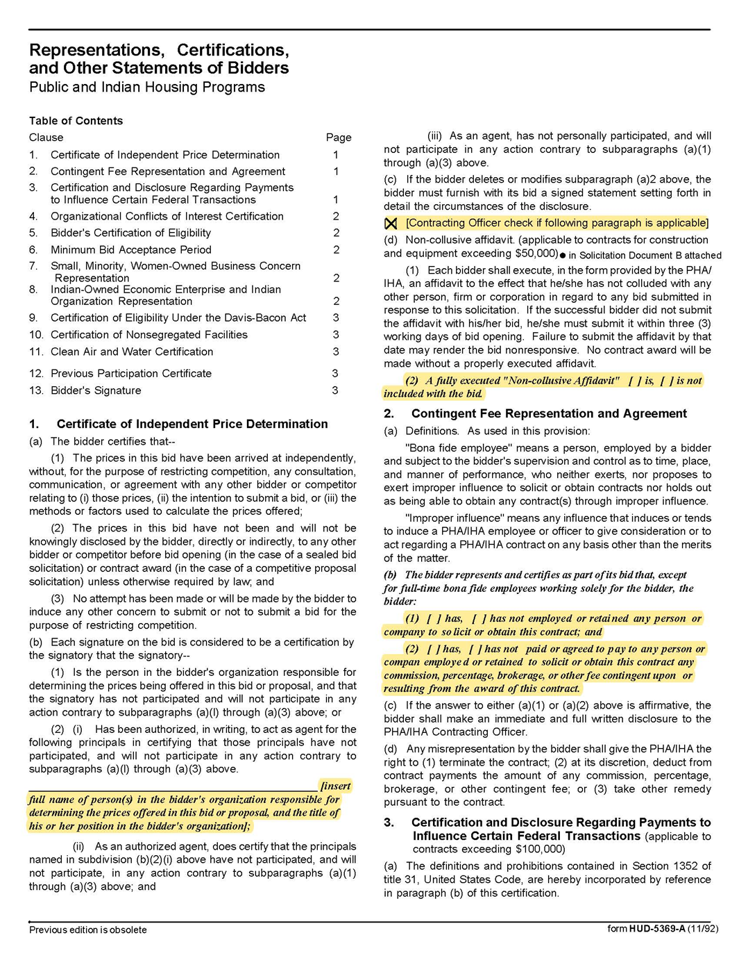
Printing Services 2008
Solicitation Document C HUD Form 5369A - Continued
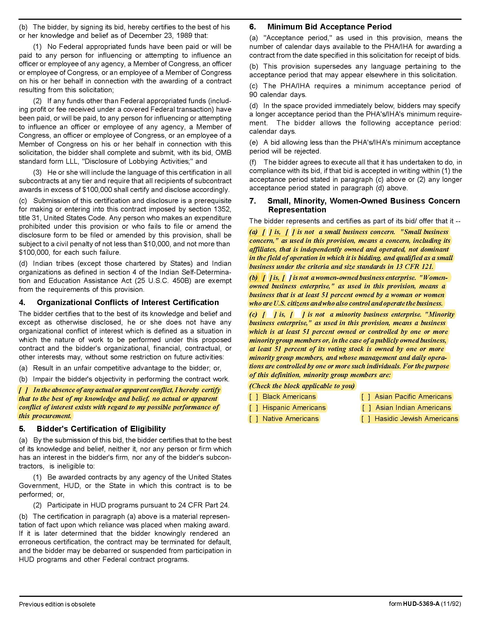

Printing Services Q1838
Solicitation Document C HUD Form 5369A - Continued

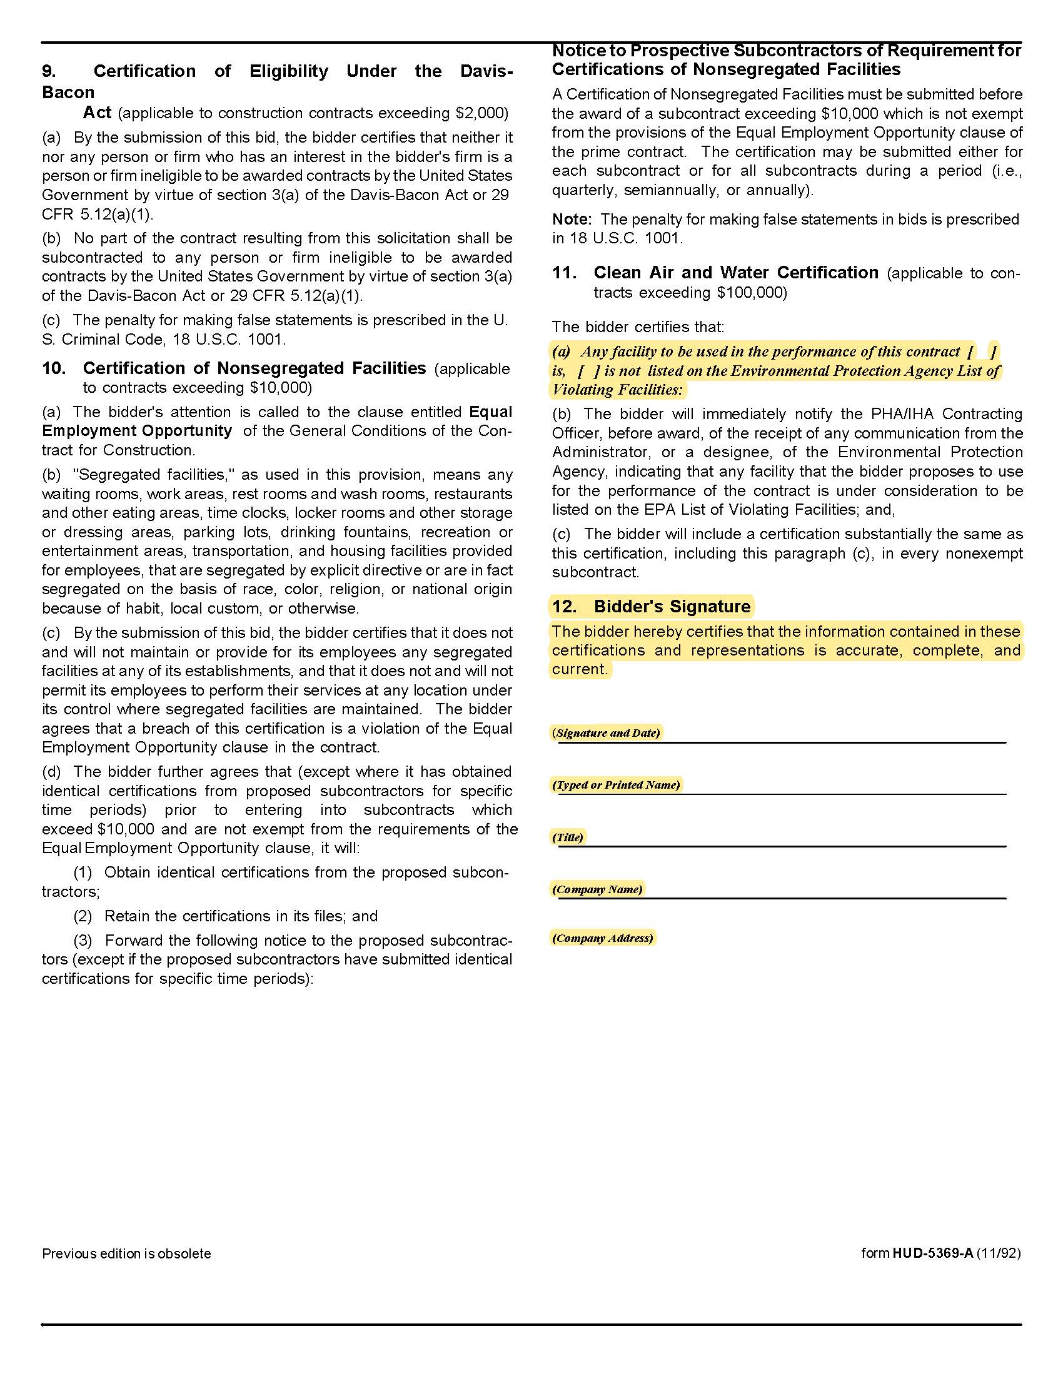

Printing Services Q2008
Solicitation Document D Cost

Item # | Item Name | Unit of  Measure | Size | Single or  Double  Sided | Binding | Ink  Color(s) | Paper Stock | Total #  Sheets  of Paper | Bleed | Cost per  Unit
1 | Notice to Resident | 50 per Pad | 5 ½” x 4 ¼” | Single | Glued Pad | Black | 20# White | N/A | Yes | $
2 | KCDC Dwelling Unit  Inspection Notice | 100 per Pad | 8 ½” x 14” | Double | Glued Pad | 4 color | 20# White | N/A | Yes | $
3 | Notice of Maintenance Call | 50 per Pad | 5 ½” x 4 ¼” | Single | Glued Pad | Black | 20# Pink | N/A | Yes | $
4 | Request for Interim  Rent Redetermination | 50 Sets  per Pack | 8 ½” x 5 ½” | N/A | Glued into  Sets | Black | White (top)  Pink (bottom) | 2 Part  Carbonless | Yes | $
5 | Knoxville Police Department  Overtime Cards | 300 per Pack | 3” x 6” | Single | N/A | Black | 67# Canary  Vellum | N/A | Yes | $
6 | Vehicle Parking sticker | 50 per Pack | 2 ½” x 4 ¼” | Single | N/A | Black | Orange Vinyl  Sticker | N/A | Yes | $
7 | LIPH Lease Packet | 50 Packets | 8 ¼” x 14” | Double | Stapled Upper  Left Corner | Black | 20# White | 4 | Yes | $
8 | Bedbug Service Preparaton Checklist | 50 Sets  per Pack | 8 ½” x 11” | N/A | Glued into  Sets | Black | White (top)  Pink (bottom) | 2 Part  Carbonless | Yes | $
9 | Grievance Procedure  Forms Packet | 50 per Pack | 8 ¼” x 14” | Double | Stapled Upper  Left Corner | Black | 20# White | 3 | Yes | $
Item # | Item Name | Unit of  Measure | Size | Single or  Double Sided | Binding | Ink  Color(s) | Paper Stock | Total #  Sheets of Paper | Bleed | Cost per  Unit
10 | Window Envelope Printed with  KCDC Logo & Return Address | 500 per Box | #10 | N/A | N/A | Black | 24# White  Wove | N/A | No | $
11 | Regular Envelope Printed with KCDC  Logo & Return Address | 500 per Box | #10 | N/A | N/A | Black | 24# White  Wove | N/A | No | $
12 | Business Card #1 with Standard  KCDC Logo | 500 per Box | 3 ½” x 2” | N/A | N/A | 2 Color PMS 193 Red  & 287 Blue | Classic Linen  Avon Brilliant White Cover | N/A | Yes | $
13 | Business Card #2 with Standard  KCDC Logo & Watermark | 500 per Box | 3 ½” x 2” | N/A | N/A | 2 Color PMS 193 Red  & 287 Blue | Classic Linen  Avon Brilliant White Cover | N/A | Yes | $
Item # | Item Name | Unit of  Measure | Size | Single or  Double Sided | Binding | Ink  Color(s) | Paper Stock | Total #  Sheets of Paper | Bleed | Cost per  Unit
14 | Section 8 – 30 Day Notice of  Intent to Move | 50 per Pack | 8½” x 11” | N/A | Glued into  Sets | Black | White, Yellow  & Pink | 3 Part  Carbonless | No | $
15 | Section 8 Briefing Packet  (Section 1) | Per Packet | 8 ½” x 11” | Single | Stapled Upper  Left Corner | Black | 20# White | 14 | No | $
16 | Section 8 Briefing Packet  Section 2 | Per Packet | 8 ½” x 11” | Single | Stapled Upper  Left Corner | Black | 20# White | 11 | No | $
17 | Section 8 Briefing Packet  Section 3 | Per Packet | 8 ½” x 11” | Single | Stapled Upper  Left Corner | Black | 20# White | 7 | No | $
18 | Section 8 Interim Reporting  Status Packet | Per Packet | 8 ½” x 11” | Single | Stapled Upper  Left Corner | Black | 20# White | 6 | No | $
19 | Section 8 Moderate  Rehabilitation Program Packet | Per Packet | 8 ½” x 11” | Single | Stapled Upper  Left Corner | Black | 20# White | 25 | No | $
20 | Section 8 Project Based Voucher  Supplemental Application Packet | Per Packet | 8 ½” x 11” | Single | Stapled Upper  Left Corner | Black | 20# White | 22 | No | $
21 | Section 8 PBV Statement of  Family Responsibility Packet & PBV  Receipt of Program Information | Per Packet | 8 ½” x 11” | Single | Stapled Upper  Left Corner | Black | 20# White | 8 | No | $
22 | Section 8 Recertification Packet | Per Packet | 8 ½” x 11” | Single | Stapled Upper  Left Corner | Black | 20# White | 19 | No | $
23 | Section 8 Recertification  Packet – Receipt of Program Information | Per Packet | 8 ½” x 11” | Single | Stapled Upper  Left Corner | Black | 20# White | 17 | No | $
24 | Section 8 Supplemental  Application Form Packet | Per Packet | 8 ½” x 11” | Single | Stapled Upper  Left Corner | Black | 20# White | 23 | No | $
25 | Section 8 Unit Complaint  Forms Packet | Per Packet | 8 ½” x 11” | Single | Stapled Upper  Left Corner | Black | 20# White | 2 | No | $
26 | Section 8 VAWA Packet | Per Packet | 8 ½” x 11” | Single | Stapled Upper  Left Corner | Black | 20# White | 5 | No | $

NOTE: Samples will be provided to supplier

Printing Services Q2008
Solicitation Document E Site Addresses
Autumn Landing & Nature’s Cove  Manager: James Pruitt  Phone: 865-403-1422  6331 Pleasant Ridge Road  Knoxville, TN 37921 | Austin Homes & The Vista  Manager: Darrell Lindsey  Phone: 865-403-1300  957 East Hill Avenue  Knoxville, TN 37915
Cagle Terrace (both buildings)  Manager: Rhonda Harris  Phone: 865-403-1310  515 Renford Drive  Knoxville, TN 37919 | Five Points & The Residences at Eastport  Manager: Kim Clark  Phone: 865-403-1390  381 McConnell Street  Knoxville, TN 37915
Isabella Towers  Manager: Sam Chambers  Phone: 865-403-1340  515 Isabella Circle  Knoxville, TN 37915 | KCDC Main Office  865-403-1100  901 North Broadway  Knoxville, TN 37917
KCDC Procurement  865-403-1133  901 North Broadway  Knoxville, TN 37917 | Lonsdale Homes & Mechanicsville  Manager: Darlene Farmer  Phone: 865-403-1350  2020 Minnesota Avenue  Knoxville, TN 37921
Love Towers (both buildings)  Manager: Steve Ellis  Phone: 865-403-1360  1171Armstrong Avenue  Knoxville, TN 37917 | Montgomery Village & The Verandas  Manager: Linda Jeter  Phone: 865-403-1380  4530 Joe Lewis Road  Knoxville, TN 37920
North Ridge Crossing & Valley Oaks  Manager: Adronicus Thomas  Phone: 865-403-1320  712 Breda Drive  Knoxville, TN 37918 | Northgate Terrace  Manager: Terri Evans  Phone: 865-403-1400  4301 Whittle Springs Road  Knoxville, TN 37917
Passport Development & The Residences at Eastport  Manager: Beth Bacon  Phone: 865-403-1154  381 McConnell Street  Knoxville, TN 37915 | Supportive Maintenance  Manager: Jack Canada  Phone: 865-403-1371  1130 Cornelia Street  Knoxville, TN 37917
The Manor at Northgate  Supportive Services: Teresa Lawson  Phone: 865-403-1410  4301 Whittle Springs Road  Knoxville, TN 37917 | Western Heights  Manager: Kristie Toby  Phone: 865-403-1420  1621 Jourolman Avenue  Knoxville, TN 37921

